COUNTY OF FRESNO
ADDENDUM NUMBER: ONE (1)
 |  | RFP NUMBER:
June 30, 2008
 |  |  | PURCHASING USE
 |  |  |  | jlg | /tmp/in/input.doc
IMPORTANT: SUBMIT PROPOSAL IN SEALED PACKAGE WITH PROPOSAL NUMBER, CLOSING DATE AND BUYER’S NAME MARKED CLEARLY ON THE OUTSIDE TO:
COUNTY OF FRESNO, Purchasing
4525 EAST HAMILTON AVENUE
FRESNO, CA 93702-4599
Closing date of proposal will be at 2:00 p.m., on July 25, 2008.
PROPOSALS WILL BE CONSIDERED LATE WHEN THE OFFICIAL PURCHASING TIME CLOCK READS 2:00 P.M.
Proposals will be opened and publicly read at that time. All proposal information will be available for review after contract award.
Clarification of specifications are to be directed to: Cathi J. Peters, phone (559) 456-7110, FAX (559) 456-7831.
NOTE THE following and attached ADDITIONS, DELETIONS AND/OR CHANGES TO THE REQUIREMENTS OF REQUEST FOR PROPOSAL NUMBER: AND INCLUDE THEM IN YOUR RESPONSE. PLEASE SIGN AND RETURN THIS ADDENDUM WITH YOUR PROPOSAL.
- Change closing date of Proposal to 2:00 P.M. on July 25, 2008. PROPOSALS WILL BE CONSIDERED LATE WHEN THE OFFICIAL PURCHASING TIME CLOCK READS 2:00 P.M.
- Copy of bid list attached
- Copy of Vendor Conference sign-up sheet attached
- Attachment “A” – Vendor questions/answers
- Attachment “B” – Additional information and requirements.

ACKNOWLEDGMENT OF ADDENDUM NUMBER ONE (1) TO RFP
COMPANY NAME:
(PRINT)
SIGNATURE:
NAME & TITLE:
(PRINT)
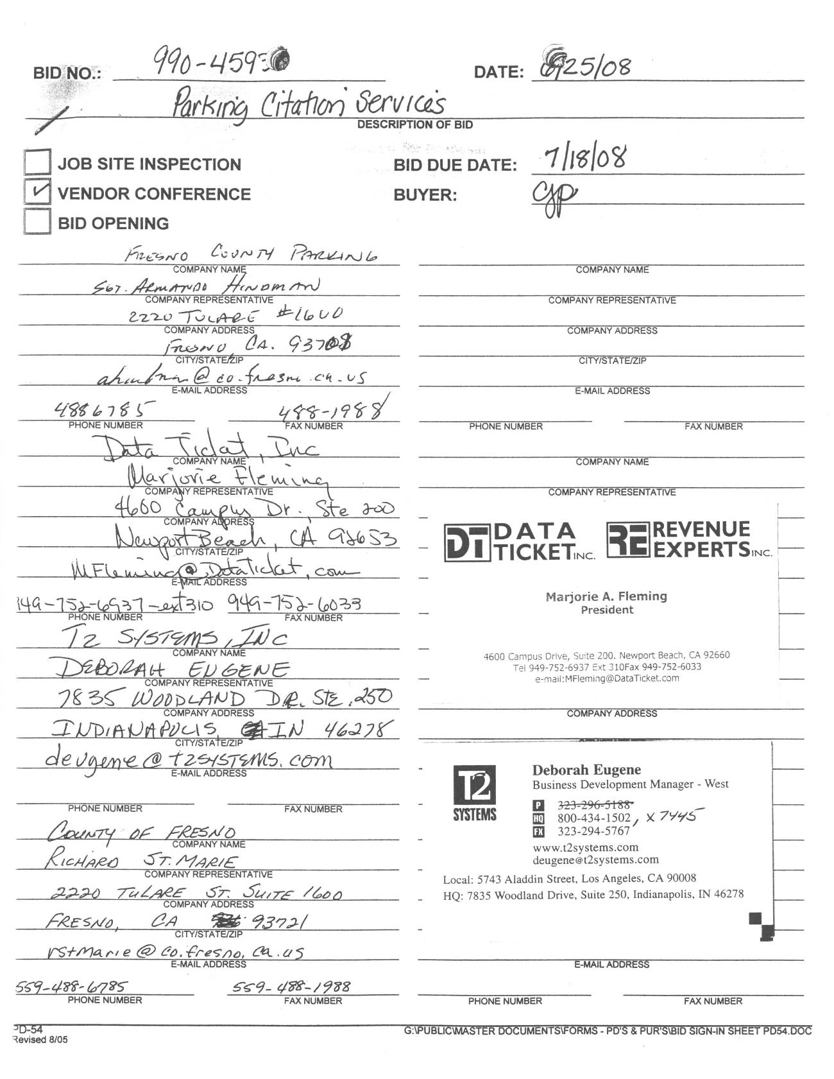
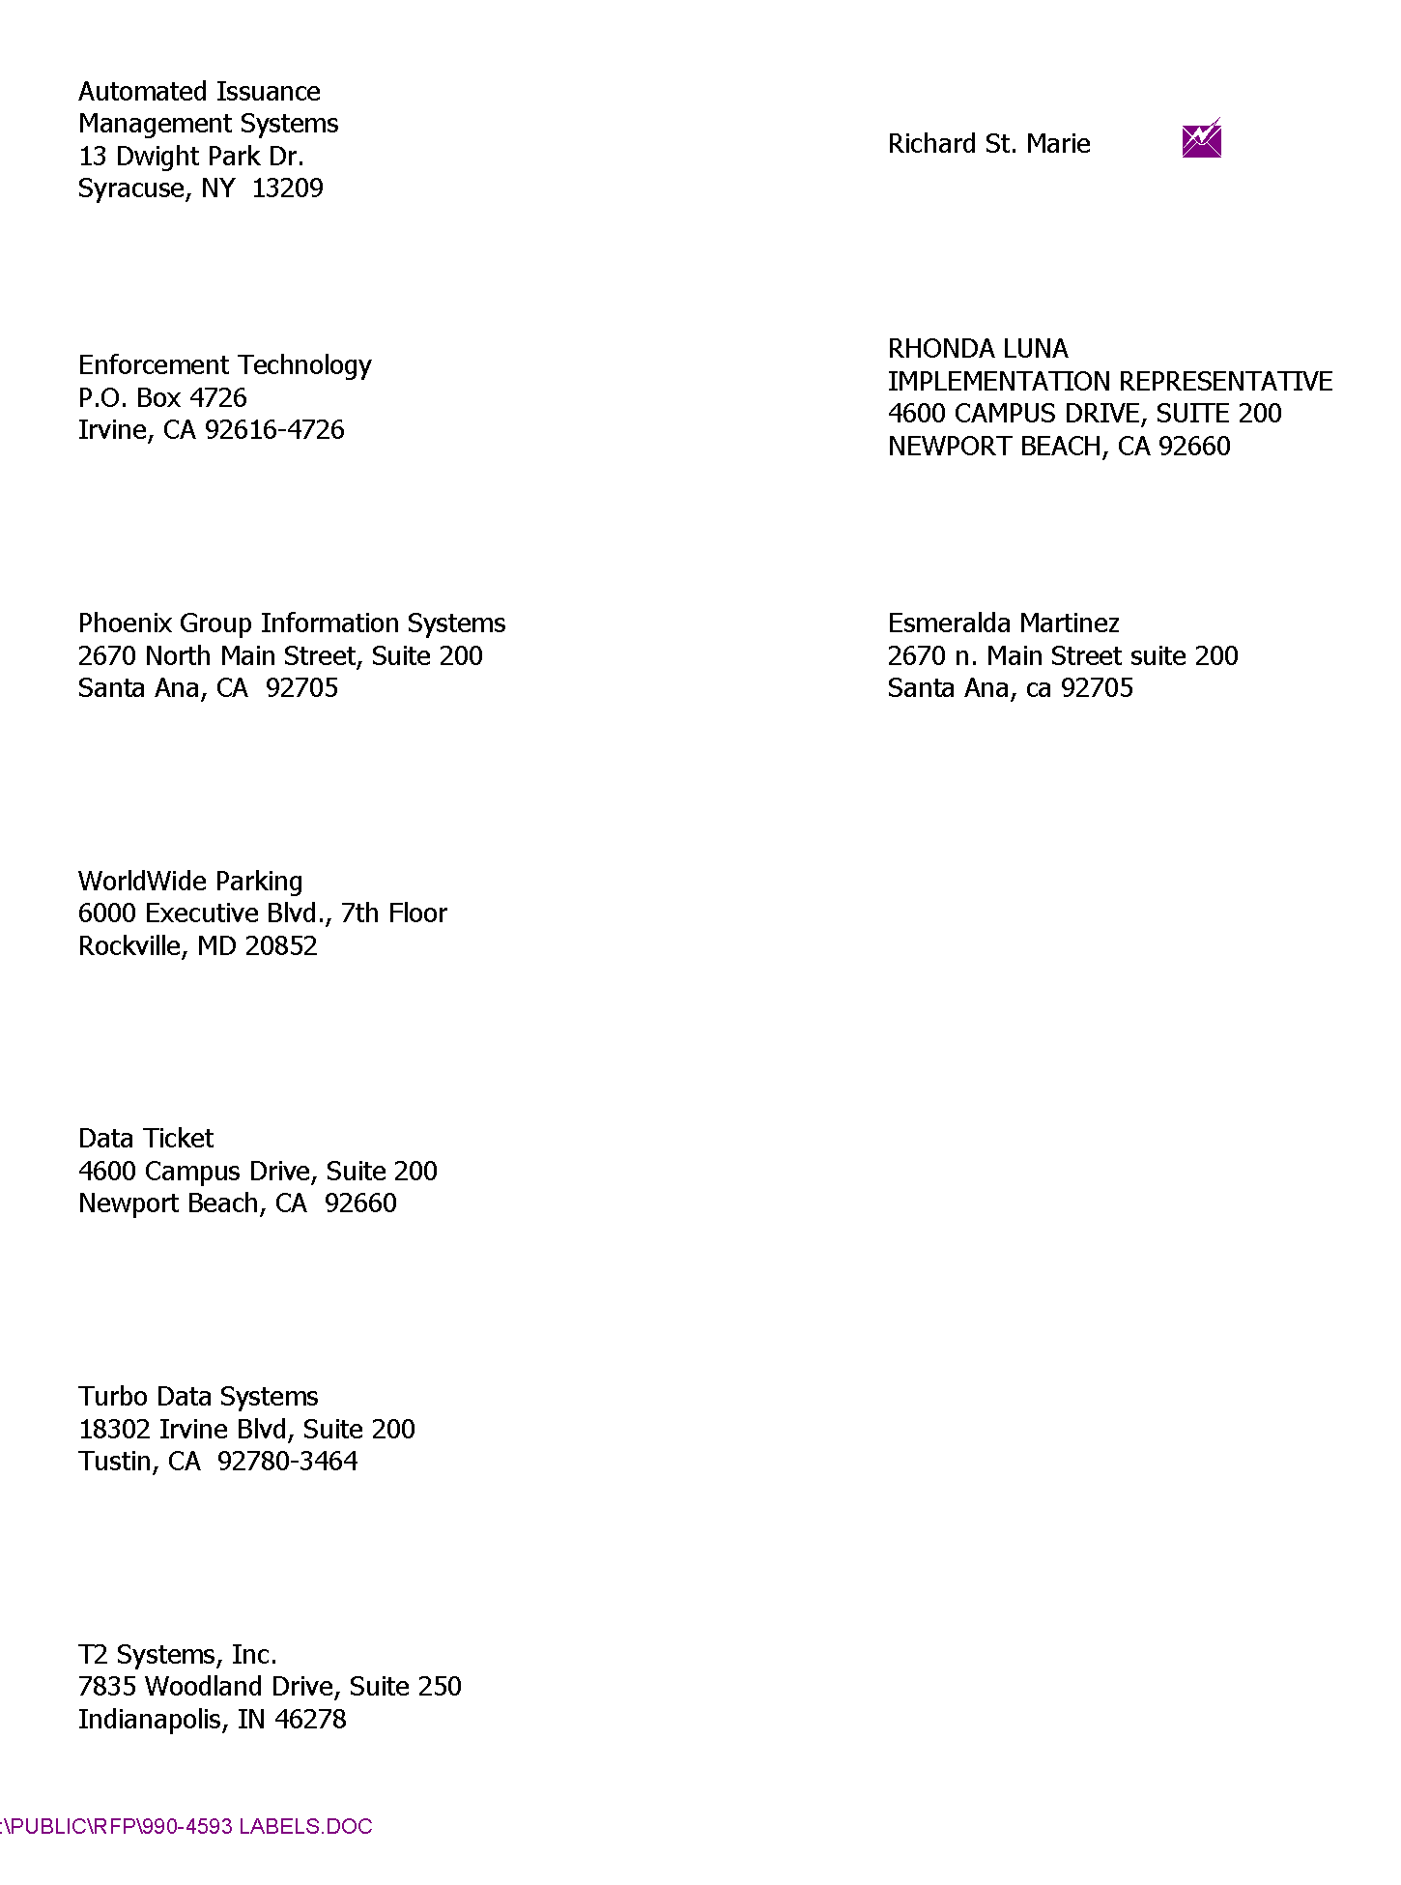
ATTACHMENT “A”
Questions Submitted by Data Ticket
- Items 23 & 24, page 19: Provide for local post office box receipt for daily payments at contractor's expense.
Would it be acceptable to have a post office box that is closer to the processing agency in order to process payments on a daily basis, rather than the weekly basis as is defined in item 24 on page 19? We have found it is in our client's best interest to enter payments as quickly as possible.
No. The County requires a local post office box in Fresno for the receipt of all mailed payments, and contest letters. If the Company receiving the contract is not located in Fresno they will be responsible for forwarding the mail from the local P.O. Box to their business address for processing. This forwarding shall be done often, but no less than weekly.
- Item 25, page 19: Deposit receipts are to be electronically transmitted to the General Services Administration Business Office daily.
In lieu of daily receipts being electronically transmitted to the General Service Administration Business Office daily, would the County accept real-time online access to reports that detail the daily deposits in the summary total deposit amount, as well as detailing each individual payment, by citation number, that comprises each deposit? This report ties directly back to the bank statement.
No. The County expects to have real time access to reports on line which will have the summary total deposit amount, however the General Services Department Business Office requires daily deposit receipts to be sent electronically (via e-mail is acceptable) so deposits can be reconciled daily.
- Item 33, page 20: Contractor to provide for the County citation dismissal processing prior to citation transfer for payment processing.
Would the county allow the citation to be entered into the database to provide for a complete audit trail and then have immediate dismissal/void capability?
Yes. It is acceptable for the citation to be entered into the database to provide for audit trail, then have immediate dismissal/void capability.
- Please provide a copy of the current contract, including both services provided and fees charged.
The current agreement is available for review at Purchasing during normal business hours.
Questions Submitted by T2 Systems, Inc.
- How many warnings are issued per year?
Warning citations are not tracked nor counted by our current parking citation processing agency. We do not have this information available.
- What percentage of citations are voided per year?
Approximately 10% of citations written during calendar year 2007 where either voided or dismissed.
- How many letters are sent per citation?
One letter is sent per citation, unless additional correspondence is needed.
  - What is the current letter policy? There is no letter policy.
  - How many letters are sent per month? There are approximately 800 letters sent per month.
- What is your current collection rate?
72% of Citations were collected in calendar year 2007.
- What percentage of citations are paid off the windshield?
24% of citations were paid without sending any notices
- What percentage do you collect from notices?
28% of citations were paid after sending the first notice
- What is the average citation fine amount?
$25.00 is the average fine
- Is there a late fee? If so, what is the average citation late fee? Are there multiple fees?
The late fee is the amount of the original fine. Therefore, the citation fine doubles after 21 days.
- Do you currently use IVR (Interactive Voice Response)? If yes, what percentage of payments are made through IVR. If not, are you interested the use of IVR?
No the County does not use an IVR system and is not interested in this system at this time.
- Page 22, Item 23 and 24 requests a local post office box. Could a local lockbox be established in lieu of a post office box?
Mailed correspondence and payments must be mailed to an address within Fresno County. If vendors are proposing something other than a post office box to receive mail, then this should be explained thoroughly in their response to the RFQ.
- Please define ‘equipment citations’ on page 21. Question #2.
Equipment citations are found in California Vehicle Code Article 9 commencing with section 5200.
- Please define ‘mechanical citations’ on page 23. Cost Proposal bullet point number 2.
Same as #11.
- Page 23, question # 33. Describe the process for dismissing appeals? Is this just data entering that the citations been dismissed or is it reviewing the appeal and determining the decision?
For the vendor the appeals process just data entry. All appeals will be done locally at the Department of General Services.
- Will a performance bond be required if awarded the contract? If yes, please provide more detail.
A performance bond will not be required.
- Does the county wish for the automated citation writing equipment to capture a color image or will black and white suffice?
The County prefers a color image of the violation.
- How many staff will need to be trained for go-live?
There will be a total of 5 staff that need training. Four (4) will need the office/front desk training and all 5 will need the in-field training for citation issuance on the automated citation writing device.
- Will all staff be able to be trained in one location?
Yes. Staff will all be trained at one location, and can be trained at the same time.
- How many concurrent users will use the system from the county (reference to page 19, question 21)?
There could be up to 4 people in the system at the same time.
Questions Submitted by Turbo Data Systems
- Scope of work item 13: It is mentioned that the vendor is to supply 4 automated citation devices. Will these 4 units be based at one location or more than one location?
The four automated citation devices will be based at one location.
- The vendor is expected to provide services for the County of Fresno, is there more than one department that issues parking citations? Is the revenue from all these citations expected to be deposited into one bank account or different accounts? Do you expect to have one database for all issued citations by the county? Or do you expect a separate database for all the different departments? Does each department get a separate set of reports?
    - Yes there are several County, State, and Federal Agencies that issue parking citation that are all processed through one County Vendor.
    - The Revenue from all citations is expected to be deposited into one bank account.
    - The County expects to have one data base for all citations issued anywhere in the County, not separate data bases for each agency.
    - The Department of General Services will manage the contract and will be the sole Department to receive or request reports.
- Will the contract have a single point of contact at the County for the services provided?
Yes. The single point of contact with be the Department of General Services-Security Division.
- Who currently provides the services addressed in the RFP?
The Phoenix Group Information Services currently is the contracted provider of these services.
- What is the current pricing for the services that you receive?
See Exhibit “A” from Contract 240113E dated November 1, 2003
ATTACHMENT “B”
Page 8
Under Interpretation of RFP correct FAX Number is (559) 456-7831.
Page 10
A performance bond is not required.
Page 13
Add the following insurance requirement:
BLANKET CRIME POLICY
Nine hundred seventy-five thousand dollars ($975,000.00) Dishonesty Crime Policy covering the dishonest acts of the Contractor’s employees.
The County currently uses the following hand-held equipment:
- IPC PP 55 Palm Printer
- HP iPAQ Pocket PC h2215
EXHIBIT “A” From Contract 240113E dated November 1, 2003
