COUNTY OF FRESNO
ADDENDUM NUMBER: ONE
 |  | RFP NUMBER:
February 2, 2006
 |  |  | PURCHASING USE
 | ORG/Requisition: 0120/ 1206000027 |  |  | jol | /tmp/in/input.doc
IMPORTANT: SUBMIT PROPOSAL IN SEALED PACKAGE WITH PROPOSAL NUMBER, CLOSING DATE AND BUYER’S NAME MARKED CLEARLY ON THE OUTSIDE TO:
COUNTY OF FRESNO, Purchasing
4525 EAST HAMILTON AVENUE
FRESNO, CA 93702-4599
Closing date of proposal will be at 2:00 p.m., on FEBRUARY 16, 2006.
PROPOSALS WILL BE CONSIDERED LATE WHEN THE OFFICIAL PURCHASING TIME CLOCK READS 2:00 P.M.
Proposals will be opened and publicly read at that time. All proposal information will be available for review after contract award.
Clarification of specifications are to be directed to: GARY W. PARKINSON, phone (559) 456-7110, FAX (559) 456-7831.
NOTE THE following and attached ADDITIONS, DELETIONS AND/OR CHANGES TO THE REQUIREMENTS OF REQUEST FOR PROPOSAL NUMBER: AND INCLUDE THEM IN YOUR RESPONSE. PLEASE SIGN AND RETURN THIS ADDENDUM WITH YOUR PROPOSAL.
- The closing Date for RFP No. 990-4204 has been changed to February 16, 2006 at 2:00 P.M.

ACKNOWLEDGMENT OF ADDENDUM NUMBER ONE TO RFP
COMPANY NAME:
(PRINT)
SIGNATURE:
NAME & TITLE:
(PRINT)

- Floor plans for the Fresno County Juvenile Hall are attached as Addendum No. ONE-EXHIBIT No. ONE.
Various Vendor questions pertaining to RFP No. 990-4204 have been submitted. Those questions are listed below. Each question is immediately followed by the County’s response. The County response is to be considered a requirement or condition of the RFP and will take precedence over any previous statement with which it is in conflict.
- Page 10, “Selection Process” indicates that proposals will be evaluated by a team consisting of representatives from appropriate County Departments. Please identify which county departments will be on the evaluation team.
At this time, the evaluation team will consist of staff from Probation, County Administrative Office, Sheriff and Risk Management.
- Will a representative of the Sheriff’s department be on the evaluation team?
At this time, yes.
- Does the reference to “Medical Staff” in the second paragraph on page 20 refer to medical staff provided by the County or by the Contractor?
The County.
- Just to clarify, is it the correct understanding that all juveniles have to be returned to JJC for lunch and then after lunch be transported back to the Courthouse again?
That is the preference. Most juveniles should be done with their court appearance by noon and another group of juveniles will be transported for the afternoon session.
- Can the contractor pick-up bag lunches from the JJC and provide these to juveniles at the Courthouse thereby eliminating numerous trips back and forth?
We believe that arrangements can be made to provide some bag lunches in the morning.
- Will all juveniles be prescreened by the County in regards to what risk classification they are in before they are picked up by the Contractor at the JJC? I.e. sexual offender, gang affiliation, suicide watch, age, violent offenders, mental health juvenile, etc…
The risk classification will be determined by the Probation Department and conveyed to the transportation vendor each morning, prior to transport.
- Will the County provide the contractor access to the “Red Flag Book” presently maintained by the Probation department?
The “Red Flag Book” will not be available to the transport vendor. However, the Probation Department will utilize it and convey that pertinent information to the transport vendor, each day, prior to transport.
- What records / forms / pass-down log are presently used by the County to record the transfer from the Holding area to the Court Bailiff and vice-versa? Please, provide samples of the forms presently being used.
The Probation Department advises there are no forms currently being utilized with the Court Bailiff. However, it is expected that forms will need to be created for this new process.
- Please, provide a copy of the current policy and procedures used by the County for their current operations as they presently occur in the 10th street facility.
The transport of juveniles from the JJC to the 10th street facility is a different process than how the juveniles are being moved to court today. The juveniles’ housing unit is adjacent to the court and the juveniles are taken directly from their housing units to the court. Current procedures are not deemed relevant to this RFP.
- The contractor is aware that this contract is projected to end by August 2008 when the new courthouse will be finished on American Avenue. The investment in vehicles for such a rather short period of time can be quite expensive. In this regard, will the county consider allowing the contractor to use current county vehicles / prisoner transport vans during the course of this contract where the contractor will maintain the requisite automobile insurance for said vehicles?
The County is not in a position to provide vehicles to a contractor for this service. We suggest that the vendor might explore leasing vehicles from a private carrier.
- Will the County consider changing the requirement to have ALL juveniles transported in the morning to having only those juveniles transported and be at the courthouse at 8 a.m. to be limited to those juveniles scheduled to be heard within the next two hours and to maintain such a schedule so as to minimize overcrowding the holding area?
The County can explore this request with the Court. At this time, there is no assurance that the court will be open to such a request.
- Can OC Spray and batons be used by the guards inside the facility?
OC only, no batons.
- Whom should we contact to make another site visit of the holding area.
An additional site inspection is scheduled for February 10, 2006 at 9:00 A.M. Contact Manuel Silva at (559) 455-5238 to confirm attendance and to obtain the meeting location.
Vendors are advised that this site inspection is provided only for the inspection of the facility. The County Representative will not respond to questions pertaining to the service requirements.
- Will the county provide a bid preference to local companies?
At the bidder’s conference, Purchasing advised that no bid preference to local companies applies to this RFP. This is consistent with County policy.
- What services such as janitorial, cable TV, etc… will the county provide to the contractor?
We are making contact with the County schools to leave the cable TV channel up and running. The County will arrange for janitorial services in the Juvenile Hall area.
- What equipment will the county leave behind in the holding areas and dormitories for the contractor to use? Examples are: TVs, books, reading material, tables, chairs, blankets, etc…
The Probation Department is presently evaluating which items may be of use at the JJC. Most tables, chairs and TV’s will be left behind. Books, reading materials and blankets are not expected to remain.
- During the walk-through, it was indicated that the County will allow the contractor the use of keys as well as the electronic door opening / closing system to open and close doors to the holding cells. Is this correct? Will this include the camera system?
The County is currently exploring these matters. Our intention is to provide an electronic door opening/closing system with cameras. It is our intention to locate this system near the booking area.
- It is our understanding that Mental Health Juveniles are required to be transported and guarded in shackles and handcuffs at all times; is this a correct understanding?
No. Only high security juveniles are to be transported and guarded in shackles and handcuffs. The Probation Department will advise, on a daily basis, which juveniles fit these requirements.
- How many personnel does the County presently use for providing the Level II services when they are at maximum capacity (i.e. 47 juveniles in custody)?
This situation does not apply to current procedures because the juveniles are immediately returned to their housing units after court. In the Juvenile Hall the Probation Department follows the States minimum requirements of one Juvenile Correctional Officer for every 10 juveniles. However, there are no State minimum guidelines for the holding and transport of juveniles.
- Will the County consider establishing a minimum wage to be provided to the Security Guards for this contract? Establishing a minimum wage will enhance the quality on this project instead of competitors having to weight the issue of price versus quality as it relates to guard’s pay.
This question has been forwarded to the County Personnel office and no response has been received to date. The vendor should assume that this is not an option.
- What is the current pay provided by the County to those County employees presently providing the Level II services under this contract at the 10th street facility?
These are annual salary figures, without benefits:
Juvenile Correctional Officer I
Entry level 1: $29,718/year
Step 5 – highest level: $36,114/year
Juvenile Correctional Officer II
Entry level 1: $36,348/year
Step 5 – highest level: $44,174/year
- How many females are in the average juvenile population? Please, give a breakdown similar to the one provided in Attachment A of the RFP.
There are an average of 45 female juveniles/day in the Juvenile Hall. There are no statistics of how many of these females go to court daily. It is estimated that there could be approximately 8 females in court on any given day.
- What is the county’s present “Use of Force” policy?
The Probation Department is in the process of developing a Use of Force policy.
- What is the county’s present “Less-than-Lethal Force” policy?
The Arming Policy for Fresno County Probation is attached as EXHIBIT NO. TWO.

RFP NO. 990-4204
ADDENDUM NO. ONE
EXHIBIT NO. ONE
FLOOR PLANS
JUVENILE HALL
(SIX PAGES)
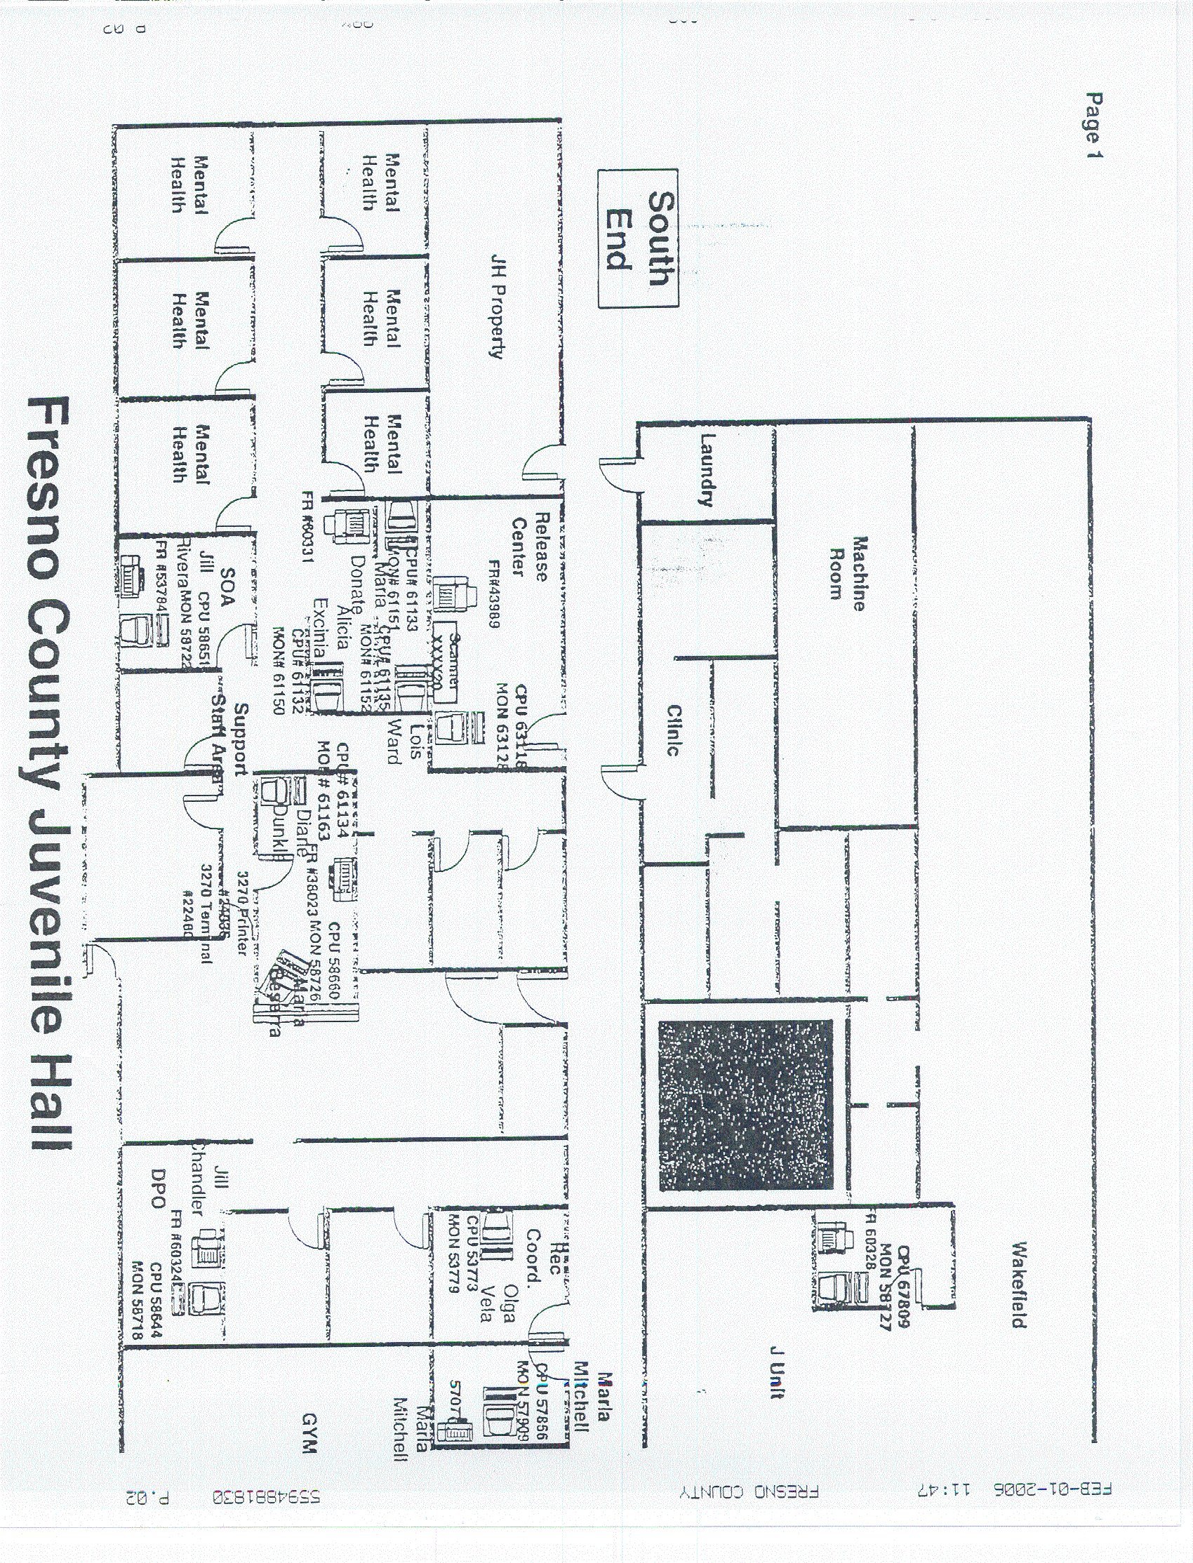
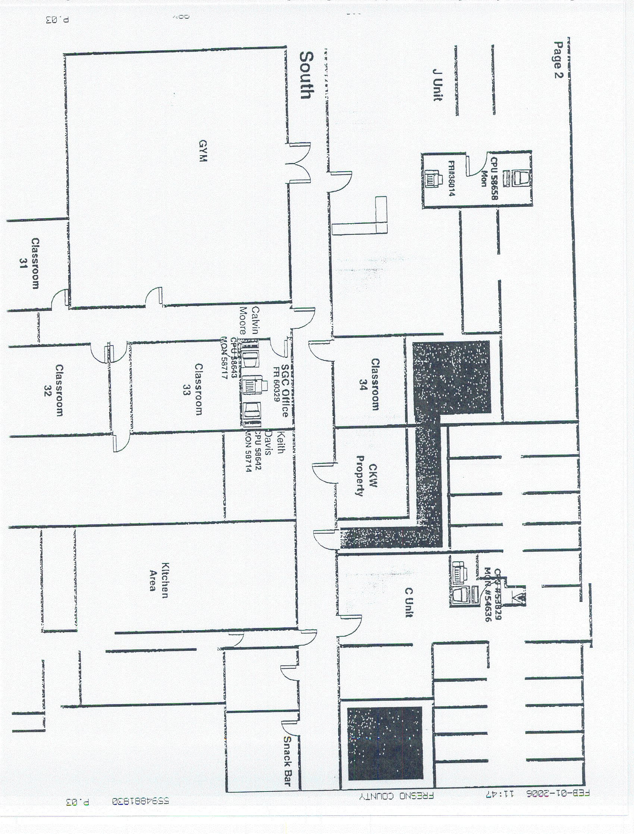
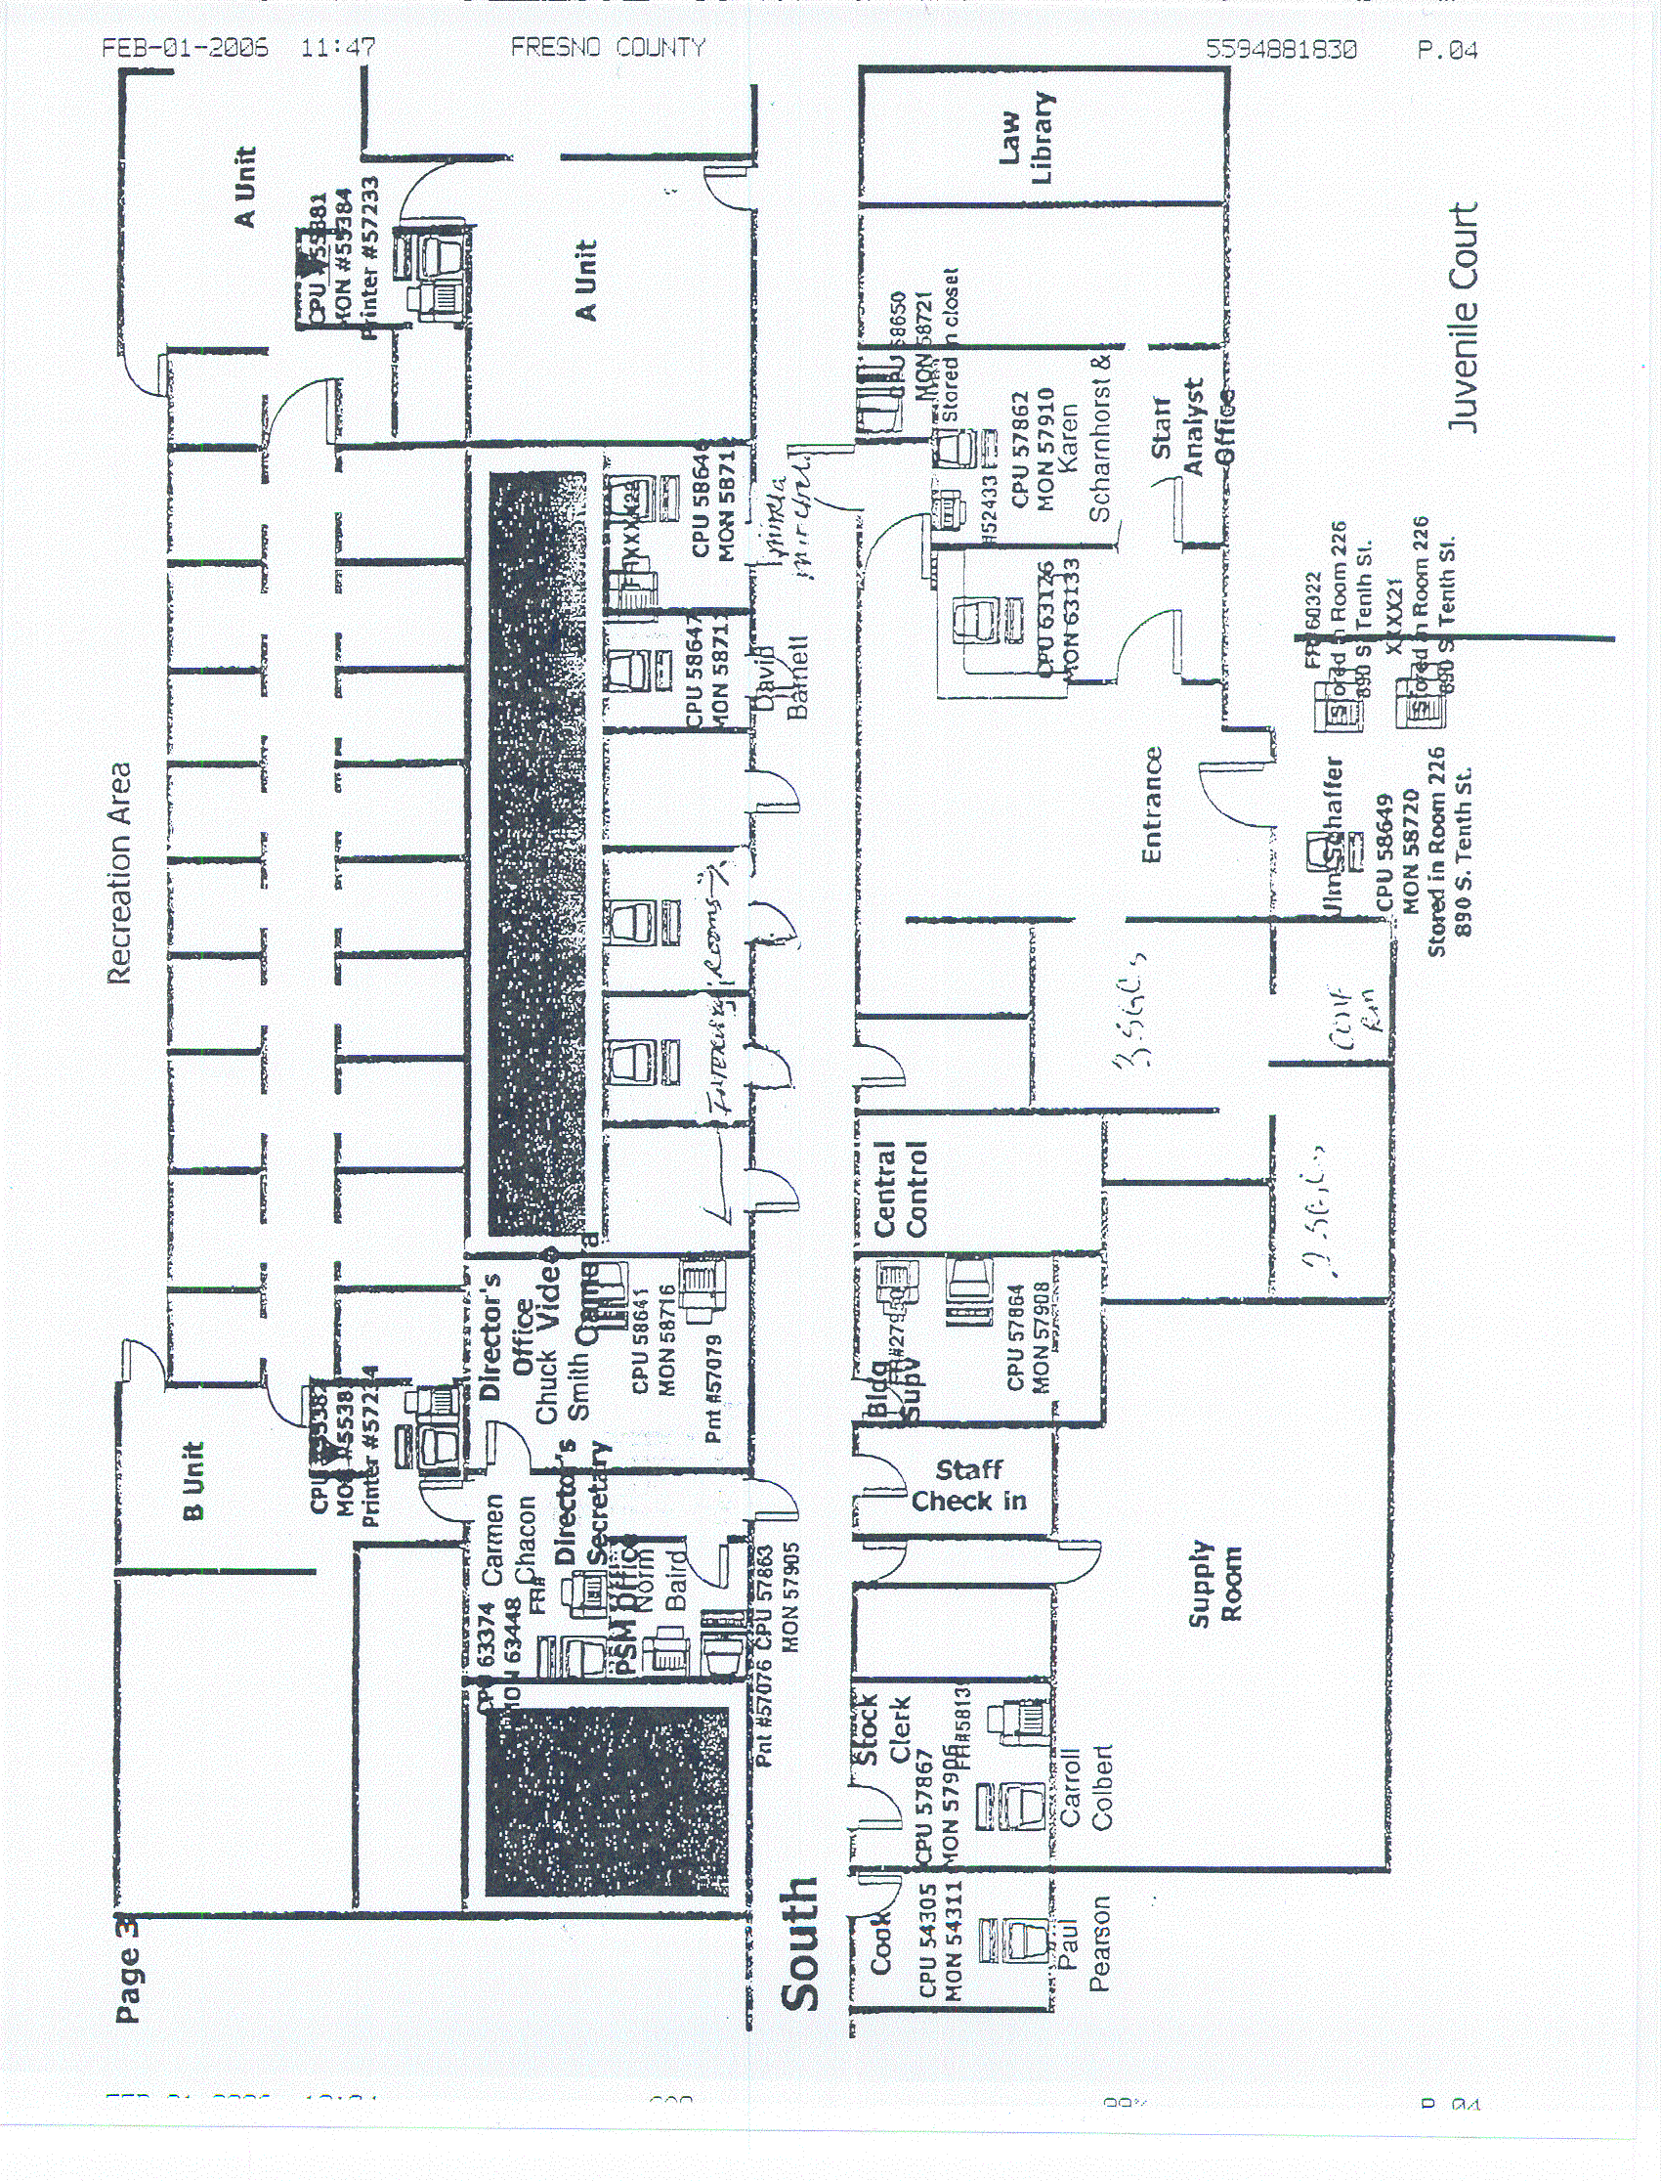
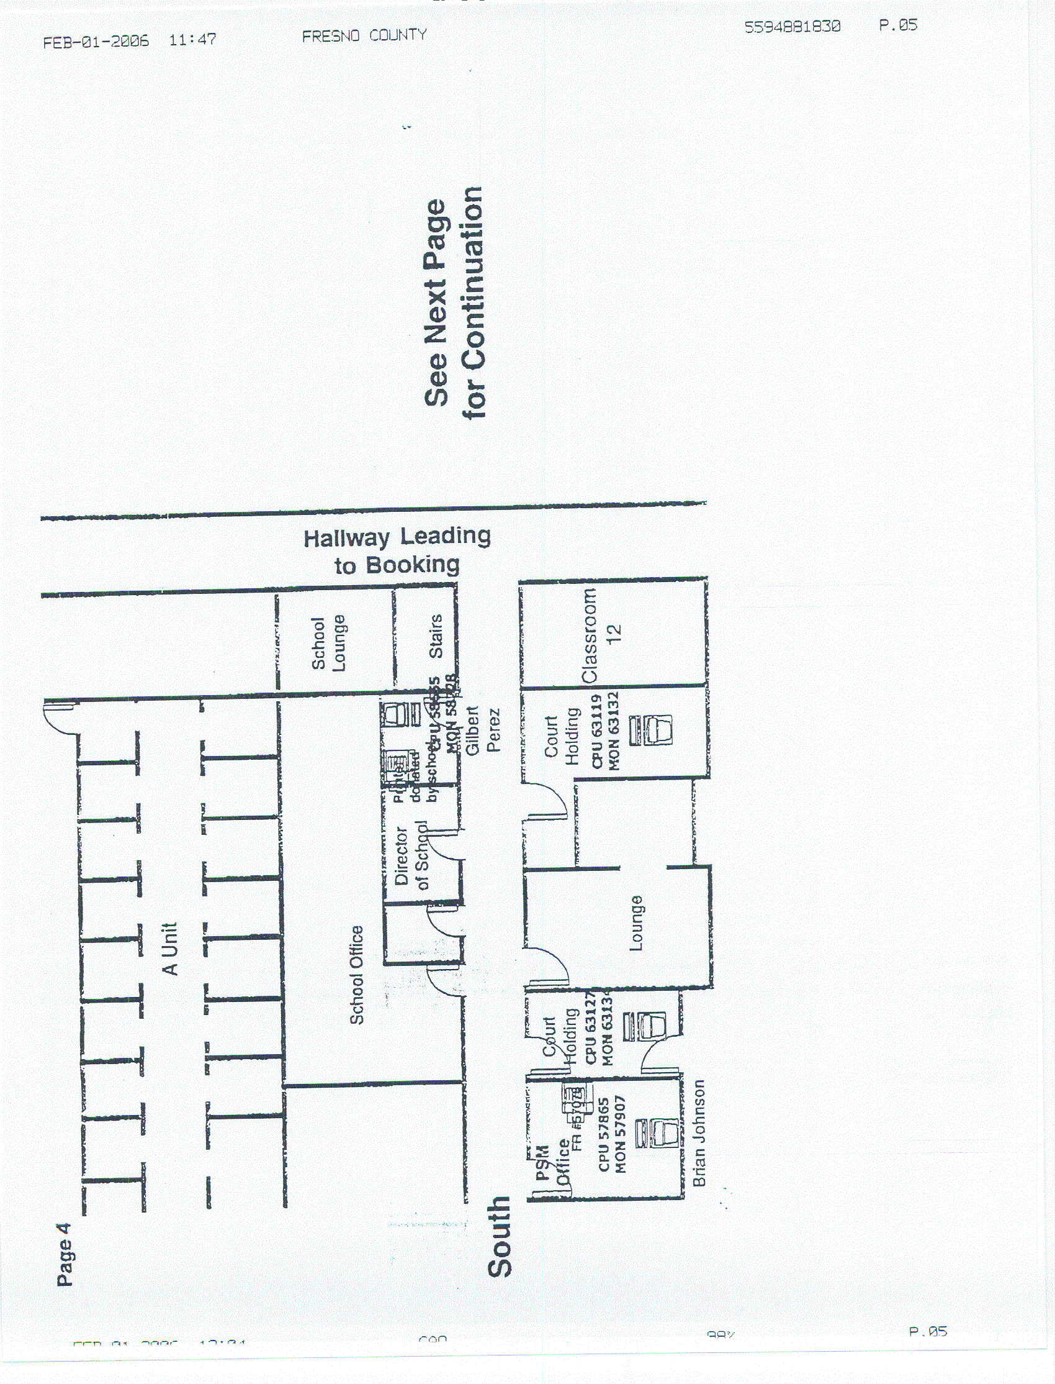
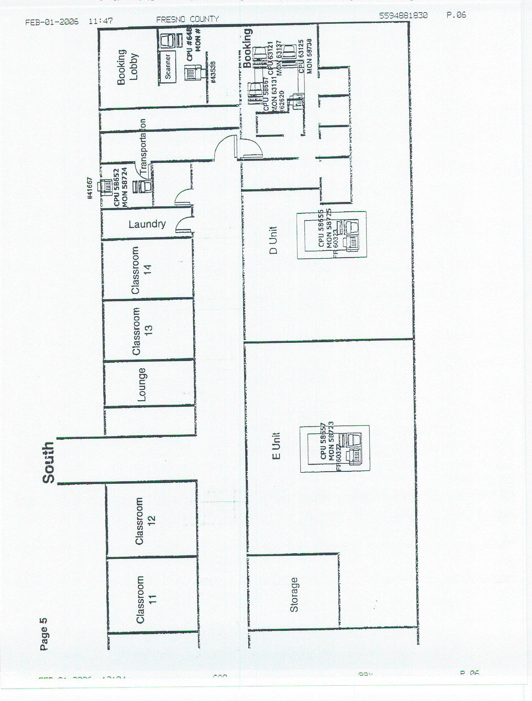
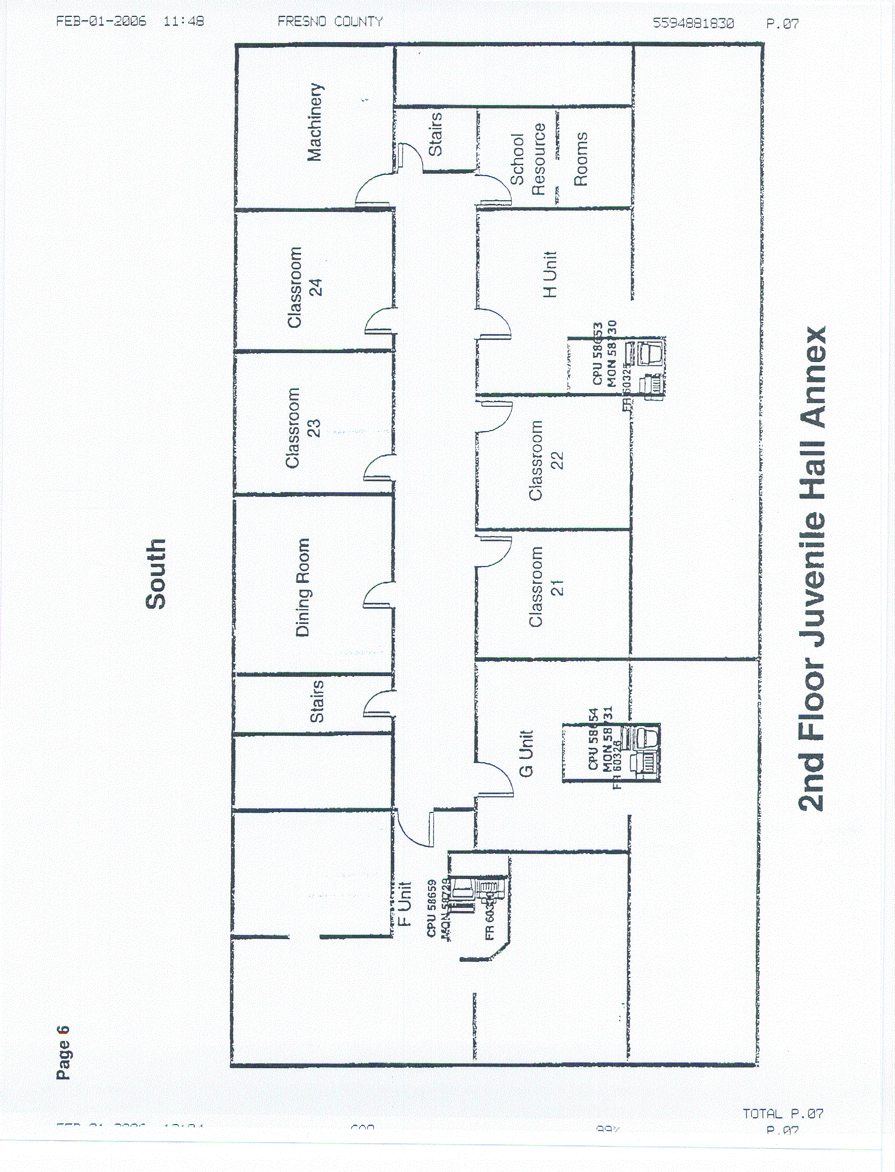

rfp no. 990-4202
addendum no. one
exhibit no. two
arming policy
