COUNTY OF FRESNO
Request for QUOTATION
 |  | NUMBER: 988-4368
January 11, 2007
ORG/Requisition: 9150, 9251, 9310/ 1507000003, 2517000003, 9317000014 |  |  |  |  |  |  | PURCHASING USE |  |  |  | /tmp/in/input.doc
 |  |  |  |  |  |  | Cn,jol
IMPORTANT: SUBMIT QUOTATION IN SEALED PACKAGE WITH QUOTATION NUMBER, CLOSING DATE AND BUYER’S NAME MARKED CLEARLY ON THE OUTSIDE TO:
COUNTY OF FRESNO, Purchasing
4525 EAST HAMILTON AVENUE
FRESNO, CA 93702-4599
Closing date of bid will be at 2:00 p.m., on January 25, 2007.
QUOTATIONS WILL BE CONSIDERED LATE WHEN THE OFFICIAL PURCHASING TIME CLOCK READS 2:00 P.M.
Quotations will be opened and publicly read at that time. All quotation information will be available for review after contract award.
Clarification of specifications are to be directed to: Craig Nickel, phone (559) 456-7110, FAX (559) 456-7831.
GENERAL CONDITIONS: See “County Of Fresno Purchasing Standard Instructions And Conditions For Request For Proposals (RFP’S) and Requests for Quotations (RFQ’S)” attached. Check County of Fresno Purchasing’s Open Solicitations website at www.co.fresno.ca.us/0440/Bidshome.asp for RFQ/RFP documents and changes.
BIDDER TO COMPLETE
UNDERSIGNED AGREES TO FURNISH THE COMMODITY OR SERVICE STIPULATED IN THE ATTACHED QUOTATION SCHEDULE AT THE PRICES AND TERMS STATED, SUBJECT TO THE “COUNTY OF FRESNO PURCHASING STANDARD INSTRUCTIONS AND CONDITIONS FOR REQUEST FOR QUOTATIONS (RFP’S) AND REQUESTS FOR QUOTATIONS (RFQ’S)”ATTACHED.
Except as noted on individual items, the following will apply to all items in the Quotation Schedule.
- Complete delivery will be made within |  |  |  |  |  |  |  | calendar days after receipt of Order.
- A cash discount of |  |  |  |  | % |  |  |  |  | days will apply.
Company
Address
City |  |  |  |  |  |  |  |  |  |  |  |  | State |  | Zip Code
( ) |  |  |  | ( )
Telephone Number |  |  |  | Facsimile Number |  |  |  |  |  |  |  |  | E-mail Address
Signed By
Print Name |  |  |  |  |  |  |  |  | Title

COUNTY OF FRESNO PURCHASING
STANDARD INSTRUCTIONS AND CONDITIONS FOR
REQUESTS FOR PROPOSALS (RFP'S) AND REQUESTS FOR QUOTATIONS (RFQ'S)
Note: the reference to “bids” in the following paragraphs applies to RFP's and RFQ's

GENERAL CONDITIONS
By submitting a bid the bidder agrees to the following conditions. These conditions will apply to all subsequent purchases based on this bid.

- BID PREPARATION:
  - All prices and notations must be typed or written in ink. No erasures permitted. Errors may be crossed out, initialed and corrections printed in ink by person signing bid.
  - Brand Names: Brand names and numbers when given are for reference. Equal items will be considered, provided the offer clearly describes the article and how it differs from that specified. In the absence of such information it shall be understood the offering is exactly as specified.
  - State brand or make of each item. If bidding on other than specified, state make, model and brand being bid and attach supporting literature/specifications to the bid.
  - Bid on each item separately. Prices should be stated in units specified herein. All applicable charges must be quoted; charges on invoice not quoted herein will be disallowed.
  - Time of delivery is a part of the consideration and must be stated in definite terms and must be adhered to. F.O.B. Point shall be destination or freight charges must be stated.
  - All bids must be dated and signed with the firm’s name and by an authorized officer or employee.
  - Unless otherwise noted, prices shall be firm for 120 days after closing date of bid.
- SUBMITTING BIDS:
  - Each bid must be submitted on forms provided in a sealed envelope with bid number and closing date and time on the outside of the envelope/package.
  - Interpretation: Should any discrepancies or omissions be found in the bid specifications or doubt as to their meaning, the bidder shall notify the Buyer in writing at once. The County shall not be held responsible for verbal interpretations. Questions regarding the bid must be received by Purchasing at least 5 working days before bid opening. All addenda issued shall be in writing, duly issued by Purchasing and incorporated into the contract.
  - ISSUING AGENT/AUTHORIZED CONTACT: This RFQ has been issued by County of Fresno Purchasing. Purchasing shall be the vendor’s sole point of contact with regard to the RFQ, its content, and all issues concerning it.
All communication regarding this RFQ shall be directed to an authorized representative of County Purchasing. The specific buyer managing this RFQ is identified on the cover page, along with his or her telephone number, and he or she should be the primary point of contact for discussions or information pertaining to the RFQ. Contact with any other County representative, including elected officials, for the purpose of discussing this RFQ, its content, or any other issue concerning it, is prohibited unless authorized by Purchasing. Violation of this clause, by the vendor having unauthorized contact (verbally or in writing) with such other County representatives, may constitute grounds for rejection by Purchasing of the vendor’s quotation.
The above stated restriction on vendor contact with County representatives shall apply until the County has awarded a purchase order or contract to a vendor or vendors, except as follows. First, in the event that a vendor initiates a formal protest against the RFQ, such vendor may contact the appropriate individual, or individuals who are managing that protest as outlined in the County’s established protest procedures. All such contact must be in accordance with the sequence set forth under the protest procedures. Second, in the event a public hearing is scheduled before the Board of Supervisors to hear testimony prior to its approval of a purchase order or contract, any vendor may address the Board.
  - Bids received after the closing time will NOT be considered.
  - Bidders are to bid what is specified or requested first. If unable to or willing to, bidder may bid alternative or option, indicating all advantages, disadvantages and their associated cost.
  - Public Contract Code Section 7028.15
Where the State of California requires a Contractor’s license, it is a misdemeanor for any person to submit a bid unless specifically exempted.
- FAILURE TO BID:
  - If not bidding, return bid sheet and state reason for no bid or your name may be removed from mailing list.
- TAXES, CHARGES AND EXTRAS:
  - County of Fresno is subject to California sales and/or use tax (7.975%). Please indicate as a separate line item if applicable.
  - DO NOT include Federal Excise Tax. County is exempt under Registration No. 94-73-03401-K.
  - County is exempt from Federal Transportation Tax. Exemption certificate is not required where shipping papers show consignee as County of Fresno.
  - Charges for transportation, containers, packing, etc. will not be paid unless specified in bid.
- W-9 – REQUEST FOR TAXPAYER IDENTIFICATION NUMBER AND CERTIFICATION:
Upon award of bid, the vendor shall submit to County Purchasing, a completed W-9 - Request for Taxpayer Identification Number and Certification if not already a current vendor with The County of Fresno. This form is available from the IRS to complete on line at http://www.irs.gov/pub/irs-pdf/fw9.pdf.
- AWARDS:
  - Subject to the local preference provisions referenced in Paragraph 6 below and more thoroughly set forth in the General Requirements section of this RFQ, award(s) will be made to the most responsive responsible bidder. The evaluation will include such things as life-cycle cost, availability, delivery costs and whose product and/or service is deemed to be in the best interest of the County. The County shall be the sole judge in making such determination.
  - Unless bidder gives notice of all-or-none award in bid, County may accept any item, group of items or on the basis of total bid.
  - The County reserves the right to reject any and all bids and to waive informalities or irregularities in bids.
  - After award, all bids shall be open to public inspection. The County assumes no responsibility for the confidentiality of information offered in a bid.
- LOCAL VENDORS
  - Local Vendor Preference (applicable to RFQ Process only)
The following provisions are applicable only to the County’s acquisition of materials, equipment or supplies through the RFQ process when the funding source does not require an exemption to the Local Vendor Preference.
THE PROVISIONS OF THIS PARAGRAPH ARE APPLICABLE, NOTWITHSTANDING ANY OTHER PROVISIONS OF THIS RFQ TO THE CONTRARY
If the apparent low bidder is not a local vendor, any local vendor who submitted a bid which was within five percent (5%) of the lowest responsive bid as determined by the purchasing agent shall have the option of submitting a new bid within forty-eight hours (not including weekends and holidays) of County’s delivery of notification. Such new bids must be in an amount less than or equal to the lowest responsive bid as determined by the purchasing agent. If the purchasing agent receives any new bids from local vendors who have the option of submitting new bids within said forty-eight hour period, it shall award the contract to the local vendor submitting the lowest responsible bid. If no new bids are received, the contract shall be awarded to the original low bidder as announced by the purchasing agent.
  - Local Vendor Defined
“Local Vendor” shall mean any business which:
- Has its headquarters, distribution point or locally-owned franchise located in or having a street address within the County for at least six (6) months immediately prior to the issuance of the request for competitive bids by the purchasing agent; and
- Holds any required business license by a jurisdiction located in Fresno County; and
- Employs at least one (1) full-time or two (2) part-time employees whose primary residence is located within Fresno County, or if the business has no employees, shall be at least fifty percent (50%) owned by one or more persons whose primary residence(s) is located within Fresno County.
- TIE BIDS:
All other factors being equal, the contract shall be awarded to the Fresno County vendor or, if neither or both are Fresno County vendors, it may be awarded by the flip of a coin in the presence of witnesses or the entire bid may be rejected and re-bid. If the General Requirements of this RFQ state that they are applicable, the provisions of the Fresno County Local Vendor Preference shall take priority over this paragraph.
- PATENT INDEMNITY:
The vendor shall hold the County, its officers, agents and employees, harmless from liability of any nature or kind, including costs and expenses, for infringement or use of any copyrighted or uncopyrighted composition, secret process, patented or unpatented invention, article or appliance furnished or used in connection with this bid.
- SAMPLES:
Samples, when required, must be furnished and delivered free and, if not destroyed by tests, will upon written request (within 30 days of bid closing date) be returned at the bidder's expense. In the absence of such notification, County shall have the right to dispose of the samples in whatever manner it deems appropriate.
- RIGHTS AND REMEDIES OF COUNTY FOR DEFAULT:
  - In case of default by vendor, the County may procure the articles or service from another source and may recover the cost difference and related expenses occasioned thereby from any unpaid balance due the vendor or by proceeding against performance bond of the vendor, if any, or by suit against the vendor. The prices paid by the County shall be considered the prevailing market price at the time such purchase is made.
  - Articles or services, which upon delivery inspection do not meet specifications, will be rejected and the vendor will be considered in default. Vendor shall reimburse County for expenses related to delivery of non-specified goods or services.
  - Regardless of F.O.B. point, vendor agrees to bear all risks of loss, injury or destruction to goods and materials ordered herein which occur prior to delivery and such loss, injury or destruction shall not release vendor from any obligation hereunder.
- DISCOUNTS:
Terms of less than 15 days for cash payment will be considered as net in evaluating this bid. A discount for payment within fifteen (15) days or more will be considered in determining the award of bid. Discount period will commence either the later of delivery or receipt of invoice by the County. Standard terms are Net Forty-five (45) days.
- SPECIAL CONDITIONS IN BID SCHEDULE SUPERSEDE GENERAL CONDITIONS.
The “General Conditions” provisions of this RFP/RFQ shall be superseded if in conflict with any other section of this bid, to the extent of any such conflict.
- SPECIAL REQUIREMENT:
With the invoice or within twenty-five (25) days of delivery, the seller must provide to the County a Material Safety Data Sheet for each product, which contains any substance on “The List of 800 Hazardous Substances”, published by the State Director of Industrial Relations. (See Hazardous Substances Information and Training Act. California State Labor Code Sections 6360 through 6399.7.)
- RECYCLED PRODUCTS/MATERIALS:
Vendors are encouraged to provide and quote (with documentation) recycled or recyclable products/materials which meet stated specifications.
- YEAR COMPLIANCE WARRANTY
Vendor warrants that any product furnished pursuant to this Agreement/order shall support a four-digit year format and be able to accurately process date and time data from, into and between the twentieth and twenty-first centuries, as well as leap year calculations. "Product" shall include, without limitation, any piece or component of equipment, hardware, firmware, middleware, custom or commercial software, or internal components or subroutines therein. This warranty shall survive termination or expiration of this Agreement.
In the event of any decrease in product functionality or accuracy related to time and/or date data related codes and/or internal subroutines that impede the product from operating correctly using dates beyond December 31, 1999, vendor shall restore or repair the product to the same level of functionality as warranted herein, so as to minimize interruption to County's ongoing business process, time being of the essence. In the event that such warranty compliance requires the acquisition of additional programs, the expense for any such associated or additional acquisitions, which may be required, including, without limitation, data conversion tools, shall be borne exclusively by vendor. Nothing in this warranty shall be construed to limit any rights or remedies the County may otherwise have under this Agreement with respect to defects other than year performance.
- PARTICIPATION:
Bidder may agree to extend the terms of the resulting contract to other political subdivision, municipalities and tax-supported agencies.
Such participating Governmental bodies shall make purchases in their own name, make payment directly to bidder, and be liable directly to the bidder, holding the County of Fresno harmless.
- CONFIDENTIALITY:
All services performed by vendor shall be in strict conformance with all applicable Federal, State of California and/or local laws and regulations relating to confidentiality, including but not limited to, California Civil Code, California Welfare and Institutions Code, Health and Safety Code, California Code of Regulations, Code of Federal Regulations.
Vendor shall submit to County’s monitoring of said compliance.
Vendor may be a business associate of County, as that term is defined in the “Privacy Rule” enacted by the Health Insurance Portability and Accountability Act of 1996 (HIPAA). As a HIPAA Business Associate, vendor may use or disclose protected health information (“PHI”) to perform functions, activities or services for or on behalf of County as specified by the County, provided that such use or disclosure shall not violate HIPAA and its implementing regulations. The uses and disclosures if PHI may not be more expansive than those applicable to County, as the “Covered Entity” under HIPAA’S Privacy Rule, except as authorized for management, administrative or legal responsibilities of the Business Associate.
Vendor shall not use or further disclose PHI other than as permitted or required by the County, or as required by law without written notice to the County.
Vendor shall ensure that any agent, including any subcontractor, to which vendor provides PHI received from, or created or received by the vendor on behalf of County, shall comply with the same restrictions and conditions with respect to such information.
- APPEALS
Appeals must be submitted in writing within seven (7) working days after the review committee notification of proposed recommendations. Appeals should be submitted to County of Fresno Purchasing, 4525 E. Hamilton Avenue, Fresno, California 93702-4599. Appeals should address only areas regarding RFP contradictions, procurement errors, quotation rating discrepancies, legality of procurement context, conflict of interest, and inappropriate or unfair competitive procurement grievance regarding the RFP process.
The Purchasing Manager will provide a written response to the complaint within seven (7) working days unless the complainant is notified more time is required.
If the protesting bidder is not satisfied with the decision of the Purchasing Manager, he/she shall have the right to appeal to the Purchasing Agent within seven (7) business days after notification of the Purchasing Manager’s decision.
If the protesting bidder is not satisfied with Purchasing Agent decision, the final appeal is with the Board of Supervisors.
- OBLIGATIONS OF CONTRACTOR:
  - CONTRACTOR shall perform as required by the ensuing contract. CONTRACTOR also warrants on behalf of itself and all subcontractors engaged for the performance of the ensuing contract that only persons authorized to work in the United States pursuant to the Immigration Reform and Control Act of 1986 and other applicable laws shall be employed in the performance of the work hereunder.
  - CONTRACTOR shall obey all Federal, State, local and special district laws, ordinances and regulations.

BIDDING INSTRUCTIONS
CONTRACT SERVICE AND SUPPLY
The County of Fresno is soliciting bids to provide all labor, materials, equipment, etc., to provide Landscape Maintenance Service at CSA Nos. 10, 10A and 47, as specified within this Request for Quotation. .
LOCAL VENDOR PREFERENCE: The Local Vendor Preference does not apply to this Request for Quotation.
AWARD: Award will be made to the vendor(s) offering the equipment and system deemed to be to the best advantage of the County. The County shall be the sole judge in making such determination.
COPIES: Submit one (1) original and two (2) copies of your quotation no later than the RFQ closing date and time as stated on the front of this document, to County of Fresno Purchasing.
ISSUING AGENT: This RFQ has been issued by County of Fresno Purchasing. The Purchasing shall be the vendor’s sole point of contact with regard to the RFQ, its content, and all issues concerning it.
AUTHORIZED CONTACT: All communication regarding this RFQ shall be directed to an authorized representative of County Purchasing. The specific buyer managing this RFQ is identified on the cover page, along with his or her telephone number, and he or she should be the primary point of contact for discussions or information pertaining to the RFQ. Contact with any other County representative, including elected officials, for the purpose of discussing this RFQ, it content, or any other issue concerning it, is prohibited unless authorized by Purchasing. Violation of this clause, by the vendor having unauthorized contact (verbally or in writing) with such other County representatives, may constitute grounds for rejection by Purchasing of the vendor’s quotation.
The above stated restriction on vendor contact with County representatives shall apply until the County has awarded a purchase order or contract to a vendor or vendors, except as follows. First, in the event that a vendor initiates a formal protest against the RFQ, such vendor may contact the appropriate individual, or individuals who are managing that protest as outlined in the County’s established protest procedures. All such contact must be in accordance with the sequence set forth under the protest procedures. Second, in the event a public hearing is scheduled before the Board of Supervisors to hear testimony prior to its approval of a purchase order or contract, any vendor may address the Board.
PAYMENT: County will make partial payments for all purchases made under this contract/purchase order and accumulated during the month.
RIGHT TO REJECT BIDS: The County reserves the right to reject any and all bids and to waive informalities or irregularities in bids.
TERM: The initial contract period shall be one (1) year.
QUANTITIES: Quantities shown in the bid schedule are approximate and the County guarantees no minimum amount. The County reserves the right to increase or decrease quantities.
SPECIFICATIONS AND EQUALS: Brand names, where used, are a means of establishing quality and style. Bidders are invited to quote their equals. Alternate offers are to be supported by literature, which fully describes items that you are bidding.
No exceptions to or deviations from this specification will be considered unless each exception or deviation is specifically stated by the bidder, in the designated places. If no exceptions or deviations are shown the bidder will be required to furnish items exactly as specified herein. The burden of proof of compliance with this specification is the responsibility of the bidder.
LITERATURE: Bidders shall submit literature, which fully describes items on which they are bidding, not later than the closing date of this bid. Any and all literature submitted must be stamped with bidders name and address.
MERCHANDISE RETURNABLE FOR FULL CREDIT: Bidder agrees to accept for full credit any merchandise sold by him on contract or award resulting from this bid, if returned in good condition by the County.
GUARANTEE AGAINST DEFECTS: All items are to carry a full guarantee against defects in materials and workmanship and guarantee against breakage and other malfunctions when performing work for which they are designed.
ORDERING: Orders will be placed as required by the various County Departments.
INVOICING: All invoices are to be delivered in duplicate to Public Works- 2220 Tulare Street, Sixth Floor, Fresno, CA 93721. Reference shall be made to the purchase order/contract number and equipment number if applicable on the invoice.
SAMPLES: On request, samples of the products on which you are bidding shall be made available to the County. County will designate where samples are to be delivered.
Successful bidder's samples may be retained for checking against delivery, in which case allowance will be made to vendor.
RENEWAL: Contract may be renewed for an additional year by mutual written consent.
VENDOR ASSISTANCE: Successful bidder shall furnish, at no cost to the County, a representative to assist County departments in determining their product requirements.
TERMINATION: This agreement may be terminated by the County at any time upon written notice.
HOLD HARMLESS CLAUSE: Contractor agrees to indemnify, save, hold harmless and at County's request, defend the County, its officers, agents and employees, from any and all costs and expenses, damages, liabilities, claims and losses occurring or resulting to County in connection with the performance, or failure to perform, by Contractor, its officers, agents or employees under this Agreement and from any and all costs and expenses, damages, liabilities, claims and losses occurring or resulting to any person, firm or corporation who may be injured or damaged by the performance, or failure to perform, of Contractor, its officers, agents or employees under this Agreement.
ASSURANCES: Any contract awarded under this RFQ must be carried out in full compliance with The Civil Rights Act of 1964, The Americans With Disabilities Act of 1990, their subsequent amendments, and any and all other laws protecting the rights of individuals and agencies. The County of Fresno has a zero tolerance for discrimination, implied or expressed, and wants to ensure that policy continues under this RFQ. The contractor must also guarantee that services, or workmanship, provided will be performed in compliance with all applicable local, state, or federal laws and regulations pertinent to the types of services, or project, of the nature required under this RFQ. In addition, the contractor may be required to provide evidence substantiating that their employees have the necessary skills and training to perform the required services or work.
INDEPENDENT CONTRACTOR: In performance of the work, duties and obligations assumed by Bidder under this agreement, it is mutually understood and agreed that Bidder, including any and all of Bidder's officers, agents, and employees will at all times be acting and performing as an independent contractor, and shall act in an independent capacity and not as an officer, agent, servant, employee, joint venturer, partner, or associate of the County. Furthermore, County shall have no right to control or supervise or direct the manner or method by which Bidder shall perform its work and function. However, County shall retain the right to administer this agreement so as to verify that Bidder is performing its obligations in accordance with the terms and conditions thereof. Bidder and County shall comply with all applicable provisions of law and the rules and regulations, if any, of Governmental authorities having jurisdiction over matters the subject thereof.
Because of its status as an independent contractor, Bidder waives any and all employment rights and benefits available to County employees. Bidder shall be solely liable and responsible for providing to, or on behalf of, its employees all legally required employee benefits. In addition, Bidder shall be solely responsible and save County harmless from all matters relating to payment of Contractor's employees, including compliance with Social Security, withholding, and all other regulations governing such matters. It is acknowledged that during the term of this agreement, Bidder may be providing services to others unrelated to the County or to this agreement.
PRICES: Bidder agrees that prices quoted are maximum for the contract period, and in the event of a price decline such lower prices shall be extended to the County of Fresno.
MATERIALS TO BE NEW: All materials shall be new and of merchantable grade, free from defect. No bid will be considered unless it is accompanied by a complete list of manufacturer's catalog numbers of the items, which the bidder proposes to furnish, together with full descriptive literature on all items so enumerated. If item proposed differs from these specifications, bidder shall present specific explanation of functioning and structural characteristics for those details which differ from the specifications listed herein.
EXAMINATION OF SITE: Where work is to be performed on County site, each bidder shall have examined the site of work before bidding and shall be responsible for having acquired full knowledge of the job and of all problems affecting it. No variations or allowance from the contract sum will be made because of lack of such examination.
DAMAGE TO EXISTING WORK: Damage to existing construction, equipment, planting, etc., by the contractor in the performance of his work shall be replaced or repaired and restored to original condition by the contractor.
CLEAN-UP: The Contractor shall at all times, keep the premises clean from accumulation of waste materials or rubbish caused by his employees or work and shall remove all resulting work debris from the job site.
SUPERVISION: The Contractor shall give efficient supervision to the work, using therein the skill and diligence for which he is remunerated in the contract price. He shall carefully inspect the site and study and compare all drawings, specifications and other instructions, as ignorance of any phase of any of the features or conditions affecting the contract will not excuse him from carrying out its provisions to its full intent.
STANDARD OF PERFORMANCE: All work shall be performed in a good and workmanlike manner.
SAFEGUARDS: The contractor shall provide safeguards, in conformity with all local codes and ordinances as may be required.
INSURANCE:
Without limiting the COUNTY's right to obtain indemnification from CONTRACTOR or any third parties, CONTRACTOR, at its sole expense, shall maintain in full force and effect the following insurance policies throughout the term of the Agreement:
- Commercial General Liability
Commercial General Liability Insurance with limits of not less than One Million Dollars ($1,000,000) per occurrence and an annual aggregate of Two Million Dollars ($2,000,000). This policy shall be issued on a per occurrence basis. COUNTY may require specific coverages including completed operations, products liability, contractual liability, Explosion-Collapse-Underground, fire legal liability or any other liability insurance deemed necessary because of the nature of this contract.
- Automobile Liability
Comprehensive Automobile Liability Insurance with limits for bodily injury of not less than Two Hundred Fifty Thousand Dollars ($250,000.00) per person, Five Hundred Thousand Dollars ($500,000.00) per accident and for property damages of not less than Fifty Thousand Dollars ($50,000.00), or such coverage with a combined single limit of Five Hundred Thousand Dollars ($500,000.00). Coverage should include owned and non-owned vehicles used in connection with this Agreement.
- Worker's Compensation
A policy of Worker's Compensation insurance as may be required by the California Labor Code.
Contractor shall obtain endorsements to the Commercial General Liability insurance naming the County of Fresno, its officers, agents, and employees, individually and collectively, as additional insured, but only insofar as the operations under this Agreement are concerned. Such coverage for additional insured shall apply as primary insurance and any other insurance, or self-insurance, maintained by County, its officers, agents and employees shall be excess only and not contributing with insurance provided under contractor's policies herein. This insurance shall not be cancelled or changed without a minimum of thirty (30) days advance written notice given to County.
Within Thirty (30) days from the date contractor executes this Agreement, CONTRACTOR shall provide certificates of insurance and endorsement as stated above for all of the foregoing policies, as required herein, to the County of Fresno, stating that such insurance coverage have been obtained and are in full force; that the County of Fresno, its officers, agents and employees will not be responsible for any premiums on the policies; that such Commercial General Liability insurance names the County of Fresno, its officers, agents and employees, individually and collectively, as additional insured, but only insofar as the operations under this Agreement are concerned; that such coverage for additional insured shall apply as primary insurance and any other insurance, or self-insurance, maintained by County, its officers, agents and employees, shall be excess only and not contributing with insurance provided under contractor's policies herein; and that this insurance shall not be cancelled or changed without a minimum of thirty (30) days advance, written notice given to County.
In the event contractor fails to keep in effect at all times insurance coverage as herein provided, the County may, in addition to other remedies it may have, suspend or terminate this Agreement upon the occurrence of such event.
All policies shall be with admitted insurers licensed to do business in the State of California. Insurance purchased shall be purchased from companies possessing a current A.M. Best, Inc. rating of A FSC VII or better.
Name of Insurance Carrier:
Public Liability: |  |  |  | Expires:
Workman's Compensation: |  |  |  | Expires:
Proof of maintenance of adequate insurance will be required before award is made to vendor.
GUARANTEE: The bidder shall state his written guarantee here:
REFERENCES: Provide a list of three (3) client references who are presently using services being quoted. (Name, phone number and contact person.)
GUARANTEED PICK-UP AND/OR DELIVERY: Bidder will be considered in award of bid only if they can guarantee. Enter guarantee on this line (i.e. number of days from receipt of order to delivery):
By: | (Authorized Signature)

WARRANTY AND SERVICE LOCATION:

BIDDER TO COMPLETE:
State the warranty and/or guarantee provisions applicable to this equipment or attach warranty form with your bid.
State specific location where service and/or maintenance can be obtained. Failure to furnish this information will be cause for rejection of bid.
The County may require additional items from those in bid schedule.
Price list for additional items:
A |  | percent discount from manufacturer's enclosed price list will be allowed on
purchases of all additional items.
State name of price list, indicate applicable price column and give effective date of price list here:
Prices on additional items will be based on successful bidder's firm discount prices from manufacturer's enclosed published price list.
State Purchase Order mailing address:

BIDDER TO COMPLETE THE FOLLOWING:

PARTICIPATION
The County of Fresno is a member of the Central Valley Purchasing Group. This group consists of Fresno, Kern, Kings, and Tulare Counties and all governmental, tax supported agencies within these counties.
Whenever possible, these agencies co-op (piggyback) on contracts put in place by one of the other agencies.
Any agency choosing to avail itself of this opportunity, will make purchases in their own name, make payment directly to the contractor, be liable to the contractor and vice versa, per the terms of the original contract, all the while holding the County of Fresno harmless. If awarded this contract, please indicate whether you would extend the same terms and conditions to all tax supported agencies within this group as you are proposing to extend to Fresno County.
Yes, we will extend contract terms and conditions to all qualified agencies within the Central Valley Purchasing Group.
No, we will not extend contract terms to any agency other than the County of Fresno.
(Authorized Signature)
Title

COUNTY SERVICE AREA NO. (CSA) 10
SPECIFICATIONS FOR LANDSCAPE MAINTENANCE

Project Locations
The location of CSA 10, northeast of the City of Clovis, is shown on the location map, Exhibit A. Exhibit B shows CSA No. 10 within the vicinity of an area approximately bounded by Sierra Avenue to the North, Academy Avenue to the East, Shaw Avenue to the South, and Indianola Avenue to the West.
The area to be maintained is noted on Exhibit B. The landscaping area is approximately 30 feet from the intersection of North Greenwood Avenue and Shaw Avenue. CSA No. 10 contains approximately 425 lineal feet of landscaping area.
Project Description
The contractor shall provide the following on-going maintenance, on a mutual agreed upon day, two times per month:
Remove all debris, trash, weeds, etc. from median strip.
Test the entire irrigation system to ensure that it is working properly.
The Contractor shall provide the following additional items, only when authorized by the County in writing and in advance:
A. Supply and apply any necessary weed control products. Contractor shall specify what types of weed control products will be used, and frequency weed control will be applied. Please specify additional labor rate if applicable on Quotation Schedule.
B. Supply and apply any necessary pesticides. Please specify additional labor rate if applicable on Quotation Schedule.
Contractor shall supply all necessary replacement parts needed to maintain or repair the irrigation system.
Contractor shall provide all labor to maintain or repair the irrigation system. Please specify additional labor rate if applicable on Quotation Schedule.
E. Contractor shall supply replacement trees, shrubs, plants, and flowers as needed.
F. Contractor shall provide all labor to install all replacement trees, shrubs, plants, and flowers. Please specify additional labor rate if applicable on Quotation Schedule.
The Contractor shall include an hourly rate for any additional items as referenced in Section 2. Materials purchased by the vendor shall be reimbursed at vendor’s actual cost. Receipts for purchases will need to be submitted with the invoice.

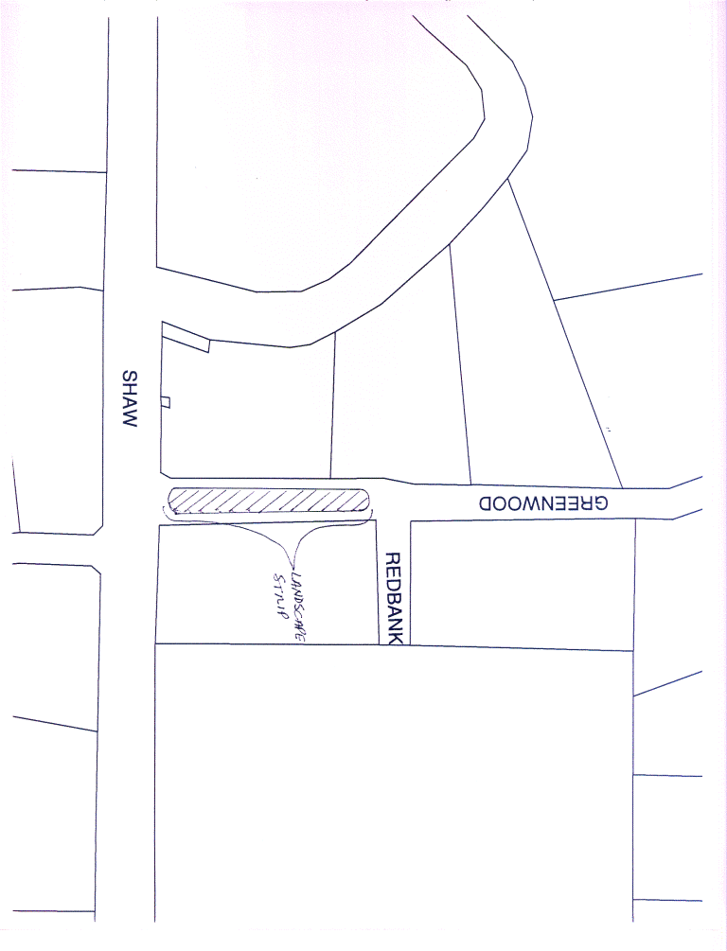
QUOTATION SCHEDULE
All labor, material, equipment, taxes, transportation,
Etc. required to perform the Landscape Maintenance
Services.
Section No. 1 – Project Description:
$_______________ per month x12 $_______________ per year
Section No. 2 - Additional Services:
Labor Rate for Weed Control $_______________ per hour
Labor Rate for Irrigation Maintenance/Repair $_______________ per hour
Labor Rate for Replacement of Landscaping $_______________ per hour
Labor Rate for Additional Items $_______________ per hour
State if there is a minimum hourly charge.

List any other related services and rates that you provide:
County Service Area No. 10A (CSA No. 10A) Mansionette Estates
Landscape Maintenance Specifications:

Project Locations
CSA No. 10A is located northeast of the City of Clovis bounded approximately by Herndon Avenue to the North, Langley Avenue to the East, Sierra Avenue to the South, and Dewolf Avenue to the West.
Enclosed are the desired specifications and a map of the District highlighting the areas in need of landscape maintenance. These areas include an approximately 30 ft x 5 ft median strip at the entrance to the subdivision, an approximately 350 ft x 5 ft of frontage along Herndon Avenue (West of Leonard), and an approximately 480 ft x 5 ft of frontage along Herndon Avenue (East of Leonard). Each area consists of trees and/or plants.
Project Description
The contractor shall provide the following on-going maintenance, on a mutual agreed upon day, four (4) times per month:
Remove all debris, trash, weeds, etc. from median strip, and Herndon Avenue frontage.
Test the entire irrigation system to ensure that it is working properly.
The Contractor shall provide the following additional items, only when authorized by the County in writing and in advance:
Supply and apply any necessary weed control products. Contractor shall specify what types of weed control products will be used, and frequency weed control will be applied. Please specify additional labor rate if applicable on Quotation Schedule.
Contractor shall supply all necessary replacement parts needed to maintain or repair the irrigation system.
Contractor shall provide all labor to maintain or repair the irrigation system. Please specify additional labor rate if applicable on Quotation Schedule.
Contractor shall supply replacement trees, shrubs, plants, and flowers as needed.
Contractor shall provide all labor to install all replacement trees, shrubs, plants, and flowers. Please specify additional labor rate if applicable on Quotation Schedule.
The Contractor shall include an hourly rate for any additional items as referenced in Section 2. Materials purchased by the vendor shall be reimbursed at vendor’s actual cost. Receipts for purchases will need to be submitted with the invoice.

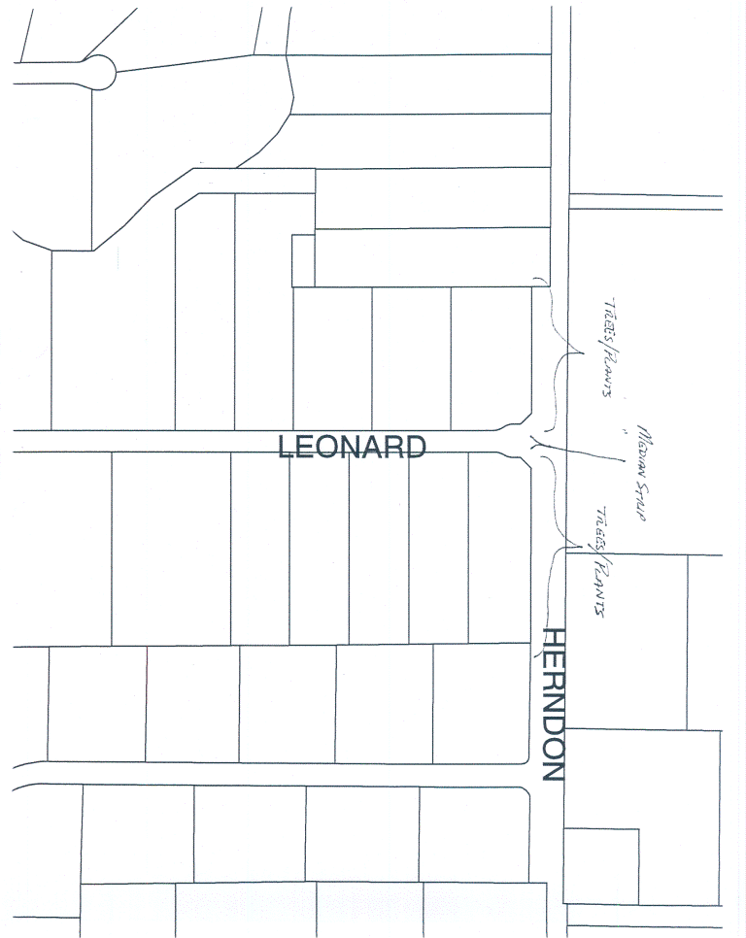

QUOTATION SCHEDULE
All labor, material, equipment, taxes, transportation,
Etc. required to perform the Landscape Maintenance
Services.

Section No. 1 – Project Description:
$_______________ per month x12 $_______________ per year
Section No. 2 - Additional Services:
Labor Rate for Weed Control $_______________ per hour
Labor Rate for Irrigation Maintenance/Repair $_______________ per hour
Labor Rate for Replacement of Landscaping $_______________ per hour
Labor Rate for Additional Items $_______________ per hour
State if there is a minimum hourly charge.

List any other related services and rates that you provide:
County Service Area No. 47 (CSA No. 47) Quail Lake
Landscape Maintenance Specifications:

Project Locations
CSA No. 47 is located east of the City of Clovis bounded by Shaw Avenue to the North, Bethel Avenue to the East, Ashlan Avenue to the South, and McCall Avenue to the West.
The County of Fresno is seeking bids for Landscape Maintenance Services for the Sewer Treatment Plant, Water Treatment Facility, and within and around the Redbank Slough. The landscape areas can be found along both the inside and outside of the gated facilities as well as along the Redbank Slough. Please refer to the attached map for the location of the subdivision and the Sewer and Water Facilities.
Please note that the water used for landscaping purposes is “reclaimed water” generated from the wastewater treatment plant.
Project Description
The Contractor shall provide the following on-going maintenance, on a mutually agreed upon day, one time per week for the water and wastewater systems:
Remove all debris, trash, weeds, etc. from designated landscape areas.
Provide all necessary services required in order to ensure proper growth and longevity of all trees, shrubs, and plants. This includes all necessary pruning of trees, shrubs and plants.
Test the entire irrigation system to ensure that it is working properly.
The Contractor shall provide the following additional items only when authorized by the County in writing and in advance, unless immediate attention is needed due to emergency repair:
Supply and apply any necessary weed control products. Contractor shall specify what types of weed control products will be used, and frequency weed control will be applied. Please specify additional labor rate if applicable on Quotation Schedule.
Supply and apply all necessary replacement parts needed to maintain or repair the irrigation system.
Supply all labor to maintain or repair the irrigation system. Please specify additional labor rate if applicable on Quotation Schedule.
Supply replacement trees, shrubs, plants, and flowers as needed.
Supply all labor to install all replacement trees, shrubs, plants, and flowers. Please specify additional labor rate if applicable on Quotation Schedule.
Maintain access trail for Consolidated Mosquito Abatement District (CMAD) staff for the purposes of mosquito control. The Contractor shall maintain an unpaved access trail no less than six feet (6’) wide on each side of the Redbank Creek for mosquito surveillance and control programs. These access trails shall accommodate motorized application equipment, and shall be located between the tree line and the water’s edge.
Supply all labor and equipment necessary for the maintenance of the CMAD access trail along Redbank Creek. Please specify additional labor rate if applicable on Quotation Street.
3. The Contractor shall include an hourly rate for any additional items not referenced in Section 2. Materials purchased by the vendor shall be reimbursed at vendor’s actual cost. Receipts for purchases shall be submitted with the invoice.
4. The Contractor (or representative) shall participate in an on-site walk through inspection one time per month with Special District Staff to be completed on a mutually agreed upon date and time.
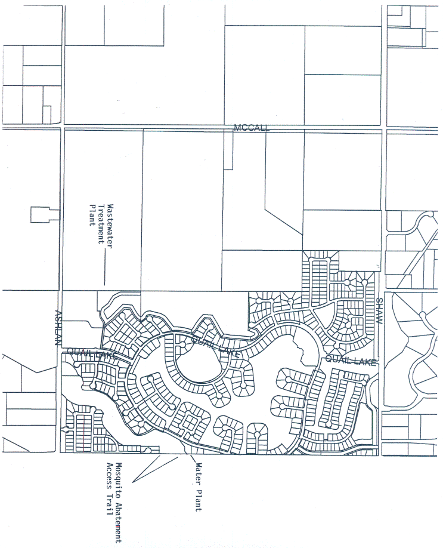
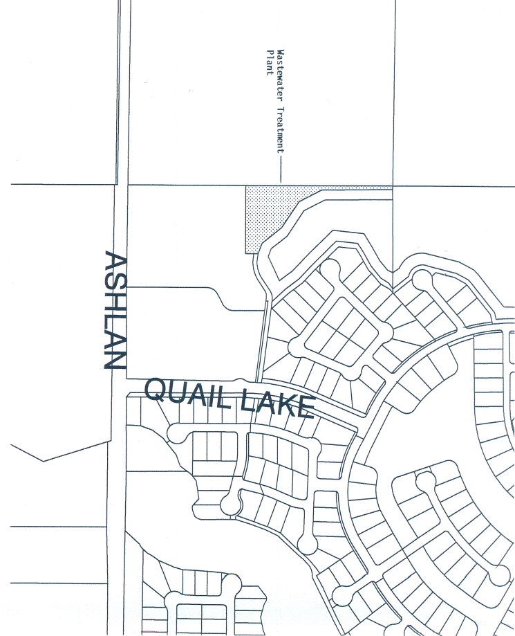
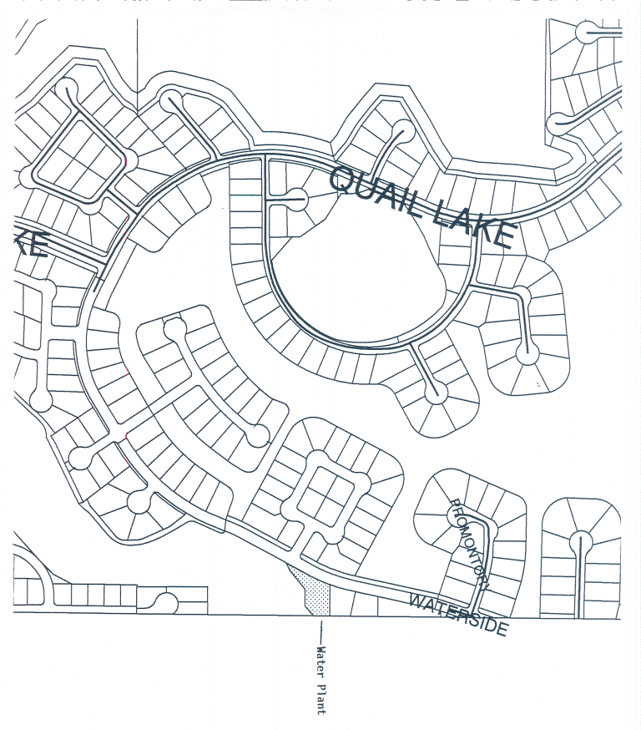
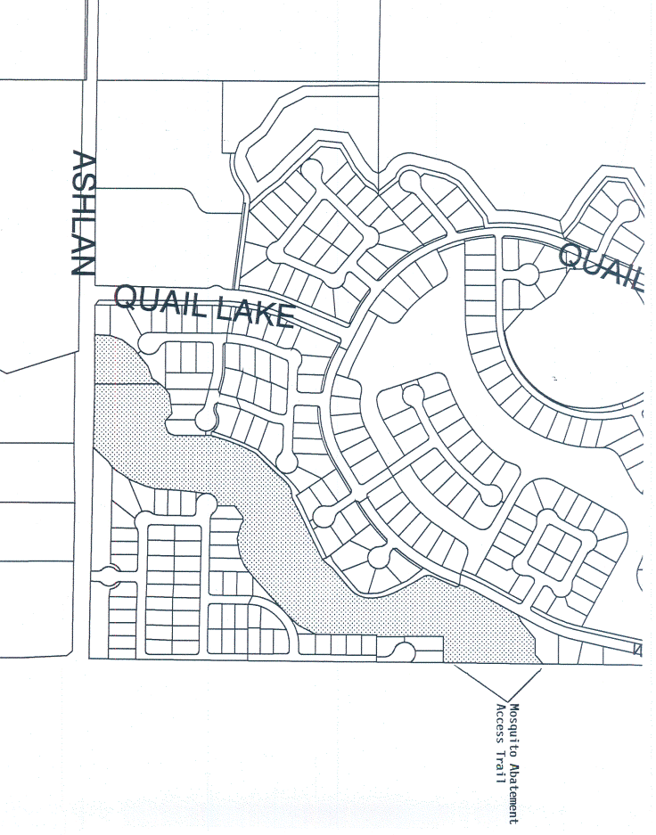
QUOTATION SCHEDULE
All labor, material, equipment, taxes, transportation,
Etc. required to perform the Landscape Maintenance
Services.
Section No. 1 – Project Description:
$_______________ per month x12 $_______________ per year
Sections No. 2 and 3 - Additional Services:
Labor Rate for Weed Control $_______________ per hour
Labor Rate for Irrigation Maintenance/Repair $_______________ per hour
Labor Rate for Replacement of Landscaping $_______________ per hour
Labor Rate for CMAD Access Trail $_______________ per hour
Labor Rate for Additional Items $_______________ per hour
State if there is a minimum hourly charge.

List any other related services and rates that you provide:

