COUNTY OF FRESNO
Request for quotation
 |  |  |  |  |  | NUMBER: 968-4159
September 15, 2005
 | ORG/Requisition: 9212/ 9216000001 |  |  |  |  |  |  |  | PURCHASING USE |  |  |  |  | /tmp/in/input.doc
 |  |  |  |  |  |  |  |  | jol
 | IMPORTANT: SUBMIT PROPOSAL IN SEALED PACKAGE WITH PROPOSAL NUMBER, CLOSING DATE AND BUYER’S NAME MARKED CLEARLY ON THE OUTSIDE TO:
COUNTY OF FRESNO, Purchasing
4525 EAST HAMILTON AVENUE
FRESNO, CA 93702-4599
Closing date of bid will be at 2:00 p.m., on OCTOBER 6, 2005.
QUOTATIONS WILL BE CONSIDERED LATE WHEN THE OFFICIAL PURCHASING TIME CLOCK READS 2:00 P.M.
 | Quotations will be opened and publicly read at that time. All proposal information will be available for review after contract award.
 | Clarification of specifications are to be directed to: Ken Vozza, phone (559) 456-7110, FAX (559) 456-7831.
 |  | GENERAL CONDITIONS
 |  | See “County Of Fresno Purchasing Standard Instructions And Conditions For Request For Proposals (RFP’S) and Requests for Quotations (RFQ’S)” attached.
BIDDER TO COMPLETE
UNDERSIGNED AGREES TO FURNISH THE COMMODITY OR SERVICE STIPULATED IN THE ATTACHED QUOTATION SCHEDULE AT THE PRICES AND TERMS STATED, SUBJECT TO THE “COUNTY OF FRESNO PURCHASING STANDARD INSTRUCTIONS AND CONDITIONS FOR REQUEST FOR PROPOSALS (RFP’S) AND REQUESTS FOR QUOTATIONS (RFQ’S)”ATTACHED.
Except as noted on individual items, the following will apply to all items in the Quotation Schedule.
 |  |  | - Complete delivery will be made within |  |  |  |  |  |  |  | calendar days after receipt of Order.
 |  |  | - A cash discount of |  |  |  |  |  | % |  |  |  | days will apply.
Company
Address
City |  |  |  |  |  |  |  |  |  |  |  |  |  |  |  | State |  | Zip Code
( ) |  |  |  |  |  |  |  | ( )
Telephone Number |  |  |  |  |  |  |  | Facsimile Number |  |  |  |  |  |  |  | E-mail Address
Taxpayer Federal I.D. No.:
Signed By
Print Name |  |  |  |  |  |  |  |  |  |  |  | Title

COUNTY OF FRESNO PURCHASING
STANDARD INSTRUCTIONS AND CONDITIONS FOR
REQUESTS FOR PROPOSALS (RFP'S) AND REQUESTS FOR QUOTATIONS (RFQ'S)
Note: the reference to “bids” in the following paragraphs applies to RFP's and RFQ's

GENERAL CONDITIONS
By submitting a bid the bidder agrees to the following conditions. These conditions will apply to all subsequent purchases based on this bid.

- BID PREPARATION:
  - All prices and notations must be typed or written in ink. No erasures permitted. Errors may be crossed out, initialed and corrections printed in ink by person signing bid.
  - Brand Names: Brand names and numbers when given are for reference. Equal items will be considered, provided the offer clearly describes the article and how it differs from that specified. In the absence of such information it shall be understood the offering is exactly as specified.
  - State brand or make of each item. If bidding on other than specified, state make, model and brand being bid and attach supporting literature/specifications to the bid.
  - Bid on each item separately. Prices should be stated in units specified herein. All applicable charges must be quoted; charges on invoice not quoted herein will be disallowed.
  - Time of delivery is a part of the consideration and must be stated in definite terms and must be adhered to. F.O.B. Point shall be destination or freight charges must be stated.
  - All bids must be dated and signed with the firm’s name and by an authorized officer or employee.
  - Unless otherwise noted, prices shall be firm for 120 days after closing date of bid.
- SUBMITTING BIDS:
  - Each bid must be submitted on forms provided in a sealed envelope with bid number and closing date and time on the outside of the envelope/package.
  - Interpretation: Should any discrepancies or omissions be found in the bid specifications or doubt as to their meaning, the bidder shall notify the Buyer in writing at once. The County shall not be held responsible for verbal interpretations. Questions regarding the bid must be received by Purchasing at least 5 working days before bid opening. All addenda issued shall be in writing, duly issued by Purchasing and incorporated into the contract.
  - ISSUING AGENT/AUTHORIZED CONTACT: This RFQ has been issued by the County of Fresno’s Purchasing Unit. The Purchasing Unit shall be the vendor’s sole point of contact with regard to the RFQ, its content, and all issues concerning it.
All communication regarding this RFQ shall be directed to an authorized representative of the County’s Purchasing Unit. The specific buyer managing this RFQ is identified on the cover page, along with his or her telephone number, and he or she should be the primary point of contact for discussions or information pertaining to the RFQ. Contact with any other County representative, including elected officials, for the purpose of discussing this RFQ, its content, or any other issue concerning it, is prohibited unless authorized by Purchasing. Violation of this clause, by the vendor having unauthorized contact (verbally or in writing) with such other County representatives, may constitute grounds for rejection by Purchasing of the vendor’s quotation.
The above stated restriction on vendor contact with County representatives shall apply until the County has awarded a purchase order or contract to a vendor or vendors, except as follows. First, in the event that a vendor initiates a formal protest against the RFQ, such vendor may contact the appropriate individual, or individuals who are managing that protest as outlined in the County’s established protest procedures. All such contact must be in accordance with the sequence set forth under the protest procedures. Second, in the event a public hearing is scheduled before the Board of Supervisors to hear testimony prior to its approval of a purchase order or contract, any vendor may address the Board.
  - Bids received after the closing time will NOT be considered.
  - Bidders are to bid what is specified or requested first. If unable to or willing to, bidder may bid alternative or option, indicating all advantages, disadvantages and their associated cost.
- FAILURE TO BID:
  - If not bidding, return bid sheet and state reason for no bid or your name may be removed from mailing list.
- TAXES, CHARGES AND EXTRAS:
  - County of Fresno is subject to California sales and/or use tax (7.975%). Please indicate as a separate line item if applicable.
  - DO NOT include Federal Excise Tax. County is exempt under Registration No. 94-73-03401-K.
  - County is exempt from Federal Transportation Tax. Exemption certificate is not required where shipping papers show consignee as County of Fresno.
  - Charges for transportation, containers, packing, etc. will not be paid unless specified in bid.
- AWARDS:
  - Subject to the local preference provisions referenced in Paragraph 6 below and more thoroughly set forth in the General Requirements section of this RFQ, award(s) will be made to the most responsive responsible bidder. The evaluation will include such things as life-cycle cost, availability, delivery costs and whose product and/or service is deemed to be in the best interest of the County. The county shall be the sole judge in making such determination.
  - Unless bidder gives notice of all-or-none award in bid, County may accept any item, group of items or on the basis of total bid.
  - The County reserves the right to reject any and all bids and to waive informalities or irregularities in bids.
  - After award, all bids shall be open to public inspection. The County assumes no responsibility for the confidentiality of information offered in a bid.
- LOCAL VENDORS
  - Local Vendor Preference (applicable to RFQ Process only)
The following provisions are applicable only to the County’s acquisition of materials, equipment or supplies through the RFQ process when the funding source does not require an exemption to the Local Vendor Preference.
THE PROVISIONS OF THIS PARAGRAPH ARE APPLICABLE, NOTWITHSTANDING ANY OTHER PROVISIONS OF THIS RFQ TO THE CONTRARY
If the apparent low bidder is not a local vendor, any local vendor who submitted a bid which was within five percent (5%) of the lowest responsive bid as determined by the purchasing agent shall have the option of submitting a new bid within forty-eight hours (not including weekends and holidays) of County’s delivery of notification. Such new bids must be in an amount less than or equal to the lowest responsive bid as determined by the purchasing agent. If the purchasing agent receives any new bids from local vendors who have the option of submitting new bids within said forty-eight hour period, it shall award the contract to the local vendor submitting the lowest responsible bid. If no new bids are received, the contract shall be awarded to the original low bidder as announced by the purchasing agent.
  - Local Vendor Defined
“Local Vendor” shall mean any business which:
- Has its headquarters, distribution point or locally-owned franchise located in or having a street address within the County for at least six (6) months immediately prior to the issuance of the request for competitive bids by the purchasing agent; and
- Holds any required business license by a jurisdiction located in Fresno County; and
- Employs at least one (1) full-time or two (2) part-time employees whose primary residence is located within Fresno County, or if the business has no employees, shall be at least fifty percent (50%) owned by one or more persons whose primary residence(s) is located within Fresno County.
- TIE BIDS:
All other factors being equal, the contract shall be awarded to the Fresno County vendor or, if neither or both are Fresno County vendors, it may be awarded by the flip of a coin in the presence of witnesses or the entire bid may be rejected and re-bid. If the General Requirements of this RFQ state that they are applicable, the provisions of the Fresno County Local Vendor Preference shall take priority over this paragraph.
- PATENT INDEMNITY:
The vendor shall hold the County, its officers, agents and employees, harmless from liability of any nature or kind, including costs and expenses, for infringement or use of any copyrighted or uncopyrighted composition, secret process, patented or unpatented invention, article or appliance furnished or used in connection with this bid.
- SAMPLES:
Samples, when required, must be furnished and delivered free and, if not destroyed by tests, will upon written request (within 30 days of bid closing date) be returned at the bidder's expense. In the absence of such notification, County shall have the right to dispose of the samples in whatever manner it deems appropriate.
- RIGHTS AND REMEDIES OF COUNTY FOR DEFAULT:
  - In case of default by vendor, the County may procure the articles or service from another source and may recover the cost difference and related expenses occasioned thereby from any unpaid balance due the vendor or by proceeding against performance bond of the vendor, if any, or by suit against the vendor. The prices paid by the County shall be considered the prevailing market price at the time such purchase is made.
  - Articles or services, which upon delivery inspection do not meet specifications, will be rejected and the vendor will be considered in default. Vendor shall reimburse County for expenses related to delivery of non-specified goods or services.
  - Regardless of F.O.B. point, vendor agrees to bear all risks of loss, injury or destruction to goods and materials ordered herein which occur prior to delivery and such loss, injury or destruction shall not release vendor from any obligation hereunder.
- DISCOUNTS:
Terms of less than 15 days for cash payment will be considered as net in evaluating this bid. A discount for payment within fifteen (15) days or more will be considered in determining the award of bid. Discount period will commence either the later of delivery or receipt of invoice by the County. Standard terms are Net Forty-five (45) days.
- SPECIAL CONDITIONS IN BID SCHEDULE SUPERSEDE GENERAL CONDITIONS.
The “General Conditions” provisions of this RFP/RFQ shall be superseded if in conflict with any other section of this bid, to the extent of any such conflict.
- SPECIAL REQUIREMENT:
With the invoice or within twenty-five (25) days of delivery, the seller must provide to the County a Material Safety Data Sheet for each product, which contains any substance on “The List of 800 Hazardous Substances”, published by the State Director of Industrial Relations. (See Hazardous Substances Information and Training Act. California State Labor Code Sections 6360 through 6399.7.)
- RECYCLED PRODUCTS/MATERIALS:
Vendors are encouraged to provide and quote (with documentation) recycled or recyclable products/materials which meet stated specifications.
- YEAR COMPLIANCE WARRANTY
Vendor warrants that any product furnished pursuant to this Agreement/order shall support a four-digit year format and be able to accurately process date and time data from, into and between the twentieth and twenty-first centuries, as well as leap year calculations. "Product" shall include, without limitation, any piece or component of equipment, hardware, firmware, middleware, custom or commercial software, or internal components or subroutines therein. This warranty shall survive termination or expiration of this Agreement.
In the event of any decrease in product functionality or accuracy related to time and/or date data related codes and/or internal subroutines that impede the product from operating correctly using dates beyond December 31, 1999, vendor shall restore or repair the product to the same level of functionality as warranted herein, so as to minimize interruption to County's ongoing business process, time being of the essence. In the event that such warranty compliance requires the acquisition of additional programs, the expense for any such associated or additional acquisitions, which may be required, including, without limitation, data conversion tools, shall be borne exclusively by vendor. Nothing in this warranty shall be construed to limit any rights or remedies the County may otherwise have under this Agreement with respect to defects other than year performance.
- PARTICIPATION:
Bidder may agree to extend the terms of the resulting contract to other political subdivision, municipalities and tax-supported agencies.
Such participating Governmental bodies shall make purchases in their own name, make payment directly to bidder, and be liable directly to the bidder, holding the County of Fresno harmless.

BIDDING INSTRUCTIONS
GENERAL REQUIREMENTS
The County of Fresno is soliciting bids from appropriately licensed vendors to provide all labor, material, equipment, taxes, fees, permits etc. to perform inspections on approximately 136 water system backflow devices. Services to be provided at Fresno County Service Area (CSA) Numbers 34A, 39, 44C, 44D, 47, Waterworks District (WWD) No. 38 and American avenue Landfill. Additionally, the successful bidder shall be qualified to perform repairs on improperly functioning devices as determined by the inspections. Services to be performed in accordance with the terms, conditions, requirements etc., as specified under this Request for Quotation.
LOCAL VENDOR PREFERENCE: The Local Vendor Preference does not apply to this Request for Quotation.
ISSUING AGENT: This RFQ has been issued by the County of Fresno’s Purchasing Unit. The Purchasing Unit shall be the vendor’s sole point of contact with regard to the RFQ, its content, and all issues concerning it.
AUTHORIZED CONTACT: All communication regarding this RFQ shall be directed to an authorized representative of the County’s Purchasing Unit. The specific buyer managing this RFQ is identified on the cover page, along with his or her telephone number, and he or she should be the primary point of contact for discussions or information pertaining to the RFQ. Contact with any other County representative, including elected officials, for the purpose of discussing this RFQ, it content, or any other issue concerning it, is prohibited unless authorized by Purchasing. Violation of this clause, by the vendor having unauthorized contact (verbally or in writing) with such other County representatives, may constitute grounds for rejection by Purchasing of the vendor’s quotation.
The above stated restriction on vendor contact with County representatives shall apply until the County has awarded a purchase order or contract to a vendor or vendors, except as follows. First, in the event that a vendor initiates a formal protest against the RFQ, such vendor may contact the appropriate individual, or individuals who are managing that protest as outlined in the County’s established protest procedures. All such contact must be in accordance with the sequence set forth under the protest procedures. Second, in the event a public hearing is scheduled before the Board of Supervisors to hear testimony prior to its approval of a purchase order or contract, any vendor may address the Board.
AWARD: Award will be made to the bidder whose product(s) service, price, and delivery is most advantageous to the County. The County will be the sole judge in making this determination.
NUMBER OF COPIES: Submit one (1) original and two (2) copies of your quotation no later than the quotation closing date and time as stated on the front of this document to the County of Fresno Purchasing Division. Each copy to be identical to the original, including all supporting documentation (i.e. literature, brochures, reports, schedules, specifications, drawings etc.). The cover page of each quotation is to be appropriately marked “Original” or “Copy”.
FIRM PROPOSAL: For purposes of award, all bids shall remain firm for at least one hundred eighty (180) calendar days from the closing date of this RFQ.
RIGHT TO REJECT BIDS: The County reserves the right to reject any and all bids and to waive informalities or irregularities in bids.
INTERPRETATION OF RFQ: Vendors must make careful examination of the requirements, specifications and conditions expressed in the RFQ and fully inform themselves as to the quality and character of equipment and services required. If any person planning to submit a quotation finds discrepancies in or omissions from the RFQ or has any doubt as to the true meaning or interpretation, correction thereof may be requested in writing from Purchasing by not later than September 26, 2005.
Questions shall be delivered to the County of Fresno Purchasing Division, 4525 E. Hamilton Avenue, Fresno, CA 93702 or emailed to kvozza@co.fresno.ca.us or faxed to (559) 456-7831. If faxing the bidder must confirm receipt by phone within one-half (1/2) hour of transmission.
NOTE: Time constraints will prevent County from responding to questions submitted after the cutoff date.
Any change in the Request for Quotation will be made by written addendum issued by the County The County will not be responsible for any other explanations or interpretations.
NOTICE TO PROCEED: Following execution of the agreement by both parties (County and Contractor), the County will issue a written Notice to Proceed for the project specified herein. The completion period as defined below, shall commence upon the date that the Notice to Proceed is delivered to the Contractor.
CODES AND REGULATIONS: All work and material to conform to all applicable state and local building and other codes and regulations.
MATERIALS TO BE NEW: All materials shall be new and of merchantable grade, free from defect. No bid will be considered unless it is accompanied by a complete list of catalog numbers of the items, which the bidder proposes to furnish, together with full descriptive literature on all items so enumerated. If item proposed differs from these specifications, bidder shall present specific explanation of functioning and structural characteristics for those details which differ from the specifications listed herein.
DAMAGE TO EXISTING WORK: Damage to existing construction, equipment, planting, etc., by the successful bidder in the performance of his work shall be replaced or repaired and restored to original condition by the successful bidder.
CLEAN-UP: The successful bidder shall at all times keep the premises clean from accumulation of waste materials or rubbish caused by his employees or work and shall remove all resulting work debris from the job site.
COORDINATE WORK WITH OWNER: Successful bidder shall coordinate and schedule the work with the County so that any interruption to the normal business operations be kept to a minimum.
TAXES, PERMITS & FEES: The successful bidder shall pay for and include all federal, state and local taxes direct or indirect upon all materials; pay all fees for, and obtain all necessary permits and licenses, unless otherwise specified herein.
INSPECTION: All material and workmanship shall be subject to inspection, examination and test by the County at any and all times during which manufacture and/or construction are carried on. The County shall have the right to reject defective material and workmanship or require its correction.
SUPERVISION: The successful bidder shall give efficient supervision to the work, using therein the skill and diligence for which he is remunerated in the contract price. He shall carefully inspect the site and study and compare all drawings, specifications and other instructions, as ignorance of any phase of any of the features or conditions affecting the contract will not excuse him from carrying out its provisions to its full intent.
SAFEGUARDS: The successful bidder shall provide, in conformity with all local codes and ordinances and as may be required, such temporary walls, fences, guardrails, barricades, lights, danger signs, enclosures, etc., and shall maintain such safeguards until all work is completed.
PAYMENT: Upon satisfactory completion of work, specified herein and approval by the County, payment will be made in full. Terms of payment will be net forty-five (45) days. County will consider the Bidder’s Cash discount Offer, as previously stated under the General Terms and Conditions in lieu of the net forty-five (45) days payment terms.
INDEPENDENT CONTRACTOR: In performance of the work, duties and obligations assumed by Contractor under this Agreement, it is mutually understood and agreed that Contractor, including any and all of Contractor's officers, agents, and employees will at all times be acting and performing as an independent contractor, and shall act in an independent capacity and not as an officer, agent, servant, employee, joint venturer, partner, or associate of the County. Furthermore, County shall have no right to control or supervise or direct the manner or method by which Contractor shall perform its work and function. However, County shall retain the right to administer this Agreement so as to verify that Contractor is performing its obligations in accordance with the terms and conditions thereof. Contractor and County shall comply with all applicable provisions of law and the rules and regulations, if any, of governmental authorities having jurisdiction over matters the subject thereof.
Because of its status as an independent contractor, Contractor shall have absolutely no right to employment rights and benefits available to County employees. Contractor shall be solely liable and responsible for providing to, or on behalf of, its employees all legally required employee benefits. In addition, Contractor shall be solely responsible and save County harmless from all matters relating to payment of Contractor's employees, including compliance with Social Security, withholding, and all other regulations governing such matters. It is acknowledged that during the term of this Agreement, Contractor may be providing services to others unrelated to the County or to this Agreement.
HOLD HARMLESS CLAUSE: Contractor agrees to indemnify, save, hold harmless and at County's request, defend its officers, agents and employees, from any and all costs and expenses, damages, liabilities, claims and losses occurring or resulting to County in connection with the performance, or failure to perform, by Contractor, its officers, agents or employees under this agreement and from any and all costs and expenses, damages, liabilities, claims and losses occurring or resulting to any person, firm or corporation who may be injured or damaged by the performance, or failure to perform, of Contractor, its officers, agents or employees under this agreement.
PREVAILING WAGES: In accordance with the provisions of Section 1770 of the Labor Code, the Director of the Department of Industrial Relations of the State of California has determined the general prevailing rates of wages and employer payments for health and welfare pension, vacation, travel time and subsistence pay as provided for in Section 1773.8, apprenticeship or other training programs authorized by Section 3093, and similar purposes applicable to the work to be done. A copy of the above-mentioned wage rates shall be posted by the successful bidder at the job site where it will be available to any interested party.
Information pertaining to Prevailing Wage Rates can be found on the web site for the State of California – Division of Labor Statistics and Research:
http://www.dir.ca.gov/dlsr/statistics_research.html

INSURANCE:
Without limiting the COUNTY's right to obtain indemnification from CONTRACTOR or any third parties, CONTRACTOR, at its sole expense, shall maintain in full force and effect the following insurance policies throughout the term of the Agreement:
- Commercial General Liability
Commercial General Liability Insurance with limits of not less than One Million Dollars ($1,000,000) per occurrence and an annual aggregate of Two Million Dollars ($2,000,000). This policy shall be issued on a per occurrence basis. COUNTY may require specific coverages including completed operations, products liability, contractual liability, Explosion-Collapse-Underground, fire legal liability or any other liability insurance deemed necessary because of the nature of this contract.
- Automobile Liability
Comprehensive Automobile Liability Insurance with limits for bodily injury of not less than Two Hundred Fifty Thousand Dollars ($250,000.00) per person, Five Hundred Thousand Dollars ($500,000.00) per accident and for property damages of not less than Fifty Thousand Dollars ($50,000.00), or such coverage with a combined single limit of Five Hundred Thousand Dollars ($500,000.00). Coverage should include owned and non-owned vehicles used in connection with this Agreement.
- Worker's Compensation
A policy of Worker's Compensation insurance as may be required by the California Labor Code.
CONTRACTOR shall obtain endorsements to the Commercial General Liability insurance naming the County of Fresno, its officers, agents, and employees, individually and collectively, as additional insured, but only insofar as the operations under this Agreement are concerned. Such coverage for additional insured shall apply as primary insurance and any other insurance, or self-insurance, maintained by COUNTY, its officers, agents and employees shall be excess only and not contributing with insurance provided under CONTRACTOR's policies herein. This insurance shall not be cancelled or changed without a minimum of thirty (30) days advance written notice given to COUNTY.
Within Thirty (30) days from the date CONTRACTOR executes this Agreement, CONTRACTOR shall provide certificates of insurance and endorsement as stated above for all of the foregoing policies, as required herein, to the County of Fresno, Purchasing Manager, stating that such insurance coverage have been obtained and are in full force; that the County of Fresno, its officers, agents and employees will not be responsible for any premiums on the policies; that such Commercial General Liability insurance names the County of Fresno, its officers, agents and employees, individually and collectively, as additional insured, but only insofar as the operations under this Agreement are concerned; that such coverage for additional insured shall apply as primary insurance and any other insurance, or self-insurance, maintained by COUNTY, its officers, agents and employees, shall be excess only and not contributing with insurance provided under CONTRACTOR's policies herein; and that this insurance shall not be cancelled or changed without a minimum of thirty (30) days advance, written notice given to COUNTY.
In the event CONTRACTOR fails to keep in effect at all times insurance coverage as herein provided, the COUNTY may, in addition to other remedies it may have, suspend or terminate this Agreement upon the occurrence of such event.
All policies shall be with admitted insurers licensed to do business in the State of California. Insurance purchased shall be purchased from companies possessing a current A.M. Best, Inc. rating of B+ FSC VIII or better.
COORDINATION AND COMPLETION: The successful bidder shall contact and meet with the County Coordinator at the job site prior to commencement and completion of any work.
Successful bidder shall complete the job as instructed and described in writing by the contract, bid or amendment. Any problem or questions that arise in the scope of work, the County must be contacted and the appropriate written amendment generated.
COMPLETION PERIOD: Time of completion for this project shall be sixty (60) calendar days, excepting delays caused by Acts of God. The sixty (60) calendar day completion period shall commence upon the date that County issues the “Notice to Proceed” to Contractor.
GUARANTEE: The successful bidder shall fully guarantee all aspects of the project for the minimum period of one (1) year. Such one (1) year period shall commence upon the date of final acceptance by County. The guarantee shall include but in no way be limited to workmanship, equipment and materials.

BIDDER TO COMPLETE

SUBCONTRACTORS:
List all subcontractors that would perform work in excess of one/half of one percent of the total amount of your bid, and state general type of work such subcontractor would be performing:
CONTRACTOR'S LICENSE:
Bidder to possess appropriate license for the project in accordance with current regulations/statutes.
The vendor shall possess a current State of California Contractor’s License appropriate for the work described herein. The proposal must indicate the license held by the bidder, which enables him/her to perform the work.
Number and Class:
Date of Issue:
INSURANCE:
Name of Insurance Carrier:
Public Liability: |  |  |  | Expires:
Workman's Compensation: |  |  |  | Expires:
Proof of maintenance of adequate insurance will be required before award is made to vendor.
BACKFLOW DEVICES
PROJECT DESCRIPTION
INSPECT AND REPAIR
PROJECT DESCRIPTION/ SCOPE OF WORK/ REQUIREMENTS

PROJECT DESCRIPTION

The County is seeking licensed vendor to inspect and repair existing back-flow prevention devices located in County Service Areas (CSAs) and Disposal Sites possessing water systems maintained by staff of the Resources Division. A back-flow prevention device is a standard and recognized mechanism utilizing gaskets, seals and differing pressures for influent and effluent to prevent water located within the pipes on the property of a water recipient from flowing back into the system’s laterals and potentially contaminating the system as a whole.

The affected districts and number of devices present are listed in the table below:

District | 1” Meter | 2” Meter
CSA 34A | 1 | 1
CSA 44C | - | 1
CSA 44D | 3 | -
CSA 47 | 5 | -
WWD 38 | 1 | -
American Avenue | 4 | -
CSA 39 | 136 | -
TOTAL | 150 | 2

County Service Are No. 39-AB (Prospect/Grove/Beran Way) is a County-maintained water system that obtains its source water from the City of Fresno’s municipal water system. The intent of the system, funded in-part through state grants and loans, was to replace the area’s existing contaminated potable water supply obtained through private, on-site wells. For the system to be furnished water from the City, it was necessary to install these back-flow prevention devices to protect the City’s system from potential contamination due to the presence of contaminated wells in the area.

The American Avenue Disposal Site is a County-maintained landfill facility located at 18950 American Avenue near the intersection of State Route 145 and Manning Avenue. The facility possesses four backflow prevention devices. Three of the devices are located at the well site and a fourth is located in front of the facility’s weigh station.

SCOPE OF WORK & PROJECT REQUIREMENTS

- The individual or company proposing to undertake the inspections and repairs must be licensed with the State of California to undertake back-flow inspections and make recommendations and repairs to back-flow prevention devices.

- The individual or company must be knowledgeable of the workings of back-flow inspection devices and the procedures used to inspect and repair these devices including inspection of the unit’s rubber gaskets and seals, testing each unit and measuring pressures of both influent and effluent components, ensuring the unit does not leak, and if leaking or failure occurs have the ability to make necessary repairs and service recommendations to County staff.

Location maps of the affected water systems and general location of backflow prevention devices are attached. There is a backflow device installed at each residence in CSA 39-AB. Attached are location maps indicating the location of the CSA and Tract Maps detailing the water system for Beran Tract No.1 and Prospect Grove Tract. These Tract Maps indicate each of the residential sites. There are approximately 136 devices. Vacant lots normally do not have backflow devices.

- The successful bidder will provide all labor, materials, equipment, taxes, fees, permits etc. to perform an inspection of each backflow device. The inspection will determine whether or not the device is properly functioning. A written report will be submitted to the County indicating the condition of each backflow device. An estimated time to repair will be included for each device requiring repair. The vendor will repair malfunctioning devices following issuance of written authorization from County.

- The vendor will perform the standard and reporting requirements at an agreed upon fee for each device

Repair work will be charged to County separately at an agreed upon hourly rate (for on site work only). To be charged in quarter hour increments. The vendor will provide a ‘not to exceed’ labor cost for the total project (150 backflow devices).

- Contractor may submit invoices for inspection services upon completion of fifty (50) inspections. County will make payment subject to its standard payment terms of Net 45 days. Completion is meant to include the delivery of inspection reports.

Repair charges may be invoiced upon completion of each repair. The repair will be considered complete when the deficiencies in the backflow device have been corrected and the contractor provides certification that device is fully functional.

Final payment for inspections will not be authorized until all inspections and repairs have been completed.

VENDOR REQUIREMENTS:

- Possession of a valid Back Flow Prevention Device General Tester Certificate from the California-Nevada Section of the American Water Works Association. Bidder to provide proof to County upon request.

The successful bidder must be able to:

- Inspect, test, and repair backflow prevention assemblies.

- Maintain service records on backflow prevention assemblies

- Explain requirements and policies to County’s field operations staff.

The successful bidder shall have knowledge of the following:

- Proper backflow prevention assembly inspection, testing and repairing.

- Knowledge of tools, equipment, and parts used in maintaining backflow prevention assemblies.

- Knowledge of municipal and community water systems and their water service components.

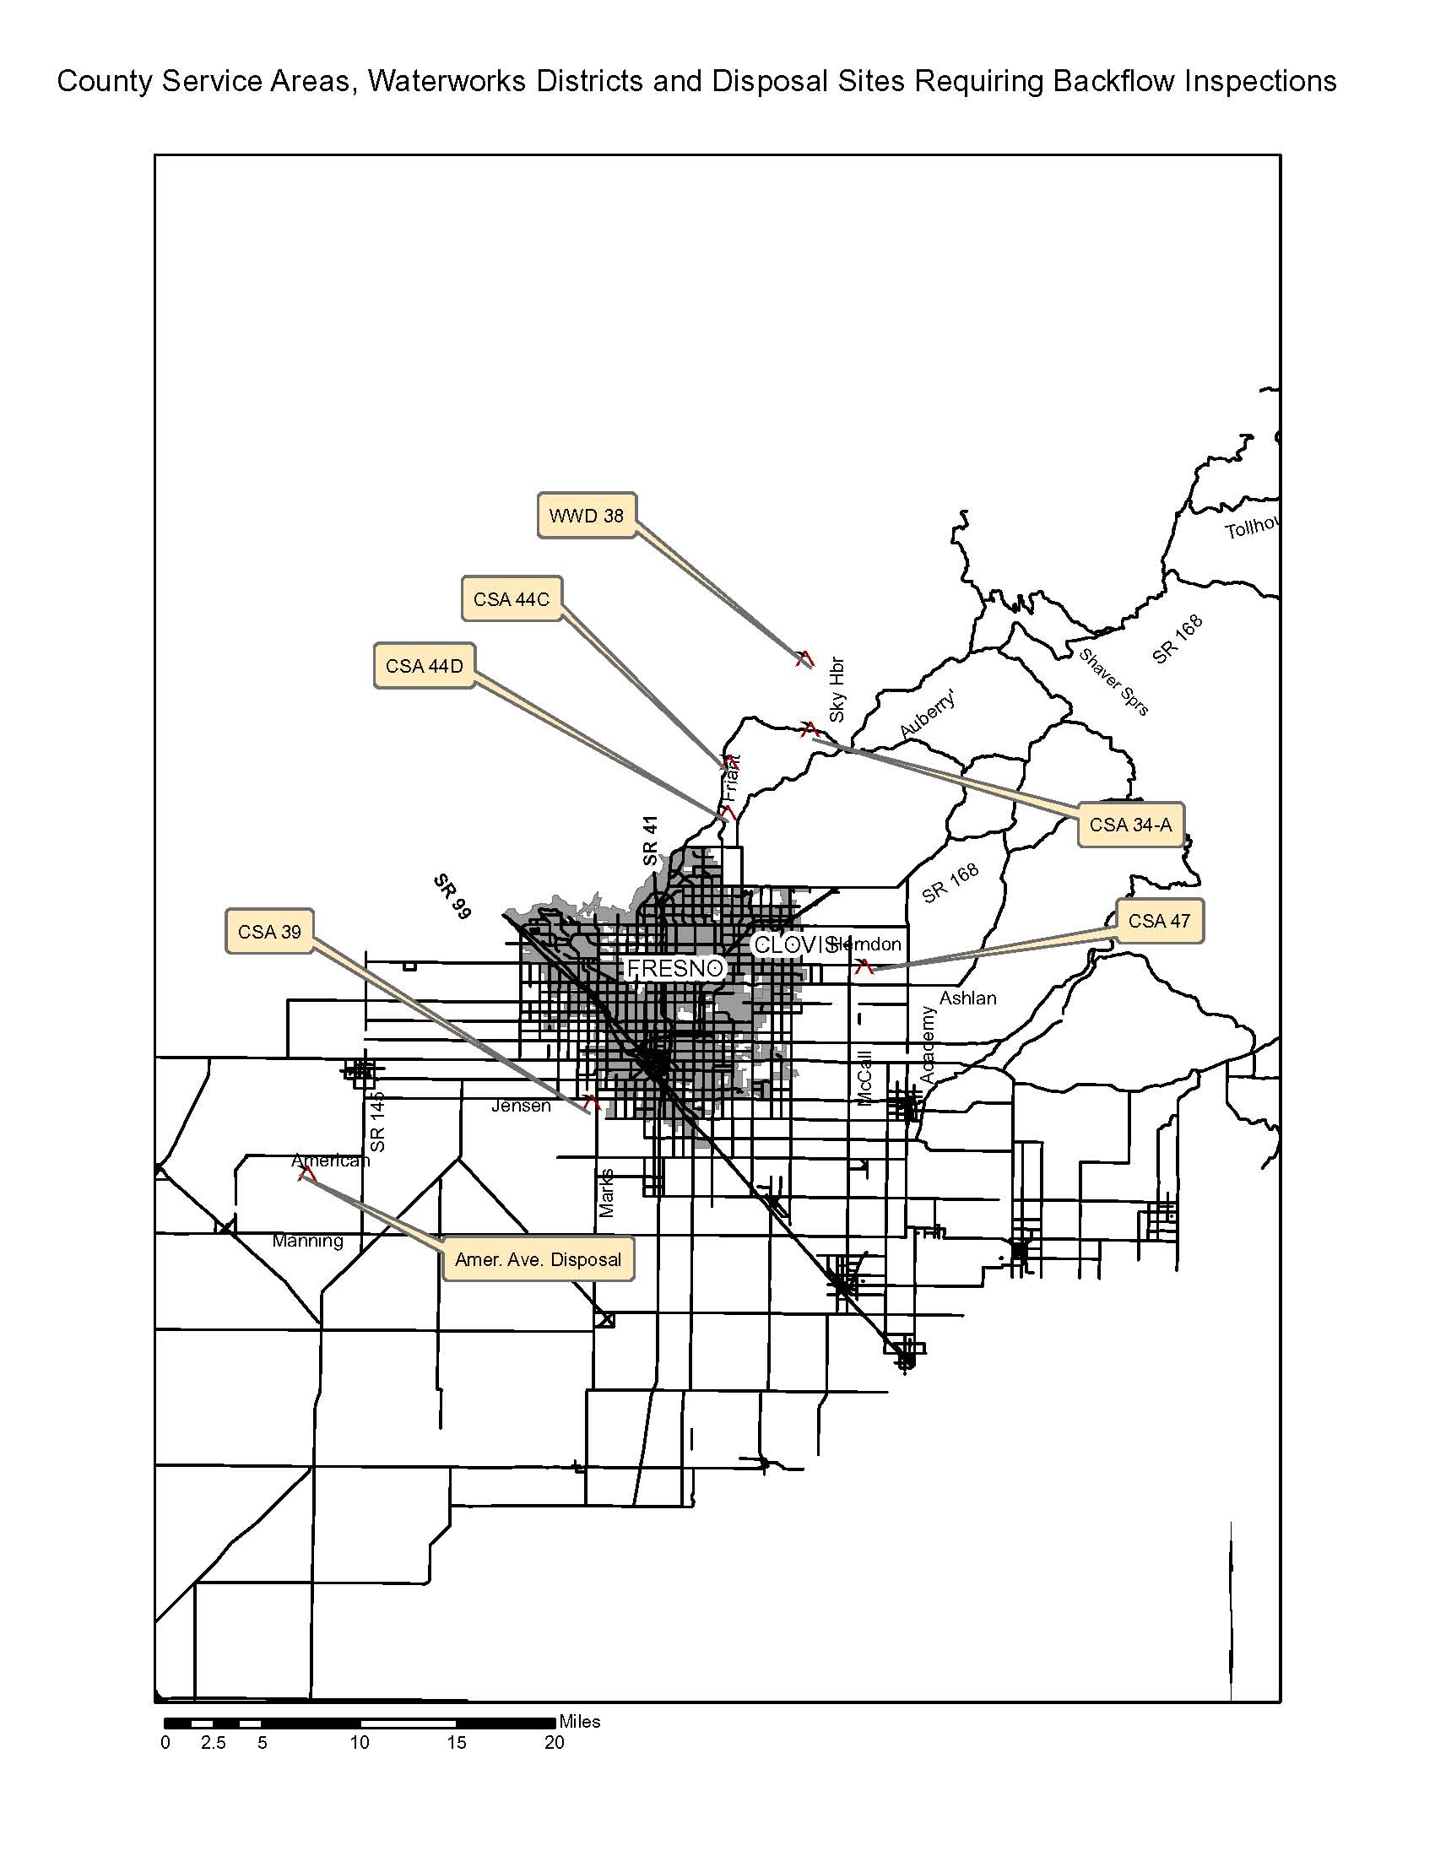
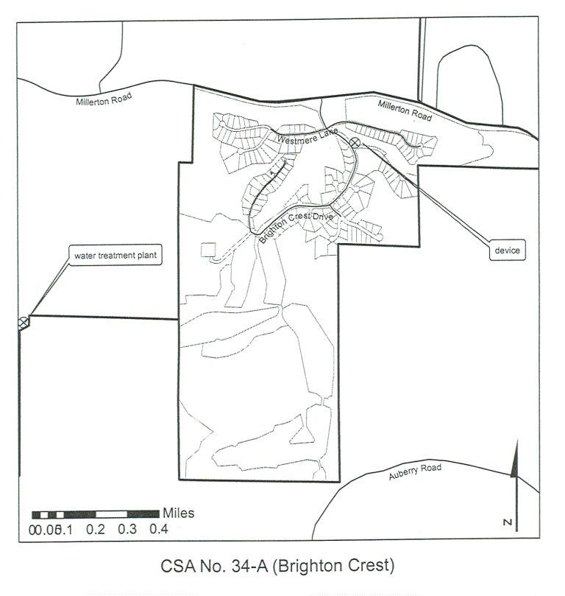
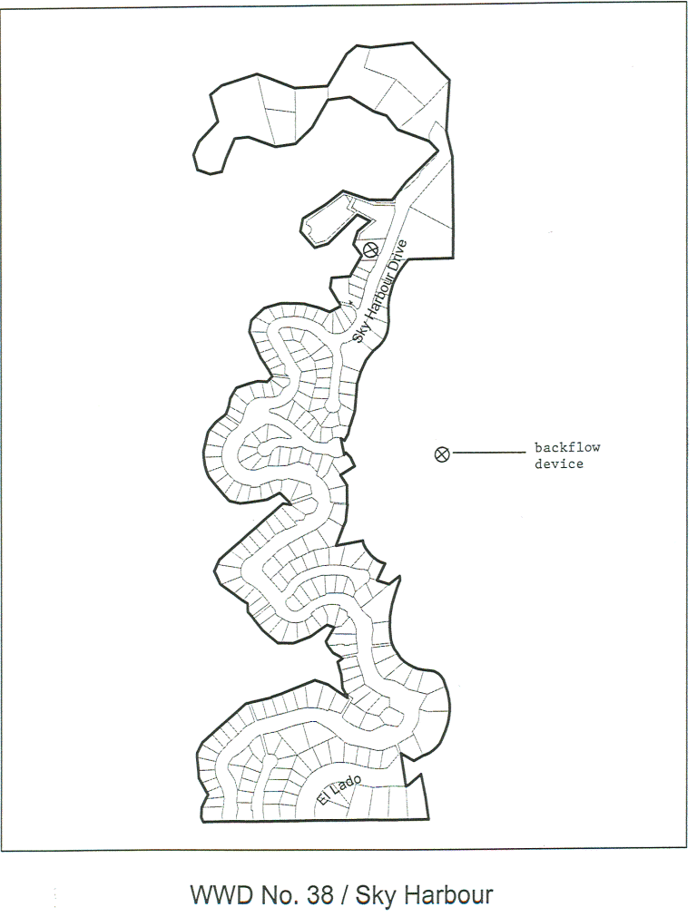

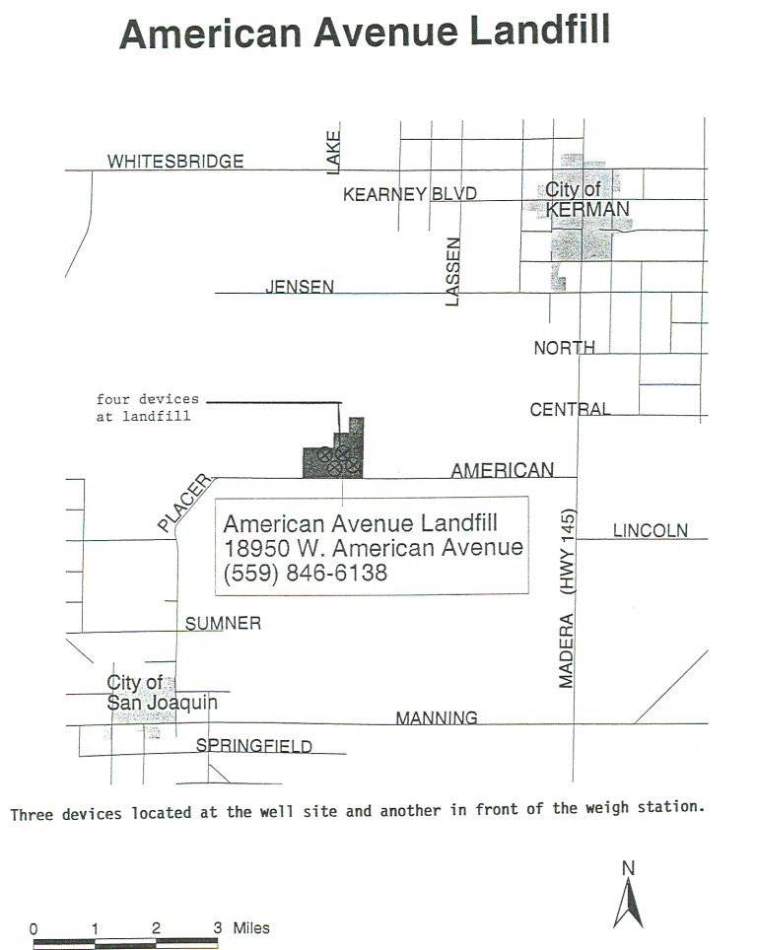
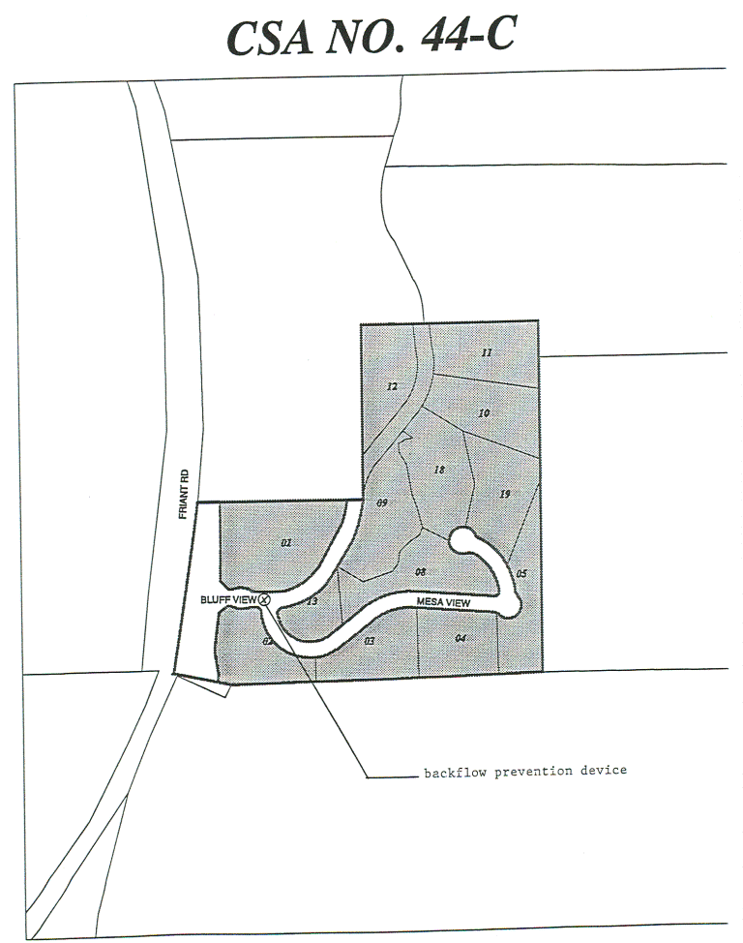
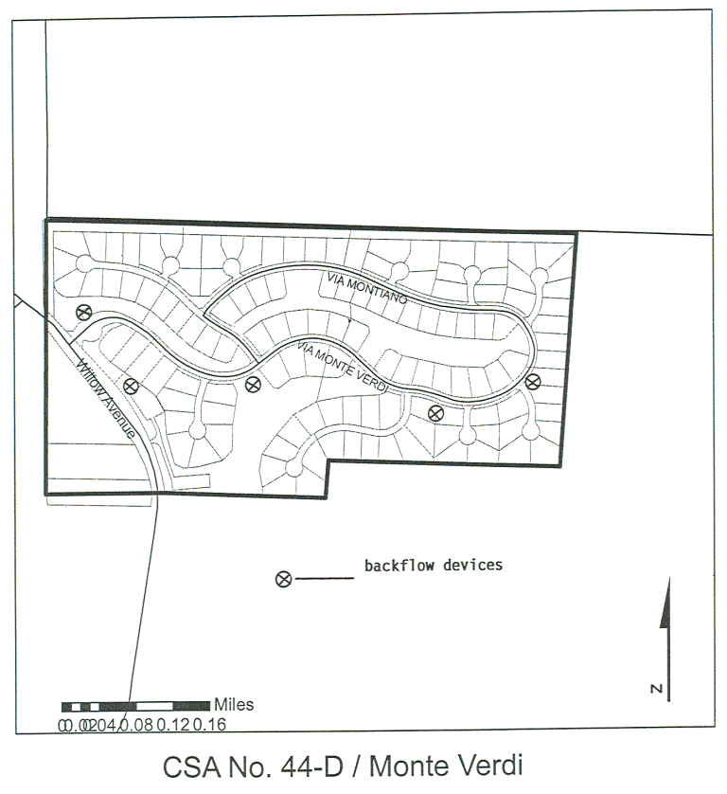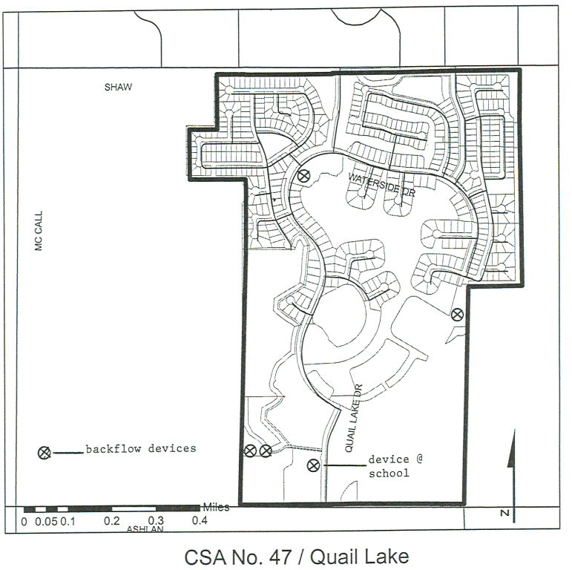
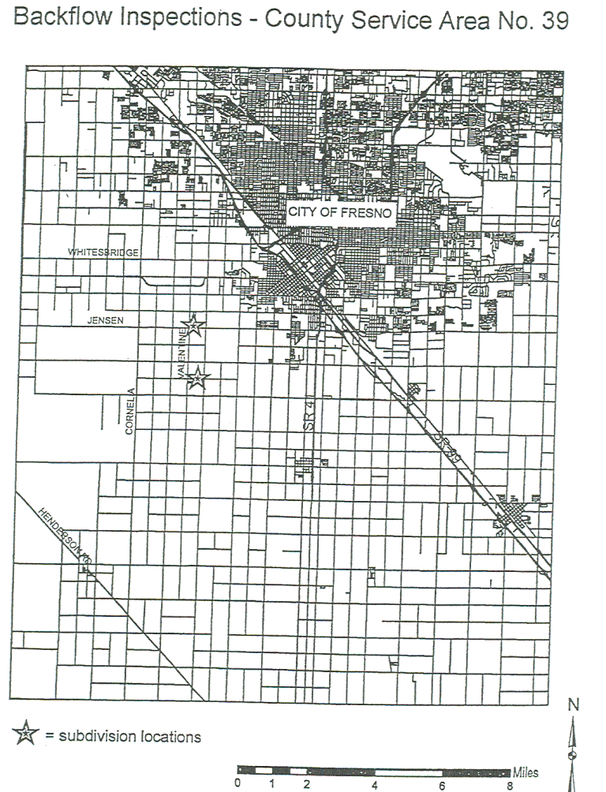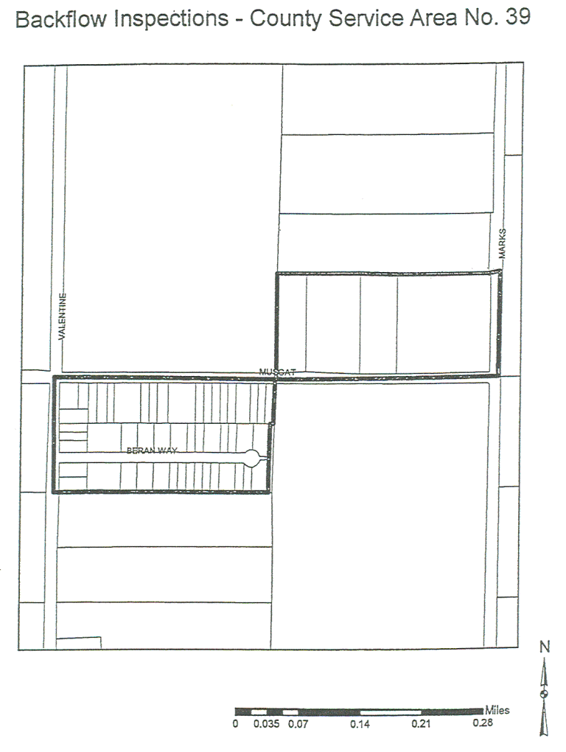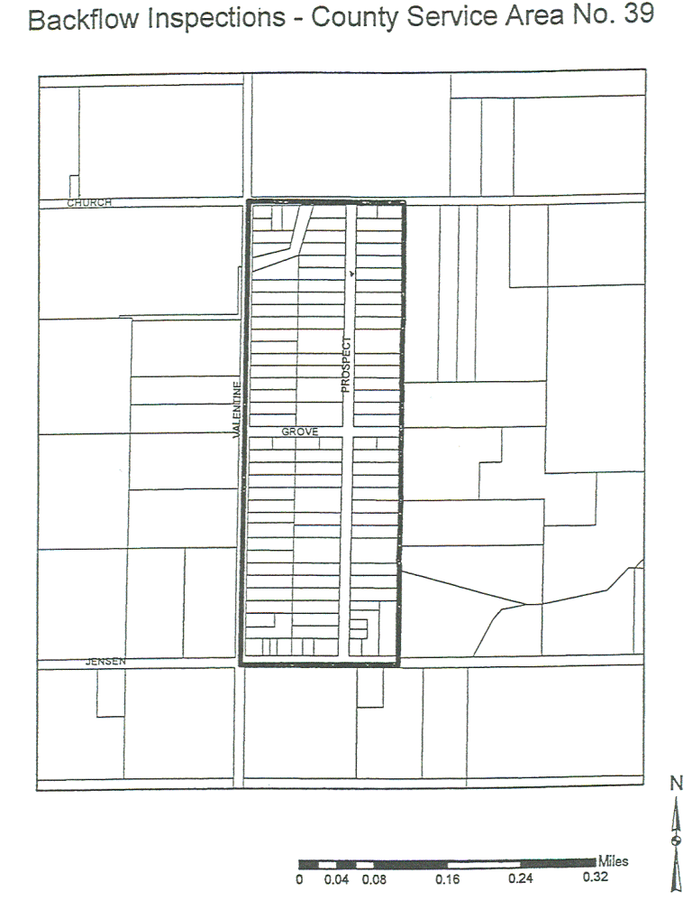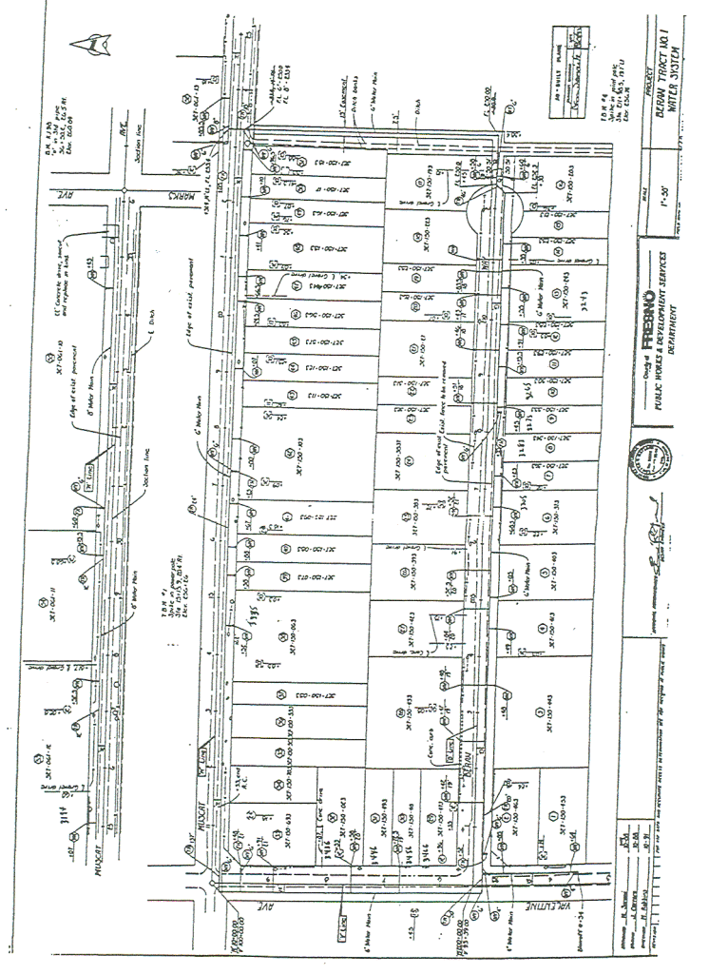
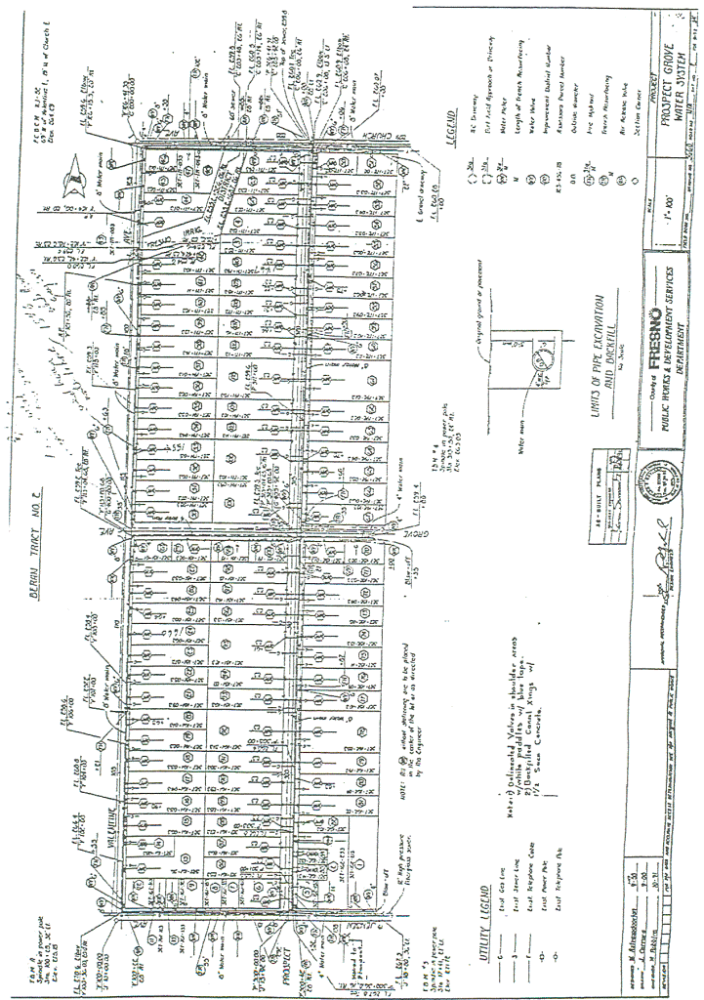METER READING REPORT
The January 2005 Meter Reading Report is included on the following pages. This report is provided to give bidders a listing of the street address involved with the project described herein.
Note: Vacant lots normally do not have backflow devices. However, there may be exceptions.
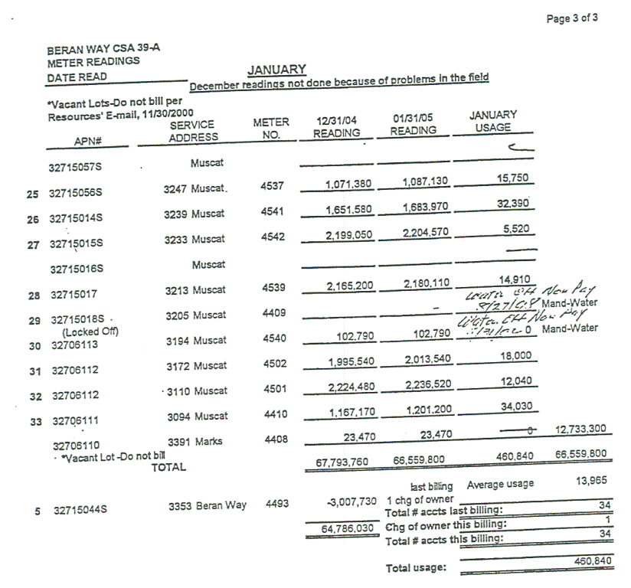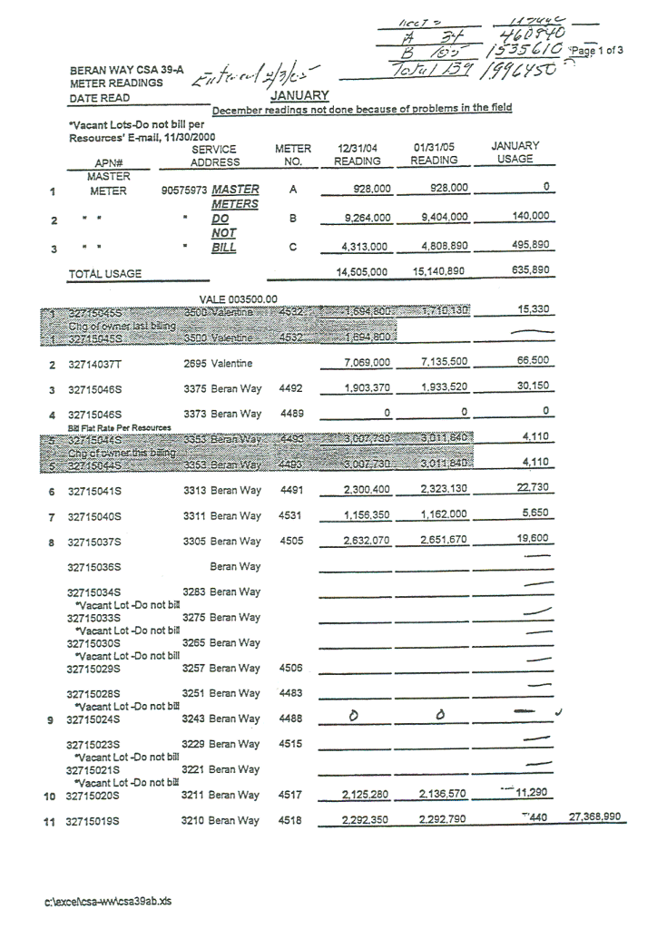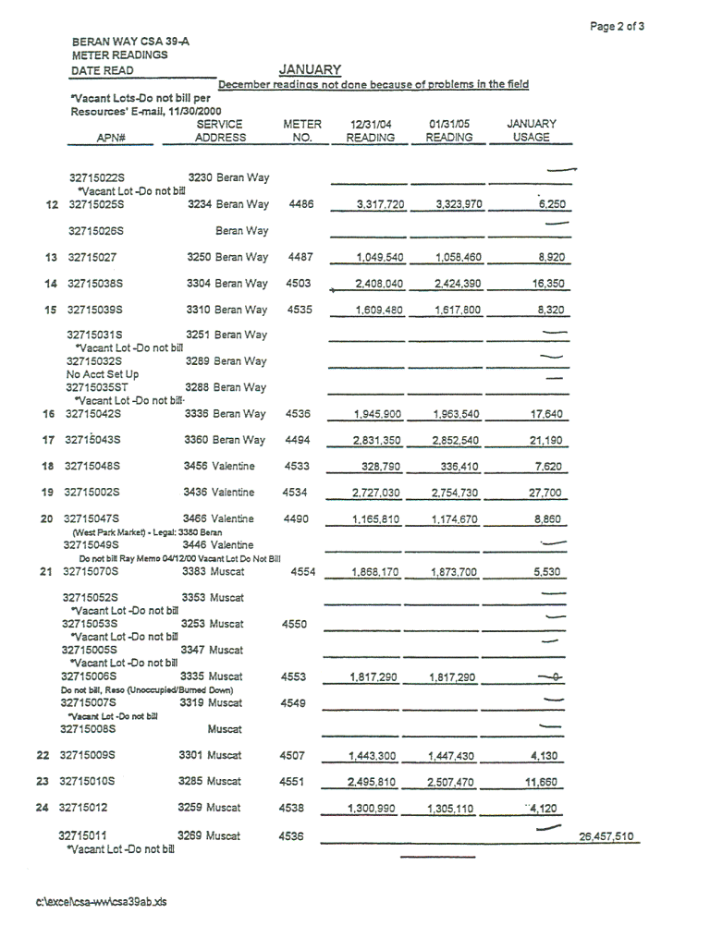

Vendor must complete and return with Request for Quotation.
Firm:
REFERENCE LIST
Submit a list of at least three (3) customer references. Such references shall be customers for whom the bidder has recently provided services that are similar to those requested herein.
Reference Name: |  |  | City:
Contact: |  |  | Phone No.:
Date and Service Provided:
Reference Name: |  |  | City:
Contact: |  |  | Phone No.:
Date and Service Provided:
Reference Name: |  |  | City:
Contact: |  |  | Phone No.:
Date and Service Provided:
Reference Name: |  |  | City:
Contact: |  |  | Phone No.:
Date and Service Provided:
Reference Name: |  |  | City:
Contact: |  |  | Phone No.:
Date and Service Provided:
FAILURE TO PROVIDE A LIST OF AT LEAST THREE (3) CUSTOMERS MAY BE CAUSE FOR REJECTION OF THIS RFQ.
QUOTATION SCHEDULE
Inspections
The vendor shall submit a quotation for the cost of performing the inspection of water system backflow devices including subsequent reporting as specified under this RFQ.
Labor Rate for Repairs
The vendor shall submit an hourly labor rate for performing repairs to water system backflow devices as specified under this RFQ.
Guaranteed Maximum (Not to Exceed Labor Cost)
The bidder shall quote his/her maximum (not to exceed) cost of labor to perform all necessary repairs (including replacements) of all malfunctioning backflow devices. The contractor will charge County an hourly rate for labor associated with repairs to each device, up to the maximum amount quoted.

The labor rate charged to the County shall be as quoted below. County will pay only for actual repairs. County will pay up to the guaranteed maximum providing that the total actual charges are at least equal to that maximum. The contractor shall perform repairs but not charge County for labor once the maximum charge has been attained. Reaching the guaranteed maximum cost of labor will not relieve the Contractor of his/her responsibility to diagnose and perform repairs.
The maximum labor cost quoted is to be determined by the bidder based on his/her experience in making repairs to backflow devices. The bidders must rely on his/her experience to accurately estimate the quantity of devices that will require repair and the extent of those repairs.
Parts
The Contractor may charge County and County shall pay for parts required to make repairs. The contractor shall not markup parts. The charge to the County shall be identical to the amount paid by the contractor. Contractor shall provide proof of his/her costs to the County upon County’s request. No other fees or charges will be allowed for repair work.
QUOTATION SCHEDULE
All labor, materials, equipment, taxes, fees, permits, etc. required to perform inspections and repair services to Water System Backflow Devices at CSA 34A, CSA 44C, CSA 44D, CSA 47, CSA 39, WWD 38 and American Avenue Landfill, as specified under this RFQ.
I. |  |  |  |  |  |  |  |  | Total
 | - INSPECTIONS, as specified:
 |  | $ | X |  |  | *150 each | = |  | $
 |  | Cost of One inspection
 | *This is an estimate only. The actual quantity of inspections may be greater than or less than this amount. The County does not guarantee a minimum quantity of inspections. County will pay only for the quantity of inspections performed.
 | - Maximum Labor Cost to perform repairs, as specified.  Repairs is intent to include replacement of backflow devices when necessary. |  |  |  |  |  |  | $
**Grand Total  (Inspections and Maximum labor cost)  **Award will be based on this total. |  |  |  |  |  |  |  |  | $
II.
 | - Hourly Labor Rate,  Labor Rate to Perform repairs (including replacement) of Backflow devices by a qualified technician, as specified. |  |  |  |  |  |  |  | $

Company Name:
SUBMITTALS
(*Check List)
The bidder shall provide the following with their quotation:
The completed and signed Page One of this RFQ.
Complete, sign and submit page one of each and all Addendums to this RFQ, which require signature (if any).
The specified number of copies of the bidder’s quotation.
The completed “QUOTATION SCHEDULE” as provided with this RFQ.
The completed “BIDDER TO COMPLETE” page of this RFQ.
A listing of all bidder exceptions to County’s requirements, conditions, and specifications as stated within this RFQ.
The completed “REFERENCE LIST” as provided with this RFQ.
Submit your quotation/proposal prior to the specified date and time. Submit in a sealed envelope, box, etc. with the following information displayed on the outside:

County of Fresno RFQ No. |  |  | 968-4159
Closing Date: | OCTOBER 6, 2005
Closing Time: | 2:00 P.M.
Commodity or Service:

*a. Submit this page as a part of your Quotation.

b. Submit all items listed on this page.

c. State Yes on the line to the left of each item to confirm that the requested information has been included, state No if it is not provided and explain why.

d. The County does not guarantee that all items to be submitted with vendor’s bid are listed above. The absence of items from the list does not exempt the bidder from providing them. The bidder must read the RFQ thoroughly to determine all items that are to be submitted with his/her quotation.

