COUNTY OF FRESNO
Request for Quotation
 |  |  |  |  |  | NUMBER: 964-4275
May 1, 2006
 | ORG/Requisition: 10100400/ 1016000117 |  |  |  |  |  |  |  |  | PURCHASING USE |  |  |  |  | /tmp/in/input.doc
 |  |  |  |  |  |  |  |  |  | jlg
 | IMPORTANT: SUBMIT QUOTATION IN SEALED PACKAGE WITH QUOTATION NUMBER, CLOSING DATE AND BUYER’S NAME MARKED CLEARLY ON THE OUTSIDE TO:
COUNTY OF FRESNO, Purchasing
4525 EAST HAMILTON AVENUE
FRESNO, CA 93702-4599
Closing date of bid will be at 2:00 p.m., on May 26, 2006.
QUOTES WILL BE CONSIDERED LATE WHEN THE OFFICIAL PURCHASING TIME CLOCK READS 2:00 P.M.
 | Quotes will be opened and publicly read at that time. All quotation information will be available for review after contract award.
 | Clarification of specifications are to be directed to: Gary Parkinson/Pat Flaherty, phone (559) 456-7110, FAX (559) 456-7831.
 |  | GENERAL CONDITIONS: See “County Of Fresno Purchasing Standard Instructions And Conditions For Request For Proposals (RFP’S) and Requests for Quotations (RFQ’S)” attached. Check County of Fresno Purchasing’s Open Solicitations website at www.co.fresno.ca.us/0440/Bidshome.asp for RFQ/RFP documents and changes.
BIDDER TO COMPLETE
UNDERSIGNED AGREES TO FURNISH THE COMMODITY OR SERVICE STIPULATED IN THE ATTACHED QUOTATION SCHEDULE AT THE PRICES AND TERMS STATED, SUBJECT TO THE “COUNTY OF FRESNO PURCHASING STANDARD INSTRUCTIONS AND CONDITIONS FOR REQUEST FOR PROPOSALS (RFP’S) AND REQUESTS FOR QUOTATIONS (RFQ’S)”ATTACHED.
Except as noted on individual items, the following will apply to all items in the Quotation Schedule.
 |  |  | - Complete delivery will be made within |  |  |  |  |  |  |  |  | calendar days after receipt of Order.
 |  |  | - A cash discount of |  |  |  |  |  | % |  |  |  |  | days will apply.
Company
Address
City |  |  |  |  |  |  |  |  |  |  |  |  |  |  |  |  | State |  | Zip Code
( ) |  |  |  |  |  |  |  | ( )
Telephone Number |  |  |  |  |  |  |  | Facsimile Number |  |  |  |  |  |  |  |  | E-mail Address
Taxpayer Federal I.D. No.:
Signed By
Print Name |  |  |  |  |  |  |  |  |  |  |  |  | Title

COUNTY OF FRESNO PURCHASING
STANDARD INSTRUCTIONS AND CONDITIONS FOR
REQUESTS FOR PROPOSALS (RFP'S) AND REQUESTS FOR QUOTATIONS (RFQ'S)
Note: the reference to “bids” in the following paragraphs applies to RFP's and RFQ's

GENERAL CONDITIONS
By submitting a bid the bidder agrees to the following conditions. These conditions will apply to all subsequent purchases based on this bid.

- BID PREPARATION:
  - All prices and notations must be typed or written in ink. No erasures permitted. Errors may be crossed out, initialed and corrections printed in ink by person signing bid.
  - Brand Names: Brand names and numbers when given are for reference. Equal items will be considered, provided the offer clearly describes the article and how it differs from that specified. In the absence of such information it shall be understood the offering is exactly as specified.
  - State brand or make of each item. If bidding on other than specified, state make, model and brand being bid and attach supporting literature/specifications to the bid.
  - Bid on each item separately. Prices should be stated in units specified herein. All applicable charges must be quoted; charges on invoice not quoted herein will be disallowed.
  - Time of delivery is a part of the consideration and must be stated in definite terms and must be adhered to. F.O.B. Point shall be destination or freight charges must be stated.
  - All bids must be dated and signed with the firm’s name and by an authorized officer or employee.
  - Unless otherwise noted, prices shall be firm for 120 days after closing date of bid.
- SUBMITTING BIDS:
  - Each bid must be submitted on forms provided in a sealed envelope with bid number and closing date and time on the outside of the envelope/package.
  - Interpretation: Should any discrepancies or omissions be found in the bid specifications or doubt as to their meaning, the bidder shall notify the Buyer in writing at once. The County shall not be held responsible for verbal interpretations. Questions regarding the bid must be received by Purchasing at least 5 working days before bid opening. All addenda issued shall be in writing, duly issued by Purchasing and incorporated into the contract.
  - ISSUING AGENT/AUTHORIZED CONTACT: This RFQ has been issued by County of Fresno Purchasing. Purchasing shall be the vendor’s sole point of contact with regard to the RFQ, its content, and all issues concerning it.
All communication regarding this RFQ shall be directed to an authorized representative of County Purchasing. The specific buyer managing this RFQ is identified on the cover page, along with his or her telephone number, and he or she should be the primary point of contact for discussions or information pertaining to the RFQ. Contact with any other County representative, including elected officials, for the purpose of discussing this RFQ, its content, or any other issue concerning it, is prohibited unless authorized by Purchasing. Violation of this clause, by the vendor having unauthorized contact (verbally or in writing) with such other County representatives, may constitute grounds for rejection by Purchasing of the vendor’s quotation.
The above stated restriction on vendor contact with County representatives shall apply until the County has awarded a purchase order or contract to a vendor or vendors, except as follows. First, in the event that a vendor initiates a formal protest against the RFQ, such vendor may contact the appropriate individual, or individuals who are managing that protest as outlined in the County’s established protest procedures. All such contact must be in accordance with the sequence set forth under the protest procedures. Second, in the event a public hearing is scheduled before the Board of Supervisors to hear testimony prior to its approval of a purchase order or contract, any vendor may address the Board.
  - Bids received after the closing time will NOT be considered.
  - Bidders are to bid what is specified or requested first. If unable to or willing to, bidder may bid alternative or option, indicating all advantages, disadvantages and their associated cost.
- FAILURE TO BID:
  - If not bidding, return bid sheet and state reason for no bid or your name may be removed from mailing list.
- TAXES, CHARGES AND EXTRAS:
  - County of Fresno is subject to California sales and/or use tax (7.975%). Please indicate as a separate line item if applicable.
  - DO NOT include Federal Excise Tax. County is exempt under Registration No. 94-73-03401-K.
  - County is exempt from Federal Transportation Tax. Exemption certificate is not required where shipping papers show consignee as County of Fresno.
  - Charges for transportation, containers, packing, etc. will not be paid unless specified in bid.
- W-9 – REQUEST FOR TAXPAYER IDENTIFICATION NUMBER AND CERTIFICATION:
Upon award of bid, the vendor shall submit to County Purchasing, a completed W-9 - Request for Taxpayer Identification Number and Certification if not already a current vendor with The County of Fresno. This form is available from the IRS to complete on line at http://www.irs.gov/pub/irs-pdf/fw9.pdf.
- AWARDS:
  - Subject to the local preference provisions referenced in Paragraph 6 below and more thoroughly set forth in the General Requirements section of this RFQ, award(s) will be made to the most responsive responsible bidder. The evaluation will include such things as life-cycle cost, availability, delivery costs and whose product and/or service is deemed to be in the best interest of the County. The County shall be the sole judge in making such determination.
  - Unless bidder gives notice of all-or-none award in bid, County may accept any item, group of items or on the basis of total bid.
  - The County reserves the right to reject any and all bids and to waive informalities or irregularities in bids.
  - After award, all bids shall be open to public inspection. The County assumes no responsibility for the confidentiality of information offered in a bid.
- LOCAL VENDORS
  - Local Vendor Preference (applicable to RFQ Process only)
The following provisions are applicable only to the County’s acquisition of materials, equipment or supplies through the RFQ process when the funding source does not require an exemption to the Local Vendor Preference.
THE PROVISIONS OF THIS PARAGRAPH ARE APPLICABLE, NOTWITHSTANDING ANY OTHER PROVISIONS OF THIS RFQ TO THE CONTRARY
If the apparent low bidder is not a local vendor, any local vendor who submitted a bid which was within five percent (5%) of the lowest responsive bid as determined by the purchasing agent shall have the option of submitting a new bid within forty-eight hours (not including weekends and holidays) of County’s delivery of notification. Such new bids must be in an amount less than or equal to the lowest responsive bid as determined by the purchasing agent. If the purchasing agent receives any new bids from local vendors who have the option of submitting new bids within said forty-eight hour period, it shall award the contract to the local vendor submitting the lowest responsible bid. If no new bids are received, the contract shall be awarded to the original low bidder as announced by the purchasing agent.
  - Local Vendor Defined
“Local Vendor” shall mean any business which:
- Has its headquarters, distribution point or locally-owned franchise located in or having a street address within the County for at least six (6) months immediately prior to the issuance of the request for competitive bids by the purchasing agent; and
- Holds any required business license by a jurisdiction located in Fresno County; and
- Employs at least one (1) full-time or two (2) part-time employees whose primary residence is located within Fresno County, or if the business has no employees, shall be at least fifty percent (50%) owned by one or more persons whose primary residence(s) is located within Fresno County.
- TIE BIDS:
All other factors being equal, the contract shall be awarded to the Fresno County vendor or, if neither or both are Fresno County vendors, it may be awarded by the flip of a coin in the presence of witnesses or the entire bid may be rejected and re-bid. If the General Requirements of this RFQ state that they are applicable, the provisions of the Fresno County Local Vendor Preference shall take priority over this paragraph.
- PATENT INDEMNITY:
The vendor shall hold the County, its officers, agents and employees, harmless from liability of any nature or kind, including costs and expenses, for infringement or use of any copyrighted or uncopyrighted composition, secret process, patented or unpatented invention, article or appliance furnished or used in connection with this bid.
- SAMPLES:
Samples, when required, must be furnished and delivered free and, if not destroyed by tests, will upon written request (within 30 days of bid closing date) be returned at the bidder's expense. In the absence of such notification, County shall have the right to dispose of the samples in whatever manner it deems appropriate.
- RIGHTS AND REMEDIES OF COUNTY FOR DEFAULT:
  - In case of default by vendor, the County may procure the articles or service from another source and may recover the cost difference and related expenses occasioned thereby from any unpaid balance due the vendor or by proceeding against performance bond of the vendor, if any, or by suit against the vendor. The prices paid by the County shall be considered the prevailing market price at the time such purchase is made.
  - Articles or services, which upon delivery inspection do not meet specifications, will be rejected and the vendor will be considered in default. Vendor shall reimburse County for expenses related to delivery of non-specified goods or services.
  - Regardless of F.O.B. point, vendor agrees to bear all risks of loss, injury or destruction to goods and materials ordered herein which occur prior to delivery and such loss, injury or destruction shall not release vendor from any obligation hereunder.
- DISCOUNTS:
Terms of less than 15 days for cash payment will be considered as net in evaluating this bid. A discount for payment within fifteen (15) days or more will be considered in determining the award of bid. Discount period will commence either the later of delivery or receipt of invoice by the County. Standard terms are Net Forty-five (45) days.
- SPECIAL CONDITIONS IN BID SCHEDULE SUPERSEDE GENERAL CONDITIONS.
The “General Conditions” provisions of this RFP/RFQ shall be superseded if in conflict with any other section of this bid, to the extent of any such conflict.
- SPECIAL REQUIREMENT:
With the invoice or within twenty-five (25) days of delivery, the seller must provide to the County a Material Safety Data Sheet for each product, which contains any substance on “The List of 800 Hazardous Substances”, published by the State Director of Industrial Relations. (See Hazardous Substances Information and Training Act. California State Labor Code Sections 6360 through 6399.7.)
- RECYCLED PRODUCTS/MATERIALS:
Vendors are encouraged to provide and quote (with documentation) recycled or recyclable products/materials which meet stated specifications.
- YEAR COMPLIANCE WARRANTY
Vendor warrants that any product furnished pursuant to this Agreement/order shall support a four-digit year format and be able to accurately process date and time data from, into and between the twentieth and twenty-first centuries, as well as leap year calculations. "Product" shall include, without limitation, any piece or component of equipment, hardware, firmware, middleware, custom or commercial software, or internal components or subroutines therein. This warranty shall survive termination or expiration of this Agreement.
In the event of any decrease in product functionality or accuracy related to time and/or date data related codes and/or internal subroutines that impede the product from operating correctly using dates beyond December 31, 1999, vendor shall restore or repair the product to the same level of functionality as warranted herein, so as to minimize interruption to County's ongoing business process, time being of the essence. In the event that such warranty compliance requires the acquisition of additional programs, the expense for any such associated or additional acquisitions, which may be required, including, without limitation, data conversion tools, shall be borne exclusively by vendor. Nothing in this warranty shall be construed to limit any rights or remedies the County may otherwise have under this Agreement with respect to defects other than year performance.
- PARTICIPATION:
Bidder may agree to extend the terms of the resulting contract to other political subdivision, municipalities and tax-supported agencies.
Such participating Governmental bodies shall make purchases in their own name, make payment directly to bidder, and be liable directly to the bidder, holding the County of Fresno harmless.
- CONFIDENTIALITY:
All services performed by vendor shall be in strict conformance with all applicable Federal, State of California and/or local laws and regulations relating to confidentiality, including but not limited to, California Civil Code, California Welfare and Institutions Code, Health and Safety Code, California Code of Regulations, Code of Federal Regulations.
Vendor shall submit to County’s monitoring of said compliance.
Vendor may be a business associate of County, as that term is defined in the “Privacy Rule” enacted by the Health Insurance Portability and Accountability Act of 1996 (HIPAA). As a HIPAA Business Associate, vendor may use or disclose protected health information (“PHI”) to perform functions, activities or services for or on behalf of County as specified by the County, provided that such use or disclosure shall not violate HIPAA and its implementing regulations. The uses and disclosures if PHI may not be more expansive than those applicable to County, as the “Covered Entity” under HIPAA’S Privacy Rule, except as authorized for management, administrative or legal responsibilities of the Business Associate.
Vendor shall not use or further disclose PHI other than as permitted or required by the County, or as required by law without written notice to the County.
Vendor shall ensure that any agent, including any subcontractor, to which vendor provides PHI received from, or created or received by the vendor on behalf of County, shall comply with the same restrictions and conditions with respect to such information.
- APPEALS
Appeals must be submitted in writing within five (5) working days after the review committee notification of proposed recommendations. Appeals should be submitted to County of Fresno Purchasing, 4525 E. Hamilton Avenue, Fresno, California 93702-4599. Appeals should address only areas regarding RFP contradictions, procurement errors, quotation rating discrepancies, legality of procurement context, conflict of interest in rating process, and inappropriate or unfair competitive procurement grievance regarding the RFP process.
The Purchasing Manager will provide a written response to the complaint within five (5) working days unless the complainant is notified more time is required.
If the protesting bidder is not satisfied with the decision of the Purchasing Manager, he/she shall have the right to appeal to the Purchasing Agent within five (5) business days after notification of the Purchasing Manager’s decision.
If the protesting bidder is not satisfied with Purchasing Agent decision, the final appeal is with the Board of Supervisors.

BIDDING INSTRUCTIONS

CONTRACT SERVICES
Overview of Services
The County of Fresno is soliciting bids from qualified vendors to establish an agreement under which the successful bidder will provide pre-employment, periodic, compulsory (also known as fit-for-duty), and DMV medical examinations for employment-related purposes for certain job classifications. A qualified vendor shall be defined as being experienced in conducting medical examinations related to prospective and current employment, as outlined in the Scope of Work section of this RFQ. These examinations shall be conducted utilizing the evaluation system provided by the County of Fresno’s medical standards program administrator (a separate contract that is currently in the Request for Proposal process and expected to be determined by this RFQ’s deadline for written or fax requests for interpretations or corrections on May 17, 2006 at 8:00 a.m. as shown under the Terms and Conditions section), and adopted by the Department of Personnel Services, in accordance with the County’s Personnel Rule 8 – Medical Examinations (see Attachment “A” or visit our website at www.co.fresno.ca.us/1010/persweb/index.htm).
The successful contractor will be required to conduct the pre-employment, periodic, compulsory, and DMV medical examinations consistent with the medical standards, guidelines, and evaluations utilized by the County of Fresno’s medical standards program administrator, as adopted by the Department of Personnel Services. The County’s medical examination program goal is to ensure that (1) an individual is medically qualified to perform the duties normally associated with a position in a specific job classification with or without reasonable accommodation, and (2) an individual, in performing the job duties, does not present a hazard to the health and safety of self, co-workers, or the public. The types of medical examinations are as follows:
- Pre-employment (post-offer of employment) examinations are required for job classifications including, but not limited to, Correctional Officer, Deputy Sheriff, Deputy Probation Officer, Juvenile Correctional Officer, and District Attorney Investigator.
- Employees in safety officer classifications are not currently undergoing periodic medical examinations (same medical examination as is conducted for pre-employment exams), but may be required in the future: employees under age 45 examined every third year after employment; employees 45 years and older examined annually. Should the periodic exams be required, the County anticipates approximately 300 per year would be conducted.
- Compulsory medical examinations may be requested when a department head believes an employee, for medical reasons, has difficulty performing effectively in the essential functions and duties of the job and/or they may be presenting a hazard to themselves or others. Compulsory examination components are determined on a case-by-case basis.
- DMV examinations are required for persons occupying job classifications that are required to drive certain types of vehicles requiring DMV Class A or B licensure pursuant to the Code of Federal Regulations, Title 49. Affected classification series’ may include Deputy Sheriff, Juvenile Correctional Officer, Correctional Officer, Road Equipment Operator, Parks Groundskeeper, Driver, and Stock Clerk.
The successful contractor will receive training regarding the system and process utilized (including forms to use in conducting the exams) by the County’s medical standards program administrator and will subsequently perform medical examinations for potential and existing County of Fresno employees upon the Department of Personnel Services’ request. For the past two and one-half (2 ½) years, the County has required approximately 300-350 medical examinations be conducted per year, however this does not necessarily indicate what future need will be. The majority of the examinations conducted during this time period fell under the pre-employment exam type (approximately 230 per year), with the second largest being DMV exams (approximately 100 per year). In addition, as stated above, should periodic exams be required in the future, we anticipate approximately 300 per year would be conducted.
Medical exams conducted by the selected contractor will be required to be completed without providing a medical recommendation. All medical interpretations and/or recommendations will be provided by the County’s medical standards program administrator. (Please see Scope of Work section for additional information and samples of what is currently utilized by the County of Fresno’s medical standards program.)
Note: The County reserves the right to enter into agreement with two vendors for the purpose of having an overflow or back-up vendor in the event the primary vendor is unable to meet the medical examination requirements set forth in this RFQ including, but not limited to, established timeframes for conducting the examinations as identified in the Scope of Work section.
Terms and Conditions
LOCAL VENDOR PREFERENCE: The Local Vendor Preference does not apply to this Request for Quotation.
DEFINITIONS: The terms Bidder, Proposer, Contractor and Vendor are all used interchangeably and refer to that person, partnership, corporation, organization, agency, etc. which is offering the quotation and is identified on page one of this Request For Quotation (RFQ).
INTERPRETATION OF RFQ: Vendors must make careful examination of the requirements, specifications and conditions expressed in the RFQ and fully inform themselves as to the quality and character of services required. If any person planning to submit a quotation finds discrepancies in or omissions from the RFQ or has any doubt as to the true meaning or interpretation, correction thereof may be requested in writing from Purchasing, no later than 8:00 a.m. on May 17, 2006. Any change in the RFQ will be made only by written addendum, duly issued by the County. The County will not be responsible for any other explanations or interpretations.
Questions may be submitted subsequent to the deadline, subject to the following conditions:
- Such questions are submitted in writing to County Purchasing as least seven (7) County business days prior to the Request for Quotation closing date. Questions must be directed to the attention of the buyer identified on page one.
- Such questions are submitted with the understanding that County can respond only to questions it considers material in nature.
Questions shall be delivered to County of Fresno Purchasing, 4525 E. Hamilton Avenue, Fresno, CA 93702 or faxed to (559) 456-7831. If faxing, the bidder must confirm receipt by phone within one-half (1/2) hour of transmission.
NOTE: The bidder is encouraged to submit all questions by the deadline. Time limitations can prevent a response to questions submitted after the deadline.
AWARD: Award will be made to the vendor(s) offering the services deemed to be to the best advantage of the County. The County shall be the sole judge in making such determination.
RIGHT TO REJECT BIDS: The County reserves the right to reject any and all bids and to waive informalities or irregularities in bids.
ISSUING AGENT: This RFQ has been issued by County of Fresno Purchasing. Purchasing shall be the vendor’s sole point of contact with regard to the RFQ, its content, and all issues concerning it.
AUTHORIZED CONTACT: All communication regarding this RFQ shall be directed to an authorized representative of County Purchasing. The specific buyer managing this RFQ is identified on the cover page, along with his or her telephone number, and he or she should be the primary point of contact for discussions or information pertaining to the RFQ. Contact with any other County representative, including elected officials, for the purpose of discussing this RFQ, its content, or any other issue concerning it, is prohibited unless authorized by Purchasing. Violation of this clause, by the vendor having unauthorized contact (verbally or in writing) with such other County representatives, may constitute grounds for rejection by Purchasing of the vendor’s quotation.
The above stated restriction on vendor contact with County representatives shall apply until the County has awarded a purchase order or contract to a vendor or vendors, except as follows. First, in the event that a vendor initiates a formal protest against the RFQ, such vendor may contact the appropriate individual, or individuals who are managing that protest as outlined in the County’s established protest procedures. All such contact must be in accordance with the sequence set forth under the protest procedures. Second, in the event a public hearing is scheduled before the Board of Supervisors to hear testimony prior to its approval of a purchase order or contract, any vendor may address the Board.
NUMBER OF COPIES: Submit one (1) original and three (3) copies of your quotation no later than the quotation closing date and time as stated on the front of this document to County of Fresno Purchasing. Each copy to be identical to the original, include all supporting documentation (i.e. literature, brochures, reports, schedules etc.). The cover page of each quotation is to be appropriately marked “Original” or “Copy”.
FIRM QUOTATION: All quotations shall remain firm for at least 60 days.
TAXES: The quoted amount must include all applicable taxes. If taxes are not specifically identified in the quotation it will be assumed that they are included in the total quoted.
SALES TAX: Fresno County pays California State Sales Tax in the amount of 7.975% regardless of vendor's place of doing business.
MINOR DEVIATIONS: The County reserves the right to negotiate minor deviations from the prescribed terms, conditions and requirements with the selected vendor.
QUOTATION REJECTION: Failure to respond to all questions or not to supply the requested information could result in rejection of your quotation.
BIDDERS’ LIABILITIES: County of Fresno will not be held liable for any cost incurred by vendors in responding to the RFQ.
PRICE RESPONSIBILITY: The selected vendor will be required to assume full responsibility for all services and activities offered in the quotation, whether or not they are provided directly. Further, the County of Fresno will consider the selected vendor to be the sole point of contact with regard to contractual matters, including payment of any and all charges resulting from the contract. The contractor may not subcontract or transfer the contract, or any right or obligation arising out of the contract, without first having obtained the express written consent of the County.
CONFIDENTIALITY: Bidders shall not disclose information about the County's business or business practices and safeguard confidential data which vendor staff may have access to in the course of system implementation.
NEWS RELEASE: Vendors shall not issue any news releases or otherwise release information to any third party about this RFQ or the vendor's quotation without prior written approval from the County of Fresno.
BACKGROUND REVIEW: The County reserves the right to conduct a background inquiry of each proposer/bidder which may include collection of appropriate criminal history information, contractual and business associations and practices, employment histories and reputation in the business community. By submitting a quotation/bid to the County, the vendor consents to such an inquiry and agrees to make available to the County such books and records the County deems necessary to conduct the inquiry.
EXCEPTIONS: Identify with explanation, any terms, conditions, specifications or stipulations of the RFQ with which you CAN NOT or WILL NOT comply.
ADDENDA: In the event that it becomes necessary to revise any part of this RFQ, addenda will be provided to all agencies and organizations that receive the basic RFQ.
SUBCONTRACTORS: If a subcontractor is proposed, complete identification of the subcontractor and his tasks shall be provided. The primary contractor is not relieved of any responsibility by virtue of using a subcontractor.
CONFLICT OF INTEREST: The County shall not contract with, and shall reject any bid or quotation submitted by the persons or entities specified below, unless the Board of Supervisors finds that special circumstances exist which justify the approval of such contract:
- Employees of the County or public agencies for which the Board of Supervisors is the governing body.
- Profit-making firms or businesses in which employees described in Subsection (1) serve as officers, principals, partners or major shareholders.
- Persons who, within the immediately preceding twelve (12) months, came within the provisions of Subsection (1), and who were employees in positions of substantial responsibility in the area of service to be performed by the contract, or participated in any way in developing the contract or its service specifications.
- Profit-making firms or businesses in which the former employees described in Subsection (3) serve as officers, principals, partners or major shareholders.
- No County employee whose position in the County enables him to influence the selection of a contractor for this RFQ, or any competing RFQ, and no spouse or economic dependent of such employee, shall be employees in any capacity by a bidder, or have any other direct or indirect financial interest in the selection of a contractor.
- In addition, no County employee will be employed by the selected vendor to fulfill the vendor’s contractual obligations to the County.
INVOICING: All invoices are to be delivered to the ordering department (see Scope of Work section for more details). Each invoice shall reference the purchase order or contract number. The contractor shall obtain the “invoice to” address when receiving the order.
PAYMENT: County will make partial payments for all purchases made under the contract/purchase order and accumulated during the month.
CONTRACT TERM: It is County’s intent to contract with the successful bidder for a term of one (1) year with the option to renew for up to four (4) additional one (1) year periods. County will retain the right to terminate the Agreement upon giving thirty (30) days advance written notification to the Contractor.
PRICES: Bidder agrees that prices quoted are maximum for the contract period, and in the event of a price decline such lower prices shall be extended to the County of Fresno.
QUANTITIES: Quantities shown in the bid schedule are approximate and the County guarantees no minimum amount. The County reserves the right to increase or decrease quantities.
ORDERING: Orders will be placed as required by the various County Departments.
INDEPENDENT CONTRACTOR: In performance of the work, duties, and obligations assumed by Contractor under any ensuing Agreement, it is mutually understood and agreed that CONTRACTOR, including any and all of Contractor’s officers, agents, and employees will at all times be acting and performing as an independent contractor, and shall act in an independent capacity and not as an officer, agent, servant, employee, joint venturer, partner, or associate of the COUNTY. Furthermore, County shall have no right to control or supervise or direct the manner or method by which Contractor shall perform its work and function. However, County shall retain the right to administer this Agreement so as to verify that Contractor is performing its obligations in accordance with the terms and conditions thereof. Contractor and County shall comply with all applicable provisions of law and the rules and regulations, if any, of governmental authorities having jurisdiction over matters the subject thereof.
Because of its status as an independent contractor, Contractor shall have absolutely no right to employment rights and benefits available to County employees. Contractor shall be solely liable and responsible for providing to, or on behalf of, its employees all legally-required employee benefits. In addition, Contractor shall be solely responsible and save County harmless from all matters relating to payment of Contractor's employees, including compliance with Social Security, withholding, and all other regulations governing such matters. It is acknowledged that during the term of the Agreement, Contractor may be providing services to others unrelated to the County or to the Agreement.
HOLD HARMLESS CLAUSE: Contractor agrees to indemnify, save, hold harmless and at County's request, defend the County, its officers, agents and employees, from any and all costs and expenses, damages, liabilities, claims and losses occurring or resulting to County in connection with the performance, or failure to perform, by Contractor, its officers, agents or employees under this Agreement and from any and all costs and expenses, damages, liabilities, claims and losses occurring or resulting to any person, firm or corporation who may be injured or damaged by the performance, or failure to perform, of Contractor, its officers, agents or employees under this Agreement.

INSURANCE:
Without limiting the COUNTY's right to obtain indemnification from CONTRACTOR or any third parties, CONTRACTOR, at its sole expense, shall maintain in full force and effect, the following insurance policies throughout the term of the Agreement:
- Commercial General Liability
Commercial General Liability Insurance with limits of not less than One Million Dollars ($1,000,000) per occurrence and an annual aggregate of Two Million Dollars ($2,000,000). This policy shall be issued on a per occurrence basis. COUNTY may require specific coverages including completed operations, products liability, contractual liability, Explosion-Collapse-Underground, fire legal liability or any other liability insurance deemed necessary because of the nature of this contract.
- Automobile Liability
Comprehensive Automobile Liability Insurance with limits for bodily injury of not less than Two Hundred Fifty Thousand Dollars ($250,000.00) per person, Five Hundred Thousand Dollars ($500,000.00) per accident and for property damages of not less than Fifty Thousand Dollars ($50,000.00), or such coverage with a combined single limit of Five Hundred Thousand Dollars ($500,000.00). Coverage should include owned and non-owned vehicles used in connection with this Agreement.
- Professional Liability
If CONTRACTOR employs licensed professional staff, (e.g., Ph.D., R.N., L.C.S.W., M.F.C.C.) in providing services, Professional Liability Insurance with limits of not less than One Million Dollars ($1,000,000.00) per occurrence, Three Million Dollars ($3,000,000.00) annual aggregate. This coverage shall be issued on a per claim basis. CONTRACTOR agrees that is shall maintain, at its sole expense, in full force and effect for a period of three (3) years following the termination of this Agreement, one or more policies of professional liability insurance with limits of coverage as specified herein.
- Worker's Compensation
A policy of Worker's Compensation insurance as may be required by the California Labor Code.
CONTRACTOR shall obtain endorsements to the Commercial General Liability insurance naming the County of Fresno, its officers, agents, and employees, individually and collectively, as additional insured, but only insofar as the operations under this Agreement are concerned. Such coverage for additional insured shall apply as primary insurance and any other insurance, or self-insurance, maintained by COUNTY, its officers, agents and employees shall be excess only and not contributing with insurance provided under CONTRACTOR's policies herein. This insurance shall not be cancelled or changed without a minimum of thirty (30) days advance written notice given to COUNTY.
Within Thirty (30) days from the date CONTRACTOR executes this Agreement, CONTRACTOR shall provide certificates of insurance and endorsement as stated above for all of the foregoing policies, as required herein, to the County of Fresno, Purchasing, stating that such insurance coverage have been obtained and are in full force; that the County of Fresno, its officers, agents and employees will not be responsible for any premiums on the policies; that such Commercial General Liability insurance names the County of Fresno, its officers, agents and employees, individually and collectively, as additional insured, but only insofar as the operations under this Agreement are concerned; that such coverage for additional insured shall apply as primary insurance and any other insurance, or self-insurance, maintained by COUNTY, its officers, agents and employees, shall be excess only and not contributing with insurance provided under CONTRACTOR's policies herein; and that this insurance shall not be cancelled or changed without a minimum of thirty (30) days advance, written notice given to COUNTY.
In the event CONTRACTOR fails to keep in effect at all times insurance coverage as herein provided, the COUNTY may, in addition to other remedies it may have, suspend or terminate this Agreement upon the occurrence of such event.
All policies shall be with admitted insurers licensed to do business in the State of California. Insurance purchased shall be purchased from companies possessing a current A.M. Best, Inc. rating of A FSC VII or better.
PERFORMANCE BOND: The successful bidders may be required to furnish a faithful performance bond.
DISPUTE RESOLUTION: The ensuing contract shall be governed by the laws of the state of California.
Any claim which cannot be amicably settled without court action will be litigated in the U. S. District Court for the Eastern District of California in Fresno, CA or in a state court for Fresno County.
TERMINATION: The County reserves the right to terminate any resulting contract upon written notice.
DEFAULT: In case of default by the selected bidder, the County may procure the services from another source and may recover the loss occasioned thereby from any unpaid balance due the selected bidder, or by any other legal means available to the County.
ASSIGNMENTS: The ensuing proposed contract will provide that the vendor may not assign any payment or portions of payments without prior written consent of the County of Fresno.
ASSURANCES: Any contract awarded under this RFQ must be carried out in full compliance with The Civil Rights Act of 1964, The Americans With Disabilities Act of 1990, their subsequent amendments, and any and all other laws protecting the rights of individuals and agencies. The County of Fresno has a zero tolerance for discrimination, implied or expressed, and wants to ensure that policy continues under this RFQ. The contractor must also guarantee that services, or workmanship, provided will be performed in compliance with all applicable local, state, or federal laws and regulations pertinent to the types of services, or project, of the nature required under this RFQ. In addition, the contractor may be required to provide evidence substantiating that their employees have the necessary skills and training to perform the required services or work.
AUDITS AND INSPECTIONS: The Contractor shall at any time during business hours, and as often as the County may deem necessary, make available to the County for examination all of its records and data and respect to the matters covered by this Agreement. The Contractor shall, upon request by the County, permit the County to audit and inspect all of such records and data necessary to ensure Contractor's compliance with the terms of this Agreement.
If this Agreement exceeds Ten Thousand and No/100 dollars ($10,000.00), Contractor shall be subject to the examination and audit of the Auditor General for a period of three (3) years after final payment under contract (Government Code Section 8546.7).
Scope of Work
The contractor(s) selected will perform all pre-employment, periodic, compulsory, and DMV medical examinations for the County of Fresno upon request of the County’s Department of Personnel Services. The specific medical examination to be conducted will be based on job classification (with the exception of DMV examinations) and is shown in Attachment “B” for each job classification with an existing medical exam profile. The County of Fresno’s medical standards program administrator (separate contract) will be responsible for training the medical examination contractor regarding the system and process utilized by the administrator, including forms used and examination components required. The following specifies the process for which the medical examinations conducted by the selected contractor(s) of this RFQ shall follow:
- The Department of Personnel Services will contact the contractor to schedule the medical examination. Upon scheduling, the contractor will be notified of the required type of examination (e.g., pre-employment, periodic, compulsory, or DMV) to be performed, including the specific job classification. Medical examinations shall be scheduled within ten (10) County business days from the date of request, unless agreed upon by County and contractor. If the contractor receives a request to perform an examination that is not specified in Attachment “B” of this RFQ, contractor will receive notification from the County of Fresno pursuant to the County medical standards program administrator’s development of the appropriate type of medical examination to be performed.
Please note that the components of each medical examination may change periodically as a result of changes to federal, state, or local laws/regulations, for example. Additionally, the need to examine certain classifications may also change during the term of the agreement.
- Contractor will receive the appropriate forms to use while applying the system utilized by the County’s medical standards program administrator. The specific forms utilized will be provided to the successful contractor(s) of this RFQ process. The forms utilized will be similar to the examples provided for: Cover Sheet/Intake Form (see Attachment “C” for a sample); Medical History Form (see Attachment “D” for a sample); and Medical Examination Form (see Attachment “E” for a sample). An explanation of each form is as follows:
The Cover Sheet/Intake Form is utilized as the fax (or other electronic means) cover sheet of all supporting documentation, including the Medical History and Medical Exam forms, for each examination conducted.
The Medical History Form will be sent by the Department of Personnel Services to potential and existing employees prior to the scheduled medical examination (exception for DMV exams – see note below). This is to assist in efficient use of staff time for the contractor in applying the medical standards administrator’s system and in conducting the examination.
The Medical Examination Form is utilized by the contractor to document all medical findings during the examination. The Medical Examination Form shall be completed in full, indicating all test results.
Once the examination is complete, applicable completed forms will be forwarded to the County of Fresno’s medical standards program administrator, along with any additional paperwork and x-ray, lab tests, etc. for interpretation/recommendation within two (2) County business days. Should a candidate fail to show for a scheduled appointment, contractor shall notify the Department of Personnel Services by telephone or electronically no later than the following County business day.
Note: DMV examinations require a Department of Motor Vehicles Medical Examination Report (Attachment “F”) to be completed in place of the Medical History Form. The employee shall complete the personal health history and the contractor shall complete the medical evaluation section. The DMV form, with certificate, shall be completed in full and given to the employee to submit to DMV at the conclusion of the examination. A copy of the DMV form shall be sent within one (1) County business day to the County’s medical standards program administrator, who will notify the Department of Personnel Services of the results.
- On occasion, a large number of medical examinations (15 or more) may need to be scheduled within ten (10) working days of being notified of the need. The contractor must be able to accommodate such referrals. In all cases, the contractor must provide the County’s medical standards program administrator, via electronic means, the required documentation within two (2) County business days.
- The contractor shall provide for a licensed physician(s) to perform the medical examinations as required by the State of California or other regulations/statutes. As allowable, when examinations are conducted by staff other than licensed physicians, such as a licensed Physician’s Assistant or Advanced Practice Nurse, they must be under a licensed physician’s supervision. In addition, the medical examination reports must be reviewed and signed off by a licensed physician.
- All examinations (including all testing) shall be performed at the contractor’s facility. If the contractor provides services at more than one site, the individual to be examined shall be required to travel only a short distance to receive all required tests. If examinees are required to travel to another location for completion of the required examination/testing, every effort shall be made to have everything completed on the same day (immediately following the initially scheduled appointment, with the exception of components that require follow up, such as TB Skin Testing results).
Contractor shall make every reasonable effort to have individuals scheduled for examinations/testing not wait to be seen by the examining staff for more than a reasonable time period (no more than 30 minutes after scheduled exam time).
- To facilitate the hiring of officers (such as Deputy Sheriffs, Correctional Officers, etc.), the County may consider conducting all pre-employment screenings for qualified candidates (including health, psychological, and polygraph testing) at one site on a weekend. Upon prior notification, contractor must be able to participate in such a joint effort.
- Contractor shall submit accurate billing invoices once per month (or as may otherwise be agreed upon) within a reasonable time period after month end, not to exceed 15 working days, to reflect the following:
  - Candidate name and date of examination
  - Classification for which examination was conducted (e.g., Correctional Officer)
  - Type of examination/testing performed (e.g., pre-employment, DMV, etc.)
  - Cost of examination

- Ownership of all examination/test results and copyrighted forms rests with the County’s medical standards program administrator. The County of Fresno and its administrator shall retain all examination/test results.
- Contractor must be willing to be trained by the County’s medical standards program administrator to conduct the medical examinations pursuant to the administrator’s system (e.g., examination components and tests to perform, forms to utilize, process to follow in communicating results, etc.) and to comply with such requirements.
- Contractor shall testify when the results of compulsory medical examinations are contested.
Quotation Content Requirements
Merely offering to meet these specifications is insufficient and will not be accepted. Each bidder shall submit a complete quotation with all information requested. Supportive material may be attached as appendices. All pages, including the appendices, must be numbered.
The content and sequence of the quotations will be as follows:
- REQUEST FOR QUOTATION IDENTIFICATION SHEET
The identification sheet (first page of this RFQ) included in this packet will be completed. The sheet will be signed by the individual, partner, or an officer or agent of the corporation authorized to bind the corporation/company, depending upon the legal nature of the bidder. A corporation submitting a quotation may be required before the contract is finally awarded to furnish a certificate as to its corporate existence and satisfactory evidence as to the officer(s) authorized to execute the contract on behalf of the corporation.
- TABLE OF CONTENTS
Include a Table of Contents identifying the required information for the quotation as outlined in the Quotation Content Requirements section.
- EXCEPTIONS
This portion of the quotation will note any exceptions to the requirements and conditions taken by the bidder. If exceptions are not noted, the County will assume the bidder’s quotations meet those requirements. The exceptions shall be noted as follows:
  - Exceptions to Terms and Conditions
  - Exceptions to Scope of Work
  - Exceptions to Quotation Content Requirements
- CONFLICT OF INTEREST STATEMENT
The contractor may become involved in situations where conflict of interest could occur due to individual or organizational activities that occur within the County. In this section the contractor should address the potential, if any, for conflict of interest and indicate plans, if applicable, to address potential conflict of interest. This section should also address any existing possible conflict of interest as outlined in the Conflict of Interest section under Terms and Conditions (see page 6). This section shall be reviewed by County Counsel for compliance with conflict of interest as part of the review process. The contractor shall comply with all federal, state, and local conflict of interest laws, statutes, and regulations.
- VENDOR COMPANY DATA
This section should include:
  - Statement demonstrating understanding and capabilities to complete all requirements and services as described in the document and the Scope of Work.
  - Descriptions of any similar or related contracts under which the bidder has provided services.
  - Descriptions of the qualifications of the physician and name(s) of the physician(s) who will be responsible for the examinations.
  - Any material (including letters of support or endorsement) indicative of the bidder’s capability/qualifications.
  - Reference List (form provided – see next page)
- COST OF PROPOSED SERVICES
Complete Attachment “G”, Cost of Service Form.
- TRADE SECRET ACKNOWLEDGEMENT (signed)
- APPENDICES (if applicable)
Award Criteria
- OVERALL COST FOR MEDICAL EXAMINATIONS
Cost of each examination per type of examination (e.g., Pre-employment, Periodic, and DMV). Compulsory medical examination components are determined on a case-by-case basis, therefore cost information is not required; it may be included at the vendor’s option.
- CAPABILITY AND QUALIFICATIONS
  - Demonstrated experience in providing the services identified in this RFQ.
  - Ability to complete multiple examinations and supporting documentation within the required timeframe while meeting with the requirements identified in this RFQ.

Vendor must complete and return with Request for Quotation.
Firm:
REFERENCE LIST
The bidder shall submit a list of at least five (5) customer references. Such references shall be customers for whom the vendor has recently performed similar services.
Reference Name: |  |  | City:
Contact: |  |  | Phone No.:
Date and Service Provided:
Reference Name: |  |  | City:
Contact: |  |  | Phone No.:
Date and Service Provided:
Reference Name: |  |  | City:
Contact: |  |  | Phone No.:
Date and Service Provided:
Reference Name: |  |  | City:
Contact: |  |  | Phone No.:
Date and Service Provided:
Reference Name: |  |  | City:
Contact: |  |  | Phone No.:
Date and Service Provided:
FAILURE TO PROVIDE A LIST OF AT LEAST THREE (3) CUSTOMERS MAY BE CAUSE FOR REJECTION OF THIS RFQ.
attachments

Attachment “A” – Personnel Rule 8 – Medical Examinations
Attachment “B” – Medical Exam Profile
Attachment “C” – Cover Sheet/Intake Form
Attachment “D” – Pre-Employment Medical History
Attachment “E” – Medical Evaluation
Attachment “F” – Medical Examination Report
Attachment “G” – Cost of Services

ATTACHMENT "A"
PERSONNEL RULE 8- MEDICAL EXAMINATIONS
The County's medical examination program is under the overall administrative direction of the Director of Personnel Services who makes decisions and takes actions based upon individual medical evaluations, findings, and opinions of California licensed physicians, health care providers or mental health professionals as consulted.
8010 Medical Examinations (Physical and/or Psychological):
8011 Purpose: Examinations are administered to insure insofar as possible that: 1) An individual is medically qualified to perform effectively the essential functions of a position in a specific job classification; and 2) An individual, in performing a position's duties, does not present a hazard to the health and safety of self, co- workers, or the public.
8012 Classified and Unclassified Permanent Positions Covered: The medical examination program applies to all permanent positions in both the classified and unclassified service. Additionally, under certain specific situations, medical examinations may also be administered for extra-help positions.
8020 Medical Examination Required - Scheduling:
8021 New Employee (Ref: Personnel Rule 4): All persons selected for prospective employment within certain job classifications will be required to complete a pre employment medical history form, as well as undergo a medical examination for the appropriate medical group description prior to beginning work.
In cases of emergency, the Director of Personnel Services may authorize employment prior to the medical examination. In these instances, continued employment is conditioned upon Department of Personnel Services’ approval after review of the medical examination results.
8022 Present Employees: Employees moving to positions in Medical Group III, IV, or V descriptions will be required to successfully complete a medical examination for the higher group description.
8023 Periodic - Safety Officer: Employees in Safety Officer positions are required to be medically examined periodically: Employees 45 years of age and older, annually; under 45, each third year after employment.
The employee and the employee's department head shall be notified in writing as to whether the employee is medically qualified for continued duty. Any physical deficiencies which are correctable, must be remedied within a reasonable period of time. Failure to complete the medical exam or to take corrective action as indicated subjects the employee to disciplinary action consideration as specified in Section 10077 of Rule 10.
-38- 1/28/03
8024 Special Compulsory:
8024.1 If a Department Head believes that an employee has difficulty performing effectively in the assigned duties and functions of the job due to physical or mental reasons, he or she may submit a written request for a special compulsory medical examination to the Director of Personnel Services. The written request shall set forth specific reasons explaining the Department Head's belief that the examination is necessary.
8024.2 If the Director of Personnel Services approves the request, the employee shall be served with a proposed order compelling the employee to undergo a medical examination. This proposed order shall contain a statement in ordinary and concise language of the basis for the conclusion that a medical examination is warranted; this statement may be made by reference to the written request provided by the Department Head.
8024.3 The proposed Order for Compulsory Exam shall be served on the employee with a notice informing the employee that the Director of Personnel Services intends to impose the Order on the employee. The employee shall be provided with copies of all documents on which the Director relied in determining the appropriateness of a compulsory medical exam. The notice shall also provide the employee with a date and time to meet with the Director regarding the intended Order. This meeting shall be held not less than five business days after service of the notice and proposed order. The purpose of this meeting shall be to give the employee an opportunity to refute the factual basis for concluding an examination is warranted.
If an employee is served with an order for compulsory exam and fails to comply with such order, the employee may be subject to disciplinary action by the Department Head.
8024.4 Where a compulsory medical examination is ordered, and the Department Head has provided information that the employee's physical or mental condition presents a hazard to the employee or others, the employee may be reassigned or placed on administrative leave with pay pending the results of the compulsory medical exam. In such case, the Order for Compulsory Medical Exam shall also state that the employee is being reassigned or placed on administrative leave with pay and provide the factual basis for this action. The employee shall have the opportunity to refute this factual basis at the meeting referenced in 8024.3.
-39- 1/28/03
8024.5 If, after the compulsory medical exam, it is determined that the employee does not meet the medical standards for the position, the employee may be reassigned, placed on compulsory leave (the employee shall not be paid his or her regular salary but shall be entitled to use accumulated vacation, sick, or annual leave before-being placed on leave without pay), dismissed or be subject to other appropriate action such as submission of an application for retirement on behalf of the employee. If the employee is placed on compulsory leave, the employee shall be first provided with a proposed order for compulsory leave and a notice informing the employee of the date and time of a meeting with the Director of Personnel Services. The proposed order shall contain a statement in simple and concise language setting forth the basis for the Director's conclusion that the employee is unfit for duty. The employee shall be provided with copies of all documents on which the Director relied in making this determination. The meeting with the Director shall be held not less than five business days after service of the notice, proposed order and supporting documentation.
8024.6 An employee-ordered to undergo-a compulsory medical examination shall be entitled to appeal such order to the Civil Service Commission pursuant to Personnel Rule 1041.1. The purpose of such a hearing is to determine whether the Department Head and the Director of Personnel Services complied with the procedural requirements for such an order and whether there was a reasonable basis for concluding that the employee is unfit for duty.
8030 Medical Group Descriptions and Medical Standards and their Application: Each class of position is assigned by the Director of Personnel Services to one of five medical group descriptions based upon the usual working conditions and duties of positions in the class of position. The medical examinations shall utilize the appropriate medical group description information in applying the medical standards to an individual examinee. The written medical standards and elements of the examination are established by the County taking into consideration the recommendations of the County Health Officer, and may include, among other things, use of other State or Federal medical standards (e.g., Peace Office Training Standards, Board of Corrections, etc.). Specific medical examinations are not restricted to the established written standards; but in all instances are expected to take into consideration the usual or known physical and mental demands of the position class.
Following are the medical group descriptions and the general distinguishing criteria:
8031 MEDICAL GROUP 1- Light Physical Activity: This group includes positions which require only light physical effort and may include lifting of small, light objects and some bending, stooping, squatting, twisting, and reaching. Considerable walking or standing may be involved.
8032 MEDICAL GROUP 11- Moderate Physical Activity: This group includes positions which require moderate physical effort using arms, legs, back, and trunk in frequent lifting, pushing or pulling of objects weighing (or offering resistance equivalent to) 10-25 pounds, and occasionally over 25 pounds. Generally, bending, stooping, squatting, twisting, reaching, as well as standing and walking are involved.
-40- 1/28/03
8033 MEDICAL GROUP 111- Heavy Physical Activity: This group includes positions which require heavy physical effort using arms, legs, back and trunk in frequent lifting, pushing, or pulling objects weighing (or offering resistance equivalent to) over 25 pounds. Generally, considerable bending, stooping, squatting, twisting, reaching, as well as standing and walking are involved. Physical stamina is usually required and explosive strength using bursts of energy may be required, depending upon specific position assignments.
8034 MEDICAL GROUP IV - Safety Officer: This group includes law enforcement positions which are covered by the Safety Officer provisions of the County’s retirement plan. Sound physical condition in all respects is required because of exposure to and need to counteract and control, violent action or behavior. Heavy physical activity as described in Medical Group III may be encountered occasionally to frequently depending upon specific assignments and emergency situations.
8035 MEDICAL GROUP V - Safety Officer (Sworn): This group includes law enforcement positions which are covered by the Safety Officer provisions of the County's retirement plan. The same physical fitness requirements exist as for Group IV. However, positions in Group V are exposed more frequently to hostile environments in which heavy physical demands such as running, jumping, and climbing occur. Also, positions in Group V more frequently are involved in situations in which the incumbent must be able to handle specific physical actions individually without immediate assistance.
8040 Reasonable Accommodation: When, in the opinion of the Director of Personnel Services, it would not impose an undue hardship on the County, every effort shall be made to provide reasonable accommodation to the known physical or mental limitations of a qualified individual with a disability. The terms "reasonable accommodation" and "qualified individual with a disability" are used herein as defined in compliance regulations pertaining to the Americans with Disabilities Act (ADA) and the Fair Employment and Housing Act (FEHA).
8050 Appeals (Medical Examinations Other Than Special Compulsory)
8051 Only Basis for Appeal: An individual who is disqualified in the County's medical examination may appeal only on a supported claim that the individual does in fact meet the medical standards for the class of position in which employment was being considered, and is, therefore, medically qualified. The claim must be supported by presentation of medical evidence supplied by a California licensed physician, health care provider or mental health professional.
8052 Appeal Procedure: A medically disqualified person in order to file an appeal, must submit it to the Director of Personnel Services in writing within ten (10) working days after the date the disqualification notice was mailed. The appeal must specify the reasons why the individual feels he or she meets the County's medical standards for the class of position. Medical evidence as noted in 8051 must accompany the appeal or a date specified, by which, in the reasonably near future the individual will supply the supportive medical evidence.
-41- 1/28/03
8053 Appeal Resolution: After reviewing the appeal along with the individual's medical examination records, the Director of Personnel Services may:
8053.1 Reject the Appeal: The Director of Personnel Services will notify the appellant in writing as to the reasons for upholding the rejection.
8053.2 Re-examination: Require re-examination by an independent California licensed physician, health care provider or mental health professional. The findings of these licensed professionals will be submitted to the Director of Personnel Services who after considering them, will render a written decision and the reasons therefore to the appellant.
8053.2 Refer to a Medical Review Board for Evaluation: A medical review board ordinarily consists of three (3) licensed physicians, health care providers or mental health professionals, as selected by the Director of Personnel Services for a specific appeal situation. Information about the duties, responsibilities, physical demands and working conditions of the position in question will be supplied the review board. In addition, the board will have access to the properly released medical records -of the appellant and may conduct its own medical examinations if deemed necessary. The medical review board will submit its findings to the Director of Personnel Services who, after considering them, will render a written decision and reasons therefore to the appellant.
-42- 1/28/03

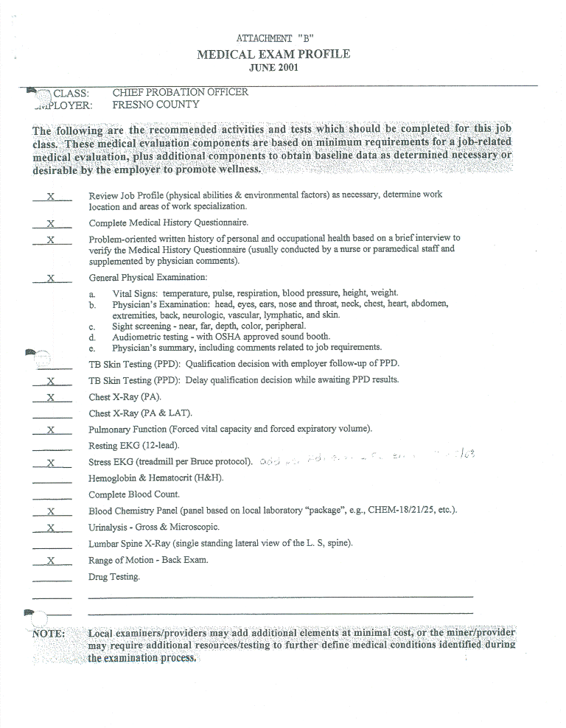
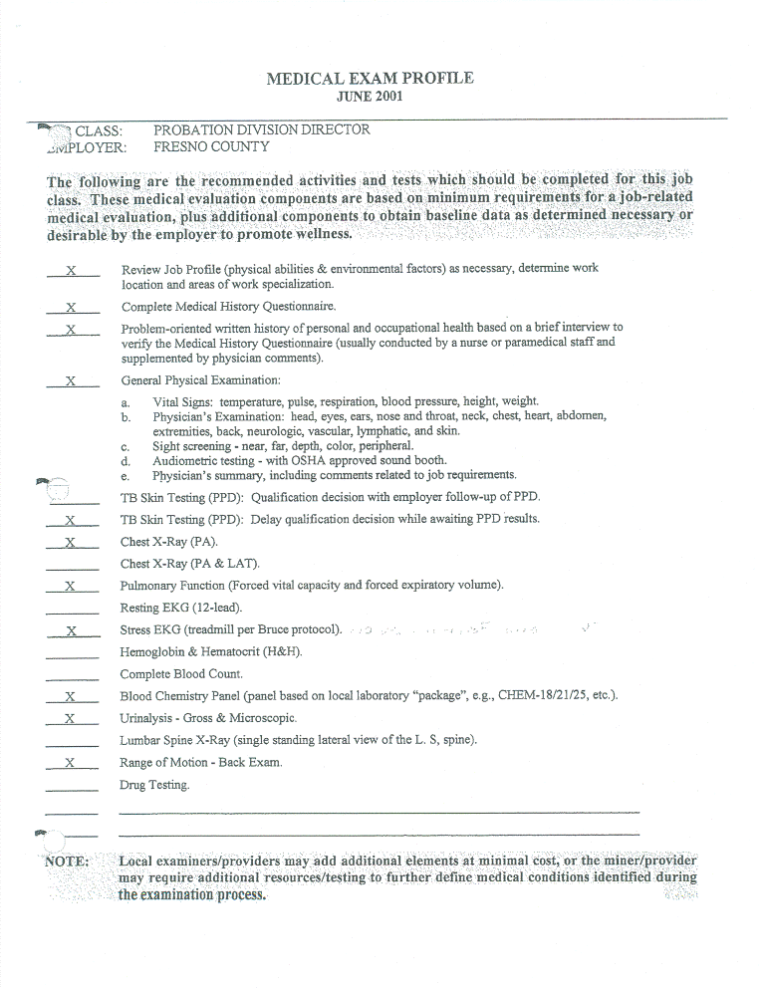
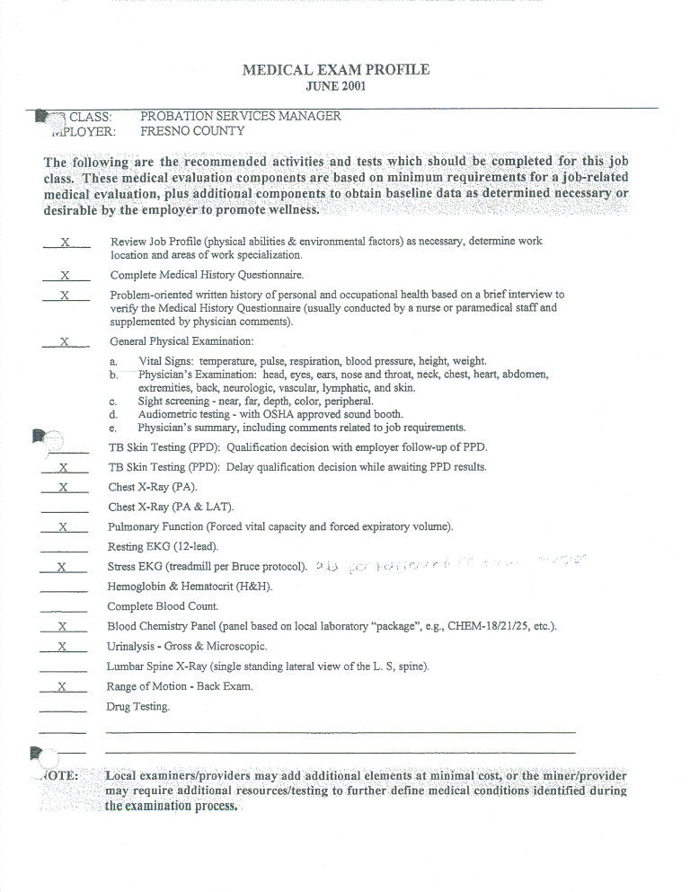
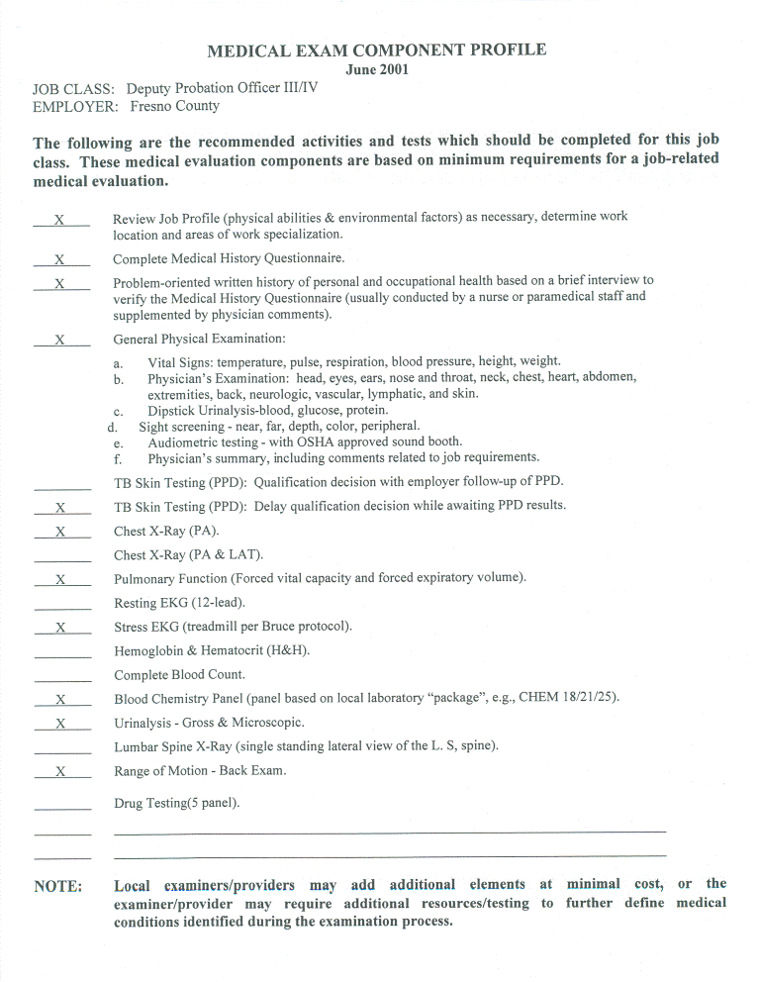
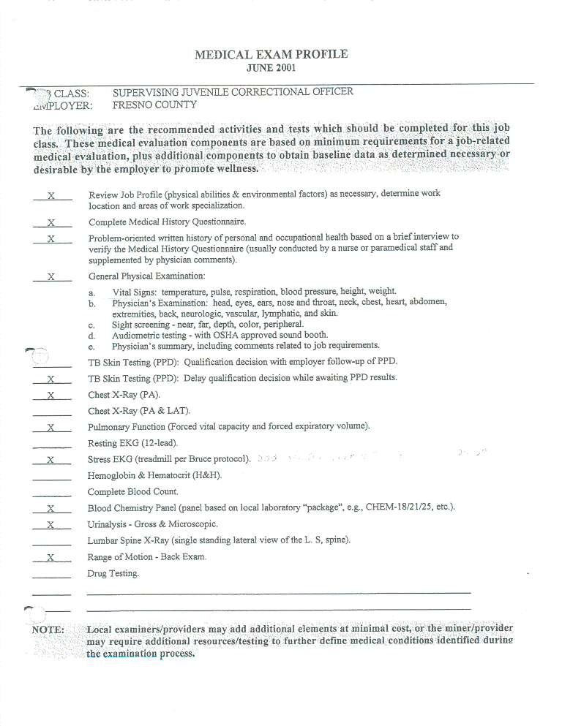
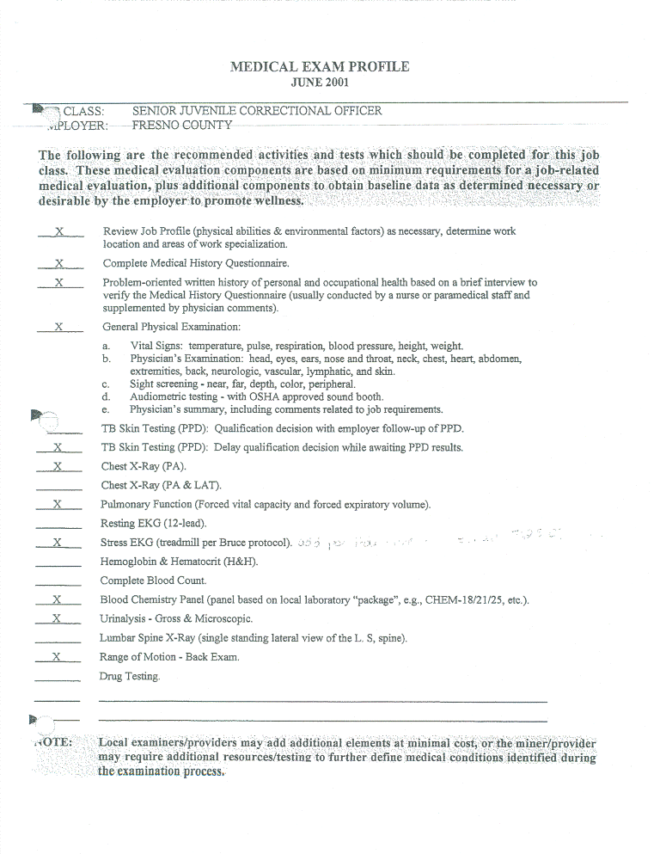
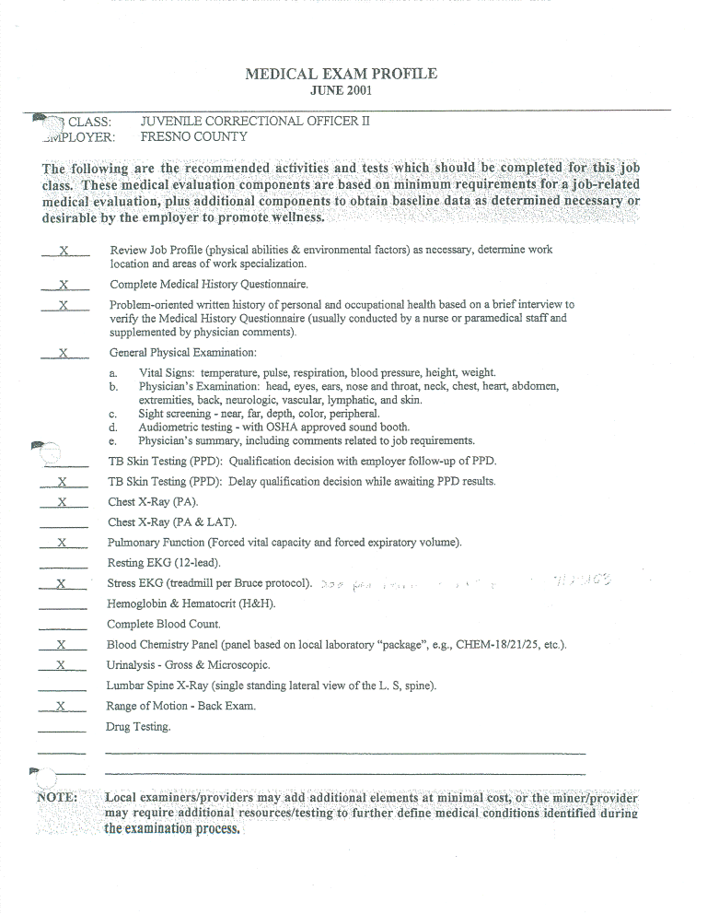
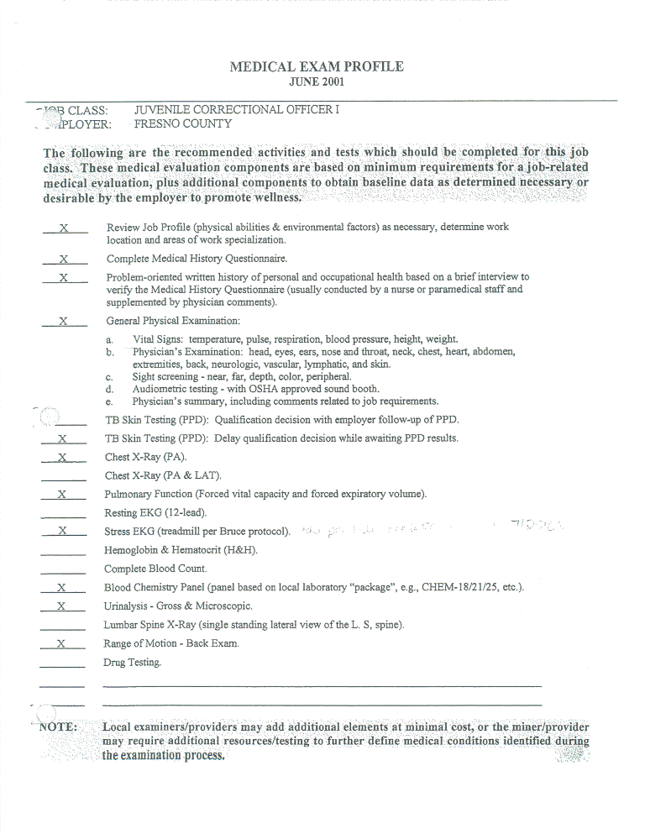
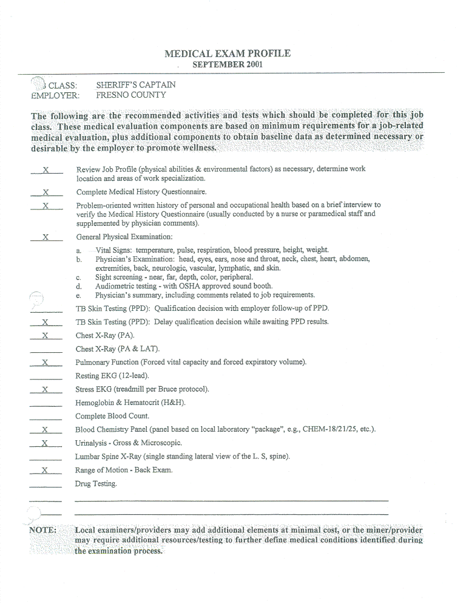
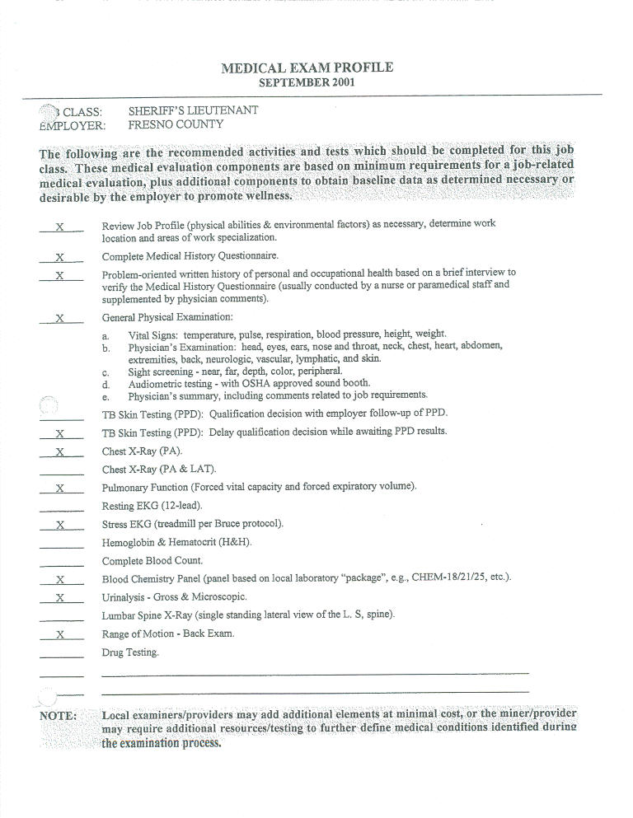
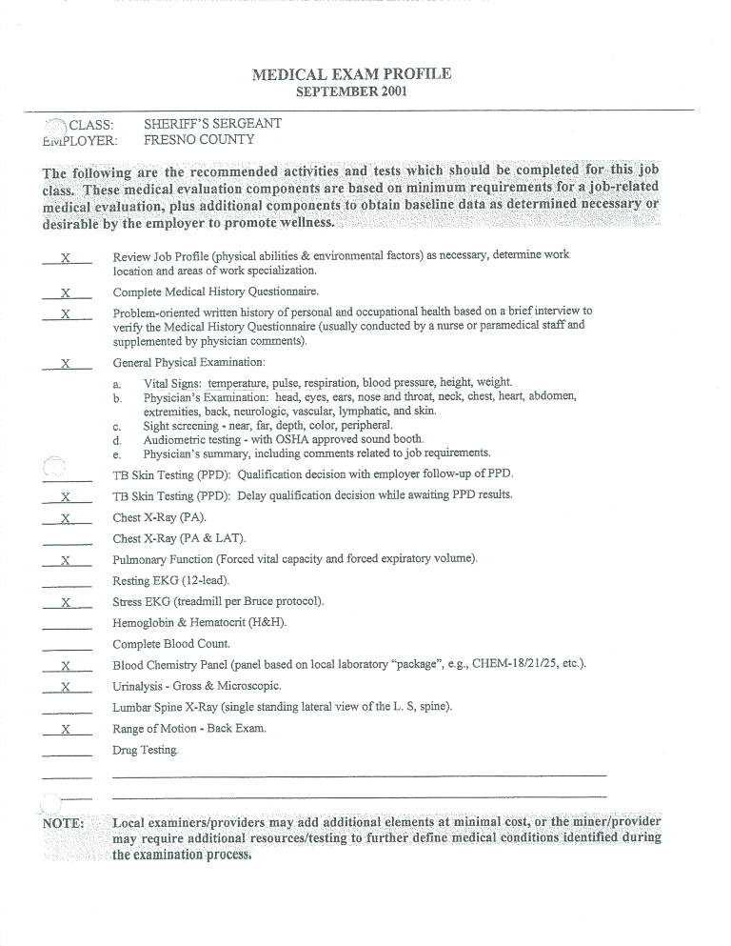
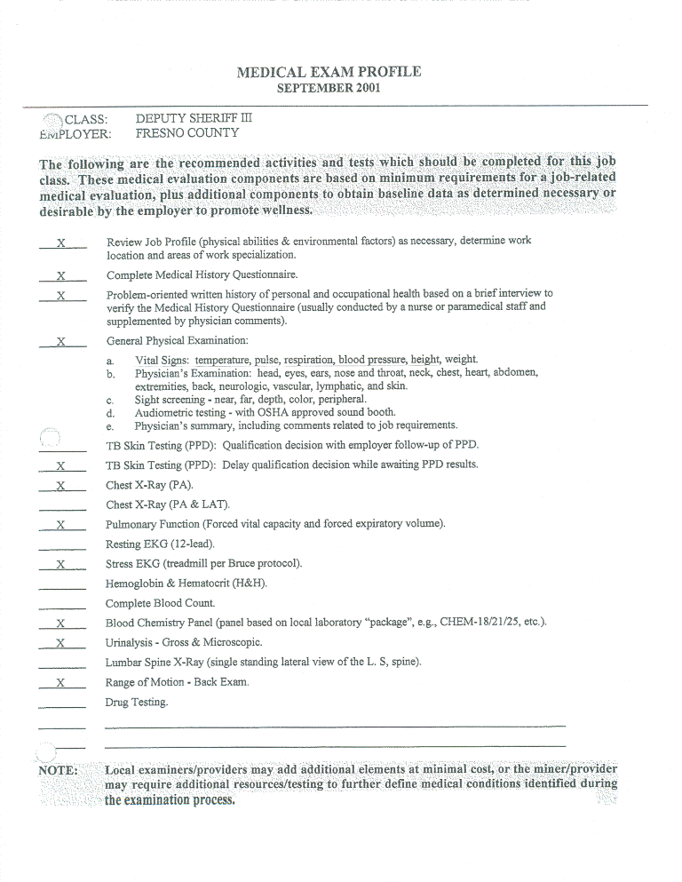
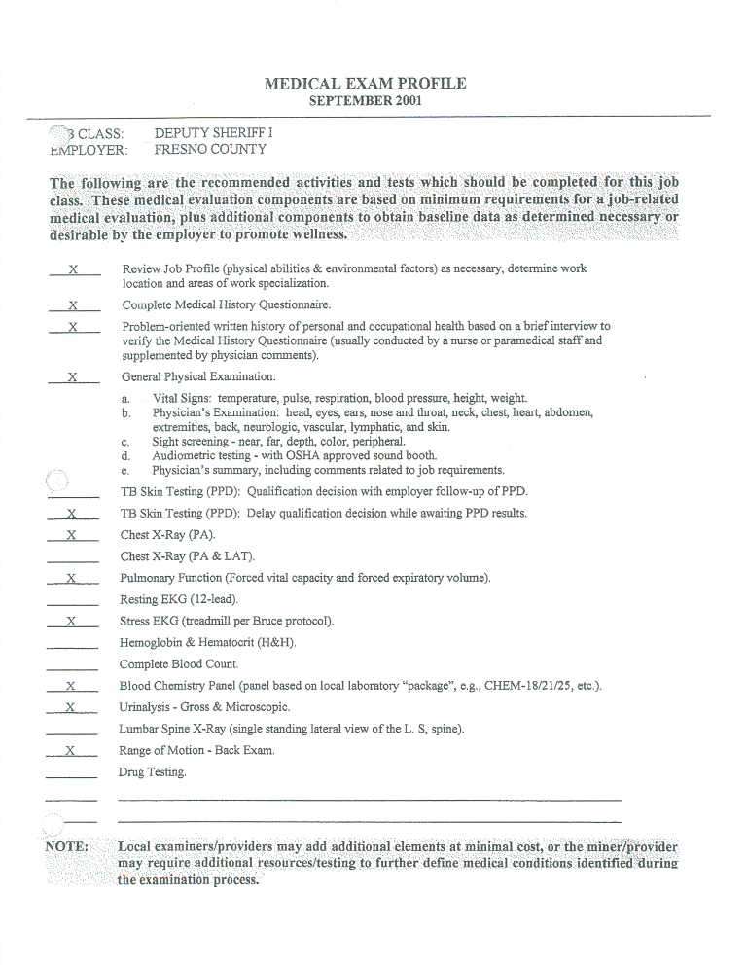
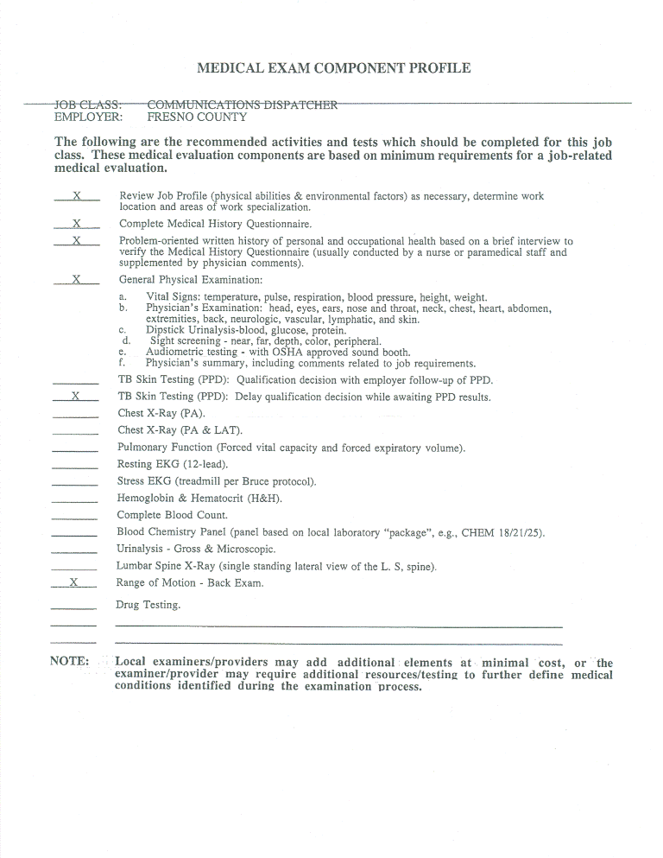
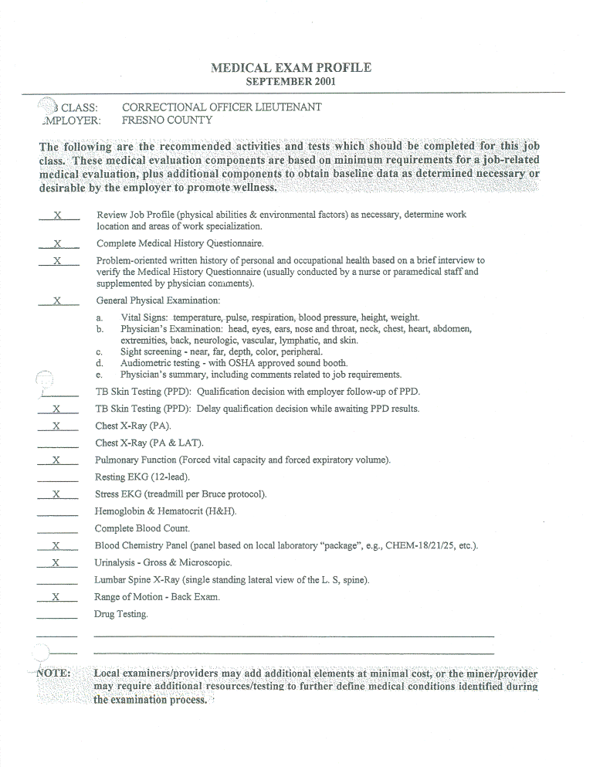
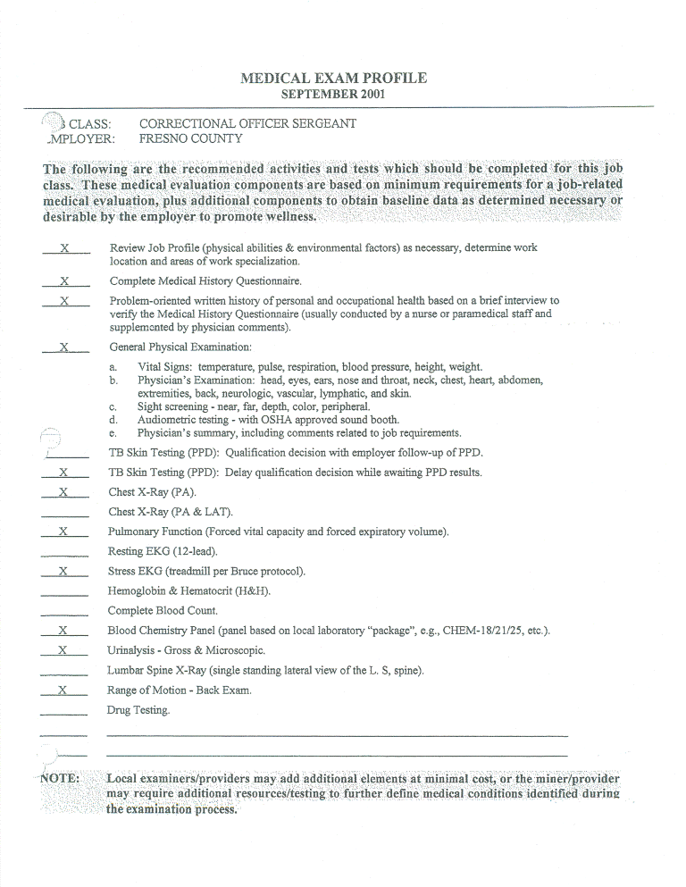
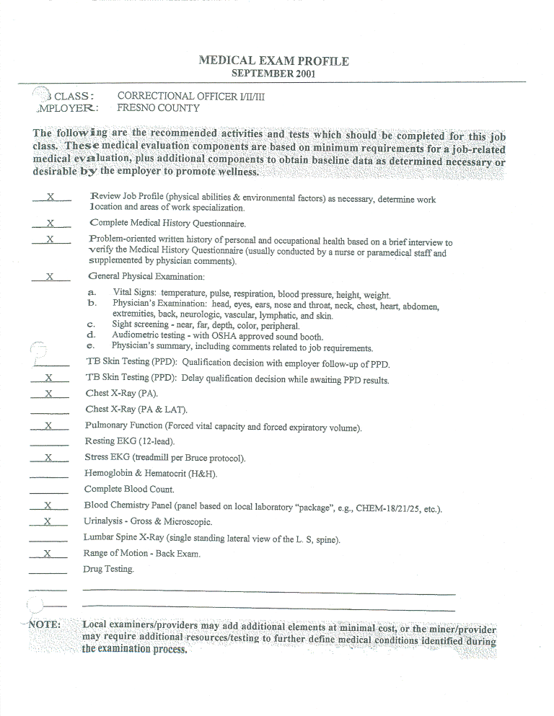
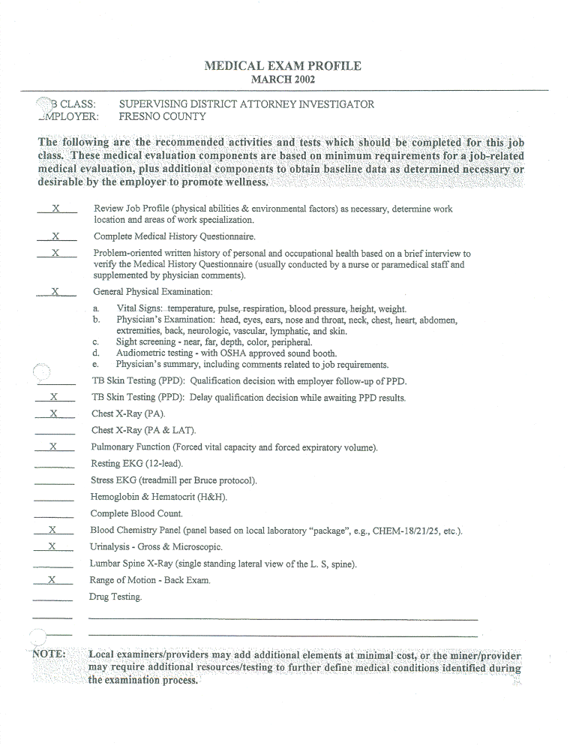
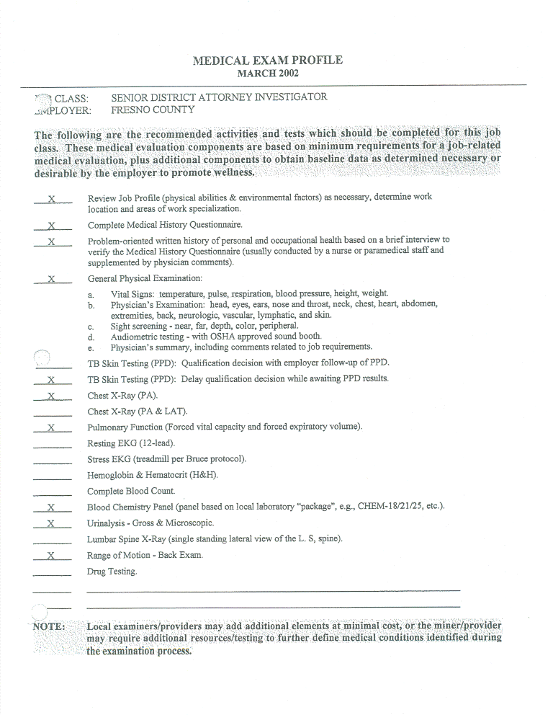
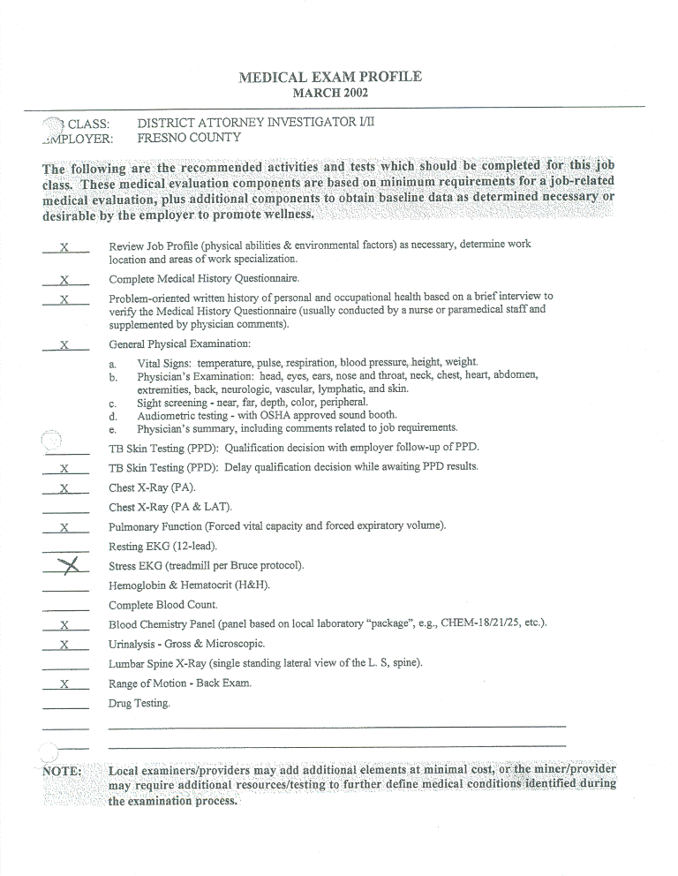
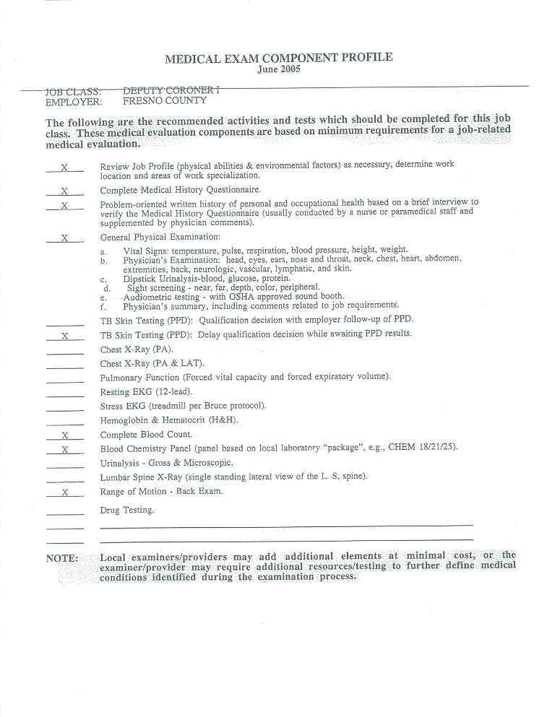
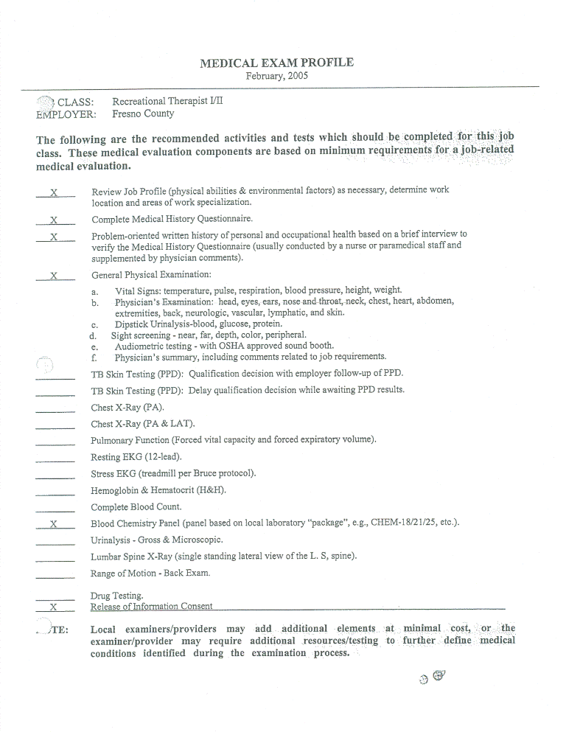
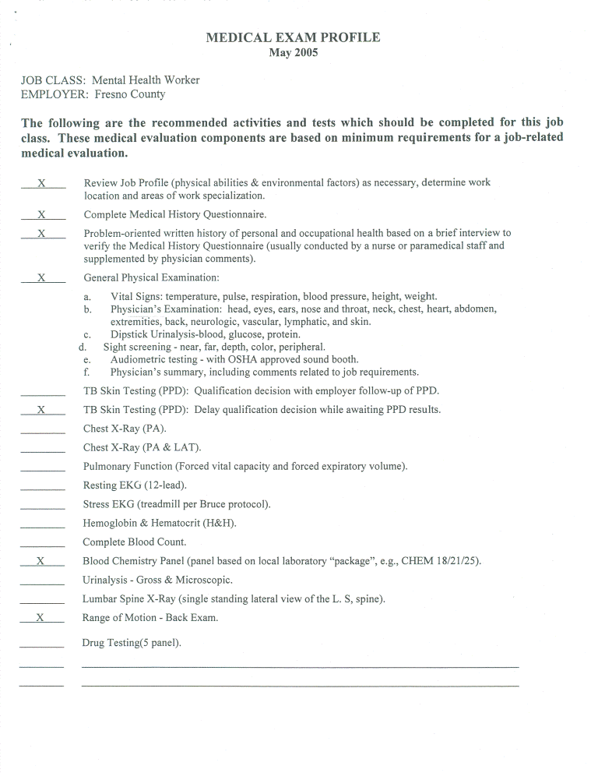

ATTACHMENT “C”
COVER SHEET/INTAKE FORM
This form will act as a cover sheet for electronic delivery of examination materials to the County’s medical standards program administrator. The actual form utilized may be specific to the administrator, but generally includes the following:
- Contractor name
- Examinee name and unique identifier (such as Social Security Number)
- Employer name (County of Fresno)
- Classification for which examination was conducted (e.g. Deputy Sheriff II)
- Date of examination
- Components of examination (what exams/tests were conducted; e.g. Blood Pressure, Range of Motion, EKG, etc.)

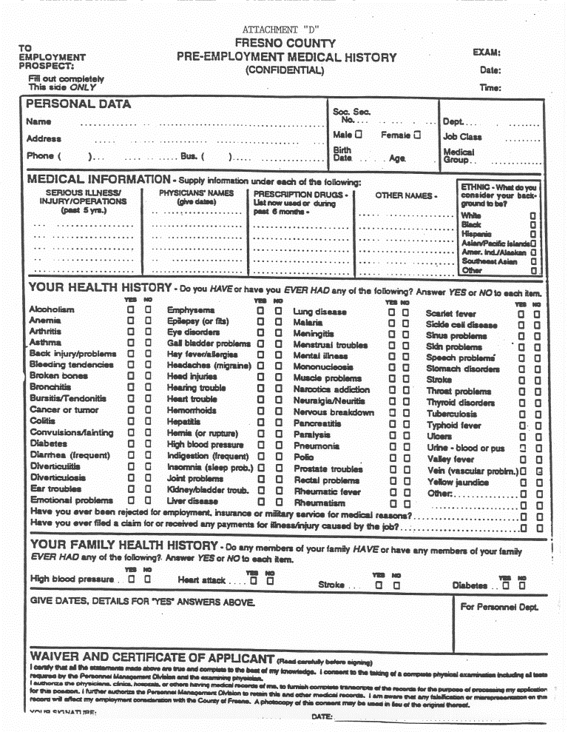
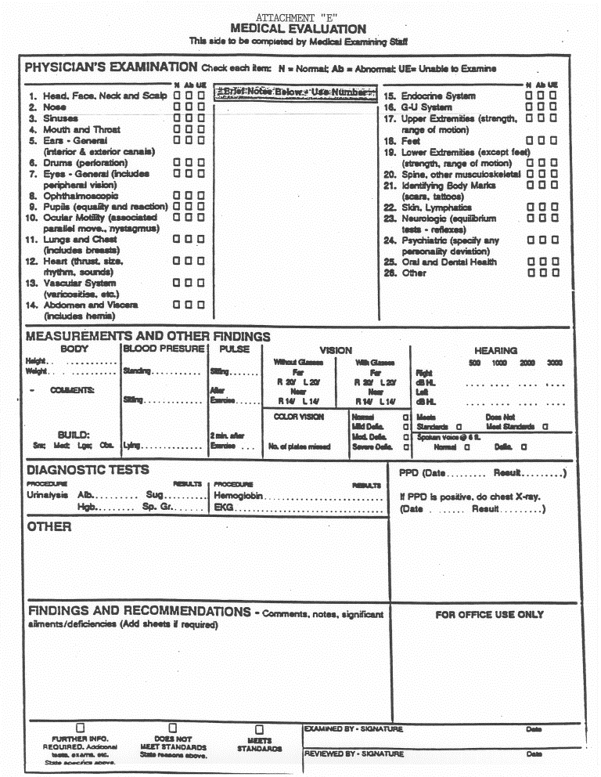
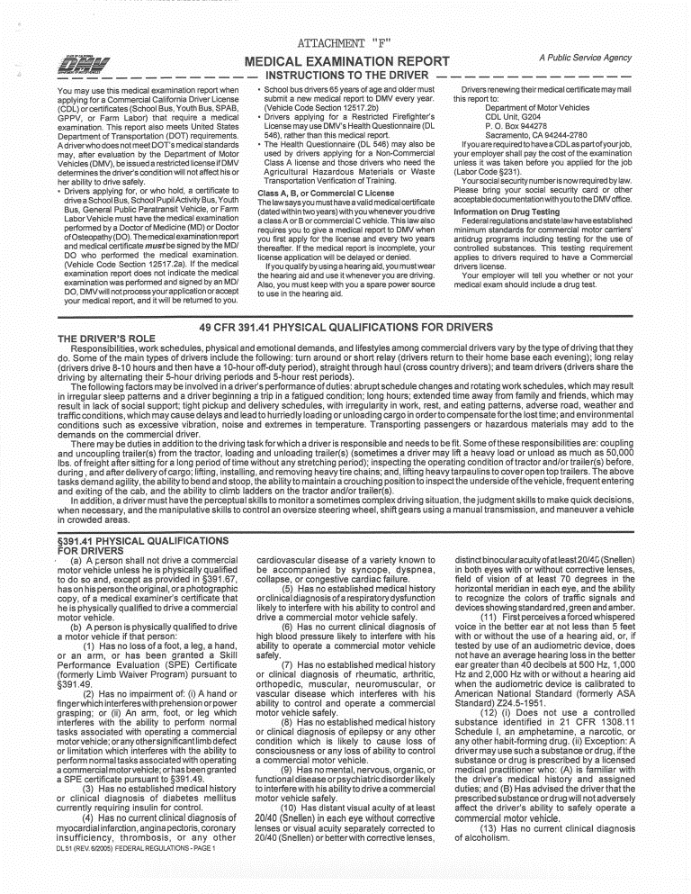
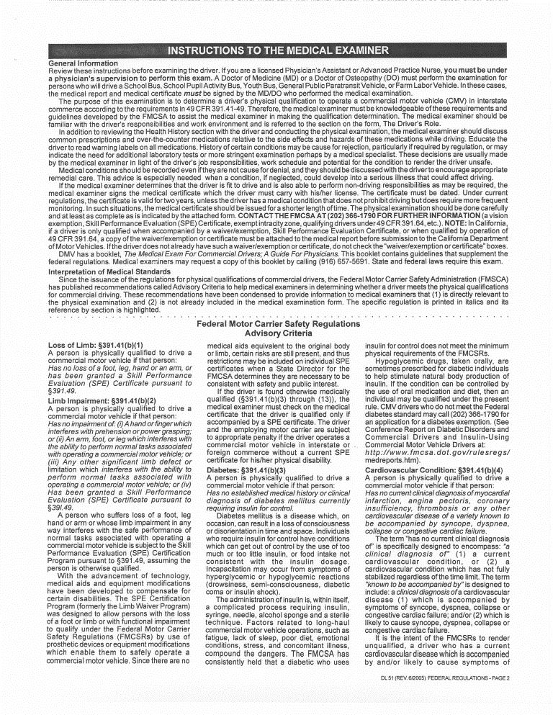
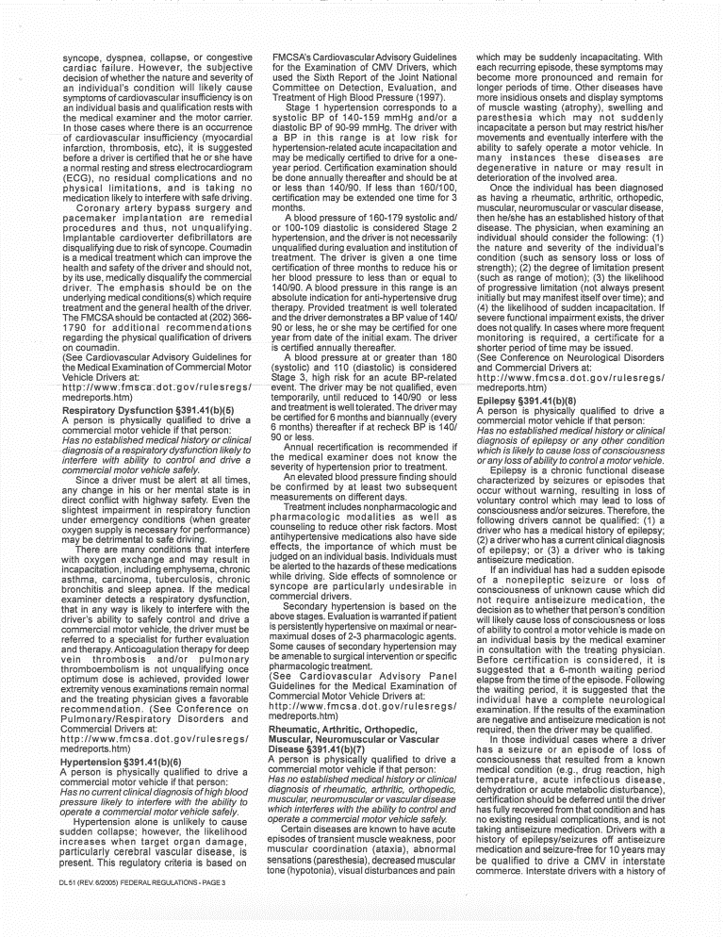
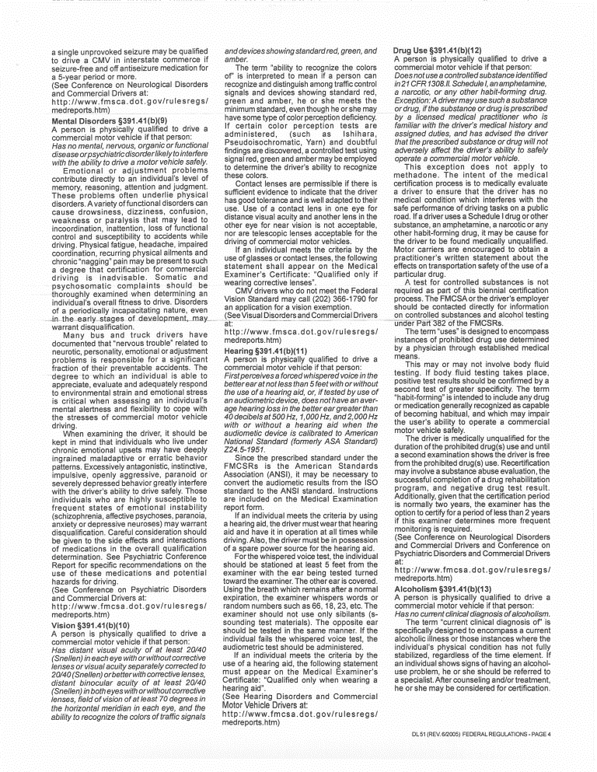
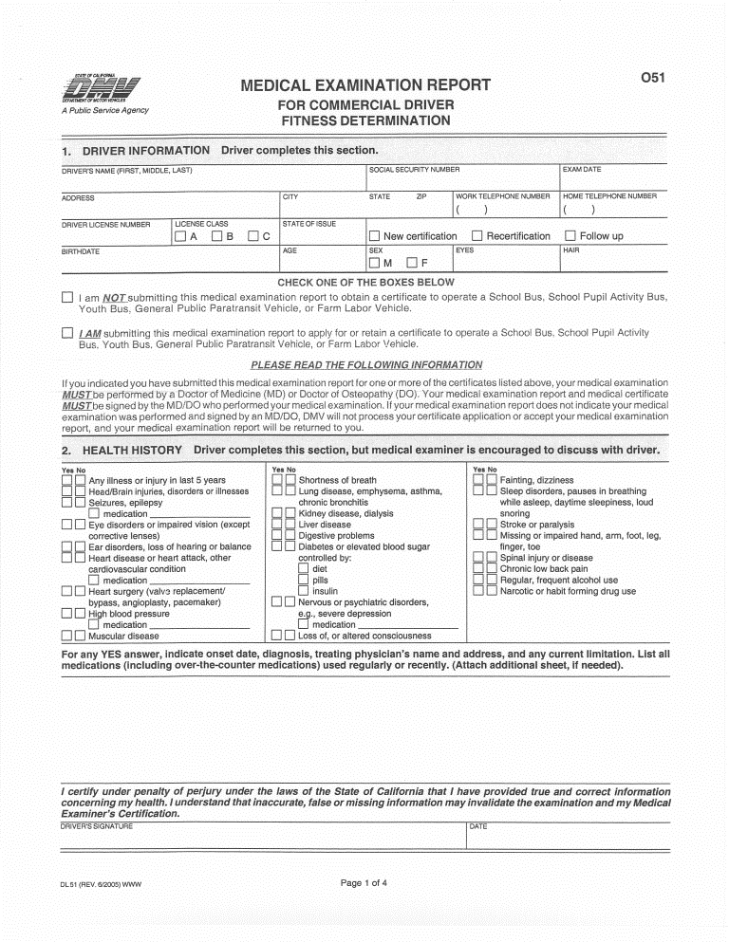
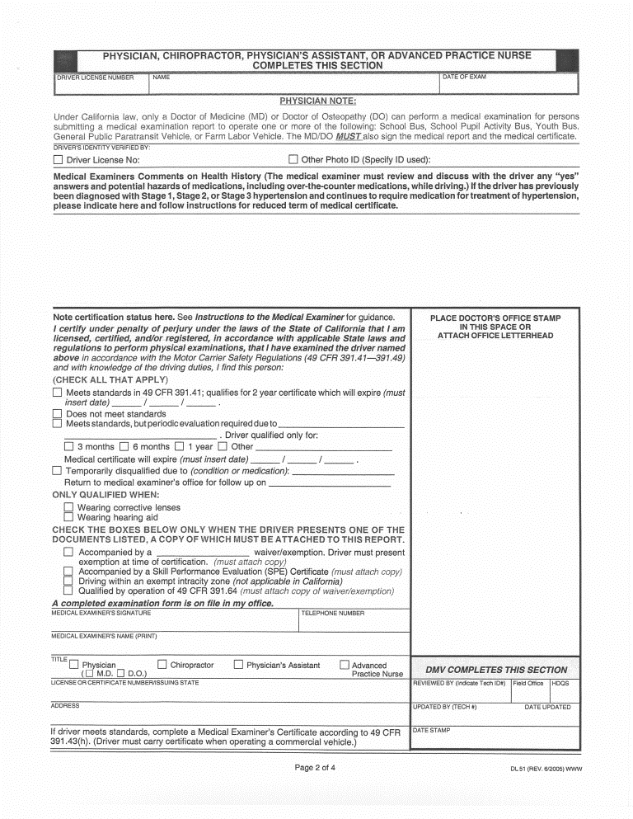
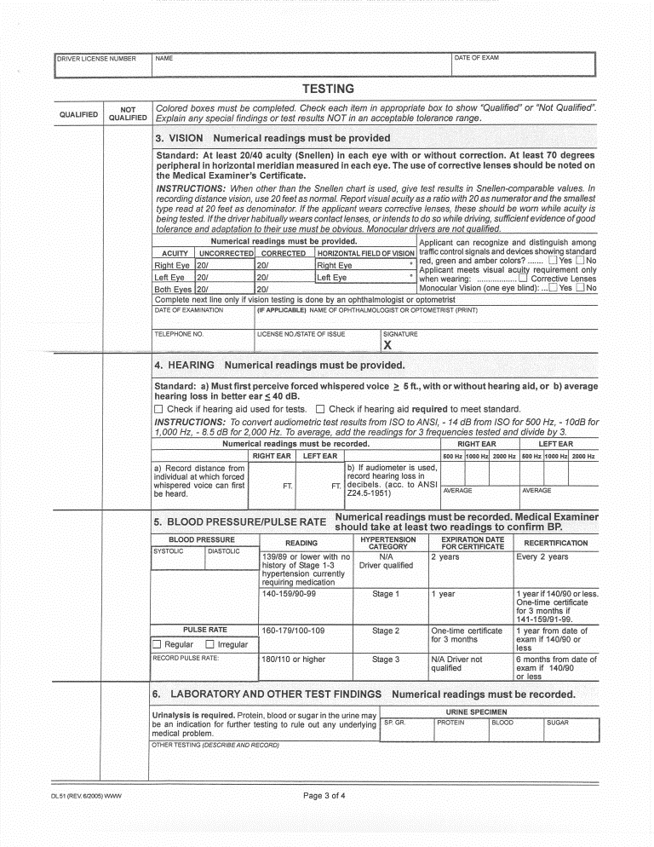
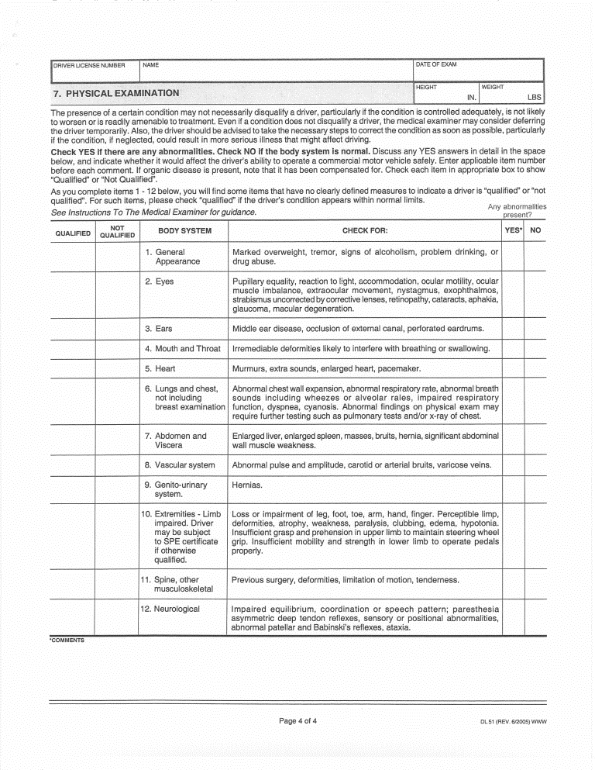

ATTACHMENT "G"
COST OF SERVICE
Cost of medical examinations (Note - pre-employment and periodic exams are the same) performed based on components of specific examination outlines as stated in Attachment "B":
1. | Chief Probation Officer | Cost: | $
2. | Probation Division Director | Cost: | $
3. | Probation Services Manager | Cost: | $
4. | Deputy Probation Officer I/II/III/IV | Cost: | $
5. | Supervising Juvenile Correctional Officer | Cost: | $
6. | Senior Juvenile Correctional Officer | Cost: | $
7. | Juvenile Correctional Officer I/II | Cost: | $
8. | Sheriff's Captain | Cost: | $
9. | Sheriff's Lieutenant | Cost: | $
10. | Sheriff's Sergeant | Cost: | $
11. | Deputy Sheriff I/II/III/IV | Cost: | $
12. | Deputy Sheriff I-Bailiff/l- Trainee/108 Reserve Officer | Cost: | $
13. | Communications Dispatcher | Cost: | $
14. | Correctional Lieutenant | Cost: | $
15. | Correctional Sergeant | Cost: | $
16. | Correctional Officer IV | Cost: | $
17. | Correctional Officer I/II/III | Cost: | $
18. | Supervising District Attorney Investigator | Cost: | $
19. | Senior District Attorney Investigator | Cost: | $
20. | District Attorney Investigator I/II | Cost: | $
21. | Deputy Coroner I/II | Cost: | $
22. | Recreational Therapist I/II | Cost: | $
23. | Mental Health Worker | Cost: | $
24. | DMV Examinations | Cost: | $
25. | Hourly rate for providing testimony on contested  Results of compulsory medical examinations | Cost: | $
 |  | Cost: | $ | /hour
26. | Other optional services: | Cost: | $

