COUNTY OF FRESNO
ADDENDUM NUMBER: ONE (1)
 |  |  | RFP NUMBER: 962-5080
September 21, 2012
 |  |  |  | PURCHASING USE
 |  |  |  |  | ssj | /tmp/in/input.doc
 | IMPORTANT: SUBMIT PROPOSAL IN SEALED PACKAGE WITH PROPOSAL NUMBER, CLOSING DATE AND BUYER’S NAME MARKED CLEARLY ON THE OUTSIDE TO:
COUNTY OF FRESNO, Purchasing
4525 EAST HAMILTON AVENUE, 2nd Floor
FRESNO, CA 93702-4599
Closing date of proposal will be at 2:00 p.m., on October 12, 2012.
PROPOSALS WILL BE CONSIDERED LATE WHEN THE OFFICIAL PURCHASING TIME CLOCK READS 2:00 P.M.
 | Proposals will be opened and publicly read at that time. All proposal information will be available for review after contract award.
Clarification of specifications is to be directed to: Brian D. Tamblin, phone (559) 600-7110,
e-mail CountyPurchasing@co.fresno.ca.us, FAX (559) 600-7126.
NOTE THE Following and Attached ADDITIONS, DELETIONS AND/OR CHANGES TO THE REQUIREMENTS OF REQUEST FOR PROPOSAL NUMBER: 962-5080 AND INCLUDE THEM IN YOUR RESPONSE. PLEASE SIGN AND RETURN THIS ADDENDUM WITH YOUR PROPOSAL.
- This Request for Proposal close date has been extended and will now close on October 12, 2012 at 2:00 P.M.
- Buyer on the RFP has been changed from Gary Cornuelle to Brian D. Tamblin.

ACKNOWLEDGMENT OF ADDENDUM NUMBER ONE (1) TO RFP 962-5080
COMPANY NAME:
(PRINT)
SIGNATURE:
NAME & TITLE:
(PRINT)
Questions and Answers
- What are your current rates?
  - Credit cards are in the process of changing their minimum charge to $3.95; otherwise the charts below are our current rates.
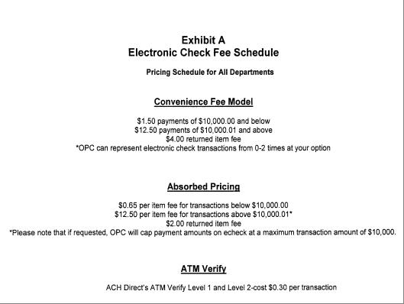
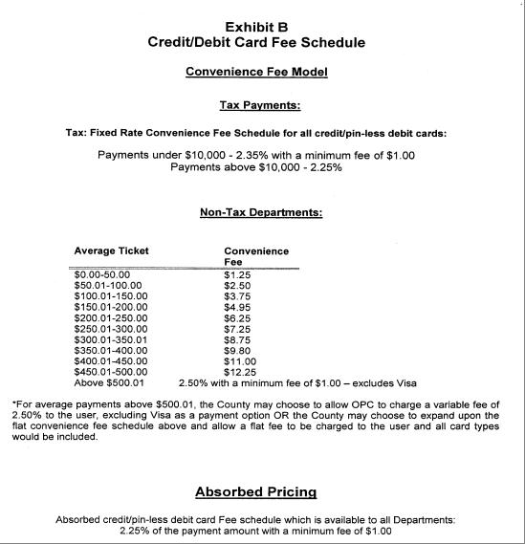
- What is your annual dollar volume?
  - See table below
2010
Total | $10,581,081.51
Internet | $10,581,081.51
IVR | $0.00
Mobile | $0.00
2011
Total | $16,231,775.37
Internet | $13,892,690.25
IVR | $2,339,085.12
Mobile | $0.00
2012
Total | $18,887,080.43
Internet | $16,284,804.98
IVR | $2,598,298.23
Mobile | $3,977.22
- What is your annual transaction volume?
  - See table below
2010
Total | 9,529
Internet | 9,529
IVR | 0
Mobile | 0
2011
Total | 13,174
Internet | 10,491
IVR | 2,683
Mobile | 0
2012
Total | 18,481
Internet | 14,087
IVR | 4,347
Mobile | 47
- Will the County of Fresno absorb the processing fees or will the County charge a convenience for each payment to your tax customers?
  - Currently, the County of Fresno uses both models. We accept some payments where we absorb the charge and others (most notably Tax payments) where we charge the customer. Each payment type for each department would have to be setup individually according to the department’s needs and appropriate statutes.
- For the POS services, can you please detail for us each department by type/name, number of transactions monthly, dollar volume of transactions monthly, and payment type.
  - See table below
 |  | TOTAL | TOTALS
 |  | Sales#
RRD | 621033557 | 1,146 | $176,691.29
PW | 621033565 | 2,669 | $1,321,711.18
HEALTH VS | 621033603 | 472 | $38,090.27
SOCIAL SERVICES | 621033611 | 1,267 | $135,308.81
PROBATION D | 621033646 | 68 | $5,005.00
HEALTH | 621040286 | - | $0.00
COUNTY CLERK | 621040294 | 5,536 | $262,964.54
PROBATION II | 621050699 | 3,291 | $181,598.00
DRUG SUPP. | 621061811 | 3 | $155.00
ENVIR. HEALTH | 8001630527 | 224 | $121,228.65
PW | 8000638281 | 1,298 | $206,773.41
Totals |  | 15,974 | $2,449,526.15
- Does Fresno County have an existing relationship with a Merchant Service Provider (MSP)? If so, who does Fresno County use as the MSP?
  - The County currently utilizes Official Payments as a card and echeck servicer.
- Is Fresno County interested in being the “Merchant of Record”, or would the County be open to the vendor taking over the role and providing a completely outsourced solution?
  - Yes, the County would want to be the “Merchant of Record.
We are not currently looking for a fully outsourced solution.
- Is Fresno County currently PCI compliant.
  - No. The County is looking for a vendor that would relieve the County of the PCI requirements.
- What is the average unit price of Fresno County credit, and debit cards, and echeck transactions?
  - See table below
2010
Total | $1,110.41
Internet | $1,110.41
IVR | 0
Mobile | 0
2011
Total | $1,232.11
Internet | $1,324.25
IVR | $871.82
Mobile | 0
2012
Total | $1,021.97
Internet | $1,156.02
IVR | $597.72
Mobile | $84.62
- ”The system should allow for effective dates (from and to) of fees, and retain fee amounts for those dates historically (for ability to enter potential back-log of old fee rates after change in new fee rates).” From the RFP section titled “Functional Requirements of the project scope:” page 27 of paragraph 10. Can the County please clarify this requirement and include a specific business example in which Fresno County would need to “enter a potential back-log of old fee rates after change in new fee rates.” In this example, does the Fresno County originating application have the ability to allow for “effective dates”?
  - i.e. if a tax payment is made by internet on July 1, could your system charge the convenience fee that was effective on June 30?
- Please describe what the County means by a “Red Flag Policy”?
  - The “Red Flag Policy” refers to the Federal Trade Commissions “Red Flag Rule”, which requires many businesses and organizations to implement a written Identity Theft Prevention Program.
- What type of payments do you expect customers to be charged a fee for?
  - The County collects a multitude of payments, from Property Taxes to business licenses, and victim restitution payments as ordered by the courts.
- Do you expect to have cash payments processed through the same vendor system as web, IVR, and CSR payments?
  - All payments collected by the County are processed by the same Remittance Processing system within the County. We do not expect our echeck/credit card processing servicer to process our cash payments.
- Please describe how you would like to receive/view these totals?
  - Ideally, the County would be able to view these totals via a secured website. In lieu of a website, monthly reports could be accepted.
- Do all payments go to the same County bank account?
  - Yes, all monies collected will be deposited to the same bank account.
- How many other agencies jumped on this RFP the last time it was presented?
  - We do not have access to this information. The joint purchasing agreement is standard language in all County of Fresno RFP’s at this time. Any other agency that chose to utilize one of our RFP’s would have to negotiate their own rates and contract with the winning bidder.
- If bidder cannot process American Express payments, would this be a deal breaker?
  - While this will not be a deal breaker, RFP scoring will included a weighted score for acceptance of each of the major card types, based on percent of historical payment, i.e. if American Express represents 10% of past transactions, acceptance of AE cards would represent 10% of the available score in that category.
- What level of integration is the County looking for?
  - Full integration is preferable, however we recognize the fact that no service provider will be able to fully integrate with some of our proprietary systems, such as the Property Tax system. The ability to create delimited file which can be uploaded to our system would be sufficient integration.
- Who is the County’s current payment IVR provider? And is the County looking to replace them at this time? What languages is the County using in their IVR?
  - Sonant Corporation currently provides the IVR used with the County’s Tax system. Please provide information on IVR solutions if available through your company.
The County is not actively soliciting IVR vendors at this time, but may release an RFP in the future.
Currently the payment IVR has English and Spanish languages available.
- Does the County utilize a payment kiosk?
  - Not at this time. We have replaced our previous kiosk with an internet capable workstation available to the public, due to the maintenance costs associated with the kiosk.
- Is the 90/90 day time frame in the RFP set in stone?
  - The actual time table for implementation will be negotiated during contract negotiations. The County’s goal is to have minimal down time during the transition.
Please be aware, there may be times during the year in which the County will not allow the transition to take place. Such times will include the periods from mid-November through the end of December and mid-March through the end of April.
- Does the County accept over the counter credit card payments?
  - At this time the County does not accept any credit card payment over the counter due to Visa restrictions which may have recently changed. The County is in the process of reviewing the new rules regarding over the counter payments. Please visit this link if you have questions about Visa’s operating regulations:
http://usa.visa.com/merchants/operations/op_regulations.html
- According to page 23 of the RFP, vendors are to provide 3 years of audited financial statements. Due to the size, is it permissible to submit this information on a single CD-ROM? Also, our 2011 annual report includes information for 3 years. Is it permissible to submit the 2011 report, or do you require 2009, 2010, and 2011 reports?
  - As stated within the RFP these will be a requirement if requested. Do not provide with your proposal.
If they are requested, they will need to be as was required in the initial response. (One (1) original, eight (8) copies and two (2) CDs)
- Is the expectation to keep the convenience fees and e-check fees at the same level as detailed on the Tax Collector’s webpage?
  - No. The convenience fees will be a selection criterion, but not the sole criteria.
- Are you asking for anything in this RFP that you are not currently getting from the current vendor?
  - No. We are offering bidders the opportunity to provide examples of service enhancements however.
- What are the names of the 27 County departments referenced in the Scope of Work?
  - See below:
    - Agriculture Department
    - Assessor / Recorder
    - Auditor-Controller/Treasurer-Tax Collector
    - Behavioral Health / Public Guardian
    - Board of Supervisors
    - Child Support Services
    - Cooperative Extension
    - Coroner / Public Administrator
    - County Administrative Office / Clerk to the Board
    - County Clerk / Registrar of Voters
    - County Counsel
    - District Attorney
    - Internal Services Department / General Services
    - Library
    - Personnel Services
    - Probation
    - Public Defender
    - Public Health
    - Public Works & Planning
    - Retirement
    - Sheriff
    - Social Services?
- Do all locations have internet enabled browsers/PCs to process transactions?
  - The County provides internet access at all its office locations.
- The RFP appears to indicate a desire to host the service internally based on the Hardware/Database sections in the Scope of work. Is the intent to host your own gateways to a payment processor or look for full service SaaS based payment solutions to address the needs of the 27 departs online and through IVR? POS is understood.
  - The County has NO desire to host their payment gateway. We are looking for a vendor that can provide the full service payment processing.
- This RFP appears to be very similar to the one issued in 2008 for these services. Are there specific issues that are driving the need to put this up for bid or is this required every specific time period for the county to issue an RFP? If there are specific issues that need to be addressed/improved, can you provide any details?
  - The County has a standing policy to go out for RFP at the end of any service contract to view available options/changes in availability for the service.

