COUNTY OF FRESNO
Request for QUOTATION
 |  | NUMBER: 962-4789
January 20, 2010
ORG/Requisition: 8935, 31114000, 31112100/ 1321001068, 3111006110, 3111006111 |  |  |  |  |  |  | PURCHASING USE |  |  |  | /tmp/in/input.doc
 |  |  |  |  |  |  | JEB
IMPORTANT: SUBMIT QUOTATION IN SEALED PACKAGE WITH QUOTATION NUMBER, CLOSING DATE AND BUYER’S NAME MARKED CLEARLY ON THE OUTSIDE TO:
COUNTY OF FRESNO, Purchasing
4525 EAST HAMILTON AVENUE
FRESNO, CA 93702-4599
Closing date of bid will be at 2:00 p.m., on February 18, 2010.
QUOTATIONS WILL BE CONSIDERED LATE WHEN THE OFFICIAL PURCHASING TIME CLOCK READS 2:00 P.M.
Quotations will be opened and publicly read at that time. All quotation information will be available for review after contract award.
Clarification of specifications is to be directed to: Brian D. Tamblin, phone (559) 456-7110, e-mail CountyPurchasing@co.fresno.ca.us FAX (559) 456-7831.
GENERAL CONDITIONS: See “County Of Fresno Purchasing Standard Instructions And Conditions For Request For Proposals (RFP’S) and Requests for Quotations (RFQ’S)” attached. Check County of Fresno Purchasing’s Open Solicitations website at http://www2.co.fresno.ca.us/0440/Bidshome2.asp for RFQ/RFP documents and changes.
BIDDER TO COMPLETE
UNDERSIGNED AGREES TO FURNISH THE COMMODITY OR SERVICE STIPULATED IN THE ATTACHED QUOTATION SCHEDULE AT THE PRICES AND TERMS STATED, SUBJECT TO THE “COUNTY OF FRESNO PURCHASING STANDARD INSTRUCTIONS AND CONDITIONS FOR REQUEST FOR QUOTATIONS (RFP’S) AND REQUESTS FOR QUOTATIONS (RFQ’S)”ATTACHED.
Except as noted on individual items, the following will apply to all items in the Quotation Schedule.
- Complete delivery will be made within |  |  |  |  |  |  |  | calendar days after receipt of Order.
- A cash discount of |  |  |  |  | % |  |  |  |  | days will apply.
Company
Address
City |  |  |  |  |  |  |  |  |  |  |  |  | State |  | Zip Code
( ) |  |  |  | ( )
Telephone Number |  |  |  | Facsimile Number |  |  |  |  |  |  |  |  | E-mail Address
Signed By
Print Name |  |  |  |  |  |  |  |  | Title

COUNTY OF FRESNO PURCHASING
STANDARD INSTRUCTIONS AND CONDITIONS FOR
REQUESTS FOR PROPOSALS (RFP'S) AND REQUESTS FOR QUOTATIONS (RFQ'S)
Note: the reference to “bids” in the following paragraphs applies to RFP's and RFQ's

GENERAL CONDITIONS
By submitting a bid the bidder agrees to the following conditions. These conditions will apply to all subsequent purchases based on this bid.

- BID PREPARATION:
  - All prices and notations must be typed or written in ink. No erasures permitted. Errors may be crossed out, initialed and corrections printed in ink by person signing bid.
  - Brand Names: Brand names and numbers when given are for reference. Equal items will be considered, provided the offer clearly describes the article and how it differs from that specified. In the absence of such information it shall be understood the offering is exactly as specified.
  - State brand or make of each item. If bidding on other than specified, state make, model and brand being bid and attach supporting literature/specifications to the bid.
  - Bid on each item separately. Prices should be stated in units specified herein. All applicable charges must be quoted; charges on invoice not quoted herein will be disallowed.
  - Time of delivery is a part of the consideration and must be stated in definite terms and must be adhered to. F.O.B. Point shall be destination or freight charges must be stated.
  - All bids must be dated and signed with the firm’s name and by an authorized officer or employee.
  - Unless otherwise noted, prices shall be firm for 180 days after closing date of bid.
- SUBMITTING BIDS:
  - Each bid must be submitted on forms provided in a sealed envelope/package with bid number and closing date and time on the outside of the envelope/package.
  - Interpretation: Should any discrepancies or omissions be found in the bid specifications or doubt as to their meaning, the bidder shall notify the Buyer in writing at once. The County shall not be held responsible for verbal interpretations. Questions regarding the bid must be received by Purchasing at least 5 working days before bid opening. All addenda issued shall be in writing, duly issued by Purchasing and incorporated into the contract.
  - ISSUING AGENT/AUTHORIZED CONTACT: This RFQ/RFP has been issued by County of Fresno Purchasing. Purchasing shall be the vendor’s sole point of contact with regard to the RFQ/RFP, its content, and all issues concerning it.
All communication regarding this RFQ/RFP shall be directed to an authorized representative of County Purchasing. The specific buyer managing this RFQ is identified on the cover page, along with his or her telephone number, and he or she should be the primary point of contact for discussions or information pertaining to the RFQ/RFP. Contact with any other County representative, including elected officials, for the purpose of discussing this RFQ/RFP, its content, or any other issue concerning it, is prohibited unless authorized by Purchasing. Violation of this clause, by the vendor having unauthorized contact (verbally or in writing) with such other County representatives, may constitute grounds for rejection by Purchasing of the vendor’s quotation.
The above stated restriction on vendor contact with County representatives shall apply until the County has awarded a purchase order or contract to a vendor or vendors, except as follows. First, in the event that a vendor initiates a formal protest against the RFQ/RFP, such vendor may contact the appropriate individual, or individuals who are managing that protest as outlined in the County’s established protest procedures. All such contact must be in accordance with the sequence set forth under the protest procedures. Second, in the event a public hearing is scheduled before the Board of Supervisors to hear testimony prior to its approval of a purchase order or contract, any vendor may address the Board.
  - Bids received after the closing time will NOT be considered.
  - Bidders are to bid what is specified or requested first. If unable to or unwilling to, bidder may bid alternative or option, indicating all advantages, disadvantages and their associated cost.
  - Public Contract Code Section 7028.15
Where the State of California requires a Contractor’s license, it is a misdemeanor for any person to submit a bid unless specifically exempted.
- FAILURE TO BID:
  - If not bidding, return bid sheet and state reason for no bid or your name may be removed from mailing list.
- TAXES, CHARGES AND EXTRAS:
  - County of Fresno is subject to California sales and/or use tax (8.975%). Please indicate as a separate line item if applicable.
  - DO NOT include Federal Excise Tax. County is exempt under Registration No. 94-73-03401-K.
  - County is exempt from Federal Transportation Tax. Exemption certificate is not required where shipping papers show consignee as County of Fresno.
  - Charges for transportation, containers, packing, etc. will not be paid unless specified in bid.
- W-9 – REQUEST FOR TAXPAYER IDENTIFICATION NUMBER AND CERTIFICATION:
Upon award of bid, the vendor shall submit to County Purchasing, a completed W-9 - Request for Taxpayer Identification Number and Certification if not already a current vendor with The County of Fresno. This form is available from the IRS to complete on line at http://www.irs.gov/pub/irs-pdf/fw9.pdf.
- AWARDS:
  - Subject to the local preference provisions referenced in Paragraph 6 below and more thoroughly set forth in the General Requirements section of this RFQ/RFP, award(s) will be made to the most responsive responsible bidder. The evaluation will include such things as life-cycle cost, availability, delivery costs and whose product and/or service is deemed to be in the best interest of the County. The County shall be the sole judge in making such determination.
  - Unless bidder gives notice of all-or-none award in bid, County may accept any item, group of items or on the basis of total bid.
  - The County reserves the right to reject any and all bids and to waive informalities or irregularities in bids.
  - After award, all bids shall be open to public inspection. The County assumes no responsibility for the confidentiality of information offered in a bid.
- LOCAL VENDORS
  - Local Vendor Preference (applicable to RFQ Process only)
The following provisions are applicable only to the County’s acquisition of materials, equipment or supplies through the RFQ process when the funding source does not require an exemption to the Local Vendor Preference.
THE PROVISIONS OF THIS PARAGRAPH ARE APPLICABLE, NOTWITHSTANDING ANY OTHER PROVISIONS OF THIS RFQ TO THE CONTRARY
If the apparent low bidder is not a local vendor, any local vendor who submitted a bid which was within five percent (5%) of the lowest responsive bid as determined by the purchasing agent shall have the option of submitting a new bid within forty-eight hours (not including weekends and holidays) of County’s delivery of notification. Such new bids must be in an amount less than or equal to the lowest responsive bid as determined by the purchasing agent. If the purchasing agent receives any new bids from local vendors who have the option of submitting new bids within said forty-eight hour period, it shall award the contract to the local vendor submitting the lowest responsible bid. If no new bids are received, the contract shall be awarded to the original low bidder as announced by the purchasing agent.
  - Local Vendor Defined
“Local Vendor” shall mean any business which:
- Has its headquarters, distribution point or locally-owned franchise located in or having a street address within the County for at least six (6) months immediately prior to the issuance of the request for competitive bids by the purchasing agent; and
- Holds any required business license by a jurisdiction located in Fresno County; and
- Employs at least one (1) full-time or two (2) part-time employees whose primary residence is located within Fresno County, or if the business has no employees, shall be at least fifty percent (50%) owned by one or more persons whose primary residence(s) is located within Fresno County.
- TIE BIDS:
All other factors being equal, the contract shall be awarded to the Fresno County vendor or, if neither or both are Fresno County vendors, it may be awarded by the flip of a coin in the presence of witnesses or the entire bid may be rejected and re-bid. If the General Requirements of this RFQ state that they are applicable, the provisions of the Fresno County Local Vendor Preference shall take priority over this paragraph.
- PATENT INDEMNITY:
The vendor shall hold the County, its officers, agents and employees, harmless from liability of any nature or kind, including costs and expenses, for infringement or use of any copyrighted or uncopyrighted composition, secret process, patented or unpatented invention, article or appliance furnished or used in connection with this bid.
- SAMPLES:
Samples, when required, must be furnished and delivered free and, if not destroyed by tests, will upon written request (within 30 days of bid closing date) be returned at the bidder's expense. In the absence of such notification, County shall have the right to dispose of the samples in whatever manner it deems appropriate.
- RIGHTS AND REMEDIES OF COUNTY FOR DEFAULT:
  - In case of default by vendor, the County may procure the articles or service from another source and may recover the cost difference and related expenses occasioned thereby from any unpaid balance due the vendor or by proceeding against performance bond of the vendor, if any, or by suit against the vendor. The prices paid by the County shall be considered the prevailing market price at the time such purchase is made.
  - Articles or services, which upon delivery inspection do not meet specifications, will be rejected and the vendor will be considered in default. Vendor shall reimburse County for expenses related to delivery of non-specified goods or services.
  - Regardless of F.O.B. point, vendor agrees to bear all risks of loss, injury or destruction to goods and materials ordered herein which occur prior to delivery and such loss, injury or destruction shall not release vendor from any obligation hereunder.
- DISCOUNTS:
Terms of less than 15 days for cash payment will be considered as net in evaluating this bid. A discount for payment within fifteen (15) days or more will be considered in determining the award of bid. Discount period will commence either the later of delivery or receipt of invoice by the County. Standard terms are Net Forty-five (45) days.
- SPECIAL CONDITIONS IN BID SCHEDULE SUPERSEDE GENERAL CONDITIONS.
The “General Conditions” provisions of this RFP/RFQ shall be superseded if in conflict with any other section of this bid, to the extent of any such conflict.
- SPECIAL REQUIREMENT:
With the invoice or within twenty-five (25) days of delivery, the seller must provide to the County a Material Safety Data Sheet for each product, which contains any substance on “The List of 800 Hazardous Substances”, published by the State Director of Industrial Relations. (See Hazardous Substances Information and Training Act. California State Labor Code Sections 6360 through 6399.7.)
- RECYCLED PRODUCTS/MATERIALS:
Vendors are encouraged to provide and quote (with documentation) recycled or recyclable products/materials which meet stated specifications.
- YEAR COMPLIANCE WARRANTY
Vendor warrants that any product furnished pursuant to this Agreement/order shall support a four-digit year format and be able to accurately process date and time data from, into and between the twentieth and twenty-first centuries, as well as leap year calculations. "Product" shall include, without limitation, any piece or component of equipment, hardware, firmware, middleware, custom or commercial software, or internal components or subroutines therein. This warranty shall survive termination or expiration of this Agreement.
In the event of any decrease in product functionality or accuracy related to time and/or date data related codes and/or internal subroutines that impede the product from operating correctly using dates beyond December 31, 1999, vendor shall restore or repair the product to the same level of functionality as warranted herein, so as to minimize interruption to County's ongoing business process, time being of the essence. In the event that such warranty compliance requires the acquisition of additional programs, the expense for any such associated or additional acquisitions, which may be required, including, without limitation, data conversion tools, shall be borne exclusively by vendor. Nothing in this warranty shall be construed to limit any rights or remedies the County may otherwise have under this Agreement with respect to defects other than year performance.
- PARTICIPATION:
Bidder may agree to extend the terms of the resulting contract to other political subdivision, municipalities and tax-supported agencies.
Such participating Governmental bodies shall make purchases in their own name, make payment directly to bidder, and be liable directly to the bidder, holding the County of Fresno harmless.
- CONFIDENTIALITY:
All services performed by vendor shall be in strict conformance with all applicable Federal, State of California and/or local laws and regulations relating to confidentiality, including but not limited to, California Civil Code, California Welfare and Institutions Code, Health and Safety Code, California Code of Regulations, Code of Federal Regulations.
Vendor shall submit to County’s monitoring of said compliance.
Vendor may be a business associate of County, as that term is defined in the “Privacy Rule” enacted by the Health Insurance Portability and Accountability Act of 1996 (HIPAA). As a HIPAA Business Associate, vendor may use or disclose protected health information (“PHI”) to perform functions, activities or services for or on behalf of County as specified by the County, provided that such use or disclosure shall not violate HIPAA and its implementing regulations. The uses and disclosures if PHI may not be more expansive than those applicable to County, as the “Covered Entity” under HIPAA’S Privacy Rule, except as authorized for management, administrative or legal responsibilities of the Business Associate.
Vendor shall not use or further disclose PHI other than as permitted or required by the County, or as required by law without written notice to the County.
Vendor shall ensure that any agent, including any subcontractor, to which vendor provides PHI received from, or created or received by the vendor on behalf of County, shall comply with the same restrictions and conditions with respect to such information.
- APPEALS
Appeals must be submitted in writing within seven (7) working days after notification of proposed recommendations. Appeals should be submitted to County of Fresno Purchasing, 4525 E. Hamilton Avenue, Fresno, California 93702-4599. Appeals should address only areas regarding RFP contradictions, procurement errors, quotation rating discrepancies, legality of procurement context, conflict of interest, and inappropriate or unfair competitive procurement grievance regarding the RFP process.
Purchasing will provide a written response to the complainant within seven (7) working days unless the complainant is notified more time is required.
If the protesting bidder is not satisfied with the decision of Purchasing, he/she shall have the right to appeal to the Purchasing Agent/CAO within seven (7) business days after Purchasing’s notification; except if, notified to appeal directly to the Board of Supervisors at the scheduled date and time.
If the protesting bidder is not satisfied with Purchasing Agent/CAO’s decision, the final appeal is with the Board of Supervisors.
- OBLIGATIONS OF CONTRACTOR:
  - CONTRACTOR shall perform as required by the ensuing contract. CONTRACTOR also warrants on behalf of itself and all subcontractors engaged for the performance of the ensuing contract that only persons authorized to work in the United States pursuant to the Immigration Reform and Control Act of 1986 and other applicable laws shall be employed in the performance of the work hereunder.
  - CONTRACTOR shall obey all Federal, State, local and special district laws, ordinances and regulations.
- AUDITS & RETENTION:
The Contractor shall maintain in good and legible condition all books, documents, papers, data files and other records related to its performance under this contract. Such records shall be complete and available to Fresno County, the State of California, the federal government or their duly authorized representatives for the purpose of audit, examination, or copying during the term of the contract and for a period of at least three years following the County's final payment under the contract or until conclusion of any pending matter (e.g., litigation or audit), whichever is later. Such records must be retained in the manner described above until all pending matters are closed.
- DISCLOSURE – CRIMINAL HISTORY & CIVIL ACTIONS:
Applies to Request for Proposal (RFP); does not apply to Request for Quotation (RFQ) unless specifically stated elsewhere in the RFQ document.
In their proposal, the bidder is required to disclose if any of the following conditions apply to them, their owners, officers, corporate managers and partners (hereinafter collectively referred to as “Bidder”):
- Within the three-year period preceding the proposal, they have been convicted of, or had a civil judgment rendered against them for:
  - fraud or a criminal offense in connection with obtaining, attempting to obtain, or performing a public (federal, state, or local) transaction or contract under a public transaction;
  - violation of a federal or state antitrust statute;
  - embezzlement, theft, forgery, bribery, falsification, or destruction of records; or
  - false statements or receipt of stolen property
Within a three-year period preceding their proposal, they have had a public transaction (federal, state, or local) terminated for cause or default.

table of contents
PAGE
BIDDING INSTRUCTIONS CONTRACT SERVICEs 3
BIDDER TO COMPLETE 10
REFERENCE LIST 11
specifications for window cleaning 12
quotation schedule 15
TENTATIVE SCHEDULE 20
maps of building locations 23
check list 32

BIDDING INSTRUCTIONS
CONTRACT SERVICEs
The County of Fresno is soliciting bids to establish an agreement under which the successful bidder will provide all labor, materials, taxes, insurance, equipment etc. as necessary to provide Window Washing services at various County Buildings as specified within this Request for Quotation.
LOCAL VENDOR PREFERENCE: The Local Vendor Preference does not apply to this Request for Quotation.
DEFINITIONS: The terms Bidder, Proposer, Contractor and Vendor are all used interchangeably and refer to that person, partnership, corporation, organization, agency, etc. which is offering the quotation and is identified on page one of this Request For Quotation (RFQ).
INTERPRETATION OF RFQ: Vendors must make careful examination of the requirements, specifications and conditions expressed in the RFQ and fully inform themselves as to the quality and character of services required. If any person planning to submit a quotation finds discrepancies in or omissions from the RFQ or has any doubt as to the true meaning or interpretation, correction thereof may be requested in writing or FAX (FAX No. (559) 456-7831) from Purchasing. The deadline for submitting Requests for Clarification is February 8, 2010 9:00 A.M.
Questions shall be delivered to County of Fresno Purchasing, 4525 E. Hamilton Avenue, Fresno, California 93702 or faxed to (559) 456-7831. If faxing the bidder must confirm receipt by phone within one-half (1/2) hour of transmission.
NOTE: Time constraints will prevent County from responding to questions submitted after the cutoff date.
Any change in the Request for Quotation will be made by written addendum issued by the County. The County will not be responsible for any other explanations or interpretations.
AWARD: Award will be made to the vendor(s) offering the services deemed to be to the best advantage of the County. The County reserves the right to make the award on the basis of the entire group, any group of items or a per line item basis. The County shall be the sole judge in making such determination.
RIGHT TO REJECT BIDS: The County reserves the right to reject any and all bids and to waive informalities or irregularities in bids.
ISSUING AGENT: This RFQ has been issued by County of Fresno Purchasing. Purchasing shall be the vendor’s sole point of contact with regard to the RFQ, its content, and all issues concerning it.
AUTHORIZED CONTACT: All communication regarding this RFQ shall be directed to an authorized representative of County Purchasing. The specific buyer managing this RFQ is identified on the cover page, along with his or her telephone number, and he or she should be the primary point of contact for discussions or information pertaining to the RFQ. Contact with any other County representative, including elected officials, for the purpose of discussing this RFQ, it content, or any other issue concerning it, is prohibited unless authorized by Purchasing. Violation of this clause, by the vendor having unauthorized contact (verbally or in writing) with such other County representatives, may constitute grounds for rejection by Purchasing of the vendor’s quotation.
The above stated restriction on vendor contact with County representatives shall apply until the County has awarded a purchase order or contract to a vendor or vendors, except as follows. First, in the event that a vendor initiates a formal protest against the RFQ, such vendor may contact the appropriate individual, or individuals who are managing that protest as outlined in the County’s established protest procedures. All such contact must be in accordance with the sequence set forth under the protest procedures. Second, in the event a public hearing is scheduled before the Board of Supervisors to hear testimony prior to its approval of a purchase order or contract, any vendor may address the Board.
NUMBER OF COPIES: Submit one (1) original and two (2) copies of your quotation no later than the quotation closing date and time as stated on the front of this document to County of Fresno Purchasing. Each copy to be identical to the original, including all supporting documentation (i.e. literature, brochures, reports, schedules etc.). The cover page of each quotation is to be appropriately marked “Original” or “Copy”.
FIRM QUOTATION: All quotations shall remain firm for at least one hundred twenty (120) days. The anticipated date of any new agreement resulting from this Request for Quotation is May 1, 2010.
TAXES: The quoted amount must include all applicable taxes. If taxes are not specifically identified in the quotation it will be assumed that they are included in the total quoted.
SALES TAX: Fresno County pays California State Sales Tax in the amount of 8.975% regardless of vendor's place of doing business.
MINOR DEVIATIONS: The County reserves the right to negotiate minor deviations from the prescribed terms, conditions and requirements with the selected vendor.
QUOTATION REJECTION: Failure to respond to all questions or not to supply the requested information could result in rejection of your quotation.
BIDDERS’ LIABILITIES: County of Fresno will not be held liable for any cost incurred by vendors in responding to the RFQ.
PRICE RESPONSIBILITY: The selected vendor will be required to assume full responsibility for all services and activities offered in the quotation, whether or not they are provided directly. Further, the County of Fresno will consider the selected vendor to be the sole point of contact with regard to contractual matters, including payment of any and all charges resulting from the contract. The contractor may not subcontract or transfer the contract, or any right or obligation arising out of the contract, without first having obtained the express written consent of the County.
CONFIDENTIALITY: Bidders shall not disclose information about the County's business or business practices and safeguard confidential data which vendor staff may have access to in the course of system implementation.
NEWS RELEASE: Vendors shall not issue any news releases or otherwise release information to any third party about this RFQ or the vendor's quotation without prior written approval from the County of Fresno.
BACKGROUND REVIEW: The County reserves the right to conduct a background inquiry of each proposer/bidder which may include collection of appropriate criminal history information, contractual and business associations and practices, employment histories and reputation in the business community. By submitting a quotation/bid to the County, the vendor consents to such an inquiry and agrees to make available to the County such books and records the County deems necessary to conduct the inquiry.
EXCEPTIONS: Identify with explanation, any terms, conditions, specifications or stipulations of the RFQ with which you CAN NOT or WILL NOT comply.
ADDENDUM: In the event that it becomes necessary to revise any part of this RFQ, an addendum will be provided to all agencies and organizations that receive the basic RFQ.
SUBCONTRACTORS: If a subcontractor is proposed, complete identification of the subcontractor and his tasks shall be provided. The primary contractor is not relieved of any responsibility by virtue of using a subcontractor.
CONFLICT OF INTEREST: The County shall not contract with, and shall reject any bid or quotation submitted by the persons or entities specified below, unless the Board of Supervisors finds that special circumstances exist which justify the approval of such contract:
- Employees of the County or public agencies for which the Board of Supervisors is the governing body.
- Profit-making firms or businesses in which employees described in Subsection (1) serve as officers, principals, partners or major shareholders.
- Persons who, within the immediately preceding twelve (12) months, came within the provisions of Subsection (1), and who were employees in positions of substantial responsibility in the area of service to be performed by the contract, or participated in any way in developing the contract or its service specifications.
- Profit-making firms or businesses in which the former employees described in Subsection (3) serve as officers, principals, partners or major shareholders.
- No County employee whose position in the County enables him to influence the selection of a contractor for this RFQ, or any competing RFQ, and no spouse or economic dependent of such employee, shall be employees in any capacity by a bidder, or have any other direct or indirect financial interest in the selection of a contractor.
PAYMENT: Upon satisfactory completion of work specified herein and approved by the County payment will be made in full.
All invoices will be forwarded in duplicate to the appropriate County Department to the following address:
County of Fresno  General Services-Facility Services  4590 E. Kings Canyon  Fresno, CA 93702 | County of Fresno  Sheriff Department  2200 Fresno Street  Fresno, CA 93721
The Contractor shall reference the contract number/purchase order number on all invoices. Invoice terms shall be net forty-five (45) days.
Separate invoices will be required for each building.
CONTRACT TERM: It is the County’s intent to contract with the successful bidder for a term of one (1) year with the option to renew for two (2) additional one (1) year periods.
PRICES: Bidder agrees that prices quoted are maximum for the contract period, and in the event of a price decline such lower prices shall be extended to the County of Fresno.
SERVICE: Services will be coordinated with Facility Services and the Sheriff Department.
INDEPENDENT CONTRACTOR: In performance of the work, duties, and obligations assumed by Contractor under any ensuing Agreement, it is mutually understood and agreed that CONTRACTOR, including any and all of Contractor’s officers, agents, and employees will at all times be acting and performing as an independent contractor, and shall act in an independent capacity and not as an officer, agent, servant, employee, joint venturer, partner, or associate of the COUNTY. Furthermore, County shall have no right to control or supervise or direct the manner or method by which Contractor shall perform its work and function. However, County shall retain the right to administer this Agreement so as to verify that Contractor is performing its obligations in accordance with the terms and conditions thereof. Contractor and County shall comply with all applicable provisions of law and the rules and regulations, if any, of governmental authorities having jurisdiction over matters the subject thereof.
Because of its status as an independent contractor, Contractor shall have absolutely no right to employment rights and benefits available to County employees. Contractor shall be solely liable and responsible for providing to, or on behalf of, its employees all legally-required employee benefits. In addition, Contractor shall be solely responsible and save County harmless from all matters relating to payment of Contractor's employees, including compliance with Social Security, withholding, and all other regulations governing such matters. It is acknowledged that during the term of the Agreement, Contractor may be providing services to others unrelated to the County or to the Agreement.
HOLD HARMLESS CLAUSE: Contractor agrees to indemnify, save, hold harmless and at County's request, defend the County, its officers, agents and employees, from any and all costs and expenses, damages, liabilities, claims and losses occurring or resulting to County in connection with the performance, or failure to perform, by Contractor, its officers, agents or employees under this Agreement and from any and all costs and expenses, damages, liabilities, claims and losses occurring or resulting to any person, firm or corporation who may be injured or damaged by the performance, or failure to perform, of Contractor, its officers, agents or employees under this Agreement.

INSURANCE:
Without limiting the COUNTY's right to obtain indemnification from CONTRACTOR or any third parties, CONTRACTOR, at its sole expense, shall maintain in full force and effect, the following insurance policies throughout the term of the Agreement:
- Commercial General Liability
Commercial General Liability Insurance with limits of not less than One Million Dollars ($1,000,000) per occurrence and an annual aggregate of Two Million Dollars ($2,000,000). This policy shall be issued on a per occurrence basis. COUNTY may require specific coverages including completed operations, products liability, contractual liability, Explosion-Collapse-Underground, fire legal liability or any other liability insurance deemed necessary because of the nature of this contract.
- Automobile Liability
Comprehensive Automobile Liability Insurance with limits for bodily injury of not less than Two Hundred Fifty Thousand Dollars ($250,000.00) per person, Five Hundred Thousand Dollars ($500,000.00) per accident and for property damages of not less than Fifty Thousand Dollars ($50,000.00), or such coverage with a combined single limit of Five Hundred Thousand Dollars ($500,000.00). Coverage should include owned and non-owned vehicles used in connection with this Agreement.
- Professional Liability
If CONTRACTOR employs licensed professional staff, (e.g., Ph.D., R.N., L.C.S.W., M.F.C.C.) in providing services, Professional Liability Insurance with limits of not less than One Million Dollars ($1,000,000.00) per occurrence, Three Million Dollars ($3,000,000.00) annual aggregate.
- Worker's Compensation
A policy of Worker's Compensation insurance as may be required by the California Labor Code.
CONTRACTOR shall obtain endorsements to the Commercial General Liability insurance naming the County of Fresno, its officers, agents, and employees, individually and collectively, as additional insured, but only insofar as the operations under this Agreement are concerned. Such coverage for additional insured shall apply as primary insurance and any other insurance, or self-insurance, maintained by COUNTY, its officers, agents and employees shall be excess only and not contributing with insurance provided under CONTRACTOR's policies herein. This insurance shall not be cancelled or changed without a minimum of thirty (30) days advance written notice given to COUNTY.
Within Thirty (30) days from the date CONTRACTOR signs and executes this Agreement, CONTRACTOR shall provide certificates of insurance and endorsement as stated above for all of the foregoing policies, as required herein, to the County of Fresno, stating that such insurance coverage have been obtained and are in full force; that the County of Fresno, its officers, agents and employees will not be responsible for any premiums on the policies; that such Commercial General Liability insurance names the County of Fresno, its officers, agents and employees, individually and collectively, as additional insured, but only insofar as the operations under this Agreement are concerned; that such coverage for additional insured shall apply as primary insurance and any other insurance, or self-insurance, maintained by COUNTY, its officers, agents and employees, shall be excess only and not contributing with insurance provided under CONTRACTOR's policies herein; and that this insurance shall not be cancelled or changed without a minimum of thirty (30) days advance, written notice given to COUNTY.
In the event CONTRACTOR fails to keep in effect at all times insurance coverage as herein provided, the COUNTY may, in addition to other remedies it may have, suspend or terminate this Agreement upon the occurrence of such event.
All policies shall be with admitted insurers licensed to do business in the State of California. Insurance purchased shall be purchased from companies possessing a current A.M. Best, Inc. rating of A FSC VII or better.
DISPUTE RESOLUTION: The ensuing contract shall be governed by the laws of the state of California.
Any claim which cannot be amicably settled without court action will be litigated in the U. S. District Court for the Eastern District of California in Fresno, CA or in a state court for Fresno County.
TERMINATION: The County reserves the right to terminate any resulting contract upon written notice.
DEFAULT: In case of default by the selected bidder, the County may procure the services from another source and may recover the loss occasioned thereby from any unpaid balance due the selected bidder, or by any other legal means available to the County.
ASSIGNMENTS: The ensuing proposed contract will provide that the vendor may not assign any payment or portions of payments without prior written consent of the County of Fresno.
ASSURANCES: Any contract awarded under this RFQ must be carried out in full compliance with The Civil Rights Act of 1964, The Americans With Disabilities Act of 1990, their subsequent amendments, and any and all other laws protecting the rights of individuals and agencies. The County of Fresno has a zero tolerance for discrimination, implied or expressed, and wants to ensure that policy continues under this RFQ. The contractor must also guarantee that services, or workmanship, provided will be performed in compliance with all applicable local, state, or federal laws and regulations pertinent to the types of services, or project, of the nature required under this RFQ. In addition, the contractor may be required to provide evidence substantiating that their employees have the necessary skills and training to perform the required services or work.
AUDITS AND INSPECTIONS: The Contractor shall at any time during business hours, and as often as the County may deem necessary, make available to the County for examination all of its records and data and respect to the matters covered by this Agreement. The Contractor shall, upon request by the County, permit the County to audit and inspect all of such records and data necessary to ensure Contractor's compliance with the terms of this Agreement.
If this Agreement exceeds Ten Thousand and No/100 dollars ($10,000.00), Contractor shall be subject to the examination and audit of the Auditor General for a period of three (3) years after final payment under contract (Government Code Section 8546.7).
EXAMINATION OF SITE: Each bidder shall have examined the site of work before bidding and shall be responsible for having acquired full knowledge of the job and of all problems affecting it. No variations or allowance from the contract sum will be made because of lack of such examination.
CODES AND REGULATIONS: All work and material to conform to all applicable state and local building and other codes and regulations.
DAMAGE TO EXISTING WORK: Damage to existing construction, equipment, planting, etc., by the successful bidder in the performance of his work shall be replaced or repaired and restored to original condition by the successful bidder.
CLEAN-UP: The successful bidder shall at all times keep the premises clean from accumulation of waste materials or rubbish caused by his employees or work and shall remove all resulting work debris from the job site.
WATER, POWER & TOILET FACILITIES: Successful bidder may use County owned water, power and toilet facilities at job site (when existing) at no expense to the successful bidder. Successful bidder will be required, however, to provide piping, fittings and other items as necessary to bring water and power from existing service to job site.
COORDINATE WORK WITH OWNER: Successful bidder shall coordinate and schedule the work with the County so that any interruption to the normal business operations be kept to a minimum.
TAXES, PERMITS & FEES: The successful bidder shall pay for and include all federal, state and local taxes direct or indirect upon all materials; pay all fees for, and obtain all necessary permits and licenses, unless otherwise specified herein.
INSPECTION: All window washing services shall be subject to inspection by the County during and after performance of service. The County at its discretion shall have the right to reject unsatisfactory services and require their correction prior to payment.
SUPERVISION: The successful bidder shall give efficient supervision to the work, using therein the skill and diligence for which he is remunerated in the contract price. He shall carefully inspect the site and study and compare all drawings, specifications and other instructions, as ignorance of any phase of any of the features or conditions affecting the contract will not excuse him from carrying out its provisions to its full intent.
SAFEGUARDS: The successful bidder shall provide, in conformity with all local codes and ordinances and as may be required, such temporary walls, fences, guardrails, barricades, lights, danger signs, enclosures, etc., and shall maintain such safeguards until all work is completed.
COORDINATION AND COMPLETION: The successful bidder shall contact and meet with the County Coordinator at the job site prior to commencement and completion of any work.
Successful bidder shall complete the job as instructed and described in writing by the contract, bid or amendment. Any problem or questions that arise in the scope of work, the County must be contacted and the appropriate written amendment generated.
BIDDER TO COMPLETE
List all subcontractors that would perform work in excess of one/half of one percent of the total amount of your bid, and state general type of work such subcontractor would be performing:
CONTRACTOR'S LICENSE:
Bidder to possess appropriate license for the project in accordance with current regulations/statutes.
Number and Class:
Date of Issue:
INSURANCE:
Name of Insurance Carrier:
Commercial General Liability: |  | Expires:
Automobile Liability: |  | Expires:
Workman's Compensation: |  | Expires:
Proof of maintenance of adequate insurance will be required before award is made to vendor.
GUARANTEE: The bidder shall state his written guarantee here:
Firm:
REFERENCE LIST
Provide a list of at least five (5) customers for whom you have recently provided similar services (preferably California State or local government agencies). Be sure to include all requested information.
Reference Name: |  |  |  |  |  |  |  | Contact:
Address:
City: |  |  |  |  |  |  |  |  | State: |  |  |  |  | Zip:
Phone No.: |  | ( |  |  | ) |  | Date:
Service Provided:
Reference Name: |  |  |  |  |  |  |  | Contact:
Address:
City: |  |  |  |  |  |  |  |  |  | State: |  |  |  |  | Zip:
Phone No.: |  | ( |  |  | ) |  | Date:
Service Provided:
Reference Name: |  |  |  |  |  |  |  | Contact:
Address:
City: |  |  |  |  |  |  |  |  | State: |  |  |  |  | Zip:
Phone No.: |  | ( |  |  | ) |  | Date:
Service Provided:
Reference Name: |  |  |  |  |  |  |  | Contact:
Address:
City: |  |  |  |  |  |  |  |  |  | State: |  |  |  |  | Zip:
Phone No.: |  | ( |  |  | ) |  | Date:
Service Provided:
Reference Name: |  |  |  |  |  |  |  | Contact:
Address:
City: |  |  |  |  |  |  |  |  | State: |  |  |  |  | Zip:
Phone No.: |  | ( |  |  | ) |  | Date:
Service Provided:
Failure to provide a list of at least five (5) customers may be cause for rejection of this RFQ.
specifications for
window cleaning
SPECIFICATIONS
WINDOW WASHING
Note: All window washing services will need to be coordinated with Facility Services (559) 456-7242.
Group I
Furnish all labor, materials, equipment, etc. and follow all safety procedures or regulations per OSHA requirements, wash windows and screens (remove and replace) at the following locations as specified below. The anticipated work will be done one (1) time in April or May of each year. Vendor will be required to provide a separate billing for each building.
- 2200 Fresno Street, Wash all exterior glass on 1st & 2nd floors of the Law Enforcement Administration Building. Remove, wash and replace all screens. (Vendor to make sure screens are replaced facing the correct way. Wash exterior windows on all three (3) entry doors. Pressure wash all walls around the building. All window ledges are to be cleaned also. Contact Ron Wallace @ 488-3106 to verify screens have been correctly replaced.)
- 2281 Tulare Street, Wash all exterior glass, inside and outside of the Hall of Records. (Some windows leak- do not use pressure washer to clean windows).
- 4455 E. Kings Canyon Road, Wash all exterior glass, inside and outside of the Welfare, Main Building #311 only, remove all screens wash and replace. Replace all of the metal screws for each screen. Vendors are to use extreme caution, the roof is tile.
- 4499 E. Kings Canyon Road, Wash all exterior glass, inside and outside of the Barton Building #315. Includes removal, washing and replacing of screens, replacement of all metal screws for each screen.
- 4449 E. Kings Canyon, Commissary Building #313. Wash all glass, outside only, 1st and 2nd floor.
- 890 S. 10th Street. Wash all exterior glass, outside only, 1st & 2nd floors of Juvenile Probation Building #515.
- 4525 E. Hamilton. Purchasing/Warehouse Office. Wash all exterior glass, outside only, 1st & 2nd floors. Remove screens, wash and replace. (Make sure screens are facing the correct way, contact Ken Vozza in Purchasing at (559) 456-7110 to verify that screens are in correctly).
- 1221 Fulton Mall, Brix Building. Wash all glass, inside and out, all six floors.
- 1221 Fulton Mall, Mercer Building. Wash all glass, inside and outside, all four floors.
- 760 W. Nielson, Coroners Office. Wash all glass, outside only and 1st & 2nd floors.
- 2135 Fresno Street, Crocker Building. Wash all interior and exterior windows, sweep and clean all ledges on 2nd, 3rd and 4th floors only.
Group II
Furnish all labor, materials, equipment, etc. and follow all safety procedures and regulations per OSHA requirements to wash interior and exterior windows at the following buildings once a year. The anticipated work will be done one (1) time in April or May of each year.
Plaza Complex:
- Plaza Tower Building, 2220 Tulare Street, Wash all exterior and interior windows, on all floors. All metal plates between windows shall be cleaned, outside only. Caulking around each window on all floors shall be inspected for loose or peeling caulking and removed and re-caulked to prevent water leaks. The County of Fresno Facility Service’s must approve replacement caulking. Recommended Caulking: NP-1, Manufacturer Sonneborn. Successful bidder shall provide recommended caulking and material data sheet for the NP-1 caulking to Facility Service’s office and have the MSDS sheets at the job site at all times until the job has been completed. All “bird netting” on Louvers at the 12th and 21st floors shall be inspected. Any netting that is torn or worn shall be replaced. (Vendor to supply netting). All netting to be installed shall be inspected as per the “Manufactures Specifications”, and approved by Facility Services. County will provide 220-volt receptacles on roof top parapet. County will provide eye bolts on parapet for safety lines.
Vendor to provide written documentation of the number windows on each floor that required caulking or other information such as deterioration, holes or gaps in structure. Facility Service’s may identify various windows that need specific caulking or repairs.
- D.A. Family Support- 310P, upper and lower levels, wash all exterior and interior windows.
- D.A. Family Support -210P, upper and lower levels, wash all exterior and interior windows.
- Public Works-Suite A & B, wash all interior and exterior windows.
- Probation, 2233 Kern Street-wash all exterior and interior windows.
- Elections, 2221 Kern Street-wash all exterior and interior windows.
(Note: Accessible interior windows)
Group III – Sheriff Department
Furnish all labor, materials, equipment, etc. and follow all safety procedures and regulations per OSHA requirements, to provide monthly window cleaning services for the following locations:
- 1225 “M” Street Main Detention Facility. Wash exterior windows on 2nd floor only. (Vendor to use appropriate material to remove calcium build up on windows).
- 2135 Fresno Street, Crocker Building 1st floor only interior and exterior (windows and marble). Pressure washing of front and back entrances, Alley and Dumpster pad.
quotation schedule

 | Furnish all labor, materials, taxes, equipment, safety procedures, and regulations in accordance with OSHA requirements, etc; to provide window washing services, at the following locations once a year as specified. (See Specification Section of RFQ) VENDORS TO PROVIDE A COST PER JOB.
 | GROUP I (Annual Service)
 | 2200 Fresno Street, Law Enforcement Administration Building. | 1 | JOB |  |  | $
 | 2281 Tulare Street, Hall of Records Building. | 1 | JOB |  |  | $
 | 4455 E. Kings Canyon Road, Main Welfare Building (#311). | 1 | JOB |  |  | $
 | 4499 E. Kings Canyon Road, Barton Building (#315). | 1 | JOB |  |  | $
 | 4449 E. Kings Canyon, Commissary Building (#313). | 1 | JOB |  |  | $
 | 890 S. 10th Street, Juvenile Probation Building (#515). | 1 | JOB |  |  | $
 | 4525 E. Hamilton, Purchasing Warehouse Office. | 1 | JOB |  |  | $
 | 1221 Fulton Mall, Brix Bldg. | 1 | JOB |  |  | $
 | 1221 Fulton Mall, Mercer Bldg. | 1 | JOB |  |  | $
 | 760 W. Neilson, Coroners Office. | 1 | JOB |  |  | $
 | 2135 Fresno Street, Crocker Building. | 1 | JOB |  |  | $
 |  |  | TOTAL GROUP I |  |  | $

 | GROUP II (Annual Service)
1. | 2220 Tulare Street, County Plaza Tower | 1 | JOB |  |  | $
2. | D.A. Family Support-310P | 1 | JOB |  |  | $
3. | D.A. Family Support-210P | 1 | JOB |  |  | $
4. | Public Works-Suite A & B | 1 | JOB |  |  | $
5. | Probation, 2233 Kern Street | 1 | JOB |  |  | $
6. | Elections, 2221 Kern Street | 1 | JOB |  |  | $
 |  |  | TOTAL GROUP II |  |  | $
Recommended Caulking: NP-1

Vendor to indicate caulking to be used in the space provided below.

GROUP III (Monthly Service)
(*Vendor to provide cost per month).
1. | 1225 “M” Street, Main Detention Facility (Sheriff Department). | 12 | Month |  | $ | $
2. | 2135 Fresno Street, Crocker Building. | 12 | Month |  | $ | $
 |  | TOTAL GROUP III |  |  |  | $

TENTATIVE SCHEDULE

Firm:
TENATIVE SCHEDULE
GROUP I
It is anticipated the windows will be scheduled in April or May of each year. Vendor to provide a tentative schedule for 2010. Such schedule will be approved by County coordinator.
BUILDING | Tentative Schedule
2200 Fresno Street, Law Enforcement Adm. Building
2281 Tulare Street, Hall of Records
4455 E. Kings Canyon Road, Main Welfare Building
4499 E. Kings Canyon Road, Barton Building
4449 E. Kings Canyon, Commissary Building
890 S. Tenth Street, Juvenile Probation
4525 E. Hamilton, Purchasing/Warehouse Office
1221 Fulton Mall, Brix Building
1221 Fulton Mall, Mercer Building
760 W. Neilson, Coroner
2135 Fresno Street, Crocker Building
GROUP II Plaza Complex
The Bidder to complete the window-cleaning schedule for Group II of County of Fresno Buildings. Scheduling shall be between the months of April and May of each year over the duration of this agreement.
BUILDING | Tentative Scheduled
Plaza Complex
D.A. Family Support-310P
D.A. Family Support-210P
Public Works-Suite A & B
Probation, 2233 Kern Street
Elections, 2221 Kern Street
Note to vendors: Schedules will be approved by County Coordinator.
GROUP III Sheriff Department
The Bidder to complete the window-cleaning services as required per the specification Section of RFQ, on a monthly basis.
Vendor to provide a tentative schedule for a one (1) year, twelve (12) month period.
- 1225 “M” Street, Main Detention Facility
Schedule:
- 2135 Fresno Street, Crocker Building
Schedule:
maps of
building locations

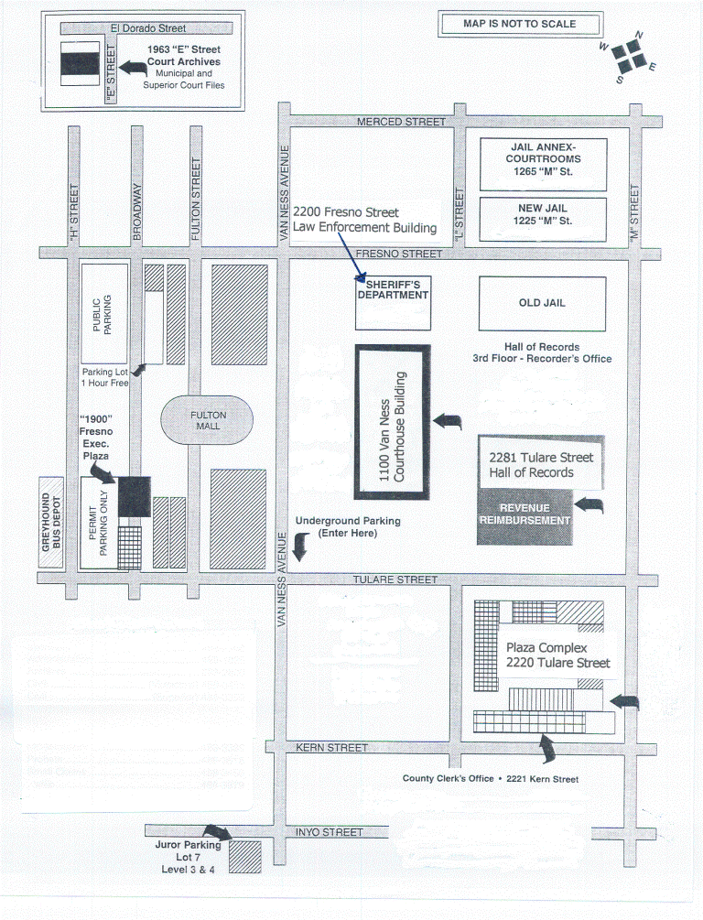
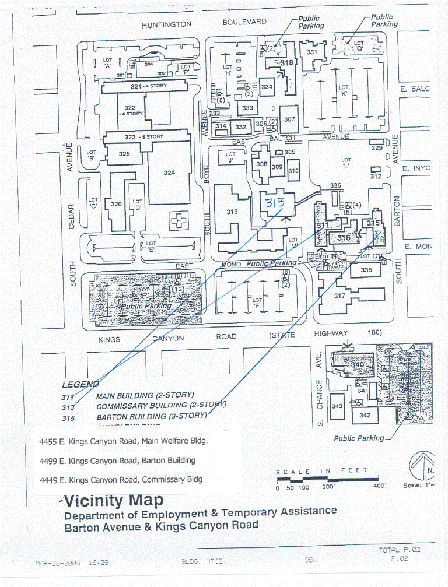
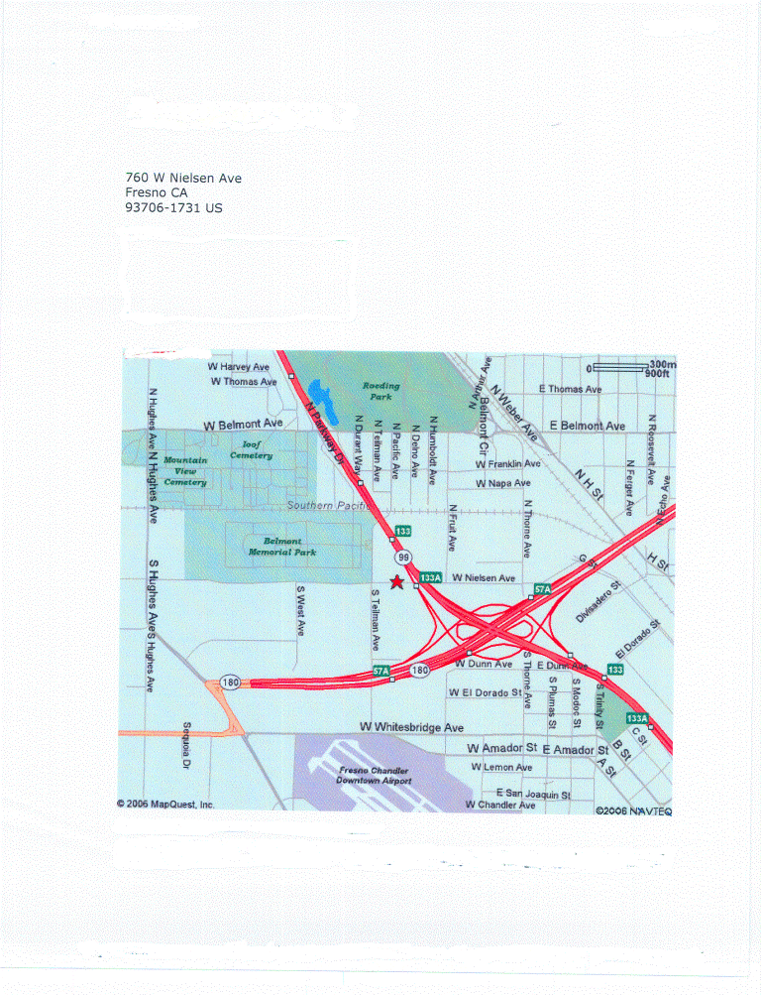
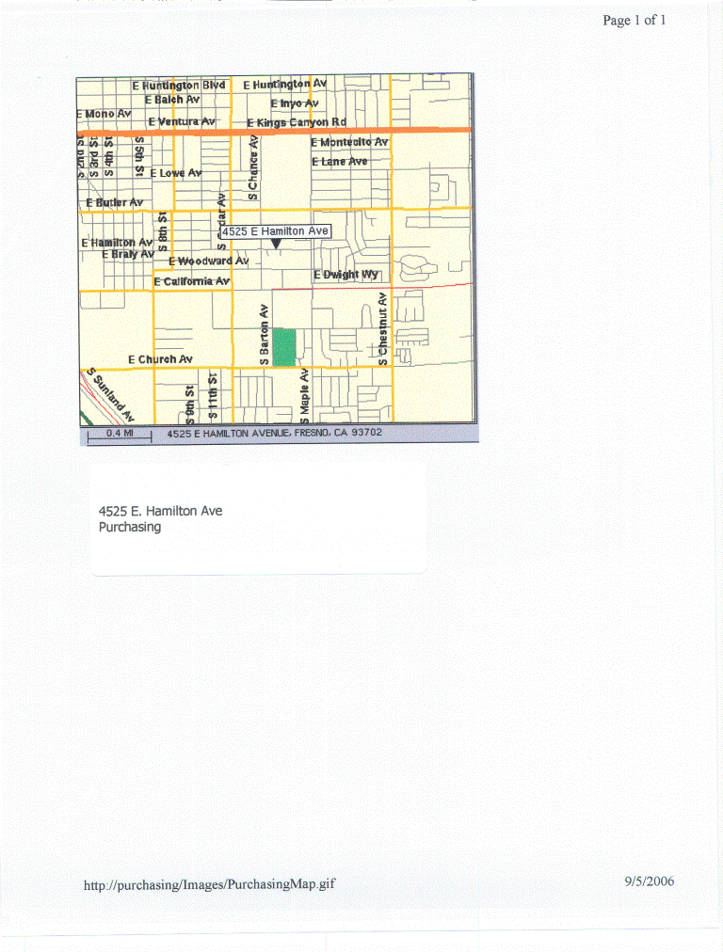
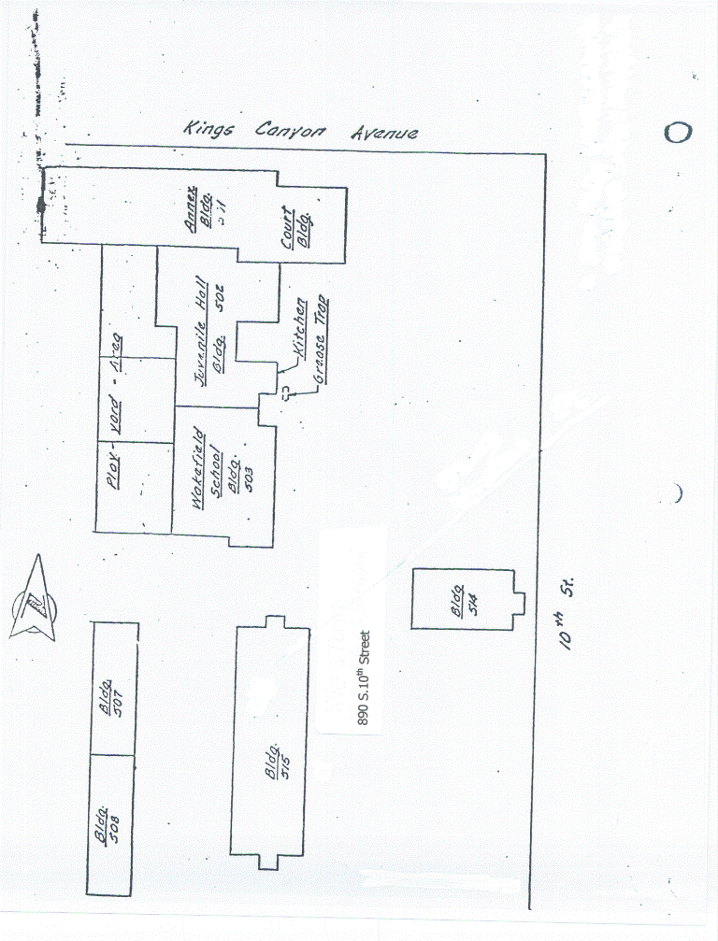
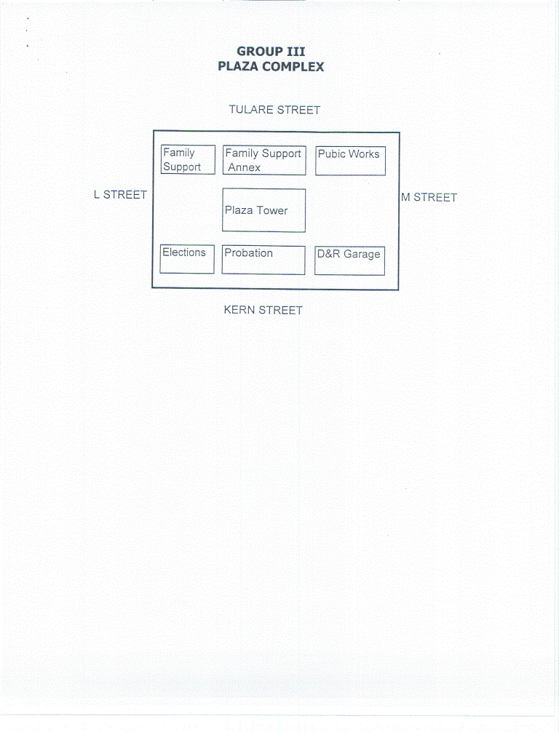
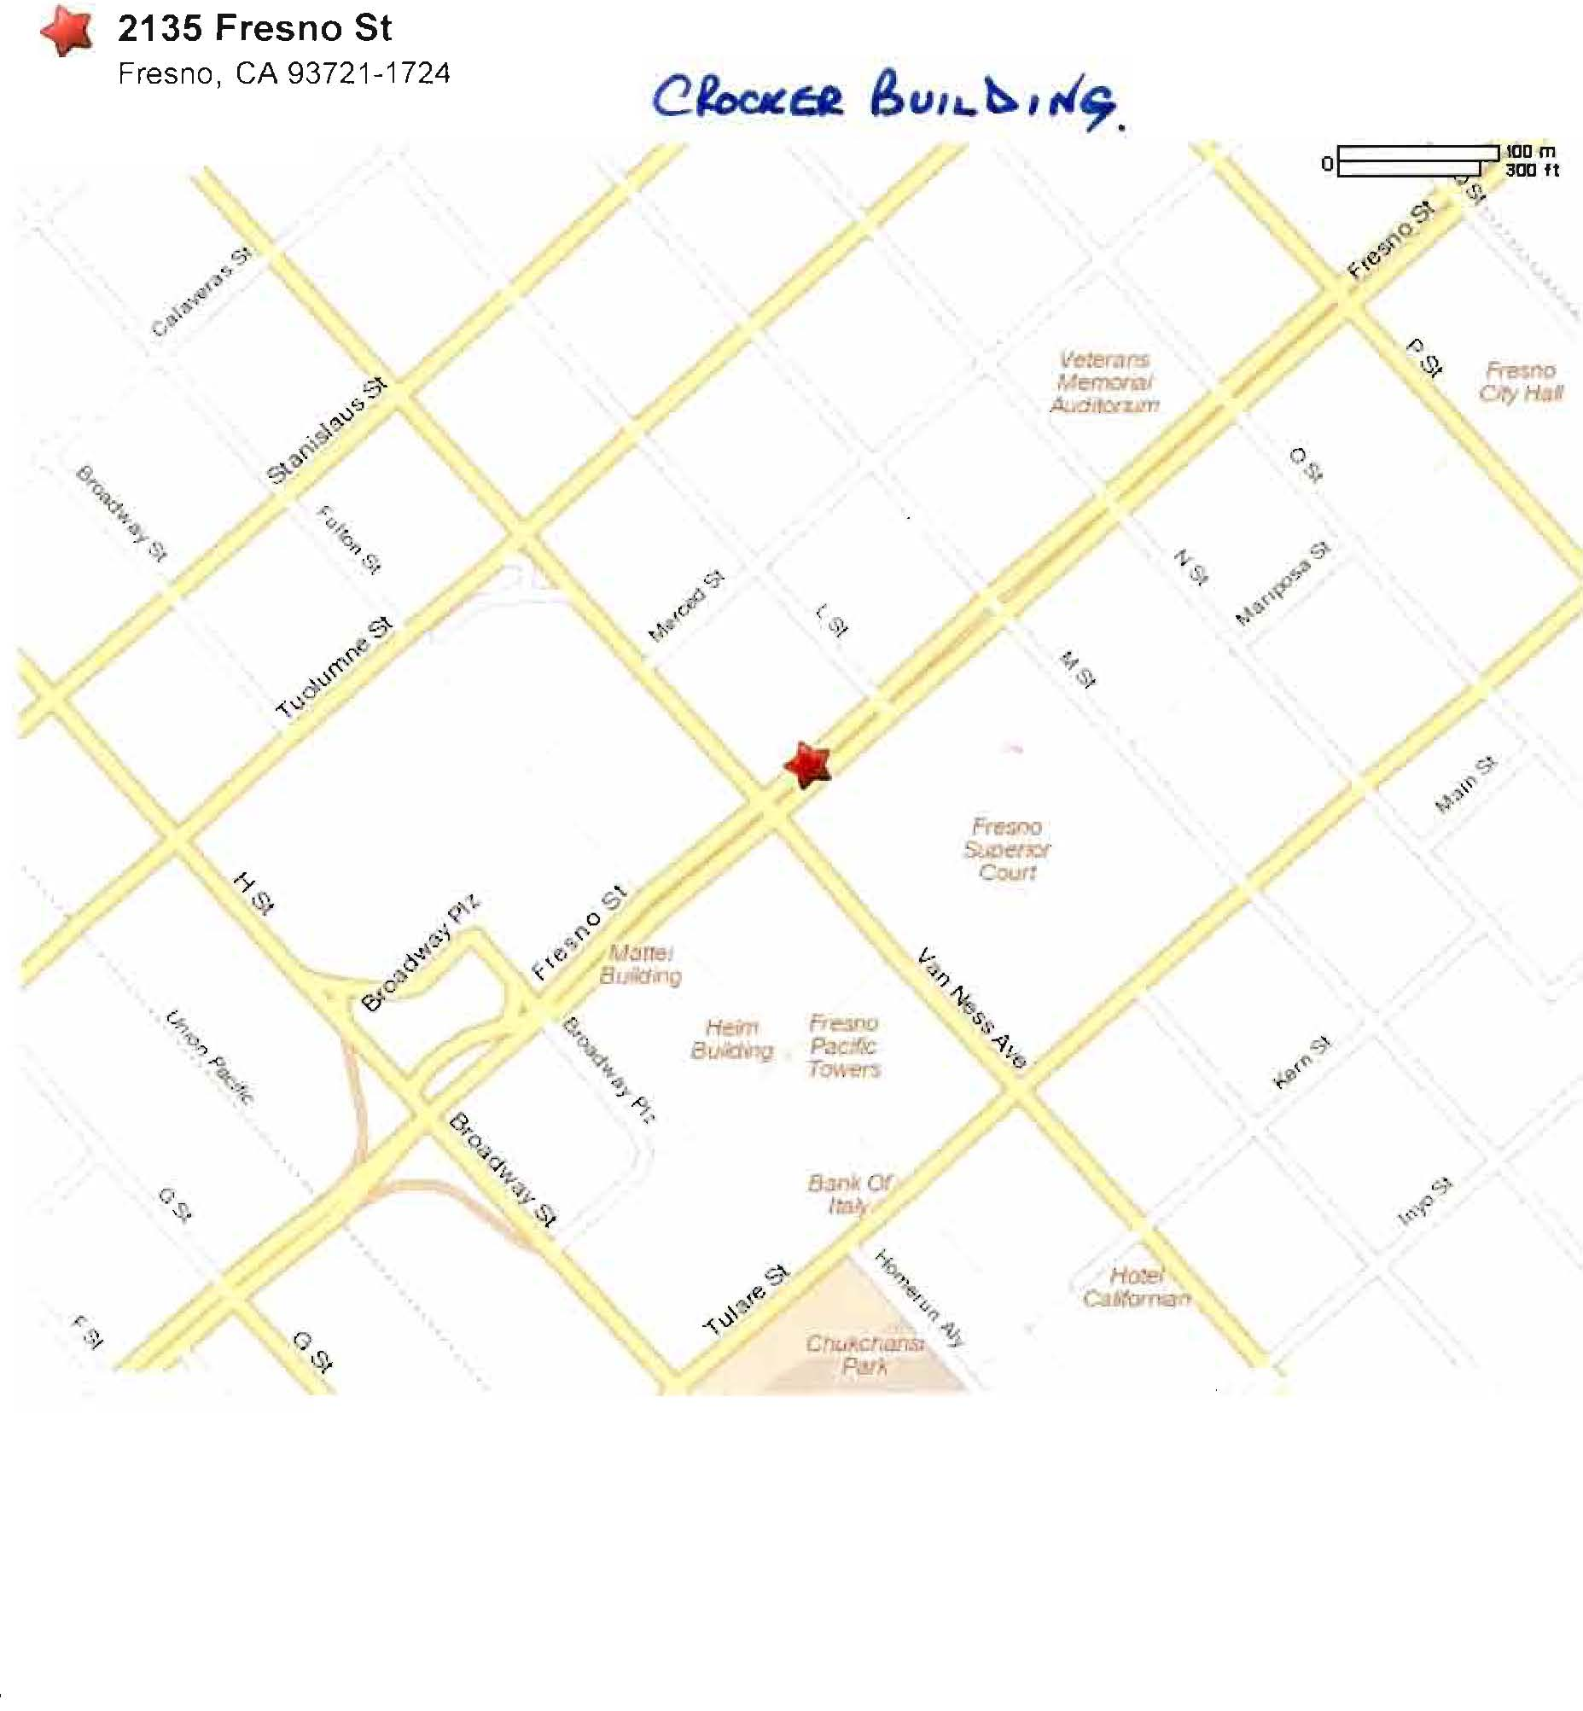
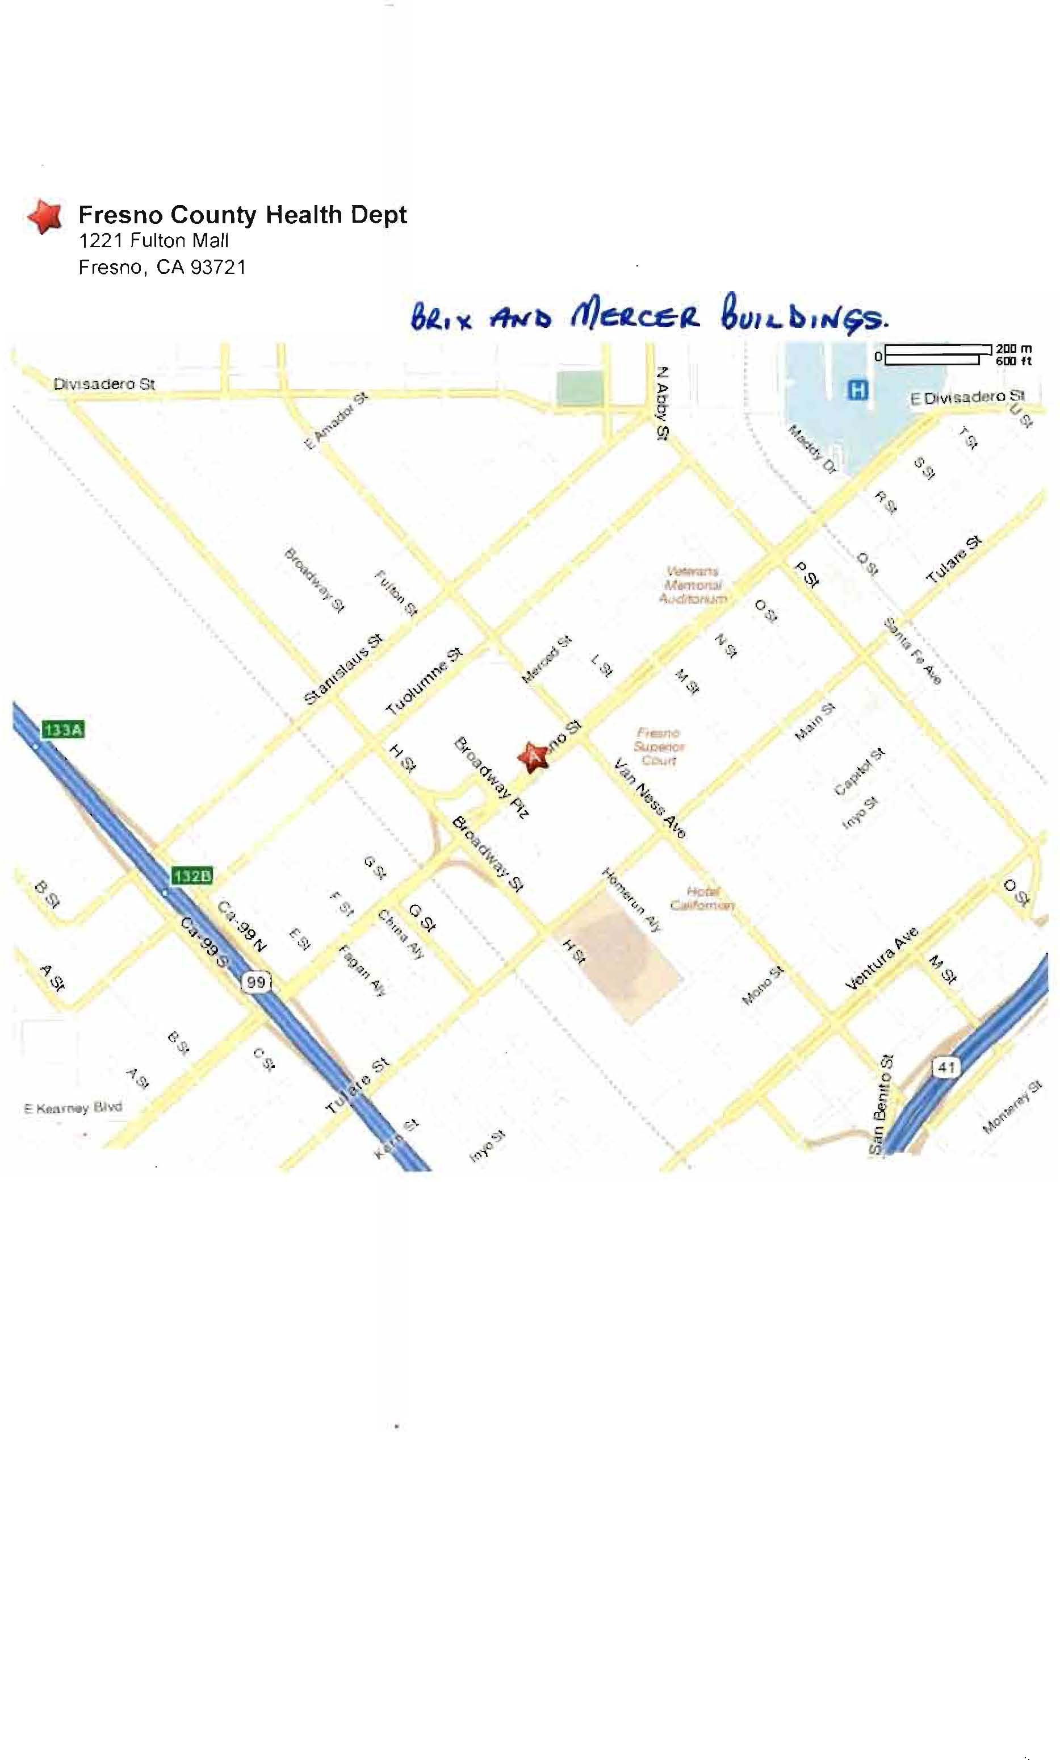
check list
This Checklist is provided to assist the vendors in the preparation of their bid response. Included in this list, are important requirements and is the responsibility of the bidder to submit with the bid package in order to make the bid compliant. Because this checklist is just a guideline, the bidder must read and comply with the bid in its entirety.
Check off each of the following:
The Request for Quotation (RFQ) has been signed and completed.
One (1) original and two (2) copies of the RFQ have been provided.
Addenda, if any, have been completed, signed and included in the bid package.
The completed Reference List as provided with this RFQ.
The Quotation Schedule as provided with this RFQ, has been completed, priced reviewed for accuracy and any corrections initialed in ink.
The Tentative Schedule Section as provided with the RFQ.
Indicate all of bidder exceptions to the County’s requirements, conditions and specifications as stated within this RFQ.
Bidder to Complete page as provided with this RFQ.
The Reference List.
Lastly, on the LOWER LEFT HAND CORNER of the sealed envelope, box, etc. transmitting your bid, attach the “Request for Quotation Label” and include the following information:

County of Fresno RFQ No. |  |  | 962-4789
Closing Date: | February 18, 2010
Closing Time: | 2:00 P.M.

Commodity or Service:
This Checklist does not need to be returned with your bid.

