COUNTY OF FRESNO
Request for QUOTATION
 |  | NUMBER: 962-4480
August 20, 2007
ORG/Requisition: 31113110/ 3118005002 |  |  |  |  |  |  | PURCHASING USE |  |  |  | /tmp/in/input.doc
 |  |  |  |  |  |  | jlg
IMPORTANT: SUBMIT QUOTATION IN SEALED PACKAGE WITH QUOTATION NUMBER, CLOSING DATE AND BUYER’S NAME MARKED CLEARLY ON THE OUTSIDE TO:
COUNTY OF FRESNO, Purchasing
4525 EAST HAMILTON AVENUE
FRESNO, CA 93702-4599
Closing date of bid will be at 2:00 p.m., on September 26, 2007.
QUOTATIONS WILL BE CONSIDERED LATE WHEN THE OFFICIAL PURCHASING TIME CLOCK READS 2:00 P.M.
Quotations will be opened and publicly read at that time. All quotation information will be available for review after contract award.
Clarification of specifications are to be directed to: Brian D. Tamblin, phone (559) 456-7110, FAX (559) 456-7831.
GENERAL CONDITIONS: See “County Of Fresno Purchasing Standard Instructions And Conditions For Request For Proposals (RFP’S) and Requests for Quotations (RFQ’S)” attached. Check County of Fresno Purchasing’s Open Solicitations website at www.co.fresno.ca.us/0440/Bidshome.asp for RFQ/RFP documents and changes.
BIDDER TO COMPLETE
UNDERSIGNED AGREES TO FURNISH THE COMMODITY OR SERVICE STIPULATED IN THE ATTACHED QUOTATION SCHEDULE AT THE PRICES AND TERMS STATED, SUBJECT TO THE “COUNTY OF FRESNO PURCHASING STANDARD INSTRUCTIONS AND CONDITIONS FOR REQUEST FOR QUOTATIONS (RFP’S) AND REQUESTS FOR QUOTATIONS (RFQ’S)”ATTACHED.
Except as noted on individual items, the following will apply to all items in the Quotation Schedule.
- Complete delivery will be made within |  |  |  |  |  |  |  | calendar days after receipt of Order.
- A cash discount of |  |  |  |  | % |  |  |  |  | days will apply.
Company
Address
City |  |  |  |  |  |  |  |  |  |  |  |  | State |  | Zip Code
( ) |  |  |  | ( )
Telephone Number |  |  |  | Facsimile Number |  |  |  |  |  |  |  |  | E-mail Address
Signed By
Print Name |  |  |  |  |  |  |  |  | Title

COUNTY OF FRESNO PURCHASING
STANDARD INSTRUCTIONS AND CONDITIONS FOR
REQUESTS FOR PROPOSALS (RFP'S) AND REQUESTS FOR QUOTATIONS (RFQ'S)
Note: the reference to “bids” in the following paragraphs applies to RFP's and RFQ's

GENERAL CONDITIONS
By submitting a bid the bidder agrees to the following conditions. These conditions will apply to all subsequent purchases based on this bid.

- BID PREPARATION:
  - All prices and notations must be typed or written in ink. No erasures permitted. Errors may be crossed out, initialed and corrections printed in ink by person signing bid.
  - Brand Names: Brand names and numbers when given are for reference. Equal items will be considered, provided the offer clearly describes the article and how it differs from that specified. In the absence of such information it shall be understood the offering is exactly as specified.
  - State brand or make of each item. If bidding on other than specified, state make, model and brand being bid and attach supporting literature/specifications to the bid.
  - Bid on each item separately. Prices should be stated in units specified herein. All applicable charges must be quoted; charges on invoice not quoted herein will be disallowed.
  - Time of delivery is a part of the consideration and must be stated in definite terms and must be adhered to. F.O.B. Point shall be destination or freight charges must be stated.
  - All bids must be dated and signed with the firm’s name and by an authorized officer or employee.
  - Unless otherwise noted, prices shall be firm for 120 days after closing date of bid.
- SUBMITTING BIDS:
  - Each bid must be submitted on forms provided in a sealed envelope with bid number and closing date and time on the outside of the envelope/package.
  - Interpretation: Should any discrepancies or omissions be found in the bid specifications or doubt as to their meaning, the bidder shall notify the Buyer in writing at once. The County shall not be held responsible for verbal interpretations. Questions regarding the bid must be received by Purchasing at least 5 working days before bid opening. All addenda issued shall be in writing, duly issued by Purchasing and incorporated into the contract.
  - ISSUING AGENT/AUTHORIZED CONTACT: This RFQ has been issued by County of Fresno Purchasing. Purchasing shall be the vendor’s sole point of contact with regard to the RFQ, its content, and all issues concerning it.
All communication regarding this RFQ shall be directed to an authorized representative of County Purchasing. The specific buyer managing this RFQ is identified on the cover page, along with his or her telephone number, and he or she should be the primary point of contact for discussions or information pertaining to the RFQ. Contact with any other County representative, including elected officials, for the purpose of discussing this RFQ, its content, or any other issue concerning it, is prohibited unless authorized by Purchasing. Violation of this clause, by the vendor having unauthorized contact (verbally or in writing) with such other County representatives, may constitute grounds for rejection by Purchasing of the vendor’s quotation.
The above stated restriction on vendor contact with County representatives shall apply until the County has awarded a purchase order or contract to a vendor or vendors, except as follows. First, in the event that a vendor initiates a formal protest against the RFQ, such vendor may contact the appropriate individual, or individuals who are managing that protest as outlined in the County’s established protest procedures. All such contact must be in accordance with the sequence set forth under the protest procedures. Second, in the event a public hearing is scheduled before the Board of Supervisors to hear testimony prior to its approval of a purchase order or contract, any vendor may address the Board.
  - Bids received after the closing time will NOT be considered.
  - Bidders are to bid what is specified or requested first. If unable to or willing to, bidder may bid alternative or option, indicating all advantages, disadvantages and their associated cost.
  - Public Contract Code Section 7028.15
Where the State of California requires a Contractor’s license, it is a misdemeanor for any person to submit a bid unless specifically exempted.
- FAILURE TO BID:
  - If not bidding, return bid sheet and state reason for no bid or your name may be removed from mailing list.
- TAXES, CHARGES AND EXTRAS:
  - County of Fresno is subject to California sales and/or use tax (7.975%). Please indicate as a separate line item if applicable.
  - DO NOT include Federal Excise Tax. County is exempt under Registration No. 94-73-03401-K.
  - County is exempt from Federal Transportation Tax. Exemption certificate is not required where shipping papers show consignee as County of Fresno.
  - Charges for transportation, containers, packing, etc. will not be paid unless specified in bid.
- W-9 – REQUEST FOR TAXPAYER IDENTIFICATION NUMBER AND CERTIFICATION:
Upon award of bid, the vendor shall submit to County Purchasing, a completed W-9 - Request for Taxpayer Identification Number and Certification if not already a current vendor with The County of Fresno. This form is available from the IRS to complete on line at http://www.irs.gov/pub/irs-pdf/fw9.pdf.
- AWARDS:
  - Subject to the local preference provisions referenced in Paragraph 6 below and more thoroughly set forth in the General Requirements section of this RFQ, award(s) will be made to the most responsive responsible bidder. The evaluation will include such things as life-cycle cost, availability, delivery costs and whose product and/or service is deemed to be in the best interest of the County. The County shall be the sole judge in making such determination.
  - Unless bidder gives notice of all-or-none award in bid, County may accept any item, group of items or on the basis of total bid.
  - The County reserves the right to reject any and all bids and to waive informalities or irregularities in bids.
  - After award, all bids shall be open to public inspection. The County assumes no responsibility for the confidentiality of information offered in a bid.
- LOCAL VENDORS
  - Local Vendor Preference (applicable to RFQ Process only)
The following provisions are applicable only to the County’s acquisition of materials, equipment or supplies through the RFQ process when the funding source does not require an exemption to the Local Vendor Preference.
THE PROVISIONS OF THIS PARAGRAPH ARE APPLICABLE, NOTWITHSTANDING ANY OTHER PROVISIONS OF THIS RFQ TO THE CONTRARY
If the apparent low bidder is not a local vendor, any local vendor who submitted a bid which was within five percent (5%) of the lowest responsive bid as determined by the purchasing agent shall have the option of submitting a new bid within forty-eight hours (not including weekends and holidays) of County’s delivery of notification. Such new bids must be in an amount less than or equal to the lowest responsive bid as determined by the purchasing agent. If the purchasing agent receives any new bids from local vendors who have the option of submitting new bids within said forty-eight hour period, it shall award the contract to the local vendor submitting the lowest responsible bid. If no new bids are received, the contract shall be awarded to the original low bidder as announced by the purchasing agent.
  - Local Vendor Defined
“Local Vendor” shall mean any business which:
- Has its headquarters, distribution point or locally-owned franchise located in or having a street address within the County for at least six (6) months immediately prior to the issuance of the request for competitive bids by the purchasing agent; and
- Holds any required business license by a jurisdiction located in Fresno County; and
- Employs at least one (1) full-time or two (2) part-time employees whose primary residence is located within Fresno County, or if the business has no employees, shall be at least fifty percent (50%) owned by one or more persons whose primary residence(s) is located within Fresno County.
- TIE BIDS:
All other factors being equal, the contract shall be awarded to the Fresno County vendor or, if neither or both are Fresno County vendors, it may be awarded by the flip of a coin in the presence of witnesses or the entire bid may be rejected and re-bid. If the General Requirements of this RFQ state that they are applicable, the provisions of the Fresno County Local Vendor Preference shall take priority over this paragraph.
- PATENT INDEMNITY:
The vendor shall hold the County, its officers, agents and employees, harmless from liability of any nature or kind, including costs and expenses, for infringement or use of any copyrighted or uncopyrighted composition, secret process, patented or unpatented invention, article or appliance furnished or used in connection with this bid.
- SAMPLES:
Samples, when required, must be furnished and delivered free and, if not destroyed by tests, will upon written request (within 30 days of bid closing date) be returned at the bidder's expense. In the absence of such notification, County shall have the right to dispose of the samples in whatever manner it deems appropriate.
- RIGHTS AND REMEDIES OF COUNTY FOR DEFAULT:
  - In case of default by vendor, the County may procure the articles or service from another source and may recover the cost difference and related expenses occasioned thereby from any unpaid balance due the vendor or by proceeding against performance bond of the vendor, if any, or by suit against the vendor. The prices paid by the County shall be considered the prevailing market price at the time such purchase is made.
  - Articles or services, which upon delivery inspection do not meet specifications, will be rejected and the vendor will be considered in default. Vendor shall reimburse County for expenses related to delivery of non-specified goods or services.
  - Regardless of F.O.B. point, vendor agrees to bear all risks of loss, injury or destruction to goods and materials ordered herein which occur prior to delivery and such loss, injury or destruction shall not release vendor from any obligation hereunder.
- DISCOUNTS:
Terms of less than 15 days for cash payment will be considered as net in evaluating this bid. A discount for payment within fifteen (15) days or more will be considered in determining the award of bid. Discount period will commence either the later of delivery or receipt of invoice by the County. Standard terms are Net Forty-five (45) days.
- SPECIAL CONDITIONS IN BID SCHEDULE SUPERSEDE GENERAL CONDITIONS.
The “General Conditions” provisions of this RFP/RFQ shall be superseded if in conflict with any other section of this bid, to the extent of any such conflict.
- SPECIAL REQUIREMENT:
With the invoice or within twenty-five (25) days of delivery, the seller must provide to the County a Material Safety Data Sheet for each product, which contains any substance on “The List of 800 Hazardous Substances”, published by the State Director of Industrial Relations. (See Hazardous Substances Information and Training Act. California State Labor Code Sections 6360 through 6399.7.)
- RECYCLED PRODUCTS/MATERIALS:
Vendors are encouraged to provide and quote (with documentation) recycled or recyclable products/materials which meet stated specifications.
- YEAR COMPLIANCE WARRANTY
Vendor warrants that any product furnished pursuant to this Agreement/order shall support a four-digit year format and be able to accurately process date and time data from, into and between the twentieth and twenty-first centuries, as well as leap year calculations. "Product" shall include, without limitation, any piece or component of equipment, hardware, firmware, middleware, custom or commercial software, or internal components or subroutines therein. This warranty shall survive termination or expiration of this Agreement.
In the event of any decrease in product functionality or accuracy related to time and/or date data related codes and/or internal subroutines that impede the product from operating correctly using dates beyond December 31, 1999, vendor shall restore or repair the product to the same level of functionality as warranted herein, so as to minimize interruption to County's ongoing business process, time being of the essence. In the event that such warranty compliance requires the acquisition of additional programs, the expense for any such associated or additional acquisitions, which may be required, including, without limitation, data conversion tools, shall be borne exclusively by vendor. Nothing in this warranty shall be construed to limit any rights or remedies the County may otherwise have under this Agreement with respect to defects other than year performance.
- PARTICIPATION:
Bidder may agree to extend the terms of the resulting contract to other political subdivision, municipalities and tax-supported agencies.
Such participating Governmental bodies shall make purchases in their own name, make payment directly to bidder, and be liable directly to the bidder, holding the County of Fresno harmless.
- CONFIDENTIALITY:
All services performed by vendor shall be in strict conformance with all applicable Federal, State of California and/or local laws and regulations relating to confidentiality, including but not limited to, California Civil Code, California Welfare and Institutions Code, Health and Safety Code, California Code of Regulations, Code of Federal Regulations.
Vendor shall submit to County’s monitoring of said compliance.
Vendor may be a business associate of County, as that term is defined in the “Privacy Rule” enacted by the Health Insurance Portability and Accountability Act of 1996 (HIPAA). As a HIPAA Business Associate, vendor may use or disclose protected health information (“PHI”) to perform functions, activities or services for or on behalf of County as specified by the County, provided that such use or disclosure shall not violate HIPAA and its implementing regulations. The uses and disclosures if PHI may not be more expansive than those applicable to County, as the “Covered Entity” under HIPAA’S Privacy Rule, except as authorized for management, administrative or legal responsibilities of the Business Associate.
Vendor shall not use or further disclose PHI other than as permitted or required by the County, or as required by law without written notice to the County.
Vendor shall ensure that any agent, including any subcontractor, to which vendor provides PHI received from, or created or received by the vendor on behalf of County, shall comply with the same restrictions and conditions with respect to such information.
- APPEALS
Appeals must be submitted in writing within seven (7) working days after the review committee notification of proposed recommendations. Appeals should be submitted to County of Fresno Purchasing, 4525 E. Hamilton Avenue, Fresno, California 93702-4599. Appeals should address only areas regarding RFP contradictions, procurement errors, quotation rating discrepancies, legality of procurement context, conflict of interest, and inappropriate or unfair competitive procurement grievance regarding the RFP process.
The Purchasing Manager will provide a written response to the complaint within seven (7) working days unless the complainant is notified more time is required.
If the protesting bidder is not satisfied with the decision of the Purchasing Manager, he/she shall have the right to appeal to the Purchasing Agent within seven (7) business days after notification of the Purchasing Manager’s decision.
If the protesting bidder is not satisfied with Purchasing Agent decision, the final appeal is with the Board of Supervisors.
- OBLIGATIONS OF CONTRACTOR:
  - CONTRACTOR shall perform as required by the ensuing contract. CONTRACTOR also warrants on behalf of itself and all subcontractors engaged for the performance of the ensuing contract that only persons authorized to work in the United States pursuant to the Immigration Reform and Control Act of 1986 and other applicable laws shall be employed in the performance of the work hereunder.
  - CONTRACTOR shall obey all Federal, State, local and special district laws, ordinances and regulations.

Table of contents
PAGE
OVERVIEW 3
KEY DATES 3
BIDDING INSTRUCTIONS 4
BIDDER TO COMPLETE 10
REFERENCE LIST 11
specifications and requirements 12
FRESNO County CODE OF ORDINANCE 15
MAPS 24
QUOTATION SCHEDULE 30
CHECK LIST 31

OVERVIEW
The County of Fresno is soliciting bids to provide all labor, equipment, materials, permits, fees, taxes, licenses, insurance and vehicles etc. to perform vehicle abatement towing services by licensed automobile dismantlers and towing companies. Services to consist of transporting abandoned, wrecked, dismantled or inoperative vehicles from private or public property including highways, to a place of storage, for demolition in accordance with the specifications and requirements as shown within this Request for Quotation.
Vehicles under this abatement program to include but not limited to: heavy duty and light duty trucks, autos, vans, boats, campers, R.V’s. and trailers etc.
The County requests that all tows under the program be completed expeditiously. Vendors are requested to state their response time (after notification of a required tow) on the Quotation Schedule.
Usage of these services over the past twelve (12) month period has been somewhat moderately limited, in that there were 23 claims turned in, and 45 to 50 claims which were not filed (tows not eligible for the vehicle abatement program).
The County’s intent at this time is to become more aggressive with the program and anticipates an estimate of 150-200 tows per year, but cannot and will not guarantee any minimum amount.
It is the County’s intent to contract with two (2) vendors for each area for these services; one (1) primary and one (1) secondary. Selected vendors may be required on a rotational basis.
The County also reserves the right to increase contracted vendors for each area if the need arises and to use all vendors in each area on a rotational basis if required.
The County would prefer areas to be bid on as a whole, but will consider quotes on individual beats within those areas.
Bidder(s) are requested to submit their pricing for any and all areas and or beats on which they would be interested (See Quotation Schedule within this RFQ).

KEY DATES
Vendor Conference: | August 30, 2007 at 10:30 A.M.
 | County of Fresno Purchasing
 | 4525 E. Hamilton Avenue, 2nd Floor
 | Fresno, CA 93702
Deadline for Questions: | September 7, 2007 at 5:00 P.M.
Deadline for Questions: | Fax No. (559) 456-7831
 | e-Mail: CountyPurchasing@co.fresno.ca.us
RFQ Closing Date: | September 26, 2007 at 2:00 P.M.
 | County of Fresno Purchasing
 | 4525 E. Hamilton Avenue, 2nd Floor
 | Fresno, CA 93702
BIDDING INSTRUCTIONS
CONTRACT SERVICES
The County of Fresno is soliciting bids to establish an agreement under which the successful bidder(s) will provide towing services as specified within this Request for Quotation.
LOCAL VENDOR PREFERENCE: The Local Vendor Preference does not apply to this Request for Quotation.
DEFINITIONS: The terms Bidder, Proposer, Contractor and Vendor are all used interchangeably and refer to that person, partnership, corporation, organization, agency, etc. which is offering the quotation and is identified on page one of this Request For Quotation (RFQ).
INTERPRETATION OF RFQ: Vendors must make careful examination of the requirements, specifications and conditions expressed in the RFQ and fully inform themselves as to the quality and character of services required. If any person planning to submit a quotation finds discrepancies in or omissions from the RFQ or has any doubt as to the true meaning or interpretation, correction thereof may be requested at the scheduled Vendor Conference. Any change in the RFQ will be made only by written addendum, duly issued by the County. The County will not be responsible for any other explanations or interpretations.
Questions may be submitted subsequent to the Vendor Conference, subject to the following conditions:
- Such questions are submitted in writing to County Purchasing at least nine (9) County business days prior to the Request for Quotation closing date. Questions must be directed to the attention of the buyer identified on page one.
- Such questions are submitted with the understanding that the County can respond only to questions it considers material in nature.
Questions shall be delivered to County of Fresno Purchasing, 4525 E. Hamilton Avenue, Fresno, CA 93702 or faxed to (559) 456-7831. If faxing the bidder must confirm receipt by phone within one-half (1/2) hour of transmission.
NOTE: The bidder is encouraged to submit all questions at the Vendor Conference. Time limitations can prevent a response to questions submitted after the conference.
AWARD: Award will be made to the vendor(s) offering the services deemed to be to the best advantage of the County. The County shall be the sole judge in making such determination.
RIGHT TO REJECT BIDS: The County reserves the right to reject any and all bids and to waive informalities or irregularities in bids.
ISSUING AGENT: This RFQ has been issued by County of Fresno Purchasing. Purchasing shall be the vendor’s sole point of contact with regard to the RFQ, its content, and all issues concerning it.
AUTHORIZED CONTACT: All communication regarding this RFQ shall be directed to an authorized representative of County Purchasing. The specific buyer managing this RFQ is identified on the cover page, along with his or her telephone number, and he or she should be the primary point of contact for discussions or information pertaining to the RFQ. Contact with any other County representative, including elected officials, for the purpose of discussing this RFQ, its content, or any other issue concerning it, is prohibited unless authorized by Purchasing. Violation of this clause, by the vendor having unauthorized contact (verbally or in writing) with such other County representatives, may constitute grounds for rejection by Purchasing of the vendor’s quotation.
The above stated restriction on vendor contact with County representatives shall apply until the County has awarded a purchase order or contract to a vendor or vendors, except as follows. First, in the event that a vendor initiates a formal protest against the RFQ, such vendor may contact the appropriate individual, or individuals who are managing that protest as outlined in the County’s established protest procedures. All such contact must be in accordance with the sequence set forth under the protest procedures. Second, in the event a public hearing is scheduled before the Board of Supervisors to hear testimony prior to its approval of a purchase order or contract, any vendor may address the Board.
VENDOR CONFERENCE: On August 28, 2007 at 10:30 A.M., a vendor's conference will be held in which the scope of the project and quotation requirements will be explained. The meeting will be held at the office of County of Fresno Purchasing, 4525 E. Hamilton Avenue 2nd Floor, (between Cedar and Maple), Fresno, California.
Bidders are to contact Brian D. Tamblin at County of Fresno Purchasing, (559) 456-7110, if they are planning to attend the conference.
NUMBER OF COPIES: Submit one (1) original and two (2) copies of your quotation no later than the quotation closing date and time as stated on the front of this document to County of Fresno Purchasing. Each copy to be identical to the original, include all supporting documentation (i.e. literature, brochures, reports, schedules etc.). The cover page of each quotation is to be appropriately marked “Original” or “Copy”.
FIRM QUOTATION: All quotations shall remain firm for at least one (1) year.
TAXES: The quoted amount must include all applicable taxes. If taxes are not specifically identified in the quotation it will be assumed that they are included in the total quoted.
SALES TAX: Fresno County pays California State Sales Tax in the amount of 7.975% regardless of vendor's place of doing business.
MINOR DEVIATIONS: The County reserves the right to negotiate minor deviations from the prescribed terms, conditions and requirements with the selected vendor(s).
QUOTATION REJECTION: Failure to respond to all questions or not to supply the requested information could result in rejection of your quotation.
BIDDERS’ LIABILITIES: County of Fresno will not be held liable for any cost incurred by vendors in responding to the RFQ.
PRICE RESPONSIBILITY: The selected vendor(s) will be required to assume full responsibility for all services and activities offered in the quotation, whether or not they are provided directly. Further, the County of Fresno will consider the selected vendor to be the sole point of contact with regard to contractual matters, including payment of any and all charges resulting from the contract. The contractor may not subcontract or transfer the contract, or any right or obligation arising out of the contract, without first having obtained the express written consent of the County.
CONFIDENTIALITY: Bidders shall not disclose information about the County's business or business practices and safeguard confidential data which vendor staff may have access to in the course of system implementation.
NEWS RELEASE: Vendors shall not issue any news releases or otherwise release information to any third party about this RFQ or the vendor's quotation without prior written approval from the County of Fresno.
BACKGROUND REVIEW: The County reserves the right to conduct a background inquiry of each proposer/bidder which may include collection of appropriate criminal history information, contractual and business associations and practices, employment histories and reputation in the business community. By submitting a quotation/bid to the County, the vendor consents to such an inquiry and agrees to make available to the County such books and records the County deems necessary to conduct the inquiry.
EXCEPTIONS: Identify with explanation, any terms, conditions, specifications or stipulations of the RFQ with which you CAN NOT or WILL NOT comply.
ADDENDA: In the event that it becomes necessary to revise any part of this RFQ, addenda will be provided to all agencies and organizations that receive the basic RFQ.
SUBCONTRACTORS: If a subcontractor is proposed, complete identification of the subcontractor and his tasks shall be provided. The primary contractor is not relieved of any responsibility by virtue of using a subcontractor.
CONFLICT OF INTEREST: The County shall not contract with, and shall reject any bid or quotation submitted by the persons or entities specified below, unless the Board of Supervisors finds that special circumstances exist which justify the approval of such contract:
- Employees of the County or public agencies for which the Board of Supervisors is the governing body.
- Profit-making firms or businesses in which employees described in Subsection (1) serve as officers, principals, partners or major shareholders.
- Persons who, within the immediately preceding twelve (12) months, came within the provisions of Subsection (1), and who were employees in positions of substantial responsibility in the area of service to be performed by the contract, or participated in any way in developing the contract or its service specifications.
- Profit-making firms or businesses in which the former employees described in Subsection (3) serve as officers, principals, partners or major shareholders.
- No County employee whose position in the County enables him to influence the selection of a contractor for this RFQ, or any competing RFQ, and no spouse or economic dependent of such employee, shall be employees in any capacity by a bidder, or have any other direct or indirect financial interest in the selection of a contractor.
INVOICING: All invoices are to be delivered in duplicate to the Sheriff’s Department. Each invoice shall reference “County Code, Abandoned Vehicle Abatement”. The contractor shall obtain the “invoice to” address prior to the contract start date.
PAYMENT: County will make partial payments for all purchases made under the contract/purchase order and accumulated during the month.
CONTRACT TERM: It is County’s intent to contract with successful bidder(s) for a period of three (3) years with the option to renew for two (2) additional one (1) year periods. Maximum renewals under the agreement would be two (2).
PRICES: Bidder agrees that prices quoted are maximum for the contract period, and in the event of a price decline such lower prices shall be extended to the County of Fresno.
INDEPENDENT CONTRACTOR: In performance of the work, duties, and obligations assumed by Contractor under any ensuing Agreement, it is mutually understood and agreed that CONTRACTOR, including any and all of Contractor’s officers, agents, and employees will at all times be acting and performing as an independent contractor, and shall act in an independent capacity and not as an officer, agent, servant, employee, joint venturer, partner, or associate of the COUNTY. Furthermore, County shall have no right to control or supervise or direct the manner or method by which Contractor shall perform its work and function. However, County shall retain the right to administer this Agreement so as to verify that Contractor is performing its obligations in accordance with the terms and conditions thereof. Contractor and County shall comply with all applicable provisions of law and the rules and regulations, if any, of governmental authorities having jurisdiction over matters the subject thereof.
Because of its status as an independent contractor, Contractor shall have absolutely no right to employment rights and benefits available to County employees. Contractor shall be solely liable and responsible for providing to, or on behalf of, its employees all legally-required employee benefits. In addition, Contractor shall be solely responsible and save County harmless from all matters relating to payment of Contractor's employees, including compliance with Social Security, withholding, and all other regulations governing such matters. It is acknowledged that during the term of the Agreement, Contractor may be providing services to others unrelated to the County or to the Agreement.
HOLD HARMLESS CLAUSE: Contractor agrees to indemnify, save hold harmless and at County's request, defend the County, its officers agents and employees, from any and all costs and expenses, damages, liabilities, claims and losses occurring or resulting to County in connection with the performance, or failure to perform, by Contractor, its officers, agents or employees under this Agreement and from any and all costs and expenses, damages, liabilities, claims and losses occurring or resulting to any person, firm or corporation who may be injured or damaged by the performance, or failure to perform, of Contractor, its officers, agents or employees under this Agreement.

INSURANCE:
Without limiting the COUNTY's right to obtain indemnification from CONTRACTOR or any third parties, CONTRACTOR, at its sole expense, shall maintain in full force and effect the following insurance policies throughout the term of the Agreement:
- Commercial General Liability
Commercial General Liability Insurance with limits of not less than One Million Dollars ($1,000,000) per occurrence and an annual aggregate of Two Million Dollars ($2,000,000). This policy shall be issued on a per occurrence basis. COUNTY may require specific coverages including completed operations, products liability, contractual liability, Explosion-Collapse-Underground, fire legal liability or any other liability insurance deemed necessary because of the nature of this contract.
- Automobile Liability
Comprehensive Automobile Liability Insurance with limits for bodily injury of not less than Two Hundred Fifty Thousand Dollars ($250,000.00) per person, Five Hundred Thousand Dollars ($500,000.00) per accident and for property damages of not less than Fifty Thousand Dollars ($50,000.00), or such coverage with a combined single limit of Five Hundred Thousand Dollars ($500,000.00). Coverage should include owned and non-owned vehicles used in connection with this Agreement.
- Professional Liability
If CONTRACTOR employs licensed professional staff, (e.g., Ph.D., R.N., L.C.S.W., M.F.C.C.) in providing services, Professional Liability Insurance with limits of not less than One Million Dollars ($1,000,000.00) per occurrence, Three Million Dollars ($3,000,000.00) annual aggregate.
- Worker's Compensation
A policy of Worker's Compensation insurance as may be required by the California Labor Code.
CONTRACTOR shall obtain endorsements to the Commercial General Liability insurance naming the County of Fresno, its officers, agents, and employees, individually and collectively, as additional insured, but only insofar as the operations under this Agreement are concerned. Such coverage for additional insured shall apply as primary insurance and any other insurance, or self-insurance, maintained by COUNTY, its officers, agents and employees shall be excess only and not contributing with insurance provided under CONTRACTOR's policies herein. This insurance shall not be cancelled or changed without a minimum of thirty (30) days advance written notice given to COUNTY.
Within Thirty (30) days from the date CONTRACTOR signs this Agreement, CONTRACTOR shall provide certificates of insurance and endorsement as stated above for all of the foregoing policies, as required herein, to the County of Fresno, stating that such insurance coverage have been obtained and are in full force; that the County of Fresno, its officers, agents and employees will not be responsible for any premiums on the policies; that such Commercial General Liability insurance names the County of Fresno, its officers, agents and employees, individually and collectively, as additional insured, but only insofar as the operations under this Agreement are concerned; that such coverage for additional insured shall apply as primary insurance and any other insurance, or self-insurance, maintained by COUNTY, its officers, agents and employees, shall be excess only and not contributing with insurance provided under CONTRACTOR's policies herein; and that this insurance shall not be cancelled or changed without a minimum of thirty (30) days advance, written notice given to COUNTY.
In the event CONTRACTOR fails to keep in effect at all times insurance coverage as herein provided, the COUNTY may, in addition to other remedies it may have, suspend or terminate this Agreement upon the occurrence of such event.
All policies shall be with admitted insurers licensed to do business in the State of California. Insurance purchased shall be purchased from companies possessing a current A.M. Best, Inc. rating of B++ VIII or better.
DISPUTE RESOLUTION: The ensuing contract shall be governed by the laws of the state of California.
Any claim which cannot be amicably settled without court action will be litigated in the U. S. District Court for the Eastern District of California in Fresno, CA or in a state court for Fresno County.
TERMINATION: The County reserves the right to terminate any resulting contract upon written notice.
DEFAULT: In case of default by the selected bidder, the County may procure the services from another source and may recover the loss occasioned thereby from any unpaid balance due the selected bidder, or by any other legal means available to the County.
ASSIGNMENTS: The ensuing proposed contract will provide that the vendor may not assign any payment or portions of payments without prior written consent of the County of Fresno.
ASSURANCES: Any contract awarded under this RFQ must be carried out in full compliance with The Civil Rights Act of 1964, The Americans With Disabilities Act of 1990, their subsequent amendments, and any and all other laws protecting the rights of individuals and agencies. The County of Fresno has a zero tolerance for discrimination, implied or expressed, and wants to ensure that policy continues under this RFQ. The contractor must also guarantee that services, or workmanship, provided will be performed in compliance with all applicable local, state, or federal laws and regulations pertinent to the types of services, or project, of the nature required under this RFQ. In addition, the contractor may be required to provide evidence substantiating that their employees have the necessary skills and training to perform the required services or work.
AUDITS AND INSPECTIONS: The Contractor shall at any time during business hours, and as often as the County may deem necessary, make available to the County for examination all of its records and data and respect to the matters covered by this Agreement. The Contractor shall, upon request by the County, permit the County to audit and inspect all of such records and data necessary to ensure Contractor's compliance with the terms of this Agreement.
If this Agreement exceeds Ten Thousand and No/100 dollars ($10,000.00), Contractor shall be subject to the examination and audit of the Auditor General for a period of three (3) years after final payment under contract (Government Code Section 10532).

BIDDER TO COMPLETE
CONTRACTOR'S LICENSE:
Bidder to possess appropriate license for the project in accordance with current regulations/statutes.
The vendor shall possess a current State of California contractor’s license covering the work to be performed. The proposal must indicate the license held by the bidder, which enables him/her to perform the work.
Number and Class:
Date of Issue:
INSURANCE:
Name of Insurance Carrier:
Public Liability: |  |  |  | Expires:
Automotive: |  |  |  | Expires:
Workman's Compensation: |  |  |  | Expires:
Proof of maintenance of adequate insurance will be required before award is made to vendor.
GUARANTEE: The bidder shall state his written guarantee here:
Firm:
REFERENCE LIST
The bidder shall submit a list of at least three (3) customer references. Such references shall be customers for whom the vendor has recently performed similar services. Be sure to include addresses and phone numbers.
Reference Name: |  | City: |  |  |  |  |  | State
Contact |  | Phone No.: |  | ( |  | )
Date:
Service Provided:
Reference Name: |  | City: |  |  |  |  |  | State
Contact |  | Phone No.: |  | ( |  | )
Date:
Service Provided:
Reference Name: |  | City: |  |  |  |  |  | State
Contact |  | Phone No.: |  | ( |  | )
Date:
Service Provided:
Reference Name: |  | City: |  |  |  |  |  | State
Contact |  | Phone No.: |  | ( |  | )
Date:
Service Provided:
Reference Name: |  | City: |  |  |  |  |  | State
Contact |  | Phone No.: |  | ( |  | )
Date:
Service Provided:
Failure to provide a list of at least three (3) customers may be cause for rejection of this RFP.

specifications and requirements

specifications and requirements
These specifications and requirements have been written by the County’s Sheriff’s Department. Any clarification of these requirements may be obtained by contacting County Purchasing, phone (559) 456-7110, or fax (559) 456-7831.
The County of Fresno requests bids for service to be performed by licensed automobile dismantlers and tow companies. Such service shall consist of transporting abandoned, wrecked, dismantled or inoperative vehicles from private or public property, (including highways), to a place of storage for demolition in accordance with the attached specifications and the Areas attached hereto:
The bidder is requested to submit his bid price for areas he/she may be interested in serving. Any or all areas may be bid on. (Attached Fresno County map, divided by Areas 1, 2, 3 & 4.)
The County of Fresno has enacted Article II of Chapter 44 of the Fresno County Code of Ordinances, which provides for the removal and dismantling of abandoned, wrecked, dismantled or inoperative vehicles on public and private property within the unincorporated area of the County.
In implementing this ordinance the County of Fresno is desirous of obtaining the services of Licensed Automobile Dismantlers and Tow Companies to remove these abandoned vehicles, parts or hulks as the case may be, from private and public property upon request from the Fresno County Sheriffs Department whose office has been charged with the enforcement responsibility.
The County has been divided into four (4) geographical areas in accordance with the attached maps. The automobile dismantler/tow operator will be required to pick up the abandoned vehicles or parts thereof after authorization has been given to them by written document, and remove same to their place of business after which the County surrenders its interest.
Junk slips or an abandoned vehicle “pick-up sheet” will be issued to the towing company directing them to tow the vehicle. The Vehicle Code states that the vehicle must be disposed of through a licensed automobile dismantler or scrap yard.
Vehicles ordered to be removed by the Fresno County Sheriff Department shall become the property of the Contractor after he has picked them up and he shall be responsible for making appropriate disposition of such vehicle. In accordance with the provisions of said Ordinance Code Such Vehicles shall not thereafter be reconstructed or made operable. No vehicle shall be salvaged. All must be destroyed by a licensed auto dismantler or scrap yard.
The Tow Companies in each geographical area will be required to provide, maintain and operate equipment sufficient to fulfill the requirements of this agreement and capable of removing at lease five (5) vehicles or parts thereof each week.
Bidders are advised that due to the condition of most of these abated vehicles, they should have in their possession a Low Boy Trailer, as in most cases these vehicles are missing major parts which would make it impossible for towing (e.g. – Axels). Some of these vehicles include RV’s, campers, trailers, automobiles, boats etc.
The Specifications are not intended to prohibit the Contractor from Soliciting automobile removal; salvage and dismantling business from other political subdivision from private individuals. However in doing so, the Contractor shall not directly or indirectly suggest, state or imply that state law or County Ordinance requires such removal. Specifications do not apply in any way to vehicles which are removed, salvaged or dismantled at the request of other political subdivides or private individual and the County shall make no payments or shall have no responsibility whatsoever in connection with any transaction undertaken by the contractor.
The Automobile Dismantler or Tow Company will also agree to remove all vehicles promptly after the written order of removal is received from the Fresno County Sheriff’s Dept. When removing the vehicles or parts thereof, the property on which it was located shall be left free from glass or other debris.
The contractor shall assume all risks incident to or in connection with its operations and shall be solely responsible for all accidents or injuries to persons on property alleged to have been caused by its operations pursuant to this work and the Contractor shall indemnity defend and save harmless the County from any and all claims, suits, losses or damages for injuries to persons or property arising out of the operations of the Contractor, its agents and employees, provided, however, that this undertaking shall not apply to claims, suits, losses or damage arising out of careless, negligent or improper acts or omissions of the county and its officers employees and agents.
The Automobile Dismantler or Tow Company is not required to obtain permission of the owner upon which a vehicle has been ordered removed before entering thereon but the contractor shall not forcibly enter nor continue his operation if objection thereto is encountered. Contractor will immediately report any such incident to the Fresno County Sheriff’s Department Official for further direction.
Vehicles will generally not be towed from back yards. Where there is a question of access, Sheriff’s Department personnel will be on scene.
Dry Runs: In the event that the towing contractor is requested to remove a vehicle by the County, and upon contractor arrival at the location properly equipped to remove the vehicle. If the vehicle has been removed, the County will pay to the contractor the sum of $0.00 for each of said “dry runs”.
It is the intent of the County to select a minimum of two (2) vendors for each area; one (1) primary and one (1) secondary. However; the County reserves the right to increase vendors in each area and use them on a rotational basis if required.
Estimate of number of vehicles to be removed: It’s unknown at the present time, how many vehicle will be towed under this ordnance.
This contract is separate and apart from the Sheriff Department Rotational tow list and the county fleet tow list.
Contractors will be paid by the Fresno County Sheriff’s Department in accordance with the bid submitted.
FRESNO County CODE OF ORDINANCE
Title 11 – Vehicles and Traffic Chapter 11.44 – Abandoned Vehicles

Title 11 VEHICLES AND TRAFFIC

Chapter 11.44 ABANDONED VEHICLES
11.44.009 Purpose.
11.44.010 Definitions.
11.44.011 Exclusions.
11.44.012 Not exclusive regulation.
11.44.020 Enforcement.
11.44.021 Citation for violation.
11.44.022 Prohibition--Criminal penalty.
11.44.030 Abandoned vehicles--Removable.
11.44.040 Right of entry upon private or public property.
11.44.050 Procedure.
11.44.055 Notice of intention to abate--Contents.
11.44.060 Request for hearing.
11.44.061 Waiver of notice of intent to abate and remove.
11.44.062 Notice of disposition of low-valued vehicle and intent to dispose.
11.44.070 Stay pending decision of hearing.
11.44.080 Hearing.
11.44.090 Voluntary removal after appeal.
11.44.100 Removal--What constitutes.
11.44.120 Notification of department of motor vehicles.
11.44.130 Collection of costs.
11.44.140 Collection of costs--Procedure.
11.44.009 Purpose.
In accordance with the authority of Section 22660 of the Vehicle Code to remove abandoned, dismantled, inoperative, or wrecked vehicles or parts thereof as public nuisances, the board of supervisors makes the following findings and declarations:
The accumulation and storage of abandoned, wrecked, dismantled or inoperative vehicles or parts thereof on private or public property, including highways, are found to create a condition tending to reduce the value of private property, to promote blight and deterioration, to invite plundering, to create fire hazards, to create a harborage for rodents and insects and to constitute a nuisance and be injurious to the health, safety and general welfare. Therefore, the presence of an abandoned, dismantled, inoperative, or wrecked vehicle, or parts thereof, on private or public property, including highways, except as expressly hereinafter permitted, constitutes a public nuisance which may be abated. (Ord. 00-001 (part): Ord. 567 § 1 (part), 1974.)
11.44.010 Definitions.
As used in this chapter, the following terms shall have the following meanings:
“Abandoned vehicle” means any vehicle left on the property of another without the property owner’s permission or any dismantled, inoperative or wrecked vehicle on private properly.
“Dismantled vehicle” is one which is in pieces.
“Inoperative vehicle” is one that is either mechanically incapable of being driven on its own power or prohibited from being operated on a public street or highway pursuant to the provisions of Vehicle Code sections 4000, 5202, 24002 or 40001, concerning license plates, registration, equipment, safety and related matters.
A “low-valued vehicle” is one which meets all the following conditions:
(1) the vehicle is inoperative due to the absence of a motor, transmission, or wheels and is incapable of being towed, (2) is valued at less than two hundred dollars ($200.00) by a person specified in Section 22855 of the California Vehicle Code, (3) is determined by the sheriff to be a public nuisance presenting an immediate threat to public health or safety, and (4) the property owners have signed a release authorizing removal and waiving her interest in the vehicle or parts thereof.
“Vehicle” for purposes of this chapter has the same meaning as Section 670 of the California Vehicle Code, which defines a vehicle as a device by which any person or property may be propelled, moved, or drawn upon a highway, excepting a device moved exclusively by human power or used exclusively upon stationary rails or tracks. The definition of “vehicle” for purposes of this chapter excludes any machine designed and to be used for an agricultural implement and not intended to be used as a means of transportation on highways, although on occasion it may be temporarily operated thereon.
“Wrecked vehicle” is one that is destroyed, disabled, seriously damaged, crashed or ruined.
For purposes of this chapter, the term abandoned vehicle will be utilized to encompass abandoned, dismantled, inoperative, or wrecked vehicles and shall be synonymous with each of these terns. (Ord. 00-001 (part): Ord. 567 § 1 (part), 1974.)
11.44.011 Exclusions.
This chapter shall not apply to any vehicle or part thereof which is:
A. Completely enclosed in a lawful manner within a building, a solid fence, wall or hedge between five (5) and six (6) feet in height, or otherwise located so as not to be visible from the street or other public or private property; or
B. Stored or parked in a lawful manner on private property in connection with the business of a licensed dismantler, licensed vehicle dealer or a junk yard.
Nothing in this chapter shall authorize the maintenance of a public or private nuisance as defined under provision of law. (Ord. 00-00l (part): Ord. 567 § 1 (part), 1974.)
11.44.012 Not exclusive regulation.
This chapter is not the exclusive regulation of abandoned, dismantled, inoperative, or wrecked vehicles within the county. It shall supplement and be in addition to the other regulatory codes, statutes, and ordinances heretofore or hereafter enacted by the county, the state, or any other legal entity or agency having jurisdiction. (Ord. 00-00l (part): Ord. 567 § 1 (part), 1974.)
11.44.020 Enforcement.
This chapter shall be administered by the sheriff of the county by and through the regularly salaried, full-time employees of the county, except that the actual removal of vehicles or parts thereof from property may be by other duly authorized persons. (Ord. 00-001 (part): Ord. 567 § 1 (part), 1974.)
11.44.021 Citation for violation.
In addition to the enforcement proceedings contained in Section 11.44.020, the sheriff and any peace officer as defined by Penal Code Sections 830 and 830.1 are hereby authorized to issue citations to the owner or occupant of the property upon which the abandoned, dismantled, inoperative, or wrecked vehicle, or parts thereof, is located. Any person issued a citation for violation of any provision of this chapter shall appear before the appropriate court within the county as set forth on the citation. (Ord. 00-001 (part): Ord. 567 § 1 (part), 1974.)
11.44.022 Prohibition--Criminal penalty.
It shall be unlawful for any person to fail or refuse to remove any abandoned, dismantled, inoperative, or wrecked vehicle, or parts thereof, or refuse to abate such nuisance. Each and every day constituting a violation of the provisions of this chapter shall constitute a separate offense. Violations of this section or any provision of this chapter, in addition to those already prescribed herein, shall be punished according to the provisions of Section 1.12.020 of the Fresno County Ordinance Code mandating that violations be punished as infractions. (Ord. 00-001 (part): Ord. 567 § 1 (part), l974.)
11.44.030 Abandoned vehicles--Removable.
Upon discovering the existence of an abandoned, dismantled, inoperative, or wrecked vehicle, or parts thereof, on private or public property within the county, the sheriff shall have the authority to abate and remove those vehicles as public nuisances pursuant to the authority set forth in Section 22660 of the Vehicle Code and this chapter. (Ord. 00-001 (part): Ord. 567 § 1 (part), 1974.)
11.44.040 Right of entry upon private or public property.
The sheriff, authorized officers, employees of the sheriff’s department, or other persons authorized by the sheriff or his authorized personnel to remove vehicles from private or public property, may enter any private or public property in the course of administering or enforcing this chapter. Any person delaying or obstructing such entry within the meaning of Penal Code Section 148(a), or otherwise interfering with such persons in carrying out their duties under this chapter is guilty of a misdemeanor. (Ord. 00-001 (part): Ord. 5671 (part), 1974.)
11.44.050 Procedure.
Upon receiving knowledge of an abandoned vehicle, the sheriff shall cause the same to be abated and removed pursuant to the following procedure:
The sheriff shall give notice of at least ten (10) calendar days of intention to abate and remove the vehicle as a public nuisance, and that the administrative and removal costs shall be charged against the owner of the land, or the vehicle owner, if different, and constitute a lien thereon collectable with the county taxes. Such notice shall contain a statement of the hearing rights of the owner of the property on which the vehicle is located and of the owner of the vehicle. The statement shall include notice to the property owner that he or she may appear in person at the hearing or may present a sworn written statement denying responsibility for the presence of the vehicle on the land with his or her reasons for such denial in lieu of appearing. The notice of intention to abate shall be mailed by registered or certified mail or personally delivered to the owner of the land on which the abandoned vehicle is located as shown on the last equalized assessment roll, to the present owner of the land if known to be different, and to the last registered and last legal owner of record of the vehicle unless it is in such condition that identification numbers are not available to determine ownership. (Ord. 00-00l (part): Ord. 567 § 1 (part), 1974.)
11.44.055 Notice of intention to abate--Contents.
The notices of intention shall be in substantially the following form:
(1) NOTICE TO OWNER OF LAND OF INTENTION TO ABATE AND REMOVE ABANDONED, DISMANTLED, INOPERATIVE, OR WRECKED VEHICLE OR PARTS THEREOF AS A PUBLIC NUISANCE
(name and address of the owner of the land--if the same as the last registered owner of the vehicle, only one notice need be sent)
As owner on the last equalized assessment roll of land located at (address), you are hereby notified that the undersigned pursuant to Title 11, Chapter 44 of the Fresno County Ordinance Code has determined that there exists upon the land (or parts of an) abandoned, dismantled, inoperative, or wrecked vehicle registered to _______________________ (if known or determined) license number ______________________, (if known or determined) which constitutes a public nuisance.
You are hereby notified to abate that nuisance by the removal of the vehicle (or parts of a vehicle) within ten (10) days from the date of mailing or personal delivery of this notice, and upon your failure to do same, the nuisance will be abated and removed by the Sheriff and the costs thereof, together with administrative costs, assessed against your land upon which vehicle (or parts of a vehicle) is located. You are also notified that you may, within ten (10) days after mailing of this notice of intention, request a public hearing. If the Fresno County Sheriff does not receive a request for a hearing within the ten (10) day period, the Sheriff shall have the authority to abate and remove the vehicle(s) (or parts of a vehicle(s)) as a public nuisance and assess the costs against your property without a public hearing. You may submit a sworn written statement within ten (10) days from the date shown below, denying responsibility for the presence of the vehicle(s) (or parts of a vehicle(s)) on your land, with your reasons for denial. This statement shall be construed as a request for a hearing at which your presence is not required.
If a hearing is requested, you or the landowner may appear in person at any hearing to contest the Sheriff’s determination of the abandoned vehicle as a public nuisance. In lieu of a personal appearance, you or the owner of the vehicle, may present a sworn written statement contesting the Sheriff’s determination of the abandoned vehicle as public nuisance, in time for consideration at the hearing.
Notice mailed or personally served:
____________
(date)
_________________________________________
(Signature Sheriff of the County of Fresno
(2) NOTICE TO REGISTERED OWNER OF VEHICLE OF INTENTION TO ABATE AND REMOVE AN ABANDONED, DISMANTLED, INOPERATIVE, OR WRECKED VEHICLE OR PARTS THEREOF AS A PUBLIC NUISANCE
(name and address of last registered owner of record of vehicle--if different than owner of land, notice should be given to both.)
As last registered or legal owner of record of (description of vehicle--make, model, license, VIN, etc.) you are hereby notified that the undersigned pursuant to Chapter 11.44 of the Fresno County Ordinance Code has determined that the vehicle (or parts of a vehicle) exist as an abandoned, dismantled, inoperative, or wrecked vehicle at (describe location on public or private property) and constitutes a public nuisance pursuant to the provisions of Chapter 11.44.
You are hereby notified to abate the nuisance by removal of the vehicle (or the parts of a vehicle) within ten (10) days after mailing or personal delivery of this notice set forth below. If you fail to remove the vehicle, it will be abated and removed by the Sheriff and the costs thereof, together with administrative costs, assessed against you as owner of the vehicle (or parts of a vehicle).
As registered or legal owner of record of the vehicle (or the parts of a vehicle), you are hereby notified that you may, within ten (10) days after the mailing or personal delivery of this notice, request a public hearing. If the Sheriff does not receive such request for a public hearing by ten (l0) days after the date on the Notice,) the Sheriff shall have the authority to abate or remove said vehicles (or the parts of a vehicle) without a hearing. You may submit a sworn written statement within ten (l0) days from the date shown below, denying responsibility for the presence of the vehicle(s) (or parts of a vehicle(s)) on your land, with your reasons for denial. This statement shall be construed as a request for a hearing at which your presence is not required. If a hearing is requested, you may appear in person at any hearing to contest the Sheriff’s determination that the abandoned vehicle constitutes a public nuisance. In lieu of a personal appearance, you may present a sworn written statement contesting the Sheriff’s determination that the abandoned vehicle constitutes a public nuisance, in time for consideration at the hearing.
Notice mailed or personally served:
____________
(date)
_________________________________________
(Signature Sheriff of the County of Fresno)
(Ord. 00-001 (part): Ord. 567 § 1 (part), 1974.)
11.44.060 Request for hearing.
The owner of the vehicle or the owner of the land on which the vehicle is located may request a public hearing to be held by the sheriff of the decision by the sheriff to abate and remove the vehicle or make the costs thereof a charge against the owner of the land, or the owner of the vehicle(s), by filing a written notice requesting such hearing with the sheriff s department before expiration of the time to abate and remove the vehicle as set forth in the notice of intention to abate and remove provided for in Section 11.44.050. If the owner of the land on which the vehicle is located or the owner of the vehicle, if different, submits, within such time period, a sworn written statement denying responsibility for the presence of the vehicle on the land, this statement shall be construed as a request for a hearing that shall not require the presence of the owner submitting the request. (Ord. 00-00l (part): Ord. 567 § 1 (part), 1974.)
11.44.061 Waiver of notice of intent to abate and remove.
The procedures set forth in Section 11.44.060 shall be waived if the property owner or the owner of the vehicle, if different, have signed releases authorizing removal of the vehicle and waiving further interest in the vehicle or parts thereof. In addition, a notice of intention to abate is not required before removing the vehicle when all of the following conditions have been met: (1) the vehicle is inoperative due to the absence of a motor, transmission, or wheels and is incapable of being towed, (2) is valued at less than two hundred dollars ($200.00) by a person specified in Section 22855 of the California Vehicle Code, (3) is determined by the sheriff to be a public nuisance presenting an immediate threat to public health or safety, and (4) the property owner or the vehicle owner has signed a release authorizing removal and waiving further interest in the vehicle or parts thereof. (Ord. 00-001 (part): Ord. 567 § 1 (part), 1974.)
11.44.062 Notice of disposition of low-valued vehicle and intent to dispose.
Before final disposition of a low-valued vehicle for which evidence of registration was recovered, the sheriff shall provide notice to the registered owners of intent to dispose of the vehicle, or parts thereof that are not claimed and removed within twelve (12) days after notice is mailed or personally served to the owners. (Ord. 00-001 (part): Ord. 567 § 1 (part), 1974.)
11.44.070 Stay pending decision of hearing.
In the event no request for a hearing is timely received, the sheriff may proceed to cause the removal of the vehicle and charge the administrative and removal costs to the owner of the land on which the vehicle is located or the owner of the vehicle, if different. In the event a request for a hearing is received, the vehicle may not be removed until ten (10) calendar days after mailing or personally delivering notice of the decision of the sheriff to all interested persons. (Ord. 00-001 (part): Ord. 567 § 1 (part), 1974.)
11.44.080 Hearing.
In the event a request for a hearing is timely received, the sheriff shall set the same for a public hearing on the question of abatement and removal of the vehicle or parts thereof as an abandoned, dismantled, inoperative, or wrecked vehicle, and the assessment of the administrative costs and the costs of removal of the vehicle or parts thereof against the property on which it is located or the owner of the vehicle. Notice of the hearing shall be mailed by registered or certified mail at least ten (10) calendar days before the hearing to the owner of the land and to the owner of the vehicle, unless the vehicle is in such condition that identification numbers are not available to determine ownership. Notice of the hearing shall be mailed to the address provided by the owner of the land or the owner of the vehicle as set forth in the request for hearing. The sheriff or his designee shall hear all interested persons and all relevant evidence offered. The technical rules of evidence shall not apply. The facts and testimony may include testimony on the condition of the vehicle or parts thereof and the circumstances concerning the vehicle’s location on the land. The sheriff or his designee may find that the vehicle is not abandoned, dismantled, inoperative or wrecked within the meaning of Section 11.44.010 and order termination of abatement proceedings. The sheriff or his designee may impose such conditions and take such other action to carry out the purpose of this chapter. The sheriff or his designee may extend the stay of the abatement order to give the vehicle owner or the landowner additional time to voluntarily remove the vehicle. At the conclusion of the public hearing, the sheriff or his designee may find that a vehicle or parts thereof have been abandoned, dismantled, inoperative, or wrecked on the land and direct the abatement and removal of the vehicle as a public nuisance, and dispose of it as provided herein and determine the administrative costs and costs of removal to be charged against the owner of the land or the owner of the vehicle. The sheriff or his designee shall prepare and shall serve the registered or legal owner of the vehicle and the owner of the land with a copy of the findings after the hearing in the form of a written order. Any written order requiring removal shall include a description of the vehicle or parts thereof and the correct identification number and license number of the vehicle, if available at the site. The written order may be served by mail or personal delivery. If it is determined at the hearing that the vehicle was placed on the land without the consent of the land owner and that he or she has not subsequently acquiesced to its presence, then the land owner shall not be assessed administrative and removal costs as permitted by Section 11.44.130 and Vehicle Code 22661. (Ord. 00-001 (part): Ord. 567 § 1 (part), 1974.)
11.44.090 Voluntary removal after appeal.
If after hearing the sheriff directs the abatement and removal of the vehicle, the owner thereof or the owner of the land may voluntarily remove the vehicle within ten (10) calendar days from the date of the notice of decision, and if it is not so removed, the sheriff may proceed to cause its removal. (Ord. 00-001 (part): Ord. 567 § 1 (part), 1974.)
11.44.100 Removal--What constitutes.
The owner, land owner or sheriff, as the case may be, may remove the vehicle by placing it so it no longer falls within the definition of an abandoned, dismantled, inoperative, or wrecked vehicle as defined in Section 11.44.010 or by disposal thereof to a scrap yard, automobile dismantler’s yard or other final disposition in a manner acceptable to the sheriff, to assure that it shall not be reconstructed or made operable. After the vehicle has been removed, it shall not be reconstructed or made operable unless the vehicle qualifies for either horseless vehicle license plates or historical vehicle license plates pursuant to Section 5004 of the Vehicle Code, in which case the vehicle may be made operable. Where the sheriff removes the vehicle, he may do so with his own employees, contract with one or more dismantlers or enterprises or issue removal orders on a rotation basis as in his opinion is most practical, efficient and economical. (Ord. 00-001 (part): Ord. 567 § 1 (part), 1974.)
11.44.120 Notification of department of motor vehicles.
When the sheriff causes a vehicle to be removed as herein provided, he shall within five days after the removal give written notice thereof to the Department of Motor Vehicles identifying the vehicle, or part thereof, and any evidence of registration available, including but not limited to registration, certificates of title and license plates. Licensed dismantlers or commercial enterprises acquiring vehicles removed by the sheriff pursuant to this chapter are excused from recording requirements of Section 11520 of the Vehicle Code and fees provided therein are waived provided that a copy of the order of the sheriff authorizing disposition of the vehicle is retained in the dismantler’s or commercial enterprise’s records. Voluntary removal by the owner of the vehicle or property owner or by a dismantler or commercial enterprise at the request of such owner shall not require the sheriff to give notice to the Department of Motor Vehicles as required in this section, but shall be considered a private transaction and the parties thereto shall adhere to the provisions of the Vehicle Code relating thereto. (Ord. 00-001 (part): Ord. 567 § 1 (part), 1974.)
11.44.130 Collection of costs.
The County of Fresno shall collect the cost to the county of removal of vehicles pursuant to the provisions of this chapter as follows:
A. Where the owner of the vehicle or owner of the property on which the vehicle is located voluntarily accomplishes the removal, there shall be no charge;
B. Where the owner of the vehicle or the owner of the property on which the vehicle is located voluntarily removes the vehicle after a hearing and decision requiring its removal, the charge shall consist of the administrative costs of the county in accordance with the schedule therefor established by the auditor-controller based upon sound cost accounting principles;
C. Where the sheriff orders the removal after formal notice, the charge shall consist of the administrative cost of the county in accordance with the schedule therefor established by the auditor-controller based upon sound cost accounting principles, together with the actual cost of vehicle removal, less the amount, if any, of payment for salvage received. (Ord. 00-001 (part): Ord. 567 § 1 (part), 1974.)
11.44.140 Collection of costs--Procedure.
Where costs have been charged by the County of Fresno or any of its entities, in accordance with Section 11.44.130, he shall mail a notice thereof by registered or certified mail to the owner of the property on which the vehicle was located or the vehicle owner, if different, demanding payment and stating that unless the amount thereof is paid within thirty (30) days after the date of the notice, such payment will be delinquent constituting a lien on the land and be collectable with the county taxes. Unless such costs are paid within thirty (30) days after the mailing of such notice, the sheriff shall report such delinquency to the board of supervisors who shall direct the county auditor-controller to place the amount of the unpaid costs on the county tax roll as a special assessment against the property pursuant to Section 25845 of the Government Code of the State of California. The assessment may be collected at the same time and in the same manner as ordinary county taxes are collected, and shall be subject to the same penalties and the same procedures and sale in the case of delinquency as provided for ordinary county taxes. All laws applicable to the levy, collection and enforcement of county taxes shall be applicable to such special assessment. (Ord. 00-001 (part): Ord. 567 § 1 (part), 1974.)

MAPS

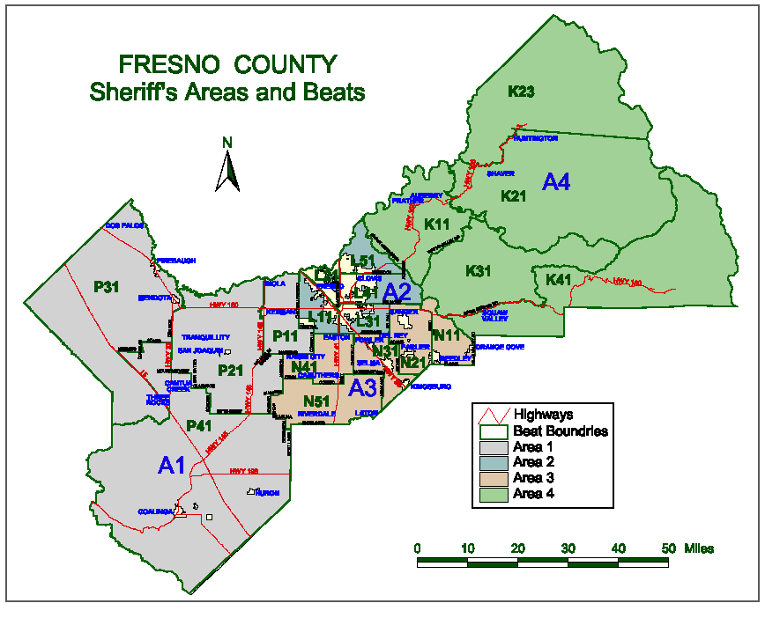

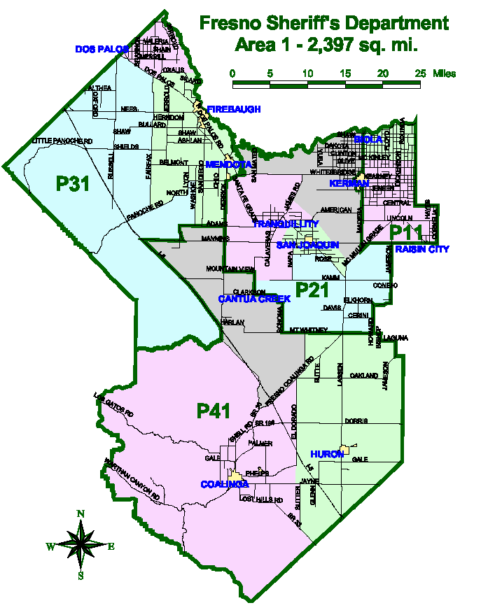
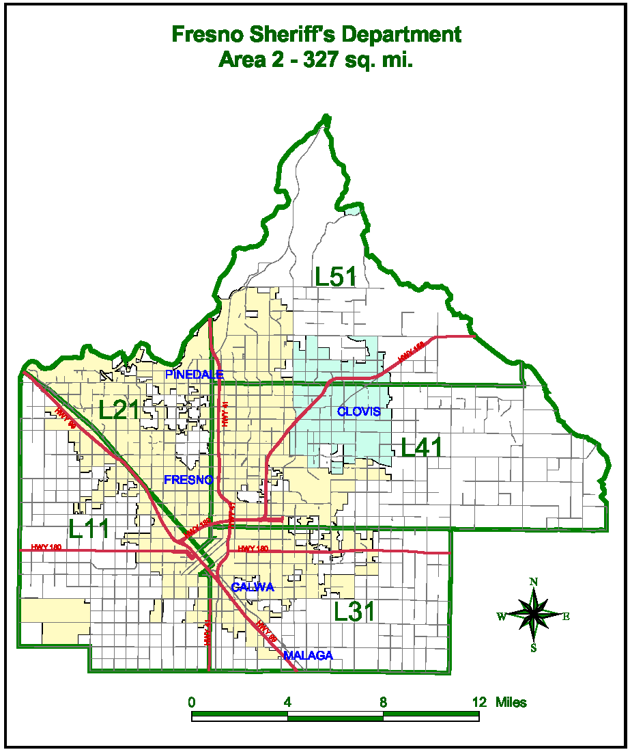

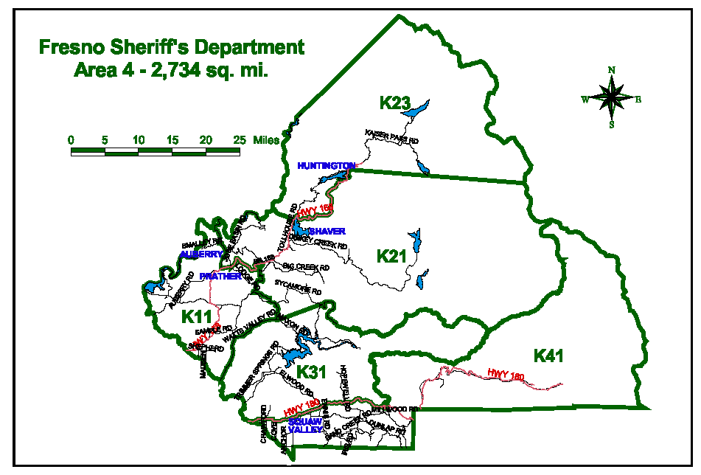
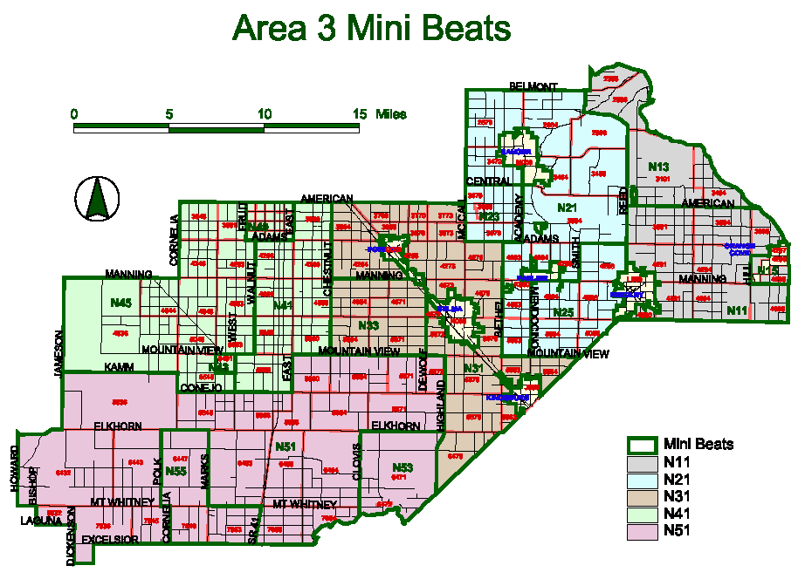

QUOTATION SCHEDULE
Company Name
All labor, materials, equipment, permits, fees, taxes, insurances, licenses and vehicles etc., to perform towing services as specified within this Request for Quotation No. 962-4480.
Bidders are requested to submit their pricing on any or all areas in which they are interested. The County would prefer areas to be bid on as a whole, but will consider quotes on individual beats within the areas.
Sheriff’s Areas and Beats |  |  | Price Per Tow
Area 1 | (All Beats) |  | $
Beats: | P11 |  | $
 | P21 |  | $
 | P31 |  | $
 | P41 |  | $
Area 2 | (All Beats) |  | $
Beats: | L11 |  | $
 | L21 |  | $
 | L31 |  | $
 | L41 |  | $
 | L51 |  | $
Area 3 | (All Beats) |  | $
Beats: | N11 |  | $
 | N21 |  | $
 | N31 |  | $
 | N41 |  | $
 | N51 |  | $
Area 4 | (All Beats) |  | $
Beats: | K11 |  | $
 | K21 |  | $
 | K23 |  | $
 | K31 |  | $
 | K41 |  | $
Bidder to state response time after notification of a required tow. |  |  |  | hours

Company Name
CHECK LIST
This Checklist is provided to assist the vendors in the preparation of their bid response. Included in this list, are important requirements and is the responsibility of the bidder to submit with the bid package in order to make the bid compliant. Because this checklist is just a guideline, the bidder must read and comply with the bid in its entirety.
Check off each of the following:
The Request for Quotation (RFQ has been signed and completed.
One (1) original and two (2) copies of the RFQ have been provided.
Addendums, if any, have been completed, signed and included in the bid package.
The completed Reference List as provided with this RFQ.
The Quotation Schedule as provided with this RFQ, has been completed, priced reviewed for accuracy and any corrections initialed in ink.
Indicate all of bidder exceptions to the County’s requirements, conditions and specifications as stated within this RFQ.
Bidder to Complete page as provided with this RFQ.
Lastly, on the LOWER LEFT HAND CORNER of the sealed envelope, box, etc. transmitting your bid, attach the “Request for Quotation Label” and include the following information:

County of Fresno RFQ No. |  |  | 962-4480
Closing Date: | September 26, 2007
Closing Time: | 2:00 P.M.

Commodity or Service:
This Checklist does not need to be returned with your bid.

