COUNTY OF FRESNO
ADDENDUM NUMBER: ONE (1)
 |  |  | RFQ NUMBER:
October 25, 2006
 |  |  |  | PURCHASING USE
 |  | ORG/Requisition: / |  |  | jlg | /tmp/in/input.doc
 | IMPORTANT: SUBMIT QUOTATION IN SEALED PACKAGE WITH QUOTATION NUMBER, CLOSING DATE AND BUYER’S NAME MARKED CLEARLY ON THE OUTSIDE TO:
COUNTY OF FRESNO, Purchasing
4525 EAST HAMILTON AVENUE
FRESNO, CA 93702-4599
Closing date of bid will be at 2:00 p.m., on November 7, 2006.
QUOTES WILL BE CONSIDERED LATE WHEN THE OFFICIAL PURCHASING TIME CLOCK READS 2:00 P.M.
 | Quotes will be opened and publicly read at that time. All quotation information will be available for review after contract award.
 | Clarification of specifications are to be directed to: Cathi J. Peters, phone (559) 456-7110, FAX (559) 456-7831.
NOTE THE following and attached ADDITIONS, DELETIONS AND/or CHANGES TO THE REQUIREMENTS OF REQUEST FOR QUOTATION NUMBER: AND INCLUDE THEM IN YOUR RESPONSE. PLEASE SIGN AND RETURN THIS ADDENDUM WITH YOUR QUOTATION.
- Attachment “A” – Clarifications from Bidder’s Conference, October 16, 2006, 10:00 A.M.
- Attachment “B” – Bid List
- Attachment “C” – Vendor Conference Sign-Up Sheet
- Attachment “D” – List of County Holidays
- Attachment “E” – Questions received from Vendors

ACKNOWLEDGMENT OF ADDENDUM NUMBER ONE (1) TO RFQ
COMPANY NAME:
(PRINT)
SIGNATURE:
NAME & TITLE:
(PRINT)
ATTACHMENT “a”
CLARIFICATIONS FROM BIDDER’S CONFERENCE, GROUP I, OCTOBER 16, 2006

Clarification requested for Specific Bid Requirements, Item N, regarding penalty for late sample analysis.

The paragraph is intended to state that analysis will be performed again free of charge, in such case that initial analysis time expires.

Will rush charges be allowed if needed?

Rush situations are not foreseen by the County. However, if the County requests rush service, the RFQ does have a section which describes Emergency Testing Services (pg 20).

Clarification requested for Specific Bid Requirements, Item S, regarding changes which will potentially incur additional extensive costs.

So far, the County has not encountered changes which have incurred extensive costs. The County will communicate with vendor to amend the Agreement in order to address additional costs, should such a case develop.

Will electronic reporting be required?

Electronic reporting is required by the State Water Resources Control Board (SWRCB) for all of the sites which have a detection monitoring program under WDRs. However, the County has an Agreement in place with a consultant to perform the electronic reporting into the State’s GeoTracker system. The laboratory will not be required to perform such electronic reporting to the State, though the data must be prepared in an Electronic Deliverable Format as required by the State and submitted directly to the County’s consultant. The lab will also be required to submit the data to the County’s consultant in a more user friendly format for consultant’s ease in entering data into existing database/data spreadsheets.

Can any of the inorganic analysis methods listed in Panel 6 of Group I be changed?

Please see answer to Question 1 in Section Questions Received 10/19/2006 From BC Laboratories.

Will charges be allowed for Trip Blanks?

No. Our research has determined that previous contract laboratories have not charged for analysis of trip blanks. The current contract laboratory does not charge for the analysis of trip blanks.

Will charges be allowed for re-runs?

We have not recently had the need to request a sample be re-analyzed. However, if a re-analysis is requested due to doubt of a reported value, we feel that it would be fair that if a re-analysis confirms the original result, then the County would pay the cost of the second analysis. However, if the re-analysis agrees with historical/expected data, then the lab would not charge the County for the re-analysis of that sample.

Should the page describing Emergency Testing Services on page 20 of the RFQ be filled out by vendor for additional unexpected costs?

Yes.
Additional Information:
CHECK LIST, Page 41, Item 2, there has been a change in County Policy, delete in its entirety. The Federal Employers Identification Number or Social Security Number will be requested only if needed.
Each vendor shall submit with their bid a standard rate sheet for all analytical services which they perform, which can be used for analyses under extra services if necessary.
ATTACHMENT “b”
Bid List
APPL, Inc.  4203 W. Swift Ave.  Fresno, CA 93722 | JL Analytical Services, Inc.  217 Primo Way  Modesto, CA 95358-5749
BC Laboratories  4100 Atlas Court  Bakersfield, CA 93308 | Sparger Technology  3738 Bradview Dr  Sacramento, CA 95827
BSK Analytical Laboratories  1414 Stanislaus Street  Fresno, CA 93706 | Twining Laboratories  2527 Fresno Street  Fresno, CA 93721
Clayton Environmental  1252 Quarry Lane  P.O. Box 9019  Pleasanton, CA 94566 | CalScience Labs  7440 Lincoln Way  Garden Grove, CA 92841
Dellavalle Laboratory, Inc.  1910 W. McKinley #110  Fresno, CA 93728 | Test America  885 Jarvis Drive  Morgan Hill, CA 95037

Attachment “C”
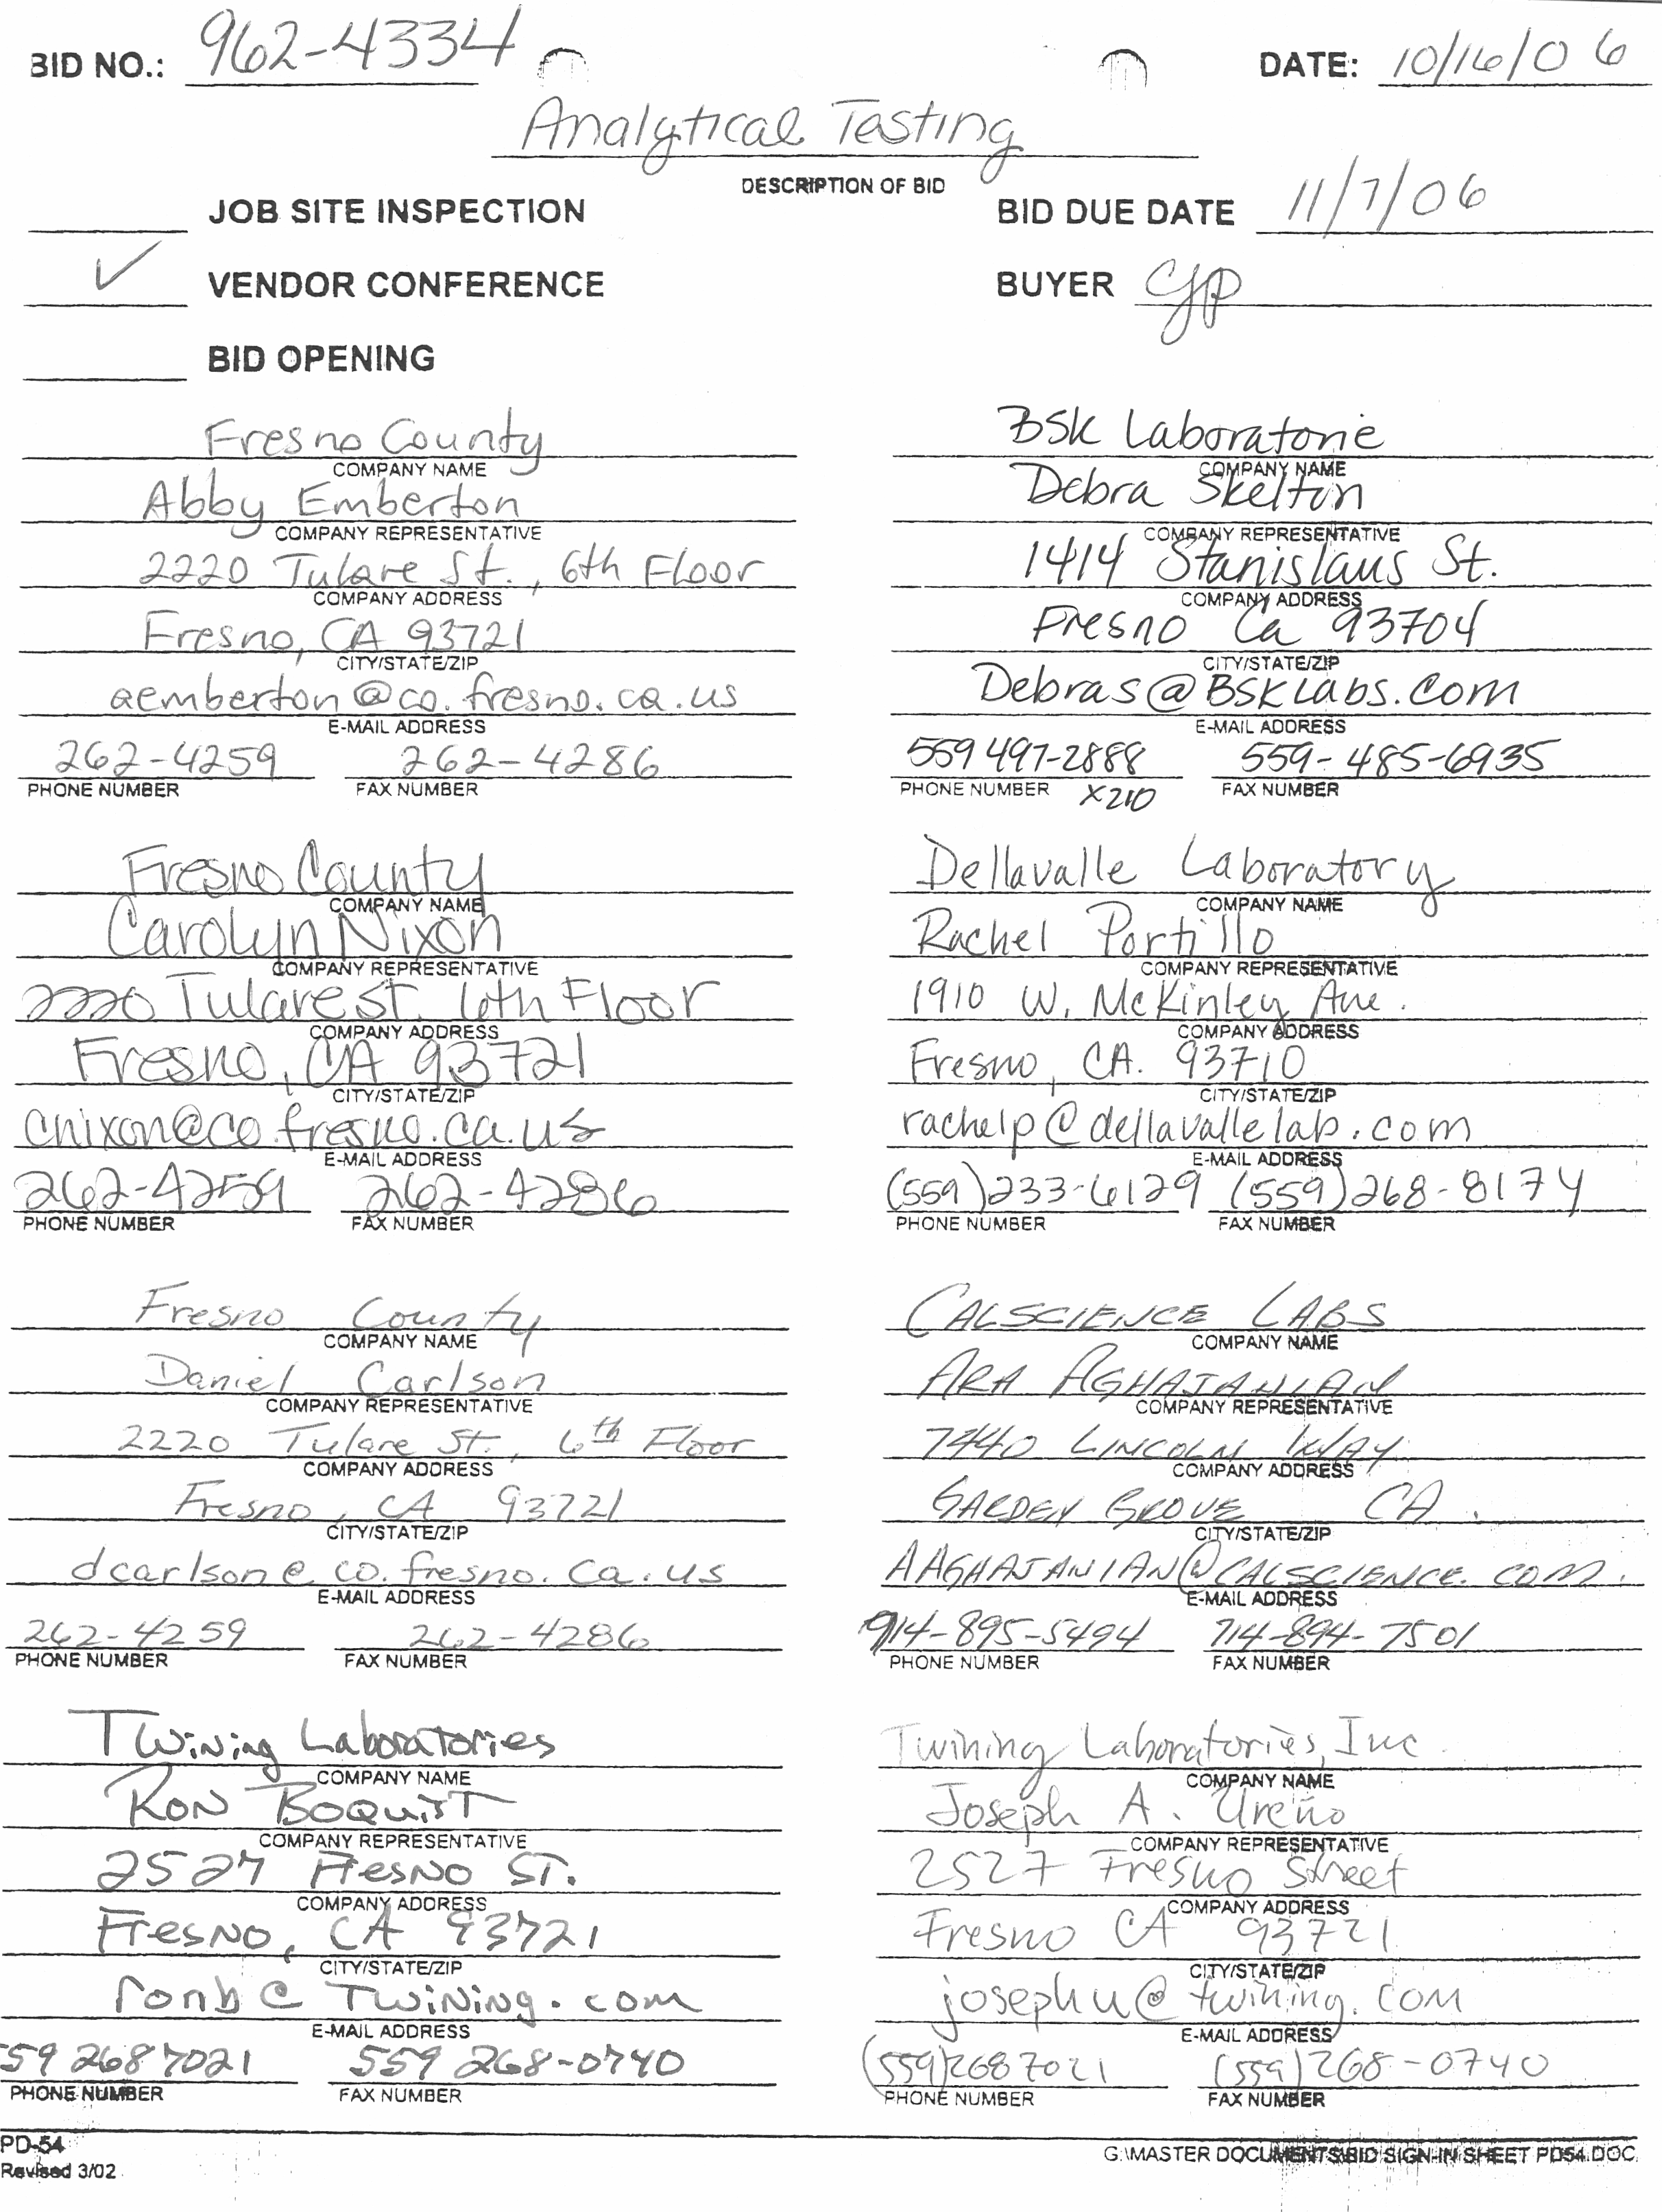
attachment “d”
COUNTY HOLIDAYS
- New Year’s Day, January 1st
- Washington-Lincoln Day, 3rd Monday in February
- Caesar Chavez, March 31st
- Memorial Day, last Monday in May
- Independence Day, July 4th
- Labor Day, first Monday in September
- Veteran’s Day, November 11th
- Christmas, December 25th
- Thanksgiving, 4th Thursday/Friday in November
- Every Monday following a Sunday which falls on January 1st, July 1st , November 11th, or December 25th.
- Every Friday when such Friday immediately precedes July 4th,
- November 11th, December 25th, or January 1st.
- Friday following Thanksgiving
- Martin Luther King Day, 3rd Monday in January
ATTACHMENT “E”
- QUESTIONS RECEIVED FROM CALSCIENCE ENVIRONMENTAL LABORATORIES, INC. OCTOBER 5, 2006
  - Question:
Can we assume that the County would deliver samples during designated time at County’s expenses to a specified designated location (not laboratory location) within the Fresno/Clovis Metropolitan area?
Answer:
If the laboratory is located outside the Fresno/Clovis Metro area, the County will deliver samples during a designated time at County’s expense to a location specified by the County (not laboratory location) within the Fresno/Clovis Metro area for the lab to pickup.
  - Question:
Group I-Disposal Sites Specific Bid Requirements Clause Q states that the bidders shall submit an example of an analysis report with their responses to this RFQ for each of the panels listed in exhibit “A”. Attached Exhibit “A” does not identify any Panels, please clarify request and identify specific list of panels bidder must provide sample report.
Answer:
The reference to Exhibit “A” in this section is incorrect. The Panels referred to are located on pages 21-28 of the RFQ.
  - Question:
Group I Panel 5, please clarify quantity of samples. Is the quantity of 35 samples for full list of Semivolatile Organics (8270) or for Bis(2-ethylene) Phthalate only.
Answer:
First, the constituent is Bis(2-ethylhexyl) phthalate, not Bis(2-ethylene) phthalate. Second, the quantity of 35 samples for Group I Panel 5 is for Bis(2-ethylhexyl) phthalate only.
  - Question:
Group I Panel 5 Chlorinated Pesticides are included in Panel 5 list specifiying EPA 8270. Standard EPA method for Chlorinated Pesticides is EPA 8081A. Can EPA 8081A be substituted for EPA 8270 for Chlorinated Pesticides?
Answer:
No. The Waste Discharge Requirements (WDRs) specify that USEPA Method 8270 be used for the analysis of these constituents and previous laboratories have complied with this requirement.
  - Question:
Would the County consider partial bids for either Group I or II?
Answer:
No; however, laboratories may subcontract some analyses which they do not perform “in-house”. County will accept work performed by sub-vendor(s) to the primary vendor. However, the primary vendor should be aware of deadlines to be adhered to and time activities accordingly. The primary vendor is ultimately responsible to submit all lab reports and other work on time.
  - Question:
Group II Special Districts Specific Bid Requirements Page 34; Please define complete title 22 if this is for drinking water or wastewater?
Please define Parameters for title 22 (please identify all tests required and preferred EPA test methods)
Answer:
Title 22 is for drinking water. Attached is a sample of Title 22 tests for Juvenile Justice Campus. The County of Fresno relies on certified Labs to have the capabilities for theses tests. The Health Department reserves the right to change monitoring schedules annually. See Exhibit “H” attached
- QUESTIONS RECEIVED FROM TWINING LABORATORIES INC. OCTOBER 12, 2006
  - Question:
It appears that the Group II testing focuses primarily on drinking water parameters with a few wastewater items added. What about some of the other wastewater testing such as ; Total Suspended Solids, Settleable Matter, Ammonia, Standard Minerals, Total Nitrogen…to name a few?
Answer:
Ten (10) tests were omitted from the Quotation Schedule. See Revised Page 39.
  - Question:
Group I, Panel 3A: This panel lists analysis by EPA 601 and 602. Per the Clean Water Act 40 CFR 136.3 Table IC, EPA 624 is an approved method; therefore may we substitute EPA 624 which lists the same target analytes and detection limits?
Answer:
EPA 601 and 602 are specifically listed by the Regional Water Quality Control Board (RWQCB) in the Waste Discharge Requirements (WDRs). However, substitution of EPA 624 should be acceptable if the list of analytes remains the same and subject to approval by the California Regional Water Quality Control Board (RWQCB).
  - Question:
Group II Individual Analytes: Providing specific test pricing for groups such as: Primary Standards, Secondary Standards and General Minerals is rather straight forward, but it is much more difficult for every analyte within the VOC or SOC methods. Whereas the aforementioned methods are made up of a group of test methods, the VOC/SOC tests are a single test method (when you run for one target analyte, you get them all) For this reason, most VOC/SOC bids are “flat rates” with some adjustments made for the number of target analytes reported.
If we were to bid a “flat rate” for each target analyte, assuming only one analyte would be requested at a time, then the total bid would be skewed extremely high ( 27 VOCs & 32 SOCs x 55 samples = 3,245 analysis x “fee” = some huge dollar value).
If we were to bid a “per analyte” rate by taking the VOC/SOC analyses rate divided by the number of analytes, then the bid would be skewed extremely low. If only one analyte was requested, then we would not be able to recover the cost of testing.
A third option would be to have a “base fee” for these tests plus a per analyte charge.
Answer:
Bid in accordance with Quotation Schedule provided with Request for Quotation.
- Question received 10/18/2006 from Calscience
During the meeting on Monday Oct 16th I was provided with the following additional information re Group I Disposal Sites.
- Partial Table of Contents for Standard Provisions & Reporting Requirements For Title 27 (CCR 20005, et seq.) and Subtitle D (40 CFR 258) April 2000
- Waste Discharge Requirements & Monitoring & Reporting Program for the Following Sites
  - American Avenue Disposal Site
  - Mendota Solid Waste Disposal Site
  - Southeast Regional Disposal Site
  - Coalinga Disposal Site
Group I Disposal Sites Page 13 of the RFQ lists 3 additional Disposal Sites they are
- Del Rey Disposal Site (WE DO NOT HAVE INFORMATION)
- Meadow Lake Disposal Site (WE DO NOT HAVE INFORMATION)
- Riverdale Disposal Site (WE DO NOT HAVE INFORMATION)
  - Question:
Can we assume that the information for the missing sites would be same as the information contained in the other sites?
Can you provide the missing information?
ANSWER
No Waste Discharge Requirements (WDRs) are missing. Not all sites which we may sample have WDRs. Only American Ave., Coalinga, Mendota, and Southeast Regional have WDRs. The Del Rey, Riverdale, and Meadow Lakes sites currently have no WDRs.
- Questions received 10/19/2006 from BC LABORATORIES
  - Question
Can the following method(s) be substituted for EPA 6020?
Arsenic | EPA 7061
Lead | EPA 7421
Nickel | EPA 7520
Selenium | EPA 7741
Thallium | EPA 7841
ANSWER
We have previously approved, including approval by the RWQCB, the substitution of EPA Method 200.8 for each of the above analytes. The reporting limits should remain the same. We have not approved, nor received approval from the RWQCB, for the substitution of EPA Method 6020 for the above constituents.
  - Question
Can we request to have Mark Ellis (with BC Laboratories) review the old contract in your facility?
ANSWER
Vendors may review the existing Agreements with B.C. Laboratories (Agreement 240141E) and Twining Laboratories (Agreement 240145E) during normal business at the County of Fresno Purchasing Office, 4525 E. Hamilton Ave., Fresno, CA 93702. Contact Cathi Peters or Gary Parkinson at (559) 456-7110 for appointment.
- Questions received 10/19/2006 from Twining Laboratories Inc.
  - Question:
Group I, Panel 3A: This panel lists analysis by EPA 601 and 602.Per the Clean Water Act 40 CFR 136.3 Table IC,EPA 624 is an approved method: therefore may we substitute EPA 624 which lists the same target analytes and detection limits. We understand that you’re looking only for the specific lists of target analystes stated in Panel 3A
ANSWER
Duplicate Question; see Questions received 10/12/06 from Twining
  - Question:
Group 1, Panel 6: We would like to substitute the following if possible:
- Arsenic by 7061 to 7060A or 7062
- Selenium by 7741 to 7740A
ANSWER
Arsenic by 7062 is acceptable, as it is the stated method in the Waste Discharge Requirements (WDRs) for the American Avenue Landfill. The reference to arsenic by method 7061 in the RFQ is incorrect. It should be by method 7062.
Selenium by 7740A is NOT ACCEPTABLE as the method specified in the WDRs for the American Avenue Landfill is 7742. The reference to selenium by method 7741 in the RFQ is incorrect. It should be by method 7742.
  - Question:
It appears that the Group II testing focuses primarily on drinking water parameters with a few wastewater items added. What about some of the other wastewater testing such as ; Total Suspended Solids, Settleable Matter, Ammonia, Standard Minerals, Total Nitrogen…to name a few?
Answer:
Duplicate Question, see Questions received 10/12/06 from Twining
  - Question:
Group II Individual Analytes: Providing specific test pricing for groups such as: Primary Standards, Secondary Standards and General Minerals is rather straight forward, but it is much more difficult for every analyte within the VOC or SOC methods. Whereas the aforementioned methods are made up of a group of test methods, the VOC/SOC tests are a single test method (when you run for one target analyte, you get them all- Please refer to attached chromatographic example) For this reason, most VOC/SOC bids are “flat rates” with some adjustments made for the number of target analytes reported.
- If we were to bid a “flat rate” for each target analyte, assuming only one analyte would be requested at a time, then the total bid would be skewed extremely high (27 VOCs & 32 SOCs x 55 samples = 3,245 analysis x “fee” = some huge dollar value).
- If we were to bid a “per analyte” rate by taking the VOC/SOC analyses rate divided by the number of analytes, then the bid would be skewed extremely low. If only one analyte was requested, then we would not be able to recover the cost of testing.
- A third option would be to have a “base fee” for these tests plus a per analyte charge.
Answer:
Duplicate Question, see Questions received 10/12/06 from Twining
  - Question:
Trip Blanks: For those sampling events that require results of Trip Blanks to be reported, will those samples be considered billable?
Answer:
No. The County’s research has determined that previous contract laboratories have not charged for analysis of trip blanks. The current contract laboratory does not charge for the analysis of trip blanks.
  - Question:
Re-evaluation of analytical reports: If reanalyses of a sample is requested due to reasonable doubt of a reported value, we would like to propose that if a similar value is obtained the second time, the second analysis would be billable. If the second analyses agree with historical/expected data, then there would be no additional charge to the County.
Answer:
The County has not recently had the need to request a sample be re-analyzed. However, if a re-analysis is requested due to doubt of a reported value, we feel that it would be fair that if a re-analysis confirms the original result, then the County would pay the cost of the second analysis. However, if the re-analysis agrees with historical/expected data, then the lab would not charge the County for the re-analysis of that sample.
- Questions received 10/20/2006 from BC LABORATORIES
  - Question:
Group II - Cost per sample/Estimated Annual Cost (VOC's and Complete SOC's) The listed individual compounds price should it be equal with Complete VOC/SOC price?
Answer: NO
- Questions received 10/20/2006 from BSK LABORATORIES
After of the RFQ identified above we have a couple questions on which we would like clarification. Any help would be greatly appreciated:
  - All questions pertain to the RFQ “Group II” Section:
- Item D: “Samples to be delivered mid-late afternoon”. We assume that all samples will be delivered to the lab the same day of sample collection. Is this correct?
Yes
- Item P: References acceptable analytical compendiums. We assume that California DHS approved “Standard Methods for the Examination of Water and Wastewater” procedures can be used as acceptable equivalent test methods?
Yes
- Item P Q: “Indicates that electronic data submission may be directed to the RWQCB”. If this is requested will the “Geotracker” EDD format be required?
Yes
Group II Price Sheet
- Individual Radioactivity: Radium is listed as “Radium 226 + 228”. We assume this to mean the county wants individual test results for Radium 226 and for Radium 228 vs. a single combined Radium (226 + 228) value?
Yes
- Individual Unregulated Chemicals lists 1,2,3-TCP. We assume this would be by the low-level CDHS Method?
Yes
- The “Cost per Sample” section requests costs for both groups of compounds listed in Title 22 as well as prices for individual compounds within a group, and, a grand total of all the extended prices. Will the “grand total” cost be used for cost comparison between the participating laboratories, or will individual line items be compared? If the total cost is the primary comparative value it would seem that the incumbent laboratory could have a bidding advantage based on the manner in which the County has made their historical analytical requests on these sites .
See award Information, General Conditions Page 1B, Number 6 “AWARDS” and Page 4, Bidding Instructions “AWARD”.
“Award will be made to the vendor(s) offering the services deemed to be to the best advantage of the County. The County shall be the sole judge in making such determination. The County reserves the right to make multiple awards.”
- Questions received 10/23/06 from TESTAMERICA:
  - QUESTION:
What will be the frequency of pick-ups for the disposal site/for water/wastewater samples?
ANSWER: Group 1 – Currently, samples will need to be picked up approximately 20 times each semi-annual period. However, this is subject to change.
Group II - Daily
  - QUESTION:
Will we be able to substitute alternate analytical methods?
ANSWER: Group 1 – Please see other responses in this addendum. Any additional proposed substitutions are subject to review, including MDLs and PQLs, for possible approval by the County and the Regional Water Quality Control Board.
Group II – Any proposed substitutions are subject to review by the County.
  - QUESTION:
Will required reporting limits be made available?
ANSWER: Group 1 – The regulations have no specific reporting limits for each method. However, each lab should submit reporting limits, including MDLs and PQLs as appropriate for each constituent and method as part of the example lab reports required to be submitted with their bid package.
  - QUESTION:
Can we group analysis cost for items in Group II. (Such as metals & VOC that will perform under the same analytical methods.) Bid as per Quotation Schedule
  - QUESTION:
Are the 1X10 & 3X5 Coliform samples waste water samples?
  - QUESTION:
How is “lab error” defined?
ANSWER: Group 1 and II – Where is it used in the RFQ?
  - QUESTION:
Will the current rates be made available?
ANSWER: See Addendum Page 10
→ NOTE: Questions received from TESTAMERICA were received after the cutoff time, Resources Group II unable to respond on some questions.

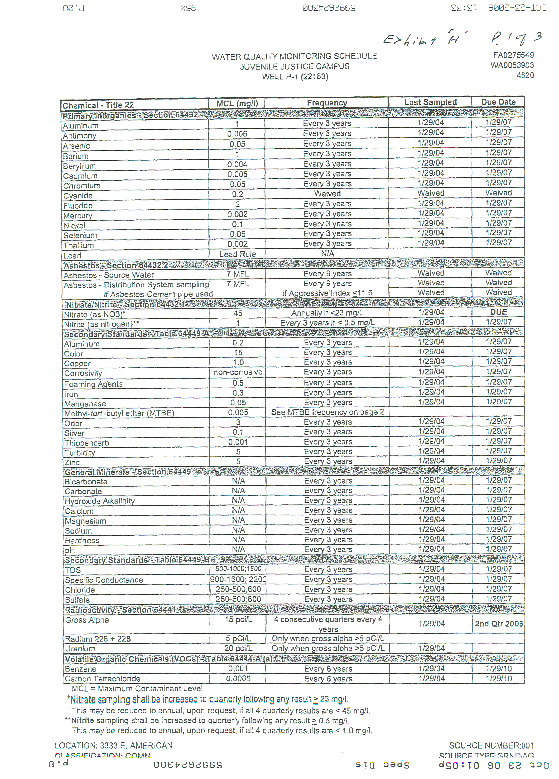
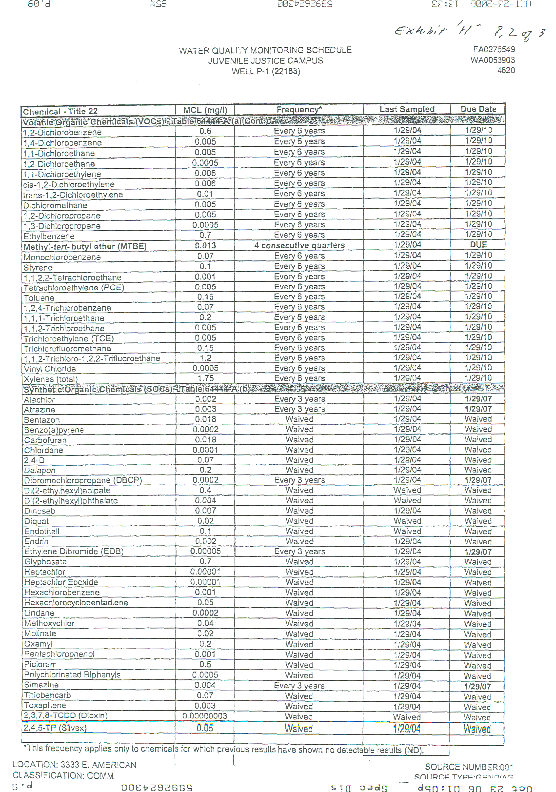
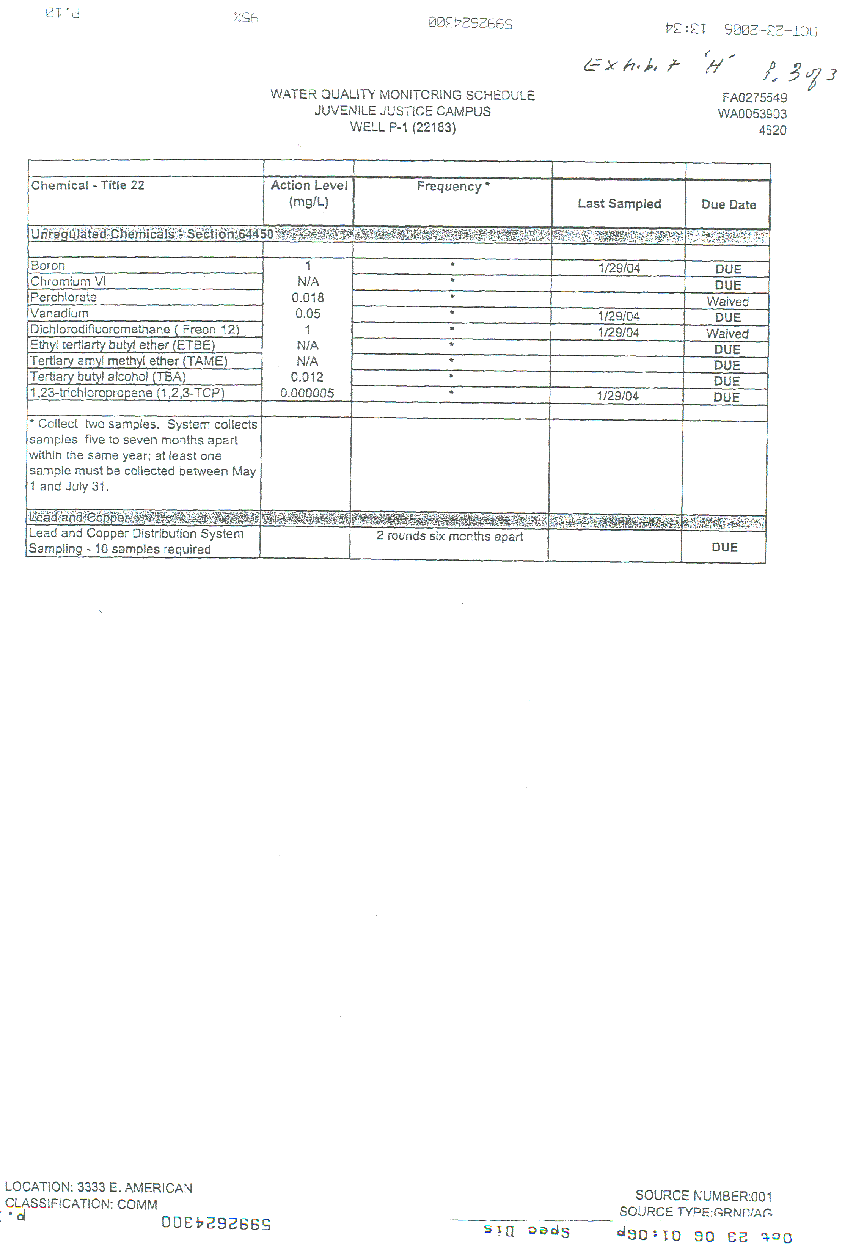

Oxamyl | $ | per test x 55 estimated tests per year | = | $
Penthachlorophenol | $ | per test x 55 estimated tests per year | = | $
Picloram | $ | per test x 55 estimated tests per year | = | $
Polychlorinated Biphenyls | $ | per test x 55 estimated tests per year | = | $
Simazine | $ | per test x 55 estimated tests per year | =
Thiobencarb | $ | per test x 55 estimated tests per year | = | $
Toxaphene | $ | per test x 55 estimated tests per year | = | $
2,3,7,8-TCDD (Dioxin) | $ | per test x 55 estimated tests per year | = | $
2,4,5-TP (Silvex) | $ | per test x 55 estimated tests per year | = | $
Complete Unregulated Chemicals | $ | per test x 55 estimated tests per year | = | $
Individual Unregulated Chemicals:
Boron | $ | per test x 55 estimated tests per year | = | $
Chromium VI | $ | per test x 55 estimated tests per year | = | $
Dichlorodifluoromethane (Freon 12) | $ | per test x 55 estimated tests per year | = | $
Ethyl Tert-Butyl Ether (ETBE) | $ | per test x 55 estimated tests per year | = | $
Perchlorate | $ | per test x 55 estimated tests per year | = | $
Tert-Amyl Methyl Ether (TAME) | $ | per test x 55 estimated tests per year | = | $
Tert-Butyl Alcohol (TBA) | $ | per test x 55 estimated tests per year | = | $
1,2,3-Thrichloropropane (TCP) | $ | per test x 55 estimated tests per year | = | $
Vanadium | $ | per test x 55 estimated tests per year | = | $
B.O.D. | $ | per test x 1460 estimated tests per year | = | $
Nitrate | $ | per test x 104 estimated tests per year | = | $
Ammonia | $ | per test x 104 estimated tests per year | = | $
Sulfates | $ | per test x 104 estimated tests per year | = | $
Total Coliform | $ | per test x 104 estimated tests per year | = | $
Chloride | $ | per test x 104 estimated tests per year | = | $
Total Suspended Solids | $ | per test x 1055 estimated tests per year | = | $
Settable Matter | $ | per test x 1055 estimated tests per year | = | $
Standard Minerals | $ | per test x 1055 estimated tests per year | = | $
Total Nitrogen | $ | per test x 1055 estimated tests per year | = | $
TOTAL ANNUAL COST |  |  | $

