COUNTY OF FRESNO
ADDENDUM NUMBER: TWO (2)
 |  | RFP NUMBER:
June 2, 2005
 |  |  | PURCHASING USE
 | ORG/Requisition: 34300300/ 3435000488 |  |  | jol | /tmp/in/input.doc
IMPORTANT: SUBMIT PROPOSAL IN SEALED PACKAGE WITH PROPOSAL NUMBER, CLOSING DATE AND BUYER’S NAME MARKED CLEARLY ON THE OUTSIDE TO:
COUNTY OF FRESNO, Purchasing
4525 EAST HAMILTON AVENUE
FRESNO, CA 93702-4599
Closing date of proposal will be at 2:00 p.m., on JUNE 20, 2005.
PROPOSALS WILL BE CONSIDERED LATE WHEN THE OFFICIAL PURCHASING TIME CLOCK READS 2:00 P.M.
Proposals will be opened and publicly read at that time. All proposal information will be available for review after contract award.
Clarification of specifications are to be directed to: KEN VOZZA, phone (559) 456-7110, FAX (559) 456-7831.
NOTE THE attached ADDITIONS, DELETIONS AND/OR CHANGES TO THE REQUIREMENTS OF REQUEST FOR PROPOSAL NUMBER: AND INCLUDE THEM IN YOUR RESPONSE. PLEASE SIGN AND RETURN THIS ADDENDUM WITH YOUR PROPOSAL.

ACKNOWLEDGMENT OF ADDENDUM NUMBER TWO (2) TO RFP
COMPANY NAME:
(PRINT)
SIGNATURE:
NAME & TITLE:
(PRINT)

Vendor questions and comments have been submitted to the County’s Purchasing Division in accordance with the instructions stated in RFP No. 961-4096. Certain of those submittals have been deemed pertinent to the preparation of the Vendor’s Proposal. As such, responses to those items are provided below.
Certain other vendor submittals have not warranted a response for one or more of the following reasons:
    - Item not material or pertinent to the preparation of a proposal.
    - Item previously addressed in the original RFP document.
    - Item not related to this RFP.
    - Item sought pre-approval of something the vendor should propose in his/her proposal.
    - Item requested a change to the RFPs stated requirements and/or conditions. The request was denied.
    - The requested information is not available.
RESPONSES TO PERTINENT VENDOR QUESTIONS AND COMMENTS
      - The attached listing entitled “VENDORS” identifies the companies to whom the County has attempted delivery of this RFP and/or companies known to have downloaded the document from the County’s web site. .
- A partial copy of the current agreement for offender funded EM Services is attached. Fresno County RFP No. 915-3225 and the contractor’s response thereto are incorporated into the agreement by reference but not included as hard copy attachments. Copies of those documents may be viewed at Fresno County Purchasing by appointment. Contact Ken Vozza (559) 456-7110 to schedule.
The agreement has been provided in response to a vendor request. The agreement’s content is excluded from the requirements of this RFP except when and if a specific requirement is also stated in this RFP.
- The current agreement covering the subject services will be extended through 9/30/05.
- Offender Services, LLC is the only vendor with whom the County has contracted for Offender Funded EM services.
- A copy of the document entitled “FRESNO COUNTY PROBATION DEPARTMENT ELECTRONIC MONITORING PROGRAM” is attached. This document describes the program and conditions applicable to the Electronic Monitoring Program.
- The County has no set policy for termination of a participant if they fail to pay. The vendor should propose his/her conditions.
- The current method of notifying the County of offender non-compliance is a phone call followed by a fax. The vendor may offer this method or propose a different method.
- Computers and Internet access are not available to all County Probation Officers. Computers are not available in all offices. Fresno County prohibits the use of third party software for Internet access. Probation Officers do not use pagers.
- History indicates that participants have been enrolled in the program for a period ranging from 30 to 240 days.
- The “PARTICIPATION” section of the RFP (Pg 13) has been included for informational purposes. The Vendor’s response to this section will not affect the scoring of his/her proposal. The vendor is encouraged to complete this section and include it as a part of their Proposal, it is not mandatory. Currently no member of the Central Valley Purchasing Group has indicated a specific interest in piggybacking the ensuing Fresno County agreement.
- The proposal evaluation process will consist of the following.
  - Evaluation Committee to score each proposal in accordance with weighted scoring criteria stated on Page 29 of RFP.
  - The proposals scoring the lowest will be removed from consideration.
  - The proposals scoring the highest will be further evaluated. The Evaluation Committee will select the proposal deemed to best satisfy the County’s requirements. The Fresno County Probation Department will recommend the Committee’s selection to the Fresno County Board of Supervisors.
- The contract term shall remain as originally stated.
- County will not provide office space for the Contractor.
- County requires a minimum of one vendor office location in the Metropolitan Fresno Area.
- Confirmation calls by Case Managers:
The County requires that the contracted Vendor perform supplemental confirmation by personal phone contact as often as is necessary to confirm offender status. The County does not specify a minimum number of such contacts.
- The lowest number of participants in the EM Offender Funded Program within the last year was 22.
- The vendor must propose his/her method for dealing with lost, stolen or damaged equipment. The County will in no way be financially or physically responsible for vendor equipment.
- Investigation of equipment tampering incidents:
The County feels that a 30 minute response time is reasonable. The vendor is to propose their response time. The vendor will also propose where the investigation will be performed.
- Electronic Monitoring Devices:
A. Reference Page 17 of the original RFQ Document.
*The third and fourth paragraphs shall be modified as follows:
These EM devices will be used to electronically record the time period when a probationer leaves and returns to their residence. This is the most basic radio frequency EM system which places a base unit in the probationer’s home. The probationer wears an EM device that electronically transmits a signal via telephone connection to the monitoring center when the probationer leaves their residence for work/school, etc., and when they return from their daily activity or other prearranged, authorized schedules. The device proposed should be of the latest technology for radio frequency EM devices. It can be an ankle or wrist model. An example of acceptable equipment would be the BI 9000 EM device. The equipment offered must perform as proposed on a consistent basis.
The selected vendor will provide, install, maintain, and remove all equipment necessary for this program. The vendor must provide in home service for equipment retrieval, tampering, and malfunction. All other services may be performed at vendor’s office. Transmitters are to be installed in the vendor’s office. The vendor may send the receiver home with the probationer and allow him/her to install. However, the vendor must follow up to verify proper installation. If this is the procedure the vendor wishes to use, he/she must include it in his/her proposal.
* Additions are indicated by bold print.
Deletions are indicated by line out.
- The Vendor’s proposed equipment must be supported by the manufacturer for a minimum period of four years beginning with the ensuing agreement’s effective date. Manufacturer’s support is deemed to include availability of parts and repairs directly from the manufacturer or factory authorized repair dealer for the product offered. Proof of this condition must be made available upon request during the proposal evaluation.
NOTE: The County has successfully used the BI9000 Unit for several years.
- Referrals:
Program participants are referred to the contractor on Mondays. The County expects to have the installation completed by 5:00 P.M. on the following Friday.
Installations are to take place on weekdays between 8:00 A.M. and 5:00 P.M.
Special schedules will be allowed when a County holiday takes place on a weekday.
- Drive-By Systems:
    - The vendor shall propose the quantity of drive-By Units he/she will provide.
    - The County does not pay for Drive-By Units (offender funded)
    - State the cost of providing Drive-By Units in the Cost Proposal section of your proposal (as previously instructed).
- The vendor must verify that the EM equipment has been successfully installed and continues to function properly. The vendor will be required to visit a participant’s home if the unit is malfunctioning due to improper installation or for any other reason. This is required if the problem can not be resolved by other means.
County Personnel will not accompany the Contractor to the participant’s home.
- INSTALLATION and RETREVIAL
    - County’s request to initiate a hook-up will be issued by fax. The program participant will also bring paperwork.
    - Fresno County Employees will not install EM Units .
    - The vendor must make his/her own determination with regard to the appropriate number of installers.
    - The quantity of hook-ups per month ranges from 2 to 10.
    - Fresno County will not store equipment.
    - The County will not revisit its program guidelines that govern a participant’s compliant termination until both pieces of equipment are together in the same place.
    - The quantities of participants returning equipment and contractor picking up equipment are not known.
    - Installs at the participant’s home will be scheduled by the contractor. The County can not and will not guarantee that the participant will keep the appointment. The County should not be liable for any charge if a participant does not keep his/her appointments. The vendor may propose differently.
    - Program participants may reside at any location within Fresno County.
    - The County Officer will not make a home visit with regard to the services requested under this RFQ.
- The financial information requested under Item No. 6 on page 19 of the original RFP document is required and must be provided with your Proposal.
- It is anticipated that the agreement resulting from this RFP will have an effective date of October 1, 2005.
- Proposals will be publicly opened upon the close of this RFP. Proposer names will be publicly announced and attendees will be allowed to review the Proposals.
- The Vendor is instructed to make the following changes to correct administrative errors.
    - Reference Page no. 3; OVERVIEW
Fourth Paragraph
The third work in this paragraph shall be changed from “if” to “is”.
    - REFERENCE PAGE NO. 18
Insert (add) the following immediately following Item H. Demonstration of Equipment.
“I. Acceptance”
    - Reference Page No. 24; Item No. C.I.
Delete the second sentence of Item No. C.I.
The bidder is instructed to acknowledge here that they will not provide the specified services.
VENDORS
See Item No.1 of Addendum No. 2

GENERAL SECURITY SERVICES CORP
SENTINEL MONITORING CORP
LINDA CONNELLY & ASSOCIATES, INC.
PMI INC.
SENTINEL MONITORING
ADT SECURITY SERVICES INC.
STRATEGIC MONITORING SERVICES INC.
MCI
SENTENCING CONCEPTS INC.
ADVANCED BUSINESS SCIENCES INC.
SECURICOR
BI INC.

attachment
agreement

See Item no. 2 of Addendum No. 3

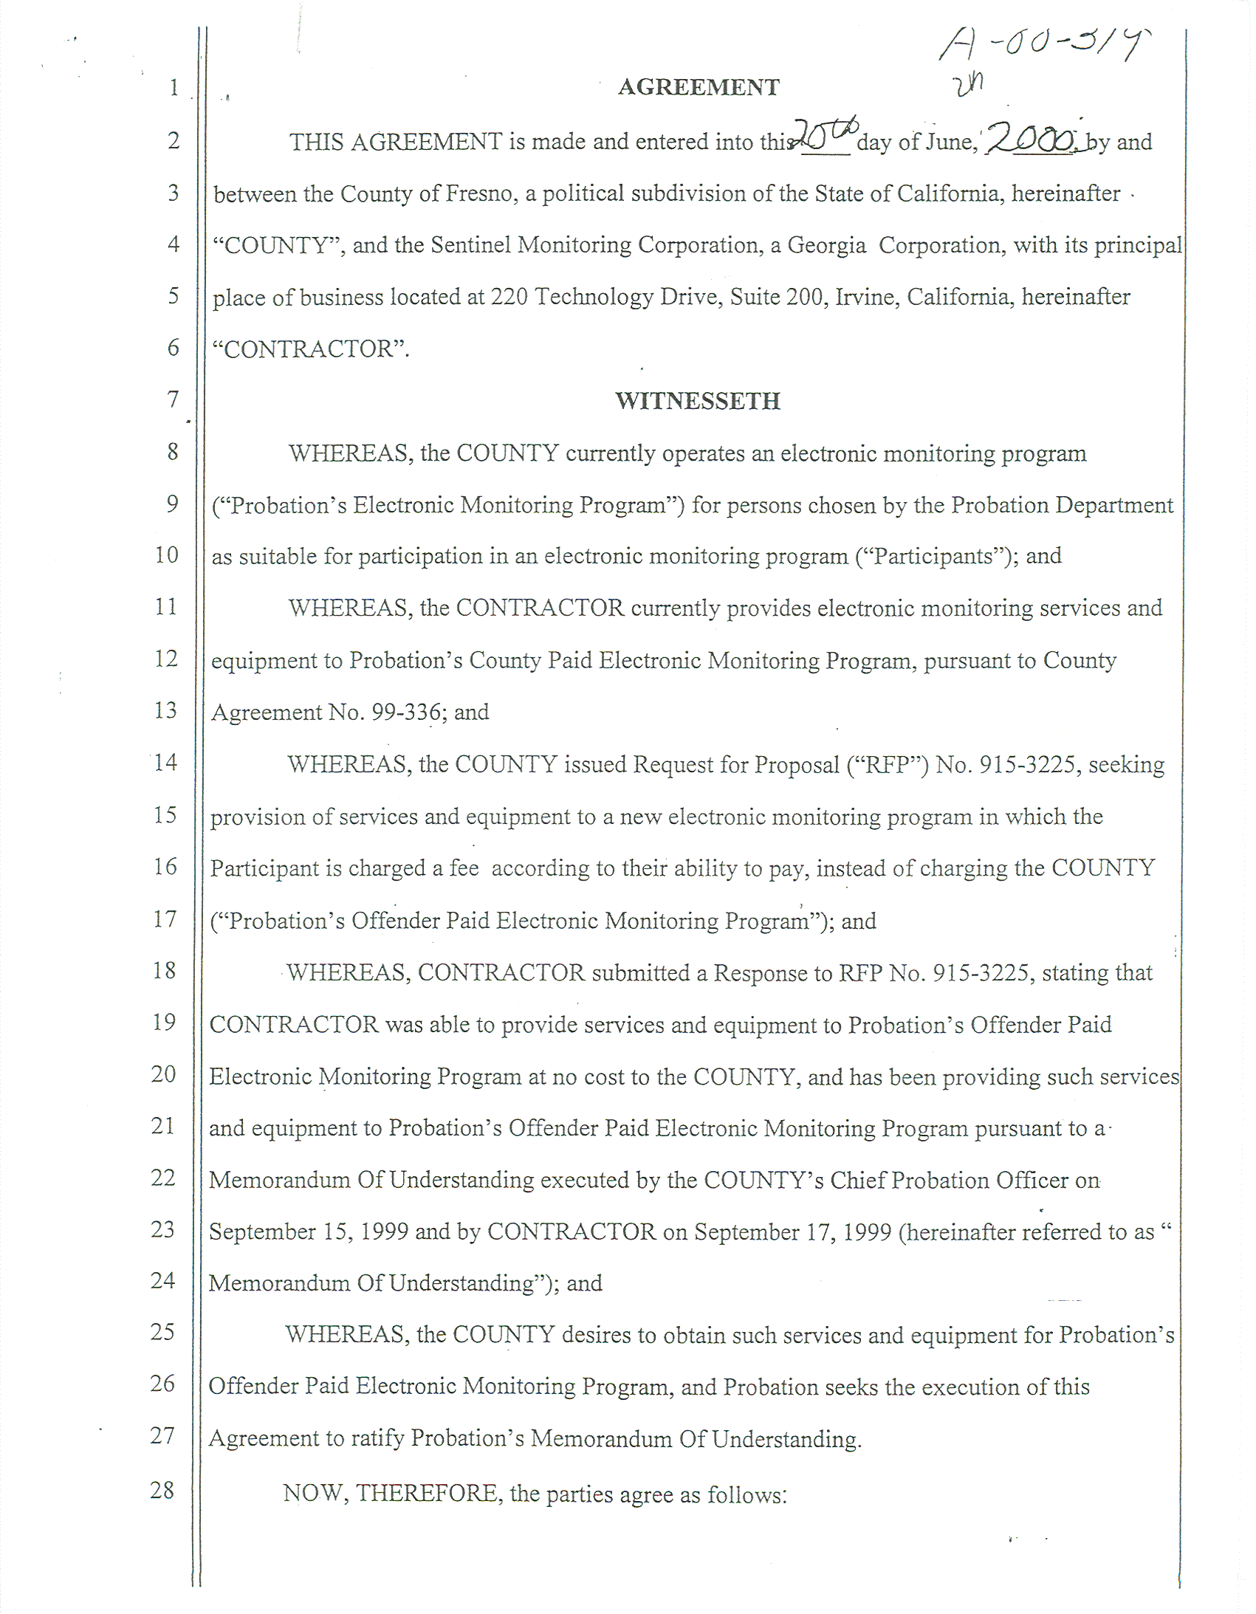
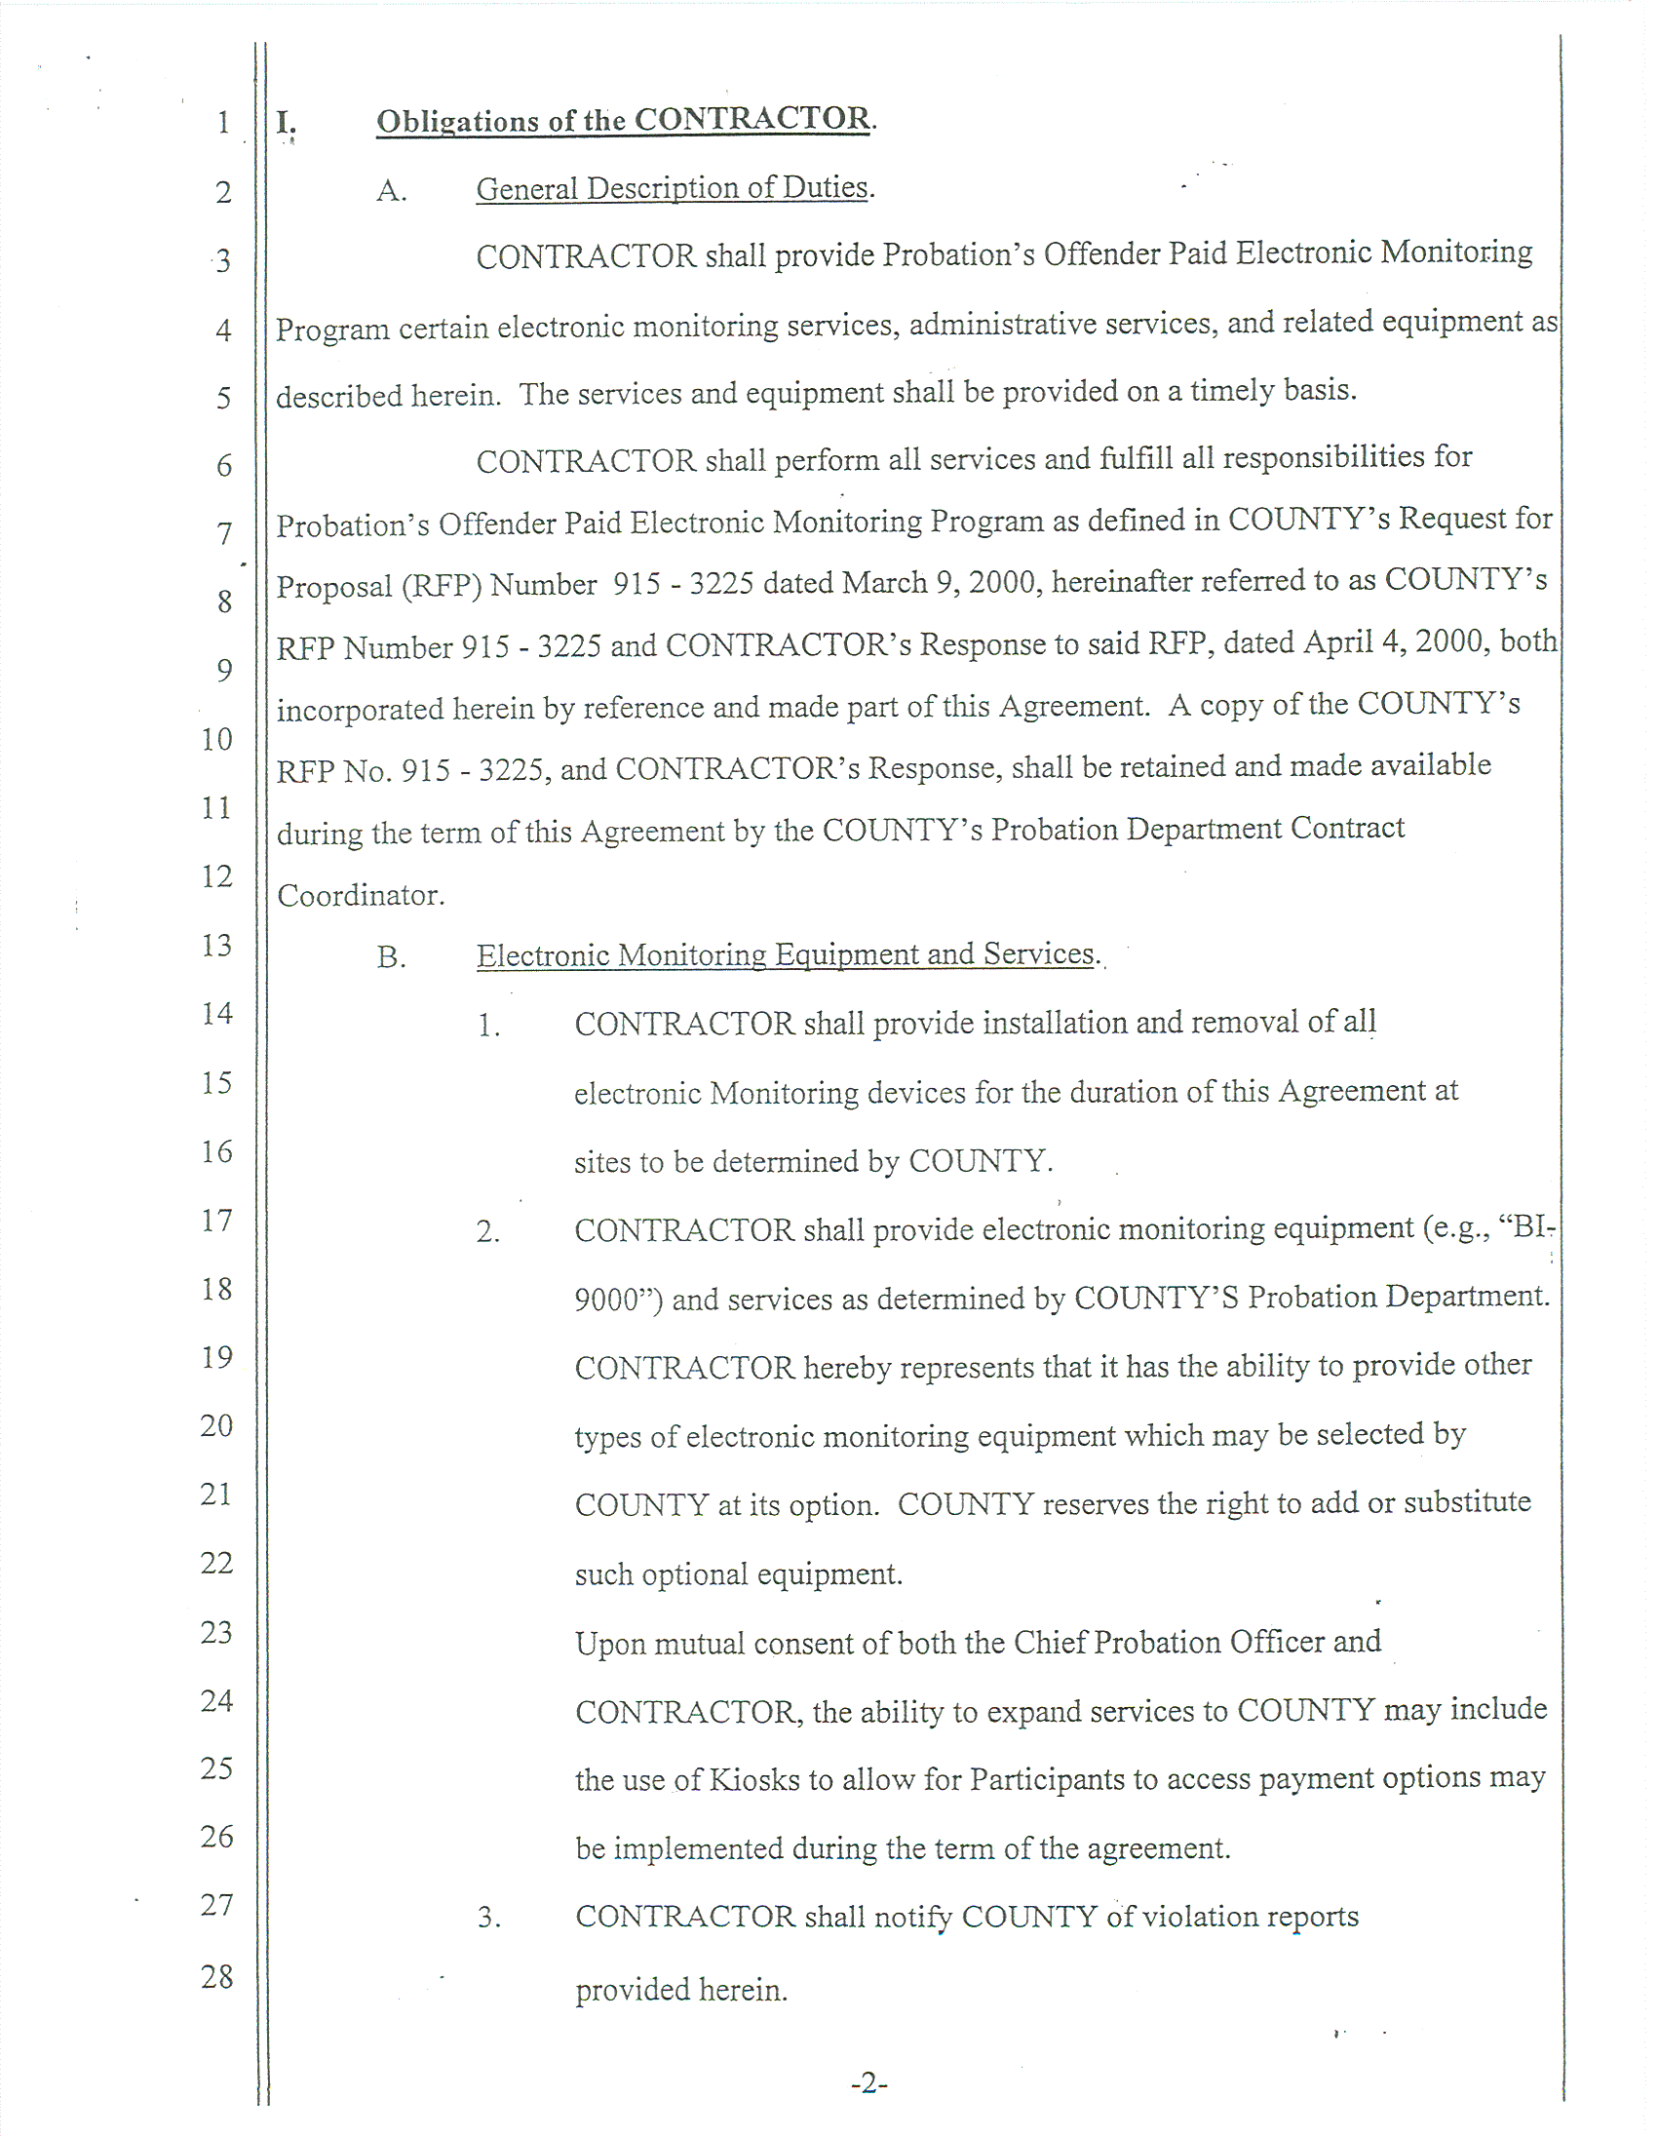
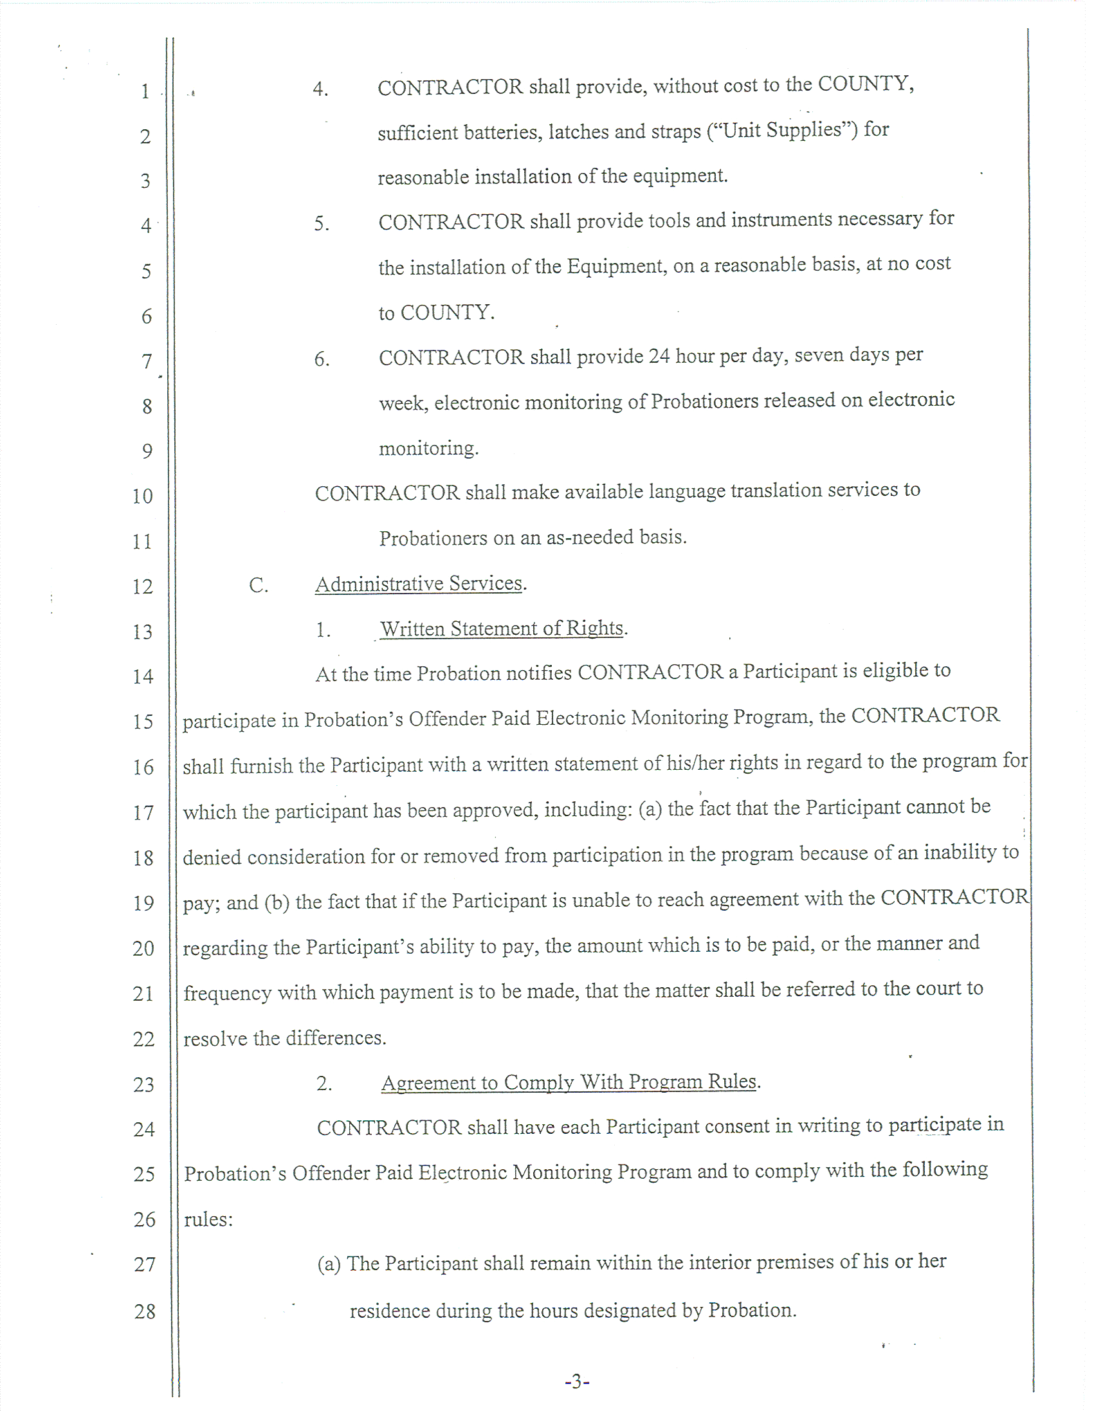
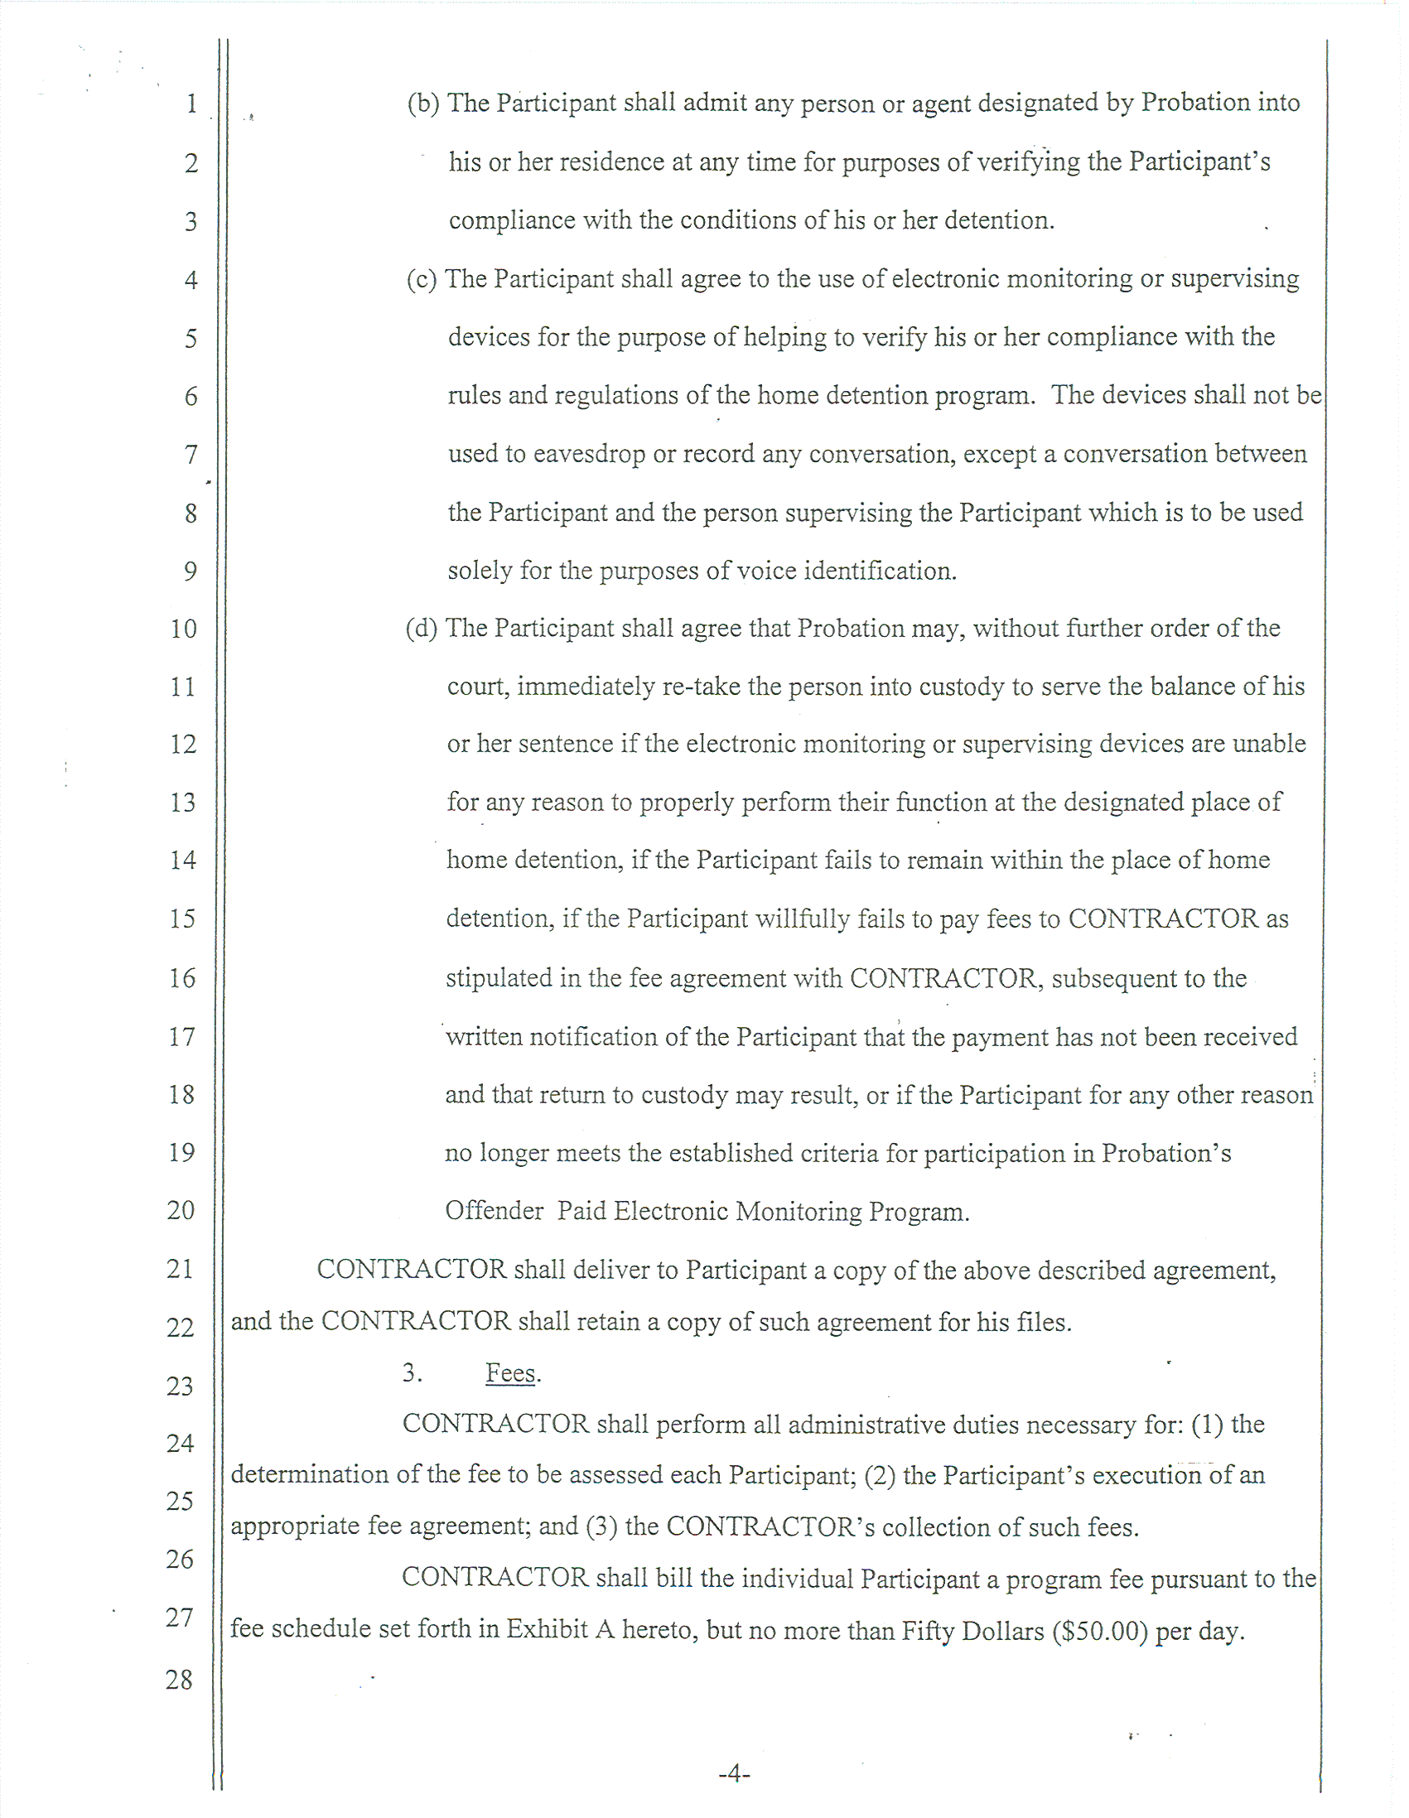
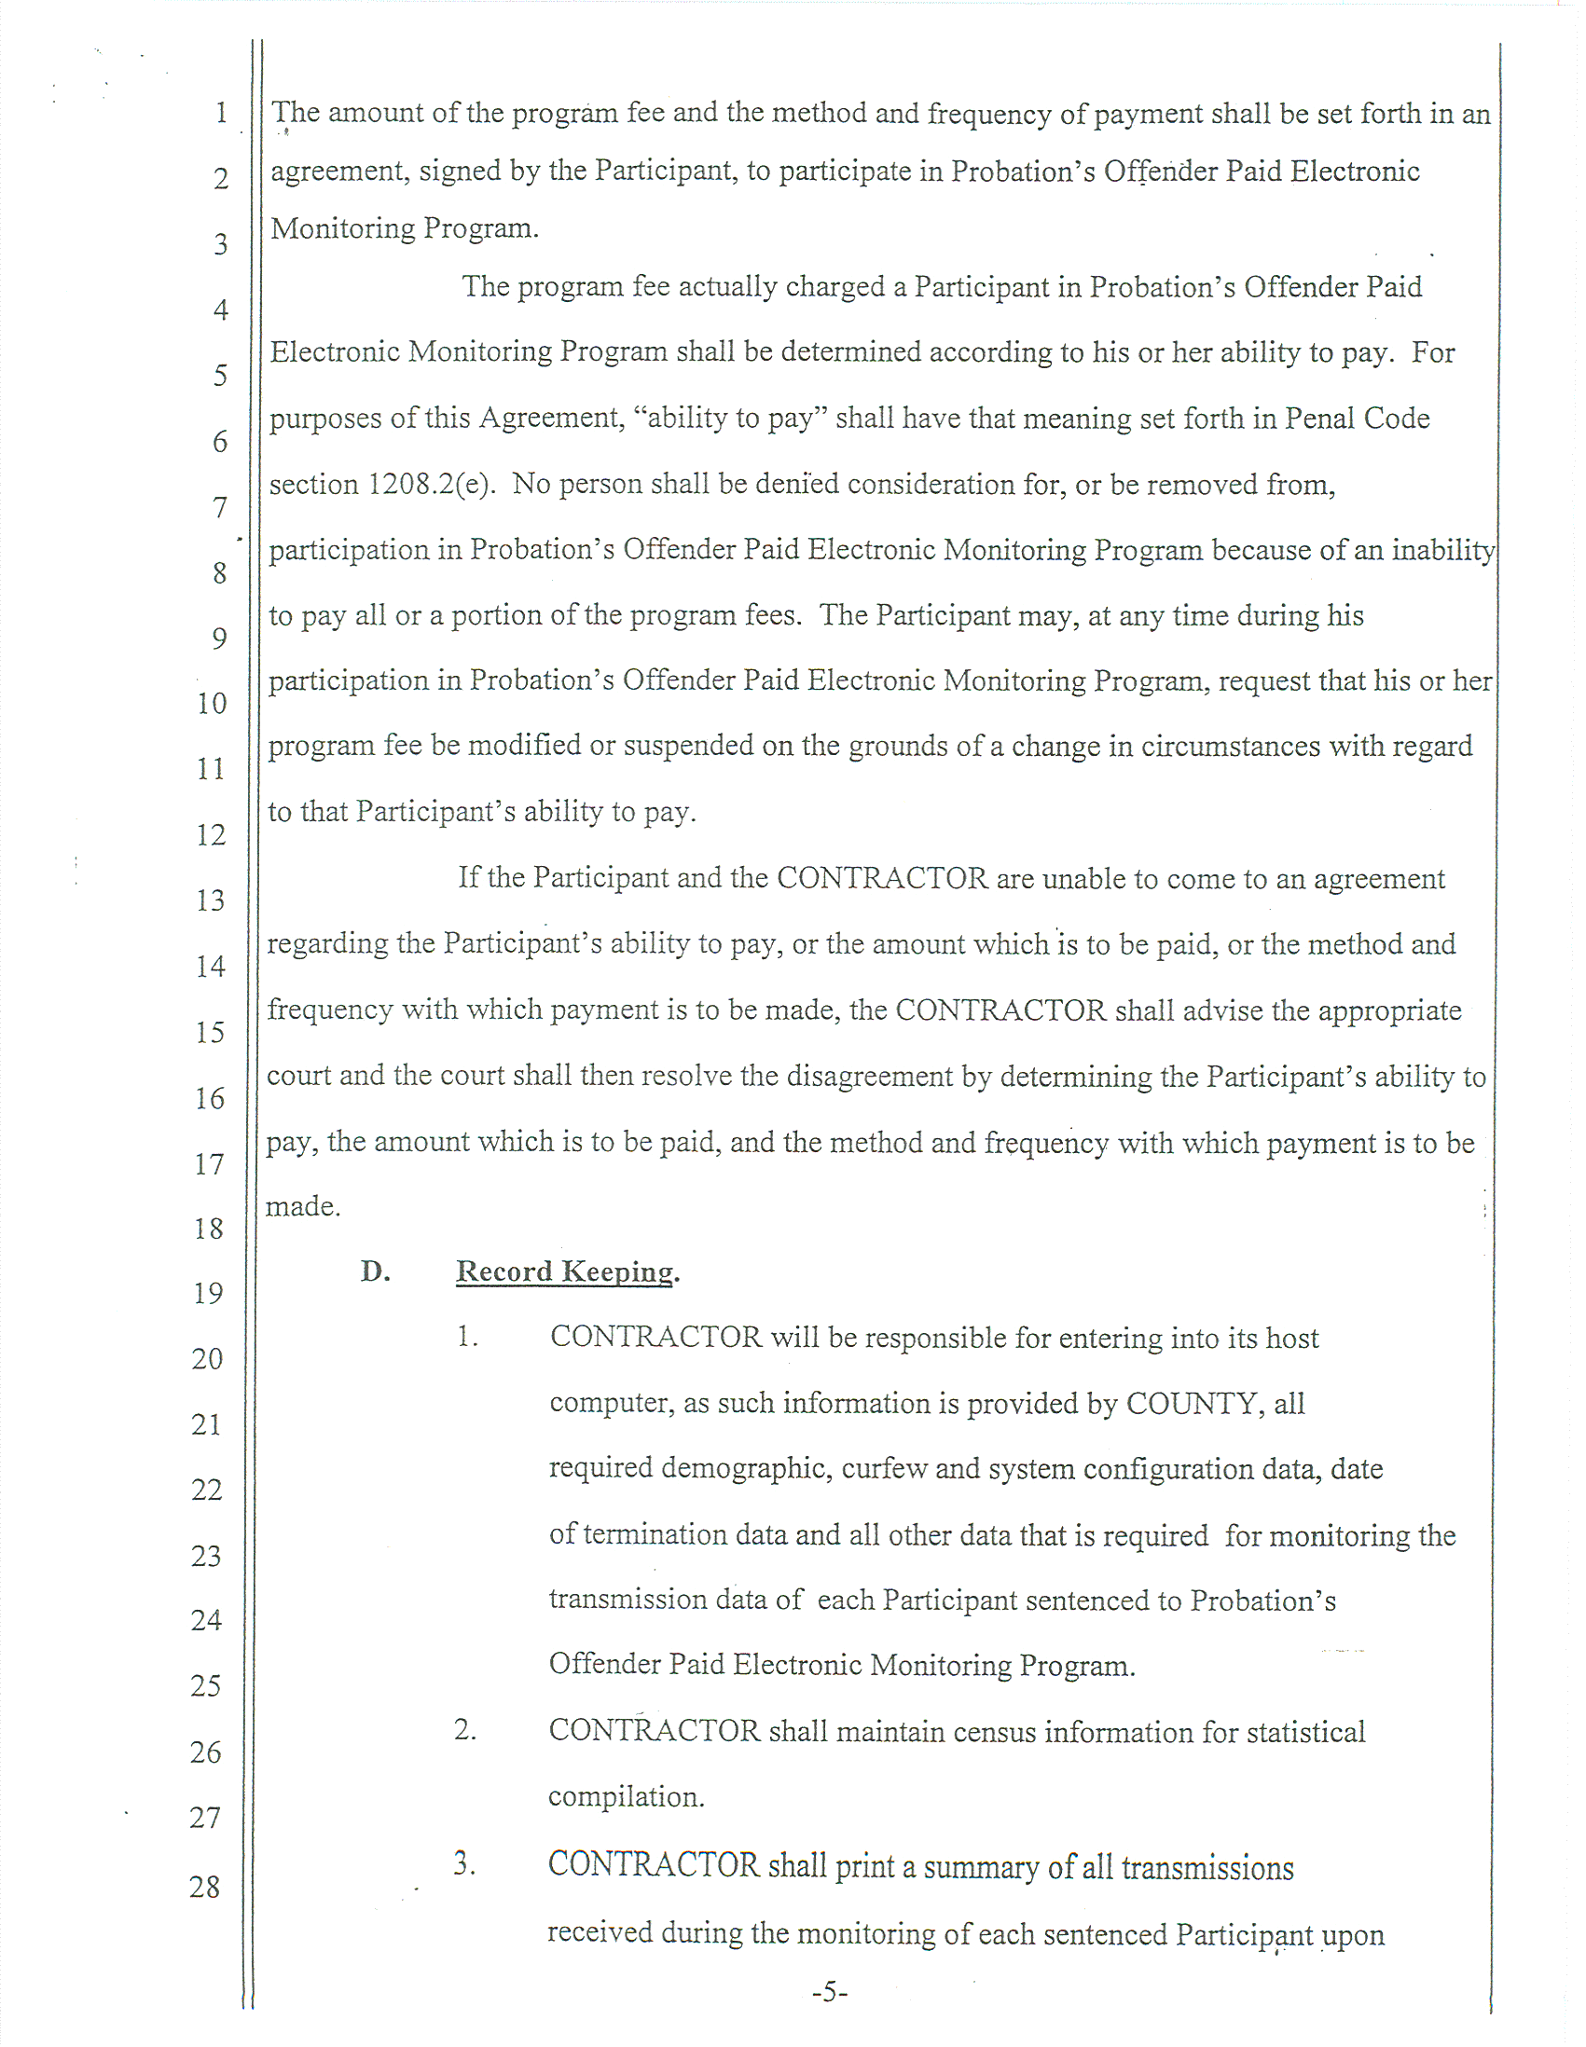
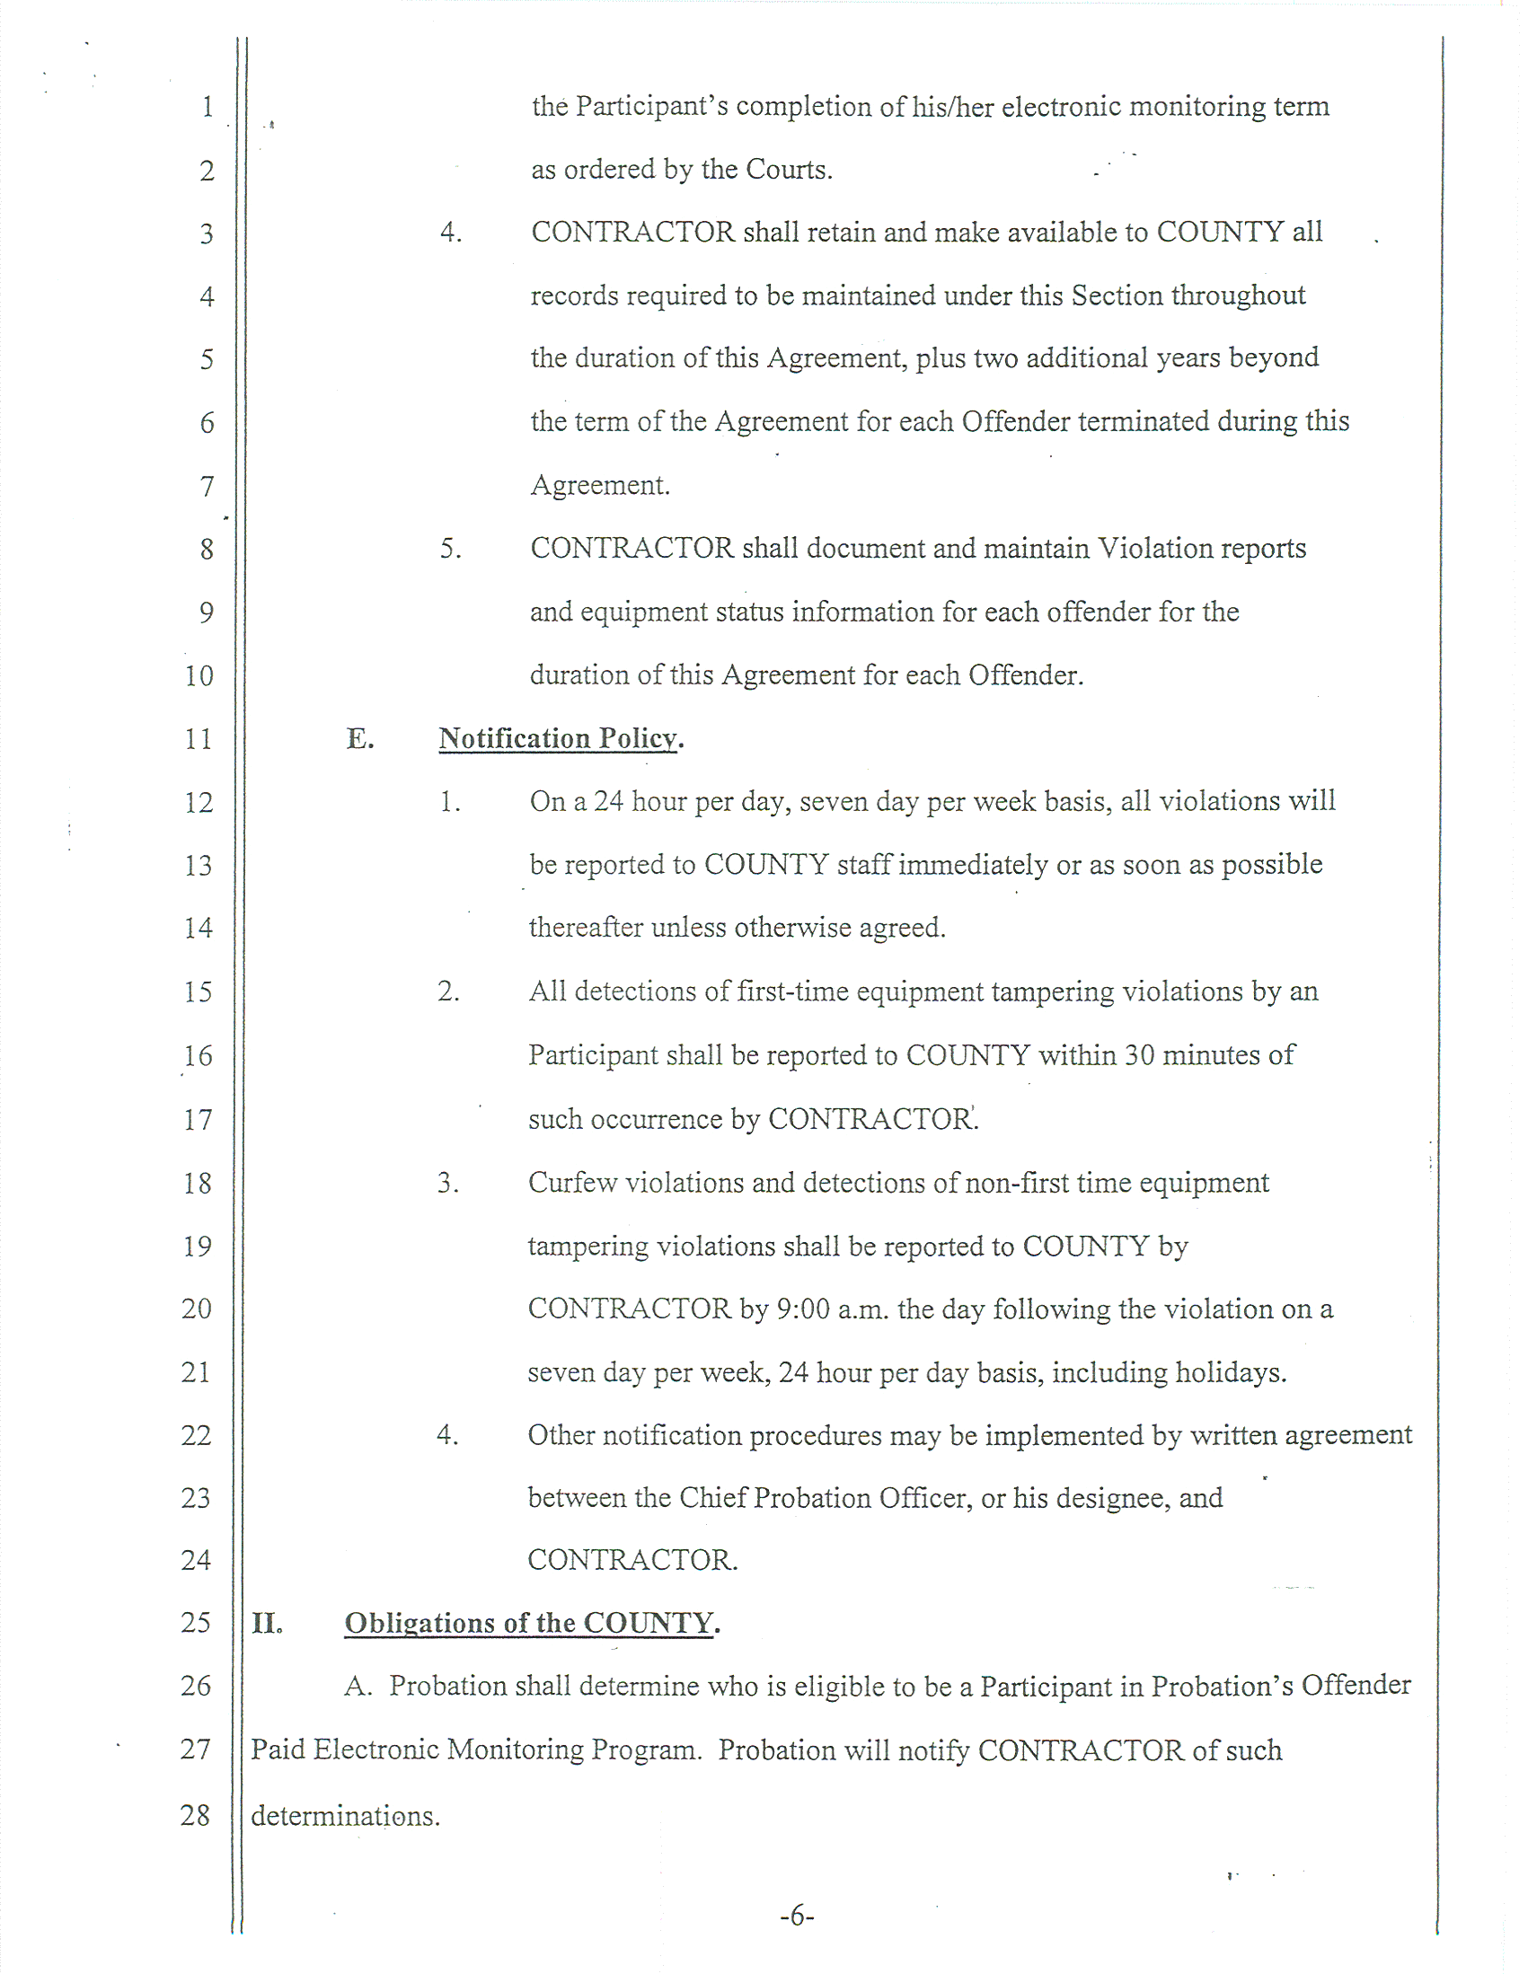
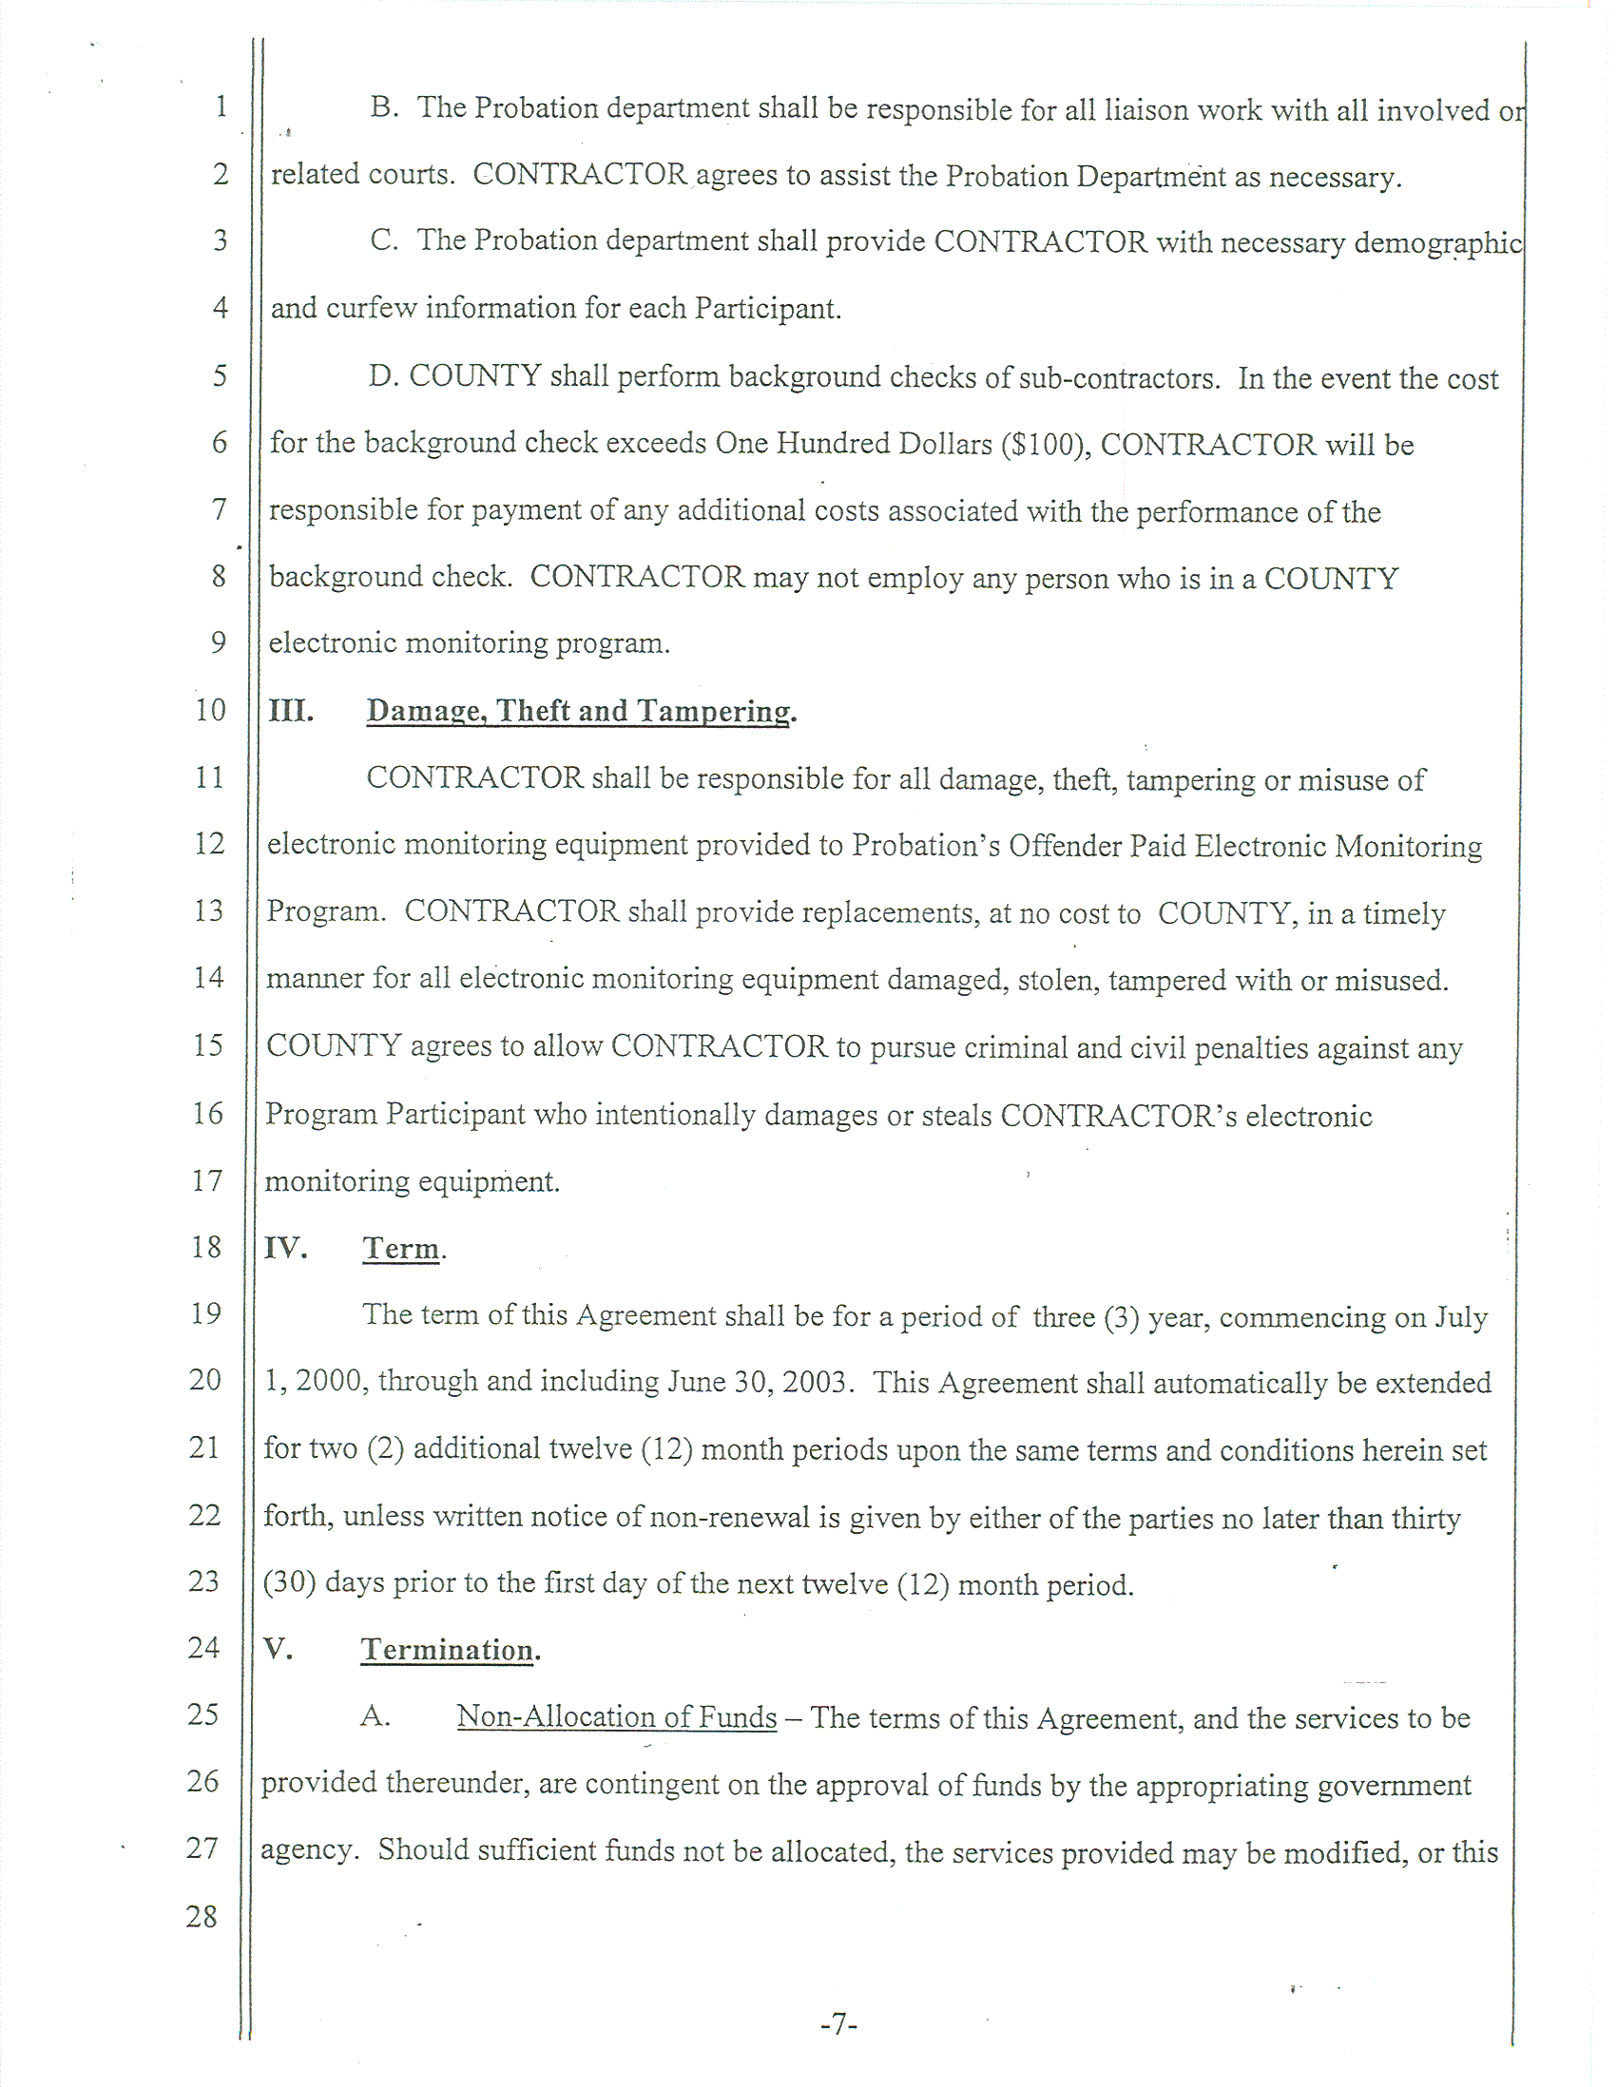
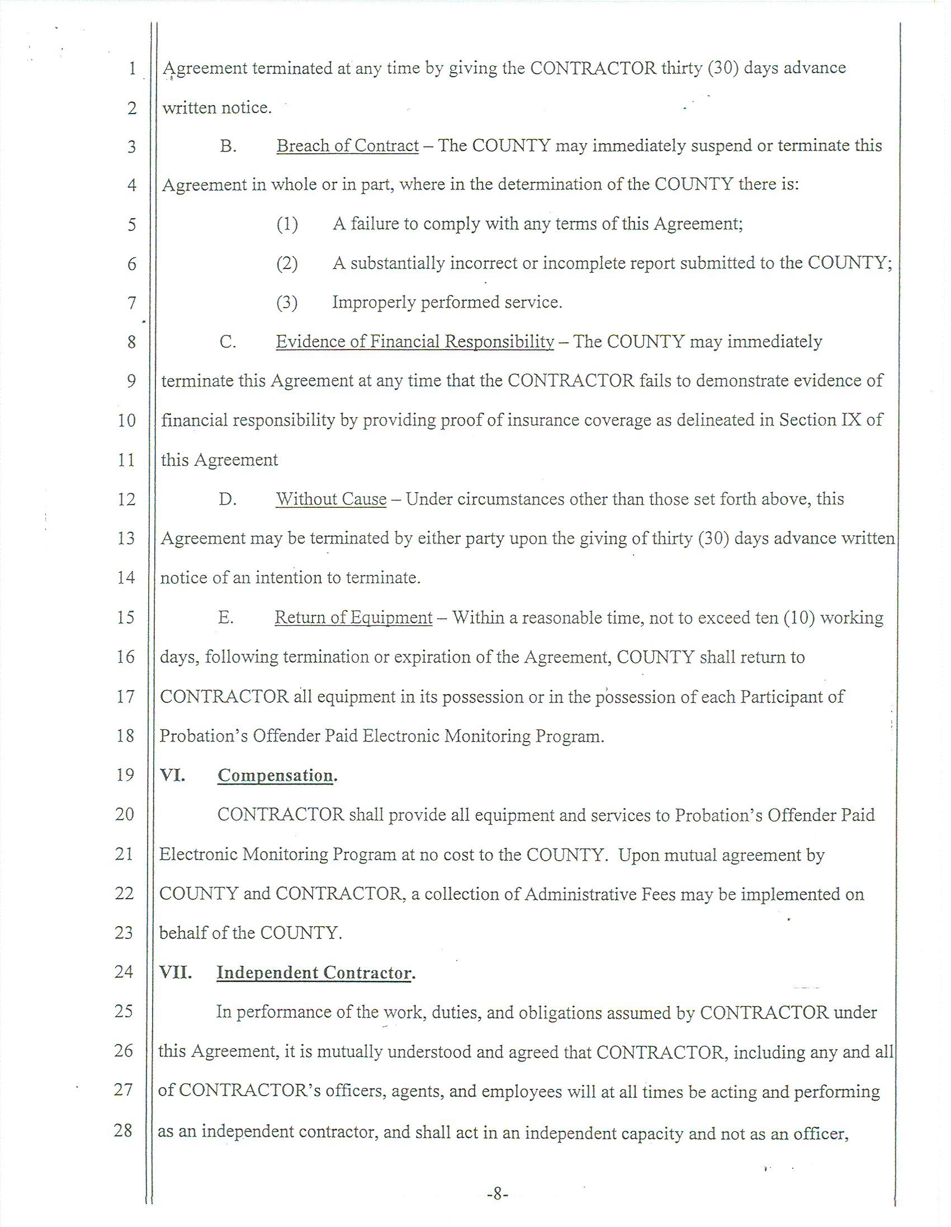
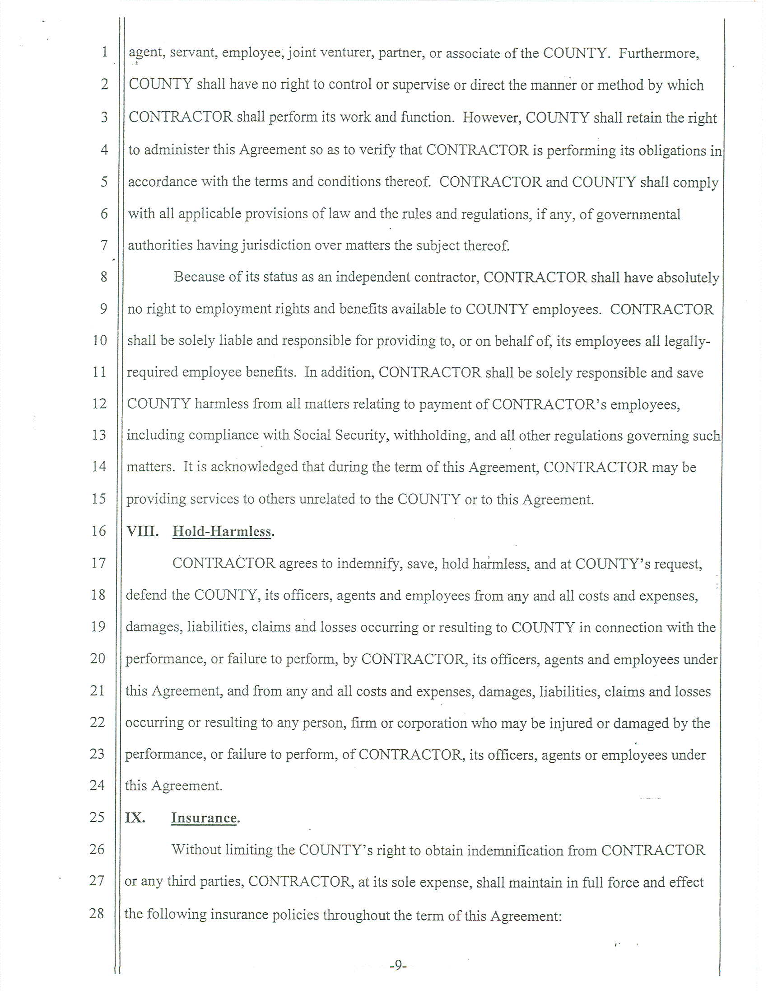
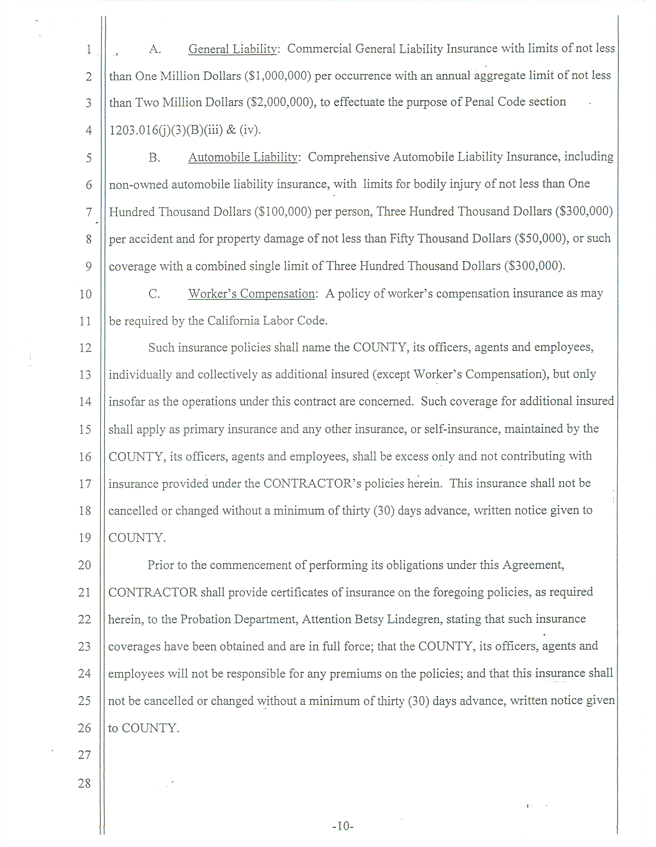
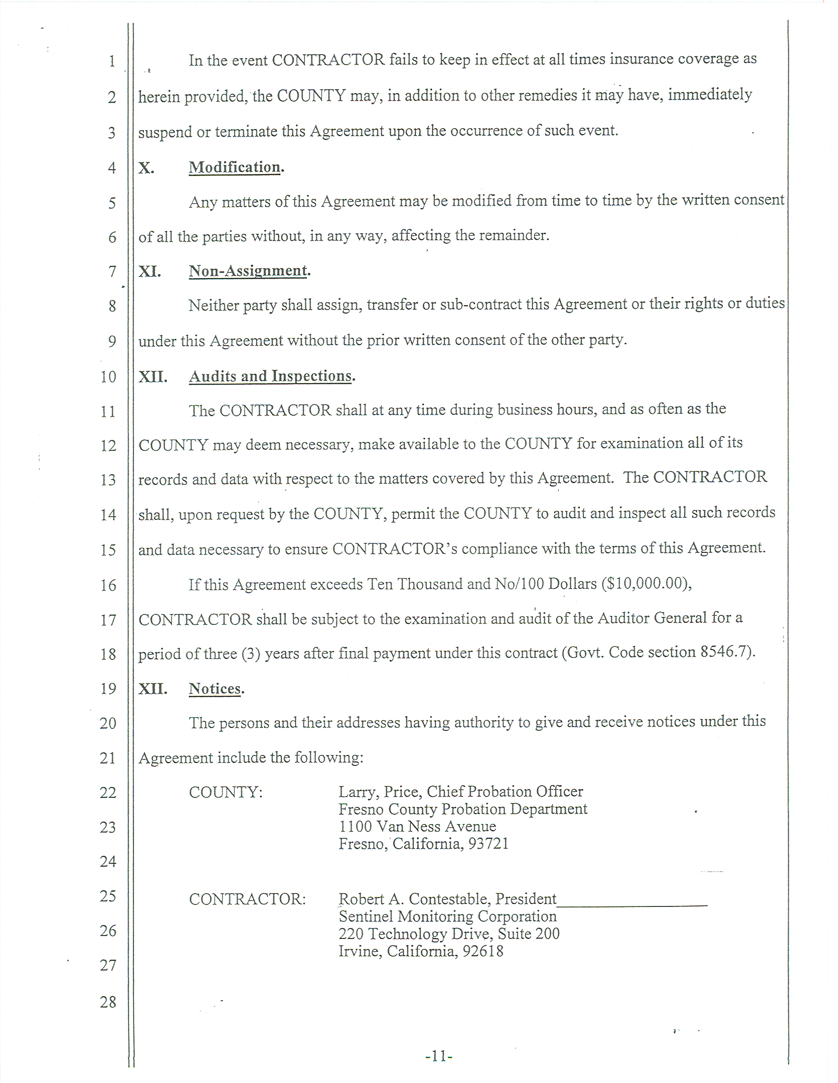
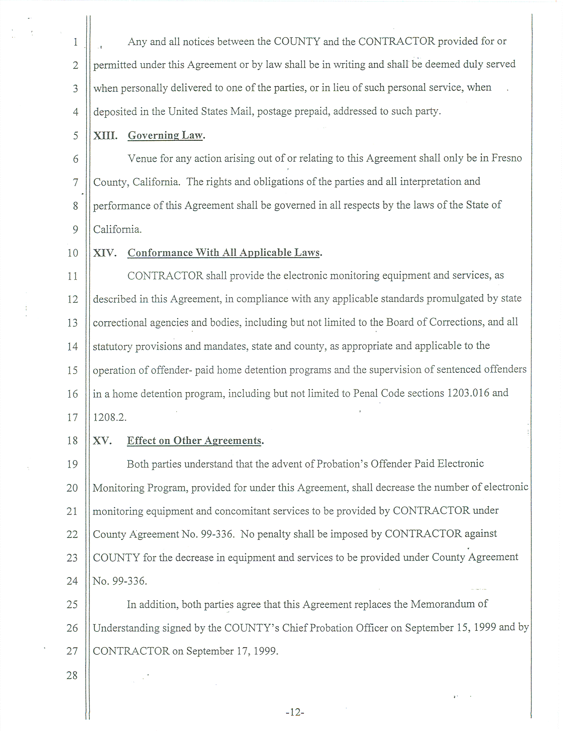
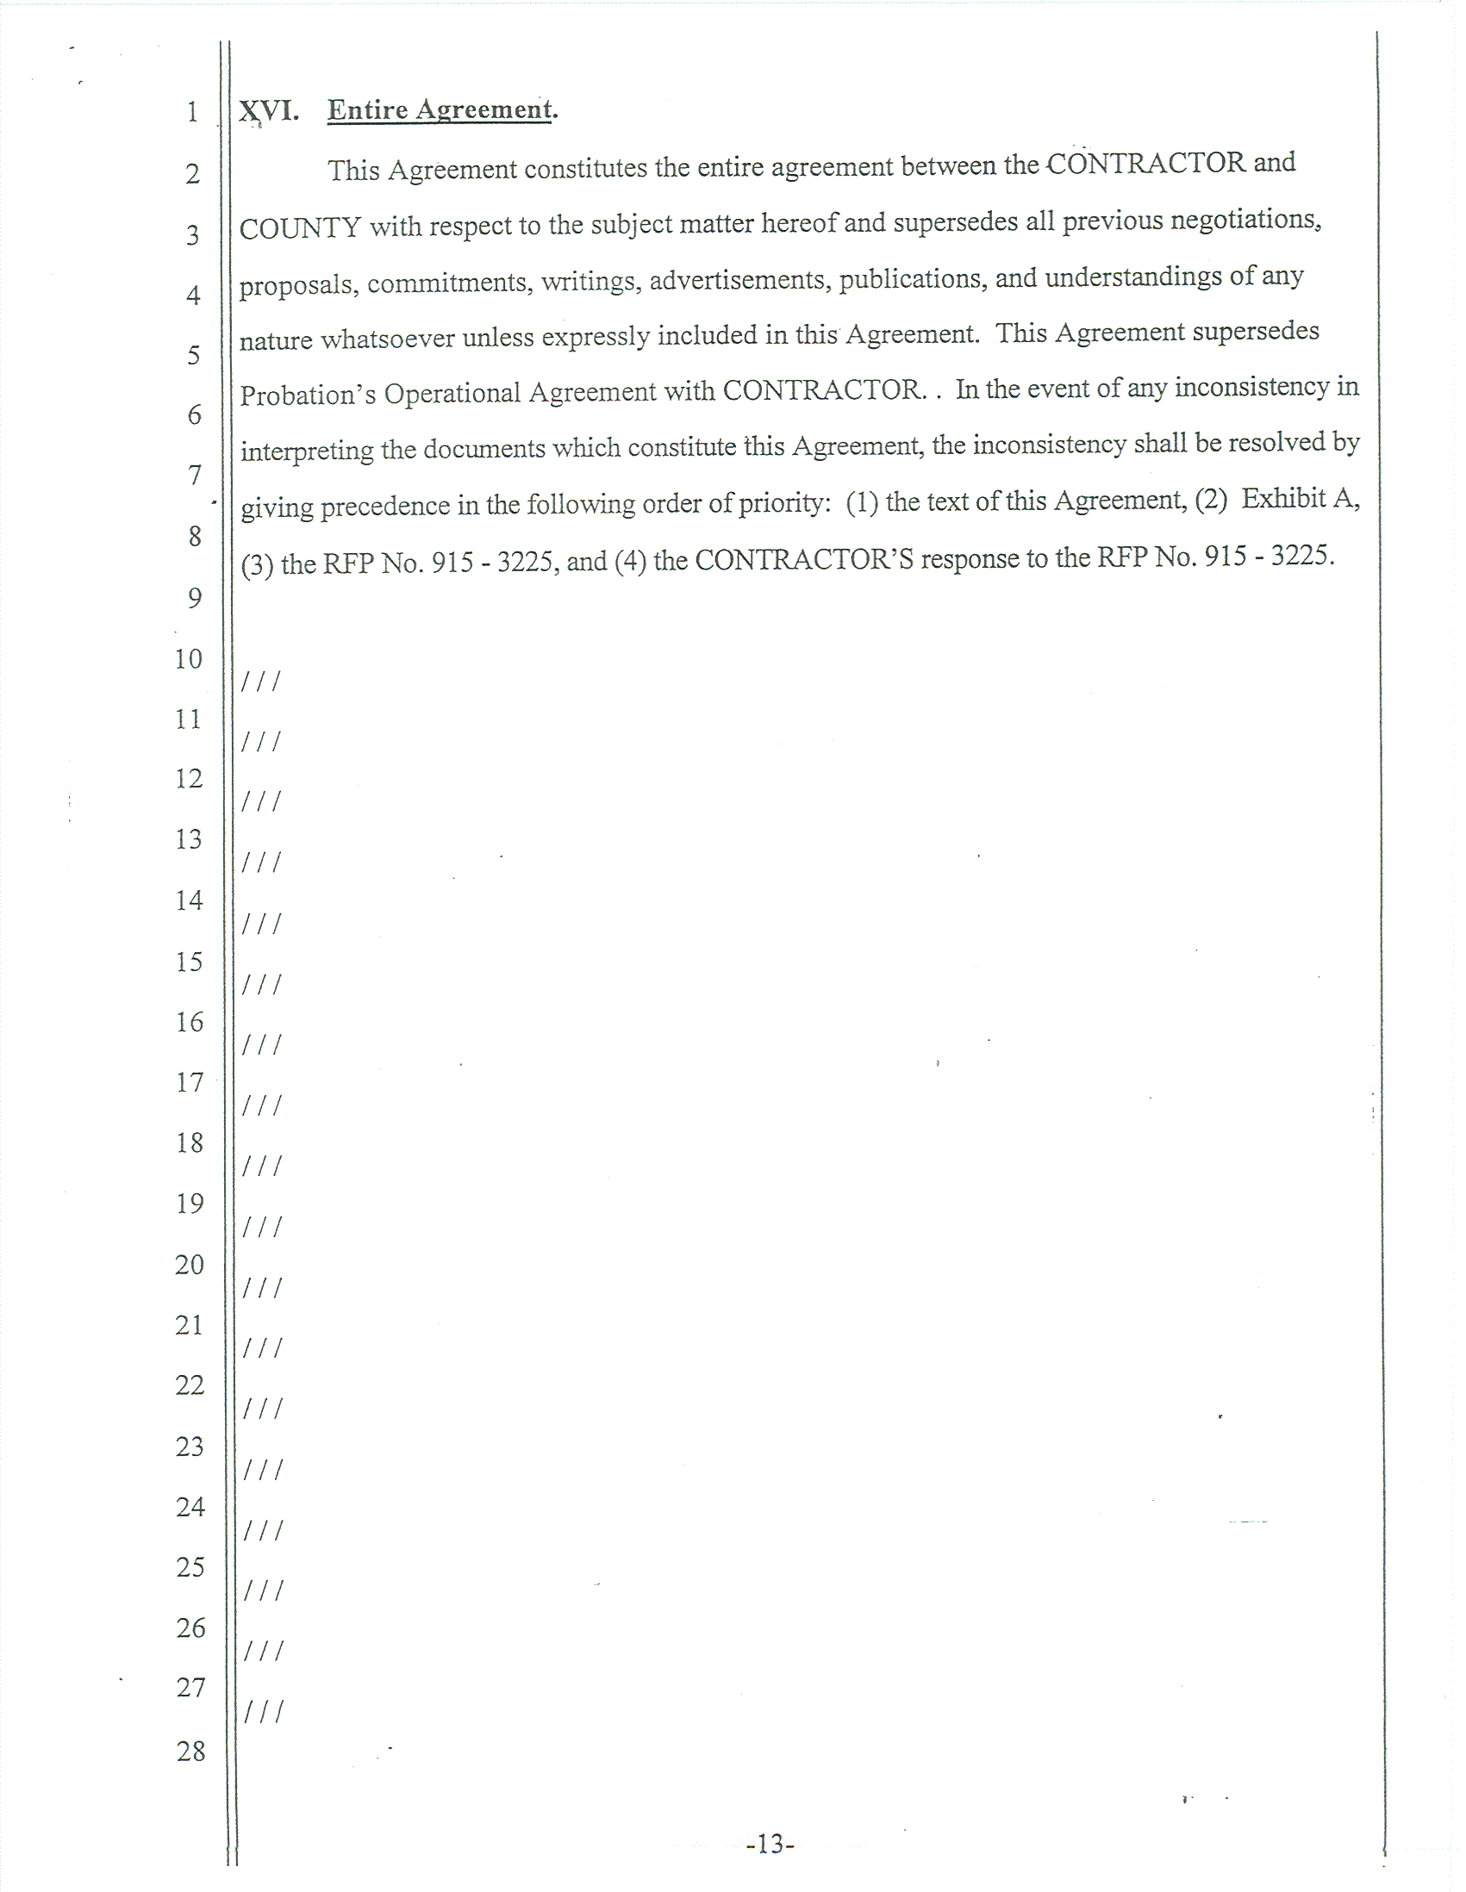
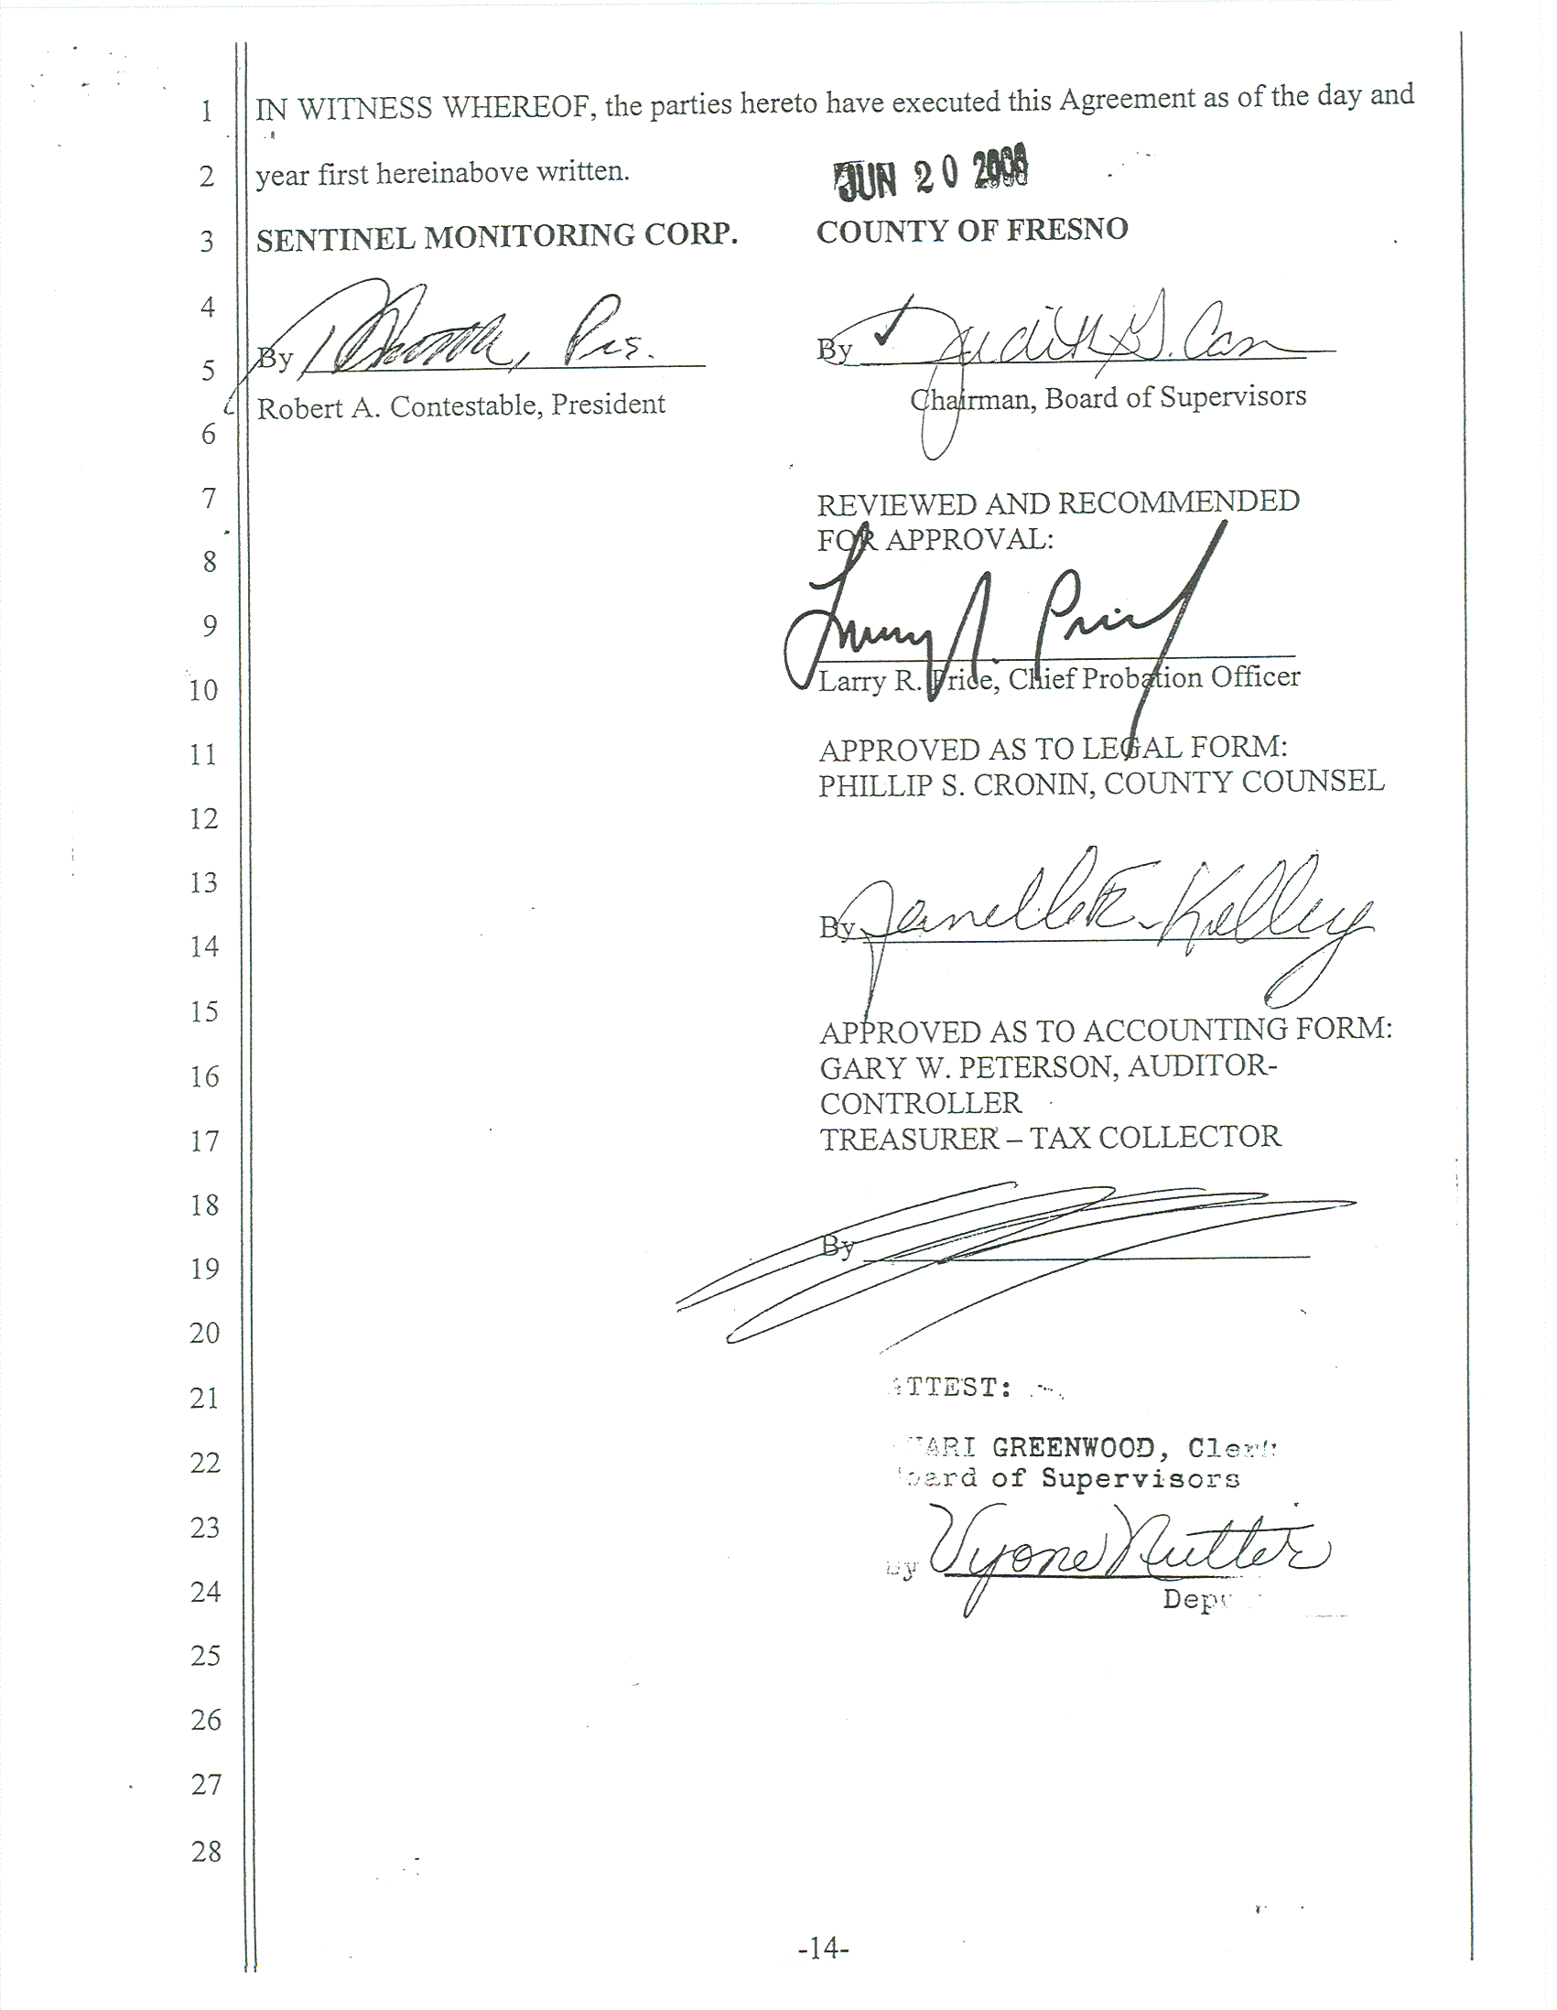
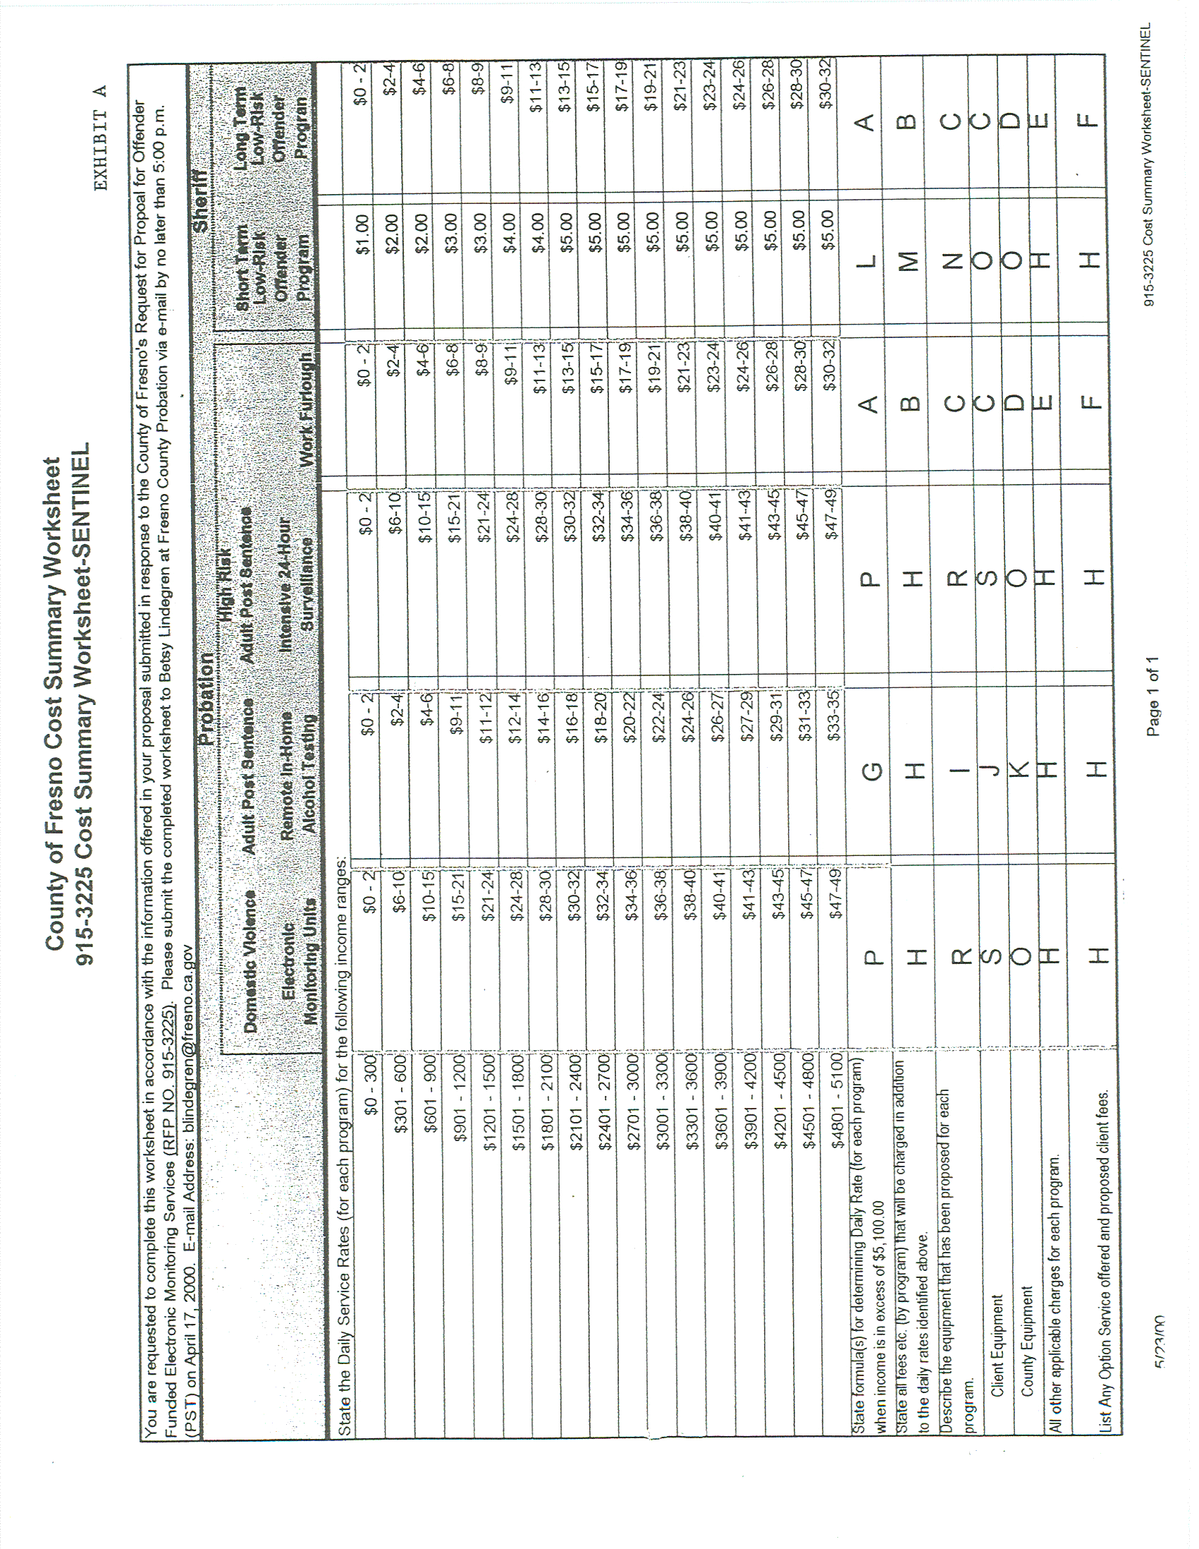

attachment
fresno county probation department
electronic monitoring program

See Item No. 5 of addendum No. 3
