COUNTY OF FRESNO
Request for proposal
 |  | NUMBER: 952-4615
August 26, 2008
ORG/Requisition: 56201685/ 5629000083 |  |  |  |  |  |  | PURCHASING USE |  |  |  | /tmp/in/input.doc
 |  |  |  |  |  |  | jlg
IMPORTANT: SUBMIT PROPOSAL IN SEALED PACKAGE WITH PROPOSAL NUMBER, CLOSING DATE AND BUYER’S NAME MARKED CLEARLY ON THE OUTSIDE TO:
COUNTY OF FRESNO, Purchasing
4525 EAST HAMILTON AVENUE
FRESNO, CA 93702-4599
Closing date of bid will be at 2:00 p.m., on September 25, 2008.
PROPOSALS WILL BE CONSIDERED LATE WHEN THE OFFICIAL PURCHASING TIME CLOCK READS 2:00 P.M.
Proposals will be opened and publicly read at that time. All proposal information will be available for review after contract award.
Clarification of specifications is to be directed to: Patricia J. Flaherty, phone (559) 456-7110, FAX (559) 456-7831.
GENERAL CONDITIONS: See “County Of Fresno Purchasing Standard Instructions And Conditions For Request For Proposals (RFP’S) and Requests for Quotations (RFQ’S)” attached. Check County of Fresno Purchasing’s Open Solicitations website at http://www2.co.fresno.ca.us/0440/Bidshome2.asp for RFQ/RFP documents and changes.
BIDDER TO COMPLETE
UNDERSIGNED AGREES TO FURNISH THE COMMODITY OR SERVICE STIPULATED IN THE ATTACHED PROPOSAL SCHEDULE AT THE PRICES AND TERMS STATED, SUBJECT TO THE “COUNTY OF FRESNO PURCHASING STANDARD INSTRUCTIONS AND CONDITIONS FOR REQUEST FOR PROPOSALS (RFP’S) AND REQUESTS FOR QUOTATIONS (RFQ’S)”ATTACHED.
Except as noted on individual items, the following will apply to all items in the Proposal Schedule.
- Complete delivery will be made within |  |  |  |  |  |  |  | calendar days after receipt of Order.
- A cash discount of |  |  |  |  | % |  |  |  |  | days will apply.
Company
Address
City |  |  |  |  |  |  |  |  |  |  |  |  | State |  | Zip Code
( ) |  |  |  | ( )
Telephone Number |  |  |  | Facsimile Number |  |  |  |  |  |  |  |  | E-mail Address
Signed By
Print Name |  |  |  |  |  |  |  |  | Title

COUNTY OF FRESNO PURCHASING
STANDARD INSTRUCTIONS AND CONDITIONS FOR
REQUESTS FOR PROPOSALS (RFP'S) AND REQUESTS FOR QUOTATIONS (RFQ'S)
Note: the reference to “bids” in the following paragraphs applies to RFP's and RFQ's

GENERAL CONDITIONS
By submitting a bid the bidder agrees to the following conditions. These conditions will apply to all subsequent purchases based on this bid.

- BID PREPARATION:
  - All prices and notations must be typed or written in ink. No erasures permitted. Errors may be crossed out, initialed and corrections printed in ink by person signing bid.
  - Brand Names: Brand names and numbers when given are for reference. Equal items will be considered, provided the offer clearly describes the article and how it differs from that specified. In the absence of such information it shall be understood the offering is exactly as specified.
  - State brand or make of each item. If bidding on other than specified, state make, model and brand being bid and attach supporting literature/specifications to the bid.
  - Bid on each item separately. Prices should be stated in units specified herein. All applicable charges must be quoted; charges on invoice not quoted herein will be disallowed.
  - Time of delivery is a part of the consideration and must be stated in definite terms and must be adhered to. F.O.B. Point shall be destination or freight charges must be stated.
  - All bids must be dated and signed with the firm’s name and by an authorized officer or employee.
  - Unless otherwise noted, prices shall be firm for 120 days after closing date of bid.
- SUBMITTING BIDS:
  - Each bid must be submitted on forms provided in a sealed envelope with bid number and closing date and time on the outside of the envelope/package.
  - Interpretation: Should any discrepancies or omissions be found in the bid specifications or doubt as to their meaning, the bidder shall notify the Buyer in writing at once. The County shall not be held responsible for verbal interpretations. Questions regarding the bid must be received by Purchasing at least 5 working days before bid opening. All addenda issued shall be in writing, duly issued by Purchasing and incorporated into the contract.
  - ISSUING AGENT/AUTHORIZED CONTACT: This RFQ has been issued by County of Fresno Purchasing. Purchasing shall be the vendor’s sole point of contact with regard to the RFQ, its content, and all issues concerning it.
All communication regarding this RFQ shall be directed to an authorized representative of County Purchasing. The specific buyer managing this RFQ is identified on the cover page, along with his or her telephone number, and he or she should be the primary point of contact for discussions or information pertaining to the RFQ. Contact with any other County representative, including elected officials, for the purpose of discussing this RFQ, its content, or any other issue concerning it, is prohibited unless authorized by Purchasing. Violation of this clause, by the vendor having unauthorized contact (verbally or in writing) with such other County representatives, may constitute grounds for rejection by Purchasing of the vendor’s quotation.
The above stated restriction on vendor contact with County representatives shall apply until the County has awarded a purchase order or contract to a vendor or vendors, except as follows. First, in the event that a vendor initiates a formal protest against the RFQ, such vendor may contact the appropriate individual, or individuals who are managing that protest as outlined in the County’s established protest procedures. All such contact must be in accordance with the sequence set forth under the protest procedures. Second, in the event a public hearing is scheduled before the Board of Supervisors to hear testimony prior to its approval of a purchase order or contract, any vendor may address the Board.
  - Bids received after the closing time will NOT be considered.
  - Bidders are to bid what is specified or requested first. If unable to or willing to, bidder may bid alternative or option, indicating all advantages, disadvantages and their associated cost.
  - Public Contract Code Section 7028.15
Where the State of California requires a Contractor’s license, it is a misdemeanor for any person to submit a bid unless specifically exempted.
- FAILURE TO BID:
  - If not bidding, return bid sheet and state reason for no bid or your name may be removed from mailing list.
- TAXES, CHARGES AND EXTRAS:
  - County of Fresno is subject to California sales and/or use tax (7.975%). Please indicate as a separate line item if applicable.
  - DO NOT include Federal Excise Tax. County is exempt under Registration No. 94-73-03401-K.
  - County is exempt from Federal Transportation Tax. Exemption certificate is not required where shipping papers show consignee as County of Fresno.
  - Charges for transportation, containers, packing, etc. will not be paid unless specified in bid.
- W-9 – REQUEST FOR TAXPAYER IDENTIFICATION NUMBER AND CERTIFICATION:
Upon award of bid, the vendor shall submit to County Purchasing, a completed W-9 - Request for Taxpayer Identification Number and Certification if not already a current vendor with The County of Fresno. This form is available from the IRS to complete on line at http://www.irs.gov/pub/irs-pdf/fw9.pdf.
- AWARDS:
  - Subject to the local preference provisions referenced in Paragraph 6 below and more thoroughly set forth in the General Requirements section of this RFQ, award(s) will be made to the most responsive responsible bidder. The evaluation will include such things as life-cycle cost, availability, delivery costs and whose product and/or service is deemed to be in the best interest of the County. The County shall be the sole judge in making such determination.
  - Unless bidder gives notice of all-or-none award in bid, County may accept any item, group of items or on the basis of total bid.
  - The County reserves the right to reject any and all bids and to waive informalities or irregularities in bids.
  - After award, all bids shall be open to public inspection. The County assumes no responsibility for the confidentiality of information offered in a bid.
- LOCAL VENDORS
  - Local Vendor Preference (applicable to RFQ Process only)
The following provisions are applicable only to the County’s acquisition of materials, equipment or supplies through the RFQ process when the funding source does not require an exemption to the Local Vendor Preference.
THE PROVISIONS OF THIS PARAGRAPH ARE APPLICABLE, NOTWITHSTANDING ANY OTHER PROVISIONS OF THIS RFQ TO THE CONTRARY
If the apparent low bidder is not a local vendor, any local vendor who submitted a bid which was within five percent (5%) of the lowest responsive bid as determined by the purchasing agent shall have the option of submitting a new bid within forty-eight hours (not including weekends and holidays) of County’s delivery of notification. Such new bids must be in an amount less than or equal to the lowest responsive bid as determined by the purchasing agent. If the purchasing agent receives any new bids from local vendors who have the option of submitting new bids within said forty-eight hour period, it shall award the contract to the local vendor submitting the lowest responsible bid. If no new bids are received, the contract shall be awarded to the original low bidder as announced by the purchasing agent.
  - Local Vendor Defined
“Local Vendor” shall mean any business which:
- Has its headquarters, distribution point or locally-owned franchise located in or having a street address within the County for at least six (6) months immediately prior to the issuance of the request for competitive bids by the purchasing agent; and
- Holds any required business license by a jurisdiction located in Fresno County; and
- Employs at least one (1) full-time or two (2) part-time employees whose primary residence is located within Fresno County, or if the business has no employees, shall be at least fifty percent (50%) owned by one or more persons whose primary residence(s) is located within Fresno County.
- TIE BIDS:
All other factors being equal, the contract shall be awarded to the Fresno County vendor or, if neither or both are Fresno County vendors, it may be awarded by the flip of a coin in the presence of witnesses or the entire bid may be rejected and re-bid. If the General Requirements of this RFQ state that they are applicable, the provisions of the Fresno County Local Vendor Preference shall take priority over this paragraph.
- PATENT INDEMNITY:
The vendor shall hold the County, its officers, agents and employees, harmless from liability of any nature or kind, including costs and expenses, for infringement or use of any copyrighted or uncopyrighted composition, secret process, patented or unpatented invention, article or appliance furnished or used in connection with this bid.
- SAMPLES:
Samples, when required, must be furnished and delivered free and, if not destroyed by tests, will upon written request (within 30 days of bid closing date) be returned at the bidder's expense. In the absence of such notification, County shall have the right to dispose of the samples in whatever manner it deems appropriate.
- RIGHTS AND REMEDIES OF COUNTY FOR DEFAULT:
  - In case of default by vendor, the County may procure the articles or service from another source and may recover the cost difference and related expenses occasioned thereby from any unpaid balance due the vendor or by proceeding against performance bond of the vendor, if any, or by suit against the vendor. The prices paid by the County shall be considered the prevailing market price at the time such purchase is made.
  - Articles or services, which upon delivery inspection do not meet specifications, will be rejected and the vendor will be considered in default. Vendor shall reimburse County for expenses related to delivery of non-specified goods or services.
  - Regardless of F.O.B. point, vendor agrees to bear all risks of loss, injury or destruction to goods and materials ordered herein which occur prior to delivery and such loss, injury or destruction shall not release vendor from any obligation hereunder.
- DISCOUNTS:
Terms of less than 15 days for cash payment will be considered as net in evaluating this bid. A discount for payment within fifteen (15) days or more will be considered in determining the award of bid. Discount period will commence either the later of delivery or receipt of invoice by the County. Standard terms are Net Forty-five (45) days.
- SPECIAL CONDITIONS IN BID SCHEDULE SUPERSEDE GENERAL CONDITIONS.
The “General Conditions” provisions of this RFP/RFQ shall be superseded if in conflict with any other section of this bid, to the extent of any such conflict.
- SPECIAL REQUIREMENT:
With the invoice or within twenty-five (25) days of delivery, the seller must provide to the County a Material Safety Data Sheet for each product, which contains any substance on “The List of 800 Hazardous Substances”, published by the State Director of Industrial Relations. (See Hazardous Substances Information and Training Act. California State Labor Code Sections 6360 through 6399.7.)
- RECYCLED PRODUCTS/MATERIALS:
Vendors are encouraged to provide and quote (with documentation) recycled or recyclable products/materials which meet stated specifications.
- YEAR COMPLIANCE WARRANTY
Vendor warrants that any product furnished pursuant to this Agreement/order shall support a four-digit year format and be able to accurately process date and time data from, into and between the twentieth and twenty-first centuries, as well as leap year calculations. "Product" shall include, without limitation, any piece or component of equipment, hardware, firmware, middleware, custom or commercial software, or internal components or subroutines therein. This warranty shall survive termination or expiration of this Agreement.
In the event of any decrease in product functionality or accuracy related to time and/or date data related codes and/or internal subroutines that impede the product from operating correctly using dates beyond December 31, 1999, vendor shall restore or repair the product to the same level of functionality as warranted herein, so as to minimize interruption to County's ongoing business process, time being of the essence. In the event that such warranty compliance requires the acquisition of additional programs, the expense for any such associated or additional acquisitions, which may be required, including, without limitation, data conversion tools, shall be borne exclusively by vendor. Nothing in this warranty shall be construed to limit any rights or remedies the County may otherwise have under this Agreement with respect to defects other than year performance.
- PARTICIPATION:
Bidder may agree to extend the terms of the resulting contract to other political subdivision, municipalities and tax-supported agencies.
Such participating Governmental bodies shall make purchases in their own name, make payment directly to bidder, and be liable directly to the bidder, holding the County of Fresno harmless.
- CONFIDENTIALITY:
All services performed by vendor shall be in strict conformance with all applicable Federal, State of California and/or local laws and regulations relating to confidentiality, including but not limited to, California Civil Code, California Welfare and Institutions Code, Health and Safety Code, California Code of Regulations, Code of Federal Regulations.
Vendor shall submit to County’s monitoring of said compliance.
Vendor may be a business associate of County, as that term is defined in the “Privacy Rule” enacted by the Health Insurance Portability and Accountability Act of 1996 (HIPAA). As a HIPAA Business Associate, vendor may use or disclose protected health information (“PHI”) to perform functions, activities or services for or on behalf of County as specified by the County, provided that such use or disclosure shall not violate HIPAA and its implementing regulations. The uses and disclosures if PHI may not be more expansive than those applicable to County, as the “Covered Entity” under HIPAA’S Privacy Rule, except as authorized for management, administrative or legal responsibilities of the Business Associate.
Vendor shall not use or further disclose PHI other than as permitted or required by the County, or as required by law without written notice to the County.
Vendor shall ensure that any agent, including any subcontractor, to which vendor provides PHI received from, or created or received by the vendor on behalf of County, shall comply with the same restrictions and conditions with respect to such information.
- APPEALS
Appeals must be submitted in writing within seven (7) working days after the review committee notification of proposed recommendations. Appeals should be submitted to County of Fresno Purchasing, 4525 E. Hamilton Avenue, Fresno, California 93702-4599. Appeals should address only areas regarding RFP contradictions, procurement errors, quotation rating discrepancies, legality of procurement context, conflict of interest, and inappropriate or unfair competitive procurement grievance regarding the RFP process.
The Purchasing Manager will provide a written response to the complaint within seven (7) working days unless the complainant is notified more time is required.
If the protesting bidder is not satisfied with the decision of the Purchasing Manager, he/she shall have the right to appeal to the Purchasing Agent within seven (7) business days after notification of the Purchasing Manager’s decision.
If the protesting bidder is not satisfied with Purchasing Agent decision, the final appeal is with the Board of Supervisors.
- OBLIGATIONS OF CONTRACTOR:
  - CONTRACTOR shall perform as required by the ensuing contract. CONTRACTOR also warrants on behalf of itself and all subcontractors engaged for the performance of the ensuing contract that only persons authorized to work in the United States pursuant to the Immigration Reform and Control Act of 1986 and other applicable laws shall be employed in the performance of the work hereunder.
  - CONTRACTOR shall obey all Federal, State, local and special district laws, ordinances and regulations.
- AUDITS & RETENTION:
The Contractor shall maintain in good and legible condition all books, documents, papers, data files and other records related to its performance under this contract. Such records shall be complete and available to Fresno County, the State of California, the federal government or their duly authorized representatives for the purpose of audit, examination, or copying during the term of the contract and for a period of at least three years following the County's final payment under the contract or until conclusion of any pending matter (e.g., litigation or audit), whichever is later. Such records must be retained in the manner described above until all pending matters are closed.

TABLE OF CONTENTS
PAGE
OVERVIEW 4
KEY DATES 4
PROPOSAL IDENTIFICATION SHEET 5
TRADE SECRET ACKNOWLEDGEMENT 6
REFERENCE LIST 8
GENERAL REQUIREMENTS 9
PARTICIPATION 16
SPECIFIC TERMS AND CONDITIONS 17
SCOPE OF WORK 18
SPECIFIC REQUIREMENTS 20
GROUP I Department of Public Health 20
GROUP II Department of behavioral health 24
GROUP III Department of coroner-public administrator/public guardian 28
GROUP IV Department of children and family services 29
COST PROPOSAL 31
GROUP I Department of Public Health 31
GROUP II Department of Behavioral Health 33
GROUP III Department of Coroner-Public Administrator/Public Guardian 36
GROUP IV Department of Children and Family Services 37
PROPOSAL CONTENT REQUIREMENTS 39
AWARD CRITERIA 42
Attachment A ADULT DETENTION FACILITY no hostage policy 43
Attachment b juvenile justice campus no hostage policy 45
attachment c probation department no hostage policy 47
Attachment d map of chest clinic 49
CHECK LIST 50

OVERVIEW
The County of Fresno, Departments of Public Health, Behavioral Health, the Coroner-Public Administrator/Public Guardian, and Children and Family Services are seeking electrocardiograph (EKG) and radiological (x-ray) services as required by the following programs: Correctional Health’s Adult Detention Facilities, Juvenile Justice Campus (JJC), and Elkhorn Correctional Facility; Community Health’s Chest Clinic; Psychiatric Health Facility (PHF), Crisis Intervention Services (CIS) program, Metro Outpatient Services, Apollo Residential Facility and Regional Clinics; Coroner Division; Children’s Crisis Assessment, Intervention and Resolution program (CCAIR), Juvenile Justice Campus Mental Health (JJCMH).
The County of Fresno desires to contract for EKG and x-ray services from an outside provider as described in this document.

KEY DATES
RFP Issue Date: | August 27, 2008
Deadline for Written or Fax Requests for Interpretations or Corrections of RFP: | September 15, 2008
Fax No. (559) 456-7831
email: CountyPurchasing@co.fresno.ca.us
RFP Closing Date: | September 25, 2008 at 2:00 P.M.
 | County of Fresno Purchasing
 | 4525 E. Hamilton Avenue
 | Fresno, CA 93702
Anticipated Contract Start Date: | November 1, 2008

PROPOSAL IDENTIFICATION SHEET

RESPONDENT TO COMPLETE AND RETURN WITH PROPOSAL
Our proposal is attached and identified as:
The undersigned agrees to furnish the service stipulated at the prices and terms stated in the cost proposal.
Work services will commence within  contract. |  |  |  | calendar days after signing of the final
Company:
Address:
 |  |  |  |  |  | Zip:
Signed by:
Print Name
Print Title
( ) |  | ( )
Telephone |  | Fax Number |  |  | E-mail Address
Date:

TRADE SECRET ACKNOWLEDGEMENT
All proposals received by the County shall be considered "Public Record" as defined by Section 6252 of the California Government Code. This definition reads as follows:
"...Public records" includes any writing containing information relating to the conduct of the public's business prepared, owned, used or retained by any state or local agency regardless of physical form or characteristics "Public records" in the custody of, or maintained by, the Governor's office means any writing prepared on or after January 6, 1975."
Each proposal submitted is Public record and is therefore subject to inspection by the public per Section 6253 of the California Government Code. This section states that "every citizen has a right to inspect any public record".
The County will not exclude any proposal or portion of a proposal from treatment as a public record except in the instance that it is submitted as a trade secret as defined by the California Government Code. Information submitted as proprietary, confidential or under any other such terms that might suggest restricted public access will not be excluded from treatment as public record.
"Trade secrets" as defined by Section 6254.7 of the California Government Code are deemed not to be public record. This section defines trade secrets as:
"...Trade secrets," as used in this section, may include, but are not limited to, any formula, plan, pattern, process, tool, mechanism, compound, procedure, production data or compilation of information that is not patented, which is known only to certain individuals within a commercial concern who are using it to fabricate, produce, or compound an article of trade or a service having commercial value and which gives its user an opportunity to obtain a business advantage over competitors who do not know or use it."
Information identified by bidder as "trade secret" will be reviewed by County of Fresno's legal counsel to determine conformance or non-conformance to this definition. Examples of material not considered to be trade secrets are pricing, cover letter, promotional materials, etc. Such material should be submitted in a separate binder not marked "Trade Secret".
INFORMATION THAT IS PROPERLY IDENTIFIED AS TRADE SECRET AND CONFORMS TO THE ABOVE DEFINITION WILL NOT BECOME PUBLIC RECORD. COUNTY WILL SAFEGUARD THIS INFORMATION IN AN APPROPRIATE MANNER.
Information identified by bidder as trade secret and determined not to be in conformance with the California Government Code definition shall be excluded from the proposal. Such information will be returned to the bidder at bidder's expense upon written request.
Trade secrets must be submitted in a separate binder that is plainly marked "Trade Secrets."
The County shall not in any way be liable or responsible for the disclosure of any proposals or portions thereof, if they are not (1) submitted in a separate binder that is plainly marked "Trade Secret" on the outside; and (2) if disclosure is required under the provision of law or by order of Court.
Vendors are advised that the County does not wish to receive trade secrets and that vendors are not to supply trade secrets unless they are absolutely necessary.

TRADE SECRET ACKNOWLEDGEMENT
I have read and understand the above "Trade Secret Acknowledgement."
I understand that the County of Fresno has no responsibility for protecting information submitted as a trade secret if it is not delivered in a separate binder plainly marked "Trade Secret."
Enter company name on appropriate line:
 | has submitted information identified as Trade Secrets
(Company Name) | has submitted information identified as Trade Secrets
 | has not submitted information identified as Trade Secrets
(Company Name) | has not submitted information identified as Trade Secrets
ACKNOWLEDGED BY:
 | ( )
Signature | Telephone
Print Name and Title |  | Date
Address
City | State | Zip

Vendor must complete and return with Request for Proposal
Firm:
REFERENCE LIST
Provide a list of at least five (5) customers for whom you have recently provided similar services (preferably California State or local government agencies). Be sure to include all requested information.
Reference Name: |  |  |  |  |  |  |  | Contact:
Address:
City: |  |  |  |  |  |  |  |  | State: |  |  |  |  | Zip:
Phone No.: |  | ( |  |  | ) |  | Date:
Service Provided:
Reference Name: |  |  |  |  |  |  |  | Contact:
Address:
City: |  |  |  |  |  |  |  |  |  | State: |  |  |  |  | Zip:
Phone No.: |  | ( |  |  | ) |  | Date:
Service Provided:
Reference Name: |  |  |  |  |  |  |  | Contact:
Address:
City: |  |  |  |  |  |  |  |  | State: |  |  |  |  | Zip:
Phone No.: |  | ( |  |  | ) |  | Date:
Service Provided:
Reference Name: |  |  |  |  |  |  |  | Contact:
Address:
City: |  |  |  |  |  |  |  |  |  | State: |  |  |  |  | Zip:
Phone No.: |  | ( |  |  | ) |  | Date:
Service Provided:
Reference Name: |  |  |  |  |  |  |  | Contact:
Address:
City: |  |  |  |  |  |  |  |  | State: |  |  |  |  | Zip:
Phone No.: |  | ( |  |  | ) |  | Date:
Service Provided:
Failure to provide a list of at least five (5) customers may be cause for rejection of this RFP.

GENERAL REQUIREMENTS
DEFINITIONS: The terms Bidder, Proposer, Contractor and Vendor are all used interchangeably and refer to that person, partnership, corporation, organization, agency, etc. which is offering the proposal and is identified on the "Provider" line of the Proposal Identification Sheet.
LOCAL VENDOR PREFERENCE: The Local Vendor Preference does not apply to this Request for Proposal.
RFP CLARIFICATION AND REVISIONS: Any revisions to the RFP will be issued and distributed as written addenda.
FIRM PROPOSAL: All proposals shall remain firm for at least one hundred eighty (180) days.
PROPOSAL PREPARATION: Proposals should be submitted in the formats shown under "PROPOSAL CONTENT REQUIREMENTS" section of this RFP.
County of Fresno will not be held liable or any cost incurred by bidders responding to RFP.
SUPPORTIVE MATERIAL: Additional material may be submitted with the proposal as appendices. Any additional descriptive material that is used in support of any information in your proposal must be referenced by the appropriate paragraph(s) and page number(s).
Bidders are asked to submit their proposals in a binder (one that allows for easy removal of pages) with index tabs separating the sections identified in the Table of Contents. Pages must be numbered on the bottom of each page.
Any proposal attachments, documents, letters and materials submitted by the vendor shall be binding and included as a part of the final contract should your bid be selected.
TAXES: The quoted amount must include all applicable taxes. If taxes are not specifically identified in the proposal it will be assumed that they are included in the total quoted.
SALES TAX: Fresno County pays California State Sales Tax in the amount of 7.975% regardless of vendor's place of doing business.
INTERPRETATION OF RFP: Vendors must make careful examination of the requirements, specifications and conditions expressed in the RFP and fully inform themselves as to the quality and character of services required. If any person planning to submit a proposal finds discrepancies in or omissions from the RFP or has any doubt as to the true meaning or interpretation, correction thereof may be requested in writing from Purchasing, a minimum of eight (8) County business days prior to the bid closing date. Any change in the RFP will be made only by written addendum, duly issued by the County. The County will not be responsible for any other explanations or interpretations.
RETENTION: County of Fresno reserves the right to retain all proposals, excluding proprietary documentation submitted per the instructions of this RFP, regardless of which response is selected.
ORAL PRESENTATIONS: Each finalist may be required to make an oral presentation in Fresno County and answer questions from County personnel.
AWARD/REJECTION: The award will be made to the vendor offering the overall proposal deemed to be to the best advantage of the County. The County shall be the sole judge in making such determination. The County reserves the right to reject any and all proposals. The lowest bidders are not arbitrarily the vendors whose proposals will be selected.
County Purchasing will chair or co-chair all award, evaluation and contract negotiation committees.
Award may require approval by the County of Fresno Board of Supervisors.
NEGOTIATION: The County will prepare and negotiate its own contract with the selected vendor, giving due consideration to the stipulation of the vendor's standard contracts and associated legal documents.
WAIVERS: The County reserves the right to waive any informalities or irregularities and any technical or clerical errors in any quote as the interest of the County may require.
TERMINATION: The County reserves the right to terminate any resulting contract upon written notice.
MINOR DEVIATIONS: The County reserves the right to negotiate minor deviations from the prescribed terms, conditions and requirements with the selected vendor.
PROPOSAL REJECTION: Failure to respond to all questions or not to supply the requested information could result in rejection of your proposal.
ASSIGNMENTS: The ensuing proposed contract will provide that the vendor may not assign any payment or portions of payments without prior written consent of the County of Fresno.
BIDDERS LIABILITIES: County of Fresno will not be held liable for any cost incurred by vendors in responding to the RFP.
CONFIDENTIALITY: Bidders shall not disclose information about the County's business or business practices and safeguard confidential data which vendor staff may have access to in the course of system implementation.
DISPUTE RESOLUTION: The ensuing contract shall be governed by the laws of the State of California.
Any claim which cannot be amicably settled without court action will be litigated in the U. S. District Court for the Eastern District of California in Fresno, CA or in a state court for Fresno County.
NEWS RELEASE: Vendors shall not issue any news releases or otherwise release information to any third party about this RFP or the vendor's quotation without prior written approval from the County of Fresno.
BACKGROUND REVIEW: The County reserves the right to conduct a background inquiry of each proposer/bidder which may include collection of appropriate criminal history information, contractual and business associations and practices, employment histories and reputation in the business community. By submitting a proposal/bid to the County, the vendor consents to such an inquiry and agrees to make available to the County such books and records the County deems necessary to conduct the inquiry.
PERFORMANCE BOND: The successful bidders may be required to furnish a faithful performance bond.
ACQUISITIONS: The County reserves the right to obtain the whole system as proposed or only a portion of the system, or to make no acquisition at all.
OWNERSHIP: The successful vendor will be required to provide to the County of Fresno documented proof of ownership by the vendor, or its designated subcontractor, of the proposed programs.
EXCEPTIONS: Identify with explanation, any terms, conditions, or stipulations of the RFP with which you CAN NOT or WILL NOT comply with by proposal group.
ADDENDA: In the event that it becomes necessary to revise any part of this RFP, addenda will be provided to all agencies and organizations that receive the basic RFP.
SUBCONTRACTORS: If a subcontractor is proposed, complete identification of the subcontractor and his tasks should be provided. The primary contractor is not relieved of any responsibility by virtue of using a subcontractor.
CONFLICT OF INTEREST: The County shall not contract with, and shall reject any bid or proposal submitted by the persons or entities specified below, unless the Board of Supervisors finds that special circumstances exist which justify the approval of such contract:
- Employees of the County or public agencies for which the Board of Supervisors is the governing body.
- Profit-making firms or businesses in which employees described in Subsection (1) serve as officers, principals, partners or major shareholders.
- Persons who, within the immediately preceding twelve (12) months, came within the provisions of Subsection (1), and who were employees in positions of substantial responsibility in the area of service to be performed by the contract, or participated in any way in developing the contract or its service specifications.
- Profit-making firms or businesses in which the former employees described in Subsection (3) serve as officers, principals, partners or major shareholders.
- No County employee, whose position in the County enables him to influence the selection of a contractor for this RFP, or any competing RFP, and no spouse or economic dependent of such employee, shall be employees in any capacity by a bidder, or have any other direct or indirect financial interest in the selection of a contractor.
- In addition, no County employee will be employed by the selected vendor to fulfill the vendor’s contractual obligations to the County.
ORDINANCE 3.08.130 – POST-SEPARATION EMPLOYMENT PROHIBITED
No officer or employee of the County who separates from County service shall for a period of one year after separation enter into any employment, contract, or other compensation arrangement with any County consultant, vendor, or other County provider of goods, materials, or services, where the officer or employee participated in any part of the decision making process that led to the County relationship with the consultant, vendor or other County provider of goods, materials or services.
Pursuant to Government Code section 25132(a), a violation of the ordinance may be enjoined by an injunction in a civil lawsuit, or prosecuted as a criminal misdemeanor.
EVALUATION CRITERIA: Respondents will be evaluated on the basis of their responses to all questions and requirements in this RFP and product cost. The County shall be the sole judge in the ranking process and reserves the right to reject any or all bids. False, incomplete or unresponsive statements in connection with this proposal may be sufficient cause for its rejection.
SELECTION PROCESS: All proposals will be evaluated by a team consisting of representatives from appropriate County Department(s), and Purchasing. It will be their responsibility to make the final recommendations. Purchasing will chair or co-chair the evaluation or evaluation process.
Organizations that submit a proposal may be required to make an oral presentation to the Selection Committee. These presentations provide an opportunity for the individual, agency, or organization to clarify its proposal to ensure thorough, mutual understanding.
INDEPENDENT CONTRACTOR: In performance of the work, duties, and obligations assumed by Contractor under any ensuing Agreement, it is mutually understood and agreed that Contractor, including any and all of Contractor's officers, agents, and employees will at all times be acting and performing as an independent contractor, and shall act in an independent capacity and not as an officer, agent, servant, employee, joint venturer, partner, or associate of the County. Furthermore, County shall have no right to control, supervise, or direct the manner or method by which Contractor shall perform its work and function. However, County shall retain the right to administer this Agreement so as to verify that Contractor is performing its obligations in accordance with the terms and conditions thereof. Contractor and County shall comply with all applicable provisions of law and the rules and regulations, if any, of governmental authorities having jurisdiction over matters the subject thereof.
Because of its status as an independent contractor, Contractor shall have absolutely no right to employment rights and benefits available to County employees. Contractor shall be solely liable and responsible for providing to, or on behalf of, its employees all legally required employee benefits. In addition, Contractor shall be solely responsible and save County harmless from all matters relating to payment of Contractor's employees, including compliance with Social Security, withholding, and all other regulations governing such matters. It is acknowledged that during the term of the Agreement, Contractor may be providing services to others unrelated to the COUNTY or to the Agreement.
HOLD HARMLESS CLAUSE: Contractor agrees to indemnify, save, hold harmless and at County's request, defend the County, its officers, agents and employees, from any and all costs and expenses, damages, liabilities, claims and losses occurring or resulting to County in connection with the performance, or failure to perform, by Contractor, its officers, agents or employees under this Agreement and from any and all costs and expenses, damages, liabilities, claims and losses occurring or resulting to any person, firm or corporation who may be injured or damaged by the performance, or failure to perform, of Contractor, its officers, agents or employees under this Agreement.
PRICE RESPONSIBILITY: The selected vendor will be required to assume full responsibility for all services and activities offered in the proposal, whether or not they are provided directly. Further, the County of Fresno will consider the selected vendor to be the sole point of contact with regard to contractual matters, including payment of any and all charges resulting from the contract. The contractor may not subcontract or transfer the contract, or any right or obligation arising out of the contract, without first having obtained the express written consent of the County.
ADDRESSES AND TELEPHONE NUMBERS: The vendor will provide the business address and mailing address, if different, as well as the telephone number of the individual signing the contract.
ASSURANCES: Any contract awarded under this RFP must be carried out in full compliance with The Civil Rights Act of 1964, The Americans With Disabilities Act of 1990, their subsequent amendments, and any and all other laws protecting the rights of individuals and agencies. The County of Fresno has a zero tolerance for discrimination, implied or expressed, and wants to ensure that policy continues under this RFP. The contractor must also guarantee that services, or workmanship, provided will be performed in compliance with all applicable local, state, or federal laws and regulations pertinent to the types of services, or project, of the nature required under this RFP. In addition, the contractor may be required to provide evidence substantiating that their employees have the necessary skills and training to perform the required services or work.

INSURANCE:
Without limiting the COUNTY's right to obtain indemnification from CONTRACTOR or any third parties, CONTRACTOR, at its sole expense, shall maintain in full force and effect, the following insurance policies or a program of self-insurance, including but not limited to, an insurance pooling arrangement or Joint Powers Agreement (JPA) throughout the term of the Agreement:
- Commercial General Liability
Commercial General Liability Insurance with limits of not less than One Million Dollars ($1,000,000) per occurrence and an annual aggregate of Two Million Dollars ($2,000,000). This policy shall be issued on a per occurrence basis. COUNTY may require specific coverages including completed operations, products liability, contractual liability, Explosion-Collapse-Underground, fire legal liability or any other liability insurance deemed necessary because of the nature of this contract.
- Automobile Liability
Comprehensive Automobile Liability Insurance with limits for bodily injury of not less than Two Hundred Fifty Thousand Dollars ($250,000.00) per person, Five Hundred Thousand Dollars ($500,000.00) per accident and for property damages of not less than Fifty Thousand Dollars ($50,000.00), or such coverage with a combined single limit of Five Hundred Thousand Dollars ($500,000.00). Coverage should include owned and non-owned vehicles used in connection with this Agreement.
- Professional Liability
If CONTRACTOR employs licensed professional staff, (e.g., Ph.D., R.N., L.C.S.W., M.F.C.C.) in providing services, Professional Liability Insurance with limits of not less than One Million Dollars ($1,000,000.00) per occurrence, Three Million Dollars ($3,000,000.00) annual aggregate.
This coverage shall be issued on a per claim basis. Contractor agrees that it shall maintain, at its sole expense, in full force and effect for a period of three (3) years following the termination of this Agreement, one or more policies of professional liability insurance with limits of coverage as specified herein.
- Worker's Compensation
A policy of Worker's Compensation insurance as may be required by the California Labor Code.
CONTRACTOR shall obtain endorsements to the Commercial General Liability insurance naming the County of Fresno, its officers, agents, and employees, individually and collectively, as additional insured, but only insofar as the operations under this Agreement are concerned. Such coverage for additional insured shall apply as primary insurance and any other insurance, or self-insurance, maintained by COUNTY, its officers, agents and employees shall be excess only and not contributing with insurance provided under CONTRACTOR's policies herein. This insurance shall not be cancelled or changed without a minimum of thirty (30) days advance written notice given to COUNTY.
Within Thirty (30) days from the date CONTRACTOR executes this Agreement, CONTRACTOR shall provide certificates of insurance and endorsement as stated above for all of the foregoing policies, as required herein, to the County of Fresno, County of Fresno, Department of Public Health, P.O. Box 11867, Fresno, CA, 93775, Attn: Contracts Section, 6th Floor, stating that such insurance coverage have been obtained and are in full force; that the County of Fresno, its officers, agents and employees will not be responsible for any premiums on the policies; that such Commercial General Liability insurance names the County of Fresno, its officers, agents and employees, individually and collectively, as additional insured, but only insofar as the operations under this Agreement are concerned; that such coverage for additional insured shall apply as primary insurance and any other insurance, or self-insurance, maintained by COUNTY, its officers, agents and employees, shall be excess only and not contributing with insurance provided under CONTRACTOR's policies herein; and that this insurance shall not be cancelled or changed without a minimum of thirty (30) days advance, written notice given to COUNTY.
In the event CONTRACTOR fails to keep in effect at all times insurance coverage as herein provided, the COUNTY may, in addition to other remedies it may have, suspend or terminate this Agreement upon the occurrence of such event.
All policies shall be with admitted insurers licensed to do business in the State of California. Insurance purchased shall be purchased from companies possessing a current A.M. Best, Inc. rating of A FSC VII or better.
AUDIT AND RETENTION: The Contractor shall maintain in good and legible condition all books, documents, papers, data files and other records related to its performance under this contract. Such records shall be complete and available to Fresno County, the State of California, the federal government or their duly authorized representatives for the purpose of audit, examination, or copying during the term of the contract and for a period of at least three years following the County's final payment under the contract or until conclusion of any pending matter (e.g., litigation or audit), whichever is later. Such records must be retained in the manner described above until all pending matters are closed.
DEFAULT: In case of default by the selected bidder, the County may procure materials and services from another source and may recover the loss occasioned thereby from any unpaid balance due the selected bidder, or by any other legal means available to the County.
BREACH OF CONTRACT: In the event of breach of contract by either party, the other party shall be relieved of its obligations under this agreement and may pursue any legal remedies.
SAMPLE CONTRACT: Submitted as a part of bidder's response to the RFP, shall be a sample of the contract he is proposing with the County of Fresno. The tentative award of the contract is based on successful negotiation pending formal recommendation of award. Bidder is to include in response the names and titles of officials authorized to conduct such negotiations.
CONFIDENTIALITY
All services performed by vendor shall be in strict conformance with all applicable Federal, State of California and/or local laws and regulations relating to confidentiality, including but not limited to, California Civil Code, California Welfare and Institutions Code, Health and Safety Code, California Code of Regulations, Code of Federal Regulations.
Vendor shall submit to County’s monitoring of said compliance.
Vendor may be a Business associate of County, as that term is defined in the “Privacy Rule” enacted by the Health Insurance Portability and Accountability Act of 1996 (HIPAA). As a HIPAA Business Associate, vendor may use or disclose protected health information (“PHI”) to perform functions, activities or services for or on behalf of County, as specified by the County, provided that such use or disclosure shall not violate HIPAA and its implementing regulations. The uses and disclosures of PHI may not be more expansive than those applicable to County, as the “Covered Entity” under HIPAA’S Privacy Rule, except as authorized for management, administrative or legal responsibilities of the Business Associate.
Vendor shall not use or further disclose PHI other than as permitted or required by the County, or as required by law without written notice to the County.
Vendor shall ensure that any agent, including any subcontractor, to which vendor provides PHI received from, or created or received by the vendor on behalf of County, shall comply with the same restrictions and conditions with respect to such information.
APPEALS
Appeals must be submitted in writing within seven (7) working days after the review committee notification of proposed recommendations. Appeals should be submitted to County of Fresno Purchasing, 4525 E. Hamilton Avenue, Fresno, California 93702-4599. Appeals should address only areas regarding RFP contradictions, procurement errors, quotation rating discrepancies, legality of procurement context, conflict of interest, and inappropriate or unfair competitive procurement grievance regarding the RFP process.
The Purchasing Manager will provide a written response to the complaint within seven (7) working days unless the complainant is notified more time is required.
If the protesting bidder is not satisfied with the decision of the Purchasing Manager, he/she shall have the right to appeal to the Purchasing Agent within seven (7) business days after notification of Purchasing Manager’s decision.
If the protesting bidder is not satisfied with Purchasing Agent decision, the final appeal is with the Board of Supervisors.
BIDDER TO COMPLETE THE FOLLOWING:

PARTICIPATION
The County of Fresno is a member of the Central Valley Purchasing Group. This group consists of Fresno, Kern, Kings, and Tulare Counties and all governmental, tax supported agencies within these counties.
Whenever possible, these agencies co-op (piggyback) on contracts put in place by one of the other agencies.
Any agency choosing to avail itself of this opportunity, will make purchases in their own name, make payment directly to the contractor, be liable to the contractor and vice versa, per the terms of the original contract, all the while holding the County of Fresno harmless. If awarded this contract, please indicate whether you would extend the same terms and conditions to all tax supported agencies within this group as you are proposing to extend to Fresno County.
Yes, we will extend contract terms and conditions to all qualified agencies within the Central Valley Purchasing Group.
No, we will not extend contract terms to any agency other than the County of Fresno.
(Authorized Signature)
Title

SPECIFIC TERMS AND CONDITIONS
ISSUING AGENT: This RFP has been issued by County of Fresno Purchasing. Purchasing shall be the vendor’s sole point of contact with regard to the RFP, its content, and all issues concerning it.
AUTHORIZED CONTACT: All communication regarding this RFP shall be directed to an authorized representative of County Purchasing. The specific buyer managing this RFP is identified on the cover page, along with his or her telephone number, and he or she should be the primary point of contact for discussions or information pertaining to the RFP. Contact with any other County representative, including elected officials, for the purpose of discussing this RFP, it content, or any other issue concerning it, is prohibited unless authorized by Purchasing. Violation of this clause, by the vendor having unauthorized contact (verbally or in writing) with such other County representatives, may constitute grounds for rejection by Purchasing of the vendor’s quotation.
The above stated restriction on vendor contact with County representatives shall apply until the County has awarded a purchase order or contract to a vendor or vendors, except as follows. First, in the event that a vendor initiates a formal protest against the RFP, such vendor may contact the appropriate individual, or individuals who are managing that protest as outlined in the County’s established protest procedures. All such contact must be in accordance with the sequence set forth under the protest procedures. Second, in the event a public hearing is scheduled before the Board of Supervisors to hear testimony prior to its approval of a purchase order or contract, any vendor may address the Board.
NUMBER OF COPIES: Submit one (1) original and eight (8) copies of your proposal no later than the proposal acceptance date and time as stated on the front of this document to County of Fresno Purchasing. The cover page of each document is to be appropriately marked “Original” or “Copy”.
SELECTION COMMITTEE: All proposals will be evaluated by a team co-chaired by Purchasing. All proposals will be evaluated by a review committee that may consist of County of Fresno Purchasing, department staff, community representatives from advisory boards and other members as appropriate.
The proposals will be evaluated in a multi-stage selection process. Some bids may be eliminated or set aside after an initial review. If a proposal does not respond adequately to the RFP or the bidder is deemed unsuitable or incapable of delivering services, the proposal maybe eliminated from consideration. It will be the selection committee’s responsibility to make the final recommendation to the Department Head.
CONTRACT TERM: It is County's intent to contract with the successful bidder for a term of three years (3) with the option to renew for up to two (2) additional one (1) year periods. County will retain the right to terminate the Agreement upon giving thirty (30) days advance written notification to the Contractor.
PAYMENT: The County of Fresno may use Procurement Card to place and make payment for orders under the ensuing contract.

SCOPE OF WORK
The County of Fresno desires to contract for EKG and x-ray services from an outside provider as described in this document. The divisions and programs requesting bids are as follows: Correctional Health’s Adult Detention Facilities, Juvenile Justice Campus (JJC), and Elkhorn Correctional Facility: Community Health’s Chest Clinic; Psychiatric Health Facility (PHF), Crisis Intervention Services (CIS) program, Metro Outpatient Services, Apollo Residential Facility and Regional Clinics; Coroner Division; Children’s Crisis Assessment, Intervention and Resolution program (CCAIR), Juvenile Justice Campus Mental Health (JJCMH). Approximately $170,000 was expended during the 2007-2008 fiscal year under the current agreement for services.
There are two County Departments that provide service at the Juvenile Justice Campus, the Departments of Public Health and Children and Family Services.
- In response to telephone requests from nursing and clerical staff, acting as agents of the assigned licensed physician, the vendor will provide EKG and x-ray services according to the regulations of the California Department of Health Services.
- EKG and x-ray services shall be performed in a professional and courteous manner equivalent to that performed for the general public.
- Radiation exposure to patients shall be limited in accordance with industry standards.
- Vendor will be responsible for providing all equipment necessary; and for the transportation, set-up, and operation of portable x-ray equipment as required by applicable County Departments.
- Emergency/STAT service requested must be provided within one (1) hour of the request or upon a time limit that is mutually agreed upon by the program and contractor. The technician who provides the service will show the x-ray/EKG to the attending requester/physician immediately after development of the x-ray or recording of the EKG, but no later than one (1) hour after provision of the service. A faxed or delivery of a report of a licensed radiologist’s findings must be provided within 12 hours after the service is provided, unless emergency/STAT service is requested. In that instance, the telephone report shall be made as soon as possible and will be received no later than two (2) hours after the service and mutually agreed upon.
- EKG and/or x-ray services shall be provided on an on-call basis 24 hours a day, seven days a week except for the Chest Clinic identified herein.
- Vendor shall provide a list of hourly rates for the Technician, Radiologist, Cardiologist, and all other associated fees.
- Copies of all registrations, certifications, permits, and accreditations applicable to radiological organizations that are issued by the Radiologic Health Branch that is within the Food, Drug, and Radiation Safety Division of the Department of Health Services of California will be returned with the bidder’s proposal. Knowledge and compliance with the Radiation Control Laws and Regulations, as well as copies of resumes, licenses, and certifications of applicable staff.
- For each consumer served, the EKG and/or x-ray will be provided along with a written interpretation of each service performed within 12 hours unless the request was for emergency/STAT service.
- Proof of service shall be provided by the Radiologist or Cardiologist by signing and dating the applicable forms provided by the various County facilities.
- Retention of all EKG’s and/or x-rays must meet the seven-year California Statute of Limitations.
- Billing for service shall be submitted monthly to Fresno County, Human Services Financial Services, Health Accounting, P.O. Box 11867, Fresno, California, 93775and include the following information:
- County Department and Division
- Cost Center, an internal mechanism for tracking costs that will be provided by Fresno County.
- Patient’s Name
- Patient’s Date of Birth
- Date of Service
- Service Provided
- Itemized Charges
SPECIFIC REQUIREMENTS
GROUP I
Department of Public Health
- Division of Correctional Health, Adult Detention Facilities (Cost Center 56201685), 1225 “M” Street, Fresno, California 93721
Fresno County’s, Adult Detention Facilities provides limited medical services to adult inmates incarcerated at the detention facility located at 1225 “M” Street, Fresno. This detention facility houses men and women inmates over the age of 18 and has a “No Hostage” policy (Attachment A). The detention facility operates 24 hours a day, seven days a week and requires on-call x-ray services. Typical service includes x-rays on adults with positive TB skin tests. Chest x-rays are performed at the detention facility to avoid increased security risks and staff required to transport inmates to Community Regional Medical Center Radiology Department. Furthermore, day-to-day injuries that require x-ray service can be treated immediately, thereby alleviating security issues and associated costs arising from transporting inmates. Specific days and times for routine and emergency (STAT) x-ray service will be mutually agreed upon. EKG services are not required for this facility.
  - Annual Usage: 850 X-rays
  - Annual Emergency Usage: 30 X-rays
  - Response time for x-ray service will be reasonable and mutually agreed upon except for emergency calls requiring a one (1) hour response time.
  - Services provided to the Division of Correctional Health include full x-ray services. No EKG services will be performed at this facility.
  - The Adult Detention Facilities has a “no hostage” policy regarding services provided within the facility (see Attachment A). Vendor will provide services to inmates who may or may not be detained with shackles, handcuffs, or other restraints. High-risk inmates will be serviced with correctional staff present. Vendor will escort inmates from holding cell to examination room (approximately 20 feet) unsupervised. Keys to the holding cell will be issued to vendor at each visit. A panic button that is monitored 24 hours a day and is available to vendor for emergencies is in the x-ray room.
  - Vendor and its employees shall not, at any time, bring weapons, drugs, or other banned items into the jail.
  - Employees entering the facility will be required to pass a background investigation from the Fresno County Sheriff’s Department. Successful bidder needs to contact Correctional Health staff to arrange investigation prior to commencement of contract.
  - An examination room will be provided for x-ray service and an automatic film developer shall be installed and maintained at no cost to the County.
  - The contractor will install at no cost to the County an automated film developing system in the Main Jail infirmary that provides quality images that are available immediately for the clinician to inspect, thereby eliminating delay.
  - X-rays will be maintained by vendor for one (1) year at the Jail facility and appropriate space will be provided.
- Division of Correctional Health, Juvenile Justice Campus Medical Services, (Cost Center 56201684), 3333 E. American Ave. Fresno, California 93725
Jail Medical Service’s Juvenile Justice Campus Medical Service program provides limited medical services to juvenile wards incarcerated at the detention facility located at 3333 E. American Ave., Fresno, CA. The Juvenile Justice Campus houses wards up to 18 years of age. The Juvenile Justice Campus is a “No Hostage” facility (Attachment B). The detention facility operates 24 hours a day, seven days a week and requires on-call x-ray and EKG services. Typical x-ray service includes x-ray service on juveniles with positive TB skin tests. Chest x-rays are performed at the detention facility to avoid increased security risks and staff required to transport inmates to Community Regional Medical Center Radiology Department. Furthermore, day-to-day injuries that require x-ray service can be treated immediately thereby alleviating security issues and associated costs arising from transporting inmates wards. Emergency EKG service is rarely required and is performed at the facility on an as-needed basis.
  - Annual Usage: 110 X-rays and 36 EKG’s.
  - Annual Emergency Usage: 4 X-rays, 1 EKG’s.
  - Response time for X-ray/EKG service will be reasonable and mutually agreed upon except for the emergency calls requiring a one (1) hour response time.
  - Services provided to Juvenile Justice Campus Medical Services include full x-ray and EKG services.
  - Juvenile Justice Campus facility has a “no hostage” policy for services provided within the facility (see Attachment B). Vendor will provide services to inmate wards who may or may not be detained with shackles, handcuffs, or other restraints. X-rays will be taken as needed from any available location within the facility. Wards will be supervised by Probation Custody Officers during procedure.
  - Employees entering facility will be required to pass a background investigation from the Fresno County Sheriff’s Department. Successful bidder needs to contact Juvenile Justice Campus medical staff to arrange background investigation prior to commencement of contract.
  - X-ray services are done in an assigned exam room.
  - X-ray records are to be stored by Vendor outside the detention facility.
  - Vendor and its employees shall not, at any time, bring weapons, drugs, or other banned items onto the Campus.
- Division of Correctional Health, Elkhorn Correctional Facility (Cost Center 56201683), 500 E. Elkhorn Ave., Caruthers, California 93609
Fresno County provides limited medical services to juvenile wards incarcerated at the Elkhorn Correctional Facility located at 500 E. Elkhorn Avenue, Caruthers. The Elkhorn Correctional Facility houses inmate wards up to the age of 18 and has a “No Hostage” policy (Attachment C). The detention facility operates 24 hours a day, seven days a week and requires on-call x-ray and EKG services. X-ray service includes taking x-rays on juveniles with positive TB skin tests. Chest x-rays are performed at the detention facility to avoid increased security risks and the correctional staff that is required to transport inmates to Community Regional Medical Center Radiology Department. Furthermore, day-to-day injuries that require x-ray service can be treated immediately, thereby alleviating security issues and associated costs arising from transporting wards. EKG service is rarely required and is performed at the facility on an as-needed basis.
- Chest Clinic (Cost Center 56201650), 1221 Fulton Mall, 1st Floor, Fresno, California 93721
The Chest Clinic provides services for the detection, prevention, and treatment of tuberculosis, specifically skin testing, chest x-rays, preventive treatment, and diagnosis and treatment of active disease. The Chest Clinic is located at 1221 Fulton Mall, Fresno, and operates Monday through Friday, 8:00 a.m. to 5:00 p.m. Chest x-rays are used solely to rule out tuberculosis and evaluate response to treatment.
Historically, the Chest Clinic has contracted with a local vendor who picks up chest x-rays taken by the Clinic’s radiologic technician and forwards them daily, or as needed, to a licensed radiologist for an interpretation report. The vendor returns the radiologist’s written interpretation to the Chest Clinic the following business day. The vendor also is responsible for providing back-up coverage as the radiologic technician to the Chest Clinic in the event the County’s radiologic technician is absent.
The Chest Clinic is seeking to change the way it conducts its x-ray interpretation process. X-rays will be taken at the Chest Clinic by a radiological technologist employed by, and under the supervision of, the selected vendor. Furthermore, the Chest Clinic requires full x-ray services, including both radiology and interpretation. EKG services are not required for this facility.
  - Annual Usage: 2,000 x-rays.
  - The Chest Clinic requires full x-ray services from contractor. The contractor should anticipate providing x-ray equipment capable of providing a full chest, lateral, apical, and posterior anterior (PA) view, a minimum of one licensed radiological technician, radiological technician supervision by a licensed physician, and a licensed radiologist to read and interpret any x-rays that are read as other than normal. Contractor should expect up to 35-40 full service x-rays in the course of one week. Full x-ray service will be provided 20 hours per week, days and hours to be determined and mutually agreed upon.
  - Services provided to the Chest Clinic include reading of x-rays by a licensed radiologist. Typed interpretation reports are required for all chest x-rays that are read as other than normal. The Chest Clinic requires the reports be delivered by the end of the next business day (Monday – Friday).
  - The Chest Clinic shall have access and viewing rights to all x-rays taken of Chest Clinic patients by vendor.
  - The Chest Clinic reserves the right to obtain second opinions on x-ray interpretations in select instances, if necessary.
  - Vendor needs to provide equipment that will allow for immediate and appropriate initial viewing of x-rays by applicable County clinic staff at no additional cost.
  - Chest Clinic requires digital x-rays or x-rays converted to digital format using CR conversion method. Chest Clinic prefers digital over CR conversion method.
  - An x-ray room is available within the Chest Clinic for vendor’s use (Attachment D).
  - The vendor is responsible for providing a back-up radiological technician in the event the assigned technician has an unscheduled absence or uses scheduled vacation time.
GROUP II
Department of behavioral health
The Fresno County Department of Behavioral Health provides mental health services to adult mentally ill clients of Fresno County in both outpatient and inpatient settings. Services provided at both the outpatient and inpatient facilities are for clients over the age of 18. The Psychiatric Health Facility and Crisis Intervention Services programs operate 24 hours a day, seven days a week and require on-call x-ray and EKG services. Typically, clients requiring EKG or x-ray services are sent to a local hospital, but there are times when the Department may need the mobile services provided on-site.
- Psychiatric Health Facility - PHF (Cost Center 56302491) 4411 E. Kings Canyon Road, Fresno, California 93702
The Psychiatric Health Facility (PHF) is a 16-bed inpatient facility that provides 24-hour intensive evaluation and treatment for acutely mentally ill consumers in a hospital setting. The average census in the PHF is 15.6 and the majority (99%) of PHF consumers are adult consumers ages 18 and above. The services include psychiatric, psychological, social services, nursing services, aftercare services, medication administration, dietetic, laundry, and pharmaceutical services. The consumer’s average length of stay in the PHF is from 5 to 7 days. X-ray and EKG services are required on an on-call basis 24 hours a day, seven days a week. Emergency/STAT services may be needed at any time.
  - Annual Usage: 30 X-rays and 30 EKG’s
  - Annual Emergency Usage: 5 X-rays and 5 EKG’s
  - Response time for X-ray/EKG service will be reasonable and mutually agreed upon except for the emergency calls requiring a one (1) hour response time.
  - Service provided includes full x-ray and EKG services.
  - For services provided to consumers referred from PHF, the vendor shall bill only the County and not bill self-pay consumers or third-party payers (i.e., Medicare, Medi-Cal, health insurance). Billings for service must be submitted to the Department of Behavioral Health, Intensive Services Division, 4411 E. Kings Canyon Road, Fresno, CA 93702.
  - For Uniform Method for Determining Eligibility (UMDAP) consumers, billings for service must be submitted to the Department of Behavioral Health, Intensive Services Division, 4411 E. Kings Canyon Road, Fresno, CA 93702.
- Crisis Intervention Services (CIS) (Cost Center 56302107) 4411 E. Kings Canyon Rd., Fresno, California 93702
The CIS program is certified by the State Department of Mental Health to provide mental health crisis intervention and stabilization services to consumers on legal holds for mental health evaluation for up to 24 hours. Approximately 900 consumers utilize CIS services per month. CIS is located in the same building as the PHF on 4411 E, Kings Canyon Road, Fresno, CA 93702. CIS operates 24 hours a day, seven days a week, and requires on-call x-ray and EKG services, as needed. Typical x-ray services include the following: Chest x-rays to rule out TB and x-rays to rule out fractures. EKG service is required and is performed at the facility on an as-needed basis to rule out cardiac problems and to ensure that the consumers can take certain medications.
  - Annual Usage: 32 X-rays and 10 EKG’s
  - Annual Emergency Usage: 5 X-rays and 5 EKG’s
  - Response time for X-ray/EKG service will be reasonable and mutually agreed upon except for the emergency calls requiring a one (1) hour response time. Service provided includes full x-ray and EKG services.
  - For services provided to consumers referred from CIS, the provider shall be responsible for billing self-pay consumers or third-party payers (i.e., Medicare, Medi-Cal, or health insurance).
  - For UMDAP (Uniform Method for Determining Eligibility) consumers, billings for service must be submitted to the Department of Behavioral Health, Intensive Services Division, 4411 E. Kings Canyon Road, Fresno, CA 93702.
- Metro Outpatient Services (Cost Center 56302100) 4441 E. Kings Canyon Road, Fresno, California 93702
Mental health therapeutic outpatient and rehabilitative group services are provided to seriously and persistently mentally ill consumers over the age of eighteen. Its hours of operation are Monday-Friday from 8:00a.m.-5:00p.m. While 2,200 consumers visit the clinic per month, very few require x-ray or EKG services. The primary program site is housed at 4441 E. Kings Canyon Road, Fresno.
  - Annual Usage: 1 X-ray and 10 EKG’s
  - Annual Emergency Usage: 0 X-rays and 10 EKG’s
  - Response time for x-ray/EKG service will be reasonable and mutually agreed upon except for the emergency calls requiring a one (1) hour response time. Service provided includes full EKG services.
  - For services provided to consumers referred from CIS, the vendor shall be responsible for billing self-pay consumers or third-party payers (i.e., Medicare, Medi-Cal, or health insurance).
  - For UMDAP (Uniform Method for Determining Eligibility) consumers, billings for service must be submitted to the Department of Behavioral Health, Metro Services Division. The contractor is to bill self-pay consumers or third-party payers i.e., Medicare, Medi-Cal, or health insurance for Metro Division consumers.
- Apollo Residential Facility (Cost Center 56302160)205 N. Blackstone, Fresno, California 93702
The Apollo operates 24 hours a day, seven days a week. It is a 16-bed residential facility for mentally ill adults ages 18-59 and usually operates at capacity. This short term social rehabilitation program is licensed by the California State Department of Social Services and the State Department of Mental Health. The program promotes a consumer-centered approach encouraging responsibility and self-reliance, a smooth transition from an acute psychiatric setting to a more independent unlocked residential care facility.
  - Annual Usage: 20 X-rays and 30 EKG’s
  - Annual Emergency Usage: 10 X-rays and 20 EKG’s
  - Response time for X-ray/EKG service will be reasonable and mutually agreed upon except for the emergency calls requiring a one (1) hour response time. Service provided includes full x-ray and EKG services.
  - For services provided to consumers at the Apollo Residential Facility, billings for service must be submitted by the contractor to the Department of Behavioral Health, Intensive Services Division, 4411 E. Kings Canyon Road, Fresno, CA 93702. The contractor is to bill self-pay consumers or third-party payers (i.e., Medicare, Medi-Cal, or health insurance) for Apollo Residential Facility consumers.
- Regional Clinics (Cost Center 56302999), Regional Services Administration 302 Fresno Street, Suite 201, Fresno, California 93726
Eight (8) outpatient regional clinics located throughout Fresno County and a Regional Center in Selma utilize mobile x-ray and EKG services. All regional clinics, including the Regional Center in Selma, operate Monday-Friday 8:00 a.m. to 5:00 p.m. Outpatient mental health consumers are self-pay or have third-party coverage, (i.e. Medicare, Medi-Cal or health insurance) and are, therefore, not required to seek services exclusively from the selected vendor. The remaining consumers are Uniform Method for Determining the Ability to Pay (UMDAP) consumers and would be referred to the selected vendor for x-ray and EKG services.
  - Annual Usage 30 X-rays and 20 EKG’s
  - Annual Emergency Usage: 10 X-rays and 5 EKG’s
  - Response time for X-ray/EKG service that is requested by a clinic in the City of Fresno will be reasonable and mutually agreed upon except for the emergency calls requiring a one (1) hour response time. Response time for X-ray/EKG services that is requested by a clinic located outside of the City of Fresno will be reasonable and mutually agreed upon except for emergency requests, which require a one and one-half hour (1 ½ hr) response time.
  - Service provided includes full x-ray and EKG services.
  - For services provided to consumers from the Regional Services Division, billings for service must be submitted by the vendor to the Department of Behavioral Health, Regional Services Division, 302 Fresno Street, Suite 201, Fresno, CA 93726. The contractor is to bill self-pay consumers or third-party payers (i.e., Medicare, Medi-Cal, or health insurance) for Regional Clinic consumers.
  - For UMDAP (Uniform Method for Determining Eligibility) consumers, billings for service must be submitted to the Department of Behavioral Health, Regional Services Division.
  - Clinic sites:
The following Department of Behavioral Health clinics are currently operational. However, due to budget constraints, some of the clinics may be consolidated or closed.
    - Coalinga Health Center
148 W. Elm Street
Coalinga, CA 93210
    - Kerman – West County Regional Clinic
275 S. Madera Avenue
Kerman, CA 93630
    - Pinedale – North Fresno Regional Clinic
28 E. Minarets
Pinedale, CA 93650
    - Reedley – Reedley Area Clinic Office
1131 “I” Street
Reedley, CA 93654
    - Sanger – East County Regional Office
225 Academy
Sanger, CA 93657
    - Selma – Selma Regional Center
3800 Mc Call Avenue
Selma, CA 93662
    - West Fresno Regional Clinic
302 Fresno Street, Suite 201-A&B
Fresno, CA 93706
GROUP III
Department of coroner-public administrator/public guardian
- Coroner Division (Cost Center 43300020) 760 W. Nielsen Ave., Fresno, California 93706-1731
The Coroner-Public Administrator/ Public Guardian Department, located at 760 W. Nielsen Ave., Fresno CA, requires x-ray service for forensic purposes on an on-call basis 24 hours a day, seven days a week. Vendor shall provide x-ray services for full body forensic survey (10 views), Kempes child abuse series (12 views), limited Kempes (4 views), chest (2 views), single body parts, and dental detail workup. EKG services are not required for this facility.
  - Annual Usage: 420 X-rays
  - Annual Emergency Services: 10 X-ray STAT service calls
  - Emergency/STAT services are instances where there are homicides that require x-rays during the autopsy process to assist law enforcement investigative staff. Emergency services required for the Coroner’s Department are on-call x-ray services on a 24 hours a day, seven days a week basis with an average of 10 emergency service calls annually. Response time for X-ray service will be reasonable and mutually agreed upon except for the emergency calls requiring a one (1) hour response time.
  - Vendor shall receive requests from the Department’s Forensic Pathologists and/or Deputy Coroners with specifications individual to each case.
  - Response time for non-emergency x-ray service will be reasonable (within four hours from time of request) and mutually agreed upon. Response time for emergency/STAT x-ray service shall be within 30-60 minutes from time of request.
  - Vendor will x-ray human remains for forensic purposes.
  - Vendor may come into contact with human body fluids.
  - Vendor may, on occasion, be required to move the human remains to facilitate x-ray service.
  - Services provided will include full x-ray services.
  - Kempes child abuse x-rays will be completed with a high detail film system specifically to demonstrate acute fractures, healing fractures, and subtle pathology typical to child abuse cases. The contractor will install an automated film developing system at no cost to the County in the Coroner’s office that provides quality images that are available immediately for the pathologist to inspect, thereby eliminating delay and increasing film quality.
GROUP IV
Department of children and family services
- Children’s Crisis Assessment Intervention & Resolution Center (CCAIR) (Cost Center 2242), 3133 N Millbrook, Fresno CA 93703
The CCAIR is a 24-hour facility that provides mental health crisis assessment, intervention, and stabilization services to minors up to 18 years of age. The CCAIR is located at 3133 N Millbrook, Fresno CA. The facility requires on-call x-ray and EKG services as-needed on a 24 hour, seven days a week basis. Typical x-ray service includes the following: Chest x-rays to rule out TB and x-rays to rule out fractures. EKG service is required periodically and is performed at the facility on an as-needed basis to rule out cardiac problems and to ensure that the consumers can take certain medications.
  - Annual Usage: 1 X-ray and 20 EKG’s
  - Annual Emergency/STAT Usage: 5 X-rays and 5 EKG’s
  - Response time for X-Ray/EKG service will be mutually agreed upon except for the emergency calls requiring a one (1) hour response time.
  - Service provided includes full x-ray and EKG services 24 hours a day, seven days a week.
  - For services provided to consumers referred from CCAIR, the provider shall be responsible for billing self-pay consumers or third-party payers (i.e., Medicare, Medi-Cal, or health insurance).
  - For UMDAP (Uniform Method for Determining Ability to Pay) consumers, billings for service must be submitted to the Department of Children and Family Services, 3133 N Millbrook, Fresno CA 93703.
- Juvenile Justice Campus Mental Health (JJCMH) (Cost Center 2255) 3333 E. American Avenue, Fresno California 93725
The Juvenile Justice Campus Mental Health program provides mental health crisis assessment, intervention, and stabilization services to children and youth mental health consumers. The Juvenile Justice Campus houses wards up to the age of 18. The detention facility operates 24 hours a day, seven days a week. The facility requires on-call x-ray and EKG services as needed on a 24-hour, seven day a week basis. Typical x-ray service includes the following: Chest x-rays to rule out TB and x-rays to rule out fractures. EKG service is required periodically and is performed at the facility on an as-needed basis to rule out cardiac problems and to ensure that the consumers can take certain medications. Minors are transferred by Probation Correction Officers from their housing unit to the medical clinic. The medical clinic provides for a holding cell, if needed.
  - Annual Usage: 21 X-rays and 30 EKG’s
  - Annual Emergency Usage: 5 X-rays and 5 EKG’s
  - Response time for X-Ray and/or EKG service will be mutually agreed upon except for the emergency calls requiring a one (1) to one and one-half (1½) hour response time.
  - Service provided includes full x-ray and EKG services.
  - The Juvenile Justice Campus facility has a “No Hostage” policy for services provided within the facility (see Attachment B). Vendor will provide services to inmate wards who may or may not be detained with shackles, handcuffs, or other restraints. X-rays will be taken as needed from any available location within the facility. Wards will be supervised by a Probation Custody Officer during procedure.
  - For services provided to consumers at JJCMH, the vendor shall be responsible for billing self-pay consumers or third-party payers (i.e., Medicare, Medi-Cal, or health insurance).
  - For UMDAP (Uniform Method for Determining Eligibility) consumers, billings for service must be submitted to the Department of Children and Family Services, 3133 N Millbrook, Fresno CA 93703 Attention: Staff Analyst.
COST PROPOSAL
GROUP I
Department of Public Health
NOTE: Emergency X-ray/EKG services may differ in each program.
Emergency service required for Correctional Health programs require emergency x-ray service for day-to-day injuries that require immediate treatment.
Correctional Health
ADULT DETENTION FACILITY
Annual usage of TB screenings: | 374 X-rays |  | @ | $ | Per X-ray = | $
Annual usage of single body parts: | 476 X-rays |  | @ | $ | Per X-ray = | $
Annual emergency usage: | 30 X-rays |  | @ | $ | Per X-ray = | $
 |  |  |  |  | Subtotal: | $
Estimated non-emergency response time
Estimated emergency response time
EKG services are not required for this facility

JUVENILE JUSTICE CAMPUS MEDICAL SERVICES
Annual usage of TB screenings: | 21 X-rays |  |  | @ | $ | Per X-ray = | $
Annual usage of single body parts: | 89 X-rays |  |  | @ | $ | Per X-ray = | $
Annual emergency usage: | 4 X-rays |  |  | @ | $ | Per X-ray = | $
Annual usage: | 36 EKG’s |  |  | @ | $ | Per EKG = | $
Annual emergency usage: | 1 EKG’s |  |  | @ | $ | Per EKG = | $
 |  |  |  |  |  | Subtotal: | $
Estimated non-emergency response time
Estimated emergency response time

ELKHORN CORRECTIONAL FACILITY
Annual usage of TB screenings: |  | 2 X-rays |  |  | @ | $ | Per X-ray = |  | $
Annual usage of single body parts: |  | 10 X-rays |  |  | @ | $ | Per X-ray = |  | $
Annual emergency usage: |  | 5 X-rays |  |  | @ | $ | Per X-ray = |  | $
Annual usage: |  | 1 EKG’s |  |  | @ | $ | Per EKG = |  | $
Annual emergency usage: |  | 1 EKG’s |  |  | @ | $ | Per EKG = |  | $
 |  |  |  |  |  |  | Subtotal: |  | $
Estimated non-emergency response time
Estimated emergency response time
CHEST CLINIC
Annual usage of TB screenings: | 2,000 X-rays |  |  |  | @ | $ | Per X-ray = |  | $
 |  |  |  |  |  |  | Subtotal: |  | $
EKG services are not required for this facility.
Make/Model of Equipment to be used:
TOTAL COST FOR GROUP I - DEPARTMENT OF PUBLIC HEALTH: |  |  |  |  |  |  |  | $

COST PROPOSAL
GROUP II
Department of Behavioral Health
NOTE: Emergency X-ray/EKG services differ in each Department. EKG services not required for all programs.
Emergency service required for the Department of Behavioral Health programs require full emergency x-ray and EKG services 24 hours a day, seven days a week.
PSYCHIATRIC HEALTH FACILITY
Annual usage of TB screenings: | 13 X-rays |  | @ | $ | Per X-ray = | $
Annual usage of single body part: | 17 X-rays |  | @ | $ | Per X-ray = | $
Annual emergency usage: | 5 X-rays |  | @ | $ | Per X-ray = | $
Annual usage: | 30 EKG’s |  | @ | $ | Per EKG = | $
Annual emergency usage: | 5 EKG’s |  | @ | $ | Per EKG = | $
 |  |  |  |  | Subtotal: | $
Estimated non-emergency response time
Estimated emergency response time

CRISIS INTERVENTION SERVICES (CIS)
Annual usage of TB screenings: | 32 X-rays |  | @ | $ | Per X-ray = |  | $
Annual usage of single body part: | 0 X-rays |  | @ | $ | Per X-ray = |  | $
Annual emergency usage: | 5 X-rays |  | @ | $ | Per X-ray = |  | $
Annual usage: | 10 EKG’s |  | @ | $ | Per EKG = |  | $
Annual emergency usage: | 5 EKG’s |  | @ | $ | Per EKG = |  | $
 |  |  |  |  | Subtotal: |  | $
Estimated non-emergency response time
Estimated emergency response time

METRO OUTPATIENT SERVICES
Annual usage of TB screenings: | 1 X-rays |  | @ | $_______ | Per X-ray = |  | $_______
Annual usage of single body part: | 0 X-rays |  | @ | $_______ | Per X-ray = |  | $_______
Annual emergency usage: | 0 X-rays |  | @ | $_______ | Per X-ray = |  | $_______
Annual usage: | 10 EKG’s |  | @ | $_______ | Per EKG = |  | $_______
Annual emergency usage: | 10 EKG’s |  | @ | $_______ | Per EKG = |  | $_______
 |  |  |  |  | Subtotal: |  | $
Estimated non-emergency response time
Estimated emergency response time

APOLLO RESIDENTIAL FACILITY
Annual usage of TB screenings: | 0 X-rays |  | @ |  | $ | Per X-ray = | $
Annual usage of single body part: | 20 X-rays |  | @ |  | $ | Per X-ray = | $
Annual emergency usage: | 10 X-rays |  | @ |  | $ | Per X-ray = | $
Annual usage: | 30 EKG’s |  | @ |  | $ | Per EKG = | $
Annual emergency usage: | 20 EKG’s |  | @ |  | $ | Per EKG = | $
 |  |  |  |  |  | Subtotal: | $
Estimated non-emergency response time
Estimated emergency response time

REGIONAL CLINICS
Annual usage of TB screenings: | 0 X-rays |  | @ |  | $ | Per X-ray = |  | $
Annual usage of single body part: | 30 X-rays |  | @ |  | $ | Per X-ray = |  | $
Annual emergency usage: | 10 X-rays |  | @ |  | $ | Per X-ray = |  | $
Annual usage: | 20 EKG’s |  | @ |  | $ | Per EKG = |  | $
Annual emergency usage: | 5 EKG’s |  | @ |  | $ | Per EKG = |  | $
 |  |  |  |  |  | Subtotal: |  | $
Estimated non-emergency response time
Estimated emergency response time
TOTAL COST FOR GROUP II DEPARTMENT OF BEHAVIORAL HEALTH: |  |  |  |  |  |  | $

COST PROPOSAL
GROUP III
Department of Coroner-Public Administrator/Public Guardian
Emergency services are instances where there are homicides that require x-rays during the autopsy process to assist law enforcement investigative staff.
Emergency service required for the Coroner program are on-call emergency x-ray services on a 24 hours a day, seven days a week basis. EKG services are not required for this facility.
CORONER DIVISION
Annual usage of full body forensic survey (10 views): | 45 X-rays | @ | $ | Per X-ray Series = |  | $
Annual usage of Kempes Child Abuse Series  (12 views) | 40 X-rays | @ | $ | Per X-ray Series = |  | $
Annual usage of Limited Kempes (4 Views) | 5 X-rays | @ | $ | Per X-ray Series = |  | $
Annual usage of Chest  (2 Views) | 45 X-rays | @ | $ | Per X-ray = |  | $
Annual usage of single body part | 280 X-rays | @ | $ | Per X-ray = |  | $
Annual usage of Dental Detail Workup | 5 X-rays | @ | $ | Per X-ray = |  | $
 |  |  |  | Subtotal: |  | $
Estimated non-emergency response time
Estimated emergency response time
EKG services are not required for this facility.
TOTAL ANNUAL COST FOR THE DEPARTMENT OF CORONER-PUBLIC ADMINISTRATOR/PUBLIC GUARDIAN: |  |  |  |  | $

COST PROPOSAL
GROUP IV
Department of Children and Family Services
NOTE: Emergency X-ray/EKG services differ in each Department. EKG services not required for all programs.
Emergency service required for the Department of Children and Family Services programs require full emergency x-ray and EKG services 24 hours a day, seven days a week.
CCAIR
Annual usage of TB screenings: | 1 X-rays |  | @ |  | $ | Per X-ray | $
Annual usage of single body part: | 0 X-rays |  | @ |  | $ | Per X-ray = | $
Annual emergency usage: | 5 X-rays |  | @ |  | $ | Per X-ray = | $
Annual usage: | 20 EKG’s |  | @ |  | $ | Per EKG = | $
Annual emergency usage: | 5 EKG’s |  | @ |  | $ | Per EKG = | $
 |  |  |  |  |  | Subtotal: | $
Estimated non-emergency response time
Estimated emergency response time

JUVENILE JUSTICE CAMPUS MENTAL HEALTH
Annual usage of TB screenings: | 1 X-rays |  | @ | $ | Per X-ray |  |  | $
Annual usage of single body part: | 20 X-rays |  | @ | $ | Per X-ray = |  |  | $
Annual emergency usage: | 5 X-rays |  | @ | $ | Per X-ray = |  |  | $
Annual usage: | 30 EKG’s |  | @ | $ | Per EKG = |  |  | $
Annual emergency usage: | 5 EKG’s |  | @ | $ | Per EKG = |  |  | $
 |  |  |  |  |  | Subtotal: |  |  | $
Estimated non-emergency response time
Estimated emergency response time
TOTAL ANNUAL COST FOR THE DEPARTMENT OF CHILDREN AND FAMILY SERVICES: |  |  |  |  |  |  | $
GRAND TOTAL FOR ALL PROGRAMS (Groups I, II, III and IV): |  |  |  |  |  |  | $

PROPOSAL CONTENT REQUIREMENTS
Bidders are requested to submit their proposals in a binder (one that allows for easy removal of pages) with index tabs separating the sections identified. Each page should be numbered.
Merely offering to meet the specifications is insufficient and will not be accepted. Each bidder shall submit a complete proposal with all information requested. Supportive material may be attached as appendices. All pages, including the appendices, must be numbered.
The content and sequence of the proposals will be as follows:
- PROPOSAL IDENTIFICATION SHEET (as provided)
- COVER LETTER: A one-page cover letter and introduction including the company name and address of the bidder and the name, address and telephone number of the person or persons to be used for contact and who will be authorized to make representations for the bidder.
  - Whether the bidder is an individual, partnership or corporation shall also be stated. It will be signed by the individual, partner, or an officer or agent of the corporation authorized to bind the corporation, depending upon the legal nature of the bidder. A corporation submitting a proposal may be required before the contract is finally awarded to furnish a certificate as to its corporate existence, and satisfactory evidence as to the officer or officers authorized to execute the contract on behalf of the corporation.
- TABLE OF CONTENTS
- CONFLICT OF INTEREST STATEMENT: The Contractor may become involved in situations where conflict of interest could occur due to individual or organizational activities that occur within the County. In this section the bidder should address the potential, if any, for conflict of interest and indicate plans, if applicable, to address potential conflict of interest. This section will be reviewed by County Counsel for compliance with conflict of interest as part of the review process. The Contractor shall comply will all federal, state and local conflict of interest laws, statutes and regulations.
- TRADE SECRET ACKNOWLEDGMENT:
  - Sign and return
- EXCEPTIONS: This portion of the proposal will note any exceptions to the requirements and conditions taken by the bidder. If exceptions are not noted, the County will assume that the bidder's proposals meet those requirements. The exceptions shall be noted as follows:
  - Exceptions to General Requirements.
  - Exceptions to Background/Scope of Work.
  - Exceptions to Specific Terms and Conditions.
  - Exceptions to Proposal Content Requirements.
- VENDOR COMPANY DATA: This section should include:
  - A narrative which demonstrates the vendor’s basic familiarity or experience with problems associated with this service/project.
  - Descriptions of any similar or related contracts under which the bidder has provided services.
  - Descriptions of the qualifications of the individual(s) providing the services.
  - Any material (including letters of support or endorsement) indicative of the bidder's capability.
  - A brief description of the bidder's current operations, and ability to provide the services.
  - Copies of all registrations, certifications, permits, and accreditations applicable to radiological organizations that are issued by the Radiologic Health Branch that is within the Food, Drug, and Radiation Safety Division of the Department of Health Services of California returned with the bidder’s proposal. Knowledge and compliance with the Radiation Control Laws and Regulations, as well as copies of resumes, licenses, and certifications of applicable staff.
  - Reference List (form provided)
  - Copies of the audited Financial Statements for the last three (3) years for the agency or program that will be providing the service(s) proposed. If audited statements are not available, complied or reviewed statements will be accepted with copies of three years of corresponding federal tax returns.
  - Describe any terminated contracts for services similar to vendor’s current bid for the RFP and provide the following:
    - Agency contract with
    - Date of original contract
    - Reason for termination
    - Contact person and telephone number for agency
  - Describe any pending lawsuits or legal actions:
    - Location filed, name of court and docket number
    - Nature of the lawsuit or legal action
  - Describe any past payment problems with the County:
    - Funding source
    - Date(s) and amount(s)
    - Resolution
    - Impact to financial viability of organization.
- SCOPE OF WORK:
  - Bidders are to use this section to describe the essence of their proposal.
  - This section should be formatted as follows:
    - A general discussion of your understanding of the project, the Scope of Work proposed and a summary of the features of your proposal.
    - A detailed description of your proposal as it relates to each item listed under the "Scope of Work" section of this RFP. Bidder's response should be stated in the same order as are the "Scope of Work" items. Each description should begin with a restatement of the "Scope of Work" item that it is addressing. Bidders must explain their approach and method of satisfying each of the listed items.
  - When reports or other documentation are to be a part of the proposal a sample of each must be submitted. Reports should be referenced in this section and submitted in a separate section entitled "REPORTS."
  - A complete description of any alternative solutions or approaches to accomplishing the desired results.
- REPORTS: Samples of reports referenced in Section VIII.C. should be displayed in this section.
- COST PROPOSAL: Quotations may be prepared in any manner to best demonstrate the worthiness of your proposal. Include rates for all services, materials, equipment, etc. to be provided under the proposal.

AWARD CRITERIA

COST
- As submitted under the "COST PROPOSAL" section.

CAPABILITY AND QUALIFICATIONS
- Projected cost for services.
- Do the service descriptions address all the areas identified in the RFP? Will the proposed services satisfy County's needs and to what degree?
- Does the bidder demonstrate knowledge or awareness of the problems associated with providing the services proposed and knowledge of laws, regulations, statutes and effective operating principles required to provide this service?
- The amount of demonstrated experience in providing the services desired in a California County.
- Bidder’s ability to provide x-ray and EKG services, including emergency services, within the schedules set forth herein.
- Bidder’s experience servicing correctional facilities, public health clinics, mental health clinics, and forensic programs.
- Ability of the bidder to provide copies of all registrations, certifications, permits, and accreditations applicable to radiological organizations that are issued by the Radiologic Health Branch that is within the Food, Drug, and Radiation Safety Division of the Department of Health Services of California. Knowledge and compliance with the Radiation Control Laws and Regulations, as demonstrated in copies of resumes, licenses, and certifications of applicable staff and the organization.
- Bidder’s ability to describe their proposed method for compliance (i.e. subcontractor, alternatives, options, exceptions, etc.) in response to this RFP.

MANAGEMENT PLAN
- Is the organizational plan and management structure adequate and appropriate for overseeing the proposed services?
Attachment A
ADULT DETENTION FACILITY no hostage policy
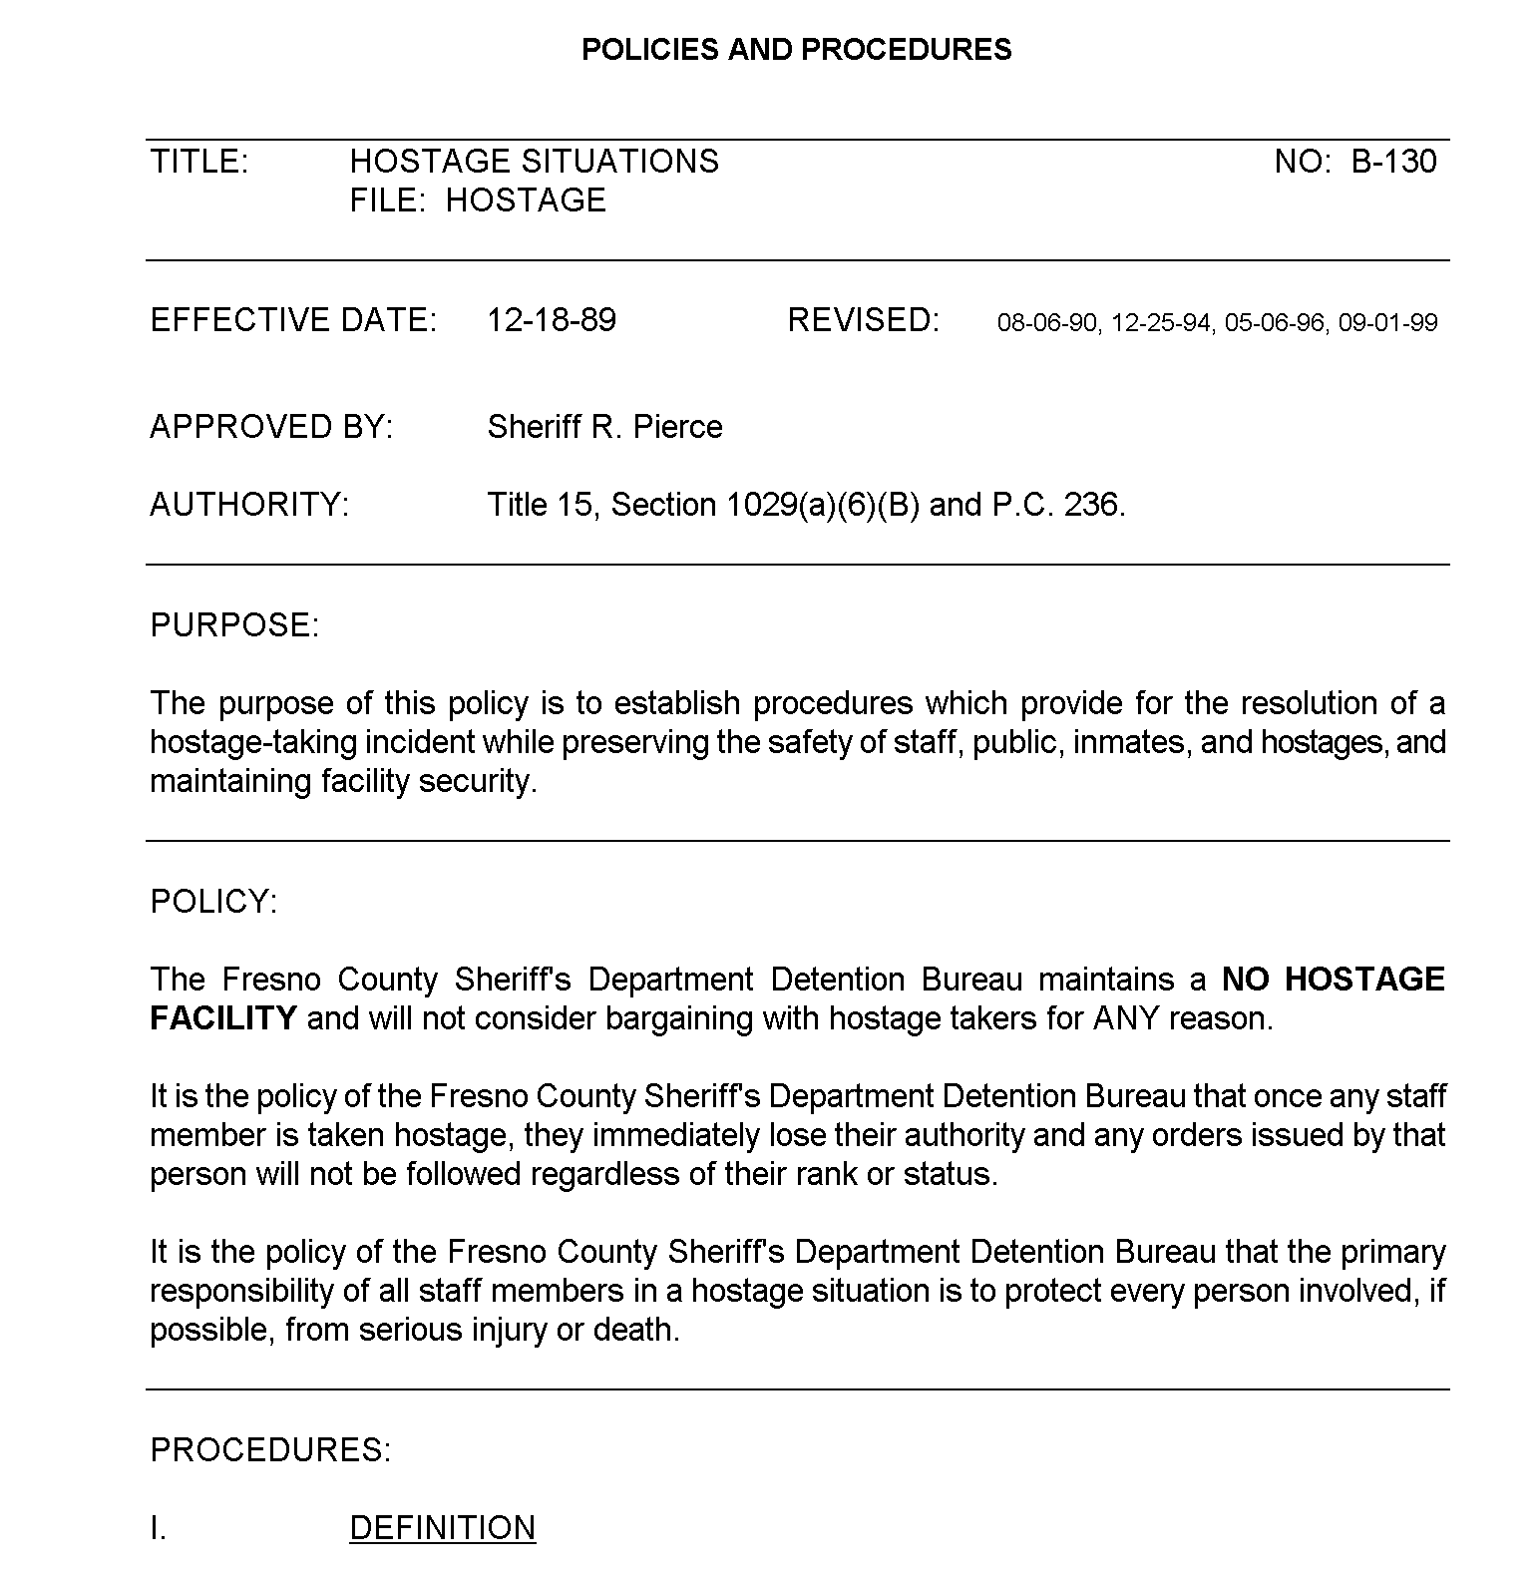
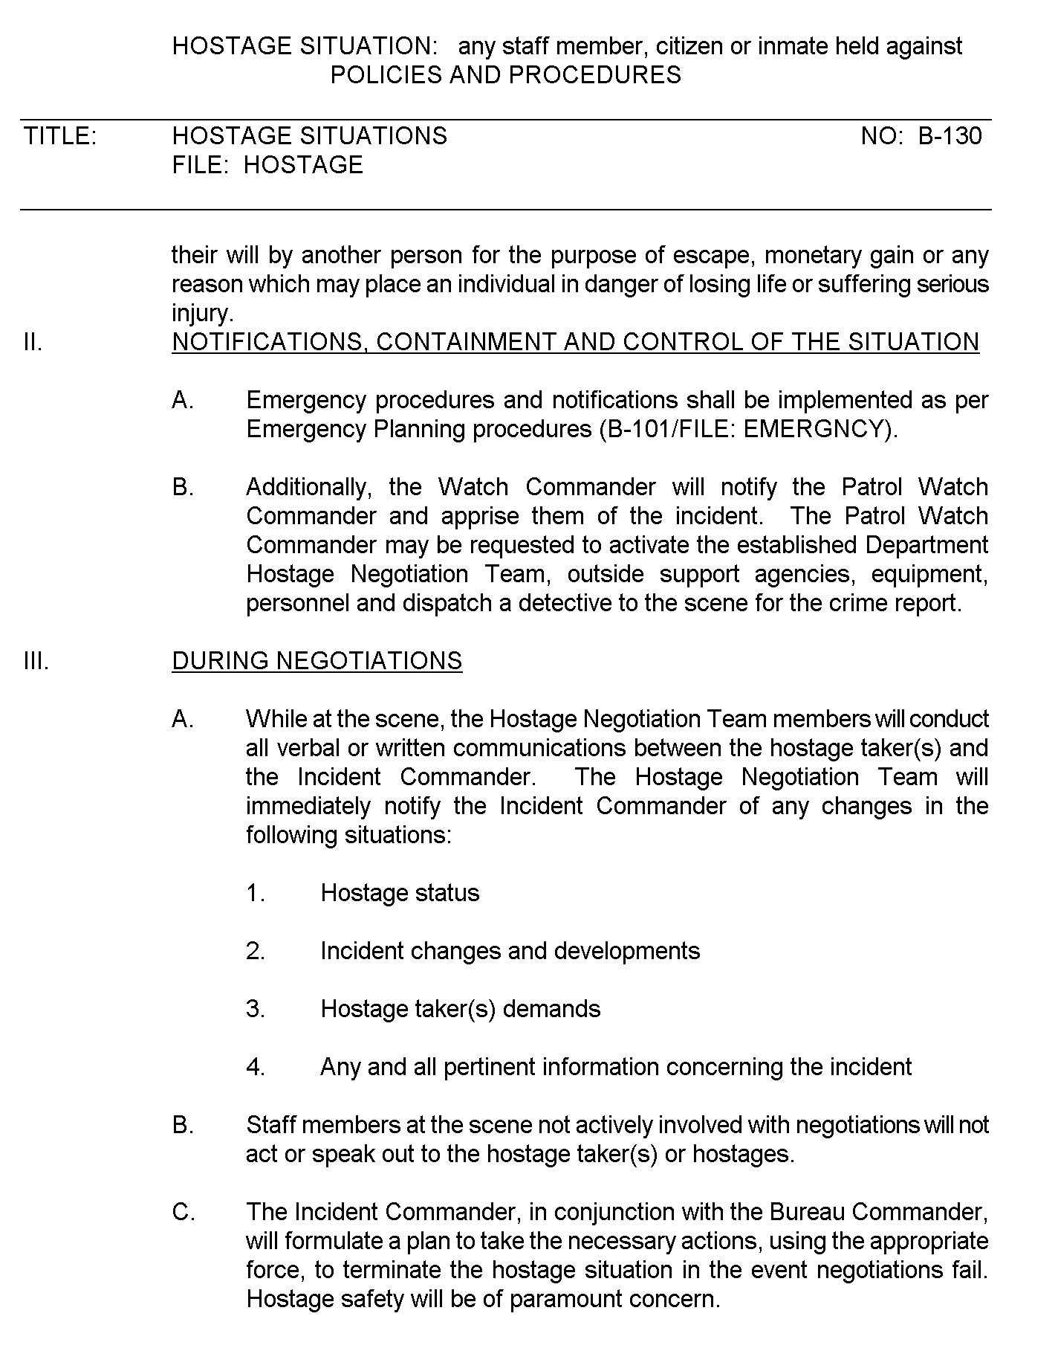
Attachment b
juvenile justice campus no hostage policy
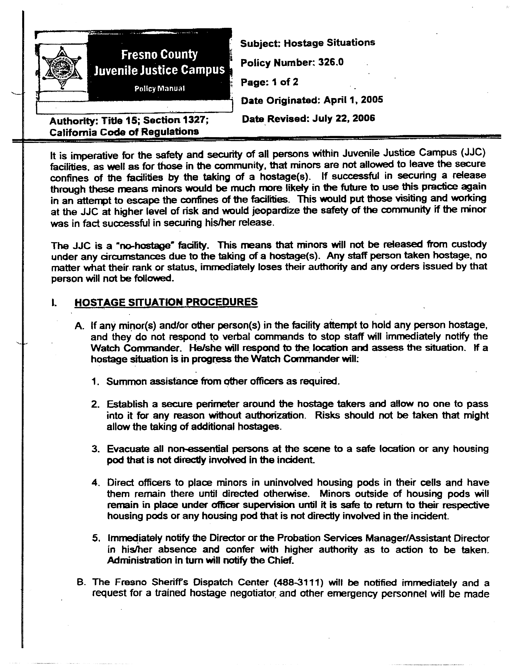
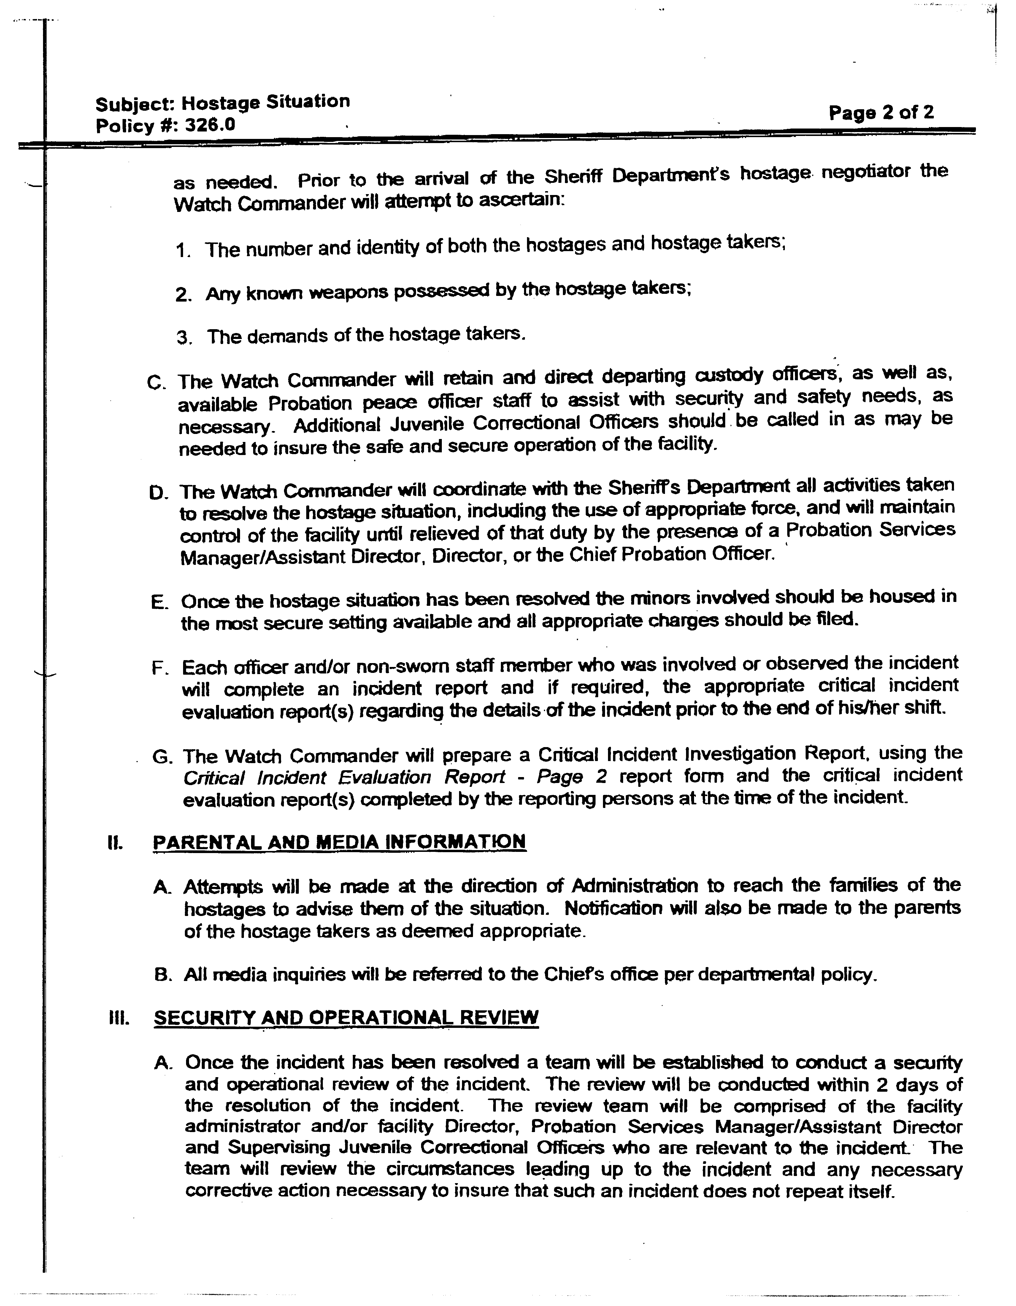
attachment c
probation department no hostage policy
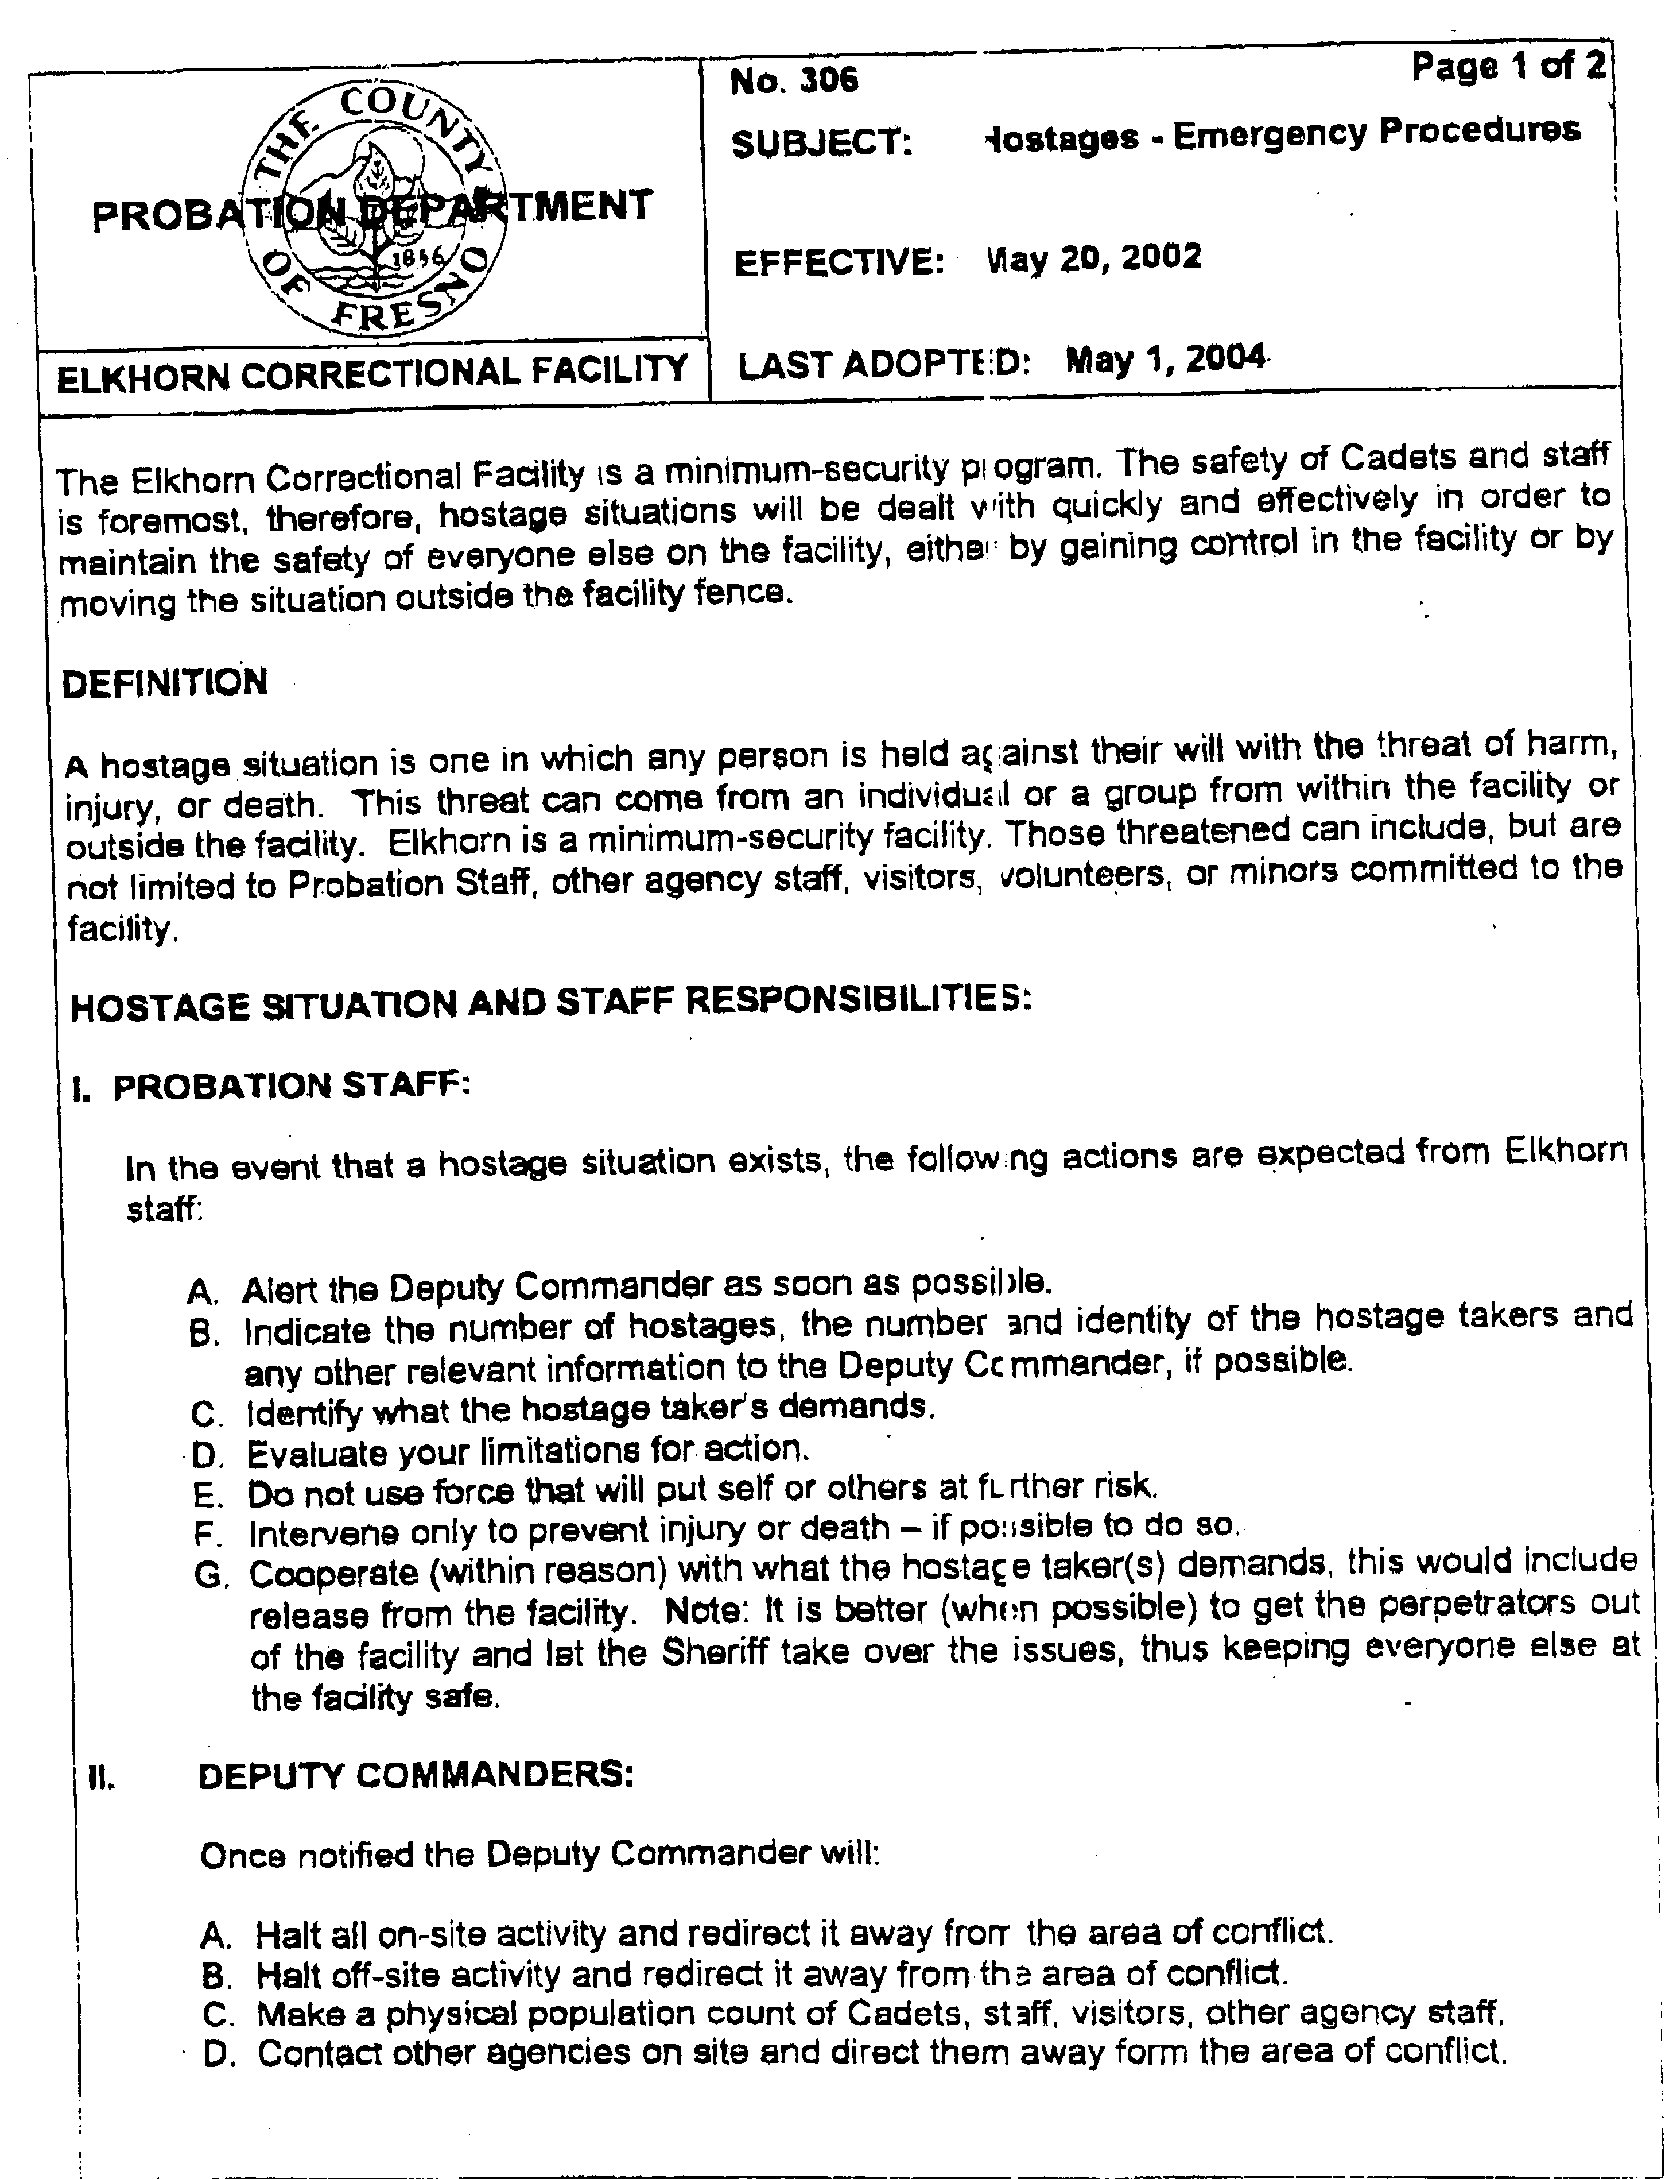
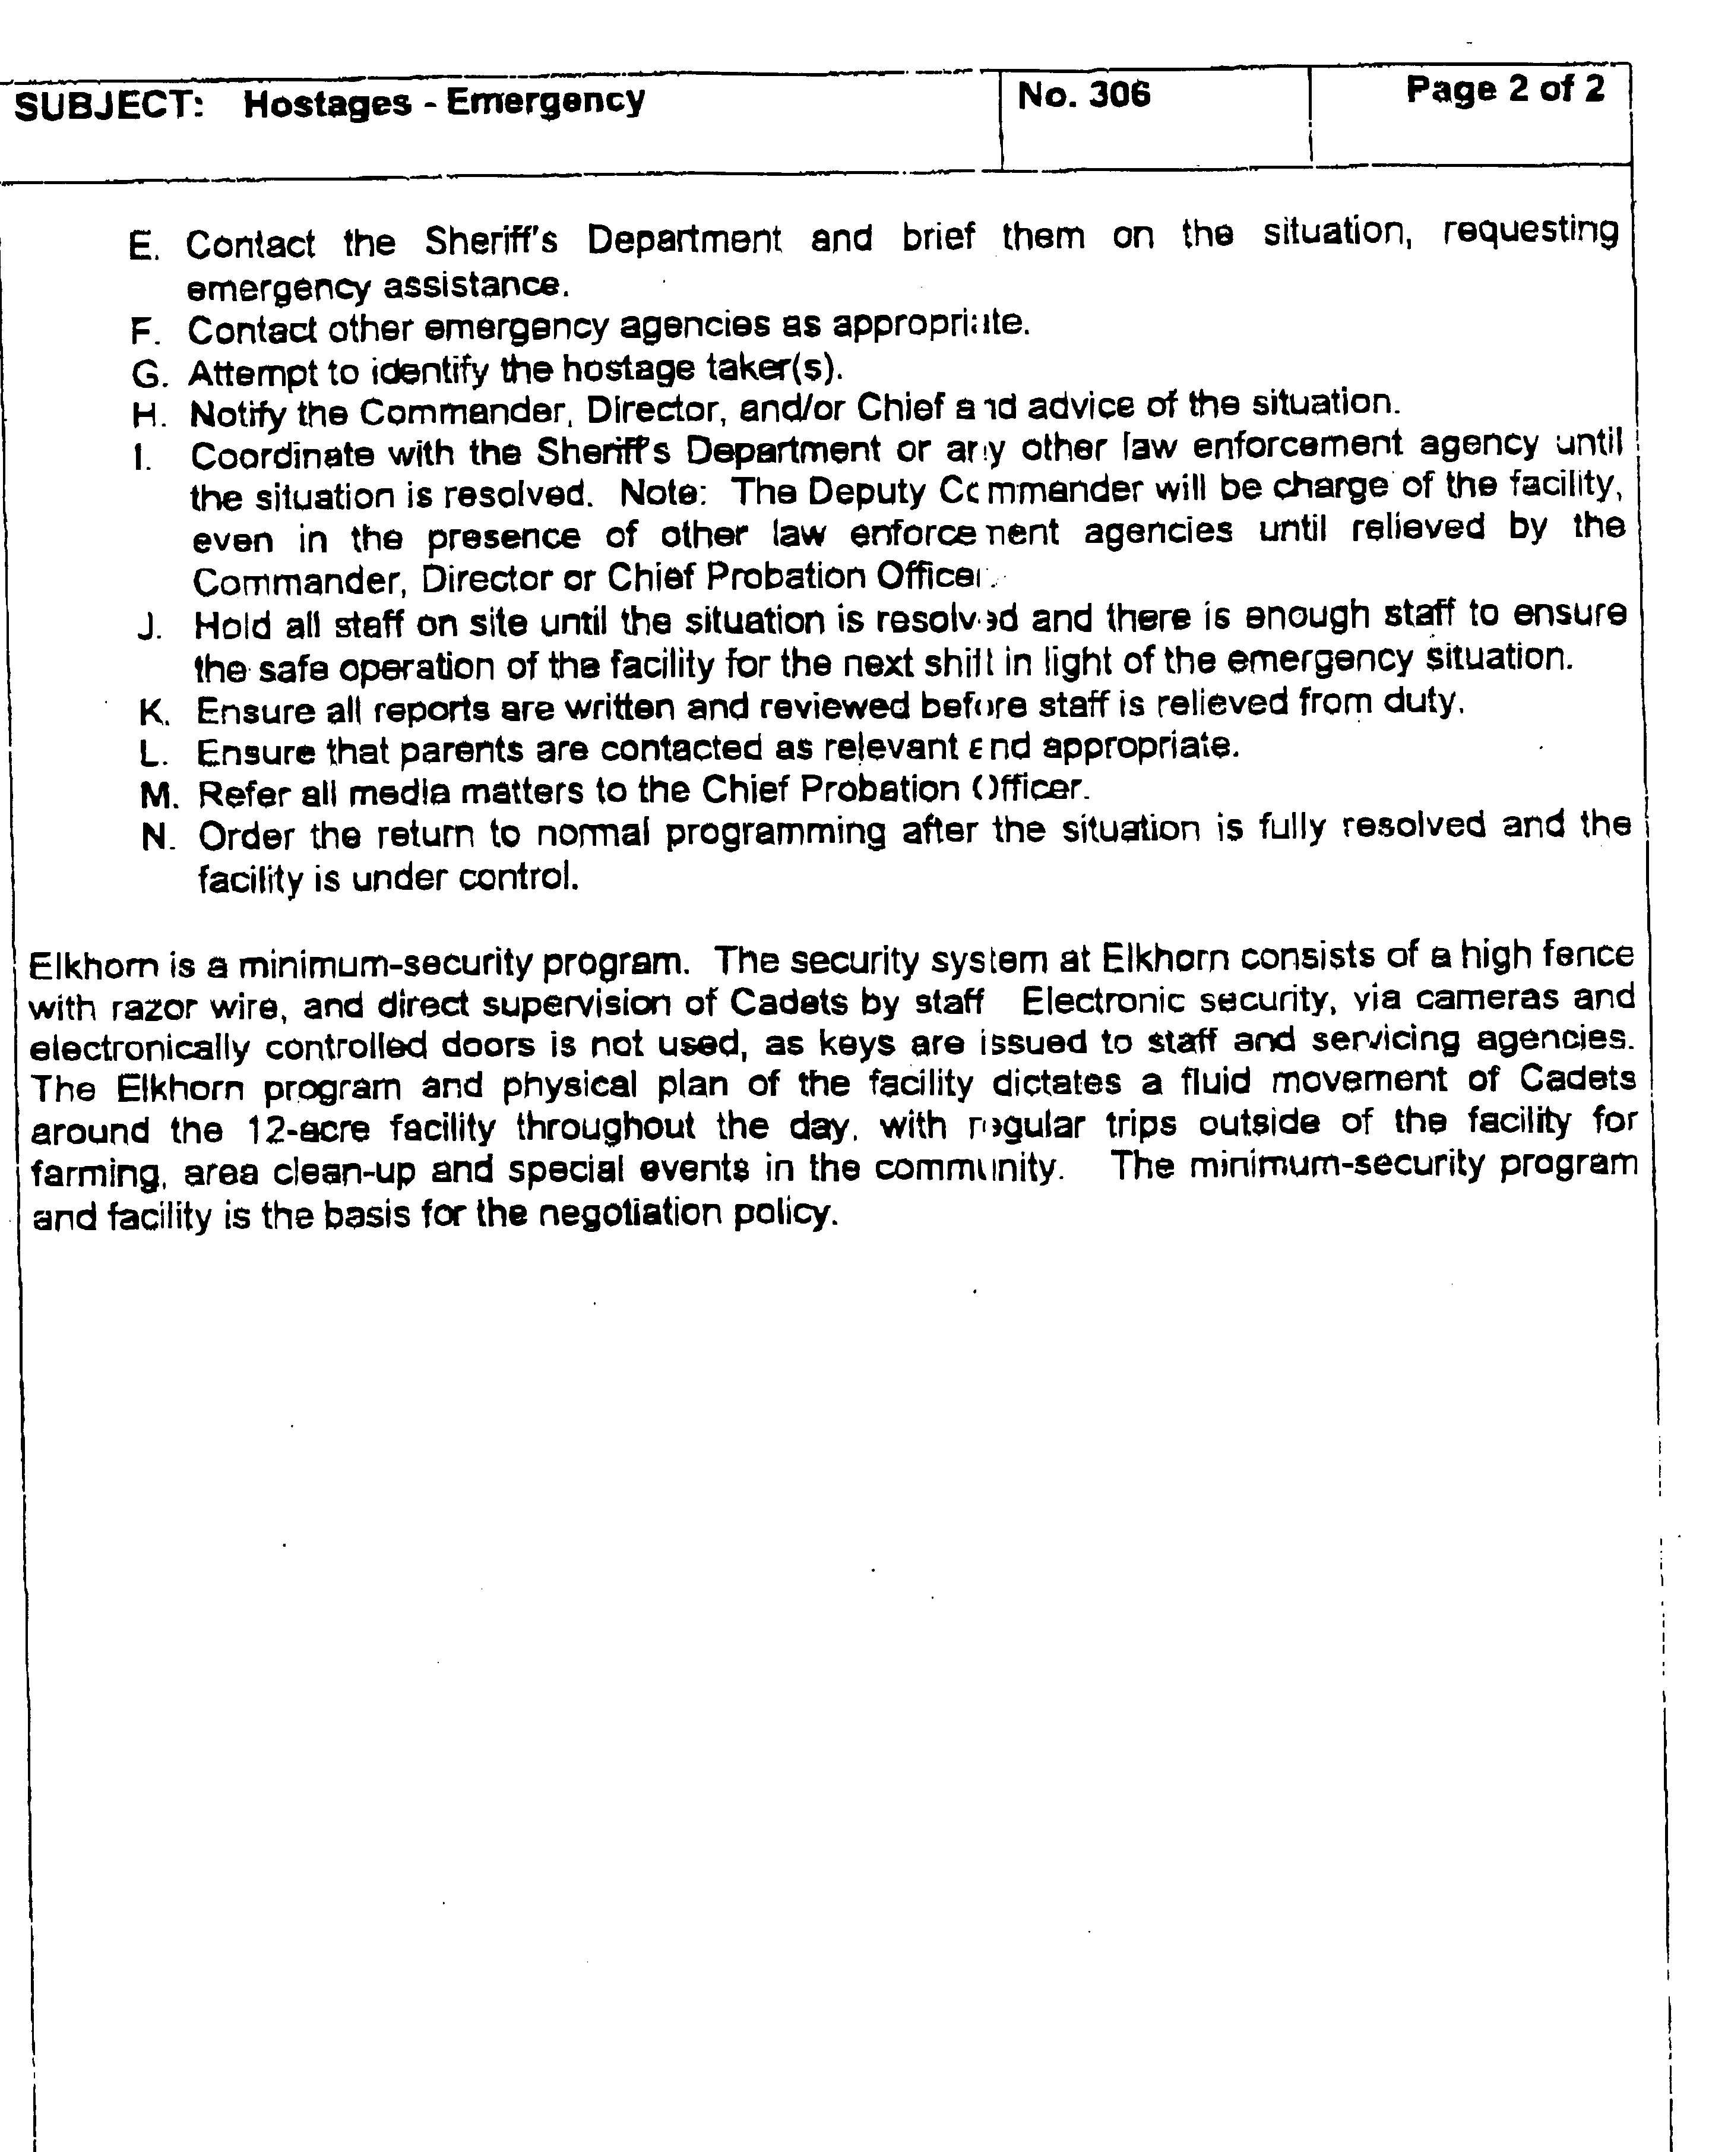
Attachment d
map of chest clinic
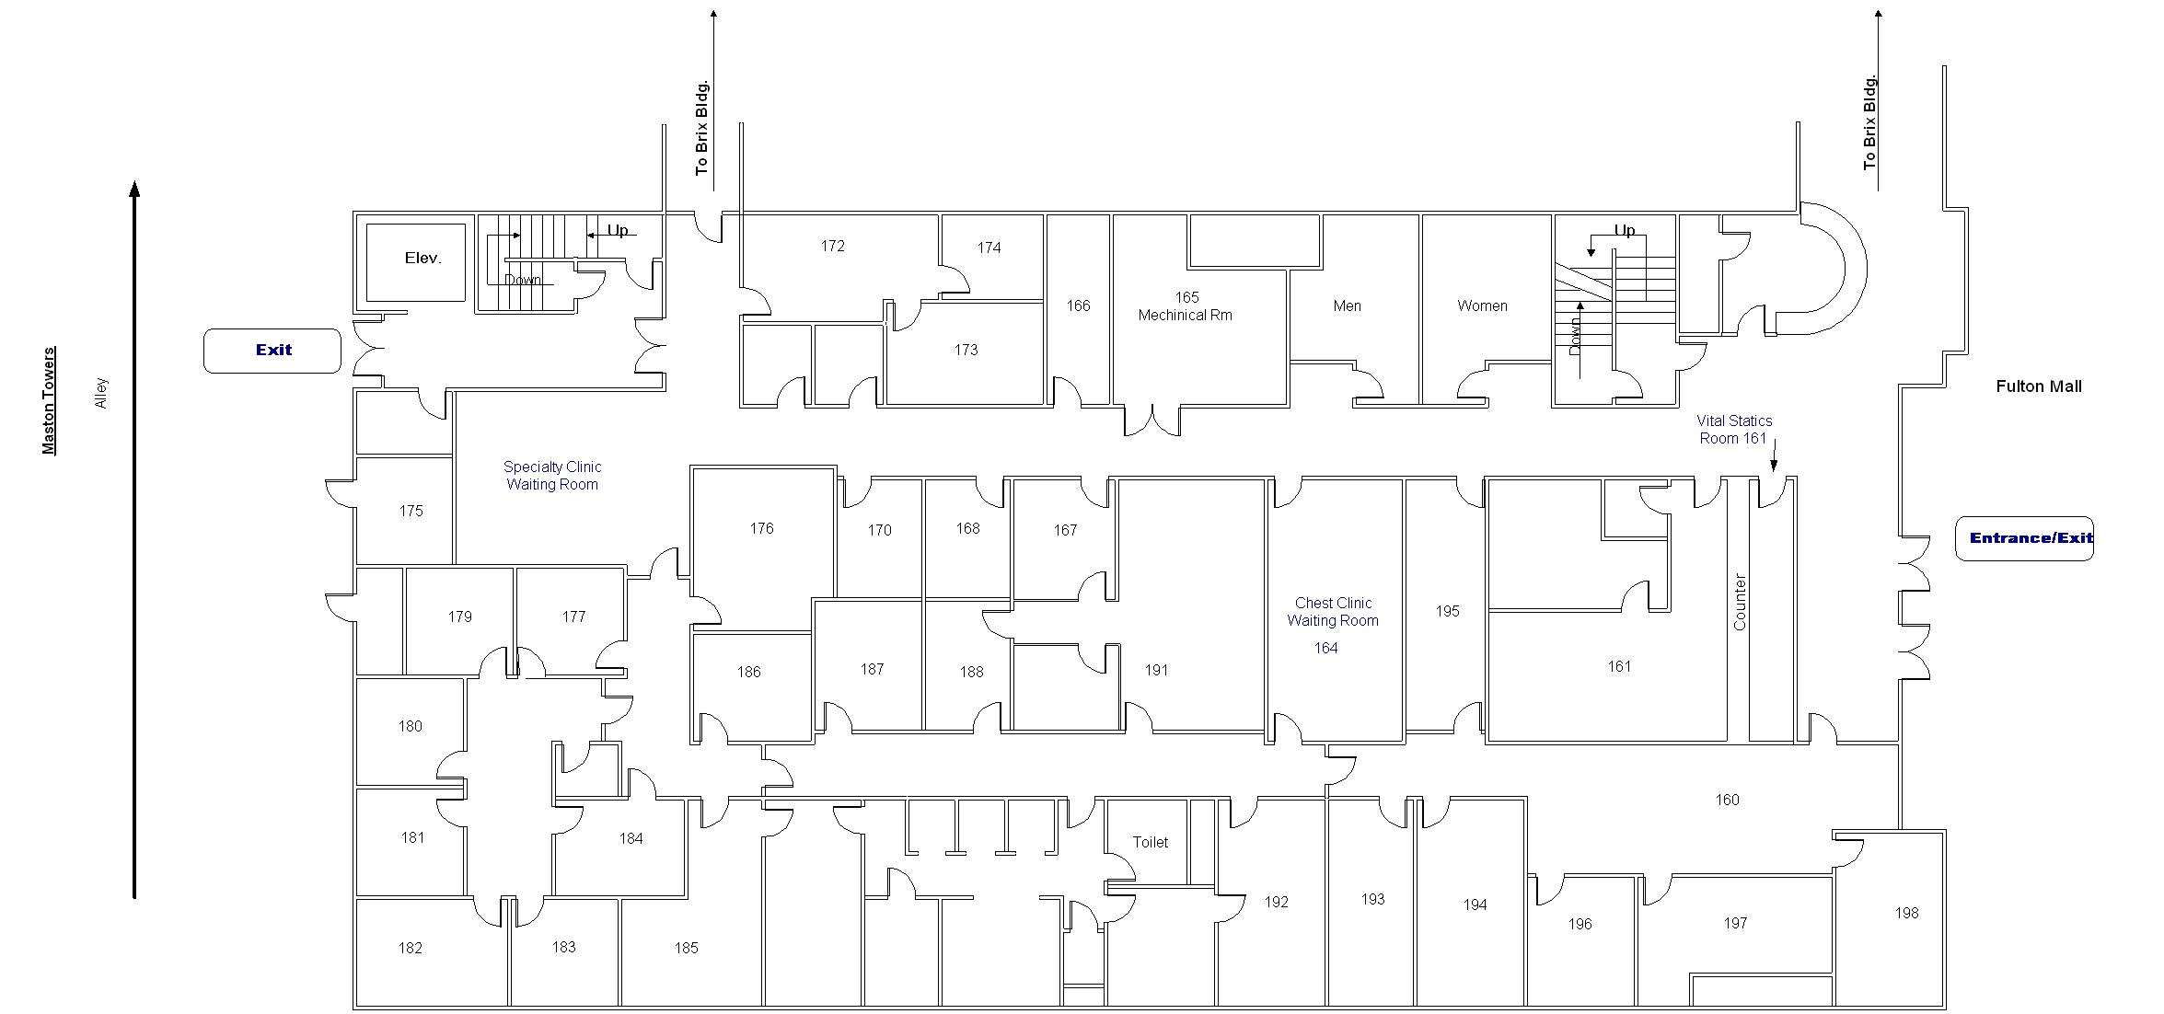
Indicates room available for taking X-rays.

CHECK LIST
This Checklist is provided to assist the vendors in the preparation of their bid response. Included in this list, are important requirements and is the responsibility of the bidder to submit with the bid package in order to make the bid compliant. Because this checklist is just a guideline, the bidder must read and comply with the bid in its entirety.
Check off each of the following:
The Request for Quotation (RFP) has been signed and completed.
The Federal Employers Identification Number or Social Security Number has been entered in the space provided.
One (1) original and two (8) copies of the RFP have been provided.
Addenda, if any, have been completed, signed and included in the bid package.
The completed Reference List as provided with this RFP.
The Cost Proposal as provided with this RFP, has been completed, priced reviewed for accuracy and any corrections initialed in ink.
Indicate all of bidder exceptions to the County’s requirements, conditions and specifications as stated within this RFP.
Bidder to Complete page as provided with this RFP.
Lastly, on the LOWER LEFT HAND CORNER of the sealed envelope, box, etc. transmitting your bid, attach the “Request for Quotation Label” and include the following information:

County of Fresno RFQ No. |  |  | 952-4615
Closing Date: | September 25, 2008
Closing Time: | 2:00 P.M.

Commodity or Service:
This Checklist does not need to be returned with your bid.

