COUNTY OF FRESNO
ADDENDUM NUMBER: Two (2)
 |  | RFP NUMBER:
March 3, 2007
 |  |  | PURCHASING USE
 | ORG/Requisition: / |  |  | jlg | /tmp/in/input.doc
IMPORTANT: SUBMIT PROPOSAL IN SEALED PACKAGE WITH PROPOSAL NUMBER, CLOSING DATE AND BUYER’S NAME MARKED CLEARLY ON THE OUTSIDE TO:
COUNTY OF FRESNO, Purchasing
4525 EAST HAMILTON AVENUE
FRESNO, CA 93702-4599
Closing date of proposal will be at 2:00 p.m., on March 9, 2007.
PROPOSALS WILL BE CONSIDERED LATE WHEN THE OFFICIAL PURCHASING TIME CLOCK READS 2:00 P.M.
Proposals will be opened and publicly read at that time. All proposal information will be available for review after contract award.
Clarification of specifications are to be directed to: Gary W. Parkinson, phone (559) 456-7110, FAX (559) 456-7831.
NOTE THE attached ADDITIONS, DELETIONS AND/OR CHANGES TO THE REQUIREMENTS OF REQUEST FOR PROPOSAL NUMBER: AND INCLUDE THEM IN YOUR RESPONSE. PLEASE SIGN AND RETURN THIS ADDENDUM WITH YOUR PROPOSAL.

ACKNOWLEDGMENT OF ADDENDUM NUMBER Two (2) TO RFP
COMPANY NAME:
(PRINT)
SIGNATURE:
NAME & TITLE:
(PRINT)
RFP QUESTIONS FROM UNION
- Will al program participants be on Conservatorship?
Response: No, item discussed in Bidder Conference
- Will sexual offenders or conservatees with violent behavioral be assigned to the ACT program?
Response: No sexual predators will be assign to the ACT team. Violent behavioral will be determined on a case by case basis.
- Is the vendor allowed to modify the staffing composition if it maintains a client to staffing ration of 1:10? Can vendor operate with solely one psychiatrist? Can vendor utilize a Nurse Practitioner in conjunction with Psychiatrist? Define Nurse Practitioner? Can vendor utilize LVN and LPT?
Response: Vendor must comply with the staff standard by number and professional discipline found in the RFP. Vendor must provide 1.5 Psychiatrist with no substitutions of other professional. Registered Nurses must be Registered Nurses and not LVN or LPT.
- Who is responsible for payment for those conservatees court ordered to a high level of care such as an IMD or State Hospital? What is the vendor’s level of responsibility when a client (Murphy Conservatee) has court order level of placement?
Response: As discussed in bidder conference, the County will be responsible for the cost of placement of clients placed in higher level of care… The number of placement in higher level of care will be used as an outcome measure within any contract for services resulting from the RFP.
- Is the vendor allowed to use a Supplemental Rate Board and Care, basic Board and Care as a transitional residence prior to independent living? Can the vendor utilize Room and Board’s and/or Supported independent Housing for transitional purposes?
Response: The RFP requires the vendor to develop and maintain independent housing for all consumers enrolled in the program. As discussed in the bidder conference, the vendor can’t use Supplemental Rate Board and Care or basic Board and Care as a transitional residence. The RFP is based on an ACT model which as been demonstrated across the county that consumer can live in independent housing given enough support services.
- Who will designate/determine the 150 conservatees to the vendor? How many do not have a source of income? Can the vendor refuse a client designated by the County who does not have a source of income? How many program participants will be removed form IMD, MHRC, SNF, State Hospital, Supplemental Board and Care, Social Rehabilitation, and Basic Board and Care into this new ACT program.
Response: As discussed in the bidder conference not all 150 clients will necessarily be conservatees. The 150 clients will potentially come from all the types of facilities listed in the questions. The County will work with the vendor to identify the clients that will be enrolled in the ACT program. Vendor will not be able to refuse clients based on the client’s source of income.
- In accordance to the Conservatorship Legal Document it is stated, “ The conservatee will be placed at the most appropriate lowest level of care”. Who in the County will determine the level of care?
Response: Legally, the person designed as the Conservator by the County determines the appropriate level of care.
- Can vendor dis-enroll or graduate (link client to Metro) client who is no longer on Conservatorship?
Response: The ACT program will be a full service partnership and will be responsible for providing services whether or not the client is on Conservatorship.
- Who pays for medications? For UMDAP’s?
Response: Since this is a cost reimbursement contract, the County will reimburse the vendor for any psychiatric medications they prescribe for consumers enrolled in the program.
- Will staff on the ACT team be deputized?
Response: A determination of this issue will be made once the consumers have been identified who are to be enrolled in the ACT program.
- Will staff on the ACT team be able to write 5150’s
Response: The licensed staff on the ACT team will be authorized 5150’s once they have taken the required County 5150 training.
- Who is responsible for the cost of the representative payee services provided by the Public Guardian Office appointed by the Court?
Response: One of service that the ACT program is to provide is representative payee services and it will be an allowable cost under the terms of the contract.
- How much is budgeted for this service?
Response: It is not clear to what service the question is referring.
- What is the maximum allowance for an advance payment or start-up costs?
Response: Services will be paid for in arrears. The amount of start of cost will be neogtiated with the successful bidder in developing the contract.
- Can copy of the mailing list be submitted to the vendor’s? If so, this program requests a copy of the most recent mailing list.
Response: See next 2 pages.

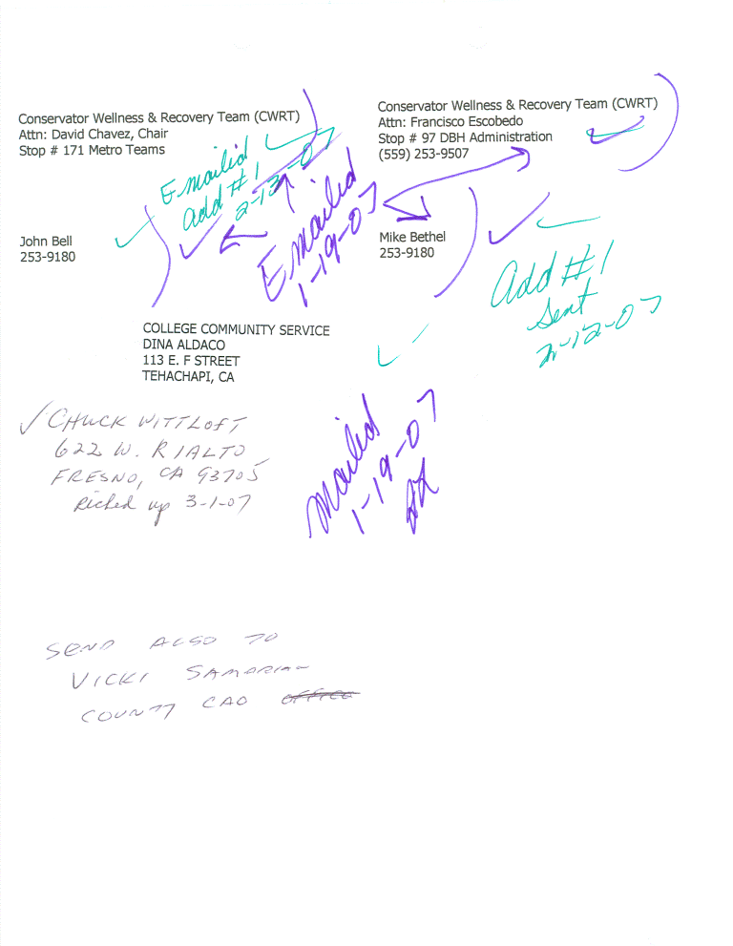
- Is the program going to receive clients without any funding source? Is the program going to receive clients that are undocumented?
The program will receive clients who are seriously mentally ill regardless of funding source.

