COUNTY OF FRESNO
Request for proposal
 |  |  | NUMBER: 952-4313
August 11, 2006
ORG/Requisition: 56302175/ 5637009630 |  |  |  |  |  |  |  | PURCHASING USE |  |  |  | /tmp/in/input.doc
 |  |  |  |  |  |  |  | jlg
IMPORTANT: SUBMIT PROPOSAL IN SEALED PACKAGE WITH PROPOSAL NUMBER, CLOSING DATE AND BUYER’S NAME MARKED CLEARLY ON THE OUTSIDE TO:
COUNTY OF FRESNO, Purchasing
4525 EAST HAMILTON AVENUE
FRESNO, CA 93702-4599
Closing date of bid will be at 2:00 p.m., on October 11, 2006.
PROPOSALS WILL BE CONSIDERED LATE WHEN THE OFFICIAL PURCHASING TIME CLOCK READS 2:00 P.M.
Proposals will be opened and publicly read at that time. All proposal information will be available for review after contract award.
Clarification of specifications are to be directed to: Brian D. Tamblin, phone (559) 456-7110, FAX (559) 456-7831.
GENERAL CONDITIONS: See “County Of Fresno Purchasing Standard Instructions And Conditions For Request For Proposals (RFP’S) and Requests for Quotations (RFQ’S)” attached.
BIDDER TO COMPLETE
UNDERSIGNED AGREES TO FURNISH THE COMMODITY OR SERVICE STIPULATED IN THE ATTACHED PROPOSAL SCHEDULE AT THE PRICES AND TERMS STATED, SUBJECT TO THE “COUNTY OF FRESNO PURCHASING STANDARD INSTRUCTIONS AND CONDITIONS FOR REQUEST FOR PROPOSALS (RFP’S) AND REQUESTS FOR QUOTATIONS (RFQ’S)”ATTACHED.
Except as noted on individual items, the following will apply to all items in the Proposal Schedule.
- Complete delivery will be made within |  |  |  |  |  |  |  |  | calendar days after receipt of Order.
- A cash discount of |  |  |  |  |  | % |  |  |  |  | days will apply.
Company
Address
City |  |  |  |  |  |  |  |  |  |  |  |  |  | State |  | Zip Code
( ) |  |  |  |  | ( )
Telephone Number |  |  |  |  | Facsimile Number |  |  |  |  |  |  |  |  | E-mail Address
Taxpayer Federal I.D. No.:
Signed By
Print Name |  |  |  |  |  |  |  |  |  | Title

COUNTY OF FRESNO PURCHASING
STANDARD INSTRUCTIONS AND CONDITIONS FOR
REQUESTS FOR PROPOSALS (RFP'S) AND REQUESTS FOR QUOTATIONS (RFQ'S)
Note: the reference to “bids” in the following paragraphs applies to RFP's and RFQ's

GENERAL CONDITIONS
By submitting a bid the bidder agrees to the following conditions. These conditions will apply to all subsequent purchases based on this bid.

- BID PREPARATION:
  - All prices and notations must be typed or written in ink. No erasures permitted. Errors may be crossed out, initialed and corrections printed in ink by person signing bid.
  - Brand Names: Brand names and numbers when given are for reference. Equal items will be considered, provided the offer clearly describes the article and how it differs from that specified. In the absence of such information it shall be understood the offering is exactly as specified.
  - State brand or make of each item. If bidding on other than specified, state make, model and brand being bid and attach supporting literature/specifications to the bid.
  - Bid on each item separately. Prices should be stated in units specified herein. All applicable charges must be quoted; charges on invoice not quoted herein will be disallowed.
  - Time of delivery is a part of the consideration and must be stated in definite terms and must be adhered to. F.O.B. Point shall be destination or freight charges must be stated.
  - All bids must be dated and signed with the firm’s name and by an authorized officer or employee.
  - Unless otherwise noted, prices shall be firm for 120 days after closing date of bid.
- SUBMITTING BIDS:
  - Each bid must be submitted on forms provided in a sealed envelope with bid number and closing date and time on the outside of the envelope/package.
  - Interpretation: Should any discrepancies or omissions be found in the bid specifications or doubt as to their meaning, the bidder shall notify the Buyer in writing at once. The County shall not be held responsible for verbal interpretations. Questions regarding the bid must be received by Purchasing at least 5 working days before bid opening. All addenda issued shall be in writing, duly issued by Purchasing and incorporated into the contract.
  - ISSUING AGENT/AUTHORIZED CONTACT: This RFQ has been issued by County of Fresno Purchasing. Purchasing shall be the vendor’s sole point of contact with regard to the RFQ, its content, and all issues concerning it.
All communication regarding this RFQ shall be directed to an authorized representative of County Purchasing. The specific buyer managing this RFQ is identified on the cover page, along with his or her telephone number, and he or she should be the primary point of contact for discussions or information pertaining to the RFQ. Contact with any other County representative, including elected officials, for the purpose of discussing this RFQ, its content, or any other issue concerning it, is prohibited unless authorized by Purchasing. Violation of this clause, by the vendor having unauthorized contact (verbally or in writing) with such other County representatives, may constitute grounds for rejection by Purchasing of the vendor’s quotation.
The above stated restriction on vendor contact with County representatives shall apply until the County has awarded a purchase order or contract to a vendor or vendors, except as follows. First, in the event that a vendor initiates a formal protest against the RFQ, such vendor may contact the appropriate individual, or individuals who are managing that protest as outlined in the County’s established protest procedures. All such contact must be in accordance with the sequence set forth under the protest procedures. Second, in the event a public hearing is scheduled before the Board of Supervisors to hear testimony prior to its approval of a purchase order or contract, any vendor may address the Board.
  - Bids received after the closing time will NOT be considered.
  - Bidders are to bid what is specified or requested first. If unable to or willing to, bidder may bid alternative or option, indicating all advantages, disadvantages and their associated cost.
- FAILURE TO BID:
  - If not bidding, return bid sheet and state reason for no bid or your name may be removed from mailing list.
- TAXES, CHARGES AND EXTRAS:
  - County of Fresno is subject to California sales and/or use tax (7.975%). Please indicate as a separate line item if applicable.
  - DO NOT include Federal Excise Tax. County is exempt under Registration No. 94-73-03401-K.
  - County is exempt from Federal Transportation Tax. Exemption certificate is not required where shipping papers show consignee as County of Fresno.
  - Charges for transportation, containers, packing, etc. will not be paid unless specified in bid.
- W-9 – REQUEST FOR TAXPAYER IDENTIFICATION NUMBER AND CERTIFICATION:
Upon award of bid, the vendor shall submit to County Purchasing, a completed W-9 - Request for Taxpayer Identification Number and Certification if not already a current vendor with The County of Fresno. This form is available from the IRS to complete on line at http://www.irs.gov/pub/irs-pdf/fw9.pdf.
- AWARDS:
  - Subject to the local preference provisions referenced in Paragraph 6 below and more thoroughly set forth in the General Requirements section of this RFQ, award(s) will be made to the most responsive responsible bidder. The evaluation will include such things as life-cycle cost, availability, delivery costs and whose product and/or service is deemed to be in the best interest of the County. The County shall be the sole judge in making such determination.
  - Unless bidder gives notice of all-or-none award in bid, County may accept any item, group of items or on the basis of total bid.
  - The County reserves the right to reject any and all bids and to waive informalities or irregularities in bids.
  - After award, all bids shall be open to public inspection. The County assumes no responsibility for the confidentiality of information offered in a bid.
- LOCAL VENDORS
  - Local Vendor Preference (applicable to RFQ Process only)
The following provisions are applicable only to the County’s acquisition of materials, equipment or supplies through the RFQ process when the funding source does not require an exemption to the Local Vendor Preference.
THE PROVISIONS OF THIS PARAGRAPH ARE APPLICABLE, NOTWITHSTANDING ANY OTHER PROVISIONS OF THIS RFQ TO THE CONTRARY
If the apparent low bidder is not a local vendor, any local vendor who submitted a bid which was within five percent (5%) of the lowest responsive bid as determined by the purchasing agent shall have the option of submitting a new bid within forty-eight hours (not including weekends and holidays) of County’s delivery of notification. Such new bids must be in an amount less than or equal to the lowest responsive bid as determined by the purchasing agent. If the purchasing agent receives any new bids from local vendors who have the option of submitting new bids within said forty-eight hour period, it shall award the contract to the local vendor submitting the lowest responsible bid. If no new bids are received, the contract shall be awarded to the original low bidder as announced by the purchasing agent.
  - Local Vendor Defined
“Local Vendor” shall mean any business which:
- Has its headquarters, distribution point or locally-owned franchise located in or having a street address within the County for at least six (6) months immediately prior to the issuance of the request for competitive bids by the purchasing agent; and
- Holds any required business license by a jurisdiction located in Fresno County; and
- Employs at least one (1) full-time or two (2) part-time employees whose primary residence is located within Fresno County, or if the business has no employees, shall be at least fifty percent (50%) owned by one or more persons whose primary residence(s) is located within Fresno County.
- TIE BIDS:
All other factors being equal, the contract shall be awarded to the Fresno County vendor or, if neither or both are Fresno County vendors, it may be awarded by the flip of a coin in the presence of witnesses or the entire bid may be rejected and re-bid. If the General Requirements of this RFQ state that they are applicable, the provisions of the Fresno County Local Vendor Preference shall take priority over this paragraph.
- PATENT INDEMNITY:
The vendor shall hold the County, its officers, agents and employees, harmless from liability of any nature or kind, including costs and expenses, for infringement or use of any copyrighted or uncopyrighted composition, secret process, patented or unpatented invention, article or appliance furnished or used in connection with this bid.
- SAMPLES:
Samples, when required, must be furnished and delivered free and, if not destroyed by tests, will upon written request (within 30 days of bid closing date) be returned at the bidder's expense. In the absence of such notification, County shall have the right to dispose of the samples in whatever manner it deems appropriate.
- RIGHTS AND REMEDIES OF COUNTY FOR DEFAULT:
  - In case of default by vendor, the County may procure the articles or service from another source and may recover the cost difference and related expenses occasioned thereby from any unpaid balance due the vendor or by proceeding against performance bond of the vendor, if any, or by suit against the vendor. The prices paid by the County shall be considered the prevailing market price at the time such purchase is made.
  - Articles or services, which upon delivery inspection do not meet specifications, will be rejected and the vendor will be considered in default. Vendor shall reimburse County for expenses related to delivery of non-specified goods or services.
  - Regardless of F.O.B. point, vendor agrees to bear all risks of loss, injury or destruction to goods and materials ordered herein which occur prior to delivery and such loss, injury or destruction shall not release vendor from any obligation hereunder.
- DISCOUNTS:
Terms of less than 15 days for cash payment will be considered as net in evaluating this bid. A discount for payment within fifteen (15) days or more will be considered in determining the award of bid. Discount period will commence either the later of delivery or receipt of invoice by the County. Standard terms are Net Forty-five (45) days.
- SPECIAL CONDITIONS IN BID SCHEDULE SUPERSEDE GENERAL CONDITIONS.
The “General Conditions” provisions of this RFP/RFQ shall be superseded if in conflict with any other section of this bid, to the extent of any such conflict.
- SPECIAL REQUIREMENT:
With the invoice or within twenty-five (25) days of delivery, the seller must provide to the County a Material Safety Data Sheet for each product, which contains any substance on “The List of 800 Hazardous Substances”, published by the State Director of Industrial Relations. (See Hazardous Substances Information and Training Act. California State Labor Code Sections 6360 through 6399.7.)
- RECYCLED PRODUCTS/MATERIALS:
Vendors are encouraged to provide and quote (with documentation) recycled or recyclable products/materials which meet stated specifications.
- YEAR COMPLIANCE WARRANTY
Vendor warrants that any product furnished pursuant to this Agreement/order shall support a four-digit year format and be able to accurately process date and time data from, into and between the twentieth and twenty-first centuries, as well as leap year calculations. "Product" shall include, without limitation, any piece or component of equipment, hardware, firmware, middleware, custom or commercial software, or internal components or subroutines therein. This warranty shall survive termination or expiration of this Agreement.
In the event of any decrease in product functionality or accuracy related to time and/or date data related codes and/or internal subroutines that impede the product from operating correctly using dates beyond December 31, 1999, vendor shall restore or repair the product to the same level of functionality as warranted herein, so as to minimize interruption to County's ongoing business process, time being of the essence. In the event that such warranty compliance requires the acquisition of additional programs, the expense for any such associated or additional acquisitions, which may be required, including, without limitation, data conversion tools, shall be borne exclusively by vendor. Nothing in this warranty shall be construed to limit any rights or remedies the County may otherwise have under this Agreement with respect to defects other than year performance.
- PARTICIPATION:
Bidder may agree to extend the terms of the resulting contract to other political subdivision, municipalities and tax-supported agencies.
Such participating Governmental bodies shall make purchases in their own name, make payment directly to bidder, and be liable directly to the bidder, holding the County of Fresno harmless.
- CONFIDENTIALITY:
All services performed by vendor shall be in strict conformance with all applicable Federal, State of California and/or local laws and regulations relating to confidentiality, including but not limited to, California Civil Code, California Welfare and Institutions Code, Health and Safety Code, California Code of Regulations, Code of Federal Regulations.
Vendor shall submit to County’s monitoring of said compliance.
Vendor may be a business associate of County, as that term is defined in the “Privacy Rule” enacted by the Health Insurance Portability and Accountability Act of 1996 (HIPAA). As a HIPAA Business Associate, vendor may use or disclose protected health information (“PHI”) to perform functions, activities or services for or on behalf of County as specified by the County, provided that such use or disclosure shall not violate HIPAA and its implementing regulations. The uses and disclosures if PHI may not be more expansive than those applicable to County, as the “Covered Entity” under HIPAA’S Privacy Rule, except as authorized for management, administrative or legal responsibilities of the Business Associate.
Vendor shall not use or further disclose PHI other than as permitted or required by the County, or as required by law without written notice to the County.
Vendor shall ensure that any agent, including any subcontractor, to which vendor provides PHI received from, or created or received by the vendor on behalf of County, shall comply with the same restrictions and conditions with respect to such information.
- APPEALS
Appeals must be submitted in writing within seven (7) working days after the review committee notification of proposed recommendations. Appeals should be submitted to County of Fresno Purchasing, 4525 E. Hamilton Avenue, Fresno, California 93702-4599. Appeals should address only areas regarding RFP contradictions, procurement errors, quotation rating discrepancies, legality of procurement context, conflict of interest in rating process, and inappropriate or unfair competitive procurement grievance regarding the RFP process.
The Purchasing Manager will provide a written response to the complaint within seven (7) working days unless the complainant is notified more time is required.
If the protesting bidder is not satisfied with the decision of the Purchasing Manager, he/she shall have the right to appeal to the Purchasing Agent within seven (7) business days after notification of the Purchasing Manager’s decision.
If the protesting bidder is not satisfied with Purchasing Agent decision, the final appeal is with the Board of Supervisors.
- OBLIGATIONS OF CONTRACTOR:
  - CONTRACTOR shall perform as required by the ensuing contract. CONTRACTOR also warrants on behalf of itself and all subcontractors engaged for the performance of the ensuing contract that only persons authorized to work in the United States pursuant to the Immigration Reform and Control Act of 1986 and other applicable laws shall be employed in the performance of the work hereunder.
  - CONTRACTOR shall obey all Federal, State, local and special district laws, ordinances and regulations.

TABLE OF CONTENTS
PAGE
OVERVIEW 3
KEY DATES 3
PROPOSAL IDENTIFICATION SHEET 4
TRADE SECRET ACKNOWLEDGEMENT 5
REFERENCE LIST 7
GENERAL REQUIREMENTS 8
PARTICIPATION 15
W-9 Request for Taxpayer I.D. Number & Certification 16
SPECIFIC TERMS AND CONDITIONS 20
SCOPE OF WORK 22
COST PROPOSAL 28
PROPOSAL CONTENT REQUIREMENTS 29
AWARD CRITERIA 32
ATTACHMENT “A” 33
ATTACHMENT “B” 36
ATTACHMENT “C” 38
ATTACHMENT “D” 40

OVERVIEW
The County of Fresno, on behalf of the Department of Behavioral Health (DBH), is requesting proposals from qualified persons or organizations to provide case management services to assess mental health, physical, medical, educational, vocational, social, or other community services required by eligible DBH consumers. Additionally, the proposal shall include on-site housing management and supportive services, these services to include, but not be limited to the following: consumer monitoring, ongoing support, crisis intervention, linkage to mental health resources, housing assistance, tenant screening, medication management and coordination of services. The population served by this proposal is transitioned age youth, ages 18 to 24, and adults, ages 25 and older, who have demonstrated to be ready for independent living, and are able to maintain a residence independently. Bidders may bid on either Part A, Part B or both.

KEY DATES
RFP Issue Date: | August 17, 2006
Vendor Conference: | August 29, 2006, 10:30 a.m.
 | County of Fresno, Purchasing
 | 4525 E. Hamilton Avenue
 | Fresno, CA 93702
Deadline for Written or Fax Requests for Interpretations or Corrections of RFP: | September 15, 2006, 9:00 a.m.
 | Fax No. (559) 456-7831
RFP Closing Date: | October 11, 2006, 2:00 p.m.
 | County of Fresno Purchasing
 | 4525 E. Hamilton Avenue
 | Fresno, CA 93702
Agreement to Board for Approval: | December 5, 2006
Contract effective date: | January 1, 2007

PROPOSAL IDENTIFICATION SHEET

RESPONDENT TO COMPLETE AND RETURN WITH PROPOSAL
Our proposal is attached and identified as:
The undersigned agrees to furnish the service stipulated at the prices and terms stated in the cost proposal.
Work services will commence within  contract. |  |  |  |  | calendar days after signing of the final
Company:
Address:
 |  |  |  |  |  |  | Zip:
Signed by:
Print Name
Print Title
( ) |  |  | ( )
Telephone |  |  | Fax Number |  |  | E-mail Address
Date:
Taxpayer Identification No.:

TRADE SECRET ACKNOWLEDGEMENT
All proposals received by the County shall be considered "Public Record" as defined by Section 6252 of the California Government Code. This definition reads as follows:
"...Public records" includes any writing containing information relating to the conduct of the public's business prepared, owned, used or retained by any state or local agency regardless of physical form or characteristics "Public records" in the custody of, or maintained by, the Governor's office means any writing prepared on or after January 6, 1975."
Each proposal submitted is Public record and is therefore subject to inspection by the public per Section 6253 of the California Government Code. This section states that "every citizen has a right to inspect any public record".
The County will not exclude any proposal or portion of a proposal from treatment as a public record except in the instance that it is submitted as a trade secret as defined by the California Government Code. Information submitted as proprietary, confidential or under any other such terms that might suggest restricted public access will not be excluded from treatment as public record.
"Trade secrets" as defined by Section 6254.7 of the California Government Code are deemed not to be public record. This section defines trade secrets as:
"...Trade secrets," as used in this section, may include, but are not limited to, any formula, plan, pattern, process, tool, mechanism, compound, procedure, production data or compilation of information that is not patented, which is known only to certain individuals within a commercial concern who are using it to fabricate, produce, or compound an article of trade or a service having commercial value and which gives its user an opportunity to obtain a business advantage over competitors who do not know or use it."
Information identified by bidder as "trade secret" will be reviewed by County of Fresno's legal counsel to determine conformance or non-conformance to this definition. Examples of material not considered to be trade secrets are pricing, cover letter, promotional materials, etc. Such material should be submitted in a separate binder not marked "Trade Secret".
INFORMATION THAT IS PROPERLY IDENTIFIED AS TRADE SECRET AND CONFORMS TO THE ABOVE DEFINITION WILL NOT BECOME PUBLIC RECORD. COUNTY WILL SAFEGUARD THIS INFORMATION IN AN APPROPRIATE MANNER.
Information identified by bidder as trade secret and determined not to be in conformance with the California Government Code definition shall be excluded from the proposal. Such information will be returned to the bidder at bidder's expense upon written request.
Trade secrets must be submitted in a separate binder that is plainly marked "Trade Secrets."
The County shall not in any way be liable or responsible for the disclosure of any proposals or portions thereof, if they are not (1) submitted in a separate binder that is plainly marked "Trade Secret" on the outside; and (2) if disclosure is required under the provision of law or by order of Court.
Vendors are advised that the County does not wish to receive trade secrets and that vendors are not to supply trade secrets unless they are absolutely necessary.

TRADE SECRET ACKNOWLEDGEMENT
I have read and understand the above "Trade Secret Acknowledgement."
I understand that the County of Fresno has no responsibility for protecting information submitted as a trade secret if it is not delivered in a separate binder plainly marked "Trade Secret."
Enter company name on appropriate line:
 | has submitted information identified as Trade Secrets
(Company Name) | has submitted information identified as Trade Secrets
 | has not submitted information identified as Trade Secrets
(Company Name) | has not submitted information identified as Trade Secrets
ACKNOWLEDGED BY:
 | ( )
Signature | Telephone
Print Name and Title |  | Date
Address
City | State | Zip

Firm:
REFERENCE LIST
Provide a list of at least five (5) customers for whom you have recently provided similar services (preferably California State or local government agencies). Be sure to include addresses and phone numbers.
Reference Name: |  | City:
Contact |  | Phone No.: | ( )
Date:
Service Provided:
Reference Name: |  | City:
Contact |  | Phone No.: | ( )
Date:
Service Provided:
Reference Name: |  | City:
Contact |  | Phone No.: | ( )
Date:
Service Provided:
Reference Name: |  | City:
Contact |  | Phone No.: | ( )
Date:
Service Provided:
Reference Name: |  | City:
Contact |  | Phone No.: | ( )
Date:
Service Provided:
Failure to provide a list of at least five (5) customers may be cause for rejection of this RFP.

GENERAL REQUIREMENTS
DEFINITIONS: The terms Bidder, Proposer, Contractor and Vendor are all used interchangeably and refer to that person, partnership, corporation, organization, agency, etc. which is offering the proposal and is identified on the "Provider" line of the Proposal Identification Sheet.
LOCAL VENDOR PREFERENCE: The Local Vendor Preference does not apply to this Request for Quotation.
RFP CLARIFICATION AND REVISIONS: Any revisions to the RFP will be issued and distributed as written addenda.
FIRM PROPOSAL: All proposals shall remain firm for at least one hundred eighty (180) days.
PROPOSAL PREPARATION: Proposals should be submitted in the formats shown under "PROPOSAL CONTENT REQUIREMENTS" section of this Request for Proposal (RFP).
SUPPORTIVE MATERIAL: Additional material may be submitted with the proposal as appendices. Any additional descriptive material that is used in support of any information in your proposal must be referenced by the appropriate paragraph(s) and page number(s).
Bidders are asked to submit their proposals in a binder (one that allows for easy removal of pages) with index tabs separating the sections identified in the Table of Contents. Pages must be numbered on the bottom of each page.
Any proposal attachments, documents, letters and materials submitted by the vendor shall be binding and included as a part of the final contract should your bid be selected.
TAXES: The quoted amount must include all applicable taxes. If taxes are not specifically identified in the proposal it will be assumed that they are included in the total quoted.
SALES TAX: Fresno County pays California State Sales Tax in the amount of 7.975% regardless of vendor's place of doing business.
INTERPRETATION OF RFP: Vendors must make careful examination of the requirements, specifications and conditions expressed in the RFP and fully inform themselves as to the quality and character of services required. If any person planning to submit a proposal finds discrepancies in or omissions from the RFP or has any doubt as to the true meaning or interpretation, correction thereof may be requested in writing from Purchasing, a minimum of seven (7) County business days prior to the bid closing date. Any change in the RFP will be made only by written addendum, duly issued by the County. The County will not be responsible for any other explanations or interpretations.
RETENTION: County of Fresno reserves the right to retain all proposals, excluding proprietary documentation submitted per the instructions of this RFP, regardless of which response is selected.
ORAL PRESENTATIONS: Each finalist may be required to make an oral presentation in Fresno County and answer questions from County personnel.
AWARD/REJECTION: The award will be made to the vendor offering the overall proposal deemed to be to the best advantage of the County. The County shall be the sole judge in making such determination. The County reserves the right to reject any and all proposals. The lowest bidders are not arbitrarily the vendors whose proposals will be selected.
County Purchasing will chair or co-chair all award, evaluation and contract negotiation committees.
Award may require approval by the County of Fresno Board of Supervisors.
NEGOTIATION: The County will prepare and negotiate its own contract with the selected vendor, giving due consideration to the stipulation of the vendor's standard contracts and associated legal documents.
WAIVERS: The County reserves the right to waive any informalities or irregularities and any technical or clerical errors in any quote as the interest of the County may require.
TERMINATION: The County reserves the right to terminate any resulting contract upon written notice.
MINOR DEVIATIONS: The County reserves the right to negotiate minor deviations from the prescribed terms, conditions and requirements with the selected vendor.
PROPOSAL REJECTION: Failure to respond to all questions or not to supply the requested information could result in rejection of your proposal.
ASSIGNMENTS: The ensuing proposed contract will provide that the vendor may not assign any payment or portions of payments without prior written consent of the County of Fresno.
BIDDERS LIABILITIES: County of Fresno will not be held liable for any cost incurred by vendors in responding to the RFP.
CONFIDENTIALITY: Bidders shall not disclose information about the County's business or business practices and safeguard confidential data which vendor staff may have access to in the course of system implementation.
DISPUTE RESOLUTION: The ensuing contract shall be governed by the laws of the State of California.
Any claim which cannot be amicably settled without court action will be litigated in the U. S. District Court for the Eastern District of California in Fresno, CA or in a state court for Fresno County.
NEWS RELEASE: Vendors shall not issue any news releases or otherwise release information to any third party about this RFP or the vendor's quotation without prior written approval from the County of Fresno.
BACKGROUND REVIEW: The County reserves the right to conduct a background inquiry of each proposer/bidder which may include collection of appropriate criminal history information, contractual and business associations and practices, employment histories and reputation in the business community. By submitting a proposal/bid to the County, the vendor consents to such an inquiry and agrees to make available to the County such books and records the County deems necessary to conduct the inquiry.
PERFORMANCE BOND: The successful bidders may be required to furnish a faithful performance bond.
ACQUISITIONS: The County reserves the right to obtain the whole system as proposed or only a portion of the system, or to make no acquisition at all.
OWNERSHIP: The successful vendor will be required to provide to the County of Fresno documented proof of ownership by the vendor, or its designated subcontractor, of the proposed programs.
EXCEPTIONS: Identify with explanation, any terms, conditions, or stipulations of the RFP with which you CAN NOT or WILL NOT comply with by proposal group.
ADDENDA: In the event that it becomes necessary to revise any part of this RFP, addenda will be provided to all agencies and organizations that receive the basic RFP.
SUBCONTRACTOR: If a subcontractor is proposed, complete identification of the subcontractor and his tasks should be provided. The primary bidder is not relieved of any responsibility by virtue of using a subcontractor.
CONFLICT OF INTEREST: The County shall not contract with, and shall reject any bid or proposal submitted by the persons or entities specified below, unless the Board of Supervisors finds that special circumstances exist which justify the approval of such contract:
- Employees of the County or public agencies for which the Board of Supervisors is the governing body.
- Profit-making firms or businesses in which employees described in Subsection (1) serve as officers, principals, partners or major shareholders.
- Persons who, within the immediately preceding twelve (12) months, came within the provisions of Subsection (1), and who were employees in positions of substantial responsibility in the area of service to be performed by the contract, or participated in any way in developing the contract or its service specifications.
- Profit-making firms or businesses in which the former employees described in Subsection (3) serve as officers, principals, partners or major shareholders.
- No County employee, whose position in the County enables him to influence the selection of a bidder for this RFP, or any competing RFP, and no spouse or economic dependent of such employee, shall be employees in any capacity by a bidder, or have any other direct or indirect financial interest in the selection of a bidder.
- In addition, no County employee will be employed by the selected vendor to fulfill the vendor’s contractual obligations to the County.
ORDINANCE 3.08.130 – POST-SEPARATION EMPLOYMENT PROHIBITED
No officer or employee of the County who separates from County service shall for a period of one year after separation enter into any employment, contract, or other compensation arrangement with any County consultant, vendor, or other County provider of goods, materials, or services, where the officer or employee participated in any part of the decision making process that led to the County relationship with the consultant, vendor or other County provider of goods, materials or services.
Pursuant to Government Code section 25132(a), a violation of the ordinance may be enjoined by an injunction in a civil lawsuit, or prosecuted as a criminal misdemeanor.
EVALUATION CRITERIA: Respondents will be evaluated on the basis of their responses to all questions and requirements in this RFP and product cost. The County shall be the sole judge in the ranking process and reserves the right to reject any or all bids. False, incomplete or unresponsive statements in connection with this proposal may be sufficient cause for its rejection.
SELECTION PROCESS: All proposals will be evaluated by a team consisting of representatives from appropriate County Department(s), and Purchasing. It will be their responsibility to make the final recommendations. Purchasing will chair or co-chair the evaluation or evaluation process.
Organizations that submit a proposal may be required to make an oral presentation to the Selection Committee. These presentations provide an opportunity for the individual, agency, or organization to clarify its proposal to ensure thorough, mutual understanding.
INDEPENDENT CONTRACTOR: In performance of the work, duties, and obligations assumed by contractor under any ensuing Agreement, it is mutually understood and agreed that contractor, including any and all of contractor’s officers, agents, and employees will at all times be acting and performing as an independent contractor, and shall act in an independent capacity and not as an officer, agent, servant, employee, joint venturer, partner, or associate of the County. Furthermore, County shall have no right to control, supervise, or direct the manner or method by which contractor shall perform its work and function. However, County shall retain the right to administer this Agreement so as to verify that contractor is performing its obligations in accordance with the terms and conditions thereof. Contractor and County shall comply with all applicable provisions of law and the rules and regulations, if any, of governmental authorities having jurisdiction over matters which are directly or indirectly the subject of this Agreement.
Because of its status as an independent contractor, contractor shall have absolutely no right to employment rights and benefits available to County employees. Contractor shall be solely liable and responsible for providing to, or on behalf of, its employees all legally required employee benefits. In addition, contractor shall be solely responsible and save County harmless from all matters relating to payment of Contractor’s employees, including compliance with Social Security, withholding, and all other regulations governing such matters. It is acknowledged that during the term of the Agreement, contractor may be providing services to others unrelated to the County or to the Agreement.
HOLD HARMLESS CLAUSE: Contractor agrees to indemnify, save, hold harmless and at County's request, defend the County, its officers, agents and employees, from any and all costs and expenses, including attorney fees and court costs, damages, liabilities, claims and losses occurring or resulting to County in connection with the performance, or failure to perform, by contractor, its officers, agents or employees under this Agreement and from any and all costs and expenses, including attorney fees and court costs, damages, liabilities, claims and losses occurring or resulting to any person, firm or corporation who may be injured or damaged by the performance, or failure to perform, of contractor, its officers, agents or employees under this Agreement.
PRICE RESPONSIBILITY: The selected vendor will be required to assume full responsibility for all services and activities offered in the proposal, whether or not they are provided directly. Further, the County of Fresno will consider the selected vendor to be the sole point of contact with regard to contractual matters, including payment of any and all charges resulting from the contract. The bidder may not subcontract or transfer the contract, or any right or obligation arising out of the contract, without first having obtained the express written consent of the County.
ADDRESSES AND TELEPHONE NUMBERS: The vendor will provide the business address and mailing address, if different, as well as the telephone number of the individual signing the contract.
ASSURANCES: Any contract awarded under this RFP must be carried out in full compliance with The Civil Rights Act of 1964, The Americans With Disabilities Act of 1990, their subsequent amendments, and any and all other laws protecting the rights of individuals and agencies. The County of Fresno has a zero tolerance for discrimination, implied or expressed, and wants to ensure that policy continues under this RFP. The bidder must also guarantee that services, or workmanship, provided will be performed in compliance with all applicable local, state, or federal laws and regulations pertinent to the types of services, or project, of the nature required under this RFP. In addition, the bidder may be required to provide evidence substantiating that their employees have the necessary skills and training to perform the required services or work.

INSURANCE:
Without limiting the County's right to obtain indemnification from contractor or any third parties, contractor, at its sole expense, shall maintain in full force and effect the following insurance policies throughout the term of the Agreement:
- Commercial General Liability
Commercial General Liability Insurance with limits of not less than One Million Dollars ($1,000,000) per occurrence and an annual aggregate of Two Million Dollars ($2,000,000). This policy shall be issued on a per occurrence basis. County may require specific coverages including completed operations, products liability, contractual liability, Explosion-Collapse-Underground, fire legal liability or any other liability insurance deemed necessary because of the nature of this contract.
- Automobile Liability
Comprehensive Automobile Liability Insurance with limits for bodily injury of not less than Two Hundred Fifty Thousand Dollars ($250,000.00) per person, Five Hundred Thousand Dollars ($500,000.00) per accident and for property damages of not less than Fifty Thousand Dollars ($50,000.00), or such coverage with a combined single limit of Five Hundred Thousand Dollars ($500,000.00). Coverage should include owned and non-owned vehicles used in connection with this Agreement.
- Professional Liability
If contractor employs licensed professional staff, (e.g., Ph.D., R.N., L.C.S.W., L.M.F.T.)
in providing services, Professional Liability Insurance with limits of not less than One Million Dollars ($1,000,000.00) per occurrence, Three Million Dollars ($3,000,000.00) annual aggregate.
This coverage shall be issued on a per claim basis. Contractor agrees that it shall maintain, at its sole expense, in full force and effect for a period of three (3) years following the termination of this Agreement, one or more policies of professional liability insurance with limits of coverage as specified herein.
- Worker's Compensation
A policy of Worker's Compensation insurance as may be required by the California Labor Code.
Contractor shall obtain endorsements to the Commercial General Liability insurance naming the County of Fresno, its officers, agents, and employees, individually and collectively, as additional insured, but only insofar as the operations under this Agreement are concerned. Such coverage for additional insured shall apply as primary insurance and any other insurance, or self-insurance, maintained by County, its officers, agents and employees shall be excess only and not contributing with insurance provided under 's policies herein. This insurance shall not be cancelled or changed without a minimum of thirty (30) days advance written notice given to County.
Within Thirty (30) days from the date contractor executes and signs this Agreement, contractor shall provide certificates of insurance and endorsement as stated above for all of the foregoing policies, as required herein, to the County of Fresno, Department of Behavioral Health, 4441 E. Kings Canyon Road, Fresno, CA 93702, stating that such insurance coverage have been obtained and are in full force; that the County of Fresno, its officers, agents and employees will not be responsible for any premiums on the policies; that such Commercial General Liability insurance names the County of Fresno, its officers, agents and employees, individually and collectively, as additional insured, but only insofar as the operations under this Agreement are concerned; that such coverage for additional insured shall apply as primary insurance and any other insurance, or self-insurance, maintained by County, its officers, agents and employees, shall be excess only and not contributing with insurance provided under contractor’s policies herein; and that this insurance shall not be cancelled or changed without a minimum of thirty (30) days advance, written notice given to County.
In the event contractor fails to keep in effect at all times insurance coverage as herein provided, the County may, in addition to other remedies it may have, suspend or terminate this Agreement upon the occurrence of such event.
All policies shall be with admitted insurers licensed to do business in the State of California. Insurance purchased shall be purchased from companies possessing a current A.M. Best, Inc. rating of A FSC VII or better.
AUDITS AND INSPECTIONS: The contractor shall at any time during business hours, and as often as the County may deem necessary, make available to the County for examination all of its records and data and respect to the matters covered by this Agreement. The contractor shall, upon request by the County, permit the County to audit and inspect all of such records and data necessary to ensure contractor’s compliance with the terms of this Agreement.
If this Agreement exceeds Ten Thousand and No/100 Dollars ($10,000.00), contractor shall be subject to the examination and audit of the Auditor General for a period of three (3) years after final payment under contract (California Government Code Section 8546.7).
County of Fresno will not be held liable for any cost incurred by bidders in responding to RFP.
DEFAULT: In case of default by the selected bidder, the County may procure materials and services from another source and may recover the loss occasioned thereby from any unpaid balance due the selected bidder, or by any other legal means available to the County.
BREACH OF CONTRACT: In the event of breach of contract by either party, the other party shall be relieved of its obligations under this agreement and may pursue any legal remedies.
SAMPLE CONTRACT: Submitted as a part of bidder's response to the RFP, shall be a sample of the contract he is proposing with the County of Fresno. The tentative award of the contract is based on successful negotiation pending formal recommendation of award. Bidder is to include in response the names and titles of officials authorized to conduct such negotiations.
CONFIDENTIALITY
All services performed by vendor shall be in strict conformance with all applicable Federal, State of California and/or local laws and regulations relating to confidentiality, including but not limited to, California Civil Code, California Welfare and Institutions Code, Health and Safety Code, California Code of Regulations, Code of Federal Regulations.
Vendor shall submit to County’s monitoring of said compliance.
Vendor may be a Business associate of County, as that term is defined in the “Privacy Rule” enacted by the Health Insurance Portability and Accountability Act of 1996 (HIPAA). As a HIPAA Business Associate, vendor may use or disclose protected health information (“PHI”) to perform functions, activities or services for or on behalf of County, as specified by the County, provided that such use or disclosure shall not violate HIPAA and its implementing regulations. The uses and disclosures of PHI may not be more expansive than those applicable to County, as the “Covered Entity” under HIPAA’S Privacy Rule, except as authorized for management, administrative or legal responsibilities of the Business Associate.
Vendor shall not use or further disclose PHI other than as permitted or required by the County, or as required by law without written notice to the County.
Vendor shall ensure that any agent, including any subcontractor, to which vendor provides PHI received from, or created or received by the vendor on behalf of County, shall comply with the same restrictions and conditions with respect to such information.
APPEALS
Appeals must be submitted in writing within seven (7) working days after the review committee notification of proposed recommendations. Appeals should be submitted to County of Fresno Purchasing, 4525 E. Hamilton Avenue, Fresno, California 93702-4599. Appeals should address only areas regarding RFP contradictions, procurement errors, quotation rating discrepancies, legality of procurement context, conflict of interest, and inappropriate or unfair competitive procurement grievance regarding the RFP process.
The Purchasing Manager will provide a written response to the complaint within seven (7) working days unless the complainant is notified more time is required.
If the protesting bidder is not satisfied with the decision of the Purchasing Manager, he/she shall have the right to appeal to the Purchasing Agent within seven (7) business days after notification of Purchasing Manager’s decision.
If the protesting bidder is not satisfied with Purchasing Agent decision, the final appeal is with the Board of Supervisors.
BIDDER TO COMPLETE THE FOLLOWING:

PARTICIPATION
The County of Fresno is a member of the Central Valley Purchasing Group. This group consists of Fresno, Kern, Kings, and Tulare Counties and all governmental, tax supported agencies within these counties.
Whenever possible, these agencies co-op (piggyback) on contracts put in place by one of the other agencies.
Any agency choosing to avail itself of this opportunity, will make purchases in their own name, make payment directly to the bidder, be liable to the bidder and vice versa, per the terms of the original contract, all the while holding the County of Fresno harmless. If awarded this contract, please indicate whether you would extend the same terms and conditions to all tax supported agencies within this group as you are proposing to extend to Fresno County.
Yes, we will extend contract terms and conditions to all qualified agencies within the Central Valley Purchasing Group.
No, we will not extend contract terms to any agency other than the County of Fresno.
(Authorized Signature)
Title

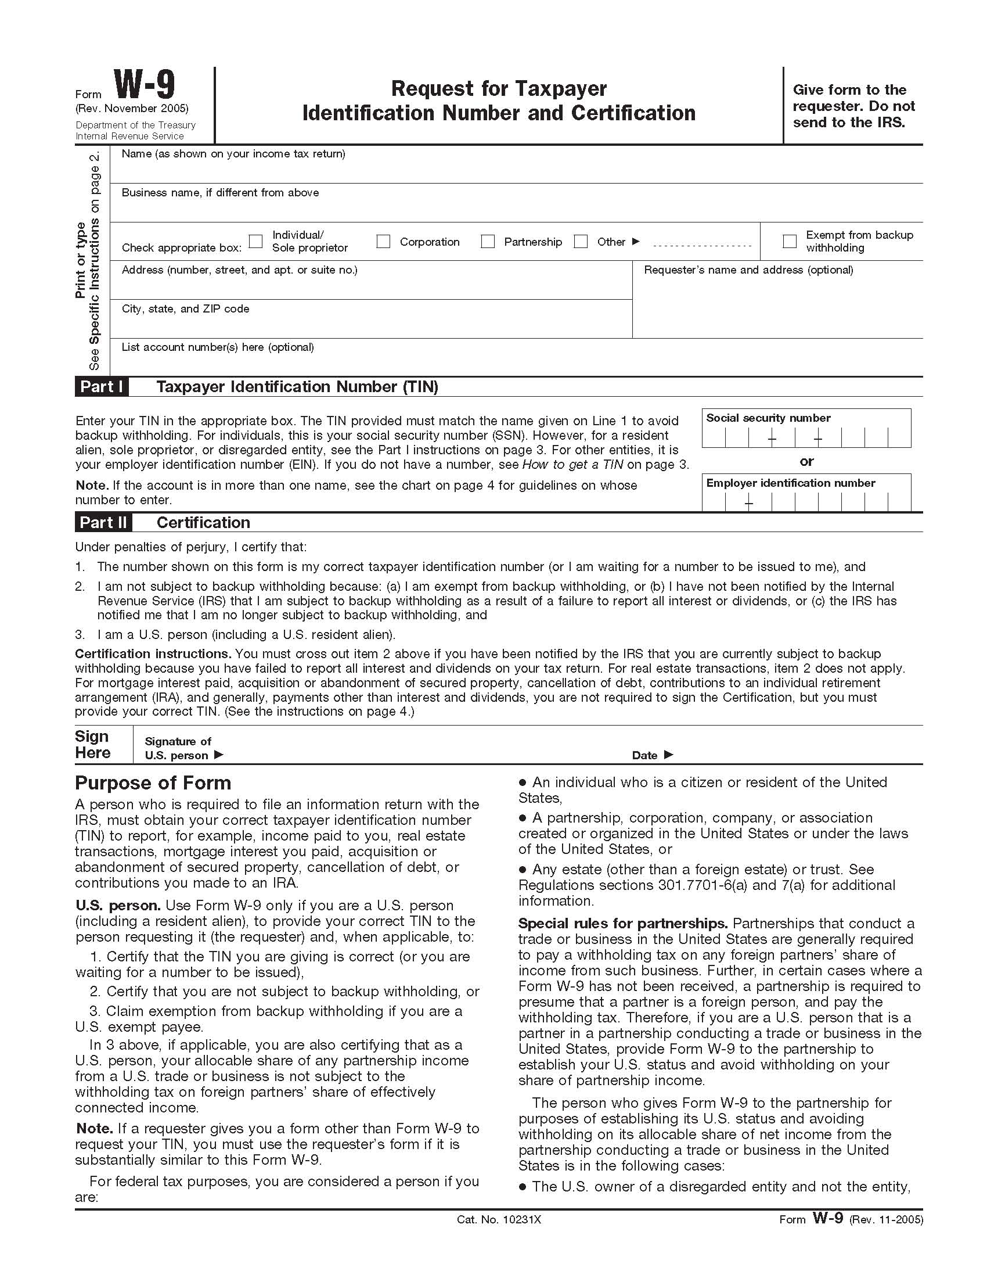
W-9 Request for Taxpayer I.D. Number & Certification

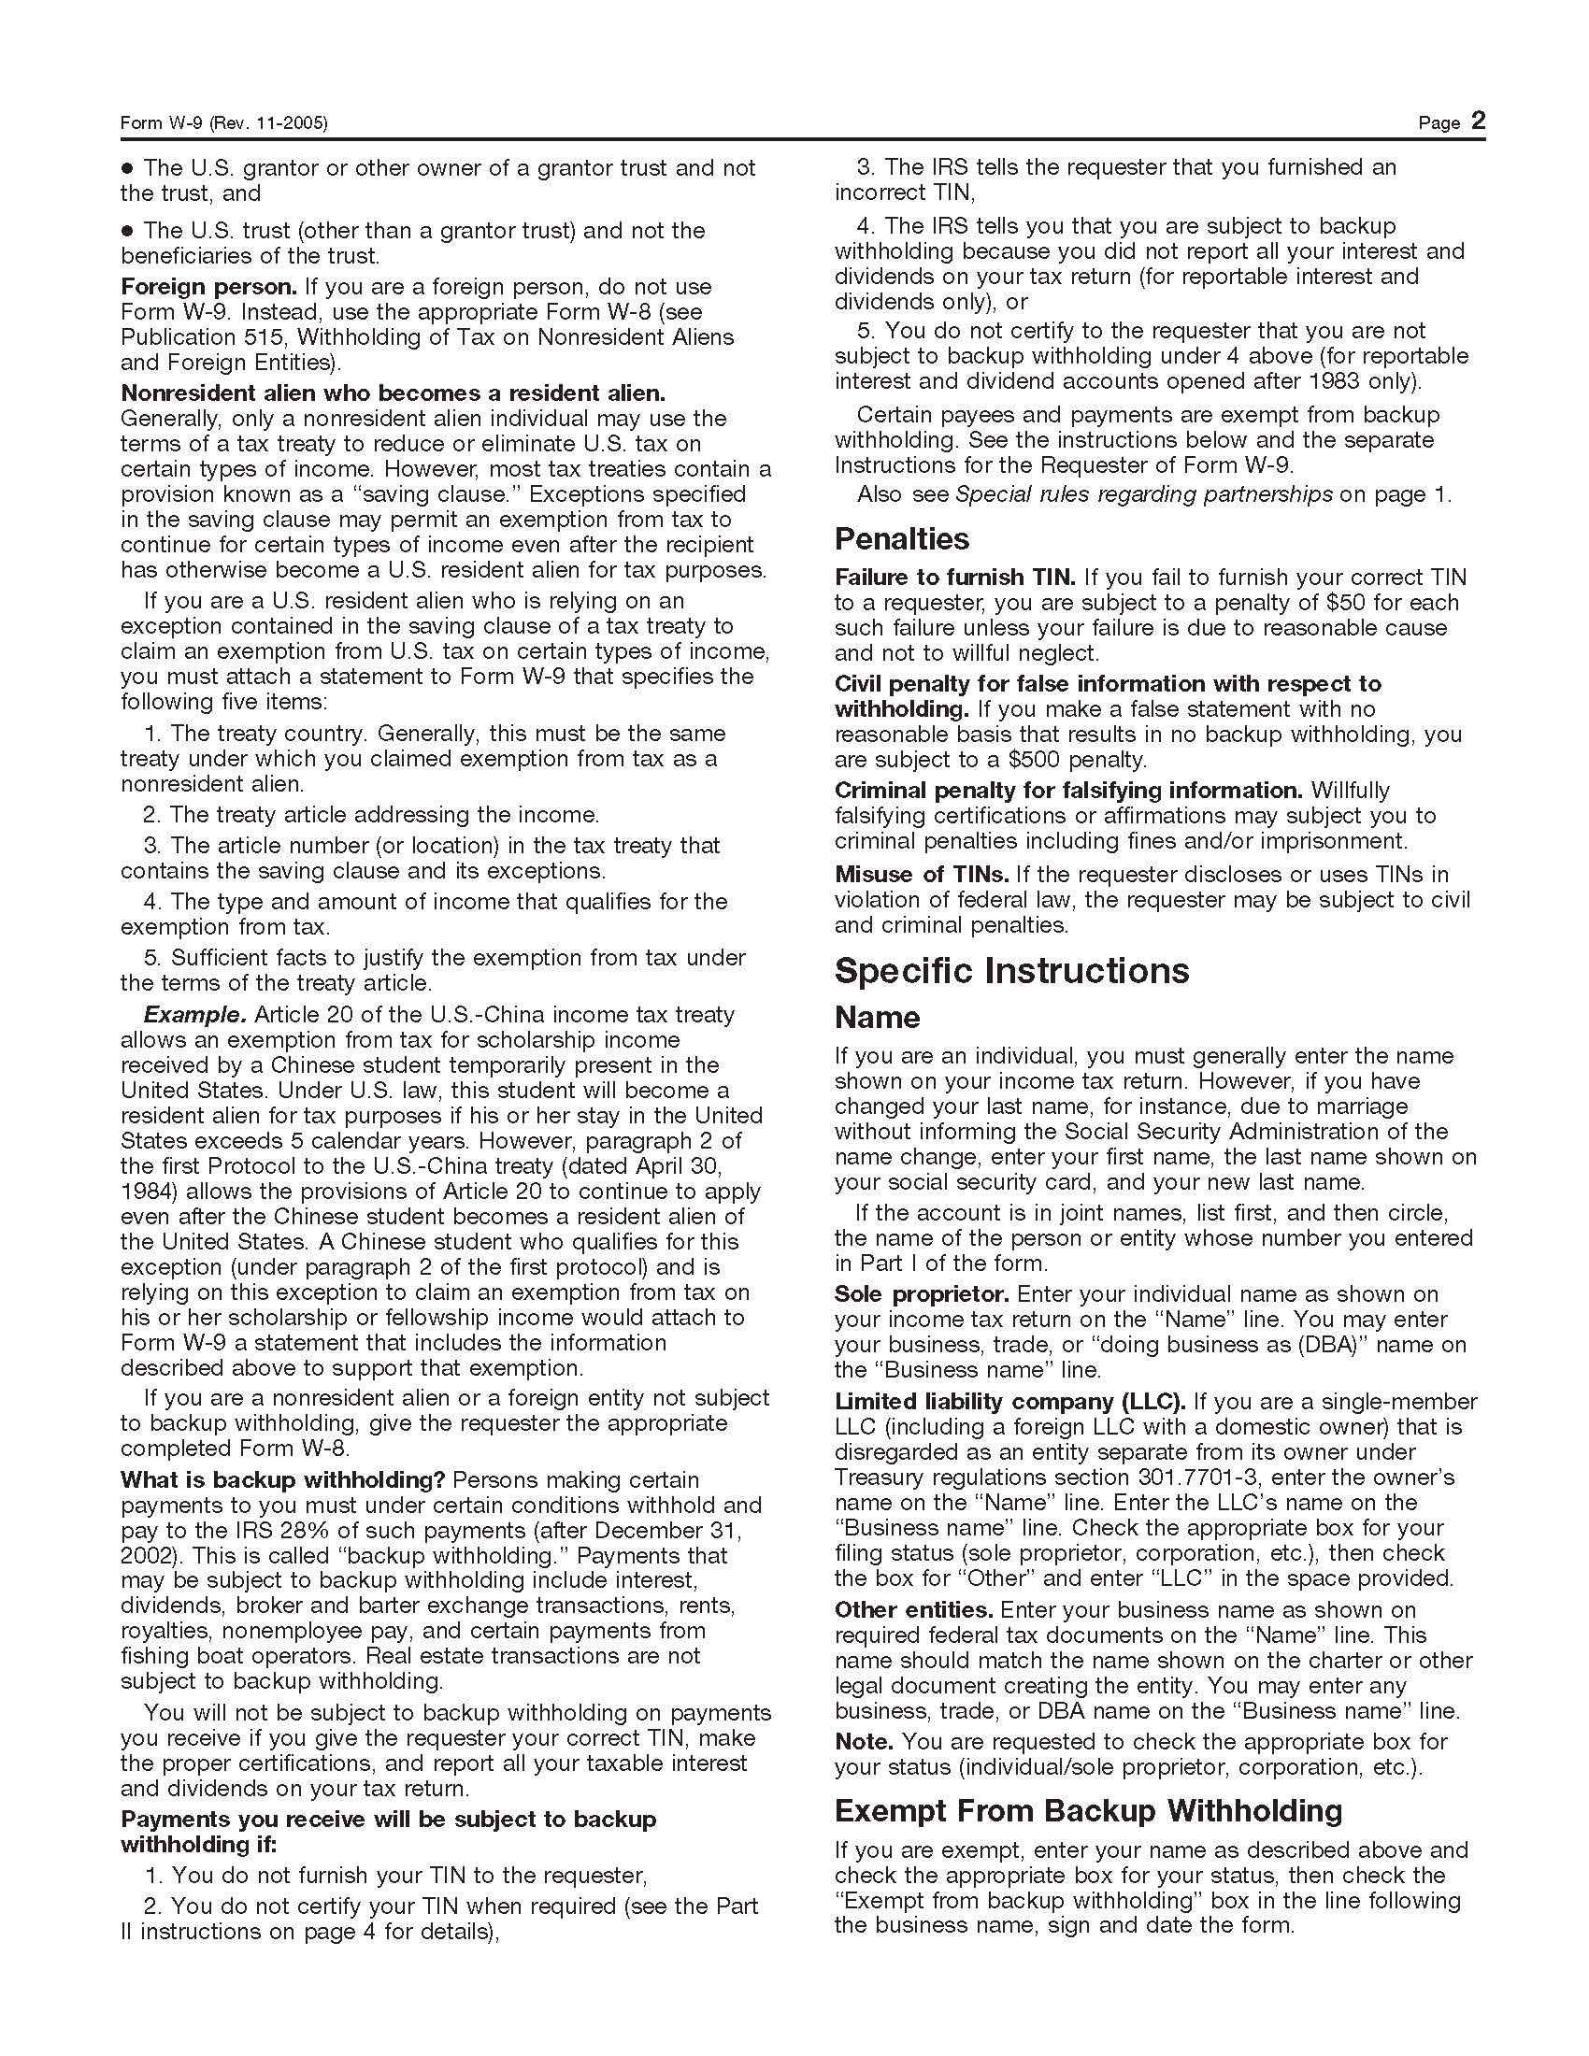
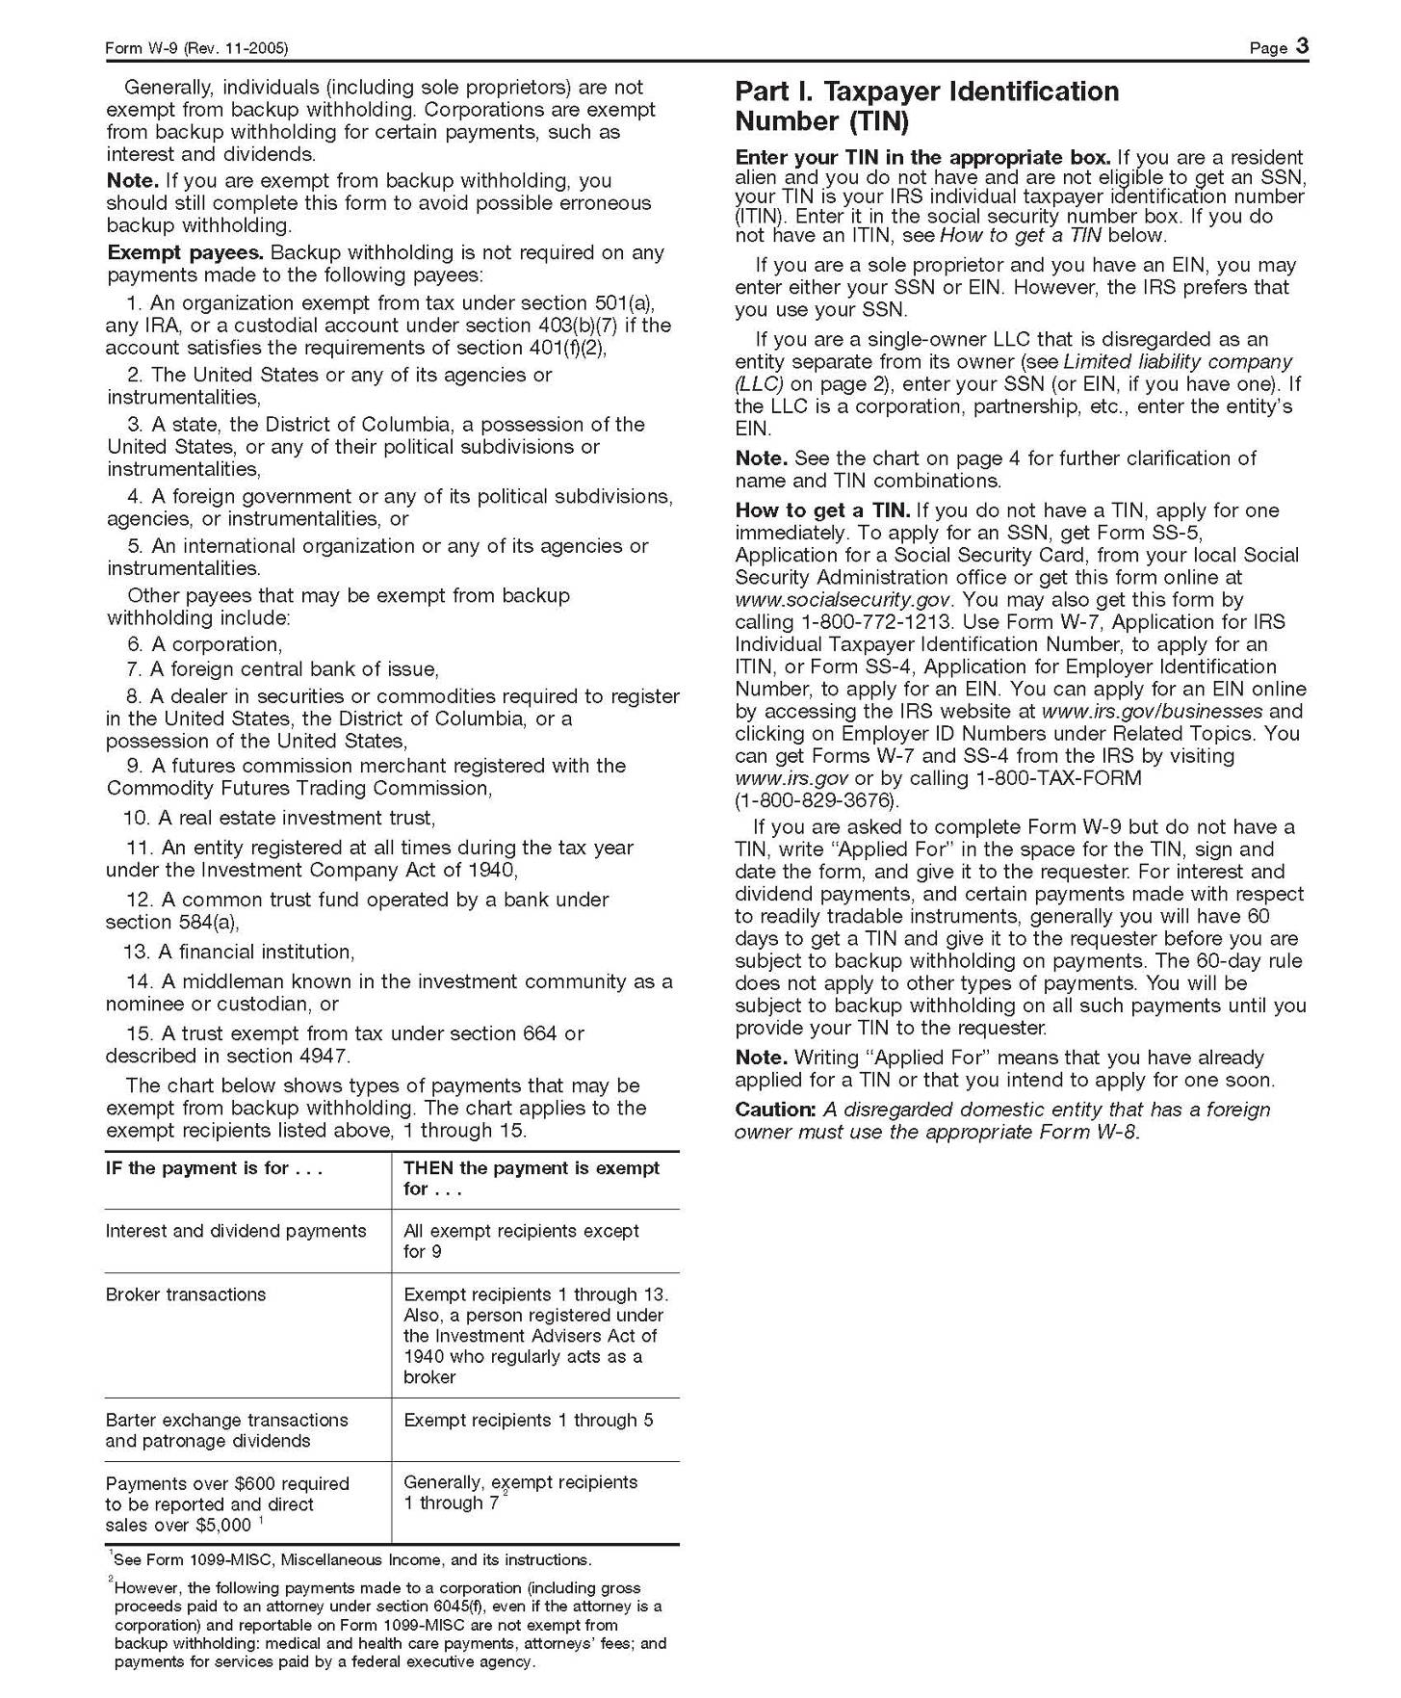
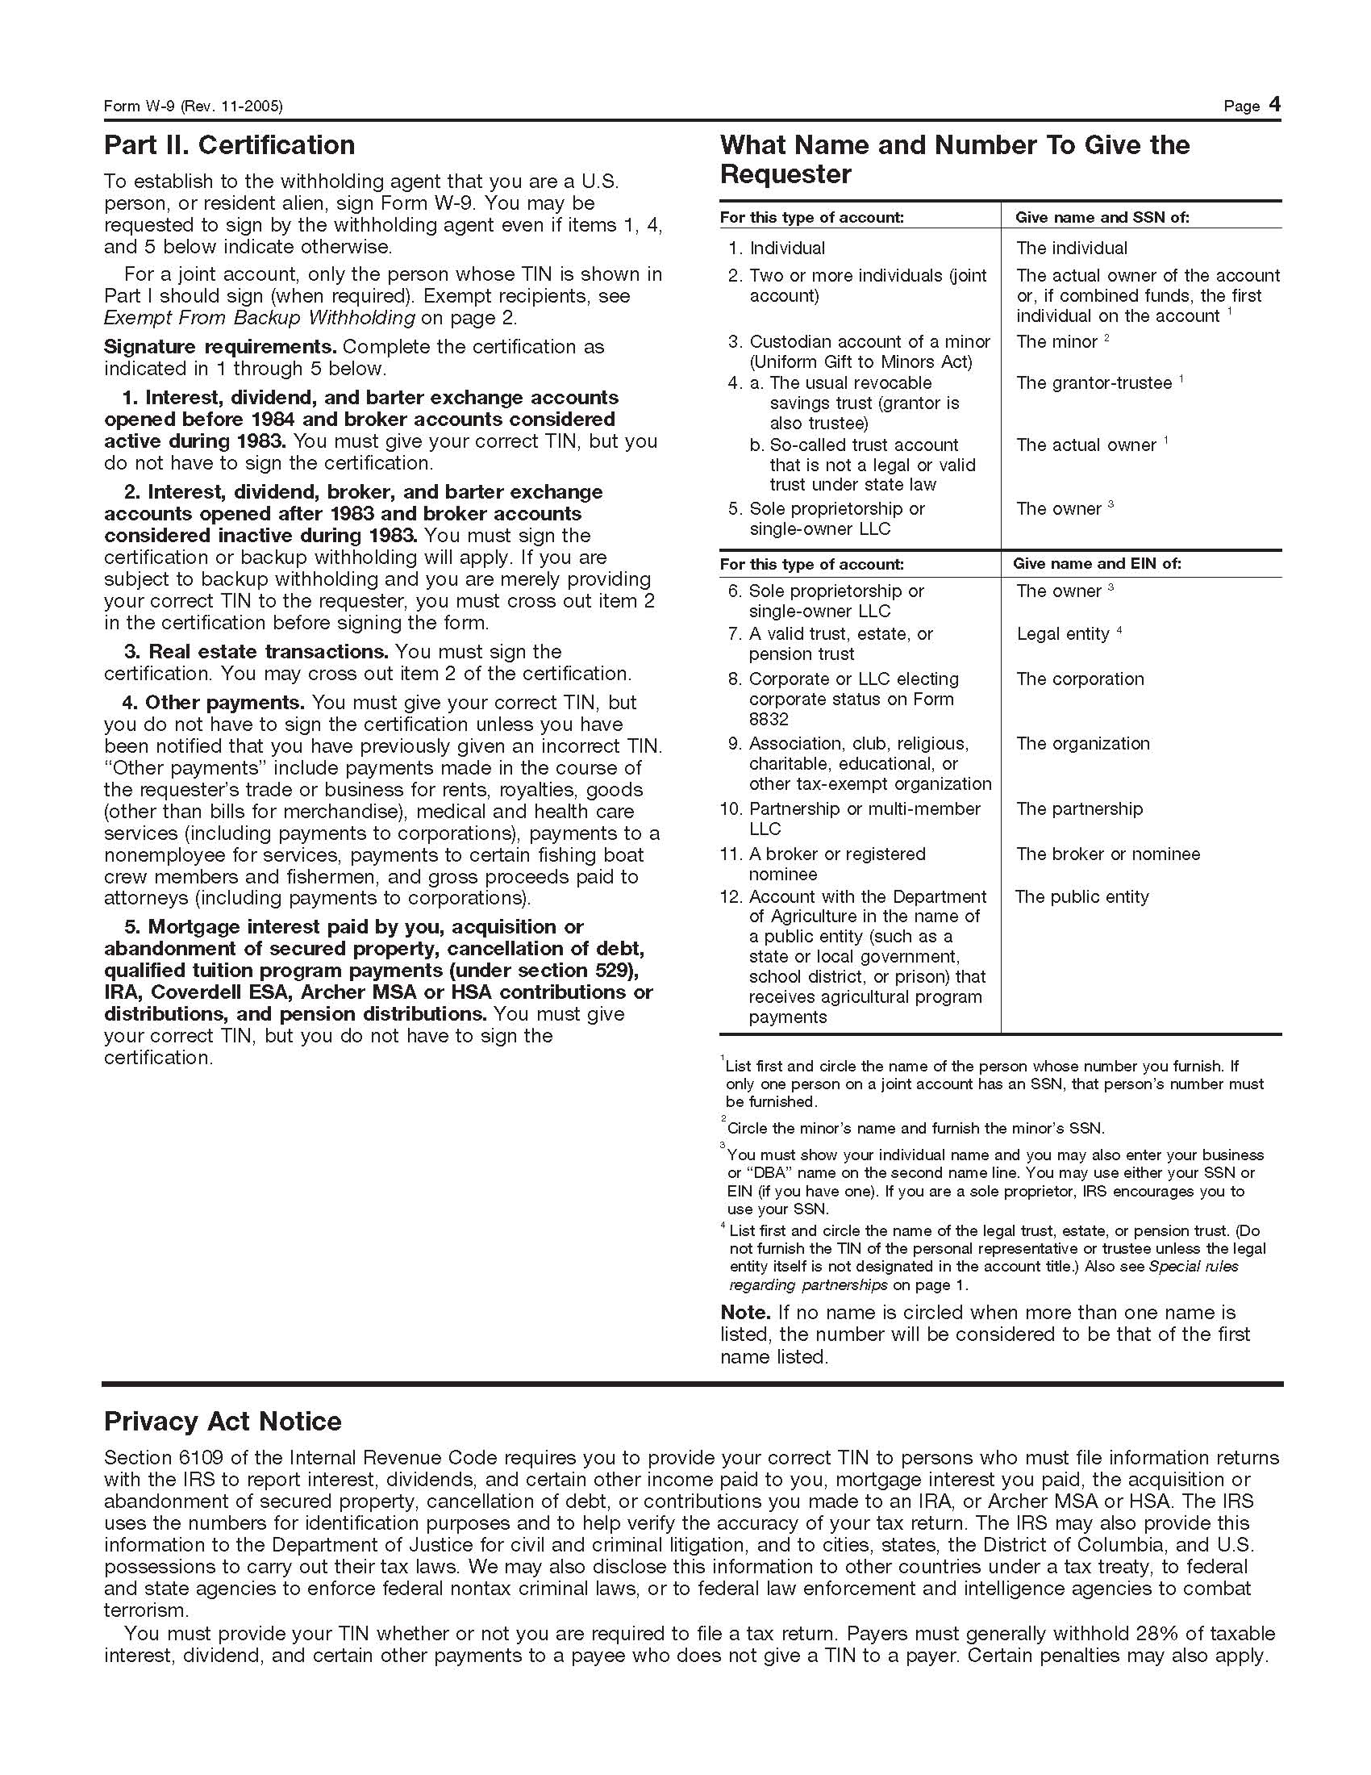

SPECIFIC TERMS AND CONDITIONS
ISSUING AGENT: This RFP has been issued by County of Fresno Purchasing. Purchasing shall be the vendor’s sole point of contact with regard to the RFP, its content, and all issues concerning it.
AUTHORIZED CONTACT: All communication regarding this RFP shall be directed to an authorized representative of County Purchasing. The specific buyer managing this RFP is identified on the cover page, along with his or her telephone number, and he or she should be the primary point of contact for discussions or information pertaining to the RFP. Contact with any other County representative, including elected officials, for the purpose of discussing this RFP, its content, or any other issue concerning it, is prohibited unless authorized by Purchasing. Violation of this clause, by the vendor having unauthorized contact (verbally or in writing) with such other County representatives, may constitute grounds for rejection by Purchasing of the vendor’s quotation.
The above stated restriction on vendor contact with County representatives shall apply until the County has awarded a purchase order or contract to a vendor or vendors, except as follows. First, in the event that a vendor initiates a formal protest against the RFP, such vendor may contact the appropriate individual, or individuals who are managing that protest as outlined in the County’s established protest procedures. All such contact must be in accordance with the sequence set forth under the protest procedures. Second, in the event a public hearing is scheduled before the Board of Supervisors to hear testimony prior to its approval of a purchase order or contract, any vendor may address the Board.
VENDOR CONFERENCE: On August 29, 2006 at 10:30 am, a vendor's conference will be held in which the scope of the project and proposal requirements will be explained. The meeting will be held at the office of County of Fresno Purchasing, 4525 E. Hamilton (between Cedar and Maple), Fresno, California. Addendum will be prepared and distributed to all bidders only if necessary to clarify substantive items raised during the bidders' conference.
Bidders are to contact Brian Tamblin at County of Fresno Purchasing, (559) 456-7110, if they are planning to attend the conference.
NUMBER OF COPIES: Submit one (1) original and 8 copies of your proposal no later than the proposal acceptance date and time as stated on the front of this document to County of Fresno Purchasing. The cover page of each document is to be appropriately marked “Original” or “Copy”.
SELECTION COMMITTEE: All proposals will be evaluated by a team co-chaired by Purchasing. All proposals will be evaluated by a review committee that may consist of County of Fresno Purchasing, department staff, community representatives from advisory boards and other members as appropriate.
The proposals will be evaluated in a multi-stage selection process. Some bids may be eliminated or set aside after an initial review. If a proposal does not respond adequately to the RFP or the bidder is deemed unsuitable or incapable of delivering services, the proposal may be eliminated from consideration. It will be the selection committee’s responsibility to make the final recommendation to the Department Head.
CONTRACT TERM: It is County's intent to contract with the successful contractor for a term of one year with the option to renew for up to two (2) additional one (1) year periods. County will retain the right to terminate the Agreement upon giving sixty (60) days advance written notification to the contractor.
PAYMENT: Payment by County shall be in arrears, for services provided during the preceding month, within forty-five (45) days after receipt and verification of Contractor’s invoices by County. If Contractor should fail to comply with any provision of the Agreement, County shall be relieved of its obligations for further compensation.
PROPERTY: Certain purchases as determined by COUNTY’s DBH Director or designee made during the life of this Agreement shall be identified as County propertyventory Number. These fixed assets shall be retained by COUNTY, as COUNTY property, in the event this Agreement is terminated or upon expiration of this Agreement. The CONTRACTOR agrees to participate in an annual inventory of all COUNTY fixed assets and shall be physically present when fixed assets are returned to COUNTY possession at the termination or expiration of this Agreement.

SCOPE OF WORK
The County, on behalf of the Department of Behavioral Health (DBH), is requesting proposals from qualified persons or organizations to provide professional on-site housing management and supportive services for the County supported independent living project. Currently there are approximately one hundred (100) DBH consumers who are eligible to receive on-site housing and supportive services. Service sites do not require licensing by the Community Care Licensing Division of the State Department of Social Services. Bidders may bid on either Part A or Part B or both.
PART A
Provide on-site housing management and supportive services to fifty (50) existing DBH consumers. Bidder(s) proposal shall address two(2) alternatives: 1) how on-site housing management and supportive services are to be provided at the existing service site; and 2) how the bidder(s) proposes, if necessary, to provide on-site housing management and supportive services at a new location. The bidder(s) proposal shall demonstrate, if necessary, how the transition from the current contract provider to the new contract provider will be accomplished in a manner with minimum impact to the consumer, and if necessary, how the bidder(s) will notify consumers thirty (30) days in advance of the change in contract provider. The bidder(s) proposal shall present to the County in what way items purchased with County funds are identified, inventoried, replaced and if necessary, transferred from current contract provider to the new contract provider.
PART B
Contingent upon available funding, it is the County’s intent to expand its existing independent living project. The County, on behalf of DBH, is requesting proposals to provide housing management and supportive services for approximately forty (40) additional DBH consumers. The expansion is to include on-site management, housing and supportive services at scattered housing sites, clustered housing sites, or a mixture of scattered and clustered housing sites. Properties selected for expansion are subject to County approval.
- PROPOSAL DETAILS as it relates to PART A and PART B:
  - The Bidder(s) shall demonstrate how it will comply with the requirements of the Adult Performance Outcomes System developed by the California Department of Mental Health (http://www.dmh.ca.gov/press/docs/RPOD Legislative Report.pdf.). This includes the use of State approved instruments, administration of said instruments within established timelines and any other requirements.
  - The State Department of Mental Health mandates Fresno County to develop and implement a Cultural Competency Plan. Services delivered by the County and the County’s contractor must be culturally and linguistically competent. Cultural competency requires the County and its contractors to have the capacity to (1) value diversity, (2) conduct self-assessment, (3) manage the dynamics of difference, (4) acquire and institutionalize cultural knowledge, and (5) adapt to the diversity and cultural contexts of the individuals and communities served.
    - Bidder(s) proposal shall demonstrate how its program will provide culturally and linguistically appropriate services.
    - Bidder(s) shall ensure staff provides linguistic and culturally appropriate services with consideration to age, culture, gender, and language.
    - The County shall provide technical assistance, to the extent of available resources, to the bidder(s) upon request.
    - The bidder(s) proposal shall describe its Cultural Competency Plan.
  - Bidder(s) proposal shall demonstrate how bidder(s) will deter loitering, illegal activity, and monitor unwarranted presence of non-residents.
  - Bidder(s) proposal shall contain program Policies and Procedures Guidelines. Polices and procedures shall include, but not be limited to: tenant screening; program evaluation and outcomes; medication management and monitoring; vocational, socialization and recovery activities; roommate arrangements; crisis intervention; Personal Service Care Plans; enrollment/discharge regulations and staff conflict of interest. Policy and Procedures shall be updated and reviewed annually. Should changes be made to the Policies and Procedures, the DBH Director/Designee shall review and provide final approval of bidder’s Policies and Procedures.
  - The proposal shall detail the bidder’s Policies and Procedures for emergency and safety notifications to the County, landlord/property owner, the consumer’s relatives, and other emergency services.
  - The bidder(s) proposal shall demonstrate, if necessary, how the transition from the current contract provider to the new contract provider will be accomplished in accordance with therapeutically appropriate practices; and if necessary, how the bidder(s) will notify consumers thirty (30) days in advance of the change in contract provider.
  - The bidder(s) proposal shall demonstrate, if necessary, how items purchased with County funds, are identified and transferred from current contract to the new contract provider.
  - The proposal shall detail the reporting process for purchases made with County funds. Said purchases shall have prior approval of the DBH Director or designee. DBH will require copies of invoices for the purchases be forwarded to them for inventory and accountability purposes.
- ADDITIONAL PROPOSAL DETAILS as it relates to PART B:
  - The bidder(s) proposal shall demonstrate how services are to be delivered at scattered sites.
  - The bidder(s) proposal shall demonstrate how real estate properties for expansion are determined.
  - The bidder(s) proposal shall demonstrate how consumers residing at scattered sites are provided with activities which provide for tenant council meetings, vocational, socialization, and recovery.
- CONTRACTOR RESPONSIBILITIES:
  - Contractor(s) shall maintain an up to date Caseload Record of all DBH consumers, provide consumer demographics, maintain a 12-month history of consumer mental health services, track psychiatric hospitalizations and incarcerations. Reports are to be submitted to DBH Metro Services on a monthly basis.
  - Contractor shall provide staff to coordinate services, assign consumer to a residence, assist consumers in maintaining their residence, and to coordinate rents/leases. Contractor shall also establish a working relationship with the landlords/property owners to resolve any issues, such as maintenance and landscape, and provide oversight to tenant council meetings and other activities.
  - It is expected the contractor shall maintain a staff to consumer ratio of 2:25.
  - Contractor’s staff shall be available to provide professional management and supportive housing services twenty-four (24) hours per day, seven (7) days per week throughout the entire year. Staff work schedules shall be responsive to consumer needs and will require staff to work evenings and weekends. During off-hours (8:00pm-8:00am), staff shall be on call and available to respond immediately to consumers by telephone or in person, as dictated by consumer needs.
  - Contractor shall assign staff to all new consumers within twenty-four (24) hours and work with DBH case management to review and understand the consumer’s Personal Service Care Plan in order to meet the consumer’s identified needs.
  - Contractor’s staff shall assign appropriate pairing of roommates and assist every consumer to maintain and secure appropriate independent housing.
  - Contractor shall ensure staff makes frequent contacts, to assess the consumer’s mental health and housing needs, at least three (3) times per week where the consumer lives or feels most comfortable.
  - Contractor shall provide medication management, including education, and remind consumers when and how to take their medications. Contractor or contractor staff will not dispense medications.
  - Contractor shall provide assistance and advocacy in obtaining available public benefits and accessing needed behavioral health and physical health care for consumers and provide linkage to physical health care services, as necessary.
  - Contractor shall assist residents with personal care and living skills required to successfully live in the community.
  - Contractor shall link all current and new residents to County Job Options program in order for them to be assessed for training needs and employability.
  - Contractor shall link residents to representative payee services, not owned and/or operated by the contractor, to help the resident better manage his/her money, where appropriate.
  - Contractor’s staff shall provide whatever direct assistance is reasonable and necessary to ensure that the residents obtain the basic necessities of daily life, including public transportation. Public transportation, at a minimum, will be accessible to all residents. Bus token/passes will be made available by the contractor to encourage and empower residents in utilizing public transportation to their scheduled appointments.
  - Contractor shall ensure all residents, who meet criteria and are eligible for entitlement programs, shall be linked to those programs for benefits/services and linked to County’s Department of Employment and Temporary Assistance (ET&A) for financial resources.
  - Contractor shall ensure all residents are assigned, at a minimum, a residence that includes a kitchen, a bath and at least one (1) bedroom.
  - Contractor shall provide furnishings and supplies for daily living needs and secure housing for all residents.
  - Contractor shall ensure residents pay rent and utilities for which General Relief Cash Aid is provided.
  - Contractor shall ensure that residents on waiting lists will be provided housing within 6 months.
  - Contactor shall ensure a rental agreement stipulates the amount of rent and the minimum utility expense that a resident is required to pay. Contactor shall ensure a monthly rental receipt is provided to each resident.
  - Contractor shall provide, at a minimum, monthly group activities and identify said activities on a monthly calendar which is provided to each resident. A copy of the calendar shall be provided to County with each monthly invoice.
  - Contractor shall organize tenant council meetings, maintain existing tenant council meetings, and encourage residents to participate. The goal of the tenant council is to empower consumers, provide peer support, discuss housing issues and tenant rights, and provide an opportunity for socialization. A copy of tenant council meeting minutes shall be provided to County with each monthly invoice.
  - Contractor shall maintain an activity room to hold tenant council meetings.
  - Contractor shall not be required to provide any services which require licensure by the State Department of Social Services, Community Care Licensing, or by any other regulatory body.
  - Contractor shall submit Incident Reports, (Attachment A), to County housing liaison, within 24 hours from the time of the incident, or the next business day. An “incident” is defined as any event that may lead or will cause a crisis situation which affects a consumer, a visitor, or a Fresno County employee or Contractor staff.
- PERFORMANCE OUTCOMES: Performance outcomes allow the County to evaluate the program to better meet the needs of the consumer. The Department’s standard for all current and future programs is to follow the State’s “Best Practice” approach for recovery and wellness:
 | Outcomes: | It is expected that inpatient psychiatric hospitalization rates will be reduced.
 | Indicator: | Reduction in aggregate number of inpatient psychiatric hospitalization days since enrollment compared with twelve (12) months prior to enrollment for enrolled consumers.
 | Target: | Fifty percent (50%) reduction.
 | Outcome: | It is expected that consumer incarceration rates will be reduced.
 | Indicator: | Reduction in aggregate number of jail days since enrollment compared with twelve (12) months prior to enrollment for enrolled consumers.
 | Target: | Fifty percent (50%) reduction.
 | Outcome: | It is expected that consumers actively involved in employment, education, or vocational training will increase.
 | Indicator: | Increase in the number of days consumers are employed, in school, or in vocational training since enrollment compared with twelve (12) months prior to enrollment for enrolled consumers.
 | Target: | At least sixty percent (60%) of enrolled transition age youth, ages 18 to 24, and enrolled adults, ages 25 and older, by the end of a twelve month enrollment period are involved in employment, education, or vocational training.
 | Outcome: | It is expected that consumers will assume responsibility for their own housing cost.
 | Indicator: | Within one month of enrollment, consumers will have submitted Supplemental Security Income (SSI) applications, and have established benefits or have developed, as part of their Personal Services Care Plan, eventual assumptions of their own housing costs.
 | Target: | One hundred percent (100%) of enrolled consumers will have submitted SSI applications, established benefits or have developed a plan for assuming their own housing costs.
 | Outcome: | It is expected that consumers will maintain their supportive living status for a minimum of 18 months.
 | Indicator: | Consumers will follow housing rules and regulations.
 | Target: | Eighty percent (80%) of enrolled consumers will maintain their housing status for a minimum of 18 months.
 | Outcome: | It is expected that consumers will graduate to a higher level of independent living.
 | Indicator: | Consumers will develop the skills necessary to maintain a residence and function at an acceptable level of independence, as determined by DBH.
 | Target: | Twenty percent (20%) of enrolled consumers will move on to a higher level of independent living.
  - For the purpose of evaluating performance outcomes, the County requires the participation of the Contractor in gathering data on a monthly basis. Incident, Change of Status, and Caseload reports shall be submitted in a timely manner to the Department liaison Three key reports are as follows:
    - INCIDENT REPORTS: Incident Reports, in which a DBH consumer is involved, are to be submitted to the DBH liaison within 24 hours from the time of the incident or the next business day. Incident Reports shall state the date, time, location of incident, contractor staff, and identify anyone who is not a County employee.
Incident Reports should have background information as to injuries or property damage. The cause of the incident should be listed in sequential order, identifying the cause (who, where, what, how, and if the incident was foreseeable and preventable etc.). A Sample Incident Report form is attached, (Attachment A).
    - CHANGE OF STATUS REPORT/FORM: The Change of Status Report will be submitted for each individual on a monthly basis, for each change of status for a consumer. The report shall include the name of the consumer, key date of admission to hospital or incarceration and key date of discharge from hospital or incarceration. The name and address of the facility should also be identified. The purpose of the hospitalization or incarceration should also be identified. Lastly, all forms must identify the Contractor staff submitting the document and the date the form was completed. A sample Change of Status from is attached, (Attachment B).
    - CASELOAD REPORT: The Caseload Report will be submitted on a monthly basis. This report will list the names of the consumers, DBH #, consumer date of birth, age, gender, admit date, ethnicity, address, zip code, phone, and emergency contact and contact’s phone number. A sample Caseload Report is attached, (Attachment C).
- COUNTY RESPONSIBILITES
  - The County Department of Behavioral Health, Metro Services Division, will provide oversight of the on-site management and all supportive housing programs and collaborate with Contractor(s) and various County Departmental agencies to help achieve program goals and outcomes.
  - The County shall make available cultural competency training for DBH personnel and contract personnel. Staff will be required to attend one cultural competency training per year. The County shall make available, to the extent of available resources, technical assistance for contractor in translating mental health information into threshold language(s) (Hmong, Lao, Cambodian, and Spanish).
  - The County’s DBH shall assist the contractor in making linkages within the mental health system. The County’s DBH shall act as a liaison and provide assistance which will enable contractor access to all County mental health programs which are available to consumers.
  - The County DBH shall participate in evaluating the progress of the overall program and the efficiency of contractor staff and be available to the contractor for ongoing consultation.

COST PROPOSAL
PART A
The Cost Proposal shall provide a breakdown of anticipated expenses for professional management and housing and supportive services. Attached is a sample annual line item budget (Attachment D) that should be used as a guideline by bidder. A single budget can be submitted on behalf of more than one agency/organization responding to this Request for Proposal. One vendor must be identified as the “lead Agency” and serve as the legal party to the agreement with the County that will be recommended to the Board of Supervisors. As it relates to Part A, start-up cost, will only be available to a new contractor. On going costs will be paid 45 days in arrears.
PART B
The Cost Proposal shall provide a breakdown of the anticipated expenses for professional management and housing and supportive services. Attached is a sample annual line item budget (Attachment D) that should be used as a guideline by bidder. A single budget can be submitted on behalf of more than one agency/organization responding to this Request for Proposal. One vendor must be identified as the “lead Agency” and serve as the legal party to the agreement with the County that will be recommend to the Board of Supervisors. As it relates to Part B, requests for start-up cost or advance payment is to be included and clearly identified in the first year budget. The Cost Proposal shall indicate how the additional housing sites are financed, if applicable and how many consumers are to be served.
The Cost Proposal shall include a three year budget with a budget detail and narrative description of the requested funding.

PROPOSAL CONTENT REQUIREMENTS
Bidders are requested to submit their proposals in a binder (one that allows for easy removal of pages) with index tabs separating the sections identified. Each page should be numbered. Bidders are to prepare separate proposals for Part A and Part B presented in separate binders which are appropriately identified.
Merely offering to meet the specifications is insufficient and will not be accepted. Each bidder shall submit a complete proposal with all information requested. Supportive material may be attached as appendices. All pages, including the appendices, must be numbered.
The content and sequence of the proposals will be as follows:
- PROPOSAL IDENTIFICATION SHEET (as provided)
- COVER LETTER: A one-page cover letter and introduction including the company name and address of the bidder and the name, address and telephone number of the person or persons to be used for contact and who will be authorized to make representations for the bidder.
  - Whether the bidder is an individual, partnership or corporation shall also be stated. It will be signed by the individual, partner, or an officer or agent of the corporation authorized to bind the corporation, depending upon the legal nature of the bidder. A corporation submitting a proposal may be required before the contract is finally awarded to furnish a certificate as to its corporate existence, and satisfactory evidence as to the officer or officers authorized to execute the contract on behalf of the corporation.
- TABLE OF CONTENTS
- CONFLICT OF INTEREST STATEMENT: The bidder may become involved in situations where conflict of interest could occur due to individual or organizational activities that occur within the County. In this section the bidder should address the potential, if any, for conflict of interest and indicate plans, if applicable, to address potential conflict of interest. This section will be reviewed by County Counsel for compliance with conflict of interest as part of the review process. The Bidder shall comply with all federal, state and local conflict of interest laws, statutes and regulations.
- TRADE SECRET ACKNOWLEDGMENT:
  - Sign and return
- EXCEPTIONS: This portion of the proposal will note any exceptions to the requirements and conditions taken by the bidder. If exceptions are not noted, the County will assume that the bidder's proposals meet those requirements. The exceptions shall be noted as follows:
  - Exceptions to General Requirements.
  - Exceptions to Background/Scope of Work.
  - Exceptions to Specific Terms and Conditions.
  - Exceptions to Proposal Content Requirements.
- VENDOR COMPANY DATA: This section should include:
  - A narrative which demonstrates the vendor’s basic familiarity or experience with problems associated with this service/project.
  - Descriptions of any similar or related contracts under which the bidder has provided services.
  - Descriptions of the qualifications of the individual(s) providing the services.
  - Any material (including letters of support or endorsement) indicative of the bidder's capability.
  - A brief description of the bidder's current operations, and ability to provide the services.
  - Reference List (form provided)
  - W-9 Request for Tax Payer I.D. (form provided)
  - Copies of the audited Financial Statements for the last three (3) years for the agency or program that will be providing the service(s) proposed. If audited statements are not available, complied or reviewed statements will be accepted with copies of three years of corresponding federal tax returns.
  - Describe any terminated contracts for services similar to vendor’s current bid for the RFP and provide the following:
    - Agency contract with
    - Date of original contract
    - Reason for termination
    - Contact person and telephone number for agency
  - Describe any pending lawsuits or legal actions:
    - Location filed, name of court and docket number
    - Nature of the lawsuit or legal action
  - Describe any past payment problems with the County:
    - Funding source
    - Date(s) and amount(s)
    - Resolution
    - Impact to financial viability of organization.
- SCOPE OF WORK:
  - Bidders are to use this section to describe the essence of their proposal.
  - This section should be formatted as follows:
    - A general discussion of your understanding of the project, the Scope of Work proposed and a summary of the features of your proposal.
    - A detailed description of your proposal as it relates to each item listed under the "Scope of Work" section of this RFP. Bidder's response should be stated in the same order as are the "Scope of Work" items. Each description should begin with a restatement of the "Scope of Work" item that it is addressing. Bidders must explain their approach and method of satisfying each of the listed items.
  - When reports or other documentation are to be a part of the proposal a sample of each must be submitted. Reports should be referenced in this section and submitted in a separate section entitled "REPORTS."
  - A complete description of any alternative solutions or approaches to accomplishing the desired results.
- REPORTS: Samples of reports referenced in Section VIII.C shall be displayed in this section.
- COST PROPOSAL: Quotations must be prepared in the format and detail as described herein to best demonstrate the worthiness of your proposal. Include rates for all services, materials, equipment, etc. to be provided under the proposal.

AWARD CRITERIA

COST
As submitted under the "COST PROPOSAL" section.

CAPABILITY AND QUALIFICATIONS
- Do the service descriptions address all the areas identified in the RFP? Will the proposed services satisfy County's needs and to what degree?
- Does the bidder demonstrate knowledge or awareness of the problems associated with providing the services proposed and knowledge of laws, regulations, statutes and effective operating principles required to provide this service?
- Does the response indicate the amount of demonstrated experience in providing the services desired in a California County.
- Does the ratio of staff to consumer meet the requirements of the RFP?

MANAGEMENT PLAN
Is the organizational plan and management structure adequate and appropriate for overseeing the proposed services?
ATTACHMENT “A”
(INCIDENT REPORT SHEET)
PROTOCOL FOR COMPLETION & SAMPLE FORM
ATTACHMENT A
PROTOCOL FOR COMPLETION OF INCIDENT REPORT
- The Incident Report must be completed for all incidents involving tenants. The staff person who becomes aware of the incident completes this form, and the supervisor co-signs it.
- When more than one tenant is involved in an incident, a separate form must be completed for each tenant.
Where should the forms be sent - within 24 hours from the time of the incident
- Incident Report should be sent to:
- DBH Division Manager
- Copy to DBH Housing Coordinator, or designee
INCIDENT REPORT WORKSHEET
When did this happen? (date/time) |  |  |  |  |  |  |  |  | Where did this happen?
Name/DMH #
1. Background information of the incident:
2. Method of investigation: (chart review, face-to-face interview, etc.)
Who was affected? (If other than consumer)
List key people involved (witnesses, visitors, physicians, employees).
3. Preliminary findings: How did it happen? Sequence of events. Be specific. If attachments are needed write comments on an 8 1/2 sheet of paper and attach to worksheet.
Outcome severity: Nonexistent |  |  | inconsequential |  |  |  | consequential |  |  | death |  |  |  | not applicable |  | unknown
4. Response: a) corrective action, b) Plan of Action, c) other
Completed by (please print) |  |  |  |  |  |  |  |  |  |  |  | Date completed
Reviewed by Supervisor |  |  |  |  |  |  |  |  |  |  |  | Date

ATTACHMENT “B”
(CHANGE OF STATUS FORM)
SAMPLE FORM
Change of Status Form
(Sample Form)
Consumer Name |  |  |  |  |  |  |  |  |  |  |  | DMH #
Staff Name |  |  |  |  |  |  |  |  |  |  |  | Date form Completed
Hospitalization:
Date of admission |  |  |  |  |  |  |  |  |  |  |  | Discharge
Facility Name |  |  |  |  |  | Address |  |  |  |  |  |  |  | City |  |  |  |  | State |  |  |  |  | Zip
Was hospitalization (Check one)
 | Physical |  |  |  |  |  |  | Psychiatric |  |  | Substance Abuse |  |  |  |  |  |  |  |  |  | Routine/Surgical
Incarceration:
Date of incarceration |  |  |  |  |  |  |  |  |  |  |  | Date of Release
Facility Name |  |  |  |  |  | Address |  |  |  |  |  |  |  | City |  |  |  |  | State |  |  |  |  | Zip
Was incarceration (Check one)
 | Psychiatric |  |  |  |  |  |  |  | Substance Abuse
 | Other, please specify

ATTACHMENT “C”
(CASE LOAD REPORT - FORM)

CASE LOAD REPORT – SAMPLE FORM
 | DMH # | CLIENT | DOB | Age | Gender | ADMIT DATE | Ethnicity | ADDRESS | ZIP CODE | PHONE | Emergency Contact | Emergency Contact Phone
1
2
3
4
5
6
7
8
9
10
11
12
13
14
15

ATTACHMENT “D”
(Budget Narrative Justification Instructions & Budget Worksheets)
BUDGET NARRATIVE JUSTIFICATION INSTRUCIONS
The Budge Justification Narrative is a supporting explanation of each item listed on the Budget Worksheet pages for the Proposed Program Budget. It must include all particulars necessary for evaluating each expenditure. It must also include detailed descriptions of the responsibilities for each budgeted position and specific information regarding all other listed expenditures. This portion of the budget documents is used for management, monitoring, and auditing proposes. Please construct the Budget Justification Narrative using the format below:
Personnel/Salaries | Provide the following information for each position:  Classification  Annual (12 Month) Salary  Full-time equivalent (FTE) percentage  Description of duties/functions, indicate if the duties/functions are administrative or direct services.
Payroll Tax | Provide an explanation of how the figures are calculated.
Employee Benefits/Insurance | Provide an explanation of how each category was calculated. Provide a brief description of each insurance.
Operational Expense
Travel | List travel costs categories and provide brief description of each – Staff Mileage (include description of anticipated destination and purpose, generally funding for private auto mileage reimbursement for staff in providing services); Staff Training/Registration (include description of subject matter); and Transportation (include description of modes of transportation other than automobile).
Facilities | List facility categories and provide brief description of each – Rent/Lease/Purchases (include description of all rents/leases paid for the use of land, structures, and improvements. Include description all real estate purchases); Facilities Maintenance (include description for all expenses for the upkeep of buildings and grounds); Utilities (include description of types of expenditures, such as electricity, heating and cooling, natural gas, butane, sewage disposal, water).
Office Expense | List office expense categories and provide brief description of each – Office Supplies (items may include paper, filing supplies, pens, pencils, scissors, and other supplies necessary to carry out daily activities to accomplish the program goals and objectives.); Postage (includes postage stamps or other mail charges, such as Federal Express, necessary to carry out the daily activities of the program.); Printing/Reproduction (may include items such as printing of business cards or reproduction of pamphlets or other material related to needs of the organization.); Publications (include such items as memberships in societies, associations of officials, trade associations and other organizations which issue official publications. Be specific and describe reason publication is necessary for the professional development of your organization.); Legal Notices/Advertising (types of items may include expenses such as those necessary for publication of legally required notices and reports).
Equipment | Purchase of Equipment (include description of expected equipment purchases); Equipment Rent/Lease (include description of rented/leased equipment; Equipment Maintenance (include description for all expenditures for keeping equipment in efficient operation condition).
Communication | List the communication categories and provide a brief description of each.
Program Supplies | List the categories of program supplies requested and provide a brief description of each.
Consultant Services | List the consultant services and provide brief description of the nature of consultant services.
Contract Services | List the contract services and provide brief description of the nature of contract services.
Fiscal and Audits | List fiscal and audit categories and provide brief description of each.
Recruitment | Provide a brief description of recruitment activities billed to the proposed agreement.
Transcription | Provide a brief description of transcription services billed to the proposed agreement.
Consumer Activity & Recreation | Provide a brief description of consumer activities and consumer recreation which are to billed to the proposed agreement.
Consumer Personal Needs | Provide a brief description of consumer personal needs which are to be billed to the proposed agreement.
Consumer Transportation | Provide a brief description of consumer transportation needs which are to be billed to the proposed agreement.
Consumer Furniture Purchases | Provide a brief description of consumer furniture purchase needs which are to be billed to the proposed agreement.
Consumer Furniture Maintenance and Repair | Provide a brief description of the types of consumer furniture maintenance and repairs which are to be billed to the proposed agreement.
Consumer Household Supplies | Provide a brief description of the kinds of consumer household supplies which are to be billed to the proposed agreement.
Other Costs | Specify and provide a description and explanation of all indirect costs and other costs which are to be billed to the proposed agreement.
Miscellaneous | Provide a brief description of any expense, not listed above, which is to be billed to the proposed agreement.
Revenue/Match | Please identify all anticipated funding sources and distinguish whether the revenue offsets expenditures for the proposed program.

Link to Budget Worksheets (952-4313 Attachment D.xls)

