COUNTY OF FRESNO
ADDENDUM NUMBER: ONE (1)
 |  | RFP NUMBER:
November 23, 2005
 |  |  | PURCHASING USE
 | ORG/Requisition: / |  |  | jlg | /tmp/in/input.doc
IMPORTANT: SUBMIT PROPOSAL IN SEALED PACKAGE WITH PROPOSAL NUMBER, CLOSING DATE AND BUYER’S NAME MARKED CLEARLY ON THE OUTSIDE TO:
COUNTY OF FRESNO, Purchasing
4525 EAST HAMILTON AVENUE
FRESNO, CA 93702-4599
Closing date of proposal will be at 2:00 p.m., on December 14, 2005.
PROPOSALS WILL BE CONSIDERED LATE WHEN THE OFFICIAL PURCHASING TIME CLOCK READS 2:00 P.M.
Proposals will be opened and publicly read at that time. All proposal information will be available for review after contract award.
Clarification of specifications are to be directed to: Gary Parkinson/Pat Flaherty, phone (559) 456-7110,
FAX (559) 456-7831.
NOTE THE following and attached ADDITIONS, DELETIONS AND/OR CHANGES TO THE REQUIREMENTS OF REQUEST FOR PROPOSAL NUMBER: AND INCLUDE THEM IN YOUR RESPONSE. PLEASE SIGN AND RETURN THIS ADDENDUM WITH YOUR PROPOSAL.
- Hard copies of maps of facility layout are available upon request – contact Purchasing.
- Attachment “A” - Medical Condition Report
- Attachment “B”
- Attachment “C”
- Forms “A” & “B” – these forms have not changed; same as original RFP and website. Placed into Addendum due to previous inability to access these on the Internet (http://www.co.fresno.ca.us/0440/Bidshome.asp).
- No additional tours of the facility will be offered.

ACKNOWLEDGMENT OF ADDENDUM NUMBER ONE (1) TO RFP
COMPANY NAME:
(PRINT)
SIGNATURE:
NAME & TITLE:
(PRINT)
RFP Clarification and Service Delivery
Page 9, Reference List shall be modified as follows: Provide at lease five (5) customers to whom you have provided similar services. List California Government Agencies first. Indicate the size of the institution and the number of wards.
Page 14 C: The following shall be added to Professional Liability.
CONTRACTOR agrees that it shall maintain, at its sole expense, in full force and effect for a period of three (3) years following the termination of this Agreement, one or more policies of professional liability insurance with limits of coverage specified herein.
Page 19: The County would prefer to contract with a vendor for a five year term; however a vendor may provide an alternative term with justification for consideration by the County. Standard County contract language includes a termination provision that allows the Contractor or County to terminate for no cause upon giving a certain number of days notice. Notice of 180 days is considered reasonable.
Page 20, first paragraph: The successful Contractor will not be responsible for providing direct psychiatric, psychological, or dental care; but will be required to provide support services to the County’s Department of Children and Family Services further described on page 23, #8 distribution of medications; #14 scheduling and coordinating Mental Health requested labs and EKGs; #15 management of mental health pharmaceuticals, and page 25; #6 obtain and avoid expired/lapsed consents. The cost of these support services shall be detailed separately as requested on page 31 of the RFP. The cost of Mental Health ordered psychotropic drugs, labs, and EKGs are not the responsibility of the Contractor.
Page 22, #1: Current practice is that Probation staff performs the initial screening on each juvenile at intake. Attachment “A” (included in this Addendum) medical questionnaires is completed at booking by Probation staff. Vendors may offer alternatives to this practice with justification for consideration by the County.
Page 22, #11: Contractor will be required to receive facility orientation from County Probation. Orientation will cover general rules and regulations, information on entering and exiting the facility, employee parking, security issues, and key check-out procedures. Vendors should allow 4-6 hours for orientation. A vendor may choose to pay for staff time, travel, etc. associated with orientation through its own budget, or may request the County to pay by including in the budget proposal.
Page 26: Add “Insurance Premium” to the financial requirements list. Vendors are required to maintain adequate insurance coverage as outlined in the insurance section of the RFP.
Page 26: Prosthesis shall be excluded from the financial requirement of the Contractor. Eyewear shall remain the financial requirement of the Contractor. On average seven frames/lenses are purchased annually, eyewear is not purchased through a contract.
Additional Information
Vendors will be required to pass medications throughout the populated Core Building, Detention Building, and Commitment Buildings. Medications may be passed throughout the cells and/or the medical exam room. The cells are not equipped with pill-pass windows.
There are no routinely held clinics.
Statistics/Cost Information
Attachment “B” (included in this Addendum) includes the number of intakes by day and month for 2004 and 2005.
There have been no suicides at the juvenile hall facility since 1991. Probation Department staff provides observation/suicide watch over the juveniles. Medical staffing beyond the sixteen hours of operation for observation/suicide watch is not necessary, nor will the County provide compensation for extended operating hours. Overnight staffing to provide observation is not an alternative to an overnight stay at University Medical Center.
There are approximately 200-300 restraints annually, which include either hands-on or chair restraints. Medical staff will be required to provide vital sign checks within normal staffing hours.
The current contracted vendor for EKGs and X-rays is Ferrigan Diagnostics. The contracted cost for a single view chest X-ray is $56.50 and $76.50 for an EKG.
Attachment “C” (included in this Addendum) are salaries and benefits of County staff described in Exhibit C of the RFP. The staffing pattern provided as Exhibit C is merely an example; Vendors shall describe and provide a staffing pattern sufficient to fulfill the responsibilities described in the RFP.
Medical services are not coordinated through a provider network. Medical services described in the RFP shall be provided by a general practitioner and/or clinician. Situations that require specialized medical expertise beyond this shall be provided by University Medical Center as described on page 27 of the RFP.
There are currently no vacancies in the County Juvenile Hall Medical Staffing Unit; Vendors shall include in their proposals a staffing pattern and cost proposal that effectively addresses coverage for vacancies, sick-leave, vacation, etc.
Medi-Cal is not a potential source of payment for services provided to juvenile detainees.
Hospital claims shall be submitted to the Vendor. The Vendor shall verify accuracy and submit to County Contract Administrator along with approved referral justification and any supporting documentation.
Facility
The pod layout is identical within each respective building with the exception of the Special Needs Unit in the Detention Housing and the High Security building in Commitment. Detention Housing includes six 30-bed pods, all single-cell two-story with the exception of Special Needs Unit which is a single-story, 30-bed single-cell pod. Commitment Housing includes three buildings with a total of six 30-bed pods. Each pod includes 12 double-cells and 6 single-cells. Also, in Commitment Housing is the High Security building which includes two 30-bed pods, all single-cell two-story.
Initially, six pods in the Detention Housing and five pods in the Commitment will be populated. Probation has not determined which pods within each respective building will be populated initially, but within the first year, the juveniles will be rotated into the remaining pods within each building. Neither has it been determined which will house male or female.
There are five safety cells, three in the booking area of the Core building and two in the Special Needs Unit (Pod J) in Detention Housing.
There are no designated medical isolation rooms. The facility does not have a negative pressure room.
One Commitment Building will include one medication locked cart in the exam room. Vendors shall determine the best way to stock and/or store over the counter medication.
The facility does not have elevators.
One motorized cart will be available to the contracted Vendor for use on the facility grounds.
Miscellaneous
The current juvenile hall is not operating under a court order or consent decree.
Currently there are no medical litigations against the County’s juvenile hall medical care unit.
Accreditation by NCCHC or ACA is not desired.
Current Medical Care Bargaining Units include: SEIU represents Bargaining Unit 12 and 36 is scheduled for renegotiation/expiration on 10/19/08; CNA – Unit 7 is scheduled for renegotiation/expiration on 12/16/08

ATTACHMENT A

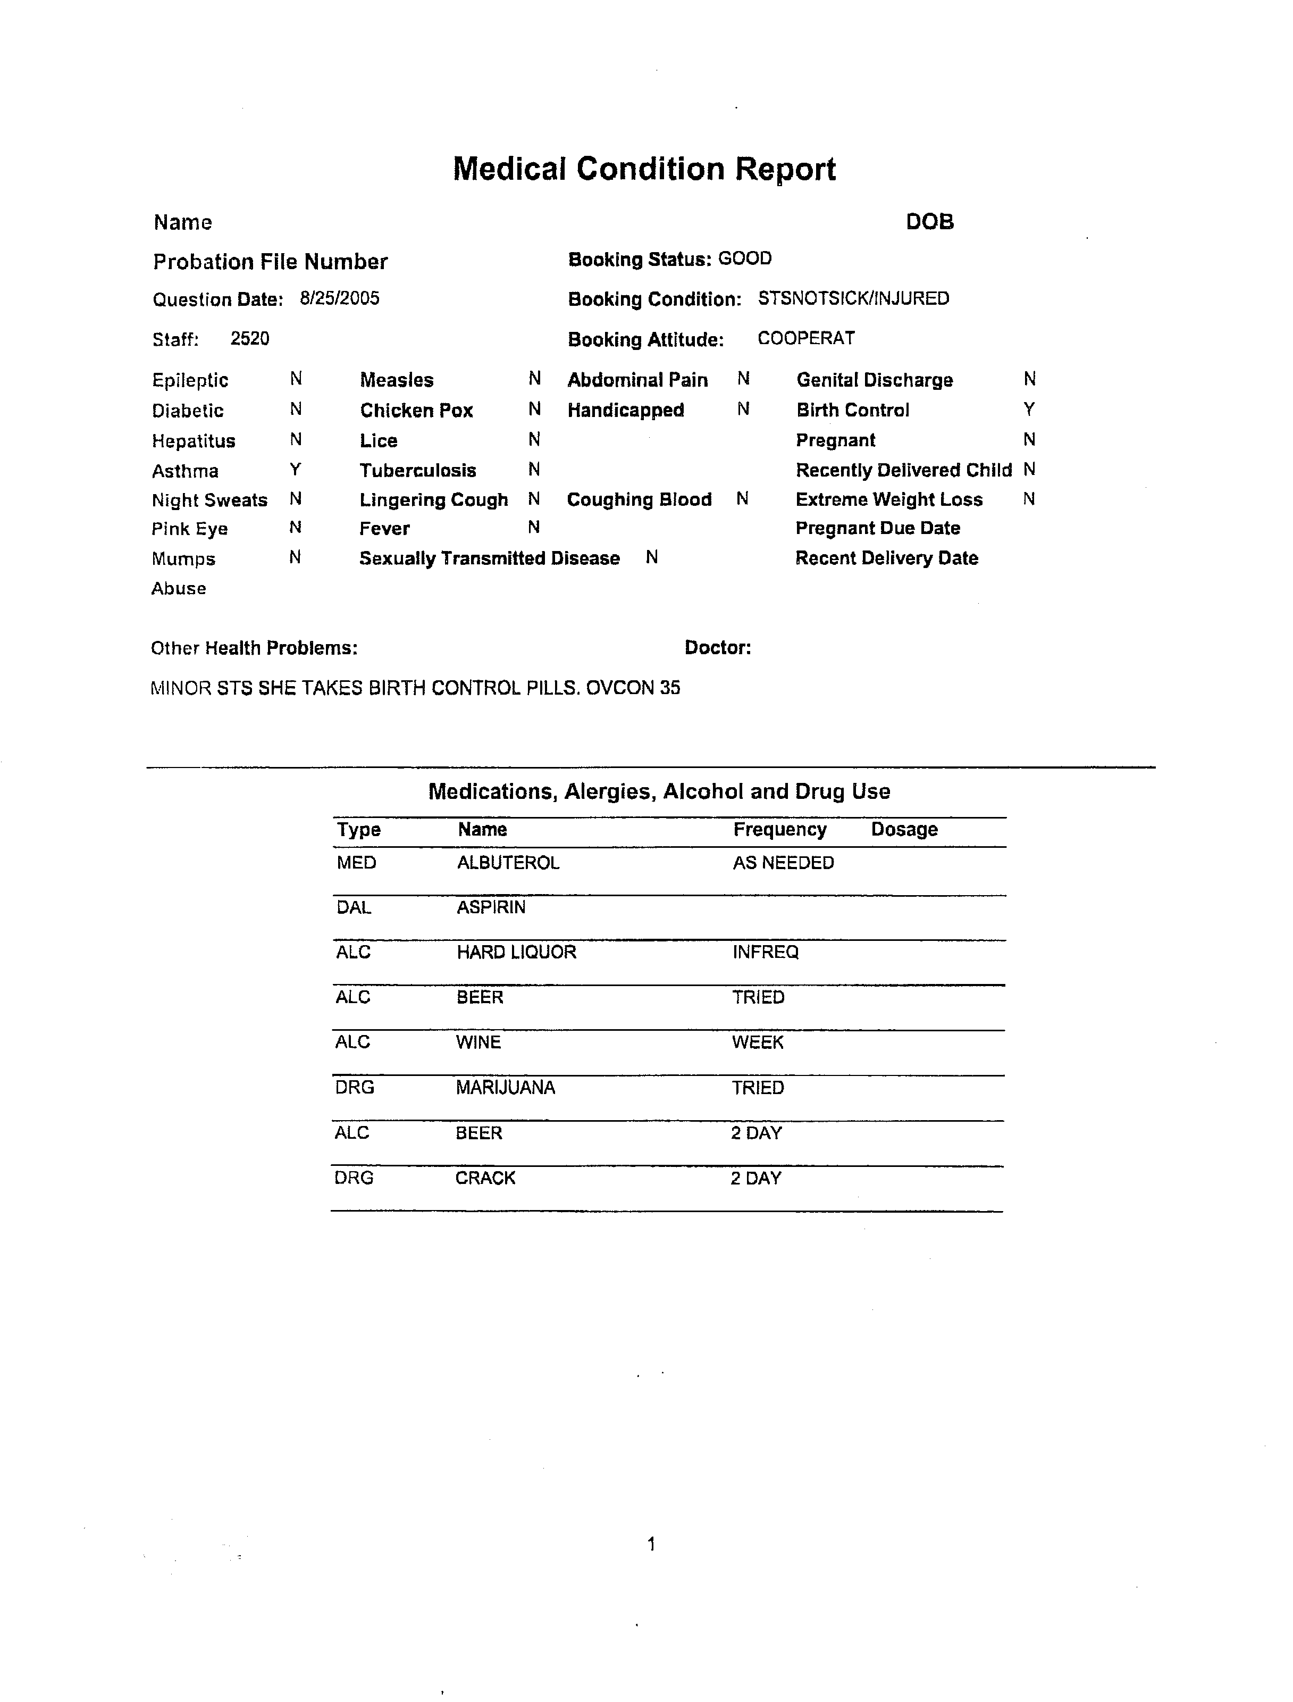
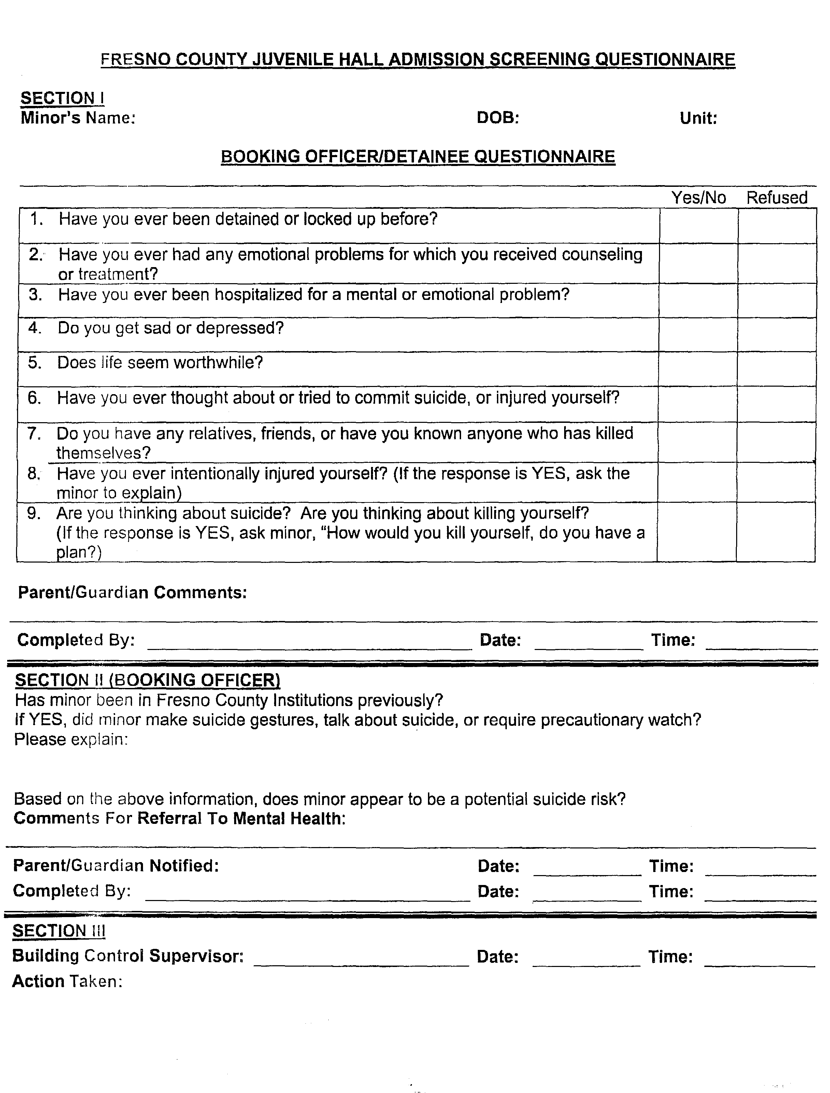
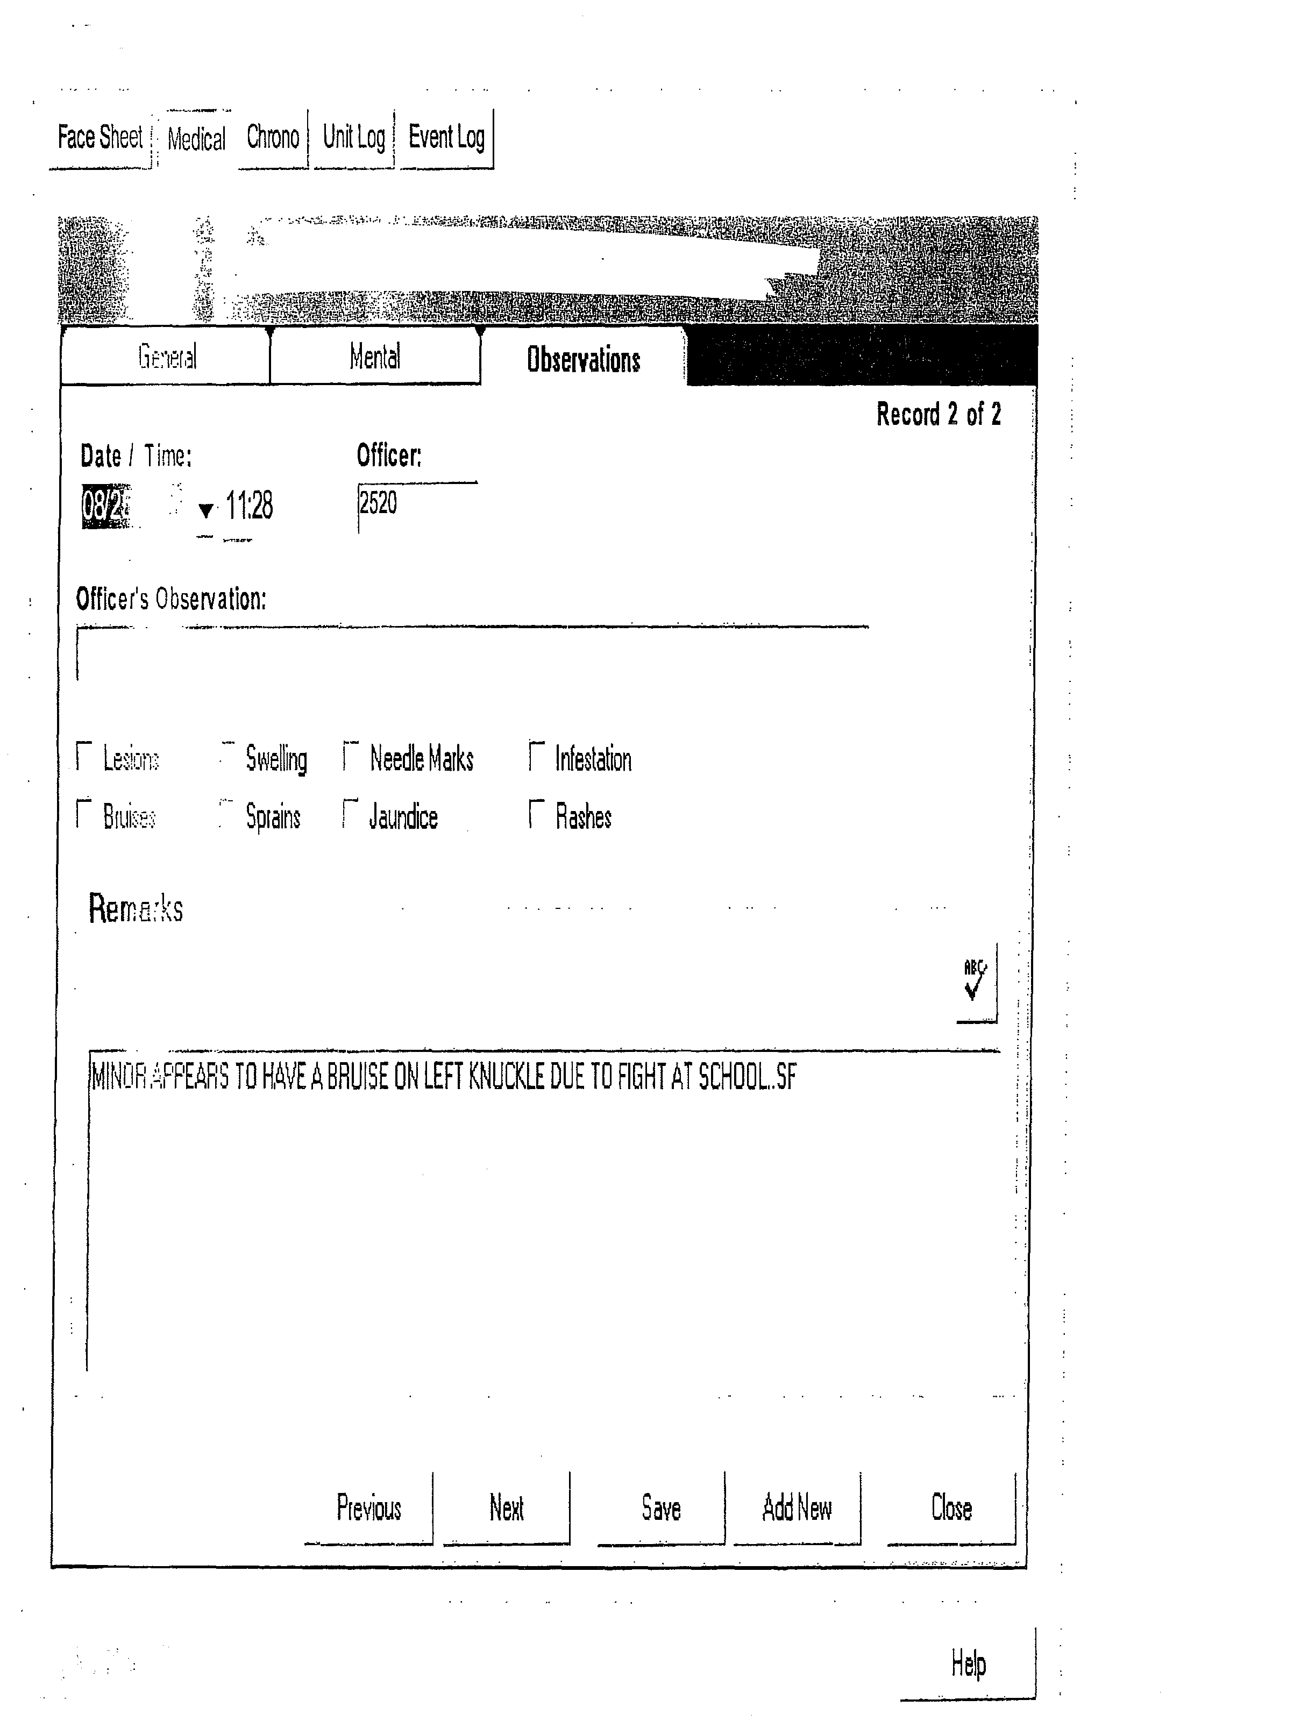

ATTACHMENT "B"
2005 | Monthly Total | 1 | 2 | 3 | 4 | 5 | 6 | 7 | 8 | 9 | 10 | 11 | 12 | 13 | 14 | 15 | 16 | 17 | 18 | 19 | 20 | 21 | 22 | 23 | 24 | 25 | 26 | 27 | 28 | 29 | 30 | 31
January | 418 | 6 | 6 | 17 | 9 | 19 | 7 | 25 | 8 | 3 | 19 | 6 | 17 | 21 | 16 | 11 | 8 | 8 | 16 | 14 | 13 | 39 | 16 | 8 | 14 | 11 | 18 | 19 | 17 | 9 | 4 | 14
February | 402 | 17 | 20 | 15 | 14 | 10 | 9 | 16 | 18 | 13 | 11 | 10 | 5 | 5 | 14 | 16 | 15 | 14 | 19 | 15 | 9 | 12 | 20 | 21 | 18 | 24 | 14 | 6 | 22
March | 414 | 18 | 15 | 21 | 16 | 12 | 8 | 13 | 17 | 17 | 21 | 14 | 12 | 12 | 11 | 21 | 16 | 17 | 22 | 1 | 4 | 16 | 15 | 12 | 14 | 12 | 1 | 2 | 14 | 16 | 13 | 11
April | 432 | 18 | 11 | 9 | 13 | 13 | 21 | 16 | 14 | 16 | 5 | 17 | 14 | 16 | 18 | 31 | 13 | 6 | 23 | 14 | 15 | 23 | 9 | 7 | 8 | 12 | 17 | 13 | 14 | 15 | 11
May | 413 | 7 | 7 | 8 | 18 | 24 | 19 | 8 | 10 | 10 | 16 | 18 | 19 | 23 | 15 | 11 | 13 | 16 | 27 | 9 | 17 | 3 | 8 | 16 | 13 | 13 | 10 | 14 | 7 | 8 | 14 | 12
June | 396 | 16 | 24 | 23 | 4 | 11 | 13 | 12 | 9 | 16 | 14 | 9 | 7 | 16 | 18 | 22 | 20 | 14 | 8 | 11 | 6 | 20 | 16 | 7 | 16 | 9 | 8 | 17 | 11 | 10 | 9
July | 367 | 17 | 9 | 2 | 7 | 16 | 9 | 17 | 9 | 16 | 8 | 11 | 13 | 14 | 15 | 23 | 16 | 11 | 15 | 12 | 18 | 15 | 16 | 7 | 7 | 4 | 8 | 15 | 10 | 9 | 7 | 11
August | 378 | 15 | 20 | 14 | 19 | 14 | 4 | 11 | 12 | 7 | 11 | 21 | 9 | 6 | 11 | 6 | 11 | 26 | 8 | 12 | 6 | 8 | 8 | 13 | 15 | 13 | 17 | 8 | 5 | 13 | 17 | 18
September | 401 | 20 | 18 | 5 | 10 | 16 | 17 | 11 | 14 | 20 | 10 | 4 | 17 | 22 | 8 | 15 | 22 | 9 | 7 | 13 | 11 | 19 | 19 | 14 | 10 | 2 | 16 | 12 | 16 | 10 | 14
October | 406 | 9 | 5 | 22 | 13 | 13 | 13 | 9 | 5 | 5 | 11 | 17 | 24 | 21 | 23 | 16 | 5 | 11 | 11 | 15 | 7 | 25 | 6 | 8 | 13 | 20 | 17 | 14 | 22 | 5 | 10 | 11
Total | 4027 | 143 | 135 | 136 | 123 | 148 | 120 | 138 | 116 | 123 | 126 | 127 | 137 | 156 | 149 | 172 | 139 | 132 | 156 | 116 | 106 | 180 | 133 | 113 | 128 | 120 | 126 | 120 | 138 | 95 | 99 | 77
Average |  | 14.3 | 13.5 | 13.6 | 12.3 | 14.8 | 12.0 | 13.8 | 11.6 | 12.3 | 12.6 | 12.7 | 13.7 | 15.6 | 14.9 | 17.2 | 13.9 | 13.2 | 15.6 | 11.6 | 10.6 | 18.0 | 13.3 | 11.3 | 12.8 | 12.0 | 12.6 | 12.0 | 13.8 | 10.6 | 11.0 | 12.8
2004 | Monthly Total | 1 | 2 | 3 | 4 | 5 | 6 | 7 | 8 | 9 | 10 | 11 | 12 | 13 | 14 | 15 | 16 | 17 | 18 | 19 | 20 | 21 | 22 | 23 | 24 | 25 | 26 | 27 | 28 | 29 | 30 | 31
January | 423 | 5 | 8 | 6 | 4 | 18 | 16 | 15 | 17 | 23 | 9 | 3 | 19 | 23 | 24 | 16 | 23 | 10 | 10 | 9 | 20 | 21 | 23 | 17 | 4 | 0 | 15 | 13 | 12 | 19 | 13 | 8
February | 360 | 4 | 9 | 7 | 21 | 16 | 17 | 8 | 5 | 7 | 17 | 12 | 8 | 26 | 8 | 4 | 7 | 12 | 13 | 18 | 19 | 1 | 9 | 13 | 19 | 20 | 20 | 24 | 10 | 6
March | 403 | 5 | 17 | 20 | 11 | 13 | 5 | 11 | 11 | 15 | 18 | 16 | 15 | 5 | 5 | 15 | 18 | 22 | 17 | 20 | 15 | 7 | 20 | 16 | 15 | 8 | 8 | 7 | 5 | 13 | 20 | 10
April | 427 | 13 | 31 | 5 | 8 | 11 | 15 | 17 | 10 | 8 | 9 | 6 | 13 | 17 | 16 | 19 | 17 | 9 | 7 | 13 | 19 | 17 | 16 | 21 | 10 | 5 | 23 | 23 | 28 | 9 | 12
May | 416 | 8 | 10 | 14 | 11 | 14 | 19 | 21 | 8 | 10 | 17 | 18 | 23 | 15 | 16 | 9 | 14 | 22 | 17 | 15 | 10 | 13 | 12 | 7 | 18 | 17 | 13 | 8 | 23 | 4 | 6 | 4
June | 342 | 8 | 9 | 16 | 11 | 13 | 6 | 15 | 15 | 15 | 12 | 12 | 10 | 9 | 12 | 14 | 15 | 7 | 19 | 4 | 15 | 12 | 14 | 12 | 15 | 6 | 8 | 6 | 7 | 15 | 10
July | 366 | 14 | 7 | 4 | 16 | 7 | 18 | 18 | 15 | 13 | 7 | 10 | 8 | 9 | 7 | 11 | 15 | 6 | 6 | 15 | 10 | 15 | 14 | 10 | 10 | 16 | 15 | 16 | 12 | 12 | 21 | 9
August | 316 | 3 | 7 | 19 | 11 | 9 | 11 | 8 | 17 | 13 | 9 | 15 | 12 | 6 | 7 | 8 | 10 | 15 | 8 | 14 | 8 | 6 | 8 | 11 | 11 | 11 | 4 | 13 | 4 | 9 | 13 | 16
September | 382 | 18 | 13 | 18 | 15 | 8 | 8 | 8 | 18 | 8 | 15 | 6 | 6 | 16 | 17 | 18 | 17 | 25 | 2 | 1 | 13 | 12 | 15 | 15 | 13 | 13 | 7 | 17 | 8 | 14 | 18
October | 362 | 16 | 8 | 4 | 10 | 17 | 8 | 19 | 11 | 7 | 7 | 10 | 16 | 22 | 6 | 21 | 4 | 8 | 8 | 9 | 18 | 17 | 13 | 5 | 8 | 14 | 9 | 13 | 18 | 21 | 8 | 7
November | 400 | 16 | 12 | 24 | 16 | 10 | 5 | 10 | 15 | 18 | 18 | 6 | 12 | 6 | 10 | 14 | 18 | 10 | 13 | 16 | 11 | 11 | 17 | 17 | 18 | 4 | 7 | 13 | 12 | 19 | 22
December | 389 | 17 | 10 | 29 | 6 | 8 | 7 | 17 | 11 | 9 | 16 | 3 | 11 | 16 | 21 | 20 | 22 | 22 | 16 | 6 | 14 | 22 | 19 | 7 | 10 | 3 | 3 | 7 | 10 | 11 | 12 | 4
Total | 4586 | 127 | 141 | 166 | 140 | 144 | 135 | 167 | 153 | 146 | 154 | 117 | 153 | 170 | 149 | 169 | 180 | 168 | 136 | 140 | 172 | 154 | 180 | 151 | 151 | 117 | 132 | 160 | 149 | 152 | 155 | 58
Average |  | 10.6 | 11.8 | 13.8 | 11.7 | 12.0 | 11.3 | 13.9 | 12.8 | 12.2 | 12.8 | 9.8 | 12.8 | 14.2 | 12.4 | 14.1 | 15.0 | 14.0 | 11.3 | 11.7 | 14.3 | 12.8 | 15.0 | 12.6 | 12.6 | 9.8 | 11.0 | 13.3 | 12.4 | 12.7 | 14.1 | 8.3
Attachment “B” (in Excel Program) is also available on Purchasing’s Open Solicitations Page or by clicking here.
COST PROPOSAL - FORM "A"
Agency Name:
Contract Period: | June 1, 2006 - May 31, 2007
Direct Personnel |  |  | COST
Position | % of FTE * | Annual Salary
Direct Salary Total
Tax/Benefits
Description
Direct Tax/Benefit Total
Indirect Personnel |  |  | COST
Position | % of FTE | Annual Salary
Indirect Salary Total
Tax/Benefits
Description
Indirect Tax/Benefit Total
* full-time equivalent
COST PROPOSAL - FORM "A" (cont.)
Agency Name:
Contract Period: | June 1, 2006 - May 31, 2007
Operating Budget |  |  | COST
Description | Quantity | Cost/Item
Office Supplies:
Medical Supplies:
Office Equipment:
Telephone Charges:
Medical Equipment:
Pharmaceuticals: **
Lab Services: **
X-Ray: **
EKG: **
Total Operating Cost
TOTAL ANNUAL COST:
** Do not include costs associated with psychiatric ordered services.
** Do not include any cost if Bidder chooses to use County Service Contract

Cost Proposal Form "B"
DRUG NAME | NDC# | Cost/each | Comments
IBUPROFEN 600 MG TABLET | 904518640
ALDROXICON I LIQ UD 30ML | 47682010742
POVIDONE-IODINE 10% SOLN | 52380190506
MILK OF MAGNESIA 30ML | 121043130
PERMETHRIN 1% LOTION | 472524267
BENZOYL PEROXIDE 5% GEL | 603770982
PSEUDOEPHEDRINE 60MG TABLET | 904512559
ANALGESIC BALM OINTMENT | 54162055501
ISONIAZID 300MG TABLET | 65162018211
VITAMIN B-6 50MG TABLET | 536440810
ACETAMINOPHEN 325MG TABLET | 10135012310
CLOTRIMAZOLE 7 VAG. CRM | 51672200306
INTRON A 18ML SQ | 5513321
LEVAQUIN 500MG TABLET | 5654737
FLUOXETINE 20MG CAPS | 50111064803
ZOLOFT 100MG TABLET | 49491073
SEROQUEL 200MG TABLET | 310027210
SEROQUEL 300MG TABLET | 310027460
SEROQUEL 100MG TABLET | 310027110
DEPAKOTE *ER 500MG TAB | 74712653
SEROQUEL 25MG TABLET | 310027534
LITHIUM *ER 300MG TAB | 53265028310
CONCERTA 36MG TABLET | 2139433
STRATTERA 40MG TABLET | 5687793
X-Ray/EKG |  | Cost/each | Comments
Single View Chest X-Ray
EKG
STAT calls
Other X-Ray exams
Labs |  | Cost/each | Comments
Pap smears and levels
Rheumatoid panels
Thyroid
H. Pylori
RH Factor
RBO and Type
CBC
CMP
TSH
T3/T4
UA
Drug Screen
All levels Dilantin
Tegretal
Depakote
RFP
GC
CT
O&P
Cultures
Hepatitis
Herpes
UA
CBC
CMP
Sed Rate
LFT
Rubella

(Also available in Excel Format on Purchasing’s Solicitations Page or by clicking here.)

