COUNTY OF FRESNO
Request for Quotation
 |  |  |  |  |  | NUMBER: 928-4268
May 12, 2006
 | ORG/Requisition: 75110700/ 7516003175 |  |  |  |  |  |  |  |  | PURCHASING USE |  |  |  |  | /tmp/in/input.doc
 |  |  |  |  |  |  |  |  |  | jlg
 | IMPORTANT: SUBMIT QUOTATION IN SEALED PACKAGE WITH QUOTATION NUMBER, CLOSING DATE AND BUYER’S NAME MARKED CLEARLY ON THE OUTSIDE TO:
COUNTY OF FRESNO, Purchasing
4525 EAST HAMILTON AVENUE
FRESNO, CA 93702-4599
Closing date of bid will be at 2:00 p.m., on June 6, 2006.
QUOTES WILL BE CONSIDERED LATE WHEN THE OFFICIAL PURCHASING TIME CLOCK READS 2:00 P.M.
 | Quotes will be opened and publicly read at that time. All quotation information will be available for review after contract award.
 | Clarification of specifications are to be directed to: Craig Nickel, phone (559) 456-7110, FAX (559) 456-7831.
 |  | GENERAL CONDITIONS
 |  | See “County Of Fresno Purchasing Standard Instructions And Conditions For Request For Proposals (RFP’S) and Requests for Quotations (RFQ’S)” attached.
BIDDER TO COMPLETE
UNDERSIGNED AGREES TO FURNISH THE COMMODITY OR SERVICE STIPULATED IN THE ATTACHED QUOTATION SCHEDULE AT THE PRICES AND TERMS STATED, SUBJECT TO THE “COUNTY OF FRESNO PURCHASING STANDARD INSTRUCTIONS AND CONDITIONS FOR REQUEST FOR PROPOSALS (RFP’S) AND REQUESTS FOR QUOTATIONS (RFQ’S)”ATTACHED.
Except as noted on individual items, the following will apply to all items in the Quotation Schedule.
 |  |  | - Complete delivery will be made within |  |  |  |  |  |  |  |  | calendar days after receipt of Order.
 |  |  | - A cash discount of |  |  |  |  |  | % |  |  |  |  | days will apply.
Company
Address
City |  |  |  |  |  |  |  |  |  |  |  |  |  |  |  |  | State |  | Zip Code
( ) |  |  |  |  |  |  |  | ( )
Telephone Number |  |  |  |  |  |  |  | Facsimile Number |  |  |  |  |  |  |  |  | E-mail Address
Taxpayer Federal I.D. No.:
Signed By
Print Name |  |  |  |  |  |  |  |  |  |  |  |  | Title

COUNTY OF FRESNO PURCHASING
STANDARD INSTRUCTIONS AND CONDITIONS FOR
REQUESTS FOR PROPOSALS (RFP'S) AND REQUESTS FOR QUOTATIONS (RFQ'S)
Note: the reference to “bids” in the following paragraphs applies to RFP's and RFQ's

GENERAL CONDITIONS
By submitting a bid the bidder agrees to the following conditions. These conditions will apply to all subsequent purchases based on this bid.

- BID PREPARATION:
  - All prices and notations must be typed or written in ink. No erasures permitted. Errors may be crossed out, initialed and corrections printed in ink by person signing bid.
  - Brand Names: Brand names and numbers when given are for reference. Equal items will be considered, provided the offer clearly describes the article and how it differs from that specified. In the absence of such information it shall be understood the offering is exactly as specified.
  - State brand or make of each item. If bidding on other than specified, state make, model and brand being bid and attach supporting literature/specifications to the bid.
  - Bid on each item separately. Prices should be stated in units specified herein. All applicable charges must be quoted; charges on invoice not quoted herein will be disallowed.
  - Time of delivery is a part of the consideration and must be stated in definite terms and must be adhered to. F.O.B. Point shall be destination or freight charges must be stated.
  - All bids must be dated and signed with the firm’s name and by an authorized officer or employee.
  - Unless otherwise noted, prices shall be firm for 120 days after closing date of bid.
- SUBMITTING BIDS:
  - Each bid must be submitted on forms provided in a sealed envelope with bid number and closing date and time on the outside of the envelope/package.
  - Interpretation: Should any discrepancies or omissions be found in the bid specifications or doubt as to their meaning, the bidder shall notify the Buyer in writing at once. The County shall not be held responsible for verbal interpretations. Questions regarding the bid must be received by Purchasing at least 5 working days before bid opening. All addenda issued shall be in writing, duly issued by Purchasing and incorporated into the contract.
  - ISSUING AGENT/AUTHORIZED CONTACT: This RFQ has been issued by County of Fresno Purchasing. Purchasing shall be the vendor’s sole point of contact with regard to the RFQ, its content, and all issues concerning it.
All communication regarding this RFQ shall be directed to an authorized representative of County Purchasing. The specific buyer managing this RFQ is identified on the cover page, along with his or her telephone number, and he or she should be the primary point of contact for discussions or information pertaining to the RFQ. Contact with any other County representative, including elected officials, for the purpose of discussing this RFQ, its content, or any other issue concerning it, is prohibited unless authorized by Purchasing. Violation of this clause, by the vendor having unauthorized contact (verbally or in writing) with such other County representatives, may constitute grounds for rejection by Purchasing of the vendor’s quotation.
The above stated restriction on vendor contact with County representatives shall apply until the County has awarded a purchase order or contract to a vendor or vendors, except as follows. First, in the event that a vendor initiates a formal protest against the RFQ, such vendor may contact the appropriate individual, or individuals who are managing that protest as outlined in the County’s established protest procedures. All such contact must be in accordance with the sequence set forth under the protest procedures. Second, in the event a public hearing is scheduled before the Board of Supervisors to hear testimony prior to its approval of a purchase order or contract, any vendor may address the Board.
  - Bids received after the closing time will NOT be considered.
  - Bidders are to bid what is specified or requested first. If unable to or willing to, bidder may bid alternative or option, indicating all advantages, disadvantages and their associated cost.
- FAILURE TO BID:
  - If not bidding, return bid sheet and state reason for no bid or your name may be removed from mailing list.
- TAXES, CHARGES AND EXTRAS:
  - County of Fresno is subject to California sales and/or use tax (7.975%). Please indicate as a separate line item if applicable.
  - DO NOT include Federal Excise Tax. County is exempt under Registration No. 94-73-03401-K.
  - County is exempt from Federal Transportation Tax. Exemption certificate is not required where shipping papers show consignee as County of Fresno.
  - Charges for transportation, containers, packing, etc. will not be paid unless specified in bid.
- W-9 – REQUEST FOR TAXPAYER IDENTIFICATION NUMBER AND CERTIFICATION:
Upon award of bid, the vendor shall submit to County Purchasing, a completed W-9 - Request for Taxpayer Identification Number and Certification if not already a current vendor with The County of Fresno. This form is available from the IRS to complete on line at http://www.irs.gov/pub/irs-pdf/fw9.pdf.
- AWARDS:
  - Subject to the local preference provisions referenced in Paragraph 6 below and more thoroughly set forth in the General Requirements section of this RFQ, award(s) will be made to the most responsive responsible bidder. The evaluation will include such things as life-cycle cost, availability, delivery costs and whose product and/or service is deemed to be in the best interest of the County. The County shall be the sole judge in making such determination.
  - Unless bidder gives notice of all-or-none award in bid, County may accept any item, group of items or on the basis of total bid.
  - The County reserves the right to reject any and all bids and to waive informalities or irregularities in bids.
  - After award, all bids shall be open to public inspection. The County assumes no responsibility for the confidentiality of information offered in a bid.
- LOCAL VENDORS
  - Local Vendor Preference (applicable to RFQ Process only)
The following provisions are applicable only to the County’s acquisition of materials, equipment or supplies through the RFQ process when the funding source does not require an exemption to the Local Vendor Preference.
THE PROVISIONS OF THIS PARAGRAPH ARE APPLICABLE, NOTWITHSTANDING ANY OTHER PROVISIONS OF THIS RFQ TO THE CONTRARY
If the apparent low bidder is not a local vendor, any local vendor who submitted a bid which was within five percent (5%) of the lowest responsive bid as determined by the purchasing agent shall have the option of submitting a new bid within forty-eight hours (not including weekends and holidays) of County’s delivery of notification. Such new bids must be in an amount less than or equal to the lowest responsive bid as determined by the purchasing agent. If the purchasing agent receives any new bids from local vendors who have the option of submitting new bids within said forty-eight hour period, it shall award the contract to the local vendor submitting the lowest responsible bid. If no new bids are received, the contract shall be awarded to the original low bidder as announced by the purchasing agent.
  - Local Vendor Defined
“Local Vendor” shall mean any business which:
- Has its headquarters, distribution point or locally-owned franchise located in or having a street address within the County for at least six (6) months immediately prior to the issuance of the request for competitive bids by the purchasing agent; and
- Holds any required business license by a jurisdiction located in Fresno County; and
- Employs at least one (1) full-time or two (2) part-time employees whose primary residence is located within Fresno County, or if the business has no employees, shall be at least fifty percent (50%) owned by one or more persons whose primary residence(s) is located within Fresno County.
- TIE BIDS:
All other factors being equal, the contract shall be awarded to the Fresno County vendor or, if neither or both are Fresno County vendors, it may be awarded by the flip of a coin in the presence of witnesses or the entire bid may be rejected and re-bid. If the General Requirements of this RFQ state that they are applicable, the provisions of the Fresno County Local Vendor Preference shall take priority over this paragraph.
- PATENT INDEMNITY:
The vendor shall hold the County, its officers, agents and employees, harmless from liability of any nature or kind, including costs and expenses, for infringement or use of any copyrighted or uncopyrighted composition, secret process, patented or unpatented invention, article or appliance furnished or used in connection with this bid.
- SAMPLES:
Samples, when required, must be furnished and delivered free and, if not destroyed by tests, will upon written request (within 30 days of bid closing date) be returned at the bidder's expense. In the absence of such notification, County shall have the right to dispose of the samples in whatever manner it deems appropriate.
- RIGHTS AND REMEDIES OF COUNTY FOR DEFAULT:
  - In case of default by vendor, the County may procure the articles or service from another source and may recover the cost difference and related expenses occasioned thereby from any unpaid balance due the vendor or by proceeding against performance bond of the vendor, if any, or by suit against the vendor. The prices paid by the County shall be considered the prevailing market price at the time such purchase is made.
  - Articles or services, which upon delivery inspection do not meet specifications, will be rejected and the vendor will be considered in default. Vendor shall reimburse County for expenses related to delivery of non-specified goods or services.
  - Regardless of F.O.B. point, vendor agrees to bear all risks of loss, injury or destruction to goods and materials ordered herein which occur prior to delivery and such loss, injury or destruction shall not release vendor from any obligation hereunder.
- DISCOUNTS:
Terms of less than 15 days for cash payment will be considered as net in evaluating this bid. A discount for payment within fifteen (15) days or more will be considered in determining the award of bid. Discount period will commence either the later of delivery or receipt of invoice by the County. Standard terms are Net Forty-five (45) days.
- SPECIAL CONDITIONS IN BID SCHEDULE SUPERSEDE GENERAL CONDITIONS.
The “General Conditions” provisions of this RFP/RFQ shall be superseded if in conflict with any other section of this bid, to the extent of any such conflict.
- SPECIAL REQUIREMENT:
With the invoice or within twenty-five (25) days of delivery, the seller must provide to the County a Material Safety Data Sheet for each product, which contains any substance on “The List of 800 Hazardous Substances”, published by the State Director of Industrial Relations. (See Hazardous Substances Information and Training Act. California State Labor Code Sections 6360 through 6399.7.)
- RECYCLED PRODUCTS/MATERIALS:
Vendors are encouraged to provide and quote (with documentation) recycled or recyclable products/materials which meet stated specifications.
- YEAR COMPLIANCE WARRANTY
Vendor warrants that any product furnished pursuant to this Agreement/order shall support a four-digit year format and be able to accurately process date and time data from, into and between the twentieth and twenty-first centuries, as well as leap year calculations. "Product" shall include, without limitation, any piece or component of equipment, hardware, firmware, middleware, custom or commercial software, or internal components or subroutines therein. This warranty shall survive termination or expiration of this Agreement.
In the event of any decrease in product functionality or accuracy related to time and/or date data related codes and/or internal subroutines that impede the product from operating correctly using dates beyond December 31, 1999, vendor shall restore or repair the product to the same level of functionality as warranted herein, so as to minimize interruption to County's ongoing business process, time being of the essence. In the event that such warranty compliance requires the acquisition of additional programs, the expense for any such associated or additional acquisitions, which may be required, including, without limitation, data conversion tools, shall be borne exclusively by vendor. Nothing in this warranty shall be construed to limit any rights or remedies the County may otherwise have under this Agreement with respect to defects other than year performance.
- PARTICIPATION:
Bidder may agree to extend the terms of the resulting contract to other political subdivision, municipalities and tax-supported agencies.
Such participating Governmental bodies shall make purchases in their own name, make payment directly to bidder, and be liable directly to the bidder, holding the County of Fresno harmless.
- CONFIDENTIALITY:
All services performed by vendor shall be in strict conformance with all applicable Federal, State of California and/or local laws and regulations relating to confidentiality, including but not limited to, California Civil Code, California Welfare and Institutions Code, Health and Safety Code, California Code of Regulations, Code of Federal Regulations.
Vendor shall submit to County’s monitoring of said compliance.
Vendor may be a business associate of County, as that term is defined in the “Privacy Rule” enacted by the Health Insurance Portability and Accountability Act of 1996 (HIPAA). As a HIPAA Business Associate, vendor may use or disclose protected health information (“PHI”) to perform functions, activities or services for or on behalf of County as specified by the County, provided that such use or disclosure shall not violate HIPAA and its implementing regulations. The uses and disclosures if PHI may not be more expansive than those applicable to County, as the “Covered Entity” under HIPAA’S Privacy Rule, except as authorized for management, administrative or legal responsibilities of the Business Associate.
Vendor shall not use or further disclose PHI other than as permitted or required by the County, or as required by law without written notice to the County.
Vendor shall ensure that any agent, including any subcontractor, to which vendor provides PHI received from, or created or received by the vendor on behalf of County, shall comply with the same restrictions and conditions with respect to such information.
- APPEALS
Appeals must be submitted in writing within five (5) working days after the review committee notification of proposed recommendations. Appeals should be submitted to County of Fresno Purchasing, 4525 E. Hamilton Avenue, Fresno, California 93702-4599. Appeals should address only areas regarding RFP contradictions, procurement errors, quotation rating discrepancies, legality of procurement context, conflict of interest in rating process, and inappropriate or unfair competitive procurement grievance regarding the RFP process.
The Purchasing Manager will provide a written response to the complaint within five (5) working days unless the complainant is notified more time is required.
If the protesting bidder is not satisfied with the decision of the Purchasing Manager, he/she shall have the right to appeal to the Purchasing Agent within five (5) business days after notification of the Purchasing Manager’s decision.
If the protesting bidder is not satisfied with Purchasing Agent decision, the final appeal is with the Board of Supervisors.

BIDDING INSTRUCTIONS

CONTRACT SERVICES
The County of Fresno is soliciting bids to provide all labor, materials, equipment, etc., to for the provision, application and maintenance of paint and exterior graphics (Vehicle Wrap) on the Fresno County Library’s Bookmobile. Anticipated completion of service is projected for six weeks after the contract award date.
The vendor shall send pictures via email or provide access to work site, at County’s discretion, so that County representatives can monitor progress and ensure the quality
The County of Fresno is located in the Central San Joaquin Valley of California. The normal prevailing weather conditions range from below 20 degrees in the winter months to in excess of 100 degrees on the valley floor in the summer. Driving will occur primarily on rural roads, highways, freeways, and terrain will mainly consist on flat or valley roads and mountainous driving conditions.
DEFINITIONS: The terms Bidder, Proposer, Contractor and Vendor are all used interchangeably and refer to that person, partnership, corporation, organization, agency, etc. which is offering the quotation and is identified on page one of this Request For Quotation (RFQ).
INTERPRETATION OF RFQ: Vendors must make careful examination of the requirements, specifications and conditions expressed in the RFQ and fully inform themselves as to the quality and character of services required. If any person planning to submit a quotation finds discrepancies in or omissions from the RFQ or has any doubt as to the true meaning or interpretation, correction thereof may be requested at the scheduled Vendor Conference (see below). Any change in the RFQ will be made only by written addendum, duly issued by the County. The County will not be responsible for any other explanations or interpretations.
Questions may be submitted subsequent to the Vendor Conference, subject to the following conditions:
- Such questions are submitted in writing to County Purchasing at least three (3) County business days prior to the Request for Quotation closing date. Questions must be directed to the attention of the buyer identified on page one.
- Such questions are submitted with the understanding that County can respond only to questions it considers material in nature.
Questions shall be delivered to County of Fresno Purchasing, 4525 E. Hamilton Avenue, Fresno, CA 93702 or faxed to (559) 456-7831. If faxing the bidder must confirm receipt by phone within one-half (1/2) hour of transmission.
NOTE: The bidder is encouraged to submit all questions at the Vendor Conference. Time limitations can prevent a response to questions submitted after the conference.
AWARD: Award will be made to the vendor(s) offering the services deemed to be to the best advantage of the County. The County shall be the sole judge in making such determination.
RIGHT TO REJECT BIDS: The County reserves the right to reject any and all bids and to waive informalities or irregularities in bids.
ISSUING AGENT: This RFQ has been issued by County of Fresno Purchasing. Purchasing shall be the vendor’s sole point of contact with regard to the RFQ, its content, and all issues concerning it.
AUTHORIZED CONTACT: All communication regarding this RFQ shall be directed to an authorized representative of County Purchasing. The specific buyer managing this RFQ is identified on the cover page, along with his or her telephone number, and he or she should be the primary point of contact for discussions or information pertaining to the RFQ. Contact with any other County representative, including elected officials, for the purpose of discussing this RFQ, it content, or any other issue concerning it, is prohibited unless authorized by Purchasing. Violation of this clause, by the vendor having unauthorized contact (verbally or in writing) with such other County representatives, may constitute grounds for rejection by Purchasing of the vendor’s quotation.
The above stated restriction on vendor contact with County representatives shall apply until the County has awarded a purchase order or contract to a vendor or vendors, except as follows. First, in the event that a vendor initiates a formal protest against the RFQ, such vendor may contact the appropriate individual, or individuals who are managing that protest as outlined in the County’s established protest procedures. All such contact must be in accordance with the sequence set forth under the protest procedures. Second, in the event a public hearing is scheduled before the Board of Supervisors to hear testimony prior to its approval of a purchase order or contract, any vendor may address the Board.
VENDOR CONFERENCE: On May 24, 2006 at 10:00 a.m., a vendor's conference will be held in which the scope of the project and quotation requirements will be explained. The meeting will be held at the office of County of Fresno Purchasing, 4525 E. Hamilton (between Cedar and Maple), Fresno, California. Minutes will be prepared and distributed to all bidders only if necessary to clarify substantive items raised during the bidders' conference.
Bidders are to contact Craig Nickel at County of Fresno Purchasing, (559) 456-7110, if they are planning to attend the conference.
NUMBER OF COPIES: Submit one (1) original and two (2) copies of your quotation no later than the quotation closing date and time as stated on the front of this document to County of Fresno Purchasing. Each copy to be identical to the original, include all supporting documentation (i.e. literature, brochures, reports, schedules etc.). The cover page of each quotation is to be appropriately marked “Original” or “Copy”.
FIRM QUOTATION: All quotations shall remain firm for at least ninety (90) days.
TAXES: The quoted amount must include all applicable taxes. If taxes are not specifically identified in the quotation it will be assumed that they are included in the total quoted.
SALES TAX: Fresno County pays California State Sales Tax in the amount of 7.975% regardless of vendor's place of doing business.
MINOR DEVIATIONS: The County reserves the right to negotiate minor deviations from the prescribed terms, conditions and requirements with the selected vendor.
QUOTATION REJECTION: Failure to respond to all questions or not to supply the requested information could result in rejection of your quotation.
BIDDERS’ LIABILITIES: County of Fresno will not be held liable for any cost incurred by vendors in responding to the RFQ.
PRICE RESPONSIBILITY: The selected vendor will be required to assume full responsibility for all services and activities offered in the quotation, whether or not they are provided directly. Further, the County of Fresno will consider the selected vendor to be the sole point of contact with regard to contractual matters, including payment of any and all charges resulting from the contract. The contractor may not subcontract or transfer the contract, or any right or obligation arising out of the contract, without first having obtained the express written consent of the County.
CONFIDENTIALITY: Bidders shall not disclose information about the County's business or business practices and safeguard confidential data which vendor staff may have access to in the course of system implementation.
NEWS RELEASE: Vendors shall not issue any news releases or otherwise release information to any third party about this RFQ or the vendor's quotation without prior written approval from the County of Fresno.
BACKGROUND REVIEW: The County reserves the right to conduct a background inquiry of each proposer/bidder which may include collection of appropriate criminal history information, contractual and business associations and practices, employment histories and reputation in the business community. By submitting a quotation/bid to the County, the vendor consents to such an inquiry and agrees to make available to the County such books and records the County deems necessary to conduct the inquiry.
EXCEPTIONS: Identify with explanation, any terms, conditions, specifications or stipulations of the RFQ with which you CAN NOT or WILL NOT comply.
ADDENDA: In the event that it becomes necessary to revise any part of this RFQ, addenda will be provided to all agencies and organizations that receive the basic RFQ.
SUBCONTRACTORS: If a subcontractor is proposed, complete identification of the subcontractor and his tasks shall be provided. The primary contractor is not relieved of any responsibility by virtue of using a subcontractor.
CONFLICT OF INTEREST: The County shall not contract with, and shall reject any bid or quotation submitted by the persons or entities specified below, unless the Board of Supervisors finds that special circumstances exist which justify the approval of such contract:
- Employees of the County or public agencies for which the Board of Supervisors is the governing body.
- Profit-making firms or businesses in which employees described in Subsection (1) serve as officers, principals, partners or major shareholders.
- Persons who, within the immediately preceding twelve (12) months, came within the provisions of Subsection (1), and who were employees in positions of substantial responsibility in the area of service to be performed by the contract, or participated in any way in developing the contract or its service specifications.
- Profit-making firms or businesses in which the former employees described in Subsection (3) serve as officers, principals, partners or major shareholders.
- No County employee whose position in the County enables him to influence the selection of a contractor for this RFQ, or any competing RFQ, and no spouse or economic dependent of such employee, shall be employees in any capacity by a bidder, or have any other direct or indirect financial interest in the selection of a contractor.
INVOICING: All invoices are to be delivered in duplicate to the ordering department. Each invoice shall reference the purchase order or contract no. The contractor shall obtain the “invoice to” address when receiving the order.
CONTRACT TERM: It is County’s intent to contract with the successful bidder for a term of one (1) year with the option to renew for additional one (1) year periods.
PRICES: Bidder agrees that prices quoted are maximum for the contract period, and in the event of a price decline such lower prices shall be extended to the County of Fresno.
INDEPENDENT CONTRACTOR: In performance of the work, duties, and obligations assumed by Contractor under any ensuing Agreement, it is mutually understood and agreed that CONTRACTOR, including any and all of Contractor’s officers, agents, and employees will at all times be acting and performing as an independent contractor, and shall act in an independent capacity and not as an officer, agent, servant, employee, joint venturer, partner, or associate of the COUNTY. Furthermore, County shall have no right to control or supervise or direct the manner or method by which Contractor shall perform its work and function. However, County shall retain the right to administer this Agreement so as to verify that Contractor is performing its obligations in accordance with the terms and conditions thereof. Contractor and County shall comply with all applicable provisions of law and the rules and regulations, if any, of governmental authorities having jurisdiction over matters the subject thereof.
Because of its status as an independent contractor, Contractor shall have absolutely no right to employment rights and benefits available to County employees. Contractor shall be solely liable and responsible for providing to, or on behalf of, its employees all legally-required employee benefits. In addition, Contractor shall be solely responsible and save County harmless from all matters relating to payment of Contractor's employees, including compliance with Social Security, withholding, and all other regulations governing such matters. It is acknowledged that during the term of the Agreement, Contractor may be providing services to others unrelated to the County or to the Agreement.
HOLD HARMLESS CLAUSE: Contractor agrees to indemnify, save, hold harmless and at County's request, defend the County, its officers, agents and employees, from any and all costs and expenses, damages, liabilities, claims and losses occurring or resulting to County in connection with the performance, or failure to perform, by Contractor, its officers, agents or employees under this Agreement and from any and all costs and expenses, damages, liabilities, claims and losses occurring or resulting to any person, firm or corporation who may be injured or damaged by the performance, or failure to perform, of Contractor, its officers, agents or employees under this Agreement.

INSURANCE:
Without limiting the COUNTY's right to obtain indemnification from CONTRACTOR or any third parties, CONTRACTOR, at its sole expense, shall maintain in full force and effect, the following insurance policies throughout the term of the Agreement:
- Commercial General Liability
Commercial General Liability Insurance with limits of not less than One Million Dollars ($1,000,000) per occurrence and an annual aggregate of Two Million Dollars ($2,000,000). This policy shall be issued on a per occurrence basis. COUNTY may require specific coverages including completed operations, products liability, contractual liability, Explosion-Collapse-Underground, fire legal liability or any other liability insurance deemed necessary because of the nature of this contract.
- Automobile Liability
Comprehensive Automobile Liability Insurance with limits for bodily injury of not less than Two Hundred Fifty Thousand Dollars ($250,000.00) per person, Five Hundred Thousand Dollars ($500,000.00) per accident and for property damages of not less than Fifty Thousand Dollars ($50,000.00), or such coverage with a combined single limit of Five Hundred Thousand Dollars ($500,000.00). Coverage should include owned and non-owned vehicles used in connection with this Agreement.
- Worker's Compensation
A policy of Worker's Compensation insurance as may be required by the California Labor Code.
CONTRACTOR shall obtain endorsements to the Commercial General Liability insurance naming the County of Fresno, its officers, agents, and employees, individually and collectively, as additional insured, but only insofar as the operations under this Agreement are concerned. Such coverage for additional insured shall apply as primary insurance and any other insurance, or self-insurance, maintained by COUNTY, its officers, agents and employees shall be excess only and not contributing with insurance provided under CONTRACTOR's policies herein. This insurance shall not be cancelled or changed without a minimum of thirty (30) days advance written notice given to COUNTY.
Within Thirty (30) days from the date CONTRACTOR executes this Agreement, CONTRACTOR shall provide certificates of insurance and endorsement as stated above for all of the foregoing policies, as required herein, to the County of Fresno, stating that such insurance coverage have been obtained and are in full force; that the County of Fresno, its officers, agents and employees will not be responsible for any premiums on the policies; that such Commercial General Liability insurance names the County of Fresno, its officers, agents and employees, individually and collectively, as additional insured, but only insofar as the operations under this Agreement are concerned; that such coverage for additional insured shall apply as primary insurance and any other insurance, or self-insurance, maintained by COUNTY, its officers, agents and employees, shall be excess only and not contributing with insurance provided under CONTRACTOR's policies herein; and that this insurance shall not be cancelled or changed without a minimum of thirty (30) days advance, written notice given to COUNTY.
In the event CONTRACTOR fails to keep in effect at all times insurance coverage as herein provided, the COUNTY may, in addition to other remedies it may have, suspend or terminate this Agreement upon the occurrence of such event.
All policies shall be with admitted insurers licensed to do business in the State of California. Insurance purchased shall be purchased from companies possessing a current A.M. Best, Inc. rating of A FSC VII or better.
COORDINATION AND COMPLETION: The successful bidder shall contact and meet with the County Coordinator prior to commencement and completion of any work.
Successful bidder shall complete the job as instructed and described in writing by the contract, bid or amendment. Any problem or questions that arise in the scope of work, the County must be contacted and the appropriate written amendment generated.
COMPLETION PERIOD: Time of completion for this project shall be sixty (60) calendar days, excepting delays caused by acts of God.
LIQUIDATED DAMAGES: The Contractor will be assessed liquidated damages in the amount of one-hundred dollars ($100.00) per day for each calendar day delay over the specified time of completion.
DISPUTE RESOLUTION: The ensuing contract shall be governed by the laws of the state of California.
Any claim which cannot be amicably settled without court action will be litigated in the U. S. District Court for the Eastern District of California in Fresno, CA or in a state court for Fresno County.
TERMINATION: The County reserves the right to terminate any resulting contract upon written notice.
DEFAULT: In case of default by the selected bidder, the County may procure the services from another source and may recover the loss occasioned thereby from any unpaid balance due the selected bidder, or by any other legal means available to the County.
ASSIGNMENTS: The ensuing proposed contract will provide that the vendor may not assign any payment or portions of payments without prior written consent of the County of Fresno.
ASSURANCES: Any contract awarded under this RFQ must be carried out in full compliance with The Civil Rights Act of 1964, The Americans With Disabilities Act of 1990, their subsequent amendments, and any and all other laws protecting the rights of individuals and agencies. The County of Fresno has a zero tolerance for discrimination, implied or expressed, and wants to ensure that policy continues under this RFQ. The contractor must also guarantee that services, or workmanship, provided will be performed in compliance with all applicable local, state, or federal laws and regulations pertinent to the types of services, or project, of the nature required under this RFQ. In addition, the contractor may be required to provide evidence substantiating that their employees have the necessary skills and training to perform the required services or work.
AUDITS AND INSPECTIONS: The Contractor shall at any time during business hours, and as often as the County may deem necessary, make available to the County for examination all of its records and data and respect to the matters covered by this Agreement. The Contractor shall, upon request by the County, permit the County to audit and inspect all of such records and data necessary to ensure Contractor's compliance with the terms of this Agreement.
If this Agreement exceeds Ten Thousand and No/100 dollars ($10,000.00), Contractor shall be subject to the examination and audit of the Auditor General for a period of three (3) years after final payment under contract (Government Code Section 8546.7).
MATERIALS TO BE NEW: All materials shall be new and of merchantable grade, free from defect. No bid will be considered unless it is accompanied by a complete list of manufacturer's catalog numbers of the items, which the bidder proposes to furnish, together with full descriptive literature on all items so enumerated. If item proposed differs from these specifications, bidder shall present specific explanation of functioning and structural characteristics for those details which differ from the specifications listed herein.
EXAMINATION OF SITE: Where work is to be performed on County site, each bidder shall have examined the site of work before bidding and shall be responsible for having acquired full knowledge of the job and of all problems affecting it. No variations or allowance from the contract sum will be made because of lack of such examination.
DAMAGE TO EXISTING WORK: Damage to existing construction, equipment, planting, etc., by the contractor in the performance of his work shall be replaced or repaired and restored to original condition by the contractor.
CLEAN-UP: The Contractor shall at all times, keep the premises clean from accumulation of waste materials or rubbish caused by his employees or work and shall remove all resulting work debris from the job site.
SUPERVISION: The Contractor shall give efficient supervision to the work, using therein the skill and diligence for which he is remunerated in the contract price. He shall carefully inspect the site and study and compare all drawings, specifications and other instructions, as ignorance of any phase of any of the features or conditions affecting the contract will not excuse him from carrying out its provisions to its full intent.
STANDARD OF PERFORMANCE: All work shall be performed in a good and workmanlike manner.
SAFEGUARDS: The contractor shall provide safeguards, in conformity with all local codes and ordinances as may be required.

Local Vendor Preference
The County of Fresno Local Vendor Preference is applicable to this Request for Quotation. Refer to the General Conditions section for details.
Qualified Vendors that desire consideration as a Fresno County Local Vendor under this RFQ must complete the “Statement of Local Vendor Certification” contained herein and submit it as a part of their quotation. Late submittals of the “Statement of Local Vendor Certification” will not be considered. Submission of this statement will qualify the vendor for treatment as a local vendor for purposes of this RFQ only. The statement made under this RFQ shall not qualify the vendor as a local vendor under any other RFQ.
LOCAL VENDOR CERTIFICATION:
Any vendor claiming to be a local vendor, as defined under the General Conditions section of this RFQ, shall so certify in writing to the purchasing agent. The purchasing agent shall not be required to verify the accuracy or any such certifications, and shall have sole discretion to determine if a vendor meets the definition of “local vendor.”
Any person or business falsely claiming to be a local vendor under this section shall be ineligible to transact any business with the County for a period of not less than three (3) months and not more twenty-four (24) months as determined in the sole discretion of the purchasing agent. The purchasing agent shall also have the right to terminate all or any part of any contract entered into with such person or business.
STATEMENT OF LOCAL VENDOR CERTIFICATION
COUNTY OF FRESNO
Qualified local vendors desiring consideration under the Fresno County Local Vendor Preference must complete the following and submit with their quotation (print or type).
I |  |  |  |  |  | ,
 | (individual submitting bid) |  |  |  |  |  | (title)
Of/for |  |  |  | Certify that
 |  | (Company Name) |  |  |  |  |  | (Company Name)
Is a Fresno County local Vendor as defined under the General Conditions section of this RFQ and therefore qualifies for the Local Vendor Preference.
Signature |  |  |  |  | Title |  |  |  |  | Date

NOTIFICATION OF RE-BID
If a local vendor’s bid qualifies under Fresno County’s Local Vendor Preference, the local vendor will be notified of his/her opportunity to re-bid. if so notified, the Vendor must submit his/her re-bid within forty-eight (48) hours of notification (excluding weekends and holidays). Notification will be issued by e-mail or Fax, whichever is preferred by the vendor. Notification to Vendor shall be considered complete upon County’s transmission of e-mail or Fax.
The local vendor shall state his/her preferred method of notification below along with the appropriate e-mail address or Fax number. Notification by County will be limited to one of those two (2) methods. It will be the local vendor’s responsibility to check his/her e-mail or Fax messages for notification. The vendor’s delay in receiving his/her notification will not alter the forty-eight (48) hour period allowed for re-bid submission.
LOCAL VENDOR TO COMPLETE:
Indicate *ONE method for notification of Local Vendor re-bid by providing the appropriate e-mail address or Fax number. Submit this document as a part of your quotation.
E-Mail Address or Fax Number (Identify contact person if using a Fax Number)
SCOPE OF WORK
The Fresno County Library is requesting proposals from qualified businesses to provide and apply paint and exterior graphics (Vehicle Wrap) on (1) mobile unit. Anticipated completion of service is projected to be six weeks after the contract award date.

Fresno County is located in the Central San Joaquin Valley of California. The normal prevailing weather conditions range from below 20 degrees in the winter months to in excess of 100 degrees on the valley floor in the summer. Driving will occur primarily on rural roads, highways, freeways, and terrain will mainly consist of flat or valley roads and mountainous driving conditions.

The successful vendor will possess the expertise and ability to complete the requested specifications within a reasonable time frame, of highest quality, and within a reasonable cost. The following specifications are required:

SPECIFICATION:

Type of Paint: One shot automotive paint (oil based not acrylic, high gloss enamel with UV inhibitors- resist fading and retains color intensity). Bubbling, ripples, runs, will not be accepted.

Coating: High gloss clear coat (acrylic).

Vendor to clean and prep surfaces as needed.

Lettering: High gloss vinyl, 3 millimeters, or as specified.

Vendor must have painted, completed at least five (5) vehicles over 25’ in length.

Vendor to provide portfolio for preview.

Warranty: minimum of five years.

In response to proposal, Vendor to indicate any design conflicts with the graphics and application of materials.

Vendor to state schedule for completion of work.

Selection to be based on meeting these specifications and the suitability of the artist’s work for this project.
The vendor will guarantee repairing any manufacturing or installation defects for up-to-five years. This guarantee will not cover damage to the exterior graphics that is caused by conditions other than manufacturing or installation defect. If a problem with any of the exterior graphics arises during the warranty period, the selected vendor will work through the County Contact or designee to resolve the problem.
The selected vendor will agree to perform minor exterior graphic modifications as requested by the County Contact or designee on an as needed basis up to 3 years from the final approval date.
Specifications & Equals: Brand names, where used, are a means of establishing quality and style. Vendors are invited to quote their equals. Alternate offers are to be supported by literature, which fully describes items that you are bidding.
Specification Variances: If any of the material bids vary from the specification, such variations must be listed in writing and attached as part of the proposal. The County of Fresno reserves the right to waive minor variations if, in the opinion of the County, the basic material meets the general intent of these specifications.
Inspection:
The following inspections are required:
The County Contact or designee will proof and approve the final draft before the exterior graphics (Vehicle Wrap) are applied.
PHOTOGRAPHS/VIDEOS: The Contractor shall provide, upon request from County, photographs and videos of the vehicle during the graphic application process. Such requests will specify phase of construction and items to be photographed or video taped.
Photographs and/or video tapes shall be taken when requested by the County. Photographs shall be taken within 24 hours and sent to the County within 48 hours.
PRE-CONSTRUCTION MEETING: The County will require a pre-application meeting with the successful vendor. The intent of the meeting is to thoroughly discuss the bookmobile graphics, written specifications, design, layout, and expectations of the County. This meeting will be conducted at either a County facility or the successful vendors manufacturing location. All expenses of the Pre-Construction meeting shall be borne by the successful vendor including travel and lodging as needed.
INSPECTIONS: The bookmobile will be inspected during the application process by a minimum of two County representatives from the Fresno County Library and/or Fleet Services Division. The inspection will consist of appearance and conformance to all requirements of these specifications. Vendor is required to notify the County no less than one week prior to the date which the vehicle will be near completion and available for inspection. For purposes of reference, this inspection shall henceforth be referred to as the “85% complete Inspection”.
At the County’s option, County will perform a second inspection at 100% of completion and prior to delivery at the Vendor’s plant. This Inspection would occur if major discrepancies are still unresolved.
All expenses associated with Inspection(s) will be borne by the successful vendor.
FINAL INSPECTION AT DELIVERY: A final inspection will be performed upon delivery to County. County will accept vehicle at this point subject to its passing inspection.
At the time of the final inspection and after final approval has been given, the vendor will provide the County with an itemized invoice for the full amount for the painting and application of the exterior graphics (Vehicle Wrap). It is anticipated that the vendor will receive full payment within 4 – 6 weeks upon the submitting of the final itemized invoice.

Quotation Elements:
At a minimum the successful vendor will demonstrate the following:
Capacity to fulfill contract requirements as outlined above;
Exterior graphic materials life-span;
Vendor ability to ensure adequate adhesion and any preparation technique in painting and application process;
Detailed timeline outlining the steps to perform the services required within the specified timeframe;
Ability to work closely with County Contact or designee;
Description of similar experiences with the provision and application of exterior graphics (Vehicle Wrap) and painting.

Pictures and Graphics of Bookmobile.
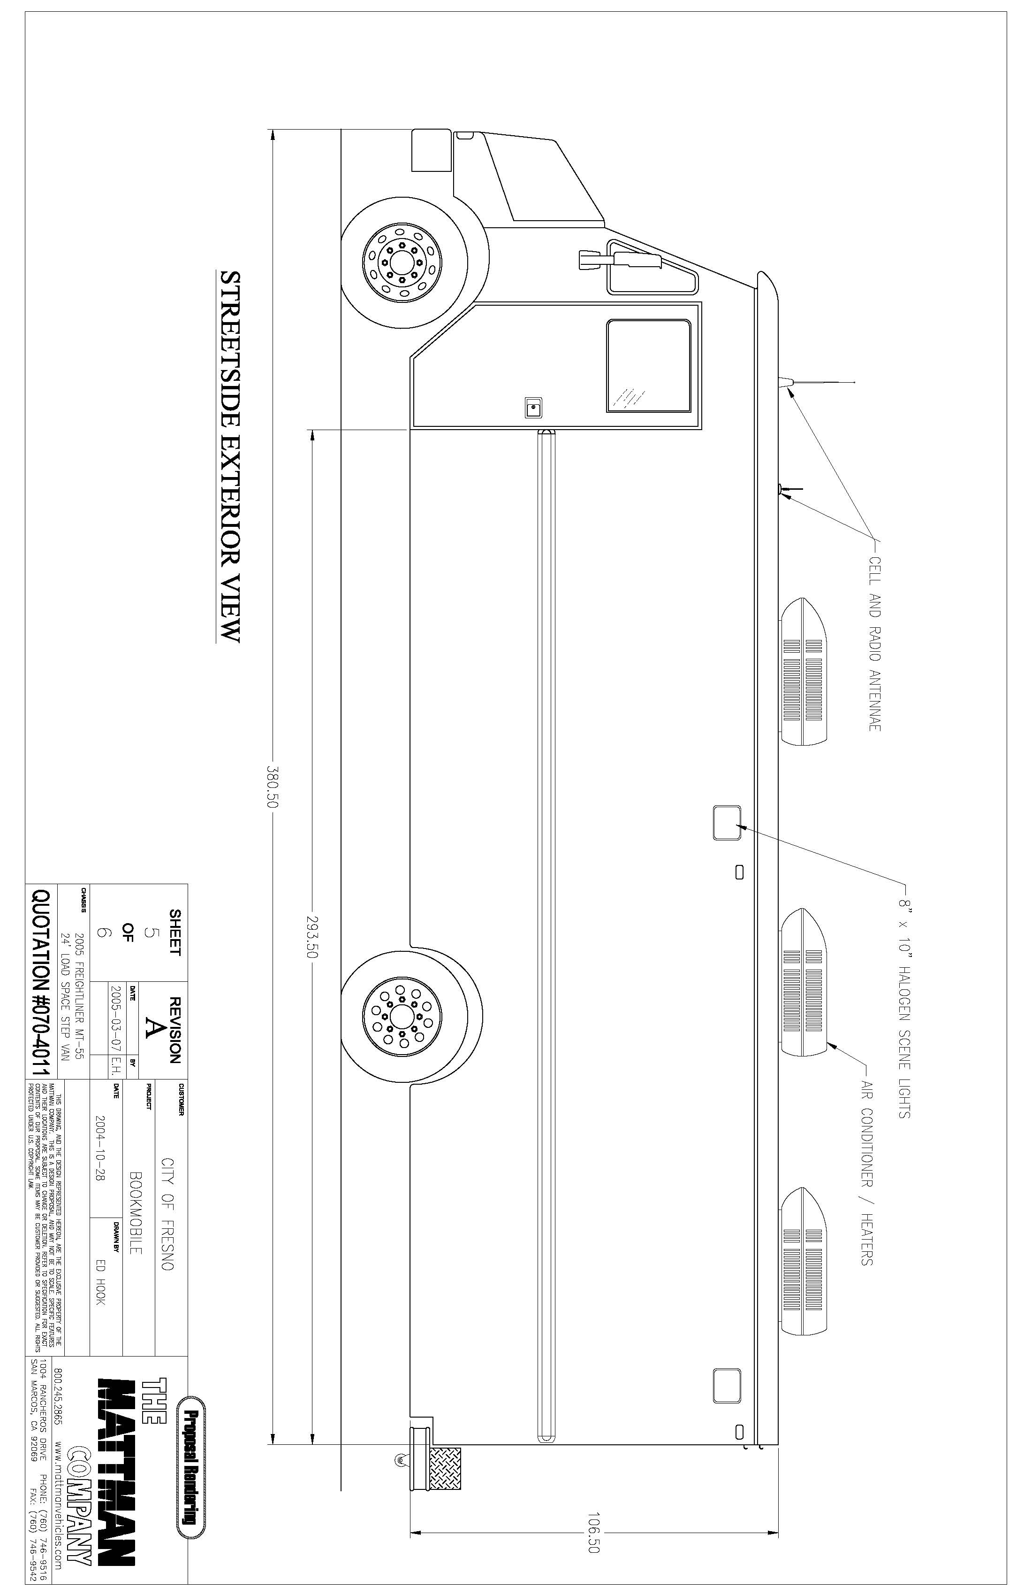
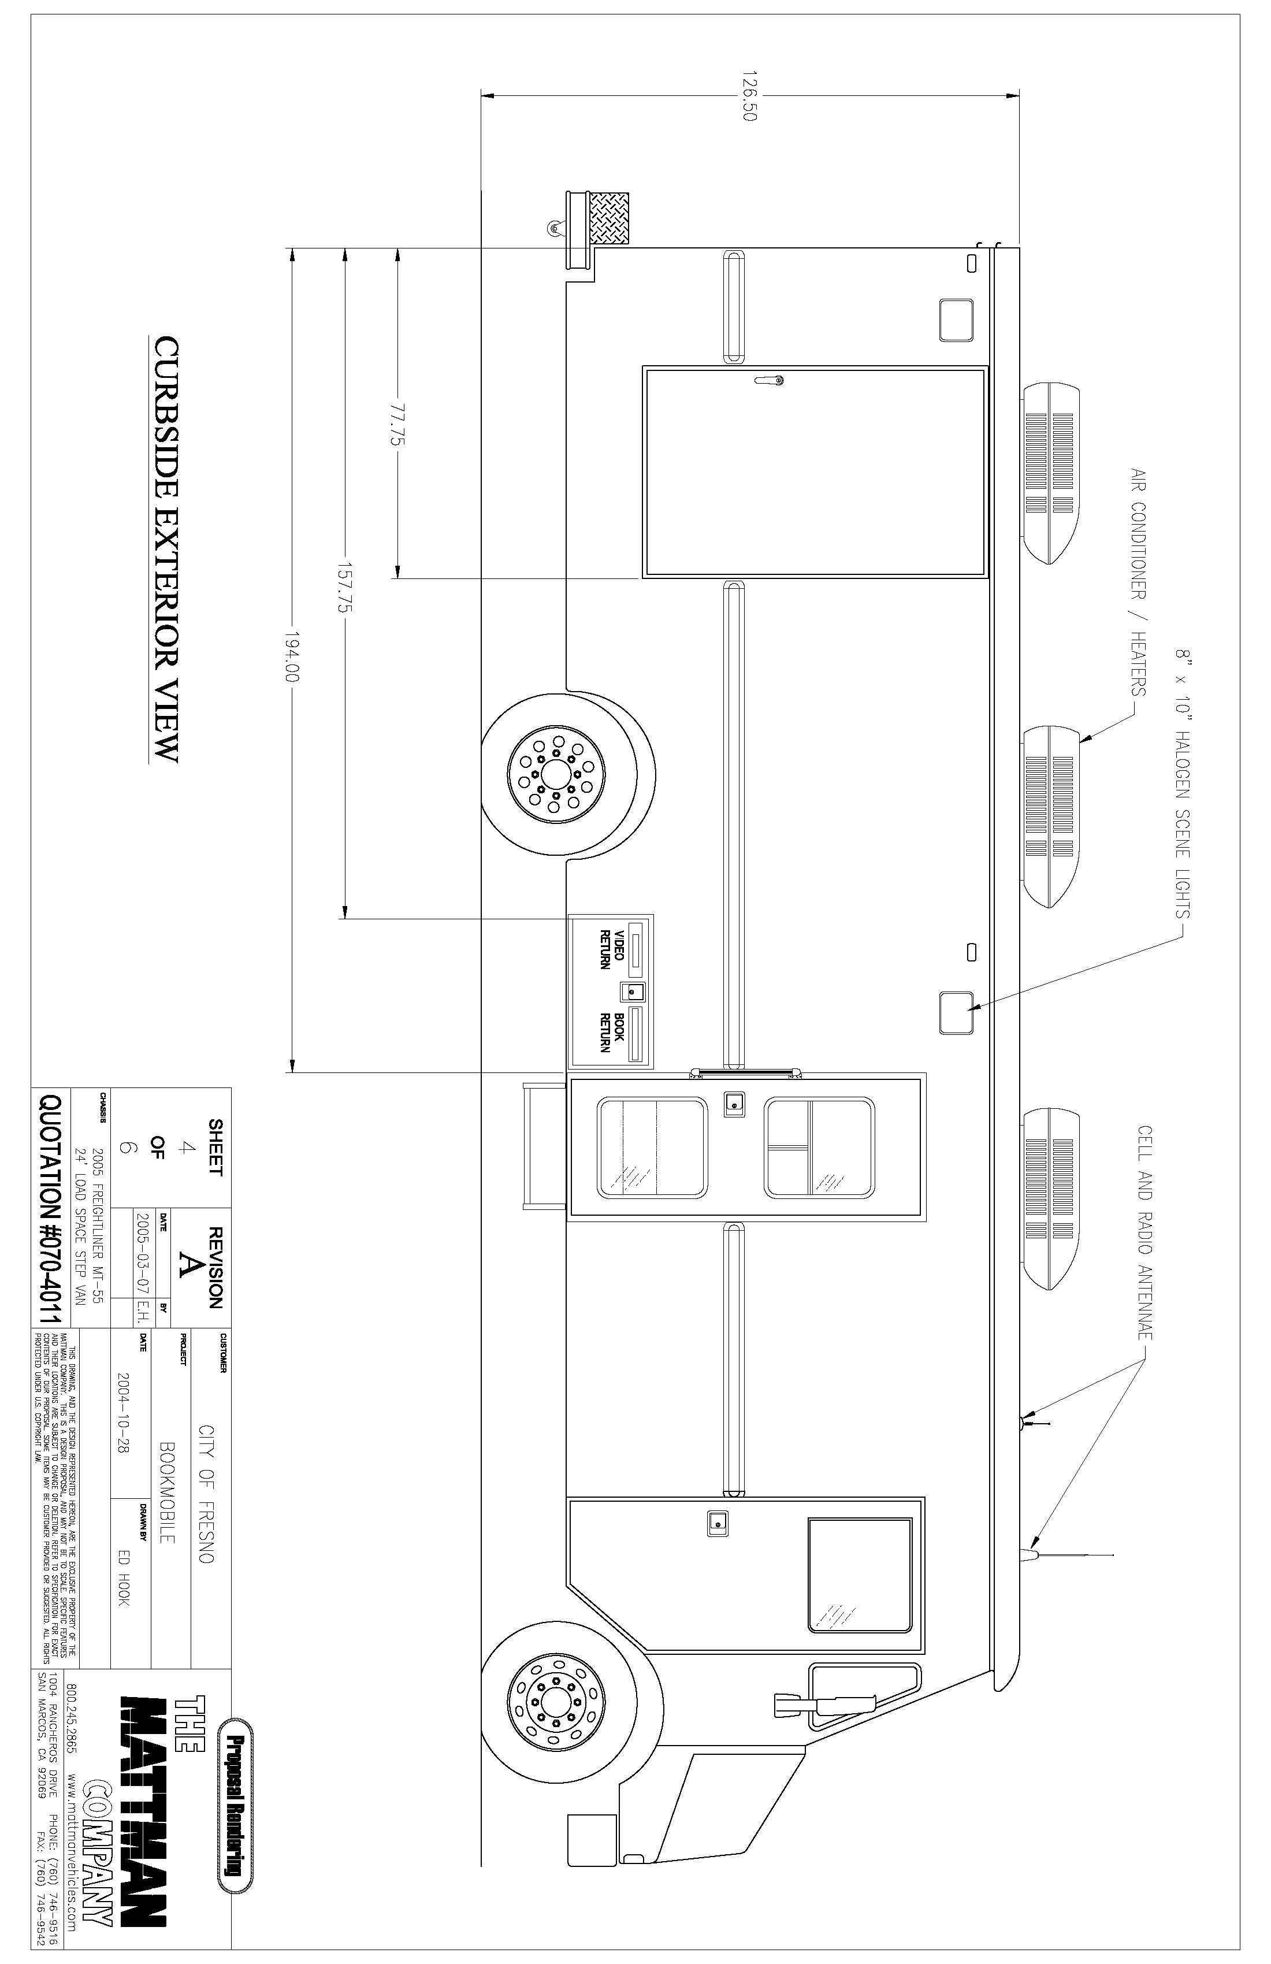
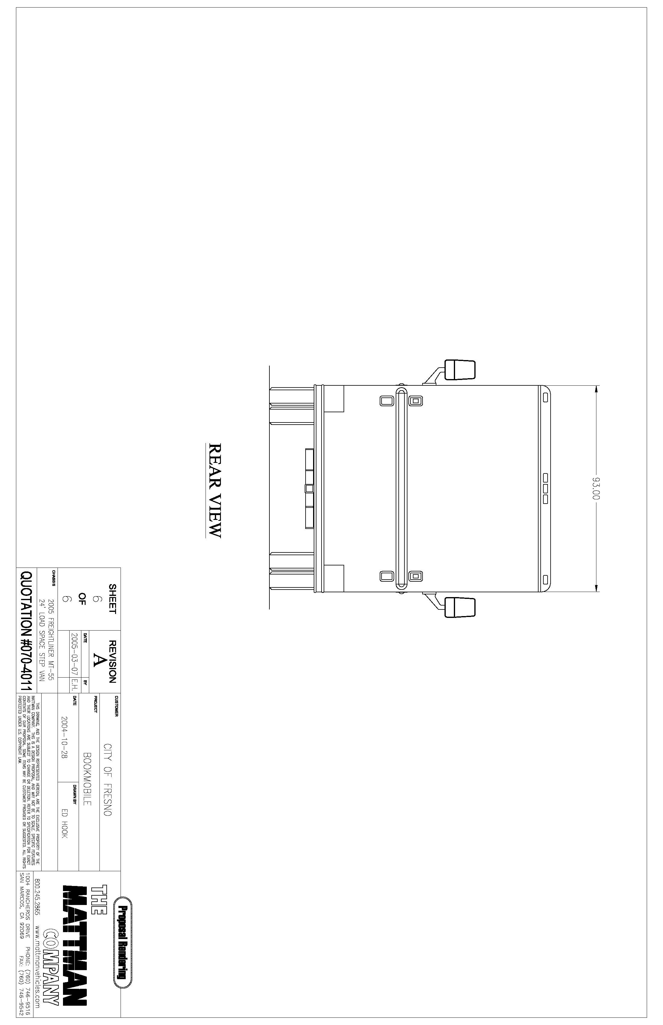
There will be a window (42”x 26 11/16”) that is 52 3/16” up from the top of the bumper and 17 ¾” down from the top, in the rear of the vehicle.
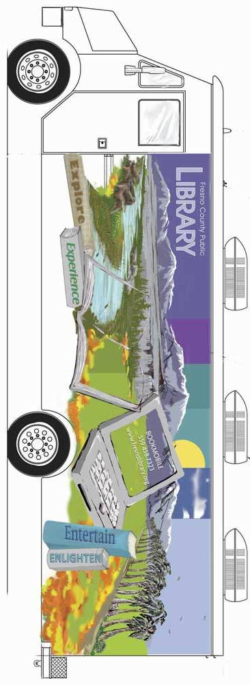
This Graphic will appear on the left and right sides of the vehicle.
There will be a window (42”x 26 11/16”) that is 52 3/16” up from the top of the bumper and 17 ¾” down from the top, in the rear of the vehicle.


Company Name
COST PROPOSAL
Quotations may be prepared in any manner to best demonstrate cost effectiveness. This includes future costs associated with circumstances requiring modifications to the exterior graphics. Elaborate on the cost per hour, per square foot, and/or impacts associated.
Exterior Graphics
Total amount for provision and application of exterior graphics (Vehicle Wrap) on Mobile Library unit as specified within this Request for Quotation.
$
Maintenance
$ | per hour to perform non-warranty service calls. Please provide an itemized description of all costs included in this rate.
$ | Bidders are to indicate price per square foot to provide and apply subsequent decal applications if applicable.
Samples
Vendors to include with their quote a minimum of four (4), at least size 3-1/2” x 5” photos, depicting four (4) different examples of their work similar to this quote.

Vendor must complete and return with Request for Quotation.
Firm:
REFERENCE LIST
The bidder shall submit a list of at least five (5) customer references. Such references shall be customers for whom the vendor has recently performed similar services.
Reference Name: |  |  | City:
Contact: |  |  | Phone No.:
Date and Service Provided:
Reference Name: |  |  | City:
Contact: |  |  | Phone No.:
Date and Service Provided:
Reference Name: |  |  | City:
Contact: |  |  | Phone No.:
Date and Service Provided:
Reference Name: |  |  | City:
Contact: |  |  | Phone No.:
Date and Service Provided:
Reference Name: |  |  | City:
Contact: |  |  | Phone No.:
Date and Service Provided:
FAILURE TO PROVIDE A LIST OF AT LEAST THREE (3) CUSTOMERS MAY BE CAUSE FOR REJECTION OF THIS RFQ.

