COUNTY OF FRESNO
Request for proposal
 |  |  | NUMBER: 926-4223
February 3, 2006
ORG/Requisition: 43600400/ 4366004032 |  |  |  |  |  |  |  | PURCHASING USE |  |  |  | /tmp/in/input.doc
 |  |  |  |  |  |  |  | jlg
IMPORTANT: SUBMIT PROPOSAL IN SEALED PACKAGE WITH PROPOSAL NUMBER, CLOSING DATE AND BUYER’S NAME MARKED CLEARLY ON THE OUTSIDE TO:
COUNTY OF FRESNO, Purchasing
4525 EAST HAMILTON AVENUE
FRESNO, CA 93702-4599
Closing date of bid will be at 2:00 p.m., on March 13, 2006.
PROPOSALS WILL BE CONSIDERED LATE WHEN THE OFFICIAL PURCHASING TIME CLOCK READS 2:00 P.M.
Proposals will be opened and publicly read at that time. All proposal information will be available for review after contract award.
Clarification of specifications are to be directed to: Cathi J. Peters, phone (559) 456-7110, FAX (559) 456-7831.
GENERAL CONDITIONS: See “County Of Fresno Purchasing Standard Instructions And Conditions For Request For Proposals (RFP’S) and Requests for Quotations (RFQ’S)” attached.
BIDDER TO COMPLETE
UNDERSIGNED AGREES TO FURNISH THE COMMODITY OR SERVICE STIPULATED IN THE ATTACHED PROPOSAL SCHEDULE AT THE PRICES AND TERMS STATED, SUBJECT TO THE “COUNTY OF FRESNO PURCHASING STANDARD INSTRUCTIONS AND CONDITIONS FOR REQUEST FOR PROPOSALS (RFP’S) AND REQUESTS FOR QUOTATIONS (RFQ’S)”ATTACHED.
Except as noted on individual items, the following will apply to all items in the Proposal Schedule.
- Complete delivery will be made within |  |  |  |  |  |  |  |  | calendar days after receipt of Order.
- A cash discount of |  |  |  |  |  | % |  |  |  |  | days will apply.
Company
Address
City |  |  |  |  |  |  |  |  |  |  |  |  |  | State |  | Zip Code
( ) |  |  |  |  | ( )
Telephone Number |  |  |  |  | Facsimile Number |  |  |  |  |  |  |  |  | E-mail Address
Taxpayer Federal I.D. No.:
Signed By
Print Name |  |  |  |  |  |  |  |  |  | Title

COUNTY OF FRESNO PURCHASING
STANDARD INSTRUCTIONS AND CONDITIONS FOR
REQUESTS FOR PROPOSALS (RFP'S) AND REQUESTS FOR QUOTATIONS (RFQ'S)
Note: the reference to “bids” in the following paragraphs applies to RFP's and RFQ's
GENERAL CONDITIONS
By submitting a bid the bidder agrees to the following conditions. These conditions will apply to all subsequent purchases based on this bid.

- BID PREPARATION:
  - All prices and notations must be typed or written in ink. No erasures permitted. Errors may be crossed out, initialed and corrections printed in ink by person signing bid.
  - Brand Names: Brand names and numbers when given are for reference. Equal items will be considered, provided the offer clearly describes the article and how it differs from that specified. In the absence of such information it shall be understood the offering is exactly as specified.
  - State brand or make of each item. If bidding on other than specified, state make, model and brand being bid and attach supporting literature/specifications to the bid.
  - Bid on each item separately. Prices should be stated in units specified herein. All applicable charges must be quoted; charges on invoice not quoted herein will be disallowed.
  - Time of delivery is a part of the consideration and must be stated in definite terms and must be adhered to. F.O.B. Point shall be destination or freight charges must be stated.
  - All bids must be dated and signed with the firm’s name and by an authorized officer or employee.
  - Unless otherwise noted, prices shall be firm for 120 days after closing date of bid.
- SUBMITTING BIDS:
  - Each bid must be submitted on forms provided in a sealed envelope with bid number and closing date and time on the outside of the envelope/package.
  - Interpretation: Should any discrepancies or omissions be found in the bid specifications or doubt as to their meaning, the bidder shall notify the Buyer in writing at once. The County shall not be held responsible for verbal interpretations. Questions regarding the bid must be received by Purchasing at least 5 working days before bid opening. All addenda issued shall be in writing, duly issued by Purchasing and incorporated into the contract.
  - ISSUING AGENT/AUTHORIZED CONTACT: This RFQ has been issued by County of Fresno Purchasing. Purchasing shall be the vendor’s sole point of contact with regard to the RFQ, its content, and all issues concerning it.
All communication regarding this RFQ shall be directed to an authorized representative of County Purchasing. The specific buyer managing this RFQ is identified on the cover page, along with his or her telephone number, and he or she should be the primary point of contact for discussions or information pertaining to the RFQ. Contact with any other County representative, including elected officials, for the purpose of discussing this RFQ, its content, or any other issue concerning it, is prohibited unless authorized by Purchasing. Violation of this clause, by the vendor having unauthorized contact (verbally or in writing) with such other County representatives, may constitute grounds for rejection by Purchasing of the vendor’s quotation.
The above stated restriction on vendor contact with County representatives shall apply until the County has awarded a purchase order or contract to a vendor or vendors, except as follows. First, in the event that a vendor initiates a formal protest against the RFQ, such vendor may contact the appropriate individual, or individuals who are managing that protest as outlined in the County’s established protest procedures. All such contact must be in accordance with the sequence set forth under the protest procedures. Second, in the event a public hearing is scheduled before the Board of Supervisors to hear testimony prior to its approval of a purchase order or contract, any vendor may address the Board.
  - Bids received after the closing time will NOT be considered.
  - Bidders are to bid what is specified or requested first. If unable to or willing to, bidder may bid alternative or option, indicating all advantages, disadvantages and their associated cost.
- FAILURE TO BID:
  - If not bidding, return bid sheet and state reason for no bid or your name may be removed from mailing list.
- TAXES, CHARGES AND EXTRAS:
  - County of Fresno is subject to California sales and/or use tax (7.975%). Please indicate as a separate line item if applicable.
  - DO NOT include Federal Excise Tax. County is exempt under Registration No. 94-73-03401-K.
  - County is exempt from Federal Transportation Tax. Exemption certificate is not required where shipping papers show consignee as County of Fresno.
  - Charges for transportation, containers, packing, etc. will not be paid unless specified in bid.
- W-9 – REQUEST FOR TAXPAYER IDENTIFICATION NUMBER AND CERTIFICATION:
Upon award of bid, the vendor shall submit to County Purchasing, a completed W-9 - Request for Taxpayer Identification Number and Certification if not already a current vendor with The County of Fresno. This form is available from the IRS to complete on line at http://www.irs.gov/pub/irs-pdf/fw9.pdf.
- AWARDS:
  - Subject to the local preference provisions referenced in Paragraph 6 below and more thoroughly set forth in the General Requirements section of this RFQ, award(s) will be made to the most responsive responsible bidder. The evaluation will include such things as life-cycle cost, availability, delivery costs and whose product and/or service is deemed to be in the best interest of the County. The County shall be the sole judge in making such determination.
  - Unless bidder gives notice of all-or-none award in bid, County may accept any item, group of items or on the basis of total bid.
  - The County reserves the right to reject any and all bids and to waive informalities or irregularities in bids.
  - After award, all bids shall be open to public inspection. The County assumes no responsibility for the confidentiality of information offered in a bid.
- LOCAL VENDORS
  - Local Vendor Preference (applicable to RFQ Process only)
The following provisions are applicable only to the County’s acquisition of materials, equipment or supplies through the RFQ process when the funding source does not require an exemption to the Local Vendor Preference.
THE PROVISIONS OF THIS PARAGRAPH ARE APPLICABLE, NOTWITHSTANDING ANY OTHER PROVISIONS OF THIS RFQ TO THE CONTRARY
If the apparent low bidder is not a local vendor, any local vendor who submitted a bid which was within five percent (5%) of the lowest responsive bid as determined by the purchasing agent shall have the option of submitting a new bid within forty-eight hours (not including weekends and holidays) of County’s delivery of notification. Such new bids must be in an amount less than or equal to the lowest responsive bid as determined by the purchasing agent. If the purchasing agent receives any new bids from local vendors who have the option of submitting new bids within said forty-eight hour period, it shall award the contract to the local vendor submitting the lowest responsible bid. If no new bids are received, the contract shall be awarded to the original low bidder as announced by the purchasing agent.
  - Local Vendor Defined
“Local Vendor” shall mean any business which:
- Has its headquarters, distribution point or locally-owned franchise located in or having a street address within the County for at least six (6) months immediately prior to the issuance of the request for competitive bids by the purchasing agent; and
- Holds any required business license by a jurisdiction located in Fresno County; and
- Employs at least one (1) full-time or two (2) part-time employees whose primary residence is located within Fresno County, or if the business has no employees, shall be at least fifty percent (50%) owned by one or more persons whose primary residence(s) is located within Fresno County.
- TIE BIDS:
All other factors being equal, the contract shall be awarded to the Fresno County vendor or, if neither or both are Fresno County vendors, it may be awarded by the flip of a coin in the presence of witnesses or the entire bid may be rejected and re-bid. If the General Requirements of this RFQ state that they are applicable, the provisions of the Fresno County Local Vendor Preference shall take priority over this paragraph.
- PATENT INDEMNITY:
The vendor shall hold the County, its officers, agents and employees, harmless from liability of any nature or kind, including costs and expenses, for infringement or use of any copyrighted or uncopyrighted composition, secret process, patented or unpatented invention, article or appliance furnished or used in connection with this bid.
- SAMPLES:
Samples, when required, must be furnished and delivered free and, if not destroyed by tests, will upon written request (within 30 days of bid closing date) be returned at the bidder's expense. In the absence of such notification, County shall have the right to dispose of the samples in whatever manner it deems appropriate.
- RIGHTS AND REMEDIES OF COUNTY FOR DEFAULT:
  - In case of default by vendor, the County may procure the articles or service from another source and may recover the cost difference and related expenses occasioned thereby from any unpaid balance due the vendor or by proceeding against performance bond of the vendor, if any, or by suit against the vendor. The prices paid by the County shall be considered the prevailing market price at the time such purchase is made.
  - Articles or services, which upon delivery inspection do not meet specifications, will be rejected and the vendor will be considered in default. Vendor shall reimburse County for expenses related to delivery of non-specified goods or services.
  - Regardless of F.O.B. point, vendor agrees to bear all risks of loss, injury or destruction to goods and materials ordered herein which occur prior to delivery and such loss, injury or destruction shall not release vendor from any obligation hereunder.
- DISCOUNTS:
Terms of less than 15 days for cash payment will be considered as net in evaluating this bid. A discount for payment within fifteen (15) days or more will be considered in determining the award of bid. Discount period will commence either the later of delivery or receipt of invoice by the County. Standard terms are Net Forty-five (45) days.
- SPECIAL CONDITIONS IN BID SCHEDULE SUPERSEDE GENERAL CONDITIONS.
The “General Conditions” provisions of this RFP/RFQ shall be superseded if in conflict with any other section of this bid, to the extent of any such conflict.
- SPECIAL REQUIREMENT:
With the invoice or within twenty-five (25) days of delivery, the seller must provide to the County a Material Safety Data Sheet for each product, which contains any substance on “The List of 800 Hazardous Substances”, published by the State Director of Industrial Relations. (See Hazardous Substances Information and Training Act. California State Labor Code Sections 6360 through 6399.7.)
- RECYCLED PRODUCTS/MATERIALS:
Vendors are encouraged to provide and quote (with documentation) recycled or recyclable products/materials which meet stated specifications.
- YEAR COMPLIANCE WARRANTY
Vendor warrants that any product furnished pursuant to this Agreement/order shall support a four-digit year format and be able to accurately process date and time data from, into and between the twentieth and twenty-first centuries, as well as leap year calculations. "Product" shall include, without limitation, any piece or component of equipment, hardware, firmware, middleware, custom or commercial software, or internal components or subroutines therein. This warranty shall survive termination or expiration of this Agreement.
In the event of any decrease in product functionality or accuracy related to time and/or date data related codes and/or internal subroutines that impede the product from operating correctly using dates beyond December 31, 1999, vendor shall restore or repair the product to the same level of functionality as warranted herein, so as to minimize interruption to County's ongoing business process, time being of the essence. In the event that such warranty compliance requires the acquisition of additional programs, the expense for any such associated or additional acquisitions, which may be required, including, without limitation, data conversion tools, shall be borne exclusively by vendor. Nothing in this warranty shall be construed to limit any rights or remedies the County may otherwise have under this Agreement with respect to defects other than year performance.
- PARTICIPATION:
Bidder may agree to extend the terms of the resulting contract to other political subdivision, municipalities and tax-supported agencies.
Such participating Governmental bodies shall make purchases in their own name, make payment directly to bidder, and be liable directly to the bidder, holding the County of Fresno harmless.
- CONFIDENTIALITY:
All services performed by vendor shall be in strict conformance with all applicable Federal, State of California and/or local laws and regulations relating to confidentiality, including but not limited to, California Civil Code, California Welfare and Institutions Code, Health and Safety Code, California Code of Regulations, Code of Federal Regulations.
Vendor shall submit to County’s monitoring of said compliance.
Vendor may be a business associate of County, as that term is defined in the “Privacy Rule” enacted by the Health Insurance Portability and Accountability Act of 1996 (HIPAA). As a HIPAA Business Associate, vendor may use or disclose protected health information (“PHI”) to perform functions, activities or services for or on behalf of County as specified by the County, provided that such use or disclosure shall not violate HIPAA and its implementing regulations. The uses and disclosures if PHI may not be more expansive than those applicable to County, as the “Covered Entity” under HIPAA’S Privacy Rule, except as authorized for management, administrative or legal responsibilities of the Business Associate.
Vendor shall not use or further disclose PHI other than as permitted or required by the County, or as required by law without written notice to the County.
Vendor shall ensure that any agent, including any subcontractor, to which vendor provides PHI received from, or created or received by the vendor on behalf of County, shall comply with the same restrictions and conditions with respect to such information.
- APPEALS
Appeals must be submitted in writing within five (5) working days after the review committee notification of proposed recommendations. Appeals should be submitted to County of Fresno Purchasing, 4525 E. Hamilton Avenue, Fresno, California 93702-4599. Appeals should address only areas regarding RFP contradictions, procurement errors, quotation rating discrepancies, legality of procurement context, conflict of interest in rating process, and inappropriate or unfair competitive procurement grievance regarding the RFP process.
The Purchasing Manager will provide a written response to the complaint within five (5) working days unless the complainant is notified more time is required.
If the protesting bidder is not satisfied with the decision of the Purchasing Manager, he/she shall have the right to appeal to the Purchasing Agent within five (5) business days after notification of the Purchasing Manager’s decision.
If the protesting bidder is not satisfied with Purchasing Agent decision, the final appeal is with the Board of Supervisors.
- OBLIGATIONS OF CONTRACTOR:
  - CONTRACTOR shall perform as required by the ensuing contract. CONTRACTOR also warrants on behalf of itself and all subcontractors engaged for the performance of the ensuing contract that only persons authorized to work in the United States pursuant to the Immigration Reform and Control Act of 1986 and other applicable laws shall be employed in the performance of the work hereunder.
  - CONTRACTOR shall obey all Federal, State, local and special district laws, ordinances and regulations.

TABLE OF CONTENTS

PAGE
KEY DATES 3
PROPOSAL IDENTIFICATION SHEET 4
TRADE SECRET ACKNOWLEDGEMENT 5
REFERENCE LIST 7
GENERAL REQUIREMENTS 8
PARTICIPATION 16
SPECIFIC TERMS AND CONDITIONS 17
SCOPE OF WORK 19
COST PROPOSAL 29
PROPOSAL CONTENT REQUIREMENTS 32
EVALUATION CRITERIA 37
AWARD CRITERIA 39
EXHIBITS 40

OVERVIEW
Fresno County (County), in conjunction with the 15 incorporated cities in the County, seeks to hire a qualified Contractor to conduct a countywide residential program for the collection and disposal of household hazardous waste (HHW), including Conditionally Exempt Small Quantity Generator (CESQG) Waste and specified Universal Waste (UW), including but not limited to, Cathode Ray Tubes (CRTs) and Universal Waste Electronic Devices (UWEDs). The HHW Collection Program (Program) described in the Request for Proposal (RFP) reflects the joint efforts of the above agencies to comply with the mandates of the Integrated Waste Management Act of 1989 (AB 939).
An AB 939 Oversight Committee, comprised of representatives from the County and the 15 incorporated cities, has been formed to enable all jurisdictions to participate in the development and implementation of the Program. The Fresno County Department of Public Works and Planning, Resources Division, will administer the Events.

KEY DATES
RFP Issue Date: | February 1, 2006
Vendor Conference: | February 16, 2006 10:00 A.M.
 | Fresno County Purchasing
 | 4525 E Hamilton
 | Fresno, CA 93702
Deadline for Written or Fax Requests for Interpretations or Corrections of RFP: | February 28, 2006 8:00 A.M.
Fresno County Purchasing
4525 E Hamilton
Fresno, CA 93702
Fax (559) 456-7831
RFP Closing Date: | March 13, 2006 at 2:00 P.M.
 | County of Fresno Purchasing
 | 4525 E. Hamilton Avenue
 | Fresno, CA 93702
Anticipated Date Of New Contract | July 1, 2006
→ Vendors are requested to contact Cathi J. Peters at (559) 456-7110 if they plan on attending the Vendor Conference.

PROPOSAL IDENTIFICATION SHEET

RESPONDENT TO COMPLETE AND RETURN WITH PROPOSAL
Our proposal is attached and identified as:
The undersigned agrees to furnish the service stipulated at the prices and terms stated in the cost proposal.
Work services will commence within  contract. |  |  |  |  | calendar days after signing of the final
Company:
Address:
 |  |  |  |  |  |  | Zip:
Signed by:
Print Name
Print Title
( ) |  |  | ( )
Telephone |  |  | Fax Number |  |  | E-mail Address
Date:
Taxpayer Identification No.:

TRADE SECRET ACKNOWLEDGEMENT
All proposals received by the County shall be considered "Public Record" as defined by Section 6252 of the California Government Code. This definition reads as follows:
"...Public records" includes any writing containing information relating to the conduct of the public's business prepared, owned, used or retained by any state or local agency regardless of physical form or characteristics "Public records" in the custody of, or maintained by, the Governor's office means any writing prepared on or after January 6, 1975."
Each proposal submitted is Public record and is therefore subject to inspection by the public per Section 6253 of the California Government Code. This section states that "every citizen has a right to inspect any public record".
The County will not exclude any proposal or portion of a proposal from treatment as a public record except in the instance that it is submitted as a trade secret as defined by the California Government Code. Information submitted as proprietary, confidential or under any other such terms that might suggest restricted public access will not be excluded from treatment as public record.
"Trade secrets" as defined by Section 6254.7 of the California Government Code are deemed not to be public record. This section defines trade secrets as:
"...Trade secrets," as used in this section, may include, but are not limited to, any formula, plan, pattern, process, tool, mechanism, compound, procedure, production data or compilation of information that is not patented, which is known only to certain individuals within a commercial concern who are using it to fabricate, produce, or compound an article of trade or a service having commercial value and which gives its user an opportunity to obtain a business advantage over competitors who do not know or use it."
Information identified by bidder as "trade secret" will be reviewed by County of Fresno's legal counsel to determine conformance or non-conformance to this definition. Examples of material not considered to be trade secrets are pricing, cover letter, promotional materials, etc. Such material should be submitted in a separate binder not marked "Trade Secret".
INFORMATION THAT IS PROPERLY IDENTIFIED AS TRADE SECRET AND CONFORMS TO THE ABOVE DEFINITION WILL NOT BECOME PUBLIC RECORD. COUNTY WILL SAFEGUARD THIS INFORMATION IN AN APPROPRIATE MANNER.
Information identified by bidder as trade secret and determined not to be in conformance with the California Government Code definition shall be excluded from the proposal. Such information will be returned to the bidder at bidder's expense upon written request.
Trade secrets must be submitted in a separate binder that is plainly marked "Trade Secrets."
The County shall not in any way be liable or responsible for the disclosure of any proposals or portions thereof, if they are not (1) submitted in a separate binder that is plainly marked "Trade Secret" on the outside; and (2) if disclosure is required under the provision of law or by order of Court.
Vendors are advised that the County does not wish to receive trade secrets and that vendors are not to supply trade secrets unless they are absolutely necessary.

TRADE SECRET ACKNOWLEDGEMENT
I have read and understand the above "Trade Secret Acknowledgement."
I understand that the County of Fresno has no responsibility for protecting information submitted as a trade secret if it is not delivered in a separate binder plainly marked "Trade Secret."
Enter company name on appropriate line:
 | has submitted information identified as Trade Secrets
(Company Name) | has submitted information identified as Trade Secrets
 | has not submitted information identified as Trade Secrets
(Company Name) | has not submitted information identified as Trade Secrets
ACKNOWLEDGED BY:
 | ( )
Signature | Telephone
Print Name and Title |  | Date
Address
City | State | Zip

Firm:
REFERENCE LIST
Provide a list of at least five (5) customers for whom you have provided similar services, in the last three (3) years (preferably California State or local government agencies). Be sure to include addresses (location) and phone numbers, project name and name of Agency and/or municipality. Please list if you were Contractor or Subcontractor.
Reference Name: |  | City:
Contact Name |  | Phone No.: | ( )
Date:
Service Provided:
Reference Name: |  | City:
Contact Name |  | Phone No.: | ( )
Date:
Service Provided:
Reference Name: |  | City:
Contact Name |  | Phone No.: | ( )
Date:
Service Provided:
Reference Name: |  | City:
Contact Name |  | Phone No.: | ( )
Date:
Service Provided:
Reference Name: |  | City:
Contact Name |  | Phone No.: | ( )
Date:
Service Provided:
Failure to provide a list of at least five (5) customers may be cause for rejection of this RFP.

GENERAL REQUIREMENTS
DEFINITIONS: The terms Bidder, Proposer, Contractor and Vendor are all used interchangeably and refer to that person, partnership, corporation, organization, agency, etc. which is offering the proposal and is identified on the "Provider" line of the Proposal Identification Sheet.
LOCAL VENDOR PREFERENCE: The Local Vendor Preference does not apply to this Request for Proposal.
RFP CLARIFICATION AND REVISIONS: Any revisions to the RFP will be issued and distributed as written addenda. The County may request clarification or additional information from Proposers at any point prior to the award of contract. The County reserves the right to negotiate the actual Agreement details after the Contractor has been selected.
All proposals submitted in response to this request shall be deemed public record. If a Contractor desires to claim portions of its proposal exempt from disclosure, the Contractor shall clearly identify those portions with the word “Confidential” printed on the lower right-hand corner of the page. The County will consider a Contractor’s request for exemption from disclosure; however, the County will make a decision based upon applicable laws. An assertion by a Contractor that the entire proposal, or a large portion of such, is exempt from disclosure will not be honored.
FIRM PROPOSAL: for purpose of award all proposals shall remain firm for at least one hundred eighty (180) days.
PROPOSAL PREPARATION: Proposals should be submitted in the formats shown under "PROPOSAL CONTENT REQUIREMENTS" section of this RFP.
SUPPORTIVE MATERIAL: Additional material may be submitted with the proposal as appendices. Any additional descriptive material that is used in support of any information in your proposal must be referenced by the appropriate paragraph(s) and page number(s).
Bidders are asked to submit their proposals in a binder (one that allows for easy removal of pages) with index tabs separating the sections identified in the Table of Contents. Pages must be numbered on the bottom of each page.
Any proposal attachments, documents, letters and materials submitted by the vendor shall be binding and included as a part of the final contract should your bid be selected.
TAXES: The quoted amount must include all applicable taxes. If taxes are not specifically identified in the proposal it will be assumed that they are included in the total quoted.
SALES TAX: Fresno County pays California State Sales Tax in the amount of 7.975% regardless of vendor's place of doing business.
INTERPRETATION OF RFP: Vendors must make careful examination of the requirements, specifications and conditions expressed in the RFP and fully inform themselves as to the quality and character of services required. If any person planning to submit a proposal finds discrepancies in or omissions from the RFP or has any doubt as to the true meaning or interpretation, correction thereof may be requested in writing or FAX (Fax No. (559) 456-7831) from Purchasing. The deadline for submitting Requests for Clarification is February 28, 2006 8:00 A.M. Any change in the RFP will be made only by written addendum, duly issued by the County. The County will not be responsible for any other explanations or interpretations.
RETENTION: County of Fresno reserves the right to retain all proposals, excluding proprietary documentation submitted per the instructions of this RFP. The County reserves the right to use any or all of the ideas presented in any proposal submitted in response to an RFP without charge or limitation. The selection or rejection of a proposal does not affect these rights.
ORAL PRESENTATIONS: Each finalist may be required to make an oral presentation in Fresno County and answer questions from County personnel.
AWARD/REJECTION: The award will be made to the vendor offering the overall proposal deemed to be to the best advantage of the County. The County shall be the sole judge in making such determination. The County reserves the right to reject any and all proposals. The lowest bidders are not arbitrarily the vendors whose proposals will be selected.
County Purchasing will chair or co-chair all award, evaluation and contract negotiation committees.
Award may require approval by the County of Fresno Board of Supervisors.
NEGOTIATION: The County will prepare and negotiate its own contract with the selected vendor, giving due consideration to the stipulation of the vendor's standard contracts and associated legal documents.
WAIVERS: The County reserves the right to waive any informality or irregularities and any technical or clerical errors in any quote as the interest of the County may require.
TERMINATION: The County reserves the right to terminate any resulting contract upon written notice.
MINOR DEVIATIONS: The County reserves the right to negotiate minor deviations from the prescribed terms, conditions and requirements with the selected vendor.
PROPOSAL REJECTION: Failure to respond to all questions or not to supply the requested information could result in rejection of your proposal.
ASSIGNMENTS: The ensuing proposed contract will provide that the vendor may not assign any payment or portions of payments without prior written consent of the County of Fresno.
BIDDERS LIABILITIES: County of Fresno will not be held liable for any cost incurred by vendors in responding to the RFP.
CONFIDENTIALITY: Bidders shall not disclose information about the County's business or business practices and safeguard confidential data which vendor staff may have access to in the course of system implementation.
DISPUTE RESOLUTION: The ensuing contract shall be governed by the laws of the State of California.
Any claim which cannot be amicably settled without court action will be litigated in the U. S. District Court for the Eastern District of California in Fresno, CA or in a state court for Fresno County.
NEWS RELEASE: Vendors shall not issue any news releases or otherwise release information to any third party about this RFP or the vendor's quotation without prior written approval from the County of Fresno.
BACKGROUND REVIEW: The County reserves the right to conduct a background inquiry of each Proposer/bidder which may include collection of appropriate criminal history information, contractual and business associations and practices, employment histories and reputation in the business community. By submitting a proposal/bid to the County, the vendor consents to such an inquiry and agrees to make available to the County such books and records the County deems necessary to conduct the inquiry.
PERFORMANCE BOND: The successful bidders may be required to furnish a fifty percent (50%) faithful performance bond to ensure completion of the HHW Collection Program.
ACQUISITIONS: The County reserves the right to obtain the whole system as proposed or only a portion of the system, or to make no acquisition at all.
OWNERSHIP: The successful vendor will be required to provide to the County of Fresno documented proof of ownership by the vendor, or its designated subcontractor, of the proposed programs.
EXCEPTIONS: Identify with explanation, any terms, conditions, or stipulations of the RFP with which you CAN NOT or WILL NOT comply with by proposal group.
ADDENDUM: In the event that it becomes necessary to revise any part of this RFP, an addendum will be provided to all agencies and organizations that receive the basic RFP.
SUBCONTRACTORS: If a subcontractor is proposed, complete identification of the subcontractor and his tasks should be provided. The primary contractor is not relieved of any responsibility by virtue of using a subcontractor.
CONFLICT OF INTEREST: The County shall not contract with, and shall reject any bid or proposal submitted by the persons or entities specified below, unless the Board of Supervisors finds that special circumstances exist which justify the approval of such contract:
- Employees of the County or public agencies for which the Board of Supervisors is the governing body.
- Profit-making firms or businesses in which employees described in Subsection (1) serve as officers, principals, partners or major shareholders.
- Persons who, within the immediately preceding twelve (12) months, came within the provisions of Subsection (1), and who were employees in positions of substantial responsibility in the area of service to be performed by the contract, or participated in any way in developing the contract or its service specifications.
- Profit-making firms or businesses in which the former employees described in Subsection (3) serve as officers, principals, partners or major shareholders.
- No County employee, whose position in the County enables him to influence the selection of a contractor for this RFP, or any competing RFP, and no spouse or economic dependent of such employee, shall be employees in any capacity by a bidder, or have any other direct or indirect financial interest in the selection of a contractor.
- In addition, no County employee will be employed by the selected vendor to fulfill the vendor’s contractual obligations to the County.
ORDINANCE 3.08.130 – POST-SEPARATION EMPLOYMENT PROHIBITED
No officer or employee of the County who separates from County service shall for a period of one year after separation enter into any employment, contract, or other compensation arrangement with any County consultant, vendor, or other County provider of goods, materials, or services, where the officer or employee participated in any part of the decision making process that led to the County relationship with the consultant, vendor or other County provider of goods, materials or services.
Pursuant to Government Code section 25132(a), a violation of the ordinance may be enjoined by an injunction in a civil lawsuit, or prosecuted as a criminal misdemeanor.
EVALUATION CRITERIA: Respondents will be evaluated on the basis of their responses to all questions and requirements in this RFP and product cost. The County shall be the sole judge in the ranking process and reserves the right to reject any or all bids. False, incomplete or unresponsive statements in connection with this proposal may be sufficient cause for its rejection.
SELECTION PROCESS: All proposals will be evaluated by a team consisting of representatives from appropriate County Department(s), and Purchasing. It will be their responsibility to make the final recommendations. Purchasing will chair or co-chair the evaluation or evaluation process.
Organizations that submit a proposal may be required to make an oral presentation to the Selection Committee. These presentations provide an opportunity for the individual, agency, or organization to clarify its proposal to ensure thorough, mutual understanding.
INDEPENDENT CONTRACTOR: In performance of the work, duties, and obligations assumed by Contractor under any ensuing Agreement, it is mutually understood and agreed that Contractor, including any and all of Contractor's officers, agents, and employees will at all times be acting and performing as an independent contractor, and shall act in an independent capacity and not as an officer, agent, servant, employee, joint venturer, partner, or associate of the County. Furthermore, County shall have no right to control, supervise, or direct the manner or method by which Contractor shall perform its work and function. However, County shall retain the right to administer this Agreement so as to verify that Contractor is performing its obligations in accordance with the terms and conditions thereof. Contractor and County shall comply with all applicable provisions of law and the rules and regulations, if any, of governmental authorities having jurisdiction over matters the subject thereof.
Because of its status as an independent contractor, Contractor shall have absolutely no right to employment rights and benefits available to County employees. Contractor shall be solely liable and responsible for providing to, or on behalf of, its employees all legally required employee benefits. In addition, Contractor shall be solely responsible and save County harmless from all matters relating to payment of Contractor's employees, including compliance with Social Security, withholding, and all other regulations governing such matters. It is acknowledged that during the term of the Agreement, Contractor may be providing services to others unrelated to the COUNTY or to the Agreement.
HOLD HARMLESS CLAUSE: Contractor agrees to indemnify, save, hold harmless and at County's request, defend the County, its officers, agents and employees, from any and all costs and expenses, damages, liabilities, claims and losses occurring or resulting to County in connection with the performance, or failure to perform, by Contractor, its officers, agents or employees under this Agreement and from any and all costs and expenses, damages, liabilities, claims and losses occurring or resulting to any person, firm or corporation who may be injured or damaged by the performance, or failure to perform, of Contractor, its officers, agents or employees under this Agreement.
PRICE RESPONSIBILITY: The selected vendor will be required to assume full responsibility for all services and activities offered in the proposal, whether or not they are provided directly. Further, the County of Fresno will consider the selected vendor to be the sole point of contact with regard to contractual matters, including payment of any and all charges resulting from the contract. The contractor may not subcontract or transfer the contract, or any right or obligation arising out of the contract, without first having obtained the express written consent of the County.
ADDRESSES AND TELEPHONE NUMBERS: The vendor will provide the business address and mailing address, if different, as well as the telephone number of the individual signing the contract.
ASSURANCES: Any contract awarded under this RFP must be carried out in full compliance with The Civil Rights Act of 1964, The Americans With Disabilities Act of 1990, their subsequent amendments, and any and all other laws protecting the rights of individuals and agencies. The County of Fresno has a zero tolerance for discrimination, implied or expressed, and wants to ensure that policy continues under this RFP. The contractor must also guarantee that services, or workmanship, provided will be performed in compliance with all applicable local, state, or federal laws and regulations pertinent to the types of services, or project, of the nature required under this RFP. In addition, the contractor may be required to provide evidence substantiating that their employees have the necessary skills and training to perform the required services or work.

INSURANCE:
Without limiting the COUNTY's right to obtain indemnification from CONTRACTOR or any third parties, CONTRACTOR, at its sole expense, shall maintain in full force and effect the following insurance policies throughout the term of the Agreement:
- Commercial General Liability
Commercial General Liability Insurance with limits of not less than One Million Dollars ($1,000,000) per occurrence and an annual aggregate of Two Million Dollars ($2,000,000). This policy shall be issued on a per occurrence basis. COUNTY may require specific coverages including completed operations, products liability, contractual liability, Explosion-Collapse-Underground, fire legal liability or any other liability insurance deemed necessary because of the nature of this contract.
- Commercial Automobile Liability
Commercial General Liability insurance covering bodily injury and property damage, with limits of not less than One Million Dollars ($1,000,000) per occurrence. The Commercial Automobile Liability policy shall be endorsed to delete the Pollution and/or the Asbestos exclusion and add the Motor Carrier Act endorsement (MCS-90). TL 1005, TL 1007 and/or other endorsements required by federal or state authorities.
- Environmental Impairment Liability
Environmental Impairment Liability Insurance with limits of not less than One Million Dollars ($1,000,000) per occurrence and an annual aggregate of One Million Dollars ($1,000,000).
- Automobile Liability
Comprehensive Automobile Liability Insurance with limits for bodily injury of not less than Two Hundred Fifty Thousand Dollars ($250,000.00) per person, Five Hundred Thousand Dollars ($500,000.00) per accident and for property damages of not less than Fifty Thousand Dollars ($50,000.00), or such coverage with a combined single limit of Five Hundred Thousand Dollars ($500,000.00). Coverage should include owned and non-owned vehicles used in connection with this Agreement.
- Professional Liability
If CONTRACTOR employs licensed professional staff, (e.g., Ph.D., R.N., L.C.S.W., M.F.C.C.) in providing services, Professional Liability Insurance with limits of not less than One Million Dollars ($1,000,000.00) per occurrence, Three Million Dollars ($3,000,000.00) annual aggregate.
This coverage shall be issued on a per claim basis. Contractor agrees that it shall maintain, at its sole expense, in full force and effect for a period of three (3) years following the termination of this Agreement, one or more policies of professional liability insurance with limits of coverage as specified herein.
- Worker's Compensation
A policy of Worker's Compensation insurance as may be required by the California Labor Code.
CONTRACTOR shall obtain endorsements to the Commercial General Liability insurance naming the County of Fresno, its officers, agents, and employees, individually and collectively, as additional insured, but only insofar as the operations under this Agreement are concerned. Such coverage for additional insured shall apply as primary insurance and any other insurance, or self-insurance, maintained by COUNTY, its officers, agents and employees shall be excess only and not contributing with insurance provided under CONTRACTOR's policies herein. This insurance shall not be cancelled or changed without a minimum of thirty (30) days advance written notice given to COUNTY.
Within Thirty (30) days from the date CONTRACTOR executes this Agreement, CONTRACTOR shall provide certificates of insurance and endorsement as stated above for all of the foregoing policies, as required herein, to the County of Fresno, attention: Leslie Kline, Recycling Coordinator, 2220 Tulare Street, 6th Floor, Fresno, California 93721, stating that such insurance coverage have been obtained and are in full force; that the County of Fresno, its officers, agents and employees will not be responsible for any premiums on the policies; that such Commercial General Liability insurance names the County of Fresno, its officers, agents and employees, individually and collectively, as additional insured, but only insofar as the operations under this Agreement are concerned; that such coverage for additional insured shall apply as primary insurance and any other insurance, or self-insurance, maintained by COUNTY, its officers, agents and employees, shall be excess only and not contributing with insurance provided under CONTRACTOR's policies herein; and that this insurance shall not be cancelled or changed without a minimum of thirty (30) days advance, written notice given to COUNTY.
In the event CONTRACTOR fails to keep in effect at all times insurance coverage as herein provided, the COUNTY may, in addition to other remedies it may have, suspend or terminate this Agreement upon the occurrence of such event.
All policies shall be with admitted insurers licensed to do business in the State of California. Insurance purchased shall be purchased from companies possessing a current A.M. Best, Inc. rating of A FSC VII or better.
AUDITS AND INSPECTIONS: The Contractor shall at any time during business hours, and as often as the County may deem necessary, make available to the County for examination all of its records and data and respect to the matters covered by this Agreement. The Contractor shall, upon request by the County, permit the County to audit and inspect all of such records and data necessary to ensure Contractor's compliance with the terms of this Agreement.
If this Agreement exceeds Ten Thousand and No/100 dollars ($10,000.00), Contractor shall be subject to the examination and audit of the Auditor General for a period of three (3) years after final payment under contract (Government Code Section 8546.7).
County of Fresno will not be held liable for any cost incurred by bidders in responding to RFP.
DEFAULT: In case of default by the selected bidder, the County may procure materials and services from another source and may recover the loss occasioned thereby from any unpaid balance due the selected bidder, or by any other legal means available to the County.
BREACH OF CONTRACT: In the event of breach of contract by either party, the other party shall be relieved of its obligations under this agreement and may pursue any legal remedies.
SAMPLE CONTRACT: Submitted as a part of bidder's response to the RFP, shall be a sample of the contract he is proposing with the County of Fresno. The tentative award of the contract is based on successful negotiation pending formal recommendation of award. Bidder is to include in response the names and titles of officials authorized to conduct such negotiations.
CONFIDENTIALITY
All services performed by vendor shall be in strict conformance with all applicable Federal, State of California and/or local laws and regulations relating to confidentiality, including but not limited to, California Civil Code, California Welfare and Institutions Code, Health and Safety Code, California Code of Regulations, Code of Federal Regulations.
Vendor shall submit to County’s monitoring of said compliance.
Vendor may be a Business associate of County, as that term is defined in the “Privacy Rule” enacted by the Health Insurance Portability and Accountability Act of 1996 (HIPAA). As a HIPAA Business Associate, vendor may use or disclose protected health information (“PHI”) to perform functions, activities or services for or on behalf of County, as specified by the County, provided that such use or disclosure shall not violate HIPAA and its implementing regulations. The uses and disclosures of PHI may not be more expansive than those applicable to County, as the “Covered Entity” under HIPAA’S Privacy Rule, except as authorized for management, administrative or legal responsibilities of the Business Associate.
Vendor shall not use or further disclose PHI other than as permitted or required by the County, or as required by law without written notice to the County.
Vendor shall ensure that any agent, including any subcontractor, to which vendor provides PHI received from, or created or received by the vendor on behalf of County, shall comply with the same restrictions and conditions with respect to such information.
APPEALS
Appeals must be submitted in writing within five (5) working days after the review committee notification of proposed recommendations. Appeals should be submitted to County of Fresno Purchasing, 4525 E. Hamilton Avenue, Fresno, California 93702-4599. Appeals should address only areas regarding RFP contradictions, procurement errors, quotation rating discrepancies, legality of procurement context, conflict of interest in rating process, and inappropriate or unfair competitive procurement grievance regarding the RFP process.
The Purchasing Manager will provide a written response to the complaint within five (5) working days unless the complainant is notified more time is required.
If the protesting bidder is not satisfied with the decision of the Purchasing Manager, he/she shall have the right to appeal to the Purchasing Agent within five (5) business days after notification of Purchasing Manager’s decision.
If the protesting bidder is not satisfied with Purchasing Agent decision, the final appeal is with the Board of Supervisors.

BIDDER TO COMPLETE THE FOLLOWING:

PARTICIPATION
The County of Fresno is a member of the Central Valley Purchasing Group. This group consists of Fresno, Kern, Kings, and Tulare Counties and all governmental, tax supported agencies within these counties.
Whenever possible, these agencies co-op (piggyback) on contracts put in place by one of the other agencies.
Any agency choosing to avail itself of this opportunity, will make purchases in their own name, make payment directly to the contractor, be liable to the contractor and vice versa, per the terms of the original contract, all the while holding the County of Fresno harmless. If awarded this contract, please indicate whether you would extend the same terms and conditions to all tax supported agencies within this group as you are proposing to extend to Fresno County.
Yes, we will extend contract terms and conditions to all qualified agencies within the Central Valley Purchasing Group.
No, we will not extend contract terms to any agency other than the County of Fresno.
(Authorized Signature)
Title

SPECIFIC TERMS AND CONDITIONS
ISSUING AGENT: This RFP has been issued by County of Fresno Purchasing. Purchasing shall be the vendor’s sole point of contact with regard to the RFP, its content, and all issues concerning it.
AUTHORIZED CONTACT: All communication regarding this RFP shall be directed to an authorized representative of County Purchasing. The specific buyer managing this RFP is identified on the cover page, along with his or her telephone number, and he or she should be the primary point of contact for discussions or information pertaining to the RFP. Contact with any other County representative, including elected officials, for the purpose of discussing this RFP, it content, or any other issue concerning it, is prohibited unless authorized by Purchasing. Violation of this clause, by the vendor having unauthorized contact (verbally or in writing) with such other County representatives, may constitute grounds for rejection by Purchasing of the vendor’s quotation.
The above stated restriction on vendor contact with County representatives shall apply until the County has awarded a purchase order or contract to a vendor or vendors, except as follows. First, in the event that a vendor initiates a formal protest against the RFP, such vendor may contact the appropriate individual, or individuals who are managing that protest as outlined in the County’s established protest procedures. All such contact must be in accordance with the sequence set forth under the protest procedures. Second, in the event a public hearing is scheduled before the Board of Supervisors to hear testimony prior to its approval of a purchase order or contract, any vendor may address the Board.
VENDOR CONFERENCE: On February 16, 2006 at 10:00 A.M. a vendor's conference will be held in which the scope of the project and proposal requirements will be explained. The meeting will be held at the office of County of Fresno Purchasing, 4525 E. Hamilton (between Cedar and Maple), Fresno, California. Addendum will be prepared and distributed to all bidders only if necessary to clarify substantive items raised during the bidders' conference.
Bidders are to contact Cathi Peters at County of Fresno Purchasing, (559) 456-7110, if they are planning to attend the conference.
NUMBER OF COPIES: Submit one (1) original (single-sided, unbound and reproducible), plus (6) six printed copies (double-sided) of your proposal and one (1) electronic copy on a compact computer disk (CD). The documents on the CD should be prepared using MS Word and Excel, Edition 2000 or later. All hard copies should be submitted on recycled content paper. All material must be submitted no later than the proposal acceptance date and time as stated on the front of this document to County of Fresno Purchasing.
SELECTION COMMITTEE: All proposals will be evaluated by a team co-chaired by Purchasing. All proposals will be evaluated by a review committee that may consist of County of Fresno Purchasing, department staff, community representatives from advisory boards and other members as appropriate.
The proposals will be evaluated in a multi-stage selection process. Some bids may be eliminated or set aside after an initial review. If a proposal does not respond adequately to the RFP or the bidder is deemed unsuitable or incapable of delivering services, the proposal maybe eliminated from consideration. It will be the selection committee’s responsibility to make the final recommendation to the Department Head.
CONTRACT TERM: It is County's intent to contract with the successful bidder for a term of one (1) year with the option to renew for up to two (2) additional one (1) year periods. County will retain the right to terminate the Agreement upon giving thirty (30) days advance written notification to the Contractor.

SCOPE OF WORK
- BACKGROUND
The County of Fresno (County), in conjunction with the 15 incorporated cities in the County, seeks to hire a qualified Contractor to conduct a county-wide residential program for the collection and disposal of household hazardous waste (HHW), including Conditionally Exempt Small Quantity Generator (CESQG) waste and specified Universal Waste (UW), including but not limited to, Cathode Ray Tubes (CRTs) and Universal Waste Electronic Devices (UWEDs). The HHW Collection Program (Program) described in the Request for Proposal (RFP) reflects the joint efforts of the above agencies to comply with the mandates of the Integrated Waste Management Act of 1989 (AB 939).
An AB 939 Oversight Committee, comprised of representatives from the County and the 15 incorporated cities, has been formed to enable all jurisdictions to participate in the development and implementation of the Program. The Fresno County Department of Public Works and Planning, Resources Division, will administer the Program. Since the early 1990’s, the County has held free full-range events for residential waste and CESQGs. These events (Events) are held twice each year, once in the spring and once in the fall.
Residential Waste: Each semi-annual Event is held on a Saturday and includes three (3) collection sites (Sites) operating simultaneously, one (1) on the rural east side of Fresno County, one (1) on the rural west side of Fresno County and one in the Fresno/Clovis metropolitan area (FCMA). Highway 99 is the dividing line between the east and west side cities of Fresno County (See Exhibit One). Periodically, a site in the foothills to the east of the FCMA been added, either in place of the eastside city site or as a fourth site.
Conditionally Exempt Small Quantity Generators (CESQG): Reservations are accepted from CESQGs to deliver hazardous waste to the FCMA Site on the Friday afternoon prior to the scheduled Saturday Event. Participants in the CESQG pay the Contractor directly for the waste delivered for disposal.
Statistics for previous Events:
Copies of California Integrated Waste Management Board (CIWMB) and the Department of Toxic Substance Control (DTSC) Form 303, which detail quantities and types of materials collected at the Events listed above, are attached to the RFP as Exhibit Two. (Note: In Spring 2005 and Fall 2004, the third site was replaced by a door-to-door collection on the west side. In Spring 2004, a fourth site was added on a temporary basis.)
- PROJECT DESCRIPTION
In conjunction with the County and the AB 939 Oversight Committee, participants in the planning process may include the Fresno County, Department of Community Health (Health Department), interested governmental agencies, waste treatment facilities, public interest/service groups, local businesses, and private citizens. The County’s Program is being conducted to achieve the following goals:
- To comply with the mandates of AB939.
- To provide a means by which County residents can safely, legally and cost-effectively dispose of their HHW.
- To provide a means by which CESQGs can safely, legally and cost-effectively dispose of their hazardous waste.
- To promote the reduction of HHW currently disposed of in landfills and to encourage recycling.
- To educate County residents about the dangers of improper disposal of HHW, to encourage them to use alternative material; and, as consumers, to promote better purchasing decisions.
- Event Dates
It is planned that the Events will take place on a Friday (CESQGs) and subsequent Saturday (residential participants). The first Event will be scheduled for the fall (October/November) and the second Event will be scheduled in the spring (April/May). The County reserves the right not to conduct a spring Event if the cost of the fall Event exceeds cost projections. The dates of the Events may be changed if they conflict with a Proposers existing Event schedule or the County deems it desirable to change the dates. The County will make its decision regarding the exact dates of the Event once the Contractor is selected.
The proposal should cover the costs associated with the fall Event. If fee proposal calculations for the initial Event in the fall would not be the same as for the planned spring Event, please note this fact and indicate proposed charges for future Events in your response.
- Event Scheduling
The CESQG Event shall take place on Friday at the FCMA Site. The residential Event shall take place on the Saturday immediately following the CESQG Event. The Contractor shall provide three (3) crews for the Saturday Event, one (1) for each of the selected Sites.
The Site in the FCMA shall be open to the public for a minimum of seven (7) hours
(8:00 a.m. to 3:00 p.m.), unless the County and the Proposer agree to an alternate schedule.
Each of the two (2) rural Sites shall be operational for a minimum of four (4) hours between the hours of 8:00 a.m. to 3:00 p.m., unless the County and Proposer agree to an alternate schedule. If the reservations at the rural Sites are ten (10) or less, the County may elect to schedule door-to-door (DTD) collection for the rural Site. The County currently has a contract for DTD collection of HHW in place through June 2008.
The County retains the right to modify the days/times of operation due to unforeseen circumstances.
- Collection Site Selection
Events will consist of a two (2)-day, Friday and Saturday collection period for the FCMA Site and a one (1)-day, Saturday only, collection period for two (2) rural Sites in Fresno County. One (1) Site will be in the rural area on the west side of the County, and one (1) Site will be located in the rural area on the east side of the County. Travel time from a rural Site to the FCMA Site could be as much as ninety (90) minutes. Attached to this RFP is a map of the County (Exhibit One) indicating the location of each city and its relative location to the east or west side of Highway 99. The three (3) Sites have not been selected at this time.
The selection of the Sites will reflect the County’s commitment to spatially distribute the Program throughout the County. All three (3) Sites will be readily accessible to the public.
- Number of Participants
Participation in the Program will be on a reservation-only basis. An estimated twelve hundred (1,200) County residents may participate in the fall countywide Event and an estimated ten (10) to fifteen (15) CESQGs. The County may, however, receive greater or fewer residential Event reservations than estimated.
It is anticipated that one thousand (1,000) of the residential Event reservation slots will be allocated to the FCMA Site. It is anticipated that the west side Site will be allocated seventy five (75) reservation slots and the east side Site will be allocated twenty five (25) residential reservation slots.
The County reserves the right to increase or decrease the maximum number of residential reservation slots depending on number of reservations received and available funding. Accordingly, Contractors will provide price quotes for various incremental anticipated participation rates.
- Items Collected
The Contractor shall solicit and accept liquid and solid flammables (including oil-based paint), poisons, acids, bases, oxidizers, aerosols, antifreeze, latex paint, used motor oil, batteries (automobile and household), oil filters, mercury, propane tanks (twenty (20) gallons or less) and items containing polychlorinated biphenyls (PCB’s) in quantities consistent with residential use. “Sharps” (needles and lancets) shall also be accepted.
The Contractor shall not solicit or accept radioactive materials, explosives, pyrophoric materials, biological/medical wastes (except sharps), gas in pressurized containers (except propane tanks of the type utilized for barbecues), or asbestos, unless specifically requested to do so by the Health Department representative. The Contractor shall advise CESQGs as to the types and amounts of materials that will be accepted. Prior to rejection of any hazardous waste, the Contractor shall consult with the representative of the Health Department to determine if the waste should be accepted or if the rejected materials will require initiation of tracking by the Health Department.
- SERVICES/MATERIALS REQUIRED OF THE CONTRACTOR
Services/materials required of the Contractor shall include, but will not necessarily be limited to the following:
- Permits: The Contractor shall be a valid California registered hazardous waste hauler, or subcontract to a valid California registered hazardous waste hauler, and provide evidence of valid registration no later than thirty (30) days after execution of the project agreement.
- Operations and Contingency Plan (Plan): The Contractor shall be required to prepare an Operations and Contingency Plan, including an Emergency Response, Health and Safety component, and any other required State permits for each Site. The Contractor shall provide the local fire department, police department, Site owner, and the Health Department, a copy of the Plan for any Sites within their purview, for review and comment. The Plan shall include, but not be limited to, a physical description of each of the three (3) Sites, evacuation routes, and local hospital and other emergency facilities to be used in the vicinity of each of the three (3) Sites.
No less than thirty (30) days prior to the Event, the Contractor shall provide six (6) copies and one (1) electronic copy of the Plan on a CD. The documents on the electronic copy should be prepared using MS Word and Excel, Edition 2000 or later. The submittal will be an update of the Safety Plan (which includes any Site-specific health and safety information relating to the physical characteristics) for each Site selected. The updated Plan will provide a physical description, evacuation routes, and local hospital and other emergency facilities in the vicinity.
The Contractor shall distribute the Plans as follows:
- One (1) hard copy and the electronic copy to the County Representative;
- One (1) hard copy to each collection Site owner, the fire and police departments serving each Site; and
- One (1) hard copy to the Health Department.
The Emergency Response component must be reviewed and approved by the Health Department at least thirty (30) days in advance of the Event and shall include:
  - A list of HHWs the Contractor manages:
  - Procedures and options for dealing with HHW for which the Contractor does not manage, including designation of disposal methods to be used; and
  - Procedures and options for dealing with HHW for which the Contractor is not able to provide and/or arrange management including designation of appropriate disposal methods to be used for each HHW.
As part of this proposal, the Contractor shall prepare and provide to the County a generic Plan for the operation of the proposed HHW collection Event.
- Reservations: The Contractor shall provide a reservation system that will consist of the following elements:
An “800” telephone line established to receive calls from interested County residents.
- For no less than four (4) weeks prior to the Event, the line shall be staffed by one (1) or more live persons qualified to answer questions in English and Spanish related to the management, disposal and transportation of HHW, as well as able to effectively screen/qualify potential participants and make and schedule reservations. A taped message is not permitted.
- There will be separate messages for callers reaching the system when it is busy as opposed to those calling when the system is closed. Both types of callers will be advised to call again or be given the opportunity to leave a name and number where they can be reached.
- For one week (the Follow-up Week) following the Event, the system shall consist of a taped informational message, including an opportunity for callers to place their names, addresses and phone numbers on a reservation list for the next Event.
- The “800” number shall be operational at least eight (8) hours a day, five (5) days a week. Hours of operation shall include 12 noon to 1 p.m.
- Scripts for each taped message and a written outline of the live screening program shall be provided to the County for review and approval thirty (30) days prior to activation on the line.
- A system for collecting, storing and reporting calls received and reservations made.
- The Contractor shall track the number of reservations made daily per Site. Each Friday the Contractor shall provide the County with the total number of reservations per Site to date and indicate the total reservations for the Event overall. The Contractor shall provide the estimated number of CRTs with and without other HHW with each weekly report. When the total number of Event reservations for the three (3) Sites reaches 80% of the predetermined cumulative target reservations, the County will have the option of requiring daily reports until the County determines that reservations will close.
- At the end of the reservation period, the contractor will provide the County with a computer spreadsheet, broken down by Site, detailing the names, addresses, phone numbers, and reservation times of each participant. To facilitate analysis of this data, the names and addresses shall be recorded in the following eleven (11) separate fields:
- At the end of the Follow-up Week, in the format described above, the Contractor will provide the County with a list, detailing the names, addresses and phone number of each caller requesting his/her name be placed on the waiting list for the next Event.
- The required reports shall be prepared in Excel on a computer. They shall not be handwritten.
- Questionnaires and Reminder Flyers (Flyers): The Contractor shall mail county-approved Flyers to participants not less than four (4) days prior to the day of an Event. The Flyer shall contain the following elements:

- The Flyer shall be mailed (first class) to participants within two (2) working days after the reservation is made and shall include the following client-specific information:
  - Client Name
  - Address
  - Event Site
  - Appointment Time
Some or all of this information may be consolidated and configured on a mailing label that could be used in an envelope with a window for mailing purposes or located appropriately on the Flyer.
- The Flyer must include information on:
  - What items are and are not acceptable
  - What quantities are acceptable
  - Rules related to safe and legal transport of HHW
  - Consequences of bringing inappropriate items or quantities
  - Time of appointment and location of collection point assigned
  - Map and directions to the appropriate site(s)
  - The County prepared and camera-ready questionnaire shall be incorporated as the second side of the Flyer
- The text of the Flyer must be presented to the County for review and approval of content and readability 30 days prior to the event.
- The County will design and provide the questionnaire portion of the Flyer.
- Relationships: The Contractor shall establish and maintain a good working relationship with each Site owner/manager and the neighborhood surrounding each Site.
- Environmental, Health and Safety Compliance: The Contractor is responsible for its’ employees’ compliance with all environmental, health and safety regulations. Event staff provided by Contractor shall have the appropriate training, including current 40 hour Hazardous Waste Operations and Emergency Response “HAZWOPER” Training and an annual eight-hour refresher training if required. Additional training must be obtained by Contractor staff if required by local, state or federal law.
Contractor shall prepare a written Injury and Illness Prevention Plan, Respiratory Protection Plan, and other additional written plans as required for on-site job functions. Training documentation and written plans shall be available at all Events and provided to the County, Health Department, and other State and local regulators upon request.
The Contractor will exercise utmost precaution for the protection of Contractor and County staff, the public, Site personnel, and property. The Contractor will install adequate safety guards and protective devices for all equipment and machinery. All care will be employed to ensure that work proceeds under the highest standards of safety and prudence, and in compliance with all applicable laws.
- CESQG Program: The Contractor shall be responsible for setting up and conducting the CESQG Program. This includes, but is not limited to, screening the CESQG participants during the reservation process, developing a system for contracting directly with, and collecting payment from the CESQGs. The Contractor, may, at his expense and with County approval, arrange for promotion of the CESQG Program.
- Site Set-up, Management, and Breakdown: The Contractor shall be responsible for the setting up and the breaking down of each Site. This includes providing all equipment and supplies necessary for collecting, identifying, separating, handling, packaging and transporting the HHW; posting of signage identifying each Site, all generic signage (directional and safety), safety equipment, and any gear required to protect the Contractor’s crew, County staff, and collected HHW from the weather (including rain and sun).
Equipment provided may include, but not be limited to, tarp material to cover ground and tables in work area and tables for identification and separation of items collected. Restroom facilities will be provided by the Contractor if they are not readily available at the Site(s). The following items shall be provided by the Contractor if required, but not available at the Site(s): a generator (power source); portable lights; telephone or radio communication; and a forklift with a 55 gallon drum adapter. The Contractor shall provide an adequate number of recovery drums and absorbent for on-site packaging.
- Staffing: The Contractor shall provide an adequate number of properly trained and equipped personnel to manage the program, including staff to set up the Site, direct traffic, and enforce rules pertaining to participation (e.g. remaining in vehicles, observing disposal limits, etc.), and handing out, distributing and collecting questionnaires and educational literature if requested by the County.
- HHW Handling: The Contractor shall provide the necessary staff required to collect, review, identify, segregate, package, manifest, and transport incoming HHW in an efficient and timely manner. While County staff and representatives from the Health Department plan to be on-site, acting as observers and consultants, they shall not be included in personnel count or cost calculations.
Arrangements shall be made by the Contractor to have the Site secured with a security guard the night before the Event and, if needed, after the Event is over in the event that equipment must be left on-site overnight. Any paint and/or chemical contamination or other damage to any Site resulting from the operation of the Event will be the sole financial responsibility of the Contractor to clean, repair, or replace. The Contractor shall pick up all trash, sweep the area, clean restrooms and generally return the Site to equivalent or better condition than existed prior to the Event as soon as possible, but no later than twenty-four (24) hours from the time the last HHW is removed from the Site.
- Emergencies: The Contractor shall manage the Site in accordance with the standards set forth by the DTSC. A decontamination station will be established in proximity to each HHW collection area. The decontamination station will be subject to the inspection and approval of the Health Department. This station will provide all appropriate emergency apparatus to effectively mitigate a chemical exposure. The Contractor shall provide a source of water, if not readily available at each Site. All spills, accidents, or explosions will be reported immediately to the designated Health Department representative and will be handled pursuant to the provisions contained in the Emergency Response Plan.
- Manifests/Documentation: The Contractor shall be responsible for unloading participants’ vehicles; identifying and segregating materials as necessary; packaging all materials in accordance with DOT-requirements; and supplying and properly preparing all forms, manifests, notifications, bills of lading, certifications, and other shipping documents. Copies of all said documentation shall be provided to the County.
- Management, Packaging and Transportation: The Contractor will identify, categorize, package, label, manifest, transport, recycle, and otherwise manage all HHW collected.
- All HHW will be packaged in DOT-approved containers and transported to a licensed treatment, recycling, storage, or disposal facility within twenty-four (24) hours of the close of each Event.
- When possible, similar items should be bulked on-site (according to regulations) to provide the most cost-effective means of disposal. Transportation of all items will be conducted by appropriately licensed haulers, secured prior to the Event. All vehicles used to transport items, whether owned or leased by the Contractor, will be properly licensed, placarded, and certified to transport the various wastes. The Contractor shall be responsible for all disposal/recycling fees.
- The Contractor will accept and manage all HHW brought to the Site by participants. If a particular waste arrives that the Contractor is either not licensed and/or nor qualified to handle, the Contractor shall make arrangements to have that waste managed the day of the Event by a third party that is licensed to handle the waste. Should the Contactor be unable or unwilling to accept a particular item that does not qualify as HHW but represents a potential threat to Public Health and/or safety, the Contractor will be obligated to assist the County to identify and arrange for appropriate management of that item (e.g., radioactive material, explosives, ammunition). The Contractor shall charge the County no more than the cost plus 15% for such assistance. Upon request, the Contractor shall provide the County with invoice(s) to verify said costs.
- Solid Waste: Trash and other non-hazardous wastes will be sent to the American Avenue Landfill located at 18950 W. American Avenue, Kerman, another local Class III landfill site, or a transfer/recycling station. The Contractor shall be responsible for disposing of these non-hazardous wastes.
- Recycling: At a minimum, corrugated cardboard accumulated throughout the collection day will be collected, flattened and sent for recycling. The Contractor shall provide the County with proof that these materials were sent for recycling and the amount (in pounds) of such material. The Contractor is encouraged to identify, segregate and recycle other items, whenever practical.
- Quantifying Amount of Waste Collected: The Contractor shall be responsible for calculating the amount of material collected for each waste stream (e.g. tabulating size and number of drums) and for estimating the number of pounds collected. This information shall be distributed to the “County Representative” no later than thirty (30) days after the day of the Event. The Contractor shall use the most current DTSC/CIWMB Form 303 when compiling this data.
- Cathode Ray Tubes (CRTs): The Contractor shall be responsible for providing all required services necessary to collect, package, label transport, recycle and/or dispose of, in an efficient and safe manner, any CRTs collected from participants at the Site. The Contractor shall be required to follow guidelines established by the CIWMB pertaining to Designated Approved Collectors, and the Electronic Waste (CEW) Recovery and Recycling Payment System regulations. The Contractor shall identify, describe and quantify any potential revenue reimbursement to the County related to the collection of CRTs.
- Universal Waste Electronic Devices (UWEDs) Including Major Appliances: The Contractor shall as part of his response to this RFP, discuss the topic of UWEDs management. The required form and content of this discussion is defined in the Proposed Content Requirements, Section IX, Scope of Work, A.8.
- Invoices: The Contractor shall provide the County with invoices that are cross-referenced to the manifests and/or bills of lading.
- Service Coordinator: The Contractor shall designate a Service Coordinator and/or Supervisor that shall represent the Contractor and act as an official liaison between the Contractor and the County, and be responsible for overseeing the event(s).
- Licensed and Permitted Facilities: Contractor shall warrant that Contractor owned or approved storage treatment/disposal facilities are currently, and at time of receipt of County’s waste, licensed and permitted. In the event that the storage/treatment facility loses its permitted status hereafter, during the term of the Agreement, Contractor shall promptly notify the County of such loss and work in good faith with the County to secure appropriate disposal capacity.
- SERVICES PROVIDED BY THE COUNTY OF FRESNO
- Coordination: The County shall coordinate the activities of the sponsoring agencies. County shall be responsible for selecting the Sites and arranging for the Sites to be available for the Event.
- County Staff: The County anticipates that County staff will work at the Event as advisors and observers only. No volunteers from the community are anticipated to work at the Event. However, if the Contractor and the County decide that non-contracted personnel will “work” on-site, the County shall organize and supervise program volunteers and coordinate volunteer program elements with the contracted services. The County’s responsibility shall include working with the Contractor to ensure that the two elements (contracted programs and volunteer programs) are compatible and that there is an adequate flow of information among all participants.
- Maps, Commute Distances: The County shall provide the Contractor with information on commute distances among the various County areas where the selected Sites will be located (Exhibit Three). County staff will arrange a pre-Event Site visit to each location selected. The County shall provide the maps to be included in the Flyer.
- Permit-By-Rule: The County shall obtain California Identification Numbers (CAH#), prepare, and file the Permit By-Rule Notification and, if available, a variance request. The County will be listed as the Generator of all HHW collected at the residential Event.
- Questionnaires and Reminder Flyer: The County shall provide the Contractor with an adequate supply of questionnaires, pencils and the equivalent of clipboards to service participants who neglected to bring their pre-mailed forms.
- County Representative: The County shall provide a “County Representative” who will work with the Contractor in carrying out the provisions of the Agreement. However, such work between the County Representative and the Contractor shall not in any way diminish the Contractor’s obligations under the Agreement.
- Notice of Designation: The County shall execute a Designated Approved Collectors Notice for the Contractor so he can participate in the CIWMB’s CEW Recovery and Recycling Payment System program.

COST PROPOSAL
A detailed description of the costs necessary to perform all the tasks will be included in the proposal. For purpose of award all proposals shall remain firm for at least one-hundred eighty days. The anticipated date of any new Agreement resulting from this Request for Proposal is July 1, 2006.
THE CONTRACTOR IS REQUIRED TO USE THE ATTACHED EXCEL HHW COLLECTION PROGRAM COST PROPOSAL WORKSHEETS (EXHIBITS FOUR, FIVE, SIX SEVEN EIGHT AND NINE). COST DATA SUMBITTED ON OTHER FORMS WILL NOT BE ACCEPTED. THE CONTRACTOR MAY PROVIDE INFORMATION FOR EXHIBT 7, H thru K (Alternative Management/Disposal Methods) IN A SPREADSHEET OR NARRATIVE FORM.
- Reservation System Worksheet (Exhibit Four):
The Contractor shall provide costs figures for setting up and running a reservation system, including cost figures for duplication/printing and mailing reminder Flyers.
- Sample Collection Manifest: (Exhibit Five):
The Contractor shall provide cost figures to conduct a hypothetical HHW Event where participants dropped off the wastes in the quantities listed on the attached “SAMPLE COLLECTION MANIFEST” worksheet. Please note the following:
  - The Site must be vacated and all waste removed within twenty-four (24) hours of the close of collection, but preferably by the end of the collection day (12 midnight).
  - Definitions of “actual weight”, “number of drums” “management methods” and each “waste type” referred to on the SAMPLE COLLECTION MANIFEST worksheet are those indicated by the DTSC/CIWMB in the “Instructions for Completing Form 303” (Exhibit Two).
  - Please be certain to use the quantities provided in the example. Use of other units (such as drum size in place of gallons) will disqualify the bid from consideration.
  - Column A, “WASTE TYPE” – This is a list of the various types of items which the Contractor may have to handle and for which the County requests data. You may refer to Exhibit Two for definitions and detailed descriptions of the various waste types. Please submit pricing for all materials, which your firm can manage. Even if the County does not anticipate collecting an item at this time, this information will be helpful for planning future Events.
  - Column B, C or D, “AMOUNT OF ITEM COLLECTED” – Indicates a theoretical amount to be collected for each waste type. This information is based on data gleaned from previous County projects and other projects similar to the one proposed.
  - Column E, “PACKING OPTION” – Describes the packing to be used for each waste stream, i.e. lab pack, bulk drum, roll-off bin, tanker truck, pallet, etc. For example, the “TYPE OF PACKING UNIT” for used motor oil might be “tank”.
  - Column F, “CAPACITY OF PACKING UNIT” – Indicate the size and type of drum, container, tank, roll-off bin to be used. For example, the “tank” used for collecting used motor oil might be “500 gallons.”
  - Column G, “MANAGEMENT/DISPOSAL OPTION” – Indicate how the collected item will be handled. This may be the disposal method utilized for each waste stream, i.e., fuels blending, destructive incineration, landfill/Class 1, landfill/Class111, etc. or it may be recycling or treatment/neutralization. Refer to Exhibit Seven for descriptions of the various management options. For example, the ‘MANAGEMENT OPTION” for used motor oil collected in the “500 gallon tank” would be “recycled”
  - Column H, “UNIT COST” - Indicate the cost of managing each packaging unit, including all costs associated with handling, packaging, transporting and disposal of each waste steam. Each Unit Cost will include all drum or container costs, absorbent costs labels/markings, transportation costs to the receiving facility, profiling changes and the cost for ultimate disposal or recycling.
  - Column I, “TOTAL UNITS” – Indicates how many of the units entered in Column E (Packing Option) will be required to manage the amount of material collected as indicated in Column B (Amount of Waste Collected). For example, the “2,000 gallons” of used motor oil projected would fill “4 tanks” with a capacity of 500 gallons.
  - Column J, “TOTAL COST” – The Excel formula in this column will multiply the “TOTAL UNITS” times the “UNIT COST” to get the ‘TOTAL COST”. For example, four 500-gallon tanks of used motor oil times a ‘UNIT COST’ of $100 per 500-gallon tank would yield a “TOTAL COST’ of $400.
- Fixed Costs Worksheet (Exhibit Six):
  - Set-up Costs (Metro and Rural):
Preparation, Mobilization, Set-up and Breakdown – These quotes will include all the necessary costs to prepare, set up and breakdown one (1) two (2) -day Event. These costs will include, but not be limited to, Plan preparation plus all the equipment, safety supplies, food, beverages, portable restrooms, tents, etc., that would be needed for a single Event (consisting of three Sites).
  - Each Labor Category (General and Traffic) – These quotes will include all the necessary labor to conduct one (1) two (2) -day Event. They will include all travel expenditures, per diem costs, hotel accommodations, etc.
  - Total Costs – The Excel formula in this column will sum the various costs (described in sections one (1) and two (2) above), providing a separate total figure for various different sized Events.
- Unit Cost Worksheet (Exhibit Seven) Columns B through G:
Given specific management and packing options (B and C), the Contractor shall provide a cost breakdown for the disposal of the types of HHW listed as a function of the size of the disposal unit used (D through G).
- Optional - Unit Cost Worksheet (Exhibit Seven) Columns H through K.
Completion of this section by the Contractor is not required. This section of the proposal will provide the Contractor with an opportunity to offer the County alternative management/disposal methods that will provide a cost savings to the County. A response to this section may be submitted in a spreadsheet or narrative form.
- CRTs Unit Cost/Revenue Worksheet (Exhibit Eight).
- UWED Unit Cost Worksheet (Optional) (Exhibit Nine).

PROPOSAL CONTENT REQUIREMENTS
Bidders are requested to submit their proposals in a binder (one that allows for easy removal of pages) with index tabs separating the sections identified. Proposals are to be straightforward, clear, concise and specific to the information requested. Responses are to be in the sequence set forth in this section of the RFP, and are to be numbered and labeled accordingly. In order for the proposals to be considered complete, Proposers must provide all information requested on the forms provided, unless the item is optional. Required supporting documentation should be included as Reports/Attachments and should be appropriately identified. Merely offering to meet the specifications is insufficient and will not be accepted.
FORMAT AND NUMBER OF COPIES
- The proposals shall be printed on 8.5 inch by 11-ich paper containing post consumer recycled content with letters no smaller than 12 points.
- Any oversize documents shall be folded to size and secured in the proposal.
- All pages of the proposal must be numbered consecutively and the various sections clearly identified.
- The one (1) original copy of the proposal shall be single-sided, unbound and reproducible.
- The six (6) printed copies of the proposal shall be double sided.
- The one (1) hard copy of financial audit documentation should NOT be included it in the electronic copy of your proposal.
- One (1) electronic copy of the entire proposal (minus the financial audit documentation) should be placed on a compact computer disk (CD). Proposers should maintain a backup copy of this CD. The documents on the CD should be prepared using MS Word and Excel, Edition 2000 or later.
- Proposals must be delivered in a sealed envelope or box.
- Proposals will be accepted in person or by mail (at the address listed in the cover page of this RFP).
All proposals submitted in response to this request shall be deemed public record.
The content and sequence of the proposals will be as follows:
- PROPOSAL IDENTIFICATION SHEET (Form provided, page 4)
- COVER LETTER: An one-page cover letter and introduction including the company name and address of the bidder and the name, address, and telephone number of the person or persons to be used for contact and who will be authorized to make representations for the bidder.
  - Whether the bidder is an individual, partnership or corporation shall be stated in the cover letter.
  - The cover letter will be signed by the individual, partner, or an officer or agent of the corporation authorized to bind the corporation, depending upon the legal nature of the bidder. (A corporation submitting a proposal may be required before the contract is finally awarded to furnish a certificate as to its corporate existence, and satisfactory evidence as to the officer or officers authorized to execute the contract on behalf of the corporation.)
- TABLE OF CONTENTS
- CONFLICT OF INTEREST STATEMENT: The Contractor may become involved in situations where conflict of interest could occur due to individual or organizational activities that occur within the County. In this section the bidder should address the potential, if any, for conflict of interest and indicate plans, if applicable, to address potential conflict of interest. This section will be reviewed by County Counsel for compliance with conflict of interest as part of the review process. The Contractor shall comply with all federal, state and local conflict of interest laws, statutes and regulations.
- TRADE SECRET ACKNOWLEDGMENT:
  - Sign and return (Form provided on page 6)
- PARTICIPATION
  - Sign and return (Form provided on page 16)
- EXCEPTIONS: This portion of the proposal will note any exceptions to the requirements and conditions taken by the bidder. If exceptions are not noted, the County will assume that the bidder's proposals meet those requirements. The exceptions shall be noted as follows:
  - Exceptions to General Requirements
  - Exceptions to Background/Scope of Work
  - Exceptions to Specific Terms and Conditions
  - Exceptions to Proposal Content Requirements
- VENDOR COMPANY DATA: This section should include:
  - Firm’s name, addresses, and phone numbers
  - Type of Organization (individual, partnership, or corporation)
  - Firm principals and key personnel who will be responsible for the Program and their education, credentials and experience on comparable projects. Provide organizational chart of company.
  - Descriptions of any similar or related contracts under which the bidder has provided services. For the work referenced, indicate the following information (please note that the County may contact the referenced clients): (1) name of project, (2) project location, (3) name of jurisdiction/agency, (4) name of jurisdiction/agency’s contact person and telephone number, (5) your company’s specific involvement (i.e. primary responsibility or subcontractor), and (6) project status. (Reference List form provided, page 7).
  - Identify, describe and provide contact information (company name contact person, mail/physical address, phone number) on entities that will/may be handling, processing or be involved in the final disposition of material collected at a County Event. Include sub-contractors, waste haulers, recyclers, waste processing/management facilities, recycling facilities, processors and destination facilities. The description should include the type of facility (e.g., landfill, recycler), items handled, services provided, equipment used/management option, permit status (if applicable), time in business and length of Contractors relationship with subcontractor. Be sure to include all intermediary facilities/handlers.
  - For the Proposer and each of the proposed major subcontractors, include copies of all notices of violations, administrative orders, or other enforcement actions taken by any regulatory agencies during the past three years.
  - Submit with the original proposal a complete audited financial statement. The financial statement should cover a one-year period, have been prepared by an independent Certified Public Accountant or another equivalent statement source. The statement shall be no more than twelve (12) months old at the time of submission and be prepared in conformity with generally accepted accounting principles. The above financial statement may be provided for parent company (ies) if not available for the primary Contractor. Provide only one (1) hard copy of this item. Do not include the audited financial statement on the CD.
- SCOPE OF WORK:
Bidders are to use this section to describe the essence of their proposal. When reports or other documentation are to be a part of the proposal, a sample of each must be submitted. Reports should be referenced in this section and submitted in a separate section entitled "REPORTS/ATTACHMENTS."
  - This section should contain the following elements. Each of the nine (9) elements should be separated by a tab into a separate section:
    - A general discussion of your understanding of the project, the Scope of Work proposed and a summary of the features of your proposal.
    - A narrative describing three (3) major problems that are associated with drop-off Events and a description of how the Contractor would address each problem.
    - Describe or otherwise identify the timing and manner, and provide examples of, the way in which Proposer will confirm the final disposition of each waste type and disposal category.
    - Describe your proposed reservation system, equipment and staff and indicate how these resources will be utilized to ensure that you provide quality customer service for the potentially large volume of calls. Include a description of how an overflow of calls will be handled.
    - Provide a sample (generic) of an Operations and Contingency Plan, including Emergency Response and Health and Safety Components.
    - Describe and submit samples of any reports/feedback the Contractor will provide to the County after each Event, beyond that found in Form 303.
    - Describe your on-site traffic control plan, equipment and staff and indicate how these resources will be utilized to ensure that you provide quality customer service for the potentially large volume of vehicles.
    - The scope and format of UWEDs management services that the Contractor will need to provide over the next three (3) years of this Agreement is unclear at this time. The recent passage of AB 2277 (Major Appliance Recycling) has only added to the uncertainty as to what HHW programs may be called upon to manage in the foreseeable future. The County wishes to determine the extent to which the Contractor’s corporate policy and/or planning documents have or will be addressing UWEDs and/or Major Appliance Recycling. Please provide the following information:
- Do your company’s current corporate policies and/or planning documents address the management of UWEDs, other than CRTs?
- If the answer to this question is “NO”, please provide information to indicate whether your company will be addressing UWEDs in the future or if your company has determined that it not interested in pursuing this aspect of the HHW management. (Exhibit Nine is optional for Contractors responding NO to this item)
- If the answer to this question is “YES”, please provide: 1) a brief one (1) page or less summary of said policy/plans; and 2) provide the following information:
    - A list of UWEDs the Contractor is/will be able to manage;
    - A description of how each of the UWEDs identified in “a)” above is/will be managed;
    - A description of the factors that shape/will shape your management of UWEDs (e.g., regulatory issues, available markets, costs). Indicate how each factor is/will be addressed;
    - Complete Exhibit Nine of the Cost Proposal (Form provided). If cost data is not available, indicate when such data will be available/provided.
    - (Optional) A complete description of any alternative solutions or approaches to accomplishing the County’s goals as defined in the Scope of Work, Section 2 (page 19). Each alternative should reference and clearly indicate the location in the RFP that addresses said item.
- REPORTS/ATTACHMENTS: Sample of reports/attachments should be displayed in this Section.
- SAMPLE AGREEMENT: The Contractor shall provide:
  - Names and Titles of officials authorized to negotiate the final Agreement, and
  - Either:
    - Sample of the Contract to be proposed by the Contractor upon initiation of negotiations, or
    - Copy of the Sample Agreement provided by the County (Exhibit Ten), where the Contractor has clearly indicated any language or provisions to be modified, added, replaced and/or deleted.
- COST PROPOSAL: (Forms provided) The Cost Proposal consists of the following six (6) worksheets:
Exhibit Four: Reservation System Worksheet
Exhibit Five: Sample Collection Manifest Worksheet
Exhibit Six: Fixed-Cost Worksheet
Exhibit Seven: Unit Cost Worksheet
Columns D through G (Required)
Columns H through K (Optional)
Exhibit Eight: Cathode Ray Tube Worksheet
Exhibit Nine: UWED (Optional)
Please follow the guidelines and use forms provided by the County. In addition to the printed copies, it is required that each Proposer submit his Cost Proposal on a CD, using Excel, Edition 2000 or later.

EVALUATION CRITERIA
The County reserves the right to waive minor informalities in proposals, to reject any and all cost proposals, to evaluate alternative methods or proposals, and to award this Agreement to the respondent whose proposal is deemed to be in the best interest of the County, irrespective of individual or aggregate quantitative tallies. Each proposal received will be evaluated based on the following criteria
MINIMUM STANDARDS FOR PROPOSAL CONSIDERATION
- Contains all required information (Proposal Content Requirements) | (Y) | (N)
- All required permits in place and current | (Y) | (N)
- Accuracy (math, spelling, grammar, format, etal) | (Y) | (N)
- Financial Stability (Audited Financial Statement) | (Y) | (N)
- Subcontractors.
Appropriate subcontractor and disposal/recycling option for all materials | (Y) | (N)
Subcontractors’ required permits are in place and current | (Y) | (N)
Contractor’s established relationships with subcontractors | (Y) | (N)
RATING CRITERIA
- COST PROPOSAL:
- Reservation System Worksheet Exhibit Four
- Sample Collection Manifest Worksheet Exhibit Five
- Fixed Costs Worksheet Exhibit Six
- Unit Cost Worksheet Exhibit Seven
- CRT Cost/Revenue Worksheet Exhibit Eight
- UWED Unit Cost Worksheet (Optional) Exhibit Nine
- REFERENCES:
- Remained within budget restrictions
- Easy to work with, cooperative
- Accessibility/Responsiveness of Contractor's representative
- Accurate and timely submission of reports, invoices, documentation
- Events
- No major problems (e.g., spills) | (Y) | (N)
- No significant delays in service (smooth flow of participants) | (Y) | (N)
- All needed equipment and staff in place | (Y) | (N)
- All required permits in place and current | (Y) | (N)
- STAFFING:
- Number allocated for Traffic, Reservations
- Number allocated for Set-up
- Number allocated to work Event
- Experience and Education of staff
- VIOLATIONS:
- Major
- Minor
- OPERATIONS PLAN (Reviewed by Health Department)
- Contains all elements required by regulation
- Contains all elements required for a successful (smooth flowing, incident-free) event

AWARD CRITERIA

COST
- As submitted under the "COST PROPOSAL" section.

CAPABILITY AND QUALIFICATIONS
- Do the service descriptions address all the areas identified in the RFP?
- Will the proposed services satisfy County's needs and to what degree? (Customer service, regulatory compliance, costs, communication, safety, materials targeted).
- Does the bidder demonstrate knowledge or awareness of the problems associated with providing the services proposed and knowledge of laws, regulations, statutes and effective operating principles required to provide this service?
- The amount of demonstrated experience in providing the services desired in a California County.
- Any insurmountable impediment to successfully renegotiate the Final Agreement?

MANAGEMENT PLAN
- Is the organizational plan and management structure adequate and appropriate for overseeing the proposed services?

EXHIBITS
EXHIBIT ONE
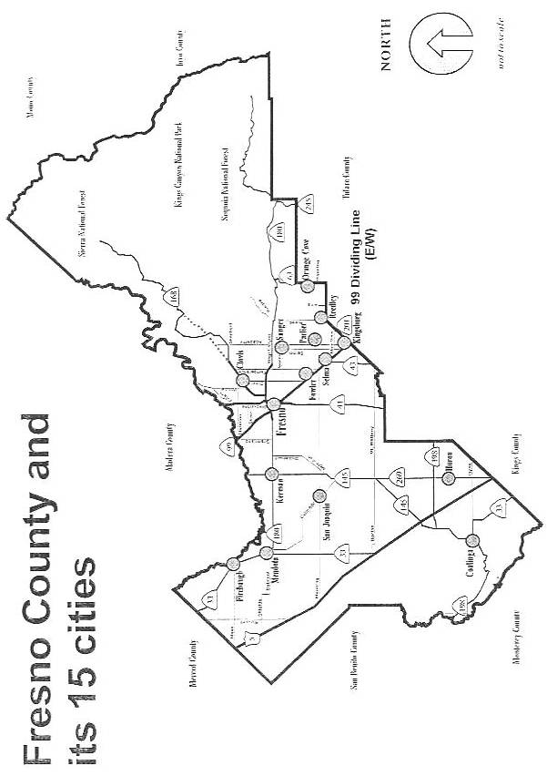
EXHIBIT TWO
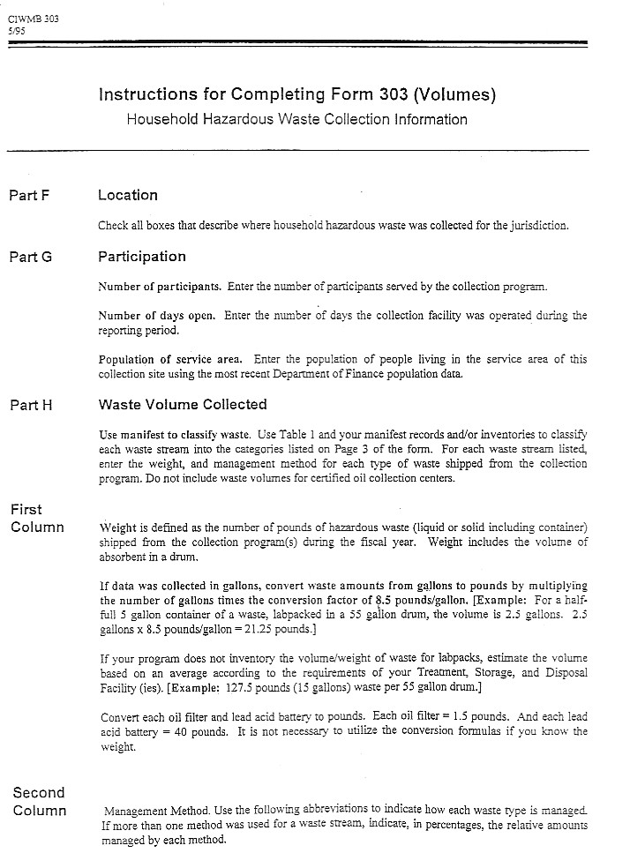
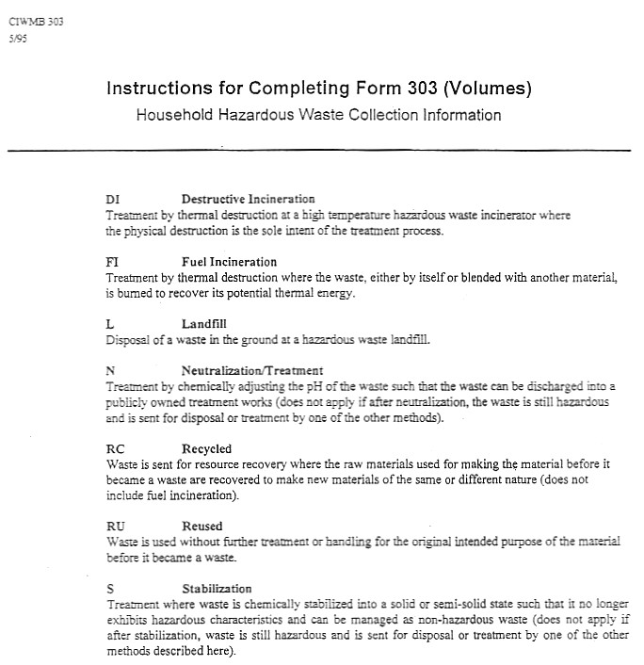
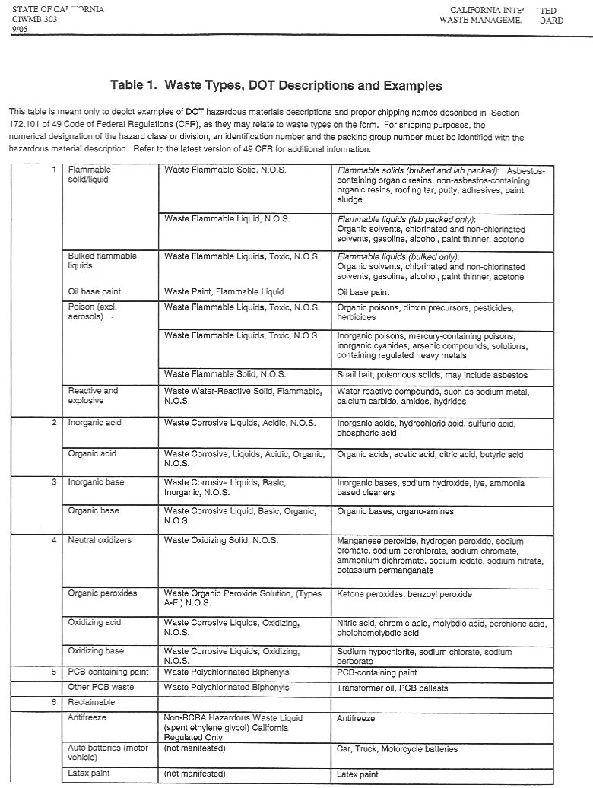
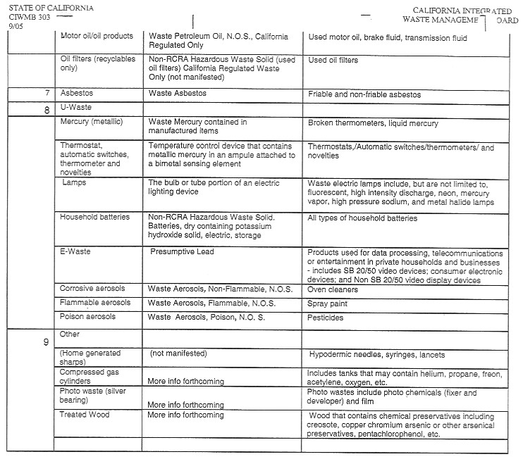
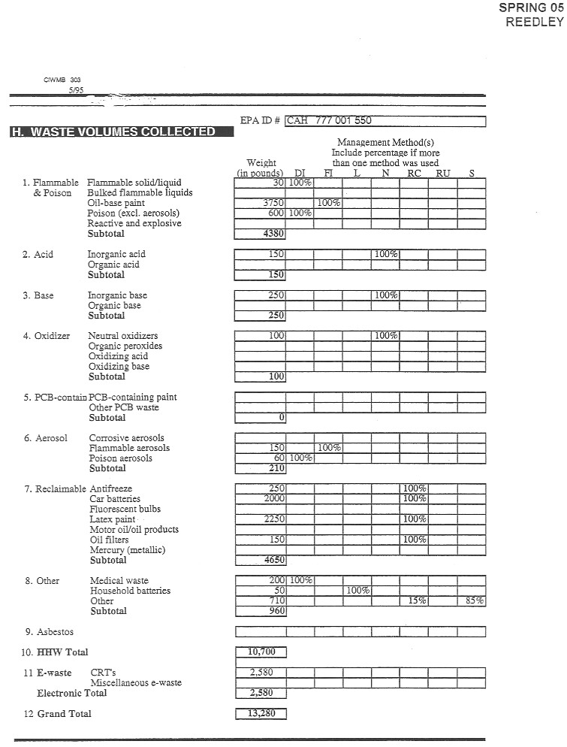
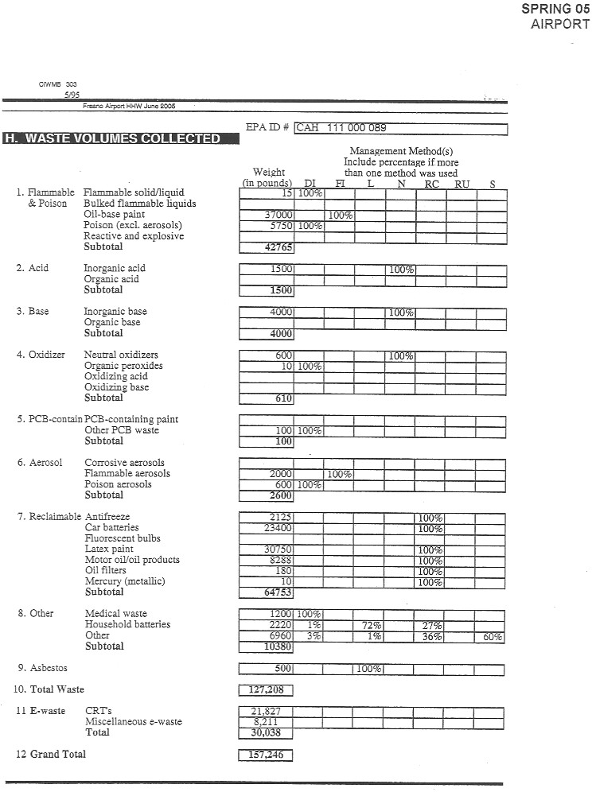
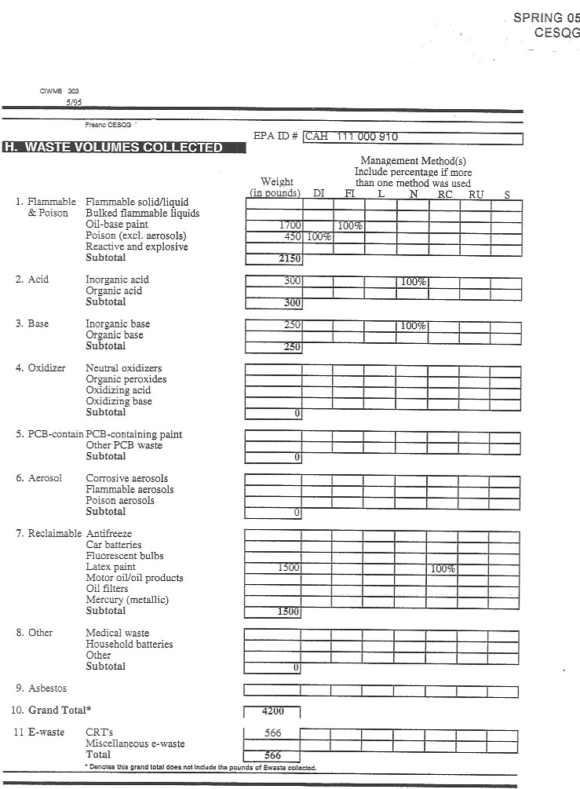
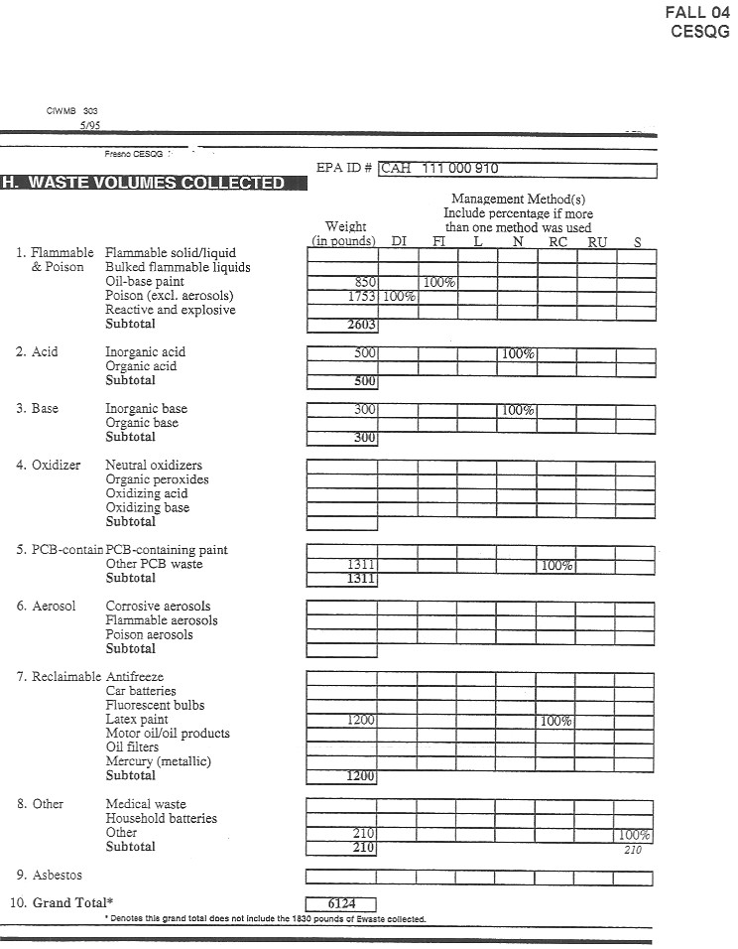
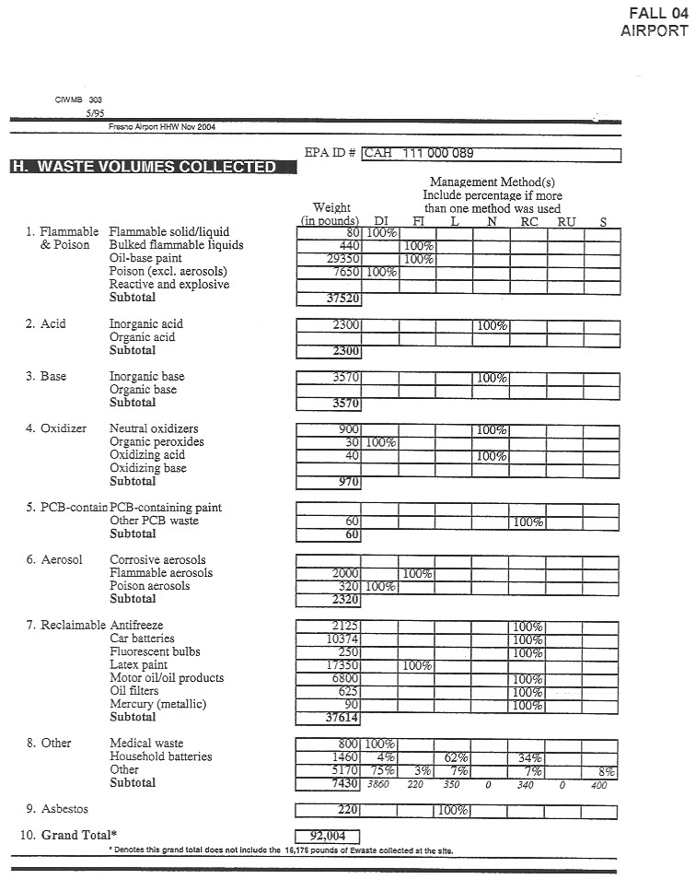
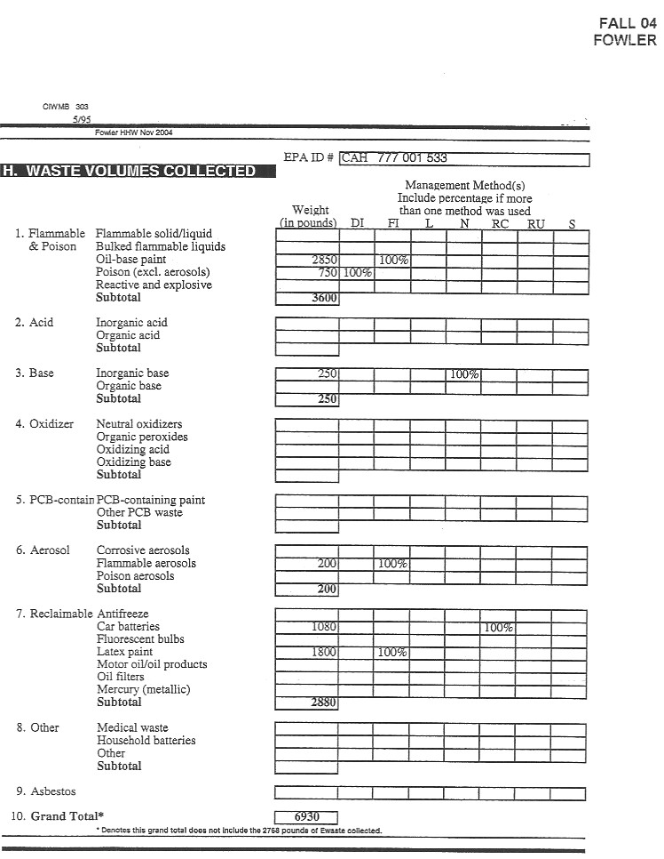
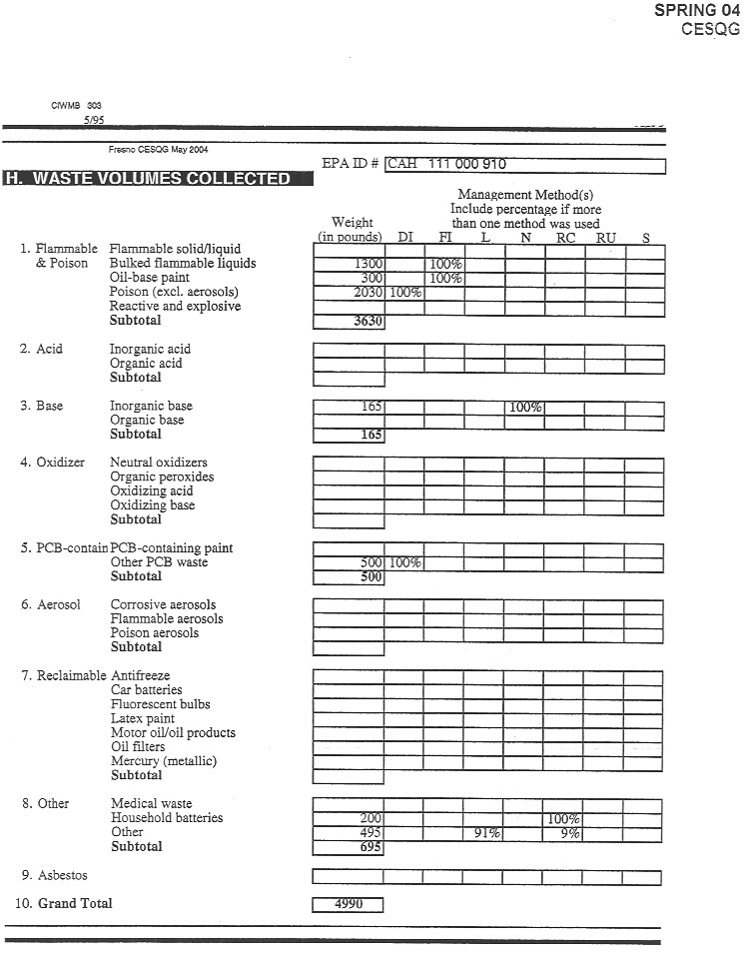
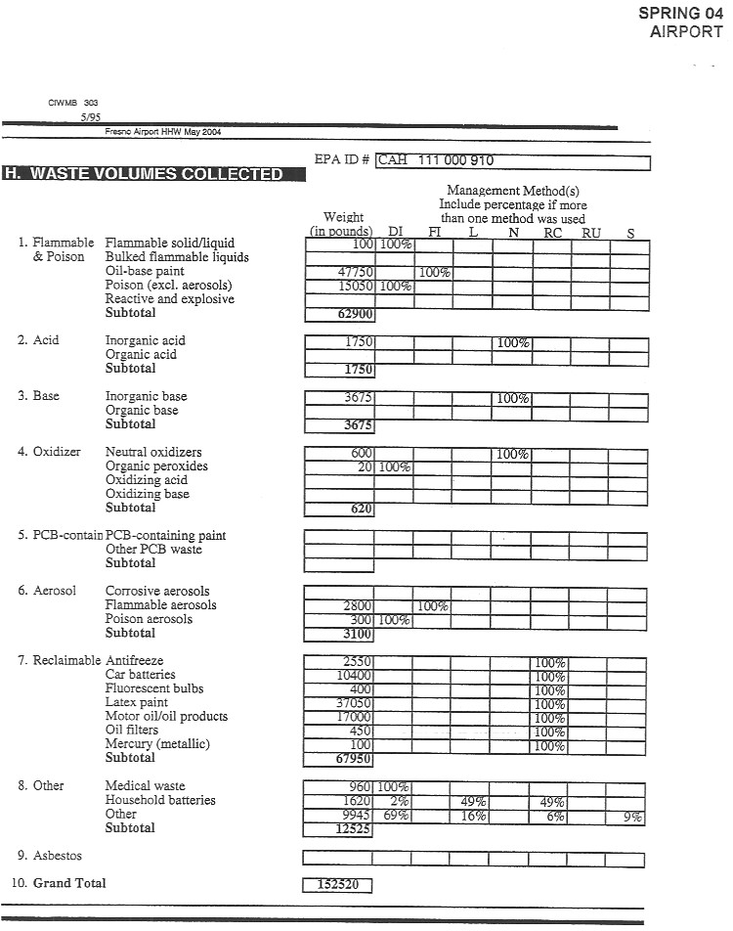
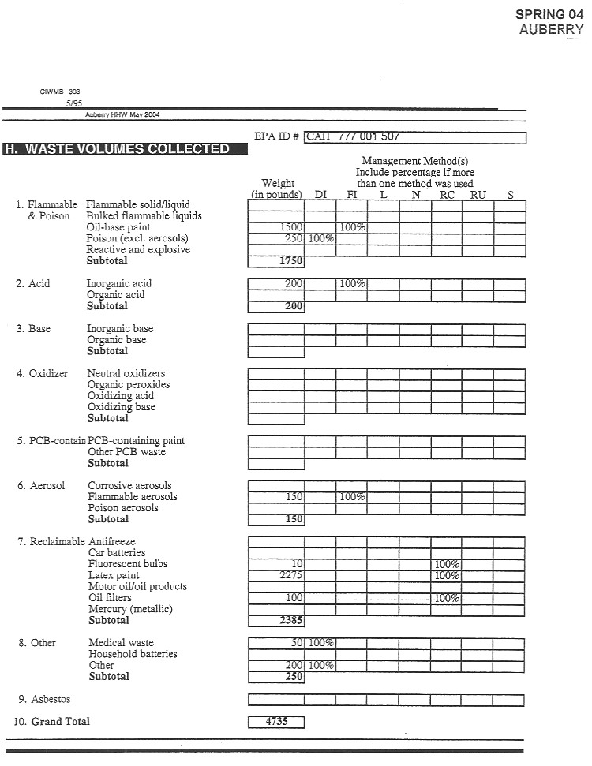
SPRING 04
PARLIER
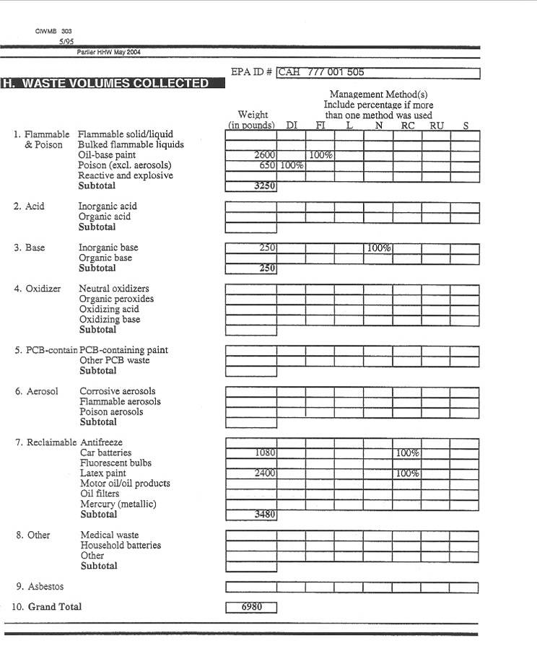
EXHIBIT THREE
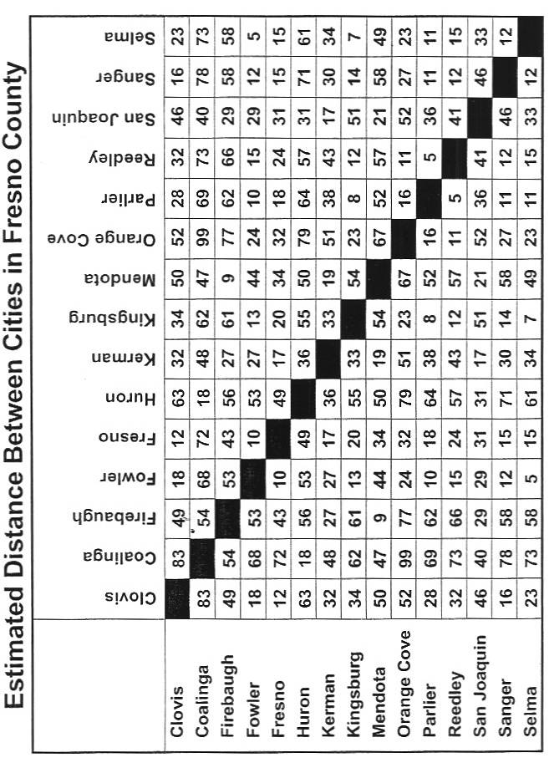

EXHIBITS FOUR THROUGH NINE
EXHIBIT FOUR – HHW Collection Program Reservation System Worksheet
EXHIBIT FIVE – Sample Collection Manifest
EXHIBIT SIX – HHW Collection Program Fixed Costs Worksheet
EXHIBIT SEVEN – Unit Cost Worksheet
EXHIBIT EIGHT – Cathode Ray Tube Worksheet
EXHIBIT NINE – UWED Worksheet

EXHIBIT TEN
SAMPLE AGREEMENT

EXHIBIT TEN

COUNTY-WIDE HOUSEHOLD HAZARDOUS WASTE COLLECTION PROGRAM
THIS AGREEMENT is made and entered into on this ______ day of _________________, 2006, by and between the County of Fresno, a Political Subdivision of the State of California (referred to as "COUNTY"), and NEW COMPANY, hereinafter referred to as "CONTRACTOR".

W I T N E S S E T H:
WHEREAS, the Integrated Waste Management Act of 1989 (AB 939), as amended, requires the preparation and adoption of several solid waste management planning documents, including a Household Hazardous Waste Element (HHWE); and
WHEREAS, the COUNTY prepared a memorandum of understanding in conjunction with the incorporated cities of the COUNTY to address the goals and objectives as required by AB 939, including the management of household hazardous waste (HHW); and
WHEREAS, the COUNTY Board of Supervisors adopted the COUNTY's HHWE on March 12, 1992, and the HHWE includes recommended programs designed to reduce the amount of HHW used by COUNTY residents and to provide for the safe recycling/disposal of these materials; and
WHEREAS, on MONTH - DAY- YEAR, the COUNTY issued a Request for Proposal to contractors interested in providing a countywide HHW collection program, including up to two (2) HHW Collection Events during fiscal year 2006-07 (hereinafter referred to as Program); and
WHEREAS, the CONTRACTOR agrees to conduct the Program pursuant to the terms and conditions stated in this Agreement; and
WHEREAS, the CONTRACTOR is qualified to perform the services necessary to conduct the Program and is willing to perform such services pursuant to the terms and conditions stated in this Agreement.
NOW, THEREFORE, in consideration of the foregoing premises and the mutual promises herein, the COUNTY and the CONTRACTOR agree as follows:
I. DEFINITIONS:
- “Calendar Year” means a year beginning with January 1 and ending with December 31, of the same year.
- “Collection Site" means any one of three (3) countywide, publicly or privately owned sites that will be established as a Temporary Household Hazardous Waste Collection Facility (THHWCF) where Participants may bring their Household Hazardous Waste (HHW) for recycling/disposal by the CONTRACTOR.
- "Conditionally Exempt Small Quantity Generator" or "CESQG" means a business generating no more than one hundred (100) kilograms (or twenty-seven [27] gallons) per month of HHW that meets the requirements set forth in Section 25218.1(a) of the California Health and Safety Code.
- "CESQG Participant" means any qualifying CESQG bringing HHW for disposal at a HHW Collection event.
- “Fiscal Year” means a year beginning with July 1 and ending with June 30 of the following year.
- "Household" means a single detached residence or a single unit of a multiple residence unit and all appurtenant structures.
- "Household Hazardous Waste" or "HHW" means any hazardous waste, as that term is defined under the California Hazardous Waste Control Law (California Health & Safety Code §25100 et seq.) and corresponding regulations (California Code of Regulations, Title 22, Division 4.5), that is generated incidental to owning and/or maintaining a place of residence, excluding any hazardous waste generated in the course of operating a business at a place of residence. For purposes of this Agreement, HHW also shall mean any hazardous wastes submitted by a qualified CESQG. HHW shall include, but not be limited to, liquid and solid flammables (including oil-based paint), poisons, acids, bases, oxidizers, aerosols, antifreeze, latex paint, batteries (automobile and household), used motor oil, oil filters, mercury, items containing non-TSCA (Toxic Substance Control Act) polychlorinated biphenyls (ballasts), Universal Waste Electronic Devices (UWEDs) and other Universal Waste (UW) that may be agreed upon, including cathode ray tubes (CRTs), and treated wood (railroad ties).
- "HHW Collection Event" or "Event" means the establishment and operation of a THHWCF or multiple THHWCFs, operating simultaneously and/or within a short time frame (such as over a consecutive Friday and Saturday).
- "HHW Collection Program" or "Program" means one (1) HHW Collection event and an option for a second Event. Should the option be exercised by the COUNTY, the Program shall consist of the two (2) Events annually.
- "Participant" means a vehicle carrying one or more COUNTY resident(s) who brings HHW to a HHW Collection event during the Program.
- "Residential Participant" means any participant bringing HHW for disposal at a HHW Collection event.
- “Sharps” means needles, syringes, lancets or similar devices with a thin, keen edge or fine point, used to monitor an individual’s medical condition and/or to administer medication. Sharps acceptable for collection in the Program shall be generated by individuals, who self-medicate and/or receive medical treatment in places such as, but not limited to, their own homes or places of work. Sharps generated in a medical setting, such as, but not limited to, a clinic, doctor’s office or licensed care facility, are not acceptable for collection in the Program.
- "Temporary Household Hazardous Waste Collection Facility" or "THHWCF" means a facility operated by a public agency in accordance with Permit By Rule Regulations for THHWCFs as defined and regulated under California Code of Regulations, Title 22, Division 4.5, Chapter 10, Article 2, Sections 66260.10, 66270.1(c)(1)(F) and 66270.60(d)(5).
- “Universal Waste” or “UW” means the category of lower risk hazardous wastes that are conditionally exempt from management as hazardous wastes provided that they are managed in compliance with the standards set forth in the Title 22, California Code of Regulations (CCR), Division 4.5. Waste currently designated as UW by the Department of Toxic Substance Control (DTSC) includes, but is not limited to: 1) thermostats and thermometers; 2) batteries; 3) sharps: 4) fluorescent lamps; and 5) State-regulated items containing CRTs.
II. SCOPE OF WORK:
A. OVERVIEW OF PROGRAM:
The COUNTY, in cooperation with the fifteen (15) incorporated cities of the COUNTY, will sponsor the Program. The Program will consist of an initial collection Event, which will take place on a date to be agreed upon by both the COUNTY and the CONTRACTOR in the fall period of the contract year (hereinafter referred to as Event Day), and may include one subsequent Event. The subsequent Event, if conducted, is tentatively scheduled for the spring period of the contract year. (As scheduling details will not impact contract costs nor alter the scope of work stipulated in this Agreement, the COUNTY and the CONTRACTOR reserve the option to reschedule the Event Day to another mutually agreed upon time period.) Each individual Event will be conducted simultaneously at three (3) Collection Sites within the COUNTY. During each Event, one (1) Collection Site may be located in the rural area of the west side of the COUNTY or may be rotated to the mountain area of the COUNTY, one (1) Collection Site will be located in the rural area of the east side of the COUNTY, and one (1) Collection Site will be located in the Fresno-Clovis Metropolitan Area (FCMA).
The Program shall be open to residents of Fresno County only. Residential Participants may legally transport a maximum of one hundred twenty-five (125) pounds or fifteen (15) gallons of HHW to any one (1) of the three (3) Collection Sites. There will be no charge to Residential Participants.
CESQG Participants may bring the types and quantities of HHW subject to the limitations set forth in the definition of CESQG in Section I.C. above. Each CESQG Participant will be charged a pro-rata share of the cost of collection and disposal (plus overhead) for the type and quantity of HHW brought to the Event, based upon the rates defined in Exhibits Four through Nine. The CONTRACTOR shall enter into an agreement directly with each CESQG to provide for the collection and disposal of the HHW at the rates defined in Exhibits Four through Nine. This Agreement shall include provisions for billing and collecting from the CESQG any monies owed for services rendered by the CONTRACTOR. All costs associated with management of all HHW delivered by a CESQG shall be covered by separate agreement(s) between the CONTRACTOR and each CESQG and said CESQG costs shall not be the responsibility of the COUNTY.
A reservation system, conducted by the CONTRACTOR, shall be in place. Twelve hundred (1,200) reservations are anticipated for the initial Event Day, twenty-five (25) and seventy-five (75) at the rural sites and one thousand one-hundred (1,100) for the FCMA. The COUNTY has the option to modify the allocation of reservation slots/participants over the three (3) selected sites and the door-to-door program in response to actual demand generated during the reservation process. Response to the initial Event Day will be used by the COUNTY to determine the number of reservations accepted for any subsequent HHW Collection event. The CONTRACTOR shall be responsible for the setting up and breaking down of each of the three (3) Collection Sites at each HHW Collection event. This includes providing all staff, equipment and supplies necessary for collecting, testing, identifying, separating, packaging, and transporting all HHW for which the CONTRACTOR is able to provide and/or arrange management. The CONTRACTOR shall also be responsible for preparing all transportation documents and ensuring that all HHW for which the CONTRACTOR is able to provide and/or arrange management, is properly treated, recycled and/or disposed. The CONTRACTOR shall assist the COUNTY to identify and arrange for management of all hazardous waste that the CONTRACTOR is unable to manage, examples of which may include radioactive materials, explosives, pyrophoric materials, organic peroxides, or biological/medical wastes other than Sharps.
B. CONTRACTOR'S REQUIREMENTS:
1. Pursuant to the terms and conditions of COUNTY's Request for Proposal (dated XXXXX XX, 2006) and the CONTRACTOR'S response bid, which by this reference are all made a part hereof, the CONTRACTOR shall be responsible for conducting all required Program operations necessary to collect, test, identify, consolidate, sort, package, transport, treat, recycle and/or dispose of, in an efficient and safe manner, any HHW and, for providing or arranging for an alternative means to manage any HHW brought to a Collection Site by a Participant which is not listed as a type of HHW managed by the CONTRACTOR. In the event of an inconsistency among these documents, the inconsistency shall be resolved by giving precedence in the following order of priority:
a. This Agreement;
b. Request for Proposal; then
c. Response to the Request for Proposal.
2. The CONTRACTOR shall provide all Program personnel, equipment, and supplies necessary for collecting, testing, packaging, transporting, treating, recycling and/or disposing of all HHW for which the CONTRACTOR is able to provide and/or arrange management, including safety equipment for the protection of Program personnel and the collected HHW in the event of heat, cold, rain, wind and other adverse weather. Nothing in this Section precludes the CONTRACTOR from suspending or postponing the Program in the event of adverse weather, such as tornados or lightning storms, for which there are no appropriate protocols addressing the health and safety of staff and participants other than withdrawal from the area. The CONTRACTOR shall provide Program directional and safety signs for each of the three (3) Collection Sites. The CONTRACTOR shall also provide on Event day, food and beverages for its personnel and COUNTY staff, and if unavailable at the site, portable restrooms to be used by the CONTRACTOR’s personnel, COUNTY staff, and Participants.
3. Prior to each HHW Collection event, the CONTRACTOR shall be required to prepare an Operations and Contingency Plan (Plan), and any State-required permits for each of the three (3) Collection Sites during the Program.
4. The CONTRACTOR shall provide to the COUNTY two (2) copies (one of which is to be an unbound reproducible copy) of the Plan for each of the three (3) Collection Sites thirty (30) days prior to the commencement of an Event Day. In addition, the CONTRACTOR shall provide the local fire department, police department, site owner, and the Fresno County Community Health Department (Health Department) with a copy of the Plan(s) for any site(s) within its purview, for review and comment. Each entity receiving a copy of the Plan shall be invited in writing by the CONTRACTOR to make a site visit the day of the Event.
The Plan shall include a physical description of each of the three (3) Collection Sites, evacuation routes, and local hospital and other emergency facilities to be used in the vicinity of each of the three (3) Collection Sites. The CONTRACTOR shall ensure that its personnel adhere to all provisions in the CONTRACTOR's Plan while handling, collecting, packaging, transporting, treating, recycling and/or disposing of all HHW during the Program.
The Plan shall include an Emergency Response component. The Emergency Response component shall include: 1) a list of HHW the CONTRACTOR manages; and 2) procedures and options for dealing with HHW for which the CONTRACTOR is not able to provide and/or arrange management. The information on options should include designation of appropriate disposal methods to be used for each HHW including HHW the CONTRACTOR does not manage. The Emergency Response component of the Plan must be reviewed and approved by the Health Department at least thirty (30) days in advance of the Event.
5. The CONTRACTOR shall be responsible for setting up and implementing a CESQG program. While the COUNTY is responsible for promoting the CESQG program, the CONTRACTOR is welcome to propose to the COUNTY strategies for increasing participation in this program with the understanding that all such proposals must be in writing, approved by the County and carried out/funded by the CONTRACTOR. This program will provide for screening, registering and contracting with Participants, and arranging for any required transportation variances available. Screening of applicants to the CESQG program will determine eligibility and determine the types and quantities of HHW to be managed and billed under the CESQG program. The CONTRACTOR shall provide potential CESQGs with a free written estimate of cost(s) of service(s) requested. The CONTRACTOR shall accept reservations only from eligible CESQGs and for HHW that the CONTRACTOR has listed as HHW managed by the CONTRACTOR. The CONTRACTOR shall not make reservations for any HHW not managed by the CONTRACTOR. The reservation process (which requires Participants to meet certain eligibility criteria before they can receive the address of the collection site), together with the CONTRACTOR's CESQG screening process, will ensure that only eligible CESQGs, which have agreed to bring to the Event only HHW pre-approved by the CONTRACTOR, shall have reservations to an Event. Therefore, the CONTRACTOR shall accept, from any Participant to whom the CONTRACTOR has issued a CESQG reservation, all HHW covered by the CONTRACTOR's confirmation letter.
The CONTRACTOR shall provide the COUNTY, for review and approval, a copy of the rate sheet to be used to calculate charges to CESQGs and information on the disposal options to be utilized for the various waste streams collected from the CESQGs. The CONTRACTOR shall prepare and distribute to qualified CESQGs all the instructions and forms required to participate in the CESQG program, including but not limited to eligibility, acceptability of the various types and quantities of HHW, packing, transportation, inventory, certification and payment information.
- The CONTRACTOR shall assume all legal and financial responsibility for the cleanup of any chemical spill/contamination or any damage to a site or property on a site that may occur during each HHW Collection event as a direct result of the CONTRACTOR's Program operations.
- The CONTRACTOR shall provide all of its personnel with adequate safety training, safety equipment, restroom facilities, and water for washing and drinking.
8. The CONTRACTOR shall be responsible for clearing all activity from each of the three (3) Collection Sites and returning sites to pre-Event conditions within twenty-four (24) hours after the Event Day. The CONTRACTOR shall be responsible for collecting and disposing of all trash resulting from each HHW Collection Event at each of the three (3) Collection Sites and for returning the site to its pre-Event condition.
9. The CONTRACTOR shall be responsible for determining the method of management (how packaged and recycled/disposed) of all HHW and for arranging, if possible, for alternative management of HHW not managed by the CONTRACTOR, but received during each HHW Collection Event at each of the three (3) Collection Sites, according to the parameters set out in Exhibits Four through Nine. The CONTRACTOR shall also be responsible for determining the total weight/volume of all HHW collected at each HHW Collection Event at each of the three (3) Collection Sites.
10. The CONTRACTOR shall be responsible for managing traffic entering, traversing and leaving each of the three (3) Collection sites, unloading Participants' vehicles and segregating the HHW as necessary; packaging all HHW for which the CONTRACTOR is able to provide and/or arrange management, in accordance with Federal Department of Transportation (DOT) requirements; supplying and properly preparing inventory sheets, manifests, notifications, certifications, and other shipping documents, as required; and for collecting fees from CESQGs.
11. The CONTRACTOR shall ensure that all drivers of vehicles used to transport the HHW shall be properly trained and licensed under both sate and federal regulations.
12. The CONTRACTOR shall assist the COUNTY in planning and implementing Program operations, including conducting an exit survey of COUNTY residents, and attending one (1) site visit before an Event Day, and one (1) review meeting after the Event. The CONTRACTOR shall also assist Participants by providing information about their HHW, including identification of unknown chemicals, during an Event.
13. The CONTRACTOR shall be responsible for paying all disposal/management fees for all HHW for which the CONTRACTOR is able to provide and/or arrange disposal/management.
14. The CONTRACTOR shall: (a) transport, or arrange transport for, the HHW for which the CONTRACTOR is able to provide and/or arrange management to an appropriate offsite hazardous waste disposal facility in an appropriately certified vehicle and container; and (b) provide, or arrange for the provision of, a completed manifest or other appropriate documentation for the nonrecyclable HHW for which the CONTRACTOR was able to provide and/or arrange management, in accordance with all applicable requirements of California Health and Safety Code, including but not limited to Sections 25160 and 25163 thereof. The HHW for which the CONTRACTOR is able to provide and/or arrange management shall also be handled and transported in accordance with the regulations adopted by the U.S. Environmental Protection Agency concerning the management of hazardous waste, including, but not limited to, the regulations specified in Title 40, Part 260 (commencing with Section 260.1) through and including Part 270 (commencing with Section 270.1), inclusive, of Subchapter I of Chapter 1 of the Code of Federal Regulations, the regulations adopted by the DOT concerning the transportation of hazardous materials, and any other applicable State laws and regulations.
15. The CONTRACTOR shall submit, thirty (30) days after completion of an Event Day, a report to the COUNTY. The report shall include inventory sheets, manifests, total weight/volume of the collected HHW (listed on the most current version of the DTSC/California Integrated Waste Management Board [CIWMB] Form 303), and a certificate of waste acceptance for the disposed HHW, if available, from the disposal facility operator within the specified thirty (30)-day period. The CONTRACTOR shall also be required to submit on an annual basis two reports that summarize all Events conducted by the CONTRACTOR for the County. The first report will itemize the information from all DTSC/CIWMB Form 303 reports, on a calendar year basis, and shall be submitted thirty (30)-days after the end of the year; the second report will itemize the information on a fiscal year basis and shall be submitted thirty (30) days after the last Event. A hard copy and an electronic copy of the reports shall be submitted to the County representative within the allotted time.
16. The CONTRACTOR shall, at no charge to the COUNTY, duplicate, distribute and collect COUNTY-designed exit surveys and distribute other literature/material prepared and provided by the COUNTY to Participants as part of the exit interview process, at each of the three (3) Collection Sites during each HHW Collection Event.
17. The CONTRACTOR shall be responsible for processing that portion of the latex paint collected at the Event which can be recycled. After having been strained and tested for mercury, chrome, lead, polychlorinated biphenyls, and total volatile organic compounds, the recycled paint shall be made available to the COUNTY in five (5) gallon containers at a cost of XXXX dollars ($XX) per gallon in five (5)-gallon containers. The cost of XXXX dollars ($XX) per gallon includes the cost of delivery of the paint to the COUNTY. The COUNTY is under no obligation to accept any of this recycled paint. However, should it wish to take possession of any of the recycled paint or assist local jurisdictions or non-profit groups in Fresno County to take possession of any of this recycled paint, the COUNTY shall provide the CONTRACTOR with two (2)-weeks notice. The CONTRACTOR shall notify the COUNTY in writing that paint is available for transport. The CONTRACTOR shall store recycled latex paint no longer than forty-five (45) days from the date of the written notification. After forty-five (45) days, the CONTRACTOR may find other recycling markets for the paint or manage the paint appropriately.
18. The CONTRACTOR shall provide an adequate number of properly trained personnel and all equipment required to provide for the operation of a reservation system. (Trained means able to initiate and sustain a friendly conversation, to effectively screen callers about program eligibility, to answer basic questions about what types and quantities of materials are acceptable and how they should be transported, to suggest alternative disposal options when appropriate, and to refer callers to a source of additional or more technical information when appropriate.)
The system shall consist of a toll-free reservation line which will be staffed by live people daily for the four (4) weeks prior to an Event and provide a referral message service for one week after an Event. The staffed service will be supplemented with two separate recorded messages during the four (4)-week period, one (1) message indicating that the attendant is taking another call and a separate message for calls received outside of business hours. This staffed reservation line may be replaced with a pre-recorded message before the end of the initial four (4) weeks if and when a mutually agreed upon number of reservations has been made for an Event. At the end of the four (4) weeks, the CONTRACTOR may continue to staff the reservation line or may exercise an option to replace the live staff person with an automated message service for one (1) week following the Event. The reservation line shall be operational eight (8) hours a day, five (5) days a week, Monday through Friday for the entire five (5) weeks. The CONTRACTOR has the option to replace any one eight (8)-hour weekday with either four (4) hours on a Saturday or Sunday or four (4) hours one (1) weekday evening (5 p.m. through 9 p.m.).
The CONTRACTOR shall provide the COUNTY with a log (name, complete address, telephone number, and site assignment where applicable) of all calls received over the five (5)-week period. The screener shall ask all Participants to spell their names, and the names of their streets. This log shall be computer-printed, and shall not be handwritten. The COUNTY shall provide the CONTRACTOR with a template for the log. The CONTRACTOR is required to use said template. A Reminder Flyer (8 1/2 x 11 inches, envelope optional) shall be placed in the mail by the CONTRACTOR, for first-class delivery to each Participant (Residential and CESQG), together with Event information, including location map and reservation appointment date and time, not less than four (4) days prior to the day of an Event. The Reminder Flyer shall clearly spell out the types and quantities of materials which will be accepted at an Event, who is eligible to participate (e.g., only residents of Fresno County, CESQGs) and clearly indicate that inappropriate items or quantities of waste shall be turned away and may be reported to the Health Department. Information on appropriate alternative disposal options, safe transportation of HHW, and the time and location of the reservation, along with a map indicating the location, shall be included in the flyer. The text and format of the flyer shall be approved by the COUNTY before it is distributed by the CONTRACTOR.
19. The CONTRACTOR shall draw, package and provide the COUNTY with a sample representative of the bulk oil collected during the Event. Oil collected from each of the rural sites may be consolidated with that collected at the FCMA site prior to sampling. However, if the oil is in more than one (1) container at the time of sampling, a separate sample shall be collected from each container. Such sample(s) shall be drawn after collection of oil is complete and prior to transfer of the oil to any container(s), tank(s), or vehicle for transport or consolidation. The sample(s) shall be left in the custody of the COUNTY prior to the departure of the CONTRACTOR from the Event site in the FCMA.
C. COUNTY'S REQUIREMENTS:
1. The COUNTY shall coordinate the activities of the sponsoring agencies and selection of HHW collection sites with the CONTRACTOR and the Health Department. The final approval of the site shall be the responsibility of the CONTRACTOR. Any applications and/or contracts related to site use shall be the responsibility of the COUNTY.
2. At the time the specific HHW Collection Event sites are selected, the COUNTY shall provide the CONTRACTOR with a vicinity map and commute times among the various county areas where Event sites will be located.
3. The COUNTY shall provide the CONTRACTOR with access to the three (3) Collection Sites and any subsequent HHW Collection event sites. Each site shall provide reasonable space to set up and operate the Program and shall be available to the CONTRACTOR up to six (6) hours prior to, and up to six (6) hours after, the hours of operation stated on the THHWCF permit. Should the CONTRACTOR require additional hours of access to site, the COUNTY will endeavor to arrange for such access. This provision in no way relieves the CONTRACTOR of its obligation under Section II.B.8. above to complete its operation within twenty-four (24) hours after the Event.
4. The COUNTY shall provide a COUNTY Representative who will represent the COUNTY and will work with the CONTRACTOR in carrying out the provisions of this Agreement. However, such work between the COUNTY Representative and the CONTRACTOR shall not, in any way, diminish the CONTRACTOR'S obligations under this Agreement. The Director of the Department of Public Works and Planning shall serve as the COUNTY Representative or will designate a representative. The CONTRACTOR shall communicate and coordinate with the COUNTY Representative. The Director of the Department of Public Works and Planning, or designee, shall have the authority to approve the terms of any subsequent HHW Collection Events pursuant to the provisions of Section III.A. herein.
5. The COUNTY shall sign and file the Permit By-Rule Notification and any other required forms/applications or permits, including, as necessary, any State-required or local/county-required permits, assisted by the CONTRACTOR as required. The COUNTY shall apply for the required Environmental Protection Agency identification numbers (CAH #). The COUNTY will be listed as the Generator of all HHW.
6. The COUNTY shall be responsible for providing writing tools and clipboards necessary for the CONTRACTOR-administered exit survey process.
7. The COUNTY shall be responsible for development, implementation and all other costs associated with public relations tasks (including advertising, publicity, and those signs at each site identifying the Event sponsors).
8. The COUNTY, as staff time and funding permits, will be responsible for promoting the CESQG program. The CONTRACTOR, at his expense and with COUNTY approval, may arrange for promotion of the CESQG program.
III. COMPENSATION:

A. TOTAL CONTRACT COST:
The COUNTY and the CONTRACTOR agree that the Total Contract Cost is the total amount of compensation for conducting the Program (consisting of the Event Day and up to one [1] subsequent HHW Collection Event during the contract year) which shall be limited to an amount not to exceed two hundred sixty-thousand dollars ($260,000).
The Total Contract Cost includes all of the prices, fees, charges, and expenses necessary to conduct the Program. The Total Contract Cost is the sole consideration to be paid to the CONTRACTOR hereunder and includes provisions for all out-of-pocket costs such as the reservation system, computer time, freight, telephone charges, telecopying, photocopying, document preparation, faxing and postage, lodging, travel expenses, and for all materials or services necessary to conduct the Program, including collection, screening, testing, packing, recycling and disposal of all HHW for which the CONTRACTOR is able to provide and/or arrange management.
The Total Contract Cost, as defined in this Agreement, is based on an approximate one (1)-year contract term (encompassing a maximum of two [2] Events annually), expiring on July 31, 2007, as set forth below in Section XVII.A., and accordingly represent the maximum amount of compensation that may become payable annually under this Agreement. Provided, however, that if the term of this Agreement is extended, pursuant to the provisions of Section XVII.B., then all references to the Total Contract Cost shall be deemed to include the term Annual in the definition provided herein (e.g., Annual Total Contract Costs). It follows, accordingly, and is the intent of the parties hereto, that the cumulative maximum amount of compensation under this Agreement, if it is extended for one (1) additional year to July 31, 2008, shall not exceed five hundred and twenty-thousand dollars ($520,000) over the extended two (2)-year life of the Agreement, and shall not exceed two hundred sixty-thousand dollars ($260,000) for either of the one (1)-year terms; and that the cumulative maximum amount of compensation under this Agreement, if it is extended for two (2) additional years, for a final expiration date of July 31, 2009, shall not exceed seven hundred eighty -thousand dollars ($780,000) over the extended three (3)-year life of the Agreement and shall not exceed two hundred sixty-thousand dollars ($260,000) for any of the one (1)-year terms.

B. DISTRIBUTION OF THE CONTRACT:
It is anticipated that the CONTRACT for the Program described above will be distributed over two (2) Events, on dates to be agreed upon by both parties, one (1) to be held in the fall period of the contract year, and another equivalent, two (2)-day Event to be held in the spring period of the contract year. Plans call for the two hundred sixty-thousand dollars ($260,000) to be expended approximately equally over the two (2) Events, with one hundred thirty-thousand dollars ($130,000) being expended on each Event. This amount, one hundred thirty-thousand dollars ($130,000), is the Event Target Amount. The estimated allocation of funds to each Event, one hundred thirty-thousand dollars ($130,000), will be expended on two (2) basic categories of expenditures: 1) Fixed Costs and 2) Disposal Costs. This allocation (Event Target Amount) will allow for an expenditure of XXX-thousand dollars ($XXX) on Fixed Costs combined with an expenditure of XXXX hundred-thousand dollars ($XXXX) on Disposal Costs. These amounts, XXXX-thousand dollars and XXXX hundred-thousand dollars ($XXX and $XXXX) are the Fixed Cost Target Amount and the Disposal Cost Target Amount, respectively. However, the COUNTY is not obligated to pay the Event Target Amount. The cost to the COUNTY for an Event shall be based upon the actual cost of the Event. Should the cost of the initial Event exceed the Event Target Amount of XXXX hundred-thousand dollars ($XXXXX), the subsequent Event may be scaled back, or the COUNTY may decide not to exercise its option for a subsequent Event, to ensure that it does not exceed the Total Contract Cost of two hundred sixty-thousand dollars ($260,000).
The CONTRACTOR and the COUNTY shall monitor the number of reservations made for each Event and shall mutually agree, in writing, on the total number of reservations to be accepted. This Agreement is designed to control the Total Event Costs so they do not exceed the CONTRACT. The total number of reservations agreed upon shall not be higher than the COUNTY recommends, but will be set at the number recommended by the CONTRACTOR if the CONTRACTOR’s recommendation is lower.
1. Fixed Costs
Fixed Costs include, but are not limited to, items such as set-up costs, administration, the reservation program, mobilization, general labor and traffic control. The COUNTY and the CONTRACTOR agree that the Fixed Costs for an Event with three (3) HHW Collection Sites shall be determined by the total Anticipated Participation Rate, according to the schedule below:

ANTICIPATED PARTICIPATION RATE/COST SCHEDULE
TOTAL FOR THREE (3) SITES
ANTICIPATED  PARTICIPATION/  RATE | SET UP /TRAFFIC/  RESERVATION  SYSTEM | LABOR COSTS | TOTAL FIXED  COSTS
600 Reservations | $XXXX | $XXXX | $XXXX
700 Reservations | $XXXX | $XXXX | $XXXX
800 Reservations | $XXXX | $XXXX | $XXXX
900 Reservations | $XXXX | $XXXX | $XXXX
1000 Reservations | $XXXX | $XXXX | $XXXX
1100 Reservations | $XXXX | $XXXX | $XXXX
1200 Reservations | $XXXX | $XXXX | $XXXX
1300 Reservations | $XXXX | $XXXX | $XXXX
For each additional 100 Anticipated Participants
The Total Anticipated Participation Rate shall be determined no less than seven (7) days prior to the Event Day and shall be agreed upon in writing by the COUNTY and the CONTRACTOR, except that the COUNTY shall retain the right to limit the total number of Reservations at any one Event. The initial Event Day is anticipated to have Fixed Costs of no more than the Fixed Cost Target Amount, XXXX-thousand dollars ($XX,XXX), as the COUNTY anticipates that twelve hundred (1200) reservations will be accepted for the fall Event. If actual participation (the number of cars actually served by the CONTRACTOR) is lower than the agreed-upon Anticipated Participation Rate, the fee will remain unchanged. It is possible that the Actual Participation Rate will exceed the Anticipated Participation Rate. In this case, the Administration/Mobilization Fixed Costs will remain fixed at the previously agreed-upon Anticipated Participation Rate. After the initial Event, and prior to any subsequent Event, the Fixed Cost Target Amount and the Event target amount for any subsequent Event shall be appropriately reviewed and appropriately adjusted by the COUNTY based upon the funds remaining under the contract.

2. Disposal Costs
The Disposal Costs for HHW (for which the CONTRACTOR is able to provide and/or arrange management) to be collected at a HHW Collection event, shall be charged to the COUNTY as follows:
a. HHW Collected
The CONTRACTOR agrees to charge the COUNTY on a per drum/box/pallet/count or, when appropriate, (by volume) gallons to screen, test, recycle, treat, and/or dispose of as appropriate, all HHW collected at an Event, except for Electronic Waste (E-Waste) – and any agreed upon UWEDS. E-waste and designated UWEDS will be charged by the unit/pound as defined in Exhibits Four through Nine. The appropriate disposal method and associated disposal cost per drum/box/pallet/count or gallons to be used for each waste stream shall be as indicated in Exhibits Four through Nine. The CONTRACTOR agrees that this fee shall be the sole and complete compensation for all labor, materials, and transportation, recycling, treatment and/or disposal charges for all HHW that the CONTRACTOR has listed as HHW managed by the CONTRACTOR and that is collected at the three (3) Collection Sites during a HHW Collection Event.
b. The CONTRACTOR shall use its best efforts to process or to arrange for an appropriate contractor or agency to process all HHW which the CONTRACTOR has not listed as HHW managed by the CONTRACTOR that is brought to an Event. HHW, for which the CONTRACTOR is able to provide and/or arrange management, shall be the responsibility of the CONTRACTOR. The COUNTY agrees to pay the CONTRACTOR the CONTRACTOR's cost plus fifteen percent (15%) for management of HHW not listed as HHW managed by the CONTRACTOR for which the CONTRACTOR is able to provide and/or arrange management. Costs associated with processing HHW not listed as managed by the CONTRACTOR, but for which the CONTRACTOR is able to provide and/or arrange management, shall include all actual CONTRACTOR labor, subcontractor costs, materials, transportation, recycling, treatment, and/or disposal charges. These costs shall be evidenced by itemized invoices submitted by the CONTRACTOR to the COUNTY for managing, and/or arranging for an appropriate contractor or agency to manage the HHW not listed as a type(s) managed by the CONTRACTOR. The appropriate management method to be used for each type of HHW shall be as indicated in the Emergency Response component of the operations and contingency plan. The CONTRACTOR agrees that this fee, cost plus fifteen percent (15%), shall be the sole and complete compensation for all labor, subcontractors, materials, tests, packaging, transportation, recycling, treatment and/or disposal charges for all types of HHW that are collected at the three (3) Collection Sites during a HHW Collection Event that is not listed as a type(s) managed by the CONTRACTOR, but for which the CONTRACTOR is able to provide and/or arrange management.
c. The CONTRACTOR shall accept HHW for which the CONTRACTOR is able to provide and/or arrange management which is brought to the Event unless an on-site representative of the Health Department requires the CONTRACTOR to reject waste due to any one of the following:
(1.) It has been determined that the waste to be rejected was generated by an CESQG in the course of operating a business or commercial enterprise and the CESQG refuses to enter into an agreement with the CONTRACTOR to pay the appropriate CESQG fees and the on-site, Health Department representative has initiated appropriate waste tracking protocols; or
(2.) The waste to be rejected is that portion of the waste which exceeded by more than one hundred percent (100%) the volume and/or weight limits for HHW for a Residential Participant cited in Section II.A.; and, in the opinion of the on-site Health Department representative, that portion of the HHW to be accepted by the CONTRACTOR represents the most toxic or difficult to dispose of portion of the Participant's load; and, the on-site Health Department representative has initiated appropriate waste tracking protocols; or
(3.) The waste to be rejected is HHW not listed as a type managed by the CONTRACTOR and, (a) in the opinion of the on-site Health Department representative, rejection of that HHW either does not pose a significant risk to public health and safety, or there is no appropriate disposal method available; and (b) that the on-site Health Department representative has initiated appropriate waste tracking protocols.
d. Estimate of Disposal Costs
The COUNTY is not obligated to pay the Disposal Costs Target Amount. The Actual Disposal Costs shall depend upon the volume (i.e., the number of drums/boxes/pallets/count or gallons – when appropriate of HHW collected, plus the CONTRACTOR's invoiced costs, plus fifteen percent (15%) for HHW not listed as a type(s) managed by the CONTRACTOR and for which the CONTRACTOR is able to provide and/or arrange management, that actually is collected at an Event. The CONTRACTOR agrees that the Actual Disposal Costs shall be the sole and complete compensation for all labor, materials, and transportation, screening, testing, treatment, recycling and/or disposal charges for all HHW collected at an Event, including all HHW not listed as a type(s) managed and for which the CONTRACTOR is able to provide and/or arrange management. Should the Actual Disposal Costs for the initial Event exceed the Unit Costs Target Amount, any subsequent Event would be scaled back or the COUNTY's option for an additional Event may not be exercised, to ensure that the Total Contract Costs shall not exceed two hundred sixty-thousand dollars ($260,000).

C. PAYMENTS:
1. Invoice(s) shall be submitted in duplicate to the County of Fresno, Department of Public Works and Planning, Resources Division, 2220 Tulare Street, Sixth Floor, Fresno, CA 93721. Upon receipt of a proper invoice, the COUNTY will take a maximum of five (5) working days to review, approve, and submit it to the COUNTY Auditor-Controller/Treasurer-Tax Collector. A proper invoice shall be an original document free of errors and include a clear reference for each item to a manifest or other appropriate document. Payment will be issued to the CONTRACTOR within thirty (30) calendar days of the date the Auditor-Controller/Treasurer-Tax Collector receives the approved invoice(s).
2. The COUNTY shall notify the CONTRACTOR by facsimile within this five (5) working day period that the invoice(s) have been approved for payment by Resources Division staff and that a request to process the invoice for payment has been sent to the Business Office; or provide the CONTRACTOR by facsimile, a written description of any questions, requests for clarification, discrepancies or omissions in the invoices and/or related supporting documentation received from the CONTRACTOR. A new review period of five (5) working days shall begin upon receipt of the additional data/or corrected data requested. Any individual items or group of items appearing on a disputed invoice that do not require further clarification or correction may be separately invoiced by the CONTRACTOR for partial payment by the COUNTY. Under no circumstances shall the COUNTY authorize payment for an invoice that is not correct or in dispute until all corrections have been made and/or all disputes have been resolved to the satisfaction of both parties. An unresolved dispute over a possible error or omission may cause payment of CONTRACTOR fees in the disputed amount to be reasonably withheld by the COUNTY.
3. In the event the COUNTY reduces the scope of the project, the CONTRACTOR will be compensated for actual work completed and accepted by the COUNTY in accordance with the terms of this Agreement.
4. Final invoices shall be submitted to the COUNTY no later than sixty (60) days after project is completed. County may withhold payment of all invoices until manifests signed by a designated representative of the designated disposal/recycling facility are received by County Representative. Additionally, County may withhold ten percent (10%) of invoice until a Certificate of Destruction or other proof of proper waste management is provided.
5. Within sixty (60) days after the initial Event Day, the COUNTY and the CONTRACTOR shall review collection, participation, and expense data related to the initial Event. If the COUNTY and the CONTRACTOR agree that a subsequent Event, subject to the Total Contract Cost, is to be conducted, the COUNTY Representative shall authorize the subsequent Event, in writing, and shall stipulate the following information about the subsequent Event:
a. That no provision of Section III.A. (addressing Total Contract Cost, the CONTRACT, two hundred sixty-thousand dollars ($260,000), and the obligations/compensation of the CONTRACTOR for conducting the Program) or any other provisions of this Agreement shall be altered except as specifically enumerated in Section III.B. and Section III.C.5b-5e. (below).
b. The Fixed Costs Target Amount, the Disposal Cost Target Amount, and the Event Target Amount for the subsequent Event.
c. (i) How the target amounts stipulated in Section III.C.5b. (above) were determined; (ii) how these target amounts have been appropriately adjusted, based upon the funds remaining under this Agreement (after payment in full of the COUNTY'S obligations related to the initial Event); and (iii) how these target amounts have been appropriately adjusted, based upon Actual Fixed Costs and Actual Disposal Costs incurred during the initial Event, so as to assure that the Total Program Costs (the sum of the Actual Event Costs for both the initial Event and the subsequent Event) do not exceed the CONTRACT.
d. Said written statement authorizing a subsequent HHW Collection event shall be binding upon both parties, shall become a part of this Agreement, and shall serve as the basis for calculating compensation for the subsequent HHW Collection Event during the subsequent contract year.
6. The COUNTY, after the review required in Section III.C.5. (above), may unilaterally decide not to hold a subsequent Event during any contract year. In that event, the COUNTY’s decision shall be confirmed in writing by the COUNTY and effective upon delivery to the CONTRACTOR, pursuant to the terms and conditions stated in this Agreement. Provided, however, that such decision by the COUNTY shall not constitute a termination of this Agreement, nor does it affect the parties’ right to extend the Agreement under Section XVII.
IV. AUDITS AND INSPECTIONS ACCESS:
A. The CONTRACTOR shall at any time during regular business hours, and as often as the COUNTY may deem necessary, make available for examination by the State, or the COUNTY Auditor-Controller/Treasurer-Tax Collector, or their authorized representatives, the CONTRACTOR’s records and data with respect to matters covered by this Agreement. The CONTRACTOR shall permit the COUNTY or State to audit and inspect all invoices, materials, payrolls, records of personnel, conditions of employment, and other data relating to matters covered by this Agreement.
B. The CONTRACTOR shall be subject to the examination and audit of the State Auditor for a period of three (3) years after final payment under Agreement (Government Code Section 8546.7).
V. INDEPENDENT CONTRACTOR:
A. In performance of the work, duties, and obligations assumed by the CONTRACTOR under this Agreement, it is mutually understood and agreed that the CONTRACTOR, including any and all of the CONTRACTOR's officers, agents and employees, will at all times be acting and performing as an independent contractor, and shall act in an independent capacity and not as an officer, agent, servant, employee, joint venturer, partner or associate of the COUNTY. Furthermore, the COUNTY shall have no right to control or supervise or direct the manner or method by which the CONTRACTOR shall perform its work and function. However, the COUNTY shall retain the right to administer this Agreement so as to verify that the CONTRACTOR is performing its obligations in accordance with the terms and conditions thereof. The CONTRACTOR and the COUNTY shall comply with all applicable provisions of law and the rules and regulations, if any, of governmental authorities having jurisdiction over matters the subject thereof.
B. Because of its status as an independent contractor, the CONTRACTOR shall have absolutely no right to employment rights and benefits available to the COUNTY employees. The CONTRACTOR shall be solely liable and responsible for providing to, or on behalf of its employees all legally-required employee benefits. In addition, the CONTRACTOR shall be solely responsible and save the COUNTY harmless from all matters relating to payment of the CONTRACTOR's employees, including compliance with Social Security, withholding, and all other regulations governing such matters. It is acknowledged that during the term of this Agreement the CONTRACTOR may be providing services to others unrelated to the COUNTY or to this Agreement.
VI. PARTIES BOUND BY AGREEMENT:
This Agreement shall be binding upon the COUNTY, the CONTRACTOR, and their respective successors in interest, legal representatives, executors, administrators, and assigns with respect to all covenants set forth herein.
VII. ASSIGNMENT WITH APPROVAL:
It is understood that the CONTRACTOR shall not assign, sublet or transfer the CONTRACTOR's interest in this Agreement without the prior approval and written consent of the COUNTY.
VIII. COMPLIANCE WITH LAWS:
The CONTRACTOR shall comply with all local, State, and Federal laws, ordinances, regulations, and Fresno County Charter Provisions applicable in the performance of its services.
IX. GOVERNING LAW:
A. Any controversy or claim arising out of or relating to this Agreement which cannot be amicably settled without court action shall be litigated only in state court for Fresno County, California, or in the U.S. District Court for the Eastern District of California, located in Fresno County.
B. The rights and obligations of the parties and all interpretations and performance of this Agreement shall be governed in all respects by the laws of the State of California.
X. AMENDMENTS:
A. The CONTRACTOR understands that the COUNTY may request, that due to new regulations and/or change in material(s) targeted for collection, the CONTRACTOR to perform certain additional services that are related to the CONTRACTOR’s operation of the HHW Collection Program and that would assist and benefit the COUNTY. The CONTRACTOR shall use its best efforts to provide any additional work related to the work performed hereunder when requested in writing by the COUNTY. All additional requested work shall be performed in accordance with the provisions of this Agreement, subject to related adjustments/additions in the management, method, and/or packaging option or Disposal Cost sections in Exhibits Four through Nine.
B. Any changes to this Agreement requested either by the COUNTY or the CONTRACTOR may only be effected if mutually agreed upon in writing by the COUNTY and the CONTRACTOR. This Agreement shall not be modified or amended, nor may any rights of a party hereto be waived except by such a writing.
XI. CONTRACTOR'S LEGAL AUTHORITY:
Each individual executing or attesting this Agreement on behalf of the CONTRACTOR hereby covenants, warrants, and represents: (i) that he or she is duly authorized to execute or attest and deliver this Agreement on behalf of such corporation in accordance with a duly adopted resolution of the corporation's board of directors and in accordance with such corporation's articles of incorporation or charter and bylaws; (ii) that this Agreement is binding upon such corporation; and (iii) that the CONTRACTOR is a duly organized and legally existing corporation in good standing in the State of California and licensed to do business in the State of California.
XII. HOLD HARMLESS:
The CONTRACTOR shall hold harmless, indemnify and, at the COUNTY's request, defend the COUNTY, its officers, agents, and employees, against the payment of any and all costs and expenses (including reasonable attorney fees and court costs), damages, claims, suits, losses, and liability for bodily and personal injury to or death of any person or for loss of any property resulting from or arising out of any negligent or wrongful acts, errors or omissions of the CONTRACTOR, its officers, agents, and employees, in performing or failing to perform any work, services, or functions under this Agreement.
XIII. LIABILITY INSURANCE:
A. Without limiting the COUNTY'S right to obtain indemnification from the CONTRACTOR or any third parties, the CONTRACTOR at its sole expense shall maintain in full force and effect the following insurance policies throughout the term of this Agreement:
1. Commercial General Liability Insurance covering bodily injury and property damage in amounts of not less than one-million dollars ($1,000,000) per occurrence and two-million dollars ($2,000,000) annual aggregate. If General Liability, Pollution and/or Asbestos Pollution Liability and/or Errors and Omissions coverage are written on a Claims Made form:
(a) The Retro Date must be shown, and must be before the date of the Agreement or the beginning of contract work.
(b) Insurance must be maintained and evidence of insurance must be provided for at least five (5) years after completion of the Agreement, or earlier termination of the Agreement.
(c) If coverage is canceled or non-renewed, and not replaced with another claims made policy form with a Retro Date prior to the effective date of the Agreement, the successful proposer must purchase extended reporting coverage for a minimum of five (5) years after completion of contract work.
2. Workers' Compensation Insurance with statutory limits as required by the Labor Code of the State of California.
3. Environmental Impairment Liability Insurance with limits of not less than one-million dollars ($1,000,000) per occurrence and one-million dollars ($1,000,000) annual aggregate.
4. Commercial Automobile Liability insurance covering bodily injury and property damage in an amount no less than one-million dollars ($1,000,000) combined single limit per occurrence. The Commercial automobile Liability policy shall be endorsed to delete the Pollution and/or the Asbestos exclusion and add the Motor Carrier Act endorsement (MCS-90), TL 1005, TL 1007 and/or other endorsements required by federal or state authorities.
B. The insurance policies specified in paragraphs one (1) and three (3) shall contain endorsements to the following effect:
1. The COUNTY officers, agents, and employees are named as additional insureds for all liability arising out of the operations by or on behalf of, and assumed herein by, named insured in the performance of the Program.
2. The inclusion of more than one insured shall not operate to impair the rights of one insured against another insured, and the coverage shall apply as though separate policies had been issued to each insured, but the inclusion of more than one insured shall not operate to increase the limits of the respective policies.
Thirty (30) days prior to the commencement of performing its obligations under this Agreement, the CONTRACTOR shall provide certificates of insurance on the foregoing policies as required herein, to the COUNTY'S Representative, stating that such insurance coverages have been obtained and are in full force; that such insurance names the COUNTY, its officers, and employees, individually and collectively, as additional insured, but only insofar as the operations under this contract are concerned; that such coverage for additional insured (Commercial General Liability Insurance only) shall apply as primary insurance and any other insurance, or self-insurance, maintained by the COUNTY, its officers, and employees, shall be excess only and not contributing with insurance provided under the CONTRACTOR's policies herein; and that this insurance shall not be canceled or changed without a minimum of thirty (30) days advance, written notice given to the COUNTY. In the event the CONTRACTOR fails to keep in effect at all times insurance coverage as herein provided, the COUNTY may, in addition to other remedies it may have, suspend or terminate this Agreement upon the occurrence of such event.
XIV. OWNERSHIP OF DOCUMENTS:
All audio-visual materials, documents, drawings, including calculations, required in performing services under this Agreement shall be submitted to, and will at all times remain the property of the COUNTY. The CONTRACTOR reserves the right to retain working copies of aforesaid documents, subject to the COUNTY’s right of ownership of such originals.
XV. FORCE MAJEURE:
Neither the COUNTY nor the CONTRACTOR, will be responsible hereunder for any delay, default or nonperformance of this Agreement, to the extent that such delay, default or nonperformance is caused by an act of God, weather, accident, labor strike, fire, explosion, riot, war, rebellion, sabotage, or flood, or any other cause beyond the reasonable control of such party.
XVI. TERMINATION OF AGREEMENT:
A. This Agreement may be terminated without cause at any time by the COUNTY, by and through its Director of the Department of Public Works and Planning, or his designee, upon thirty (30) calendar days written notice. If the COUNTY terminates this Agreement, the CONTRACTOR shall be compensated for services satisfactorily completed to the date of termination based upon the compensation rates and subject to the maximum amounts payable as agreed to in Article III, together with such additional services satisfactorily performed after termination which are expressly authorized by the COUNTY Representative to conclude the work performed to date of termination.
B. The COUNTY may immediately suspend or terminate this Agreement in whole or in part, where in the determination of the COUNTY there is:
1. An illegal or improper use of funds;
2. A failure to comply with any term of this Agreement;
3. A substantially incorrect or incomplete report submitted to the COUNTY; and/or
4. Improperly performed service.
C. In no event shall any payment by the COUNTY constitute a waiver by the COUNTY of any breach of this Agreement or any default which may then exist on the part of the CONTRACTOR. Neither shall such payment impair or prejudice any remedy available to the COUNTY with respect to the breach or default.
D. The remedies for breach set forth in this Agreement are cumulative as to one another and as to any others provided by law, rather than exclusive; and the expression of certain remedies in this Agreement does not preclude resort by either party to any other remedies provided by law.
E. The terms of this Agreement, and the services to be provided thereunder, are contingent on the approval of funds by the appropriating government agency. Should sufficient funds not be allocated, the services provided may be modified, or this Agreement terminated at any time by giving the CONTRACTOR thirty (30) days advance written notice.
- TERM OF AGREEMENT:
- The term of this Agreement shall be from the date first above written to and including July 31, 2007, unless earlier terminated as herein provided, or unless extended in writing by mutual agreement.
- This Agreement may be extended for no more than two (2) additional one (1)-year periods, for performance of the services specified herein, at the rates and costs specified herein, upon the mutual written agreement of the COUNTY, by and through its Director of the Department of Public Works and Planning, or his designee, and the CONTRACTOR.
XVIII. ENTIRE AGREEMENT
This Agreement constitutes the entire Agreement between the COUNTY and the CONTRACTOR with respect to the subject matter hereof and supersedes all previous negotiations, proposals, commitments, writings, advertisements, publications, and understandings of any nature whatsoever unless expressly included in this Agreement.
///
///
///
///
///
///
///
///
///
///
///
///
///
IN WITNESS WHEREOF, the parties hereto have caused this Agreement to be executed as of the day and year first above written.

XXXXXXXX CORPORATION, A WHOLLY-OWNED SUBSIDIARY OF XXXXXXXXXXXXXXX CORPORATION

BY: ____________________________

TITLE: __________________________

ADDRESS: ______________________

________________________________

FEDERAL I.D. NO.: ________________

REVIEWED AND RECOMMENDED

FOR APPROVAL

ALAN WEAVER, DIRECTOR
DEPARTMENT OF PUBLIC WORKS AND PLANNING

BY: ____________________________

BUDGET/ACCOUNT:4360/0400/7295
ACTIVITY: 4302 PROJECT: X04305

/tmp/in/input.doc

COUNTY OF FRESNO

BY: ____________________________

CHAIRMAN
BOARD OF SUPERVISORS

APPROVED AS TO LEGAL FORM:

DENNIS MARSHAL

COUNTY COUNSEL

BY: ____________________________

APPROVED AS TO ACCOUNTING FORM:

VICKI CROW, C.P.A.

AUDITOR-CONTROLLER/

TREASURER-TAX COLLECTOR

BY: ____________________________

ATTEST:

BERNICE E. SEIDEL

CLERK TO THE BOARD

BY: ____________________________

