COUNTY OF FRESNO
ADDENDUM NUMBER: TWO (2)
 |  | RFP NUMBER:
March 10, 2005
 |  |  | PURCHASING USE
 | ORG/Requisition: |  |  | jol | /tmp/in/input.doc
IMPORTANT: SUBMIT PROPOSAL IN SEALED PACKAGE WITH PROPOSAL NUMBER, CLOSING DATE AND BUYER’S NAME MARKED CLEARLY ON THE OUTSIDE TO:
COUNTY OF FRESNO, Purchasing
4525 EAST HAMILTON AVENUE
FRESNO, CA 93702-4599
Closing date of proposal will be at 2:00 p.m., on APRIL 6, 2005.
PROPOSALS WILL BE CONSIDERED LATE WHEN THE OFFICIAL PURCHASING TIME CLOCK READS 2:00 P.M.
Proposals will be opened and publicly read at that time. All proposal information will be available for review after contract award.
Clarification of specifications are to be directed to: Cathi J. Peters, phone (559) 456-7110, FAX (559) 456-7831.
NOTE THE following and attached ADDITIONS, DELETIONS AND/OR CHANGES TO THE REQUIREMENTS OF REQUEST FOR PROPOSAL NUMBER: AND INCLUDE THEM IN YOUR RESPONSE. PLEASE SIGN AND RETURN THIS ADDENDUM WITH YOUR PROPOSAL.
- Attachment “A” – Clarifications from Bidders Conference March 9, 2005.
- Attachment “B” – Sample of Client Information Form.

ACKNOWLEDGMENT OF ADDENDUM NUMBER TWO (2) TO RFP
COMPANY NAME:
(PRINT)
SIGNATURE:
NAME & TITLE:
(PRINT)
attachment “A”
- Are manifests generated from the program during the last year available for vendors to review? Copies of the manifests will be available for review at the Purchasing Office, 4525 E. Hamilton, Fresno, CA during normal business hours. Vendors are requested to contact Cathi J. Peters at (559) 456-7110 to make an appointment to review.
- Are sharps manifested as part of the HHW that is collected? According to the County’s current contractor representative, who was present at the vendor’s conference, sharps are exempt form being manifested as medical waste, but are manifested with the other HHW that is collected. The representative also stated that the sharps are sent to Stericycle for disposal. If only sharps are collected, the clients receive a mail-back packet and they are then incinerated.
- Vendors may request Electronic Copy of Request for Proposal 926-4063 by e-mail cpeters@co.fresno.ca.us

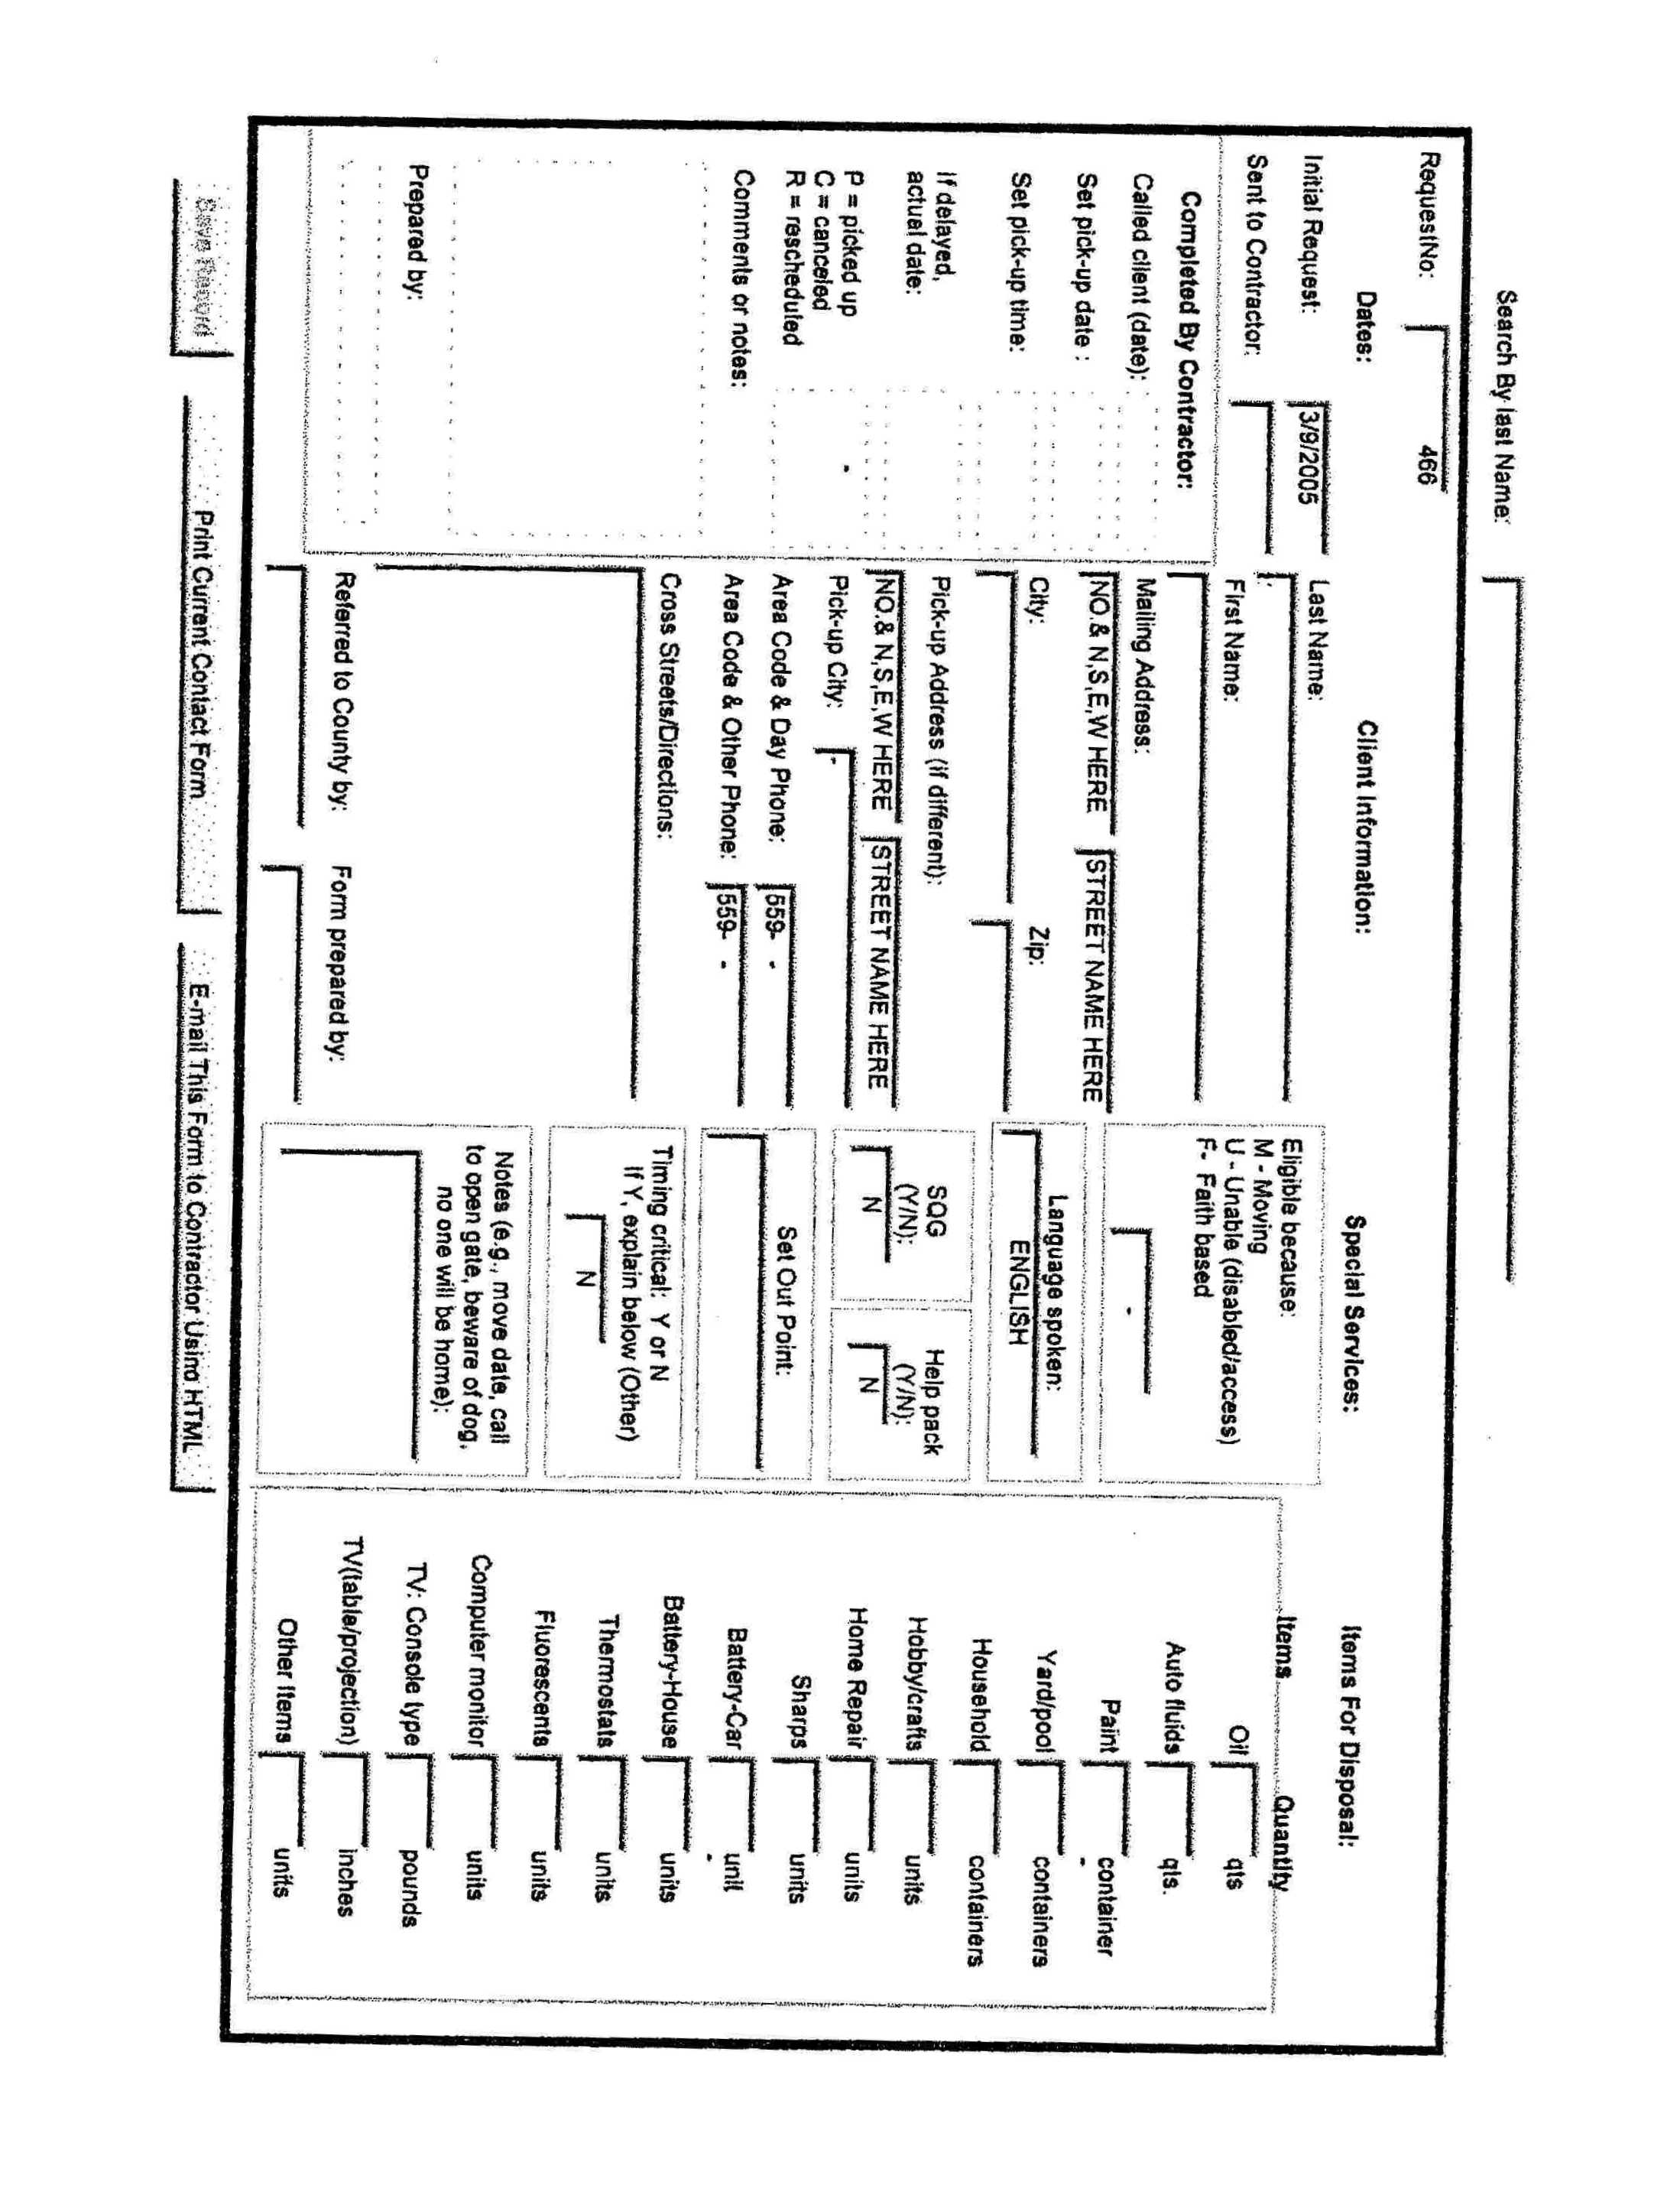
attachment “b”

