COUNTY OF FRESNO
ADDENDUM NUMBER: TWO (2)
 |  | RFP NUMBER:
November 2, 2006
 |  |  |  |  | PURCHASING USE
 | ORG/Requisition: / |  |  |  |  | jol | /tmp/in/input.doc
IMPORTANT: SUBMIT PROPOSAL IN SEALED PACKAGE WITH PROPOSAL NUMBER, CLOSING DATE AND BUYER’S NAME MARKED CLEARLY ON THE OUTSIDE TO:
COUNTY OF FRESNO, Purchasing
4525 EAST HAMILTON AVENUE
FRESNO, CA 93702-4599
Closing date of proposal will be at 2:00 p.m., on NOVEMBER 14, 2006.
PROPOSALS WILL BE CONSIDERED LATE WHEN THE OFFICIAL PURCHASING TIME CLOCK READS 2:00 P.M.
Proposals will be opened and publicly read at that time. All proposal information will be available for review after contract award.
Clarification of specifications are to be directed to: Cathi J. Peters, phone (559) 456-7110, FAX (559) 456-7831.
NOTE THE following and attached ADDITIONS, DELETIONS AND/OR CHANGES TO THE REQUIREMENTS OF REQUEST FOR PROPOSAL NUMBER: AND INCLUDE THEM IN YOUR RESPONSE. PLEASE SIGN AND RETURN THIS ADDENDUM WITH YOUR PROPOSAL.
- Attachment “A” – Requests for Clarification received from vendors.
- Attachment “B” – Vendor conference 10.24.06 sign in sheet.
- Attachment “C” – County of Fresno Model Contract (Note: Final negotiations to be made with successful bidder.
- Additional information will be forthcoming in Addendum Three (3).
ACKNOWLEDGMENT OF ADDENDUM NUMBER TWO (2) TO RFP
COMPANY NAME:
(PRINT)
SIGNATURE:
NAME & TITLE:
(PRINT)

attachment “A”
Clarification
- The Fresno County Operational Area includes the entire geographic boundary of Fresno County. Bidders should not interpret the Operational Area as the unincorporated areas of the County only. There is no established goal on the number of jurisdictions that will participate in the LHMP
- Page 14 of the RFP requires Bidders to submit a sample of the contract he is proposing with the County. Normally the County of Fresno will use the County’s standard Agreement. A copy of the standard Agreement is attached; final negotiations will be made with the successful bidder.
- As stated on page 19 of the RFP, the County will be responsible for forming the Steering Committee. This Committee does not currently exist but will be formed prior to the start of a Contract.
- As referenced on page 19 of the RFP, the Contractor shall schedule an educational meeting to inform interested stakeholders on the LHMP project. It is unknown the level of knowledge this group will have on Disaster Mitigation Act requirements within the operational area.
- Page 20 of the RFP states, “Contractor shall post key information, meeting dates, plan progress and a draft copy of the LHMP on an accessible Website during the development process.” This website shall be a contractor sponsored site.
- Page 21 of the RFP references the use of HAZUS-MH and/or Marshall and Swift Evaluation Service in estimating potential damages. The County is interested in an effective, consistent and accurate damage estimate method and has no preference among these two tools.
Additional Information
- The County will make available to the Contractor basic GIS layers such as base map, roads, etc. It does not include a specific layer with critical infrastructure or assets.
Misc. Questions and Answers
- It is the County’s intent to have this plan include non-natural hazards such as hazardous materials, or human caused hazards, even though non-natural hazards are not required under the DMA?
Yes, if the hazard is considered statistically relevant.
- It is the County’ desire for the plan to meet the mitigation planning requirements of other FEMA programs such as the Flood Mitigation Assistance Grant Program (FMA) and the Community Rating System (CRS)?
They may be considered if it is beneficial to the County and its residents.
- Is there any advantage to a Proposer having successfully completed this same service for other counties within the County Central Purchasing Group?
There is no advantage to a bidder that has provided the services to a County within the Purchasing Group, the bids will be evaluated based on the criteria set forth in the RFP. Proposal Content – page 26 under Vendor Company Data is where the vendors would detail similar contracts, experience, qualifications, etc.
ATTACHMENT “B”
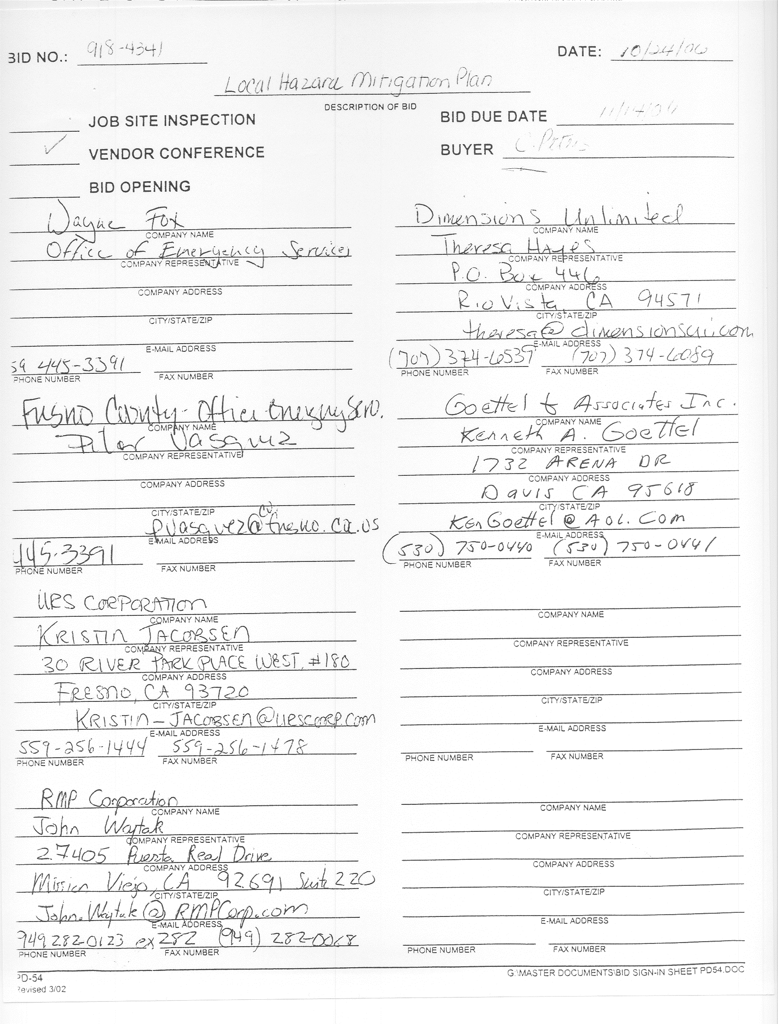
ATTACHMENT “C”
MODEL CONTRACT
Sample Only
FINAL NEGOTATIONS
Will Be Made With Successful Bidder

A G R E E M E N T
THIS AGREEMENT is made and entered into this day of _________________, 200__, by and between the COUNTY OF FRESNO, a Political Subdivision of the State of California, hereinafter referred to as "COUNTY", and _______________________ whose address is________________________________________, hereinafter referred to as "CONTRACTOR".
W I T N E S S E T H:
- OBLIGATIONS OF THE CONTRACTOR

  - (etc.)
- OBLIGATIONS OF THE COUNTY

  - (etc.)
- TERM
This Agreement shall become effective on the ____ day of _______________, 200__, and shall terminate on the ____ day of _______________, 200__.
- TERMINATION
  - Non-Allocation of Funds - The terms of this Agreement, and the services to be provided thereunder, are contingent on the approval of funds by the appropriating government agency. Should sufficient funds not be allocated, the services provided may be modified, or this Agreement terminated, at any time by giving the CONTRACTOR thirty (30) days advance written notice.
  - Breach of Contract - The COUNTY may immediately suspend or terminate this Agreement in whole or in part, where in the determination of the COUNTY there is:
    - An illegal or improper use of funds;
    - A failure to comply with any term of this Agreement;
    - A substantially incorrect or incomplete report submitted to the COUNTY;
    - Improperly performed service.
In no event shall any payment by the COUNTY constitute a waiver by the COUNTY of any breach of this Agreement or any default which may then exist on the part of the CONTRACTOR. Neither shall such payment impair or prejudice any remedy available to the COUNTY with respect to the breach or default. The COUNTY shall have the right to demand of the CONTRACTOR the repayment to the COUNTY of any funds disbursed to the CONTRACTOR under this Agreement, which in the judgment of the COUNTY were not expended in accordance with the terms of this Agreement. The CONTRACTOR shall promptly refund any such funds upon demand.
  - Without Cause - Under circumstances other than those set forth above, this Agreement may be terminated by COUNTY upon the giving of thirty (30) days advance written notice of an intention to terminate to CONTRACTOR.
- COMPENSATION/INVOICING: (Note to County staff: If sales tax is applicable and to be paid to an out-of-state vendor, it must be separated from the total compensation and the vendor must have a California Sales Tax Permit Number.) COUNTY agrees to pay CONTRACTOR and CONTRACTOR agrees to receive compensation as follows:
___________________________. CONTRACTOR shall submit monthly invoices in triplicate to the County of Fresno (department name)
In no event shall services performed under this Agreement be in excess of
during the term of this Agreement. It is understood that all expenses incidental to CONTRACTOR'S performance of services under this Agreement shall be borne by CONTRACTOR. (Note to County staff: If the number of days within which payment must be made is specified, this paragraph must provide for payment after a minimum of forty-five (45) days from date of receipt of invoice by the COUNTY.)
- INDEPENDENT CONTRACTOR: In performance of the work, duties and obligations assumed by CONTRACTOR under this Agreement, it is mutually understood and agreed that CONTRACTOR, including any and all of the CONTRACTOR'S officers, agents, and employees will at all times be acting and performing as an independent contractor, and shall act in an independent capacity and not as an officer, agent, servant, employee, joint venturer, partner, or associate of the COUNTY. Furthermore, COUNTY shall have no right to control or supervise or direct the manner or method by which CONTRACTOR shall perform its work and function. However, COUNTY shall retain the right to administer this Agreement so as to verify that CONTRACTOR is performing its obligations in accordance with the terms and conditions thereof.
CONTRACTOR and COUNTY shall comply with all applicable provisions of law and the rules and regulations, if any, of governmental authorities having jurisdiction over matters the subject thereof.
Because of its status as an independent contractor, CONTRACTOR shall have absolutely no right to employment rights and benefits available to COUNTY employees. CONTRACTOR shall be solely liable and responsible for providing to, or on behalf of, its employees all legally-required employee benefits. In addition, CONTRACTOR shall be solely responsible and save COUNTY harmless from all matters relating to payment of CONTRACTOR'S employees, including compliance with Social Security withholding and all other regulations governing such matters. It is acknowledged that during the term of this Agreement, CONTRACTOR may be providing services to others unrelated to the COUNTY or to this Agreement.
- MODIFICATION: Any matters of this Agreement may be modified from time to time by the written consent of all the parties without, in any way, affecting the remainder.
- NON-ASSIGNMENT: Neither party shall assign, transfer or sub-contract this Agreement nor their rights or duties under this Agreement without the prior written consent of the other party.
- HOLD HARMLESS: CONTRACTOR agrees to indemnify, save, hold harmless, and at COUNTY'S request, defend the COUNTY, its officers, agents, and employees from any and all costs and expenses, damages, liabilities, claims, and losses occurring or resulting to COUNTY in connection with the performance, or failure to perform, by CONTRACTOR, its officers, agents, or employees under this Agreement, and from any and all costs and expenses, damages, liabilities, claims, and losses occurring or resulting to any person, firm, or corporation who may be injured or damaged by the performance, or failure to perform, of CONTRACTOR, its officers, agents, or employees under this Agreement.
- INSURANCE: Without limiting the COUNTY'S right to obtain indemnification from CONTRACTOR or any third parties, CONTRACTOR, at is sole expense, shall maintain in full force and effect the following insurance policies throughout the term of this Agreement:
  - (State the type and minimum amount of insurance coverage for each policy.)
  - Workers Compensation insurance in accordance with the California Labor Code.
Such insurance policies shall name the COUNTY, its officers, agents, and employees, individually and collectively as additional insured, but only insofar as the operations under this contract are concerned. (Note to County staff: If the Contractor is to name County as additional insured for less than all the policies, state here which ones apply, such as "Comprehensive General Liability only". Check with Risk Management Division to see which policies, if any, should name the County as an additional insured.) Such coverage for additional insured shall apply as primary insurance and any other insurance, or self-insurance, maintained by the COUNTY, its officers, agents, and employees, shall be excess only and not contributing with insurance provided under the CONTRACTOR'S policies herein. This insurance shall not be cancelled or changed without a minimum of thirty (30) days advance, written notice given to COUNTY.
Prior to the commencement of performing its obligations under this Agreement, CONTRACTOR shall provide certificates of insurance on the foregoing policies (Note to County staff: If the Contractor is to provide certificates for less than all the policies, state here which ones apply, such as "Comprehensive General Liability only"), as required herein, to the COUNTY'S
(department name) , stating that such insurance coverages have been obtained and are in full force; that the COUNTY, its officers, agents, and employees will not be responsible for any premiums on the policies; that such insurance names the COUNTY, its officers, agents, and employees, individually and collectively, as additional insured (except Workers Compensation Insurance), but only insofar as the operations under this contract are concerned; that such coverage for additional insured shall apply as primary insurance and any other insurance, or self-insurance, maintained by the COUNTY, its officers, agents, and employees, shall be excess only and not contributing with insurance provided under the CONTRACTOR'S policies herein; and that this insurance shall not be cancelled or changed without a minimum of thirty (30) days advance, written notice given to COUNTY.
In the event CONTRACTOR fails to keep in effect at all times insurance coverage as herein provided, the COUNTY may, in addition to other remedies it may have, suspend or terminate this Agreement upon the occurrence of such event.
- AUDITS AND INSPECTIONS: The CONTRACTOR shall at any time during business hours, and as often as the COUNTY may deem necessary, make available to the COUNTY for examination all of its records and data with respect to the matters covered by this Agreement. The CONTRACTOR shall, upon request by the COUNTY, permit the COUNTY to audit and inspect all of such records and data necessary to ensure CONTRACTOR'S compliance with the terms of this Agreement.
If this Agreement exceeds ten thousand dollars ($10,000.00), CONTRACTOR shall be subject to the examination and audit of the Auditor General for a period of three (3) years after final payment under contract (Government Code Section 8546.7).
- NOTICES: The persons and their addresses having authority to give and receive notices under this Agreement include the following:
COUNTY | CONTRACTOR
COUNTY OF FRESNO
Any and all notices between the COUNTY and the CONTRACTOR provided for or permitted under this Agreement or by law shall be in writing and shall be deemed duly served when personally delivered to one of the parties, or in lieu of such personal services, when deposited in the United States Mail, postage prepaid, addressed to such party.
- GOVERNING LAW: Venue for any action arising out of or related to this Agreement shall only be in Fresno County, California.
The rights and obligations of the parties and all interpretation and performance of this Agreement shall be governed in all respects by the laws of the State of California.
- ENTIRE AGREEMENT: This Agreement constitutes the entire agreement between the CONTRACTOR and COUNTY with respect to the subject matter hereof and supersedes all previous Agreement negotiations, proposals, commitments, writings, advertisements, publications, and understanding of any nature whatsoever unless expressly included in this Agreement. [If applicable, add the following: In the event of any inconsistency in interpreting the documents which constitute this Agreement, the inconsistency shall be resolved by giving precedence in the following order of priority: (1) the text of this Agreement (excluding Attachment "A", the COUNTY'S Request for Quotation No. and the CONTRACTOR'S Quote in response thereto); (2) Agreement Renewal Attachment "A", dated ; (3) the COUNTY'S Request for Quotation No. ; and (4) the CONTRACTOR'S quotation made in response to COUNTY'S Request for Quotation No. .]
IN WITNESS WHEREOF, the parties hereto have executed this Agreement as of the day and year first hereinabove written.
CONTRACTOR |  |  |  | COUNTY OF FRESNO
(Authorized Signature) |  |  |  | Chairman, Board of Supervisors
Print Name & Title
Mailing Address
DATE: |  |  |  | DATE:
 |  |  |  | REVIEWED & RECOMMENDED FOR APPROVAL
 |  |  |  | Department Head's Signature
APPROVED AS TO LEGAL FORM |  |  |  | APPROVED AS TO ACCOUNTING FORM
County Counsel |  |  |  | Auditor-Controller/Treasurer-Tax Collector
FOR ACCOUNTING USE ONLY:
ORG No.: |  | [click to type type org]
Account No.: |  | [click to type type account]
Requisition No.: |  | [click to type requisition number]
FCMC 1/95

/tmp/in/input.doc

