COUNTY OF FRESNO
Request for QUOTATION
 |  | NUMBER: 910-4650
December 15, 2008
ORG/Requisition: 56107001/ 5619000651 |  |  |  |  |  |  | PURCHASING USE |  |  |  | /tmp/in/input.doc
 |  |  |  |  |  |  | JOL
IMPORTANT: SUBMIT QUOTATION IN SEALED PACKAGE WITH QUOTATION NUMBER, CLOSING DATE AND BUYER’S NAME MARKED CLEARLY ON THE OUTSIDE TO:
COUNTY OF FRESNO, Purchasing
4525 EAST HAMILTON AVENUE
FRESNO, CA 93702-4599
Closing date of bid will be at 2:00 p.m., on January 20, 2009.
QUOTATIONS WILL BE CONSIDERED LATE WHEN THE OFFICIAL PURCHASING TIME CLOCK READS 2:00 P.M.
Quotations will be opened and publicly read at that time. All quotation information will be available for review after contract award.
Clarification of specifications is to be directed to: Craig Nickel/Gary Parkinson, phone (559) 456-7110, FAX (559) 456-7831.
GENERAL CONDITIONS: See “County Of Fresno Purchasing Standard Instructions And Conditions For Request For Proposals (RFP’S) and Requests for Quotations (RFQ’S)” attached. Check County of Fresno Purchasing’s Open Solicitations website at http://www2.co.fresno.ca.us/0440/Bidshome2.asp for RFQ/RFP documents and changes.
BIDDER TO COMPLETE
UNDERSIGNED AGREES TO FURNISH THE COMMODITY OR SERVICE STIPULATED IN THE ATTACHED QUOTATION SCHEDULE AT THE PRICES AND TERMS STATED, SUBJECT TO THE “COUNTY OF FRESNO PURCHASING STANDARD INSTRUCTIONS AND CONDITIONS FOR REQUEST FOR QUOTATIONS (RFP’S) AND REQUESTS FOR QUOTATIONS (RFQ’S)”ATTACHED.
Except as noted on individual items, the following will apply to all items in the Quotation Schedule.
- Complete delivery will be made within |  |  |  |  |  |  |  | calendar days after receipt of Order.
- A cash discount of |  |  |  |  | % |  |  |  |  | days will apply.
Company
Address
City |  |  |  |  |  |  |  |  |  |  |  |  | State |  | Zip Code
( ) |  |  |  | ( )
Telephone Number |  |  |  | Facsimile Number |  |  |  |  |  |  |  |  | E-mail Address
Signed By
Print Name |  |  |  |  |  |  |  |  | Title

COUNTY OF FRESNO PURCHASING
STANDARD INSTRUCTIONS AND CONDITIONS FOR
REQUESTS FOR PROPOSALS (RFP'S) AND REQUESTS FOR QUOTATIONS (RFQ'S)
Note: the reference to “bids” in the following paragraphs applies to RFP's and RFQ's

GENERAL CONDITIONS
By submitting a bid the bidder agrees to the following conditions. These conditions will apply to all subsequent purchases based on this bid.

- BID PREPARATION:
  - All prices and notations must be typed or written in ink. No erasures permitted. Errors may be crossed out, initialed and corrections printed in ink by person signing bid.
  - Brand Names: Brand names and numbers when given are for reference. Equal items will be considered, provided the offer clearly describes the article and how it differs from that specified. In the absence of such information it shall be understood the offering is exactly as specified.
  - State brand or make of each item. If bidding on other than specified, state make, model and brand being bid and attach supporting literature/specifications to the bid.
  - Bid on each item separately. Prices should be stated in units specified herein. All applicable charges must be quoted; charges on invoice not quoted herein will be disallowed.
  - Time of delivery is a part of the consideration and must be stated in definite terms and must be adhered to. F.O.B. Point shall be destination or freight charges must be stated.
  - All bids must be dated and signed with the firm’s name and by an authorized officer or employee.
  - Unless otherwise noted, prices shall be firm for 120 days after closing date of bid.
- SUBMITTING BIDS:
  - Each bid must be submitted on forms provided in a sealed envelope with bid number and closing date and time on the outside of the envelope/package.
  - Interpretation: Should any discrepancies or omissions be found in the bid specifications or doubt as to their meaning, the bidder shall notify the Buyer in writing at once. The County shall not be held responsible for verbal interpretations. Questions regarding the bid must be received by Purchasing at least 5 working days before bid opening. All addenda issued shall be in writing, duly issued by Purchasing and incorporated into the contract.
  - ISSUING AGENT/AUTHORIZED CONTACT: This RFQ has been issued by County of Fresno Purchasing. Purchasing shall be the vendor’s sole point of contact with regard to the RFQ, its content, and all issues concerning it.
All communication regarding this RFQ shall be directed to an authorized representative of County Purchasing. The specific buyer managing this RFQ is identified on the cover page, along with his or her telephone number, and he or she should be the primary point of contact for discussions or information pertaining to the RFQ. Contact with any other County representative, including elected officials, for the purpose of discussing this RFQ, its content, or any other issue concerning it, is prohibited unless authorized by Purchasing. Violation of this clause, by the vendor having unauthorized contact (verbally or in writing) with such other County representatives, may constitute grounds for rejection by Purchasing of the vendor’s quotation.
The above stated restriction on vendor contact with County representatives shall apply until the County has awarded a purchase order or contract to a vendor or vendors, except as follows. First, in the event that a vendor initiates a formal protest against the RFQ, such vendor may contact the appropriate individual, or individuals who are managing that protest as outlined in the County’s established protest procedures. All such contact must be in accordance with the sequence set forth under the protest procedures. Second, in the event a public hearing is scheduled before the Board of Supervisors to hear testimony prior to its approval of a purchase order or contract, any vendor may address the Board.
  - Bids received after the closing time will NOT be considered.
  - Bidders are to bid what is specified or requested first. If unable to or willing to, bidder may bid alternative or option, indicating all advantages, disadvantages and their associated cost.
  - Public Contract Code Section 7028.15
Where the State of California requires a Contractor’s license, it is a misdemeanor for any person to submit a bid unless specifically exempted.
- FAILURE TO BID:
  - If not bidding, return bid sheet and state reason for no bid or your name may be removed from mailing list.
- TAXES, CHARGES AND EXTRAS:
  - County of Fresno is subject to California sales and/or use tax (7.975%). Please indicate as a separate line item if applicable.
  - DO NOT include Federal Excise Tax. County is exempt under Registration No. 94-73-03401-K.
  - County is exempt from Federal Transportation Tax. Exemption certificate is not required where shipping papers show consignee as County of Fresno.
  - Charges for transportation, containers, packing, etc. will not be paid unless specified in bid.
- W-9 – REQUEST FOR TAXPAYER IDENTIFICATION NUMBER AND CERTIFICATION:
Upon award of bid, the vendor shall submit to County Purchasing, a completed W-9 - Request for Taxpayer Identification Number and Certification if not already a current vendor with The County of Fresno. This form is available from the IRS to complete on line at http://www.irs.gov/pub/irs-pdf/fw9.pdf.
- AWARDS:
  - Subject to the local preference provisions referenced in Paragraph 6 below and more thoroughly set forth in the General Requirements section of this RFQ, award(s) will be made to the most responsive responsible bidder. The evaluation will include such things as life-cycle cost, availability, delivery costs and whose product and/or service is deemed to be in the best interest of the County. The County shall be the sole judge in making such determination.
  - Unless bidder gives notice of all-or-none award in bid, County may accept any item, group of items or on the basis of total bid.
  - The County reserves the right to reject any and all bids and to waive informalities or irregularities in bids.
  - After award, all bids shall be open to public inspection. The County assumes no responsibility for the confidentiality of information offered in a bid.
- LOCAL VENDORS
  - Local Vendor Preference (applicable to RFQ Process only)
The following provisions are applicable only to the County’s acquisition of materials, equipment or supplies through the RFQ process when the funding source does not require an exemption to the Local Vendor Preference.
THE PROVISIONS OF THIS PARAGRAPH ARE APPLICABLE, NOTWITHSTANDING ANY OTHER PROVISIONS OF THIS RFQ TO THE CONTRARY
If the apparent low bidder is not a local vendor, any local vendor who submitted a bid which was within five percent (5%) of the lowest responsive bid as determined by the purchasing agent shall have the option of submitting a new bid within forty-eight hours (not including weekends and holidays) of County’s delivery of notification. Such new bids must be in an amount less than or equal to the lowest responsive bid as determined by the purchasing agent. If the purchasing agent receives any new bids from local vendors who have the option of submitting new bids within said forty-eight hour period, it shall award the contract to the local vendor submitting the lowest responsible bid. If no new bids are received, the contract shall be awarded to the original low bidder as announced by the purchasing agent.
  - Local Vendor Defined
“Local Vendor” shall mean any business which:
- Has its headquarters, distribution point or locally-owned franchise located in or having a street address within the County for at least six (6) months immediately prior to the issuance of the request for competitive bids by the purchasing agent; and
- Holds any required business license by a jurisdiction located in Fresno County; and
- Employs at least one (1) full-time or two (2) part-time employees whose primary residence is located within Fresno County, or if the business has no employees, shall be at least fifty percent (50%) owned by one or more persons whose primary residence(s) is located within Fresno County.
- TIE BIDS:
All other factors being equal, the contract shall be awarded to the Fresno County vendor or, if neither or both are Fresno County vendors, it may be awarded by the flip of a coin in the presence of witnesses or the entire bid may be rejected and re-bid. If the General Requirements of this RFQ state that they are applicable, the provisions of the Fresno County Local Vendor Preference shall take priority over this paragraph.
- PATENT INDEMNITY:
The vendor shall hold the County, its officers, agents and employees, harmless from liability of any nature or kind, including costs and expenses, for infringement or use of any copyrighted or uncopyrighted composition, secret process, patented or unpatented invention, article or appliance furnished or used in connection with this bid.
- SAMPLES:
Samples, when required, must be furnished and delivered free and, if not destroyed by tests, will upon written request (within 30 days of bid closing date) be returned at the bidder's expense. In the absence of such notification, County shall have the right to dispose of the samples in whatever manner it deems appropriate.
- RIGHTS AND REMEDIES OF COUNTY FOR DEFAULT:
  - In case of default by vendor, the County may procure the articles or service from another source and may recover the cost difference and related expenses occasioned thereby from any unpaid balance due the vendor or by proceeding against performance bond of the vendor, if any, or by suit against the vendor. The prices paid by the County shall be considered the prevailing market price at the time such purchase is made.
  - Articles or services, which upon delivery inspection do not meet specifications, will be rejected and the vendor will be considered in default. Vendor shall reimburse County for expenses related to delivery of non-specified goods or services.
  - Regardless of F.O.B. point, vendor agrees to bear all risks of loss, injury or destruction to goods and materials ordered herein which occur prior to delivery and such loss, injury or destruction shall not release vendor from any obligation hereunder.
- DISCOUNTS:
Terms of less than 15 days for cash payment will be considered as net in evaluating this bid. A discount for payment within fifteen (15) days or more will be considered in determining the award of bid. Discount period will commence either the later of delivery or receipt of invoice by the County. Standard terms are Net Forty-five (45) days.
- SPECIAL CONDITIONS IN BID SCHEDULE SUPERSEDE GENERAL CONDITIONS.
The “General Conditions” provisions of this RFP/RFQ shall be superseded if in conflict with any other section of this bid, to the extent of any such conflict.
- SPECIAL REQUIREMENT:
With the invoice or within twenty-five (25) days of delivery, the seller must provide to the County a Material Safety Data Sheet for each product, which contains any substance on “The List of 800 Hazardous Substances”, published by the State Director of Industrial Relations. (See Hazardous Substances Information and Training Act. California State Labor Code Sections 6360 through 6399.7.)
- RECYCLED PRODUCTS/MATERIALS:
Vendors are encouraged to provide and quote (with documentation) recycled or recyclable products/materials which meet stated specifications.
- YEAR COMPLIANCE WARRANTY
Vendor warrants that any product furnished pursuant to this Agreement/order shall support a four-digit year format and be able to accurately process date and time data from, into and between the twentieth and twenty-first centuries, as well as leap year calculations. "Product" shall include, without limitation, any piece or component of equipment, hardware, firmware, middleware, custom or commercial software, or internal components or subroutines therein. This warranty shall survive termination or expiration of this Agreement.
In the event of any decrease in product functionality or accuracy related to time and/or date data related codes and/or internal subroutines that impede the product from operating correctly using dates beyond December 31, 1999, vendor shall restore or repair the product to the same level of functionality as warranted herein, so as to minimize interruption to County's ongoing business process, time being of the essence. In the event that such warranty compliance requires the acquisition of additional programs, the expense for any such associated or additional acquisitions, which may be required, including, without limitation, data conversion tools, shall be borne exclusively by vendor. Nothing in this warranty shall be construed to limit any rights or remedies the County may otherwise have under this Agreement with respect to defects other than year performance.
- PARTICIPATION:
Bidder may agree to extend the terms of the resulting contract to other political subdivision, municipalities and tax-supported agencies.
Such participating Governmental bodies shall make purchases in their own name, make payment directly to bidder, and be liable directly to the bidder, holding the County of Fresno harmless.
- CONFIDENTIALITY:
All services performed by vendor shall be in strict conformance with all applicable Federal, State of California and/or local laws and regulations relating to confidentiality, including but not limited to, California Civil Code, California Welfare and Institutions Code, Health and Safety Code, California Code of Regulations, Code of Federal Regulations.
Vendor shall submit to County’s monitoring of said compliance.
Vendor may be a business associate of County, as that term is defined in the “Privacy Rule” enacted by the Health Insurance Portability and Accountability Act of 1996 (HIPAA). As a HIPAA Business Associate, vendor may use or disclose protected health information (“PHI”) to perform functions, activities or services for or on behalf of County as specified by the County, provided that such use or disclosure shall not violate HIPAA and its implementing regulations. The uses and disclosures if PHI may not be more expansive than those applicable to County, as the “Covered Entity” under HIPAA’S Privacy Rule, except as authorized for management, administrative or legal responsibilities of the Business Associate.
Vendor shall not use or further disclose PHI other than as permitted or required by the County, or as required by law without written notice to the County.
Vendor shall ensure that any agent, including any subcontractor, to which vendor provides PHI received from, or created or received by the vendor on behalf of County, shall comply with the same restrictions and conditions with respect to such information.
- APPEALS
Appeals must be submitted in writing within seven (7) working days after the review committee notification of proposed recommendations. Appeals should be submitted to County of Fresno Purchasing, 4525 E. Hamilton Avenue, Fresno, California 93702-4599. Appeals should address only areas regarding RFP contradictions, procurement errors, quotation rating discrepancies, legality of procurement context, conflict of interest, and inappropriate or unfair competitive procurement grievance regarding the RFP process.
The Purchasing Manager will provide a written response to the complaint within seven (7) working days unless the complainant is notified more time is required.
If the protesting bidder is not satisfied with the decision of the Purchasing Manager, he/she shall have the right to appeal to the Purchasing Agent within seven (7) business days after notification of the Purchasing Manager’s decision.
If the protesting bidder is not satisfied with Purchasing Agent decision, the final appeal is with the Board of Supervisors.
- OBLIGATIONS OF CONTRACTOR:
  - CONTRACTOR shall perform as required by the ensuing contract. CONTRACTOR also warrants on behalf of itself and all subcontractors engaged for the performance of the ensuing contract that only persons authorized to work in the United States pursuant to the Immigration Reform and Control Act of 1986 and other applicable laws shall be employed in the performance of the work hereunder.
  - CONTRACTOR shall obey all Federal, State, local and special district laws, ordinances and regulations.
- AUDITS & RETENTION:
The Contractor shall maintain in good and legible condition all books, documents, papers, data files and other records related to its performance under this contract. Such records shall be complete and available to Fresno County, the State of California, the federal government or their duly authorized representatives for the purpose of audit, examination, or copying during the term of the contract and for a period of at least three years following the County's final payment under the contract or until conclusion of any pending matter (e.g., litigation or audit), whichever is later. Such records must be retained in the manner described above until all pending matters are closed.

BIDDING INSTRUCTIONS

CONTRACT SERVICES
The County of Fresno is soliciting bids to establish an agreement under which the successful bidder will provide Janitorial Services for the following locations:
- 36678 S. Lassen Ave #1
Huron, CA 93234
Approximately 720 square feet
- 311 Coalinga Plaza
Coalinga, CA 93210
Approximately 24,000 square feet
LOCAL VENDOR PREFERENCE: The Local Vendor Preference does not apply to this Request for Quotation.
DEFINITIONS: The terms Bidder, Proposer, Contractor and Vendor are all used interchangeably and refer to that person, partnership, corporation, organization, agency, etc. which is offering the quotation and is identified on page one of this Request For Quotation (RFQ).
INTERPRETATION OF RFQ: Vendors must make careful examination of the requirements, specifications and conditions expressed in the RFQ and fully inform themselves as to the quality and character of services required. If any person planning to submit a quotation finds discrepancies in or omissions from the RFQ or has any doubt as to the true meaning or interpretation, correction thereof may be requested at the scheduled Vendor Conference (see below). Any change in the RFQ will be made only by written addendum, duly issued by the County. The County will not be responsible for any other explanations or interpretations.
Questions may be submitted subsequent to the Vendor Conference, subject to the following conditions:
- Such questions are submitted in writing, by FAX (FAX No. (559)456-7831) or by e-mail (countypurchasing@co.fresno.ca.us) to County Purchasing. The deadline for submitting requests for clarification is January 5, 2009 8:00 A.M. Questions must be directed to the attention of the buyer identified on page one.
- Such questions are submitted with the understanding that County can respond only to questions it considers material in nature.
If faxing the bidder must confirm receipt by phone within one-half (1/2) hour of transmission.
NOTE: The bidder is encouraged to submit all questions at the Vendor Conference. Time limitations can prevent a response to questions submitted after the conference.
AWARD: Award will be made to the vendor(s) offering the services deemed to be to the best advantage of the County. The County shall be the sole judge in making such determination. The County reserves the right to award each location independent of the other.
RIGHT TO REJECT BIDS: The County reserves the right to reject any and all bids and to waive informalities or irregularities in bids.
ISSUING AGENT: This RFQ has been issued by County of Fresno Purchasing. Purchasing shall be the vendor’s sole point of contact with regard to the RFQ, its content, and all issues concerning it.
AUTHORIZED CONTACT: All communication regarding this RFQ shall be directed to an authorized representative of County Purchasing. The specific buyer managing this RFQ is identified on the cover page, along with his or her telephone number, and he or she should be the primary point of contact for discussions or information pertaining to the RFQ. Contact with any other County representative, including elected officials, for the purpose of discussing this RFQ, it content, or any other issue concerning it, is prohibited unless authorized by Purchasing. Violation of this clause, by the vendor having unauthorized contact (verbally or in writing) with such other County representatives, may constitute grounds for rejection by Purchasing of the vendor’s quotation.
The above stated restriction on vendor contact with County representatives shall apply until the County has awarded a purchase order or contract to a vendor or vendors, except as follows. First, in the event that a vendor initiates a formal protest against the RFQ, such vendor may contact the appropriate individual, or individuals who are managing that protest as outlined in the County’s established protest procedures. All such contact must be in accordance with the sequence set forth under the protest procedures. Second, in the event a public hearing is scheduled before the Board of Supervisors to hear testimony prior to its approval of a purchase order or contract, any vendor may address the Board.
SITE INSPECTION /BIDDERS CONFERENCE: A site inspection and bidders conference has been scheduled to allow the bidders an opportunity to tour the facilities and formally present their questions and concerns regarding this project. The site inspection will begin at Huron, and then continue to Coalinga. After both site inspections the bidders conference will be held. An addendum to the RFQ will be prepared and distributed if necessary to clarify, change, add or delete substantive items raised during the conference.
DATE: Monday December 29th, 2008
TIME: 10:00 A.M.
LOCATION: 36678 S. Lassen Ave #1
Huron, CA 93234
*Vendors are requested to contact Kent Luckin at (559) 253-9555 or Ed Moreno at (559) 453-3927 if they plan on attending the bidder’s conference. Note: If no vendors show up for the site inspection at Huron there will not be a site inspection at Coalinga.
NUMBER OF COPIES: Submit one (1) original and three (3) copies of your quotation no later than the quotation closing date and time as stated on the front of this document to County of Fresno Purchasing. Each copy to be identical to the original, include all supporting documentation (i.e. literature, brochures, reports, schedules etc.). The cover page of each quotation is to be appropriately marked “Original” or “Copy”.
FIRM QUOTATION: For purpose of award, all quotations shall remain firm for at least one hundred twenty (120) days. The anticipated date of any new agreements resulting from this RFQ is April 1, 2009.
TAXES: The quoted amount must include all applicable taxes. If taxes are not specifically identified in the quotation it will be assumed that they are included in the total quoted.
SALES TAX: Fresno County pays California State Sales Tax in the amount of 7.975% regardless of vendor's place of doing business.
MINOR DEVIATIONS: The County reserves the right to negotiate minor deviations from the prescribed terms, conditions and requirements with the selected vendor.
QUOTATION REJECTION: Failure to respond to all questions or not to supply the requested information could result in rejection of your quotation.
BIDDERS’ LIABILITIES: County of Fresno will not be held liable for any cost incurred by vendors in responding to the RFQ.
PRICE RESPONSIBILITY: The selected vendor will be required to assume full responsibility for all services and activities offered in the quotation, whether or not they are provided directly. Further, the County of Fresno will consider the selected vendor to be the sole point of contact with regard to contractual matters, including payment of any and all charges resulting from the contract. The contractor may not subcontract or transfer the contract, or any right or obligation arising out of the contract, without first having obtained the express written consent of the County.
CONFIDENTIALITY: Bidders shall not disclose information about the County's business or business practices and safeguard confidential data which vendor staff may have access to in the course of system implementation.
NEWS RELEASE: Vendors shall not issue any news releases or otherwise release information to any third party about this RFQ or the vendor's quotation without prior written approval from the County of Fresno.
BACKGROUND REVIEW: The County reserves the right to conduct a background inquiry of each proposer/bidder which may include collection of appropriate criminal history information, contractual and business associations and practices, employment histories and reputation in the business community. By submitting a quotation/bid to the County, the vendor consents to such an inquiry and agrees to make available to the County such books and records the County deems necessary to conduct the inquiry.
EXCEPTIONS: Identify with explanation, any terms, conditions, specifications or stipulations of the RFQ with which you CAN NOT or WILL NOT comply.
ADDENDA: In the event that it becomes necessary to revise any part of this RFQ, addenda will be provided to all agencies and organizations that receive the basic RFQ.
SUBCONTRACTORS: If a subcontractor is proposed, complete identification of the subcontractor and his tasks shall be provided. The primary contractor is not relieved of any responsibility by virtue of using a subcontractor.
CONFLICT OF INTEREST: The County shall not contract with, and shall reject any bid or quotation submitted by the persons or entities specified below, unless the Board of Supervisors finds that special circumstances exist which justify the approval of such contract:
- Employees of the County or public agencies for which the Board of Supervisors is the governing body.
- Profit-making firms or businesses in which employees described in Subsection (1) serve as officers, principals, partners or major shareholders.
- Persons who, within the immediately preceding twelve (12) months, came within the provisions of Subsection (1), and who were employees in positions of substantial responsibility in the area of service to be performed by the contract, or participated in any way in developing the contract or its service specifications.
- Profit-making firms or businesses in which the former employees described in Subsection (3) serve as officers, principals, partners or major shareholders.
- No County employee whose position in the County enables him to influence the selection of a contractor for this RFQ, or any competing RFQ, and no spouse or economic dependent of such employee, shall be employees in any capacity by a bidder, or have any other direct or indirect financial interest in the selection of a contractor.
INVOICING: Contractor shall invoice the County monthly. All invoices are to be delivered in triplicate to the County of Fresno, Department of Employment and Temporary Assistance, 4499 E.Kings Canyon Road, Barton 3rd Floor, Fresno, CA 93702. Invoice shall reference the time period covered and the contract number.
PAYMENT: County will make payments in arrears, for services provided during the preceding month, within forty-five (45) days after receipt and verification of contractor’s invoices by the County.
CONTRACT TERM: It is County’s intent to contract with the successful bidder for a term of three (3) years with the option to renew for two (2) additional one (1) year periods.
PRICES: Bidder agrees that prices quoted are maximum for the contract period, and in the event of a price decline such lower prices shall be extended to the County of Fresno.
INDEPENDENT CONTRACTOR: In performance of the work, duties, and obligations assumed by Contractor under any ensuing Agreement, it is mutually understood and agreed that CONTRACTOR, including any and all of Contractor’s officers, agents, and employees will at all times be acting and performing as an independent contractor, and shall act in an independent capacity and not as an officer, agent, servant, employee, joint venturer, partner, or associate of the COUNTY. Furthermore, County shall have no right to control or supervise or direct the manner or method by which Contractor shall perform its work and function. However, County shall retain the right to administer this Agreement so as to verify that Contractor is performing its obligations in accordance with the terms and conditions thereof. Contractor and County shall comply with all applicable provisions of law and the rules and regulations, if any, of governmental authorities having jurisdiction over matters the subject thereof.
Because of its status as an independent contractor, Contractor shall have absolutely no right to employment rights and benefits available to County employees. Contractor shall be solely liable and responsible for providing to, or on behalf of, its employees all legally-required employee benefits. In addition, Contractor shall be solely responsible and save County harmless from all matters relating to payment of Contractor's employees, including compliance with Social Security, withholding, and all other regulations governing such matters. It is acknowledged that during the term of the Agreement, Contractor may be providing services to others unrelated to the County or to the Agreement.
HOLD HARMLESS CLAUSE: Contractor agrees to indemnify, save, hold harmless and at County's request, defend the County, its officers, agents and employees, from any and all costs and expenses, damages, liabilities, claims and losses occurring or resulting to County in connection with the performance, or failure to perform, by Contractor, its officers, agents or employees under this Agreement and from any and all costs and expenses, damages, liabilities, claims and losses occurring or resulting to any person, firm or corporation who may be injured or damaged by the performance, or failure to perform, of Contractor, its officers, agents or employees under this Agreement.
INSURANCE:
Without limiting the COUNTY's right to obtain indemnification from CONTRACTOR or any third parties, CONTRACTOR, at its sole expense, shall maintain in full force and effect, the following insurance policies or a program of self-insurance, including but not limited to, an insurance pooling arrangement or Joint Powers Agreement (JPA) throughout the term of the Agreement:
- Commercial General Liability
Commercial General Liability Insurance with limits of not less than One Million Dollars ($1,000,000) per occurrence and an annual aggregate of Two Million Dollars ($2,000,000). This policy shall be issued on a per occurrence basis. COUNTY may require specific coverages including completed operations, products liability, contractual liability, Explosion-Collapse-Underground, fire legal liability or any other liability insurance deemed necessary because of the nature of this contract.
- Automobile Liability
Comprehensive Automobile Liability Insurance with limits for bodily injury of not less than Two Hundred Fifty Thousand Dollars ($250,000.00) per person, Five Hundred Thousand Dollars ($500,000.00) per accident and for property damages of not less than Fifty Thousand Dollars ($50,000.00), or such coverage with a combined single limit of Five Hundred Thousand Dollars ($500,000.00). Coverage should include owned and non-owned vehicles used in connection with this Agreement.
- Professional Liability
If CONTRACTOR employs licensed professional staff, (e.g., Ph.D., R.N., L.C.S.W., M.F.C.C.) in providing services, Professional Liability Insurance with limits of not less than One Million Dollars ($1,000,000.00) per occurrence, Three Million Dollars ($3,000,000.00) annual aggregate.
- Worker's Compensation
A policy of Worker's Compensation insurance as may be required by the California Labor Code.
CONTRACTOR shall obtain endorsements to the Commercial General Liability insurance naming the County of Fresno, its officers, agents, and employees, individually and collectively, as additional insured, but only insofar as the operations under this Agreement are concerned. Such coverage for additional insured shall apply as primary insurance and any other insurance, or self-insurance, maintained by COUNTY, its officers, agents and employees shall be excess only and not contributing with insurance provided under CONTRACTOR's policies herein. This insurance shall not be cancelled or changed without a minimum of thirty (30) days advance written notice given to COUNTY.
Within Thirty (30) days from the date CONTRACTOR executes this Agreement, CONTRACTOR shall provide certificates of insurance and endorsement as stated above for all of the foregoing policies, as required herein, to the County of Fresno, Kent Luckin, Senior Staff Analyst at 4499 E. Kings Canyon Rd,, Fresno, CA 93702 stating that such insurance coverage have been obtained and are in full force; that the County of Fresno, its officers, agents and employees will not be responsible for any premiums on the policies; that such Commercial General Liability insurance names the County of Fresno, its officers, agents and employees, individually and collectively, as additional insured, but only insofar as the operations under this Agreement are concerned; that such coverage for additional insured shall apply as primary insurance and any other insurance, or self-insurance, maintained by COUNTY, its officers, agents and employees, shall be excess only and not contributing with insurance provided under CONTRACTOR's policies herein; and that this insurance shall not be cancelled or changed without a minimum of thirty (30) days advance, written notice given to COUNTY.
In the event CONTRACTOR fails to keep in effect at all times insurance coverage as herein provided, the COUNTY may, in addition to other remedies it may have, suspend or terminate this Agreement upon the occurrence of such event.
All policies shall be with admitted insurers licensed to do business in the State of California. Insurance purchased shall be purchased from companies possessing a current A.M. Best, Inc. rating of A FSC VII or better.

BONDS:
Bonding Company Requirements: Each bond specified in this RFQ (bid bond, faithful performance bond and payment bond) shall meet the requirements of all applicable statutes, including but not limited to those specified in Public Contract Code section 20129 and Civil Code section 3248. Each bond specified in this RFQ shall be issued by a surety company designated as an admitted surety insurer in good standing with and authorized to transact business in this state by the California Department of Insurance, and acceptable to the County of Fresno. Bidders are cautioned that representations made by surety companies will be verified with the California Department of Insurance. Additionally, the County of Fresno, in its discretion, when determining the sufficiency of a proposed surety company, may require the surety company to provide additional information supported by documentation. The County generally requires such information and documentation whenever the proposed surety company has either a Best’s Key Rating Guide of less than B+ or a financial size designation of less than VIII. Provided, however, that the County expressly reserves its right to require all information and documentation to which the County is legally entitled from any proposed surety company.
PERFORMANCE BOND: The successful bidders may be required to furnish a faithful performance bond.
DISPUTE RESOLUTION: The ensuing contract shall be governed by the laws of the state of California.
Any claim which cannot be amicably settled without court action will be litigated in the U. S. District Court for the Eastern District of California in Fresno, CA or in a state court for Fresno County.
TERMINATION: The County reserves the right to terminate any resulting contract upon written notice.
DEFAULT: In case of default by the selected bidder, the County may procure the services from another source and may recover the loss occasioned thereby from any unpaid balance due the selected bidder, or by any other legal means available to the County.
ASSIGNMENTS: The ensuing proposed contract will provide that the vendor may not assign any payment or portions of payments without prior written consent of the County of Fresno.
ASSURANCES: Any contract awarded under this RFQ must be carried out in full compliance with The Civil Rights Act of 1964, The Americans With Disabilities Act of 1990, their subsequent amendments, and any and all other laws protecting the rights of individuals and agencies. The County of Fresno has a zero tolerance for discrimination, implied or expressed, and wants to ensure that policy continues under this RFQ. The contractor must also guarantee that services, or workmanship, provided will be performed in compliance with all applicable local, state, or federal laws and regulations pertinent to the types of services, or project, of the nature required under this RFQ. In addition, the contractor may be required to provide evidence substantiating that their employees have the necessary skills and training to perform the required services or work.
AUDITS AND RETENTION: The Contractor shall maintain in good and legible condition all books, documents, papers, data files and other records related to its performance under this contract. Such records shall be complete and available to Fresno County, the State of California, the federal government or their duly authorized representatives for the purpose of audit, examination, or copying during the term of the contract and for a period of at least three years following the County's final payment under the contract or until conclusion of any pending matter (e.g., litigation or audit), whichever is later. Such records must be retained in the manner described above until all pending matters are closed.

BIDDER TO COMPLETE THE FOLLOWING:

PARTICIPATION
The County of Fresno is a member of the Central Valley Purchasing Group. This group consists of Fresno, Kern, Kings, and Tulare Counties and all governmental, tax supported agencies within these counties.
Whenever possible, these and other tax supported agencies co-op (piggyback) on contracts put in place by one of the other agencies.
Any agency choosing to avail itself of this opportunity, will make purchases in their own name, make payment directly to the contractor, be liable to the contractor and vice versa, per the terms of the original contract, all the while holding the County of Fresno harmless. If awarded this contract, please indicate whether you would extend the same terms and conditions to all tax supported agencies within this group as you are proposing to extend to Fresno County.
Yes, we will extend contract terms and conditions to all qualified agencies within the Central Valley Purchasing Group and other tax supported agencies.
No, we will not extend contract terms to any agency other than the County of Fresno.
(Authorized Signature)
Title

SCOPE OF WORK
Additional Bidding instructions
Services to be performed for the following locations in accordance with Exhibit “A”.
SERVICE LOCATIONS
- 36678 S. Lassen Ave #1
Huron, CA 93234
Approximately 720 square feet
- 311 Coalinga Plaza
Coalinga, CA 93210
Approximately 24,000 square feet
SUPPLIES
CONTRACTOR shall furnish supplies, including but not limited to paper supplies (toilet paper and paper towels), feminine hygiene products, light bulbs, hard soap, toilet deodorizers, air fresheners and refills, and other related supplies.
CLEANING TIMES
Service Days: Services shall be performed after each work day, Monday through Friday, except COUNTY observed holidays.
Service Hours: Services shall be performed between the hours of 5:30 p.m. and 7:00 a.m. following each work day, except for services following Friday work days may be performed at any time after 5:30 p.m. on the Friday and prior to 7:00 a.m. on the following Monday.
Services shall not be required on the following COUNTY observed holidays and the County will not pay for the Holidays listed below:
New Year’s Day, Martin Luther King Jr. Day, President’s Day, Cesar Chavez Day, Memorial Day, Fourth of July, Labor Day, Veterans Day, Thanksgiving Day, the day after Thanksgiving, and Christmas Day.
The invoicing from the Contractor shall reflect a reduction in the monthly bill for the above listed Holidays. Credit to be based on the average daily cost for the month in which the Holiday falls.
LAWS AND REGULATIONS: The successful bidder shall comply with all laws, rules and regulations whether they be Federal, State or municipal, which may be applicable to Contractor’s business, equipment and personnel engaged in service covered by any Agreement resulting from this Request for Quotation.
Note: The provisions of the Displaced Janitor Opportunity Act (Labor code Section 1060 et seq.), effective January 1, 2002, including specifically Labor code Section 1061 (b) (1), must be complied with by successful bidder during the term of any agreement resulting from this request for Quotation.
Exhibit A
Janitorial Duties
General Specifications
- The general day-to-day housekeeping activities are performed in accordance with commercial building housekeeping standards.
- A schedule of housekeeping activities is attached to this Exhibit, and identified as Exhibit “B”.
- There shall be sufficient housekeeping cleaning supplies and equipment provided to perform duties on a daily basis.
- Housekeeping cleaning supplies and equipment shall be stored in designated housekeeping rooms.
- A detergent germicide shall be used for all cleaning and dusting purposes.
- Mop heads shall be removable and changed regularly.
- There shall be sufficient housekeeping personnel to maintain the interior of the buildings in a safe, clean, orderly, attractive manner and free from offensive odors.
- Unexpected or unscheduled needs for housekeeping services shall be categorized into three priority levels.
  - The highest priority services shall be those required for safety and sanitation. Any unsafe or unsanitary condition shall be corrected as soon as possible (always within twenty-four (24) hours).
  - The second priority level shall be services required for the general functioning of the facility, but for which no hazard is present. These shall be corrected as soon as possible, with written timelines for repairs provided to E&TA Facilities Analyst.
  - All other situations shall be handled on a scheduled basis.
ONCE PER DAY CLEANING
- Vacuum all carpets thoroughly:
  - Under and around furniture.
  - Corners, behind doors and along the baseboards.
  - Spot clean spills, stains and remove gum.
- Empty all wastebaskets and waste containers and replace liners as needed.
- Damp wipe all counters, modular furniture work surfaces, and desktops, providing they are free of work materials.
- Dust (with treated mop), spot clean and damp mop hard surface floors.
- Clean elevator:
  - Stainless steel areas are to be cleaned with a metal polish.
  - Wood finish areas are to be cleaned with furniture wax.
  - Damp wipe walls.
  - Floors/carpets are to be vacuumed.
  - Elevator tracks are to be cleaned and vacuumed.
- Clean up all spillage.
- Clean all entry/exit doors and door glass, inside and outside.
- Dust with treated mop and damp mop all outside and inside entry floors.
- Restrooms:
  - Floors are to be mopped with a disinfectant approved by Fresno County.
  - Fixtures on the sinks, toilets, urinals, and the mirrors are to be cleaned with a disinfectant approved by Fresno County.
  - Toilets and urinals, plus the surrounding wall areas, are to be cleaned with a disinfectant approved by Fresno County.
  - Sinks are to be cleaned with a powder cleanser containing bleach, if permitted.
  - Tile surrounding sinks are to be cleaned using a disinfectant approved by Fresno County.
  - Empty wastebasket containers.
  - Refill toilet paper, paper towel, soap dispensers, sanitary products, air freshener dispensers, and seat covers.
  - Other cleaning agents to remove resistant soil, polish metal, or preserve floors should be used as needed, after any required treatment with disinfectant cleaner. Cleaning agents to be approved by Fresno County
  - Clean all toilet paper, paper towel and soap dispensers.
- Spot clean windows, walls, doors, door jams and area around light switches.
- Clean with sanitizing disinfectant doorknobs and stairwell handrails.
- Remove empty boxes, cardboard and miscellaneous material and place in appropriate containers.
- Damp wipe waiting area chairs and benches in waiting room.
- Remove staples and paper clips from carpet.
- Clean sinks and counters in break rooms.
- Remove cobwebs.
- Clean thresholds.
- Replace all inoperative light bulbs/fluorescent tubes.
- Wash fingerprints from walls.
- Remove graffiti from wall areas.
WEEKLY CLEANING
- Sweep, clean and damp mop all stairwells and stairwell landings.
- Damp wipe all metal and wood window ledges.
- Clean both sides of all interior window glass.
- Damp wipe tops of all modular furniture partitions and furniture systems.
MONTHLY CLEANING
- Clean and dust air vents.
QUARTERLY CLEANING: Every three (3) months
- Strip and wax all linoleum and VCT flooring.
- Shampoo carpets (using extraction method) throughout the building, including all waiting and reception areas.
AS NEEDED
- Replace light bulbs as needed.
Exhibit B
Housekeeping Schedule
 | DAILY | WEEKLY | MONTHLY | AS NEEDED
Flooring – All Areas
Tile/VCT
Dust floors | X
Wet mop floors | X
Spot Clean | X
Strip/Wax/Polish floors |  |  |  | Quarterly
Carpeted Areas
Vacuum | X
Spot clean | X
Spot clean – Reception/Lobby | X
Shampoo |  |  |  | Quarterly
Restrooms - Staff
Sinks | X
Toilets | X
Floors | X
Walls | X
Baseboard | X
Restrooms - Public
Sinks | X
Toilets | X
Floors | X
Walls | X
Baseboard | X
Office/Lobby/Reception Areas
Empty trash containers | X
Stairways – clean & damp mop |  | X
Doors - clean & polish |  | X
Door windows - clean | X
Walls/spot clean |  | X
Elevator | X
Upholstered furniture - Shampoo |  |  | X
Clean HVAC related vents |  |  | X
Change light bulbs as needed |  |  |  | X
Drinking fountains – clean/sanitize/polish | X
Dust furniture, counters, cabinets, bookshelves, tops of modular furniture partitions, etc. |  | X
Damp wipe all counter surfaces | X
Polish furniture |  |  |  | X
Clean windows (interior) |  |  |  | 6 months
Clean window ledges – damp wipe |  | X
Clean lunch/break/kitchen rooms | X
Clean entrance & exit doors | X

- Bidder to Complete:
 |  | - Business Name
 |  | - Address
 |  | - Is business a Corporation |  |  |  | Partnership |  |  |  |  | or Individual Owned
 |  |  | If incorporated, in which state?
 |  |  | If a partnership, list all partners
 |  | Is business operating as a franchisee? |  |  |  |  |  | Yes |  |  |  | No
 |  | If yes, list franchiser and number of years.
Current Staffing as of Bid Closing date: (Attach a separate sheet if necessary)
Number of full-time staff, classification and years of service:
Number of part time staff, classification and years of service:
Specific time(s) Contractor expects to be on jobsite each day:

- Bidder to Furnish:
  - A minimum list of three (3) organizations or firms, addresses, contact persons, phone number and approximate square feet cleaned for all previous customers for whom your services have been discontinued for any reason within the last twelve (12) months, within the Coalinga/Huron/Hanford/Visalia/Fresno area. (Form provided, page 20)
  - A minimum of three (3) organizations or firms, address, contact person, phone number and approximate square feet cleaned for current customers within the Coalinga/Huron/Hanford/Visalia/Fresno area. (Form provided, page 19)
  - List vacation policy and paid holidays, if provided by your firm.
  - Cost per hour for emergency and/or non-scheduled service (i.e. emergency carpet extraction/cleaning from restroom overflow.)
  - Detailed description of staff training methods and programs.
  - Detailed description of staff safety training program.
FAILURE TO PROVIDE WITH BID RESPONSE MAY BE CAUSE TO REJECT BID.
- The following to be provided if awarded contract:
  - A copy of your organization’s Injury and Illness Prevention Program if awarded contract.
  - A copy of your last fiscal year financial statement if awarded contract.
  - Your firm’s organizational chart.

CHEMICAL LIST
Bidder to Complete:
The Contractor shall list below all brands of chemical and equipment which will be used in the performance of services and provide MSDA sheets (provided by the manufacturers) for all chemicals used to perform services to the County Coordinator.
Chemicals | Name | Manufacturer
All-purpose cleaner
Cleanser
Glass Cleaner
Acid Bowl Cleaner
Scale, Calcium Remover
Stainless Steel Polish and Cleanser
Furniture Polish
Graffiti Remover
Quaternary/Germicide Disinfectant
Carpet Shampoo
Carpet Pre-Spray
Other
EQUIPMENT LIST
Bidder to Complete:
List equipment that you are proposing to use:
Equipment | Name | Manufacturer
Standard Speed Floor Machine
High Speed Buffing Machine
Upright Carpet Vacuum
Wet/Dry Vacuum
Carpet Extractor System
Other Equipment

Firm:
REFERENCE LIST – CURRENT CUSTOMERS
Provide a list of at least three (3) customers that have recently used vendor’s similar services/equipment within the Fresno Area. Be sure to include firm name, address, phone number and approximate square footage cleaned.
Client Name: |  |  |  |  |  |  |  |  |  | Contact:
Address:
City: |  |  |  |  |  |  |  |  |  |  | State: |  |  |  |  | Zip:
Phone No.: |  | ( |  |  |  | ) |  |  | Date:
Service Provided:
Number of years: |  |  |  |  |  |  |  | Square Footage:
Client Name: |  |  |  |  |  |  |  |  |  | Contact:
Address:
City: |  |  |  |  |  |  |  |  |  |  | State: |  |  |  |  | Zip:
Phone No.: |  | ( |  |  |  | ) |  |  | Date:
Service Provided:
Number of years: |  |  |  |  |  |  |  | Square Footage:
Client Name: |  |  |  |  |  |  |  |  |  | Contact:
Address:
City: |  |  |  |  |  |  |  |  |  |  | State: |  |  |  |  | Zip:
Phone No.: |  | ( |  |  |  | ) |  |  | Date:
Service Provided:
Number of years: |  |  |  |  |  |  |  | Square Footage:
Client Name: |  |  |  |  |  |  |  |  |  | Contact:
Address:
City: |  |  |  |  |  |  |  |  |  |  | State: |  |  |  |  | Zip:
Phone No.: |  | ( |  |  |  | ) |  |  | Date:
Service Provided:
Number of years: |  |  |  |  |  |  |  | Square Footage:
Client Name: |  |  |  |  |  |  |  |  |  | Contact:
Address:
City: |  |  |  |  |  |  |  |  |  |  | State: |  |  |  |  | Zip:
Phone No.: |  | ( |  |  |  | ) |  |  | Date:
Service Provided:
Number of years: |  |  |  |  |  |  |  | Square Footage:
Client Name: |  |  |  |  |  |  |  |  |  | Contact:
Address:
City: |  |  |  |  |  |  |  |  |  |  | State: |  |  |  |  | Zip:
Phone No.: |  | ( |  |  |  | ) |  |  | Date:
Service Provided:
Number of years: |  |  |  |  |  |  |  | Square Footage:
Failure to provide a list of at least three (3) customers may be cause for rejection of this RFQ.
Firm:
REFERENCE LIST – DISCONTINUED CUSTOMERS
Provide a list of at least three (3) customers that have discontinued vendor’s similar services/equipment within the Fresno Area. Be sure to include firm name, address, phone number, and approximate square footage cleaned.
Client Name: |  |  |  |  |  |  |  |  |  | Contact:
Address:
City: |  |  |  |  |  |  |  |  |  |  | State: |  |  |  |  | Zip:
Phone No.: |  | ( |  |  |  | ) |  |  | Date:
Service Provided:
Number of years: |  |  |  |  |  |  |  | Square Footage:
Client Name: |  |  |  |  |  |  |  |  |  | Contact:
Address:
City: |  |  |  |  |  |  |  |  |  |  | State: |  |  |  |  | Zip:
Phone No.: |  | ( |  |  |  | ) |  |  | Date:
Service Provided:
Number of years: |  |  |  |  |  |  |  | Square Footage:
Client Name: |  |  |  |  |  |  |  |  |  | Contact:
Address:
City: |  |  |  |  |  |  |  |  |  |  | State: |  |  |  |  | Zip:
Phone No.: |  | ( |  |  |  | ) |  |  | Date:
Service Provided:
Number of years: |  |  |  |  |  |  |  | Square Footage:
Client Name: |  |  |  |  |  |  |  |  |  | Contact:
Address:
City: |  |  |  |  |  |  |  |  |  |  | State: |  |  |  |  | Zip:
Phone No.: |  | ( |  |  |  | ) |  |  | Date:
Service Provided:
Number of years: |  |  |  |  |  |  |  | Square Footage:
Client Name: |  |  |  |  |  |  |  |  |  | Contact:
Address:
City: |  |  |  |  |  |  |  |  |  |  | State: |  |  |  |  | Zip:
Phone No.: |  | ( |  |  |  | ) |  |  | Date:
Service Provided:
Number of years: |  |  |  |  |  |  |  | Square Footage:
Client Name: |  |  |  |  |  |  |  |  |  | Contact:
Address:
City: |  |  |  |  |  |  |  |  |  |  | State: |  |  |  |  | Zip:
Phone No.: |  | ( |  |  |  | ) |  |  | Date:
Service Provided:
Number of years: |  |  |  |  |  |  |  | Square Footage:
Failure to provide a list of at least three (3) customers may be cause for rejection of this RFQ.
Firm:

QUOTATION SCHEDULE
All labor, material, equipment, taxes, insurance, bonds, etc. to perform Janitorial Services as specified within this Request for Quotation for the following locations:
 | 36678 S. Lassen Ave, #1  Huron, California 93234 | $ | Per year

ADDITIONAL SERVICES: State an hourly rate to perform services not previously covered by this Request for Quotation.
$ | per hour

Additional services performed at an hourly rate shall be pre-approved by the Department.
 | 311 Coalinga Plaza  Coalinga, California 93210 | $ | Per year

ADDITIONAL SERVICES: State an hourly rate to perform services not previously covered by this Request for Quotation.
$ | per hour

Additional services performed at an hourly rate shall be pre-approved by the Department.
* Annual fee as quoted on Quotation Schedule will be divided by twelve (12) and paid monthly in arrears to successful bidder(s).
CHECK LIST
This Checklist is provided to assist the vendors in the preparation of their bid response. Included in this list, are important requirements and is the responsibility of the bidder to submit with the bid package in order to make the bid compliant. Because this checklist is just a guideline, the bidder must read and comply with the bid in its entirety.
Check off each of the following:
The Request for Quotation (RFQ) has been signed and completed.
One (1) original and three (3) copies of the RFQ have been provided.
Addenda, if any, have been completed, signed and included in the bid package.
The completed Reference List as provided with this RFQ.
The Quotation Schedule as provided with this RFQ, has been completed, priced reviewed for accuracy and any corrections initialed in ink.
Indicate all of bidder exceptions to the County’s requirements, conditions and specifications as stated within this RFQ.
Bidder to Complete page as provided with this RFQ.
Lastly, on the LOWER LEFT HAND CORNER of the sealed envelope, box, etc. transmitting your bid, attach the “Request for Quotation Label” and include the following information:

County of Fresno RFQ No. |  |  | 910-4650
Closing Date: | January 20, 2009
Closing Time: | 2:00 P.M.

Commodity or Service:
This Checklist does not need to be returned with your bid.

MAPS AND
FLOORPLANS

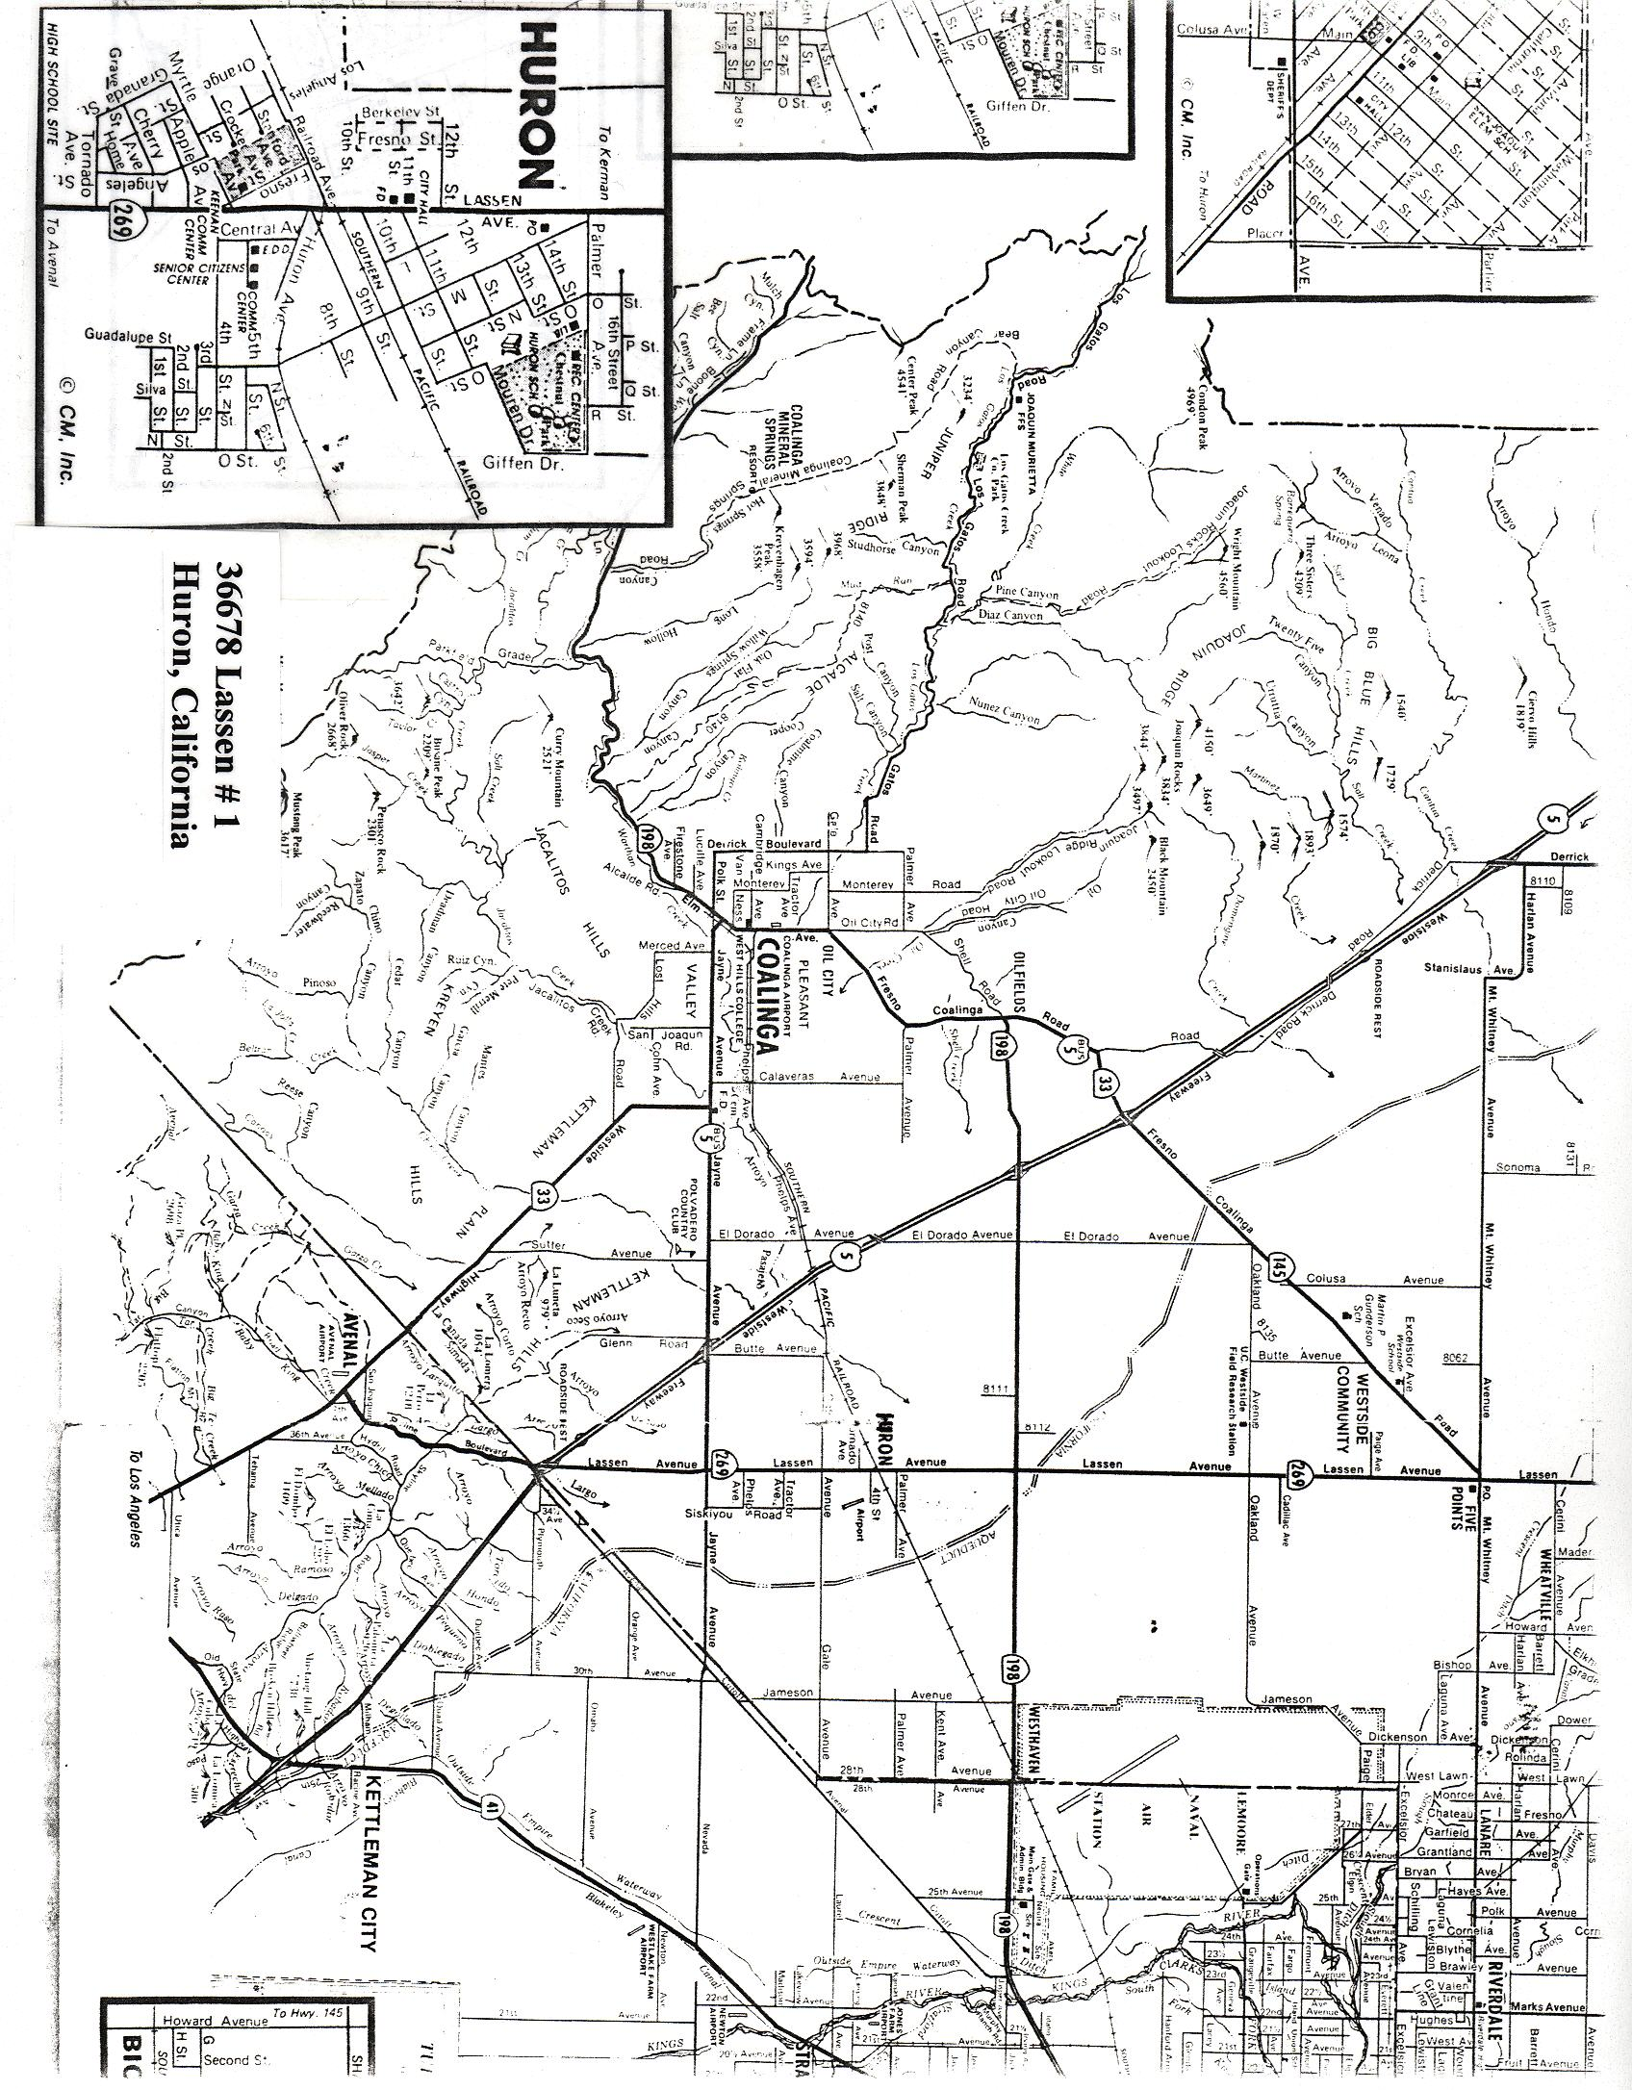
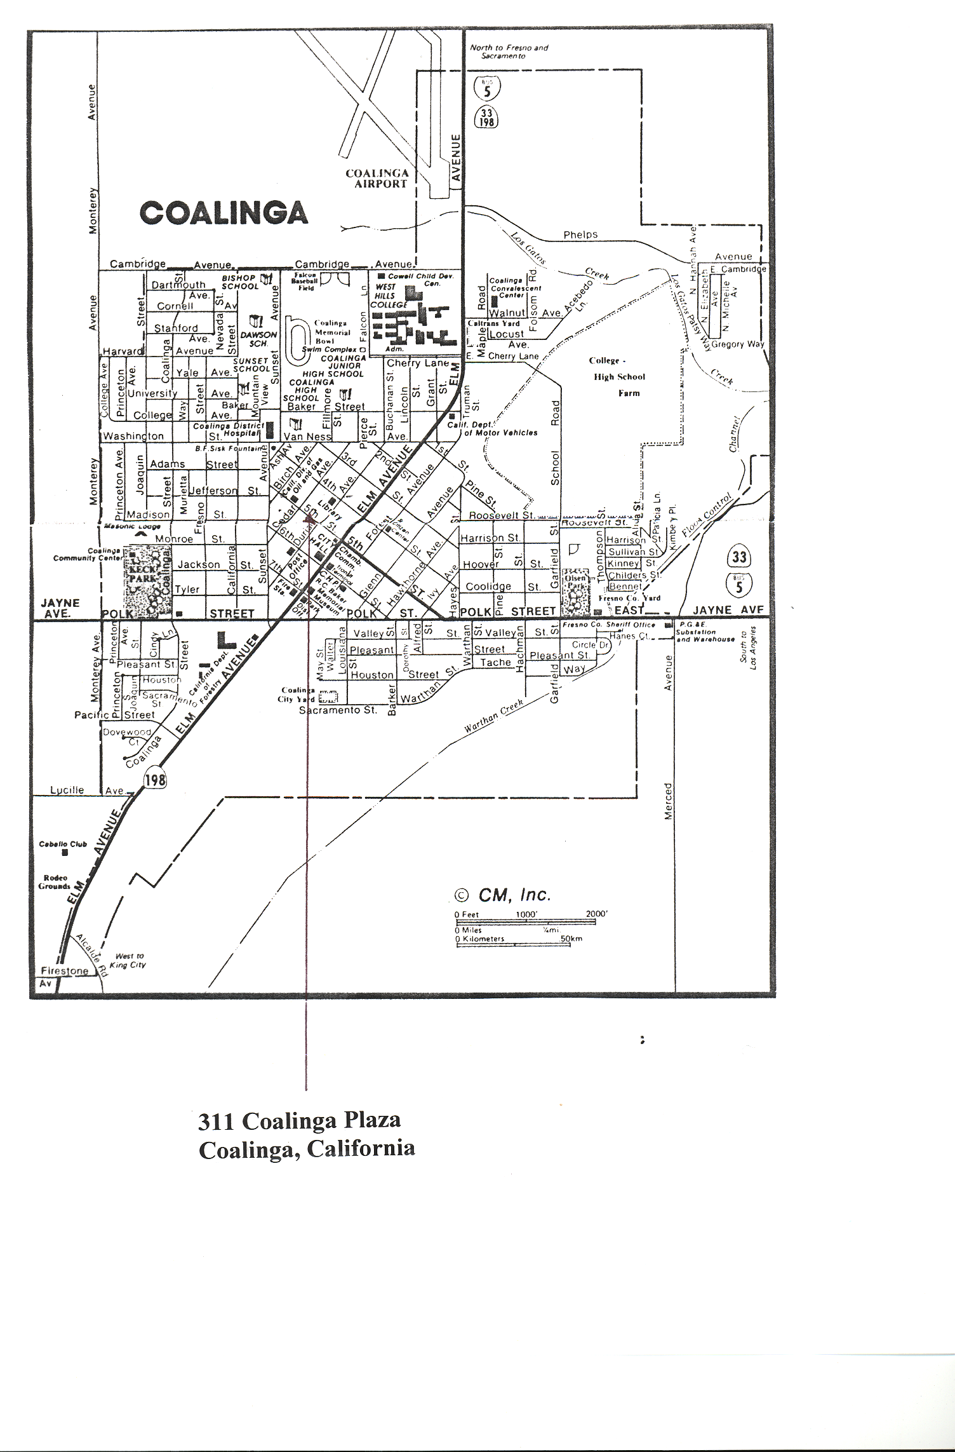
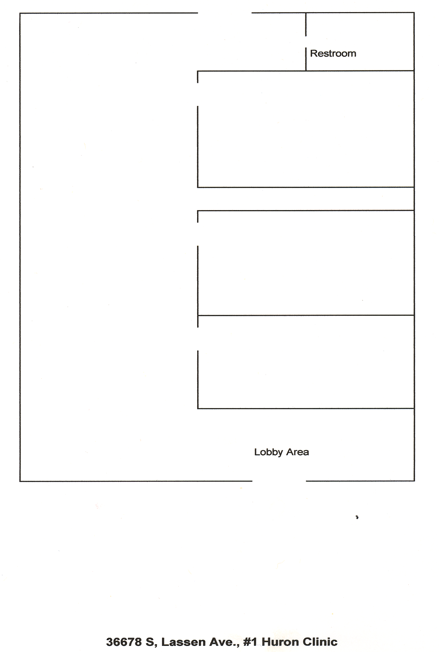

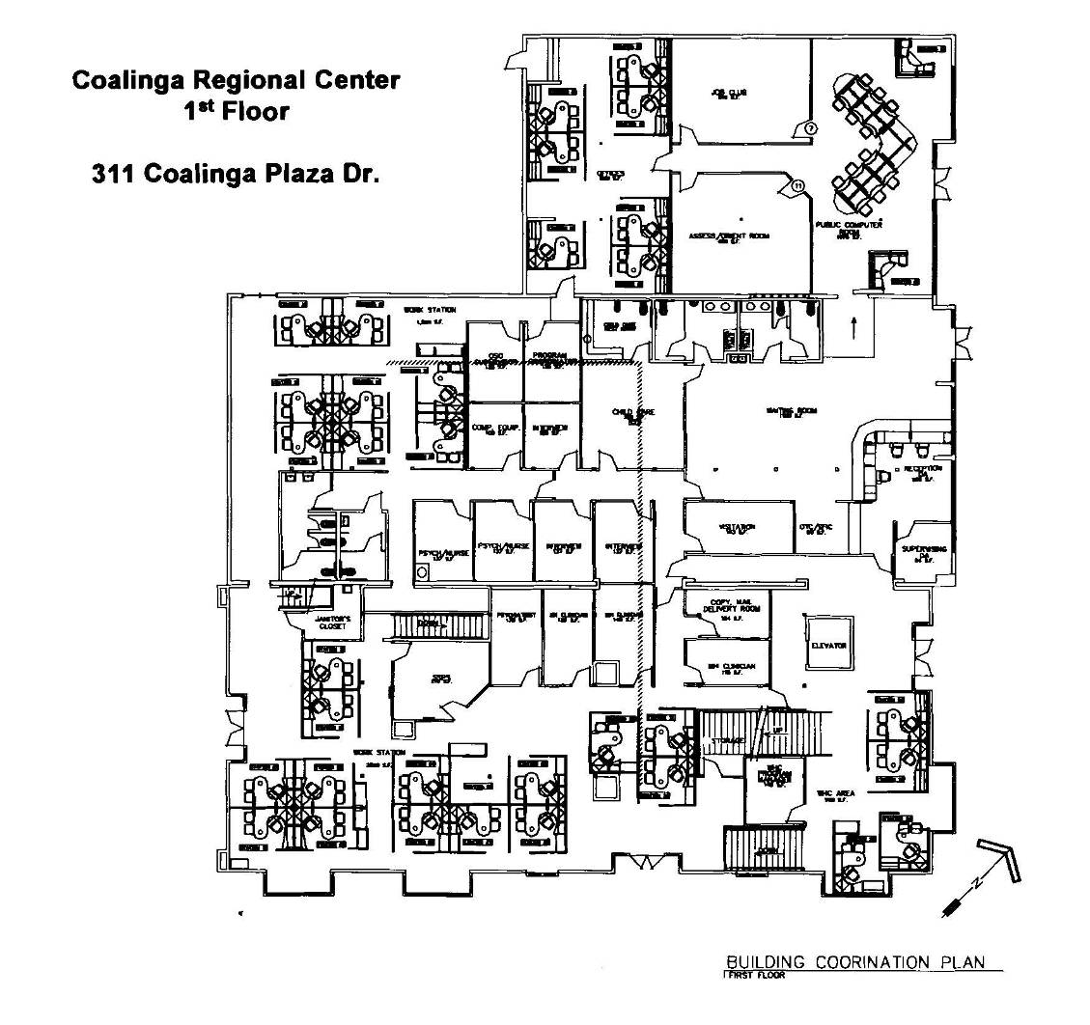
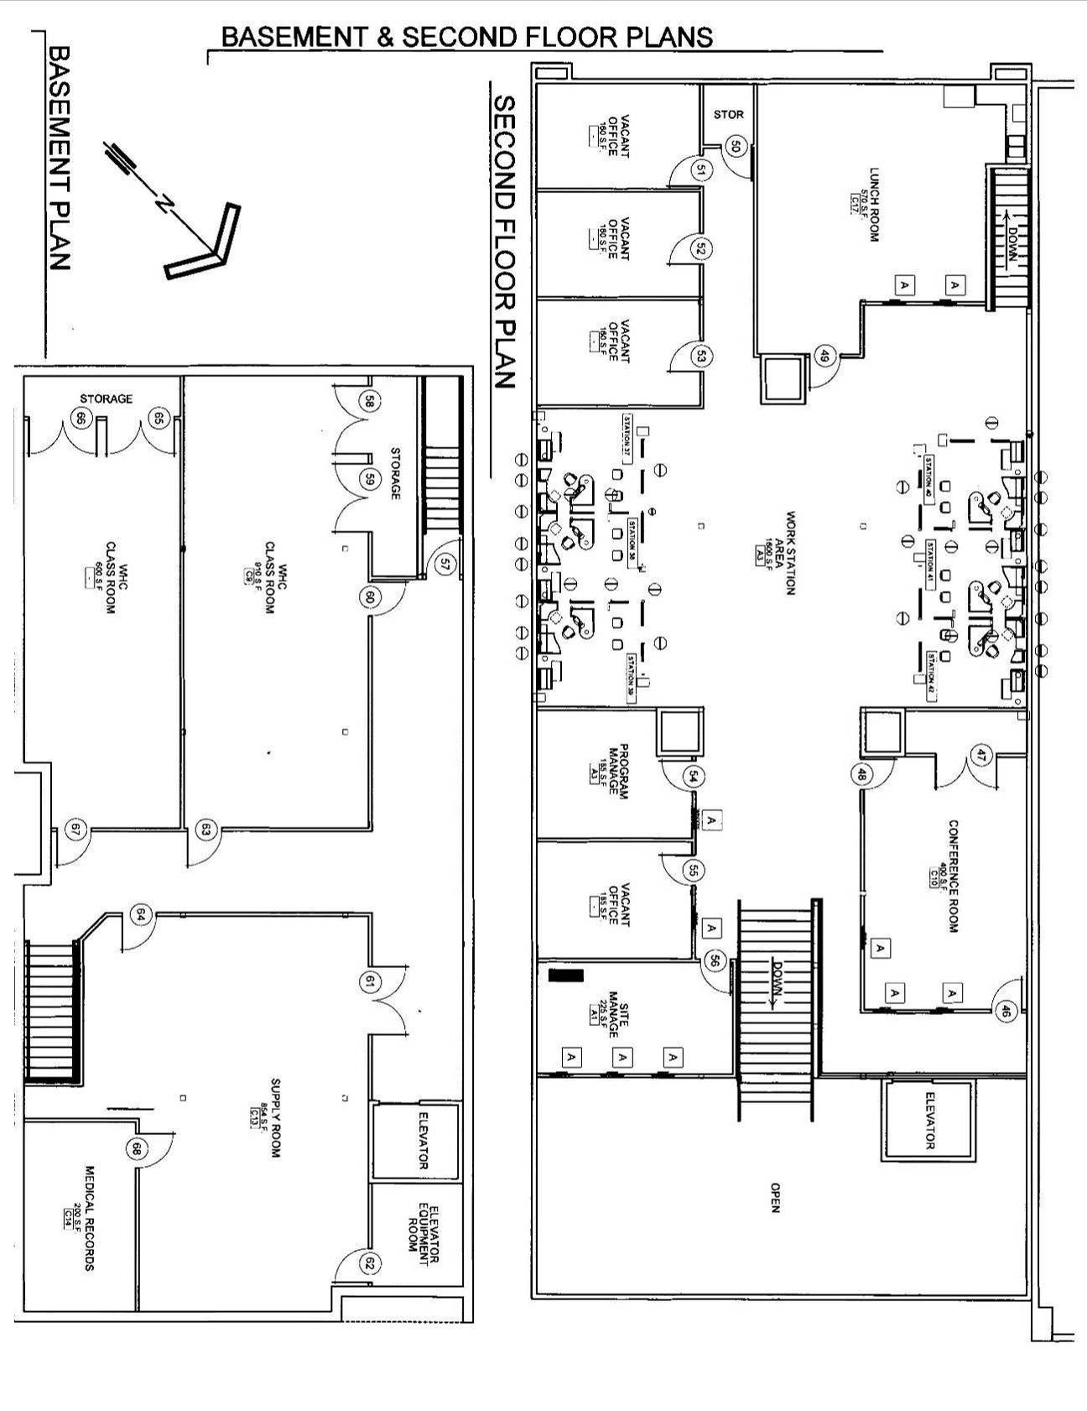

SAMPLE AGREEMENT

The following Agreement is a

Sample Agreement Only.

A G R E E M E N T
THIS AGREEMENT is made and entered into this day of _________________, 200__, by and between the COUNTY OF FRESNO, a Political Subdivision of the State of California, hereinafter referred to as "COUNTY", and _______________________ whose address is________________________________________, hereinafter referred to as "CONTRACTOR".
W I T N E S S E T H:
- OBLIGATIONS OF THE CONTRACTOR

  - (etc.)
- OBLIGATIONS OF THE COUNTY

  - (etc.)
- TERM
This Agreement shall become effective on the ____ day of _______________, 200__, and shall terminate on the ____ day of _______________, 200__.
- TERMINATION
  - Non-Allocation of Funds - The terms of this Agreement, and the services to be provided thereunder, are contingent on the approval of funds by the appropriating government agency. Should sufficient funds not be allocated, the services provided may be modified, or this Agreement terminated, at any time by giving the CONTRACTOR thirty (30) days advance written notice.
  - Breach of Contract - The COUNTY may immediately suspend or terminate this Agreement in whole or in part, where in the determination of the COUNTY there is:
    - An illegal or improper use of funds;
    - A failure to comply with any term of this Agreement;
    - A substantially incorrect or incomplete report submitted to the COUNTY;
    - Improperly performed service.
In no event shall any payment by the COUNTY constitute a waiver by the COUNTY of any breach of this Agreement or any default which may then exist on the part of the CONTRACTOR. Neither shall such payment impair or prejudice any remedy available to the COUNTY with respect to the breach or default. The COUNTY shall have the right to demand of the CONTRACTOR the repayment to the COUNTY of any funds disbursed to the CONTRACTOR under this Agreement, which in the judgment of the COUNTY were not expended in accordance with the terms of this Agreement. The CONTRACTOR shall promptly refund any such funds upon demand.
  - Without Cause - Under circumstances other than those set forth above, this Agreement may be terminated by COUNTY upon the giving of thirty (30) days advance written notice of an intention to terminate to CONTRACTOR.
- COMPENSATION/INVOICING: (Note to County staff: If sales tax is applicable and to be paid to an out-of-state vendor, it must be separated from the total compensation and the vendor must have a California Sales Tax Permit Number.) COUNTY agrees to pay CONTRACTOR and CONTRACTOR agrees to receive compensation as follows:
___________________________. CONTRACTOR shall submit monthly invoices in triplicate to the County of Fresno (department name)
In no event shall services performed under this Agreement be in excess of
during the term of this Agreement. It is understood that all expenses incidental to CONTRACTOR'S performance of services under this Agreement shall be borne by CONTRACTOR. (Note to County staff: If the number of days within which payment must be made is specified, this paragraph must provide for payment after a minimum of forty-five (45) days from date of receipt of invoice by the COUNTY.)
- INDEPENDENT CONTRACTOR: In performance of the work, duties and obligations assumed by CONTRACTOR under this Agreement, it is mutually understood and agreed that CONTRACTOR, including any and all of the CONTRACTOR'S officers, agents, and employees will at all times be acting and performing as an independent contractor, and shall act in an independent capacity and not as an officer, agent, servant, employee, joint venturer, partner, or associate of the COUNTY. Furthermore, COUNTY shall have no right to control or supervise or direct the manner or method by which CONTRACTOR shall perform its work and function. However, COUNTY shall retain the right to administer this Agreement so as to verify that CONTRACTOR is performing its obligations in accordance with the terms and conditions thereof.
CONTRACTOR and COUNTY shall comply with all applicable provisions of law and the rules and regulations, if any, of governmental authorities having jurisdiction over matters the subject thereof.
Because of its status as an independent contractor, CONTRACTOR shall have absolutely no right to employment rights and benefits available to COUNTY employees. CONTRACTOR shall be solely liable and responsible for providing to, or on behalf of, its employees all legally-required employee benefits. In addition, CONTRACTOR shall be solely responsible and save COUNTY harmless from all matters relating to payment of CONTRACTOR'S employees, including compliance with Social Security withholding and all other regulations governing such matters. It is acknowledged that during the term of this Agreement, CONTRACTOR may be providing services to others unrelated to the COUNTY or to this Agreement.
- MODIFICATION: Any matters of this Agreement may be modified from time to time by the written consent of all the parties without, in any way, affecting the remainder.
- NON-ASSIGNMENT: Neither party shall assign, transfer or sub-contract this Agreement nor their rights or duties under this Agreement without the prior written consent of the other party.
- HOLD HARMLESS: CONTRACTOR agrees to indemnify, save, hold harmless, and at COUNTY'S request, defend the COUNTY, its officers, agents, and employees from any and all costs and expenses, damages, liabilities, claims, and losses occurring or resulting to COUNTY in connection with the performance, or failure to perform, by CONTRACTOR, its officers, agents, or employees under this Agreement, and from any and all costs and expenses, damages, liabilities, claims, and losses occurring or resulting to any person, firm, or corporation who may be injured or damaged by the performance, or failure to perform, of CONTRACTOR, its officers, agents, or employees under this Agreement.
- INSURANCE: Without limiting the COUNTY'S right to obtain indemnification from CONTRACTOR or any third parties, CONTRACTOR, at is sole expense, shall maintain in full force and effect the following insurance policies throughout the term of this Agreement:
  - (State the type and minimum amount of insurance coverage for each policy.)
  - Workers Compensation insurance in accordance with the California Labor Code.
Such insurance policies shall name the COUNTY, its officers, agents, and employees, individually and collectively as additional insured, but only insofar as the operations under this contract are concerned. (Note to County staff: If the Contractor is to name County as additional insured for less than all the policies, state here which ones apply, such as "Comprehensive General Liability only". Check with Risk Management Division to see which policies, if any, should name the County as an additional insured.) Such coverage for additional insured shall apply as primary insurance and any other insurance, or self-insurance, maintained by the COUNTY, its officers, agents, and employees, shall be excess only and not contributing with insurance provided under the CONTRACTOR'S policies herein. This insurance shall not be cancelled or changed without a minimum of thirty (30) days advance, written notice given to COUNTY.
Prior to the commencement of performing its obligations under this Agreement, CONTRACTOR shall provide certificates of insurance on the foregoing policies (Note to County staff: If the Contractor is to provide certificates for less than all the policies, state here which ones apply, such as "Comprehensive General Liability only"), as required herein, to the COUNTY'S (department name) , stating that such insurance
coverages have been obtained and are in full force; that the COUNTY, its officers, agents, and employees will not be responsible for any premiums on the policies; that such insurance names the COUNTY, its officers, agents, and employees, individually and collectively, as additional insured (except Workers Compensation Insurance), but only insofar as the operations under this contract are concerned; that such coverage for additional insured shall apply as primary insurance and any other insurance, or self-insurance, maintained by the COUNTY, its officers, agents, and employees, shall be excess only and not contributing with insurance provided under the CONTRACTOR'S policies herein; and that this insurance shall not be cancelled or changed without a minimum of thirty (30) days advance, written notice given to COUNTY.
In the event CONTRACTOR fails to keep in effect at all times insurance coverage as herein provided, the COUNTY may, in addition to other remedies it may have, suspend or terminate this Agreement upon the occurrence of such event.
- AUDITS AND INSPECTIONS: The CONTRACTOR shall at any time during business hours, and as often as the COUNTY may deem necessary, make available to the COUNTY for examination all of its records and data with respect to the matters covered by this Agreement. The CONTRACTOR shall, upon request by the COUNTY, permit the COUNTY to audit and inspect all of such records and data necessary to ensure CONTRACTOR'S compliance with the terms of this Agreement.
If this Agreement exceeds ten thousand dollars ($10,000.00), CONTRACTOR shall be subject to the examination and audit of the Auditor General for a period of three (3) years after final payment under contract (Government Code Section 8546.7).
- NOTICES: The persons and their addresses having authority to give and receive notices under this Agreement include the following:
COUNTY CONTRACTOR
COUNTY OF FRESNO

Any and all notices between the COUNTY and the CONTRACTOR provided for or permitted under this Agreement or by law shall be in writing and shall be deemed duly served when personally delivered to one of the parties, or in lieu of such personal services, when deposited in the United States Mail, postage prepaid, addressed to such party.
- GOVERNING LAW: Venue for any action arising out of or related to this Agreement shall only be in Fresno County, California.
The rights and obligations of the parties and all interpretation and performance of this Agreement shall be governed in all respects by the laws of the State of California.
- ENTIRE AGREEMENT: This Agreement constitutes the entire agreement between the CONTRACTOR and COUNTY with respect to the subject matter hereof and supersedes all previous Agreement negotiations, proposals, commitments, writings, advertisements, publications, and understanding of any nature whatsoever unless expressly included in this Agreement. [If applicable, add the following: In the event of any inconsistency in interpreting the documents which constitute this Agreement, the inconsistency shall be resolved by giving precedence in the following order of priority: (1) the text of this Agreement (excluding Attachment "A", the COUNTY'S Request for Quotation No. 910-4650 and the CONTRACTOR'S Quote in response thereto); (2) Agreement Renewal Attachment "A", dated ; (3) the COUNTY'S Request for Quotation No. 910-4650; and (4) the CONTRACTOR'S quotation made in response to COUNTY'S Request for Quotation No. 910-4650.]
IN WITNESS WHEREOF, the parties hereto have executed this Agreement as of the day and year first hereinabove written.
CONTRACTOR COUNTY OF FRESNO

(Authorized Signature) Chairman, Board of Supervisors

Print Name & Title

Mailing Address
DATE: DATE:
TAXPAYER FEDERAL I.D. #: REVIEWED & RECOMMENDED
FOR APPROVAL
CA Sales Tax Permit No.
(Out-of-State vendors):

Department Head's Signature
APPROVED AS TO LEGAL FORM APPROVED AS TO ACCOUNTING FORM

County Counsel Auditor-Controller/Treasurer-Tax Collector
FOR ACCOUNTING USE ONLY:
ORG No.:
Account No.:
Requisition No.:
FCMC 1/95

/tmp/in/input.doc

