COUNTY OF FRESNO
Request for Quotation
 |  |  |  |  |  | NUMBER: 801-4271
April 24, 2006
 | ORG/Requisition: 31111413/ 3116002378 |  |  |  |  |  |  |  |  | PURCHASING USE |  |  |  |  | /tmp/in/input.doc
 |  |  |  |  |  |  |  |  |  | jol
 | IMPORTANT: SUBMIT QUOTATION IN SEALED PACKAGE WITH QUOTATION NUMBER, CLOSING DATE AND BUYER’S NAME MARKED CLEARLY ON THE OUTSIDE TO:
COUNTY OF FRESNO, Purchasing
4525 EAST HAMILTON AVENUE
FRESNO, CA 93702-4599
Closing date of bid will be at 2:00 p.m., on MAY 26, 2006.
QUOTES WILL BE CONSIDERED LATE WHEN THE OFFICIAL PURCHASING TIME CLOCK READS 2:00 P.M.
 | Quotes will be opened and publicly read at that time. All quotation information will be available for review after contract award.
 | Clarification of specifications are to be directed to: Cathi J. Peters, phone (559) 456-7110, FAX (559) 456-7831.
 |  | GENERAL CONDITIONS
 |  | See “County Of Fresno Purchasing Standard Instructions And Conditions For Request For Proposals (RFP’S) and Requests for Quotations (RFQ’S)” attached.
BIDDER TO COMPLETE
UNDERSIGNED AGREES TO FURNISH THE COMMODITY OR SERVICE STIPULATED IN THE ATTACHED QUOTATION SCHEDULE AT THE PRICES AND TERMS STATED, SUBJECT TO THE “COUNTY OF FRESNO PURCHASING STANDARD INSTRUCTIONS AND CONDITIONS FOR REQUEST FOR PROPOSALS (RFP’S) AND REQUESTS FOR QUOTATIONS (RFQ’S)”ATTACHED.
Except as noted on individual items, the following will apply to all items in the Quotation Schedule.
 |  |  | - Complete delivery will be made within |  |  |  |  |  |  |  |  | calendar days after receipt of Order.
 |  |  | - A cash discount of |  |  |  |  |  | % |  |  |  |  | days will apply.
Company
Address
City |  |  |  |  |  |  |  |  |  |  |  |  |  |  |  |  | State |  | Zip Code
( ) |  |  |  |  |  |  |  | ( )
Telephone Number |  |  |  |  |  |  |  | Facsimile Number |  |  |  |  |  |  |  |  | E-mail Address
Taxpayer Federal I.D. No.:
Signed By
Print Name |  |  |  |  |  |  |  |  |  |  |  |  | Title

COUNTY OF FRESNO PURCHASING
STANDARD INSTRUCTIONS AND CONDITIONS FOR
REQUESTS FOR PROPOSALS (RFP’S) AND REQUESTS FOR QUOTATIONS (RFQ’S)
Note: the reference to “bids” in the following paragraphs applies to RFP’s and RFQ’s

GENERAL CONDITIONS
By submitting a bid the bidder agrees to the following conditions. These conditions will apply to all subsequent purchases based on this bid.

- BID PREPARATION:
  - All prices and notations must be typed or written in ink. No erasures permitted. Errors may be crossed out, initialed and corrections printed in ink by person signing bid.
  - Brand Names: Brand names and numbers when given are for reference. Equal items will be considered, provided the offer clearly describes the article and how it differs from that specified. In the absence of such information it shall be understood the offering is exactly as specified.
  - State brand or make of each item. If bidding on other than specified, state make, model and brand being bid and attach supporting literature/specifications to the bid.
  - Bid on each item separately. Prices should be stated in units specified herein. All applicable charges must be quoted; charges on invoice not quoted herein will be disallowed.
  - Time of delivery is a part of the consideration and must be stated in definite terms and must be adhered to. F.O.B. Point shall be destination or freight charges must be stated.
  - All bids must be dated and signed with the firm’s name and by an authorized officer or employee.
  - Unless otherwise noted, prices shall be firm for 120 days after closing date of bid.
- SUBMITTING BIDS:
  - Each bid must be submitted on forms provided in a sealed envelope with bid number and closing date and time on the outside of the envelope/package.
  - Interpretation: Should any discrepancies or omissions be found in the bid specifications or doubt as to their meaning, the bidder shall notify the Buyer in writing at once. The County shall not be held responsible for verbal interpretations. Questions regarding the bid must be received by Purchasing at least 5 working days before bid opening. All addenda issued shall be in writing, duly issued by Purchasing and incorporated into the contract.
  - ISSUING AGENT/AUTHORIZED CONTACT: This RFQ has been issued by County of Fresno Purchasing. Purchasing shall be the vendor’s sole point of contact with regard to the RFQ, its content, and all issues concerning it.
All communication regarding this RFQ shall be directed to an authorized representative of County Purchasing. The specific buyer managing this RFQ is identified on the cover page, along with his or her telephone number, and he or she should be the primary point of contact for discussions or information pertaining to the RFQ. Contact with any other County representative, including elected officials, for the purpose of discussing this RFQ, its content, or any other issue concerning it, is prohibited unless authorized by Purchasing. Violation of this clause, by the vendor having unauthorized contact (verbally or in writing) with such other County representatives, may constitute grounds for rejection by Purchasing of the vendor’s quotation.
The above stated restriction on vendor contact with County representatives shall apply until the County has awarded a purchase order or contract to a vendor or vendors, except as follows. First, in the event that a vendor initiates a formal protest against the RFQ, such vendor may contact the appropriate individual, or individuals who are managing that protest as outlined in the County’s established protest procedures. All such contact must be in accordance with the sequence set forth under the protest procedures. Second, in the event a public hearing is scheduled before the Board of Supervisors to hear testimony prior to its approval of a purchase order or contract, any vendor may address the Board.
  - Bids received after the closing time will NOT be considered.
  - Bidders are to bid what is specified or requested first. If unable to or willing to, bidder may bid alternative or option, indicating all advantages, disadvantages and their associated cost.
- FAILURE TO BID:
  - If not bidding, return bid sheet and state reason for no bid or your name may be removed from mailing list.
- TAXES, CHARGES AND EXTRAS:
  - County of Fresno is subject to California sales and/or use tax (7.975%). Please indicate as a separate line item if applicable.
  - DO NOT include Federal Excise Tax. County is exempt under Registration No. 94-73-03401-K.
  - County is exempt from Federal Transportation Tax. Exemption certificate is not required where shipping papers show consignee as County of Fresno.
  - Charges for transportation, containers, packing, etc. will not be paid unless specified in bid.
- W-9 – REQUEST FOR TAXPAYER IDENTIFICATION NUMBER AND CERTIFICATION:
Upon award of bid, the vendor shall submit to County Purchasing, a completed W-9 – Request for Taxpayer Identification Number and Certification if not already a current vendor with The County of Fresno. This form is available from the IRS to complete on line at http://www.irs.gov/pub/irs-pdf/fw9.pdf.
- AWARDS:
  - Subject to the local preference provisions referenced in Paragraph 6 below and more thoroughly set forth in the General Requirements section of this RFQ, award(s) will be made to the most responsive responsible bidder. The evaluation will include such things as life-cycle cost, availability, delivery costs and whose product and/or service is deemed to be in the best interest of the County. The County shall be the sole judge in making such determination.
  - Unless bidder gives notice of all-or-none award in bid, County may accept any item, group of items or on the basis of total bid.
  - The County reserves the right to reject any and all bids and to waive informalities or irregularities in bids.
  - After award, all bids shall be open to public inspection. The County assumes no responsibility for the confidentiality of information offered in a bid.
- LOCAL VENDORS
  - Local Vendor Preference (applicable to RFQ Process only)
The following provisions are applicable only to the County’s acquisition of materials, equipment or supplies through the RFQ process when the funding source does not require an exemption to the Local Vendor Preference.
THE PROVISIONS OF THIS PARAGRAPH ARE APPLICABLE, NOTWITHSTANDING ANY OTHER PROVISIONS OF THIS RFQ TO THE CONTRARY
If the apparent low bidder is not a local vendor, any local vendor who submitted a bid which was within five percent (5%) of the lowest responsive bid as determined by the purchasing agent shall have the option of submitting a new bid within forty-eight hours (not including weekends and holidays) of County’s delivery of notification. Such new bids must be in an amount less than or equal to the lowest responsive bid as determined by the purchasing agent. If the purchasing agent receives any new bids from local vendors who have the option of submitting new bids within said forty-eight hour period, it shall award the contract to the local vendor submitting the lowest responsible bid. If no new bids are received, the contract shall be awarded to the original low bidder as announced by the purchasing agent.
  - Local Vendor Defined
“Local Vendor” shall mean any business which:
- Has its headquarters, distribution point or locally-owned franchise located in or having a street address within the County for at least six (6) months immediately prior to the issuance of the request for competitive bids by the purchasing agent; and
- Holds any required business license by a jurisdiction located in Fresno County; and
- Employs at least one (1) full-time or two (2) part-time employees whose primary residence is located within Fresno County, or if the business has no employees, shall be at least fifty percent (50%) owned by one or more persons whose primary residence(s) is located within Fresno County.
- TIE BIDS:
All other factors being equal, the contract shall be awarded to the Fresno County vendor or, if neither or both are Fresno County vendors, it may be awarded by the flip of a coin in the presence of witnesses or the entire bid may be rejected and re-bid. If the General Requirements of this RFQ state that they are applicable, the provisions of the Fresno County Local Vendor Preference shall take priority over this paragraph.
- PATENT INDEMNITY:
The vendor shall hold the County, its officers, agents and employees, harmless from liability of any nature or kind, including costs and expenses, for infringement or use of any copyrighted or uncopyrighted composition, secret process, patented or unpatented invention, article or appliance furnished or used in connection with this bid.
- SAMPLES:
Samples, when required, must be furnished and delivered free and, if not destroyed by tests, will upon written request (within 30 days of bid closing date) be returned at the bidder’s expense. In the absence of such notification, County shall have the right to dispose of the samples in whatever manner it deems appropriate.
- RIGHTS AND REMEDIES OF COUNTY FOR DEFAULT:
  - In case of default by vendor, the County may procure the articles or service from another source and may recover the cost difference and related expenses occasioned thereby from any unpaid balance due the vendor or by proceeding against performance bond of the vendor, if any, or by suit against the vendor. The prices paid by the County shall be considered the prevailing market price at the time such purchase is made.
  - Articles or services, which upon delivery inspection do not meet specifications, will be rejected and the vendor will be considered in default. Vendor shall reimburse County for expenses related to delivery of non-specified goods or services.
  - Regardless of F.O.B. point, vendor agrees to bear all risks of loss, injury or destruction to goods and materials ordered herein which occur prior to delivery and such loss, injury or destruction shall not release vendor from any obligation hereunder.
- DISCOUNTS:
Terms of less than 15 days for cash payment will be considered as net in evaluating this bid. A discount for payment within fifteen (15) days or more will be considered in determining the award of bid. Discount period will commence either the later of delivery or receipt of invoice by the County. Standard terms are Net Forty-five (45) days.
- SPECIAL CONDITIONS IN BID SCHEDULE SUPERSEDE GENERAL CONDITIONS.
The “General Conditions” provisions of this RFP/RFQ shall be superseded if in conflict with any other section of this bid, to the extent of any such conflict.
- SPECIAL REQUIREMENT:
With the invoice or within twenty-five (25) days of delivery, the seller must provide to the County a Material Safety Data Sheet for each product, which contains any substance on “The List of 800 Hazardous Substances”, published by the State Director of Industrial Relations. (See Hazardous Substances Information and Training Act. California State Labor Code Sections 6360 through 6399.7.)
- RECYCLED PRODUCTS/MATERIALS:
Vendors are encouraged to provide and quote (with documentation) recycled or recyclable products/materials which meet stated specifications.
- YEAR COMPLIANCE WARRANTY
Vendor warrants that any product furnished pursuant to this Agreement/order shall support a four-digit year format and be able to accurately process date and time data from, into and between the twentieth and twenty-first centuries, as well as leap year calculations. “Product” shall include, without limitation, any piece or component of equipment, hardware, firmware, middleware, custom or commercial software, or internal components or subroutines therein. This warranty shall survive termination or expiration of this Agreement.
In the event of any decrease in product functionality or accuracy related to time and/or date data related codes and/or internal subroutines that impede the product from operating correctly using dates beyond December 31, 1999, vendor shall restore or repair the product to the same level of functionality as warranted herein, so as to minimize interruption to County’s ongoing business process, time being of the essence. In the event that such warranty compliance requires the acquisition of additional programs, the expense for any such associated or additional acquisitions, which may be required, including, without limitation, data conversion tools, shall be borne exclusively by vendor. Nothing in this warranty shall be construed to limit any rights or remedies the County may otherwise have under this Agreement with respect to defects other than year performance.
- PARTICIPATION:
Bidder may agree to extend the terms of the resulting contract to other political subdivision, municipalities and tax-supported agencies.
Such participating Governmental bodies shall make purchases in their own name, make payment directly to bidder, and be liable directly to the bidder, holding the County of Fresno harmless.
- CONFIDENTIALITY:
All services performed by vendor shall be in strict conformance with all applicable Federal, State of California and/or local laws and regulations relating to confidentiality, including but not limited to, California Civil Code, California Welfare and Institutions Code, Health and Safety Code, California Code of Regulations, Code of Federal Regulations.
Vendor shall submit to County’s monitoring of said compliance.
Vendor may be a business associate of County, as that term is defined in the “Privacy Rule” enacted by the Health Insurance Portability and Accountability Act of 1996 (HIPAA). As a HIPAA Business Associate, vendor may use or disclose protected health information (“PHI”) to perform functions, activities or services for or on behalf of County as specified by the County, provided that such use or disclosure shall not violate HIPAA and its implementing regulations. The uses and disclosures if PHI may not be more expansive than those applicable to County, as the “Covered Entity” under HIPAA’S Privacy Rule, except as authorized for management, administrative or legal responsibilities of the Business Associate.
Vendor shall not use or further disclose PHI other than as permitted or required by the County, or as required by law without written notice to the County.
Vendor shall ensure that any agent, including any subcontractor, to which vendor provides PHI received from, or created or received by the vendor on behalf of County, shall comply with the same restrictions and conditions with respect to such information.
- APPEALS
Appeals must be submitted in writing within five (5) working days after the review committee notification of proposed recommendations. Appeals should be submitted to County of Fresno Purchasing, 4525 E. Hamilton Avenue, Fresno, California 93702-4599. Appeals should address only areas regarding RFP contradictions, procurement errors, quotation rating discrepancies, legality of procurement context, conflict of interest in rating process, and inappropriate or unfair competitive procurement grievance regarding the RFP process.
The Purchasing Manager will provide a written response to the complaint within five (5) working days unless the complainant is notified more time is required.
If the protesting bidder is not satisfied with the decision of the Purchasing Manager, he/she shall have the right to appeal to the Purchasing Agent within five (5) business days after notification of the Purchasing Manager’s decision.
If the protesting bidder is not satisfied with Purchasing Agent decision, the final appeal is with the Board of Supervisors.

TABLE OF CONTENTS
PAGE
bidding instructions 3
REFERENCE LIST 8
Local Vendor Preference 9
PARTICIPATION 11
SPECIFICATIONS 12
QUOTATION SCHEDULE 17
attachment a 32
ATTACHMENT B 42

bidding instructions
contract supplies
The County of Fresno Purchasing on behalf of Public Works-Road Maintenance and Operations is soliciting bids to establish an Agreement for the purchase of Traffic Signs and related materials on an as needed basis as specified within this Request for Quotation.
Local Vendor Preference: The Local Vendor Preference applies to this Request for Quotation.
REPORTS: Contractor upon request will provide annual reports for all products purchased under any agreement resulting from this Request for Quotation.
Report information to include usage (type and quantity of product purchased, manufacture and manufacture part number) dates of each purchase and price charged. Reports must be delivered to County of Fresno Purchasing, 4525 E. Hamilton Avenue, Fresno, California 93702, Attention: Cathi J. Peters not later than thirty (30) days following the date of the request. The agreement number should be referenced on all reports.
AWARD: Award will be made to the vendor whose product, price, delivery and service is deemed most advantageous to the County. The County will be the sole judge in making such determination. The County reserves the right to make multiple awards.
FIRM QUOTATION: For purpose of award all quotations shall remain firm for ninety (90) days.
COPIES: Submit one (1) original and two (2) copies of your quotation no later than the RFQ closing date and time as stated on the front of this document, to County of Fresno Purchasing. Each copy to be identical to the original, including all supporting documentation (i.e. literature, brochures etc.). The cover page of each quotation is to be appropriately marked “Original” or “Copy”.
INTERPRETATION OF REQUEST FOR QUOTATION: Vendors must make careful examination of the requirements, specifications and conditions expressed in the Request for Quotation and fully inform themselves as to the quality and character of the product required. If any person planning to submit a Quotation finds discrepancies in or omissions from the Request for Quotation or has any doubt as to the true meaning or interpretation, correction thereof may be requested in writing or by Fax (Fax No. (559) 456-7831) from Purchasing. The deadline for submitting requests for clarification is May 12, 2006 8:00 A.M.
Questions shall be delivered to the County of Fresno Purchasing, 4525 E. Hamilton Avenue, Fresno, CA 93702 or faxed to (559) 456-7831. If faxing the bidder must confirm receipt by phone within one-half (1/2) hour of transmissions.
NOTE: Time constraints will prevent County from responding to questions submitted after the cutoff date.
Any change in the Request for Quotation will be made only by written addendum, duly issued by the County. The County will not be responsible for any other explanations or interpretations.
ISSUING AGENT: This RFQ has been issued by County of Fresno Purchasing. Purchasing shall be the vendor’s sole point of contact with regard to the RFQ, its content, and all issues concerning it.
AUTHORIZED CONTACT: All communication regarding this RFQ shall be directed to an authorized representative of County Purchasing. The specific buyer managing this RFQ is identified on the cover page, along with his or her telephone number, and he or she should be the primary point of contact for discussions or information pertaining to the RFQ. Contact with any other County representative, including elected officials, for the purpose of discussing this RFQ, it content, or any other issue concerning it, is prohibited unless authorized by Purchasing. Violation of this clause, by the vendor having unauthorized contact (verbally or in writing) with such other County representatives, may constitute grounds for rejection by Purchasing of the vendor’s quotation.
The above stated restriction on vendor contact with County representatives shall apply until the County has awarded a purchase order or contract to a vendor or vendors, except as follows. First, in the event that a vendor initiates a formal protest against the RFQ, such vendor may contact the appropriate individual, or individuals who are managing that protest as outlined in the County’s established protest procedures. All such contact must be in accordance with the sequence set forth under the protest procedures. Second, in the event a public hearing is scheduled before the Board of Supervisors to hear testimony prior to its approval of a purchase order or contract, any vendor may address the Board.
RIGHT TO REJECT BIDS: The County reserves the right to reject any and all bids and to waive informalities or irregularities in bids.
TERM: The initial contract period shall be for one (1) year.
QUANTITIES: Quantities shown in the bid schedule are approximate and the County guarantees no minimum amount. The County reserves the right to increase or decrease quantities.
SPECIFICATIONS: No exceptions to or deviations from this specification will be considered unless each exception or deviation is specifically stated by the bidder, in the designated places. If no exceptions or deviations are shown the bidder will be required to furnish items exactly as specified herein. The burden of proof of compliance with this specification is the responsibility of the bidder.
LITERATURE: Bidders shall submit literature, which fully describes items on which they are bidding, not later than the closing date of this bid. Any and all literature submitted must be stamped with bidders name and address.
MERCHANDISE RETURNABLE FOR FULL CREDIT: Bidder agrees to accept for full credit any merchandise sold by him on contract or award resulting from this bid, if returned in good condition by the County.
GUARANTEE AGAINST DEFECTS: All items are to carry a full guarantee against defects in materials and workmanship and guarantee against breakage and other malfunctions when performing work for which they are designed.
ORDERING: Orders will be placed as required by Public Works-Road Maintenance and Operations..
INVOICING: All invoices are to be mailed in duplicate the County of Fresno, P.W.-Roads Maintenance and Operations, 2220 Tulare St., Sixth Floor, Fresno CA 93721 in accordance with invoicing instructions included in each order. The Agreement/Purchase Order number must appear on all shipping documents and invoices. Invoice terms shall be net forty-five (45) days.
SAMPLES: On request, samples shall be made available to the County. The County will designate where samples are to be delivered.
All samples shall be furnished within five (5) working days from the date of request and furnished at no cost to the County (including shipping, handling, etc.).
Successful bidder’s samples may be retained for checking against delivery.
County will return samples to the bidder at the bidder’s expense. Bidder must submit a written request for return of samples not later than thirty (30) days following award of bid. Request to be delivered to County’s Purchasing Manager.
RENEWAL: Contract may be renewed for two (2) additional one (1) year periods by mutual consent.
VENDOR ASSISTANCE: Successful bidder shall furnish, at no cost to the County, a representative to assist County departments in determining their product requirements.
TERMINATION: This agreement may be terminated by the County at any time upon written notice.
INSURANCE:
Without limiting the COUNTY’s right to obtain indemnification from CONTRACTOR or any third parties, CONTRACTOR, at its sole expense, shall maintain in full force and effect the following insurance policies throughout the term of the Agreement:
- Commercial General Liability
Commercial General Liability Insurance with limits of not less than One Million Dollars ($1,000,000) per occurrence and an annual aggregate of Two Million Dollars ($2,000,000). This policy shall be issued on a per occurrence basis. COUNTY may require specific coverages including completed operations, products liability, contractual liability, Explosion-Collapse-Underground, fire legal liability or any other liability insurance deemed necessary because of the nature of this contract.
- Automobile Liability
Comprehensive Automobile Liability Insurance with limits for bodily injury of not less than Two Hundred Fifty Thousand Dollars ($250,000.00) per person, Five Hundred Thousand Dollars ($500,000.00) per accident and for property damages of not less than Fifty Thousand Dollars ($50,000.00), or such coverage with a combined single limit of Five Hundred Thousand Dollars ($500,000.00). Coverage should include owned and non-owned vehicles used in connection with this Agreement.

- Worker’s Compensation
A policy of Worker’s Compensation insurance as may be required by the California Labor Code.
- Professional Liability
If CONTRACTOR employs licensed professional staff, (e.g., Ph.D., R.N., L.C.S.W., M.F.C.C.) in providing services, Professional Liability Insurance with limits of not less than One Million Dollars ($1,000,000.00) per occurrence, Three Million Dollars ($3,000,000.00) annual aggregate.

Contractor shall obtain endorsements to the Commercial General Liability insurance naming the County of Fresno, its officers, agents, and employees, individually and collectively, as additional insured, but only insofar as the operations under this Agreement are concerned. Such coverage for additional insured shall apply as primary insurance and any other insurance, or self-insurance, maintained by County, its officers, agents and employees shall be excess only and not contributing with insurance provided under contractor’s policies herein. This insurance shall not be cancelled or changed without a minimum of thirty (30) days advance written notice given to County.
Within Thirty (30) days from the date contractor executes this Agreement, contractor shall provide certificates of insurance and endorsement as stated above for all of the foregoing policies, as required herein, to the County of Fresno, stating that such insurance coverage have been obtained and are in full force; that the County of Fresno, its officers, agents and employees will not be responsible for any premiums on the policies; that such Commercial General Liability insurance names the County of Fresno, its officers, agents and employees, individually and collectively, as additional insured, but only insofar as the operations under this Agreement are concerned; that such coverage for additional insured shall apply as primary insurance and any other insurance, or self-insurance, maintained by County, its officers, agents and employees, shall be excess only and not contributing with insurance provided under contractor’s policies herein; and that this insurance shall not be cancelled or changed without a minimum of thirty (30) days advance, written notice given to County.
In the event contractor fails to keep in effect at all times insurance coverage as herein provided, the County may, in addition to other remedies it may have, suspend or terminate this Agreement upon the occurrence of such event.
All policies shall be with admitted insurers licensed to do business in the State of California. Insurance purchased shall be purchased from companies possessing a current A.M. Best, Inc. rating of A FSC VII or better.
HOLD HARMLESS CLAUSE: Contractor agrees to indemnify, save, hold harmless and at County’s request, defend the County, its officers, agents and employees, from any and all costs and expenses, damages, liabilities, claims and losses occurring or resulting to County in connection with the performance, or failure to perform, by Contractor, its officers, agents or employees under this Agreement and from any and all costs and expenses, damages, liabilities, claims and losses occurring or resulting to any person, firm or corporation who may be injured or damaged by the performance, or failure to perform, of Contractor, its officers, agents or employees under this Agreement.
ASSURANCES: Any contract awarded under this RFQ must be carried out in full compliance with The Civil Rights Act of 1964, The Americans With Disabilities Act of 1990, their subsequent amendments, and any and all other laws protecting the rights of individuals and agencies. The County of Fresno has a zero tolerance for discrimination, implied or expressed, and wants to ensure that policy continues under this RFQ. The contractor must also guarantee that services, or workmanship, provided will be performed in compliance with all applicable local, state, or federal laws and regulations pertinent to the types of services, or project, of the nature required under this RFQ. In addition, the contractor may be required to provide evidence substantiating that their employees have the necessary skills and training to perform the required services or work.
PRICES: All prices quoted shall be firm for the contract period. No price increase shall be permitted on quantities ordered from the contract prior to expiration date of the contract. Quotations are to be F.O.B. Destination.
PRICE DECREASE: The vendor shall immediately notify the County of Fresno of all manufacturer's price decreases and the County of Fresno shall receive full benefit of all such decreases, effective on the date of the manufacturer's general public announcement.
BIDDER TO COMPLETE THE FOLLOWING:
GUARANTEED DELIVERY: Bidder will be considered in award of bid only if they can guarantee delivery. Enter guaranteed delivery on this line (i.e. number of days from receipt of order to delivery): Delivery shall be F.O.B. Destination.
By: | (Authorized Signature)
ADDITIONAL ITEMS: The County may require additional items from those in bid schedule.
Bidders are strongly encouraged to bid related items/products that are not specifically addressed as line items in this Request for Quotation by offering discount pricing off their product line. Catalogs/Pricing documents and any additional pricing offered shall be made available upon request.
Prices on additional items will be based on successful bidder's firm discount prices from current published price list. Successful bidder will be required to file any new price list that may become effective during the life of the contract with the County of Fresno Purchasing Manager within thirty (30) days of its becoming effective.

State Purchase Order mailing address:
MINIMUM ORDER: Bidder to state minimum order quantities and charges for less than minimum order quantity (if not stated it will be assumed there are none).
Phone Orders:
Fax Orders:
Phone Orders:
E-Mail:
Company Website (if available):
Vendor must complete and return with Request for Quotation.
Firm:
REFERENCE LIST
Provide a list of at least three (3) customers for whom you have recently provided similar products (preferably California State or local government agencies). Be sure to include addresses and phone numbers.
Reference Name: |  | City:
Contact |  | Phone No.: | ( )
Date:
Product Provided:
Reference Name: |  | City:
Contact |  | Phone No.: | ( )
Date:
Product Provided:
Reference Name: |  | City:
Contact |  | Phone No.: | ( )
Date:
Product Provided:
Reference Name: |  | City:
Contact |  | Phone No.: | ( )
Date:
Product Provided:
FAILURE TO PROVIDE A LIST OF AT LEAST THREE (3) CUSTOMERS MAY BE CAUSE FOR REJECTION OF THIS RFQ.
Local Vendor Preference
The County of Fresno Local Vendor Preference is applicable to this Request for Quotation. Refer to the General Conditions section for details.
Qualified Vendors that desire consideration as a Fresno County Local Vendor under this RFQ must complete the “Statement of Local Vendor Certification” contained herein and submit it as a part of their quotation. Late submittals of the “Statement of Local Vendor Certification” will not be considered. Submission of this statement will qualify the vendor for treatment as a local vendor for purposes of this RFQ only. The statement made under this RFQ shall not qualify the vendor as a local vendor under any other RFQ.
Local Vendor Certification:
Any vendor claiming to be a local vendor, as defined under the General Conditions section of this RFQ, shall so certify in writing to the purchasing agent. The purchasing agent shall not be required to verify the accuracy or any such certifications, and shall have sole discretion to determine if a vendor meets the definition of “local vendor.”
Any person or business falsely claiming to be a local vendor under this section shall be ineligible to transact any business with the County for a period of not less than three (3) months and not more twenty-four (24) months as determined in the sole discretion of the purchasing agent. The purchasing agent shall also have the right to terminate all or any part of any contract entered into with such person or business.
STATEMENT OF LOCAL VENDOR CERTIFICATION
COUNTY OF FRESNO
Qualified local vendors desiring consideration under the Fresno County Local Vendor Preference must complete the following and submit with their quotation (print or type).
I |  |  |  |  |  | ,
 | (Individual Submitting Bid) |  |  |  |  |  | (Title)
Of/for |  |  |  | Certify that
 |  | (Company Name) |  |  |  |  |  | (Company Name)
Is a Fresno County local Vendor as defined under the General Conditions section of this RFQ and therefore qualifies for the Local Vendor Preference.
Signature |  |  |  |  | Title |  |  |  |  | Date

NOTIFICATION OF RE-BID
The local vendor will be notified of his/her opportunity to re-bid under Fresno County’s Local Vendor Preference. The Vendor must submit his/her re-bid within forty-eight (48) hours of notification (excluding weekends and holidays). Notification will be issued by e-mail or Fax, whichever is preferred by the vendor. Notification to Vendor shall be considered complete upon County’s transmission of e-mail or Fax.
The local vendor shall state his/her preferred method of notification below along with the appropriate e-mail address or Fax number. Notification by County will be limited to one of those two (2) methods. It will be the local vendor’s responsibility to check his/her e-mail or Fax messages for notification. The vendor’s delay in receiving his/her notification will not alter the forty-eight (48) hour period allowed for re-bid submission.
Local Vendor To Complete:
Indicate *ONE method for notification of Local Vendor re-bid by providing the appropriate e-mail address or Fax number. Submit this document as a part of your quotation.
E-Mail Address or Fax Number (Identify contact person if using a Fax Number)
BIDDER TO COMPLETE THE FOLLOWING:
PARTICIPATION
The County of Fresno is a member of the Central Valley Purchasing Group. This group consists of Fresno, Kern, Kings, and Tulare Counties and all governmental, tax supported agencies within these counties.
Whenever possible, these agencies co-op (piggyback) on contracts put in place by one of the other agencies.
Any agency choosing to avail itself of this opportunity, will make purchases in their own name, make payment directly to the contractor, be liable to the contractor and vice versa, per the terms of the original contract, all the while holding the County of Fresno harmless. If awarded this contract, please indicate whether you would extend the same terms and conditions to all tax supported agencies within this group as you are proposing to extend to Fresno County.
Yes, we will extend contract terms and conditions to all qualified agencies within the Central Valley Purchasing Group.
No, we will not extend contract terms to any agency other than the County of Fresno.
(Authorized Signature)
Title

SPECIFICATIONS
The following pages state the specifications for the product covered under this Request for Quotation. Bidders are instructed to respond as instructed below.
      - Compliance and understanding of the specification is to be noted by marking “COMPY” on the line provided to the right of the specification. Non-compliance is to be indicated by marking “DOES NOT COMPLY” on the line. All non-compliant items must be accompanied by a detailed statement explaining why they fail to meet the stated specification or requirement.

Note: Merely attaching pre-printed product literature, specifications, etc., does not satisfy the above requirement. As such, it will not exempt the bidder from responding as instructed.

SPECIFICATIONS
manufactured reflective
sheeting aluminum signs
COMPLIANCE
All signs, sign components, formats, and materials to meet State of California Department of Transportation or Fresno County sign specifications.
Reflective sheeting shall conform to specifications per section 718, FP-92: FHWA Standard Specifications for Construction of Bridges and Highways on Federal Projects. Reflective sheeting on all signs shall be Engineering Grade, except those specified as Super Engineer Grade (SEG).
Signs shall be .063 thick aluminum alloy 5052-H38 or 6061-T6 unless otherwise specified. All signs greater than 9 square feet shall be .080 thick aluminum alloy unless otherwise specified. Street name signs shall be .125 aluminum alloy and faced on both sides unless otherwise specified.
Graffiti proof ink shall be used on all Super Engineer Grade signs and above that use transparent inks.
All signs to be printed on the face in silk screen: "PROPERTY COUNTY OF FRESNO" and year manufactured with manufacture's identification.
Street Name Sign Face shall conform to attached specifications sheet. The County may order Street Name Signs with brown engineers grade sheeting.
W55(FLOODED) shall conform to attached specifications sheet.
W55C(FLOODED) shall conform to attached specifications sheet.
W63A(ALL YEAR SCHOOL) shall conform to attached specifications sheet.
SR70(BUS LOADING ONLY) shall conform to attached specifications sheet.
SR71(PASSENGER LOADING ONLY) shall conform to attached specifications sheet.
SR72(MOTOR VEHICLES MOTOR-DRIVEN CYCLES PROHIBITED) shall conform to attached specifications sheet.
SR73(NOT A COUNTY ROAD) shall conform to attached specifications sheet.
Sign posts shall conform to attached specifications sheet.
The attached bid list reflects estimated annual usage of the County's most commonly used signs, but may not be inclusive. The ability to provide any California Department of Transportation uniform sign is required of the bidder.
Please quote the items listed on "Quotation Schedule" individually in the indicated amount, FOB to Fresno County Public Works, Sign Shop, 4551 E. Hamilton, Fresno, CA. 93702.
County specifications, standard drawings and diagrams are attached (see Attachment "A").

specifications for metal traffic sign posts
COMPLIANCE
DESCRIPTION: Posts are to be hot rolled flanged channel with either baked green or galvanized per ASTM A123 finish and intended to be used as supports for signs.
MATERIAL: Posts shall be produced from high strength rail steel according to ASTM A499-80, grade 60.
WEIGHT: The weight of the sign post before holes are punched shall be 2.00 lbs./ft. as specified. The weight tolerance shall be plus or minus 3 ½%.
LENGTH: The length of the sign post shall be 5’, 7'0", 10'0" or 12'0", with a tolerance of plus or minus 1.00 inch. One end to be tapered for easy installations.
PUNCHING: Punching shall be full length .375 diameter holes on 1.00" centers. First holes to be 1.00" from top of post and bottom pointed.
FABRICATION: The finished post shall be machine straightened and have a smooth uniform finish, free from injurious defects affecting their strength, durability or appearance. Bolt holes shall be carefully spaced vertically and horizontally. All holes and sheared ends shall be commercially free from burrs.
SAMPLES: A sample for testing shall consist of one post selected from each 1,000 posts or fraction thereof.
SHIPPING: Sign posts shall be nested and bundled in packages of not more than 100 with galvanized wire or straps at each end of the bundle.
SECTION: Posts shall be of a uniform flanged channel section. The dimensions of the posts shall be as shown in Attachment “B”.

QUOTATION SCHEDULE
INFORMATION
Quantities shown on the Quotation Schedule are approximate and the County makes no guarantee as to minimum amount.
The County of Fresno is responsible for sales tax in the amount of 7.975% regardless of the vendors place of doing business. Appropriate sales tax will be added to all purchases made under any agreements resulting from this Request for Quotation.
Under Sign Type on Quotation Schedule SEG indicates Super Engineering Grade, EG indicates Engineering Grade.
Quotations are to be F.O.B. Destination.

QUOTATION SCHEDULE
ITEM | SIGN | SIZE | DESCRIPTION | TYPE | QUANTITY | UNIT | UNIT COST | EXTENDED COST
 | C20 (CA) | 30 X 30 | LEFT LANE CLOSED AHEAD | SEG | 20 | ea | $ | $
 | C20 (CA) | 30 X 30 | RIGHT LANE CLOSED AHEAD | SEG | 20 | ea | $ | $
 | C28 (CA) | 18 X 18 | STOP--SLOW | SEG | 10 | ea | $ | $
 | C30 (CA) | 30 X 30 | LANE CLOSED | SEG | 20 | ea | $ | $
 | C40A (CA) | 36 X 36 | FINES DOUBLED IN WORK ZONES | EG | 10 | ea | $ | $
 | C9A (CA) | 30 X 30 | [FLAGGER SYMBOL] | EG | 10 | ea | $ | $
 | D11-1 | 18 X 24 | [BIKE ROUTE SYMBOL] | SEG | 20 | ea | $ | $
 | D3 | 15 X 48 | BLANK | SEG | 40 | ea | $ | $
 | D3 | 15 X 60 | BLANK | SEG | 40 | ea | $ | $
 | D3 | 18 X 60 | BLANK | SEG | 40 | ea | $ | $
 | D3 | 15 X 45 | BLANK | SEG | 40 | ea | $ | $
 | D3 | 18 X 48 | BLANK | SEG | 20 | ea | $ | $
 | FR99* | 24 X 36 | COUNTY WIDE [BLACK ON WHITE] | SEG | 10 | ea | $ | $
 | G10 (CA) | 18 X 36 | FRESNO COUNTY LINE | SEG | 20 | ea | $ | $
 | M4-10 | 18 X 48 | DETOUR | SEG | 10 | ea | $ | $
 | M4-8a | 18 X 30 | END DETOUR | SEG | 10 | ea | $ | $
 | OM1-3 | 24 X 24 | [YELLOW MARKER] | SEG | 70 | ea | $ | $
 | OM1-3 | 30 X 30 | [YELLOW MARKER] | SEG | 50 | ea | $ | $
 | OM2-2V | 8 X 24 | [YELLOW MARKER[ | SEG | 1900 | ea | $ | $
 | OM-3 | 12 X 36 | [MARKER] | SEG | 100 | ea | $ | $
 | OM4-3 | 24 X 24 | RED MARKER] | SEG | 10 | ea | $ | $
 | OM4-3 | 30 X 30 | [RED MARKER] | SEG | 25 | ea | $ | $
 | R1-1 | 18 X 18 | STOP | SEG | 10 | ea | $ | $
 | R1-1 | 30 X 30 | STOP | SEG | 800 | ea | $ | $
 | R1-1 | 30 X 30 | STOP [F-CAL NIKKALITE EF-50801 OR EQUAL) | SEG | 10 | ea | $ | $
 | R1-1 | 36 X 36 | STOP | SEG | 150 | ea | $ | $
 | R1-1 | 36 X 36 | STOP [F-CAL NIKKALITE EF-50801 OR EQUAL) | SEG | 10 | ea | $ | $
 | R1-1 | 48 X 48 | STOP | SEG | 10 | ea | $ | $
 | R11-2 | 30 X 48 | BRIDGE CLOSED | SEG | 10 | ea | $ | $
 | R11-2 | 30 X 48 | ROAD CLOSED | SEG | 10 | ea | $ | $
 | R11-3A | 30 X 60 | ROAD CLOSED ___ MILES AHEAD LOCAL TRAFFIC ONLY | SEG | 10 | ea | $ | $
 | R11-4 | 30 X 60 | ROAD CLOSED TO THRU TRAFFIC | SEG | 10 | ea | $ | $
 | R1-2 | 36 X 36 X 36 | YIELD | SEG | 10 | ea | $ | $
 | R1-4 | 6 X 18 | ALL WAY | SEG | 50 | ea | $ | $
 | R2-1 | 24 X 30 | SPEED LIMIT ____ | SEG | 150 | ea | $ | $
 | R26 (CA) | 12 X 18 | NO PARKING ANY TIME | SEG | 25 | ea | $ | $
 | R26A (CA) | 18 X 24 | NO PARKING ANY TIME | SEG | 20 | ea | $ | $
 | R26A(S) (CA) | 18 X 24 | NO STOPPING ANY TIME | SEG | 20 | ea | $ | $
 | R26S (CA) | 12 X 18 | NO STOPPING ANY TIME | SEG | 20 | ea | $ | $
 | R28 (CA) | 12 X 18 | NO PARKING ANY TIME | SEG | 30 | ea | $ | $
 | R28A (CA) | 18 X 24 | NO PARKING ANY TIME | SEG | 25 | ea | $ | $
 | R28A(S) (CA) | 18 X 24 | NO STOPPING ANY TIME | SEG | 25 | ea | $ | $
 | R28S (CA) | 12 X 18 | NO STOPPING ANY TIME | SEG | 25 | ea | $ | $
 | R3 (CA) | 24 X 30 | END ____ SPEED LIMIT | SEG | 70 | ea | $ | $
 | R3-4 | 24 X 24 | [NO U-TURN SYMBOL] | SEG | 10 | ea | $ | $
 | R4-1 | 24 X 30 | DO NOT PASS | SEG | 10 | ea | $ | $
 | R4-7 | 24 X 30 | [KEEP RIGHT SYMBOL] | SEG | 10 | ea | $ | $
 | R48 (CA) | 30 X 30 | SPEED ENFORCED BY RADAR | SEG | 30 | ea | $ | $
 | R5-1 | 30 X 30 | DO NOT ENTER | SEG | 10 | ea | $ | $
 | R6-1 | 16 X 48 | ONE WAY ARROW | SEG | 20 | ea | $ | $
 | R81 (CA) | 8 X 12 | BIKE LANE | SEG | 10 | ea | $ | $
 | R81A (CA) | 5 X 12 | BEGIN | SEG | 10 | ea | $ | $
 | R81B (CA) | 5 X 8 | END | SEG | 10 | ea | $ | $
 | S1-1 | 30 X 30 | [ADVANCE SCHOOL SYMBOL] | SEG | 25 | ea | $ | $
 | S4-2 | 10 X 24 | WHEN CHILDREN ARE PRESENT | SEG | 20 | ea | $ | $
 | S4-3 | 8 X 24 | SCHOOL | SEG | 20 | ea | $ | $
 | SC3 (CA) | 18 X 48 | DETOUR [VERTICAL ARROW] | SEG | 10 | ea | $ | $
 | SR70* | 12 X 18 | BUS LOADING ONLY | SEG | 10 | ea | $ | $
 | SR71* | 12 X 18 | PASSENGER LOADING ONLY | SEG | 10 | ea | $ | $
 | SR72* | 24 X 24 | MOTOR ... PROHIBITED | SEG | 10 | ea | $ | $
 | SR73* | 24 X 24 | NOT A COUNTY ROAD | SEG | 10 | ea | $ | $
 | TYPE F-1 (CA) |  | [FLEXIBLE SILVER DELINEATOR] CARSONITE [CRM-375] |  | 170 | ea | $ | $
 | TYPE F-2 (CA) | 8 X 24 | [SILVER DELINEATOR] | SEG | 400 | ea | $ | $
 | W10-1 | 30 D | [RAILROAD XING SYMBOL] | SEG | 80 | ea | $ | $
 | W1-1 | 30 X 30 | [LEFT/RIGHT CURVE] | SEG | 30 | ea | $ | $
 | W11-3 | 30 X 30 | DEER SYMBOL | SEG | 5 | ea | $ | $
 | W11-4 | 30 X 30 | [CATTLE SYMBOL] | SEG | 10 | ea | $ | $
 | W11-8 | 30 X 30 | [FIRE TRUCK SYMBOL] | SEG | 20 | ea | $ | $
 | W1-2 | 30 X 30 | [CURVE SYMBOL] | SEG | 30 | ea | $ | $
 | W1-3 | 30 X 30 | REVERSE SHARP CURVE SYMBOL] | SEG | 20 | ea | $ | $
 | W13-1 | 24 X 24 | ____ MPH | SEG | 150 | ea | $ | $
 | W1-4 | 30 X 30 | [REVERSE CURVE SYMBOL] | SEG | 30 | ea | $ | $
 | W1-5 | 30 X 30 | [WINDING ROAD SYMBOL] | SEG | 20 | ea | $ | $
 | W1-6 | 18 X 36 | [SINGLE ARROW SYMBOL] | SEG | 70 | ea | $ | $
 | W16-7 | 12 X 24 | [DIAGONAL ARROW SYMBOL] | SEG | 50 | ea | $ | $
 | W16-9p | 12 X 24 | AHEAD | SEG | 50 | ea | $ | $
 | W1-7 | 18 X 36 | [DOUBLE ARROW SYMBOL] | SEG | 100 | ea | $ | $
 | W1-7 | 24 X 48 | [DOUBLE ARROW SYMBOL] | SEG | 10 | ea | $ | $
 | W1-7 | 24 X 48 | [DOUBLE ARROW] [BLACK ON ORANGE] | SEG | 10 | ea | $ | $
 | W1-8 | 24 X 30 | [CHEVRON] | SEG | 30 | ea | $ | $
 | W20-1 | 30 X 30 | ROAD WORK AHEAD | SEG | 25 | ea | $ | $
 | W20-3 | 30 X 30 | ROAD CLOSED AHEAD | SEG | 20 | ea | $ | $
 | W21-2 | 24 X 24 | FRESH OIL | EG | 20 | ea | $ | $
 | W21-2 | 30 X 30 | FRESH OIL | EG | 50 | ea | $ | $
 | W2-2 | 30 X 30 | [SIDE ROAD SYMBOL] | SEG | 10 | ea | $ | $
 | W2-4 | 30 X 30 | [T INTERSECTION SYMBOL] | SEG | 20 | ea | $ | $
 | W3-1 | 30 X 30 | [STOP AHEAD SYMBOL] | SEG | 30 | ea | $ | $
 | W3-1 | 36 X 36 | [STOP AHEAD SYMBOL] | SEG | 300 | ea | $ | $
 | W31 (CA) | 24 X 24 | END | SEG | 50 | ea | $ | $
 | W31A (CA) | 30 X 30 | ROAD ENDS _____ FT | SEG | 10 | ea | $ | $
 | W3-3 | 36 X 36 | [SIGNAL AHEAD SYMBOL] | SEG | 15 | ea | $ | $
 | W4-2 | 30 X 30 | [MERGE SYMBOL] | SEG | 10 | ea | $ | $
 | W4-4p | 12 X 30 | CROSS TRAFFIC DOES NOT STOP | SEG | 10 | ea | $ | $
 | W4-4p | 18 X 36 | CROSS TRAFFIC DOES NOT STOP | SEG | 30 | ea | $ | $
 | W4-4p | 8 X 24 | CROSS TRAFFIC DOES NOT STOP | SEG | 10 | ea | $ | $
 | W46A (CA) | 9 X 15 | [EXEMPT ______] | SEG | 10 | ea | $ | $
 | W50-1 (CA) | 30 X 30 | [ROCK SLIDE AREA SYMBOL] | SEG | 20 | ea | $ | $
 | W5-2 | 30 X 30 | NARROW BRIDGE | SEG | 20 | ea | $ | $
 | W55* | 12 X 30 | FLOODED | SEG | 130 | ea | $ | $
 | W55B (CA) | 30 X 30 | SUBJECT TO FLOODING | SEG | 30 | ea | $ | $
 | W55C* | 30 X 30 | FLOODED [HINGED] | SEG | 30 | ea | $ | $
 | W6-1 | 36 X 36 | [BEGIN DIVIDED ROAD SYMBOL] | SEG | 10 | ea | $ | $
 | W6-2 | 36 X 36 | [END DIVIDED ROAD SYMBOL] | SEG | 10 | ea | $ | $
 | W6-3 | 30 X 30 | [TWO WAY TRAFFIC SYMBOL] | SEG | 10 | ea | $ | $
 | W63A (CA) | 8 X 24 | ALL YEAR SCHOOL | SEG | 10 | ea | $ | $
 | W7-3A | 18 X 24 | NEXT MILES | SEG | 10 | ea | $ | $
 | W8-1 | 30 X 30 | BUMP | SEG | 10 | ea | $ | $
 | W8-2 | 30 X 30 | DIP | SEG | 10 | ea | $ | $
 | W8-3 | 30 X 30 | PAVEMENT ENDS [BLACK ON ORANGE] | SEG | 10 | ea | $ | $
 | W8-4 | 30 X 30 | SOFT SHOULDER [BLACK ON ORANGE] | SEG | 10 | ea | $ | $
 | W8-4 | 30 X 30 | SOFT SHOULDER [BLACK ON YELLOW] | SEG | 10 | ea | $ | $
 | W8-5 | 24 X 24 | [SLIPPERY WHEN WET SYMBOL] | SEG | 10 | ea | $ | $
 | W8-5 | 30 X 30 | [SLIPPERY WHEN WET SYMBOL] | SEG | 30 | ea | $ | $
 | W8-5 | 36 X 36 | [SLIPPERY WHEN WET SYMBOL] | SEG | 10 | ea | $ | $
 | W8-7 | 24 X 24 | LOOSE GRAVEL | SEG | 25 | ea | $ | $
 | W8-7 | 30 X 30 | LOOSE GRAVEL | SEG | 25 | ea | $ | $
 | W8-9 | 24 X 24 | LOW SHOULDER | EG | 10 | ea | $ | $
 | W8-9 | 30 X 30 | LOW SHOULDER | EG | 40 | ea | $ | $
 | SIGN POST | 10' | U CHANNEL SIGN POST |  | 1000 | ea | $ | $
 | SIGN POST | 12' | U CHANNEL SIGN POST |  | 25 | ea | $ | $
 | SIGN POST | 5' | U CHANNEL SIGN POST |  | 500 | ea | $ | $
 | SIGN POST | 7' | U CHANNEL SIGN POST |  | 500 | ea | $ | $
 | STREET NAME CAP |  | SUPER LOCK-MODEL 91UF OR EQUAL |  | 200 | ea | $ | $
 | STREET NAME CROSS |  | SUPER LOCK-MODEL 990F OR EQUAL |  | 200 | ea | $ | $
 | POSTS-SQUARE | 1 3/4" X 10' | UNISTRUT (1 3/4") 14 GA |  | 10 | ea | $ | $
 | POSTS-SQUARE | 2" X 10' | UNISTRUT (2" SQU) 14 GA |  | 10 | ea | $ | $
 | ANCHOR - 12 GA | 2" X 30" | UNISTRUT 20F12 A 2.5 |  | 10 | ea | $ | $
 | ANCHOR 12 GA | 2 1/4" X 30" | TELESPAR 22F12 22A 2.5 |  | 10 | ea | $ | $
 | ANCHOR SLEEVE 12 GA | 2 1/2" X 18" | TELESPAR 24F12 A |  | 10 | ea | $ | $
 | RIVET/FASTENER |  | TELESPAR TL3806 |  | 10 | ea | $ | $
 |  |  | SUBTOTAL |  |  |  |  | $
 |  |  | 7.975 % SALES TAX |  |  |  |  | $
 |  |  | TOTAL |  |  |  |  | $

QUOTATION SCHEDULE
STREET SIGNS AND BLANK SIGN MATERIAL
ITEM  NO. |  | DESCRIPTION | UNIT | COST
STREET NAME SIGNS
.125 ALUMINUM
WILL BE ORDERED IN LOTS OF 20, FACED ON BOTH SIDES WITH THE SAME MATERIAL. (VENDOR TO PRICE IN LOTS OF 20.)
 |  | FACING MATERIAL TYPE
 |  | SUPER ENGINEERING GRADE
 |  | A. SILVER SEG 8 X 30 | lot 20 | $
 |  | B. SILVER SEG 8 X 36 | lot 20 | $
 |  | C. GREEN SEG 8 X 30 | lot 20 | $
 |  | D. GREEN SEG 8 X 36 | lot 20 | $
 |  | E. BROWN SEG 8 X 30 | lot 20 | $
 |  | F. BROWN SEG 8 X 36 | lot 20 | $
 |  | ENGINEERING GRADE
 |  | A. SILVER EG 8 X 30 | lot 20 | $
 |  | B. SILVER EG 8 X 36 | lot 20 | $
 |  | C. GREEN EG 8 X 30 | lot 20 | $
 |  | D. GREEN EG 8 X 36 | lot 20 | $
 |  | E. BROWN EG 8 X 30 | lot 20 | $
 |  | F. BROWN EG 8 X 36 | lot 20 | $
 |  | .063 ALUMINUM BLANKS - PRICE PER SQUARE FOOT
 |  | FACING MATERIAL
 |  | BELOW 4 SQ FT:
 |  | A. BLANK | SQ FT | $
 |  | B. SILVER EG | SQ FT | $
 |  | C. SILVER SEG | SQ FT | $
 |  | D. GREEN EG | SQ FT | $
 |  | E. GREEN SEG | SQ FT | $
 |  | F. BROWN EG | SQ FT | $
 |  | G. BROWN SEG | SQ FT | $
 |  | 4 TO 6.25 SQ FT:
 |  | A. BLANK | SQ FT | $
 |  | B. SILVER EG | SQ FT | $
 |  | C. SILVER SEG | SQ FT | $
 |  | D. GREEN EG | SQ FT | $
 |  | E. GREEN SEG | SQ FT | $
 |  | F. BROWN EG | SQ FT | $
 |  | G. BROWN SEG | SQ FT | $
 |  | 6.26 TO 9 SQ FT:
 |  | A. BLANK | SQ FT | $
 |  | B. SILVER EG | SQ FT | $
 |  | C. SILVER SEG | SQ FT | $
 |  | D. GREEN EG | SQ FT | $
 |  | E. GREEN SEG | SQ FT | $
 |  | F. BROWN EG | SQ FT | $
 |  | G. BROWN SEG | SQ FT | $
 |  | (200 SQ FT TOTAL)
 |  | .080 ALUMINUM BLANKS - PRICE PER SQUARE FOOT
FACING MATERIAL -
9 SQUARE FEET AND LARGER
 |  | 500 SQ FT TOTAL
 |  | A. BLANK | SQ FT | $
 |  | B. SILVER EG | SQ FT | $
 |  | C. SILVER SEG | SQ FT | $
 |  | D. GREEN EG | SQ FT | $
 |  | E. GREEN SEG | SQ FT | $
 |  | F. BROWN EG | SQ FT | $
 |  | G. BROWN SEG | SQ FT | $

attachment a
product detail
and
specifications

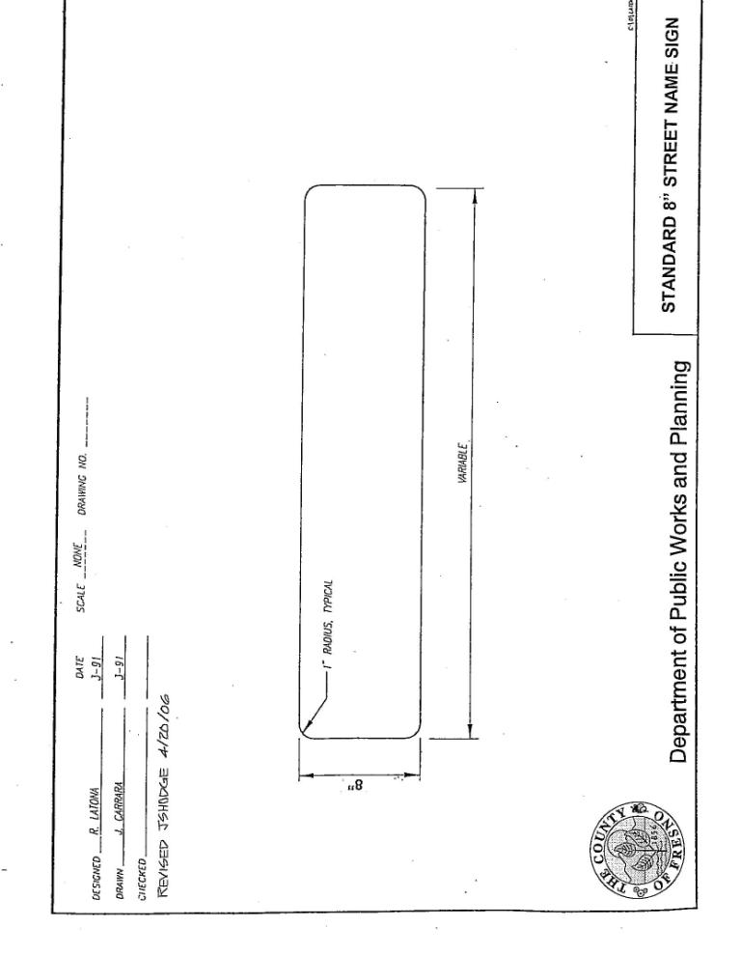
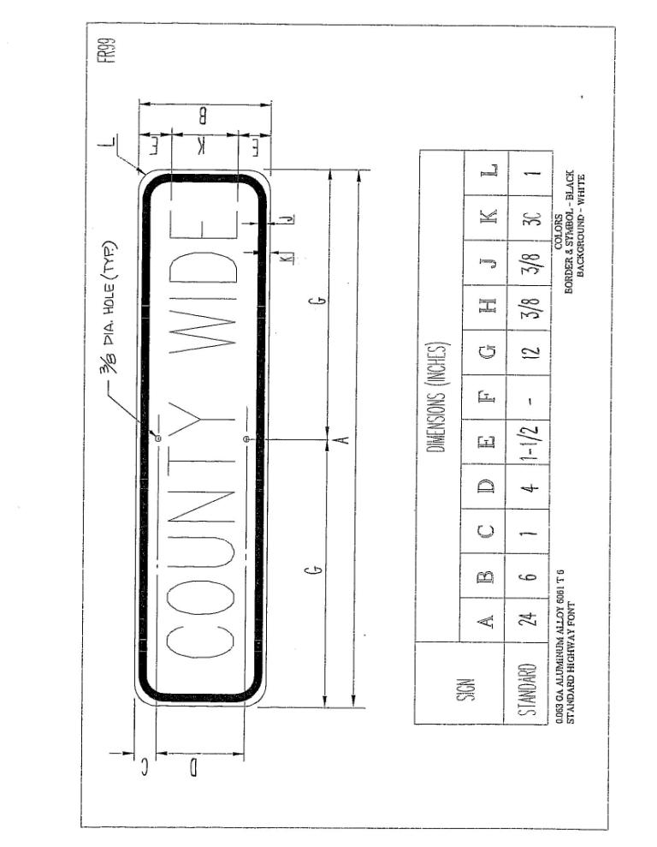
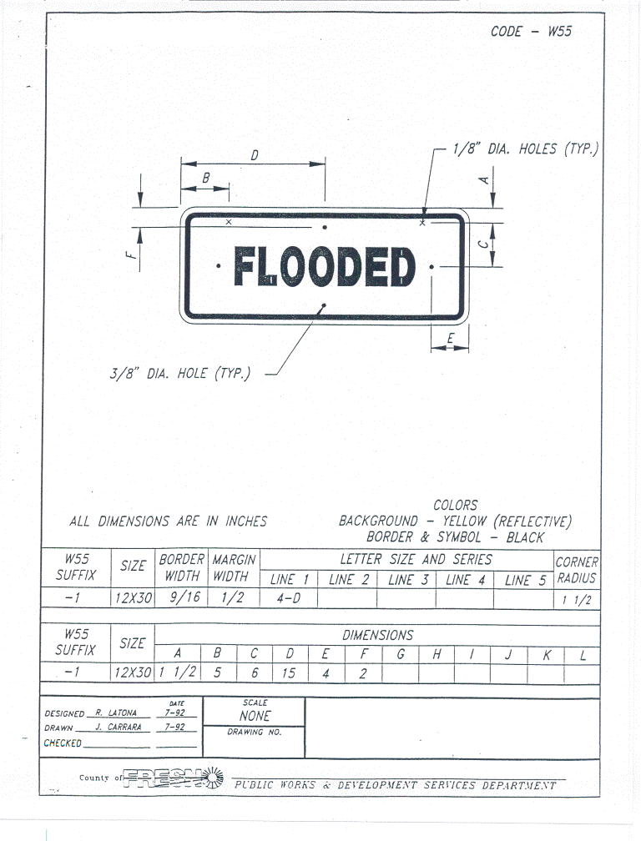
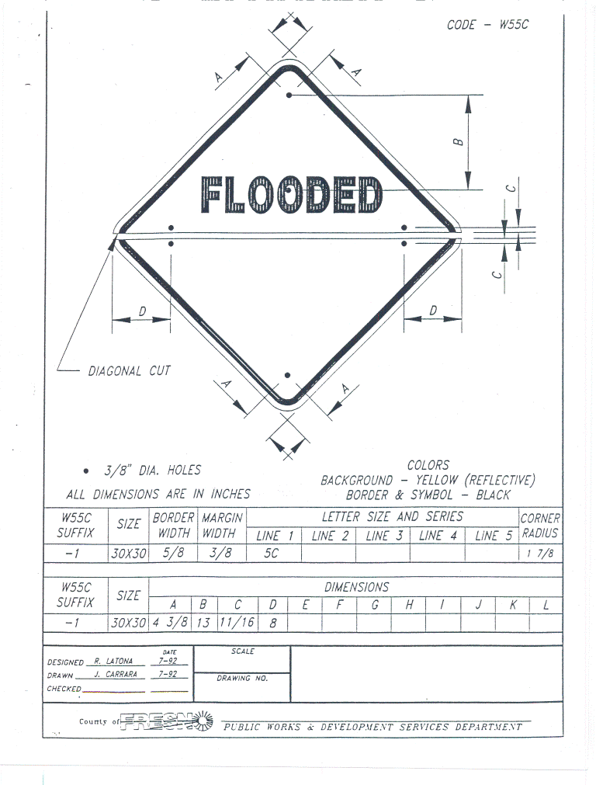
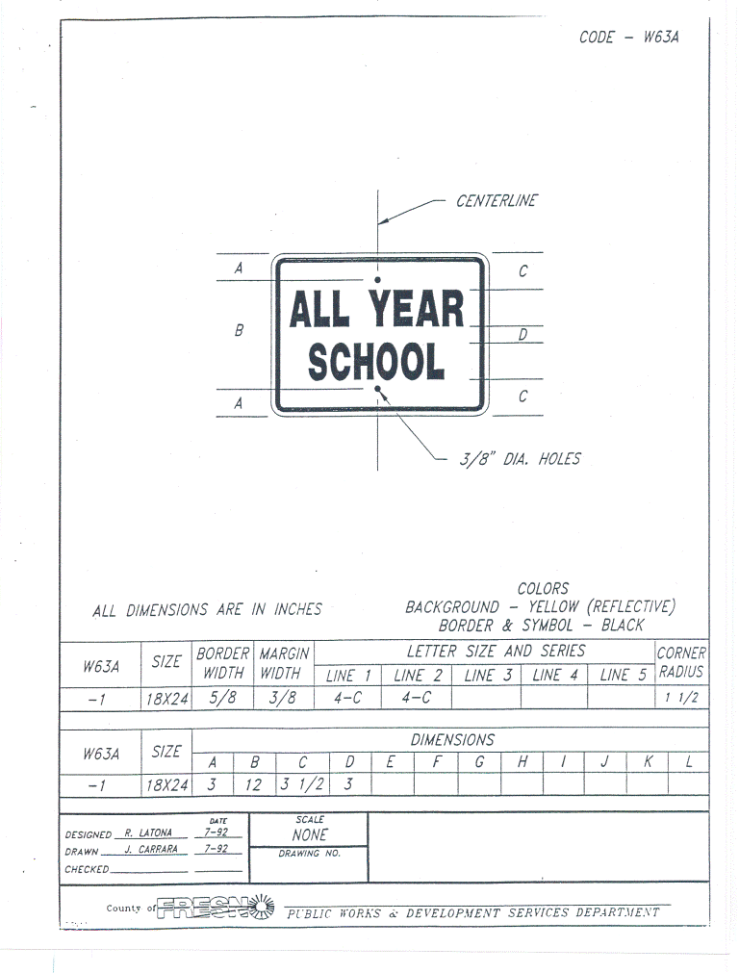
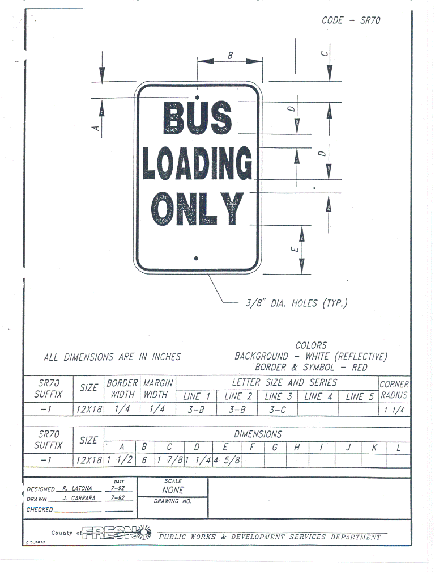
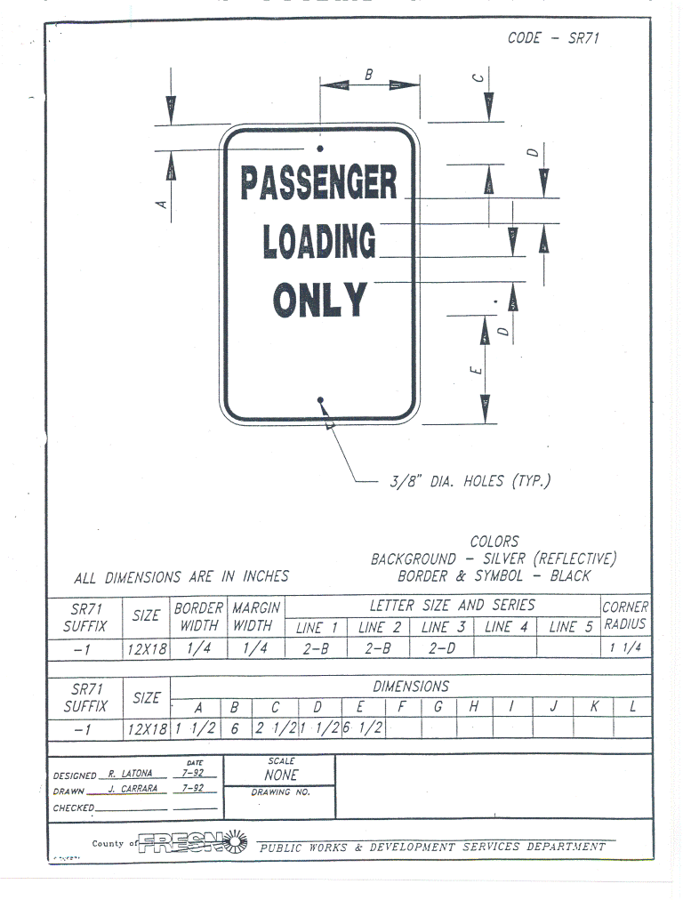
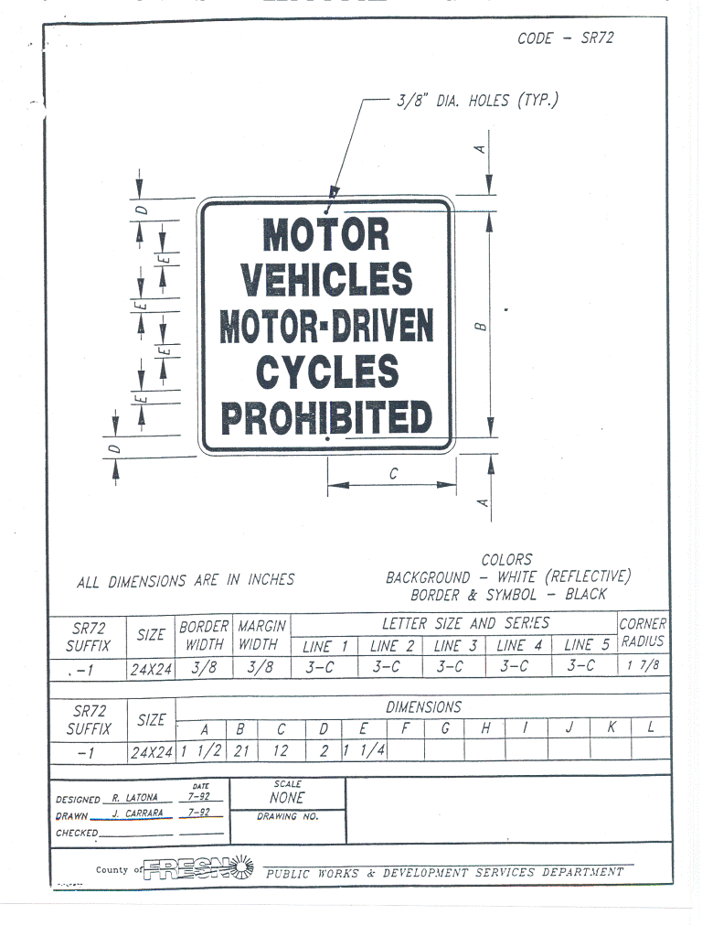
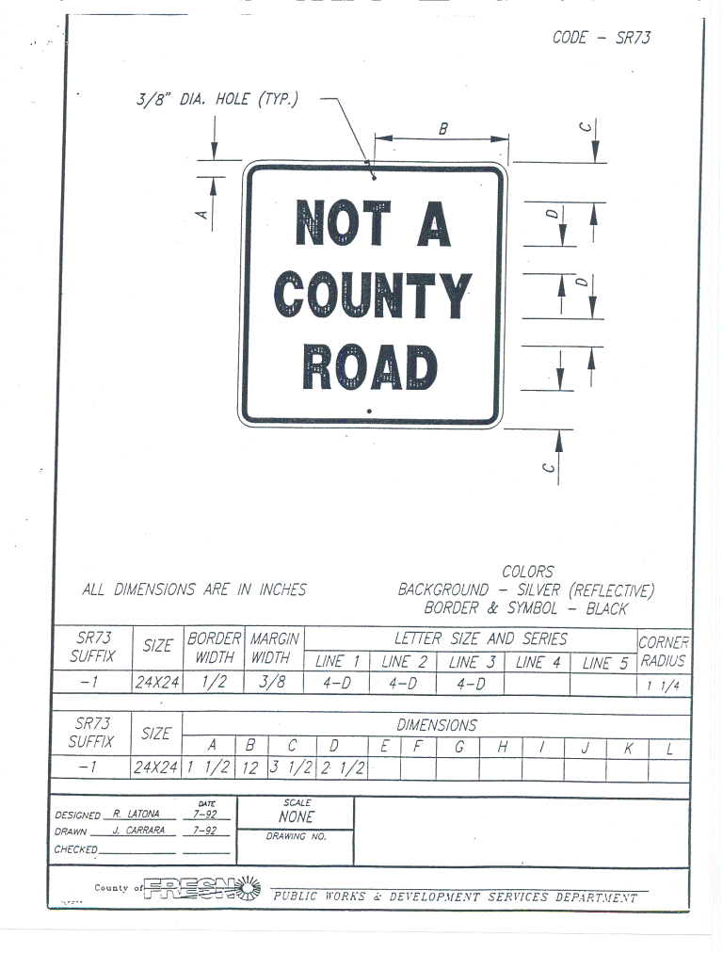
ATTACHMENT B
