COUNTY OF FRESNO
Request for quotation
 |  |  |  |  |  | NUMBER: 770-4110
June 7, 2005
 | ORG/Requisition: 1910/ 1905000010 |  |  |  |  |  |  |  | PURCHASING USE |  |  |  |  | /tmp/in/input.doc
 |  |  |  |  |  |  |  |  | jol
 | IMPORTANT: SUBMIT PROPOSAL IN SEALED PACKAGE WITH PROPOSAL NUMBER, CLOSING DATE AND BUYER’S NAME MARKED CLEARLY ON THE OUTSIDE TO:
COUNTY OF FRESNO, Purchasing
4525 EAST HAMILTON AVENUE
FRESNO, CA 93702-4599
Closing date of bid will be at 2:00 p.m., on JULY 15, 2005.
PROPOSALS WILL BE CONSIDERED LATE WHEN THE OFFICIAL PURCHASING TIME CLOCK READS 2:00 P.M.
 | Proposals will be opened and publicly read at that time. All proposal information will be available for review after contract award.
 | Clarification of specifications are to be directed to: Brian D. Tamblin, phone (559) 456-7110, FAX (559) 456-7831.
 |  | GENERAL CONDITIONS
 |  | See “County Of Fresno Purchasing Standard Instructions And Conditions For Request For Proposals (RFP’S) and Requests for Quotations (RFQ’S)” attached.
BIDDER TO COMPLETE
UNDERSIGNED AGREES TO FURNISH THE COMMODITY OR SERVICE STIPULATED IN THE ATTACHED PROPOSAL SCHEDULE AT THE PRICES AND TERMS STATED, SUBJECT TO THE “COUNTY OF FRESNO PURCHASING STANDARD INSTRUCTIONS AND CONDITIONS FOR REQUEST FOR PROPOSALS (RFP’S) AND REQUESTS FOR QUOTATIONS (RFQ’S)”ATTACHED.
Except as noted on individual items, the following will apply to all items in the Proposal Schedule.
 |  |  | - Complete delivery will be made within |  |  |  |  |  |  |  | calendar days after receipt of Order.
 |  |  | - A cash discount of |  |  |  |  |  | % |  |  |  | days will apply.
Company
Address
City |  |  |  |  |  |  |  |  |  |  |  |  |  |  |  | State |  | Zip Code
( ) |  |  |  |  |  |  |  | ( )
Telephone Number |  |  |  |  |  |  |  | Facsimile Number |  |  |  |  |  |  |  | E-mail Address
Taxpayer Federal I.D. No.:
Signed By
Print Name |  |  |  |  |  |  |  |  |  |  |  | Title

COUNTY OF FRESNO PURCHASING
STANDARD INSTRUCTIONS AND CONDITIONS FOR
REQUESTS FOR PROPOSALS (RFP'S) AND REQUESTS FOR QUOTATIONS (RFQ'S)
Note: the reference to “bids” in the following paragraphs applies to RFP's and RFQ's

GENERAL CONDITIONS
By submitting a bid the bidder agrees to the following conditions. These conditions will apply to all subsequent purchases based on this bid.

- BID PREPARATION:
  - All prices and notations must be typed or written in ink. No erasures permitted. Errors may be crossed out, initialed and corrections printed in ink by person signing bid.
  - Brand Names: Brand names and numbers when given are for reference. Equal items will be considered, provided the offer clearly describes the article and how it differs from that specified. In the absence of such information it shall be understood the offering is exactly as specified.
  - State brand or make of each item. If bidding on other than specified, state make, model and brand being bid and attach supporting literature/specifications to the bid.
  - Bid on each item separately. Prices should be stated in units specified herein. All applicable charges must be quoted; charges on invoice not quoted herein will be disallowed.
  - Time of delivery is a part of the consideration and must be stated in definite terms and must be adhered to. F.O.B. Point shall be destination or freight charges must be stated.
  - All bids must be dated and signed with the firm’s name and by an authorized officer or employee.
  - Unless otherwise noted, prices shall be firm for 120 days after closing date of bid.
- SUBMITTING BIDS:
  - Each bid must be submitted on forms provided in a sealed envelope with bid number and closing date and time on the outside of the envelope/package.
  - Interpretation: Should any discrepancies or omissions be found in the bid specifications or doubt as to their meaning, the bidder shall notify the Buyer in writing at once. The County shall not be held responsible for verbal interpretations. Questions regarding the bid must be received by Purchasing at least 5 working days before bid opening. All addenda issued shall be in writing, duly issued by Purchasing and incorporated into the contract.
  - ISSUING AGENT/AUTHORIZED CONTACT: This RFQ has been issued by County of Fresno Purchasing. Purchasing shall be the vendor’s sole point of contact with regard to the RFQ, its content, and all issues concerning it.
All communication regarding this RFQ shall be directed to an authorized representative of County Purchasing. The specific buyer managing this RFQ is identified on the cover page, along with his or her telephone number, and he or she should be the primary point of contact for discussions or information pertaining to the RFQ. Contact with any other County representative, including elected officials, for the purpose of discussing this RFQ, its content, or any other issue concerning it, is prohibited unless authorized by Purchasing. Violation of this clause, by the vendor having unauthorized contact (verbally or in writing) with such other County representatives, may constitute grounds for rejection by Purchasing of the vendor’s quotation.
The above stated restriction on vendor contact with County representatives shall apply until the County has awarded a purchase order or contract to a vendor or vendors, except as follows. First, in the event that a vendor initiates a formal protest against the RFQ, such vendor may contact the appropriate individual, or individuals who are managing that protest as outlined in the County’s established protest procedures. All such contact must be in accordance with the sequence set forth under the protest procedures. Second, in the event a public hearing is scheduled before the Board of Supervisors to hear testimony prior to its approval of a purchase order or contract, any vendor may address the Board.
  - Bids received after the closing time will NOT be considered.
  - Bidders are to bid what is specified or requested first. If unable to or willing to, bidder may bid alternative or option, indicating all advantages, disadvantages and their associated cost.
- FAILURE TO BID:
  - If not bidding, return bid sheet and state reason for no bid or your name may be removed from mailing list.
- TAXES, CHARGES AND EXTRAS:
  - County of Fresno is subject to California sales and/or use tax (7.975%). Please indicate as a separate line item if applicable.
  - DO NOT include Federal Excise Tax. County is exempt under Registration No. 94-73-03401-K.
  - County is exempt from Federal Transportation Tax. Exemption certificate is not required where shipping papers show consignee as County of Fresno.
  - Charges for transportation, containers, packing, etc. will not be paid unless specified in bid.
- W-9 – REQUEST FOR TAXPAYER IDENTIFICATION NUMBER AND CERTIFICATION:
Upon award of bid, the vendor shall submit to County Purchasing, a completed W-9 - Request for Taxpayer Identification Number and Certification if not already a current vendor with The County of Fresno. This form is available from the IRS to complete on line at http://www.irs.gov/pub/irs-pdf/fw9.pdf.
- AWARDS:
  - Subject to the local preference provisions referenced in Paragraph 6 below and more thoroughly set forth in the General Requirements section of this RFQ, award(s) will be made to the most responsive responsible bidder. The evaluation will include such things as life-cycle cost, availability, delivery costs and whose product and/or service is deemed to be in the best interest of the County. The County shall be the sole judge in making such determination.
  - Unless bidder gives notice of all-or-none award in bid, County may accept any item, group of items or on the basis of total bid.
  - The County reserves the right to reject any and all bids and to waive informalities or irregularities in bids.
  - After award, all bids shall be open to public inspection. The County assumes no responsibility for the confidentiality of information offered in a bid.
- LOCAL VENDORS
  - Local Vendor Preference (applicable to RFQ Process only)
The following provisions are applicable only to the County’s acquisition of materials, equipment or supplies through the RFQ process when the funding source does not require an exemption to the Local Vendor Preference.
THE PROVISIONS OF THIS PARAGRAPH ARE APPLICABLE, NOTWITHSTANDING ANY OTHER PROVISIONS OF THIS RFQ TO THE CONTRARY
If the apparent low bidder is not a local vendor, any local vendor who submitted a bid which was within five percent (5%) of the lowest responsive bid as determined by the purchasing agent shall have the option of submitting a new bid within forty-eight hours (not including weekends and holidays) of County’s delivery of notification. Such new bids must be in an amount less than or equal to the lowest responsive bid as determined by the purchasing agent. If the purchasing agent receives any new bids from local vendors who have the option of submitting new bids within said forty-eight hour period, it shall award the contract to the local vendor submitting the lowest responsible bid. If no new bids are received, the contract shall be awarded to the original low bidder as announced by the purchasing agent.
  - Local Vendor Defined
“Local Vendor” shall mean any business which:
- Has its headquarters, distribution point or locally-owned franchise located in or having a street address within the County for at least six (6) months immediately prior to the issuance of the request for competitive bids by the purchasing agent; and
- Holds any required business license by a jurisdiction located in Fresno County; and
- Employs at least one (1) full-time or two (2) part-time employees whose primary residence is located within Fresno County, or if the business has no employees, shall be at least fifty percent (50%) owned by one or more persons whose primary residence(s) is located within Fresno County.
- TIE BIDS:
All other factors being equal, the contract shall be awarded to the Fresno County vendor or, if neither or both are Fresno County vendors, it may be awarded by the flip of a coin in the presence of witnesses or the entire bid may be rejected and re-bid. If the General Requirements of this RFQ state that they are applicable, the provisions of the Fresno County Local Vendor Preference shall take priority over this paragraph.
- PATENT INDEMNITY:
The vendor shall hold the County, its officers, agents and employees, harmless from liability of any nature or kind, including costs and expenses, for infringement or use of any copyrighted or uncopyrighted composition, secret process, patented or unpatented invention, article or appliance furnished or used in connection with this bid.
- SAMPLES:
Samples, when required, must be furnished and delivered free and, if not destroyed by tests, will upon written request (within 30 days of bid closing date) be returned at the bidder's expense. In the absence of such notification, County shall have the right to dispose of the samples in whatever manner it deems appropriate.
- RIGHTS AND REMEDIES OF COUNTY FOR DEFAULT:
  - In case of default by vendor, the County may procure the articles or service from another source and may recover the cost difference and related expenses occasioned thereby from any unpaid balance due the vendor or by proceeding against performance bond of the vendor, if any, or by suit against the vendor. The prices paid by the County shall be considered the prevailing market price at the time such purchase is made.
  - Articles or services, which upon delivery inspection do not meet specifications, will be rejected and the vendor will be considered in default. Vendor shall reimburse County for expenses related to delivery of non-specified goods or services.
  - Regardless of F.O.B. point, vendor agrees to bear all risks of loss, injury or destruction to goods and materials ordered herein which occur prior to delivery and such loss, injury or destruction shall not release vendor from any obligation hereunder.
- DISCOUNTS:
Terms of less than 15 days for cash payment will be considered as net in evaluating this bid. A discount for payment within fifteen (15) days or more will be considered in determining the award of bid. Discount period will commence either the later of delivery or receipt of invoice by the County. Standard terms are Net Forty-five (45) days.
- SPECIAL CONDITIONS IN BID SCHEDULE SUPERSEDE GENERAL CONDITIONS.
The “General Conditions” provisions of this RFP/RFQ shall be superseded if in conflict with any other section of this bid, to the extent of any such conflict.
- SPECIAL REQUIREMENT:
With the invoice or within twenty-five (25) days of delivery, the seller must provide to the County a Material Safety Data Sheet for each product, which contains any substance on “The List of 800 Hazardous Substances”, published by the State Director of Industrial Relations. (See Hazardous Substances Information and Training Act. California State Labor Code Sections 6360 through 6399.7.)
- RECYCLED PRODUCTS/MATERIALS:
Vendors are encouraged to provide and quote (with documentation) recycled or recyclable products/materials which meet stated specifications.
- YEAR COMPLIANCE WARRANTY
Vendor warrants that any product furnished pursuant to this Agreement/order shall support a four-digit year format and be able to accurately process date and time data from, into and between the twentieth and twenty-first centuries, as well as leap year calculations. "Product" shall include, without limitation, any piece or component of equipment, hardware, firmware, middleware, custom or commercial software, or internal components or subroutines therein. This warranty shall survive termination or expiration of this Agreement.
In the event of any decrease in product functionality or accuracy related to time and/or date data related codes and/or internal subroutines that impede the product from operating correctly using dates beyond December 31, 1999, vendor shall restore or repair the product to the same level of functionality as warranted herein, so as to minimize interruption to County's ongoing business process, time being of the essence. In the event that such warranty compliance requires the acquisition of additional programs, the expense for any such associated or additional acquisitions, which may be required, including, without limitation, data conversion tools, shall be borne exclusively by vendor. Nothing in this warranty shall be construed to limit any rights or remedies the County may otherwise have under this Agreement with respect to defects other than year performance.
- PARTICIPATION:
Bidder may agree to extend the terms of the resulting contract to other political subdivision, municipalities and tax-supported agencies.
Such participating Governmental bodies shall make purchases in their own name, make payment directly to bidder, and be liable directly to the bidder, holding the County of Fresno harmless.
- CONFIDENTIALITY:
All services performed by vendor shall be in strict conformance with all applicable Federal, State of California and/or local laws and regulations relating to confidentiality, including but not limited to, California Civil Code, California Welfare and Institutions Code, Health and Safety Code, California Code of Regulations, Code of Federal Regulations.
Vendor shall submit to County’s monitoring of said compliance.
Vendor may be a business associate of County, as that term is defined in the “Privacy Rule” enacted by the Health Insurance Portability and Accountability Act of 1996 (HIPAA). As a HIPAA Business Associate, vendor may use or disclose protected health information (“PHI”) to perform functions, activities or services for or on behalf of County as specified by the County, provided that such use or disclosure shall not violate HIPAA and its implementing regulations. The uses and disclosures if PHI may not be more expansive than those applicable to County, as the “Covered Entity” under HIPAA’S Privacy Rule, except as authorized for management, administrative or legal responsibilities of the Business Associate.
Vendor shall not use or further disclose PHI other than as permitted or required by the County, or as required by law without written notice to the County.
Vendor shall ensure that any agent, including any subcontractor, to which vendor provides PHI received from, or created or received by the vendor on behalf of County, shall comply with the same restrictions and conditions with respect to such information.
- APPEALS
Appeals must be submitted in writing within five (5) working days after the review committee notification of proposed recommendations. Appeals should be submitted to County of Fresno Purchasing, 4525 E. Hamilton Avenue, Fresno, California 93702-4599. Appeals should address only areas regarding RFP contradictions, procurement errors, quotation rating discrepancies, legality of procurement context, conflict of interest in rating process, and inappropriate or unfair competitive procurement grievance regarding the RFP process.
The Purchasing Manager will provide a written response to the complaint within five (5) working days unless the complainant is notified more time is required.
If the protesting bidder is not satisfied with the decision of the Purchasing Manager, he/she shall have the right to appeal to the Purchasing Agent within five (5) business days after notification of the Purchasing Manager’s decision.
If the protesting bidder is not satisfied with Purchasing Agent decision, the final appeal is with the Board of Supervisors.

TABLE OF CONTENTS
PAGE

This is an Automatic Table of Contents... If you don’t want to use it, just delete it and use the Manual Table of Contents following this one.
OVERVIEW 3
KEY DATES 3
BIDDING INSTRUCTIONS 4
BIDDER TO COMPLETE 10
REFERENCE LIST 11
FORM W-9 12
REQUIREMENTS & SPECIFICATIONS 16
QUOTATION SCHEDULE 33
SUBMITTALS 34

OVERVIEW
The County of Fresno is soliciting bids to provide all labor, materials, equipment, permits, fees, taxes and insurances etc., for replacement of County’s Main Jail Roof, with a Thermoplastic Membrane Roofing system as specified within this Request for Quotation.
Where specific products and manufacturer’s are referenced in the “Requirements and Specification” section of this RFQ, bidder(s) are invited to quote “As Specified” or their equal.
Any bidder(s) intending to submit their equal system for consideration, shall be required to supply to the County Coordinator at the site inspection, all relative samples, brochures and specifications etc. outlining their systems features.
An evaluation of all alternate system proposals will be carried out by the County prior to the close date of the RFQ, and vendor(s) will be notified as to the acceptability of their proposed system.
Note: Roof drawings and plans will be available at the site inspection.
Approximate area of roof is 15,520 sq ft.

KEY DATES
Date of site Inspection: | Wednesday, June 22, 2005 at 9:30 A.M.
Location: | Randal Bolens Office
 | Main Jail Central Plant
Fresno St. and L
Fresno, CA
Verification or Clarification of verbal and/or written information from County Purchasing.: | Tuesday, July 5, 2005 at 9:00 A.M.
Request for Quotation Closing  Date.: | Friday, July 15, 2005 at 2:00 P.M.
Location: | County of Fresno Purchasing
 | 4525 E. Hamilton Avenue (2nd Floor)
 | Fresno, CA 93702

BIDDING INSTRUCTIONS
The County of Fresno is soliciting bids to provide all labor, material, equipment, taxes, fees, insurances, permits etc. to replace the roof of the County’s Main Jail facility with a Thermoplastic Membrane Roofing System as specified within this Request for Quotation.
LOCAL VENDOR PREFERENCE: The Local Vendor Preference does not apply to this Request for Quotation.
ISSUING AGENT: This RFQ has been issued by County of Fresno Purchasing. The Purchasing shall be the vendor’s sole point of contact with regard to the RFQ, its content, and all issues concerning it.
AUTHORIZED CONTACT: All communication regarding this RFQ shall be directed to an authorized representative of County Purchasing. The specific buyer managing this RFQ is identified on the cover page, along with his or her telephone number, and he or she should be the primary point of contact for discussions or information pertaining to the RFQ. Contact with any other County representative, including elected officials, for the purpose of discussing this RFQ, it content, or any other issue concerning it, is prohibited unless authorized by Purchasing. Violation of this clause, by the vendor having unauthorized contact (verbally or in writing) with such other County representatives, may constitute grounds for rejection by Purchasing of the vendor’s quotation.
The above stated restriction on vendor contact with County representatives shall apply until the County has awarded a purchase order or contract to a vendor or vendors, except as follows. First, in the event that a vendor initiates a formal protest against the RFQ, such vendor may contact the appropriate individual, or individuals who are managing that protest as outlined in the County’s established protest procedures. All such contact must be in accordance with the sequence set forth under the protest procedures. Second, in the event a public hearing is scheduled before the Board of Supervisors to hear testimony prior to its approval of a purchase order or contract, any vendor may address the Board.
AWARD: Award will be made to the bidder(s) whose product(s) service, price, and delivery is most advantageous to the County. The County will be the sole judge in making this determination.
NUMBER OF COPIES: Submit one (1) original and two (2) copies of your quotation no later than the quotation closing date and time as stated on the front of this document to County of Fresno Purchasing. Each copy to be identical to the original, including all supporting documentation (i.e. literature, brochures, reports, schedules, specifications, drawings etc.). The cover page of each quotation is to be appropriately marked “Original” or “Copy”.

BONDS:
Performance and Payment Bonds: The successful bidder shall furnish a faithful performance bond and a payment bond in the amount of 100 percent of the contract amount.
Bonding Company Requirements: Each bond specified in this RFQ (bid bond, faithful performance bond and payment bond) shall meet the requirements of all applicable statutes, including but not limited to those specified in Public Contract Code section 20129 and Civil Code section 3248. Each bond specified in this RFQ shall be issued by a surety company designated as an admitted surety insurer in good standing with and authorized to transact business in this state by the California Department of Insurance, and acceptable to the County of Fresno. Bidders are cautioned that representations made by surety companies will be verified with the California Department of Insurance. Additionally, the County of Fresno, in its discretion, when determining the sufficiency of a proposed surety company, may require the surety company to provide additional information supported by documentation. The County generally requires such information and documentation whenever the proposed surety company has either a Best’s Key Rating Guide of less than B+ or a financial size designation of less than VIII. Provided, however, that the County expressly reserves its right to require all information and documentation to which the County is legally entitled from any proposed surety company.
FIRM PROPOSAL: For purposes of award, all bids shall remain firm for at least one hundred eighty (180) calendar days from the closing date of this RFQ.
RIGHT TO REJECT BIDS: The County reserves the right to reject any and all bids and to waive informalities or irregularities in bids.
INTERPRETATION OF RFQ: Vendors must make careful examination of the requirements, specifications and conditions expressed in the RFQ and fully inform themselves as to the quality and character of services required. If any person planning to submit a quotation finds discrepancies in or omissions from the RFQ or has any doubt as to the true meaning or interpretation, correction thereof may be requested at the scheduled Site Inspection (see below). Any change in the RFQ will be made only by written addendum, duly issued by the County. The County will not be responsible for any other explanations or interpretations.
Questions may be submitted subsequent to the Site Inspection, subject to the following conditions:
- Such questions are submitted in writing to County Purchasing at least seven (7) County business days prior to the Request for Quotation closing date. Questions must be directed to the attention of the buyer identified on page one.
- Such questions are submitted with the understanding that County can respond only to questions it considers material in nature.
Questions shall be delivered to County of Fresno Purchasing, 4525 E. Hamilton Avenue, Fresno, CA 93702 or faxed to (559) 456-7831. If faxing the bidder must confirm receipt by phone within one-half (1/2) hour of transmission.
NOTE: The bidder is encouraged to submit all questions at the Site Inspection. Time limitations can prevent a response to questions submitted after the cutoff date. This cut off date/time shall be July 5, 2005 at 9:00 A.M.

Site Inspection: Each bidder shall have examined the site of work before bidding and shall be responsible for having acquired full knowledge of the job and of all problems affecting it. No variations or allowance from the contract sum will be made because of lack of such examination. The date inspection will be held as follows:
DATE: June 22, 2005
TIME: 9:30 A.M.
LOCATION: Randal Bolen’s Office
Main Jail Central Plant
Fresno St. and L.
NOTICE TO PROCEED: Following execution of the agreement by both parties (County and Contractor), the County will issue a written Notice to Proceed for the project specified herein. The completion period shall commence upon the date that the Notice to Proceed is delivered to the Contractor.
CODES AND REGULATIONS: All work and material to conform to all applicable state and local building and other codes and regulations.
MATERIALS TO BE NEW: All materials shall be new and of merchantable grade, free from defect. No bid will be considered unless it is accompanied by a complete list of catalog numbers of the items, which the bidder proposes to furnish, together with full descriptive literature on all items so enumerated. If item proposed differs from these specifications, bidder shall present specific explanation of functioning and structural characteristics for those details which differ from the specifications listed herein.
DAMAGE TO EXISTING WORK: Damage to existing construction, equipment, planting, etc., by the successful bidder in the performance of his work shall be replaced or repaired and restored to original condition by the successful bidder.
CLEAN-UP: The successful bidder shall at all times keep the premises clean from accumulation of waste materials or rubbish caused by his employees or work and shall remove all resulting work debris from the job site.
WATER, POWER & TOILET FACILITIES: Successful bidder may use County owned water, power and toilet facilities at job site (when existing) at no expense to the successful bidder. Successful bidder will be required, however, to provide piping, fittings and other items as necessary to bring water and power from existing service to job site.
COORDINATE WORK WITH OWNER: Successful bidder shall coordinate and schedule the work with the County so that any interruption to the normal business operations be kept to a minimum.
TAXES, PERMITS & FEES: The successful bidder shall pay for and include all federal, state and local taxes direct or indirect upon all materials; pay all fees for, and obtain all necessary permits and licenses, unless otherwise specified herein.
INSPECTION: All material and workmanship shall be subject to inspection, examination and test by the County at any and all times during which manufacture and/or construction are carried on. The County shall have the right to reject defective material and workmanship or require its correction.
SUPERVISION: The successful bidder shall give efficient supervision to the work, using therein the skill and diligence for which he is remunerated in the contract price. He shall carefully inspect the site and study and compare all drawings, specifications and other instructions, as ignorance of any phase of any of the features or conditions affecting the contract will not excuse him from carrying out its provisions to its full intent.
SAFEGUARDS: The successful bidder shall provide, in conformity with all local codes and ordinances and as may be required, such temporary walls, fences, guardrails, barricades, lights, danger signs, enclosures, etc., and shall maintain such safeguards until all work is completed.
PAYMENT: Upon satisfactory completion of work, specified herein and approval by the County, payment will be made in full. Terms of payment will be net forty-five (45) days. County will consider the Bidder’s Cash discount Offer, as previously stated under the General Terms and Conditions in lieu of the net forty-five (45) days payment terms.
INVOICING: Invoices shall be delivered in triplicate to: the requesting County department..
INDEPENDENT CONTRACTOR: In performance of the work, duties and obligations assumed by Contractor under this Agreement, it is mutually understood and agreed that Contractor, including any and all of Contractor's officers, agents, and employees will at all times be acting and performing as an independent contractor, and shall act in an independent capacity and not as an officer, agent, servant, employee, joint venturer, partner, or associate of the County. Furthermore, County shall have no right to control or supervise or direct the manner or method by which Contractor shall perform its work and function. However, County shall retain the right to administer this Agreement so as to verify that Contractor is performing its obligations in accordance with the terms and conditions thereof. Contractor and County shall comply with all applicable provisions of law and the rules and regulations, if any, of governmental authorities having jurisdiction over matters the subject thereof.
Because of its status as an independent contractor, Contractor shall have absolutely no right to employment rights and benefits available to County employees. Contractor shall be solely liable and responsible for providing to, or on behalf of, its employees all legally required employee benefits. In addition, Contractor shall be solely responsible and save County harmless from all matters relating to payment of Contractor's employees, including compliance with Social Security, withholding, and all other regulations governing such matters. It is acknowledged that during the term of this Agreement, Contractor may be providing services to others unrelated to the County or to this Agreement.
HOLD HARMLESS CLAUSE: Contractor agrees to indemnify, save, hold harmless and at County's request, defend its officers, agents and employees, from any and all costs and expenses, damages, liabilities, claims and losses occurring or resulting to County in connection with the performance, or failure to perform, by Contractor, its officers, agents or employees under this agreement and from any and all costs and expenses, damages, liabilities, claims and losses occurring or resulting to any person, firm or corporation who may be injured or damaged by the performance, or failure to perform, of Contractor, its officers, agents or employees under this agreement.
PREVAILING WAGES: In accordance with the provisions of Section 1770 of the Labor Code, the Director of the Department of Industrial Relations of the State of California has determined the general prevailing rates of wages and employer payments for health and welfare pension, vacation, travel time and subsistence pay as provided for in Section 1773.8, apprenticeship or other training programs authorized by Section 3093, and similar purposes applicable to the work to be done. A copy of the above-mentioned wage rates shall be posted by the successful bidder at the job site where it will be available to any interested party.
Information pertaining to Prevailing Wage Rates can be found on the web site for the State of California – Division of Labor Statistics and Research:
http://www.dir.ca.gov/dlsr/statistics_research.html

INSURANCE:
Without limiting the COUNTY's right to obtain indemnification from CONTRACTOR or any third parties, CONTRACTOR, at its sole expense, shall maintain in full force and effect the following insurance policies throughout the term of the Agreement:
- Commercial General Liability
Commercial General Liability Insurance with limits of not less than One Million Dollars ($1,000,000) per occurrence and an annual aggregate of Two Million Dollars ($2,000,000). This policy shall be issued on a per occurrence basis. COUNTY may require specific coverages including completed operations, products liability, contractual liability, Explosion-Collapse-Underground, fire legal liability or any other liability insurance deemed necessary because of the nature of this contract.
- Automobile Liability
Comprehensive Automobile Liability Insurance with limits for bodily injury of not less than Two Hundred Fifty Thousand Dollars ($250,000.00) per person, Five Hundred Thousand Dollars ($500,000.00) per accident and for property damages of not less than Fifty Thousand Dollars ($50,000.00), or such coverage with a combined single limit of Five Hundred Thousand Dollars ($500,000.00). Coverage should include owned and non-owned vehicles used in connection with this Agreement.
- Professional Liability
If CONTRACTOR employs licensed professional staff, (e.g., Ph.D., R.N., L.C.S.W., M.F.C.C.) in providing services, Professional Liability Insurance with limits of not less than One Million Dollars ($1,000,000.00) per occurrence, Three Million Dollars ($3,000,000.00) annual aggregate.
- Worker's Compensation
A policy of Worker's Compensation insurance as may be required by the California Labor Code.
Contractor shall obtain endorsements to the Commercial General Liability insurance naming the County of Fresno, its officers, agents, and employees, individually and collectively, as additional insured, but only insofar as the operations under this Agreement are concerned. Such coverage for additional insured shall apply as primary insurance and any other insurance, or self-insurance, maintained by County, its officers, agents and employees shall be excess only and not contributing with insurance provided under contractor's policies herein. This insurance shall not be cancelled or changed without a minimum of thirty (30) days advance written notice given to County.
Within Thirty (30) days from the date contractor signs Agreement, contractor shall provide certificates of insurance and endorsement as stated above for all of the foregoing policies, as required herein, to the County of Fresno, stating that such insurance coverage have been obtained and are in full force; that the County of Fresno, its officers, agents and employees will not be responsible for any premiums on the policies; that such Commercial General Liability insurance names the County of Fresno, its officers, agents and employees, individually and collectively, as additional insured, but only insofar as the operations under this Agreement are concerned; that such coverage for additional insured shall apply as primary insurance and any other insurance, or self-insurance, maintained by County, its officers, agents and employees, shall be excess only and not contributing with insurance provided under contractor's policies herein; and that this insurance shall not be cancelled or changed without a minimum of thirty (30) days advance, written notice given to County.
In the event contractor fails to keep in effect at all times insurance coverage as herein provided, the County may, in addition to other remedies it may have, suspend or terminate this Agreement upon the occurrence of such event.
All policies shall be with admitted insurers licensed to do business in the State of California. Insurance purchased shall be purchased from companies possessing a current A.M. Best, Inc. rating of A FSC VII or better.
BONDS: The successful bidder will be required to furnish a Faithful Performance Bond and a Labor and Materials Bond in an amount equal to one hundred percent (100%) of the contract price.
BONDING COMPANY: The company issuing bonds shall be a corporate surety admitted by the California Insurance Commissioner to do business in the State of California with an A.M Best rating of B++ VIII or better.
COORDINATION AND COMPLETION: The successful bidder shall contact and meet with the County Coordinator at the job site prior to commencement and completion of any work.
Successful bidder shall complete the job as instructed and described in writing by the contract, bid or amendment. Any problem or questions that arise in the scope of work, the County must be contacted and the appropriate written amendment generated.

BIDDER TO COMPLETE

SUBCONTRACTORS:
List all subcontractors that would perform work in excess of one/half of one percent of the total amount of your bid, and state general type of work such subcontractor would be performing:
CONTRACTOR'S LICENSE:
Bidder to possess appropriate license for the project in accordance with current regulations/statutes.
The vendor shall possess a current State of California contractor’s Licenses, that covers the work to be performed. The proposal must indicate the license held by the bidder, which enables him/her to perform the work.
Bidder explain why his/her license(s) is acceptable. The County will review and determine if acceptable.
Number and Class:
Date of Issue:
INSURANCE:
Name of Insurance Carrier:
Commercial General Liability: |  |  |  | Expires:
Automobile Liability: |  |  |  | Expires
Workman's Compensation: |  |  |  | Expires:
Proof of maintenance of adequate insurance will be required before award is made to vendor.
GUARANTEE: The bidder shall state his written guarantee here:

Vendor must complete and return with Request for Quotation.
Firm:
REFERENCE LIST
Submit a list of at least three (3) customer references. Such references shall be customers for whom the bidder has recently provided services to those requested herein.
Reference Name: |  |  | City:
Contact: |  |  | Phone No.:
Date and Service Provided:
Reference Name: |  |  | City:
Contact: |  |  | Phone No.:
Date and Service Provided:
Reference Name: |  |  | City:
Contact: |  |  | Phone No.:
Date and Service Provided:
Reference Name: |  |  | City:
Contact: |  |  | Phone No.:
Date and Service Provided:
Reference Name: |  |  | City:
Contact: |  |  | Phone No.:
Date and Service Provided:
FAILURE TO PROVIDE A LIST OF AT LEAST THREE (3) CUSTOMERS MAY BE CAUSE FOR REJECTION OF THIS RFQ.

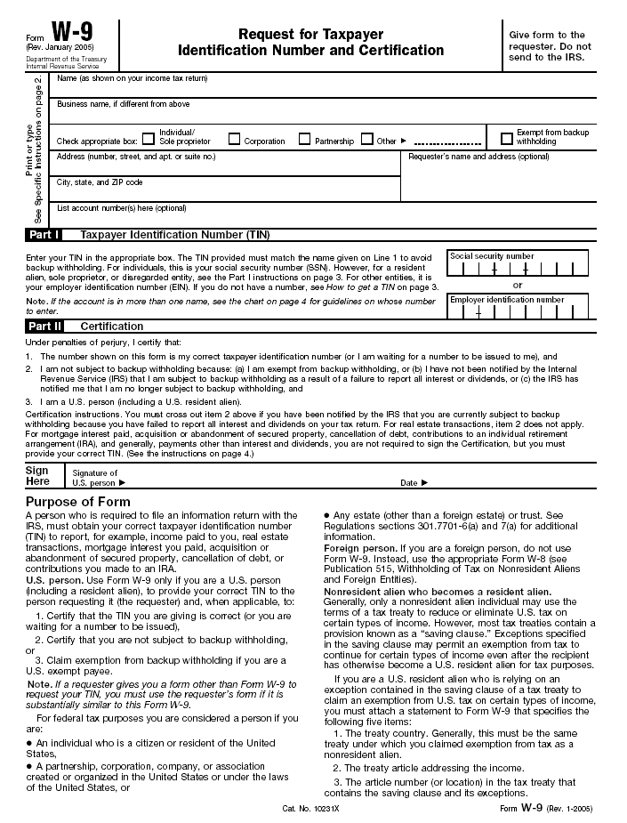
FORM W-9

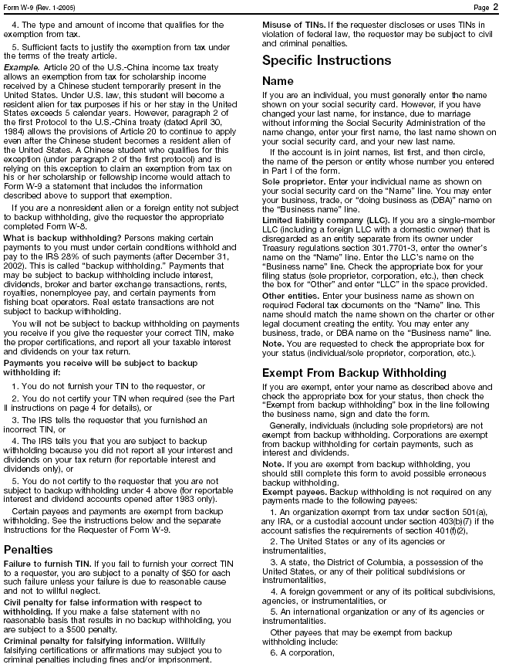
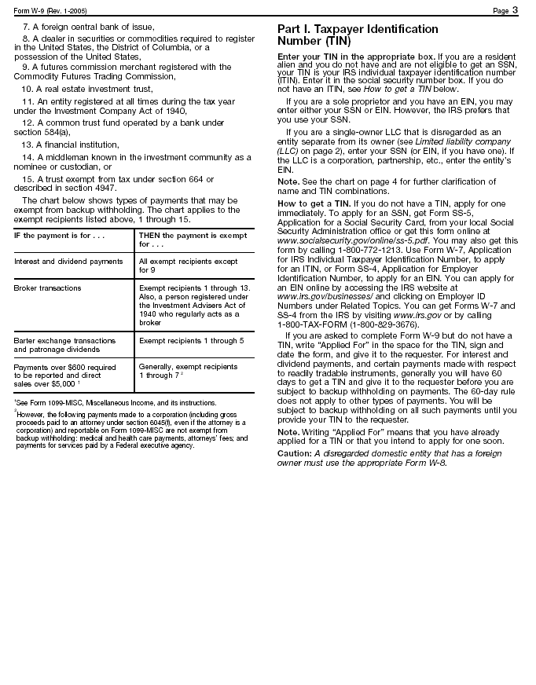
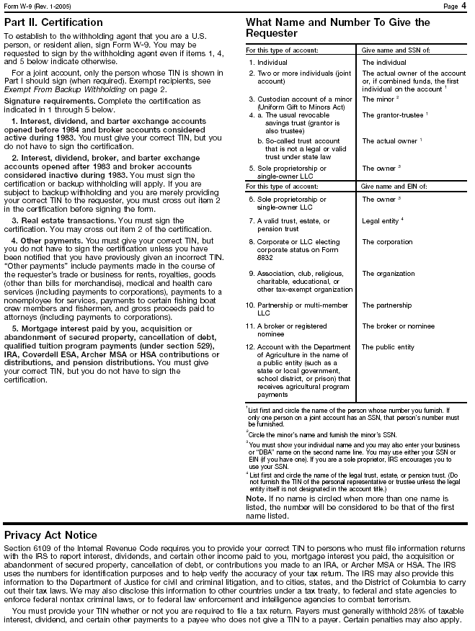

REQUIREMENTS & SPECIFICATIONS
(Products and manufacturer’s referenced within this section are a means of establishing quality and style. Bidders are invited to quote their equal.)

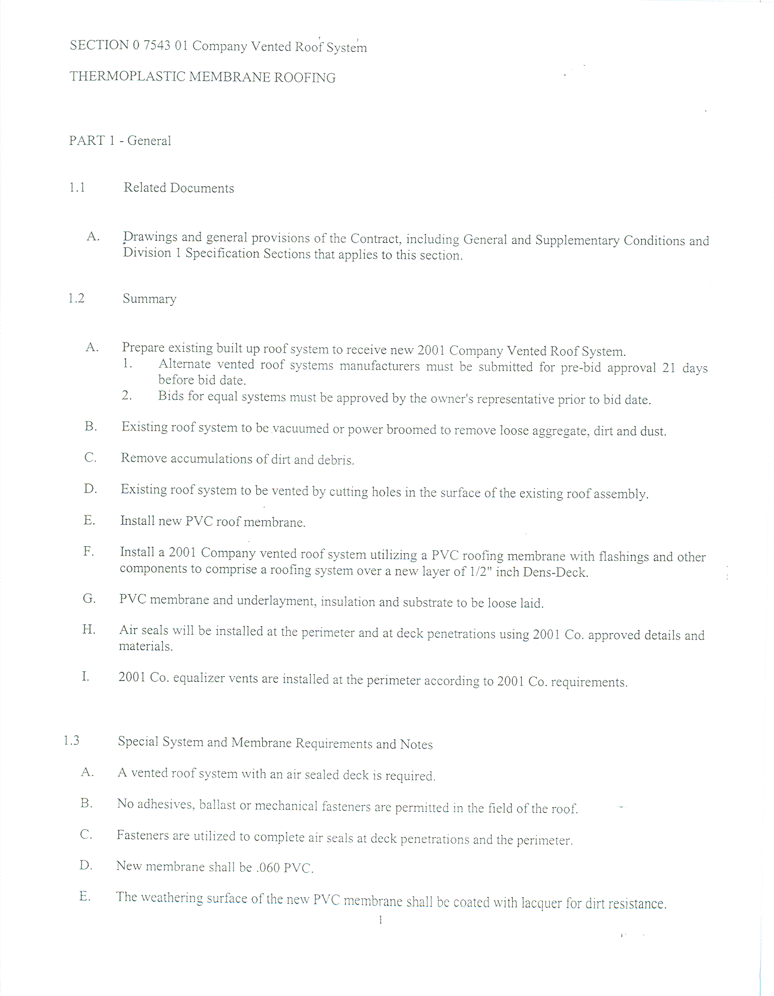
Type
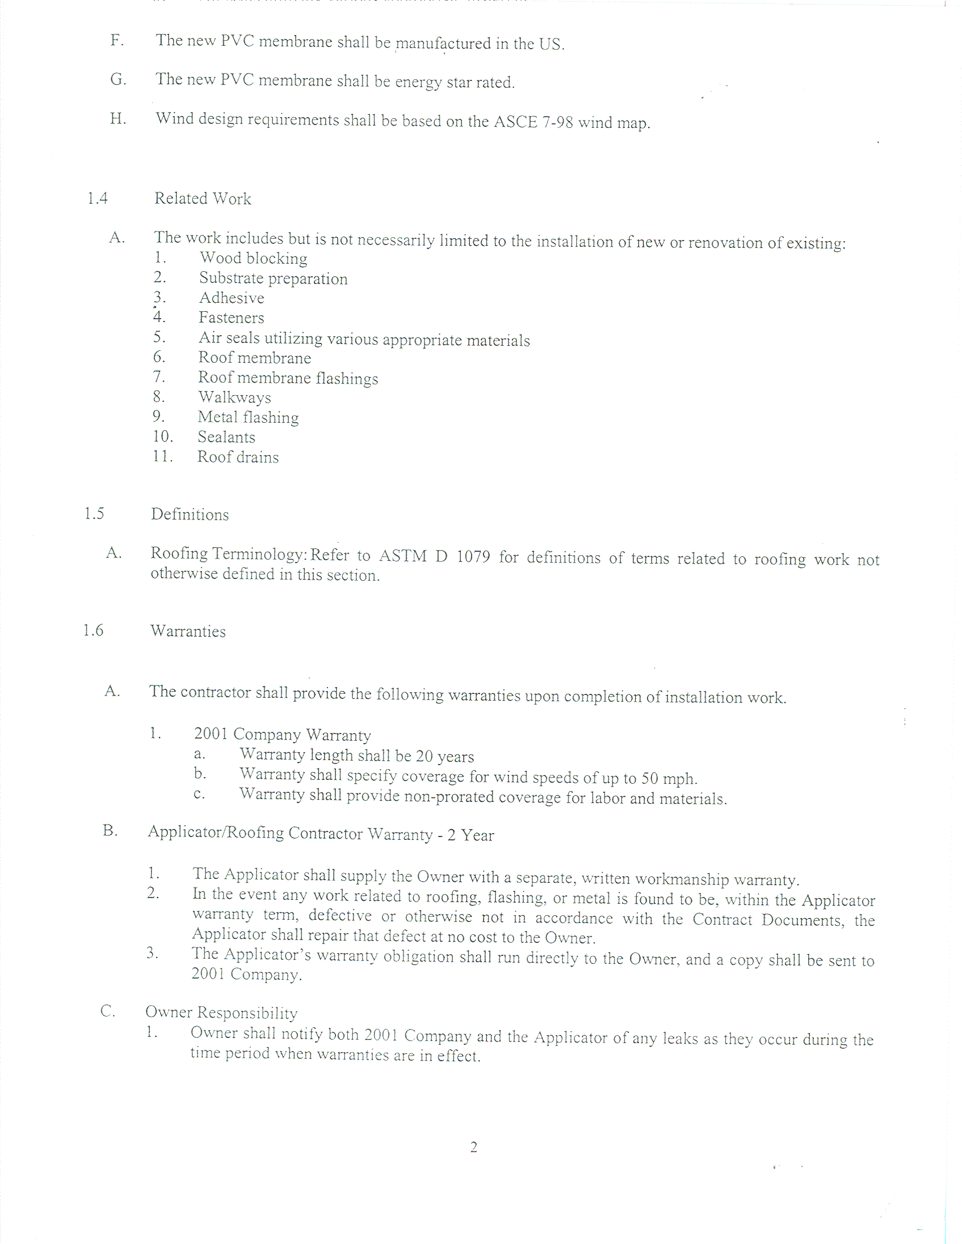
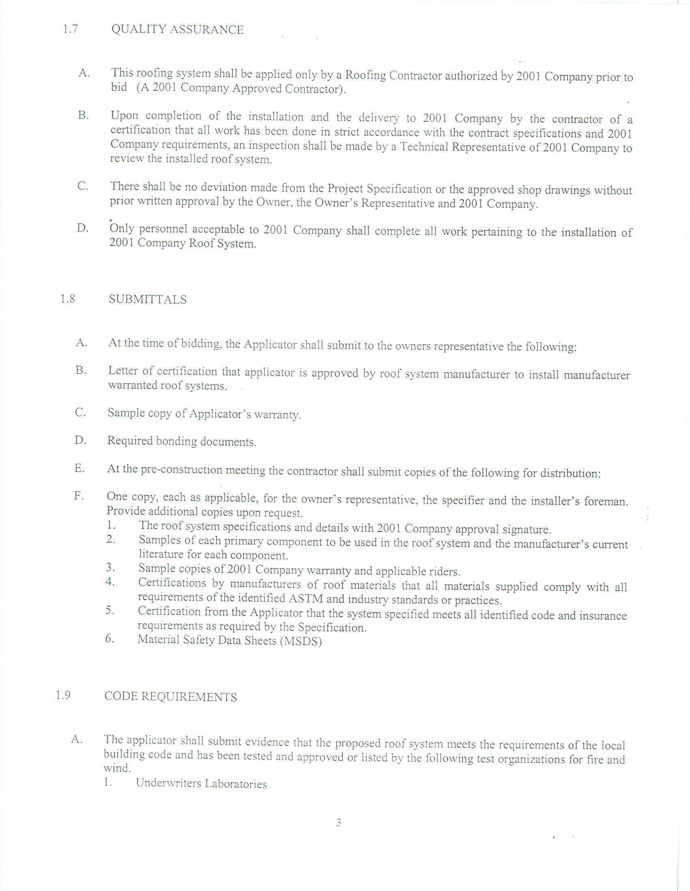
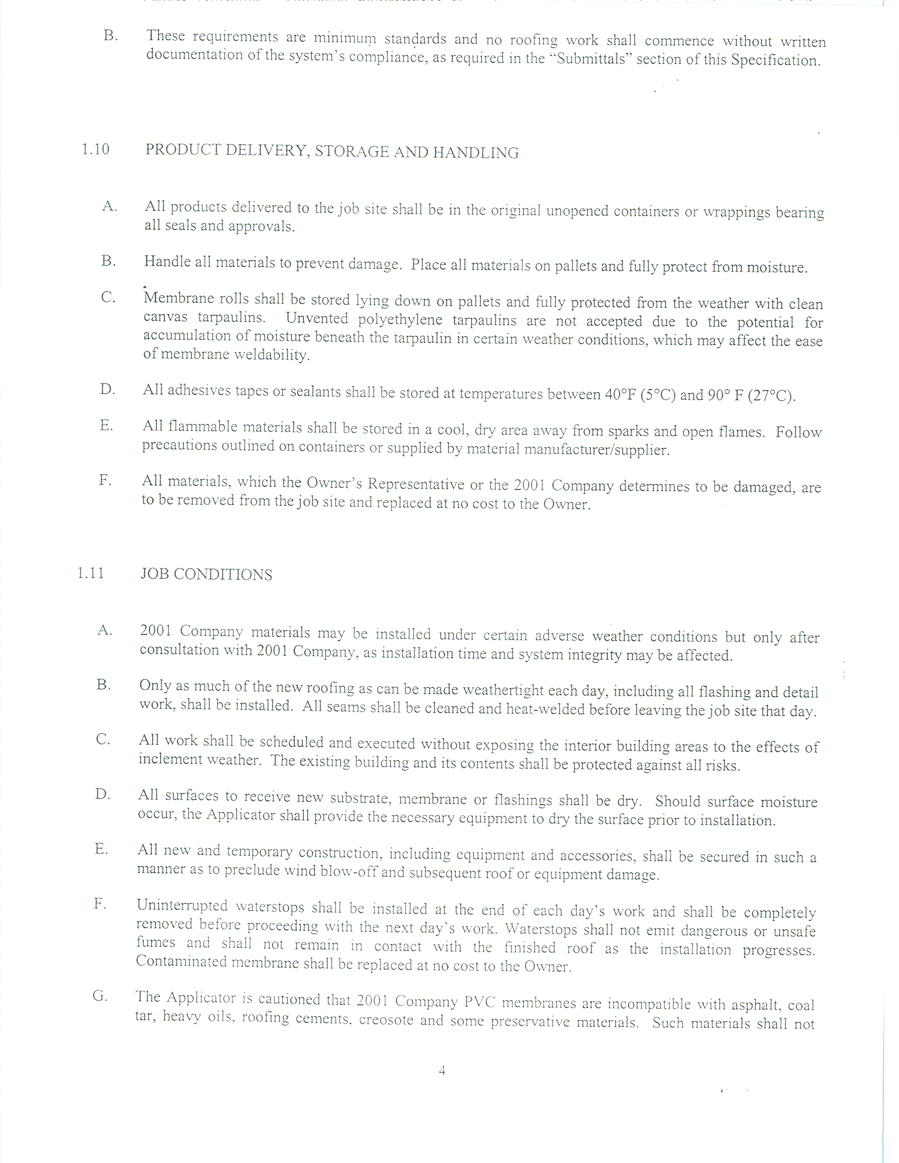
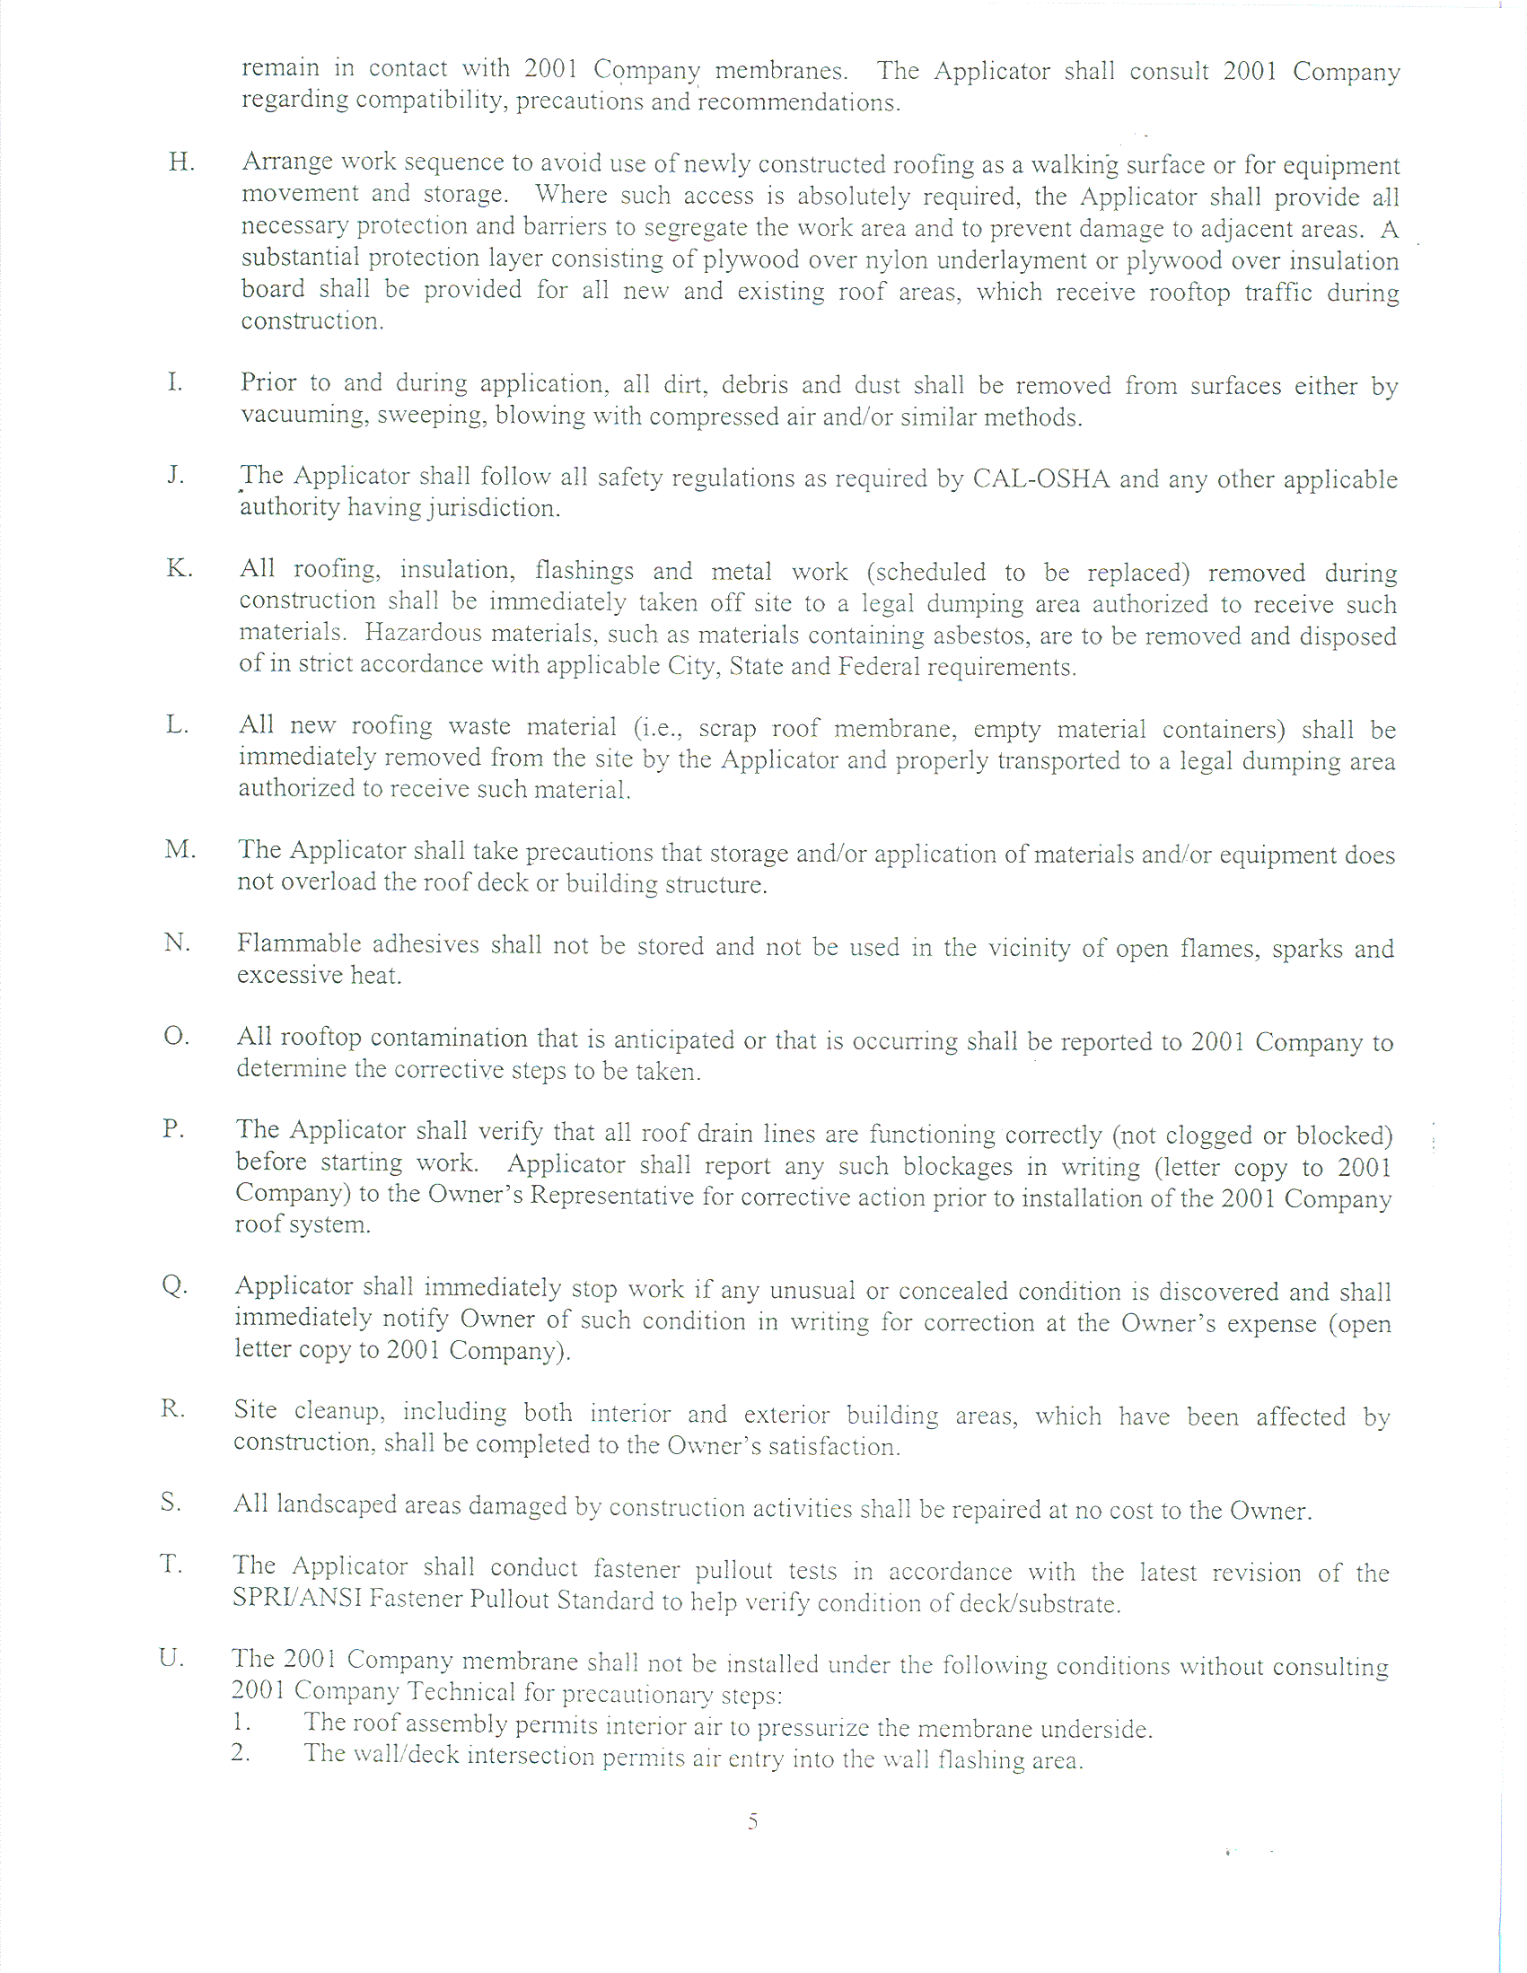
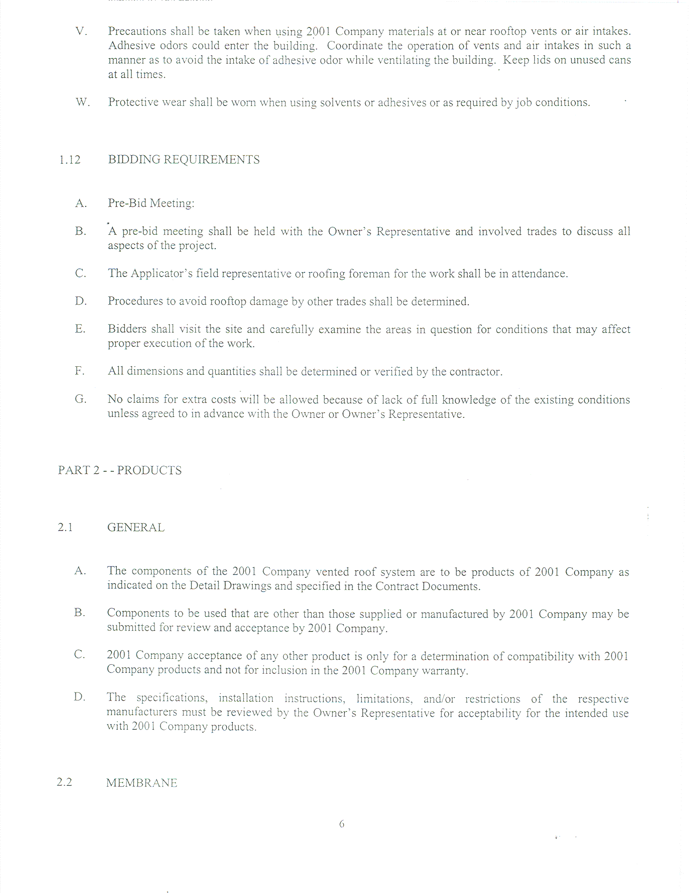
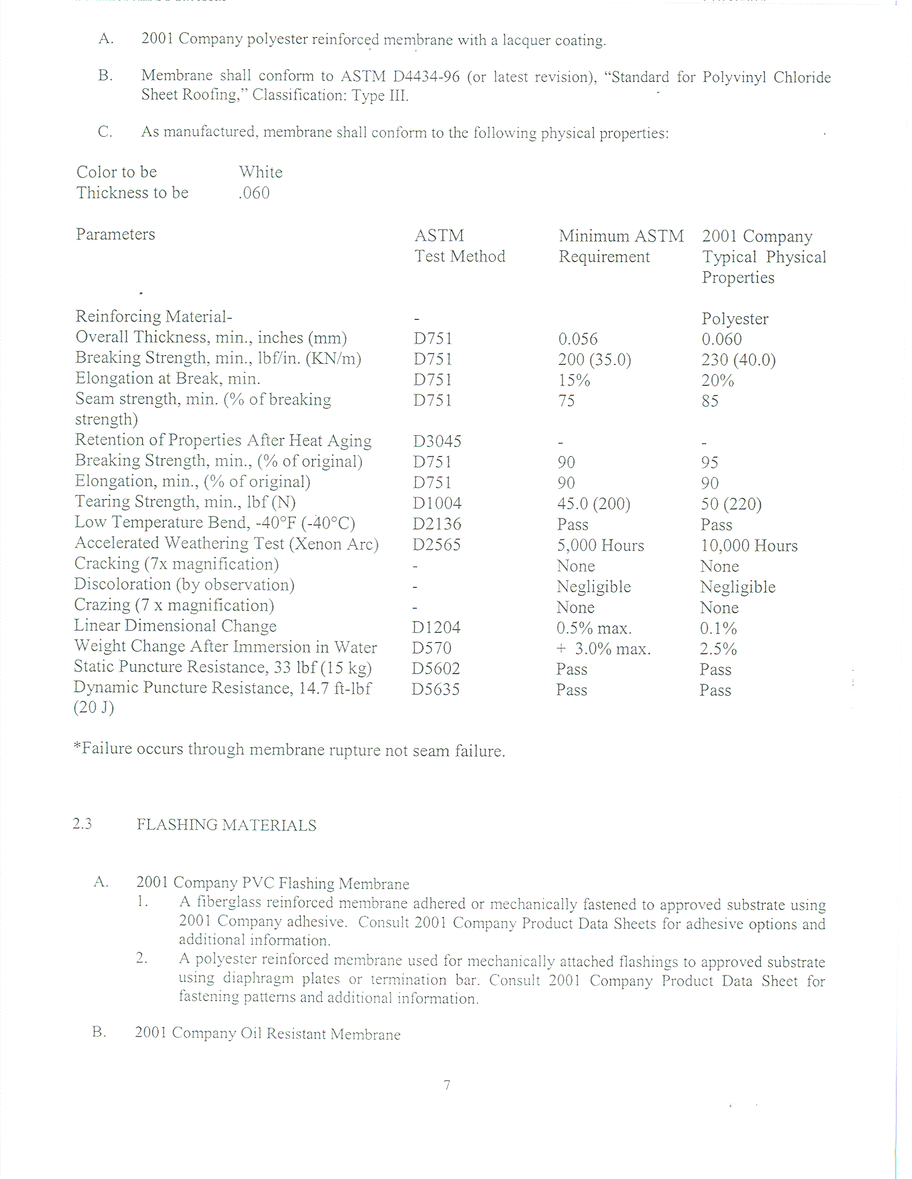
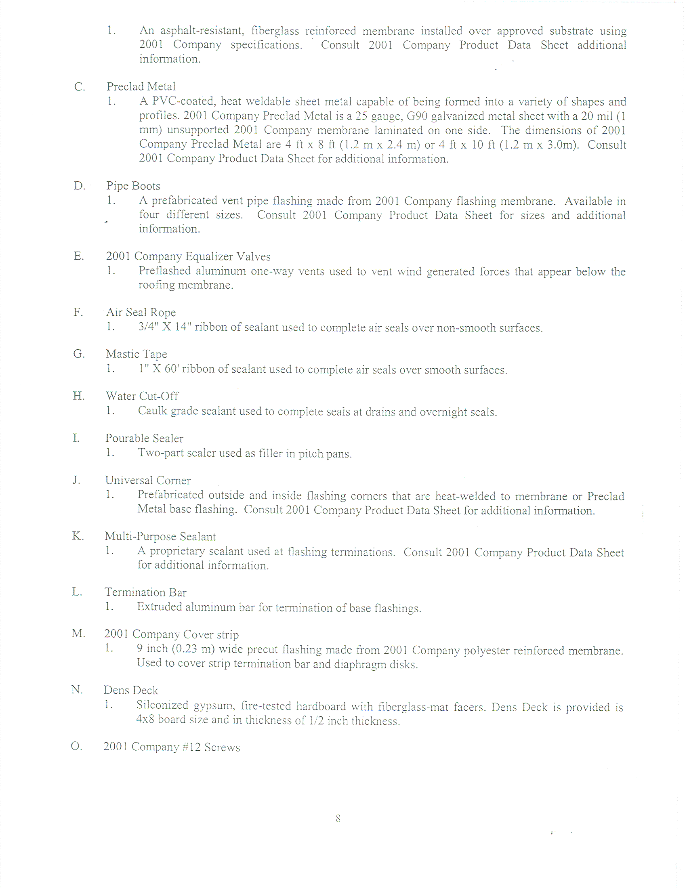
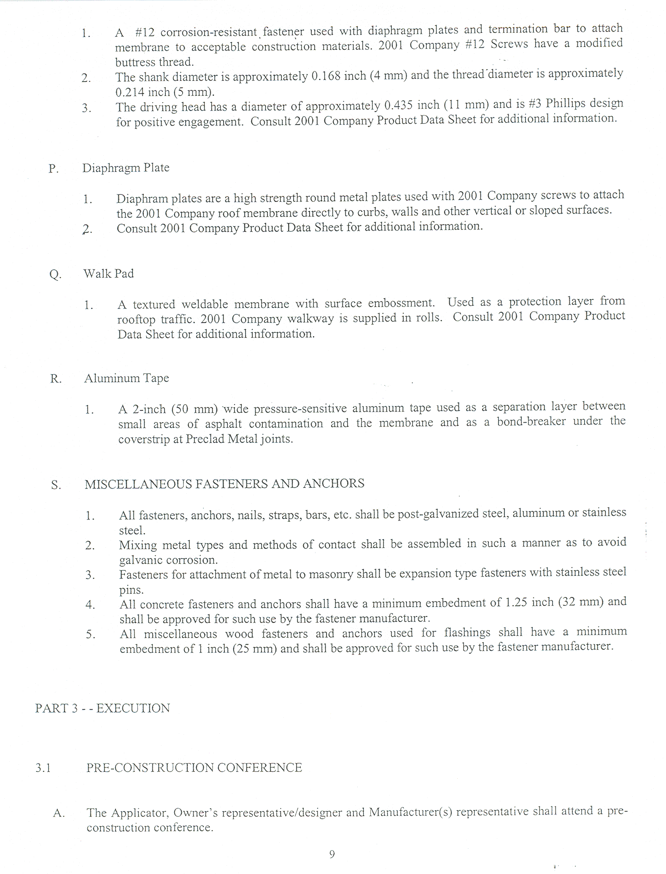
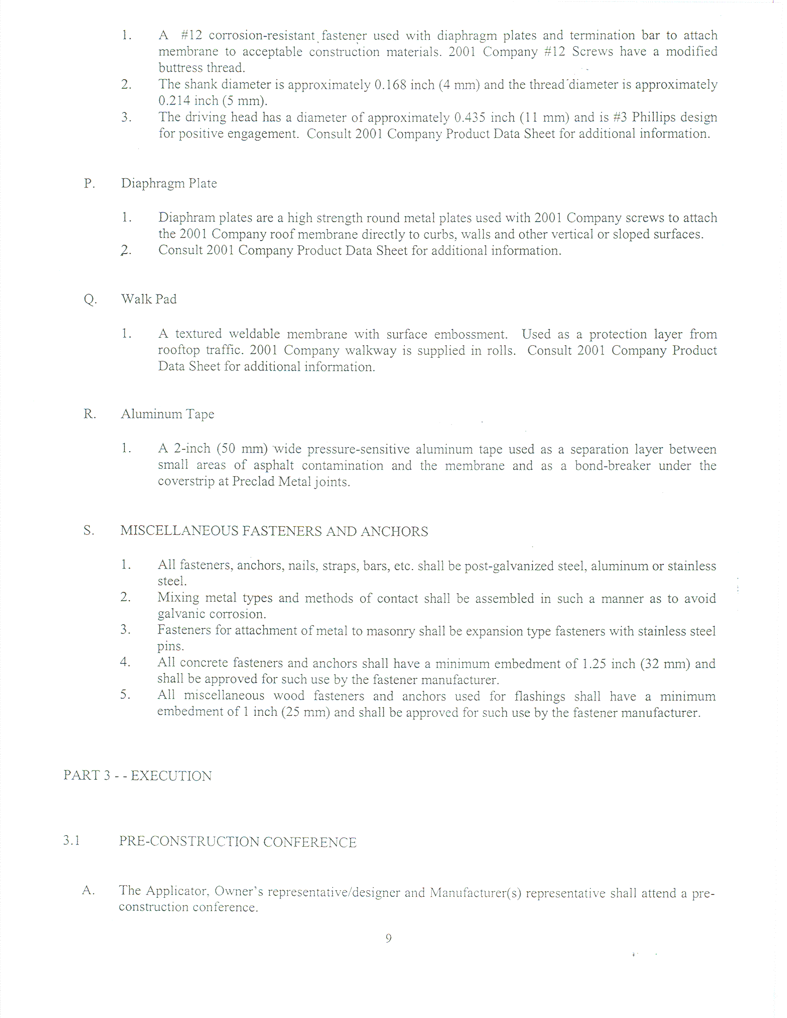
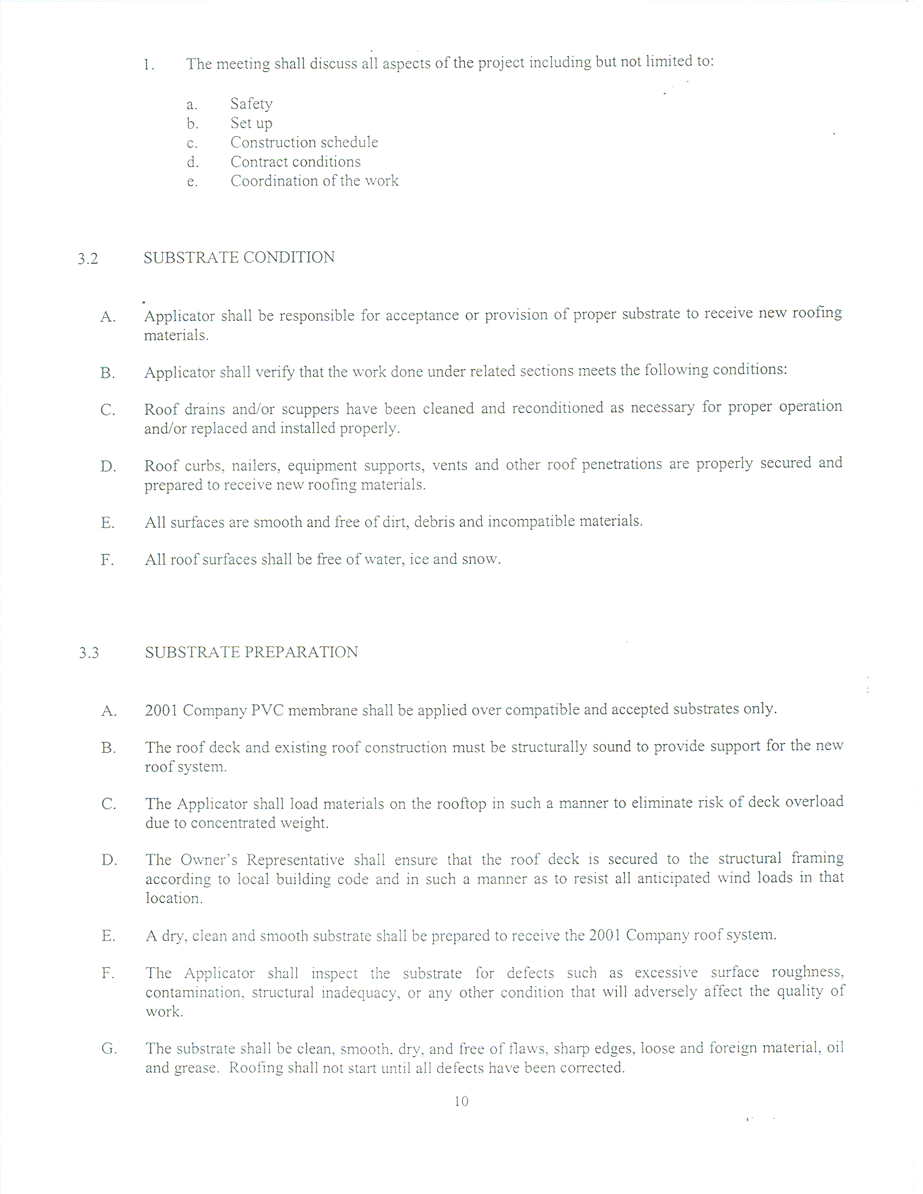
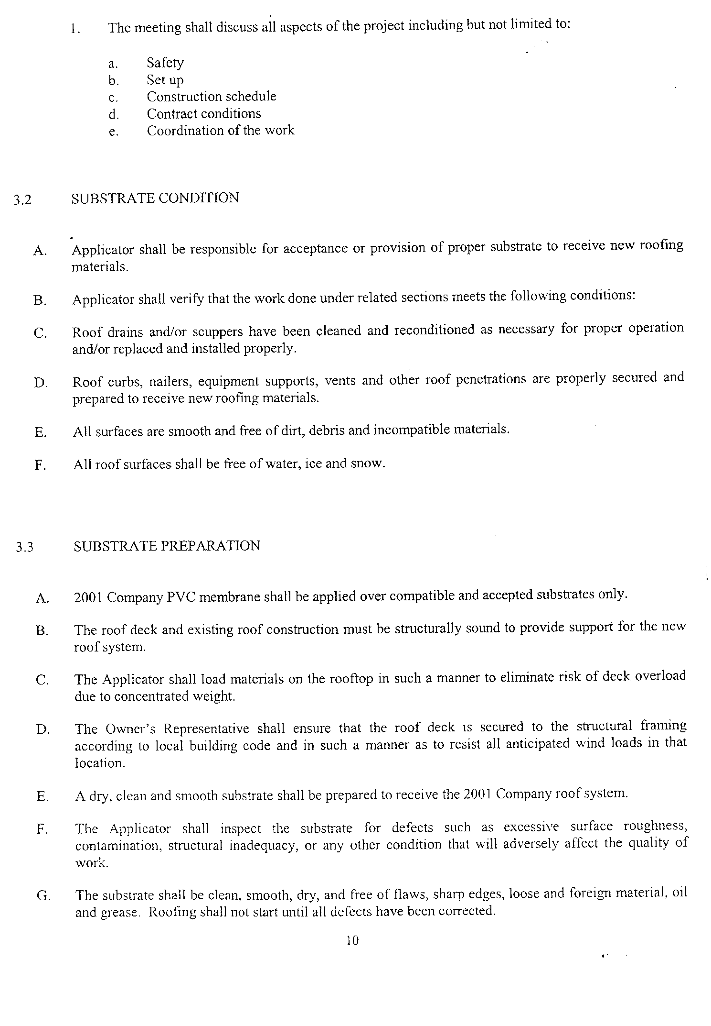
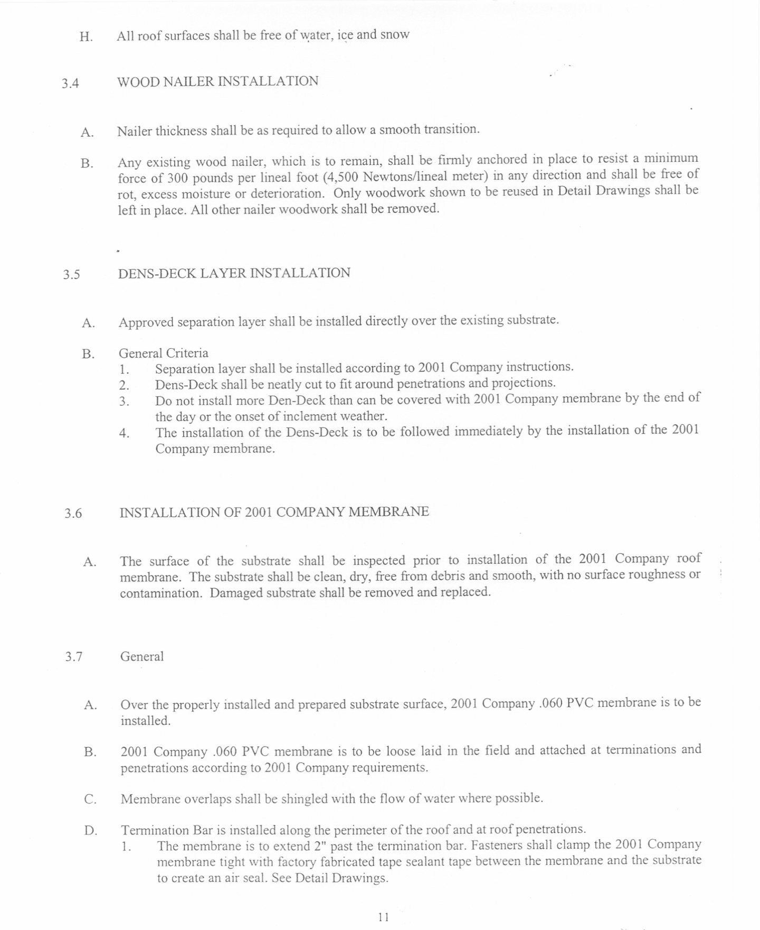
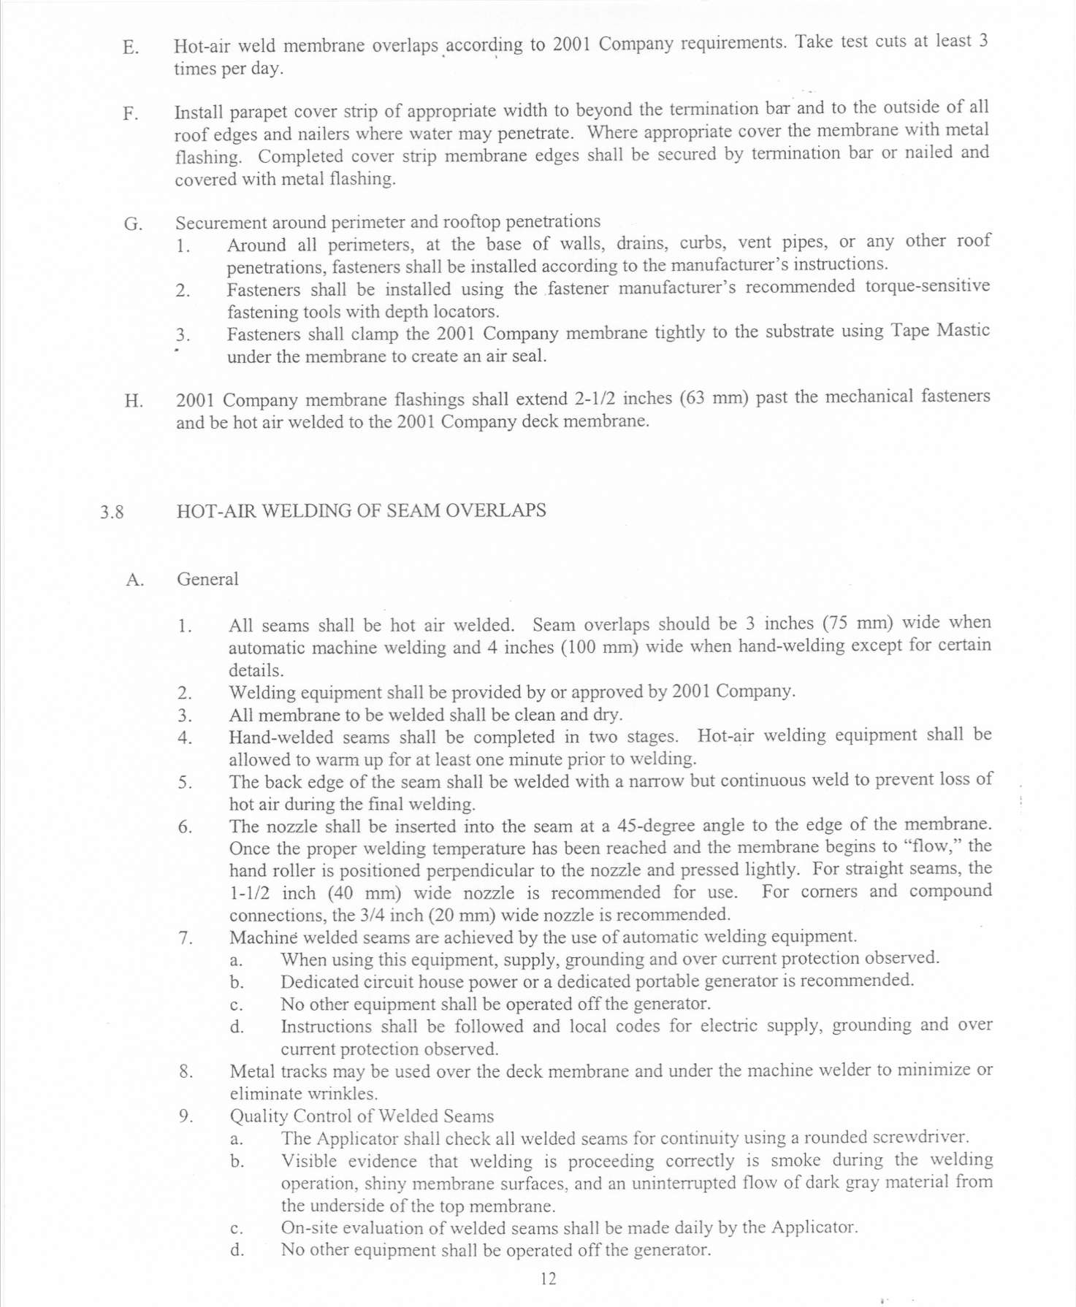
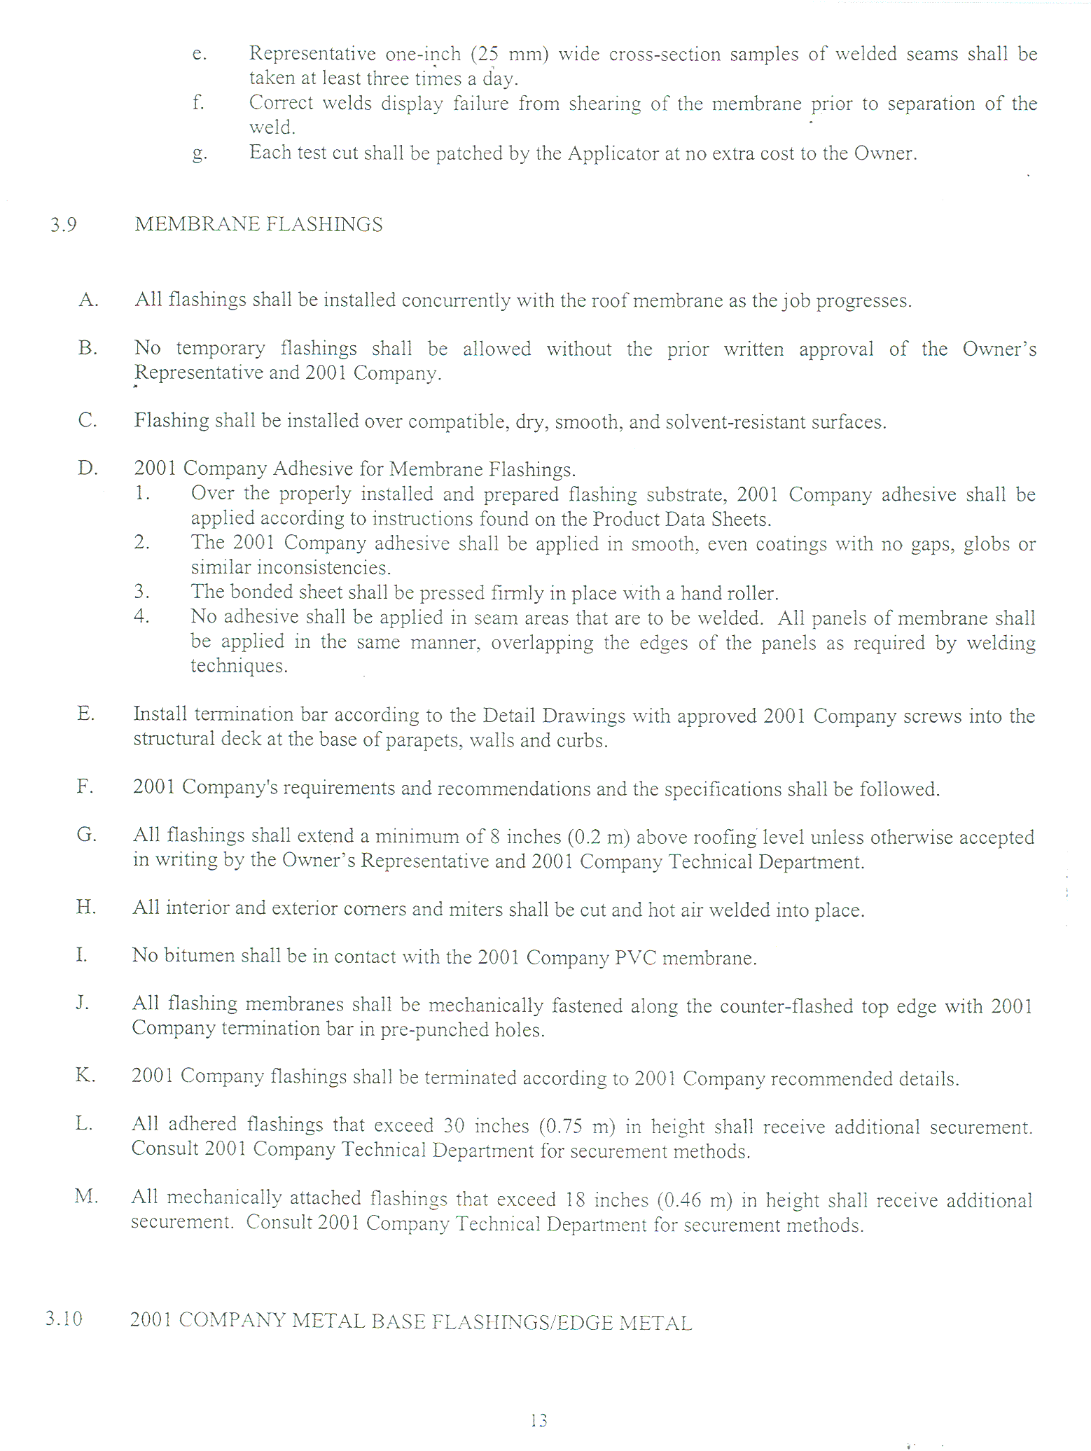
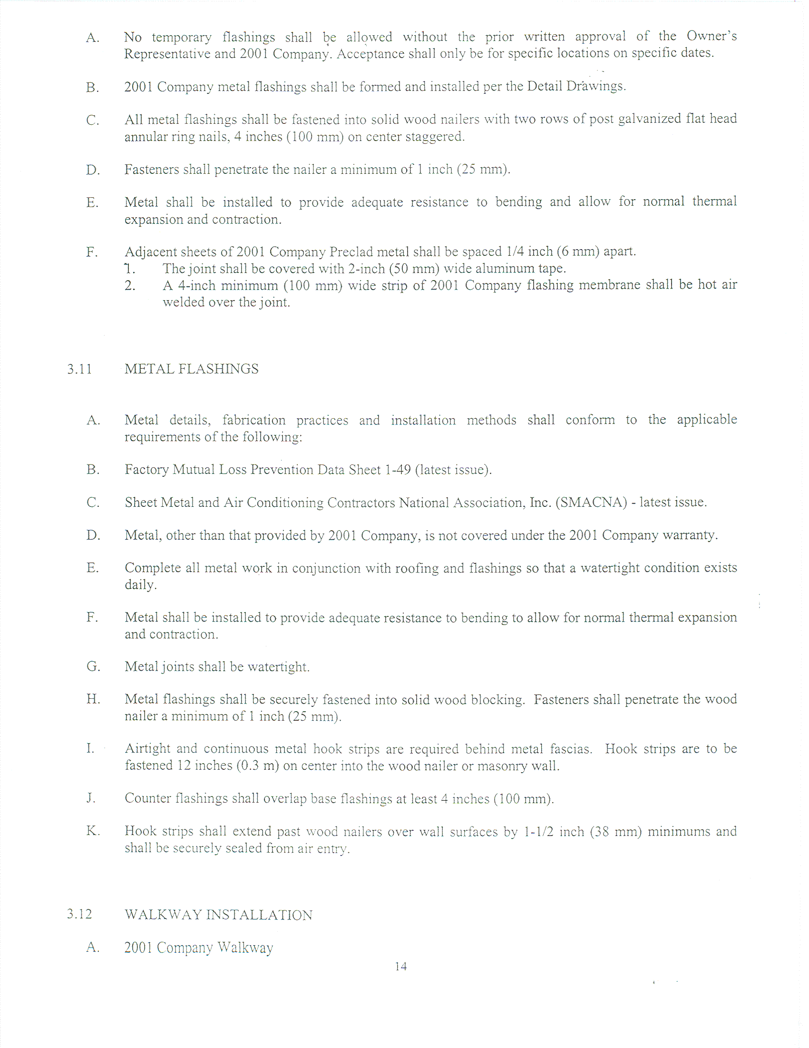
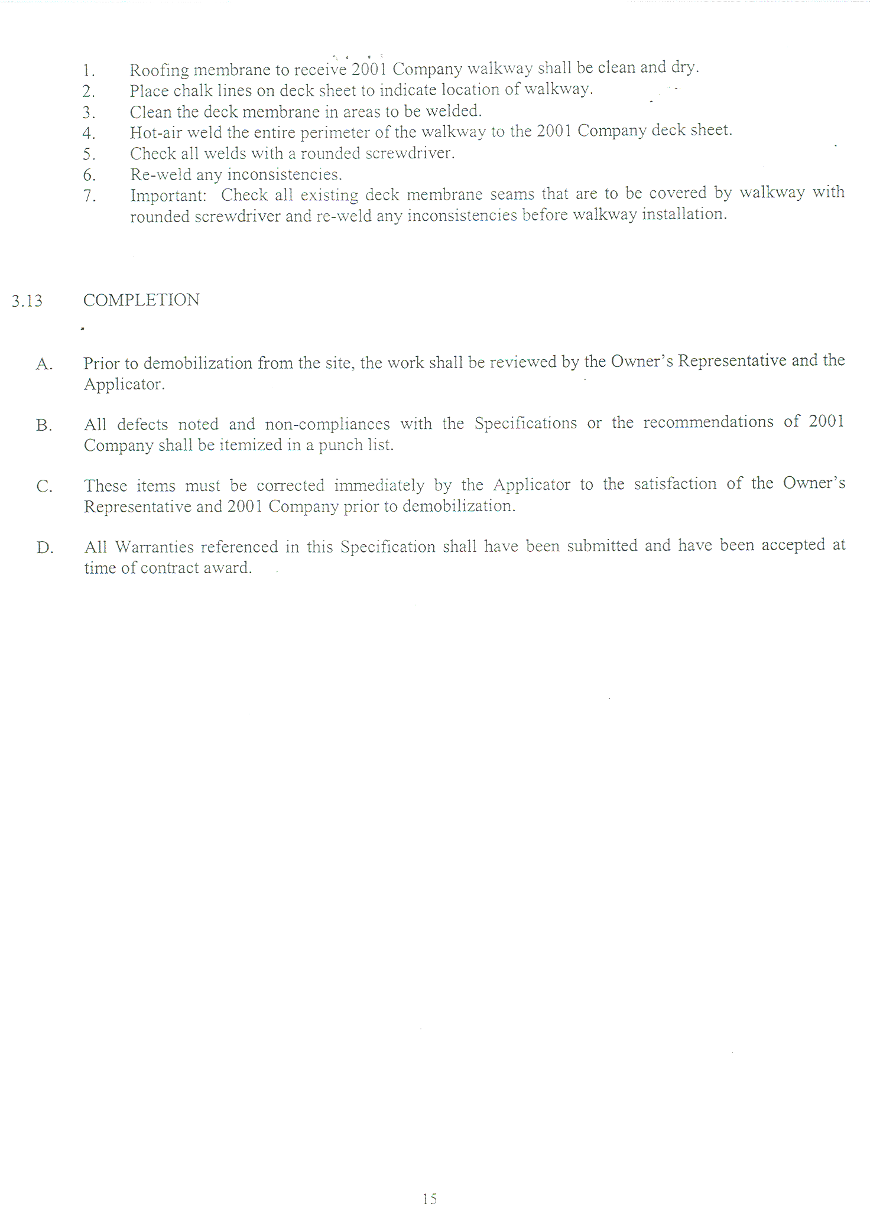
QUOTATION SCHEDULE
Company Name:

All, labor, materials, equipment, permit, fees, taxes and insurances etc. to replace County’s Main Jail roof with a Thermoplastic Membrane Roofing System as specified within this Request for quotation No. 770-4110. | 1 | JOB |  | $
100% Performance/Labor and Materials Bonds |  |  |  | $
 |  |  | TOTAL

Project completion time from start to finish days.

Signature:
Title:

SUBMITTALS
The bidder shall provide the following with their quotation:
- The completed and signed Page One of this RFQ.
- Complete, sign and submit page one of each and all Addendums to this RFQ which require signature (if any).
- The specified number of copies of the bidder’s quotation.
- The completed Bidder to Complete page of this RFQ.
- The completed Reference List.
- The completed W-9 Form.
- The completed Quotation Schedule as provided with this RFQ.
- A listing of all bidder exceptions to County’s requirements, conditions, and specifications as stated within this RFQ.
- Specifications, descriptions etc. for items offered under the bidder’s quotation.
- Submit your quotation/proposal prior to the specified date and time. Submit in a sealed envelope, box, etc. with the following information displayed on the outside:
County of Fresno RFQ No. |  |  | 770-4110
Closing Date: | July 15, 2005
Closing Time: | 2:00 P.M.
Commodity or Service:

