COUNTY OF FRESNO
ADDENDUM NUMBER: ONE (1)
 |  |  | RFQ NUMBER: 770-4110
July 5, 2005
 |  |  |  |  |  | PURCHASING USE
 |  | ORG/Requisition: / |  |  |  |  | jlg | /tmp/in/input.doc
 | IMPORTANT: SUBMIT QUOTATION IN SEALED PACKAGE WITH QUOTATION NUMBER, CLOSING DATE AND BUYER’S NAME MARKED CLEARLY ON THE OUTSIDE TO:
COUNTY OF FRESNO, Purchasing
4525 EAST HAMILTON AVENUE
FRESNO, CA 93702-4599
Closing date of bid will be at 2:00 p.m., on July 21, 2005.
QUOTES WILL BE CONSIDERED LATE WHEN THE OFFICIAL PURCHASING TIME CLOCK READS 2:00 P.M.
 | Quotes will be opened and publicly read at that time. All quotation information will be available for review after contract award.
 | Clarification of specifications are to be directed to: Brian D. Tamblin, phone (559) 456-7110, FAX (559) 456-7831.
NOTE THE following and attached ADDITIONS, DELETIONS AND/or CHANGES TO THE REQUIREMENTS OF REQUEST FOR QUOTATION NUMBER: 770-4110 AND INCLUDE THEM IN YOUR RESPONSE. PLEASE SIGN AND RETURN THIS ADDENDUM WITH YOUR QUOTATION.
- These are responses, clarifications and additional information regarding questions arising from the project site inspection on June 22, 2005.
- Request for Quotation close date shall be extended, and will now close at 2:00 p.m. on Thursday, July 21, 2005
- Replace Page 33 (Quotation Schedule) with revised Page 33 (Revised Quotation Schedule.
- Adequate Space will be set aside for the awarded Contractor to store their supplies and materials. However, Contractor shall be required to supply and erect a safety fence to safeguard their supplies and materials.
 | ACKNOWLEDGMENT OF ADDENDUM NUMBER ONE (1) TO RFQ 770-4110
 | COMPANY NAME:
 | (PRINT)
 | SIGNATURE:
 | NAME & TITLE:
 | (PRINT)

- The color of the Thermoplastic Membrane Roofing System shall be GRAY.
- Security passes will be provided to the awarded Contractor’s employees on completion of a “Live Scan” and prior to any work to be performed. (See attached Live Scan Application form.)
- Existing walk way shall be removed and a new one laid down after the installation of the roofing system.
- The lightning protection will have to be disconnected from the vent pipes and re-connected after the pipe flashing is installed.
- There will be no working hour restrictions, but Contractor will be required to coordinate the work hours with the County Coordinator.
- There will be no cell phone restrictions, however; there shall be NO instances of allowing the use of any cell phone to an in-mate.
- On completion of the roofing installation, all lightning rods and conductors etc. shall be reinstalled as originally set up.
- ATTACHED:
  - Revised Quotation Schedule
  - Live Scan Application Form
  - Additional drawings showing requirements for specific areas of concern.
  - “As Built” Roof Plans
REVISED
QUOTATION SCHEDULE

REVISED QUOTATION SCHEDULE
Company Name:

All, labor, materials, equipment, permit, fees, taxes and insurances etc. to replace County’s Main Jail roof with a Thermoplastic Membrane Roofing System (Color: Gray)as specified within this Request for quotation No. 770-4110. |  |  |  | 1 | JOB |  | $
100% Performance/Labor and Materials Bonds |  |  |  |  |  |  | $
 |  |  |  |  |  | TOTAL
(Alternate)
All, labor, materials, equipment, permit, fees, taxes and insurances etc. to replace County’s Main Jail roof and five (5) Penthouse roofs with a Thermoplastic Membrane Roofing System (Color: Gray) as specified within this Request for quotation No. 770-4110. |  |  |  | 1 | JOB |  | $
100% Performance/Labor and Materials Bonds |  |  |  |  |  |  | $
 |  |  |  |  |  | TOTAL
Project completion time from start to finish |  |  | Days.
Signature:
Title:

“live scan”
application form
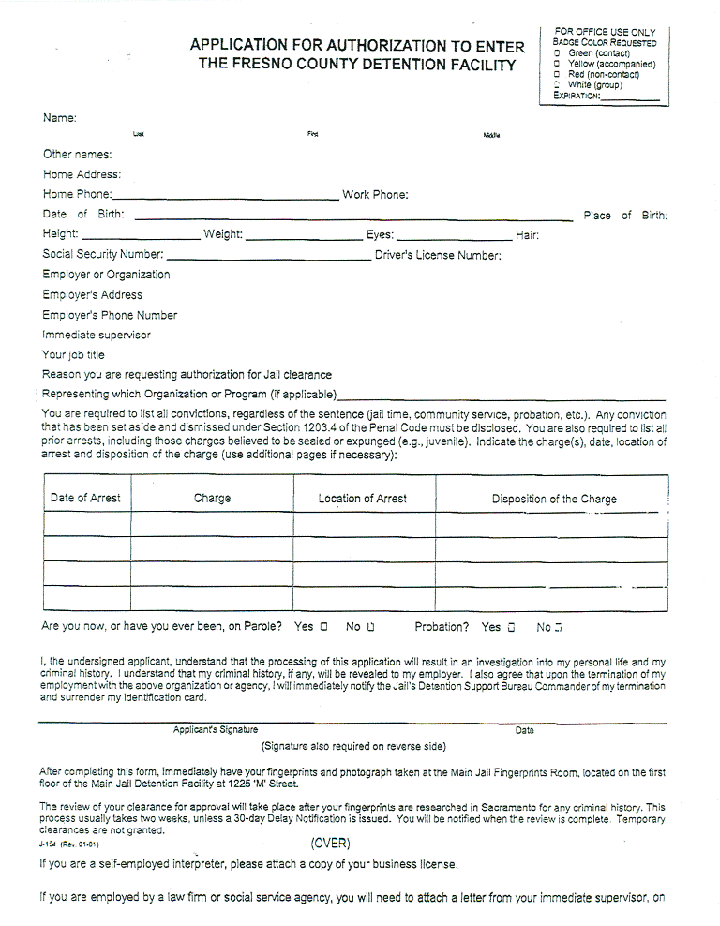
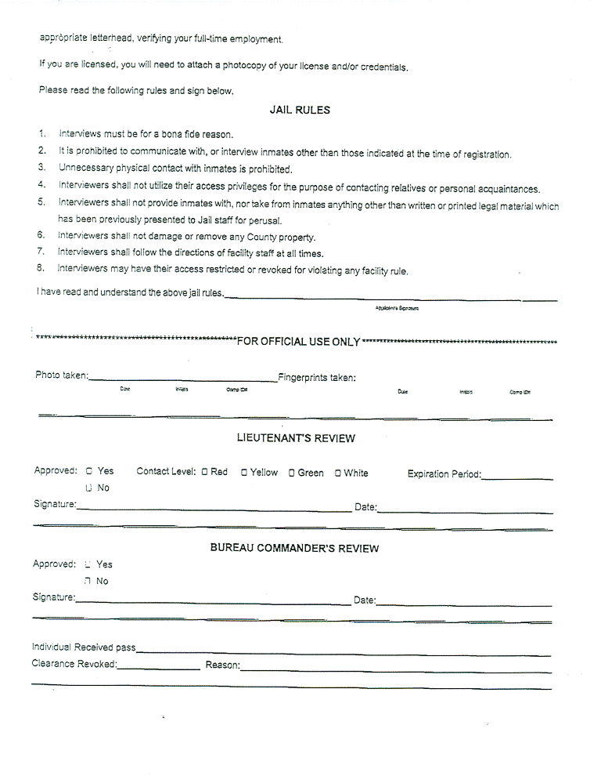
DRAWINGS
“AS Built”
Roof Plans

