COUNTY OF FRESNO
Request for QUOTATION
 |  | NUMBER: 680-4780
January 14, 2010
ORG/Requisition: 31113207/ 3111000064 |  |  |  |  |  |  | PURCHASING USE |  |  |  | /tmp/in/input.doc
 |  |  |  |  |  |  | saw
IMPORTANT: SUBMIT QUOTATION IN SEALED PACKAGE WITH QUOTATION NUMBER, CLOSING DATE AND BUYER’S NAME MARKED CLEARLY ON THE OUTSIDE TO:
COUNTY OF FRESNO, Purchasing
4525 EAST HAMILTON AVENUE
FRESNO, CA 93702-4599
Closing date of bid will be at 2:00 p.m., on February 18, 2010.
QUOTATIONS WILL BE CONSIDERED LATE WHEN THE OFFICIAL PURCHASING TIME CLOCK READS 2:00 P.M.
Quotations will be opened and publicly read at that time. All quotation information will be available for review after contract award.
Clarification of specifications is to be directed to: Craig Nickel, phone (559) 456-7110, e-mail CountyPurchasing@co.fresno.ca.us FAX (559) 456-7831.
GENERAL CONDITIONS: See “County Of Fresno Purchasing Standard Instructions And Conditions For Request For Proposals (RFP’S) and Requests for Quotations (RFQ’S)” attached. Check County of Fresno Purchasing’s Open Solicitations website at http://www2.co.fresno.ca.us/0440/Bidshome2.asp for RFQ/RFP documents and changes.
BIDDER TO COMPLETE
UNDERSIGNED AGREES TO FURNISH THE COMMODITY OR SERVICE STIPULATED IN THE ATTACHED QUOTATION SCHEDULE AT THE PRICES AND TERMS STATED, SUBJECT TO THE “COUNTY OF FRESNO PURCHASING STANDARD INSTRUCTIONS AND CONDITIONS FOR REQUEST FOR PROPOSALS (RFP’s) AND REQUESTS FOR QUOTATIONS (RFQ’S)”ATTACHED.
Except as noted on individual items, the following will apply to all items in the Quotation Schedule.
- Complete delivery will be made within |  |  |  |  |  |  |  | calendar days after receipt of Order.
- A cash discount of |  |  |  |  | % |  |  |  |  | days will apply.
Company
Address
City |  |  |  |  |  |  |  |  |  |  |  |  | State |  | Zip Code
( ) |  |  |  | ( )
Telephone Number |  |  |  | Facsimile Number |  |  |  |  |  |  |  |  | E-mail Address
Signed By
Print Name |  |  |  |  |  |  |  |  | Title

COUNTY OF FRESNO PURCHASING
STANDARD INSTRUCTIONS AND CONDITIONS FOR
REQUESTS FOR PROPOSALS (RFP'S) AND REQUESTS FOR QUOTATIONS (RFQ'S)
Note: the reference to “bids” in the following paragraphs applies to RFP's and RFQ's

GENERAL CONDITIONS
By submitting a bid the bidder agrees to the following conditions. These conditions will apply to all subsequent purchases based on this bid.

- BID PREPARATION:
  - All prices and notations must be typed or written in ink. No erasures permitted. Errors may be crossed out, initialed and corrections printed in ink by person signing bid.
  - Brand Names: Brand names and numbers when given are for reference. Equal items will be considered, provided the offer clearly describes the article and how it differs from that specified. In the absence of such information it shall be understood the offering is exactly as specified.
  - State brand or make of each item. If bidding on other than specified, state make, model and brand being bid and attach supporting literature/specifications to the bid.
  - Bid on each item separately. Prices should be stated in units specified herein. All applicable charges must be quoted; charges on invoice not quoted herein will be disallowed.
  - Time of delivery is a part of the consideration and must be stated in definite terms and must be adhered to. F.O.B. Point shall be destination or freight charges must be stated.
  - All bids must be dated and signed with the firm’s name and by an authorized officer or employee.
  - Unless otherwise noted, prices shall be firm for 180 days after closing date of bid.
- SUBMITTING BIDS:
  - Each bid must be submitted on forms provided in a sealed envelope/package with bid number and closing date and time on the outside of the envelope/package.
  - Interpretation: Should any discrepancies or omissions be found in the bid specifications or doubt as to their meaning, the bidder shall notify the Buyer in writing at once. The County shall not be held responsible for verbal interpretations. Questions regarding the bid must be received by Purchasing at least 5 working days before bid opening. All addenda issued shall be in writing, duly issued by Purchasing and incorporated into the contract.
  - ISSUING AGENT/AUTHORIZED CONTACT: This RFQ/RFP has been issued by County of Fresno Purchasing. Purchasing shall be the vendor’s sole point of contact with regard to the RFQ/RFP, its content, and all issues concerning it.
All communication regarding this RFQ/RFP shall be directed to an authorized representative of County Purchasing. The specific buyer managing this RFQ is identified on the cover page, along with his or her telephone number, and he or she should be the primary point of contact for discussions or information pertaining to the RFQ/RFP. Contact with any other County representative, including elected officials, for the purpose of discussing this RFQ/RFP, its content, or any other issue concerning it, is prohibited unless authorized by Purchasing. Violation of this clause, by the vendor having unauthorized contact (verbally or in writing) with such other County representatives, may constitute grounds for rejection by Purchasing of the vendor’s quotation.
The above stated restriction on vendor contact with County representatives shall apply until the County has awarded a purchase order or contract to a vendor or vendors, except as follows. First, in the event that a vendor initiates a formal protest against the RFQ/RFP, such vendor may contact the appropriate individual, or individuals who are managing that protest as outlined in the County’s established protest procedures. All such contact must be in accordance with the sequence set forth under the protest procedures. Second, in the event a public hearing is scheduled before the Board of Supervisors to hear testimony prior to its approval of a purchase order or contract, any vendor may address the Board.
  - Bids received after the closing time will NOT be considered.
  - Bidders are to bid what is specified or requested first. If unable to or unwilling to, bidder may bid alternative or option, indicating all advantages, disadvantages and their associated cost.
  - Public Contract Code Section 7028.15
Where the State of California requires a Contractor’s license, it is a misdemeanor for any person to submit a bid unless specifically exempted.
- FAILURE TO BID:
  - If not bidding, return bid sheet and state reason for no bid or your name may be removed from mailing list.
- TAXES, CHARGES AND EXTRAS:
  - County of Fresno is subject to California sales and/or use tax (8.975%). Please indicate as a separate line item if applicable.
  - DO NOT include Federal Excise Tax. County is exempt under Registration No. 94-73-03401-K.
  - County is exempt from Federal Transportation Tax. Exemption certificate is not required where shipping papers show consignee as County of Fresno.
  - Charges for transportation, containers, packing, etc. will not be paid unless specified in bid.
- W-9 – REQUEST FOR TAXPAYER IDENTIFICATION NUMBER AND CERTIFICATION:
Upon award of bid, the vendor shall submit to County Purchasing, a completed W-9 - Request for Taxpayer Identification Number and Certification if not already a current vendor with The County of Fresno. This form is available from the IRS to complete on line at http://www.irs.gov/pub/irs-pdf/fw9.pdf.
- AWARDS:
  - Subject to the local preference provisions referenced in Paragraph 6 below and more thoroughly set forth in the General Requirements section of this RFQ/RFP, award(s) will be made to the most responsive responsible bidder. The evaluation will include such things as life-cycle cost, availability, delivery costs and whose product and/or service is deemed to be in the best interest of the County. The County shall be the sole judge in making such determination.
  - Unless bidder gives notice of all-or-none award in bid, County may accept any item, group of items or on the basis of total bid.
  - The County reserves the right to reject any and all bids and to waive informalities or irregularities in bids.
  - After award, all bids shall be open to public inspection. The County assumes no responsibility for the confidentiality of information offered in a bid.
- LOCAL VENDORS
  - Local Vendor Preference (applicable to RFQ Process only)
The following provisions are applicable only to the County’s acquisition of materials, equipment or supplies through the RFQ process when the funding source does not require an exemption to the Local Vendor Preference.
THE PROVISIONS OF THIS PARAGRAPH ARE APPLICABLE, NOTWITHSTANDING ANY OTHER PROVISIONS OF THIS RFQ TO THE CONTRARY
If the apparent low bidder is not a local vendor, any local vendor who submitted a bid which was within five percent (5%) of the lowest responsive bid as determined by the purchasing agent shall have the option of submitting a new bid within forty-eight hours (not including weekends and holidays) of County’s delivery of notification. Such new bids must be in an amount less than or equal to the lowest responsive bid as determined by the purchasing agent. If the purchasing agent receives any new bids from local vendors who have the option of submitting new bids within said forty-eight hour period, it shall award the contract to the local vendor submitting the lowest responsible bid. If no new bids are received, the contract shall be awarded to the original low bidder as announced by the purchasing agent.
  - Local Vendor Defined
“Local Vendor” shall mean any business which:
- Has its headquarters, distribution point or locally-owned franchise located in or having a street address within the County for at least six (6) months immediately prior to the issuance of the request for competitive bids by the purchasing agent; and
- Holds any required business license by a jurisdiction located in Fresno County; and
- Employs at least one (1) full-time or two (2) part-time employees whose primary residence is located within Fresno County, or if the business has no employees, shall be at least fifty percent (50%) owned by one or more persons whose primary residence(s) is located within Fresno County.
- TIE BIDS:
All other factors being equal, the contract shall be awarded to the Fresno County vendor or, if neither or both are Fresno County vendors, it may be awarded by the flip of a coin in the presence of witnesses or the entire bid may be rejected and re-bid. If the General Requirements of this RFQ state that they are applicable, the provisions of the Fresno County Local Vendor Preference shall take priority over this paragraph.
- PATENT INDEMNITY:
The vendor shall hold the County, its officers, agents and employees, harmless from liability of any nature or kind, including costs and expenses, for infringement or use of any copyrighted or uncopyrighted composition, secret process, patented or unpatented invention, article or appliance furnished or used in connection with this bid.
- SAMPLES:
Samples, when required, must be furnished and delivered free and, if not destroyed by tests, will upon written request (within 30 days of bid closing date) be returned at the bidder's expense. In the absence of such notification, County shall have the right to dispose of the samples in whatever manner it deems appropriate.
- RIGHTS AND REMEDIES OF COUNTY FOR DEFAULT:
  - In case of default by vendor, the County may procure the articles or service from another source and may recover the cost difference and related expenses occasioned thereby from any unpaid balance due the vendor or by proceeding against performance bond of the vendor, if any, or by suit against the vendor. The prices paid by the County shall be considered the prevailing market price at the time such purchase is made.
  - Articles or services, which upon delivery inspection do not meet specifications, will be rejected and the vendor will be considered in default. Vendor shall reimburse County for expenses related to delivery of non-specified goods or services.
  - Regardless of F.O.B. point, vendor agrees to bear all risks of loss, injury or destruction to goods and materials ordered herein which occur prior to delivery and such loss, injury or destruction shall not release vendor from any obligation hereunder.
- DISCOUNTS:
Terms of less than 15 days for cash payment will be considered as net in evaluating this bid. A discount for payment within fifteen (15) days or more will be considered in determining the award of bid. Discount period will commence either the later of delivery or receipt of invoice by the County. Standard terms are Net Forty-five (45) days.
- SPECIAL CONDITIONS IN BID SCHEDULE SUPERSEDE GENERAL CONDITIONS.
The “General Conditions” provisions of this RFP/RFQ shall be superseded if in conflict with any other section of this bid, to the extent of any such conflict.
- SPECIAL REQUIREMENT:
With the invoice or within twenty-five (25) days of delivery, the seller must provide to the County a Material Safety Data Sheet for each product, which contains any substance on “The List of 800 Hazardous Substances”, published by the State Director of Industrial Relations. (See Hazardous Substances Information and Training Act. California State Labor Code Sections 6360 through 6399.7.)
- RECYCLED PRODUCTS/MATERIALS:
Vendors are encouraged to provide and quote (with documentation) recycled or recyclable products/materials which meet stated specifications.
- YEAR COMPLIANCE WARRANTY
Vendor warrants that any product furnished pursuant to this Agreement/order shall support a four-digit year format and be able to accurately process date and time data from, into and between the twentieth and twenty-first centuries, as well as leap year calculations. "Product" shall include, without limitation, any piece or component of equipment, hardware, firmware, middleware, custom or commercial software, or internal components or subroutines therein. This warranty shall survive termination or expiration of this Agreement.
In the event of any decrease in product functionality or accuracy related to time and/or date data related codes and/or internal subroutines that impede the product from operating correctly using dates beyond December 31, 1999, vendor shall restore or repair the product to the same level of functionality as warranted herein, so as to minimize interruption to County's ongoing business process, time being of the essence. In the event that such warranty compliance requires the acquisition of additional programs, the expense for any such associated or additional acquisitions, which may be required, including, without limitation, data conversion tools, shall be borne exclusively by vendor. Nothing in this warranty shall be construed to limit any rights or remedies the County may otherwise have under this Agreement with respect to defects other than year performance.
- PARTICIPATION:
Bidder may agree to extend the terms of the resulting contract to other political subdivision, municipalities and tax-supported agencies.
Such participating Governmental bodies shall make purchases in their own name, make payment directly to bidder, and be liable directly to the bidder, holding the County of Fresno harmless.
- CONFIDENTIALITY:
All services performed by vendor shall be in strict conformance with all applicable Federal, State of California and/or local laws and regulations relating to confidentiality, including but not limited to, California Civil Code, California Welfare and Institutions Code, Health and Safety Code, California Code of Regulations, Code of Federal Regulations.
Vendor shall submit to County’s monitoring of said compliance.
Vendor may be a business associate of County, as that term is defined in the “Privacy Rule” enacted by the Health Insurance Portability and Accountability Act of 1996 (HIPAA). As a HIPAA Business Associate, vendor may use or disclose protected health information (“PHI”) to perform functions, activities or services for or on behalf of County as specified by the County, provided that such use or disclosure shall not violate HIPAA and its implementing regulations. The uses and disclosures if PHI may not be more expansive than those applicable to County, as the “Covered Entity” under HIPAA’S Privacy Rule, except as authorized for management, administrative or legal responsibilities of the Business Associate.
Vendor shall not use or further disclose PHI other than as permitted or required by the County, or as required by law without written notice to the County.
Vendor shall ensure that any agent, including any subcontractor, to which vendor provides PHI received from, or created or received by the vendor on behalf of County, shall comply with the same restrictions and conditions with respect to such information.
- APPEALS
Appeals must be submitted in writing within seven (7) working days after notification of proposed recommendations. Appeals should be submitted to County of Fresno Purchasing, 4525 E. Hamilton Avenue, Fresno, California 93702-4599. Appeals should address only areas regarding RFP contradictions, procurement errors, quotation rating discrepancies, legality of procurement context, conflict of interest, and inappropriate or unfair competitive procurement grievance regarding the RFP process.
Purchasing will provide a written response to the complainant within seven (7) working days unless the complainant is notified more time is required.
If the protesting bidder is not satisfied with the decision of Purchasing, he/she shall have the right to appeal to the Purchasing Agent/CAO within seven (7) business days after Purchasing’s notification; except if, notified to appeal directly to the Board of Supervisors at the scheduled date and time.
If the protesting bidder is not satisfied with Purchasing Agent/CAO’s decision, the final appeal is with the Board of Supervisors.
- OBLIGATIONS OF CONTRACTOR:
  - CONTRACTOR shall perform as required by the ensuing contract. CONTRACTOR also warrants on behalf of itself and all subcontractors engaged for the performance of the ensuing contract that only persons authorized to work in the United States pursuant to the Immigration Reform and Control Act of 1986 and other applicable laws shall be employed in the performance of the work hereunder.
  - CONTRACTOR shall obey all Federal, State, local and special district laws, ordinances and regulations.
- AUDITS & RETENTION:
The Contractor shall maintain in good and legible condition all books, documents, papers, data files and other records related to its performance under this contract. Such records shall be complete and available to Fresno County, the State of California, the federal government or their duly authorized representatives for the purpose of audit, examination, or copying during the term of the contract and for a period of at least three years following the County's final payment under the contract or until conclusion of any pending matter (e.g., litigation or audit), whichever is later. Such records must be retained in the manner described above until all pending matters are closed.
- DISCLOSURE – CRIMINAL HISTORY & CIVIL ACTIONS:
Applies to Request for Proposal (RFP); does not apply to Request for Quotation (RFQ) unless specifically stated elsewhere in the RFQ document.
In their proposal, the bidder is required to disclose if any of the following conditions apply to them, their owners, officers, corporate managers and partners (hereinafter collectively referred to as “Bidder”):
- Within the three-year period preceding the proposal, they have been convicted of, or had a civil judgment rendered against them for:
  - fraud or a criminal offense in connection with obtaining, attempting to obtain, or performing a public (federal, state, or local) transaction or contract under a public transaction;
  - violation of a federal or state antitrust statute;
  - embezzlement, theft, forgery, bribery, falsification, or destruction of records; or
  - false statements or receipt of stolen property
Within a three-year period preceding their proposal, they have had a public transaction (federal, state, or local) terminated for cause or default.

BIDDING INSTRUCTIONS
VEHICLES OR HEAVY EQUIPMENT
The County of Fresno is soliciting bids to modify a County owned Wells Cargo Model EW1622 Trailer to be used as a Dive Team Trailer.
LOCAL VENDOR PREFERENCE: The Local Vendor Preference does not apply to this Request for Quotation.
DEFINITIONS: The terms Bidder, Proposer, Contractor and Vendor are all used interchangeably and refer to that person, partnership, corporation, organization, agency, etc. which is offering the quotation and is identified on page one of this Request For Quotation (RFQ).
ISSUING AGENT: This RFQ has been issued by County of Fresno Purchasing. The Purchasing shall be the vendor’s sole point of contact with regard to the RFQ, its content, and all issues concerning it.
AUTHORIZED CONTACT: All communication regarding this RFQ shall be directed to an authorized representative of the County’s Purchasing. The specific buyer managing this RFQ is identified on the cover page, along with his or her telephone number, and he or she should be the primary point of contact for discussions or information pertaining to the RFQ. Contact with any other County representative, including elected officials, for the purpose of discussing this RFQ, it content, or any other issue concerning it, is prohibited unless authorized by Purchasing. Violation of this clause, by the vendor having unauthorized contact (verbally or in writing) with such other County representatives, may constitute grounds for rejection by Purchasing of the vendor’s quotation.
The above stated restriction on vendor contact with County representatives shall apply until the County has awarded a purchase order or contract to a vendor or vendors, except as follows. First, in the event that a vendor initiates a formal protest against the RFQ, such vendor may contact the appropriate individual, or individuals who are managing that protest as outlined in the County’s established protest procedures. All such contact must be in accordance with the sequence set forth under the protest procedures. Second, in the event a public hearing is scheduled before the Board of Supervisors to hear testimony prior to its approval of a purchase order or contract, any vendor may address the Board.
VENDOR CONFERENCE: On February 8, 2010 at 10:00 a.m., a vendor's conference will be held in which the scope of the project and quotation requirements will be explained. The meeting will be held at the office of County of Fresno Purchasing, 4525 E. Hamilton (between Cedar and Maple), Fresno, California. An addendum to the RFQ will be prepared and distributed to all bidders only if necessary to clarify substantive items raised during the bidders' conference.
Bidders are to contact Craig Nickel at County of Fresno Purchasing, (559) 456-7110, if they are planning to attend the conference.
INTERPRETATION OF RFQ: Vendors must make careful examination of the requirements, specifications and conditions expressed in the RFQ and fully inform themselves as to the quality and character of services required. If any person planning to submit a quotation finds discrepancies in or omissions from the RFQ or has any doubt as to the true meaning or interpretation, correction thereof may be requested at the scheduled Vendor Conference (see above). Any change in the RFQ will be made only by written addendum, duly issued by the County. The County will not be responsible for any other explanations or interpretations.
Questions may be submitted subsequent to the Vendor Conference, subject to the following conditions:
- Such questions are submitted in writing to County Purchasing at least five (5) County business days prior to the Request for Quotation closing date. Questions must be directed to the attention of the buyer identified on page one.
- Such questions are submitted with the understanding that County can respond only to questions it considers material in nature.
Questions shall be delivered to County of Fresno Purchasing, 4525 E. Hamilton Avenue, Fresno, CA 93702 or faxed to (559) 456-7831. If faxing, the bidder must confirm receipt by phone ((559) 456-7110) within one-half (½) hour of transmission.
NOTE: The bidder is encouraged to submit all questions at the Vendor Conference. Time limitations can prevent a response to questions submitted after the conference.
NUMBER OF COPIES: Submit one (1) original and two (2) copies of your quotation no later than the quotation closing date and time as stated on the front of this document to County of Fresno Purchasing. Each copy is to be identical to the original, including all supporting documentation (i.e. literature, brochures, reports, schedules, specifications, drawings etc.). The cover page of each quotation is to be appropriately marked “Original” or “Copy”.
AWARD: Award will be made to the vendor(s) offering the equipment deemed to be to the best advantage of the County. The County shall be the sole judge in making such determination.
RIGHT TO REJECT BIDS: The County reserves the right to reject any and all bids and to waive informalities or irregularities in bids.
FIRM QUOTATION: All quotations shall remain firm for at least ninety (90) days.
NON-FUNDING CLAUSE: Funds provided for equipment supplied under the terms of this bid are contingent on the approval of the appropriating government agency. Should sufficient funds not be allocated, the equipment or the amount of equipment to be supplied may be modified or terminated at any time.
TAXES: The quoted amount must include all applicable taxes. If taxes are not specifically identified in the quotation it will be assumed that they are included in the total quoted.
SALES TAX: Fresno County pays California State Sales Tax in the amount of 8.975% regardless of vendor's place of doing business.
MINOR DEVIATIONS: The County reserves the right to negotiate minor deviations from the prescribed terms, conditions and requirements with the selected vendor.
QUOTATION REJECTION: Failure to respond to all questions or not to supply the requested information could result in rejection of your quotation.
AMERINET: The County of Fresno is a member of the Amerinet Group Purchasing Organization.
BIDDERS’ LIABILITIES: County of Fresno will not be held liable for any cost incurred by vendors in responding to the RFQ.
PRICE RESPONSIBILITY: The selected vendor will be required to assume full responsibility for all equipment and services offered in the quotation, whether or not they are provided directly. Further, the County of Fresno will consider the selected vendor to be the sole point of contact with regard to contractual matters, including payment of any and all charges resulting from the contract. The contractor may not subcontract or transfer the contract, or any right or obligation arising out of the contract, without first having obtained the express written consent of the County.
CONFIDENTIALITY: Bidders shall not disclose information about the County's business or business practices and safeguard confidential data which vendor staff may have access to in the course of system implementation.
NEWS RELEASE: Vendors shall not issue any news releases or otherwise release information to any third party about this RFQ or the vendor's quotation without prior written approval from the County of Fresno.
BACKGROUND REVIEW: The County reserves the right to conduct a background inquiry of each proposer/bidder which may include collection of appropriate criminal history information, contractual and business associations and practices, employment histories and reputation in the business community. By submitting a quotation/bid to the County, the vendor consents to such an inquiry and agrees to make available to the County such books and records the County deems necessary to conduct the inquiry.
EXCEPTIONS: Identify with explanation, any terms, conditions, specifications or stipulations of the RFQ with which you CAN NOT or WILL NOT comply. Exceptions to items contained in the SPECIFICATIONS/REQUIREMENTS Section of this RFQ shall be stated in the bidder’s response to that section. All other exceptions shall be stated under a separate section of the bidder’s response to this RFQ. Such section shall be entitled “EXCEPTIONS”.
ADDENDA: In the event that it becomes necessary to revise any part of this RFQ, addenda will be provided to all agencies and organizations that receive the basic RFQ.
CONFLICT OF INTEREST: The County shall not Contract with, and shall reject any bid or quotation submitted by the persons or entities specified below, unless the Board of Supervisors finds that special circumstances exist which justify the approval of such contract:
- Employees of the County or public agencies for which the Board of Supervisors is the governing body.
- Profit-making firms or businesses in which employees described in Subsection (1) serve as officers, principals, partners or major shareholders.
- Persons who, within the immediately preceding twelve (12) months, came within the provisions of Subsection (1), and who were employees in positions of substantial responsibility in the area of service to be performed by the contract, or participated in any way in developing the Contract or its service specifications.
- Profit-making firms or businesses in which the former employees described in Subsection (3) serve as officers, principals, partners or major shareholders.
No County employee whose position in the County enables him to influence the selection of a contractor for this RFQ, or any competing RFQ, and no spouse or economic dependent of such employee, shall be employees in any capacity by a bidder, or have any other direct or indirect financial interest in the selection of a contractor.
INVOICING: All invoices are to be delivered in duplicate to the ordering department. Each invoice shall reference the Purchase Order/Contract number. The Contractor shall obtain the “Invoice to” address when receiving the order.
PAYMENT: The bidder agrees to provide equipment and other requirements as stated in this Request for Quotation. The County of Fresno agrees to pay bidder at the terms and conditions stated in the Request for Quotation.
Payment will be withheld until complete delivery is made by the Vendor and such delivery is accepted by County as being complete and satisfactory.
Partial payment may or may not be acceptable to the County of Fresno. Should partial payment be made by the County of Fresno, a percentage of the agreement amount shall be held until all terms and conditions of the Request for Quotations are satisfied.
PAYMENT TERMS: Payment terms are Net 45 days except when bidder offers an acceptable cash discount. The payment period shall be computed from the date that County makes final acceptance of the equipment or from date of receipt of invoice, whichever is latest. Invoices must be submitted as stated in the Purchase Order/Contract.
INDEPENDENT CONTRACTOR: In performance of the work, duties, and obligations assumed by Contractor under any ensuing Agreement, it is mutually understood and agreed that CONTRACTOR, including any and all of Contractor’s officers, agents, and employees will at all times be acting and performing as an independent contractor, and shall act in an independent capacity and not as an officer, agent, servant, employee, joint venturer, partner, or associate of the COUNTY. Furthermore, County shall have no right to control or supervise or direct the manner or method by which Contractor shall perform its work and function. However, County shall retain the right to administer this Agreement so as to verify that Contractor is performing its obligations in accordance with the terms and conditions thereof. Contractor and County shall comply with all applicable provisions of law and the rules and regulations, if any, of governmental authorities having jurisdiction over matters the subject thereof.
Because of its status as an independent contractor, Contractor shall have absolutely no right to employment rights and benefits available to County employees. Contractor shall be solely liable and responsible for providing to, or on behalf of, its employees all legally-required employee benefits. In addition, Contractor shall be solely responsible and save County harmless from all matters relating to payment of Contractor's employees, including compliance with Social Security, withholding, and all other regulations governing such matters. It is acknowledged that during the term of the Agreement, Contractor may be providing services to others unrelated to the County or to the Agreement.
HOLD HARMLESS CLAUSE: Contractor agrees to indemnify, save, hold harmless and at County's request, defend the County, its officers, agents and employees, from any and all costs and expenses, damages, liabilities, claims and losses occurring or resulting to County in connection with the performance, or failure to perform, by Contractor, its officers, agents or employees under this Agreement and from any and all costs and expenses, damages, liabilities, claims and losses occurring or resulting to any person, firm or corporation who may be injured or damaged by the performance, or failure to perform, of Contractor, its officers, agents or employees under this Agreement.
INSURANCE:
Without limiting the COUNTY's right to obtain indemnification from CONTRACTOR or any third parties, CONTRACTOR, at its sole expense, shall maintain in full force and effect, the following insurance policies or a program of self-insurance, including but not limited to, an insurance pooling arrangement or Joint Powers Agreement (JPA) throughout the term of the Agreement:
- Commercial General Liability
Commercial General Liability Insurance with limits of not less than One Million Dollars ($1,000,000) per occurrence and an annual aggregate of Two Million Dollars ($2,000,000). This policy shall be issued on a per occurrence basis. COUNTY may require specific coverages including completed operations, products liability, contractual liability, Explosion-Collapse-Underground, fire legal liability or any other liability insurance deemed necessary because of the nature of this contract.
- Automobile Liability
Comprehensive Automobile Liability Insurance with limits for bodily injury of not less than Two Hundred Fifty Thousand Dollars ($250,000.00) per person, Five Hundred Thousand Dollars ($500,000.00) per accident and for property damages of not less than Fifty Thousand Dollars ($50,000.00), or such coverage with a combined single limit of Five Hundred Thousand Dollars ($500,000.00). Coverage should include owned and non-owned vehicles used in connection with this Agreement.
- Professional Liability
If CONTRACTOR employs licensed professional staff, (e.g., Ph.D., R.N., L.C.S.W., M.F.C.C.) in providing services, Professional Liability Insurance with limits of not less than One Million Dollars ($1,000,000.00) per occurrence, Three Million Dollars ($3,000,000.00) annual aggregate.
- Worker's Compensation
A policy of Worker's Compensation insurance as may be required by the California Labor Code.
CONTRACTOR shall obtain endorsements to the Commercial General Liability insurance naming the County of Fresno, its officers, agents, and employees, individually and collectively, as additional insured, but only insofar as the operations under this Agreement are concerned. Such coverage for additional insured shall apply as primary insurance and any other insurance, or self-insurance, maintained by COUNTY, its officers, agents and employees shall be excess only and not contributing with insurance provided under CONTRACTOR's policies herein. This insurance shall not be cancelled or changed without a minimum of thirty (30) days advance written notice given to COUNTY.
Within Thirty (30) days from the date CONTRACTOR executes this Agreement, CONTRACTOR shall provide certificates of insurance and endorsement as stated above for all of the foregoing policies, as required herein, to the County of Fresno, stating that such insurance coverage have been obtained and are in full force; that the County of Fresno, its officers, agents and employees will not be responsible for any premiums on the policies; that such Commercial General Liability insurance names the County of Fresno, its officers, agents and employees, individually and collectively, as additional insured, but only insofar as the operations under this Agreement are concerned; that such coverage for additional insured shall apply as primary insurance and any other insurance, or self-insurance, maintained by COUNTY, its officers, agents and employees, shall be excess only and not contributing with insurance provided under CONTRACTOR's policies herein; and that this insurance shall not be cancelled or changed without a minimum of thirty (30) days advance, written notice given to COUNTY.
In the event CONTRACTOR fails to keep in effect at all times insurance coverage as herein provided, the COUNTY may, in addition to other remedies it may have, suspend or terminate this Agreement upon the occurrence of such event.
All policies shall be with admitted insurers licensed to do business in the State of California. Insurance purchased shall be purchased from companies possessing a current A.M. Best, Inc. rating of A FSC VII or better.
DISPUTE RESOLUTION: The ensuing Purchase Order/Contract shall be governed by the laws of the state of California.
Any claim which cannot be amicably settled without court action will be litigated in the U. S. District Court for the Eastern District of California in Fresno, CA or in a state court for Fresno County.
TERMINATION: The County reserves the right to terminate any resulting Purchase Order/Contract upon written notice.
DEFAULT: In case of default by the selected bidder, the County may procure the equipment and or services from another source and may recover the loss occasioned thereby from any unpaid balance due the selected bidder, or by any other legal means available to the County.
ASSIGNMENTS: The ensuing Purchase Order/Contract will provide that the vendor may not assign any payment or portions of payments without prior written consent of the County of Fresno.
ASSURANCES: Any contract awarded under this RFQ must be carried out in full compliance with The Civil Rights Act of 1964, The Americans With Disabilities Act of 1990, their subsequent amendments, and any and all other laws protecting the rights of individuals and agencies. The County of Fresno has a zero tolerance for discrimination, implied or expressed, and wants to ensure that policy continues under this RFQ. The contractor must also guarantee that services, or workmanship, provided will be performed in compliance with all applicable local, state, or federal laws and regulations pertinent to the types of services, or project, of the nature required under this RFQ. In addition, the contractor may be required to provide evidence substantiating that their employees have the necessary skills and training to perform the required services or work.
F.O.B. DESTINATION: All bids are to be quoted F.O.B. the County of Fresno at the following address:
Sheriff’s Office – Area 2 Substation
5717 E. Shields Avenue
Fresno, CA 93727-7822
DELIVERY: Prompt delivery is essential. Failure to furnish delivery as promised will constitute a breach of agreement and the County of Fresno may procure items in accordance with the General Conditions of this RFQ.
SPECIFICATIONS & EQUALS: Brand names, where used, are a means of establishing quality and style. Bidders are invited to quote their equals. Alternate offers are to be supported by literature, which fully describes items that you are bidding.
ALTERNATES MAY BE ACCEPTED: The County reserves the right to permit deviations from the specifications if an article offered is substantially in accord with the specifications and is deemed by the County to be satisfactory for its intended use as an article fully meeting specifications. The County will be the sole judge in the determination of acceptable deviations. Unless exceptions are noted by bidder, the article offered will be assumed to be in accord with specifications.
SAFETY/EQUIPMENT STANDARDS: Equipment must be furnished with all protection devices in accordance with the requirements of CALIFORNIA-OSHA.
BIDDER TO COMPLETE:
WARRANTY & SERVICE:
State the warranty and/or guarantee provisions applicable to the equipment offered. Describe the vendors, specific warranty coverage(s), limitation(s), and contact person and telephone number.
State the specific location where service and/or maintenance can be obtained. Failure to furnish this information will be cause for rejection of bid.
REPAIRS WHILE UNDER WARRANTY: All shipping charges, mileage, charges for servicemen, parts and labor required shall be included under warranty.
SAFETY/EQUIPMENT STANDARDS: Equipment must be furnished with all protection devices in accordance with the requirements of CALIFORNIA OSHA.
If a repair is unable to be completed in a reasonable period of time, will the vendor supply a loaner piece of equipment to the County Department at no charge?
 | Yes |  | No

BIDDER TO COMPLETE THE FOLLOWING:

PARTICIPATION
The County of Fresno is a member of the Central Valley Purchasing Group. This group consists of Fresno, Kern, Kings, and Tulare Counties and all governmental, tax supported agencies within these counties.
Whenever possible, these and other tax supported agencies co-op (piggyback) on contracts put in place by one of the other agencies.
Any agency choosing to avail itself of this opportunity, will make purchases in their own name, make payment directly to the contractor, be liable to the contractor and vice versa, per the terms of the original contract, all the while holding the County of Fresno harmless. If awarded this contract, please indicate whether you would extend the same terms and conditions to all tax supported agencies within this group as you are proposing to extend to Fresno County.
Yes, we will extend contract terms and conditions to all qualified agencies within the Central Valley Purchasing Group and other tax supported agencies.
No, we will not extend contract terms to any agency other than the County of Fresno.
(Authorized Signature)
Title

Vendor must complete and return with Request for Quotation
Firm:
REFERENCE LIST
Provide a list of at least five (5) customers for whom you have recently provided similar services (preferably California State or local government agencies). Be sure to include all requested information.
Reference Name: |  |  |  |  |  |  |  | Contact:
Address:
City: |  |  |  |  |  |  |  |  | State: |  |  |  |  | Zip:
Phone No.: |  | ( |  |  | ) |  | Date:
Service Provided:
Reference Name: |  |  |  |  |  |  |  | Contact:
Address:
City: |  |  |  |  |  |  |  |  |  | State: |  |  |  |  | Zip:
Phone No.: |  | ( |  |  | ) |  | Date:
Service Provided:
Reference Name: |  |  |  |  |  |  |  | Contact:
Address:
City: |  |  |  |  |  |  |  |  | State: |  |  |  |  | Zip:
Phone No.: |  | ( |  |  | ) |  | Date:
Service Provided:
Reference Name: |  |  |  |  |  |  |  | Contact:
Address:
City: |  |  |  |  |  |  |  |  |  | State: |  |  |  |  | Zip:
Phone No.: |  | ( |  |  | ) |  | Date:
Service Provided:
Reference Name: |  |  |  |  |  |  |  | Contact:
Address:
City: |  |  |  |  |  |  |  |  | State: |  |  |  |  | Zip:
Phone No.: |  | ( |  |  | ) |  | Date:
Service Provided:
Failure to provide a list of at least five (5) customers may be cause for rejection of this RFQ.
EQUIPMENT GENERAL REQUIREMENTS
The equipment supplied shall be new (unused), current model year production and equal in style, quality and appointments to those offered to the general public. The equipment shall be supplied with all accessories as considered standard equipment for make and model specified.
The following referenced documents of record in effect on the date of the Request for Quotation, form a part of the specifications to the extent they are applicable:
Department of Transportation, Federal Highway Administration, Motor Carrier Safety Regulations.
U.S. Environmental Protection Agency - Current Federal Energy Administration. Gas Mileage Guide California.
California Vehicle Code
Federal Motor Vehicle Safety Regulations and Standards
California Division of Industrial Safety
OSHA Standards
Title 19 State Fire Marshall Code Book
Failure on the part of the bidder to comply with all requirements and conditions of the Request for Quotation and this specification may be cause for rejection of bid.
No exceptions to or deviations from this specification will be considered unless each exception or deviation is specifically stated by the bidder in the designated places. If no exceptions or deviations are shown, the bidder will be required to furnish vehicles exactly as specified herein. The burden of proof of compliance with this specification is the responsibility of the bidder.
Federal Excise Tax Exemption - County of Fresno IRS Registration No. 94-73-03401K.
MANUFACTURING, MATERIAL AND DESIGN PRACTICES: It is intended that the manufacturer, in the selection of components will use material and design practices that are the best available in the industry for the type of operating conditions to which the vehicle/unit(s) will be subjected. Suspension, wheels, tires, and other parts shall be selected to give maximum performance, service life and safety. All parts, equipment and accessories shall conform in strength, quality of material, and workmanship to recognized industry standards.
HEAVY DUTY DEFINED: The term “heavy duty”, as used in these specifications, shall mean that the item to which the term is applied shall exceed the quality or capacity supplied with standard production vehicle/unit(s); and it shall be able to withstand unusual strain, exposure, temperature, wear and use.
SPECIFICATION VARIANCES: If any of the equipment bid varies from the specifications, such variation(s) must be listed in writing and attached as part of the quotation under a section entitled “EXCEPTIONS” or in the bidder’s response to the “SPECIFICATIONS/ REQUIREMENTS” section of this RFQ. The County of Fresno reserves the right to waive minor variations if, in the opinion of the County, the basic unit meets the general intent of these specifications.
INSPECTION: Vehicle/unit(s) will be inspected before acceptance by an authorized representative of the County of Fresno for workmanship, appearance, proper functioning of all equipment and systems, and conformance to all requirements of bid specifications. In the event deficiencies are detected, it shall be the responsibility of the delivering dealer to pick up the vehicle/unit(s), make necessary corrections, and redeliver the vehicle/unit(s) for re-inspection and acceptance. Payment and commencement of a discount period (if applicable) will not be made until corrective action has been made and County has formally accepted the equipment.
GUARANTEE:
- The manufacturer and/or dealer delivering the vehicle/unit(s) against these specifications shall guarantee that they meet the minimum requirements set forth herein. If it is found the equipment delivered does not meet the minimum requirements of these specifications, the manufacturer and/or dealer will be required to correct the same at his expense. Failure of the manufacturer and/or dealer to bring the equipment into full compliance with all requirements set forth in this specification within thirty (30) days of delivery shall constitute cause for rejection of the equipment. In case the equipment is rejected, it shall be removed promptly from the County’s premises at the manufacturer’s and/or dealer’s expense.
- In case of default by the supplier, the County of Fresno reserves the right to procure the articles or services from other sources and to hold the supplier responsible for any excess cost occasioned to the County of Fresno thereby.
SPECIFICATIONS/REQUIREMENTS
The following pages state the specifications and requirements for the equipment covered under this Request for Quotation. Bidders are instructed to respond as instructed below.
- Compliance is to be noted by marking “COMPLY” on the line provided to the right of the specification. Non-compliance is to be indicated by marking “NOT COMPLY” on the line. All non-compliant items must be accompanied by a detailed statement explaining why they fail to meet the stated specification or requirement.
NOTE: Merely attaching pre-printed product literature, specifications, etc., does not satisfy the above requirement. As such, it will not exempt the bidder from responding as instructed.
- When the specification includes a size or dimensions, the bidder shall also indicate the size or dimensions of that item for the equipment they are quoting.
- When a specific brand and model is listed, the bidder shall indicate if he/she is offering the same as stated or an equivalent unit. The vendor must identify the brand(s) and model(s) that is/are being offered as equivalents. Include complete specifications for all equivalents offered. Such specifications should be submitted as attachments to the bidder’s quotation.

Dive Team Trailer Modifications
The Wells Cargo Trailer issued to the Dive Team has a maximum trailer weight of 5,410 lbs. It is anticipated that the Dive Team will have 3,000 lbs. of equipment. The maximum weight of the cabinets cannot exceed 2,000 lbs., leaving 410 lbs. for additional equipment that may become necessary. The finished trailer must remain below the maximum tow weight of the tow vehicle, which is 12,500 lbs.
The following are modifications to the Wells Cargo Model EW1622 trailer:
“Comply”
“Not Comply”
1. | Supply and install one (1) custom built [corrosion/moisture resistant material] cabinet. Cabinet to be 54” wide x 24” deep x 74” tall. Cabinet to have two (2) doors on face and five (5) infinitely adjustable shelves on the interior. Cabinet to be constructed of [corrosion/moisture resistant material]. Both doors should have positive latching hardware and a full length continuous hinge. Fabricate and install full [corrosion/moisture resistant material] back panel for cabinet. Cabinet to be installed along driver’s side wall, directly in front of fender well.
2. | Supply and install one (1) custom built [corrosion/moisture resistant material] cabinet. Cabinet to be 54” wide x 24” deep x 74” tall. Cabinet to have two (2) doors on face and five (5) infinitely adjustable shelves on the interior. Cabinet to be constructed of [corrosion/moisture resistant material]. Both doors should have positive latching hardware and full length continuous hinge. Fabricate and install full [corrosion/moisture resistant material] back panel for cabinet. Cabinet to be installed along passenger side wall just behind curbside access door.
3. | Supply and install one (1) custom built [corrosion/moisture resistant material] overhead cabinet. Cabinet to be 60” wide x 18” deep x 24” tall. Cabinet to have three (3) doors on face and full open interior with no shelves. All three (3) doors to have positive latching hardware and full length continuous hinge. Cabinet to be constructed of [corrosion/moisture resistant material]. Fabricate and install full [corrosion/moisture resistant material] back panel for cabinet. Cabinet to be installed centered at top of front wall of trailer with the bottom at 50” above the floor.
4. | Supply and install two (2) interior RV style roof vents. Locate and cut opening in roof structure. Fabricate and install perimeter frame structure for roof vent opening.
5. | Install two (2) supplied tank holders. Tank holders to be installed centered on the fender well area on each side of trailer.
6. | Fabricate and install two (2) custom built spool hangers (for nylon rope spools). Spool ends have an 18” diameter x 24” wide. Spool rod should be removable. Hangers should be fabricated from steel and painted black for installation. Hangers to be installed at rear of trailer on driver’s side wall.
7. | Install six (6) recessed floor tie downs. Tie downs should be equally spaced on the trailer floor with three on each side of the trailer.
8. | Supply and install external electrical hook-ups on trailer. External plug and cover should be located on the front of the trailer, driver’s side. Wire interior of trailer with four (4) electrical 110 volt outlets with environmental covers. Two outlets to be installed on the front wall of the trailer. The outlets should be two feet each side of the trailer’s center, 6” below overhead cabinet. Two outlets should be on both walls, 8” below the ceiling.
9. | Supply and install LED lighting to sufficiently illuminate the interior of trailer. Lighting should be connected to interior electrical with switches at each point of entry.

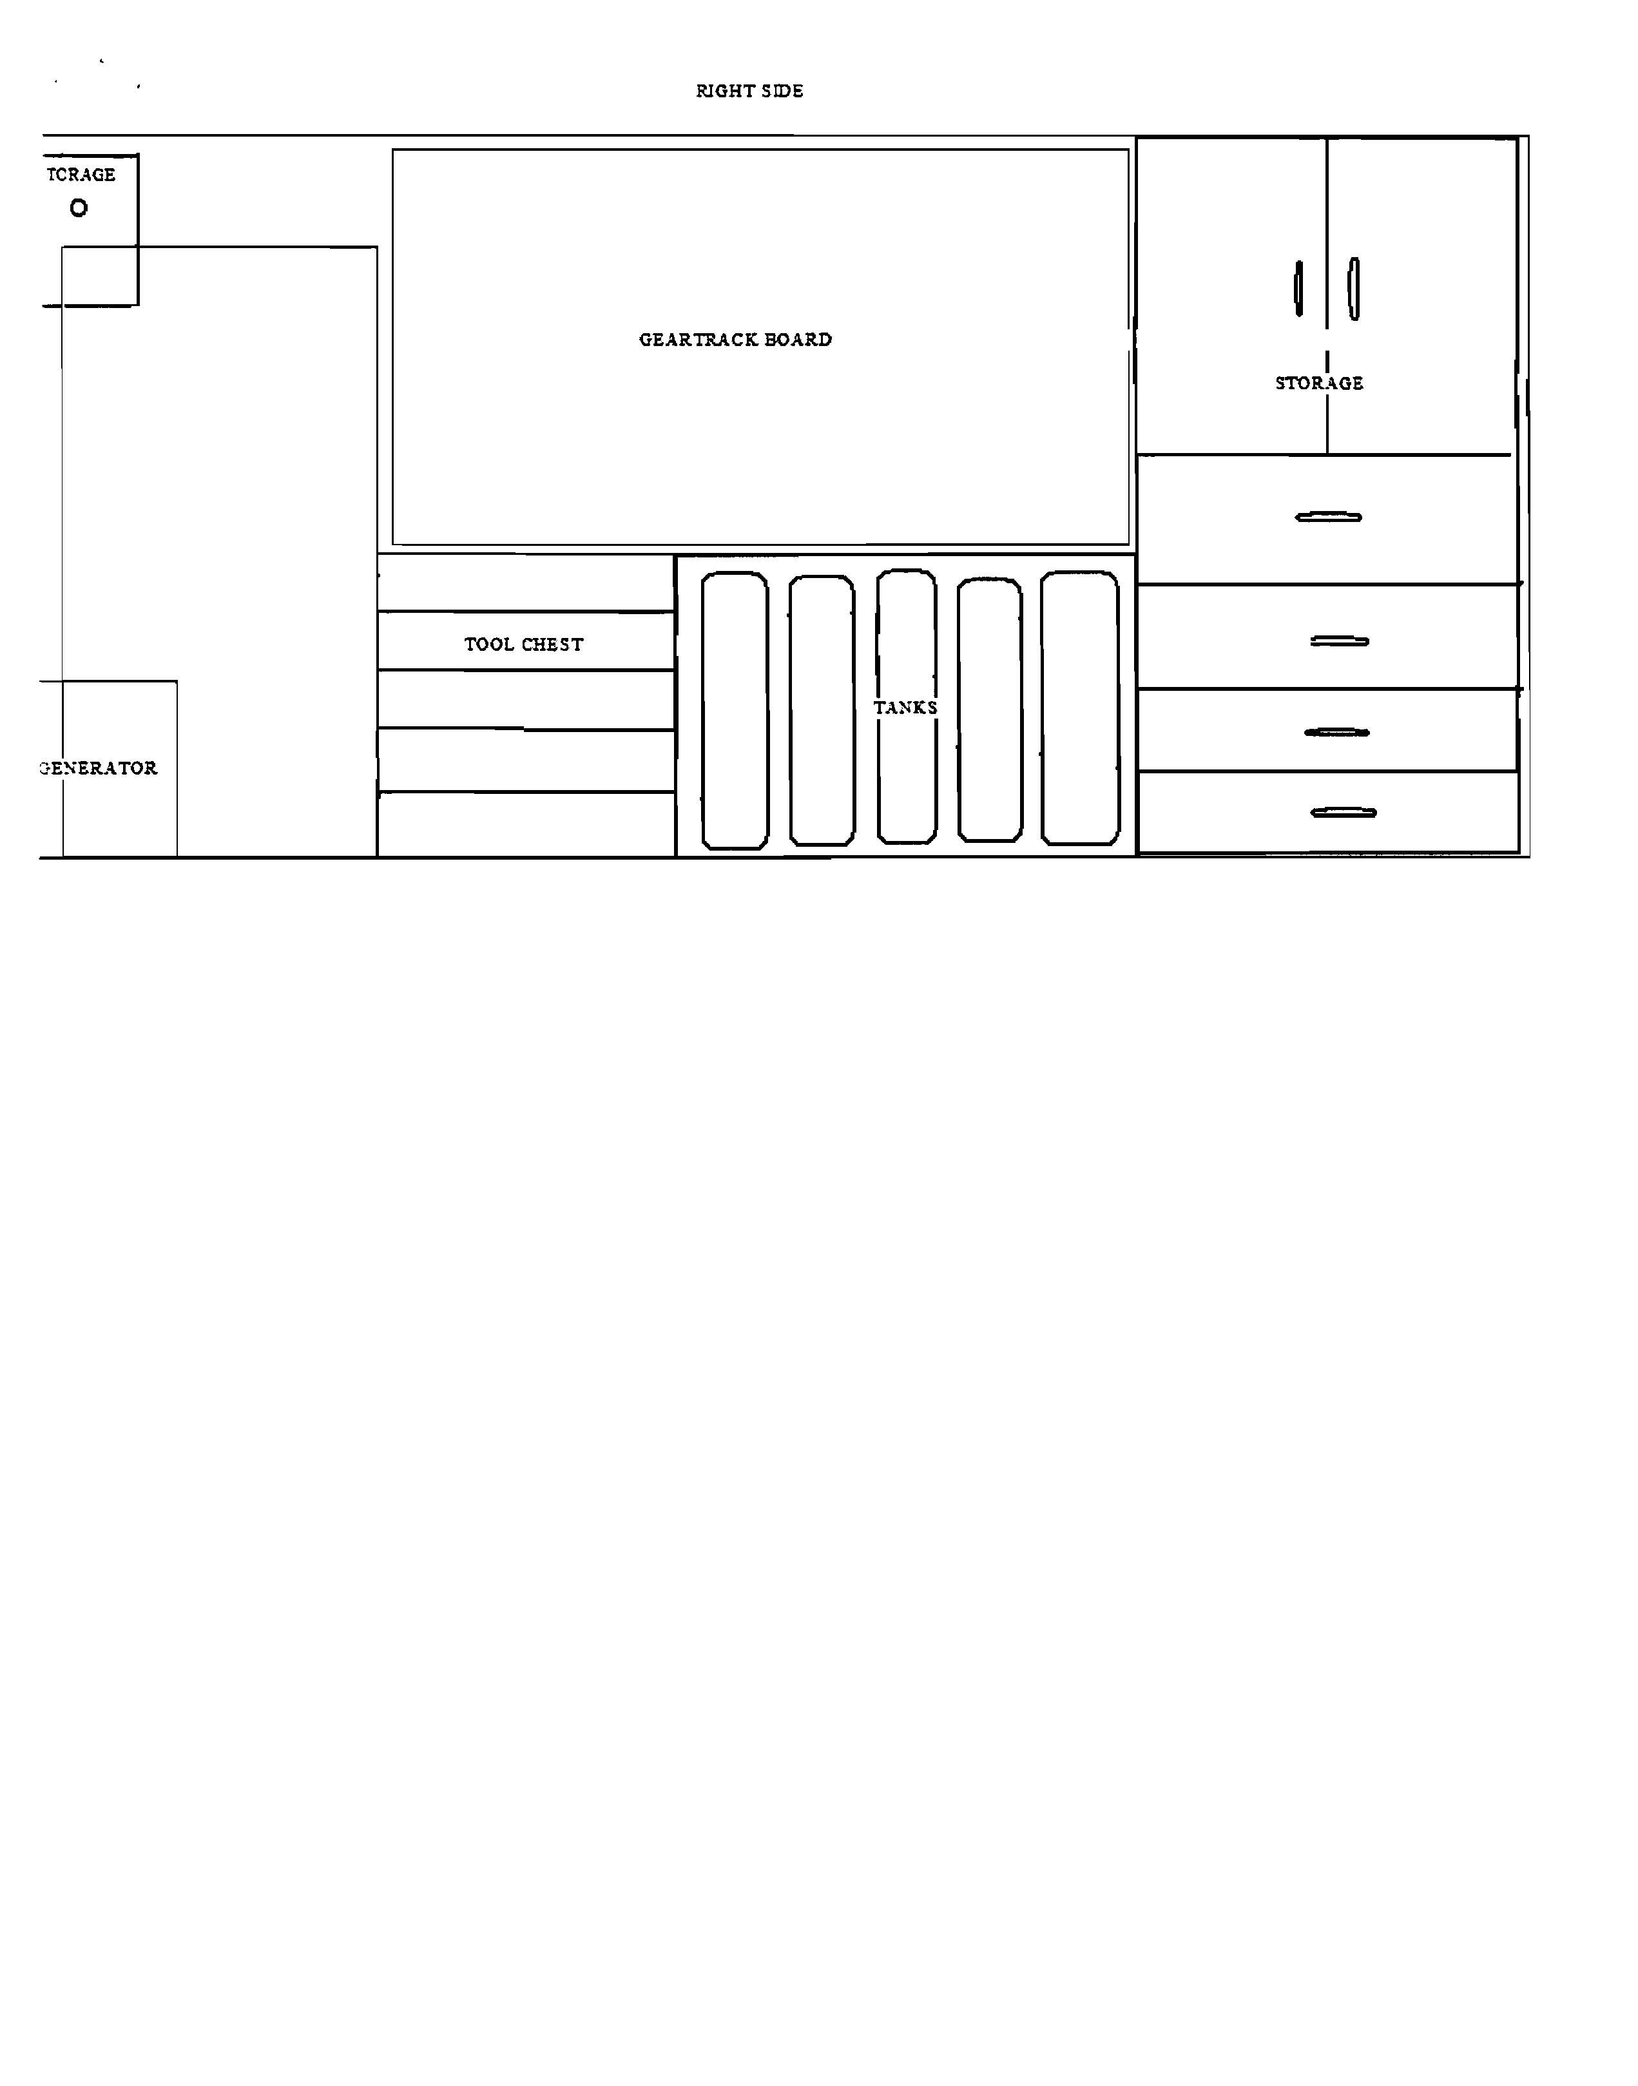
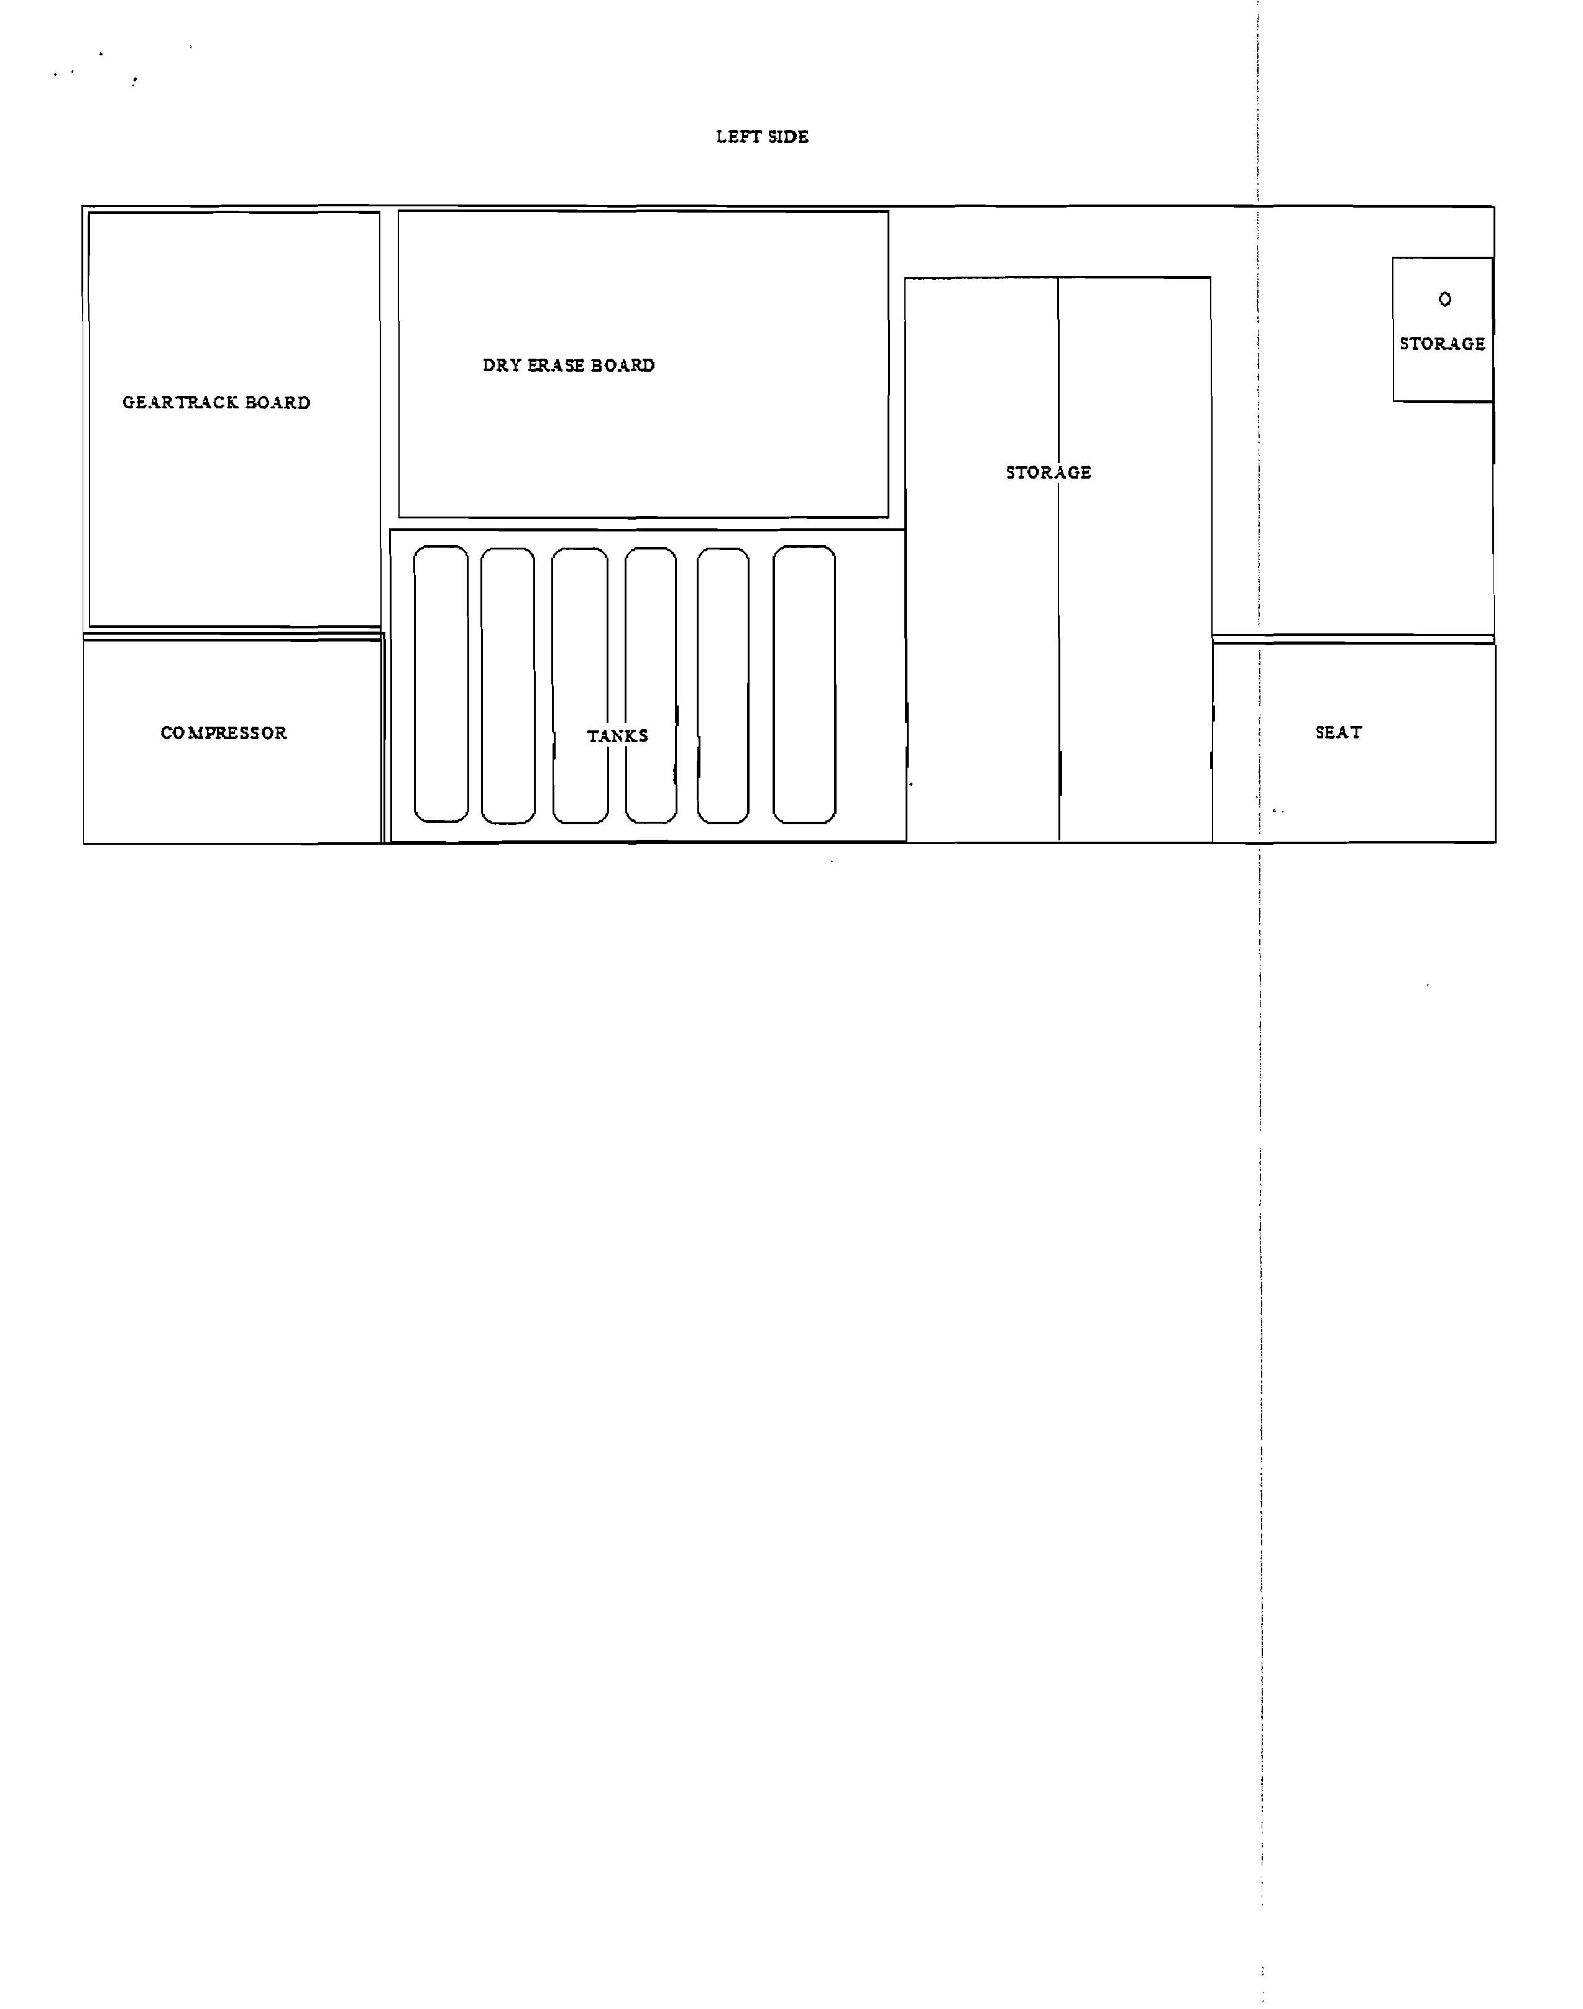
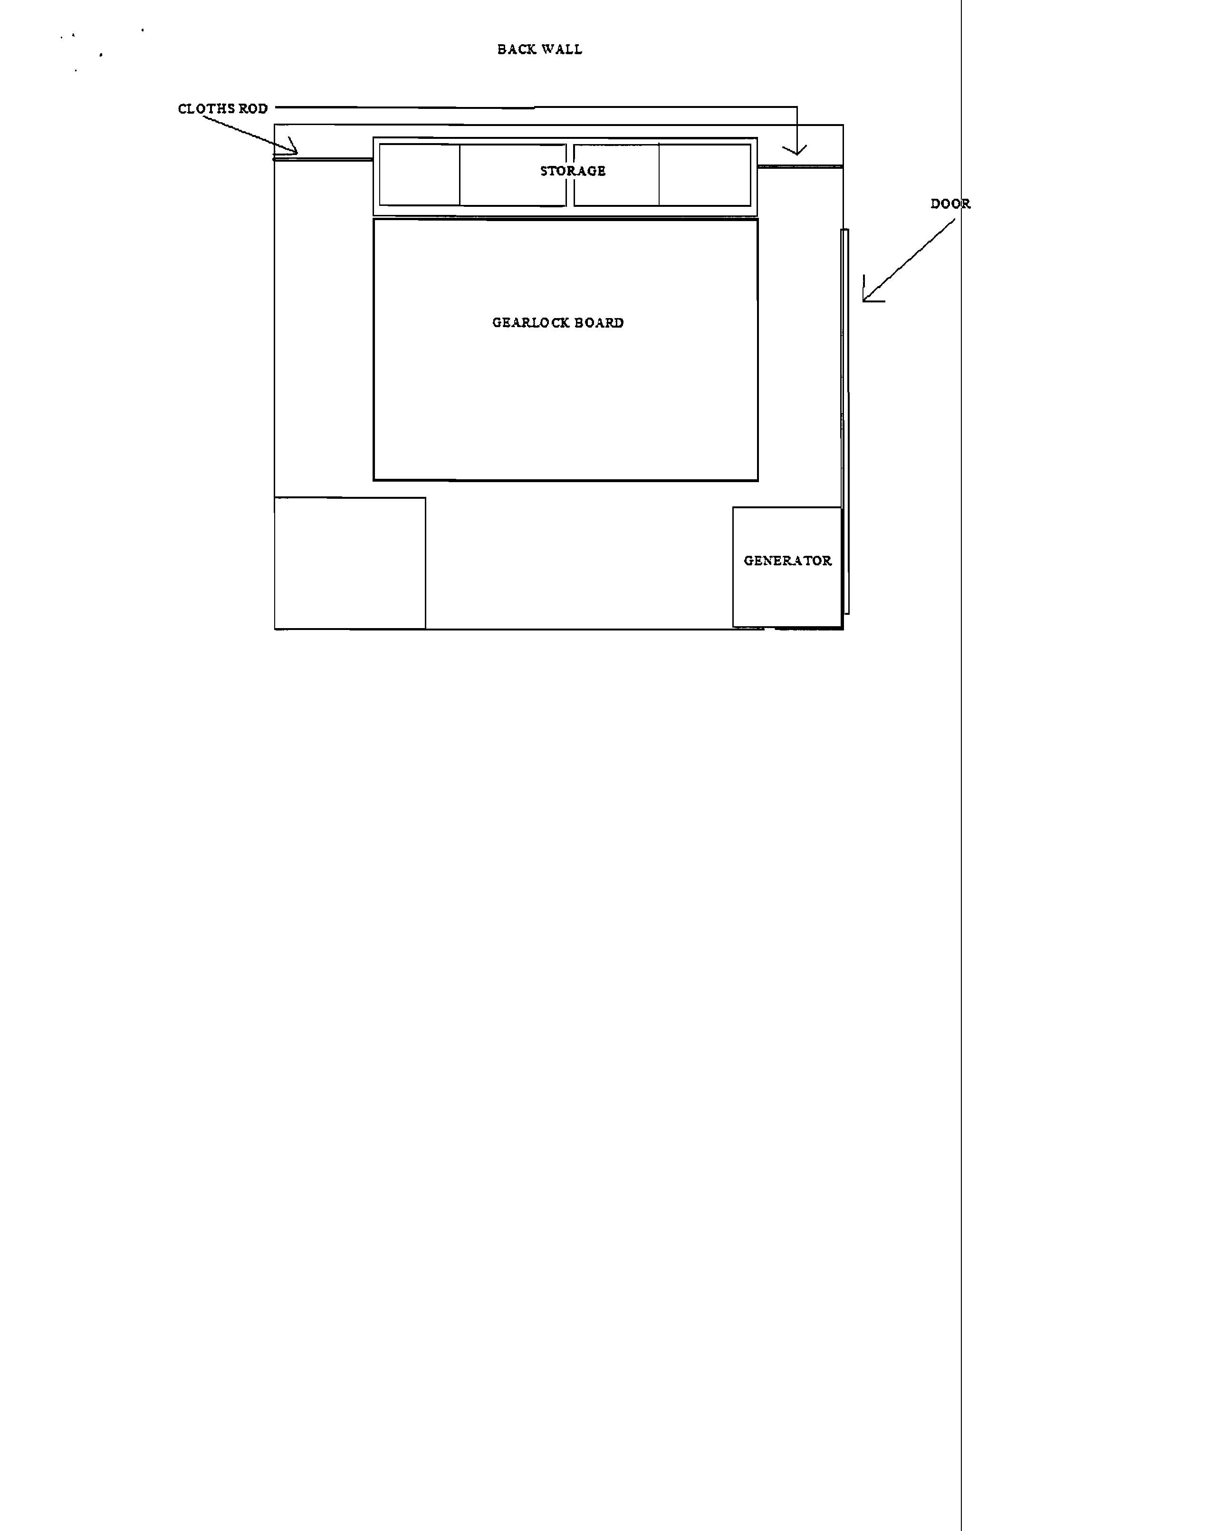
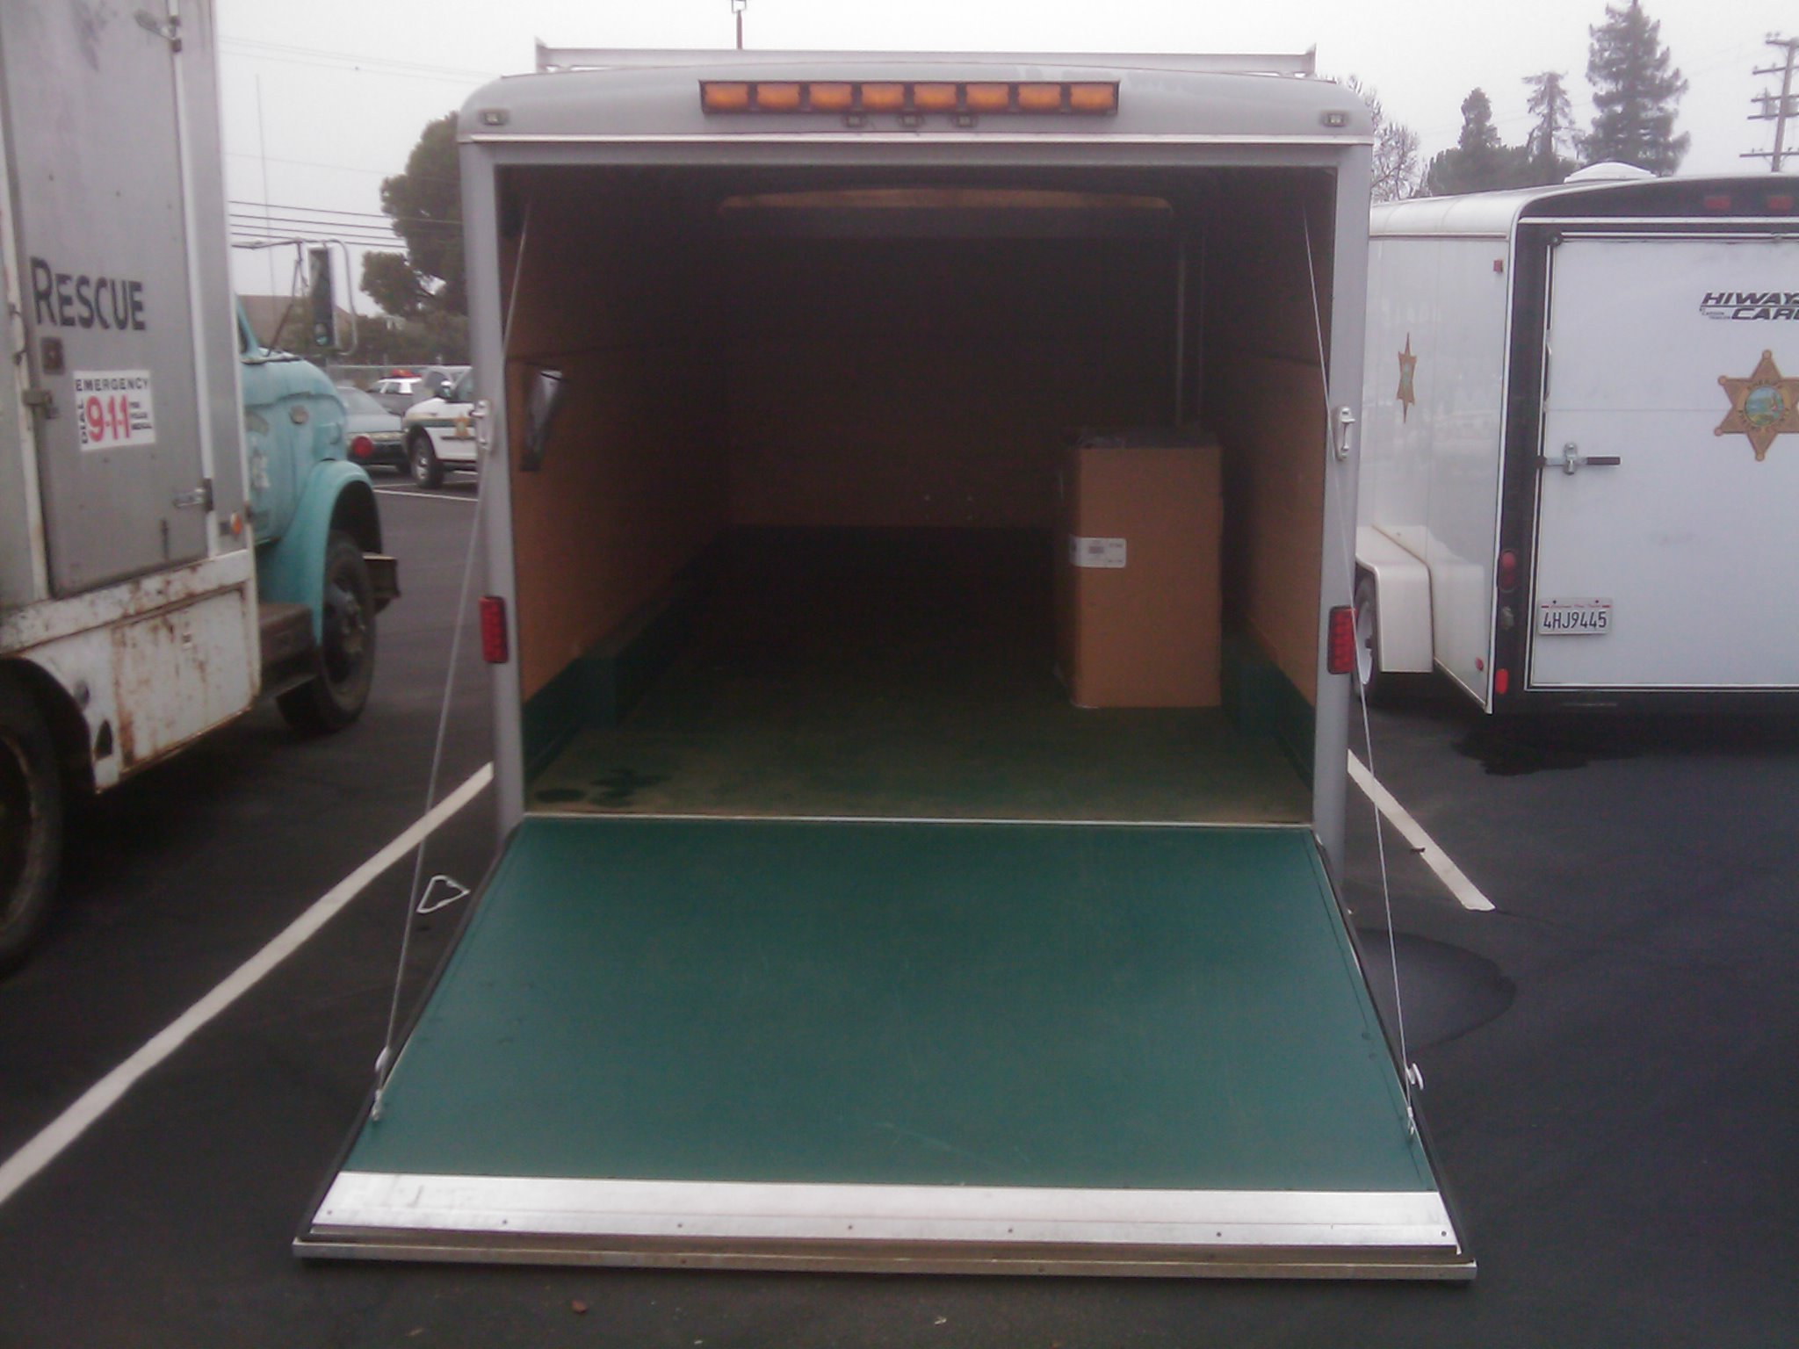
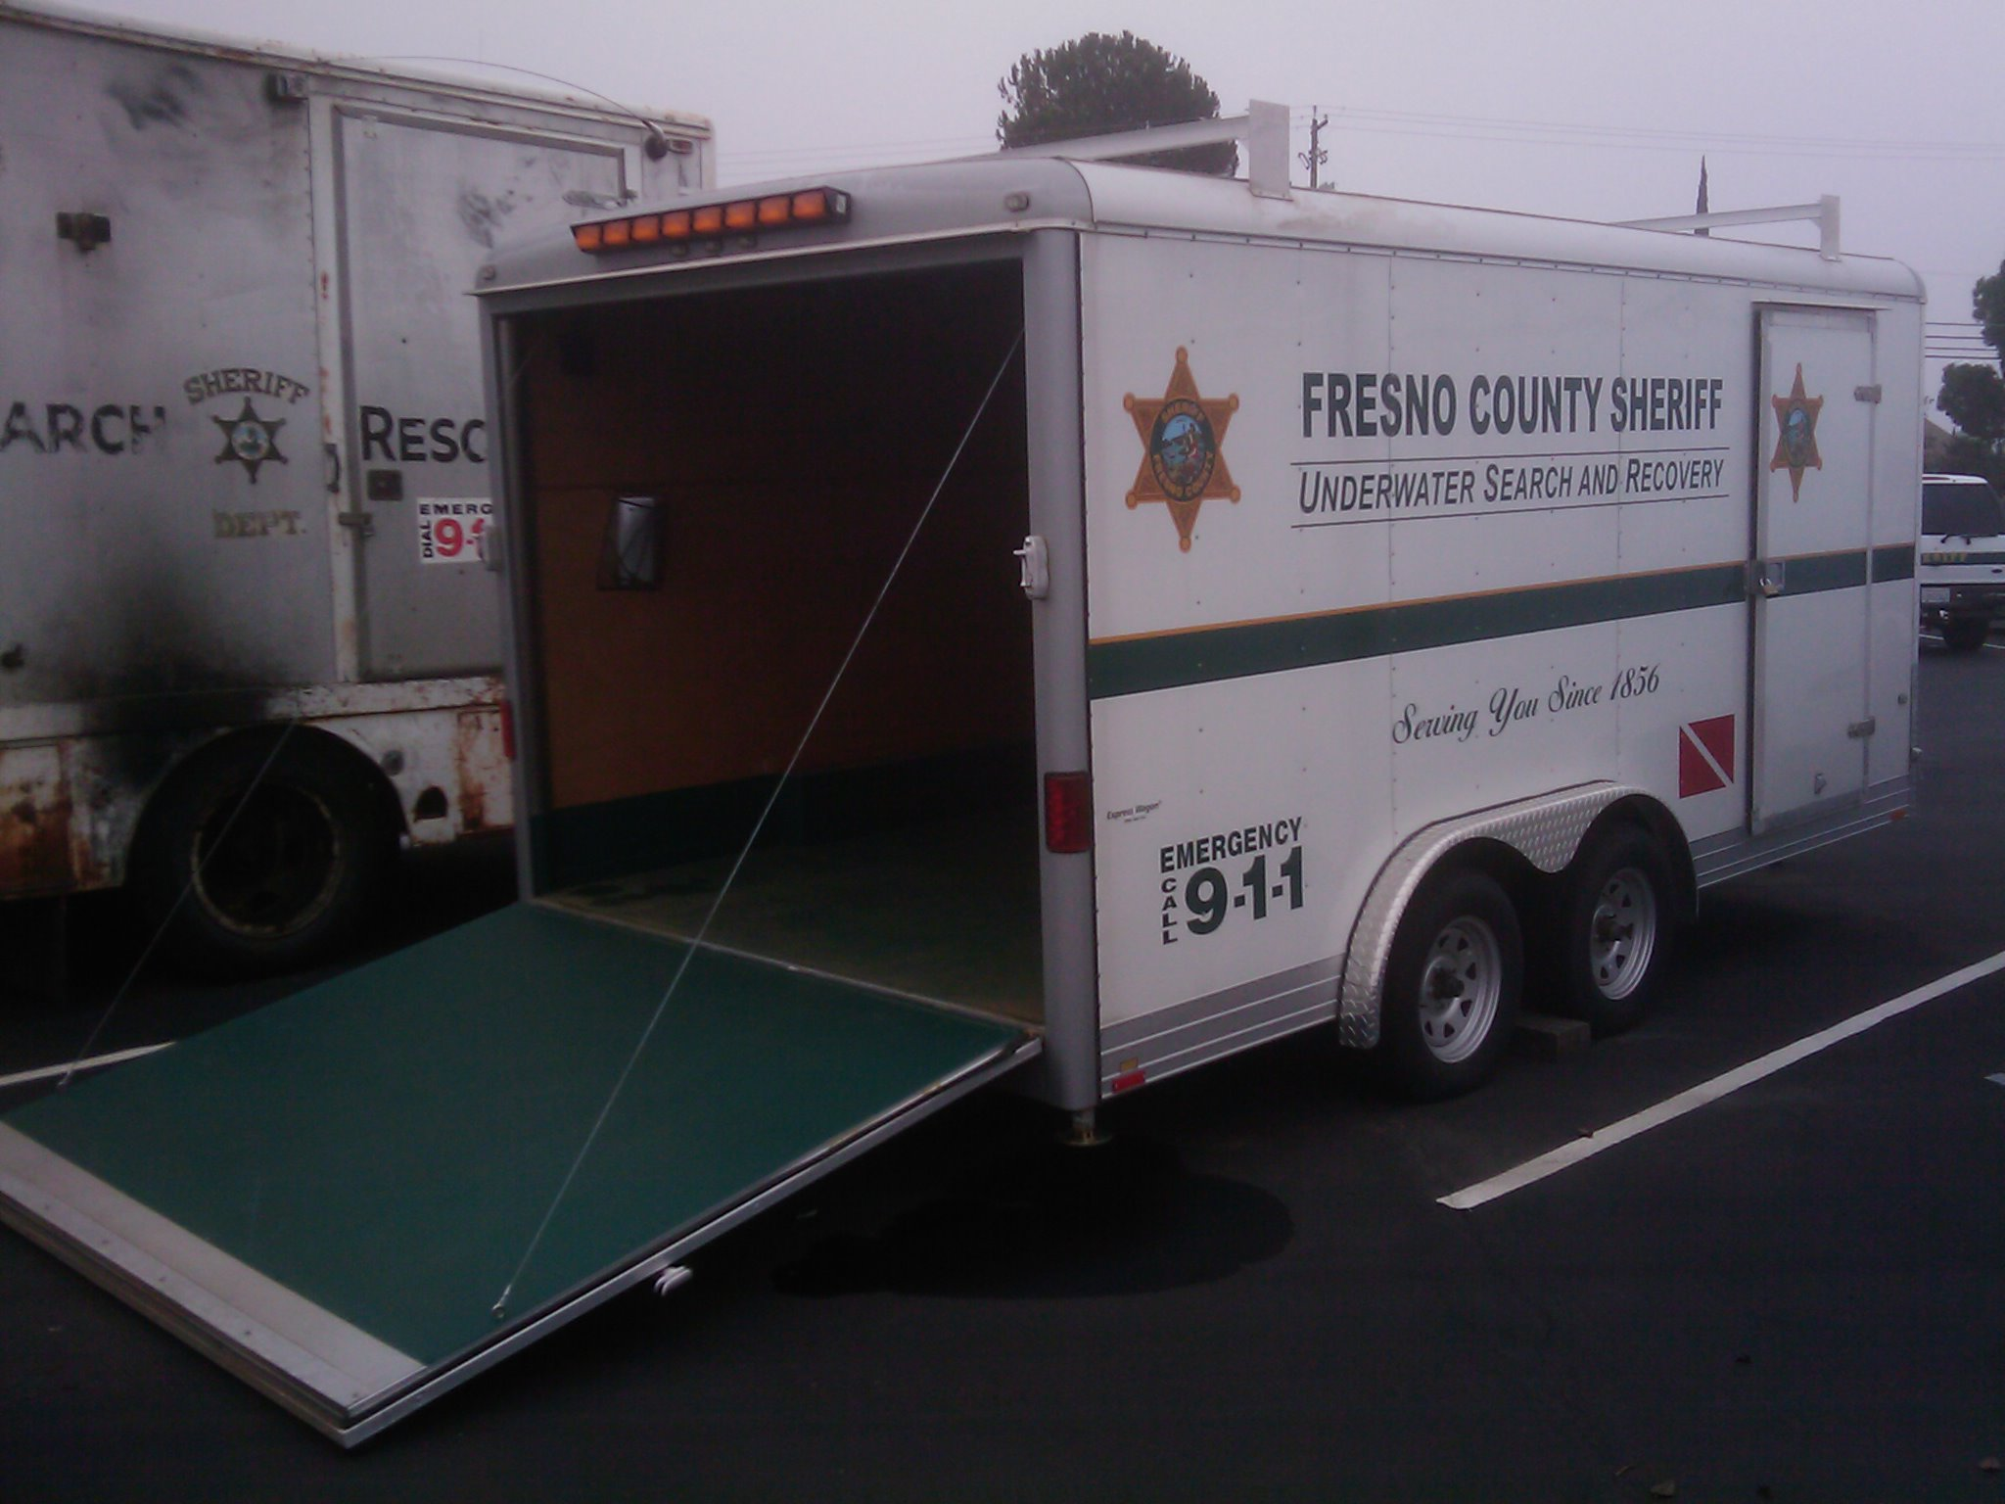
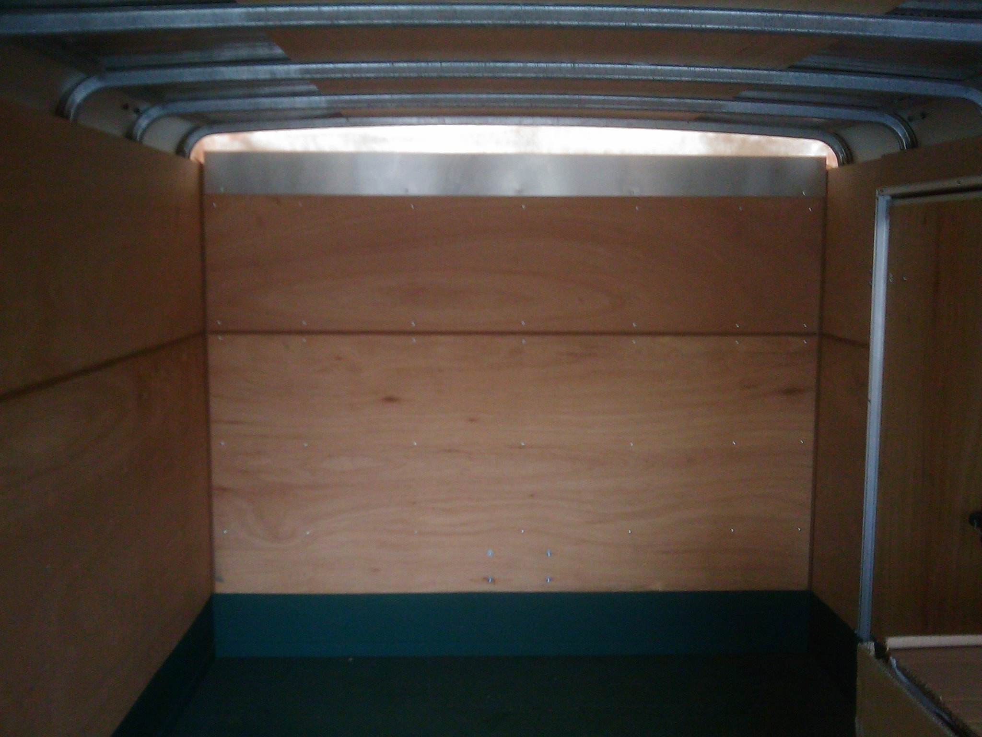

 |  |  |  |  |  |  | UNIT PRICE
- Modify County owned Wells Cargo Model EW1622 Trailer to be used as a Dive Team Trailer, as specified. |  |  |  | 1 |  | EA | $
Brand:
Model:
Year:
Sales Tax (8.975%) |  |  |  |  |  |  | $
TOTAL |  |  |  |  |  |  | $
List below all options and features included with the price stated above:
List and quote prices for all options/accessories not included in the unit price quoted above:
 |  | DESCRIPTION | PART NO. |  | * PRICE
 |  |  |  |  | $
 |  |  |  |  | $
 |  |  |  |  | $
 |  |  |  |  | $
 |  |  |  |  | $
 |  |  |  |  | $
*Do not include Sales Tax.

CHECK LIST
This Checklist is provided to assist the vendors in the preparation of their bid response. Included in this list, are important requirements and is the responsibility of the bidder to submit with the bid package in order to make the bid compliant. Because this checklist is just a guideline, the bidder must read and comply with the bid in its entirety.
Check off each of the following:
The Request for Quotation (RFQ) has been signed and completed.
One (1) original and two (2) copies of the RFQ have been provided.
Addenda, if any, have been completed, signed and included in the bid package.
The completed Reference List as provided with this RFQ.
The completed Form-W-9 (Request for Taxpayer Identification Number and Certification).
The Quotation Schedule as provided with this RFQ, has been completed, priced reviewed for accuracy and any corrections initialed in ink.
Indicate all of bidder exceptions to the County’s requirements, conditions and specifications as stated within this RFQ.
Bidder to Complete page as provided with this RFQ.
Lastly, on the LOWER LEFT HAND CORNER of the sealed envelope, box, etc. transmitting your bid, attach the “Request for Quotation Label” and include the following information:

County of Fresno RFQ No. |  |  | 680-4780
Closing Date: | February 18, 2010
Closing Time: | 2:00 P.M.

Commodity or Service:
This Checklist does not need to be returned with your bid.

