COUNTY OF FRESNO
ADDENDUM NUMBER: ONE
 |  |  | RFQ NUMBER:
February 8, 2010
 |  |  |  | PURCHASING USE
 |  | ORG/Requisition: 31113207/ 3111000064 |  |  | CJN | /tmp/in/input.doc
 | IMPORTANT: SUBMIT QUOTATION IN SEALED PACKAGE WITH QUOTATION NUMBER, CLOSING DATE AND BUYER’S NAME MARKED CLEARLY ON THE OUTSIDE TO:
COUNTY OF FRESNO, Purchasing
4525 EAST HAMILTON AVENUE
FRESNO, CA 93702-4599
Closing date of bid will be at 2:00 p.m., on February 18, 2010.
QUOTES WILL BE CONSIDERED LATE WHEN THE OFFICIAL PURCHASING TIME CLOCK READS 2:00 P.M.
 | Quotes will be opened and publicly read at that time. All quotation information will be available for review after contract award.
 | Clarification of specifications are to be directed to: Craig Nickel, phone (559) 456-7110, FAX (559) 456-7831.
NOTE THE following and attached ADDITIONS, DELETIONS AND/or CHANGES TO THE REQUIREMENTS OF REQUEST FOR QUOTATION NUMBER: AND INCLUDE THEM IN YOUR RESPONSE. PLEASE SIGN AND RETURN THIS ADDENDUM WITH YOUR QUOTATION.
- Delete Pages 17 through 19.
- Insert Revised Pages 17 through 19 in its place.
- See the following pages for Question and Answers presented as of this date.

ACKNOWLEDGMENT OF ADDENDUM NUMBER ONE TO RFQ
COMPANY NAME:
(PRINT)
SIGNATURE:
NAME & TITLE:
(PRINT)
Questions and answers
1) Page 15 of the spec: "The Wells Cargo Trailer has a maximum weight of 5,410 lbs. It is anticipated that the Dive Team will have 3,000 pounds of equipment. The maximum weight of the cabinets cannot exceed 2,000 lbs., leaving 410 lbs. for additional equipment that may become necessary. The finished trailer must remain below the maximum tow weight of the tow vehicle, which is 12,500 lbs.".......
Do you mean that the total weight of the finished trailer cannot exceed 5,410 pounds, or that the 5,410 pounds can be added to the existing weight of the trailer? Either way, if you could let us know what the empty weight of the trailer is, as well as the Gross Vehicle Weight Rating of the trailer (you can usually find this on the label at the front of the trailer).
The GVWR is 7700 lbs and subtract the max weight the trailer can carry in cargo, 5410 lbs leaves a trailer weight of 2290 lbs.
2) Items 1 & 2 describe identical cabinets, installed on opposite sides of the trailer, but the drawings show a different door layout and the curbside version has 4 large pullout drawers..... this has an impact on pricing..... which should we use, the drawings or the verbal spec?
There should be four heavy duty pullout drawers on passenger side cabinet. Top of cabinet should have one shelf with doors.
3) Page 16 of the spec: Point number 6: reference to 2 spool hangers..... these don't show on the drawings.... would they go where the drawings show 'geartrack board'?
Spool hangers should be mounted on the driver’s side wall next to the rear door.
3) The drawings all show Geartrack Board.... I'm not familiar with it, and the spec doesn't mention it..... can you clarify?
4’ X 8” sheets with built in tracks to hang gear.
4) The drawings show a generator and a compressor, but the specs don't mention them...... should they be included or not? If so, any further specs to help us to quote precisely for you?
They do not need to be installed; they will be on rollers to allow them to be removed.
5) The tool chest on the curbside drawing is not mentioned in the spec - can you clarify?
Tool chest was purchased and needs to be installed on the front wall with the left side of the tool chest against the driver’s side wall. Tool chest measures 18” deep by 36” wide.
6) The Dry Erase board on the roadside drawing is not mentioned in the spec - should it be included?
This will be provided and installed.

Revised Page 17
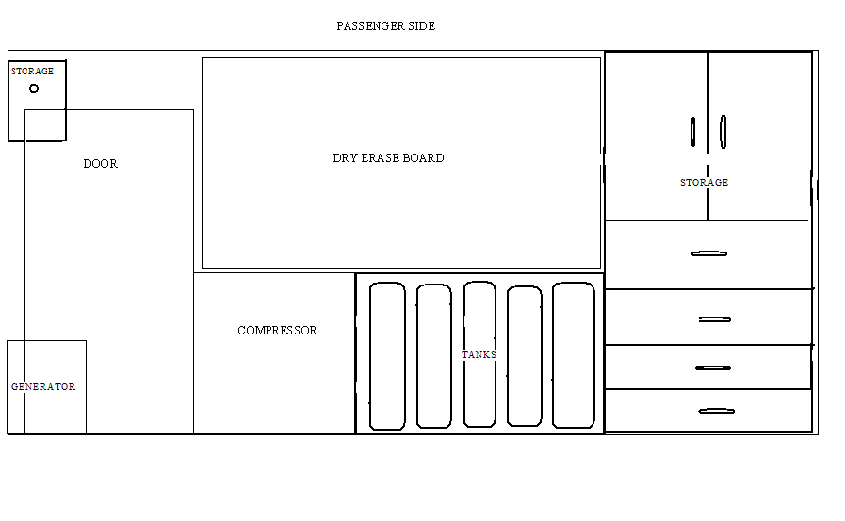

Revised Page 18
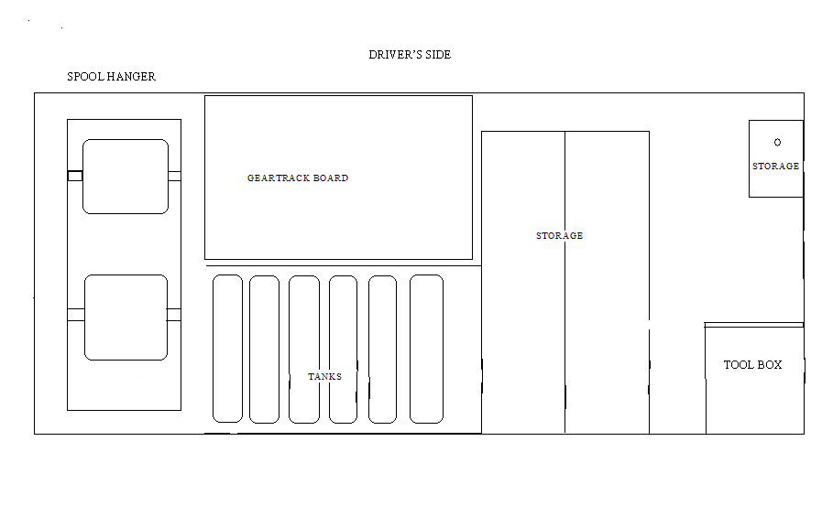

Revised Page 19
