COUNTY OF FRESNO
Request for proposal
 |  |  |  |  |  | NUMBER: 615-4238
eXTERNAL aUDIT sERVICES
February 24, 2006
 | ORG/Requisition: 2540/ 4106000251 |  |  |  |  |  |  |  | PURCHASING USE |  |  |  |  | /tmp/in/input.doc
 |  |  |  |  |  |  |  |  | jol
 | IMPORTANT: SUBMIT PROPOSAL IN SEALED PACKAGE WITH PROPOSAL NUMBER, CLOSING DATE AND BUYER’S NAME MARKED CLEARLY ON THE OUTSIDE TO:
COUNTY OF FRESNO, Purchasing
4525 EAST HAMILTON AVENUE
FRESNO, CA 93702-4599
Closing date of bid will be at 2:00 p.m., on March 30, 2006.
PROPOSALS WILL BE CONSIDERED LATE WHEN THE OFFICIAL PURCHASING TIME CLOCK READS 2:00 P.M.
 | Proposals will be opened and publicly read at that time. All proposal information will be available for review after contract award.
 | Clarifications of specifications are to be directed to: Gary Parkinson, phone (559) 456-7110, FAX (559) 456-7831.
 |  | GENERAL CONDITIONS
 |  | See “County Of Fresno Purchasing Standard Instructions And Conditions For Request For Proposals (RFP’S) and Requests for Quotations (RFQ’S)” attached.
BIDDER TO COMPLETE
UNDERSIGNED AGREES TO FURNISH THE COMMODITY OR SERVICE STIPULATED IN THE ATTACHED PROPOSAL SCHEDULE AT THE PRICES AND TERMS STATED, SUBJECT TO THE “COUNTY OF FRESNO PURCHASING STANDARD INSTRUCTIONS AND CONDITIONS FOR REQUEST FOR PROPOSALS (RFP’S) AND REQUESTS FOR QUOTATIONS (RFQ’S)”ATTACHED.
Except as noted on individual items, the following will apply to all items in the Proposal Schedule.
 |  |  | - Complete delivery will be made within |  |  |  |  |  |  |  | calendar days after receipt of Order.
 |  |  | - A cash discount of |  |  |  |  |  | % |  |  |  | days will apply.
Company
Address
City |  |  |  |  |  |  |  |  |  |  |  |  |  |  |  | State |  | Zip Code
( ) |  |  |  |  |  |  |  | ( )
Telephone Number |  |  |  |  |  |  |  | Facsimile Number |  |  |  |  |  |  |  | E-mail Address
Taxpayer Federal I.D. No.:
Signed By
Print Name |  |  |  |  |  |  |  |  |  |  |  | Title

COUNTY OF FRESNO PURCHASING
STANDARD INSTRUCTIONS AND CONDITIONS FOR
REQUESTS FOR PROPOSALS (RFP'S) AND REQUESTS FOR QUOTATIONS (RFQ'S)
Note: the reference to “bids” in the following paragraphs applies to RFP's and RFQ's

GENERAL CONDITIONS
By submitting a bid the bidder agrees to the following conditions. These conditions will apply to all subsequent purchases based on this bid.

- BID PREPARATION:
  - All prices and notations must be typed or written in ink. No erasures permitted. Errors may be crossed out, initialed and corrections printed in ink by person signing bid.
  - Brand Names: Brand names and numbers when given are for reference. Equal items will be considered, provided the offer clearly describes the article and how it differs from that specified. In the absence of such information it shall be understood the offering is exactly as specified.
  - State brand or make of each item. If bidding on other than specified, state make, model and brand being bid and attach supporting literature/specifications to the bid.
  - Bid on each item separately. Prices should be stated in units specified herein. All applicable charges must be quoted; charges on invoice not quoted herein will be disallowed.
  - Time of delivery is a part of the consideration and must be stated in definite terms and must be adhered to. F.O.B. Point shall be destination or freight charges must be stated.
  - All bids must be dated and signed with the firm’s name and by an authorized officer or employee.
  - Unless otherwise noted, prices shall be firm for 120 days after closing date of bid.
- SUBMITTING BIDS:
  - Each bid must be submitted on forms provided in a sealed envelope with bid number and closing date and time on the outside of the envelope/package.
  - Interpretation: Should any discrepancies or omissions be found in the bid specifications or doubt as to their meaning, the bidder shall notify the Buyer in writing at once. The County shall not be held responsible for verbal interpretations. Questions regarding the bid must be received by Purchasing at least 5 working days before bid opening. All addenda issued shall be in writing, duly issued by Purchasing and incorporated into the contract.
  - ISSUING AGENT/AUTHORIZED CONTACT: This RFQ has been issued by County of Fresno Purchasing. Purchasing shall be the vendor’s sole point of contact with regard to the RFQ, its content, and all issues concerning it.
All communication regarding this RFQ shall be directed to an authorized representative of County Purchasing. The specific buyer managing this RFQ is identified on the cover page, along with his or her telephone number, and he or she should be the primary point of contact for discussions or information pertaining to the RFQ. Contact with any other County representative, including elected officials, for the purpose of discussing this RFQ, its content, or any other issue concerning it, is prohibited unless authorized by Purchasing. Violation of this clause, by the vendor having unauthorized contact (verbally or in writing) with such other County representatives, may constitute grounds for rejection by Purchasing of the vendor’s quotation.
The above stated restriction on vendor contact with County representatives shall apply until the County has awarded a purchase order or contract to a vendor or vendors, except as follows. First, in the event that a vendor initiates a formal protest against the RFQ, such vendor may contact the appropriate individual, or individuals who are managing that protest as outlined in the County’s established protest procedures. All such contact must be in accordance with the sequence set forth under the protest procedures. Second, in the event a public hearing is scheduled before the Board of Supervisors to hear testimony prior to its approval of a purchase order or contract, any vendor may address the Board.
  - Bids received after the closing time will NOT be considered.
  - Bidders are to bid what is specified or requested first. If unable to or willing to, bidder may bid alternative or option, indicating all advantages, disadvantages and their associated cost.
- FAILURE TO BID:
  - If not bidding, return bid sheet and state reason for no bid or your name may be removed from mailing list.
- TAXES, CHARGES AND EXTRAS:
  - County of Fresno is subject to California sales and/or use tax (7.975%). Please indicate as a separate line item if applicable.
  - DO NOT include Federal Excise Tax. County is exempt under Registration No. 94-73-03401-K.
  - County is exempt from Federal Transportation Tax. Exemption certificate is not required where shipping papers show consignee as County of Fresno.
  - Charges for transportation, containers, packing, etc. will not be paid unless specified in bid.
- W-9 – REQUEST FOR TAXPAYER IDENTIFICATION NUMBER AND CERTIFICATION:
Upon award of bid, the vendor shall submit to County Purchasing, a completed W-9 - Request for Taxpayer Identification Number and Certification if not already a current vendor with The County of Fresno. This form is available from the IRS to complete on line at http://www.irs.gov/pub/irs-pdf/fw9.pdf.
- AWARDS:
  - Subject to the local preference provisions referenced in Paragraph 6 below and more thoroughly set forth in the General Requirements section of this RFQ, award(s) will be made to the most responsive responsible bidder. The evaluation will include such things as life-cycle cost, availability, delivery costs and whose product and/or service is deemed to be in the best interest of the County. The County shall be the sole judge in making such determination.
  - Unless bidder gives notice of all-or-none award in bid, County may accept any item, group of items or on the basis of total bid.
  - The County reserves the right to reject any and all bids and to waive informalities or irregularities in bids.
  - After award, all bids shall be open to public inspection. The County assumes no responsibility for the confidentiality of information offered in a bid.
- LOCAL VENDORS
  - Local Vendor Preference (applicable to RFQ Process only)
The following provisions are applicable only to the County’s acquisition of materials, equipment or supplies through the RFQ process when the funding source does not require an exemption to the Local Vendor Preference.
THE PROVISIONS OF THIS PARAGRAPH ARE APPLICABLE, NOTWITHSTANDING ANY OTHER PROVISIONS OF THIS RFQ TO THE CONTRARY
If the apparent low bidder is not a local vendor, any local vendor who submitted a bid which was within five percent (5%) of the lowest responsive bid as determined by the purchasing agent shall have the option of submitting a new bid within forty-eight hours (not including weekends and holidays) of County’s delivery of notification. Such new bids must be in an amount less than or equal to the lowest responsive bid as determined by the purchasing agent. If the purchasing agent receives any new bids from local vendors who have the option of submitting new bids within said forty-eight hour period, it shall award the contract to the local vendor submitting the lowest responsible bid. If no new bids are received, the contract shall be awarded to the original low bidder as announced by the purchasing agent.
  - Local Vendor Defined
“Local Vendor” shall mean any business which:
- Has its headquarters, distribution point or locally-owned franchise located in or having a street address within the County for at least six (6) months immediately prior to the issuance of the request for competitive bids by the purchasing agent; and
- Holds any required business license by a jurisdiction located in Fresno County; and
- Employs at least one (1) full-time or two (2) part-time employees whose primary residence is located within Fresno County, or if the business has no employees, shall be at least fifty percent (50%) owned by one or more persons whose primary residence(s) is located within Fresno County.
- TIE BIDS:
All other factors being equal, the contract shall be awarded to the Fresno County vendor or, if neither or both are Fresno County vendors, it may be awarded by the flip of a coin in the presence of witnesses or the entire bid may be rejected and re-bid. If the General Requirements of this RFQ state that they are applicable, the provisions of the Fresno County Local Vendor Preference shall take priority over this paragraph.
- PATENT INDEMNITY:
The vendor shall hold the County, its officers, agents and employees, harmless from liability of any nature or kind, including costs and expenses, for infringement or use of any copyrighted or uncopyrighted composition, secret process, patented or unpatented invention, article or appliance furnished or used in connection with this bid.
- SAMPLES:
Samples, when required, must be furnished and delivered free and, if not destroyed by tests, will upon written request (within 30 days of bid closing date) be returned at the bidder's expense. In the absence of such notification, County shall have the right to dispose of the samples in whatever manner it deems appropriate.
- RIGHTS AND REMEDIES OF COUNTY FOR DEFAULT:
  - In case of default by vendor, the County may procure the articles or service from another source and may recover the cost difference and related expenses occasioned thereby from any unpaid balance due the vendor or by proceeding against performance bond of the vendor, if any, or by suit against the vendor. The prices paid by the County shall be considered the prevailing market price at the time such purchase is made.
  - Articles or services, which upon delivery inspection do not meet specifications, will be rejected and the vendor will be considered in default. Vendor shall reimburse County for expenses related to delivery of non-specified goods or services.
  - Regardless of F.O.B. point, vendor agrees to bear all risks of loss, injury or destruction to goods and materials ordered herein which occur prior to delivery and such loss, injury or destruction shall not release vendor from any obligation hereunder.
- DISCOUNTS:
Terms of less than 15 days for cash payment will be considered as net in evaluating this bid. A discount for payment within fifteen (15) days or more will be considered in determining the award of bid. Discount period will commence either the later of delivery or receipt of invoice by the County. Standard terms are Net Forty-five (45) days.
- SPECIAL CONDITIONS IN BID SCHEDULE SUPERSEDE GENERAL CONDITIONS.
The “General Conditions” provisions of this RFP/RFQ shall be superseded if in conflict with any other section of this bid, to the extent of any such conflict.
- SPECIAL REQUIREMENT:
With the invoice or within twenty-five (25) days of delivery, the seller must provide to the County a Material Safety Data Sheet for each product, which contains any substance on “The List of 800 Hazardous Substances”, published by the State Director of Industrial Relations. (See Hazardous Substances Information and Training Act. California State Labor Code Sections 6360 through 6399.7.)
- RECYCLED PRODUCTS/MATERIALS:
Vendors are encouraged to provide and quote (with documentation) recycled or recyclable products/materials which meet stated specifications.
- YEAR COMPLIANCE WARRANTY
Vendor warrants that any product furnished pursuant to this Agreement/order shall support a four-digit year format and be able to accurately process date and time data from, into and between the twentieth and twenty-first centuries, as well as leap year calculations. "Product" shall include, without limitation, any piece or component of equipment, hardware, firmware, middleware, custom or commercial software, or internal components or subroutines therein. This warranty shall survive termination or expiration of this Agreement.
In the event of any decrease in product functionality or accuracy related to time and/or date data related codes and/or internal subroutines that impede the product from operating correctly using dates beyond December 31, 1999, vendor shall restore or repair the product to the same level of functionality as warranted herein, so as to minimize interruption to County's ongoing business process, time being of the essence. In the event that such warranty compliance requires the acquisition of additional programs, the expense for any such associated or additional acquisitions, which may be required, including, without limitation, data conversion tools, shall be borne exclusively by vendor. Nothing in this warranty shall be construed to limit any rights or remedies the County may otherwise have under this Agreement with respect to defects other than year performance.
- PARTICIPATION:
Bidder may agree to extend the terms of the resulting contract to other political subdivision, municipalities and tax-supported agencies.
Such participating Governmental bodies shall make purchases in their own name, make payment directly to bidder, and be liable directly to the bidder, holding the County of Fresno harmless.
- CONFIDENTIALITY:
All services performed by vendor shall be in strict conformance with all applicable Federal, State of California and/or local laws and regulations relating to confidentiality, including but not limited to, California Civil Code, California Welfare and Institutions Code, Health and Safety Code, California Code of Regulations, Code of Federal Regulations.
Vendor shall submit to County’s monitoring of said compliance.
Vendor may be a business associate of County, as that term is defined in the “Privacy Rule” enacted by the Health Insurance Portability and Accountability Act of 1996 (HIPAA). As a HIPAA Business Associate, vendor may use or disclose protected health information (“PHI”) to perform functions, activities or services for or on behalf of County as specified by the County, provided that such use or disclosure shall not violate HIPAA and its implementing regulations. The uses and disclosures if PHI may not be more expansive than those applicable to County, as the “Covered Entity” under HIPAA’S Privacy Rule, except as authorized for management, administrative or legal responsibilities of the Business Associate.
Vendor shall not use or further disclose PHI other than as permitted or required by the County, or as required by law without written notice to the County.
Vendor shall ensure that any agent, including any subcontractor, to which vendor provides PHI received from, or created or received by the vendor on behalf of County, shall comply with the same restrictions and conditions with respect to such information.

TABLE OF CONTENTS
PAGE
KEY DATES 2
PROPOSAL IDENTIFICATION SHEET 3
TRADE SECRET ACKNOWLEDGEMENT 4
REFERENCE LIST 6
GENERAL REQUIREMENTS 7
PARTICIPATION 15
SPECIFIC TERMS AND CONDITIONS 16
BACKGROUND 17
DATES AND TIME LINES 19
SCOPE OF WORK 22
COST PROPOSAL 28
PROPOSAL CONTENT REQUIREMENTS 32
APPENDIX A 36
APPENDIX B 37
APPENDIX C 45
APPENDIX D 53
APPENDIX E 54
APPENDIX F Part 1 55
APPENDIX F Part 2 56
APPENDIX F Part 3 57
APPENDIX F Part 4 58
APPENDIX F Part 5 59
APPENDIX G 60
APPENDIX H 85
APPENDIX A: Organization Chart 35
APPENDIX B: Schedule of Expenditures of Federal Awards 36
APPENDIX C: CAFR Work plan 37
APPENDIX D: Proposer Guarantees 38
APPENDIX E: Proposor Warranties 39
APPENDIX F: Schedule of Professional Fees & Expenses 40-44
APPENDIX G: First Five Programs 45
APPENDIX H: OCJP Programs 46

OVERVIEW
The County of Fresno is requesting proposals from qualified firms of certified public accountants to audit its financial statements for the fiscal year ended June 30, 2006, with the option of auditing its financial statements for each of the four (4) subsequent years. These audits are to be performed in accordance with generally accepted auditing standards set forth for financial audit in the:
- U.S. General Accounting Office’s (GAO) Government Auditing Standards (1994) as amended.
- The provisions of the Federal Single Audit Act of 1984.
- The Single Audit Act Amendments of 1996.
- The U.S. Office of Management and Budget (OMB) Circular A-133, Audits of States, Local Governments, and Non-Profit Organizations.

KEY DATES
RFP Issue Date: | February 24, 2006
Vendor Conference: | March 7, 2006 at 10:00 A.M.
 | County of Fresno Purchasing
 | 4525 E. Hamilton
 | Fresno, CA 93702
Deadline for Written or Fax Requests for Interpretations or Corrections of RFP: | March 23, 2006 8:00 A.M.
 | Fax No. (559) 456-7831
RFP Closing Date: | March 30, 2006 at 2:00 P.M.
 | County of Fresno Purchasing
 | 4525 E. Hamilton Avenue
 | Fresno, CA 93702

PROPOSAL IDENTIFICATION SHEET

RESPONDENT TO COMPLETE AND RETURN WITH PROPOSAL
Our proposal is attached and identified as:
The undersigned agrees to furnish the service stipulated at the prices and terms stated in the cost proposal.
Work services will commence within  contract. |  |  |  |  | calendar days after signing of the final
Company:
Address:
 |  |  |  |  |  |  | Zip:
Signed by:
Print Name
Print Title
( ) |  |  | ( )
Telephone |  |  | Fax Number |  |  | E-mail Address
Date:
Taxpayer Identification No.:

TRADE SECRET ACKNOWLEDGEMENT
All proposals received by the County shall be considered "Public Record" as defined by Section 6252 of the California Government Code. This definition reads as follows:
"...Public records" includes any writing containing information relating to the conduct of the public's business prepared, owned, used or retained by any state or local agency regardless of physical form or characteristics "Public records" in the custody of, or maintained by, the Governor's office means any writing prepared on or after January 6, 1975."
Each proposal submitted is Public record and is therefore subject to inspection by the public per Section 6253 of the California Government Code. This section states that "every citizen has a right to inspect any public record".
The County will not exclude any proposal or portion of a proposal from treatment as a public record except in the instance that it is submitted as a trade secret as defined by the California Government Code. Information submitted as proprietary, confidential or under any other such terms that might suggest restricted public access will not be excluded from treatment as public record.
"Trade secrets" as defined by Section 6254.7 of the California Government Code are deemed not to be public record. This section defines trade secrets as:
"...Trade secrets," as used in this section, may include, but are not limited to, any formula, plan, pattern, process, tool, mechanism, compound, procedure, production data or compilation of information that is not patented, which is known only to certain individuals within a commercial concern who are using it to fabricate, produce, or compound an article of trade or a service having commercial value and which gives its user an opportunity to obtain a business advantage over competitors who do not know or use it."
Information identified by bidder as "trade secret" will be reviewed by County of Fresno's legal counsel to determine conformance or non-conformance to this definition. Examples of material not considered to be trade secrets are pricing, cover letter, promotional materials, etc. Such material should be submitted in a separate binder not marked "Trade Secret".
INFORMATION THAT IS PROPERLY IDENTIFIED AS TRADE SECRET AND CONFORMS TO THE ABOVE DEFINITION WILL NOT BECOME PUBLIC RECORD. COUNTY WILL SAFEGUARD THIS INFORMATION IN AN APPROPRIATE MANNER.
Information identified by bidder as trade secret and determined not to be in conformance with the California Government Code definition shall be excluded from the proposal. Such information will be returned to the bidder at bidder's expense upon written request.
Trade secrets must be submitted in a separate binder that is plainly marked "Trade Secrets."
The County shall not in any way be liable or responsible for the disclosure of any proposals or portions thereof, if they are not (1) submitted in a separate binder that is plainly marked "Trade Secret" on the outside; and (2) if disclosure is required under the provision of law or by order of Court.
Vendors are advised that the County does not wish to receive trade secrets and that vendors are not to supply trade secrets unless they are absolutely necessary.

TRADE SECRET ACKNOWLEDGEMENT
I have read and understand the above "Trade Secret Acknowledgement."
I understand that the County of Fresno has no responsibility for protecting information submitted as a trade secret if it is not delivered in a separate binder plainly marked "Trade Secret."
Enter company name on appropriate line:
 | has submitted information identified as Trade Secrets
(Company Name) | has submitted information identified as Trade Secrets
 | has not submitted information identified as Trade Secrets
(Company Name) | has not submitted information identified as Trade Secrets
ACKNOWLEDGED BY:
 |  |  | ( )
Signature |  |  | Telephone
Print Name and Title |  |  |  | Date
Address
City |  |  | State | Zip
 | Firm:
REFERENCE LIST
Provide a list of at least five (5) customers for whom you have recently provided similar services (preferably California State or local government agencies). Be sure to include addresses and phone numbers.
Reference Name: |  | City:
Contact |  | Phone No.: | ( )
Date:
Service Provided:
Reference Name: |  | City:
Contact |  | Phone No.: | ( )
Date:
Service Provided:
Reference Name: |  | City:
Contact |  | Phone No.: | ( )
Date:
Service Provided:
Reference Name: |  | City:
Contact |  | Phone No.: | ( )
Date:
Service Provided:
Reference Name: |  | City:
Contact |  | Phone No.: | ( )
Date:
Service Provided:
Failure to provide a list of at least five (5) customers may be cause for rejection of this RFP.

GENERAL REQUIREMENTS
DEFINITIONS: The terms Bidder, Proposer, Contractor and Vendor are all used interchangeably and refer to that person, partnership, corporation, organization, agency, etc. which is offering the proposal and is identified on the "Provider" line of the Proposal Identification Sheet.
LOCAL VENDOR PREFERENCE: The Local Vendor Preference does not apply to this Request for Quotation.
RFP CLARIFICATION AND REVISIONS: Any revisions to the RFP will be issued and distributed as written addenda.
FIRM PROPOSAL: All proposals shall remain firm for at least one hundred eighty (180) days.
PROPOSAL PREPARATION: Proposals should be submitted in the formats shown under "PROPOSAL CONTENT REQUIREMENTS" section of this RFP.
SUPPORTIVE MATERIAL: Additional material may be submitted with the proposal as appendices. Any additional descriptive material that is used in support of any information in your proposal must be referenced by the appropriate paragraph(s) and page number(s).
Bidders are asked to submit their proposals in a binder (one that allows for easy removal of pages) with index tabs separating the sections identified in the Table of Contents. Pages must be numbered on the bottom of each page.
Any proposal attachments, documents, letters and materials submitted by the vendor shall be binding and included as a part of the final contract should your bid be selected.
TAXES: The quoted amount must include all applicable taxes. If taxes are not specifically identified in the proposal it will be assumed that they are included in the total quoted.
SALES TAX: Fresno County pays California State Sales Tax in the amount of 7.975% regardless of vendor's place of doing business.
INTERPRETATION OF RFP: Vendors must make careful examination of the requirements, specifications and conditions expressed in the RFP and fully inform themselves as to the quality and character of services required. If any person planning to submit a proposal finds discrepancies in or omissions from the RFP or has any doubt as to the true meaning or interpretation, correction thereof may be requested in writing from Purchasing, a minimum of five (5) County business days prior to the bid closing date. Any change in the RFP will be made only by written addendum, duly issued by the County. The County will not be responsible for any other explanations or interpretations.
RETENTION: County of Fresno reserves the right to retain all proposals, excluding proprietary documentation submitted per the instructions of this RFP, regardless of which response is selected.
ORAL PRESENTATIONS: Each finalist may be required to make an oral presentation in Fresno County and answer questions from County personnel.
AWARD/REJECTION: The award will be made to the vendor offering the overall proposal deemed to be to the best advantage of the County. The County shall be the sole judge in making such determination. The County reserves the right to reject any and all proposals. The lowest bidders are not arbitrarily the vendors whose proposals will be selected.
County Purchasing will chair or co-chair all award, evaluation and contract negotiation committees.
Award may require approval by the County of Fresno Board of Supervisors.
NEGOTIATION: The County will prepare and negotiate its own contract with the selected vendor, giving due consideration to the stipulation of the vendor's standard contracts and associated legal documents.
WAIVERS: The County reserves the right to waive any informalities or irregularities and any technical or clerical errors in any quote as the interest of the County may require.
TERMINATION: The County reserves the right to terminate any resulting contract upon written notice.
MINOR DEVIATIONS: The County reserves the right to negotiate minor deviations from the prescribed terms, conditions and requirements with the selected vendor.
PROPOSAL REJECTION: Failure to respond to all questions or not to supply the requested information could result in rejection of your proposal.
ASSIGNMENTS: The ensuing proposed contract will provide that the vendor may not assign any payment or portions of payments without prior written consent of the County of Fresno.
BIDDERS LIABILITIES: County of Fresno will not be held liable for any cost incurred by vendors in responding to the RFP.
CONFIDENTIALITY: Bidders shall not disclose information about the County's business or business practices and safeguard confidential data which vendor staff may have access to in the course of system implementation.
DISPUTE RESOLUTION: The ensuing contract shall be governed by the laws of the State of California.
Any claim which cannot be amicably settled without court action will be litigated in the U. S. District Court for the Eastern District of California in Fresno, CA or in a state court for Fresno County.
NEWS RELEASE: Vendors shall not issue any news releases or otherwise release information to any third party about this RFP or the vendor's quotation without prior written approval from the County of Fresno.
BACKGROUND REVIEW: The County reserves the right to conduct a background inquiry of each proposer/bidder which may include collection of appropriate criminal history information, contractual and business associations and practices, employment histories and reputation in the business community. By submitting a proposal/bid to the County, the vendor consents to such an inquiry and agrees to make available to the County such books and records the County deems necessary to conduct the inquiry.
PERFORMANCE BOND: The successful bidders may be required to furnish a faithful performance bond.
ACQUISITIONS: The County reserves the right to obtain the whole system as proposed or only a portion of the system, or to make no acquisition at all.
OWNERSHIP: The successful vendor will be required to provide to the County of Fresno documented proof of ownership by the vendor, or its designated subcontractor, of the proposed programs.
EXCEPTIONS: Identify with explanation, any terms, conditions, or stipulations of the RFP with which you CAN NOT or WILL NOT comply with by proposal group.
ADDENDA: In the event that it becomes necessary to revise any part of this RFP, addenda will be provided to all agencies and organizations that receive the basic RFP.
SUBCONTRACTORS: If a subcontractor is proposed, complete identification of the subcontractor and his tasks should be provided. The primary contractor is not relieved of any responsibility by virtue of using a subcontractor.
CONFLICT OF INTEREST: The County shall not contract with, and shall reject any bid or proposal submitted by the persons or entities specified below, unless the Board of Supervisors finds that special circumstances exist which justify the approval of such contract:
- Employees of the County or public agencies for which the Board of Supervisors is the governing body.
- Profit-making firms or businesses in which employees described in Subsection (1) serve as officers, principals, partners or major shareholders.
- Persons who, within the immediately preceding twelve (12) months, came within the provisions of Subsection (1), and who were employees in positions of substantial responsibility in the area of service to be performed by the contract, or participated in any way in developing the contract or its service specifications.
- Profit-making firms or businesses in which the former employees described in Subsection (3) serve as officers, principals, partners or major shareholders.
- No County employee, whose position in the County enables him to influence the selection of a contractor for this RFP, or any competing RFP, and no spouse or economic dependent of such employee, shall be employees in any capacity by a bidder, or have any other direct or indirect financial interest in the selection of a contractor.
- In addition, no County employee will be employed by the selected vendor to fulfill the vendor’s contractual obligations to the County.
EVALUATION CRITERIA: Respondents will be evaluated on the basis of their responses to all questions and requirements in this RFP and product cost. The County shall be the sole judge in the ranking process and reserves the right to reject any or all bids. False, incomplete or unresponsive statements in connection with this proposal may be sufficient cause for its rejection.
1. Mandatory Elements
A. The audit firm is independent and licensed to practice in California.
- The audit firm’s professional personnel have received adequate continuing education within the preceding two years.

- The firm has no conflict of interest with regard to any other work performed by the firm for the County of Fresno.
- The firm submits a copy of its most recent quality control review report and the firm has a record of quality audit work.
- The firm adheres to the instructions in this request for proposal on preparing and submitting the proposal.
2. Technical Qualifications:
A. Expertise and experience
(1) The firm’s past experience and performance on comparable government engagements.
(2) The quality of the firm’s professional personnel to be assigned to the engagement and the quality of the firm’s management support personnel to be available for technical consultation.
B. Audit Approach
(1) Adequacy of proposed staffing for various segments of the engagement.
(2) Adequacy of sampling techniques.
(3) Adequacy of analytical procedures
3. Price:
COST WILL NOT BE THE PRIMARY FACTOR IN THE SELECTION OF AN AUDIT FIRM.
SELECTION PROCESS: All proposals will be evaluated by a team co-chaired by the Purchasing Division of General Services Administration and the Auditor-Controller/Treasurer-Tax Collector. The co-chairs will select a review committee consisting of members from Fresno County staff involved in accounting and finance. In addition, staff of local governmental units may assist in the evaluation.
The review committee’s evaluations will be presented to the Fresno County Audit Committee which will recommend the firm to be selected. The Audit Committee is comprised of two members of the Board of Supervisors, County Counsel (Chairman), County Administrative Officer, and a representative of the Department Head’s Council.
REVIEW OF PROPOSALS: The review committee will use a review process to score proposals. Each member of the review committee will score each proposal by each of the criteria described in the Evaluation Criteria section. The review committee’s individual scores will then be combined to arrive at a composite score for each firm. At this point, firms with an unacceptably low score may be eliminated from further consideration.
After the composite evaluation for each firm has been established, the review committee’s evaluations will be presented to the Audit Committee who will recommend the firm to be selected
The County of Fresno reserves the right to retain all proposals submitted and use any idea in a proposal regardless of whether that proposal is selected
ORAL PRESENTATIONS: Organizations that submit a proposal may be required to make an oral presentation to the Selection Committee. These presentations provide an opportunity for the individual, agency, or organization to clarify its proposal to ensure thorough, mutual understanding.
FINAL SELECTION: The County of Fresno will select a firm based upon the recommendation of the Audit Committee. The final award of this proposal is contingent upon the approval of the County of Fresno Board of Supervisors.
It is anticipated that a firm will be selected in May 2006. Following notification of the firm selected, it is expected a contract will be executed between both parties by June 2006.
RIGHT TO REJECT PROPOSALS: Submission of a proposal indicates acceptance by the firm of the conditions contained in this request for proposal unless clearly and specifically noted in the proposal submitted and confirmed in the contract between the County of Fresno and the firm selected.
The County of Fresno reserves the right without prejudice to reject any or all proposals.
INDEPENDENT CONTRACTOR: In performance of the work, duties, and obligations assumed by Contractor under any ensuing Agreement, it is mutually understood and agreed that Contractor, including any and all of Contractor's officers, agents, and employees will at all times be acting and performing as an independent contractor, and shall act in an independent capacity and not as an officer, agent, servant, employee, joint venturer, partner, or associate of the County. Furthermore, County shall have no right to control, supervise, or direct the manner or method by which Contractor shall perform its work and function. However, County shall retain the right to administer this Agreement so as to verify that Contractor is performing its obligations in accordance with the terms and conditions thereof. Contractor and County shall comply with all applicable provisions of law and the rules and regulations, if any, of governmental authorities having jurisdiction over matters the subject thereof.
Because of its status as an independent contractor, Contractor shall have absolutely no right to employment rights and benefits available to County employees. Contractor shall be solely liable and responsible for providing to, or on behalf of, its employees all legally required employee benefits. In addition, Contractor shall be solely responsible and save County harmless from all matters relating to payment of Contractor's employees, including compliance with Social Security, withholding, and all other regulations governing such matters. It is acknowledged that during the term of the Agreement, Contractor may be providing services to others unrelated to the COUNTY or to the Agreement.
HOLD HARMLESS CLAUSE: Contractor agrees to indemnify, save, hold harmless and at County's request, defend the County, its officers, agents and employees, from any and all costs and expenses, damages, liabilities, claims and losses occurring or resulting to County in connection with the performance, or failure to perform, by Contractor, its officers, agents or employees under this Agreement and from any and all costs and expenses, damages, liabilities, claims and losses occurring or resulting to any person, firm or corporation who may be injured or damaged by the performance, or failure to perform, of Contractor, its officers, agents or employees under this Agreement.
PRICE RESPONSIBILITY: The selected vendor will be required to assume full responsibility for all services and activities offered in the proposal, whether or not they are provided directly. Further, the County of Fresno will consider the selected vendor to be the sole point of contact with regard to contractual matters, including payment of any and all charges resulting from the contract. The contractor may not subcontract or transfer the contract, or any right or obligation arising out of the contract, without first having obtained the express written consent of the County.
ADDRESSES AND TELEPHONE NUMBERS: The vendor will provide the business address and mailing address, if different, as well as the telephone number of the individual signing the contract.
ASSURANCES: Any contract awarded under this RFP must be carried out in full compliance with The Civil Rights Act of 1964, The Americans With Disabilities Act of 1990, their subsequent amendments, and any and all other laws protecting the rights of individuals and agencies. The County of Fresno has a zero tolerance for discrimination, implied or expressed, and wants to ensure that policy continues under this RFP. The contractor must also guarantee that services, or workmanship, provided will be performed in compliance with all applicable local, state, or federal laws and regulations pertinent to the types of services, or project, of the nature required under this RFP. In addition, the contractor may be required to provide evidence substantiating that their employees have the necessary skills and training to perform the required services or work.

INSURANCE:
Without limiting the COUNTY's right to obtain indemnification from CONTRACTOR or any third parties, CONTRACTOR, at its sole expense, shall maintain in full force and effect the following insurance policies throughout the term of the Agreement:
Without limiting the COUNTY's right to obtain indemnification from CONTRACTOR or any third parties, CONTRACTOR, at its sole expense, shall maintain in full force and effect the following insurance policies or a program of self-insurance, including but not limited to, an insurance pooling arrangement or Joint Powers Agreement (JPA) throughout the term of the Agreement:
- Commercial General Liability
Commercial General Liability Insurance with limits of not less than One Million Dollars ($1,000,000) per occurrence and an annual aggregate of Two Million Dollars ($2,000,000). This policy shall be issued on a per occurrence basis. COUNTY may require specific coverages including completed operations, products liability, contractual liability, Explosion-Collapse-Underground, fire legal liability or any other liability insurance deemed necessary because of the nature of this contract.
- Automobile Liability
Comprehensive Automobile Liability Insurance with limits for bodily injury of not less than Two Hundred Fifty Thousand Dollars ($250,000.00) per person, Five Hundred Thousand Dollars ($500,000.00) per accident and for property damages of not less than Fifty Thousand Dollars ($50,000.00), or such coverage with a combined single limit of Five Hundred Thousand Dollars ($500,000.00). Coverage should include owned and non-owned vehicles used in connection with this Agreement.
- Professional Liability
If CONTRACTOR employs licensed professional staff, (e.g., Ph.D., R.N., L.C.S.W., M.F.C.C.) in providing services, Professional Liability Insurance with limits of not less than One Million Dollars ($1,000,000.00) per occurrence, Three Million Dollars ($3,000,000.00) annual aggregate.

- Worker's Compensation
A policy of Worker's Compensation insurance as may be required by the California Labor Code.
CONTRACTOR shall obtain endorsements to the Commercial General Liability insurance naming the County of Fresno, its officers, agents, and employees, individually and collectively, as additional insured, but only insofar as the operations under this Agreement are concerned. Such coverage for additional insured shall apply as primary insurance and any other insurance, or self-insurance, maintained by COUNTY, its officers, agents and employees shall be excess only and not contributing with insurance provided under CONTRACTOR's policies herein. This insurance shall not be cancelled or changed without a minimum of thirty (30) days advance written notice given to COUNTY.
Within Thirty (30) days from the date CONTRACTOR executes this Agreement, CONTRACTOR shall provide certificates of insurance and endorsement as stated above for all of the foregoing policies, as required herein, to the County of Fresno, Gary W. Parkinson of the Purchasing Division, stating that such insurance coverage have been obtained and are in full force; that the County of Fresno, its officers, agents and employees will not be responsible for any premiums on the policies; that such Commercial General Liability insurance names the County of Fresno, its officers, agents and employees, individually and collectively, as additional insured, but only insofar as the operations under this Agreement are concerned; that such coverage for additional insured shall apply as primary insurance and any other insurance, or self-insurance, maintained by COUNTY, its officers, agents and employees, shall be excess only and not contributing with insurance provided under CONTRACTOR's policies herein; and that this insurance shall not be cancelled or changed without a minimum of thirty (30) days advance, written notice given to COUNTY.
In the event CONTRACTOR fails to keep in effect at all times insurance coverage as herein provided, the COUNTY may, in addition to other remedies it may have, suspend or terminate this Agreement upon the occurrence of such event.
All policies shall be with admitted insurers licensed to do business in the State of California. Insurance purchased shall be purchased from companies possessing a current A.M. Best, Inc. rating of A FSC VII or better.
AUDITS AND INSPECTIONS: The Contractor shall at any time during business hours, and as often as the County may deem necessary, make available to the County for examination all of its records and data and respect to the matters covered by this Agreement. The Contractor shall, upon request by the County, permit the County to audit and inspect all of such records and data necessary to ensure Contractor's compliance with the terms of this Agreement.
If this Agreement exceeds Ten Thousand and No/100 dollars ($10,000.00), Contractor shall be subject to the examination and audit of the Auditor General for a period of three (3) years after final payment under contract (Government Code Section 8546.7).
County of Fresno will not be held liable for any cost incurred by bidders in responding to RFP.
DEFAULT: In case of default by the selected bidder, the County may procure materials and services from another source and may recover the loss occasioned thereby from any unpaid balance due the selected bidder, or by any other legal means available to the County.
BREACH OF CONTRACT: In the event of breach of contract by either party, the other party shall be relieved of its obligations under this agreement and may pursue any legal remedies.
SAMPLE CONTRACT: Submitted as a part of bidder's response to the RFP, shall be a sample of the contract he is proposing with the County of Fresno. The tentative award of the contract is based on successful negotiation pending formal recommendation of award. Bidder is to include in response the names and titles of officials authorized to conduct such negotiations.
CONFIDENTIALITY
All services performed by vendor shall be in strict conformance with all applicable Federal, State of California and/or local laws and regulations relating to confidentiality, including but not limited to, California Civil Code, California Welfare and Institutions Code, Health and Safety Code, California Code of Regulations, Code of Federal Regulations.
Vendor shall submit to County’s monitoring of said compliance.
Vendor may be a Business associate of County, as that term is defined in the “Privacy Rule” enacted by the Health Insurance Portability and Accountability Act of 1996 (HIPAA). As a HIPAA Business Associate, vendor may use or disclose protected health information (“PHI”) to perform functions, activities or services for or on behalf of County, as specified by the County, provided that such use or disclosure shall not violate HIPAA and its implementing regulations. The uses and disclosures of PHI may not be more expansive than those applicable to County, as the “Covered Entity” under HIPAA’S Privacy Rule, except as authorized for management, administrative or legal responsibilities of the Business Associate.
Vendor shall not use or further disclose PHI other than as permitted or required by the County, or as required by law without written notice to the County.
Vendor shall ensure that any agent, including any subcontractor, to which vendor provides PHI received from, or created or received by the vendor on behalf of County, shall comply with the same restrictions and conditions with respect to such information.
APPEALS
Appeals must be submitted in writing within five (5) working days after the review committee notification of proposed recommendations. Appeals should be submitted to County of Fresno Purchasing, 4525 E. Hamilton Avenue, Fresno, California 93702-4599. Appeals should address only areas regarding RFP contradictions, procurement errors, quotation rating discrepancies, legality of procurement context, conflict of interest, and inappropriate or unfair competitive procurement grievance regarding the RFP process.
The Purchasing Manager will provide a written response to the complaint within five (5) working days unless the complainant is notified more time is required.
If the protesting bidder is not satisfied with the decision of the Purchasing Manager, he/she shall have the right to appeal to the Purchasing Agent within five (5) business days after notification of Purchasing Manager’s decision.
If the protesting bidder is not satisfied with Purchasing Agent decision, the final appeal is with the Board of Supervisors.

BIDDER TO COMPLETE THE FOLLOWING:

PARTICIPATION
The County of Fresno is a member of the Central Valley Purchasing Group. This group consists of Fresno, Kern, Kings, and Tulare Counties and all governmental, tax supported agencies within these counties.
Whenever possible, these agencies co-op (piggyback) on contracts put in place by one of the other agencies.
Any agency choosing to avail itself of this opportunity, will make purchases in their own name, make payment directly to the contractor, be liable to the contractor and vice versa, per the terms of the original contract, all the while holding the County of Fresno harmless. If awarded this contract, please indicate whether you would extend the same terms and conditions to all tax supported agencies within this group as you are proposing to extend to Fresno County.
Yes, we will extend contract terms and conditions to all qualified agencies within the Central Valley Purchasing Group.
No, we will not extend contract terms to any agency other than the County of Fresno.
(Authorized Signature)
Title

SPECIFIC TERMS AND CONDITIONS
ISSUING AGENT: This RFP has been issued by County of Fresno Purchasing. Purchasing shall be the vendor’s sole point of contact with regard to the RFP, its content, and all issues concerning it.
AUTHORIZED CONTACT: All communication regarding this RFP shall be directed to an authorized representative of County Purchasing. The specific buyer managing this RFP is identified on the cover page, along with his or her telephone number, and he or she should be the primary point of contact for discussions or information pertaining to the RFP. Contact with any other County representative, including elected officials, for the purpose of discussing this RFP, it content, or any other issue concerning it, is prohibited unless authorized by Purchasing. Violation of this clause, by the vendor having unauthorized contact (verbally or in writing) with such other County representatives, may constitute grounds for rejection by Purchasing of the vendor’s quotation.
The above stated restriction on vendor contact with County representatives shall apply until the County has awarded a purchase order or contract to a vendor or vendors, except as follows. First, in the event that a vendor initiates a formal protest against the RFP, such vendor may contact the appropriate individual, or individuals who are managing that protest as outlined in the County’s established protest procedures. All such contact must be in accordance with the sequence set forth under the protest procedures. Second, in the event a public hearing is scheduled before the Board of Supervisors to hear testimony prior to its approval of a purchase order or contract, any vendor may address the Board.
VENDOR CONFERENCE: On March 7, 2006 at 10:00 A.M., a vendor's conference will be held in which the scope of the project and proposal requirements will be explained. The meeting will be held at the office of County of Fresno Purchasing, 4525 E. Hamilton (between Cedar and Maple), Fresno, California. Addendum will be prepared and distributed to all bidders only if necessary to clarify substantive items raised during the bidders' conference.
Bidders are to contact Gary Parkinson at County of Fresno Purchasing, (559) 456-7110, if they are planning to attend the conference.
NUMBER OF COPIES: Submit one (1) original marked “Original”and (6) copies of your proposal no later than the proposal acceptance date and time as stated on the front of this document to County of Fresno Purchasing.
SELECTION COMMITTEE: All proposals will be evaluated by a team co-chaired by the Purchasing Division and Auditor-Controller/Treasurer-Tax Collector. All proposals will be evaluated by a review committee selected by co-chairs. The proposals will be evaluated in a multi-stage selection process. Some bids may be eliminated or set aside after an initial review. If a proposal does not respond adequately to the RFP or the bidder is deemed unsuitable or incapable of delivering services, the proposal maybe eliminated from consideration. The review committee’s evaluations will be presented to the Fresno County Audit Committee who will recommend the firm to be selected.
CONTRACT TERM: It is County's intent to contract with the successful bidder for a term of one year with the option to renew for up to four (4) additional one (1) year periods. County will retain the right to terminate the Agreement upon giving thirty (30) days advance written notification to the Contractor.
BACKGROUND
DESCRIPTION OF THE COUNTY OF FRESNO
- Name and telephone number of Contact Person/ Organizational Chart
The auditor's principal contact with the County of Fresno after execution of contract will be the Chief of the Audit's Division of the Auditor-Controller/Treasurer-Tax Collector Department, or a designated representative, who will coordinate the assistance to be provided by the County of Fresno to the auditor.
An organizational chart (Appendix A) of the County of Fresno is attached.
- The County of Fresno serves an area of 6,018 square miles with a population of over 862,600. The County of Fresno's fiscal year begins on July 1st and ends on June 30th.
The County of Fresno provides a full range of services including law enforcement, health and sanitation services, public ways and facilities, social services, general governmental services, recreational activities and cultural events.
The County of Fresno has a total payroll of $14,727,962 biweekly covering 8,140 employees.
The County of Fresno is organized into 25 departments and agencies. The accounting and financial reporting functions of the County of Fresno are centralized with the Auditor-Controller/Treasurer-Tax Collector. Grant claiming, billing and support records are maintained at the departmental level.
More detailed information on the government and its finances can be found in the County Budget, the Comprehensive Annual Financial Report, Fresno County Ordinance Code, Board Policy Statements, and the Administrative Officer's Management Directives. These documents are available through the Administrative Office of the Auditor-Controller/Treasurer-Tax Collector's Department who can be contacted at (559) 488-3496.
- Fund Structure
The County of Fresno uses the following fund types and account groups in its financial report.
Fund Type/Account Group | Number of Individual Funds | Number with Annual Budgets
General Fund | 1 | 1
Special Revenue Funds | 12 | 11
Debt Service Funds | 1 | 0
Capital Projects | 1 | 0
Enterprise Funds | 2 | 2
Internal Service Funds | 6 | 6
Trust Funds | 2 | 1
Agency Funds | 3 | 0
General Fixed Assets Account Group | NA | NA
General Long-Term Debt Account Group | NA | NA
- Budgetary Basis of Accounting
The County of Fresno prepares its budgets on a basis consistent with generally accepted accounting principles.
- Federal and State Financial Assistance
During the fiscal year to be audited, the County of Fresno anticipates to receive generally the same level and mix of financial assistance during the fiscal year 2005-2006. A copy of the County of Fresno's Schedule of Expenditures of Federal Awards for FY 2004-2005 is attached (Appendix B).
- Pension Plans
The Fresno County Employees' Retirement Association (Association) is a contributory defined benefit plan, which provides benefits upon retirement, death, or disability of members. The plan operates and is governed by Government Code Section 31450 et. seq. The Association is a cost-sharing, multiple-employer plan that includes substantially all full-time employees and permanent part-time employees who work 50% or more for the County of Fresno including Superior Court of California-County of Fresno, Clovis Memorial District, Fresno Mosquito and Vector Control District, North Central Fire Protection District, Fresno/Madera Area Agency on Aging, and certain employees of the Fresno County Office of Education, (collectively, the Employers). The Association is considered part of the County of Fresno financial reporting entity and is included in the County's financial reports as a pension trust fund.
The Association is administered by a Board of Retirement composed of five employees and retirees of the Employers and four appointees of the County of Fresno Board of Supervisors. The membership at June 30, 2005, consisted of 4,401 retired and 7,707 active employees.
Pension benefits are based upon a combination of age, years of service, average monthly salary for the highest paid year of the employment, the option selected by the participant, and whether the participant was employed as a safety member in law enforcement or fire suppression, or as a general member.
Contributions are made by the member and the Employers at rates recommended by the Association's independent actuary. Members’ contributions, including interest, are 100% vested at all times. Employers contributions do not become vested until employee completion of five years of credited service when they become 100% vested.
The Association's financial statements are prepared using the accrual basis of accounting. Investments of the Association include common stocks, short-term corporate and government debt instruments, bonds, mortgage backed pass-through certificates and real estate investment funds. Total investments at June 30, 2005, at market, were $2,262 billion.
- Finance Operations
The finance functions are generally centralized with the Auditor-Controller/Treasurer-Tax Collector's Department. The Auditor-Controller/Treasurer-Tax Collector is an elected position that is currently held by Vicki Crow. Ms. Crow has held the position since January 6, 2003. The principal divisions and number of employees assigned to each are as follows:

Division | Number of Employees
Administration | 10
Financial Reporting /Audits | 15
General Accounting | 27
Human Services Financial Services | 75
ITA | 5
Revenue Reimbursement | 20
Special Accounting | 10
Tax Collection | 13
Treasurer | 10
Total | 185
- Computer Environment
The Fresno County Information Technology Services Department (ITSD) provides information technology and related services to Fresno County Departments and other agencies
- Internal Audit Function
The County of Fresno provides for an internal audit function through the Audits Division of the Auditor-Controller/Treasurer-Tax Collector Department.
- Availability of Prior Audit Reports and Working Papers
Interested proposers who wish to review prior years’ audit reports and management letters should contact Jamie Flaherty at (559) 488-3496 x81117. The County of Fresno will use its best efforts to make prior audit reports and supporting working papers available to proposers to aid their response to this request for proposal.
DATES AND TIME LINES
- Date Audit May Commence: The County of Fresno will have financial system records ready for audit and all management personnel available to meet with the firm’s personnel as of August 30, 2006. Preliminary work will commence prior to this date.
- Schedule for the 2005-2006 Fiscal Year Audit (A similar schedule will be developed for the audits of future fiscal years if the County of Fresno exercises its option for additional years.)
Each of the following shall be completed by the auditor no later than the dates indicated (NOTE: This listing is not all inclusive as there are other events included in this RFP):
- Interim Work: The auditor shall complete all interim work by June 23, 2006.
- Detailed Audit Plan: The auditor shall provide the County of Fresno, by September 15, 2006, both a detailed audit plan and list of schedules to be prepared by the County of Fresno.
- Fieldwork: The auditor shall complete all fieldwork by October 30, 2006
- CAFR Draft Reports: The auditor shall have drafts of the audit reports and recommendations to management available for review by the Auditor-Controller/Treasurer-Tax Collector by November 10, 2006.
- The auditor shall complete and provide draft report copies of the County Management Letter, and SAS’s 61 and 90 Audit Committee Communication by February 9, 2007.
- Federal Single Audit: The auditor shall complete and provide draft copies, to the County of Fresno, Auditor-Controller/Treasurer-Tax Collector, of the Federal Single Audit Report by February 9, 2007 in order to meet the March 31, 2007 deadline to the State Controller.
- Quarterly Cash Counts: Quarters ending June 30 2006, September 30 2006, December 31 2006, and March 31 2007.
- The auditor shall complete and provide draft report copies of the OCJP Audit (Appendix H), American Avenue Audit, and Blue Hills Disposal Site Review by December 1, 2006 to meet the December 31, 2006 filing deadline.
- The auditor shall complete and provide draft report copies related to Treasury Oversight and the GANN Appropriations Limit by January 5, 2007.
- The auditor shall complete and provide draft report copies related to the Measure C audit by February 23, 2007.
- In Home Support Services Public Authority: Draft report due October 4, 2006.
- The auditor shall perform annual audits of the Children and Family Commission Contracts with the County of Fresno for services provided by the County related to the SMART Model of Care program (FY05-06); Child Care Health linkages Project (FY05-06); Fresno County Library Aprendo Van Project (FY05-06). Audit report(s) must be completed within 120 days of fiscal year end, so draft report(s) for 2005/06 must be submitted by October 4, 2006.
- CAFR Entrance Conference, Progress Reporting and Exit Conference (A similar time schedule will be developed for audits of future fiscal years if the County of Fresno exercises its option for additional audits.)
At a minimum, the following conference should be held by dates indicated on the schedule:
Entrance conference with Auditor-Controller/Treasurer-Tax Collector: May 2006
* The purpose of this meeting will be to discuss prior and anticipated audit problems and the interim work to be performed. This meeting will also be used to establish overall liaison for the audit and to make arrangements for work space and other needs of the auditor.
Progress conference with the Auditor-Controller/Treasurer-Tax Collector: week of June 9, 2006.
* The purpose of this meeting will be to discuss the year-end work to be performed.
Entrance conference with the Auditor-Controller/Treasurer-Tax Collector to commence year-end audit work: week of June 23, 2006
Progress conference with the Auditor-Controller/Treasurer-Tax Collector: week of August 4, 2006.
* The purpose of this meeting will be to summarize the results of the preliminary review and to identify the key internal controls or other matters to be tested.
CAFR Exit conference with the Auditor-Controller/Treasurer-Tax Collector: week of November 3, 2006.
* The purpose of this meeting will be to summarize the results of the fieldwork and to review significant findings.
In addition, the auditor shall provide written reports on the progress of the audit on the following dates:
June 23, 2006
July 28, 2006
August 25, 2006
September 15, 2006
September 29, 2006
October 13, 2006
October 27, 2006
November 3, 2006
November 14, 2006
- Date Final Report is Due
The Auditor-Controller/Treasurer-Tax Collector shall prepare financial statements, notes and all required supplementary schedules (and statistical data) by October 13, 2006 (Appendix C). The auditor shall provide all recommendations, revisions and suggestions for improvement to the Auditor-Controller/Treasurer-Tax Collector by November 3, 2006. A draft auditor’s report shall be delivered to the Auditor-Controller/Treasurer-Tax Collector by November 14, 2006.
The Auditor-Controller/Treasurer-Tax Collector will complete their review of the draft report as expeditiously as possible. Once all issues for discussion are resolved, the final signed report shall be delivered to the Auditor-Controller/Treasurer-Tax Collector by November 21, 2006.
The final signed report should be delivered to the Auditor-Controller/Treasurer-Tax Collector at the Hall of Records.

SCOPE OF WORK
NATURE OF SERVICES REQUIRED
- General
The County of Fresno is looking for an external auditor that is similar to its current auditor, M. Green & Company LLP, who has reached the maximum contract term limit.
The County of Fresno is soliciting the services of the qualified firms of certified public accountants to audit its financial statements for the fiscal year ending June 30, 2006, with the option to audit the County of Fresno’s financial statements for each of the four (4) subsequent fiscal years. These audits are to be performed in accordance with the provisions contained in this request for proposal.
- Scope of Work to be performed
1) The County of Fresno desires the auditors to express an opinion on the fair presentation of its annual general purpose financial statements in conformity with accounting principles generally accepted in the United States of America and assist County staff in the overall implementation of any applicable GASB statements.
The County of Fresno also desires the auditors to express an opinion on the fair presentation of its combining and individual fund and account group financial statements and schedules in conformity with accounting principles generally accepted in the United States of America. The auditor is not required to audit the supporting schedules contained in the comprehensive annual financial report. However, the auditor is to provide an “in-relation–to” report on the supporting schedules based on the auditing procedures applied during the audit of the general purpose financial statements and the combining and individual fund financial statements and schedules. The auditor is not required to audit the statistical section of the report.
The auditor shall also be responsible for performing certain limited procedures involving supplementary information required by the Government Accounting Standards Board as mandated by the auditing standards generally accepted in the United States of America.
The auditor is not required to audit the annual schedule of expenditures of federal awards. However, the auditor is to provide an “in-relation-to” report on that schedule based on the auditing procedures applied during the audit of the financial statements.
2) Single Audit reports on major federal programs are to be prepared in compliance with OMB A-133. In addition, the auditor will prepare the related Data Collection Form for Reporting on Audits of States, Local Governments and Non-Profit Organizations (Form SF-SAC).
3) The auditor shall conduct a count of monies in the County Treasury at least once each quarter (quarters ending June 30, September 30, December 31, and March 31).
4) The auditor shall express an opinion on the fair presentation of the annual financial statements of the American Avenue Disposal Site in conformity with accounting principles generally accepted in the United States of America.
5) The auditor shall also be responsible for issuing annual reports for the purpose of meeting the audit requirements of the Office of Criminal Justice Planning, and Fresno County Transportation Authority (Measure C) grants.
6) The auditor shall provide the annual financial review report for the Blue Hills Disposal Site for the Environmental Protection Agency.
7) The auditor shall provide an annual report on financial review of the County’s Appropriation Limit as required by Proposition 111.
8) The auditor shall be responsible for issuing the necessary annual audit reports for the purpose of meeting the requirements of California Government Code Chapter 4, Article 1, Sections 53600, 53601 and 53607; Article 2, Sections 53635 and 53646: and Chapter 5 Article 6, Sections 27130 through 27137, (Treasury Oversight Committee) related to the County Treasury Pool and the County’s investment policy.
9) The auditor shall be responsible for performing audits of:
The Children and Family Commission Contracts with the County of Fresno for services provided by the County related to the following First 5 Programs:
  - The Fresno County Library Aprendo Van Project (FY05-06) which expires April 30, 2006. Independently audited financial statements to be completed within 120 days of fiscal year end so draft report(s) for 2005/06 must be submitted by October 4, 2006. (Appendix G).
  - The Smart Model of Care Program (FY05-06). (Appendix G).
  - Child Care Health Linkages Project (FY05-06). (Appendix G).
Audit report(s) must be completed within 120 days of fiscal year end, so draft report(s) for 2005/06 must be submitted by October 4, 2006. Annual audits (perhaps one annual audit if the programs can be combined) must be completed within 120 days of fiscal year end (Appendix G).
- The Fresno County In-Home Supportive Service Public Authority (Authority) in accordance with generally accepted auditing standards and the State Controller’s Minimum Audit Requirements for California Special Districts. The Authority is granted its powers necessary and appropriate to carry out the functions mandated by Welfare and Institution Code (WIC) Section 12301.6(e) and to act in accordance with WIC Sections 12301.6(c)(1) and (h) and WIC Section 12302.25.
- Management Letters as well as Audit Committee Communications.
- Auditing Standards to be Followed
To meet the requirements of this request for proposal, the audit shall be performed in accordance with: generally accepted auditing standards as set forth by the American Instituted of Certified Public Accountants, the standards for financial audits sets forth in the U.S. General Accounting Office’s Government Auditing Standards (1994) as amended, the provisions of the Single Audit Act of 1984, as amended, and U.S. Office of Management and Budget ( OMB ) Circular A-133, Audits of States, Local Governments and Non-Profit Organizations.
* The County of Fresno has implemented the provisions of GASB 34 staring with fiscal year 2001-02 and thereafter.
- Reports to be Issued
Following the completion of the audit of the fiscal year’s financial statements, the auditor shall issue:
- A report on the fair presentation of the financial statements in conformity with accounting principles generally accepted in the United States of America.
- A report on the internal control structure based on the auditor’s understanding of the control structure and assessment of control risk.
- A report on compliance with applicable laws and regulations.
- An in-relation-to report on the schedule of expenditures of federal awards.
- A report on the internal control over major federal programs describing the scope of testing of internal control and the results of the tests, and, where applicable, a schedule of findings and questioned costs.
- A report on compliance with laws, regulations, and the provisions of contract or grants agreements, noncompliance with which could have a material effect on the financial statements. This report should include an opinion (or disclaimer of opinion) on compliance with laws, regulations, and the provisions of contract or grants agreements that may have a direct and material effect on each major federal program, and , where applicable, a schedule of findings and questioned costs.
- Quarterly reports on the count of money in the County Treasury for the quarters ending June 30, September 30, December 31, 2006 and March 31, 2007.
- Reports on the County of Fresno’s administration of the Fresno County Transportation Authority (Measure C) and Office of Criminal Justice Planning (OCJP) grants in order to meet their audit requirements.
- A report on the financial review of the County’s annual calculation of appropriations limit as required by proposition 111.
- A report on the financial statements of the County of Fresno American Avenue Disposal Site and its fair presentation in conformity accounting principles generally accepted in the United States of America
- A report on the County of Fresno’s compliance with California Government Code Section 27133 and 53646 as related to the County Treasury Pool and County’s investment policy (Treasury Oversight).
- A report on the financial review of the Blue Hills Disposal Site for the Environmental Protection Agency.
- Annual audit report(s) on the County’s contracts with the Health and Human Services, which are due within 120 days of fiscal year end.
- An annual audit report(s) on the Fresno County In-Home Supportive Service Public Authority for 2005/06 in accordance with generally accepted auditing standards and the State Controller’s Minimum Audit Requirements for California Special Districts.
The auditor shall communicate in a letter to management any reportable conditions found during the audit. A reportable condition shall be defined as a significant deficiency in the design or operation of the internal control structure, which could adversely affect the organization’s ability to record, process, summarize and report financial data consistent with the assertions of management in the financial statements.
Reportable conditions that are also material weakness shall be identified as such in the report.
Non-reportable conditions discovered by the auditors shall be reported in a separate letter to management, which shall be referred to in the report(s) on internal controls.
The report on compliance shall include all instances of noncompliance.
Irregularities and illegal acts. Auditors shall be required to make an immediate, written report of all irregularities and illegal acts of which they become aware to the following parties: the Audit Committee, and for any act involving a member of the Audit Committee, the Board of Supervisors.
Reporting to the Audit Committee (SAS’s 61 & 90 Communications Letter). Auditors shall assure that the County of Fresno’s Audit Committee is informed of each of the following:
- The auditor’s responsibility under generally accepted auditing standards.
- Significant accounting policies.
- Management judgments and accounting estimates.
- Significant audit adjustments.
- Other information in documents containing audited financial statements.
- Disagreements with management.
- Management consultation with other accountants.
- Major issues discussed with management prior to retention.
- Difficulties encountered in performing the audit.

- Special Considerations
- The County of Fresno will send its comprehensive annual financial report to the Government Finance Officers Association of the United States and Canada for review in its Certificate of Achievement for Excellence in Financial Reporting program. It is anticipated that the auditor will be required to provide minor assistance to the County of Fresno to meet the requirements of that program.
- The County of Fresno currently anticipates it will prepare one or more official statements in the connection with the sales of debt securities, which will contain the general purpose financial statements and the auditor’s report thereon. The auditor shall be required, if requested by the fiscal advisor and /or underwriter, to issue a “consent and citation of expertise “as the auditor and any necessary “comfort letters”.
- The County of Fresno has determined that the California State Controller will function as the cognizant agency in accordance with the provisions of the Single Audit Act of 1984, as amended, and the U.S. Office of Management and Budget (OMB) Circular A-133, Audits of States, Local Governments, and Non-Profit Organizations under contract by the U.S. Department of Health and Human Services.
- The schedule of expenditures of federal awards and related auditor’s report, as well as the reports on the internal control structure and compliance are not to be included in the comprehensive annual financial report, but are to be issued separately.
- All other special reports called for under this RFP are not to be included in the comprehensive annual financial reports but are to be issued separately.
- The County of Fresno’s two most recent financial statements and auditor’s report thereon will be available at the vendor conference.
- Working Papers Retention and Access to Working Papers
All working papers and reports must be retained, at the auditor’s expense for a minimum of four (4) years, unless the firm is notified in writing by the County of Fresno of the need to extend the retention period. The auditor will be required to make working papers available, upon request, to the following parties or their designees:
The County of Fresno
Fresno County Auditor-Controller/Treasurer-Tax Collector
U.S. General Accounting Office (GAO)
Parties designated by the federal or state governments or by the County of Fresno as part of an audit quality review process
Auditors of entities of which the County of Fresno is a sub-recipient of grant funds.
Auditors of entities of which the County of Fresno is a component unit
In addition, the firm shall respond to the reasonable inquiries of the successor auditors and allow successor auditors to review working papers relating to matters of continuing accounting significance.

ASSISTANCE TO BE PROVIDED TO THE AUDITOR AND REPORT PREPARATION
- Auditor-Controller/Treasurer-Tax Collector
The Auditor-Controller/Treasurer-Tax Collector staff and responsible management personnel will be available during the audit to assist the firm by providing information, documentation and explanations. The accurate preparation of confirmations will be the responsibility of the auditor. In addition, forty (40) hours of clerical support will be made available to the auditor for the preparation of routine letters and memoranda.
- Internal Audit Staff Assistance
The internal audit staff on the Auditor-Controller/Treasurer-Tax Collector will be available to assist the auditor in performing audit tests for one hundred twenty (120) hours.
- Electronic Data Processing (EDP) Assistance
The County’s Information Technology Services Department is prepared to offer reasonable assistance to the auditor in the course of the audit. EDP personnel will be available to provide systems documentation and explanations. The auditor will be provided computer time and use of computer hardware and software. The assistance shall be of a limited nature so as to not interfere with the department’s delivery of services and support.
- Statements and Schedules to be prepared by the staff of the Auditor-Controller/Treasurer-Tax Collector
The staff of the Auditor-Controller/Treasurer-Tax Collector will prepare statements and schedules for the auditor by the dates indicated in Appendix C.
- Work Area, Telephone, Photocopying and FAX Machines
The County of Fresno will provide the auditor with reasonable work space, desk and chairs. The auditor will also be provided with access to one telephone line, photocopying facilities and FAX machine subject to the following restrictions:
- Normal County of Fresno department operating hours
- Local phone calls
- Desk space will be provided subject to the county department capacity. It is anticipated that the Auditor-Controller/Treasurer-Tax Collector will have workspace for up to five auditors at a time.
- FAX services will be limited to the local service of an emergency nature.
- Access to photocopying facilities must be approved by management.
- Report Preparation
Report preparation, editing and printing shall be the responsibility of the County of Fresno for its general purpose financial statements. The auditor shall provide twenty (20) copies to the County of all other reports as well as copies for any and all filings with other government agencies.

COST PROPOSAL
TECHNICAL PROPOSAL
- General Requirements
The purpose of the technical proposal is to demonstrate the qualifications, competence and capacity of the firms seeking to undertake an independent audit of the County of Fresno in conformity with the requirements of this request for proposal. As such, the substance of proposals will carry more weight than their form or manner of presentation. The technical proposal should demonstrate the qualification of the firm and of the particular staff to be assigned to this engagement. It should also specify an audit approach that will meet the request for proposal requirements.
The technical proposal should address all the points outlined in the request for proposals. The proposal should be prepared simply and economically, providing a straightforward, concise description of the proposer’s capabilities to satisfy the requirements of the request for proposal. While additional data may be presented, the following subjects, items No. B. through K. must be included. They represent the criteria against which proposal will be evaluated.
- Independence
The firm should provide an affirmative statement that it is independent of the County of Fresno as defined by the U.S. General Accounting Office’s Government Auditing Standards (1994) as amended, should provide an affirmative statement that it is independent of all of the component units of the County of Fresno as defined by those same standards.
The firm should also list and describe the firm’s (or proposed subcontractor’s) professional relationships involving the County of Fresno or any list of its agencies or component units for the past five (5) years, together with a statement explaining why such relationships do not constitute a conflict of interest relative to performing the proposed audit.
In addition, the firm shall give the County of Fresno written notice of any professional relationships entered into during the period of this agreement that would be disclosable under this criterion.
- License to Practice in California
An affirmative statement should be included indicating that the firm and all assigned key professional staff are properly licensed to practice in California.
- Firm Qualifications and Experience
The proposal should state the size of the firm, the size of the firm’s governmental audit staff, the Location of the office from which the work on this agreement is to be performed, the number and nature of the professional staff to be employed in this engagement on a full-time basis and the number and nature of the staff to be employed on a part-time basis.
If the proposer is a joint venture or consortium, the qualifications of each firm comprising the joint venture or consortium should be separately identified and the firm that is to serve as the principal auditor should be noted, if applicable.
The firm is also required to submit a copy of the report on its most recent external quality control review, with the statement whether that quality control review included a review of specific government engagements.
The firm shall also provide information on the results of any federal or state desk reviews or field reviews of its audits during the past three (3) years. In addition, the firm shall provide information on the circumstances and status of any disciplinary action taken or pending against the firm during the past three (3) years with state regulatory bodies or professional organizations.
- Partner, Supervisory and Staff Qualifications and Experience
The firm should identify the principal supervisory and management staff, including engagement partners, managers, others supervisors and specialists, who would be assigned to the engagement and indicate whether each person is licensed to practice as a certified public accountant in the State of California. The firm also should provide information on the government auditing experience of each person, including information on relevant continuing professional education for the past three (3) years and membership in professional organizations relevant to the performance of this audit.
The firm should provide as much information as possible regarding the number, qualifications, experience and training, including relevant continuing professional education, of the specific staff to be assigned to this engagement. The firm should also indicate how the quality of staff over the term of the engagement will be assured.
Engagement partners, managers, other supervisory staff and specialist may be changed if those personnel leave the firm, are promoted or are assigned to another office. These personnel may also be changed for other reasons with the express prior written permission of the County of Fresno. However, in either case, the County of Fresno retains the right to approve or reject replacements.
Consultants and firm specialists mentioned in response to this request for proposal can only be changed with express prior permission of the County of Fresno, which retains the right to approve or reject replacements.
Other audit personnel may be changed at the discretion of the proposer provided that the replacements have substantially the same or better qualifications or experience.
- Prior Engagements with the County of Fresno
The firm shall list separately all engagements within the last five (5) years, ranked on the basis of total staff hours, for the County of Fresno by type of engagement (i.e., audit, management advisory services, others). For each engagement, the firm should indicate the scope of work, date, engagement partners, total hours, the location of the firm’s office from which the engagement was performed, and the name and telephone number of the principal client contact.
- Similar Engagement With Other Government Entities
For the firm’s office that will be assigned responsibility for the audit, list the most recent significant engagements (maximum of 5) performed in the last five years that are similar to the engagement described in this request for proposal. These engagements should be ranked on the basis of total staff hours. Indicate the scope of work, date, engagement partners, total hours, and the name and telephone number of the principal client contact.
- Specific Audit Approach
The proposal should set forth a work plan, including an explanation of the audit methodology to be followed, to perform the services required in Scope of Work section of this request for proposal. In developing the work plan, reference should be made to such sources of information as the County of Fresno’s budget and related material, organizational charts, manuals and programs, and financial and other management information systems.
Proposers will be required to provide the following information from their audit approach:
- Proposed segmentation for the engagement.
- Level of staff and number of hours to be assigned to each segment of the engagement
- Sample sizes and the extent to which statistical sampling is to be used in the engagement
- Extent of use of EDP software in the engagement
- Type and extent of analytical procedures to be used in the engagement
- Approach to be taken to gain and document an understanding of the County of Fresno’s internal control structure
- Approach to be taken in drawing audit samples for purposes for test of compliance
- Approach to be taken in determining laws and regulations that will be subject to audit test work
- Identification of Anticipated Potential Audit Problems
The proposal should identify and describe any anticipated potential audit problems, the firm’s approach to resolving these problems and any special assistance that will be requested from the County of Fresno.
- Report Format
The proposal should include sample formats for required reports.
COST PROPOSAL
- Total All-Inclusive Maximum Price
The cost proposal should contain all pricing information hours and details relative to performing the audit engagement as described in this request for proposal. The total all-inclusive maximum price per year to be bid is to contain all direct and indirect costs including all out-of-pocket expenses.
The County of Fresno will not be responsible for expenses incurred in preparing and submitting the technical proposal or the cost proposal. Such costs should not be included in the proposal. The first page of the cost proposal should include the following information:

- Name of firm
- Certification that the person signing the proposal is entitled to represent the firm empowered to submit the bid and authorized to sign a contract with the County of Fresno.
- A Total All-Inclusive Maximum Price for the Fiscal Year 2005-2006 engagement and maximum escalator or price for optional years 2, 3, 4 and 5..
- Rates by the Partner, Specialist, Supervisory and Staff Level Times Hours Anticipated for Each
The cost bid should indicate a schedule of professional fees and expenses, presented in the format provided in the attachment (Appendix F, Part 1) that supports the total all-inclusive maximum price. The cost of the audits, reviews or other services described in the Scope of Work section (other than part E) of this request for proposal should be disclosed as separate components of the total all-inclusive maximum price using the format provided in Appendix F, parts 2 and 3. Details for the special services provided as included in Part E of the Scope of Work Section should be disclosed in Appendix F, parts 4 and 5.
- Out-of-pocket Expenses Included in the Total All-Inclusive Maximum Price and Reimbursement Rates
Out-of-pocket expenses for firm personnel (e.g., travel, lodging and subsistence) will be reimbursed at the rates used by the County of Fresno for its employees. All estimated out-of-pocket expenses to be reimbursed should be presented in the cost proposal in the format provided in the attachment (Appendix F). All expense reimbursement will be charged against the total all-inclusive maximum price submitted by the firm.
In addition, a statement must be included in the cost proposal stating the firm will accept reimbursement for travel, lodging and subsistence at the prevailing County of Fresno rates for its employees.
- Rates for Additional Professional Services
If it should be necessary for the County of Fresno to request the auditor to render any additional services to either supplement the services requested in this request for proposal or to perform additional work as a result of the specific recommendations included in any report issued on this engagement, then such additional work shall be performed only if set forth in an written addendum to the contract between the County of Fresno and the firm. Any such additional work agreed to between the County of Fresno and the firm shall be performed at the same rates set forth in the schedule of fees and expenses included in the cost bid.

PROPOSAL CONTENT REQUIREMENTS
Bidders are requested to submit their proposals in a binder (one that allows for easy removal of pages) with index tabs separating the sections identified. Each page should be numbered.
Merely offering to meet the specifications is insufficient and will not be accepted. Each bidder shall submit a complete proposal with all information requested. Supportive material may be attached as appendices. All pages, including the appendices, must be numbered.
The content and sequence of the proposals will be as follows:
- PROPOSAL IDENTIFICATION SHEET (as provided)
- COVER LETTER: An one-page cover letter and introduction including the company name and address of the bidder and the name, address, and telephone number of the person or persons to be used for contact and who will be authorized to make representations for the bidder.
  - Whether the bidder is an individual, partnership or corporation shall also be stated. It will be signed by the individual, partner, or an officer or agent of the corporation authorized to bind the corporation, depending upon the legal nature of the bidder. A corporation submitting a proposal may be required before the contract is finally awarded to furnish a certificate as to its corporate existence, and satisfactory evidence as to the officer or officers authorized to execute the contract on behalf of the corporation.
- TABLE OF CONTENTS
- CONFLICT OF INTEREST STATEMENT: The Contractor may become involved in situations where conflict of interest could occur due to individual or organizational activities that occur within the County. In this section the bidder should address the potential, if any, for conflict of interest and indicate plans, if applicable, to address potential conflict of interest. This section will be reviewed by County Counsel for compliance with conflict of interest as part of the review process. The Contractor shall comply with all federal, state and local conflict of interest laws, statutes and regulations.
- TRADE SECRET ACKNOWLEDGMENT:
  - Sign and return
- EXCEPTIONS: This portion of the proposal will note any exceptions to the requirements and conditions taken by the bidder. If exceptions are not noted, the County will assume that the bidder's proposals meet those requirements. The exceptions shall be noted as follows:
  - Exceptions to General Requirements.
  - Exceptions to Background/Scope of Work.
  - Exceptions to Specific Terms and Conditions.
  - Exceptions to Proposal Content Requirements.
- VENDOR COMPANY DATA: This section should include:
  - A narrative which demonstrates the vendor’s basic familiarity or experience with problems associated with this service/project.
  - Descriptions of any similar or related contracts under which the bidder has provided services.
  - Descriptions of the qualifications of the individual(s) providing the services.
  - Any material (including letters of support or endorsement) indicative of the bidder's capability.
  - A brief description of the bidder's current operations, and ability to provide the services.
  - Reference List (form provided)
  - Copies of the audited Financial Statements for the last three (3) years for the agency or program that will be providing the service(s) proposed. If audited statements are not available, compiled or reviewed statements will be accepted with copies of three years of corresponding federal tax returns.
  - Describe any terminated contracts for services similar to vendor’s current bid for this RFP and provide the following:
    - Agency contracted with
    - Date of original contract
    - Reason for termination
    - Contact person and telephone number for agency
- Describe any pending lawsuits or legal actions:
  - Location filed, name of court and docket number
  - Nature of the lawsuit or legal action
- Describe any past payment problems with the County:
  - Funding source
  - Date(s) and amount(s)
  - Resolution
  - Impact to financial viability of organization
- SCOPE OF WORK:
  - Bidders are to use this section to describe the essence of their proposal.
  - This section should be formatted as follows:
    - A general discussion of your understanding of the project, the Scope of Work proposed and a summary of the features of your proposal.
    - A detailed description of your proposal as it relates to each item listed under the "Scope of Work" section of this RFP. Bidder's response should be stated in the same order as are the "Scope of Work" items. Each description should begin with a restatement of the "Scope of Work" item that it is addressing. Bidders must explain their approach and method of satisfying each of the listed items.
  - When reports or other documentation are to be a part of the proposal a sample of each must be submitted. Reports should be referenced in this section and submitted in a separate section entitled "REPORTS."
  - A complete description of any alternative solutions or approaches to accomplishing the desired results.
- REPORTS: Samples of reports referenced in Section VII.C. should be displayed in this section.
- COST PROPOSAL: Quotations may be prepared in any manner to best demonstrate the worthiness of your proposal. Include detail hours and rates for all services, materials, equipment, etc. to be provided under the proposal for year 1 and optional years 2, 3, 4 and 5.
AWARD CRITERIA

COST
- As submitted under the "COST PROPOSAL" section.

CAPABILITY AND QUALIFICATIONS
- Do the service descriptions address all the areas identified in the RFP? Will the proposed services satisfy County's needs and to what degree?
- Does the bidder demonstrate knowledge or awareness of the problems associated with providing the services proposed and knowledge of laws, regulations, statutes and effective operating principles required to provide this service?
- The amount of demonstrated experience in providing the services desired in a California County.

MANAGEMENT PLAN
- Is the organizational plan and management structure adequate and appropriate for overseeing the proposed services?
APPENDIX A
BOARD OF SUPERVISORS
-ASSESSOR-RECORDER
-AGRICULTURE
-COOPERATIVE EXTENSION - UC
-AUDITOR-CONTROLLER/
-INFORMATION TECHNOLOGY SERVICES
-PROBATION - JUDICIAL
TREASURER-TAX COLLECTOR
-COUNTY LIBRARY
-COUNTY CLERK/REGISTRAR OF VOTERS
-GENERAL SERVICES
-DISTRICT ATTORNEY
-HUMAN SERVICES SYSTEM
-CORONER/PUBLIC ADMINISTRATOR/
-LOCAL AGENCY FORMATION
GUARDIAN
COMMISSION
-SHERIFF
-PUBLIC DEFENDER
-PUBLIC WORKS
-PLANNING & RESOURCE
MANAGEMENT
DEPARTMENT HEADS APPOINTED
BY OTHER ENTITIES
DEPARTMENTS
WITH
ELECTED DEPARTMENT HEADS
WITH
CAO APPOINTED DEPARTMENT HEADS
COUNTY OF FRESNO ORGANIZATIONAL CHART
COUNTY ADMINISTRATIVE OFFICE
COUNTY COUNSEL
DEPARTMENTS
DEPARTMENTS WITH

APPENDIX B
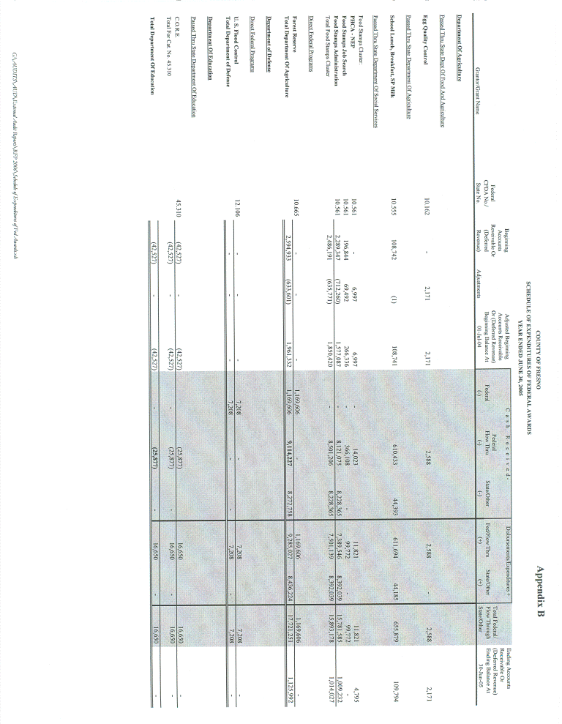
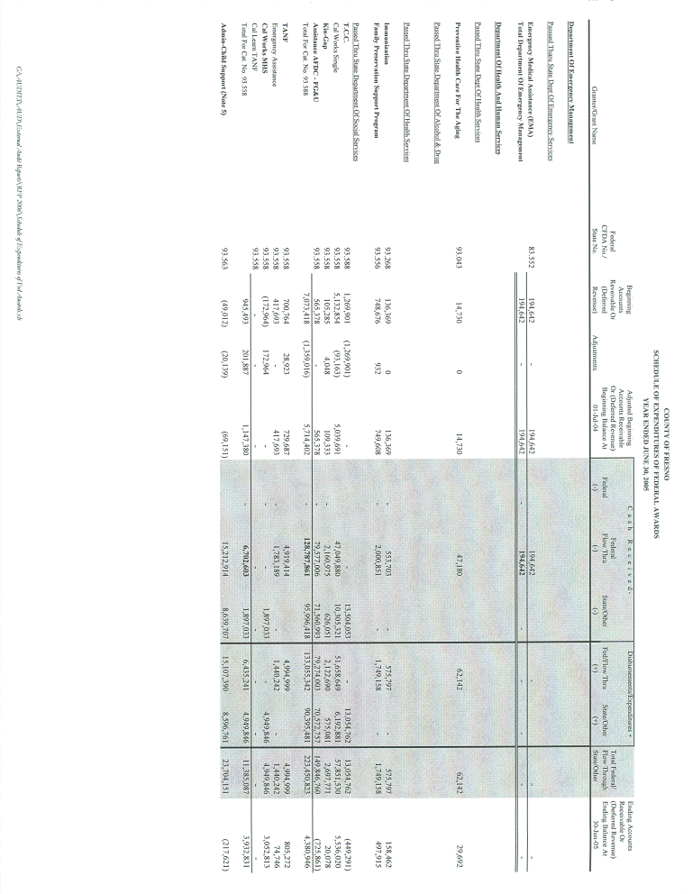
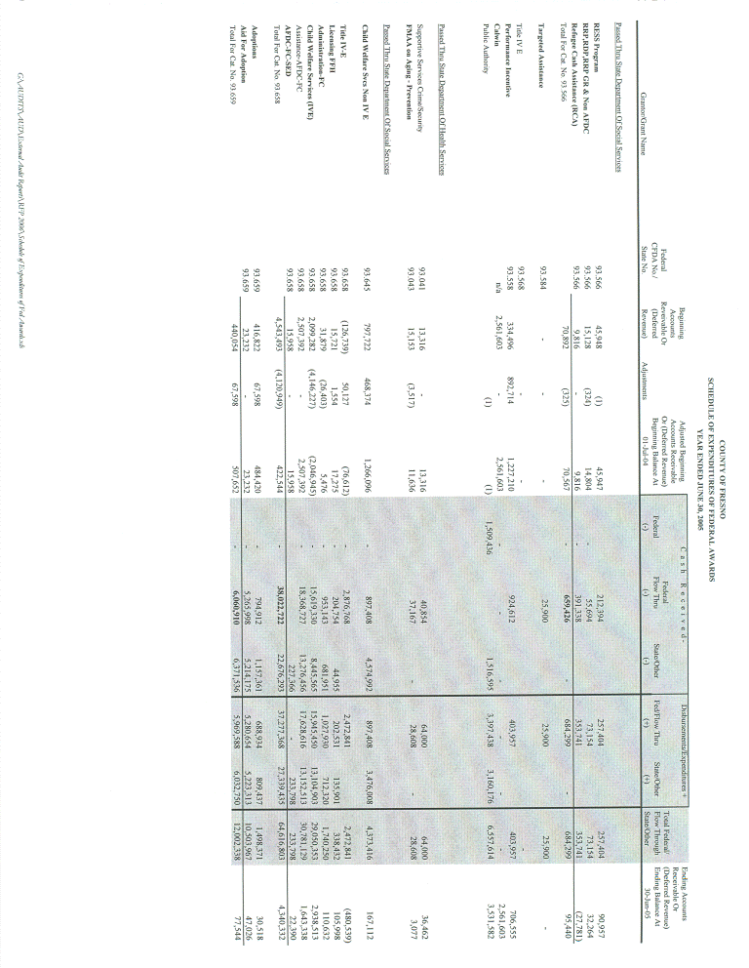
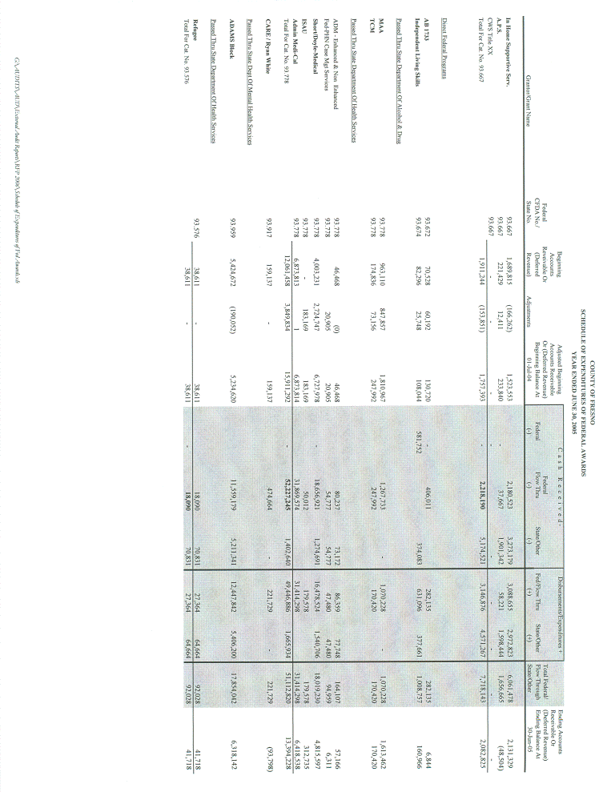
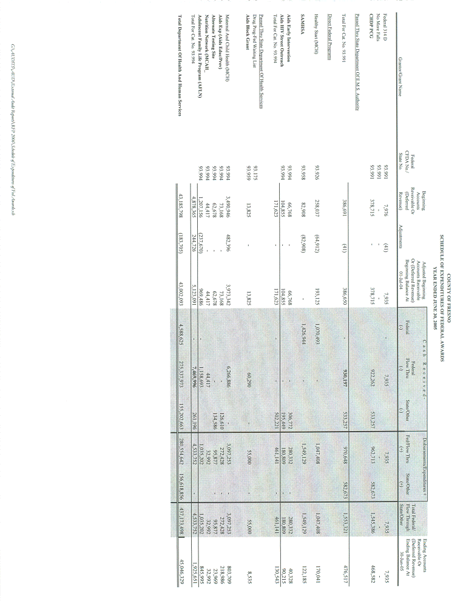
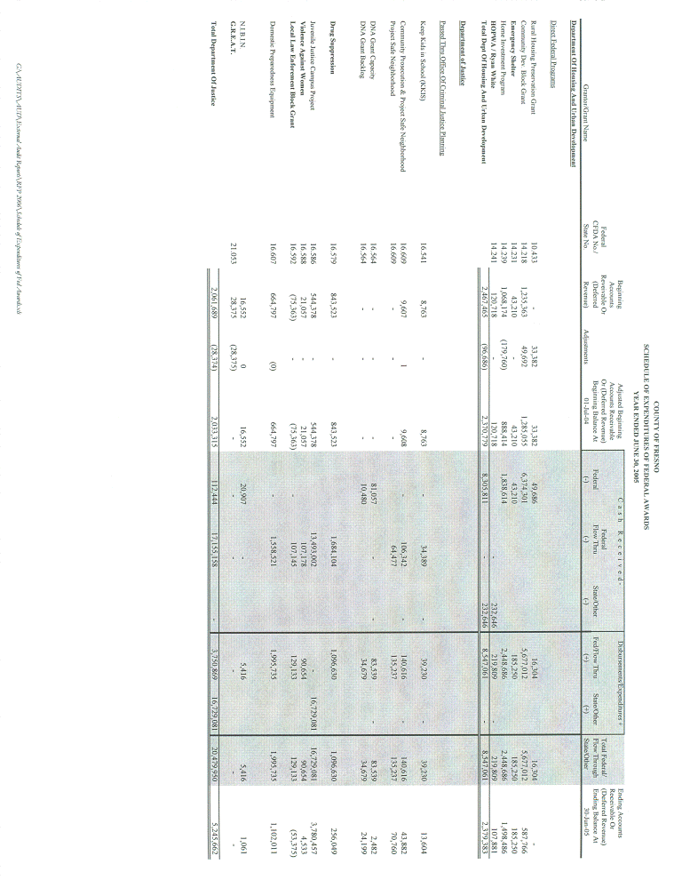
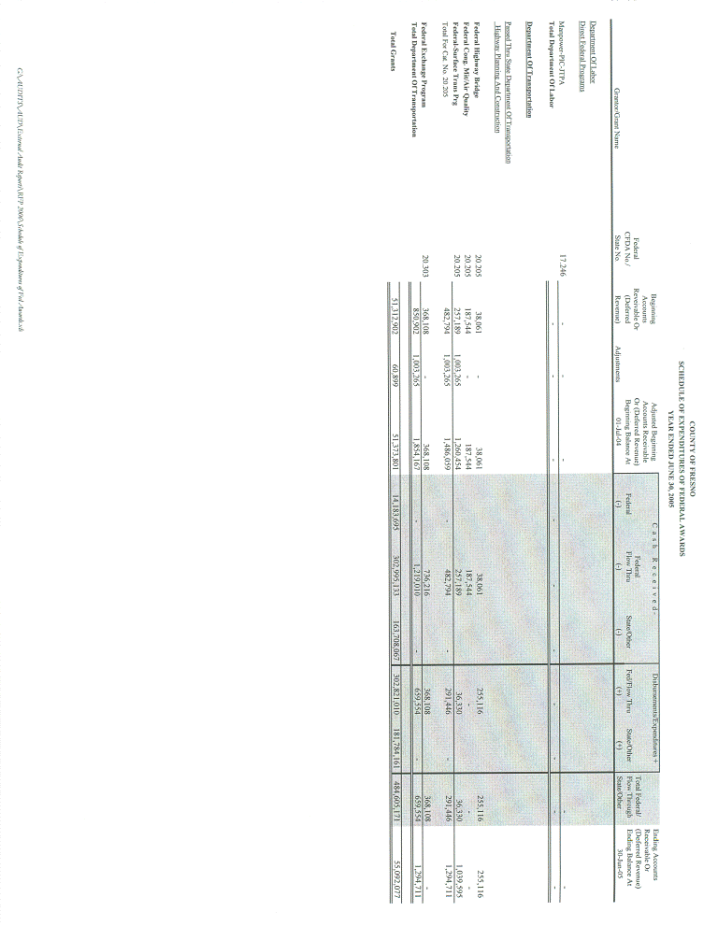

APPENDIX C
(7 PAGES)
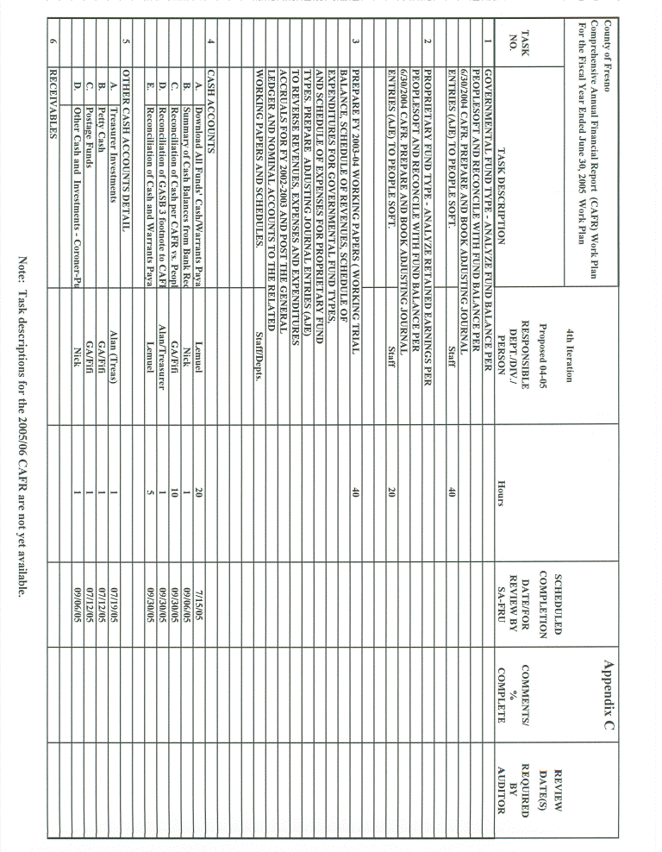
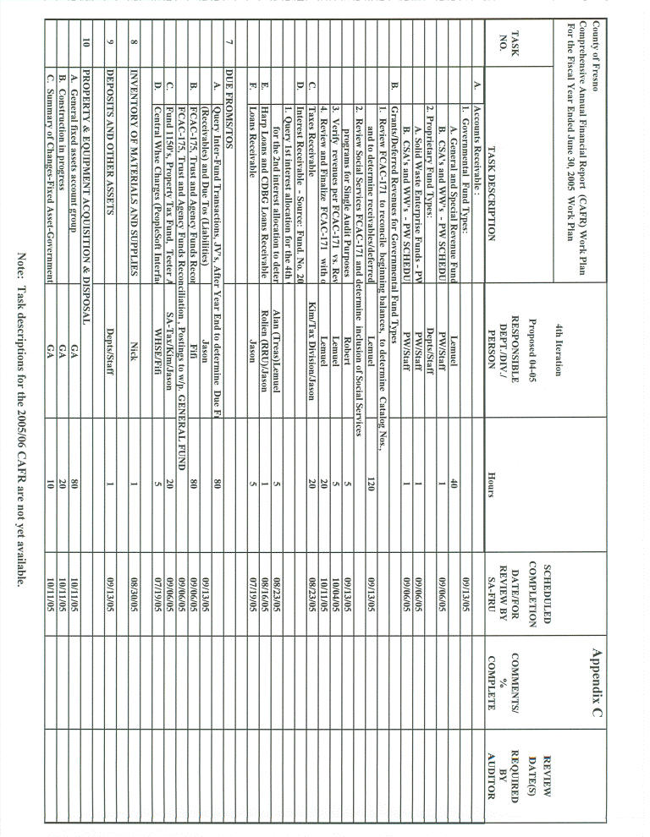
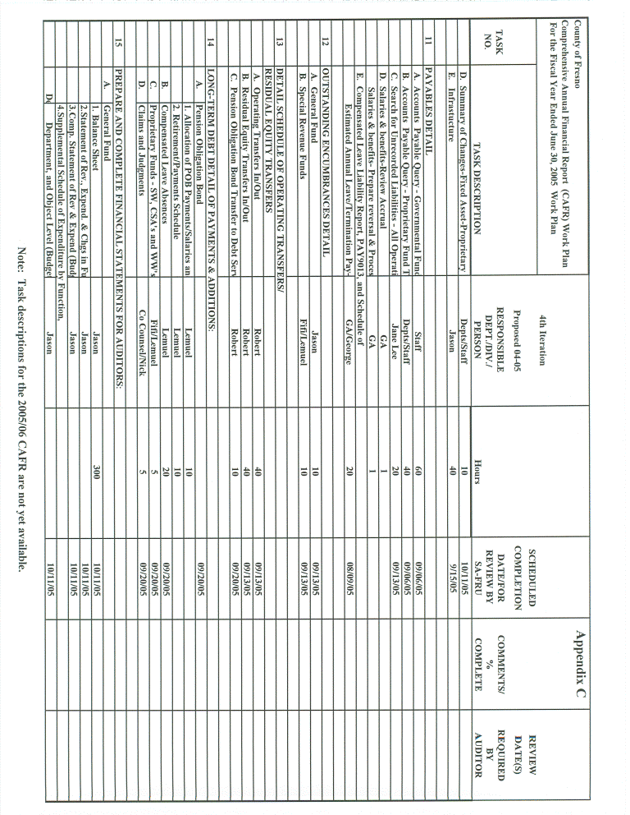
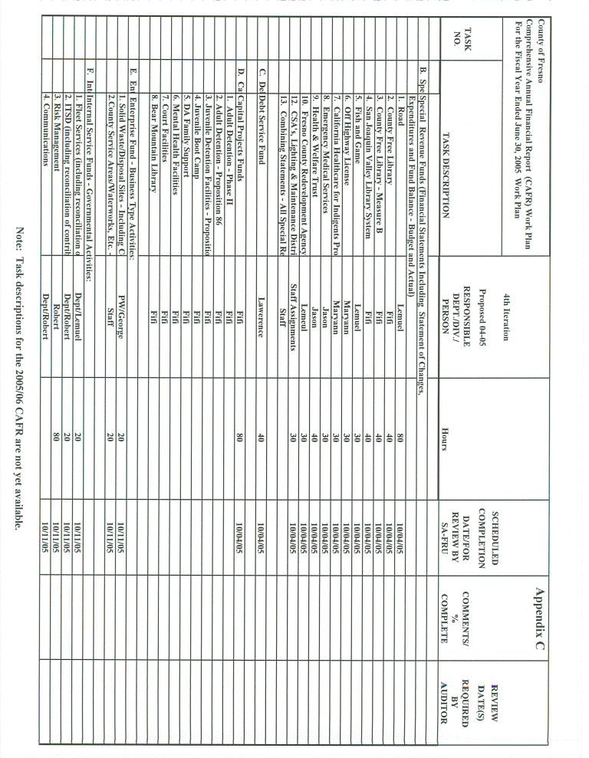
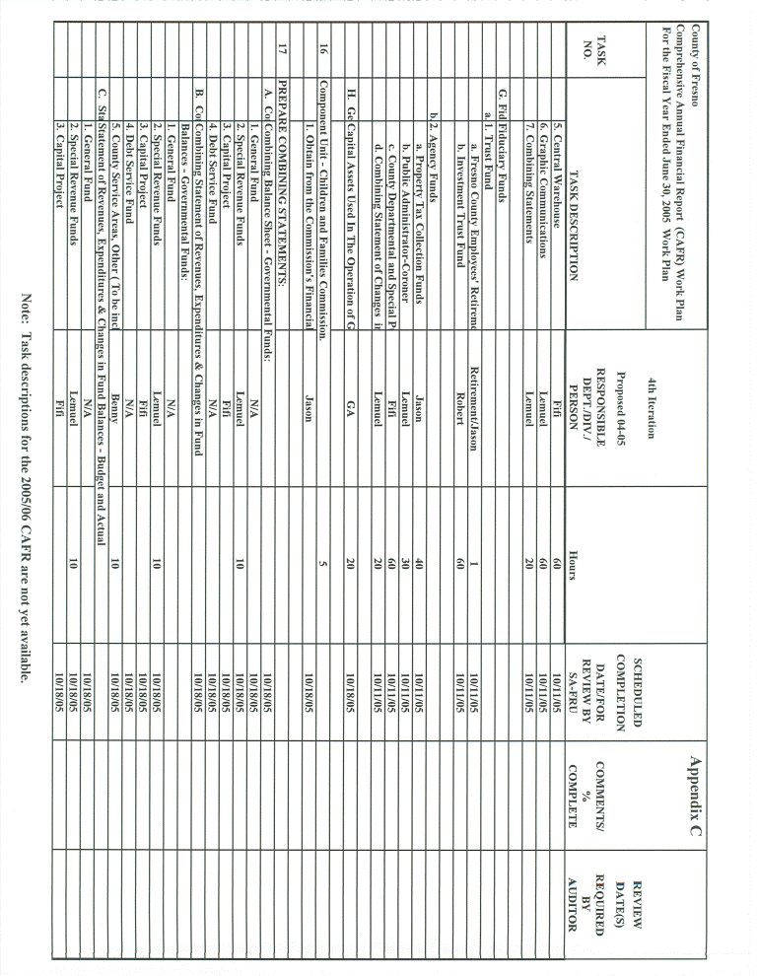
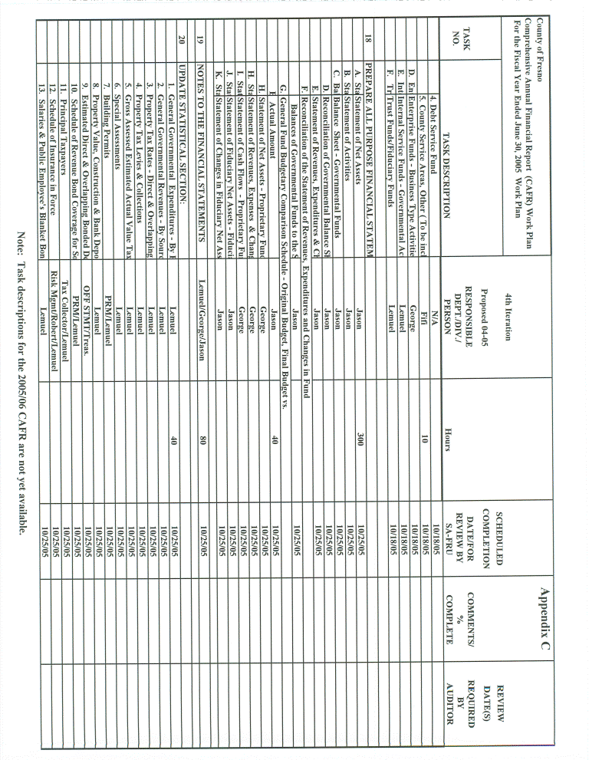
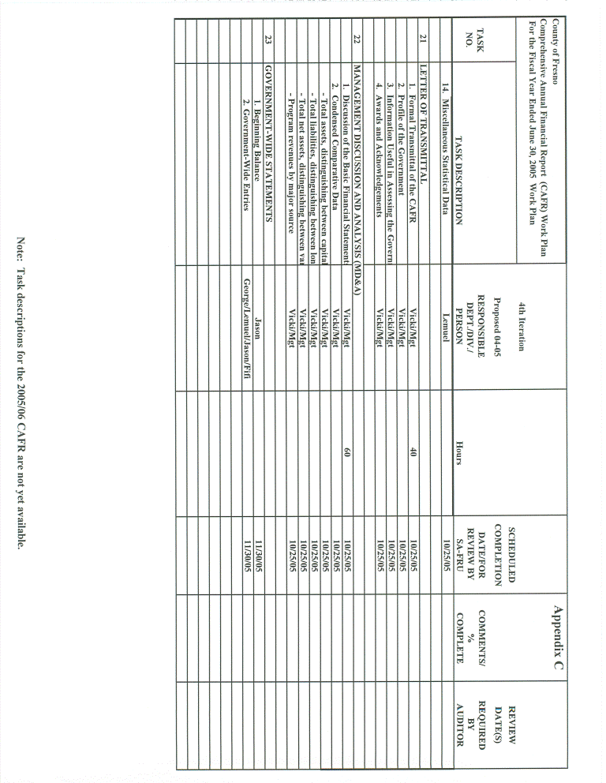
APPENDIX D
PROPOSER GUARANTEES
The proposer certifies it can and will provide and make available, at a minimum, all services set forth in Scope Section, Nature of Services Required.

Signature of Official: ___________________________________

Name (Typed): ___________________________________

Title: ___________________________________

Firm: ___________________________________

Date: ___________________________________
APPENDIX E
PROPOSER WARRANTIES
- Proposer warrants that it is willing and able to comply with State of California laws with respect to foreign (non-State of California) corporations.
- Proposer warrants that it is willing and able to obtain an errors and omissions insurance policy providing a prudent amount of coverage for the willful negligent acts, or omissions of any officers, employees or agents thereof.
- Proposer warrants that it will not delegate or subcontract its responsibilities under an agreement without the express prior written permission of the County of Fresno.
- Proposer warrants that all information provided by it in connection with this proposal is true and accurate.

Signature of Official:
Name (Typed):
Title:
Firm:
Date:

APPENDIX F Part 1
SCHEDULE OF PROFESSIONAL FEES AND EXPENSES
FOR THE AUDIT OF THE FISCAL YEAR 2005-06 FINANCIAL STATEMENTS
 |  | Hours | Standard Hourly Rates | Quoted Hourly Rates | Total
Partners |  |  | $ | $ | $
Managers
Supervisory Staff
Staff
Other (Specify):
Subtotal |  |  |  |  | $
Total for services described in Scope of Work Section Part E of the request for proposal (detail on subsequent schedules):
Out-of-pocket expenses:
Meals and lodging
Transportation
Other (specify):
Total all-inclusive maximum price for FY 2005-06 audit |  |  |  |  | $

Note: The rate quoted should not be presented as a general percentage of the standard rate or as gross deduction from the total all-inclusive maximum price.
APPENDIX F Part 2
SCHEDULE OF PROFESSIONAL FEES AND EXPENSES
FOR THE AUDIT OF THE FISCAL YEAR 2005-06 FINANCIAL STATEMENTS
COMBINING SCHEDULE - ALL SERVICES
DESCRIBED IN THE REQUEST FOR PROPOSAL SCOPE OF WORK SECTION
(OTHER THAN PART E)
Name of Audit, Review or Other Service to be Provided | Schedule |  | Total Price
 |  |  | $
TOTAL |  |  | $
EACH SERVICE DESCRIBED IN SCOPE OF WORK SECTION (OTHER THAN PART E) SHOULD BE SUPPORTED BY AN INDIVIDUAL SCHEDULE IN THE FORMAT PROVIDED IN PART 3 OF THIS APPENDIX.

APPENDIX F Part 3
SCHEDULE OF PROFESSIONAL FEES AND EXPENSES
FOR THE AUDIT OF THE FISCAL YEAR 2005-06 FINANCIAL STATEMENTS
SUPPORTING SCHEDULE FOR (NAME OF AUDIT, REVIEW OR OTHER SERVICE – OTHER THAN IN SCOPE OF WORK SECTION PART E)
 |  | Hours | Standard Hourly Rates | Quoted Hourly Rates | Total
Partners |  |  | $ | $ | $
Managers
Supervisory Staff
Staff
Other (Specify):
Subtotal |  |  |  |  | $
Out-of-pocket expenses:
Meals and lodging
Transportation
Other (specify):
Total price for (Name of Service) |  |  |  |  | $
Note: The rate quoted should not be presented as a general percentage of the standard rate or as a gross deduction from the total all-inclusive maximum price.
APPENDIX F Part 4
SCHEDULE OF PROFESSIONAL FEES AND EXPENSES
FOR THE AUDIT OF THE FISCAL YEAR 2005-06 FINANCIAL STATEMENTS
COMBINING SCHEDULE - ALL SERVICES
DESCRIBED IN REQUEST FOR PROPOSAL SCOPE OF WORK SECTION PART E
Nature of Service to be Provided | Schedule |  | Total Price
 |  |  | $
TOTAL |  |  | $
EACH SERVICE DESCRIBED IN SCOPE OF WORK SECTION PART E SHOULD BE SUPPORTED BY AN INDIVIDUAL SCHEDULE IN THE FORMAT PROVIDED IN PART 5 OF THIS APPENDIX.

APPENDIX F Part 5
SCHEDULE OF PROFESSIONAL FEES AND EXPENSES
FOR THE AUDIT OF THE FISCAL YEAR 2005-06 FINANCIAL STATEMENTS
SUPPORTING SCHEDULE FOR (NAME OF SERVICE PROVIDED IN SCOPE OF WORK SECTION PART E)
 |  | Hours | Standard Hourly Rates | Quoted Hourly Rates | Total
Partners |  |  | $ | $ | $
Managers
Supervisory Staff
Staff
Other (Specify):
Subtotal |  |  |  |  | $
Out-of-pocket expenses:
Meals and lodging
Transportation
Other (specify):
Total price for (Name of Service) |  |  |  |  | $
Note: The rate quoted should not be presented as a general percentage of the standard rate or as a gross deduction from the total all-inclusive maximum price.

APPENDIX G
First Five Program

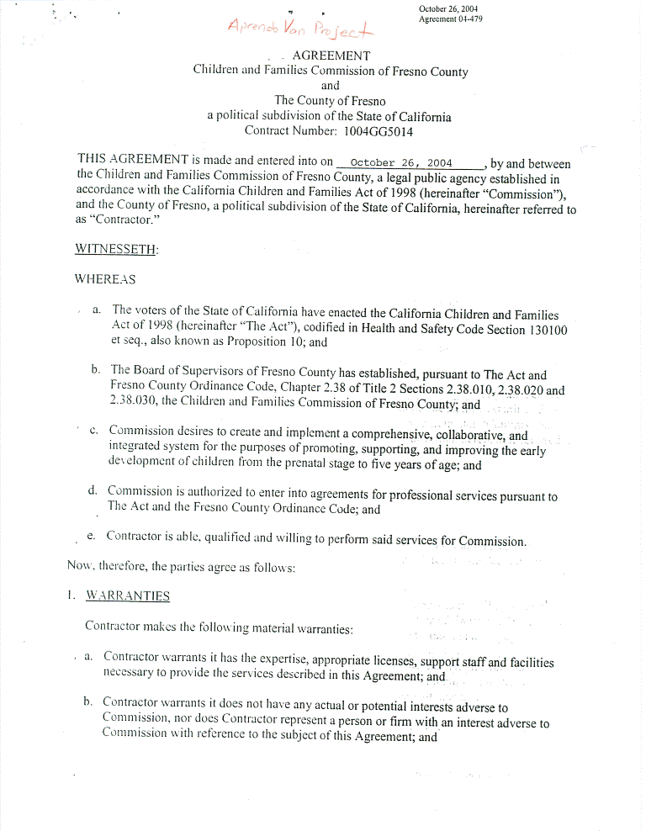
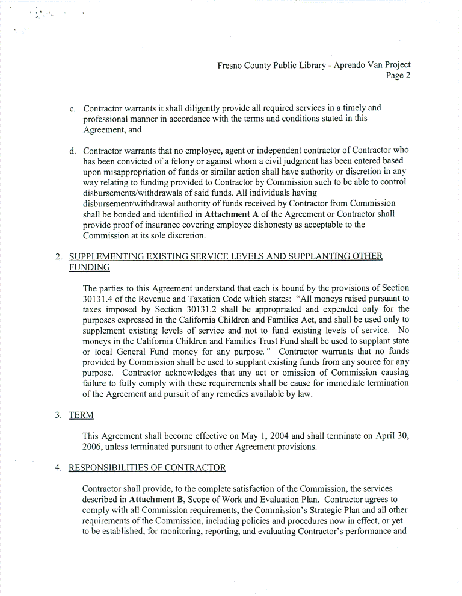
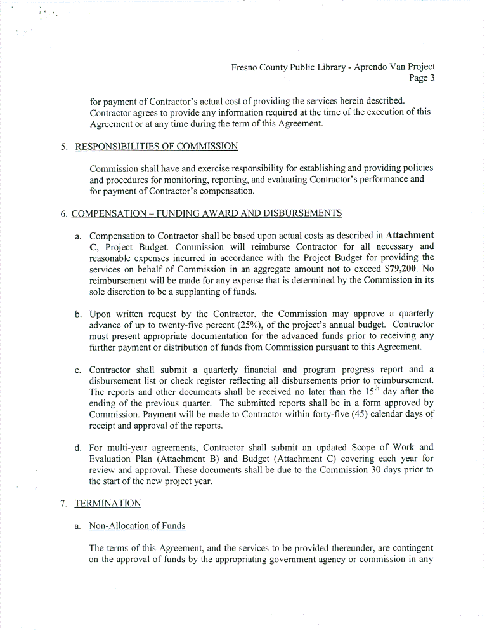
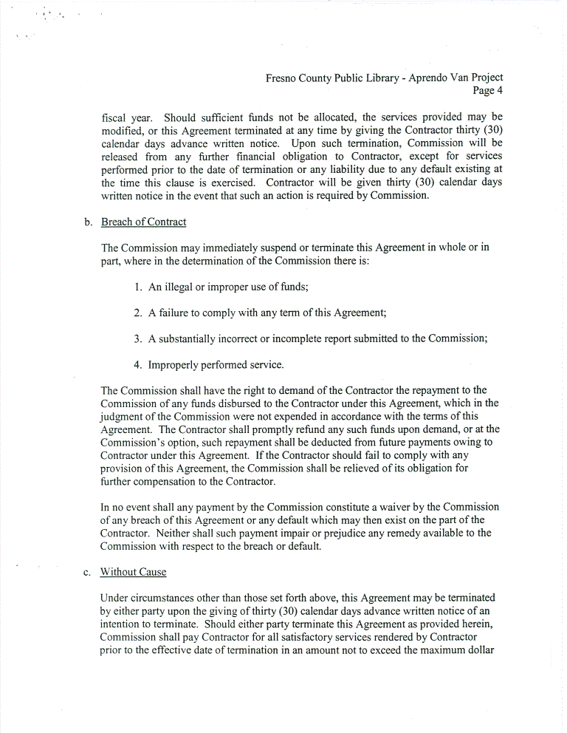
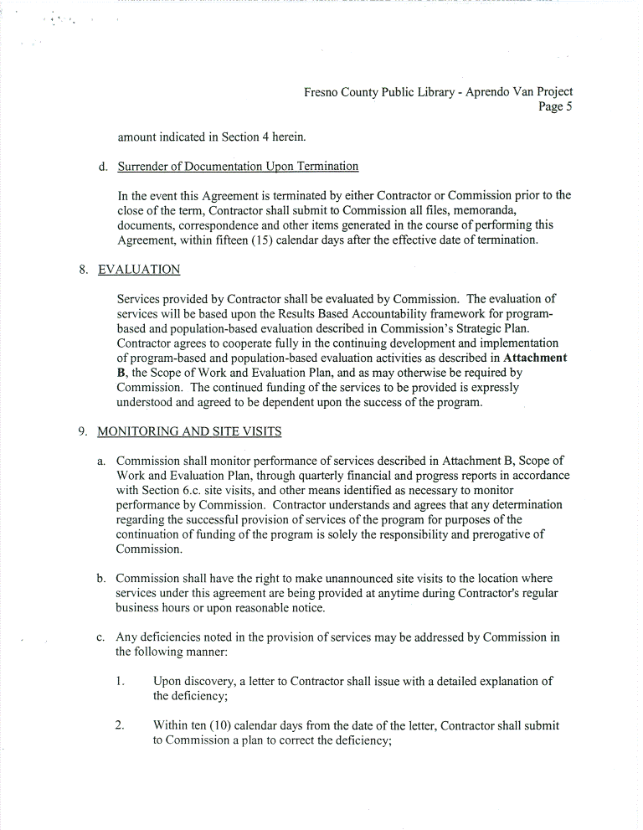
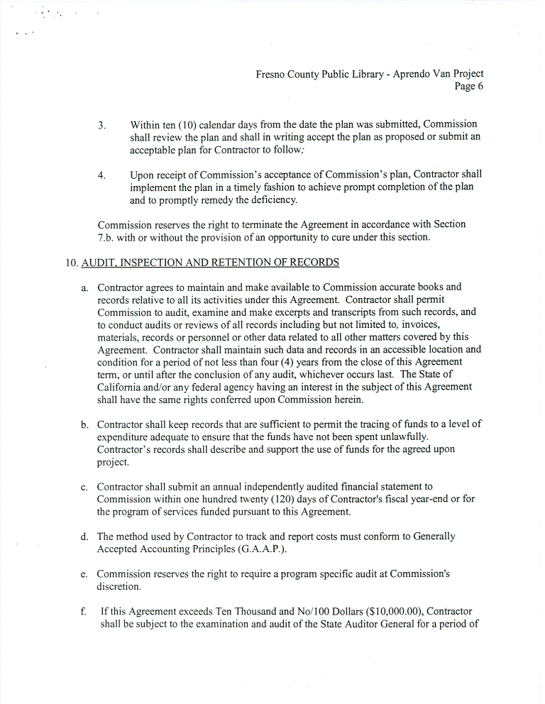
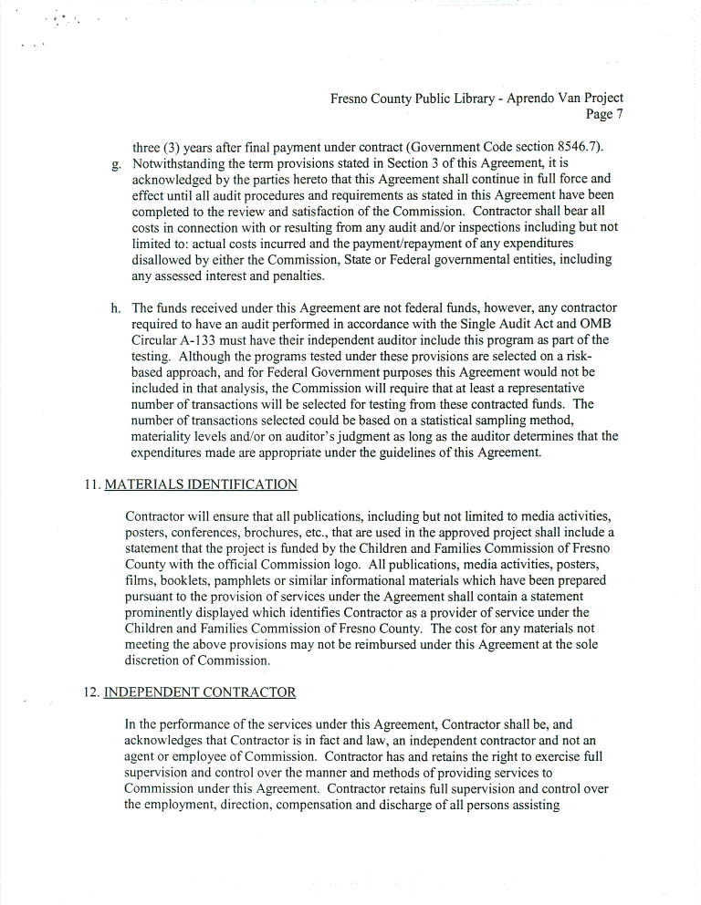
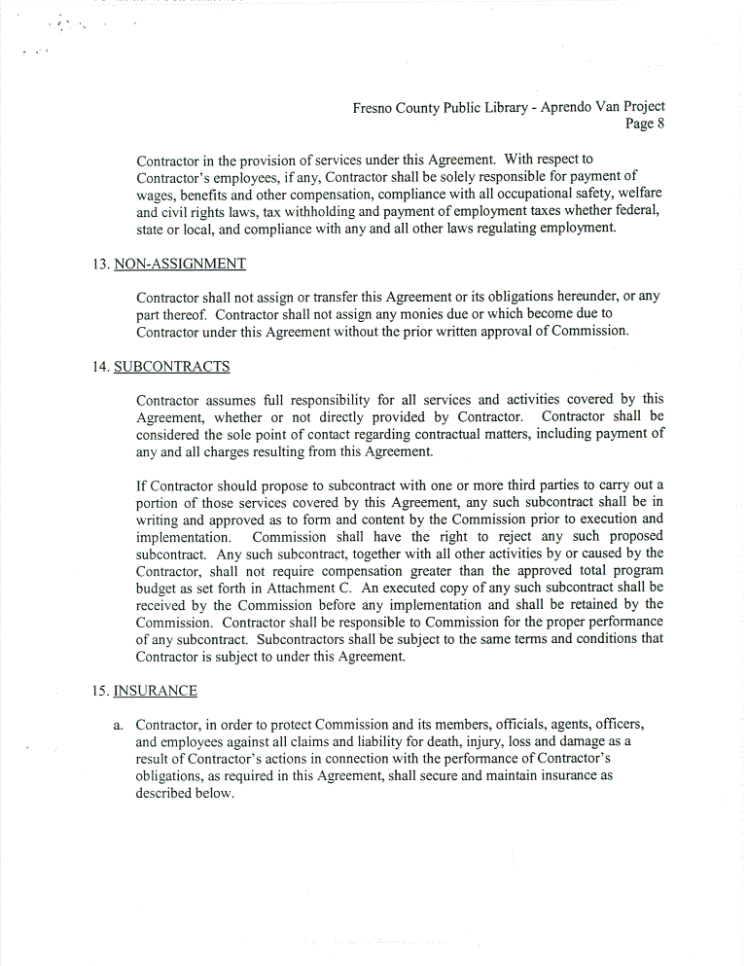
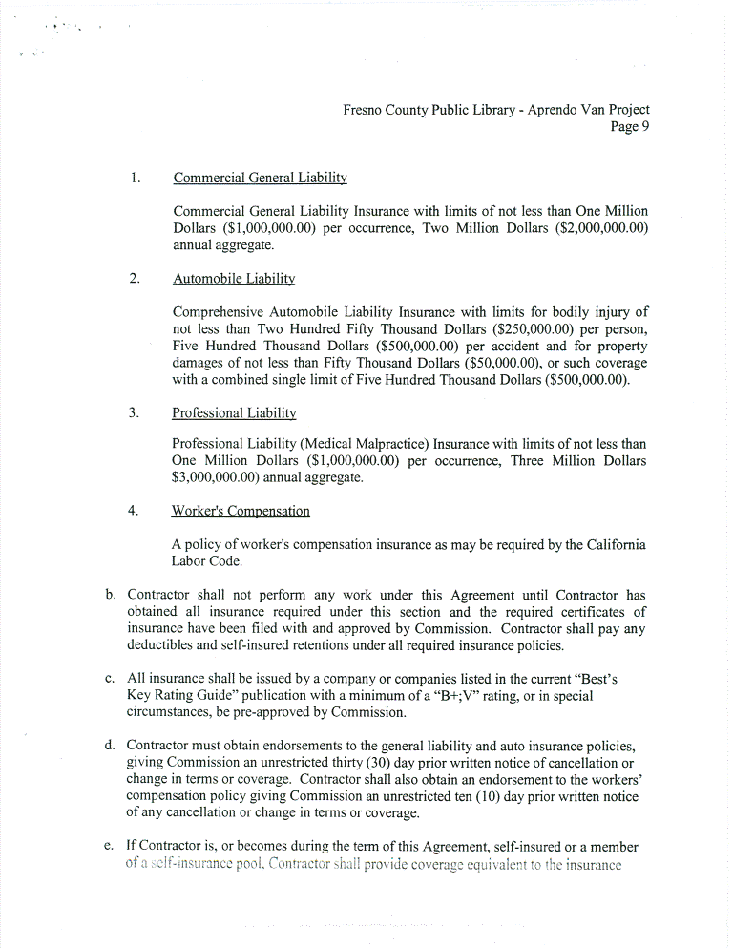
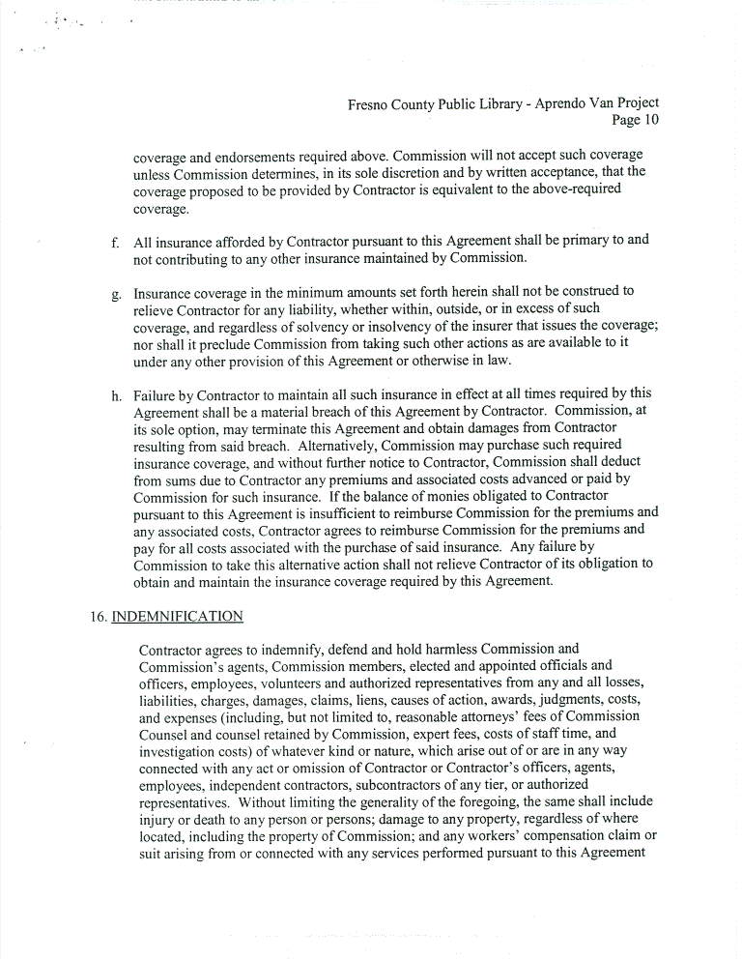
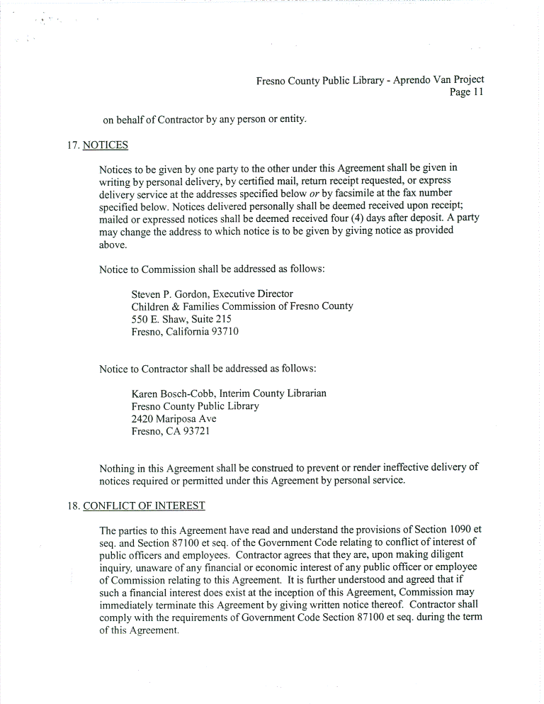
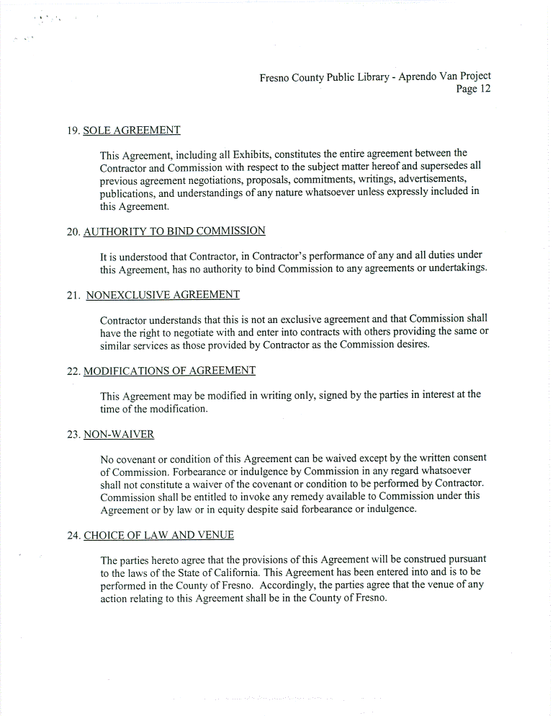
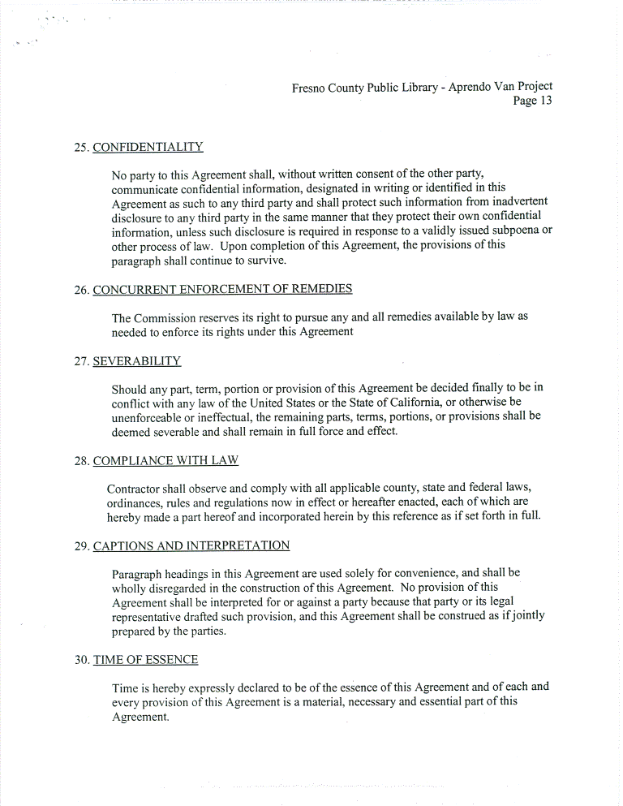
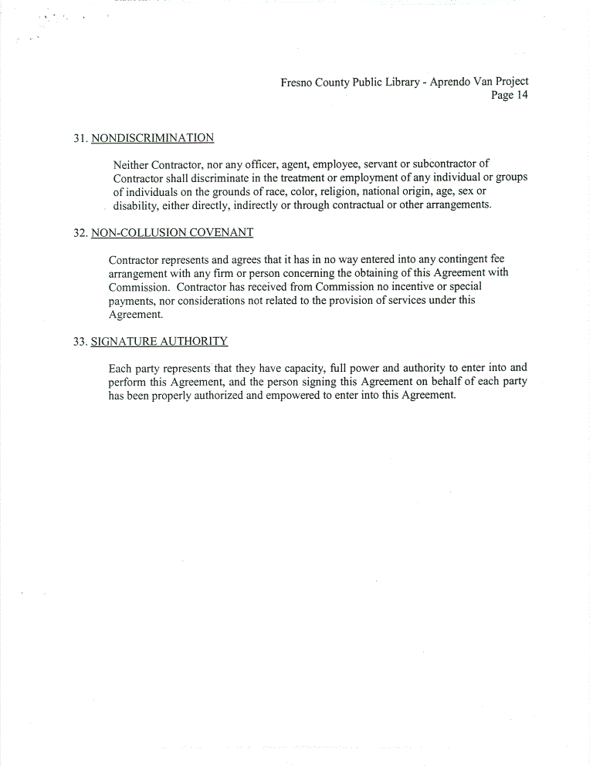
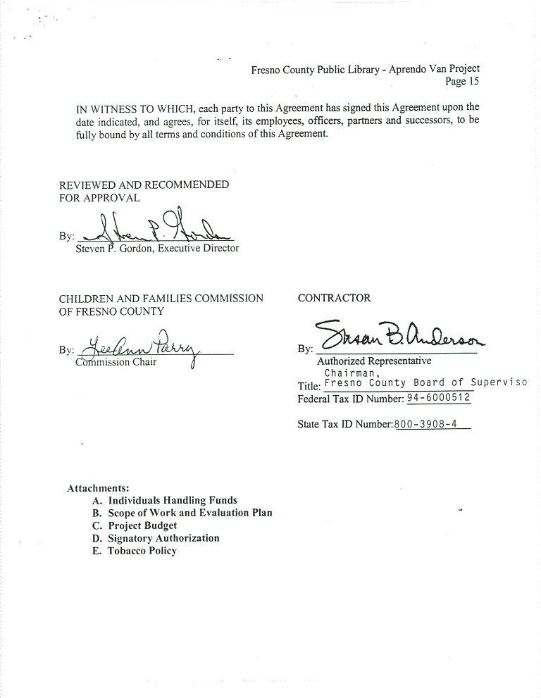
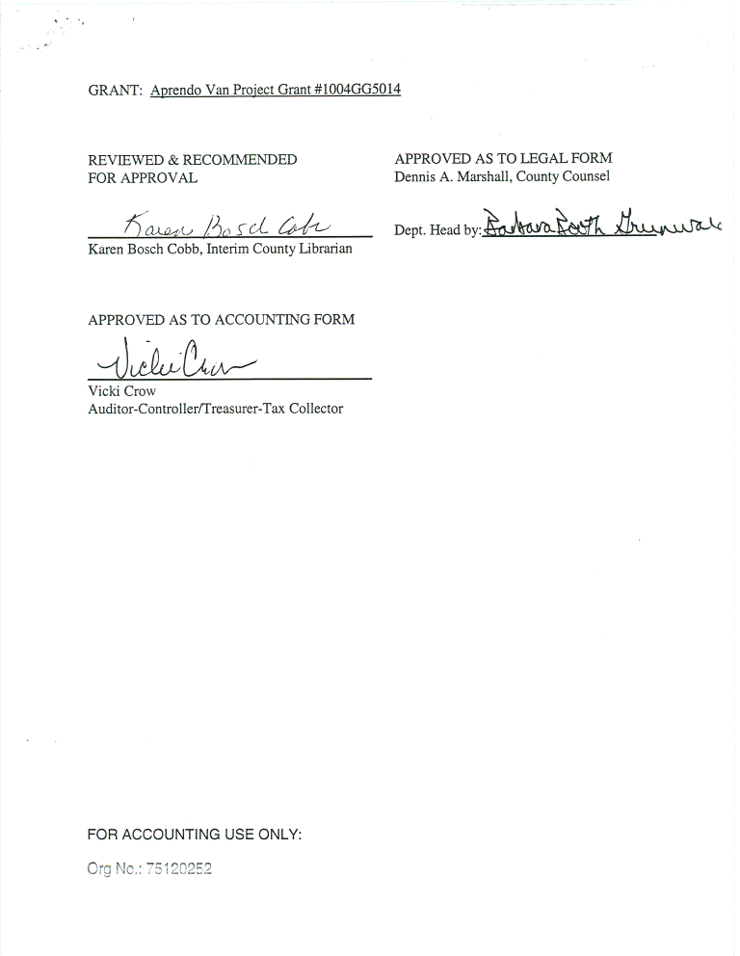
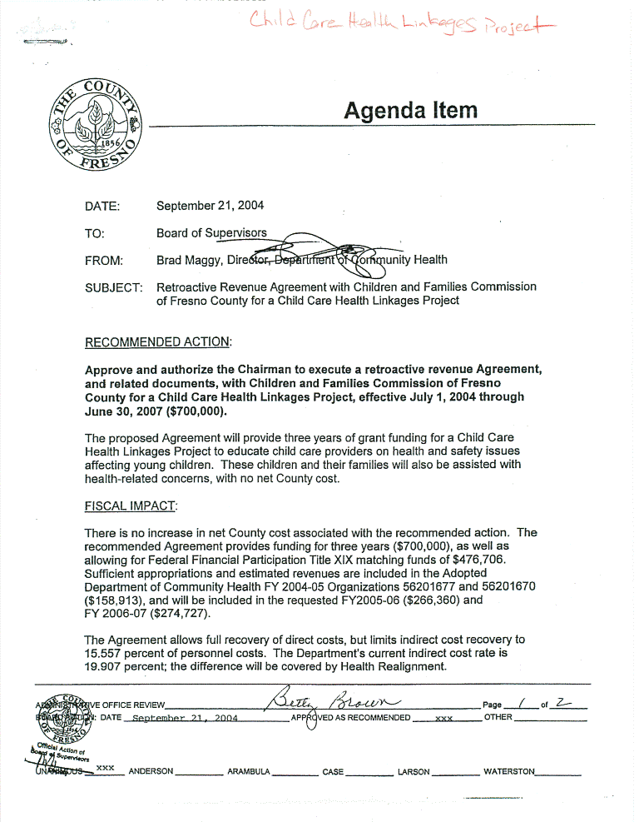
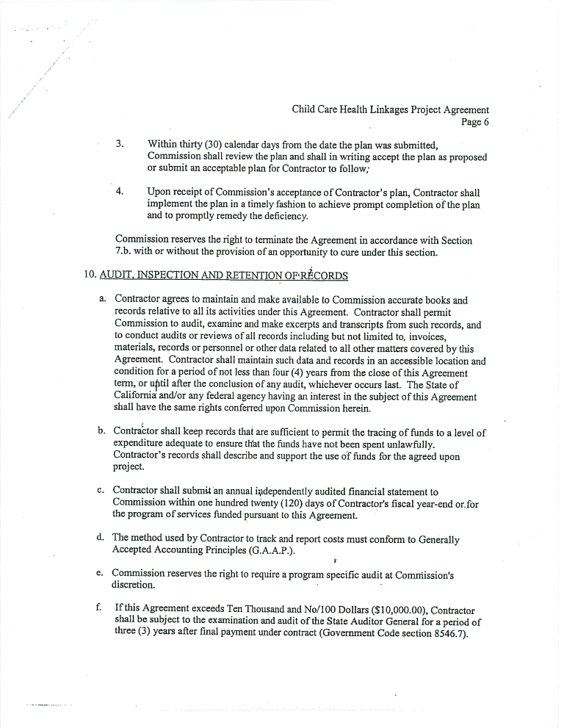
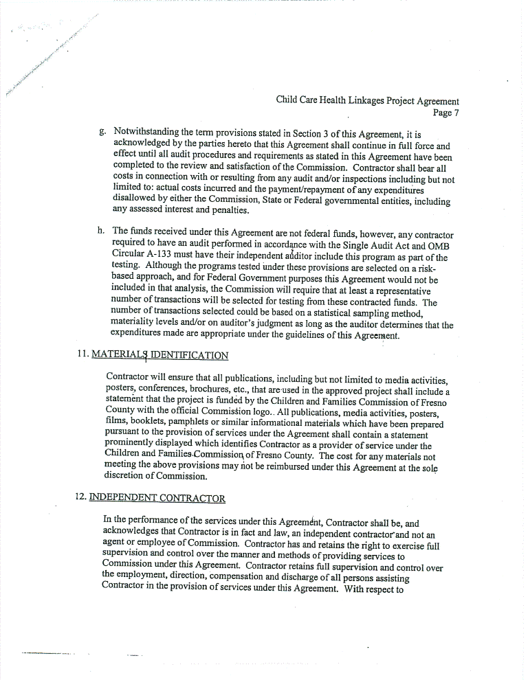
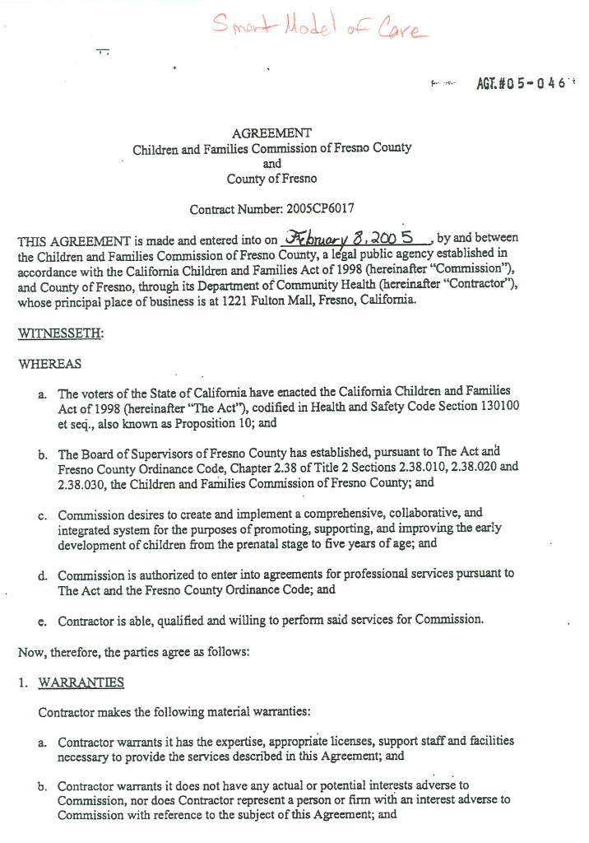
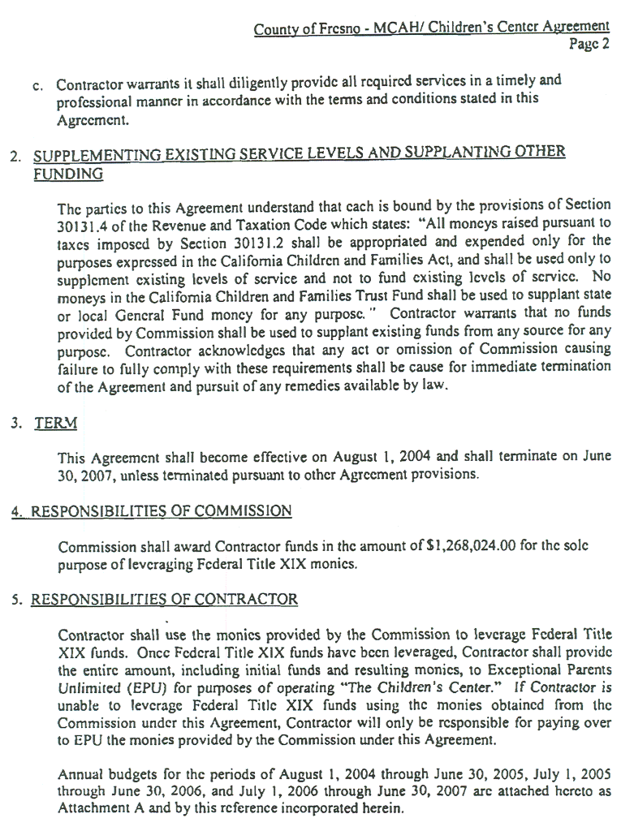
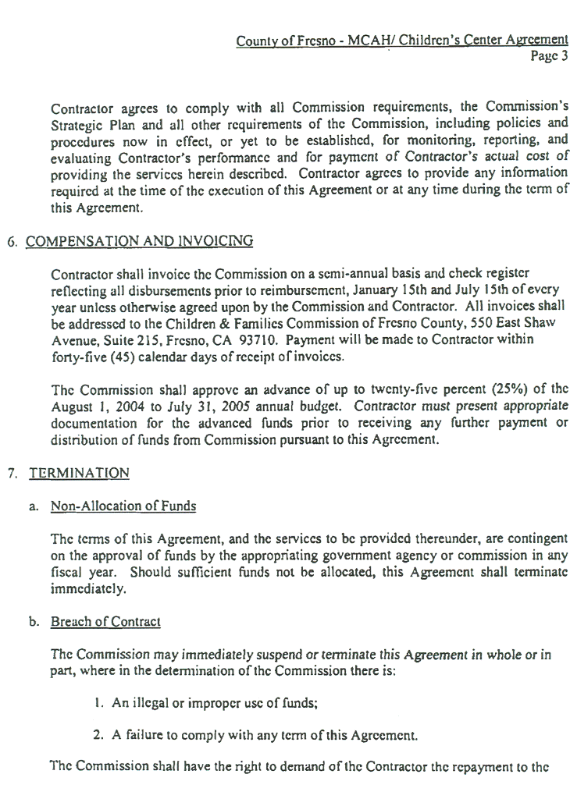
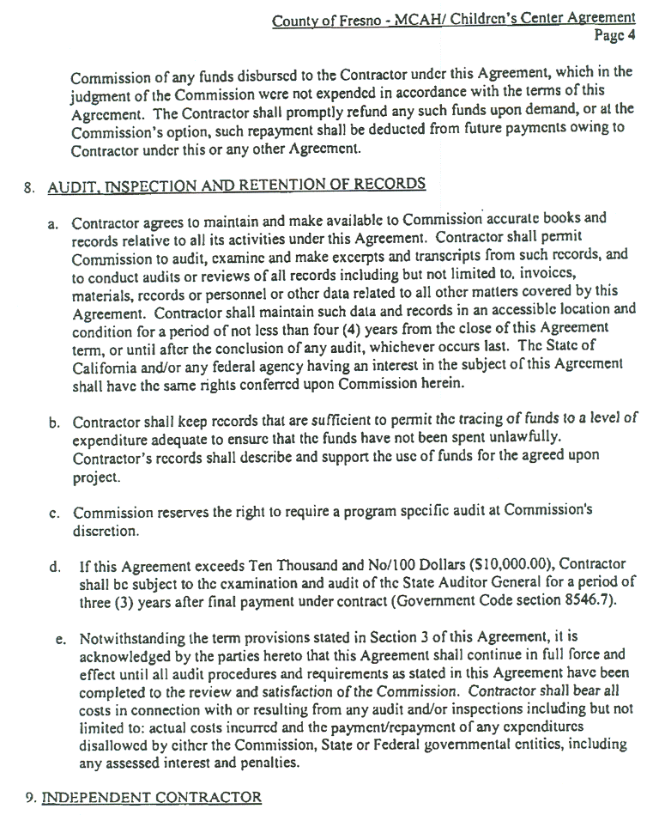

APPENDIX H
