COUNTY OF FRESNO
ADDENDUM NUMBER: THREE (3)
 |  | RFP NUMBER:
May 30, 2007
 |  |  | PURCHASING USE
 |  |  |  | jlg | /tmp/in/input.doc
IMPORTANT: SUBMIT PROPOSAL IN SEALED PACKAGE WITH PROPOSAL NUMBER, CLOSING DATE AND BUYER’S NAME MARKED CLEARLY ON THE OUTSIDE TO:
COUNTY OF FRESNO, Purchasing
4525 EAST HAMILTON AVENUE
FRESNO, CA 93702-4599
Closing date of proposal will be at 2:00 p.m., on June 22, 2007.
PROPOSALS WILL BE CONSIDERED LATE WHEN THE OFFICIAL PURCHASING TIME CLOCK READS 2:00 P.M.
Proposals will be opened and publicly read at that time. All proposal information will be available for review after contract award.
Clarification of specifications are to be directed to: Cathi J. Peters, phone (559) 456-7110, FAX (559) 456-7831.
NOTE THE attached ADDITIONS, DELETIONS AND/OR CHANGES TO THE REQUIREMENTS OF REQUEST FOR PROPOSAL NUMBER: AND INCLUDE THEM IN YOUR RESPONSE. PLEASE SIGN AND RETURN THIS ADDENDUM WITH YOUR PROPOSAL.
- Copy of Vendor Conference Sign Up Sheet attached.
- Attachment “A” – Requests for Clarification.

ACKNOWLEDGMENT OF ADDENDUM NUMBER THREE (3) TO RFP
COMPANY NAME:
(PRINT)
SIGNATURE:
NAME & TITLE:
(PRINT)

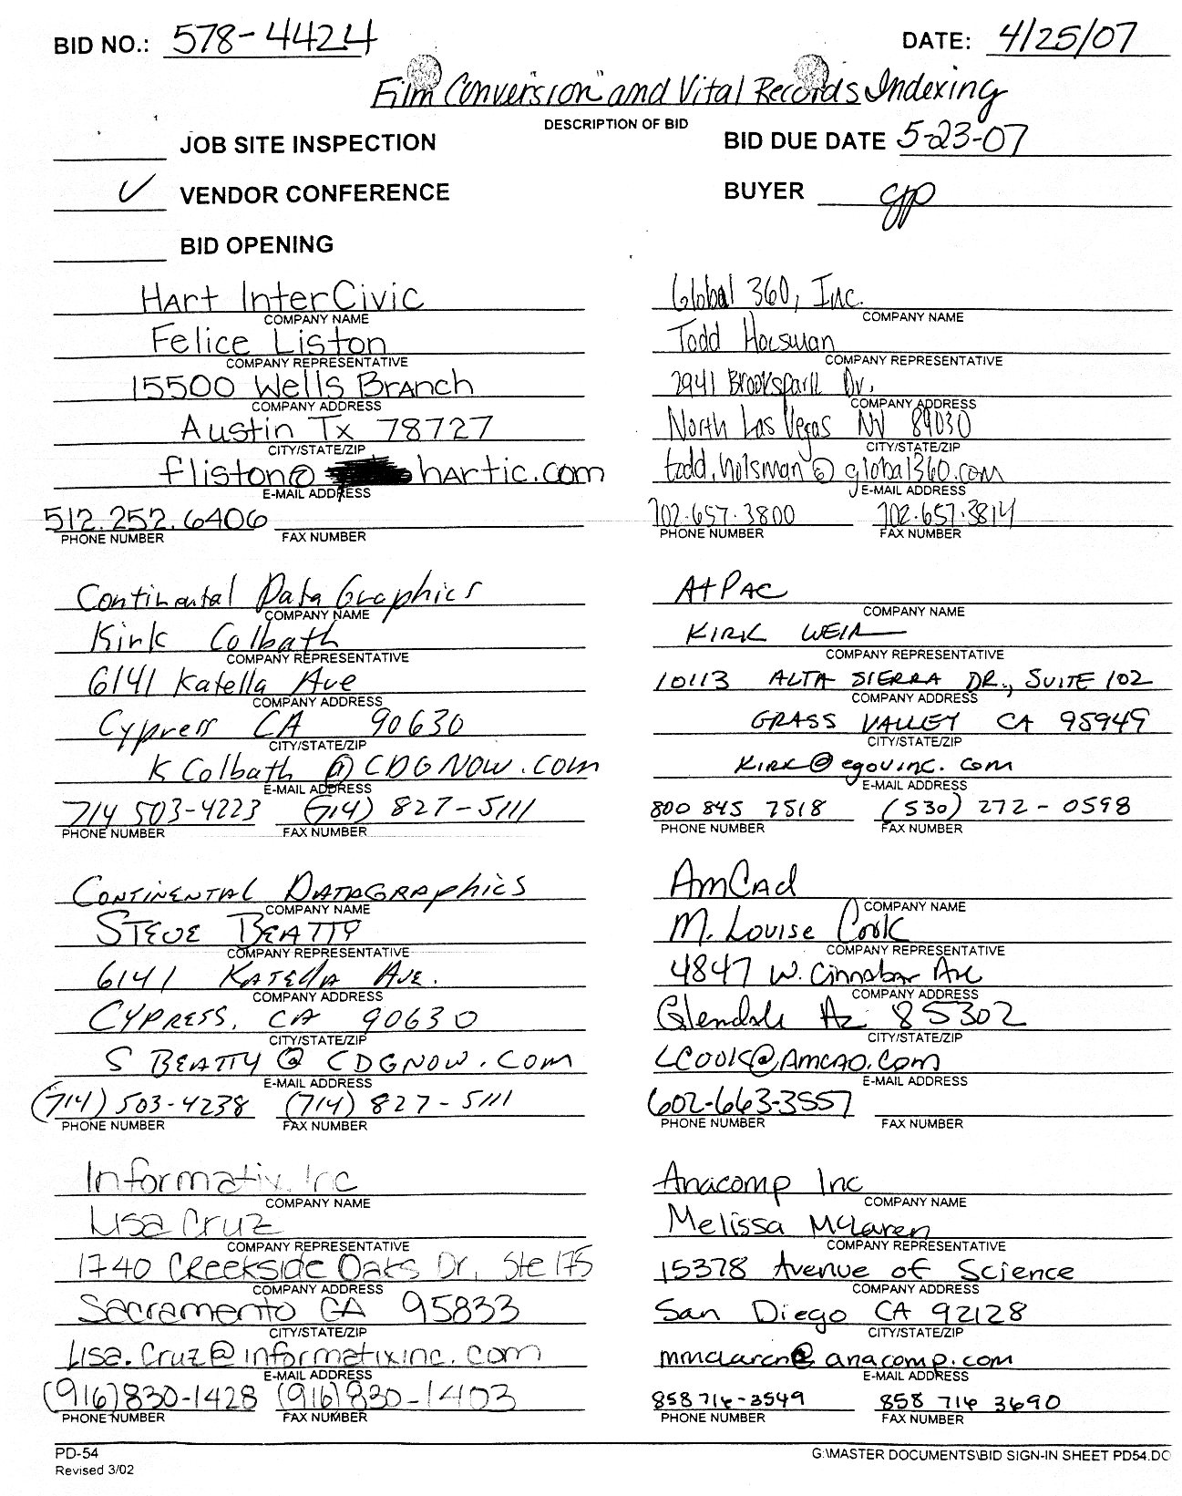
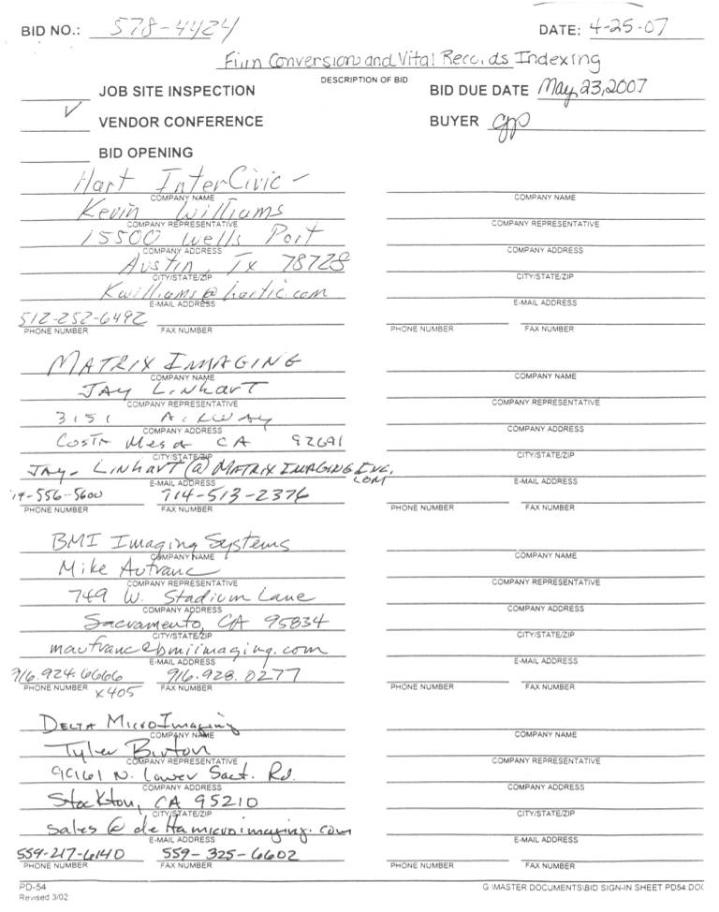
ATTACHMENT “A”
Questions received from HTC Global Services
- For Tasks 1, 2 & 3
Do we need to crop black borders from the scanned images? Please confirm.
The Recorder’s office does not wish the vital records to have a black border around them when they are printed on banknote paper.
- For Tasks 1 & 3
In Section VI (Image File Name, Indices and Delivery Instructions), it has been specified that “The bidder shall propose a method for retrieval of the images for Tasks 1 and 3 described above.”
Does the county expect the vendor to capture some data from the images and name the image files based on the captured information?
Each image contains a Book and Page as well as a Document Number that is sequential and begins with 0000001. The vendor is charged with proposing a method of retrieval if they do not wish to use the method as described in the RFP. As was explained in the Vendor conference the film is not ‘blipped’.
- If answer to the question #2 above is yes, can the county provide sample images for the vendors to analyze and offer recommendations?
- Can we perform the microfilm/ microfiche scanning services of Task 1, 2 and 3 from an offshore location?
No
- Can we perform the indexing services of Task 4 from an offshore location?
No
- Microfilm
  - What is the average number of frames in a microfilm reel?
Between 1,000 and 4,000 images per roll.
  - Are all the frames consistently 1-up or 2-up? Or would there be a combination of both?
Unable to respond. The film product to be converted was made available for viewing at the Vendor conference.
  - If combination of both (1-up and 2-up), please provide the percentage composition estimate, for each of the tasks 1, 2 & 3.
Unable to respond. The film product to be converted was made available for viewing at the Vendor conference.
  - What is the reduction ratio with which the filming has been carried out?
Unable to respond. The film product to be converted was made available for viewing at the Vendor conference.
  - In Section II.A.1.B of the Scope, One of the format Complexities defined is “Microfilm frames that overlap or that have uneven spacing and require custom handling at scan time.”
Can the county provide an estimate of such reels, for tasks 1, 2 & 3?
It is unknown if this complexity even exists. The County of Fresno wanted to point out possible problems that may exist, and the solutions for the problem that the bidder would suggest to solve the complexity.
- Microfiche
  - What is the average number of frames in a fiche card?
There are 13 horizontal rows and 16 vertical columns on each fiche.
  - Are all the frames consistently 1-up or 2-up? Or would there be a combination of both?
Unable to respond The film product to be converted was available for viewing at the Vendor conference and a sample provided with Addendum One (1).
  - If combination of both (1-up and 2-up), please provide the percentage composition estimate, for each of the tasks 1, 2 & 3.
Unable to respond The film product to be converted was available for viewing at the Vendor conference and a sample provided with Addendum One (1).
What is the reduction ratio with which the filming has been carried out?
Unknown
  - What is the size (dimensions) of the Microfiche?
The fiche is approximately 5 13/16” wide by 4 3/32” high. The microfiche was available for viewing at the Vendor conference and a sample provided with Addendum One (1).
- Tonality of Source Films
Section II.A.1.C describes the tonality of the source film
Can the county confirm that the filming has been done based on ANSI standards?
To the best of the Recorder’s office knowledge, the film meets ANSI standards.
- Task 4
Do the images from which the vital records data to be captured contain handwritten text?
Yes
If yes, please provide the percentage of handwritten text.
All of the vital records have some handwritten text. The indexes of the vital records are about 25% handwritten and 75% typed.
- Task 4
In Section II.C of Scope, it has been mentioned “We also keep other information such as Sex, Place & time of birth, and birth order”.
Our understanding is that cost provided would not include the cost of capture of “other information”.
Please confirm
The Recorder’s office prefers to have this information in their indexes. The vendor may wish to provide pricing for including this information.
- Tasks 1 & 2
Section II.A.1.e “Formats and Compression” under Task 1 & 2 requirement reads as “Normal modern printed black and white text should be digitized at 300 dpi for Vital Records in order to assure that all symbols, italic text, and other fine details are digitized”.
  - Our understanding is to deliver the images with 300 dpi CCITT G4 compressed TIF images. Kindly confirm.
The RFP allows a vendor to propose some other format. However, that vendor must guarantee that their product is capable of delivering complete details of the images as specified in the RFP.
  - Further, this requirement has been indicated only for the “Vital records”. Our understanding is that the same is applicable for “Task 1 & 3”. Please confirm.
See above response.
- In section II.A.1.e, it has been mentioned that “Further describe how you propose to provide the County with the highest possible quality image (i.e., grayscale).”
Please clarify if the county expects the vendors to provide grayscale images in case of poor quality of the bitonal images.
The RFP clearly states that the vendor is to describe how they will deliver the highest possible quality images. The term ‘grayscale’ was only offered as an example.
Can the county indicate a percentage of images that might have to be delivered as grayscale images, for Tasks 1, 2 & 3?
The County does not know how many images, if any, that might have to be delivered with improved image quality.
- In the Overview section, we have the following information. “Qualified vendors to secure a professional service to convert and index one-of-a-kind microfilm and paper files to electronic format”.
The scope description contained in the RFP document does not indicate any requirement for scanning from Paper.
Please confirm that paper scanning is not a part of the scope.
There will be no paper scanning involved in this project, unless you propose to scan the pages of the indexes that we must use for our daily work. They may also be filmed; however, we do not have a darkened work area for filming.
- One of the Delivery Media instruction reads as “Scanning Logs – The bidder shall provide and ensure that microfilm and paper documents.”
It appears as though this sentence is incomplete. Please explain this in detail.
The bidder shall provide and ensure that microfilm and paper document scanning logs are completed and maintained in accordance with instructions provided.
- Delivery Media
The RFP has specified that delivery will be in the form of USB 2.0 compliant removable drives.
Can the vendor suggest alternate modes as DVD, Tape?
No, the images must be delivered as specified in the RFP.
- Deadline for questions
Section 2.B (Submitting Bids) of General Conditions reads as Questions regarding the bid must be received by Purchasing at least 5 working days before bid opening.”
Elsewhere in the RFP document, it has been mentioned that the last date for receipt of questions is May 3, 2007.
Please clarify if the vendor can send questions till May 16, (5 days ahead of the bid opening)
Page 1C, Section 13, SPECIAL CONDITIONS IN BID SCHEDULE SUPERSEDE GENERAL CONDITIONS.
The “General Conditions” provisions of this RFP/RFQ shall be superseded if in conflict with any other section of this bid, to the extent of any such conflict.
The deadline for Requests for Clarification was May 3, 2007.
- Vendor Conference
Can you please provide a list of vendors who attended Vendor conference on Apr 25, 2007?
See attached copy of sign-up sheet
- Was there any addendum released after the Vendor conference? Can you please give us the details of the URL where it has been posted?
Addendum One (1) and Two (2)
County Website: www.co.fresno.ca.us
Doing business in the County, Open Bids and Proposals
- Please provide us with quality specifications for data capture services.
Contractor Quality Control Program is addressed in the Scope of Work page 28, Section VII. The response to the Request for Proposal must include quality assurance process and methodologies for ensuring high quality digital images.
QUESTIONS RECEIVED FROM ACS-COMMERCIAL BPO SERVICES
- Section I:
  - Task 1 and Task 2:
Is the film base nitrate, acetate, or polyester?
Considering the age of some of the film, there are probably all three types.
On average, how many images are on each roll of microfilm?
Between 1000-4000 images per roll
On average, how many Grantee-Grantor indexes per image?
The Grantor-Grantee books had about 25 lines per page.
Are the images written by a computer (COM) or are they filmed paper?
There is no fiche for Tasks 1 and 2.
If paper was filmed, was it printed on “green-bar” paper?
N/A
If paper was filmed, was the print from dot-matrix printers?
N/A
Is the film in individual paper boxes, C-Clips, NCR magazines, etc?
Almost all of the film is in paper boxes. There are a few rolls where the originals could not be located and those are in clips.
Is the film emulsion silver halide?
The County Recorder believes so, but is unsure.
Can the rolls have additional leader lengths spliced onto the leaders and trailers not removed after scanning?
The film must be returned in the same conditioned as it was delivered.
How are the rolls identified or labeled?
The containers are marked.
Do the rolls have splices and/or splice problems?
There is that possibly, but the number would be very small.
If spliced, what technology is used to splice rolls?
Unknown
Are the rolls in a generally good clean condition?
Yes
Where can we view sample images?
Samples were available at the Vendor conference
  - Task 3:
Is the fiche base acetate, or polyester?
Samples were available at the Vendor conference and included with the Addendum One (1)
Is the fiche jacketed?
No
Is the fiche COM generated?
Yes
How many images per fiche?
208
Are the fiche images in column or row order?
Columns
How are the fiche identified or labeled?
Alphabetically along the top of each fiche.
- Section III:
What is the ideal object production time frame?
Ideal time frame would be for the project to be completed within 6 months; however as per page 26, Section V of the RFP, the response must include a project Work Plan.
- Section IV:
Can you provide an example directory and filename example?
See Scope of Work Page 27
What output database format is required?
Index data in an ASCII file with either a fixed field or delimited file.
- General:
Are there any restrictions to performing data entry offshore if the film and fiche do not leave but are scanned and retained in the United States?
All processes must be done within the continental United States.
QUESTIONS RECEIVED FROM AMCAD
- If there are negative polarity images (black pages with white writing)? What is the percentage of occurrence?
The County does not know the percentage, but a guess would be approximately 20-25%.
- What is the percentage of images that are not “right side up” or “right reading” on the microfilm?
To the knowledge of Fresno County there are no images that are not right side up or right reading.
- On average how many images are on each microfilm frame for the Vital Records?
Between 1000-4000 images per roll
- On average how many pages make up each vital record?
Unless there is an amendment there is one image for each vital record. However, almost all the pages have two different records on each page. Each record shares the same book and page, but each has a unique document number (or registration number). The Recorder must be able to print only one of the two images onto a certificate of record. It is the responsibility of the bidder to suggest how this is done. However, if the bidder uses the naming convention as referred to in the RFP for each record (using the unique document number and year) and the images are Group IV tiff images, they can be loaded into our system and printed with the current software.
- What percentage of Grantor/Grantee images are Hand-Written?
For the indexes, about 25% handwritten, 75% typewritten. (Note – this is just an estimate)
- What percentage of Vitals documents have Hand-written text?
For the indexes, about 25% handwritten, 75% typewritten. (Note – this is just an estimate)
- What does the index file need to look like? (delimited, fixed width, specific format, etc.)
Index data in an ASCII file with either a fixed field or delimited file.
- Is it possible to obtain a sample of the different index files and formats?
The format for indexing was provided in the RFP and the addendums
- Is returning microfilm samples with the RFP Response acceptable? If not please specify microfilm sample return timelines and procedures.
The County will not be supplying microfilm for the bidder to make samples prior to the receipt of the bids. However, if the County determines that it is necessary to see the quality of workmanship as part of the evaluation process, the County may provide sample rolls for processing.
QUESTIONS RECEIVED FROM DIGITAL IMAGING SERVICES
General questions:
- Will sample rolls be available to test scan before providing a quote?
See answer to question immediately above.
Referencing specific points in the RFP
- 3e/Specifications/requirements:
This RFP mentions that only the vital records need to be digitized at 300 DPI – Is this an acceptable DPI resolution for the entire project?
300 dpi is acceptable if it meets the other criteria as set forth in the RFP.
- 6c/Task #4 Indexing of Vital Records:
Is the film sorted and labeled per jurisdiction and type of vial record (i.e. birth, death, marriage)? Or, are multiple jurisdictions and document types combined on the same roll?
Multiple jurisdictions are not contained on the same rolls of filmed images of the vital records. Some of the indexes make reference to the jurisdiction rolls.
- Does the county maintain a current electronic index or cross reference list?
If the vendor is referring to an index of the film, currently there is no electronic index of this film. The Recorders Office will be creating one for this project and for the movement of the film to storage.
QUESTIONS RECEIVED FROM HART INTERCIVIC
- How many books does the County have that must be scanned at the County’s offices?
The birth books have been scanned. There are eleven (11) death books that have not been scanned or filmed. For the marriages there are Twenty (20) books that have not been filmed or scanned. Also there are marriage indexes in the front of Seventy-Six (76) books that have marriage records. Those books with the index in the front have a page for each letter of the alphabet and a couple of letters like ‘S’.
  - Do they have sewn bindings, or are they in mechanical binders?
Mechanical binding
  - How many pages are in each?
Approximately 275 pages with writing on both sides.
  - What are the books dimensions (binding X width of book)?
Births: Twelve (12) Size: 13 ½” x 18”, Three (3) Size 14” x 18”, One (1) Size: 13 ½” x 18”
Deaths: Nine (9) Size 10 ½” x 16”, Two (2) Size 14” x 18”
Marriages: Twelve (12) Size: 14” x 18”, Five (5) Size: 11 ½” x 18”, Three (3) Size: 10 ½” x 16”, The Seventy-Six (76) with indexes in front are Fifty (50) Size 11 ½” x 18” and Twenty-Six(26) Size 10 ½” x 16”.
- Must any of the film (roll or microfiche) be scanned at the County’s offices? If so, for which tasks must the film be scanned onsite?
No
- For the index books, is the County requesting full indexing, meaning capturing all of the data from each page from the index book, or simply book/page indexing to allow locating a page for reference?
The County expects the indexing to have, at a minimum, the same information as contained in the written and/or typed indexes.
- Does the County request the data from the index books in the form of a database to be loaded into the recording system or index system?
Index data in an ASCII file with either a fixed field or delimited file. The lengths of the indexing fields are shown on pages 24 and 25 of the RFP.
- Who will be responsible for importing the newly created digital images and indexes into your recording system?
The importing of the newly created images and indexes into our current system will be the responsibility of the County of Fresno.
- Where in the RFP response should proposers place the RFP cover page (the form that appears as the first page in the RFP)?
At the beginning of the response
- Where in the RFP response should proposers place the Participation form?
After the page above
- Please confirm that Task 2 does not include pricing for the same indexing to be priced for Task 4 (in reference to the instructions on page 29 of the RFP).
The indexing referred to in Task 2 is not the same type of indexing referred to in Task 4. Task 2 indexing is the indexing field assigned to each image that allows the image to be filed. See page 29 for the description of indexing in Task 2.
- Is the microfiche jacketed?
No
- Will the digitized indexes be viewed only in the Assessor-Recorder’s Office (via intranet or LAN), or should the solution include Internet access also?
The Recorder currently has no plans on putting these images on the internet.
- Will all the images, including vital records, be uploaded to your AtPac system? If not, which book types will not be uploaded into the system? How and by whom will these records be viewed?
This is dependent on what the proposal the bidder is offering.
- Is Fresno County requesting, as part of this procurement, an electronic document management system for viewing the scanned land records?
If the images can not be uploaded into the current system, the County will need a method of searching for and viewing the images.
QUESTIONS RECEIVED FROM ATPAC
- Price has been identified as a key criterion for this procurement. Page 29 (Cost Proposal) contains guidance for each task (1 – 4); however, we are concerned that the County will not be able to conduct a true “apples to apples” price comparison using this method.
Based on our experience, the film sample available for inspection was far too small to be representative of all of the conversion contingencies that could arise (e.g. unsound splices, sonic splices that distort an image, skewing, cropping, speckling, and variations in image orientation or exposure within a roll, image rescans or enhancements). Bidders will be forced to either:
  - make allocations for such contingencies; or
  - face unknown potential costs (which could be expected to artificially inflate prices)
Will the County allow bidders to conduct a more thorough examination of the film to be converted (e.g. by appointment)?
No. There will not be any other opportunity to examine the film.
- Question: Will the County provide a uniform pricing submission format (which could include alternative approaches) to be able to objectively compare pricing?
Cost Proposal, Page 29 is provided for pricing of Tasks One (1) to Four (4). Quotations should be prepared in any manner to best demonstrate the worthiness of the Proposal. Include rates for all services, materials, equipment etc. to be provided under the proposal.
The County has allowed for different proposals to be offered. The County’s decision is not solely based upon pricing. As was explained in the Vendor conference, the County’s decision may also be based upon such items as compatibility with current systems and ease of use. However the decision may not be only based on the criteria listed in this answer.
- Please confirm that the County will provide copies of both film and fiche images as part of an RFP Addendum.
The County provided samples for the bidders to evaluate at the bidders conference, and a copy of the microfiche with Addendum One (1)
- Can the County provide an estimate on the percentage of images that are Photostats?
The County does not know the percentage, but a guess would be approximately 20-25%.
- Page 26 – Scanning Logs
This sentence appears to be incomplete. Please clarify this requirement
The bidder shall provide and ensure that microfilm and paper document scanning logs are completed and maintained in accordance with instructions provided
- Page 26 – Reworks
According to this item, “the bidder shall follow all contract specifications and specific task specifications as agreed (emphasis added), unless otherwise directed”…
This item appears to suggest that the manner of handling reworks will be negotiated at some point after award. Depending on film and image quality, this tends to be a major component in the overall cost of a conversion project. This goes to our earlier question regarding pricing submission.
Please indicate whether reworks (or rescans) should be priced in our response, or whether that process will be negotiated after award.
The County will not be responsible for payment of work that requires reworks (or rescans). The successful bidder should have noticed those images that require reworks (or rescans) in their quality control process. Any expenses incurred in the rework (rescan) of images will be done at the expense of the successful bidder. The County shall be the sole entity to determine if images need to be reworked (or rescanned).
- Can the County provide an estimate of how many rolls contain images from hand-written records?
For the indexes, about 25% handwritten, 75% typewritten. (Note – this is just an estimate.)
- Page 28 – Item VII. Contractor Quality Control
This item requires visual checking by a human operator of 100% of deliverables images. This requirement will add to the labor costs of the project. Additionally, human error rates, even for highly trained operators, typically run from 3 – 6%.
Question:
Will the County amend this item to allow bidders to propose the best approach for achieving the highest possible quality of deliverable images?
Section VII. Contractor Quality Program section will not be amended.

