COUNTY OF FRESNO
ADDENDUM NUMBER: ONE (1)
 |  | RFP NUMBER:
April 20, 2005
 |  |  | PURCHASING USE
 | ORG/Requisition: / |  |  | jlg | /tmp/in/input.doc
IMPORTANT: SUBMIT PROPOSAL IN SEALED PACKAGE WITH PROPOSAL NUMBER, CLOSING DATE AND BUYER’S NAME MARKED CLEARLY ON THE OUTSIDE TO:
COUNTY OF FRESNO, Purchasing
4525 EAST HAMILTON AVENUE
FRESNO, CA 93702-4599
Closing date of proposal will be at 2:00 p.m., on May 12, 2005.
PROPOSALS WILL BE CONSIDERED LATE WHEN THE OFFICIAL PURCHASING TIME CLOCK READS 2:00 P.M.
Proposals will be opened and publicly read at that time. All proposal information will be available for review after contract award.
Clarification of specifications are to be directed to: Cathi J. Peters, phone (559) 456-7110, FAX (559) 456-7831.
NOTE THE following and attached ADDITIONS, DELETIONS AND/OR CHANGES TO THE REQUIREMENTS OF REQUEST FOR PROPOSAL NUMBER: AND INCLUDE THEM IN YOUR RESPONSE. PLEASE SIGN AND RETURN THIS ADDENDUM WITH YOUR PROPOSAL.
- Questions/Clarifications from Bidder’s Conference April 13, 2005 (Attachment “A”)
- Replace Pages 18, 23 and 24 with revised pages 18, 23 and 24. Changes shown in bold print.
- Samples attached (Handed out at Bidder’s Conference)

ACKNOWLEDGMENT OF ADDENDUM NUMBER ONE (1) TO RFP
COMPANY NAME:
(PRINT)
SIGNATURE:
NAME & TITLE:
(PRINT)
ATTACHMENT “A”
- QUESTION
Need sample of data and completed AV envelopes.
Three sample pages of data Attachment “B”. Complete document available at www.co.fresno.ca.us under “Business in the County”, “Open Bids and Proposals” – “Bids Available for Download” RFP 578-4084 “Sample of Data-1” and :”Sample of Data-2”.
Attachment “B” Sample of Data-1 (Text file)
Attachment “B” Sample of Data-2 (PDF file)
See Attachment “B” – Sample of AV Envelope Available on above referenced site “Sample of AV Envelope”.
- QUESTION
Page 18 A. OVERVIEW – last paragraph, last sentence – Can process take place outside of the Fresno Area?
See revised Page 18, Vendor to address on Page 24, Section K. Notes – Item #4
- QUESTION
Delete Item 1 – Section K-Notes?
Yes – See revised page 24.
- QUESTION
Can you provide information on CASS Certification?
See revised page 18, Section A. Overview, Item 5.
- QUESTION
Can you provide information on permanent absentee voters and mail ballot precinct voters from previous election, November 24?
See revised page 23, Section G – Expected Volume, Item 5.
ATTACHMENT “B”
AV Envelope Information
1/26/2004: 2004 Primary Election.
Fresno Absentee Data file generated from DFM voter registration system.
Datasource: DFM outgoing absentee data text file.
Described here are the field elements in the data file and the location (Line Number) on the Absentee envelope.
Line1
Data fields: AppIDBarcoded
Description: Bar coded Application ID
Line 2
Data fields: AppIDText
Description: Job information code by Diebold, last element in this line is
Data filed: AppIDText
Line 3
Data fields: ElectionDate
PartyAbbr
VotingPrecinct
AffNumber.
Examples of line 3
“3/2/2004 | REP | 00001234 | 00Y 123456”
“3/2/2004 | *REP | 00001234 | 00Y 123456”
Line 4
Data fields: VoterName
Line 5
Data fields: MailAddress1
Line 6
Data Fields: MailAddress2
Line 7
Data fields: MailZip
Description: Mailing zip code, barcoded (PostNet)
Line 8
Data fields: ResAddress1
Description: Voter Residence street address.
Line 9
Data fields: ResAddress3
Description: Voter Residence City/State/Zipcode
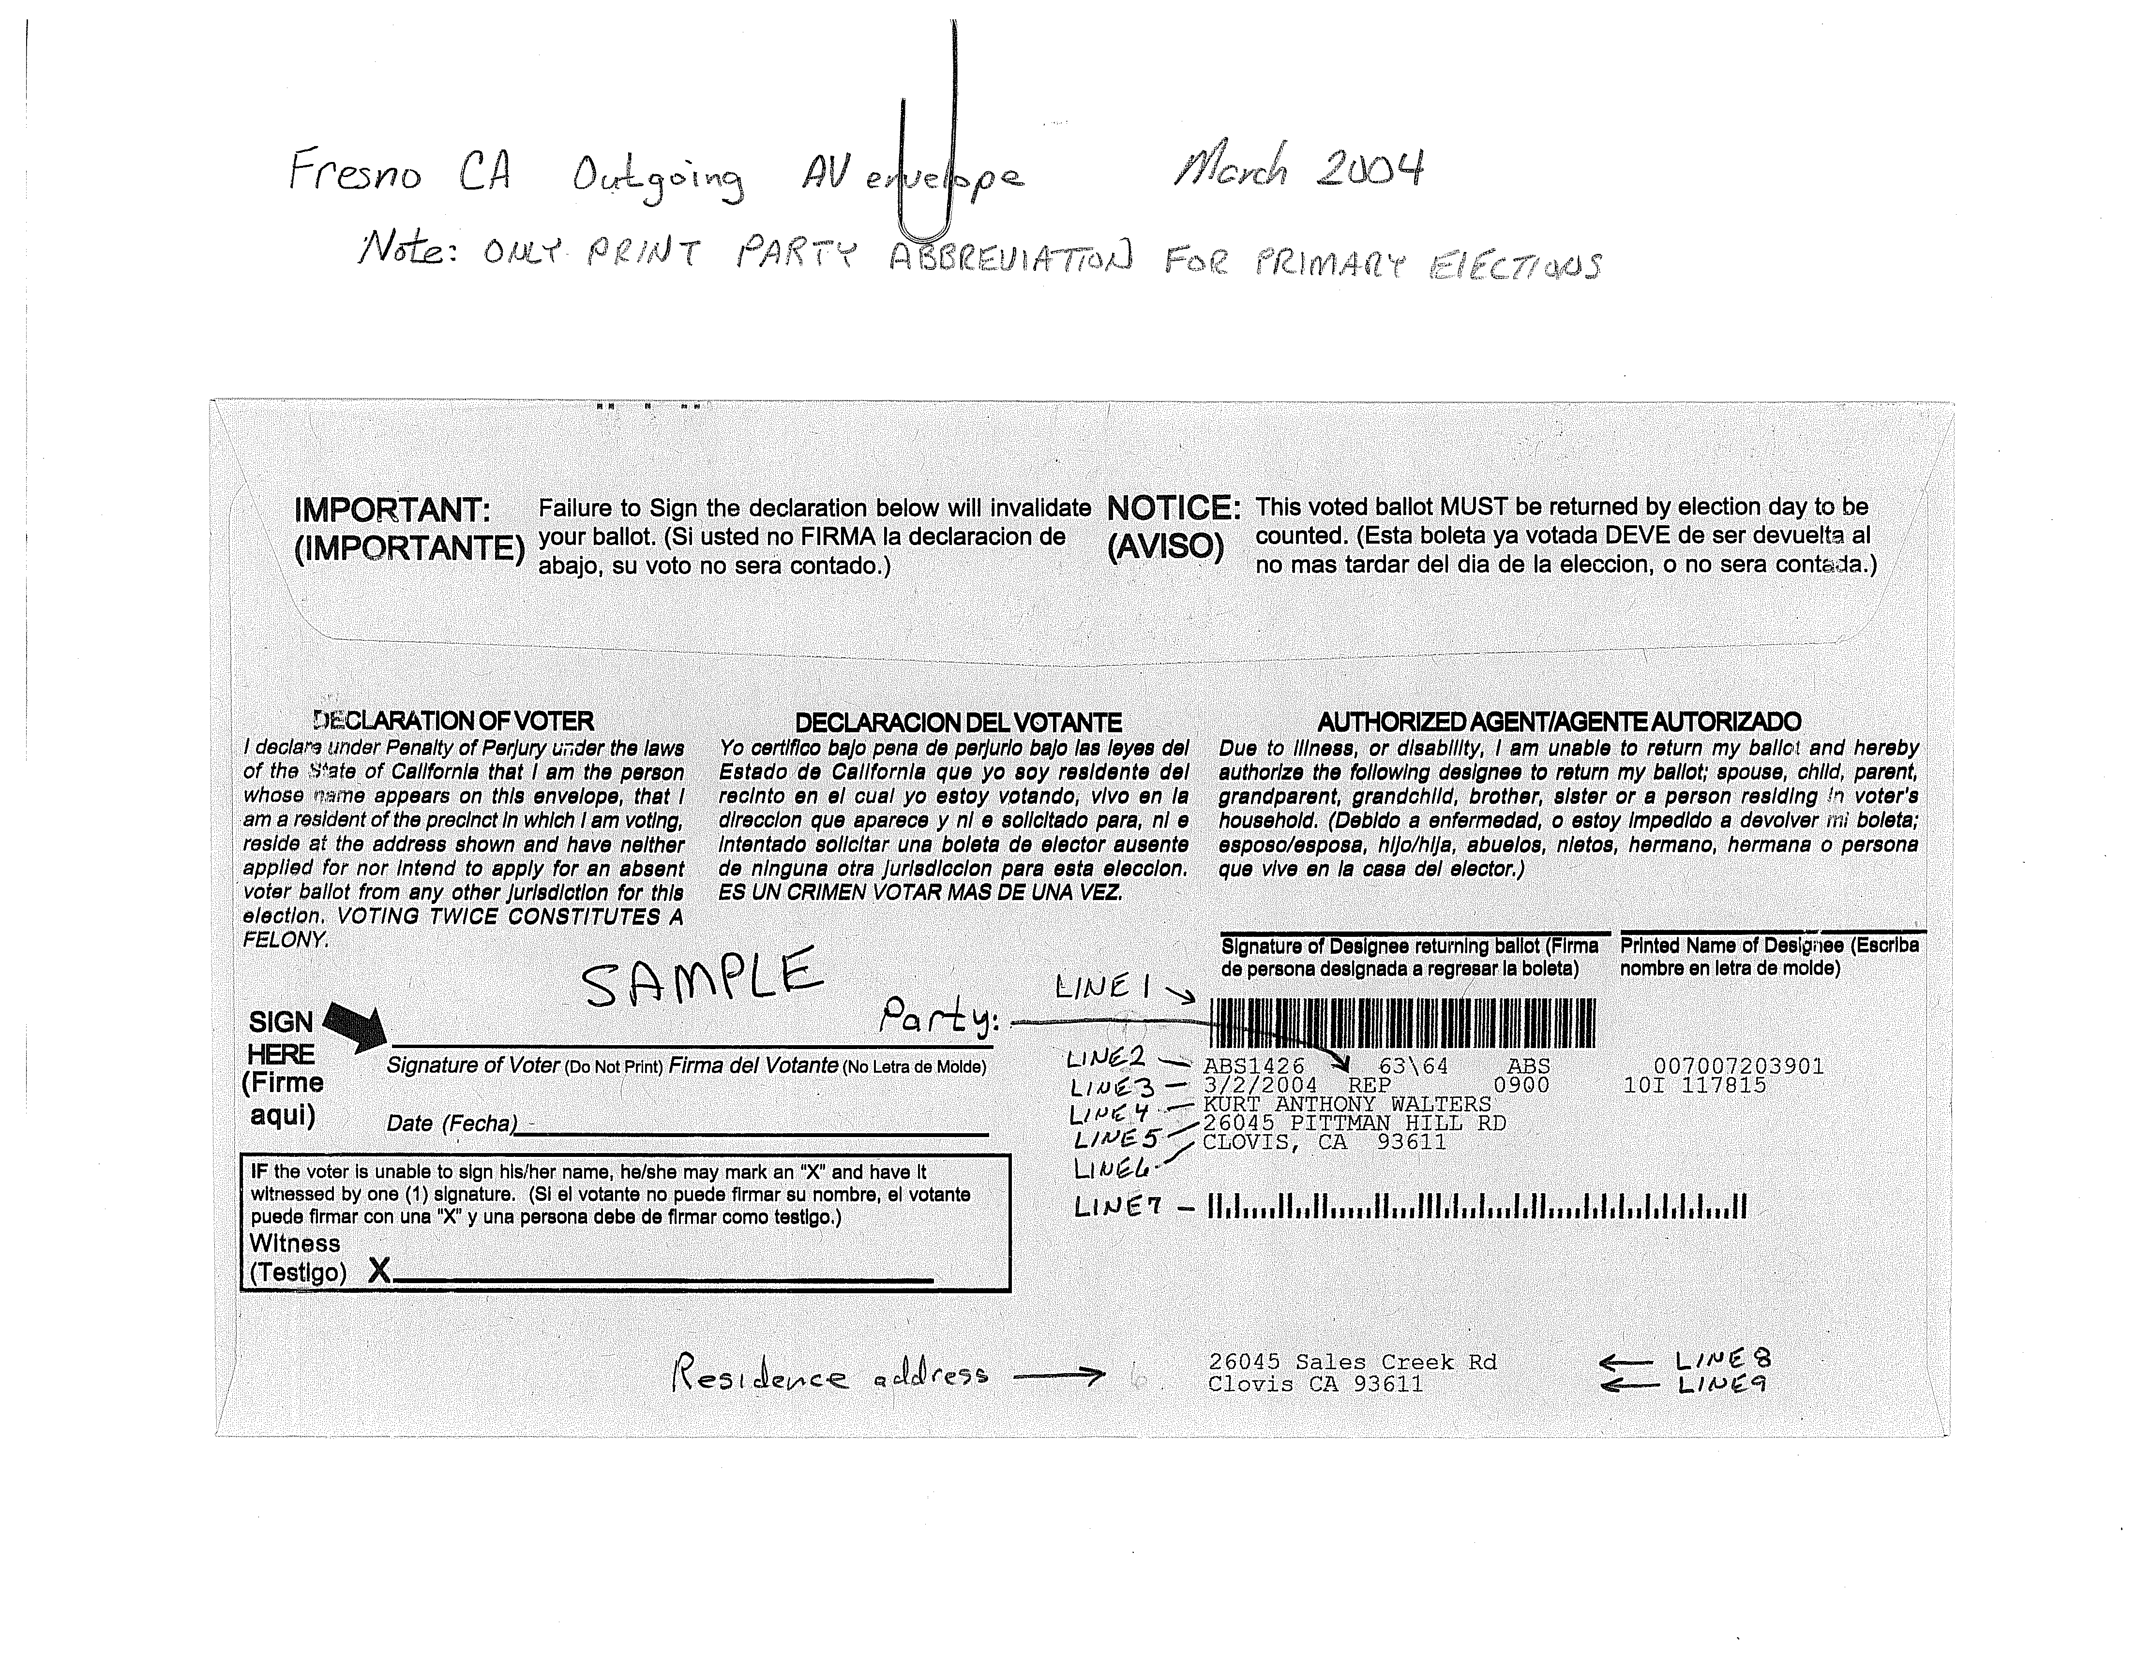
Original of above downloaded
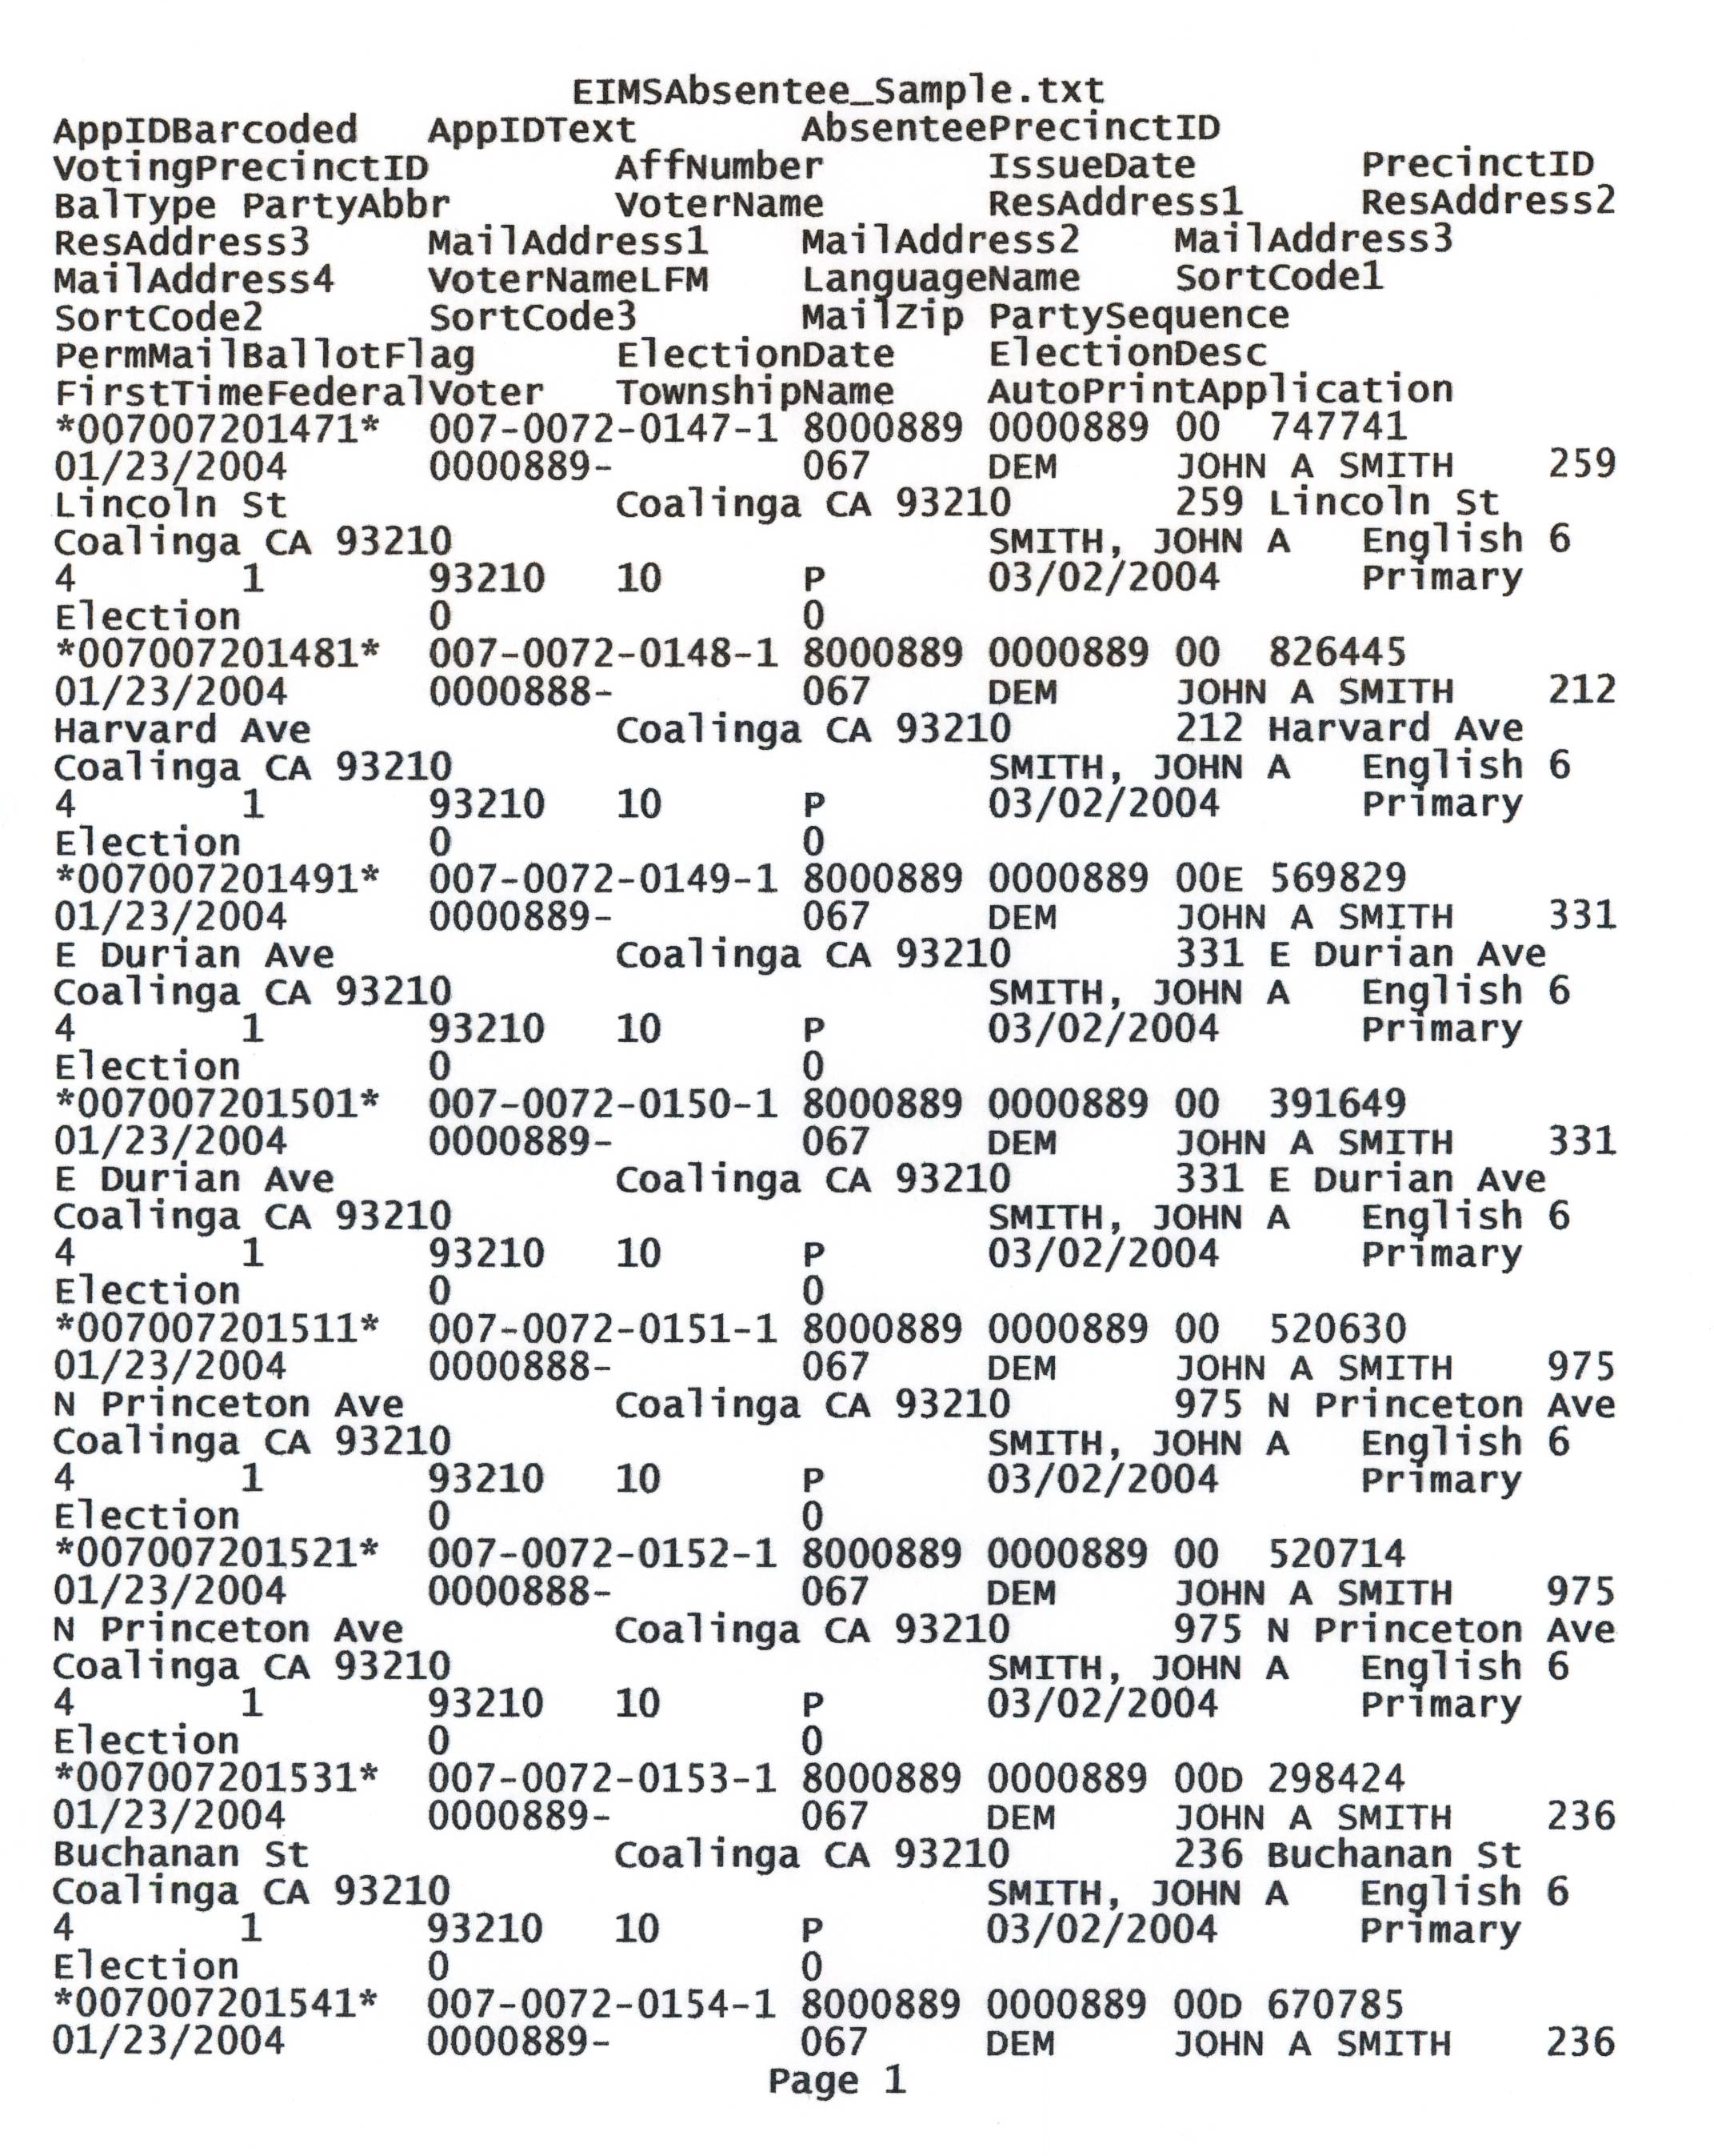
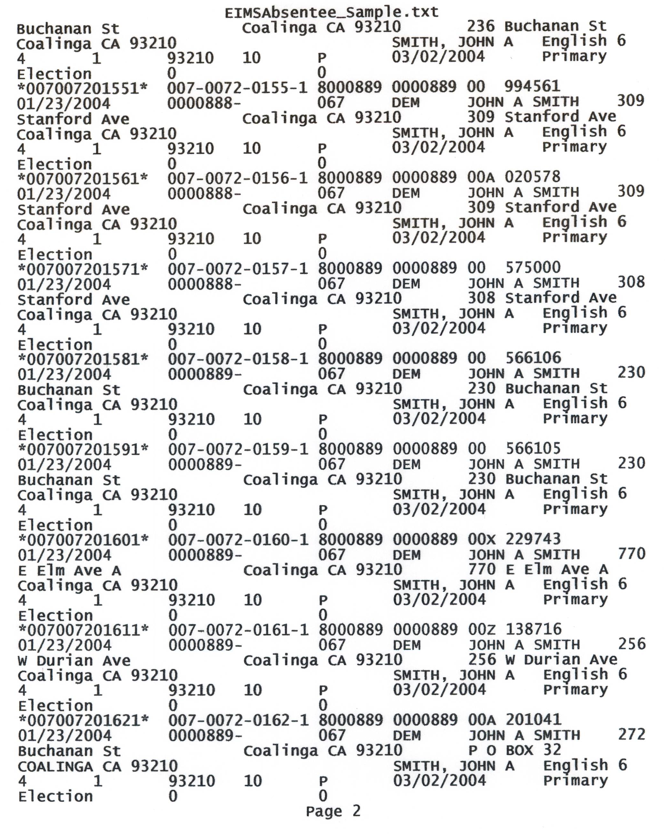
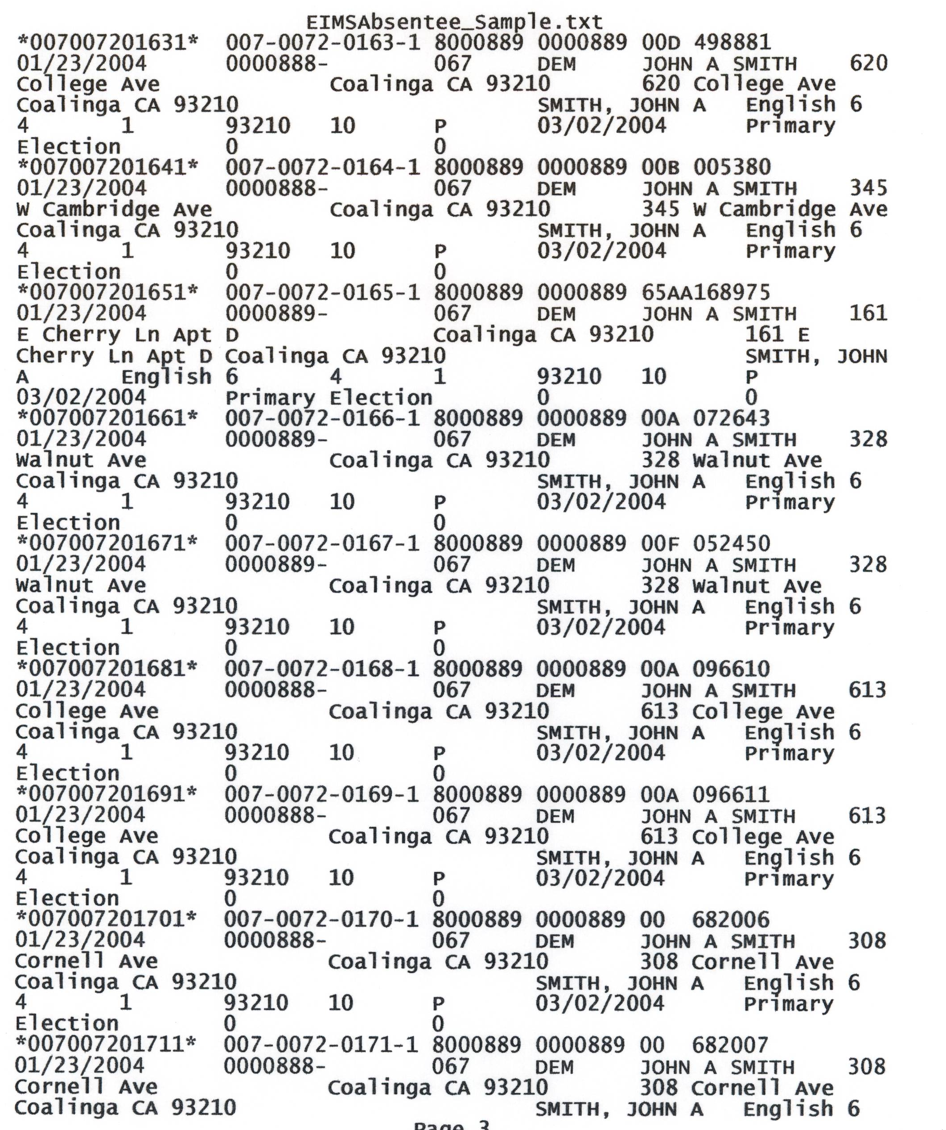

SPECIFICATIONS FOR
VOTE BY MAIL/MAIL BALLOT MAILER PROCESSING AND ENVELOPES
- OVERVIEW
Fresno County utilizes an optical scan paper ballot voting system. The county will have up to 200,000 voters using the absentee ballot process in a major election.
Fresno County requests bids to automate the following process:
- inserting of the outgoing mail pieces
We have utilized a process that automates the inserting process with voter specific data printed on the absentee envelope.
The vendor must:
  - Prepare a report by postage class, precinct and party (if a primary election) of absentee ballots to be pulled daily from our outgoing file of mailers.
  - Produce an election specific return envelope sized to accommodate the ballot. This return envelope contains imprinted barcodes or other machine-readable codes embedding precinct and voter affidavit information.
  - Receive approval from the United States Postal Service (USPS) on all envelope artwork.
  - Guarantee a perfect match between the voter specific return envelope and precinct specific ballots and other materials during an automated inserting process.
  - Prepare absentee mailings per USPS ‘Standard Mail A Non-Profit’ or presorted first-class requirements. CASS certification required for address verification for USPS postal, bar-coded discounts for automated mail. CASS certification required for address verification for USPS postal, bar-coded discounts for automated mail.
The outgoing mail preparation and inserting typically begins at E-40. Additional mail preparation is continued through E-7. The quantity of mail typically decreases with each mailing. This process must be available to the County of Fresno on a 7 days a week basis from E-29 to E-6. Proximity to Fresno preferred for mail preparation and inserting- but accessibility and length of time for deliveries will also be considered. Address in Section “K”.
- SCOPE OF WORK
  - Prepare a report by postage class, precinct and party (if a primary election) of absentee ballots to be pulled daily from our outgoing file of mailers.
  - The requested services require the preparation and transfer to the USPS of a specified number of ballot mailers within a specified period in order to meet statutory requirements for delivery of mail ballots to voters.
Two separate envelopes per voter are required. The generic windowed outgoing mailer and the ballot return envelope with variable voter data. Both types of envelopes are to be bid in this proposal.
The vendor must have artwork on envelopes approved by USPS before insertion begins.
      - Early absentee ballots inserted and ready to mail E-35.
      - Daily (or as needed) absentee ballots inserted and mailed from E-29 through E-6.
    - For daily absentee ballot mailings, all within 24 hours from the time that the variable data is provided.
    - To meet these deadlines, the county agrees to have the data available to the vendor for application of variable data as specified.
      - At 39 days before the election
      - Supplemental at approximately 29 to 25 days and daily through 7 days before the election.
  - Known election dates for which mail ballot process can be expected for 2005-2006 are:
Election | Date
UDEL | 11/05
Governor’s Primary | 6/06
General Election | 11/06
  - Once the inserting is complete, the outgoing mailer will be sealed and presorted according to USPS requirements for Non-Profit Standard Mail A or First Class (whichever is applicable.)
- EXPECTED VOLUME
  - Special Elections: This type of election varies depending on the district and the number of registered voters in the district. Generally, the election official is notified no later than 61 days before a special election, as to the services the county is to provide. (Elections Code 10002)
- Partial County Election – Traditional at-the-polls with Absentee Ballots: Range from 1,000 to 30,000 voters
- Full county Election – Traditional at-the-polls with Absentee Ballots: Approximately 130,000 plus voters
  - All County Primary Election – approximately 330,000 voters with approximately130,000 of these voters voting by mail (Absentee).
  - All County General Election – approximately 330,000 voters with approximately 130,000 of these voters voting by mail (Absentee).
  - An approximate estimate will be given 60 days before an election and a confirmed expected volume given 40 days prior to the election.
  - Approximate number of Permanent Absentee voters from November 2004 General Election: 60,000. Approximate number of Mail Ballot Precinct voters from November 2004 General Election: 16,000.
- SECURITY
  - Because of the statutory responsibility of the county in the preparation and delivery of the ballots to the voter, the vendor must provide access to county staff members at all times during the inserting of ballots and preparation for delivery to the USPS.
  - The Fresno county Clerk/Registrar of Voters, the Assistant Registrar of Voters or the Voter Services Program Coordinator, or designated staff, reserves the right to stop the operation if at any time it appears specifications are not being met and to put operations on hold until they are satisfied that the conditions are being met, as specified.
- LIQUIDATED DAMAGES
  - For each calendar day after the deadline specified in all parts of this Request for Proposal (RFP) not completed by the deadline, the vendor shall pay Fresno County the sum of $10,000 as fixed and agreed liquidated damages but not as a penalty. Liquidated damages shall under no circumstances exceed $100,000.
  - The vendor does hereby authorize Fresno County to deduct such liquidated damages from the amount due. The vendor further agrees that any such deduction shall not in any degree release it from further obligation and liabilities in regard to the fulfillment of the entire contract.
  - It is further agreed that time is of the essence in completing each portion of the contract of the specifications. The vendor shall not be charged with liquidated damages or any excess costs when the delay in completion is due to:
- Any preference, priority of allocation order duly issued by the county.
- Unforeseen causes beyond the control and without the fault of the vendor including but not restricted to acts of God, or of the public enemy.
- Provided, further, that the vendor shall, within one day of such delay, notify the County Clerk/Registrar of Voters. A supplier will grant no delays and extensions of time on account of work performed in a grossly negligent manner.
- SUBCONTRACTORS
If the vendor subcontracts any portion of the above services, the vendor must advise the county of the subcontractor’s name and address and the portion of the services they will perform.
- NOTES
  - Vendor to explain their process for capturing bar codes, in detail.
  - Vendor to include and provide any hardware or software required to complete their process.
  - County of Fresno requires hand-on demonstration of absentee processes prior to final award.
  - Proximity to Fresno preferred for mail preparation and inserting, but accessibility and length of time for deliveries will also be considered (vendor to address).

