THE COUNTY OF FRESNO IS SOLICITING BIDS FOR THE ITEM LISTED BELOW. SUBMIT YOUR BID IN A SEALED ENVELOPE. SUBMIT PER INSTRUCTIONS STATED IN THE “GENERAL CONDITIONS” SECTION OF THIS RFQ ON OR BEFORE April 7, 2005 at 2:00 P.M.

 | Markers, Pavment  Non-Reflective, Type A, White as specified on Attachment A to this RFQ. | 1 | *Lot/5000 | $ | $

Deliver to: County of Fresno
Dept. of Public Works-Sign Shop
4557 E. Hamilton Ave.
Fresno, CA 93722

* One Lot consists of 5000 Markers

STANDARD INSTRUCTIONS AND CONDITIONS FOR
REQUESTS FOR PROPOSALS (RFP'S) AND REQUESTS FOR QUOTATIONS (RFQ'S)
Note: the reference to "bids" in the following paragraphs applies to RFP's and RFQ's
GENERAL CONDITIONS
By submitting a bid the bidder agrees to the following conditions. These conditions will apply to all subsequent purchases based on this bid.

- BID PREPARATION:
  - All prices and notations must be typed or written in ink. No erasures permitted. Errors may be crossed out, initialed and corrections printed in ink by person signing bid.
  - Brand Names: Brand names and numbers when given are for reference. Equal items will be considered, provided the offer clearly describes the article and how it differs from that specified. In the absence of such information it shall be understood the offering is exactly as specified.
  - State brand or make of each item. If bidding on other than specified, state make, model and brand being bid and attach supporting literature/specifications to the bid.
  - Bid on each item separately. Prices should be stated in units specified herein. All applicable charges must be quoted; charges on invoice not quoted herein will be disallowed.
  - Time of delivery is a part of the consideration and must be stated in definite terms and must be adhered to. F.O.B. Point shall be destination or freight charges must be stated.
  - All bids must be dated and signed with the firm’s name and by an authorized officer or employee.
  - Unless otherwise noted, prices shall be firm for 120 days after closing date of bid.
- SUBMITTING BIDS:
  - Each bid must be submitted on forms provided in a sealed envelope with bid number and closing date and time on the outside of the envelope/package.
  - Interpretation: Should any discrepancies or omissions be found in the bid specifications or doubt as to their meaning, the bidder shall notify the Buyer in writing at once. The County shall not be held responsible for verbal interpretations. Questions regarding the bid must be received by Purchasing at least 5 working days before bid opening. All addenda issued shall be in writing, duly issued by Purchasing and incorporated into the contract.
  - ISSUING AGENT/AUTHORIZED CONTACT: This RFQ has been issued by County of Fresno Purchasing. Purchasing shall be the vendor’s sole point of contact with regard to the RFQ, its content, and all issues concerning it.
All communication regarding this RFQ shall be directed to an authorized representative of County Purchasing. The specific buyer managing this RFQ is identified on the cover page, along with his or her telephone number, and he or she should be the primary point of contact for discussions or information pertaining to the RFQ. Contact with any other County representative, including elected officials, for the purpose of discussing this RFQ, its content, or any other issue concerning it, is prohibited unless authorized by Purchasing. Violation of this clause, by the vendor having unauthorized contact (verbally or in writing) with such other County representatives, may constitute grounds for rejection by Purchasing of the vendor’s quotation.
The above stated restriction on vendor contact with County representatives shall apply until the County has awarded a purchase order or contract to a vendor or vendors, except as follows. First, in the event that a vendor initiates a formal protest against the RFQ, such vendor may contact the appropriate individual, or individuals who are managing that protest as outlined in the County’s established protest procedures. All such contact must be in accordance with the sequence set forth under the protest procedures. Second, in the event a public hearing is scheduled before the Board of Supervisors to hear testimony prior to its approval of a purchase order or contract, any vendor may address the Board.
  - Bids received after the closing time will NOT be considered.
  - Bidders are to bid what is specified or requested first. If unable to or willing to, bidder may bid alternative or option, indicating all advantages, disadvantages and their associated cost.
- FAILURE TO BID:
  - If not bidding, return bid sheet and state reason for no bid or your name may be removed from mailing list.
- TAXES, CHARGES AND EXTRAS:
  - County of Fresno is subject to California sales and/or use tax (7.975%). Please indicate as a separate line item if applicable.
  - DO NOT include Federal Excise Tax. County is exempt under Registration No. 94-73-03401-K.
  - County is exempt from Federal Transportation Tax. Exemption certificate is not required where shipping papers show consignee as County of Fresno.
  - Charges for transportation, containers, packing, etc. will not be paid unless specified in bid.
- W-9 – REQUEST FOR TAXPAYER IDENTIFICATION NUMBER AND CERTIFICATION:
Upon award of bid, the vendor shall submit to County Purchasing, a completed W-9 - Request for Taxpayer Identification Number and Certification if not already a current vendor with The County of Fresno. This form is available from the IRS to complete on line at http://www.irs.gov/pub/irs-pdf/fw9.pdf.
- AWARDS:
  - Subject to the local preference provisions referenced in Paragraph 6 below and more thoroughly set forth in the General Requirements section of this RFQ, award(s) will be made to the most responsive responsible bidder. The evaluation will include such things as life-cycle cost, availability, delivery costs and whose product and/or service is deemed to be in the best interest of the County. The County shall be the sole judge in making such determination.
  - Unless bidder gives notice of all-or-none award in bid, County may accept any item, group of items or on the basis of total bid.
  - The County reserves the right to reject any and all bids and to waive informalities or irregularities in bids.
  - After award, all bids shall be open to public inspection. The County assumes no responsibility for the confidentiality of information offered in a bid.
- LOCAL VENDORS
  - Local Vendor Preference (applicable to RFQ Process only)
The following provisions are applicable only to the County’s acquisition of materials, equipment or supplies through the RFQ process when the funding source does not require an exemption to the Local Vendor Preference.
THE PROVISIONS OF THIS PARAGRAPH ARE APPLICABLE, NOTWITHSTANDING ANY OTHER PROVISIONS OF THIS RFQ TO THE CONTRARY
If the apparent low bidder is not a local vendor, any local vendor who submitted a bid which was within five percent (5%) of the lowest responsive bid as determined by the purchasing agent shall have the option of submitting a new bid within forty-eight hours (not including weekends and holidays) of County’s delivery of notification. Such new bids must be in an amount less than or equal to the lowest responsive bid as determined by the purchasing agent. If the purchasing agent receives any new bids from local vendors who have the option of submitting new bids within said forty-eight hour period, it shall award the contract to the local vendor submitting the lowest responsible bid. If no new bids are received, the contract shall be awarded to the original low bidder as announced by the purchasing agent.
  - Local Vendor Defined
“Local Vendor” shall mean any business which:
- Has its headquarters, distribution point or locally-owned franchise located in or having a street address within the County for at least six (6) months immediately prior to the issuance of the request for competitive bids by the purchasing agent; and
- Holds any required business license by a jurisdiction located in Fresno County; and
- Employs at least one (1) full-time or two (2) part-time employees whose primary residence is located within Fresno County, or if the business has no employees, shall be at least fifty percent (50%) owned by one or more persons whose primary residence(s) is located within Fresno County.
- TIE BIDS:
All other factors being equal, the contract shall be awarded to the Fresno County vendor or, if neither or both are Fresno County vendors, it may be awarded by the flip of a coin in the presence of witnesses or the entire bid may be rejected and re-bid. If the General Requirements of this RFQ state that they are applicable, the provisions of the Fresno County Local Vendor Preference shall take priority over this paragraph.
- PATENT INDEMNITY:
The vendor shall hold the County, its officers, agents and employees, harmless from liability of any nature or kind, including costs and expenses, for infringement or use of any copyrighted or uncopyrighted composition, secret process, patented or unpatented invention, article or appliance furnished or used in connection with this bid.
- SAMPLES:
Samples, when required, must be furnished and delivered free and, if not destroyed by tests, will upon written request (within 30 days of bid closing date) be returned at the bidder's expense. In the absence of such notification, County shall have the right to dispose of the samples in whatever manner it deems appropriate.
- RIGHTS AND REMEDIES OF COUNTY FOR DEFAULT:
  - In case of default by vendor, the County may procure the articles or service from another source and may recover the cost difference and related expenses occasioned thereby from any unpaid balance due the vendor or by proceeding against performance bond of the vendor, if any, or by suit against the vendor. The prices paid by the County shall be considered the prevailing market price at the time such purchase is made.
  - Articles or services, which upon delivery inspection do not meet specifications, will be rejected and the vendor will be considered in default. Vendor shall reimburse County for expenses related to delivery of non-specified goods or services.
  - Regardless of F.O.B. point, vendor agrees to bear all risks of loss, injury or destruction to goods and materials ordered herein which occur prior to delivery and such loss, injury or destruction shall not release vendor from any obligation hereunder.
- DISCOUNTS:
Terms of less than 15 days for cash payment will be considered as net in evaluating this bid. A discount for payment within fifteen (15) days or more will be considered in determining the award of bid. Discount period will commence either the later of delivery or receipt of invoice by the County. Standard terms are Net Forty-five (45) days.
- SPECIAL CONDITIONS IN BID SCHEDULE SUPERSEDE GENERAL CONDITIONS.
The “General Conditions” provisions of this RFP/RFQ shall be superseded if in conflict with any other section of this bid, to the extent of any such conflict.
- SPECIAL REQUIREMENT:
With the invoice or within twenty-five (25) days of delivery, the seller must provide to the County a Material Safety Data Sheet for each product, which contains any substance on “The List of 800 Hazardous Substances”, published by the State Director of Industrial Relations. (See Hazardous Substances Information and Training Act. California State Labor Code Sections 6360 through 6399.7.)
- RECYCLED PRODUCTS/MATERIALS:
Vendors are encouraged to provide and quote (with documentation) recycled or recyclable products/materials which meet stated specifications.
- YEAR COMPLIANCE WARRANTY
Vendor warrants that any product furnished pursuant to this Agreement/order shall support a four-digit year format and be able to accurately process date and time data from, into and between the twentieth and twenty-first centuries, as well as leap year calculations. "Product" shall include, without limitation, any piece or component of equipment, hardware, firmware, middleware, custom or commercial software, or internal components or subroutines therein. This warranty shall survive termination or expiration of this Agreement.
In the event of any decrease in product functionality or accuracy related to time and/or date data related codes and/or internal subroutines that impede the product from operating correctly using dates beyond December 31, 1999, vendor shall restore or repair the product to the same level of functionality as warranted herein, so as to minimize interruption to County's ongoing business process, time being of the essence. In the event that such warranty compliance requires the acquisition of additional programs, the expense for any such associated or additional acquisitions, which may be required, including, without limitation, data conversion tools, shall be borne exclusively by vendor. Nothing in this warranty shall be construed to limit any rights or remedies the County may otherwise have under this Agreement with respect to defects other than year performance.
- PARTICIPATION:
Bidder may agree to extend the terms of the resulting contract to other political subdivision, municipalities and tax-supported agencies.
Such participating Governmental bodies shall make purchases in their own name, make payment directly to bidder, and be liable directly to the bidder, holding the County of Fresno harmless.
- CONFIDENTIALITY:
All services performed by vendor shall be in strict conformance with all applicable Federal, State of California and/or local laws and regulations relating to confidentiality, including but not limited to, California Civil Code, California Welfare and Institutions Code, Health and Safety Code, California Code of Regulations, Code of Federal Regulations.
Vendor shall submit to County’s monitoring of said compliance.
Vendor may be a business associate of County, as that term is defined in the “Privacy Rule” enacted by the Health Insurance Portability and Accountability Act of 1996 (HIPAA). As a HIPAA Business Associate, vendor may use or disclose protected health information (“PHI”) to perform functions, activities or services for or on behalf of County as specified by the County, provided that such use or disclosure shall not violate HIPAA and its implementing regulations. The uses and disclosures if PHI may not be more expansive than those applicable to County, as the “Covered Entity” under HIPAA’S Privacy Rule, except as authorized for management, administrative or legal responsibilities of the Business Associate.
Vendor shall not use or further disclose PHI other than as permitted or required by the County, or as required by law without written notice to the County.
Vendor shall ensure that any agent, including any subcontractor, to which vendor provides PHI received from, or created or received by the vendor on behalf of County, shall comply with the same restrictions and conditions with respect to such information.
- APPEALS
Appeals must be submitted in writing within five (5) working days after the review committee notification of proposed recommendations. Appeals should be submitted to County of Fresno Purchasing, 4525 E. Hamilton Avenue, Fresno, California 93702-4599. Appeals should address only areas regarding RFP contradictions, procurement errors, quotation rating discrepancies, legality of procurement context, conflict of interest in rating process, and inappropriate or unfair competitive procurement grievance regarding the RFP process.
The Purchasing Manager will provide a written response to the complaint within five (5) working days unless the complainant is notified more time is required.
If the protesting bidder is not satisfied with the decision of the Purchasing Manager, he/she shall have the right to appeal to the Purchasing Agent within five (5) business days after notification of the Purchasing Manager’s decision.
If the protesting bidder is not satisfied with Purchasing Agent decision, the final appeal is with the Board of Supervisors.

attachment a
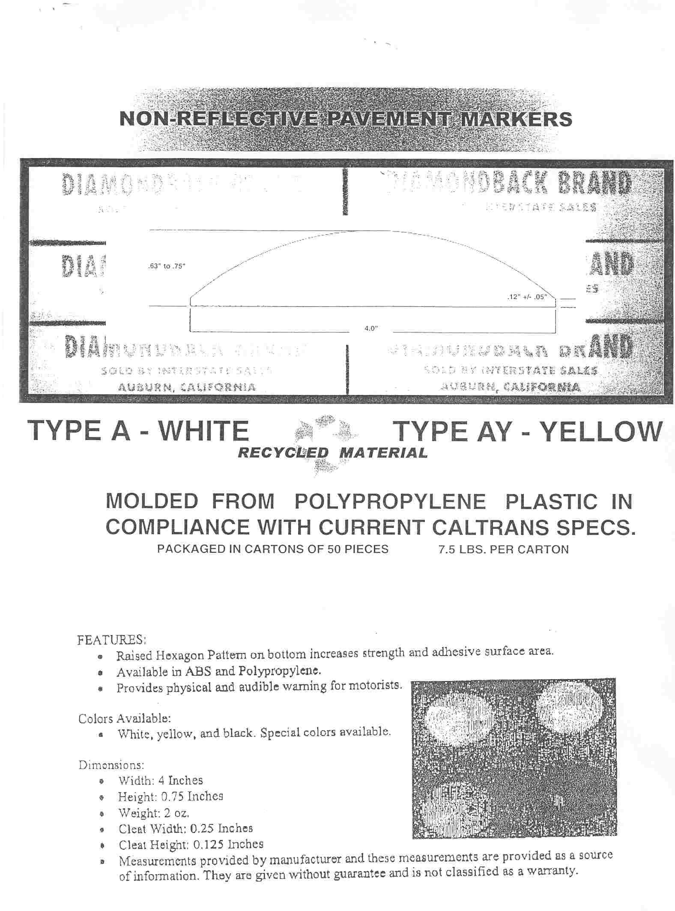

Local Vendor Preference
The County of Fresno Local Vendor Preference is applicable to this Request for Quotation. Refer to the General Conditions section for details.
Qualified Vendors that desire consideration as a Fresno County Local Vendor under this RFQ must complete the “Statement of Local Vendor Certification” contained herein and submit it as a part of their quotation. Late submittals of the “Statement of Local Vendor Certification” will not be considered. Submission of this statement will qualify the vendor for treatment as a local vendor for purposes of this RFQ only. The statement made under this RFQ shall not qualify the vendor as a local vendor under any other RFQ.
Local Vendor Certification:
Any vendor claiming to be a local vendor, as defined under the General Conditions section of this RFQ, shall so certify in writing to the purchasing agent. The purchasing agent shall not be required to verify the accuracy or any such certifications, and shall have sole discretion to determine if a vendor meets the definition of “local vendor.”
Any person or business falsely claiming to be a local vendor under this section shall be ineligible to transact any business with the County for a period of not less than three (3) months and not more twenty-four (24) months as determined in the sole discretion of the purchasing agent. The purchasing agent shall also have the right to terminate all or any part of any contract entered into with such person or business.
STATEMENT OF LOCAL VENDOR CERTIFICATION
COUNTY OF FRESNO
Qualified local vendors desiring consideration under the Fresno County Local Vendor Preference must complete the following and submit with their quotation (print or type).
I |  |  |  |  |  | ,
 | (individual submitting bid) |  |  |  |  |  | (title)
Of/for |  |  |  | Certify that
 |  | (Company Name) |  |  |  |  |  | (Company Name)
Is a Fresno County local Vendor as defined under the General Conditions section of this RFQ and therefore qualifies for the Local Vendor Preference.
Signature |  |  |  |  | Title |  |  |  |  | Date

NOTIFICATION OF RE-BID
The local vendor will be notified of his/her opportunity to re-bid under Fresno County’s Local Vendor Preference. The Vendor must submit his/her re-bid within forty-eight (48) hours of notification (excluding weekends and holidays). Notification will be issued by e-mail or Fax, whichever is preferred by the vendor. Notification to Vendor shall be considered complete upon County’s transmission of e-mail or Fax.
The local vendor shall state his/her preferred method of notification below along with the appropriate e-mail address or Fax number. Notification by County will be limited to one of those two (2) methods. It will be the local vendor’s responsibility to check his/her e-mail or Fax messages for notification. The vendor’s delay in receiving his/her notification will not alter the forty-eight (48) hour period allowed for re-bid submission.
Local Vendor To Complete:
Indicate *ONE method for notification of Local Vendor re-bid by providing the appropriate e-mail address or Fax number. Submit this document as a part of your quotation.
E-Mail Address or Fax Number (Identify contact person if using a Fax Number)

