COUNTY OF FRESNO
Request for QUOTATION
 |  | NUMBER: 525-4528
January 25, 2008
ORG/Requisition: 7530/ 7538000019 |  |  |  |  |  |  | PURCHASING USE |  |  |  | /tmp/in/input.doc
 |  |  |  |  |  |  | jlg
IMPORTANT: SUBMIT QUOTATION IN SEALED PACKAGE WITH QUOTATION NUMBER, CLOSING DATE AND BUYER’S NAME MARKED CLEARLY ON THE OUTSIDE TO:
COUNTY OF FRESNO, Purchasing
4525 EAST HAMILTON AVENUE
FRESNO, CA 93702-4599
Closing date of bid will be at 2:00 p.m., on March 18, 2008.
QUOTATIONS WILL BE CONSIDERED LATE WHEN THE OFFICIAL PURCHASING TIME CLOCK READS 2:00 P.M.
Quotations will be opened and publicly read at that time. All quotation information will be available for review after contract award.
Clarification of specifications is to be directed to: Cathi J. Peters, phone (559) 456-7110, FAX (559) 456-7831.
GENERAL CONDITIONS: See “County Of Fresno Purchasing Standard Instructions And Conditions For Request For Proposals (RFP’S) and Requests for Quotations (RFQ’S)” attached. Check County of Fresno Purchasing’s Open Solicitations website at www.co.fresno.ca.us/0440/Bidshome.asp for RFQ/RFP documents and changes.
BIDDER TO COMPLETE
UNDERSIGNED AGREES TO FURNISH THE COMMODITY OR SERVICE STIPULATED IN THE ATTACHED QUOTATION SCHEDULE AT THE PRICES AND TERMS STATED, SUBJECT TO THE “COUNTY OF FRESNO PURCHASING STANDARD INSTRUCTIONS AND CONDITIONS FOR REQUEST FOR QUOTATIONS (RFP’S) AND REQUESTS FOR QUOTATIONS (RFQ’S)”ATTACHED.
Except as noted on individual items, the following will apply to all items in the Quotation Schedule.
- Complete delivery will be made within |  |  |  |  |  |  |  | calendar days after receipt of Order.
- A cash discount of |  |  |  |  | % |  |  |  |  | days will apply.
Company
Address
City |  |  |  |  |  |  |  |  |  |  |  |  | State |  | Zip Code
( ) |  |  |  | ( )
Telephone Number |  |  |  | Facsimile Number |  |  |  |  |  |  |  |  | E-mail Address
Signed By
Print Name |  |  |  |  |  |  |  |  | Title

COUNTY OF FRESNO PURCHASING
STANDARD INSTRUCTIONS AND CONDITIONS FOR
REQUESTS FOR PROPOSALS (RFP'S) AND REQUESTS FOR QUOTATIONS (RFQ'S)
Note: the reference to “bids” in the following paragraphs applies to RFP's and RFQ's

GENERAL CONDITIONS
By submitting a bid the bidder agrees to the following conditions. These conditions will apply to all subsequent purchases based on this bid.

- BID PREPARATION:
  - All prices and notations must be typed or written in ink. No erasures permitted. Errors may be crossed out, initialed and corrections printed in ink by person signing bid.
  - Brand Names: Brand names and numbers when given are for reference. Equal items will be considered, provided the offer clearly describes the article and how it differs from that specified. In the absence of such information it shall be understood the offering is exactly as specified.
  - State brand or make of each item. If bidding on other than specified, state make, model and brand being bid and attach supporting literature/specifications to the bid.
  - Bid on each item separately. Prices should be stated in units specified herein. All applicable charges must be quoted; charges on invoice not quoted herein will be disallowed.
  - Time of delivery is a part of the consideration and must be stated in definite terms and must be adhered to. F.O.B. Point shall be destination or freight charges must be stated.
  - All bids must be dated and signed with the firm’s name and by an authorized officer or employee.
  - Unless otherwise noted, prices shall be firm for 120 days after closing date of bid.
- SUBMITTING BIDS:
  - Each bid must be submitted on forms provided in a sealed envelope with bid number and closing date and time on the outside of the envelope/package.
  - Interpretation: Should any discrepancies or omissions be found in the bid specifications or doubt as to their meaning, the bidder shall notify the Buyer in writing at once. The County shall not be held responsible for verbal interpretations. Questions regarding the bid must be received by Purchasing at least 5 working days before bid opening. All addenda issued shall be in writing, duly issued by Purchasing and incorporated into the contract.
  - ISSUING AGENT/AUTHORIZED CONTACT: This RFQ has been issued by County of Fresno Purchasing. Purchasing shall be the vendor’s sole point of contact with regard to the RFQ, its content, and all issues concerning it.
All communication regarding this RFQ shall be directed to an authorized representative of County Purchasing. The specific buyer managing this RFQ is identified on the cover page, along with his or her telephone number, and he or she should be the primary point of contact for discussions or information pertaining to the RFQ. Contact with any other County representative, including elected officials, for the purpose of discussing this RFQ, its content, or any other issue concerning it, is prohibited unless authorized by Purchasing. Violation of this clause, by the vendor having unauthorized contact (verbally or in writing) with such other County representatives, may constitute grounds for rejection by Purchasing of the vendor’s quotation.
The above stated restriction on vendor contact with County representatives shall apply until the County has awarded a purchase order or contract to a vendor or vendors, except as follows. First, in the event that a vendor initiates a formal protest against the RFQ, such vendor may contact the appropriate individual, or individuals who are managing that protest as outlined in the County’s established protest procedures. All such contact must be in accordance with the sequence set forth under the protest procedures. Second, in the event a public hearing is scheduled before the Board of Supervisors to hear testimony prior to its approval of a purchase order or contract, any vendor may address the Board.
  - Bids received after the closing time will NOT be considered.
  - Bidders are to bid what is specified or requested first. If unable to or willing to, bidder may bid alternative or option, indicating all advantages, disadvantages and their associated cost.
  - Public Contract Code Section 7028.15
Where the State of California requires a Contractor’s license, it is a misdemeanor for any person to submit a bid unless specifically exempted.
- FAILURE TO BID:
  - If not bidding, return bid sheet and state reason for no bid or your name may be removed from mailing list.
- TAXES, CHARGES AND EXTRAS:
  - County of Fresno is subject to California sales and/or use tax (7.975%). Please indicate as a separate line item if applicable.
  - DO NOT include Federal Excise Tax. County is exempt under Registration No. 94-73-03401-K.
  - County is exempt from Federal Transportation Tax. Exemption certificate is not required where shipping papers show consignee as County of Fresno.
  - Charges for transportation, containers, packing, etc. will not be paid unless specified in bid.
- W-9 – REQUEST FOR TAXPAYER IDENTIFICATION NUMBER AND CERTIFICATION:
Upon award of bid, the vendor shall submit to County Purchasing, a completed W-9 - Request for Taxpayer Identification Number and Certification if not already a current vendor with The County of Fresno. This form is available from the IRS to complete on line at http://www.irs.gov/pub/irs-pdf/fw9.pdf.
- AWARDS:
  - Subject to the local preference provisions referenced in Paragraph 6 below and more thoroughly set forth in the General Requirements section of this RFQ, award(s) will be made to the most responsive responsible bidder. The evaluation will include such things as life-cycle cost, availability, delivery costs and whose product and/or service is deemed to be in the best interest of the County. The County shall be the sole judge in making such determination.
  - Unless bidder gives notice of all-or-none award in bid, County may accept any item, group of items or on the basis of total bid.
  - The County reserves the right to reject any and all bids and to waive informalities or irregularities in bids.
  - After award, all bids shall be open to public inspection. The County assumes no responsibility for the confidentiality of information offered in a bid.
- LOCAL VENDORS
  - Local Vendor Preference (applicable to RFQ Process only)
The following provisions are applicable only to the County’s acquisition of materials, equipment or supplies through the RFQ process when the funding source does not require an exemption to the Local Vendor Preference.
THE PROVISIONS OF THIS PARAGRAPH ARE APPLICABLE, NOTWITHSTANDING ANY OTHER PROVISIONS OF THIS RFQ TO THE CONTRARY
If the apparent low bidder is not a local vendor, any local vendor who submitted a bid which was within five percent (5%) of the lowest responsive bid as determined by the purchasing agent shall have the option of submitting a new bid within forty-eight hours (not including weekends and holidays) of County’s delivery of notification. Such new bids must be in an amount less than or equal to the lowest responsive bid as determined by the purchasing agent. If the purchasing agent receives any new bids from local vendors who have the option of submitting new bids within said forty-eight hour period, it shall award the contract to the local vendor submitting the lowest responsible bid. If no new bids are received, the contract shall be awarded to the original low bidder as announced by the purchasing agent.
  - Local Vendor Defined
“Local Vendor” shall mean any business which:
- Has its headquarters, distribution point or locally-owned franchise located in or having a street address within the County for at least six (6) months immediately prior to the issuance of the request for competitive bids by the purchasing agent; and
- Holds any required business license by a jurisdiction located in Fresno County; and
- Employs at least one (1) full-time or two (2) part-time employees whose primary residence is located within Fresno County, or if the business has no employees, shall be at least fifty percent (50%) owned by one or more persons whose primary residence(s) is located within Fresno County.
- TIE BIDS:
All other factors being equal, the contract shall be awarded to the Fresno County vendor or, if neither or both are Fresno County vendors, it may be awarded by the flip of a coin in the presence of witnesses or the entire bid may be rejected and re-bid. If the General Requirements of this RFQ state that they are applicable, the provisions of the Fresno County Local Vendor Preference shall take priority over this paragraph.
- PATENT INDEMNITY:
The vendor shall hold the County, its officers, agents and employees, harmless from liability of any nature or kind, including costs and expenses, for infringement or use of any copyrighted or uncopyrighted composition, secret process, patented or unpatented invention, article or appliance furnished or used in connection with this bid.
- SAMPLES:
Samples, when required, must be furnished and delivered free and, if not destroyed by tests, will upon written request (within 30 days of bid closing date) be returned at the bidder's expense. In the absence of such notification, County shall have the right to dispose of the samples in whatever manner it deems appropriate.
- RIGHTS AND REMEDIES OF COUNTY FOR DEFAULT:
  - In case of default by vendor, the County may procure the articles or service from another source and may recover the cost difference and related expenses occasioned thereby from any unpaid balance due the vendor or by proceeding against performance bond of the vendor, if any, or by suit against the vendor. The prices paid by the County shall be considered the prevailing market price at the time such purchase is made.
  - Articles or services, which upon delivery inspection do not meet specifications, will be rejected and the vendor will be considered in default. Vendor shall reimburse County for expenses related to delivery of non-specified goods or services.
  - Regardless of F.O.B. point, vendor agrees to bear all risks of loss, injury or destruction to goods and materials ordered herein which occur prior to delivery and such loss, injury or destruction shall not release vendor from any obligation hereunder.
- DISCOUNTS:
Terms of less than 15 days for cash payment will be considered as net in evaluating this bid. A discount for payment within fifteen (15) days or more will be considered in determining the award of bid. Discount period will commence either the later of delivery or receipt of invoice by the County. Standard terms are Net Forty-five (45) days.
- SPECIAL CONDITIONS IN BID SCHEDULE SUPERSEDE GENERAL CONDITIONS.
The “General Conditions” provisions of this RFP/RFQ shall be superseded if in conflict with any other section of this bid, to the extent of any such conflict.
- SPECIAL REQUIREMENT:
With the invoice or within twenty-five (25) days of delivery, the seller must provide to the County a Material Safety Data Sheet for each product, which contains any substance on “The List of 800 Hazardous Substances”, published by the State Director of Industrial Relations. (See Hazardous Substances Information and Training Act. California State Labor Code Sections 6360 through 6399.7.)
- RECYCLED PRODUCTS/MATERIALS:
Vendors are encouraged to provide and quote (with documentation) recycled or recyclable products/materials which meet stated specifications.
- YEAR COMPLIANCE WARRANTY
Vendor warrants that any product furnished pursuant to this Agreement/order shall support a four-digit year format and be able to accurately process date and time data from, into and between the twentieth and twenty-first centuries, as well as leap year calculations. "Product" shall include, without limitation, any piece or component of equipment, hardware, firmware, middleware, custom or commercial software, or internal components or subroutines therein. This warranty shall survive termination or expiration of this Agreement.
In the event of any decrease in product functionality or accuracy related to time and/or date data related codes and/or internal subroutines that impede the product from operating correctly using dates beyond December 31, 1999, vendor shall restore or repair the product to the same level of functionality as warranted herein, so as to minimize interruption to County's ongoing business process, time being of the essence. In the event that such warranty compliance requires the acquisition of additional programs, the expense for any such associated or additional acquisitions, which may be required, including, without limitation, data conversion tools, shall be borne exclusively by vendor. Nothing in this warranty shall be construed to limit any rights or remedies the County may otherwise have under this Agreement with respect to defects other than year performance.
- PARTICIPATION:
Bidder may agree to extend the terms of the resulting contract to other political subdivision, municipalities and tax-supported agencies.
Such participating Governmental bodies shall make purchases in their own name, make payment directly to bidder, and be liable directly to the bidder, holding the County of Fresno harmless.
- CONFIDENTIALITY:
All services performed by vendor shall be in strict conformance with all applicable Federal, State of California and/or local laws and regulations relating to confidentiality, including but not limited to, California Civil Code, California Welfare and Institutions Code, Health and Safety Code, California Code of Regulations, Code of Federal Regulations.
Vendor shall submit to County’s monitoring of said compliance.
Vendor may be a business associate of County, as that term is defined in the “Privacy Rule” enacted by the Health Insurance Portability and Accountability Act of 1996 (HIPAA). As a HIPAA Business Associate, vendor may use or disclose protected health information (“PHI”) to perform functions, activities or services for or on behalf of County as specified by the County, provided that such use or disclosure shall not violate HIPAA and its implementing regulations. The uses and disclosures if PHI may not be more expansive than those applicable to County, as the “Covered Entity” under HIPAA’S Privacy Rule, except as authorized for management, administrative or legal responsibilities of the Business Associate.
Vendor shall not use or further disclose PHI other than as permitted or required by the County, or as required by law without written notice to the County.
Vendor shall ensure that any agent, including any subcontractor, to which vendor provides PHI received from, or created or received by the vendor on behalf of County, shall comply with the same restrictions and conditions with respect to such information.
- APPEALS
Appeals must be submitted in writing within seven (7) working days after the review committee notification of proposed recommendations. Appeals should be submitted to County of Fresno Purchasing, 4525 E. Hamilton Avenue, Fresno, California 93702-4599. Appeals should address only areas regarding RFP contradictions, procurement errors, quotation rating discrepancies, legality of procurement context, conflict of interest, and inappropriate or unfair competitive procurement grievance regarding the RFP process.
The Purchasing Manager will provide a written response to the complaint within seven (7) working days unless the complainant is notified more time is required.
If the protesting bidder is not satisfied with the decision of the Purchasing Manager, he/she shall have the right to appeal to the Purchasing Agent within seven (7) business days after notification of the Purchasing Manager’s decision.
If the protesting bidder is not satisfied with Purchasing Agent decision, the final appeal is with the Board of Supervisors.
- OBLIGATIONS OF CONTRACTOR:
  - CONTRACTOR shall perform as required by the ensuing contract. CONTRACTOR also warrants on behalf of itself and all subcontractors engaged for the performance of the ensuing contract that only persons authorized to work in the United States pursuant to the Immigration Reform and Control Act of 1986 and other applicable laws shall be employed in the performance of the work hereunder.
  - CONTRACTOR shall obey all Federal, State, local and special district laws, ordinances and regulations.
- AUDITS & RETENTION:
The Contractor shall maintain in good and legible condition all books, documents, papers, data files and other records related to its performance under this contract. Such records shall be complete and available to Fresno County, the State of California, the federal government or their duly authorized representatives for the purpose of audit, examination, or copying during the term of the contract and for a period of at least three years following the County's final payment under the contract or until conclusion of any pending matter (e.g., litigation or audit), whichever is later. Such records must be retained in the manner described above until all pending matters are closed.

TABLE OF CONTENTS
PAGE
KEY DATES 3
BIDDING INSTRUCTIONS 4
BIDDER TO COMPLETE 11
REFERENCE LIST 12
ADDITIONAL BIDDING INFORMATION 13
SHELVING SPECIFICATIONS FOWLER BRANCH LIBRARY 16
QUOTATION SHEDULE INSTRUCTIONS 29
Maps, & Plans 34
FLOOR PLAN 34
LOCATION MAP 35
COUNTERTOP, END PANEL AND OPAC DETAIL 36
BOOKSHELF DETAIL 39
SUBMITTALS 40
KEY DATES
Vendor Conference: | February 15, 2008 at 10:00 A.M.
 | County of Fresno Purchasing Office
 | 4525 E. Hamilton Avenue
 | Fresno, CA 93702
Written or Fax Request for Clarification of RFQ due: | February 26, 2008 at 8:00 A.M.
 | County of Fresno Purchasing Office
 | 4525 E. Hamilton Avenue
 | Fresno, CA 93702
RFQ Closing Date: | March 18, 2008 at 2:00 P.M.
 | County of Fresno Purchasing Office
 | 4525 E. Hamilton Avenue
 | Fresno, CA 93702
* Vendors are requested to contact Cathi J. Peters, Buyer III, at (559) 456-7110, if they plan on attending the Bidder’s Conference.
TARGET DATES
Contract/Purchase Order Issued | March 28, 2008
Delivery/Installation – Shelving | May 15, 2008
Opening Date of Library | July 2008
Note: The above target dates are anticipated dates only. Dates are dependent upon construction progress.
BIDDING INSTRUCTIONS
GENERAL REQUIREMENTS
The County of Fresno Purchasing on behalf of the Library is soliciting bids to establish an agreement under which the successful bidder will provide all labor, material, equipment, bonds, insurance, taxes, fees, permits etc. for the purchase, delivery, unpacking, setting in place and installation of shelving, countertops, end panels and OPAC units as specified within this Request for Quotation.
The Fowler Branch Library is currently under construction. It is located at 306 S. Seventh Street, Fowler, California 93625 and is approximately 8,500 gross square feet. The anticipated date for delivery and installation of the shelving is mid May 2008.
LOCAL VENDOR PREFERENCE: The Local Vendor Preference does not apply to this Request for Quotation.
ISSUING AGENT: This RFQ has been issued by County of Fresno Purchasing. The County Purchasing shall be the vendor’s sole point of contact with regard to the RFQ, its content, and all issues concerning it.
AUTHORIZED CONTACT: All communication regarding this RFQ shall be directed to an authorized representative of County Purchasing. The specific buyer managing this RFQ is identified on the cover page, along with his or her telephone number, and he or she should be the primary point of contact for discussions or information pertaining to the RFQ. Contact with any other County representative, including elected officials, for the purpose of discussing this RFQ, it content, or any other issue concerning it, is prohibited unless authorized by Purchasing. Violation of this clause, by the vendor having unauthorized contact (verbally or in writing) with such other County representatives, may constitute grounds for rejection by Purchasing of the vendor’s quotation.
The above stated restriction on vendor contact with County representatives shall apply until the County has awarded a purchase order or contract to a vendor or vendors, except as follows. First, in the event that a vendor initiates a formal protest against the RFQ, such vendor may contact the appropriate individual, or individuals who are managing that protest as outlined in the County’s established protest procedures. All such contact must be in accordance with the sequence set forth under the protest procedures. Second, in the event a public hearing is scheduled before the Board of Supervisors to hear testimony prior to its approval of a purchase order or contract, any vendor may address the Board.
AWARD: Award will be made to the bidder(s) whose product(s) service, price, and delivery is most advantageous to the County. The County will be the sole judge in making this determination.
NUMBER OF COPIES: Submit one (1) original and three (3) copies of your quotation no later than the quotation closing date and time as stated on the front of this document to the County of Fresno County Purchasing. Each copy to be identical to the original, including all supporting documentation (i.e. literature, brochures, reports, schedules, specifications, drawings etc.). The cover page of each quotation is to be appropriately marked “Original” or “Copy”.

BONDS:
Bid Deposit (Security): Each bidder shall provide and submit with their bid, a bid deposit in an amount equal to five percent (5%) of the total bid amount.
In the event a bidder or bidders fail to enter into an agreement(s) for the services offered under their bid(s), such bid deposit shall be forfeited to County.
The bid deposit shall be in the form of a cashier’s check, irrevocable letter of credit or a bid bond. The bidder’s security when in the form of a cashier’s check or bond shall be made payable to the County of Fresno.
The bid deposit of the apparent successful bidder(s) shall be retained by County until the agreement(s) have been fully executed by the apparent successful bidder(s) and the County or until County determines that all bids have been rejected.
All other bid deposits (except bonds) will be returned promptly following execution of all agreements or when all bids have been rejected. Bonds will be returned only upon written request from the bidder.
Performance and Payment Bonds: The successful bidder shall furnish a faithful performance bond and a payment bond in the amount of 100 percent of the contract amount.
Bonding Company Requirements: Each bond specified in this RFQ (bid bond, faithful performance bond and payment bond) shall meet the requirements of all applicable statutes, including but not limited to those specified in Public Contract Code section 20129 and Civil Code section 3248. Each bond specified in this RFQ shall be issued by a surety company designated as an admitted surety insurer in good standing with and authorized to transact business in this state by the California Department of Insurance, and acceptable to the County of Fresno. Bidders are cautioned that representations made by surety companies will be verified with the California Department of Insurance. Additionally, the County of Fresno, in its discretion, when determining the sufficiency of a proposed surety company, may require the surety company to provide additional information supported by documentation. The County generally requires such information and documentation whenever the proposed surety company has either a Best’s Key Rating Guide of less than B+ or a financial size designation of less than VIII. Provided, however, that the County expressly reserves its right to require all information and documentation to which the County is legally entitled from any proposed surety company.
FIRM PROPOSAL: For purposes of award, all bids shall remain firm for at least one hundred eighty (180) calendar days from the closing date of this RFQ.
RIGHT TO REJECT BIDS: The County reserves the right to reject any and all bids and to waive informalities or irregularities in bids.
INTERPRETATION OF RFQ: Vendors must make careful examination of the requirements, specifications and conditions expressed in the RFQ and fully inform themselves as to the quality and character of equipment and services required. If any person planning to submit a quotation finds discrepancies in or omissions from the RFQ or has any doubt as to the true meaning or interpretation, correction thereof may be requested in writing, by FAX (Fax Number (559) 456-7831) or by e-mail CountyPurchasing@co.fresno.ca.us from Purchasing. The deadline for submitting Requests for Clarification is February 26, 2008 at 8:00 a.m.
Questions shall be delivered to County of Fresno Purchasing, 4525 E. Hamilton Avenue, Fresno, CA 93702 or faxed to (559) 456-7831. If faxing the bidder must confirm receipt by phone within one-half (1/2) hour of transmission.
NOTE: Time constraints will prevent County from responding to questions submitted after the cutoff date.
Any change in the Request for Quotation will be made by written addendum issued by the County. The County will not be responsible for any other explanations or interpretations.
Such questions are submitted with the understanding that County can respond only to questions it considers material in nature.
VENDOR CONFERENCE: On Friday, February 15, 2008 at 10:00 A.M., a vendor's conference will be held in which the scope of the project and quotation requirements will be explained. The meeting will be held at the office of the County of Fresno Purchasing Division, 4525 E. Hamilton (between Cedar and Maple), and Fresno, California. Addendum will be prepared and distributed to all bidders only if necessary to clarify substantive items raised during the bidders' conference.
Bidders are to contact Cathi J. Peters, Buyer III at the County of Fresno Purchasing, (559) 456-7110, if they are planning to attend the conference.
NOTICE TO PROCEED: Following execution of the agreement by both parties (County and Contractor), the County will issue a written Notice to Proceed for the project specified herein. The completion period as defined below, shall commence upon the date that the Notice to Proceed is delivered to the Contractor.
CODES AND REGULATIONS: All work and material to conform to all applicable state and local building and other codes and regulations.
SAMPLES: Each bidder may be required to submit a sample range of two double-face sections from the normal production of the manufacturer in order to examine steel shelving for compliance with the performance characteristics described herein. This sample range shall consist of two sections joined together to form a continuous unit. The sample must be a like representation of the shelving being bid.
The County of Fresno reserves the right to disassemble any item and to subject such item to the necessary tests to determine its strength or character without being responsible for any damage the item caused thereby. The County of Fresno will be responsible for freight charges.
MATERIALS TO BE NEW: All materials shall be new and of merchantable grade, free from defect. No bid will be considered unless it is accompanied by a complete list of catalog numbers of the items, which the bidder proposes to furnish, together with full descriptive literature on all items so enumerated. If item proposed differs from these specifications, bidder shall present specific explanation of functioning and structural characteristics for those details which differ from the specifications listed herein.
DAMAGE TO EXISTING WORK: Damage to existing construction, equipment, planting, etc., by the successful bidder in the performance of his work shall be replaced or repaired and restored to original condition by the successful bidder.
CLEAN-UP: The successful bidder shall at all times keep the premises clean from accumulation of waste materials or rubbish caused by his employees or work and shall remove all resulting work debris from the job site.
WATER, POWER & TOILET FACILITIES: Successful bidder may use County owned water, power and toilet facilities at job site (when existing) at no expense to the successful bidder. Successful bidder will be required, however, to provide piping, fittings and other items as necessary to bring water and power from existing service to job site.
COORDINATE WORK WITH OWNER: Successful bidder shall coordinate and schedule the work with the County so that any interruption to the normal business operations be kept to a minimum.
TAXES, PERMITS & FEES: The successful bidder shall pay for and include all federal, state and local taxes direct or indirect upon all materials; pay all fees for, and obtain all necessary permits and licenses, unless otherwise specified herein.
INSPECTION: All material and workmanship shall be subject to inspection, examination and test by the County at any and all times during which manufacture and/or construction are carried on. The County shall have the right to reject defective material and workmanship or require its correction.
SUPERVISION: The successful bidder shall give efficient supervision to the work, using therein the skill and diligence for which he is remunerated in the contract price. He shall carefully inspect the site and study and compare all drawings, specifications and other instructions, as ignorance of any phase of any of the features or conditions affecting the contract will not excuse him from carrying out its provisions to its full intent.
SAFEGUARDS: The successful bidder shall provide, in conformity with all local codes and ordinances and as may be required, such temporary walls, fences, guardrails, barricades, lights, danger signs, enclosures, etc., and shall maintain such safeguards until all work is completed.
PAYMENT: The bidder agrees to provide product, delivery and other requirements as stated in this Request for Quotation. The County of Fresno agrees to pay bidder at the terms and conditions stated in the Request for Quotation.
Payment will be withheld until the Vendor makes complete delivery of all items and County accepts such delivery as being complete and satisfactory.
Partial payment may or may not be acceptable to the County of Fresno. Should the County of Fresno make partial payment, a percentage of the agreement amount shall be held until all terms and conditions of the Request for Quotation are satisfied.
PAYMENT TERMS: Payment terms are net forty-five (45) days. The payment period shall be computed from the date that County makes final acceptance of the product or from date of receipt of invoice, whichever is latest. Invoices must be submitted as stated in the Purchase Order or Contract.
INVOICING: Invoices shall be delivered in triplicate to: Fresno County Public Library, 2420 Mariposa Street, Fresno, California 93721, Attention: Facilities Planning.
INDEPENDENT CONTRACTOR: In performance of the work, duties and obligations assumed by Contractor under this Agreement, it is mutually understood and agreed that Contractor, including any and all of Contractor's officers, agents, and employees will at all times be acting and performing as an independent contractor, and shall act in an independent capacity and not as an officer, agent, servant, employee, joint venturer, partner, or associate of the County. Furthermore, County shall have no right to control or supervise or direct the manner or method by which Contractor shall perform its work and function. However, County shall retain the right to administer this Agreement so as to verify that Contractor is performing its obligations in accordance with the terms and conditions thereof. Contractor and County shall comply with all applicable provisions of law and the rules and regulations, if any, of governmental authorities having jurisdiction over matters the subject thereof.
Because of its status as an independent contractor, Contractor shall have absolutely no right to employment rights and benefits available to County employees. Contractor shall be solely liable and responsible for providing to, or on behalf of, its employees all legally required employee benefits. In addition, Contractor shall be solely responsible and save County harmless from all matters relating to payment of Contractor's employees, including compliance with Social Security, withholding, and all other regulations governing such matters. It is acknowledged that during the term of this Agreement, Contractor may be providing services to others unrelated to the County or to this Agreement.
HOLD HARMLESS CLAUSE: Contractor agrees to indemnify, save, hold harmless and at County's request, defend its officers, agents and employees, from any and all costs and expenses, damages, liabilities, claims and losses occurring or resulting to County in connection with the performance, or failure to perform, by Contractor, its officers, agents or employees under this agreement and from any and all costs and expenses, damages, liabilities, claims and losses occurring or resulting to any person, firm or corporation who may be injured or damaged by the performance, or failure to perform, of Contractor, its officers, agents or employees under this agreement.
ASSURANCES: Any contract awarded under this RFQ must be carried out in full compliance with The Civil Rights Act of 1964, The Americans With Disabilities Act of 1990, their subsequent amendments, and any and all other laws protecting the rights of individuals and agencies. The County of Fresno has a zero tolerance for discrimination, implied or expressed, and wants to ensure that policy continues under this RFQ. The contractor must also guarantee that services, or workmanship, provided will be performed in compliance with all applicable local, state, or federal laws and regulations pertinent to the types of services, or project, of the nature required under this RFQ. In addition, the contractor may be required to provide evidence substantiating that their employees have the necessary skills and training to perform the required services or work.
PREVAILING WAGES: In accordance with the provisions of Section 1770 of the Labor Code, the Director of the Department of Industrial Relations of the State of California has determined the general prevailing rates of wages and employer payments for health and welfare pension, vacation, travel time and subsistence pay as provided for in Section 1773.8, apprenticeship or other training programs authorized by Section 3093, and similar purposes applicable to the work to be done. A copy of the above-mentioned wage rates shall be posted by the successful bidder at the job site where it will be available to any interested party.
Information pertaining to Prevailing Wage Rates can be found on the web site for the State of California – Division of Labor Statistics and Research:
http://www.dir.ca.gov/dlsr/statistics_research.html

INSURANCE:
Without limiting the County's right to obtain indemnification from contractor or any third parties, contractor, at its sole expense, shall maintain in full force and effect the following insurance policies throughout the term of the Agreement:
- Commercial General Liability
Commercial General Liability Insurance with limits of not less than One Million Dollars ($1,000,000) per occurrence and an annual aggregate of Two Million Dollars ($2,000,000). This policy shall be issued on a per occurrence basis. County may require specific coverages including completed operations, products liability, contractual liability, explosion-collapse-underground, fire legal liability or any other liability insurance deemed necessary because of the nature of this contract.
- Automobile Liability
Comprehensive Automobile Liability Insurance with limits for bodily injury of not less than Two Hundred Fifty Thousand Dollars ($250,000.00) per person, Five Hundred Thousand Dollars ($500,000.00) per accident and for property damages of not less than Fifty Thousand Dollars ($50,000.00), or such coverage with a combined single limit of Five Hundred Thousand Dollars ($500,000.00). Coverage should include owned and non-owned vehicles used in connection with this Agreement.
- Professional Liability
If CONTRACTOR employs licensed professional staff, (e.g., Ph.D., R.N., L.C.S.W., M.F.C.C.) in providing services, Professional Liability Insurance with limits of not less than One Million Dollars ($1,000,000.00) per occurrence, Three Million Dollars ($3,000,000.00) annual aggregate.
- Worker's Compensation
A policy of Worker's Compensation insurance as may be required by the California Labor Code.
Contractor shall obtain endorsements to the Commercial General Liability insurance naming the County of Fresno, its officers, agents, and employees, individually and collectively, as additional insured, but only insofar as the operations under this Agreement are concerned. Such coverage for additional insured shall apply as primary insurance and any other insurance, or self-insurance, maintained by County, its officers, agents and employees shall be excess only and not contributing with insurance provided under contractor's policies herein. This insurance shall not be cancelled or changed without a minimum of thirty (30) days advance written notice given to County.
Within Thirty (30) days from the date contractor executes this Agreement, contractor shall provide certificates of insurance and endorsement as stated above for all of the foregoing policies, as required herein, to the County of Fresno Public Library, David J. Chavez, Facilities Coordinator, 2420 Mariposa Street, Fresno, CA 93721, stating that such insurance coverage have been obtained and are in full force; that the County of Fresno, its officers, agents and employees will not be responsible for any premiums on the policies; that such Commercial General Liability insurance names the County of Fresno, its officers, agents and employees, individually and collectively, as additional insured, but only insofar as the operations under this Agreement are concerned; that such coverage for additional insured shall apply as primary insurance and any other insurance, or self-insurance, maintained by County, its officers, agents and employees, shall be excess only and not contributing with insurance provided under contractor's policies herein; and that this insurance shall not be cancelled or changed without a minimum of thirty (30) days advance, written notice given to County.
In the event contractor fails to keep in effect at all times insurance coverage as herein provided, the County may, in addition to other remedies it may have, suspend or terminate this Agreement upon the occurrence of such event.
All policies shall be with admitted insurers licensed to do business in the State of California. Insurance purchased shall be purchased from companies possessing a current A.M. Best, Inc. rating of A FSC VII or better.
COORDINATION AND COMPLETION: The successful bidder shall contact and meet with the County Coordinator at the job site prior to commencement and completion of any work.
Successful bidder shall complete the job as instructed and described in writing by the contract, bid or amendment. Any problem or questions that arise in the scope of work, the County must be contacted and the appropriate written amendment generated.
COMPLETION PERIOD: The date of delivery and installation is dependent upon construction progress. It is currently estimated that the shelving installation will take place in mid May 2008. However, the dates are approximate and subject to change. At least 10 working days prior to the beginning date of the shelving installation, the County will send the successful bidder a notice to proceed with the installation (start date).
Time of completion for shelving installation shall be fourteen (14) calendar days, excepting delays caused by acts of God. The fourteen (14) calendar day completion period may be extended by the number of calendar days required for the successful bidder to order and receive the equipment to be installed. The 14 calendar day completion period plus the additional time required for ordering in the equipment shall be called the “ADJUSTED COMPLETION PERIOD”.
The additional time required for ordering in equipment must be stated on the Quotation Schedule that is included with this RFQ. The bidder must also state his/her vendor source(s) for the equipment. The bidder shall state the reason(s) for an equipment delivery period in excess of 14 calendar days.
The additional time period is allowed only for that period of time that it takes the successful bidder to order in the equipment to be installed. Once work has begun at the project site, the time of completion shall be 14 calendar days or the remaining calendar days under the “ADJUSTED TIME OF COMPLETION”, whichever is less.
LIQUIDATED DAMAGES: The Contractor will be assessed liquidated damages in the amount of $500 per day for each calendar day delay over the specified time of completion.
GUARANTEE: The successful bidder shall fully guarantee all aspects of the project for the minimum period of three (3) years. Such period shall commence upon the date of final acceptance by County. The guarantee shall include but in no way be limited to workmanship, equipment and materials.
BIDDER TO COMPLETE

SUBCONTRACTORS:
List all subcontractors that would perform work in excess of one/half of one percent of the total amount of your bid, and state general type of work such subcontractor would be performing:
CONTRACTOR'S LICENSE:
Bidder to possess appropriate license for the project in accordance with current regulations/statutes.
Number and Class:
Date of Issue:
INSURANCE:
Name of Insurance Carrier:
Public Liability: |  |  |  | Expires:
Workman's Compensation: |  |  |  | Expires:
Proof of maintenance of adequate insurance will be required before award is made to vendor.
GUARANTEE: The bidder shall state his written guarantee here:

Vendor must complete and return with Request for Quotation.
Firm:
REFERENCE LIST
Submit a list of at least three (3) customer references. Such references shall be customers for whom the bidder has recently provided services that are similar to those requested herein.
Reference Name: |  | City: |  |  |  |  |  | State
Contact |  | Phone No.: |  | ( |  | )
Date:
Service Provided:
Reference Name: |  | City: |  |  |  |  |  | State
Contact |  | Phone No.: |  | ( |  | )
Date:
Service Provided:
Reference Name: |  | City: |  |  |  |  |  | State
Contact |  | Phone No.: |  | ( |  | )
Date:
Service Provided:
Reference Name: |  | City: |  |  |  |  |  | State
Contact |  | Phone No.: |  | ( |  | )
Date:
Service Provided:
Reference Name: |  | City: |  |  |  |  |  | State
Contact |  | Phone No.: |  | ( |  | )
Date:
Service Provided:
FAILURE TO PROVIDE A LIST OF AT LEAST THREE (3) CUSTOMERS MAY BE CAUSE FOR REJECTION OF THIS RFQ.
ADDITIONAL BIDDING INFORMATION
- The Architect is Fresno County Public Works, Fresno, California 93721.
The Fresno County Library, Facilities Planning section is for approving shelving and related samples. Appropriate submittals should be sent to the Fresno County Library, Facilities Planning, 2420 Mariposa Street, Fresno, California 93721.
* Bidders are not to contact the architect or the Facilities Planning staff (See page 4 -AUTHORIZED CONTACT)
- Change Orders/Modifications:
Changes to any agreement/purchase order resulting from this Request for Quotation shall be valid only when authorized in advance and in writing by the County of Fresno General Services Division-Purchasing. The County of Fresno shall not be held liable for changes made without prior authorization from Purchasing. The County’s project coordinator is not authorized to approve changes to the agreement/purchase order.
- Sample Finishes:
Samples of required finishes, where required in specifications, will be sent to the successful bidders within two weeks after signing the contract documents. Contractor will submit samples of wood finishes and plastic laminates in duplicate (two copies) to the Facilities Planning section within two (2) weeks of receipt of control samples. Contractor will submit shelving color samples to the Library’s Facilities Planning section no later than two (2) weeks from receipt of the County’s Contract/Purchase order. Data accompanying samples will contain names of project, contractor, manufacturer, and finish specified.
- Shop Drawings: Shelving, End Panels, Shelving Countertops and OPAC Stands
The contractor shall submit shop drawings in detail of all items. He shall submit five (5) copies, or more if required, to the Library’s Facilities Planning section before fabrication is begun. Data accompanying drawings shall contain name of project, contractor, manufacturer and item number. Facilities Planning shall return one (1) copy marked approved, approved as corrected, or not approved, and shall retain the remaining copies of such approved drawings for their records. If corrections are necessary, the contractor shall submit revised drawing(s), promptly, until such time as Facilities Planning has approved them. Shop drawings must be submitted no later than thirty (30) days after the execution of the contract. County of Fresno reserves the right to visit factories to monitor work in progress. No drawing sheet size shall exceed 24" x 36". Contractors for shelving and custom items are responsible for visiting projects to evaluate field conditions and critical dimensions prior to fabrication.
- Deliveries:
The date of delivery and installation is dependent upon construction progress. It is currently estimated that the shelving installation will take place in mid May 2008. However, the dates are approximate and subject to change. At least 10 working days prior to the beginning date of the shelving installation, the County will send the successful bidder a Notice To Proceed with the installation (start date).
The contractor shall coordinate all deliveries so as to coincide with the completion of the Library in order to have a problem-free installation. The County of Fresno shall provide a schedule of building completion to the contractor upon execution of the contract/Purchase Order. Forty-eight (48) hours’ minimum notice must be given to County for all deliveries and installations. All deliveries and installations must be made during normal business hours. All deliveries shall be made to the interior of the Library. Refer to the attached plans for location of each item. Delivery shall include off loading product, inside delivery, uncrating, inspection and placement of shelving and end panels, assembly and or installation. All cardboard, packing and waste shall be removed from site and properly disposed of.
The contractor shall submit factory shipping acknowledgement and anticipated delivery dates. Contractor's cooperation in this regard shall assure the coordination of building completion and the shelving installation schedule. The County of Fresno will inform contractors of any revisions to the scheduled installation dates.
All pricing to F.O.B. Destination
- Storage:
There will be no locations available from the County for temporary storage of product.
Storage accommodations will be the responsibility of the contractor. If unforeseen excessive delays in building completion occur, the County of Fresno shall not be responsible for storage. Safe, weather proof storage, when necessary, shall be provided by contractor.
- Installation:
It is expected that the shelving and end panels can be installed in the branch in less than two weeks. The contractor will be expected to:
  - Bid installed prices for the branch.
  - Place factory orders so that contractor will take receipt of items a minimum of three (3) weeks prior to delivery/installation dates, check items for condition, compliance, and completeness. Approximately one week before date of delivery, Contractor shall provide official notice to Library staff that they have received and verified the shelving order is complete and all shelving is ready to be installed.
  - Installation shall be performed as the progress of the project demands, according to the installation floor plan, and by experienced and trained mechanics in the employ of the contractor, with any necessary union cards. Contractor will be responsible for unloading, staging items, installing shelving per floor plans issued by the County of Fresno, cleaning and leveling shelving, removing all packing remains, and promptly ordering any remaining or deficient parts.
The owner will submit a monthly report regarding any changes to the above dates, so that if there are delays factory orders can be adjusted accordingly.
The contractor shall take special precautions and make all necessary provisions to protect carpeting from soiling, stretching, or other damage. Contractor is required to provide a hard surface on which to roll in heavy, wheeled equipment, so as not to cause stretching or movement of carpet.
All necessary precautions must be taken to protect the building from damage during installation. Any pre-existing damage to walls, floors, or carpet noticed at the time of installation shall be brought to the attention of the County prior to the placement of shelving and end panels, since such damage may otherwise be blamed on the contractor. Should the contractor cause damage, the expense of restoring areas to their original condition shall be charged to him.
The contractor shall be responsible for notifying the County of Fresno when shelving and end panels are completely installed and ready for final inspection
- Purchase Orders:
Copies of purchase orders to the factories must be received in the Fresno County Public Works, Capital Project Division, Attention: Loyd Rolle within fifteen (15) working days after contractor's receipt of contract/purchase order from County. Purchase orders are required, as proof of prompt order placement only, and the County shall not be held responsible for their content.
Bidders as specifically instructed not to contact any other County personnel during the bid period unless first approved by the buyer whose name appears on page one (1) of this Request for Quotation. Failure to comply with this request may be considered cause to reject bid.
If the Bidder finds discrepancies in or needs further clarification of any of the items in the Quotation Schedule, a request for clarification may be submitted in writing or by fax (Fax No. (559) 456-7831). The deadline for submitting requests for clarification is Friday, February 26, 2008 8:00 A.M.
Any change in the RFQ will be made only by written addendum duly issued by the County.
- SEISMIC CRITERIA FOR FOWLER LIBRARY
Criteria for Fowler Library Shelving
- 5” thick concrete slab reinforced with #3 at 18” o.c. each way and a min. of 2,500 psi compressive strength.
- Seismic Zone 3
The Library field conditions will need to be verified prior to the start of work.
Requirements:
- All shelving shall comply with flame spread ratings of table 8A & 8B t24/CCR.
- Aisles shall be as shown on the drawings but shall have a minimum of 36” clearance and cross isles shall have a minimum of 48” clearance.
- Seismic anchorage is required for all shelving. Analysis shall comply with requirements of 1634A.1 t24/CCR loading criteria of table 16A-O/ t24/CCR Successful bidder will be responsible for submitting calculations conducted by a licensed structural engineer to the County of Fresno Public Works & Planning Department for separate review and permitting prior to assemblage on site.
- 10% of all field anchorages shall be tested and load capacity certified by a licensed testing agency. If a failure occurs in the test sampling then, all anchorages shall be tested.
Comply with permit inspection requirements.

SHELVING SPECIFICATIONS
FOWLER BRANCH LIBRARY

Sway-braceless Cantilever Shelving Performance Specifications and Schedule of Equipment
Acceptable Manufacturers include: Aetna-Montel, Estey-Tennsco, Library Bureau Steel, MJ Industries, Spacesaver Cantilever Shelving and Wilson-Borroughs
- Special Conditions
  - All shelving to be Sway-Braceless, cantilever shelving. All products submitted for bid shall comply with Library Technology Reports Nov/Dec 1998/ANSI/NISO Z39.73 - 1994. Performance specifications to follow are based on same.
  - Exception to the specifications for the above-mentioned shelving (cantilever, sway-braceless type) will be made for all shelving, as called for in these documents. Bidder shall submit literature and specifications for any utility shelving bid if called for in these documents.
  - It is the responsibility of the bidder to become fully informed as to the nature and extent of the work required. Each bidder shall carefully examine the specifications and any drawings that are made part of the specifications.
  - The submission of the proposal shall constitute an agreement to all provisions referred to herein and/or indicated on the accompanying drawings.
  - Within these specifications the word "contractor" refers to the vendor supplying and installing the book-stacks (cantilever steel shelving) for this project.
  - It is the bidder's responsibility to verify all guarantees and configurations with the drawings and written specifications.
  - It is the intent of the specifier to use materials and processes which do not harm the environment. Any finishes should be fresh and made without additional biocides and fungicides. Formulations should be water-based. Products used in construction should not contain formaldehyde. Coatings should be applied according to EPA/OSHA standards. Supply manufacturer's safety data sheets for products supplied.
- Shop drawings
  - The successful contractor shall furnish five (5) sets of blue or blackline shop drawings for approval to Facilities Planning within thirty (30) days after receipt of purchase order.
  - If corrections are necessary, the contractor shall submit revised drawing(s), promptly, until such time as Facilities Planning has approved them.
- Workmanship
  - Only top quality workmanship shall be acceptable. Framing parts shall be straight, all parts properly aligned and securely fastened, and all fittings neat in every respect.
  - Any connections requiring bolting or welding shall be neatly done.
- Guarantee
  - The entire installation shall be guaranteed for a period of three (3) years, against defects in material or workmanship, beginning with the date of acceptance of the installation by the owner.
  - The contractor shall replace, free of charge, any materials proved to be defective, within the period covered by the guarantee, providing the owner has notified the contractor, in writing, of the defects.
- Installation
  - Installation shall be performed as the progress of the project demands, according to the installation floor plan, and by experienced and trained mechanics in the employ of the manufacturer of the shelving, with any necessary union cards. Installation must comply with State of California requirements.
  - Building should be field measured in coordination with Building Project Manager.
  - Buildings should be ready for installation in mid May 2008.
  - All installations are to be coordinated with Library Project Manager or designee.
  - Shelving contractor shall be responsible for storage of material until scheduled for installation.
  - Successful shelving contractor may obtain 1/8" scale plan from Facilities Planning for installation purposes. Any questions regarding dimensions or clearances shall be brought to the attention of Facilities Planning.
  - Shelving contractor shall be responsible for maintaining all ADA aisle clearances.
  - Shelving contractor shall be responsible for notifying Facilities Planning immediately if any field conditions preclude installation according to the shelving plans. Shelving contractor shall work closely with building construction contractor to co-ordinate details of instillation, including timing and access.
- Scope of work
  - These specifications, together with the enclosed furniture plan, will cover complete installations of single-tier library sway-braceless cantilever steel shelving, countertops and end panels.
  - The book-stack contractor shall be responsible for the furnishing of all materials and labor necessary to the proper installation of all uprights, shelves, and other such items of equipment or accessories called for in “10. Schedule of Equipment - CANTILEVER SHELVING”
- Work not included in book-stack contract
  - Any adjustments to the foundations, walls, building floors, ceilings, doors and the finishing thereof shall be furnished by the general contractor and are not the responsibility of the book-stack contract.
  - Floor covering, heating, ventilation, and electrical equipment and the installation thereof shall not be considered as being part of the book-stack contract.
- Performance standards for single-tier welded-frame steel cantilever bracket shelving
  - These specifications are based on the 1998 Library Technology Reports Standard / ANSI/NISO 239.73- 1994 which establishes minimum performance requirements for the steel shelving generally known as bracket freestanding book-stacks, consisting of two upright support columns per modular section with adjustable shelves cantilever-hung on bracket on both sides of the uprights. The standard specifies the minimum performance characteristics for such shelving for book collections in public, academic, and research libraries in the United States. Such shelving conforms to three criteria:
    - Shelves are of formed sheet metal "furniture stock", of uniform lengths and widths, with cantilever-hung brackets that secure the shelves to the uprights.
    - Not used
  - Not Used:
    - Not used
  - Samples
    - Each bidder may be required to submit a sample range of two double-face sections from the normal production of the manufacturer in order to examine steel shelving for compliance with the performance characteristics described herein. This sample range shall consist of two sections joined together to form a continuous unit. The sample must be a like representation of the shelving being bid.
    - Each of the two sections of the range shall have mounted on it 12 adjustable shelves 35" wide (nominal), six on each side, equally spaced, and a base equivalent to two shelves and other parts standard with the particular brand of shelving.
    - Samples should be delivered to the owner prior to the opening of the bids. Testing will occur after the bid opening.
    - The sections shall have uprights 90 inches high. The uprights shall be furnished with protective cushions and leveling devices if required by the following schedule of equipment. The sections shall be evenly spaced on modular centers by top tie channels designed so that the range can be easily assembled, disassembled, reassembled, and extended in length. Ranges shall be braced in accordance with the manufacturer's recommendations.
    - The ranges shall be installed by the manufacturer or by his designated agent, or, when the manufacturer declines to take this responsibility, by a competent installer who will follow the detailed instructions of the manufacturer.
  - Performance specifications
    - It is not the purpose of the standard to describe the weight, thickness, composition, size or configuration of structural members, nor the method of application, composition, or thickness of the finish.
  - Appearance of finish
    - Condition of finish The shelving finish should be smooth and uniform, without runs, wrinkles, grit, or "orange peel" effects, and should show no areas of thinness, exposed substrata, or color separation.
    - Procedure. All parts--shelves, brackets, uprights, and supports--are closely examined for any signs of faults in the finish, as listed in 8.7A-8.7.8.
    - Specification. There should be no faults in the finish. The manufacturer shall supply materials to correct any scratches, chipping, or other damage that may have resulted from shipping or installation.
  - Characteristics
    - Hazards to books or people.
      - Significance. Properly formed and assembled units should have minimal gaps between the ends of abutting shelves or brackets. Properly finished parts should be free of burrs or sharp edges.
      - Procedures. Properly assembled units are inspected for evidence of burrs or sharp edges. Gaps between the ends of shelves are measured.
      - Specification. Gaps shall not exceed 3/32 of an inch. There should be no burrs or sharp edges.
    - Ease of hanging shelves or changing the position of a loaded shelf.
      - Significance. Shelves should be so designed and constructed that hanging them or changing their positions on the uprights can be done easily without disturbing other shelves or the stability of the section or range.
      - 8.6.2.2. Procedure. Both empty and loaded shelves are removed and rehung. Brackets, hooks and lugs are checked for alignment with corresponding slots.
      - Specification. One person should be able, with no difficulty, to remove and re-hang shelves without tools.
  - Tests
    - Deflection or deviation of the uprights under loads.
      - Significance. Properly constructed and installed shelving should not lean, sag, or bend excessively when loaded, even when the load is unbalanced.
      - Test procedure. (A) The sample range is properly installed and leveled, the shelves evenly spaced on the uprights, and the topmost shelves adjusted to the highest possible position on the uprights. (B) The shelves on one side of the range are then loaded from the top down, with a weight of 50 pounds per square foot distributed uniformly over each shelf. (C) The first measurements of deflection are then made. Deflection of the uprights either from a straight line (a bend) or from the vertical (a lean) in noted. (D) The weight is removed and placed on the opposite side of the range in the same manner as in (B). (E) Deflection, if any is measured on that side, in the same manner as in (C). (F) All loads are removed and the same measurements are made again to determine if any permanent bend or lean has resulted from the test. (G) When deflections are less than 1/64 of an inch, they are considered not measurable and are noted as "N.M" in the tabulation.
      - Specification. These deflections shall not be exceeded: 64th of an inch with 50 lbs per sq. ft. (1-Side) 50 lbs. per sq. ft. (2-sides) after removal
    - Deflection of shelves (shelf sag) under load.
      - Significance. Shelves of proper thickness, quality and configuration should not deflect (sag) excessively when loaded with 50 pounds per square foot. Excessive yield would produce an unsightly appearance, cause the brackets to tilt inward, produce unsightly and dangerous gaps, and indicate the possibility of a generally weak structure.
      - Test procedure. (A) Five shelves are selected at random and hung on the uprights. (B) Loads are applied uniformly over the top surface of each of them. (C) The first measure of deflection from flatness is measured after 24 hours. (D) The shelves are then unloaded and after 6 hours, a measure of permanent deflection is made.
      - Specification. These deflections shall not be exceeded: 64th of an inch with 100 lbs. sq. ft. Load after unloading
    - Deflection of uprights under horizontal pull.
      - Significance. Uprights should not deflect or lean from the vertical when subjected to a horizontal force. Excessive lean will produce an unsightly appearance and indicate the possibility of a generally weak structure.
      - Test procedure. (A) A properly installed and leveled range has 200 lbs. loaded on to each of its four base shelves (or on to each of the lowest adjustable shelves of open-base designs). (B) A 100 pound force, horizontal and parallel to the long axes of the range, is applied against the upright from a point 48 inches above the floor. (C) Deflection from the vertical is measured after the pull has been applied for 10 minutes.
      - Specification. This deflection shall not be exceeded: 64ths of an inch 100 lbs. horiz. pull x 10 min.
    - Gloss of finish.
      - Significance. Properly finished shelves shall have a uniform, overall pleasing gloss, neither so shiny as to be a distraction, nor too dull or too flat.
      - Specification. Average specular gloss values below 30 or above 60 are considered to be out of specification.
    - Adhesion of finish.
      - Significance. A proper finish should protect the metal substratum and not separate from it. There should be no observable effect or damage when the finish is subjected to the tests described below, which are designed to simulate wear that shelving may be expected to sustain in normal service.
      - Test procedure--bending. (A) A test panel, the finish side up, is placed over a mandrel 1/4th inch in diameter. The edges of the panel should be equidistant from the mandrel and the grain of its steel parallel to its length. (B) The panel is bent double (180 degrees) in approximately one second. (C) A second test panel is placed over the same mandrel, in the same manner, except that the grain of its steel should be transverse to the length of the mandrel. (D) This second panel is bent double (180 degrees) in approximately one second.
      - Specification. Adverse effects, other than cracks at either end of the panel, extending no more than 1/4th inch, shall be noted. (This is a modification of federal test method standard no. 141, Method 6221.) There should be no other adverse effects.
      - Test procedure--impact. (A) A test panel is laid, finish side up, over an opening 1-1/4" in diameter. (B) A steel ball, 2" in diameter, is dropped from 10-1/2" over the opening onto the panel. (C) A second test is laid, finish side down, over the same opening. (D) A steel ball, 2" in diameter, is dropped 10-1/2" over the opening onto the panel.
      - Specification. Cracks, hairline cracks, or chipping of the impact area is noted. There should be no adverse effects.
    - Resistance of the finish to abrasion.
      - Significance. A proper finish should resist the abrasion normally encountered. The constant sliding of stored materials can cause wear-through of defective finish, resulting in an unsightly appearance and exposure of the metal to rust.
      - Test procedure. (A) Three shelves are selected at random. (B) The film thickness of each of them is measured on six randomly selected areas, three on the top and three on the front edge. (C) The falling sand abrasion test, performed according to A.S.T.M. Method D968-51, is run on the three locations found to have the thinnest film. (D) The average number of liters of sand required to expose the substratum in these three areas in computed and recorded.
      - Specification. The minimum number of liters of sand needed to expose the substratum should be 30.
    - Resistance of the finish to acids and chemicals.
      - Significance. Shelving should be protected by a finish capable of withstanding exposure to acids and chemicals likely to be encountered in normal use, in cleaning, and as a result of accidents.
      - Test procedure. (A) Five wells, each 2" in diameter and 2" deep, are formed of modeling clay on the finish side of a test shelf. (B) Into four of these wells is poured 1) a 95% solution of alcohol, 2) a 10% solution of acetic acid, 3) machine oil, and 4) undiluted household ammonia. (C) Fifteen minutes after these solutions have been applied, a 10% solution of lye is poured into the fifth well. (D) Thirty minutes after the first four solutions were applied, all five wells are removed. (E) The test surfaces are rinsed with water and wiped dry with a clean rag. (F) Evidence of finish discoloration, softening, or blemish is noted.
      - Specification. There should be no detectable adverse effects.
    - Resistance of the finish to a lighted cigarette.
      - Significance. Shelving should be protected by a finish capable of withstanding a high degree of heat, equal to that of a lighted cigarette.
      - Test procedure. (A) A calibrated electric heater, such as described in the National Electrical Manufacturers Association Standards publication number LD1-1964, is allowed to stand on the top surface of a randomly selected shelf, until permanent damage occurs, or for 110 seconds, whichever occurs first. (B) The heater is removed and the surface is wiped with a damp cloth and a mild detergent, and rinsed with cold water. (C) Any adverse effects are noted.
      - Specification. No adverse effects should be detectable.
  - Materials
      - All sheet steel used in the book-stack construction shall be full-finished, cold or hot rolled sheet known in the trade as "furniture stock", which shall be free from scale or buckle and shall be rolled flat and true. All screws used for assembling book-stacks shall not rust.
    - Any exposed surface of the installation that may come into contact with shelved material shall be smooth and non-abrasive and coated or constructed to prevent rust. Components with chipped paint will not be accepted.
- Compliance with specifications
  - It is imperative that the owner receives the finest possible quality. As a result, these performance requirements shall be a minimum. All bidders must comply so that the owner is assured that all bids are on the exact same basis.
  - Any bidder found to be in default of any of these requirements shall be deemed non-responsive to the specifications. An award will not be made to a non-responsive bid.
  - ALL BIDDERS MUST SUBMIT WITH THEIR BID, A STATEMENT THAT THEIR PROPOSAL COMPLIES WITH ALL OF THE REQUIREMENTS AS SET FORTH IN THESE SPECIFICATIONS.
- Schedule of Equipment - CANTILEVER SHELVING
  - Shelving heights
On freestanding and wall cantilever shelving the number of shelves high shall be the following unless otherwise noted:
    - 84" High 1 base shelf and 6 adjustable shelves per single face side, 7 openings
    - 66" High 1 base shelf and 4 adjustable shelves per single face side, 5 openings
    - 45" High 1 base shelf and 2 adjustable shelves per single face side, 3 openings
  - Base supports and levelers
Manufacturers' standard configuration of sway-braceless shelving, as long as it meets the performance specifications is acceptable. All shelving shall be provided with carpet leveling glides to allow for floor irregularities of as much as 1-1/4". Shims will not be permitted.
  - Base strips
All ranges of standard flat shelving to have a sloped base shelf with a 4" back stop. Each face of every section (including specialty shelving) shall have a base strip to close the space between the base shelf and the floor. Acceptable manufacturers' standard configuration for closed base shelving is permitted.
  - Floor and wall fastening hardware
    - Appropriate hardware for attaching single-face shelving to walls and floors in order to provide absolutely stable configurations are to be supplied and installed as required by the State of California and to meet applicable seismic codes. Successful bidder shall be required to submit structural calculations verifying construction and anchorage of stacks.
  - Canopies
Canopies shall be provided for all ranges 66" high. Canopies to extend no further than the bottom shelf of each section.
    - Provide inverted type bracket supports.
    - Canopy colors to match shelving color.
    - Uprights to have matching filler caps.
  - Book supports
Wire book supports, 9” high, self locking, made from chrome wire, provided in the quantity of one per standard shelf. Provide for each top shelf self-standing steel book supports, 9” high for 12" deep shelving, 6" high for 10"deep shelving.
  - Filler Units & Corner Fillers
Provide where indicated by AX@ on plans and/or where described in List of Equipment. All fillers and corner fillers to have tops. Finish to match end panels.
  - Standard shelves [S]
Manufacturer's standard cantilever shelf configuration, shelf with backs, in depths as indicated on shelving plan. Each standard shelf to receive book support as described above nominal 12" base.
    - Display shelves [DIS]
Manufacturer's 24” standard cantilever shelf configuration, shelf with backs, in depths as indicated on shelving plan. Each standard shelf to receive book support as described above nominal 12" base.
  - Divider shelves [D]
Manufacturer's standard cantilever shelf configuration, size as listed on shelving worksheet. Divider shelves to have backs and bases with slots 1" o.c. to accept and hold firm 8" high metal dividers. Provide five (5) dividers per shelf, unless otherwise noted. 12" deep shelves to have 8" high metal dividers nominal 12" base.
  - Periodical shelves [P]
Hinged periodical shelves to be a 14" high sloping shelf with a standard lip, nominal 12" base. Provide hinged type shelf with 12" deep flat shelf for back issues. Hinge mechanisms must lock into horizontal position (open) position and pose no hazard to users.
  - Newspaper shelves [N]
Newspaper shelves, nominal 18" base, manufacturer's standard cantilever shelf configuration 18” in depth with backs.
    - Literacy shelves [O]
Literacy shelves nominal 18” deep. Divider shelves to have backs and bases with slots 1" o.c. to accept and hold firm 8" high metal dividers. Provide five (5) dividers per shelf. Provide six (6) shelves per section.
    - Reference shelves [R]
Manufacturer's standard cantilever shelf configuration, shelf with backs, 12” deep flat shelf. Each standard shelf to receive book support as described above. Provide five (5) dividers per shelf, unless otherwise noted. 12" deep shelves to have 8" high metal dividers with nominal 12" base
  - Universal Back Angled Display Divider shelves [U]
Divider shelf with bottom support and back angled 8 degree on shelf bracket to allow face out or spine out viewing of videocassettes or other materials, nominal 10”/12” base shelf. (5) Dividers per shelf, adjustable on 1" increments. All shelves per section must be Owner adjustable to sloped back or flat position.
  - Browsing box [B]
Pull out single tier browsing box with minimum (2) movable dividers per shelf. Front of box height to be 4" maximum with nominal 12" base.
  - Steel Fixed Display Shelves [SFD]
11” high display shelf with 3” deep lip depth.
  - Media Hanging Bar [H]
Brackets with hanger rod for hanging plastic media bags. Base of shelving will be nominal 12". Finish to match shelving.
  - Media Cabinet [C]
Metal media cabinet, door to lock. Finish to match shelving.
  - Spinner Towers
Standard 66" shelving, remove shelves and insert 2 paperback spinner towers per 36" section with nominal 12" base. Spinner Towers to be Gressco # 3620 6-tier plex paperback tower in Adult areas and Gressco # 3619 5-tier large paperback tower in children's area. Spinner towers must be securely attached to base and canopy. Color to be selected from manufactures standards. Gressco 800.345.3480
  - End panel brackets
Provide exact sizes required. All brackets and hardware to attach end panels to shelving uprights are to be provided for each range of shelving (two end panels per range). End panels are to be attached at three points along the vertical upright for secure and stable situation. Provide same with appropriate screws to end panel supplier.
  - Finishes
    - Color for all painted metal, including base, uprights, etc., except end panels, selected from manufactures standards.
    - Contractor shall provide six (6) quarts of brush type lacquer for owner's touch up purposes for each color shelving paint used on this project.
  - Countertops
    - Wood Construction to be provided and installed as part of this contract. Provide exact sizes required, appropriate flanged brackets and screws for countertop installation. Provide typical countertops on all ranges 45" high unless noted on drawings. Typical counter top construction shall be 3/4" minimum thickness, particle board core, balanced construction, veneered on top side and edges with horizontal grade high pressure laminate. Underside to be veneered with a backer sheet to match shelving color. Countertop finished edge shall extend flush with front of base shelf and flush with front of the end panel. Top shall be joined on a section module with tight joint fasteners. Make lengths with as few joints as possible. See laminate list for specific laminates.
    - Metal Construction of all metal countertops shall be industry standard. Typical construction is as follows: Metal countertops shall be of 18 gauge electro statically applied baked power coat paint surface. Metal finish to match sample provided to successful bidder. If countertop covers more than one section in a range, it should be continuous.
  - End panels
Provide end panels and appropriate mounting hardware. End panels to be connected to shelving uprights in an inconspicuous manner in at least 3 locations. Each range to have two end panels unless noted on the shelving worksheet. All end panels to be as follows:
    - Wood Construction of all wood end panels shall be as drawn. Typical construction is as follows: End panels shall be of 1-1/4” thick MDO with White Oak wood veneer, 1/4” X 1-1/4” eased, solid White Oak wood edge and 1-1/4” X 4” solid wood base, finish in medium Oak. Wood finish to match sample provided to successful bidder. Provide and install plastic channel snap inserts to the end panel slots.
    - Metal Construction of all metal end panels as specified in attached schedule. Typical construction is as follows: End panels shall be of 19 gauge electro statically applied baked on power coat paint surface. Metal finish to match sample provided to successful bidder.
    - Sizes (NOMINAL) VARY. BIDDER SHALL SIZE END PANELS APPROPRIATE TO EACH CONDITION. TYPICAL END PANELS SHALL EXTEND THE FULL WIDTH OF THE RANGE AS MEASURED AT THE SHELF BASE AND EVEN WITH THE FRONT EDGES OF THE DEEPEST SHELVES. EXACT SIZES, COLORS AND QUANTITIES SHALL BE COORDINATED BY SHELVING CONTRACTOR IN THE SHELVING SHOP DRAWING PHASE. SEE DRAWINGS.
EACH BIDDER MUST SUBMIT WITH HIS BID, A STATEMENT THAT QUOTATION COMPLIES WITH ALL OF THE REQUIREMENTS AS SET FORTH IN THESE SPECIFICATIONS

Authorized Signature

QUOTATION SHEDULE
INSTRUCTIONS
- All Quotations must be submitted on the forms provided
- Bidder must enter name on all pages.
- The County of Fresno is responsible for sales tax in the amount of 7.975% regardless of the vendor’s place of doing business.
- NOTES FOR FOLLOWING QUOTATION SCHEDULE:
  - *Range is comprised of “x” number of sections either (SF) single faced or (DF) double faced. Range column indicates number (quantity) of ranges with either SF (single face) or DF (Double face) sections as indicated.
  - All sections are to be 36” wide unless otherwise noted on schedule.
  - All areas: Two end panels per range unless otherwise noted on schedule.
  - All single face ranges against a wall are to have manufacturer’s standard steel back finished backs to match inner end panel construction.
  - Anchor all single face sections to wall or floor after leveling.
  - Refer to drawings for location of shelving types as well as additional information to clarify construction and installation of countertops, and end panels.
  - Countertops and end panels to comply with Architectural Woodwork Institute Premium Standards.
    - Furniture quality, formaldehyde-free, particle board substrates in thickness described in text and drawings.
    - All veneer inlays (wood veneer, high pressure laminate, etc.) to be flush with solid wood edges.
    - Vertical trim to be 1-1/4” x 1/4” solid wood, eased.
    - Wood end panel bases to be 4”h x 1-1/4” thick solid wood, eased.
    - Nominal sizes (exact sizes to be coordinated with the shelving manufacturer and field measurements.)
    - See drawings for extent of colors and designs.
  - Rubber base pads are to be included and installed wherever there are sliding browser boxes for multimedia items.
  - Wire divider bookends for all shelves except for top shelves. Six inch (6”) bookends with cork based for 10” top shelves and nine inch (9”) bookends with cork base for 12” top shelves.

Laminate List
Mfr. | Number | Color | Location
Wilsonart | 4746-HW350 | Woolamai Brush (A) | Children’s 45” shelving.
Wilsonart | 4779-HW350 | Pewter Brush (B) | Young Adult Space/Staff Workroom.
Wilsonart | 13045-HW350 | Shale Moonstone (C) | Computer Room , Quiet Rm., Adult Area
Wilsonart | 7928-HW335 | Castle Oak | Vertical Surface of Service Desk

Range Number | AREA | LOCATION | END PANEL QTY.  M= Metal  W= Wood | RANGE QTY | SECTION QTY. PER RANGE | SHELVING TYPE BY RANGE | COMPONENTS | UNIT COST PER RANGE | EXTENDED COSTS
1 | 107 | Children’s Area | 12M | 3 | 6SF | 6-45D | Shelving 12" depth. Metal canopies on each shelving unit. See attached illustration.
2 | 107 | Children’s Area | 2M | 1 | 5SF | 2-45D  3-45H | Shelving 12" depth. Wood countertop with high pressure laminate A.
3 | 107 | Children’s Area  QUOTATION sCHEDULE | 1W  1M | 1 | 4DF | 3-66S  1-66ST | Shelving 10" depth with nominal 12” base w/ one set of Spinner Towers. One continuous metal canopy on all sections Metal end panel next to column
4 | 107 | Children’s Area | 1W  1M | 1 | 3DF | 1-66S  1-66P  1-66DIS | Shelving 12" depth. One side of DF shelving section will be standard shelving the other side will be periodical shelving. One continuous metal canopy on all sections. Metal end panel next to column Location of 30” high OPAC A with high pressure laminate A.
5 | 107 | Children’s Area | 4W | 2 | 14DF | 14-66S | Shelving 10" depth with nominal 12” base. One continuous metal canopy per range.
6 | 108 | Youth Multi Media | 1W  1M | 1 | 4DF | 1-66ST  3-66D | Shelving 10" depth with nominal 12” base w/ one set of Spinner Towers. One continuous metal canopy on all sections. Metal end panel next to column.
7 | 108 | Youth Multi Media | 1W  1M | 1 | 3DF | 1-66B  1-66P  1-66DIS | All Browser bins on same side and all Periodical shelving on same side. One continuous metal canopy on all sections. Metal end panel next to column. Location of OPAC B with high pressure laminate B.
8 | 109 | Library Stacks | 1W  1M | 1 | 4DF | 4-84S | Shelving 10” depth with nominal 12” base. Metal end panel next to column
9 | 109 | Library Stacks | 1W  1M | 1 |  | 2-84S | Shelving 12” depth. Metal end panel next to column. Location of OPAC C with high pressure laminate C.
10 | 109 | Library Stacks | 4W | 2 | 14DF | 14-84S | Shelving 10” depth with nominal 12” base.
11 | 110 | Adult Seating | 1W  1M | 1 | 4DF | 4-84S | Shelving 10” depth with nominal 12” base. Metal end panel next to column.
12 | 110 | Adult Seating | 1W  1M | 1 | 3DF | 2-84D  1-84DIS | Shelving 10” depth with nominal 12” base. Metal end panel next to column Location of OPAC D with high pressure laminate C. |  | COST
13 | 110 | Adult Seating | 2W | 1 | 4DF | 3-84S  1-84ST | Shelving 10” depth with nominal 12” base w/ one set of Spinner Towers. Metal end panel next to column.
14 | 109 | Library Stacks | 1W  1M | 1 | 6DF | 6-45SFD | Wood countertop with high pressure laminate C. Metal end panel next to column.
15 | 109 | Library Stacks | 1W  1M | 1 | 2DF | 2-45SFD | Wood countertop with high pressure laminate C. Metal end panel next to column.
16 | 108 | Youth Multi Media | 1W  1M | 1 | 3DF | 1.5-45B  1.5-45S | Shelving 12” depth. West side of shelving is browsing boxes. East side is flat shelves. Wood countertop with high pressure laminate C. Metal end panel next to column. Location of OPAC E with high pressure laminate C
17 | 108 | Youth Multi Media | 1W  1M | 1 | 3DF | 3-45B | Wood countertop with high pressure laminate C. Metal end panel next to column.
18 | 126 | Reference | 2W | 1 | 6DF | 6-45S | Wood countertop with high pressure laminate C .
19 | 126 | Reference | 1M | 1 | 9SF | 9-45R | Shelving 12" depth, 4 Retractable shelves In alternate sections. Wood countertop with high pressure laminate C.
20 | 111 | Quiet Rm. | 2M | 1 | 4SF | 4-45N | Shelving 18" depth. One continuous metal canopy on all sections.
21 | 111 | Quiet Rm. | 2M | 1 | 4SF | 4-66P | One continuous metal canopy on all sections. Shelving 12” depth.
22 | 111 | Quiet Rm. | 0 | 0 | 0 |  | NOT USED
23 | 113 | Service Desk | 2M | 1 | 2SF | 2-54S | One continuous metal canopy on both sections.
24 | 112 | Self Check | 2M | 1 | 3SF | 3-54S | One continuous metal canopy on all sections.
25 | 117 | Staff Rm. | 2M | 1 | 3SF | 3-66S
 |  |  |  |  |  |  | Product Subtotal |  | $
 |  |  |  |  |  |  | Installation |  | $
 |  |  |  |  |  |  | 7.975% Sales Tax |  | $
 |  |  |  |  |  |  | Total |  | $

Maps, & Plans
FLOOR PLAN
LOCATION MAP

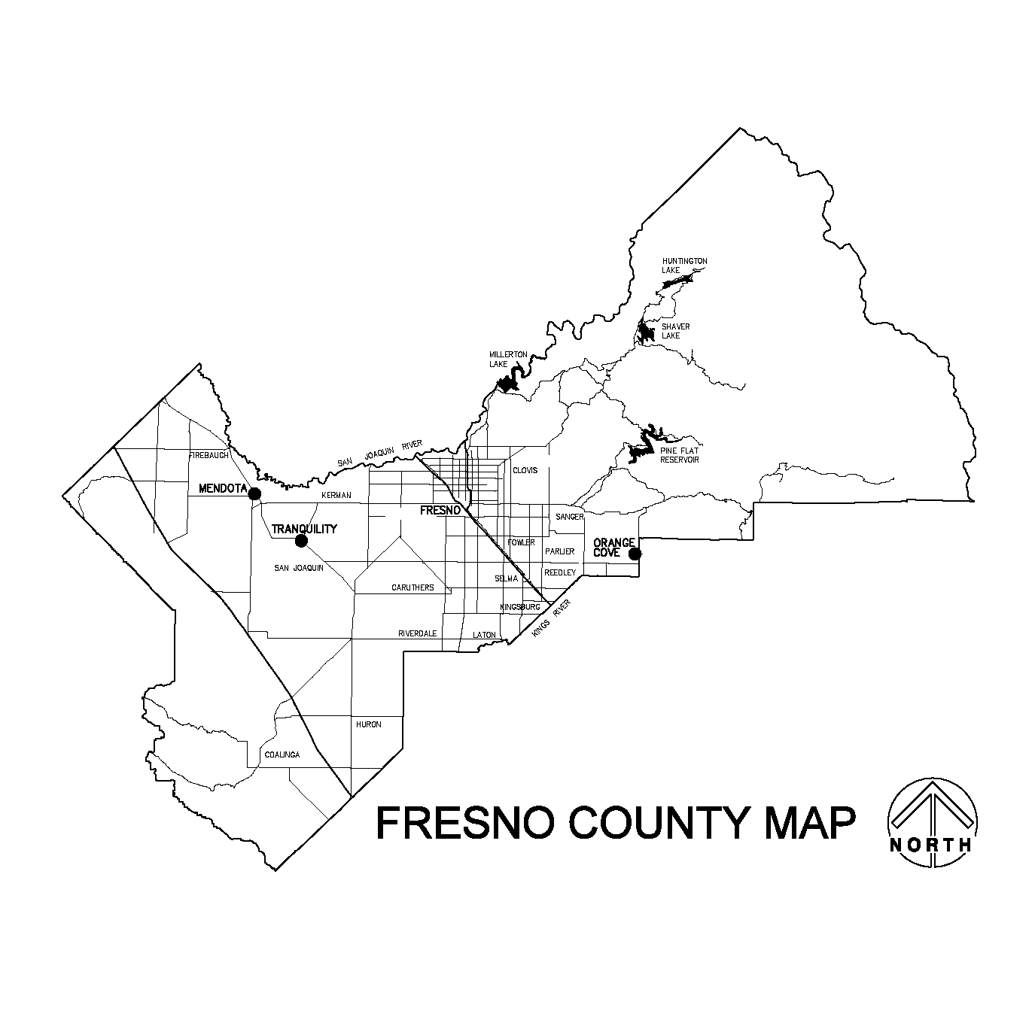

COUNTERTOP, END PANEL AND OPAC DETAIL
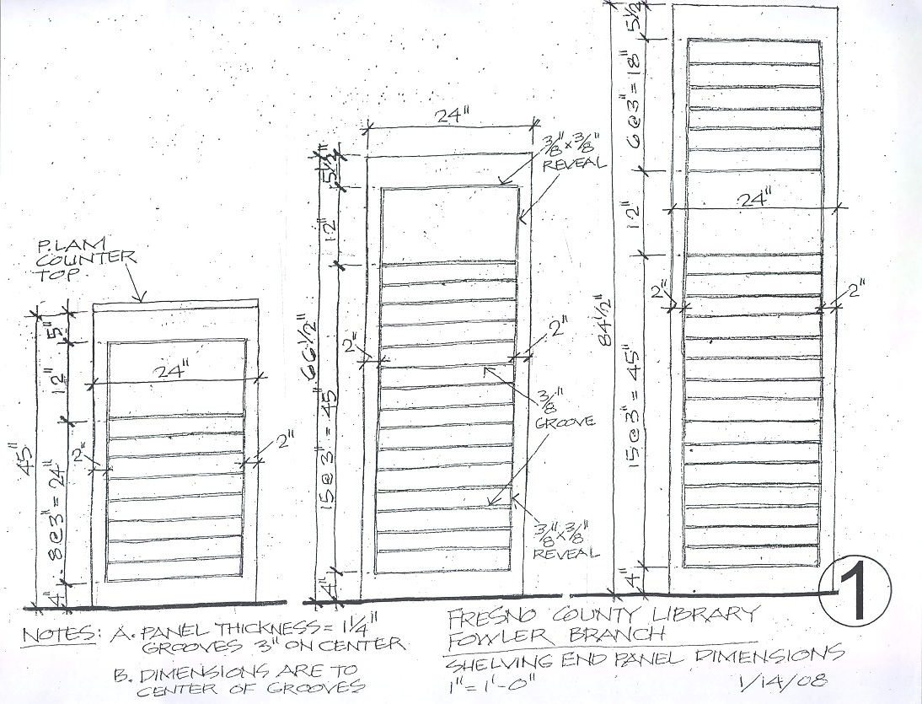

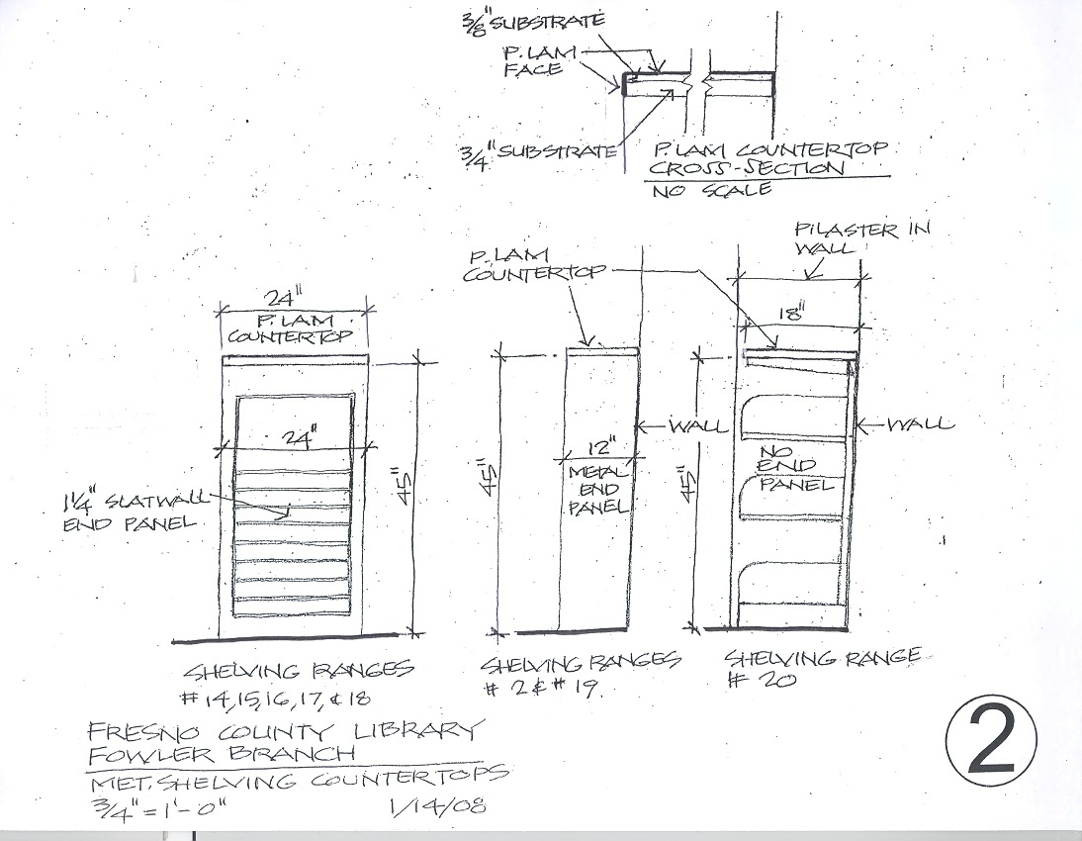

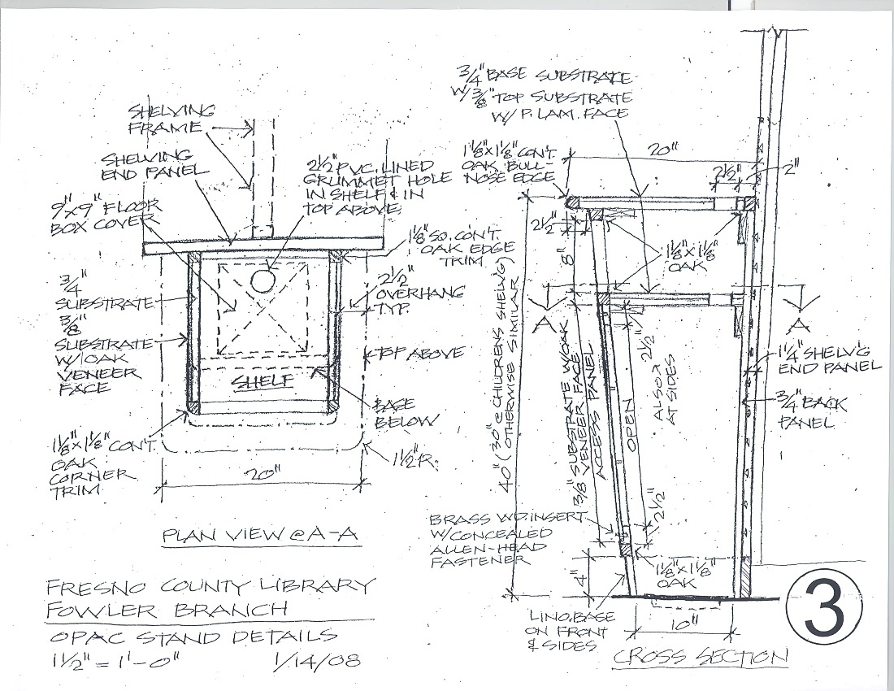

BOOKSHELF DETAIL
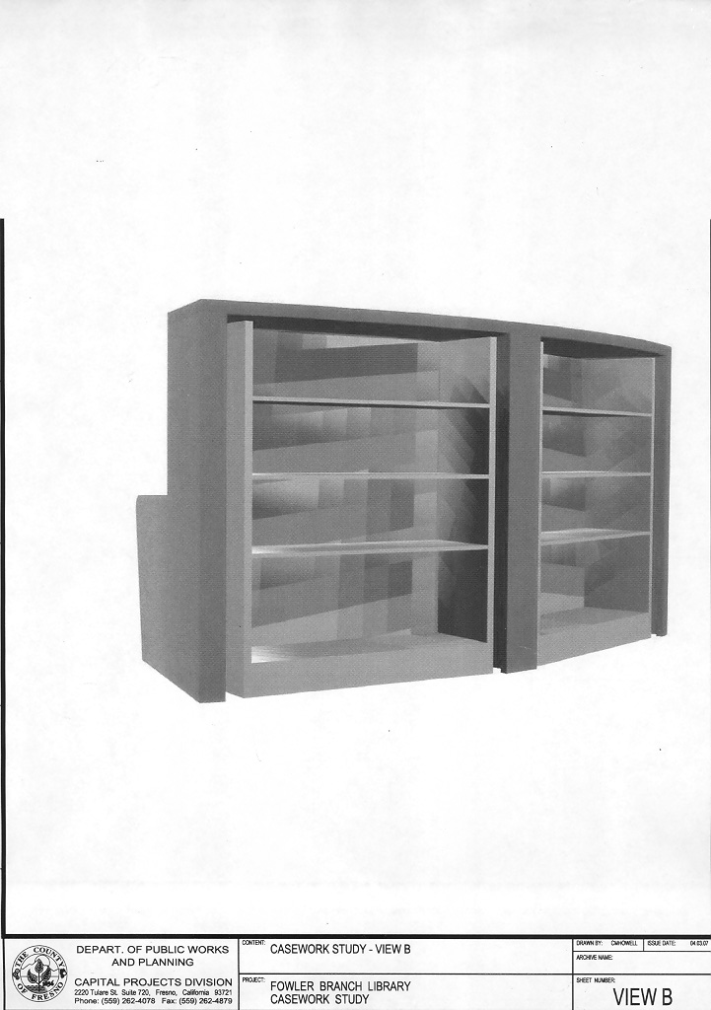
SUBMITTALS
The bidder shall provide the following with their quotation:
- The completed and signed Page One of this RFQ.
- Complete, sign and submit page one of each and all Addendums to this RFQ which require signature (if any).
- The specified number of copies of the bidder’s quotation.
- The completed Bidder to Complete page of this RFQ.
- The completed Quotation Schedule as provided with this RFQ.
- A list f all bidder exceptions to County’s requirements, conditions, and specifications as stated within this RFQ.
- Specifications, descriptions etc. for items offered under the bidder’s quotation.
- A description of the design and techniques that the bidder will use to complete the project.
- Submit your quotation/proposal prior to the specified date and time. Submit in a sealed envelope, box, etc. with the following information displayed on the outside:
County of Fresno RFQ No. |  |  | 525-4528
Closing Date: | March 18, 2008
Closing Time: | 2:00 P.M.
Commodity or Service:

