COUNTY OF FRESNO
ADDENDUM NUMBER: TWO (2)
 |  |  | RFQ NUMBER:
March 14, 2007
 |  |  |  | PURCHASING USE
 |  | ORG/Requisition: [org]-/ [requisition]- |  |  | jol | /tmp/in/input.doc
 | IMPORTANT: SUBMIT QUOTATION IN SEALED PACKAGE WITH QUOTATION NUMBER, CLOSING DATE AND BUYER’S NAME MARKED CLEARLY ON THE OUTSIDE TO:
COUNTY OF FRESNO, Purchasing
4525 EAST HAMILTON AVENUE
FRESNO, CA 93702-4599
Closing date of bid will be at 2:00 p.m., on April 4, 2007.
QUOTES WILL BE CONSIDERED LATE WHEN THE OFFICIAL PURCHASING TIME CLOCK READS 2:00 P.M.
 | Quotes will be opened and publicly read at that time. All quotation information will be available for review after contract award.
 | Clarification of specifications are to be directed to: Cathi J. Peters, phone (559) 456-7110, FAX (559) 456-7831.
NOTE THE following and attached ADDITIONS, DELETIONS AND/or CHANGES TO THE REQUIREMENTS OF REQUEST FOR QUOTATION NUMBER: AND INCLUDE THEM IN YOUR RESPONSE. PLEASE SIGN AND RETURN THIS ADDENDUM WITH YOUR QUOTATION.
- Clarifications from Bidders Conference February 23, 2007
- Questions Received from Vendors
- Replace page 26 with revised page 26, section 10. 11.1, changes in bold.
- Replace “Quotation Schedule, page 32 with revised Quotation Schedule, changes in bold.
- Revised End Panel Drawing page 34
- End Panel Detail Page 34A

ACKNOWLEDGMENT OF ADDENDUM NUMBER TWO (2) TO RFQ
COMPANY NAME:
(PRINT)
SIGNATURE:
NAME & TITLE:
(PRINT)
Pre-Bidders Conference
Request for Quotation Number: 525-4391
Mendota Branch Library Shelving
Listed below are questions and responses related to RFQ 525-4391 – Mendota Branch Library Shelving:
1. Q: Will the successful bidder have ready access to the building and where will vendor’s park their vehicles during the installation process?
R: The construction of the building is on schedule, which means the shelving vendor should have access to the building in August 2007. As such, the vendor should have ready access and parking should be plentiful.
2. Q: Will a shelving sample be required?
R: Page 7 and Page 21, section 8.3.1 of the RFQ, leaves it to the discretion of County staff to determine whether a shelving sample will be required.
3. Q: Is there a list of acceptable manufactures?
R: Yes, please see list of acceptable manufactures on page 19 of the RFQ.
4. Q: Is prevailing wage required as part of this job.
R: Due to the State participation in this project, prevailing wage is required (see page 17)
5. Q: During the installation process, will there be someone on-site to report previous damage to the carpet, walls, etc. so the shelving installer is not held responsible for damages caused by others?
R: A County inspector will be present to report these types of damages.
6. Q: Will the County be requiring standard shelving finishes?
R: Shelving finishes are standard.
7. Q: Regarding other branches that will be built in the near future, are they included in this bid?
R: No, this bid is only for the Mendota Library Project.
8. Q: What is the requirement for securing the shelving to the slab?
R: See shelving anchoring requirements on page 18 of the RFQ.
Note: Regarding the Collection Catalog Stand (End panel Detail drawing on page 34), the successful bidder will responsible for providing and installing this equipment per the attached drawing. Laminate finishes will be selected by the County at a later date. Wood base and trim finishes are the same as in counter tops listed on page 27.

“VENDOR QUESTIONS”
System Concept Questions received March 5, 2007
Q: In 10 Schedule of Equipment, Paragraph 10.16 Media Cabinet (C). There is no Media Cabinet noted in the Quotation Schedule. Are Media Cabinets to be included and if so what size? What is the Media to be stored?
R: The Media Cabinet referenced in the Schedule of Equipment is not part of this RFQ.
.Q: In 10.5 canopies are double canopy tops acceptable for double faced sections in lieu of two single canopy tops?
R: Yes, this is acceptable.
Q: The Quotation Schedule has a section SHELVING TYPE BY RANGE that refers back to 10 Schedule of equipment. On Plan FF-1.0 the shelving sections are referred to as, for example E1.01 and E1.02. What is the meaning of .01 and .02 designation?
R: The designation defines various parts of the collection and its location. These designation are for Library use only.
Q: Quotation Schedule and 10 Schedule of Equipment: What is the shelving depth?
R: The Standard [S] shelving depth is 12” nominal for single face and 24” nominal for double face. Other shelving depths are specified on page 26 of the RFQ.
Q: Counter Tops and End Panels will be provided by Shelving Contractor for 45” high shelving and Cantilever Shelving as noted in Quotation Schedule only. Please confirm.
R: Yes, the counter tops and end panels are to be provided by shelving contractor. Regarding the 45” high shelving, the end panels will be flush with the counter tops (i.e., will not extend 2” above counter tops). In all other cases, the end panels will extend 2” above the canopy tops.
Q: Page 34 End Panel Detail. Shelving Contractor to provide PVC lined hole through end panel only. Catalog Stand by Others. Please confirm.
R: End panels and catalog stands will be provided by the shelving contractor per attached drawings.
Q: 10.21.1 contains a statement finish as called out on drawings and in Quotation Schedule Instructions 7.f. See drawings for extent of colors and designs. Is there more information in the drawings on material, color or designs for the counter tops and end panels than provided in RFQ? If so, please provide.
R. Please see attached drawings for material, color and design of counter tops and end panels.
Hopley Company Inc. Questions received February 28, 2007
Q: No shelving depths are mentioned. All single face to be 12” nominal and all double face to be 24” nominal?
R: The Standard [S] shelving depth is 12” nominal for single face and 24” nominal for double face. Other shelving depth are specified on page 26 of the RFQ
Q: Specifications [10.21.2] refer to an end panel drawing. I do not have a drawing. Please supply. I have a drawing of the collection catalog stand. Is the catalog stand part of our scope? If so, were do they go?
R: Catalog stand are to be attached to designated end panels noted on the floor plan as OPAC (e.g., locations Spanish Language, Children’s Library Area, Reference/Fiction Collection.)
Q: In the specification, you describe an end panel that extends above the top canopies by 2”. All units get top canopies either steel or laminate so are all end panels to be 2” above the top? So the 45” counter tops will fit inside of the end panel? [10.21.2]
R: Regarding the 45” high shelving, the end panels will be flush with the counter tops (i.e., will not extend 2” above counter tops). In all other cases, the end panels will extend 2” above the canopy tops.

described above.
10.9 Divider shelves [D]
Manufacturer's standard cantilever shelf configuration, size as listed on shelving worksheet. Divider shelves to have backs and bases with slots 1" o.c. to accept and hold firm 8" high metal dividers. Provide five (5) dividers per shelf, unless otherwise noted. 12" deep shelves to have 8" high metal dividers.
10.10 Periodical shelves [P]
Hinged periodical shelves to be a 14" high sloping shelf with a standard lip, nominal 12" base. Provide hinged type shelf with 12" deep flat shelf for back issues. Hinge mechanisms must lock into horizontal position (open) position and pose no hazard to users.
10.11 Newspaper shelves [N]
Newspaper shelves, nominal 15” base, shall be constructed as hinged periodical shelves with the addition of a hinged acrylic cover on each retractable shelf to retain newspapers in an upright position. Hinge mechanisms must lock into horizontal position (open) position and pose no hazard to users.
10.11.1Literacy shelves [O]
Literacy shelves nominal 18” deep. Divider shelves to have backs and bases with slots 1” o.c. to accept and hold firm 8” high metal dividers. Provide five (5) dividers per shelf. Provide six (6) shelves per section.
10.12 Universal Back Angled Display Divider shelves [U]
Divider shelf with bottom support and back angled 8 degree on shelf bracket to allow face out or spine out viewing of videocassettes or other materials, nominal 10”/12” base shelf. (5) Dividers per shelf, adjustable on 1" increments. All shelves per section must be Owner adjustable to sloped back or flat position.
10.13 Browsing box [B]
Pull out single tier browsing box with minimum (2) movable dividers per shelf. Front of box height to be 4" maximum.
10.14 Zigzag display backstop [Z]
4" high zigzag back support to match shelving.
10.15 Media Hanging Bar [H]
Brackets with hanger rod for hanging plastic media bags. Finish to match shelving.
10.16 Media Cabinet [C]
Metal media cabinet, door to lock. Finish to match shelving.
10.17 Spinner Towers
Standard 66" shelving, remove shelves and insert 2 paperback spinner towers per 36" section. Spinner Towers to be Gressco # 3620 6-tier plex paperback tower in Adult areas and Gressco # 3619 5-tier large paperback tower in children's area. Spinner towers must be securely attached to base and canopy. Color to be selected from manufactures standards. Gressco 800.345.3480
10.18 End panel brackets
Provide exact sizes required. All brackets and hardware to attach end panels to shelving uprights are to be provided for each range of shelving (two end panels per range). End panels are to be attached at three points along the vertical upright for secure and stable situation. Provide same with appropriate screws to end panel supplier.
10.19 Finishes
10.19.1 Color for all painted metal, including base, uprights, etc., except end
Firm:
QUOTATION SCHEDULE
AREA | LOCATION | END  PANEL  QTY. | RANGE  QTY. | SECTION QTY. PER RANGE | SHELVING  TYPE BY  RANGE | COMPONENTS | UNIT COST PER RANGE | EXTENDED  COST
P1, A1 | Spanish Lang. | 1 | 1 | 3, 1DF | 66SP/66D | 3 sections of spinners, 1 – 66D
R1 | Young Adult | 2 | 1 | 2, 3DF | 66SP/66P | 2 sections of spinners, 3 – 66P
A1, R1 | Young Adult, Media |  | 1 | 15SF | 66S/66P/ 66B/66U | 6 – 66S, 1 – 66P, 5 – 66B, 3 – 66U with corner filler
A1 | Media | 1 | 1 | 1SF | 66U
D2 | Workroom |  | 1 | 6DF | 90P
D2 | Workroom |  | 1 | 5DF | 90S
D1 | Checkout | 2 |  | 1SF | 84P
D2 | Work room |  | 1 | 1SF | 90P
H1 | Custodial |  | 1 | 2SF | 90S
H1 | Custodial |  | 1 | 1SF | 90S
J2 | ESL Office | 1 | 1 | 3SF | 84P
J2 | ESL Office | 1 | 1 | 2SF | 840 | 2 sections-840 18” with corner filler
N1 | Outreach | 1 | 1 | 3DF | 90S
B1 | Librarian | 2 | 1 | 2SF | 90S
 | Various Locations | 6 Catalog Stands Units |  |  |  | In the specifications, Catalogs Stands are referred to as OPAC units.
 |  |  |  |  |  | Product Subtotal |  | $
 |  |  |  |  |  | Installation |  | $
 |  |  |  |  |  | 7.975% Sales Tax |  | $
 |  |  |  |  |  | Total |  | $
BONDS
Bonds shall be provided if requested by the County of Fresno.
100% Performance Bond, Labor and Materials Bond | 1 | LOT | $

END PANEL DETAIL
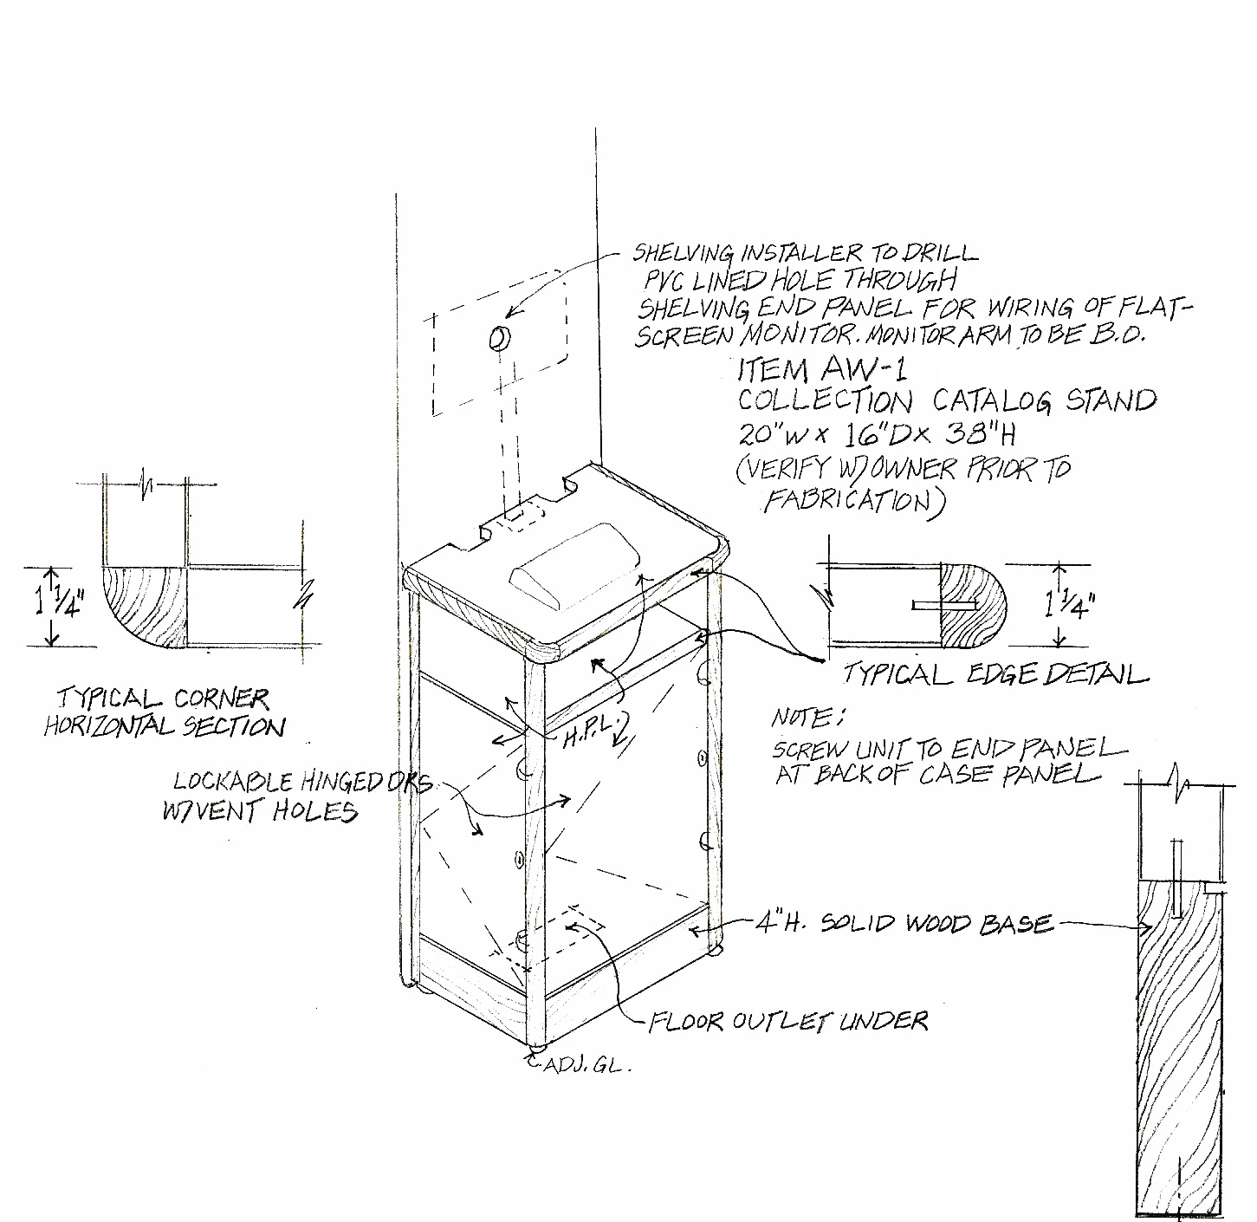

ADDITIONAL DETAIL
END PANELS
