 | THE COUNTY OF FRESNO IS SOLICITING BIDS FOR THE ITEM(S) LISTED BELOW. “Bidding Instructions” Pages 2 through 17 are attached as an integral part of this Request for Quotation.
 | Cast Bronze Plaque, Ground Breaking | 2 | EA | $ | $

 | Cast Bronze Plaque, Dedication | 2 | EA | $ | $

TRADE IN:
The following plaques may be offered as trade-in against the purchase of the new plaques. The plaques are installed at the Juvenile Justice Campus, 3333 East American Ave. Fresno, CA. The plaques are offered as-is and the successful bidder will be responsible for removal and transport. Do Not figure the trade-in allowance into the unit price. The County of Fresno reserves the right to reject or accept trade-in offer.

- 1 | Cast Bronze Dedication Plaque,Size:  2’-0” x 3’-4” | 2 | EA | $ | $

BIDDING INSTRUCTIONS
CONTRACT SUPPLIES
The County of Fresno Purchasing on behalf of Public Works-Design is soliciting bids for the purchase of four (4) cast bronze plaques as specified within this Request for Quotation.
The Request for Quotation is for two (2) separate design cast bronze plaques. The first cast bronze plaque is in commemoration of the ground breaking and the second is for the dedication of the Juvenile Justice Campus. The Request for Quotation is for a total of four (4) plaques, two (2) of each design.
The requested delivery of the plaques is currently scheduled for Friday, November 17, 2006, however this date may be adjusted to as late as Friday, December 22, 2006.
The County of Fresno currently has two (2) dedication plaques installed at the Juvenile Justice Campus and may offer these as trade-in against the purchase of the new plaques.
LOCAL VENDOR PREFERENCE: The Local Vendor Preference applies to this Request for Quotation.
AWARD: The award will be made to the vendor(s) whose product, price, delivery and service is deemed most advantageous to the County. The County will be the sole judge in making such determination.
COPIES: Submit one (1) original and two (2) copies of your quotation no later than the RFQ closing date and time as stated on the front of this document, to the County of Fresno Purchasing. Each copy to be identical to the original including all supporting documentation (i.e. literature, brochures, etc.). The cover page of each quotation is to be appropriately marked “Original” or “Copy”.
RIGHT TO REJECT BIDS: The County reserves the right to reject any and all bids and to waive informalities or irregularities in bids.
FIRM QUOTATION: All quotations shall remain firm for at least one hundred twenty (120) days.
SALES TAX: The County of Fresno is responsible for California State Sales Tax in the amount of 7.975% regardless of the vendor’s place of doing business.
INTERPRETATION OF REQUEST FOR QUOTATION: Vendors must make careful examination of the requirements, specifications and conditions expressed in the Request for Quotation and fully inform themselves as to the quality and character of the product required. If any person planning to submit a Quotation finds discrepancies in or omissions from the Request for Quotation or has any doubt as to the true meaning or interpretation, correction thereof may be requested in writing or by Fax (Fax No. (559) 456-7831) from Purchasing. The deadline for submitting requests for clarification is August 15, 2006 8:00 A.M.
Any change in the RFQ will be made only by written addendum, duly issued by the County. The County will not be responsible for any other explanations or interpretations.
Contact with County Departments during the bid period is prohibited unless first approved by the buyer whose name appears on page one (1). Failure to comply with this request will be considered cause to reject bid.
SPECIFICATIONS & EQUALS: Brand names, where used, are a means of establishing quality and style. Bidders are invited to quote their equals. Alternate offers are to be supported by literature which fully describes items that you are bidding.
No exceptions to or deviations from this specification will be considered unless each exception or deviation is specifically stated by the bidder, in the designated places. If no exceptions or deviations are shown the bidder will be required to furnish items exactly as specified herein. The burden of proof of compliance with this specification is the responsibility of the bidder.
ALTERNATES MAY BE ACCEPTED: The county reserves the right to permit deviations from the specifications if an article offered is substantially in accord with the specifications and is deemed by the County to be satisfactory for its intended use as an article fully meeting specifications. The County will be the sole judge in the determination of acceptable deviations. Unless exceptions are noted by bidder, the article offered will be assumed to be in accord with specifications.
LITERATURE: Bidders shall submit literature, which fully describes items on which they are bidding, not later than the closing date of this bid. Any and all literature submitted must be stamped with bidders name and address.
GUARANTEE AGAINST DEFECTS: All items are to carry a full guarantee against defects in materials and workmanship and guarantee against breakage and other malfunctions when performing work for which they are designed.
INVOICING: All invoices are to be mailed in duplicate to the County of Fresno, ship-to-address unless otherwise noted on the purchase order. Reference shall be made to the purchase order number.
HOLD HARMLESS CLAUSE: Contractor agrees to indemnify, save, hold harmless and at County's request, defend the County, its officers, agents and employees, from any and all costs and expenses, damages, liabilities, claims and losses occurring or resulting to County in connection with the performance, or failure to perform, by Contractor, its officers, agents or employees under this Agreement and from any and all costs and expenses, damages, liabilities, claims and losses occurring or resulting to any person, firm or corporation who may be injured or damaged by the performance, or failure to perform, of Contractor, its officers, agents or employees under this Agreement.
DELIVERY: Quotations are to be F.O.B. Destination.
BIDDER TO COMPLETE THE FOLLOWING:
GUARANTEED DELIVERY: Bidder will be considered in award of bid only if they can guarantee delivery as specified on page 3. Enter guaranteed delivery on this line (i.e. number of days from receipt of order to delivery):
By: | (Authorized Signature)
State Purchase Order mailing address:
FAX Number:
Phone Number:
E-mail Address:

Vendor must complete and return with Request for Quotation.
Firm:
REFERENCE LIST
The bidder shall submit a list of at least three (3) customer references. Such references shall be customers for whom the vendor has recently performed similar services.
Reference Name: |  |  | City:
Contact: |  |  | Phone No.:
Date and Service Provided:
Reference Name: |  |  | City:
Contact: |  |  | Phone No.:
Date and Service Provided:
Reference Name: |  |  | City:
Contact: |  |  | Phone No.:
Date and Service Provided:
Reference Name: |  |  | City:
Contact: |  |  | Phone No.:
Date and Service Provided:
Reference Name: |  |  | City:
Contact: |  |  | Phone No.:
Date and Service Provided:
FAILURE TO PROVIDE A LIST OF AT LEAST THREE (3) CUSTOMERS MAY BE CAUSE FOR REJECTION OF THIS RFQ.

LOCAL VENDOR PREFERENCE GENERAL CONDITIONS
- LOCAL VENDORS
  - Local Vendor Preference (applicable to RFQ Process only)
The following provisions are applicable only to the County’s acquisition of materials, equipment or supplies through the RFQ process when the funding source does not require an exemption to the Local Vendor Preference.
THE PROVISIONS OF THIS PARAGRAPH ARE APPLICABLE, NOTWITHSTANDING ANY OTHER PROVISIONS OF THIS RFQ TO THE CONTRARY
If the apparent low bidder is not a local vendor, any local vendor who submitted a bid which was within five percent (5%) of the lowest responsive bid as determined by the purchasing agent shall have the option of submitting a new bid within forty-eight hours (not including weekends and holidays) of County’s delivery of notification. Such new bids must be in an amount less than or equal to the lowest responsive bid as determined by the purchasing agent. If the purchasing agent receives any new bids from local vendors who have the option of submitting new bids within said forty-eight hour period, it shall award the contract to the local vendor submitting the lowest responsible bid. If no new bids are received, the contract shall be awarded to the original low bidder as announced by the purchasing agent.
  - Local Vendor Defined
“Local Vendor” shall mean any business which:
- Has its headquarters, distribution point or locally-owned franchise located in or having a street address within the County for at least six (6) months immediately prior to the issuance of the request for competitive bids by the purchasing agent; and
- Holds any required business license by a jurisdiction located in Fresno County; and
- Employs at least one (1) full-time or two (2) part-time employees whose primary residence is located within Fresno County, or if the business has no employees, shall be at least fifty percent (50%) owned by one or more persons whose primary residence(s) is located within Fresno County.
Local Vendor Preference
The County of Fresno Local Vendor Preference is applicable to this Request for Quotation. Refer to the General Conditions section for details.
Qualified Vendors that desire consideration as a Fresno County Local Vendor under this RFQ must complete the “Statement of Local Vendor Certification” contained herein and submit it as a part of their quotation. Late submittals of the “Statement of Local Vendor Certification” will not be considered. Submission of this statement will qualify the vendor for treatment as a local vendor for purposes of this RFQ only. The statement made under this RFQ shall not qualify the vendor as a local vendor under any other RFQ.
Local Vendor Certification:
Any vendor claiming to be a local vendor, as defined under the General Conditions section of this RFQ, shall so certify in writing to the purchasing agent. The purchasing agent shall not be required to verify the accuracy or any such certifications, and shall have sole discretion to determine if a vendor meets the definition of “local vendor.”
Any person or business falsely claiming to be a local vendor under this section shall be ineligible to transact any business with the County for a period of not less than three (3) months and not more twenty-four (24) months as determined in the sole discretion of the purchasing agent. The purchasing agent shall also have the right to terminate all or any part of any contract entered into with such person or business.
STATEMENT OF LOCAL VENDOR CERTIFICATION
COUNTY OF FRESNO
Qualified local vendors desiring consideration under the Fresno County Local Vendor Preference must complete the following and submit with their quotation (print or type).
I |  |  |  |  |  | ,
 | (individual submitting bid) |  |  |  |  |  | (title)
Of/for |  |  |  | Certify that
 |  | (Company Name) |  |  |  |  |  | (Company Name)
Is a Fresno County local Vendor as defined under the General Conditions section of this RFQ and therefore qualifies for the Local Vendor Preference.
Signature |  |  |  |  | Title |  |  |  |  | Date

NOTIFICATION OF RE-BID
The local vendor will be notified of his/her opportunity to re-bid under Fresno County’s Local Vendor Preference. The Vendor must submit his/her re-bid within forty-eight (48) hours of notification (excluding weekends and holidays). Notification will be issued by e-mail or Fax, whichever is preferred by the vendor. Notification to Vendor shall be considered complete upon County’s transmission of e-mail or Fax.
The local vendor shall state his/her preferred method of notification below along with the appropriate e-mail address or Fax number. Notification by County will be limited to one of those two (2) methods. It will be the local vendor’s responsibility to check his/her e-mail or Fax messages for notification. The vendor’s delay in receiving his/her notification will not alter the forty-eight (48) hour period allowed for re-bid submission.
Local Vendor To Complete:
Indicate *ONE method for notification of Local Vendor re-bid by providing the appropriate e-mail address or Fax number. Submit this document as a part of your quotation.
E-Mail Address or Fax Number (Identify contact person if using a Fax Number)
EXHIBITS
Exhibit A - County Seal
Exhibits B1 and B2 - Layouts for Cast Bronze Plaques
Exhibit C - Specification 10425-Signs
Exhibit D - Photograph of Sample Plaque
EXHIBIT A

EXHIBIT B-1
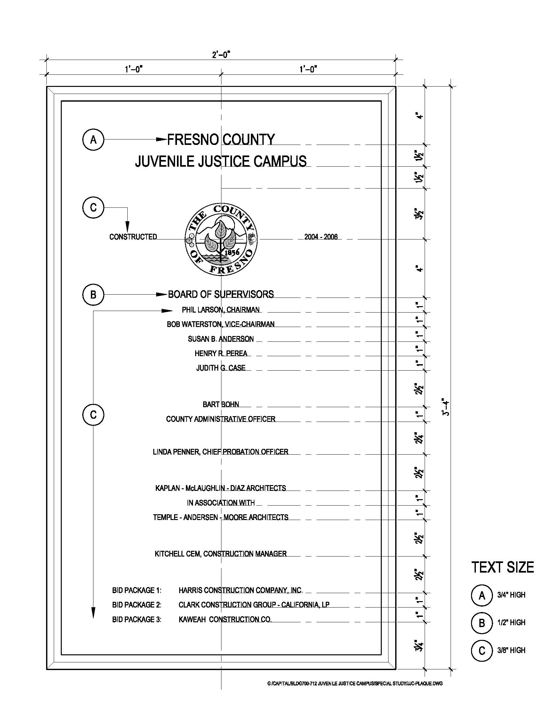
EXHIBIT B-2
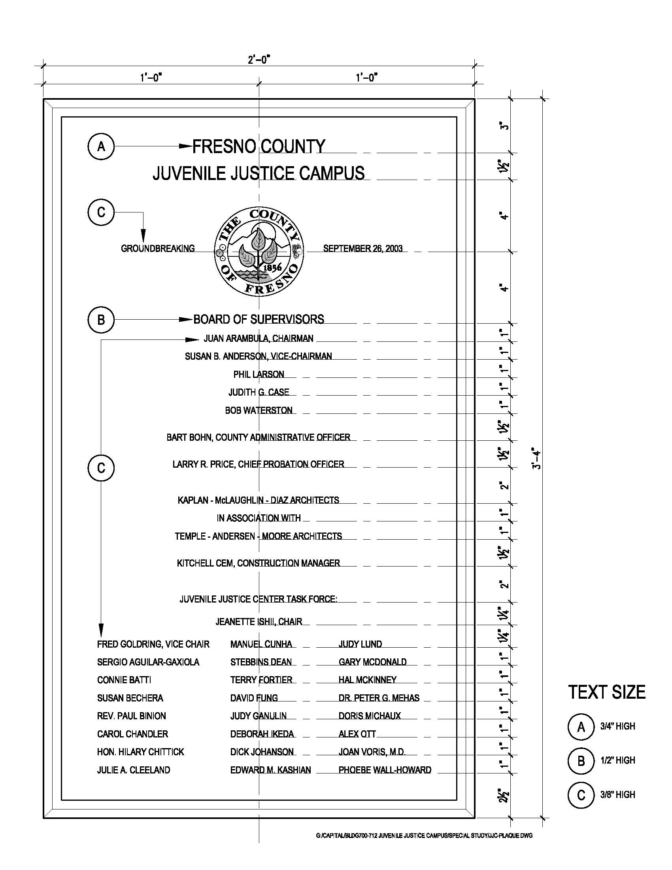
EXHIBIT C
SECTION 10425 – SIGNS
PART 1 - GENERAL
DESCRIPTION OF WORK:
Extent of specialty signs are shown on drawings
Exhibit A (County of Fresno Seal)
Exhibit B (Layouts for Cast Bronze Plaques)
Exhibit C (Specification 10425 – Signs)
Exhibit D (Photograph of Sample Plaque)
Forms of specialty signs required include the following:
Two (2) sets of two (2) identical cast metal plaques (total of four plaques) as shown on attached exhibits with blind mounting for installation on concrete wall. To be received and installed at the Juvenile Justice Campus no later than Friday, November 17, 2006. If delivery cannot be completed by the date indicated, the proposer shall specify the date delivery can be achieved.
QUALITY ASSURANCE:
Uniformity of Manufacturer: Sign form and graphic image process indicated, furnish products of a single manufacturer.
SUBMITTALS:
Shop Drawings: Successful vendor to submit shop drawings for fabrication and erection of specialty sign. Include plans, elevations, and large scale details of sign wording and lettering layout. Show anchorages and accessory items. Furnish location template drawings for items supported or anchored to permanent construction.
Furnish full-size rubbings for metal plaque.
Product Data: Submit manufacturer's technical data and installation instructions for type of sign required.
Samples: Submit samples of sign form and material showing finishes, colors, surface textures and qualities of manufacturer and design of each sign component including graphics.
Submit full-size sample units or rubbing of the proposed work prior to casting.
SIGNS | 10425 - 1

Acceptable units may be installed as part of the work.
PART 2 - PRODUCTS
Bronze Castings: Provide bronze casting, copper alloy UNS C83600, complying with the requirements of ASTM B 584. Background texture shall be pebble texture with a dark statuary oxidation.
Mounting: Concealed studs for substrates encountered.
FABRICATION:
Graphic content and Style: Provide sign copy and full size dedication board that compiles with the requirements indicated for style, spacing, content, position, material, finishes, and colors of letters, numbers, and other graphic devices. See attached Exhibits A, B and C.
Plaques: Castings shall be free from pits, scale, sand holes, or other defects with letters straight and true. Comply with requirements specified for metal, border style, background texture, and finish and with requirements shown for thickness, size, shape and copy. Hand-tool and buff borders and raised copy to produce the manufacturer’s standard satin polished finish. Refer to the “Finishes” Article for other finish requirements.
Metal: Bronze
Font: Helvetica
Border Style: Raised flat band with bevel
Background Texture: Manufacturer’s standard pebble texture
Background Finish: Provide dark statuary finish to comply with the requirement specified for bronze finishes, except provide background texture specified above in lieu of mechanical finish indicated.
FINISHES
Colors and Surface Textures: For exposed sign material that requires selection of materials with integral or applied colors, surface textures or other characteristics related to appearance, provide color matches indicated, or if not indicated, as selected by the County from the manufacturer’s standards.
Metal Finishes: Comply with NAAMM “Metal Finishes Manual” for finish designations and applications recommendations.
Bronze Finishes: Finish designations prefixed by “CDA” conform to the system established
SIGNS | 10425 - 2

by the copper Development Association for designating finishes.
Natural Satin Finish: CDA-M31O6x (Mechanical Finish: Fine satin directional textured; Clear Organic Coating: Manufacturer’s standard air-dry clear organic coating as specified below).
Clear Organic Coating: Air-dried acrylic coating Incralac as developed by International Copper Research Corporation, 1.0-mil minimum dry thickness.
Staturary Finish: Provide NAAMM-M-31-C55-06x (fine satin directional textured finish, sulfide conversion coating for chemical finish, with clear organic coating specified below).
Clear Organic Coating: Manufacturer’s standard clear coating.
PART 3 EXECUTION
SHIPPING INSTRUCTIONS
Plaques to be shipped to following address to arrive no later than date indicated:
Mr. Doug D. Barnard
Facility Services Division
Department of General Services
3333 East American Avenue
Fresno, California 93725
(559) 495-3764
END OF SECTION 10425
SIGNS | 10425 - 3

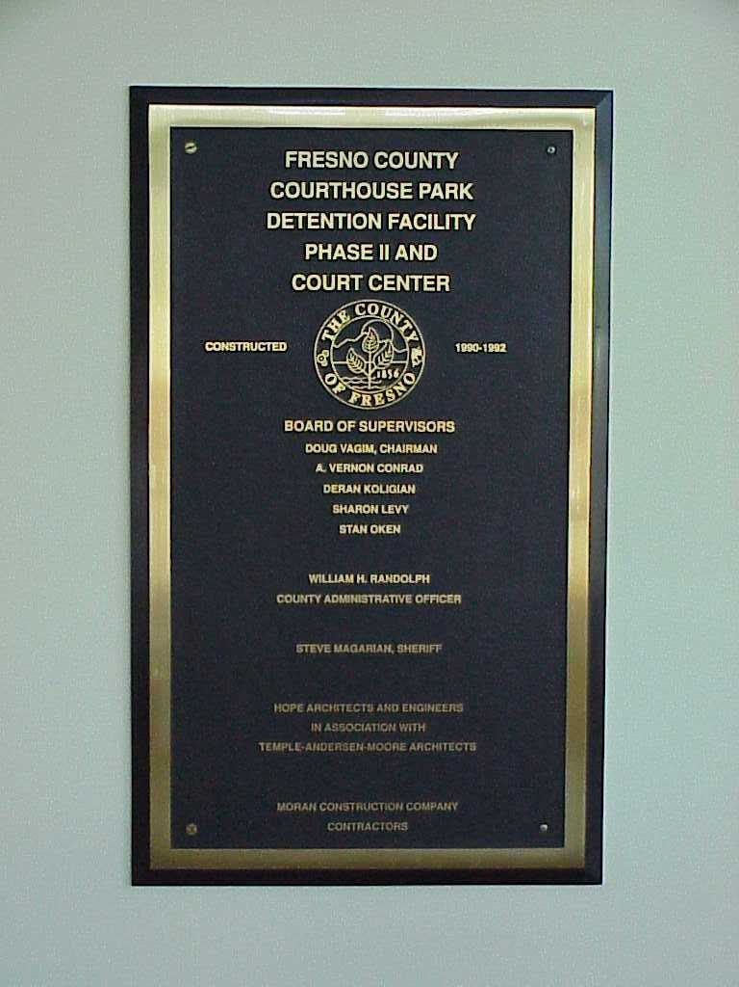
EXHIBIT D

