COUNTY OF FRESNO
ADDENDUM NUMBER: ONE (1)
 |  | RFP NUMBER:
October 21, 2008
 |  |  | PURCHASING USE
 |  |  |  | jol | /tmp/in/input.doc
IMPORTANT: SUBMIT PROPOSAL IN SEALED PACKAGE WITH PROPOSAL NUMBER, CLOSING DATE AND BUYER’S NAME MARKED CLEARLY ON THE OUTSIDE TO:
COUNTY OF FRESNO, Purchasing
4525 EAST HAMILTON AVENUE
FRESNO, CA 93702-4599
Closing date of proposal will be at 2:00 p.m., on OCTOBER 30, 2008.
PROPOSALS WILL BE CONSIDERED LATE WHEN THE OFFICIAL PURCHASING TIME CLOCK READS 2:00 P.M.
Proposals will be opened and publicly read at that time. All proposal information will be available for review after contract award.
Clarification of specifications are to be directed to: Ken Vozza, phone (559) 456-7110, FAX (559) 456-7831.
NOTE THE following and attached ADDITIONS, DELETIONS AND/OR CHANGES TO THE REQUIREMENTS OF REQUEST FOR PROPOSAL NUMBER: AND INCLUDE THEM IN YOUR RESPONSE. PLEASE SIGN AND RETURN THIS ADDENDUM WITH YOUR PROPOSAL.
- The closing date for RFP No. 393-4629 has been changed to October 30, 2008 at 2:00 P.M.

ACKNOWLEDGMENT OF ADDENDUM NUMBER ONE (1) TO RFP
COMPANY NAME:
(PRINT)
SIGNATURE:
NAME & TITLE:
(PRINT)

- Attached as EXHIBIT NO. ONE is an inventory of Central Kitchen equipment (excluding forklift and battery charger) that will be available for use by the contractor. The equipment listed on EXHIBIT NO. ONE shall be subject to all requirements stated under item III of the “SCOPE OF WORK-GENERAL” section of this RFP.
- The forklift and battery charger in use at the Central Kitchen are County owned; the contractor will have use of this equipment. The equipment shall be maintained by the contractor per the requirements of this RFP including those stated under item III of the “SCOPE OF WORK-GENERAL” section. This equipment will be subject to the $100,000 annual expenditure for the repair and replacement of small wares and capital kitchen equipment.
- The heated food carts currently in use at the Central Kitchen will not be made available to the awarded vendor. The vendor shall provide heated carts as is necessary to perform the specified services.
- The County and the successful bidder will conduct a site inspection at the Central Kitchen prior to commencement of the contract. The purpose of such inspection shall be to verify the existence and condition of all equipment that the contractor will be responsible for maintaining. This final inventory may differ slightly from the inventory provided with this RFP; in such case the verified inventory will be used for contract purposes. The new contractor will not be responsible for repairing equipment that is non-operational at the contract’s starting date.
- As stated under section V of the “SCOPE OF WORK-GENERAL” section: The “Contractor will use forklift drivers that are certified under a County approved Certification Program”.
Add the following to this section: “The contractor shall be responsible for all costs related to such certification.”
- The cost of meals under the current agreement with Aramark is shown below.
  - * Sheriff and Probation Staff - $1.567 per meal.
  - * Probation Juveniles - $2.043 per meal plus $0.45 for a daily snack.
  - * PHF Consumers - $3.039 per meal
  - * Kosher meals, regardless of facility - $3.38 per meal.
*Sales Tax to be added where appropriate.
- The vendor’s proposed cost shall indicate the pre-sales tax cost per meal. The amount of sales tax per meal and the total cost per meal including sales tax.
- The menus for the Sheriff (Corrections), Juvenile Justice Campus (JJC) and the Psychiatric Health Facility (PHF), as provided with the original RFP document under Attachment “E”, shall be deleted in their entirety. The menus provided with this Addendum No. ONE as EXHIBIT No. TWO shall be inserted in place of the deleted menus.
The menus provided with this Addendum are those which are currently in use; however, the bidder must be aware that such menus are to be considered “Sample Menus”. The menus to be used under the ensuing agreement will be approved by the County prior to the agreement’s start. The actual menus could differ slightly.
- A sample delivery schedule for meals at the jail facility is attached as EXHIBIT No. THREE. This is a sample reflects the current schedule; however, the actual schedule may be changed at any time at the Sheriff’s discretion.
- Reference ATTACHEMENT “G” (Kitchen Utility Expense) of the original RFP document. The listed sewer charge for 6/1/2008 is incorrect. The vendor is instructed to delete the amount shown (33394) and to insert the following amount $3,339.40.
- Reference SCOPE OF WORK-BEHAVORIAL HEALTH GROUP III. This section indicates that a sack lunch will be required when a consumer is discharged to another location. This requirement states that the sack lunch shall include a “soda”; the word “soda” shall be deleted and the word “beverage” shall be inserted in its place. The following shall be added to this section:
“Beverage shall be defined as a soda or juice which is stored in plastic bottling, or pouch, or carton (no aluminum or glass). Regular or diet type beverages for the sack lunches will be identified and requested by department program staff”.
- The cost per meal for jail inmate meals will be based on a sliding scale using inmate population to determine the meal cost. The inmate population used in determining meal cost will be the quantity stated when meals are ordered. This may potentially result in two different meal prices for one day.
- The required one hundred thousand dollar ($100,000.00) annual expenditure by contractor for the repair and replacement of small wares and capital equipment (see SCOPE OF WORK-GENERAL) does not include pest control services; the contractor will however be responsible for payment of such services.
- The quantity of sack lunches required for Booking, Work Programs, Transportation, etc. are included in the historical meal quantities provided in the original RFP document.
- Reference the “SCOPE OF WORK”, GROUP I – SHERIFF” section of the original RFP document. The following shall be added to Item Number 9 of the “Inmate Menus and Meals” subsection.
The quantity of participants in the Culinary Vocational Food Handler Program are listed below.
October 2007 through April 2008: 45 inmate participants
May 2008 to October 2008: 17 inmates have graduated from the program.
The bidder must note that the “Culinary Vocational Food Handler Program” may be discontinued at any time at the Sheriff’s discretion.
- Historical data relative to utilities, gas & electricity, waste disposal and repair expenditures is provided under EXHIBIT NO. FOUR.
- Reference to “COST PROPOSAL” section of the original RFP document.
The first page of this section, up to and including the “FAITHFUL PERFORMANCE BOND” subsection, shall be deleted in its entirety. The “REVISED COST PROPOSAL” section as included with this Addendum shall be inserted in its place.

revised COST PROPOSAL
- The bidder shall propose a per meal unit price for each of the three County Departments identified under this RFP (Sheriff Department, Department of Probation and Department of Behavioral Health).
- The proposed pricing shall include all food, labor, materials, transportation, utilities, taxes, fees, small wares etc. to provide all meals, snacks, bulk foods and services specified under this RFP; the Contractor shall conform to all requirements, terms and conditions set forth herein.
- The bidder’s proposed pricing shall reflect the use of the County’s Central Kitchen in accordance with the requirements of this RFP.
- The bidder must propose pricing for all three County Departments.
- The proposed pricing shall be based on a three (3) year contract term subject to the previously stated escalation provision.
- Pricing for the Sheriff (Jail) and the Juvenile Justice Campus shall be stated as a per meal or snack cost and shall be based on the facility’s daily population.
- The vendor shall complete the following Cost Proposal schedules; such schedules allow for different pricing in increments of one hundred inmates.
- The Cost Proposal Schedule for the Department of Behavioral Health is based on a per meal cost without use of a sliding price scale.

FAITHFUL PERFORMANCE BOND
Bidder shall quote the cost of a Faithful Performance Bond which guarantees their performance under the ensuing agreement. Such bond shall be in the amount of five hundred thousand dollars ($500,000.00) and shall be maintained for the agreement’s five (5) year term.
Faithful Performance bond - $500,000.00 / 5 years | $
The cost of bond will be added to the contract amount if required. Payment for the cost of bond will be made monthly in sixty (60) equal payments over the term of the agreement; County shall be invoiced separately each month for this charge.
exhibit no. one
CENTRAL KITCHEN
EQUIPMENT INVENTORY

EQUIPMENT | FR # | SERIAL #
40 GAL GAS TILTING | FR014435 | 600136
COMBI OVEN, RATIONAL CPC202 | FR077667 | E22CD0102104/9352
CONVECTION OVEN-SINGLE, VULC | FR077677 | 48-1429579
CONVECTION OVEN-SINGLE, VULC | FR077678 | 48-1432272
CONVECTION OVEN-SINGLE, VULC | FR077679 | 48-1432267
CONVECTION OVEN-SINGLE, VULC | FR077680 | 48-1429577
CONVECTION OVEN-SINGLE, VULC | FR077681 | 48-1432263
CONVECTION OVEN-SINGLE, VULC | FR077682 | 48-1432270
DEEP FAT FRYER 14" | FR006262 | 77J475IEY
FOOD CUTTER, VCM, HOBART HCM | FR077668 | 31-1240-261
FRYMASTER DEEP FRYER | FR010928 | 84D0031116
GRINDER, HOBART | FR005207 | 1595150
MEAT GRINDER, HOBART | FR010095 | 1303943
MIXER, HOBART | FR005216 | 1807623
MIXER, HOBART | FR010098 | 1293957
MIXER, HOBART | FR010105 | 11033780
POT WASHER, STERO U-31-A | FR077669 | 69566-9-01
REFRIGERATOR, COLD CABINET | FR077656 | 1029841
REFRIGERATOR, McCALL | FR077661 | S-774200
REFRIGERATOR, McCALL | FR077662 | S-774217
SLICER CART, SERVOLIFT | FR077670 | N/A
SLICER CART, SERVOLIFT | FR077671 | N/A
STANDING FAN DAYTON | FR017308 | N/A
STEAM COOKER, MARKET FORGE | FR077665 | 209501/2
STEAM COOKER, MARKET FORGE | FR077666 | 209497/8
STEAM KETTLE, MARKET FORGE | FR077663 | 208705
STEAM KETTLE, MARKET FORGE | FR077664 | 208704
STEAM TABLE STAINLESS STEEL | FR008297 | 81268205
TILT SKILLET, MARKET FORGE | FR077657 | 209532
TRAY CONVEYOR, CADDY RFC | FR077660 | N/A
TRAY RACK | FRO77632 | N/A
TRAY RACK | FRO77633 | N/A
TRAY RACK | FRO77634 | N/A
TRAY RACK | FRO77635 | N/A
TRAY RACK | FRO77636 | N/A
TRAY RACK | FRO77637 | N/A
TRAY RACK | FRO77638 | N/A
TRAY RACK | FRO77639 | N/A
TRAY RACK | FRO77640 | N/A
TRAY RACK | FRO77641 | N/A
TRAY RACK | FRO77642 | N/A
TRAY RACK | FRO77643 | N/A
TRAY RACK | FRO77644 | N/A
TRAY RACK | FRO77645 | N/A
TRAY RACK | FRO77646 | N/A
TRAY RACK | FRO77647 | N/A
TRAY RACK | FRO77648 | N/A
TRAY RACK | FRO77649 | N/A
TRAY RACK | FRO77650 | N/A
TRAY RACK | FRO77651 | N/A
TRAY RACK | FRO77652 | N/A
TRAY RACK | FRO77653 | N/A
TRAY RACK | FRO77654 | N/A
TRAY RACK | FRO77655 | N/A
TRAY RACK | FRO77656 | N/A
TRAY WASHER, STERO STW-110 | FR0077659 | 69567-9-0
WARMER CABINET | FR077658 | 102924
WORK TABLE 14", GEMINI | FR077672 | N/A
WORK TABLE 14", GEMINI | FR077673 | N/A
WORK TABLE 7", GEMINI | FR077674 | N/A
WORK TABLE 8", GEMINI | FR077675 | N/A
WORK TABLE 8", GEMINI | FR077676 | N/A

exhibit no. two
Menus
pROBATION mENU - 393-4629 Probation Menu.pdf
Corrections Menu - 393-4629 Corrections Menu.pdf
PHF MENU - 393-4629 PHF Menu.pdf
EXHIBIT NO. THREE
JAIL
SAMPLE DELIVERY SCHEDULE
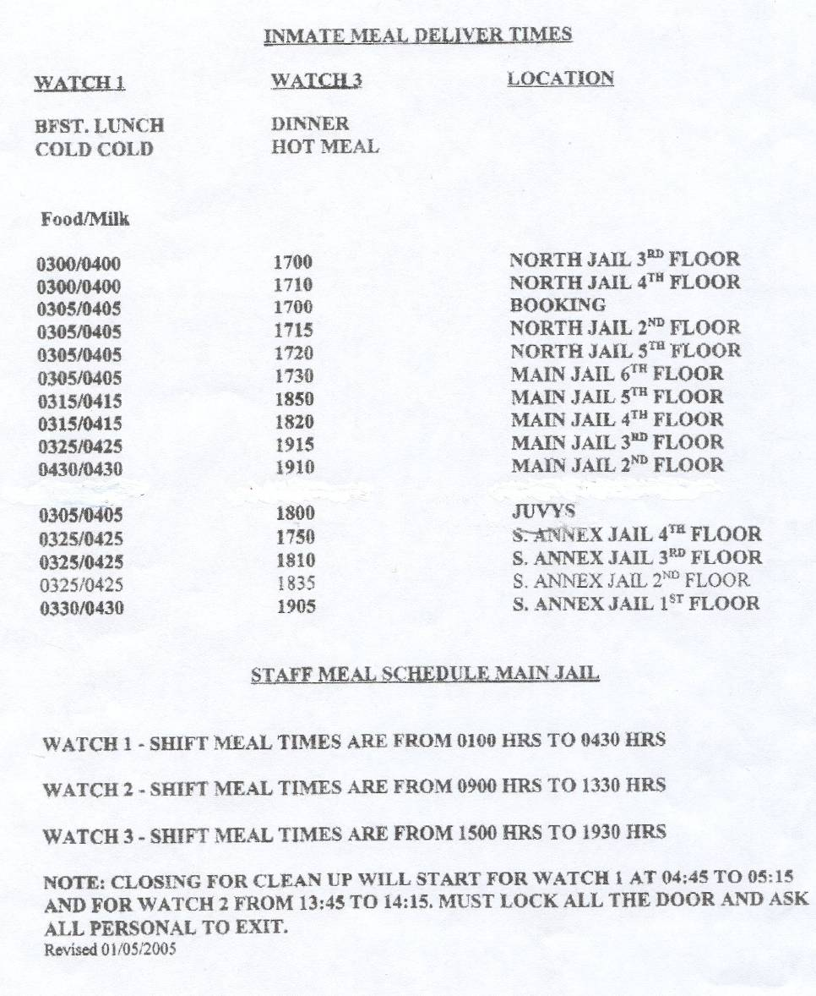

EXHIBIT NO. FOUR
HISTORICAL USAGE DATE
UTILITIES - 393-4629 YTD Muncipal Bill0001.pdf
GAS & ELECTRICITY - 393-4629 YTD PGE0001.pdf
WASTE DISPOSAL - 393-4629 YTD Waste Salvage0001.pdf
REPAIRS - 393-4629 Repair and Maintenance1.xls

