COUNTY OF FRESNO
Request for QUOTATION
 |  | NUMBER: 360-4479
August 8, 2007
ORG/Requisition: multi |  |  |  |  |  |  | PURCHASING USE |  |  |  | /tmp/in/input.doc
 |  |  |  |  |  |  | jlg
IMPORTANT: SUBMIT PROPOSAL IN SEALED PACKAGE WITH QUOTATION NUMBER, CLOSING DATE AND BUYER’S NAME MARKED CLEARLY ON THE OUTSIDE TO:
COUNTY OF FRESNO, Purchasing
4525 EAST HAMILTON AVENUE
FRESNO, CA 93702-4599
Closing date of bid will be at 2:00 p.m., on September 7, 2007.
QUOTATIONS WILL BE CONSIDERED LATE WHEN THE OFFICIAL PURCHASING TIME CLOCK READS 2:00 P.M.
Quotations will be opened and publicly read at that time. All quotation information will be available for review after contract award.
Clarification of specifications are to be directed to: CATHI J. PETERS, phone (559) 456-7110, FAX (559) 456-7831.
GENERAL CONDITIONS: See “County Of Fresno Purchasing Standard Instructions And Conditions For Request For Proposals (RFP’S) and Requests for Quotations (RFQ’S)” attached. Check County of Fresno Purchasing’s Open Solicitations website at www.co.fresno.ca.us/0440/Bidshome.asp for RFQ/RFP documents and changes.
BIDDER TO COMPLETE
UNDERSIGNED AGREES TO FURNISH THE COMMODITY OR SERVICE STIPULATED IN THE ATTACHED PROPOSAL SCHEDULE AT THE PRICES AND TERMS STATED, SUBJECT TO THE “COUNTY OF FRESNO PURCHASING STANDARD INSTRUCTIONS AND CONDITIONS FOR REQUEST FOR PROPOSALS (RFP’S) AND REQUESTS FOR QUOTATIONS (RFQ’S)”ATTACHED.
Except as noted on individual items, the following will apply to all items in the Quotation Schedule.
- Complete delivery will be made within |  |  |  |  |  |  |  | calendar days after receipt of Order.
- A cash discount of |  |  |  |  | % |  |  |  |  | days will apply.
Company
Address
City |  |  |  |  |  |  |  |  |  |  |  |  | State |  | Zip Code
( ) |  |  |  | ( )
Telephone Number |  |  |  | Facsimile Number |  |  |  |  |  |  |  |  | E-mail Address
Signed By
Print Name |  |  |  |  |  |  |  |  | Title

COUNTY OF FRESNO PURCHASING
STANDARD INSTRUCTIONS AND CONDITIONS FOR
REQUESTS FOR PROPOSALS (RFP'S) AND REQUESTS FOR QUOTATIONS (RFQ'S)
Note: the reference to “bids” in the following paragraphs applies to RFP's and RFQ's

GENERAL CONDITIONS
By submitting a bid the bidder agrees to the following conditions. These conditions will apply to all subsequent purchases based on this bid.

- BID PREPARATION:
  - All prices and notations must be typed or written in ink. No erasures permitted. Errors may be crossed out, initialed and corrections printed in ink by person signing bid.
  - Brand Names: Brand names and numbers when given are for reference. Equal items will be considered, provided the offer clearly describes the article and how it differs from that specified. In the absence of such information it shall be understood the offering is exactly as specified.
  - State brand or make of each item. If bidding on other than specified, state make, model and brand being bid and attach supporting literature/specifications to the bid.
  - Bid on each item separately. Prices should be stated in units specified herein. All applicable charges must be quoted; charges on invoice not quoted herein will be disallowed.
  - Time of delivery is a part of the consideration and must be stated in definite terms and must be adhered to. F.O.B. Point shall be destination or freight charges must be stated.
  - All bids must be dated and signed with the firm’s name and by an authorized officer or employee.
  - Unless otherwise noted, prices shall be firm for 120 days after closing date of bid.
- SUBMITTING BIDS:
  - Each bid must be submitted on forms provided in a sealed envelope with bid number and closing date and time on the outside of the envelope/package.
  - Interpretation: Should any discrepancies or omissions be found in the bid specifications or doubt as to their meaning, the bidder shall notify the Buyer in writing at once. The County shall not be held responsible for verbal interpretations. Questions regarding the bid must be received by Purchasing at least 5 working days before bid opening. All addenda issued shall be in writing, duly issued by Purchasing and incorporated into the contract.
  - ISSUING AGENT/AUTHORIZED CONTACT: This RFQ has been issued by County of Fresno Purchasing. Purchasing shall be the vendor’s sole point of contact with regard to the RFQ, its content, and all issues concerning it.
All communication regarding this RFQ shall be directed to an authorized representative of County Purchasing. The specific buyer managing this RFQ is identified on the cover page, along with his or her telephone number, and he or she should be the primary point of contact for discussions or information pertaining to the RFQ. Contact with any other County representative, including elected officials, for the purpose of discussing this RFQ, its content, or any other issue concerning it, is prohibited unless authorized by Purchasing. Violation of this clause, by the vendor having unauthorized contact (verbally or in writing) with such other County representatives, may constitute grounds for rejection by Purchasing of the vendor’s quotation.
The above stated restriction on vendor contact with County representatives shall apply until the County has awarded a purchase order or contract to a vendor or vendors, except as follows. First, in the event that a vendor initiates a formal protest against the RFQ, such vendor may contact the appropriate individual, or individuals who are managing that protest as outlined in the County’s established protest procedures. All such contact must be in accordance with the sequence set forth under the protest procedures. Second, in the event a public hearing is scheduled before the Board of Supervisors to hear testimony prior to its approval of a purchase order or contract, any vendor may address the Board.
  - Bids received after the closing time will NOT be considered.
  - Bidders are to bid what is specified or requested first. If unable to or willing to, bidder may bid alternative or option, indicating all advantages, disadvantages and their associated cost.
  - Public Contract Code Section 7028.15
Where the State of California requires a Contractor’s license, it is a misdemeanor for any person to submit a bid unless specifically exempted.
- FAILURE TO BID:
  - If not bidding, return bid sheet and state reason for no bid or your name may be removed from mailing list.
- TAXES, CHARGES AND EXTRAS:
  - County of Fresno is subject to California sales and/or use tax (7.975%). Please indicate as a separate line item if applicable.
  - DO NOT include Federal Excise Tax. County is exempt under Registration No. 94-73-03401-K.
  - County is exempt from Federal Transportation Tax. Exemption certificate is not required where shipping papers show consignee as County of Fresno.
  - Charges for transportation, containers, packing, etc. will not be paid unless specified in bid.
- W-9 – REQUEST FOR TAXPAYER IDENTIFICATION NUMBER AND CERTIFICATION:
Upon award of bid, the vendor shall submit to County Purchasing, a completed W-9 - Request for Taxpayer Identification Number and Certification if not already a current vendor with The County of Fresno. This form is available from the IRS to complete on line at http://www.irs.gov/pub/irs-pdf/fw9.pdf.
- AWARDS:
  - Subject to the local preference provisions referenced in Paragraph 6 below and more thoroughly set forth in the General Requirements section of this RFQ, award(s) will be made to the most responsive responsible bidder. The evaluation will include such things as life-cycle cost, availability, delivery costs and whose product and/or service is deemed to be in the best interest of the County. The County shall be the sole judge in making such determination.
  - Unless bidder gives notice of all-or-none award in bid, County may accept any item, group of items or on the basis of total bid.
  - The County reserves the right to reject any and all bids and to waive informalities or irregularities in bids.
  - After award, all bids shall be open to public inspection. The County assumes no responsibility for the confidentiality of information offered in a bid.
- LOCAL VENDORS
  - Local Vendor Preference (applicable to RFQ Process only)
The following provisions are applicable only to the County’s acquisition of materials, equipment or supplies through the RFQ process when the funding source does not require an exemption to the Local Vendor Preference.
THE PROVISIONS OF THIS PARAGRAPH ARE APPLICABLE, NOTWITHSTANDING ANY OTHER PROVISIONS OF THIS RFQ TO THE CONTRARY
If the apparent low bidder is not a local vendor, any local vendor who submitted a bid which was within five percent (5%) of the lowest responsive bid as determined by the purchasing agent shall have the option of submitting a new bid within forty-eight hours (not including weekends and holidays) of County’s delivery of notification. Such new bids must be in an amount less than or equal to the lowest responsive bid as determined by the purchasing agent. If the purchasing agent receives any new bids from local vendors who have the option of submitting new bids within said forty-eight hour period, it shall award the contract to the local vendor submitting the lowest responsible bid. If no new bids are received, the contract shall be awarded to the original low bidder as announced by the purchasing agent.
  - Local Vendor Defined
“Local Vendor” shall mean any business which:
- Has its headquarters, distribution point or locally-owned franchise located in or having a street address within the County for at least six (6) months immediately prior to the issuance of the request for competitive bids by the purchasing agent; and
- Holds any required business license by a jurisdiction located in Fresno County; and
- Employs at least one (1) full-time or two (2) part-time employees whose primary residence is located within Fresno County, or if the business has no employees, shall be at least fifty percent (50%) owned by one or more persons whose primary residence(s) is located within Fresno County.
- TIE BIDS:
All other factors being equal, the contract shall be awarded to the Fresno County vendor or, if neither or both are Fresno County vendors, it may be awarded by the flip of a coin in the presence of witnesses or the entire bid may be rejected and re-bid. If the General Requirements of this RFQ state that they are applicable, the provisions of the Fresno County Local Vendor Preference shall take priority over this paragraph.
- PATENT INDEMNITY:
The vendor shall hold the County, its officers, agents and employees, harmless from liability of any nature or kind, including costs and expenses, for infringement or use of any copyrighted or uncopyrighted composition, secret process, patented or unpatented invention, article or appliance furnished or used in connection with this bid.
- SAMPLES:
Samples, when required, must be furnished and delivered free and, if not destroyed by tests, will upon written request (within 30 days of bid closing date) be returned at the bidder's expense. In the absence of such notification, County shall have the right to dispose of the samples in whatever manner it deems appropriate.
- RIGHTS AND REMEDIES OF COUNTY FOR DEFAULT:
  - In case of default by vendor, the County may procure the articles or service from another source and may recover the cost difference and related expenses occasioned thereby from any unpaid balance due the vendor or by proceeding against performance bond of the vendor, if any, or by suit against the vendor. The prices paid by the County shall be considered the prevailing market price at the time such purchase is made.
  - Articles or services, which upon delivery inspection do not meet specifications, will be rejected and the vendor will be considered in default. Vendor shall reimburse County for expenses related to delivery of non-specified goods or services.
  - Regardless of F.O.B. point, vendor agrees to bear all risks of loss, injury or destruction to goods and materials ordered herein which occur prior to delivery and such loss, injury or destruction shall not release vendor from any obligation hereunder.
- DISCOUNTS:
Terms of less than 15 days for cash payment will be considered as net in evaluating this bid. A discount for payment within fifteen (15) days or more will be considered in determining the award of bid. Discount period will commence either the later of delivery or receipt of invoice by the County. Standard terms are Net Forty-five (45) days.
- SPECIAL CONDITIONS IN BID SCHEDULE SUPERSEDE GENERAL CONDITIONS.
The “General Conditions” provisions of this RFP/RFQ shall be superseded if in conflict with any other section of this bid, to the extent of any such conflict.
- SPECIAL REQUIREMENT:
With the invoice or within twenty-five (25) days of delivery, the seller must provide to the County a Material Safety Data Sheet for each product, which contains any substance on “The List of 800 Hazardous Substances”, published by the State Director of Industrial Relations. (See Hazardous Substances Information and Training Act. California State Labor Code Sections 6360 through 6399.7.)
- RECYCLED PRODUCTS/MATERIALS:
Vendors are encouraged to provide and quote (with documentation) recycled or recyclable products/materials which meet stated specifications.
- YEAR COMPLIANCE WARRANTY
Vendor warrants that any product furnished pursuant to this Agreement/order shall support a four-digit year format and be able to accurately process date and time data from, into and between the twentieth and twenty-first centuries, as well as leap year calculations. "Product" shall include, without limitation, any piece or component of equipment, hardware, firmware, middleware, custom or commercial software, or internal components or subroutines therein. This warranty shall survive termination or expiration of this Agreement.
In the event of any decrease in product functionality or accuracy related to time and/or date data related codes and/or internal subroutines that impede the product from operating correctly using dates beyond December 31, 1999, vendor shall restore or repair the product to the same level of functionality as warranted herein, so as to minimize interruption to County's ongoing business process, time being of the essence. In the event that such warranty compliance requires the acquisition of additional programs, the expense for any such associated or additional acquisitions, which may be required, including, without limitation, data conversion tools, shall be borne exclusively by vendor. Nothing in this warranty shall be construed to limit any rights or remedies the County may otherwise have under this Agreement with respect to defects other than year performance.
- PARTICIPATION:
Bidder may agree to extend the terms of the resulting contract to other political subdivision, municipalities and tax-supported agencies.
Such participating Governmental bodies shall make purchases in their own name, make payment directly to bidder, and be liable directly to the bidder, holding the County of Fresno harmless.
- CONFIDENTIALITY:
All services performed by vendor shall be in strict conformance with all applicable Federal, State of California and/or local laws and regulations relating to confidentiality, including but not limited to, California Civil Code, California Welfare and Institutions Code, Health and Safety Code, California Code of Regulations, Code of Federal Regulations.
Vendor shall submit to County’s monitoring of said compliance.
Vendor may be a business associate of County, as that term is defined in the “Privacy Rule” enacted by the Health Insurance Portability and Accountability Act of 1996 (HIPAA). As a HIPAA Business Associate, vendor may use or disclose protected health information (“PHI”) to perform functions, activities or services for or on behalf of County as specified by the County, provided that such use or disclosure shall not violate HIPAA and its implementing regulations. The uses and disclosures if PHI may not be more expansive than those applicable to County, as the “Covered Entity” under HIPAA’S Privacy Rule, except as authorized for management, administrative or legal responsibilities of the Business Associate.
Vendor shall not use or further disclose PHI other than as permitted or required by the County, or as required by law without written notice to the County.
Vendor shall ensure that any agent, including any subcontractor, to which vendor provides PHI received from, or created or received by the vendor on behalf of County, shall comply with the same restrictions and conditions with respect to such information.
- APPEALS
Appeals must be submitted in writing within seven (7) working days after the review committee notification of proposed recommendations. Appeals should be submitted to County of Fresno Purchasing, 4525 E. Hamilton Avenue, Fresno, California 93702-4599. Appeals should address only areas regarding RFP contradictions, procurement errors, quotation rating discrepancies, legality of procurement context, conflict of interest, and inappropriate or unfair competitive procurement grievance regarding the RFP process.
The Purchasing Manager will provide a written response to the complaint within seven (7) working days unless the complainant is notified more time is required.
If the protesting bidder is not satisfied with the decision of the Purchasing Manager, he/she shall have the right to appeal to the Purchasing Agent within seven (7) business days after notification of the Purchasing Manager’s decision.
If the protesting bidder is not satisfied with Purchasing Agent decision, the final appeal is with the Board of Supervisors.
- OBLIGATIONS OF CONTRACTOR:
  - CONTRACTOR shall perform as required by the ensuing contract. CONTRACTOR also warrants on behalf of itself and all subcontractors engaged for the performance of the ensuing contract that only persons authorized to work in the United States pursuant to the Immigration Reform and Control Act of 1986 and other applicable laws shall be employed in the performance of the work hereunder.
  - CONTRACTOR shall obey all Federal, State, local and special district laws, ordinances and regulations.

TABLE OF CONTENTS
PAGE
bidding instructions 3
REFERENCE LIST 9
Local Vendor Preference 10
PARTICIPATION 12
additional bidding information 13
Product information sheet-PETO 26 (OR EQUAL) 16
Product information sheet-madrid III (OR EQUAL) 17
Product information sheet-synthesis III (OR EQUAL) 18
Product information sheet-CHIT CHAT STYLE 59249 (OR EQUAL) 19
SPECIFICATIONS 20
PRODUCT SPECIFICATIONS ATTACHMENT “A” 26
CHECK LIST 31

bidding instructions
contract supplies
The County of Fresno Purchasing on behalf G.S. – Facility Services, is soliciting bids to establish an agreement for the purchase of Modular Carpet Tiles and Adhesive on an as needed basis as specified within this Request for Quotation.
The items listed on the Quotation Schedule are a small sampling of items purchased by various County Departments for a period of twelve (12) months and are being used for bidding purposes only. The County reserves the right to increase or decrease quantities and guarantees no minimum amount.
LOCAL VENDOR PREFERENCE: The Local Vendor Preference applies to this Request for Quotation.
REPORTS: Contractor upon request will provide annual reports for all products purchased under any agreement resulting from this Request for Quotation.
Report information to include usage (type and quantity of product purchased, manufacture and manufacture part number) dates of each purchase and price charged. Reports must be delivered to County of Fresno Purchasing, 4525 E. Hamilton Avenue, Fresno, California 93702, Attention: Cathi J. Peters not later than thirty (30) days following the date of the request. The agreement number should be referenced on all reports.
MULTIPLE DELIVERIES: This Request For Quotation reflects the needs of various County departments. Delivery will be required to each individual department.
NON-EXCLUSIVE: This will be a non-exclusive Agreement. The County of Fresno reserves the right to requote any of the items depending on department usage, increase in quantities, etc.
AWARD: Award will be made to the vendor whose product, price, delivery and service is deemed most advantageous to the County. The County reserves the right to make the award on the basis of the entire group, per line item basis or any combination of items. The County will be the sole judge in making such determination. The County reserves the right to make multiple awards.
FIRM QUOTATION: For purpose of award all quotations shall remain firm for one hundred twenty (120) days.
COPIES: Submit one (1) original and two (2) copies of your quotation no later than the RFQ closing date and time as stated on the front of this document, to County of Fresno Purchasing. Each copy to be identical to the original, including all supporting documentation (i.e. literature, brochures etc.). The cover page of each quotation is to be appropriately marked “Original” or “Copy”.
INTERPRETATION OF REQUEST FOR QUOTATION: Vendors must make careful examination of the requirements, specifications and conditions expressed in the Request for Quotation and fully inform themselves as to the quality and character of the product required. If any person planning to submit a Quotation finds discrepancies in or omissions from the Request for Quotation or has any doubt as to the true meaning or interpretation, correction thereof may be requested in writing, by Fax (Fax No. (559) 456-7831) or by e-mail (cpeters@co.fresno.ca.us ) from Purchasing. The deadline for submitting requests for clarification August 21, 2007 8:00 A.M.
Questions shall be delivered to the County of Fresno Purchasing, 4525 E. Hamilton Avenue, Fresno, CA 93702 or faxed to (559) 456-7831. If faxing the bidder must confirm receipt by phone within one-half (1/2) hour of transmissions.
NOTE: Time constraints will prevent County from responding to questions submitted after the cutoff date.
Any change in the Request for Quotation will be made only by written addendum, duly issued by the County. The County will not be responsible for any other explanations or interpretations.
ISSUING AGENT: This RFQ has been issued by County of Fresno Purchasing. Purchasing shall be the vendor’s sole point of contact with regard to the RFQ, its content, and all issues concerning it.
AUTHORIZED CONTACT: All communication regarding this RFQ shall be directed to an authorized representative of County Purchasing. The specific buyer managing this RFQ is identified on the cover page, along with his or her telephone number, and he or she should be the primary point of contact for discussions or information pertaining to the RFQ. Contact with any other County representative, including elected officials, for the purpose of discussing this RFQ, it content, or any other issue concerning it, is prohibited unless authorized by Purchasing. Violation of this clause, by the vendor having unauthorized contact (verbally or in writing) with such other County representatives, may constitute grounds for rejection by Purchasing of the vendor’s quotation.
The above stated restriction on vendor contact with County representatives shall apply until the County has awarded a purchase order or contract to a vendor or vendors, except as follows. First, in the event that a vendor initiates a formal protest against the RFQ, such vendor may contact the appropriate individual, or individuals who are managing that protest as outlined in the County’s established protest procedures. All such contact must be in accordance with the sequence set forth under the protest procedures. Second, in the event a public hearing is scheduled before the Board of Supervisors to hear testimony prior to its approval of a purchase order or contract, any vendor may address the Board.
RIGHT TO REJECT BIDS: The County reserves the right to reject any and all bids and to waive informalities or irregularities in bids.
TERM: The initial contract period shall be for one (1) year. The anticipated effective date of any agreements(s) resulting from this RFQ is October 1, 2007.
QUANTITIES: Quantities shown in the bid schedule are approximate and the County guarantees no minimum amount. The County reserves the right to increase or decrease quantities.
SPECIFICATIONS AND EQUALS: Brand names where used, are a means of establishing quality and style. Bidders are invited to quote their equals. Alternate offers are to be supported by literature, which fully describes items that you are bidding.
No exceptions to or deviations from this specification will be considered unless each exception or deviation is specifically stated by the bidder, in the designated places. If no exceptions or deviations are shown, the bidder will be required to furnish items exactly as specified herein. The burden of proof of compliance with this specification is the responsibility of the bidder.
LITERATURE: Bidders shall submit literature, which fully describes items on which they are bidding, not later than the closing date of this bid. Any and all literature submitted must be stamped with bidders name and address.
MERCHANDISE RETURNABLE FOR FULL CREDIT: Bidder agrees to accept for full credit any merchandise sold by him on contract or award resulting from this bid, if returned in good condition by the County.
GUARANTEE AGAINST DEFECTS: All items are to carry a full guarantee against defects in materials and workmanship and guarantee against breakage and other malfunctions when performing work for which they are designed.
ORDERING: Orders will be placed as required by various County Departments.
INVOICING: All invoices are to be mailed in duplicate the requesting County Department in accordance with invoicing instructions included in each order. The Agreement/Purchase Order number must appear on all shipping documents and invoices. Invoice terms shall be net forty-five (45) days.
SAMPLES: On request, samples of the products on which you are bidding shall be made available to the County. County will designate where samples are to be delivered. All samples shall be delivered within five (5) working days from date of request.
Successful bidder’s samples may be retained for checking against delivery, in which case allowance will be made to vendor. Samples may be used for testing product which the bidder has quoted and therefore may be destroyed by such test. Such samples destroyed by testing will be considered as furnished free to the County and no allowance will be made to the vendor.
County will return samples to the bidder at the bidder’s expense. Bidder must submit a written request for return of samples not later than thirty (30) days following award of bid. Request to be delivered to County’s Purchasing Manager.
RENEWAL: Contract may be renewed for two (2) additional one (1) year periods by mutual consent.
VENDOR ASSISTANCE: Successful bidder shall furnish, at no cost to the County, a representative to assist County departments in determining their product requirements.
TERMINATION: This agreement may be terminated by the County at any time upon written notice.
INSURANCE:
Without limiting the COUNTY’s right to obtain indemnification from CONTRACTOR or any third parties, CONTRACTOR, at its sole expense, shall maintain in full force and effect the following insurance policies throughout the term of the Agreement:
- Commercial General Liability
Commercial General Liability Insurance with limits of not less than One Million Dollars ($1,000,000) per occurrence and an annual aggregate of Two Million Dollars ($2,000,000). This policy shall be issued on a per occurrence basis. COUNTY may require specific coverages including completed operations, products liability, contractual liability, Explosion-Collapse-Underground, fire legal liability or any other liability insurance deemed necessary because of the nature of this contract.
- Automobile Liability
Comprehensive Automobile Liability Insurance with limits for bodily injury of not less than Two Hundred Fifty Thousand Dollars ($250,000.00) per person, Five Hundred Thousand Dollars ($500,000.00) per accident and for property damages of not less than Fifty Thousand Dollars ($50,000.00), or such coverage with a combined single limit of Five Hundred Thousand Dollars ($500,000.00). Coverage should include owned and non-owned vehicles used in connection with this Agreement.
- Worker’s Compensation
A policy of Worker’s Compensation insurance as may be required by the California Labor Code.
- Professional Liability
If CONTRACTOR employs licensed professional staff, (e.g., Ph.D., R.N., L.C.S.W., M.F.C.C.) in providing services, Professional Liability Insurance with limits of not less than One Million Dollars ($1,000,000.00) per occurrence, Three Million Dollars ($3,000,000.00) annual aggregate.
Contractor shall obtain endorsements to the Commercial General Liability insurance naming the County of Fresno, its officers, agents, and employees, individually and collectively, as additional insured, but only insofar as the operations under this Agreement are concerned. Such coverage for additional insured shall apply as primary insurance and any other insurance, or self-insurance, maintained by County, its officers, agents and employees shall be excess only and not contributing with insurance provided under contractor’s policies herein. This insurance shall not be cancelled or changed without a minimum of thirty (30) days advance written notice given to County.
Within Thirty (30) days from the date contractor executes this Agreement, contractor shall provide certificates of insurance and endorsement as stated above for all of the foregoing policies, as required herein, to the County of Fresno, stating that such insurance coverage have been obtained and are in full force; that the County of Fresno, its officers, agents and employees will not be responsible for any premiums on the policies; that such Commercial General Liability insurance names the County of Fresno, its officers, agents and employees, individually and collectively, as additional insured, but only insofar as the operations under this Agreement are concerned; that such coverage for additional insured shall apply as primary insurance and any other insurance, or self-insurance, maintained by County, its officers, agents and employees, shall be excess only and not contributing with insurance provided under contractor’s policies herein; and that this insurance shall not be cancelled or changed without a minimum of thirty (30) days advance, written notice given to County.
In the event contractor fails to keep in effect at all times insurance coverage as herein provided, the County may, in addition to other remedies it may have, suspend or terminate this Agreement upon the occurrence of such event.
All policies shall be with admitted insurers licensed to do business in the State of California. Insurance purchased shall be purchased from companies possessing a current A.M. Best, Inc. rating of A FSC VII or better.
HOLD HARMLESS CLAUSE: Contractor agrees to indemnify, save, hold harmless and at County’s request, defend the County, its officers, agents and employees, from any and all costs and expenses, damages, liabilities, claims and losses occurring or resulting to County in connection with the performance, or failure to perform, by Contractor, its officers, agents or employees under this Agreement and from any and all costs and expenses, damages, liabilities, claims and losses occurring or resulting to any person, firm or corporation who may be injured or damaged by the performance, or failure to perform, of Contractor, its officers, agents or employees under this Agreement.
ASSURANCES: Any contract awarded under this RFQ must be carried out in full compliance with The Civil Rights Act of 1964, The Americans With Disabilities Act of 1990, their subsequent amendments, and any and all other laws protecting the rights of individuals and agencies. The County of Fresno has a zero tolerance for discrimination, implied or expressed, and wants to ensure that policy continues under this RFQ. The contractor must also guarantee that services, or workmanship, provided will be performed in compliance with all applicable local, state, or federal laws and regulations pertinent to the types of services, or project, of the nature required under this RFQ. In addition, the contractor may be required to provide evidence substantiating that their employees have the necessary skills and training to perform the required services or work.
PRICES: All prices quoted shall be firm for the contract period. No price increase shall be permitted on quantities ordered from the contract prior to expiration date of the contract. Quotations are to be F.O.B. Destination.
PRICE DECREASE: The vendor shall immediately notify the County of Fresno of all manufacturer's price decreases and the County of Fresno shall receive full benefit of all such decreases, effective on the date of the manufacturer's general public announcement.
SALES TAX: The County of Fresno is responsible for sales tax in the amount of 7.975% regardless of the vendor’s place of doing business.
PRODUCT DISCONTINUANCE: In the event that a manufacturer discontinues a product and/or model, the County of Fresno may allow the successful bidder to provide a substitute for the discontinued items or may cancel the contract. If the successful bidder requests permission to substitute a new product or model, the following information must be provided to the County:
- Documentation from the manufacturer that the product and/or model has been discontinued.
- Documentation that names the replacement product or model.
- Documentation that provides clear and convincing evidence that the replacement meets or exceeds all of the Specification required by the original Request for Quotation.
- Documentation confirming that the price for the replacement is the same as or less than the discontinued product or model.
Note: Product discontinuance applies only to those items specifically listed on any agreement resulting from the Request for Quotation. This will not apply to catalog items not specifically listed on the agreement.
BIDDER TO COMPLETE THE FOLLOWING:
GUARANTEED DELIVERY: Bidder will be considered in award of bid only if they can guarantee delivery. Enter guaranteed delivery on this line (i.e. number of days from receipt of order to delivery): Delivery shall be F.O.B. Destination.
- Delivery time from date of order for in-stock material. |  | days
- Delivery time from date of order for non-stock material. |  | days
By: | (Authorized Signature)
ADDITIONAL ITEMS: The County may require additional items from those in bid schedule.
Bidders are strongly encouraged to bid related items/products that are not specifically addressed as line items in this Request for Quotation by offering discount pricing off their product line. Catalogs/Pricing documents and any additional pricing offered shall be made available upon request.
Prices on additional items will be based on successful bidder's firm discount prices from current published price list. Successful bidder will be required to file any new price list that may become effective during the life of the contract with the County of Fresno Purchasing Manager within thirty (30) days of its becoming effective.

Purchase Order mailing address:
MINIMUM ORDER: Bidder to state minimum order quantities and charges for less than minimum order quantity (if not stated it will be assumed there are none).
Phone Orders:
Fax Orders:
E-Mail:
Company Website (if available):
Vendor must complete and return with Request for Quotation.
Firm:
REFERENCE LIST
Provide a list of at least four (4) customers that have recently used vendor’s same or similar products in the State of California. (Preferably California State or local government agencies.) Be sure to include addresses and phone numbers.
- Number of years product has been in use in public facilities:
- List four public facilities, number of years, style and square yards for each facility.
Name
Address
Contact Person
Telephone Number
Style of Carpet
Number of Years
Square Yards Installed
Name
Address
Contact Person
Telephone Number
Style of Carpet
Number of Years
Square Yards Installed
Name
Address
Contact Person
Telephone Number
Style of Carpet
Number of Years
Square Yards Installed
Name
Address
Contact Person
Telephone Number
Style of Carpet
Number of Years
Square Yards Installed
FAILURE TO PROVIDE A LIST OF AT LEAST FOUR (4) CUSTOMERS MAY CAUSE FOR REJECTION OF THIS RFQ.
Local Vendor Preference
The County of Fresno Local Vendor Preference is applicable to this Request for Quotation. Refer to the General Conditions section for details.
Qualified Vendors that desire consideration as a Fresno County Local Vendor under this RFQ must complete the “Statement of Local Vendor Certification” contained herein and submit it as a part of their quotation. Late submittals of the “Statement of Local Vendor Certification” will not be considered. Submission of this statement will qualify the vendor for treatment as a local vendor for purposes of this RFQ only. The statement made under this RFQ shall not qualify the vendor as a local vendor under any other RFQ.
Local Vendor Certification:
Any vendor claiming to be a local vendor, as defined under the General Conditions section of this RFQ, shall so certify in writing to the purchasing agent. The purchasing agent shall not be required to verify the accuracy or any such certifications, and shall have sole discretion to determine if a vendor meets the definition of “local vendor.”
Any person or business falsely claiming to be a local vendor under this section shall be ineligible to transact any business with the County for a period of not less than three (3) months and not more twenty-four (24) months as determined in the sole discretion of the purchasing agent. The purchasing agent shall also have the right to terminate all or any part of any contract entered into with such person or business.
STATEMENT OF LOCAL VENDOR CERTIFICATION
COUNTY OF FRESNO
Qualified local vendors desiring consideration under the Fresno County Local Vendor Preference must complete the following and submit with their quotation (print or type).
I |  |  |  |  |  | ,
 | (Individual Submitting Bid) |  |  |  |  |  | (Title)
Of/for |  |  |  | Certify that
 |  | (Company Name) |  |  |  |  |  | (Company Name)
Is a Fresno County local Vendor as defined under the General Conditions section of this RFQ and therefore qualifies for the Local Vendor Preference.
Signature |  |  |  |  | Title |  |  |  |  | Date

NOTIFICATION OF RE-BID
The local vendor will be notified of his/her opportunity to re-bid under Fresno County’s Local Vendor Preference. The Vendor must submit his/her re-bid within forty-eight (48) hours of notification (excluding weekends and holidays). Notification will be issued by e-mail or Fax, whichever is preferred by the vendor. Notification to Vendor shall be considered complete upon County’s transmission of e-mail or Fax.
The local vendor shall state his/her preferred method of notification below along with the appropriate e-mail address or Fax number. Notification by County will be limited to one of those two (2) methods. It will be the local vendor’s responsibility to check his/her e-mail or Fax messages for notification. The vendor’s delay in receiving his/her notification will not alter the forty-eight (48) hour period allowed for re-bid submission.
Local Vendor To Complete:
Indicate *ONE method for notification of Local Vendor re-bid by providing the appropriate e-mail address or Fax number. Submit this document as a part of your quotation.
E-Mail Address or Fax Number (Identify contact person if using a Fax Number)
BIDDER TO COMPLETE THE FOLLOWING:
PARTICIPATION
The County of Fresno is a member of the Central Valley Purchasing Group. This group consists of Fresno, Kern, Kings, and Tulare Counties and all governmental, tax supported agencies within these counties.
Whenever possible, these agencies co-op (piggyback) on contracts put in place by one of the other agencies.
Any agency choosing to avail itself of this opportunity, will make purchases in their own name, make payment directly to the contractor, be liable to the contractor and vice versa, per the terms of the original contract, all the while holding the County of Fresno harmless. If awarded this contract, please indicate whether you would extend the same terms and conditions to all tax supported agencies within this group as you are proposing to extend to Fresno County.
Yes, we will extend contract terms and conditions to all qualified agencies within the Central Valley Purchasing Group.
No, we will not extend contract terms to any agency other than the County of Fresno.
(Authorized Signature)
Title

additional bidding information
- Successful bidder will be required to coordinate deliveries with County personnel.
- The County of Fresno is responsible for sales tax in the amount of 7.975% regardless of vendors place of doing business.
- Separate invoicing will be required to individual user departments. Any invoice that does not comply with the pricing, terms and conditions of any agreement resulting from this RFQ will have to be credited and rebilled at the correct contract terms. Billing errors must be corrected in a timely manner. Continuous billing errors may result in termination of contract.
- At a minimum, invoices will be required to provide the following information (Additional information may be required by individual departments)
- Contract Number
- Department Name/Address
- Complete Product Description, Manufacture Stock Number
- Quantity
- Unit Price/Extended Price/Total
- Tax
- Bid prices shall be made FOB Destination to the user department within the County of Fresno. The successful bidder(s) shall retain title and control of all goods until they are delivered and the contract terms have been completed.
- The successful bidder(s) will be expected to stock sufficient quantities as may be necessary to meet the County’s needs.
- The successful bidder(s) shall assign a customer sales/service representative to the County of Fresno. The representative shall assist the user department with inquiries, quotes and follow up on orders whenever necessary.
- All Quotations must be submitted on the forms provided.
- Bidders may bid on one, some or all of the items.
- Quantities shown are estimated and are being used for bidding purposes only. The County guarantees no minimum amount, and reserves the right to increase or decrease quantities.
* SPECIFICATIONS & EQUALS: Brand names, where used, are a means of establishing quality and style. Bidders are invited to quote their equals. Alternate offers are to be supported by literature, which fully describes items that you are bidding. |  |  |  |  |  | QUOTATION SCHEDULE
Quotations to be F.O.B. Destination
 |  | Carpet Tile (Sq.) Style 59107, Peto 26 Square or equal |  |  | 600 | Sq.Yd. |  | $ | $ | $ | $
 |  | Carpet Tile (Sq.) Style 60441, Madrid III Square or equal |  |  | 4,350 | Sq.Yd. |  | $ | $ | $ | $
 |  | Carpet Tile (Sq.) Style 59050, Synthesis III Square or equal |  |  | 100 | Sq.Yd. |  | $ | $ | $ | $
 |  | Carpet Tile (Sq.) Style 59249 Chit Chat Square or equal |  |  | 4,000 | Sq.Yd. |  | $ | $ | $ | $
 |  | Adhesive, Modular, Sureset 5000 or equal, 4 Gal Pail |  |  | 18 | EA |  | $ | $ | $ | $
 |  |  |  |  |  |  |  |  | Grand Total |  | $
* Style, Brand Names are from Shaw Industries
** NOTE: The County of Fresno is responsible for sales tax in the amount of 7.975% regardless of the vendor’s place of business.
ADDITIONAL PRODUCTS:
The County may require additional products from those in bid schedule.
DISCOUNT ADDITIONAL ITEMS:
A |  |  | percent discount from
catalog, product line, contractor’s net price book, etc.) entire store line, will be allowed on all additional purchases.
Enclose two 2 copies of current catalog if available.
AWARD: The County of Fresno reserves the right to make the award on the basis of the entire group or a per line item basis. The award will be made in a manner determined to be to the best advantage of the County. The County will be the sole judge in making such determination

Product information sheet-PETO 26 (OR EQUAL)
Bidder to complete in ink or type. Attachments will not be accepted in lieu of completing the bid form. One form must be completed for each carpet tile.
Product Standards: Modular Carpet Tiles
Product:
Description:
Fiber Content:
Tufted Yarn Weight: |  | oz.
Dye Method:
Material Size:
Polymer:
Stain Resistance:
Stitches Per Inch:
Gauge:
Yarn Size:
Finished Pile Height:
Total Thickness:
Primary Backing:
Secondary Backing:
Backing Weight:
Total Weight: |  | oz. per yard
Density:
Weight Density:
Density Factor:
Coefficient of Friction:
Static Control Type:
Odor Emissions:
Warranty: |  | years
Face Wear: |  | percent
Delamination (Wet/Dry): |  | years
Edgeravel: |  | years
Zippered Seams: |  | years
Dishing, Cupping, Curling, Doming, Stretching, Shrinking: |  | years
Product information sheet-madrid III (OR EQUAL)
Bidder to complete in ink or type. Attachments will not be accepted in lieu of completing the bid form. One form must be completed for each carpet tile.
Product Standards: Modular Carpet Tiles
Product:
Description:
Fiber Content:
Tufted Yarn Weight: |  | oz.
Dye Method:
Material Size:
Polymer:
Stain Resistance:
Stitches Per Inch:
Gauge:
Yarn Size:
Finished Pile Height:
Total Thickness:
Primary Backing:
Secondary Backing:
Backing Weight:
Total Weight: |  | oz. per yard
Density:
Weight Density:
Density Factor:
Coefficient of Friction:
Static Control Type:
Odor Emissions:
Warranty: |  | years
Face Wear: |  | percent
Delamination (Wet/Dry): |  | years
Edgeravel: |  | years
Zippered Seams: |  | years
Dishing, Cupping, Curling, Doming, Stretching, Shrinking: |  | years
Product information sheet-synthesis III (OR EQUAL)
Bidder to complete in ink or type. Attachments will not be accepted in lieu of completing the bid form. One form must be completed for each carpet tile.
Product Standards: Modular Carpet Tiles
Product:
Description:
Fiber Content:
Tufted Yarn Weight: |  | oz.
Dye Method:
Material Size:
Polymer:
Stain Resistance:
Stitches Per Inch:
Gauge:
Yarn Size:
Finished Pile Height:
Total Thickness:
Primary Backing:
Secondary Backing:
Backing Weight:
Total Weight: |  | oz. per yard
Density:
Weight Density:
Density Factor:
Coefficient of Friction:
Static Control Type:
Odor Emissions:
Warranty: |  | years
Face Wear: |  | percent
Delamination (Wet/Dry): |  | years
Edgeravel: |  | years
Zippered Seams: |  | years
Dishing, Cupping, Curling, Doming, Stretching, Shrinking: |  | years
Product information sheet-CHIT CHAT STYLE 59249 (OR EQUAL)
Bidder to complete in ink or type. Attachments will not be accepted in lieu of completing the bid form. One form must be completed for each carpet tile.
Product Standards: Modular Carpet Tiles
Product:
Description:
Fiber Content:
Tufted Yarn Weight: |  | oz.
Dye Method:
Material Size:
Polymer:
Stain Resistance:
Stitches Per Inch:
Gauge:
Yarn Size:
Finished Pile Height:
Total Thickness:
Primary Backing:
Secondary Backing:
Backing Weight:
Total Weight: |  | oz. per yard
Density:
Weight Density:
Density Factor:
Coefficient of Friction:
Static Control Type:
Odor Emissions:
Warranty: |  | years
Face Wear: |  | percent
Delamination (Wet/Dry): |  | years
Edgeravel: |  | years
Zippered Seams: |  | years
Dishing, Cupping, Curling, Doming, Stretching, Shrinking: |  | years
SPECIFICATIONS
The following pages state the specifications for the products covered under this Request for Quotation. Bidders are instructed to respond as instructed below.
      - Compliance and understanding of the specification is to be noted by marking “COMPLY” on the line provided to the right of the specification. Non-compliance is to be indicated by marking “DOES NOT COMPLY” on the line. All non-compliant items must be accompanied by a detailed statement explaining why they fail to meet the stated specification or requirement.
Note: Merely attaching pre-printed product literature, specifications, etc., does not satisfy the above requirement. As such, it will not exempt the bidder from responding as instructed.

SPECIFICATIONS
FRESNO COUNTY FACILITY SERVICES
SPECIFICATIONS FOR 26OZ., 28OZ. AND 30OZ. MODULAR CARPET TILES
SPECIFICATION |  |  |  |  | COMPLIANCE
- PURPOSE
To define County of Fresno requirements for Modular Carpet Tile.
- VENDOR QUALIFICATIONS
Vendor must meet the following qualifications
  - Must have standard running line products available and in use in the public for over 3 years utilizing the advanced technology of fiberglass reinforced closed cell condensed vinyl backed carpet tile.
- BIDDER SUBMITTALS
All bids submitted must have the following:
  - Quotation Schedule must be completely filled out in type or ink.
  - BIDDER MUST SUBMIT A STANDARD ARCHITECT FOLDER FORMAT OF THE 26 OZ., 28 OZ, AND 30 OZ. MODULAR CARPET TILES TO BE SUBMITTED FOR EVALUATION.
  - All certificates of testing and adherence for each of the carpet tiles specification must be included. The results of the following tests shall be submitted:
Static Protection: |  |  | AATCC-134-75
 |  |  | DOC-FF-1-70/Pill Test passes
 |  |  | Astm E-648 Radiant Panel/Class I
 |  |  | NFPA 258 NBS Smoke Chamber
AACHEN
Dimensional Stability: |  |  | DIN 54318
Methenamine Tablet Test |  |  | CPSC FFI-70
  - Price schedule for all material offered under the category of “other carpet” described in Additional Products
  - One copy of specifications, brochures, installation instructions, and warranties are required.
- AWARD SUMITTALS (UPON REQUEST)
  - Upon award the vendor shall submit two (2) complete sets of architectural presentation books for all carpet that is offered under the contract.
  - Provide two (2) 18” x 18” carpet samples for each type of carpet, color, pattern and construction selected as primary products.
  - Provide two (2) copies of Material Safety Data Sheets for Adhesives.
  - Provide recommended maintenance instructions for installation and maintenance of carpet.
- PRODUCTS
  - General Requirements
    - All carpet shall be vendor’s first quality.
    - all yarn shall be made from U.S. Certified 100% type 6.6 BCF Nylon
    - All products must be standard running line, customs will not be accepted, (unless specifically requested in writing).
    - Carpet tile and related carpet material must be totally void of 4-Phenylcyclohexene, a by-product of SBR latex, which contributes to sick building syndrome.
    - All Modular carpet must resist permanent staining as described in Attachment “A”.
  - Carpet tile (26oz., 28oz., 30 oz.)
    - Carpet tile shall be produced using a combination of advanced tufting technology with closed cell condensed fiberglass reinforced vinyl backing.
    - Carpet must meet or exceed the specifications listed for each product (Attachment “A”)
  - Other Carpet, Related Materials
    - Prices on additional items will be based on successful bidders firm discount prices form current published price list(s). Successful bidder will be required to submit price list(s) updates thirty (30) days in advance of price increases. Any price increase not acknowledged and accepted by the County in writing will not be paid by the County.
  - Adhesives and Sealers
    - Adhesive shall be non-solvent pressure sensitive.
    - If manufacturer does not offer an adhesive as part of their product line for quotation schedule, then they shall recommend and quote alternative type (from another source) and warranty.
- DELIVERY
Delivery of product:
  - Carpet materials will be delivered in sealed cartons for carpet tile, and sealed containers for all other related materials. Carpet materials shall be palletized and bound with secure plastic wrapping.
  - Lead-time: (origin to destination of material from date of order).
    - In stock carpet/maximum lead-time of 14 calendar days from the time of order.
    - Non stock carpet/maximum lead-time of 70 calendar days from time of order.
  - All defective material will be rejected and returned freight collect to Contractor.
  - Delivery to be F.O.B. Destination
- WARRANTY
Manufacturer/standard 15 year Non-Prorated Limited Warranty.
15 year warranty to cover Carpet Tiles.
  - Wear-no more than 10% face yarn loss
  - No edge ravel
  - No Doming, Cupping, Curling, Dishing, Zippered Seams, Shrinking and Stretching.
  - No Delamination (Wet/Dry)
  - Fade resistant to direct sun or gas
  - Static protection
  - Color is as described in sample
- TECHNICIAL SERVICE
To provide and assist in the following:
  - Technical Service
  - Quality Control (MSDA and Specification sheets on all products purchased).
  - Carpet maintenance
  - Installation procedures (training).
  - Provide quarterly purchasing carpet data (style, color, quantity, etc.).
  - Vendor response to inquiries within two (2) business days.
- All Modular carpet tiles shall be resistant to 97% of the common stains listed below.
 | Beer | Iodine |  | Taco Sauce
 | Juices (Beet, Apple, Grape, etc.) | Kool-Aid |  | Tobacco Juice
 | Tea | Lipstick |  | Tomato Paste
 | Blood | Liquor |  | Toothpaste
 | Butter | Magic Markers |  | Urine
 | Candy | Maple Syrup |  | Vomit
 | Catsup | Mayonnaise |  | Watercolors
 | Chocolate | Milk |  | Wine
 | Coffee | Milk Shakes
 | Cough Syrup | Peanut Butter
 | Gravy | Rust |  | Oil
 | Hand Lotion | Salad Dressing |  | Grease
 | Honey | Soft Drinks |  | Bleach
 | Ice Cream | Soy Sauce |  | Vinegar
 | Blue Ink Pen | Sugar
A stain is defined as an irreversible or permanent change in color of the face yarn.

PRODUCT SPECIFICATIONS
ATTACHMENT “A”
(4 pages)
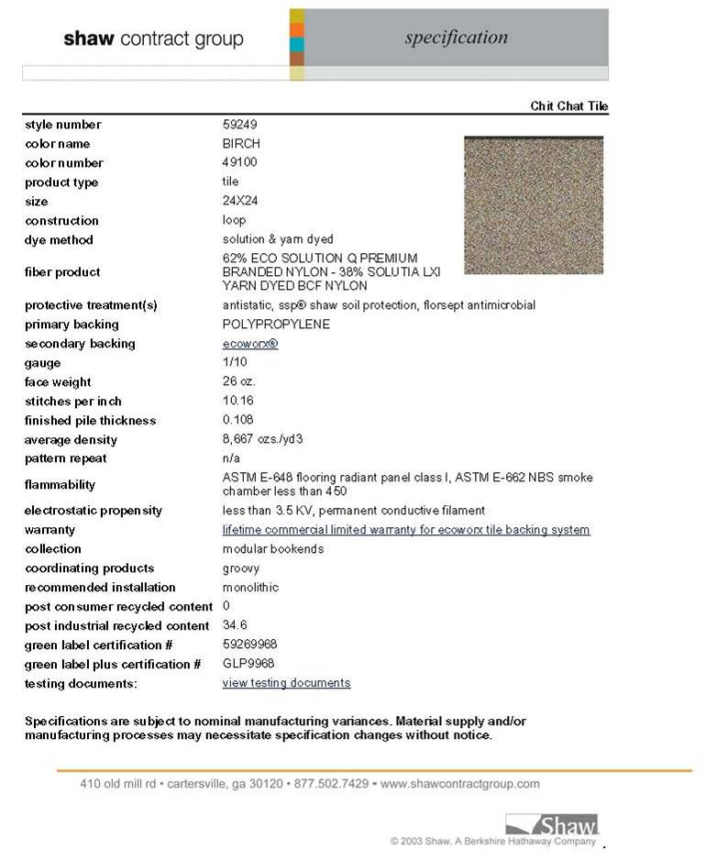
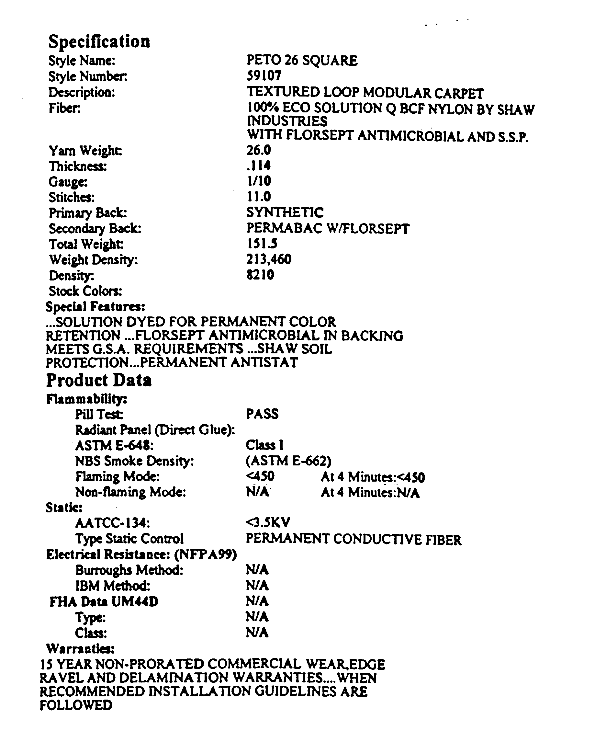
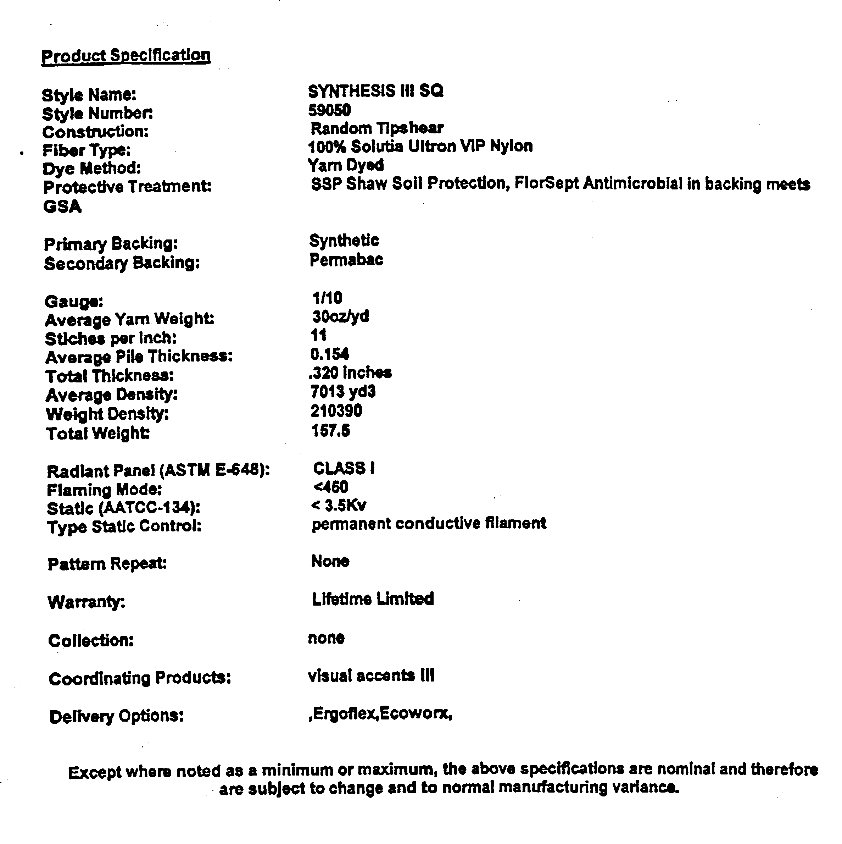
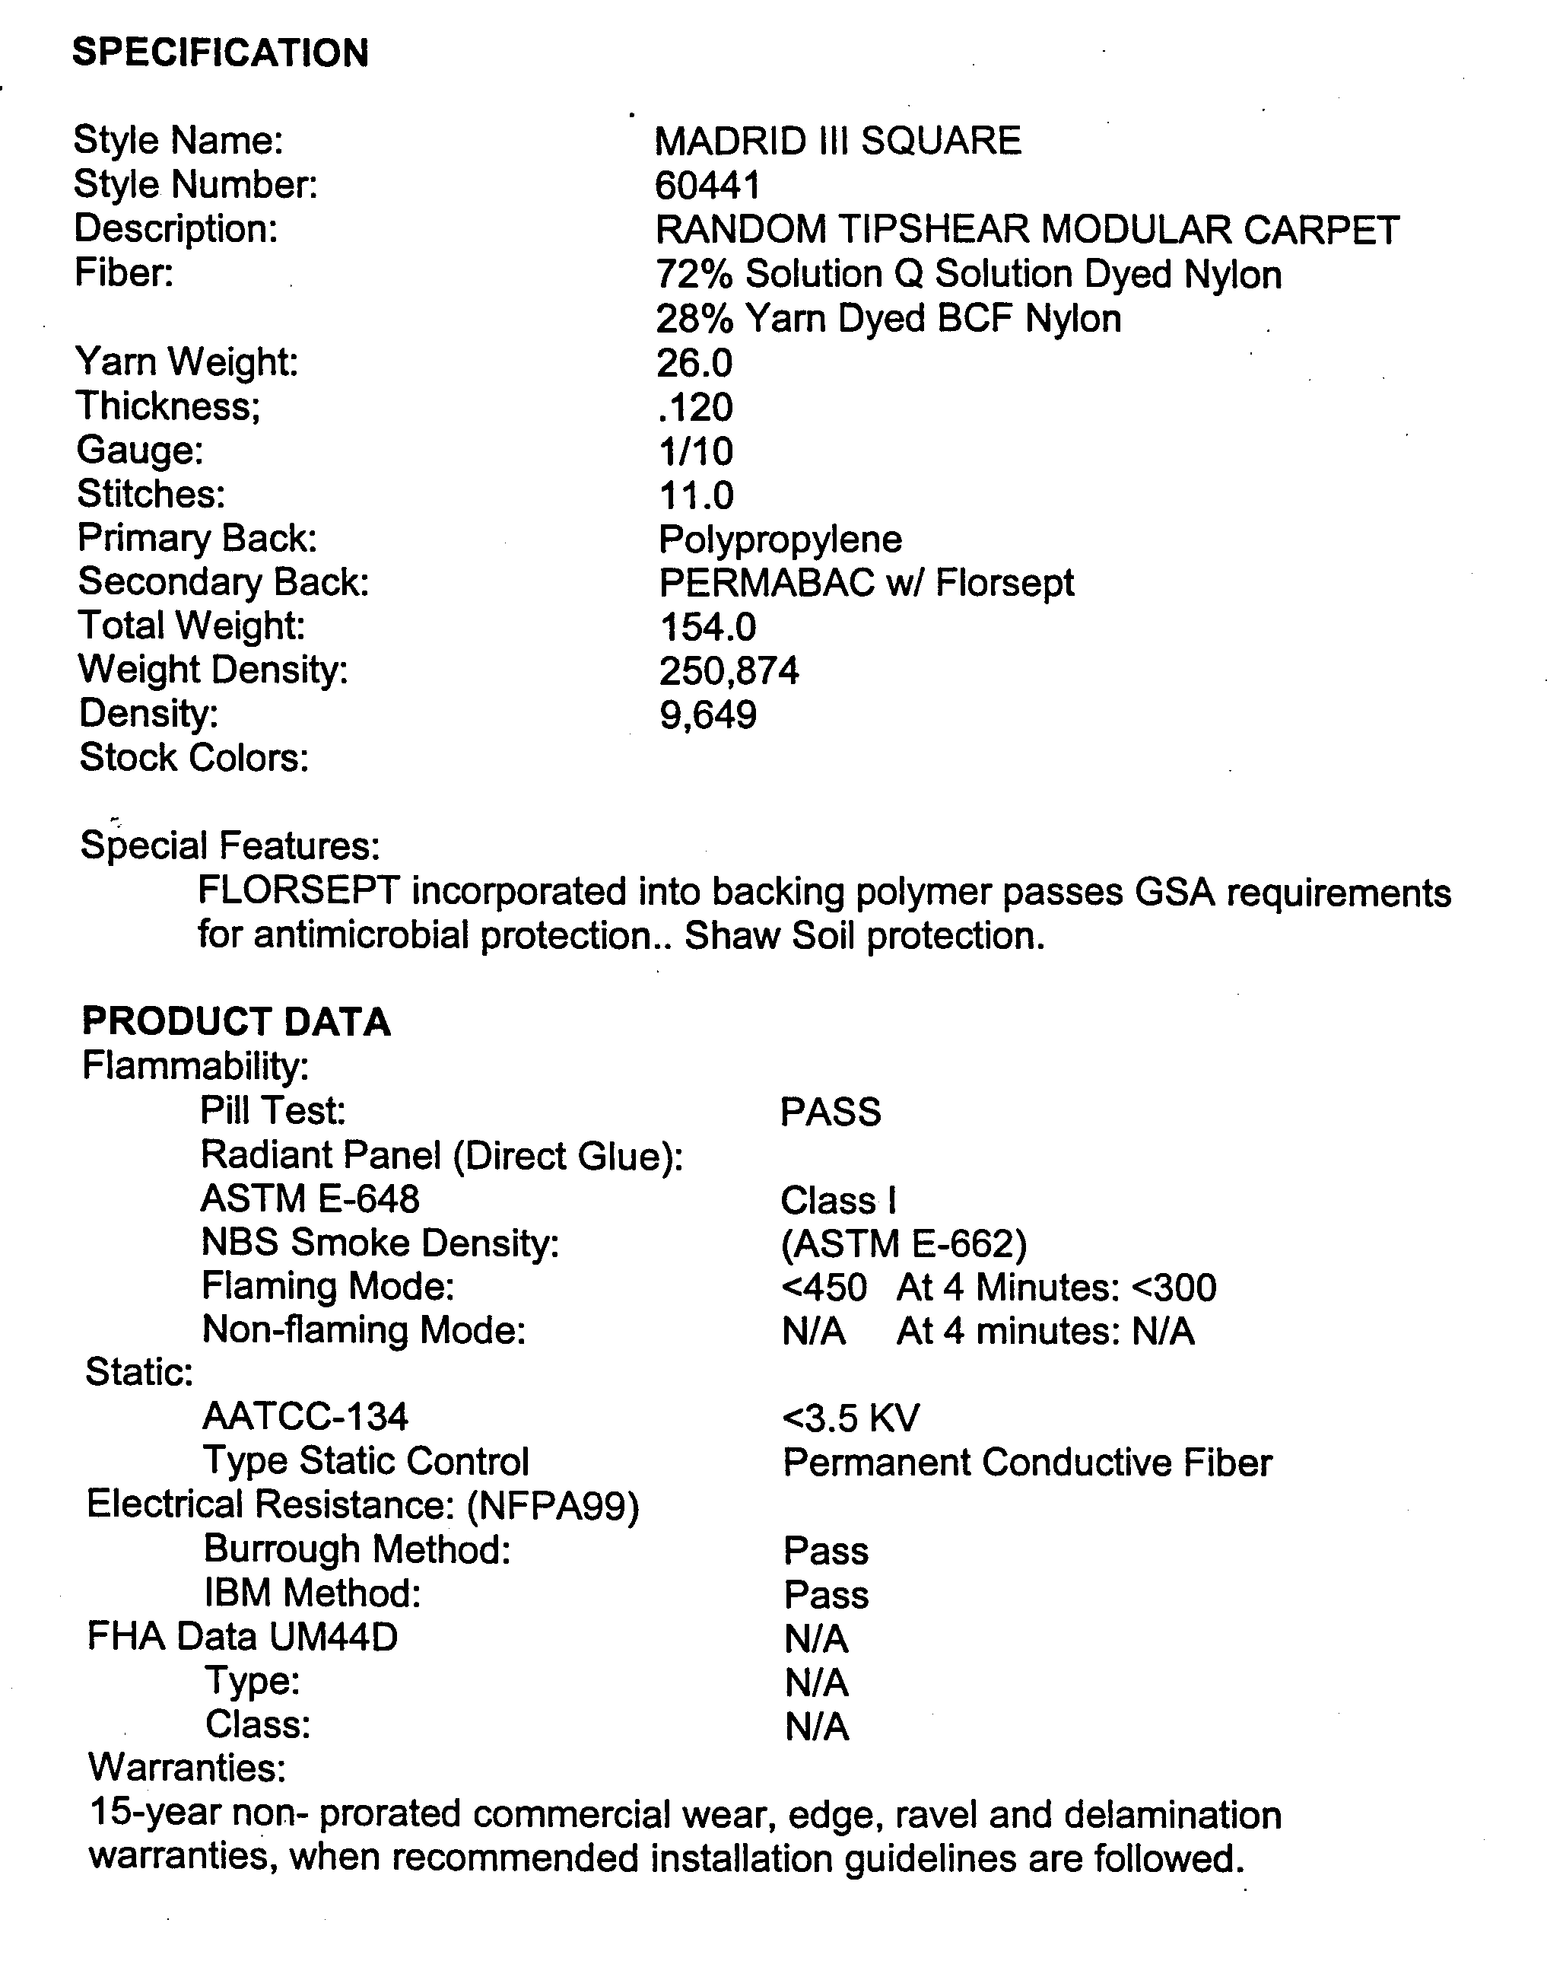

CHECK LIST
This Checklist is provided to assist the vendors in the preparation of their bid response. Included in this list, are important requirements and is the responsibility of the bidder to submit with the bid package in order to make the bid compliant. Because this checklist is just a guideline, the bidder must read and comply with the bid in its entirety.
Check off each of the following:
The Request for Quotation (RFQ) has been signed and completed.
The completed Form-W-9 (Request for Taxpayer Identification Number and Certification) found on the IRS website.
One (1) original and two (2) copies of the RFQ have been provided.
The completed Reference List as provided with this RFQ.
The Quotation Schedule as provided with this RFQ, has been completed, priced reviewed for accuracy and any corrections initialed in ink.
Product Information Sheet has been completed for each modular carpet tile listed on the Quotation Schedule.
The Specifications section has been thoroughly reviewed for compliance to the bid requirements with any exception noted.
The completed Local Vendor Preference page as provided with this RFQ.
Addendums, if any, have been completed, signed and included in the bid package.
Lastly, on the LOWER LEFT HAND CORNER of the sealed envelope, box, etc. transmitting your bid, attach the “Request for Quotation Label” and include the following information:

County of Fresno RFQ No. |  |  | 360-4479
Closing Date: | September 7, 2007
Closing Time: | 2:00 P.M.

Commodity or Service:
This Checklist does not need to be returned with your bid.

