COUNTY OF FRESNO
ADDENDUM NUMBER: THREE (3)
 |  |  | RFQ NUMBER:
May 11, 2011
 |  |  |  | PURCHASING USE
 |  |  |  |  | JEB | /tmp/in/input.doc
 | IMPORTANT: SUBMIT QUOTATION IN SEALED PACKAGE WITH QUOTATION NUMBER, CLOSING DATE AND BUYER’S NAME MARKED CLEARLY ON THE OUTSIDE TO:
COUNTY OF FRESNO, Purchasing
4525 EAST HAMILTON AVENUE, 2ND FLOOR
FRESNO, CA 93702-4599
Closing date of bid will be at 2:00 p.m., on May 25, 2011.
QUOTES WILL BE CONSIDERED LATE WHEN THE OFFICIAL PURCHASING TIME CLOCK READS 2:00 P.M.
 | Quotes will be opened and publicly read at that time. All quotation information will be available for review after contract award.
 | Clarification of specifications are to be directed to: Craig Nickel, phone (559) 600-7110, FAX (559) 456-7831.
NOTE THE following and attached ADDITIONS, DELETIONS AND/or CHANGES TO THE REQUIREMENTS OF REQUEST FOR QUOTATION NUMBER: AND INCLUDE THEM IN YOUR RESPONSE. PLEASE SIGN AND RETURN THIS ADDENDUM WITH YOUR QUOTATION.
- The following pages are:
  - Questions provided by vendors prior to the Vendor’s Conference/ Site Inspection and answers provided by County.
  - Questions asked by vendors at the Vendor’s Conference portion of the April 12, 2011 meeting and the answers or comments provided by County.
  - Questions asked by vendors at the Site Inspection and submitted by email and answers and/or comments provided by County.
Any other questions not addressed in this Addendum Number Three must be submitted to the Purchasing email address by May 18, 2011 at 2:00 p.m. or they will not be addressed.

ACKNOWLEDGMENT OF ADDENDUM NUMBER THREE (3) TO RFQ
COMPANY NAME:
(PRINT)
SIGNATURE:
NAME & TITLE:
- Delete Quotation Schedules from RFQ No. 285-4917 (Pages 64, 66 and 68)
Insert Quotation Schedules (revised), which are included in this addendum, in their place (Pages 64a, 64b, 66a, 66b, 68a and 68b).
Delete Page 63 (Diagram of Radio and Battery/equipment Room).
Insert Page 63 (revised), which is included in the addendum, in its place.
- Clarifications pertaining to both UPS #1 & UPS #2 units:
Insert the following to UPS UNIT #1 EQUIPMENT PURCHASE SPECIFICATION
  - Provision 1.1.B. Vendor shall make product line “phase out” statement based upon best available knowledge and state source of information in RFQ response.
  - 1.3.A1.e. Equipment footprint dimensions cited in RFQ are maximum dimensions of equipment allowed. Vendor proposed equipment that exceeds dimensions cited in RFQ will be considered non-responsive.
  - 1.3.B.7. Vendor shall provide seismic calculations of equipment anchorage, attachment of all equipment, and provide verifications by independent testing lab of field attachment.
  - 1.3.B.8. Equipment shall be equipped with remote monitoring of Modes of operation described. Software and firmware shall be included in bid price.
  - B.2. Where battery weight is above 50lbs, a permanently attached lift out carrier shall be included in quoted price.
  - 2.2.F. Battery components provided shall be approved and certified for compatible installation with UPS system specified and shall not void warranty of UPS unit.
Insert the following to UPS UNIT #2 EQUIPMENT PURCHASE SPECIFICATION
- Provision 1.1.B. Vendor shall make product line “phase out” statement based upon best available knowledge and state source of information in RFQ response.
- 1.3.A1.e. Equipment footprint dimensions cited in RFQ are maximum dimensions of equipment allowed. Vendor proposed equipment that exceeds dimensions cited in RFQ will be considered non-responsive.
- 1.3.B.7. Vendor shall provide seismic calculations of equipment anchorage, attachment of all equipment, and provide verifications by independent testing lab of field attachment.
- 1.3.B.8. Equipment shall be equipped with remote monitoring of Modes of operation described. Software and firmware shall be included in bid price.
- B.2. Where battery weight is above 50lbs, a permanently attached lift out carrier shall be included in quoted price.
- 2.2.F. Battery components provided shall be approved and certified for compatible installation with UPS system specified and shall not void warranty of UPS unit.
The following are questions that were submitted by vendors prior to the Vendor’s Conference/ Site Inspection and answers provide by County.
Note: The County responses are in bold italic font.
- Clarifications pertaining specifically to UPS #1 units:
Question # 1:
On UPS system #1, the battery cab and UPS are remote from each other but does not say how far. You asked for high grade connection cable. Our system comes with a cable to attach between the UPS and battery cabinets only if the cabinets are located next to each other. If they are installed remotely, we must make a custom cable to the appropriate length. We need to know how far the UPS are from each other.
Answer # 1:
The maximum lineal distance from the UPS cabinet to the battery cabinet is less than 20’-0” (center of cabinet to center of cabinet). It is safe to assume that vertical distance on either end would be < 15’-0”, therefore cable length each of two conductors) is 50’-0”, or total 100’-0” single cable length.
The battery cable is TYPE DLO (Diesel Locomotive Cable) sized for maximum DC amperage flow (times 1.25 + within acceptable manufacture’s voltage drop) when installed in metallic conduit.
Question # 2:
What floor is the battery system located?
Answer # 2:
UPS #1 All work is on the second floor.
Question # 3:
Is there a freight elevator?
Answer # 3:
At UPS Unit #1 there is a freight elevator from the elevated loading dock to the second floor where both the UPS unit and the separate battery unit are to be installed. Hoists and pallet jacks required to off-load and move the equipment into position shall be the responsibility of the Vendor.
Question # 4:
What is the project timeline?
Answer # 4:
Product delivery within 60 days after award; Time shall include 1 week for shop drawing review and review of engineering anchorage; installation 30 days after receipt. On-site work shall be coordinated with ongoing construction prime contractor.
- Clarifications pertaining specifically to UPS #2 units:
Question # 5:
For the 48vdc Plant - The part number for the disconnect is incomplete according to the C&D factory. The following question needs to be answered in order to provide the correct unit. Operation: Specify one type.
1) Manual Open/Manual Close.
2) Remote Open/Manual Close
3) Remote Open Capable
4) Remote Open/Remote Close
Answer # 5:
48VDC Disconnect is manual open/Manual close.(1))
Insert the following to UPS UNIT #2 EQUIPMENT PURCHASE SPECIFICATION
- 1.3.B. Change configuration to a one (1) three foot (3’) wide rack design based on an AT-39P or equal unit having 2100AH at a constant current draw of 120A. Supply 350MCM five stranded locomotive cable, one cable cover colored black, the other cable cover colored red. A circuit breaker style disconnect switch shall be mounted in the battery room. New
- Current battery systems shall be removed and a new 48VDC battery bank at bank #4 location shall be installed along with feeder system. Vendor shall remove all feeders to removed battery systems and lawfully dispose of battery system components within room which shall include:
Bank #1 24vDC battery bank
Bank #2 & #3 24vDC banks feeding radio room.
Bank #4 48vDC shall be delivered to the County ITSD Dept. for reinstallation.
Bank #5 (two small car batteries) – County to disconnect and remove from service.
- Vendor is to provide a temporary power plant that is 208VAC input and 48VDC @ 200 amps output.
- County ITSD staff will make final connections to converters, rearrange equipment in racks as needed, and make required changes to the distribution panels in the Radio Room. Vendor to provide feeders terminations to the top of the existing rack.
Question # 6:
Spec says you can go to Maint Bypass by pushing a front panel push button. I don't know of any UPS that can do this. Our system you will need to change a switch position on the Maint Bypass Switch to go to Maint Bypass. Is this what you meant on pushing buttons?
Answer # 6:
Bypass to static switch is via front button (and/or program) as specified and bypass of entire unit via maintenance bypass is manual.
We have additional questions on the 48VDC plant .Can you please provide the specifics for the following questions:
Question # 7:
What floor is the battery system located?
Answer # 7:
UPS #2; all work and equipment is on ground floor (i.e. side walk level) therefore no elevator. See page 63 Revised plan (attached).
Question # 8:
How far away does the temporary battery bank need to be from the system?
Answer # 8:
Temporary battery bank is to be located outside of building where bidder will place and install protection from intruders for safe and secure operation. Best route for temporary DC feeders to existing power supplies on racks inside can be field investigated after pre-bid conference as battery site is within adjacent County facilities. Any cut over time of DC supplies will be at County requested times, limited to two times, (once to cut over to temporary and once to cut over to new). Bidder is advised to figure worst case times as radio use will be minimal and cut over of supply feeders must be done quickly.
As to question involving time, bid documents state actual project length. There is the time period where the existing supply conductors are cut over to temporary feed which then starts time radio systems are on temporary battery supply. During this time the existing batteries are removed, new batteries are installed connected and tested and new power feeders are installed between battery banks and batteries to power supplies. Also during this time a separate Contractor will be sealing room for air conditioning modifications and installing a split system condenser on north wall. This work is minimal and will be coordinated with battery removal and installation work requirements. Bidder will assume that initial cutover to temporary batteries will be done early on a Monday morning between 0000 hrs to 0500 hrs. Work on removal and replacement and other crafts will consume no more than five working days (24 hour days if need be) and new batteries will be ready for cut over from temporary source to new source by 1700 hrs. on proceeding Friday. Actual cut over will occur after that time (at any time as directed by County) no later than the proceeding Monday morning between 0000 hrs. and 0400 hrs. Therefore all equipment must be on site.
Question # 9:
How thick is the concrete slab (for anchoring purposes)?
Answer # 9:
Equipment mounted on floor are on ground slab and will be anchored with 4” embedded “red head” drilled anchors of size and quantity as defined by approved licensed structural engineering calculation for Zone 4 seismic requirements. Battery banks are also backed up against concrete block walls which may be used also. Anchorage details to block walls if used) will be submitted for approval. Engineered equipment mounting shall account for eccentric loading created by existing raised floor design. Anchorage at raised floor may be epoxy grouted into concrete slab.
Question # 10:
How many days do we have to complete the work?
Answer # 10:
Sixty days from placement of order for unit fabrication (includes time for shop drawing review and anchorage engineering). Thirty days for installation.
There is no enclosed or covered storage for new equipment delivered to site. The bidder will be responsible for all deliveries as specified and storage, protection, movement to and from, and security of equipment delivered to site until actual installation inside rooms.
Question # 11
The battery room dimensions in the RFQ do not match the actual room dimensions.
Will the room layout be changed to accommodate the equipment called out in the RFQ?
Answer # 11
See revised plan included with Addendum 2.
Question # 12
Will string #2 be removed by owner prior to job start?
Answer # 12
That floor space will be needed for new batteries. See response D.3.
The following 3 questions are being asked to determine the actual battery cable size, length and wiring method that will need to be figured into the quote:
Question # 13
Where exactly does the current battery conduit exit in the telephone and/or radio room as we were unable to determine during the site visit?
Answer # 13
See revised plan included in this Addendum.
Question # 14
What is the voltage drop requirement for sizing battery cables?
Answer # 14
Voltage drop has already been calculated – use size specified.
Question # 15
What is the actual loop length of the battery cables? Part of question about termination of the battery conduit.
Answer # 15
Vendor must field verify required length.
Question # 16
The spec called out 350mcm battery cables. Those might not too big to pull through the existing conduits.
If that’s the case will larger conduit be installed by the owner?
Answer # 16
See Addendum #2, Bidder is furnishing and install Conduits and Cables. The 2” conduit is existing from battery room to where shown stubbed up under raised floor and will be used with pulling lubricant if needed. Otherwise, change reference to all other conduits and/or extensions of existing conduits to 2 ½” from noted 2”.
Question # 17
The spec calls for one battery disconnect. For future servicing, each battery should have its own disconnect.
Should that be included in the quote?
Answer # 17
Leave as shown in this Addendum- revised plan.
Question # 18
The battery cables could be bussed together after the disconnect(s) in the battery room and one set of cables extended to the power plant. Is that an option to consider?
Answer # 18
Batteries are paralleled and connected to disconnect, where disconnect feeds termination point on radio rack as shown.
Question # 19
During the job walk, it was noted that there is a C&D Site Monitor and a C&D Battery Monitor on site but not connected. Will those need to be connected?
Answer # 19
If so, they will be connected by County.
Question # 20
In order to eliminate the 24 volt battery the Wilmore converters will need to be connected to the 48 volt plant and brought online to feed the 24 volt loads. Will this be done prior to job start?
Answer # 20
This function will be done by County. Vendor shall coordinate their work to facilitate Owner.
Question # 21
Will the existing C&D DC-DC, 24VDC to 12VDC, Converter continue to be used? It’s not customary to go from one converted plant (the 24 volt) to another (12 volt). The more common approach is to convert at the main power supply (the 48 volt plant).
Answer # 21
This function will be done by County. Vendor shall coordinate their work to facilitate Owner.
Question # 22
With the installation of a new AM1 circuit breaker panel, the Sageon DC power system will need to be moved down in the rack in order to make room.
Who will move the DC plant?
Answer # 22
This function will be done by County. Vendor shall coordinate their work to facilitate Owner.
Question # 23
To vacate the existing battery cable conduits, to pull new cables, the temporary 48 volt battery will need to be set in the radio room. Will this be allowed?
Answer # 23
Temporary Battery will be placed outside as shown and specified.
Question # 24
Page 5 Will there be progress payments for this project and/or invoice discount i.e., 1% net 20 days?
Answer # 24
Payment will be made upon proof of equipments’ proper installation and proof of operation.
Question # 25
Page 18 Bid must be from "one Entity" and must be an authorized representative of the manufacturer, Can an electrical contractor submit a bid who is qualified and meets your guidelines for experience? Or must the bid only be from an authorized factory rep hiring a C-10 contractor as a sub to perform the installation?
Answer # 25
If C-10 is prime, then guarantee for first year goes thru them. They will just act as a go between the manufacturer or qualified service representative. The preference is to have Vendor be an authorized rep or manufacturer for better service on warranty as it is direct
Question # 26
Page 19 Total width of UPS cabinet not to exceed 26.0". What about the maintenance bypass cabinet as defined on Page 31, item 3 of Section G "Optional Accessories to be furnished and installed". This cabinet could be 26" wide by itself to meet the specs. Can a wall mounted Maintenance bypass cabinet with kirk-key interlock breakers be supplied instead of a UPS mountable cabinet? This would install near xfmr "KH" to allow for supply from panel "KH" to UPS and bypass cabinet.
Answer # 26
See Page 19 of RFQ for dimensions paragraph which includes answer.
Question # 27
Page 35 Conduit and Conductor Schedule call out 600V Delco Welding EPR Rubber Jacket Cable for UPS utility supply (item 3), UPS bypass (M&O) supply (item 4) and ups load connections (item 5), (not just battery cabinet connections). Can THHN conductor be substituted for the AC supply to UPS (item 3&4) and AC load from UPS (item 5) similar to UPS#2 install?
Answer # 27
Type THHN may be used for AC supply and load connections to UPS.
Question # 28
Page 35 Brand/Model of load center "KH" so accurate quotes for necessary supply (M&O) 125a/3p breaker.
Answer # 28
SQ D I-Line Type.
Question # 29
Page 35 Will panel "KH" have to remain energized to perform necessary work?
Answer # 29
YES – I-Line can have breaker added energized.
Question # 30
Page 52 UPS#2 Where will temporary power for initial startup and testing of new UPS be supplied from? Will county personnel provide?
Answer # 30
Vendor shall furnish temporary generator to perform functions along with needed temporary supply cables. Vendor will have access to under side raised floor thru conduit stubs from battery room to UPS room once battery cables removed.
The following were questions asked by vendors at the Vendor Conference (in the conference room at County Purchasing) and answers or comments made by County.
Note: Questions asked by vendors as we visited the sites will be submitted by vendors to the County email address provide on the front page of the RFQ and responded to in a future addendum.
Question # 31: For the UPS at the Central library (Unit #1); why does it call for the unit to be 60 kVA, scalable to 80 kVA?
Answer # 31: The County anticipates that there will be a future need at the Central Library for 80 kVA.
NOTE: The unit will be scalable by means of a software upgrade, which will require no hardware or cooling modification.
Question # 32: Will the County require that an Electrical Contractor perform the UPS installation?
Answer # 32: The Request for Quotation (RFQ) states that electrical work to connect UPS in and out power will be accomplished using a licensed (C-10 California) Electrical Contractor.
Question # 33: Are the required references for the system or the installation of the system?
Answer # 33: The Bidder shall provide five (5) references for each.
Question # 34: Will submittals be required with the bid or after an award is made to the awarded bidder?
Answer # 34: Submittals are required with the bid and will be required again after the award.
Question # 35: The RFQ states that “product lines slated to be discontinued or phased out of production within the next five (5) years are not acceptable”. How is a bidder to know the intent of the manufacturer?
Answer # 35: The bidder shall, to the best of his/her ability, using his/her industry knowledge, offer product(s) that will provide service for the County for many years to come. The County shall consider length of production in the evaluation of the bidder’s response to County’s Request for Quotation.
Additional Requirements and Comments :
The batteries in the room at EMS will be sealed. Since the room will no longer require to be vented, the County is having the room sealed to provide a controlled environment. This work will be coordinated so as not to interfere with bidder’s work.
Unit #2 is located at the Emergency Medical Services Communications Center. Subsequently, the transition or cut-over from existing power to temporary power for Unit #2 shall take place during the time that is normally the least active (est. 4:00 a.m.) to minimize down time.
The Quotation Schedule is separated for the three (3) units; two (2) UPS Systems and one (1) Battery Bank. The bidder shall provide a separate quote for automatic site monitoring, which shall be purchased solely at the County’s option.

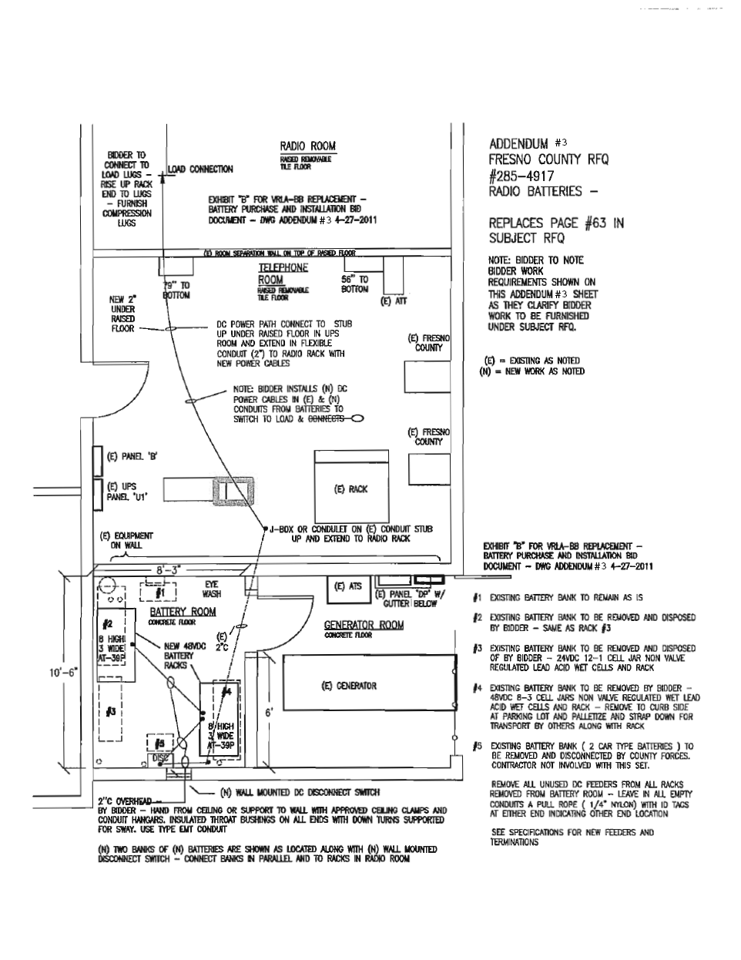

QUOTATION SCHEDULE (revised)
UPS, associated controls, transformers and battery unit must be by same manufacturer.  The County reserves the right to award Unit #1, Unit #2 and the Battery Bank separately. |  |  | UNIT PRICE
- UPS Unit #1- Library, as specified. *(Include all taxable items. Tax will be stated on the line provided below.)  *Same as or equivalent to the equipment listed under the SPECIFICATIONS/REQUIREMENTS section of this RFQ. | 1 | EA | $
Brand:
Model:
All non-taxable items (i.e. training, delivery) |  |  | $
Sales tax (8.975%) |  |  | $
TOTAL |  |  | $
Site Monitoring (monthly)  Detail below the service that you are quoting. |  |  | $

QUOTATION SCHEDULE (revised)
UPS Unit #1- Library
List below all items and features included above that are taxable:
List and quote prices for all items included in the unit price quoted above that are non-taxable:
 | DESCRIPTION | * PRICE
 |  | $
 |  | $
 |  | $
 |  | $
 |  | $
 |  | $

QUOTATION SCHEDULE (revised)
UPS, associated controls, transformers and battery unit must be by same manufacturer.  The County reserves the right to award Unit #1, Unit #2 and the Battery Bank separately. |  |  | UNIT PRICE
- UPS Unit #2- Bldg. 435 Emergency Services Telephone Equipment Room, as specified. *(Include all taxable items. Tax will be stated on the line provided below.)  *Same as or equivalent to the equipment listed under the SPECIFICATIONS/REQUIREMENTS section of this RFQ. | 1 | EA | $
Brand:
Model:
All non-taxable items (i.e. training, installation, delivery) |  |  | $
Sales tax (8.975%) |  |  | $
TOTAL |  |  | $
Site Monitoring (monthly)  Detail below the service that you are quoting. |  |  | $

QUOTATION SCHEDULE (revised)
UPS Unit #2- Bldg. 435 Emergency Services Telephone Equipment Room
List below all items and features included above that are taxable:
List and quote prices for all items included in the unit price quoted above that are non-taxable:
 | DESCRIPTION | PART NO. | * PRICE
 |  |  | $
 |  |  | $
 |  |  | $
 |  |  | $
 |  |  | $

QUOTATION SCHEDULE (revised)
Telephone / Radio Battery back-up bank and temporary construction battery system may be by separate vendor.  The County reserves the right to award Unit #1, Unit #2 and the Battery Bank separately. |  |  | UNIT PRICE
- Battery Bank- Bldg. 435 , as specified. *(Include all taxable items)  *Same as or equivalent to the equipment listed under the SPECIFICATIONS/REQUIREMENTS section of this RFQ. | 1 | EA | $
Brand:
Model:
All non-taxable items (i.e. training, installation, delivery) |  |  | $
Sales tax (8.975%) |  |  | $
TOTAL |  |  | $
Site Monitoring (monthly)  Detail below the service that you are quoting. |  |  | $

QUOTATION SCHEDULE (revised)
Battery Bank- Bldg. 435
List below all items and features included above that are taxable:
List and quote prices for all items included in the unit price quoted above that are non-taxable:
 | DESCRIPTION | PART NO. | * PRICE
 |  |  | $
 |  |  | $
 |  |  | $
 |  |  | $
 |  |  | $
 |  |  | $

