COUNTY OF FRESNO
Request for QUOTATION
 |  | NUMBER: 070-4365
January 16, 2007
ORG/Requisition: 31111229/ 3117004060 |  |  |  |  |  |  | PURCHASING USE |  |  |  | /tmp/in/input.doc
 |  |  |  |  |  |  | CJN JLG
IMPORTANT: SUBMIT QUOTATION IN SEALED PACKAGE WITH QUOTATION NUMBER, CLOSING DATE AND BUYER’S NAME MARKED CLEARLY ON THE OUTSIDE TO:
COUNTY OF FRESNO, Purchasing
4525 EAST HAMILTON AVENUE
FRESNO, CA 93702-4599
Closing date of bid will be at 2:00 p.m., on February 8, 2007.
QUOTATIONS WILL BE CONSIDERED LATE WHEN THE OFFICIAL PURCHASING TIME CLOCK READS 2:00 P.M.
Quotations will be opened and publicly read at that time. All quotation information will be available for review after contract award.
Clarification of specifications are to be directed to: Craig Nickel, phone (559) 456-7110, FAX (559) 456-7831.
GENERAL CONDITIONS: See “County Of Fresno Purchasing Standard Instructions And Conditions For Request For Proposals (RFP’S) and Requests for Quotations (RFQ’S)” attached. Check County of Fresno Purchasing’s Open Solicitations website at www.co.fresno.ca.us/0440/Bidshome.asp for RFQ/RFP documents and changes.
BIDDER TO COMPLETE
UNDERSIGNED AGREES TO FURNISH THE COMMODITY OR SERVICE STIPULATED IN THE ATTACHED QUOTATION SCHEDULE AT THE PRICES AND TERMS STATED, SUBJECT TO THE “COUNTY OF FRESNO PURCHASING STANDARD INSTRUCTIONS AND CONDITIONS FOR REQUEST FOR QUOTATIONS (RFP’S) AND REQUESTS FOR QUOTATIONS (RFQ’S)”ATTACHED.
Except as noted on individual items, the following will apply to all items in the Quotation Schedule.
- Complete delivery will be made within |  |  |  |  |  |  |  | calendar days after receipt of Order.
- A cash discount of |  |  |  |  | % |  |  |  |  | days will apply.
Company
Address
City |  |  |  |  |  |  |  |  |  |  |  |  | State |  | Zip Code
( ) |  |  |  | ( )
Telephone Number |  |  |  | Facsimile Number |  |  |  |  |  |  |  |  | E-mail Address
Signed By
Print Name |  |  |  |  |  |  |  |  | Title

COUNTY OF FRESNO PURCHASING
STANDARD INSTRUCTIONS AND CONDITIONS FOR
REQUESTS FOR PROPOSALS (RFP'S) AND REQUESTS FOR QUOTATIONS (RFQ'S)
Note: the reference to “bids” in the following paragraphs applies to RFP's and RFQ's

GENERAL CONDITIONS
By submitting a bid the bidder agrees to the following conditions. These conditions will apply to all subsequent purchases based on this bid.

- BID PREPARATION:
  - All prices and notations must be typed or written in ink. No erasures permitted. Errors may be crossed out, initialed and corrections printed in ink by person signing bid.
  - Brand Names: Brand names and numbers when given are for reference. Equal items will be considered, provided the offer clearly describes the article and how it differs from that specified. In the absence of such information it shall be understood the offering is exactly as specified.
  - State brand or make of each item. If bidding on other than specified, state make, model and brand being bid and attach supporting literature/specifications to the bid.
  - Bid on each item separately. Prices should be stated in units specified herein. All applicable charges must be quoted; charges on invoice not quoted herein will be disallowed.
  - Time of delivery is a part of the consideration and must be stated in definite terms and must be adhered to. F.O.B. Point shall be destination or freight charges must be stated.
  - All bids must be dated and signed with the firm’s name and by an authorized officer or employee.
  - Unless otherwise noted, prices shall be firm for 120 days after closing date of bid.
- SUBMITTING BIDS:
  - Each bid must be submitted on forms provided in a sealed envelope with bid number and closing date and time on the outside of the envelope/package.
  - Interpretation: Should any discrepancies or omissions be found in the bid specifications or doubt as to their meaning, the bidder shall notify the Buyer in writing at once. The County shall not be held responsible for verbal interpretations. Questions regarding the bid must be received by Purchasing at least 5 working days before bid opening. All addenda issued shall be in writing, duly issued by Purchasing and incorporated into the contract.
  - ISSUING AGENT/AUTHORIZED CONTACT: This RFQ has been issued by County of Fresno Purchasing. Purchasing shall be the vendor’s sole point of contact with regard to the RFQ, its content, and all issues concerning it.
All communication regarding this RFQ shall be directed to an authorized representative of County Purchasing. The specific buyer managing this RFQ is identified on the cover page, along with his or her telephone number, and he or she should be the primary point of contact for discussions or information pertaining to the RFQ. Contact with any other County representative, including elected officials, for the purpose of discussing this RFQ, its content, or any other issue concerning it, is prohibited unless authorized by Purchasing. Violation of this clause, by the vendor having unauthorized contact (verbally or in writing) with such other County representatives, may constitute grounds for rejection by Purchasing of the vendor’s quotation.
The above stated restriction on vendor contact with County representatives shall apply until the County has awarded a purchase order or contract to a vendor or vendors, except as follows. First, in the event that a vendor initiates a formal protest against the RFQ, such vendor may contact the appropriate individual, or individuals who are managing that protest as outlined in the County’s established protest procedures. All such contact must be in accordance with the sequence set forth under the protest procedures. Second, in the event a public hearing is scheduled before the Board of Supervisors to hear testimony prior to its approval of a purchase order or contract, any vendor may address the Board.
  - Bids received after the closing time will NOT be considered.
  - Bidders are to bid what is specified or requested first. If unable to or willing to, bidder may bid alternative or option, indicating all advantages, disadvantages and their associated cost.
  - Public Contract Code Section 7028.15
Where the State of California requires a Contractor’s license, it is a misdemeanor for any person to submit a bid unless specifically exempted.
- FAILURE TO BID:
  - If not bidding, return bid sheet and state reason for no bid or your name may be removed from mailing list.
- TAXES, CHARGES AND EXTRAS:
  - County of Fresno is subject to California sales and/or use tax (7.975%). Please indicate as a separate line item if applicable.
  - DO NOT include Federal Excise Tax. County is exempt under Registration No. 94-73-03401-K.
  - County is exempt from Federal Transportation Tax. Exemption certificate is not required where shipping papers show consignee as County of Fresno.
  - Charges for transportation, containers, packing, etc. will not be paid unless specified in bid.
- W-9 – REQUEST FOR TAXPAYER IDENTIFICATION NUMBER AND CERTIFICATION:
Upon award of bid, the vendor shall submit to County Purchasing, a completed W-9 - Request for Taxpayer Identification Number and Certification if not already a current vendor with The County of Fresno. This form is available from the IRS to complete on line at http://www.irs.gov/pub/irs-pdf/fw9.pdf.
- AWARDS:
  - Subject to the local preference provisions referenced in Paragraph 6 below and more thoroughly set forth in the General Requirements section of this RFQ, award(s) will be made to the most responsive responsible bidder. The evaluation will include such things as life-cycle cost, availability, delivery costs and whose product and/or service is deemed to be in the best interest of the County. The County shall be the sole judge in making such determination.
  - Unless bidder gives notice of all-or-none award in bid, County may accept any item, group of items or on the basis of total bid.
  - The County reserves the right to reject any and all bids and to waive informalities or irregularities in bids.
  - After award, all bids shall be open to public inspection. The County assumes no responsibility for the confidentiality of information offered in a bid.
- LOCAL VENDORS
  - Local Vendor Preference (applicable to RFQ Process only)
The following provisions are applicable only to the County’s acquisition of materials, equipment or supplies through the RFQ process when the funding source does not require an exemption to the Local Vendor Preference.
THE PROVISIONS OF THIS PARAGRAPH ARE APPLICABLE, NOTWITHSTANDING ANY OTHER PROVISIONS OF THIS RFQ TO THE CONTRARY
If the apparent low bidder is not a local vendor, any local vendor who submitted a bid which was within five percent (5%) of the lowest responsive bid as determined by the purchasing agent shall have the option of submitting a new bid within forty-eight hours (not including weekends and holidays) of County’s delivery of notification. Such new bids must be in an amount less than or equal to the lowest responsive bid as determined by the purchasing agent. If the purchasing agent receives any new bids from local vendors who have the option of submitting new bids within said forty-eight hour period, it shall award the contract to the local vendor submitting the lowest responsible bid. If no new bids are received, the contract shall be awarded to the original low bidder as announced by the purchasing agent.
  - Local Vendor Defined
“Local Vendor” shall mean any business which:
- Has its headquarters, distribution point or locally-owned franchise located in or having a street address within the County for at least six (6) months immediately prior to the issuance of the request for competitive bids by the purchasing agent; and
- Holds any required business license by a jurisdiction located in Fresno County; and
- Employs at least one (1) full-time or two (2) part-time employees whose primary residence is located within Fresno County, or if the business has no employees, shall be at least fifty percent (50%) owned by one or more persons whose primary residence(s) is located within Fresno County.
- TIE BIDS:
All other factors being equal, the contract shall be awarded to the Fresno County vendor or, if neither or both are Fresno County vendors, it may be awarded by the flip of a coin in the presence of witnesses or the entire bid may be rejected and re-bid. If the General Requirements of this RFQ state that they are applicable, the provisions of the Fresno County Local Vendor Preference shall take priority over this paragraph.
- PATENT INDEMNITY:
The vendor shall hold the County, its officers, agents and employees, harmless from liability of any nature or kind, including costs and expenses, for infringement or use of any copyrighted or uncopyrighted composition, secret process, patented or unpatented invention, article or appliance furnished or used in connection with this bid.
- SAMPLES:
Samples, when required, must be furnished and delivered free and, if not destroyed by tests, will upon written request (within 30 days of bid closing date) be returned at the bidder's expense. In the absence of such notification, County shall have the right to dispose of the samples in whatever manner it deems appropriate.
- RIGHTS AND REMEDIES OF COUNTY FOR DEFAULT:
  - In case of default by vendor, the County may procure the articles or service from another source and may recover the cost difference and related expenses occasioned thereby from any unpaid balance due the vendor or by proceeding against performance bond of the vendor, if any, or by suit against the vendor. The prices paid by the County shall be considered the prevailing market price at the time such purchase is made.
  - Articles or services, which upon delivery inspection do not meet specifications, will be rejected and the vendor will be considered in default. Vendor shall reimburse County for expenses related to delivery of non-specified goods or services.
  - Regardless of F.O.B. point, vendor agrees to bear all risks of loss, injury or destruction to goods and materials ordered herein which occur prior to delivery and such loss, injury or destruction shall not release vendor from any obligation hereunder.
- DISCOUNTS:
Terms of less than 15 days for cash payment will be considered as net in evaluating this bid. A discount for payment within fifteen (15) days or more will be considered in determining the award of bid. Discount period will commence either the later of delivery or receipt of invoice by the County. Standard terms are Net Forty-five (45) days.
- SPECIAL CONDITIONS IN BID SCHEDULE SUPERSEDE GENERAL CONDITIONS.
The “General Conditions” provisions of this RFP/RFQ shall be superseded if in conflict with any other section of this bid, to the extent of any such conflict.
- SPECIAL REQUIREMENT:
With the invoice or within twenty-five (25) days of delivery, the seller must provide to the County a Material Safety Data Sheet for each product, which contains any substance on “The List of 800 Hazardous Substances”, published by the State Director of Industrial Relations. (See Hazardous Substances Information and Training Act. California State Labor Code Sections 6360 through 6399.7.)
- RECYCLED PRODUCTS/MATERIALS:
Vendors are encouraged to provide and quote (with documentation) recycled or recyclable products/materials which meet stated specifications.
- YEAR COMPLIANCE WARRANTY
Vendor warrants that any product furnished pursuant to this Agreement/order shall support a four-digit year format and be able to accurately process date and time data from, into and between the twentieth and twenty-first centuries, as well as leap year calculations. "Product" shall include, without limitation, any piece or component of equipment, hardware, firmware, middleware, custom or commercial software, or internal components or subroutines therein. This warranty shall survive termination or expiration of this Agreement.
In the event of any decrease in product functionality or accuracy related to time and/or date data related codes and/or internal subroutines that impede the product from operating correctly using dates beyond December 31, 1999, vendor shall restore or repair the product to the same level of functionality as warranted herein, so as to minimize interruption to County's ongoing business process, time being of the essence. In the event that such warranty compliance requires the acquisition of additional programs, the expense for any such associated or additional acquisitions, which may be required, including, without limitation, data conversion tools, shall be borne exclusively by vendor. Nothing in this warranty shall be construed to limit any rights or remedies the County may otherwise have under this Agreement with respect to defects other than year performance.
- PARTICIPATION:
Bidder may agree to extend the terms of the resulting contract to other political subdivision, municipalities and tax-supported agencies.
Such participating Governmental bodies shall make purchases in their own name, make payment directly to bidder, and be liable directly to the bidder, holding the County of Fresno harmless.
- CONFIDENTIALITY:
All services performed by vendor shall be in strict conformance with all applicable Federal, State of California and/or local laws and regulations relating to confidentiality, including but not limited to, California Civil Code, California Welfare and Institutions Code, Health and Safety Code, California Code of Regulations, Code of Federal Regulations.
Vendor shall submit to County’s monitoring of said compliance.
Vendor may be a business associate of County, as that term is defined in the “Privacy Rule” enacted by the Health Insurance Portability and Accountability Act of 1996 (HIPAA). As a HIPAA Business Associate, vendor may use or disclose protected health information (“PHI”) to perform functions, activities or services for or on behalf of County as specified by the County, provided that such use or disclosure shall not violate HIPAA and its implementing regulations. The uses and disclosures if PHI may not be more expansive than those applicable to County, as the “Covered Entity” under HIPAA’S Privacy Rule, except as authorized for management, administrative or legal responsibilities of the Business Associate.
Vendor shall not use or further disclose PHI other than as permitted or required by the County, or as required by law without written notice to the County.
Vendor shall ensure that any agent, including any subcontractor, to which vendor provides PHI received from, or created or received by the vendor on behalf of County, shall comply with the same restrictions and conditions with respect to such information.
- APPEALS
Appeals must be submitted in writing within seven (7) working days after the review committee notification of proposed recommendations. Appeals should be submitted to County of Fresno Purchasing, 4525 E. Hamilton Avenue, Fresno, California 93702-4599. Appeals should address only areas regarding RFP contradictions, procurement errors, quotation rating discrepancies, legality of procurement context, conflict of interest, and inappropriate or unfair competitive procurement grievance regarding the RFP process.
The Purchasing Manager will provide a written response to the complaint within seven (7) working days unless the complainant is notified more time is required.
If the protesting bidder is not satisfied with the decision of the Purchasing Manager, he/she shall have the right to appeal to the Purchasing Agent within seven (7) business days after notification of the Purchasing Manager’s decision.
If the protesting bidder is not satisfied with Purchasing Agent decision, the final appeal is with the Board of Supervisors.
- OBLIGATIONS OF CONTRACTOR:
  - CONTRACTOR shall perform as required by the ensuing contract. CONTRACTOR also warrants on behalf of itself and all subcontractors engaged for the performance of the ensuing contract that only persons authorized to work in the United States pursuant to the Immigration Reform and Control Act of 1986 and other applicable laws shall be employed in the performance of the work hereunder.
  - CONTRACTOR shall obey all Federal, State, local and special district laws, ordinances and regulations.

TABLE OF CONTENTS

PAGE
BIDDING INSTRUCTIONS VEHICLES 3
PARTICIPATION 6
Local Vendor Preference 7
EQUIPMENT REQUIREMENTS 10
SPECIFICATIONS 11
SHERIFF’S DEPARTMENT REQUIREMENT TO BID 12
2007 Patrol Vehicle UP-FITTERS Guide 33

BIDDING INSTRUCTIONS
VEHICLES
The County of Fresno is soliciting bids for approximately forty (40) Patrol Vehicles, as specified within this Request for Quotation. Additional vehicles may be purchased from this Request for Quotation, as well. Any additional purchases will be made within 90 days of award of first purchase order.
GENERAL REQUIREMENTS
AWARD: Award will be made to the Vendor(s) offering equipment, price, service, delivery and support deemed to be to the best advantage of the County of Fresno. Included in the Award Criteria may be all or part of the following factors:
- Energy (Life Cycle Cost [LCC])
- Mechanical Evaluation
- Communication Evaluation (compatible with radio equipment)
- Test Driver's Subjective Evaluation
- Re-Sale
Prices quoted shall be firm for 90 days.
The County of Fresno shall be the sole judge in making this determination.
COPIES: Submit one (1) original and two (2) copies of your quotation no later than the RFQ closing date and time as stated on the front of this document, to County of Fresno Purchasing.
RIGHT TO REJECT BIDS: The County of Fresno Purchasing Manager reserves the right to reject any and all bids and to waive informalities or irregularities in the bids.
DEMONSTRATION: Upon request by the County of Fresno, bidder shall provide a demonstration unit as stated in bidder's offer to the Equipment Division, for a period of time not to exceed five (5) calendar days. Failure to provide a demonstration unit within ten (10) working days of the County's request may be cause for rejection of bidder's offer.
LITERATURE: Bidders shall submit literature, which fully describes units on which they are bidding, Not later than the opening date of this bid. Any and all literature submitted must be stamped with bidder's name and address.
TRAINING: The successful bidder(s) may be required to make available maintenance mechanic training classes. The County of Fresno will assume responsibility for travel and lodging expenses.
MAINTENANCE: The successful bidder shall provide all tools or minor equipment specifically required to maintain equipment supplied. Bidder shall list any special oils, additives, or other lubricants needed for maintenance of equipment supplied.
FACTORY MANUALS: The successful bidder shall provide two (2) parts manuals, two (2) shop repair manuals for equipment supplied. Manuals shall be in possession of the County of Fresno before delivery will be considered complete.
HOLD HARMLESS CLAUSE: Contractor agrees to indemnify, save, hold harmless and at County's request, defend the County, its officers, agents and employees, from any and all costs and expenses, damages, liabilities, claims and losses occurring or resulting to County in connection with the performance, or failure to perform, by Contractor, its officers, agents or employees under this Agreement and from any and all costs and expenses, damages, liabilities, claims and losses occurring or resulting to any person, firm or corporation who may be injured or damaged by the performance, or failure to perform, of Contractor, its officers, agents or employees under this Agreement.
INSURANCE:
Without limiting the COUNTY's right to obtain indemnification from CONTRACTOR or any third parties, CONTRACTOR, at its sole expense, shall maintain in full force and effect the following insurance policies throughout the term of the Agreement:
- Commercial General Liability
Commercial General Liability Insurance with limits of not less than One Million Dollars ($1,000,000) per occurrence and an annual aggregate of Two Million Dollars ($2,000,000). This policy shall be issued on a per occurrence basis. COUNTY may require specific coverages including completed operations, products liability, contractual liability, Explosion-Collapse-Underground, fire legal liability or any other liability insurance deemed necessary because of the nature of this contract.
- Automobile Liability
Comprehensive Automobile Liability Insurance with limits for bodily injury of not less than Two Hundred Fifty Thousand Dollars ($250,000.00) per person, Five Hundred Thousand Dollars ($500,000.00) per accident and for property damages of not less than Fifty Thousand Dollars ($50,000.00), or such coverage with a combined single limit of Five Hundred Thousand Dollars ($500,000.00). Coverage should include owned and non-owned vehicles used in connection with this Agreement.
- Worker's Compensation
A policy of Worker's Compensation insurance as may be required by the California Labor Code.
CONTRACTOR shall obtain endorsements to the Commercial General Liability insurance naming the County of Fresno, its officers, agents, and employees, individually and collectively, as additional insured, but only insofar as the operations under this Agreement are concerned. Such coverage for additional insured shall apply as primary insurance and any other insurance, or self-insurance, maintained by COUNTY, its officers, agents and employees shall be excess only and not contributing with insurance provided under CONTRACTOR's policies herein. This insurance shall not be cancelled or changed without a minimum of thirty (30) days advance written notice given to COUNTY.
Within Thirty (30) days from the date contractor executes this Agreement, contractor shall provide certificates of insurance and endorsement as stated above for all of the foregoing policies, as required herein, to the County of Fresno, stating that such insurance coverage have been obtained and are in full force; that the County of Fresno, its officers, agents and employees will not be responsible for any premiums on the policies; that such Commercial General Liability insurance names the County of Fresno, its officers, agents and employees, individually and collectively, as additional insured, but only insofar as the operations under this Agreement are concerned; that such coverage for additional insured shall apply as primary insurance and any other insurance, or self-insurance, maintained by County, its officers, agents and employees, shall be excess only and not contributing with insurance provided under contractor's policies herein; and that this insurance shall not be cancelled or changed without a minimum of thirty (30) days advance, written notice given to County.
In the event contractor fails to keep in effect at all times insurance coverage as herein provided, the County may, in addition to other remedies it may have, suspend or terminate this Agreement upon the occurrence of such event.
All policies shall be with admitted insurers licensed to do business in the State of California. Insurance purchased shall be purchased from companies possessing a current A.M. Best, Inc. rating of A FSC VII or better.
ASSURANCES: Any contract awarded under this RFQ must be carried out in full compliance with The Civil Rights Act of 1964, The Americans With Disabilities Act of 1990, their subsequent amendments, and any and all other laws protecting the rights of individuals and agencies. The County of Fresno has a zero tolerance for discrimination, implied or expressed, and wants to ensure that policy continues under this RFQ. The contractor must also guarantee that services, or workmanship, provided will be performed in compliance with all applicable local, state, or federal laws and regulations pertinent to the types of services, or project, of the nature required under this RFQ. In addition, the contractor may be required to provide evidence substantiating that their employees have the necessary skills and training to perform the required services or work.
NON-FUNDING CLAUSE: Funds provided for equipment supplied under the terms of this bid are contingent on the approval of the appropriating government agency. Should sufficient funds not be allocated, the equipment or the amount of equipment to be supplied may be modified or terminated at any time.

BIDDER TO COMPLETE THE FOLLOWING:

PARTICIPATION
The County of Fresno is a member of the Central Valley Purchasing Group. This group consists of Fresno, Kern, Kings, and Tulare Counties and all governmental, tax supported agencies within these counties.
Whenever possible, these agencies co-op (piggyback) on contracts put in place by one of the other agencies.
Any agency choosing to avail itself of this opportunity, will make purchases in their own name, make payment directly to the contractor, be liable to the contractor and vice versa, per the terms of the original contract, all the while holding the County of Fresno harmless. If awarded this contract, please indicate whether you would extend the same terms and conditions to all tax supported agencies within this group as you are proposing to extend to Fresno County.
Yes, we will extend contract terms and conditions to all qualified agencies within the Central Valley Purchasing Group.
No, we will not extend contract terms to any agency other than the County of Fresno.
(Authorized Signature)
Title
Local Vendor Preference
The County of Fresno Local Vendor Preference is applicable to this Request for Quotation. Refer to the General Conditions section for details.
Qualified Vendors that desire consideration as a Fresno County Local Vendor under this RFQ must complete the “Statement of Local Vendor Certification” contained herein and submit it as a part of their quotation. Late submittals of the “Statement of Local Vendor Certification” will not be considered. Submission of this statement will qualify the vendor for treatment as a local vendor for purposes of this RFQ only. The statement made under this RFQ shall not qualify the vendor as a local vendor under any other RFQ.
LOCAL VENDOR CERTIFICATION:
Any vendor claiming to be a local vendor, as defined under the General Conditions section of this RFQ, shall so certify in writing to the purchasing agent. The purchasing agent shall not be required to verify the accuracy or any such certifications, and shall have sole discretion to determine if a vendor meets the definition of “local vendor.”
Any person or business falsely claiming to be a local vendor under this section shall be ineligible to transact any business with the County for a period of not less than three (3) months and not more twenty-four (24) months as determined in the sole discretion of the purchasing agent. The purchasing agent shall also have the right to terminate all or any part of any contract entered into with such person or business.
STATEMENT OF LOCAL VENDOR CERTIFICATION
COUNTY OF FRESNO
Qualified local vendors desiring consideration under the Fresno County Local Vendor Preference must complete the following and submit with their quotation (print or type).
I |  |  |  |  |  | ,
 | (individual submitting bid) |  |  |  |  |  | (title)
Of/for |  |  |  | Certify that
 |  | (Company Name) |  |  |  |  |  | (Company Name)
Is a Fresno County local Vendor as defined under the General Conditions section of this RFQ and therefore qualifies for the Local Vendor Preference.
Signature |  |  |  |  | Title |  |  |  |  | Date

NOTIFICATION OF RE-BID
If a local vendor’s bid qualifies under Fresno County’s Local Vendor Preference, the local vendor will be notified of his/her opportunity to re-bid. if so notified, the Vendor must submit his/her re-bid within forty-eight (48) hours of notification (excluding weekends and holidays). Notification will be issued by e-mail or Fax, whichever is preferred by the vendor. Notification to Vendor shall be considered complete upon County’s transmission of e-mail or Fax.
The local vendor shall state his/her preferred method of notification below along with the appropriate e-mail address or Fax number. Notification by County will be limited to one of those two (2) methods. It will be the local vendor’s responsibility to check his/her e-mail or Fax messages for notification. The vendor’s delay in receiving his/her notification will not alter the forty-eight (48) hour period allowed for re-bid submission.
LOCAL VENDOR TO COMPLETE:
Indicate *ONE method for notification of Local Vendor re-bid by providing the appropriate e-mail address or Fax number. Submit this document as a part of your quotation.
E-Mail Address or Fax Number (Identify contact person if using a Fax Number)
PRE-DELIVERY AND INSPECTION: Prior to delivery, each vehicle shall be completely inspected and serviced by the delivering dealer and/or the manufacturer's pre-delivery service center.
Normally, vehicles will be inspected at dealer's place of business before delivery. Inspection will be made by an authorized representative of the purchasing agency for workmanship, appearance, proper functioning of all equipment and systems, and conformance to all requirements of bid specifications. In the event deficiencies are detected, the vehicle(s) will be rejected and the delivering dealer will be required to make necessary repairs, adjustments or replacement. Alternately, if the vehicle(s) are inspected after delivery and rejected because of deficiencies, it shall be the dealer's responsibility to pick up the vehicle(s), make the necessary corrections and re-deliver the vehicle(s) for re-inspection and acceptance.
DELIVERY: All bids are to be F.O.B. County of Fresno.
Prompt delivery is essential. Failure to furnish delivery as promised will constitute a breach of agreement and the County of Fresno may procure items in accordance with Paragraph 9A of General Conditions.
PAYMENT: The bidder agrees to provide equipment and other requirements as stated in this Request for Quotation. The County of Fresno agrees to pay bidder at the terms and conditions stated in the Request for Quotation.
Should deficiencies be detected in equipment supplied, payment/or the commencement of a discount period (if applicable) will not be made until the defects are corrected and accepted by the County of Fresno.
Partial payment may or may not be acceptable to the County of Fresno. Should partial payment be made by the County of Fresno, a percentage of the agreement amount shall be held until all terms and conditions of the Request for Quotations are satisfied.
ISSUING AGENT: This RFQ has been issued by County of Fresno Purchasing. Purchasing shall be the vendor’s sole point of contact with regard to the RFQ, its content, and all issues concerning it.
AUTHORIZED CONTACT: All communication regarding this RFQ shall be directed to an authorized representative of County Purchasing. The specific buyer managing this RFQ is identified on the cover page, along with his or her telephone number, and he or she should be the primary point of contact for discussions or information pertaining to the RFQ. Contact with any other County representative, including elected officials, for the purpose of discussing this RFQ, it content, or any other issue concerning it, is prohibited unless authorized by Purchasing. Violation of this clause, by the vendor having unauthorized contact (verbally or in writing) with such other County representatives, may constitute grounds for rejection by Purchasing of the vendor’s quotation.
The above stated restriction on vendor contact with County representatives shall apply until the County has awarded a purchase order or contract to a vendor or vendors, except as follows. First, in the event that a vendor initiates a formal protest against the RFQ, such vendor may contact the appropriate individual, or individuals who are managing that protest as outlined in the County’s established protest procedures. All such contact must be in accordance with the sequence set forth under the protest procedures. Second, in the event a public hearing is scheduled before the Board of Supervisors to hear testimony prior to its approval of a purchase order or contract, any vendor may address the Board.
EQUIPMENT REQUIREMENTS
The equipment supplied shall be new (unused), current model year production and equal in style, quality and appointments to those offered to the general public. The equipment shall be supplied with all accessories as considered standard equipment for make and model specified.
The following referenced documents of record in effect on the date of the Request for Quotation form a part of the specifications to the extent they are applicable:
Department of Transportation, Federal Highway Administration, Motor Carrier Safety Regulations.
U.S. Environmental Protection Agency - Current Federal Energy Administration. Gas Mileage Guide California.

California Vehicle Code
Federal Motor Vehicle Safety Regulations and Standards
California Division of Industrial Safety
OSHA Standards
Title 19 State Fire Marshall Code Book
Failure on the part of the bidder to comply with all requirements and conditions of the Request for Quotation and this specification may be cause for rejection of bid. No exceptions to or deviations from this specification will be considered unless each exception or deviation is specifically stated by the bidder in the designated places. If no exceptions or deviations are shown the bidder will be required to furnish vehicles exactly as specified herein. The burden of proof of compliance with this specification is the responsibility of the bidder.
Federal Excise Tax Exemption - County of Fresno IRS Registration No. 94-73-03401K.
SPECIFICATIONS
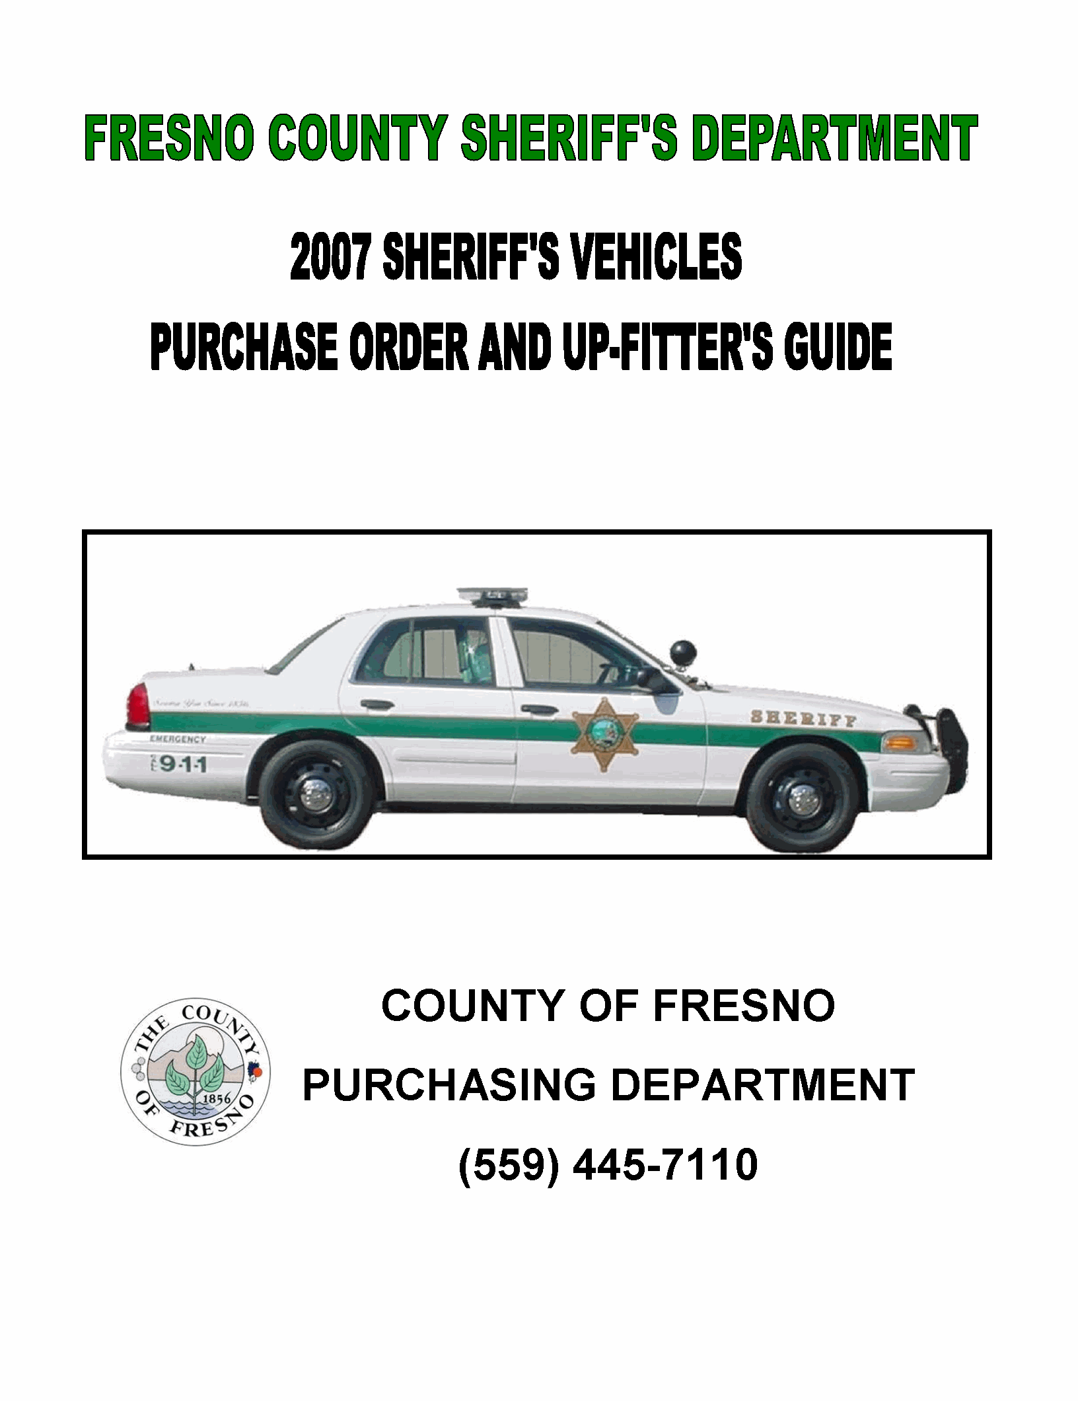
SHERIFF’S DEPARTMENT REQUIREMENT TO BID
The following requirements are in addition to any County of Fresno contract requirements.
DELIVERY: The Contractor shall deliver completed vehicles to the Fresno County Sheriff’s Department within six (6) months from the date of award of the contract.
PRE-CONSTRUCTION MEETING: The County will require a pre-construction meeting with the successful vendor. The meeting will take place within 30 days of the date of award of the bid. The meeting shall take place at the Fresno County Sheriff’s Department between the vendor and his up-fitter and the Sheriff’s Fleet Manager and Lead Mechanic. The intent of the meeting is to thoroughly discuss the written specifications, design, layout and expectation of the County. All expenses of the Pre-Construction meeting shall be borne by the successful vendor.
INSPECTION MEETING: The Sheriff’s Fleet Manager and Lead Mechanic shall meet with the successful vendor and up-fitter once one pilot vehicle has been built (and prior to mass construction of vehicles). This meeting shall take place at the location where the vehicles are being up-fitted. The vendor is required to notify Sheriff’s Fleet Services no less than two weeks prior to the date which the vehicle will be in the above described condition and available for inspection. The meeting is intended to formally accept the up-fitters construction as required by the Up-fitter’s Guide. If the up-fitter’s location is out of state, then all costs associated with travel, meals, and hotel for the Fleet Manager and Lead Mechanic shall be borne by the successful vendor.
At the County’s option, County will perform a second inspection at 100% of completion and prior to delivery at the vendor’s location. This inspection would occur if major discrepancies are still unresolved.
COMMUNICATION: The successful vendor and up-fitter shall have an email contact address for the Sheriff’s Fleet Manger to have continued contact through the building process. One person employed by the up-fitter shall be assigned as the contact person to lessen communication confusion. Photographs shall be provided upon request of Sheriff’s Fleet Services at various stages of construction at the determination of Fleet Services or the County of Fresno.
FINAL INSPECTION AT DELIVERY: A final inspection will be performed upon delivery to Sheriff’s Fleet Services.
LIQUIDATED DAMAGES: The Contractor will be assessed liquidated damages in the amount of one hundred dollars ($100.00) per vehicle per day for each calendar day delay over the specified time of completion for delivery and acceptance.
Any changes or variation to the specifications of vehicles or equipment fitted to the vehicles shall only be made by written amendment to the subsequent contract or purchase order.
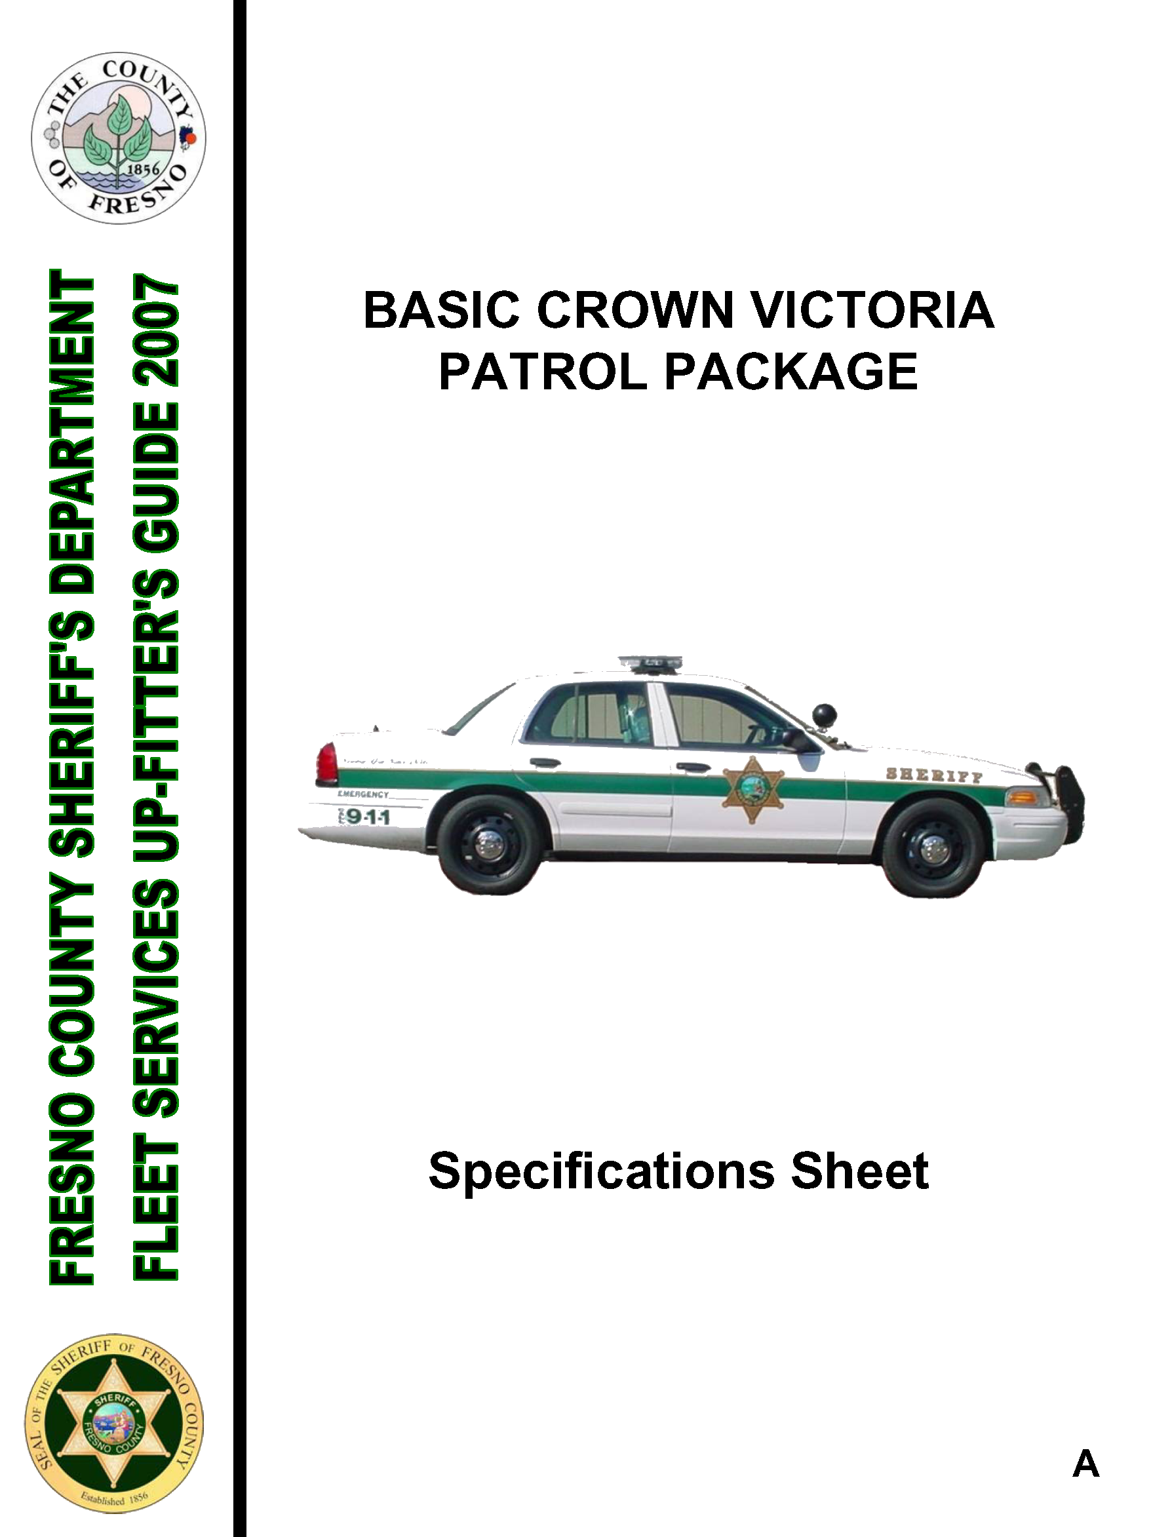
SHERIFF’S 2007 FULL SIZE PATROL CAR
REAR-WHEEL DRIVE - FOUR (4) DOOR SEDAN
Vehicle Must Meet California Smog Emission Standards, Taxes and Fees.
 |  |  | COMPLY  (Yes / No) |  | ITEM COST
VEHICLE
 | Make & Model | FORD Crown Victoria Police Interceptor Package (or equal) |  |  | $
POWERTRAIN
 | Engine | V-8 4.6L minimum |  |  | $
 | Transmission | 4-Speed Automatic Transmission w/ OD |  |  | $
 | Cooling System | HD radiator w/coolant recovery |  |  | $
 | Brakes | Power, 4-wheel Electronic Anti-lock Brake System (ABS) |  |  | $
 | Steering | Power Assist |  |  | $
 | Battery | 750 CCA minimum |  |  | $
 | Alternator | 200 amp High Output |  |  | $
 | Suspension | Standard Heavy Duty |  |  | $
 | Tires(5) | Manufacturer’s Standard (Full-size spare) |  |  | $
 | Rear Axle Ratio | 3.27:1 Option # 720A |  |  | $
EXTERIOR
 | Bumpers | Manufacturer’s Standard |  |  | $
 | Glass | Manufacturer’s Standard Solar-Tinted |  |  | $
 | Mirrors | Manufacturer’s Standard Fold-away / Dual Power |  |  | $
INTERIOR
 | Steering Column | Tilt |  |  | $
 | Door Locks | Power |  |  | $
 | Air Conditioning | Manufacturer’s Standard |  |  | $
 | Heater | Manufacturer’s Standard |  |  | $
 | Defroster | Manufacturer’s Standard |  |  | $
 | Radio | AM/FM Stereo |  |  | $
 | Airbags | Manufacturer’s Standard |  |  | $
 | Floor Cover | Heavy Duty Black Rubber Flooring |  |  | $
 | Seats | Front Cloth Buckets / Rear Vinyl Bench |  |  | $
 | Interior Color | Charcoal |  |  | $
 | Exterior Paint | Vibrant White Clear Coat Metallic |  |  | $
 | Warranty | Manufacturer’s Standard  5 Yrs. 50,000 Miles |  |  | $
REQUIRED UPGRADE EQUIPMENT FROM FORD
 | Drivers Power Seat | Option Code- 21A |  |  | $
 | Radio Suppression | Ground Suppression Straps  Option # 53M |  |  | $
 | Front Seat Side Airbags | Manufacturer’s Standard  Option # 59M |  |  | $
2007 STANDARD PATROL EQUIPMENT BID
CROWN VICTORIA PATROL VEHICLE UP-FITTERS EQUIPMENT
ITEM | CATEGORY |  | DESCRIPTION |  | COMPLY  (Yes / No) |  |  |  | ITEM COST
 | ALARM
 | Anti-Theft Remote Alarm with separate alarm siren |  | Car alarm with two (2) keyless entry remotes.  [Alarms shall not be on the same data address as any other patrol cars ordered. Separate alarm siren for alarm – can not use car’s horn] |  |  |  |  |  | $
 | ANTENNAS
 | - UHF Antenna |  | Larsen Antenna with co-axial cable and connections – PL259 connector |  |  |  |  |  | $
 | - VHF Antenna |  | Larsen Antenna with co-axial cable and connections – PL259 connector |  |  |  |  |  | $
 | - Computer Antenna |  | PCTEL Antenna Specialists Dual Band Cellular/PCS Antenna 824-894 MHz Roof Mount |  |  |  |  |  | $
 | - Antenna Computer Cable |  | Gold-plated male SMA connector #NMOKUDSMI |  |  |  |  |  | $
 | - Antenna Base |  | K729 Computer |  |  |  |  |  | $
 | BATTERY PROTECTOR
 | Battery Brain |  | 12V BB Type 1 (Manual reset only) |  |  |  |  |  | $
 | COMPUTER MOUNT & FLOOR PLATE
 | - Computer Mount |  | Gamber Johnson # DS-LIFT / Heavy gauge steel/Black powder coat – height adjustable – air bag compliant  [Product is not in catalog, however Gamber Johnson will manufacture for Fresno Sheriff’s patrol cars – Contact company] |  |  |  |  |  | $
 | - Computer Docking Station |  | Gamber Johnson CF-29 docking station #NP-PANDOCK-1 Docking Station with single FR |  |  |  |  |  | $
 | - Floor Plate |  | Gamber Johnson floor plate with front legs for Ford Crown Victoria MCS-CCV-3S |  |  |  |  |  | $
 | - Power Supply |  | Federal Signal 3-port power supply  (to be attached on front of DS-LIFT) |  |  |  |  |  | $
 | CONSOLE EQUIPMENT
 | - 10” Console |  | Troy with faceplates #CC-MODCON-10 |  |  |  |  |  | $
 | - Beverage Holder |  | Troy AC-BH 95(S) single cup holder |  |  |  |  |  | $
 | - Spotlights |  | Post mount - unity brand dual spotlights 6” round black housing with mounting brackets |  |  |  |  |  | $
 | - Spot Light Switch |  | Manual toggle switch for passenger side spot light |  |  |  |  |  | $
 | - Time-Out Timer |  | 4-hour time-out timer (used to cut electric drain on vehicle after 4 hours) |  |  |  |  |  | $
 | DECALS
 | Patrol Package Decals  Fresno County Sheriff  - 3M Brand - |  | Two (2) Reflective Door Stars  Two (2) “Serving You Since 1856” (Green)  Two (2) “Emergency Call 911” (Green)  Three (3) Reflective “SHERIFF” (Gold)  Four (4) 18” tall roof numbers (Black)  Two (2) Four 2” bumper numbers (Green)  Green Striping with gold reflective at top of green |  |  |  |  |  | $
 | EMERGENCY LIGHTING & SIREN
 | - LED Light Bar |  | Federal Signal Arjent 44-S2 LED light bar [Part # 583004-00069] |  |  |  |  |  | $
 | - Control Head |  | Federal Smart-Siren #SS2000 Controller |  |  |  |  |  | $
 | - Corner Strobes |  | Federal Signal corner strobe kit with cables and power supply # 416125-4A |  |  |  |  |  | $
 | - Siren Speaker |  | Federal Signal Siren / Outside Speaker  Model AS124 with bracket |  |  |  |  |  | $
 | - Headlight Flasher |  | Federal Signal headlight flasher unit (wig-wag) #FHL2SC |  |  |  |  |  | $
 | - Map Light |  | Federal Signal Little Map Light # LF12ER |  |  |  |  |  | $
 | - Park-Kill Module |  | Federal Signal UPKM3 (Park-kill for siren) |  |  |  |  |  | $
 | - Speaker Wire Harness |  | Ford harness adapter # XW72 |  |  |  |  |  | $
 | GUN LOCKS & MOUNTS
 | - Passenger Compartment |  | Pro-Gard #G7210-FSO  vertical dual gun mount, gun locks and timers for 870 &AR-15  [w/barrel key override (barrel key is the same for all cars ordered and Nylock Fasteners] |  |  |  |  |  | $
 | - Trunk Compartment |  | Pro-Gard 870 Shotgun gun lock / Mount / Timer / Hidden button  [Mount will be manufactured by up fitter – see Up-Fitter’s Guide] |  |  |  |  |  | $
 | PRISONER PARTITION
 | Pro-Gard or Patriot |  | Prisoner partition with center recess for gun racks in middle. Plexiglas behind driver and mesh metal behind passenger |  |  |  |  |  | $
 |  | PUSH BUMPER
 |  | Pro-Gard |  | Pro-Gard Push Bumper #E1105F |  |  |  |  |  | $
 |  | POLICE RADIO
 |  | Kenwood Dual Band  VHF = 148 – 174 mhz  UHF = 450 - 490 mhz  160 CH, 45W |  | Kenwood Dual-Band radio and full function control head TK790/890BK & ULT9FMMDB |  |  |  |  |  | $
 |  | REAR DOOR & WINDOW DISABLE
 |  | Up-fitter Manufactured |  | Rear doors and windows will be disabled as per the Up-Fitter Guide |  |  |  |  |  | $
 |  | COMPONENT / UP-FITTING WIRING
 |  | Industry Standard or Above |  | - ALL VEHICLES WILL BE WIRED THE SAME -  All wiring will be color coded and the gauge of wire used will be able to handle the load of equipment and components.  The wire used shall be approved by the Fresno Sheriff’s Department Fleet Services at the Pre-Construction meeting A wiring schematic of each car will be provided. |  |  |  |  |  | $

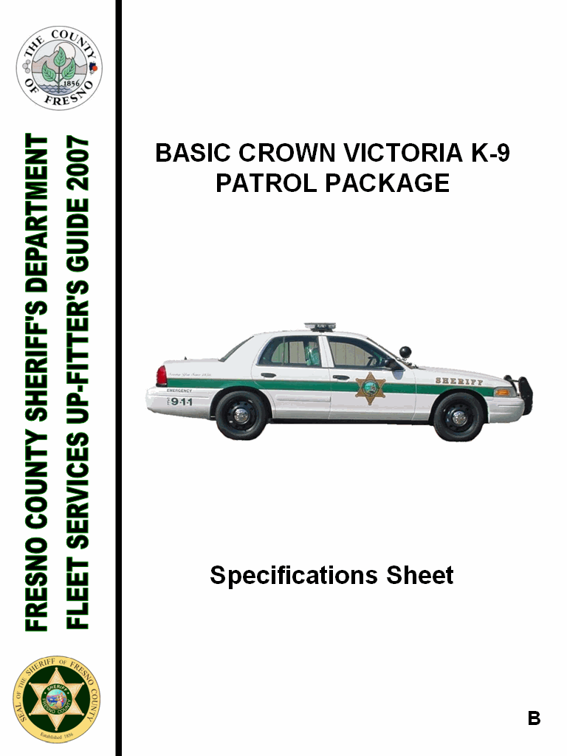
SHERIFF’S 2007 FULL SIZE K-9 UNIT PATROL CAR
REAR-WHEEL DRIVE - FOUR (4) DOOR SEDAN
Vehicle Must Meet California Smog Emission Standards, Taxes & Fees
 |  |  |  | COMPLY  (Yes / No) |  | ITEM COST
VEHICLE
 | Make & Model | FORD Crown Victoria Police Interceptor Package (or equal) |  |  |  | $
POWERTRAIN
 | Engine | V-8 4.6L minimum |  |  |  | $
 | Transmission | 4-Speed Automatic Transmission w/ OD |  |  |  | $
 | Cooling System | HD radiator w/coolant recovery |  |  |  | $
 | Brakes | Power, 4-wheel Electronic anti-lock Brake system (ABS) |  |  |  | $
 | Steering | Power Assist |  |  |  | $
 | Battery | 750 CCA minimum |  |  |  | $
 | Alternator | 200 amp High Output |  |  |  | $
 | Suspension | Standard Heavy Duty |  |  |  | $
 | Tires(5) | Manufacturer’s Standard (Full-size spare) |  |  |  | $
 | Rear Axle Ratio | 3.27:1 Option # 720A |  |  |  | $
EXTERIOR
 | Bumpers | Manufacturer’s Standard |  |  |  | $
 | Glass | Manufacturer’s Standard  Solar-Tinted |  |  |  | $
 | Mirrors | Manufacturer’s Standard  Fold-away / Dual Power |  |  |  | $
INTERIOR
 | Steering Column | Tilt |  |  |  | $
 | Door Locks | Power |  |  |  | $
 | Air Conditioning | Manufacturer’s Standard |  |  |  | $
 | Heater | Manufacturer’s Standard |  |  |  | $
 | Defroster | Manufacturer’s Standard |  |  |  | $
 | Radio | AM/FM Stereo |  |  |  | $
 | Airbags | Manufacturer’s Standard |  |  |  | $
 | Floor Cover | Heavy Duty Black Rubber Flooring |  |  |  | $
 | Seats | Front Cloth Buckets / Rear Vinyl Bench |  |  |  | $
 | Interior Color | Charcoal |  |  |  | $
 | Exterior Paint | Vibrant White Clear Coat Metallic |  |  |  | $
 | Warranty | Manufacturer’s Standard  5 Yrs. 50,000 Miles |  |  |  | $
REQUIRED UPGRADE EQUIPMENT FROM FORD
 | Drivers Power Seat |  | Option Code- 21A |  |  | $
 | Radio Suppression |  | Ground Suppression Straps  Option # 53M |  |  | $
 | Front Seat Side Airbags |  | Manufacturer’s Standard  Option # 59M
2007 STANDARD PATROL EQUIPMENT BID
CROWN VICTORIA PATROL VEHICLE UP-FITTERS EQUIPMENT
ITEM | CATEGORY |  |  | DESCRIPTION | COMPLY  Yes / No |  | ITEM COST
 | ALARM
 | Anti-Theft Remote Alarm with separate alarm siren |  |  | Car alarm with two (2) keyless entry remotes.  [Alarms shall not be on the same data address as any other patrol cars ordered. Separate alarm siren for alarm – can not use car’s horn] |  |  | $
 | ANTENNAS
 | - UHF Antenna |  |  | Larsen Antenna with co-axial cable and connections – PL259 connector |  |  | $
 | - VHF Antenna |  |  | Larsen Antenna with co-axial cable and connections – PL259 connector |  |  | $
 | - Computer Antenna |  |  | PCTEL Antenna Specialists Dual Band Cellular/PCS Antenna 824-894 MHz Roof Mount |  |  | $
 | - Antenna Computer Cable |  |  | Gold-plated male SMA connector  #NMOKUDSMI |  |  | $
 | - Antenna Base |  |  | K729 Computer |  |  | $
 | BATTERY PROTECTOR
 | - Battery Brain |  |  | 12V BB Type 1 (Manual reset only) |  |  | $
 | COMPUTER MOUNT & FLOOR PLATE
 | - Computer Mount |  |  | Gamber Johnson # DS-LIFT / Heavy gauge steel/Black powder coat – height adjustable – air bag compliant  [Product is not in catalog, however Gamber Johnson will manufacture for Fresno Sheriff’s patrol cars – Contact company] |  |  | $
 | - Computer Docking Station |  |  | Gamber Johnson CF-29 docking station #NP-PANDOCK-1 Docking Station with single FR |  |  | $
 | - Floor Plate |  |  | Gamber Johnson floor plate with front legs for Ford Crown Victoria MCS-CCV-3S |  |  | $
 | - Power Supply |  |  | Federal Signal 3-port power supply  (to be attached on front of DS-LIFT) |  |  | $
 | CONSOLE EQUIPMENT
 | - 10” Console |  |  | Troy with faceplates #CC-MODCON-10 |  |  | $
 | - Beverage Holder |  |  | Troy AC-BH 95(S) single cup holder |  |  | $
 | - Spotlights |  |  | Post mount - unity brand dual spotlights 6” round black housing with mounting brackets |  |  | $
 | - Spot Light Switch |  |  | Manual toggle switch for passenger side spot light |  |  | $
 | - Time-Out Timer |  |  | 4-hour time-out timer (used to cut electric drain on vehicle after 4 hours) |  |  | $
 | DECALS
 | Patrol Package Decals  Fresno County Sheriff  - 3M Brand - |  |  | Two (2) Reflective Door Stars  Two (2) “Serving You Since 1856” (Green)  Two (2) “Emergency Call 911” (Green)  Three (3) Reflective “SHERIFF” (Gold)  Four (4) 18” tall roof numbers (Black)  Two (2) Four 2” bumper numbers (Green)  Green Striping with gold reflective at top of green |  |  | $
 | EMERGENCY LIGHTING & SIREN
 | - LED Light Bar |  |  | Federal Signal Arjent 44-S2 LED light bar [Part # 583004-00069] |  |  | $
 | - Control Head |  |  | Federal Smart-Siren #SS2000 Controller |  |  | $
 | - Corner Strobes |  |  | Federal Signal corner strobe kit with cables and power supply # 416125-4A |  |  | $
 | - Siren Speaker |  |  | Federal Signal Siren / Outside Speaker  Model AS124 with bracket |  |  | $
 | - Headlight Flasher |  |  | Federal Signal headlight flasher unit (wig-wag) #FHL2SC |  |  | $
 | - Map Light |  |  | Federal Signal Little Map Light # LF12ER |  |  | $
 | - Park-Kill Module |  |  | Federal Signal UPKM3 (Park-kill for siren) |  |  | $
 | - Speaker Wire Harness |  |  | Ford harness adapter # XW72 |  |  | $
 | GUN LOCKS & MOUNTS
 | - Passenger Compartment |  |  | Pro-Gard #G7210-FSO  vertical dual gun mount, gun locks and timers for 870 &AR-15  [w/barrel key override (barrel key is the same for all cars ordered and Nylock Fasteners] |  |  | $
 | - Trunk Compartment |  |  | Pro-Gard 870 Shotgun gun lock / Mount / Timer / Hidden button  [Mount will be manufactured by up fitter – see Up-Fitter’s Guide] |  |  | $
 | PRISONER PARTITION
 | Pro-Gard or Patriot |  |  | Prisoner partition with center recess for gun racks in middle. Plexiglas behind driver and mesh metal behind passenger |  |  | $
 | PUSH BUMPER
 | Pro-Gard |  |  | Pro-Gard Push Bumper #E1105F |  |  | $
 | POLICE RADIO
 | Kenwood Dual Band  VHF = 148 – 174 mhz  UHF = 450 - 490 mhz  160 CH, 45W |  |  | Kenwood Dual-Band radio and full function control head TK790/890BK & ULT9FMMDB |  |  | $
 | REAR DOOR & WINDOW DISABLE
 | Up-fitter Manufactured |  |  | Rear doors and windows will be disabled as per the Up-Fitter Guide |  |  | $
 | COMPONENT / UP-FITTING WIRING
 | Industry Standard or Above |  |  | - ALL VEHICLES WILL BE WIRED THE SAME -  All wiring will be color coded and the gauge of wire used will be able to handle the load of equipment and components.  The wire used shall be approved by the Fresno Sheriff’s Department Fleet Services at the Pre-Construction meeting A wiring schematic of each car will be provided. |  |  | $
K-9 PACKAGE
[The equipment listed on the Basic Patrol Vehicle and Up-Fitter’s Information are also part of the K-9 Package Bid]
K9- I | K-9 INSERT CAGE
 | American Aluminum E/Z K-9 Container |  |  | Aluminum K-9 insert cage with window and door guards. Black rubber matting on floor |  |  | $
K9 – II | REMOTE DOOR OPENING SYSTEM & TEMPERATURE ALERT
 | Ray Allen or equal |  |  | Premier Canine System  Bail Out & Hot Dog  [Remote immediate unlock, unlatch, push and hold the vehicle door open with range up to 1000ft. Temperature setting that lowers vehicle window and activates car horn or lights to alert driver. Pager notifies driver with range up to 2 miles] |  |  | $
K9 - III | SECURE IDLE IGNITION OVERRIDE
 | Secure Idle Inc. |  |  | Part # SI440TH for 2007 Crown Victoria |  |  | $
K9 - IV | THERMOSTATE AIR CIRCULATING FAN
 | Ray Allen Savvy Fan |  |  | Part # CR7 [Thermostatically controlled mountable fan that creates air flow. Fan increases speed as temperature rises, then stops once the temperature returns to normal] |  |  | $
K9 - V | K-9 DECAL ADD-ON PACKAGE
 | K-9 Decals |  |  | Two (2) 7 “ black outline of German Shepard head for rear posts  Two (2) 3” Reflective red “CAUTION” for rear doors  One (1) 18” Trunk “K-9” numbers |  |  | $

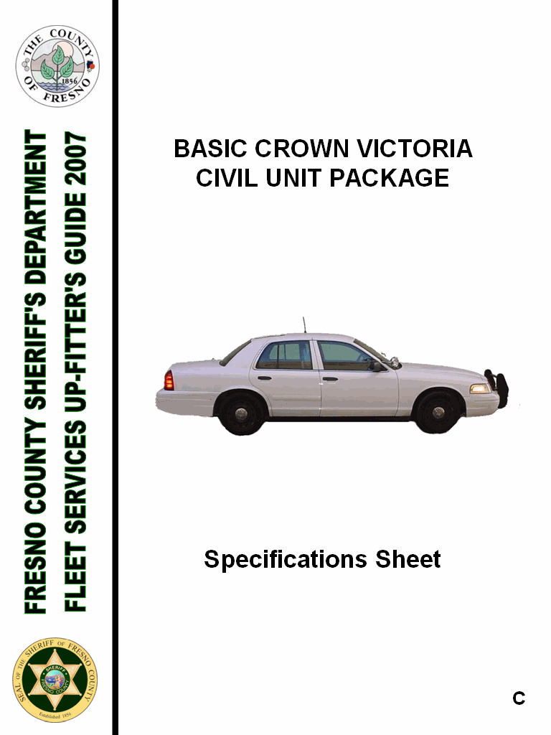
SHERIFF’S 2007 FULL SIZE PATROL CAR
REAR-WHEEL DRIVE - FOUR (4) DOOR SEDAN
Vehicle Must Meet California Smog Emission Standards, Taxes & Fees

 |  |  | COMPLY  (Yes / No) |  | ITEM COST
VEHICLE
 | Make & Model | FORD Crown Victoria Police Interceptor Package (or equal) |  |  | $
POWERTRAIN
 | Engine | V-8 4.6L minimum |  |  | $
 | Transmission | 4-Speed Automatic Transmission w/ OD |  |  | $
 | Cooling System | HD radiator w/coolant recovery |  |  | $
 | Brakes | Power, 4-wheel Electronic anti-lock Brake system (ABS) |  |  | $
 | Steering | Power Assist |  |  | $
 | Battery | 750 CCA minimum |  |  | $
 | Alternator | 200 amp High Output |  |  | $
 | Suspension | Standard Heavy Duty |  |  | $
 | Tires(5) | Manufacturer’s Standard (Full-size spare) |  |  | $
 | Rear Axle Ratio | 3.27:1 Option # 720A |  |  | $
EXTERIOR
 | Bumpers | Manufacturer’s Standard |  |  | $
 | Glass | Manufacturer’s Standard  Solar-Tinted |  |  | $
 | Mirrors | Manufacturer’s Standard  Fold-away / Dual Power |  |  | $
INTERIOR
 | Steering Column | Tilt |  |  | $
 | Door Locks | Power |  |  | $
 | Air Conditioning | Manufacturer’s Standard |  |  | $
 | Heater | Manufacturer’s Standard |  |  | $
 | Defroster | Manufacturer’s Standard |  |  | $
 | Radio | AM/FM Stereo |  |  | $
 | Airbags | Manufacturer’s Standard |  |  | $
 | Floor Cover | Heavy Duty Black Rubber Flooring |  |  | $
 | Seats | Front Cloth Buckets / Rear Vinyl Bench |  |  | $
 | Interior Color | Charcoal |  |  | $
 | Exterior Paint | Vibrant White Clear Coat Metallic |  |  | $
 | Warranty | Manufacturer’s Standard 5 Yrs. 50,000 Miles |  |  | $
REQUIRED UPGRADE EQUIPMENT FROM FORD
 | Drivers Power Seat | Option Code- 21A |  |  | $
 | Radio Suppression | Ground Suppression Straps Option # 53M |  |  | $
 | Front Seat Side Airbags | Manufacturer’s Standard  Option # 59M |  |  | $

2007 STANDARD PATROL EQUIPMENT BID
CROWN VICTORIA PATROL VEHICLE UP-FITTERS EQUIPMENT
ITEM | CATEGORY | DESCRIPTION | COMPLY  (Yes / No) |  | ITEM COST
 | ALARM
 | Anti-Theft Remote Alarm with separate alarm siren | Car alarm with two (2) keyless entry remotes.  [Alarms shall not be on the same data address as any other patrol cars ordered. Separate alarm siren for alarm – can not use car’s horn] |  |  | $
 | ANTENNAS
 | - UHF Antenna | Larsen Antenna with co-axial cable and connections – PL259 connector |  |  | $
 | - VHF Antenna | Larsen Antenna with co-axial cable and connections – PL259 connector |  |  | $
 | - Computer Antenna | PCTEL Antenna Specialists Dual Band Cellular/PCS Antenna 824-894 MHz Roof Mount |  |  | $
 | - Antenna Computer Cable | Gold-plated male SMA connector  #NMOKUDSMI |  |  | $
 | - Antenna Base | K729 Computer |  |  | $
 | BATTERY PROTECTOR
 | - Battery Brain | 12V BB Type 1 (Manual reset only) |  |  | $
 | COMPUTER MOUNT & FLOOR PLATE
 | - Computer Mount | Gamber Johnson # DS-LIFT / Heavy gauge steel/Black powder coat – height adjustable – air bag compliant  [Product is not in catalog, however Gamber Johnson will manufacture for Fresno Sheriff’s patrol cars – Contact company] |  |  | $
 | - Computer Docking Station | Gamber Johnson CF-29 docking station #NP-PANDOCK-1 Docking Station with single FR |  |  | $
 | - Floor Plate | Gamber Johnson floor plate with front legs for Ford Crown Victoria  MCS-CCV-3S |  |  | $
 | - Power Supply | Federal Signal 3-port power supply  (to be attached on front of DS-LIFT) |  |  | $
 | CONSOLE EQUIPMENT
 | - 10” Console | Troy with faceplates #CC-MODCON-10 |  |  | $
 | - Beverage Holder | Troy AC-BH 95(S) single cup holder |  |  | $
 | - Spotlights | Post mount - unity brand dual spotlights 6” round black housing with mounting brackets |  |  | $
 | - Spot Light Switch | Manual toggle switch for passenger side spot light |  |  | $
 | - Time-Out Timer | 4-hour time-out timer (used to cut electric drain on vehicle after 4 hours) |  |  | $
 | DECALS
 | Patrol Package Decals  Fresno County Sheriff  - 3M Brand - | Two (2) Reflective Door Stars  Two (2) “Serving You Since 1856” (Green)  Two (2) “Emergency Call 911” (Green)  Three (3) Reflective “SHERIFF” (Gold)  Four (4) 18” tall roof numbers (Black)  Two (2) Four 2” bumper numbers (Green)  Green Striping with gold reflective at top of green |  |  | $
 | EMERGENCY LIGHTING & SIREN
 | - LED Light Bar | Federal Signal Arjent 44-S2 LED light bar [Part # 583004-00069] |  |  | $
 | - Control Head | Federal Smart-Siren #SS2000 Controller |  |  | $
 | - Corner Strobes | Federal Signal corner strobe kit with cables and power supply # 416125-4A |  |  | $
 | - Siren Speaker | Federal Signal Siren / Outside Speaker  Model AS124 with bracket |  |  | $
 | - Headlight Flasher | Federal Signal headlight flasher unit (wig-wag) #FHL2SC |  |  | $
 | - Map Light | Federal Signal Little Map Light # LF12ER |  |  | $
 | - Park-Kill Module | Federal Signal UPKM3 (Park-kill for siren) |  |  | $
 | - Speaker Wire Harness | Ford harness adapter # XW72 |  |  | $
 | GUN LOCKS & MOUNTS
 | - Passenger Compartment | Pro-Gard #G7210-FSO  vertical dual gun mount, gun locks and timers for 870 &AR-15  [w/barrel key override (barrel key is the same for all cars ordered and Nylock Fasteners] |  |  | $
 | - Trunk Compartment | Pro-Gard 870 Shotgun gun lock / Mount / Timer / Hidden button  [Mount will be manufactured by up fitter – see Up-Fitter’s Guide] |  |  | $
 | PRISONER PARTITION
 | Pro-Gard or Patriot | Prisoner partition with center recess for gun racks in middle. Plexiglas behind driver and mesh metal behind passenger |  |  | $
 | PUSH BUMPER
 | Pro-Gard | Pro-Gard Push Bumper #E1105F |  |  | $
 | POLICE RADIO
 | Kenwood Dual Band  VHF = 148 – 174 mhz  UHF = 450 - 490 mhz  160 CH, 45W | Kenwood Dual-Band radio and full function control head  TK790/890BK & ULT9FMMDB |  |  | $
 | REAR DOOR & WINDOW DISABLE
 | Up-fitter Manufactured | Rear doors and windows will be disabled as per the Up-Fitter Guide |  |  | $
 | COMPONENT / UP-FITTING WIRING
 | Industry Standard or Above | - ALL VEHICLES WILL BE WIRED THE SAME -  All wiring will be color coded and the gauge of wire used will be able to handle the load of equipment and components.  The wire used shall be approved by the Fresno Sheriff’s Department Fleet Services at the Pre-Construction meeting A wiring schematic of each car will be provided. |  |  | $

2007 Patrol Vehicle UP-FITTERS Guide

