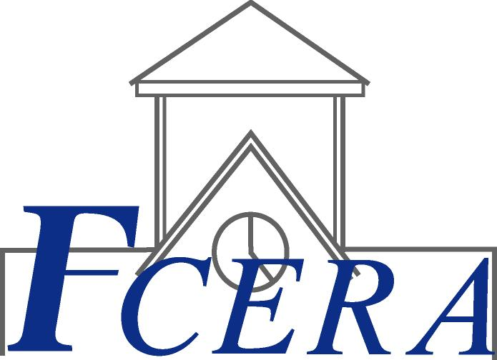
Roberto L. Peña
Retirement Administrator
FRESNO COUNTY EMPLOYEES’ RETIREMENT ASSOCIATION
BOARD OF RETIREMENT
John P. Souza, Chair
Vera Dominguez, Vice Chair
Michael Cardenas
Vicki Crow
Steven J. Jolly
Phil Larson
A. Papaleo
Stephanie Savrnoch
Michael Thobe
Ronald S. Frye, Alternate

November 30, 2005

Subject: Health Insurance Premiums

Dear Retiree:

For those retirees enrolled in the health insurance programs sponsored by the County of Fresno - new premiums (rates) will be included in the December 2005 monthly retirement benefit.

Please note that any questions regarding eligibility, coverage of the insurance program or premiums should be directed to the County of Fresno Department of Personnel Services, Employee Benefits Division at (559) 488-3069.

Sincerely,

ROBERTO L. PEÑA
RETIREMENT ADMINISTRATOR

Becky Van Wyk
Chief Accountant

RLP:BW:ea

