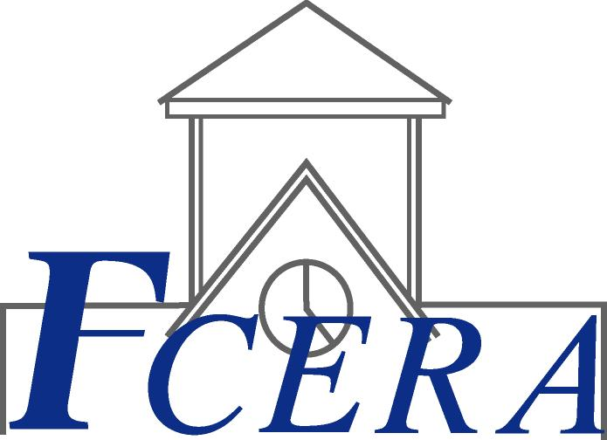
Roberto L. Peña
Retirement Administrator
FRESNO COUNTY EMPLOYEES’ RETIREMENT ASSOCIATION
BOARD OF RETIREMENT
Alan Cade, Jr., Chair
Eulalio Gomez, Vice Chair
Michael Cardenas
Nick Cornacchia
Vicki Crow
James E. Hackett
Steven J. Jolly
Phil Larson
John P. Souza
Ronald S. Frye, Alternate

Request for Quotation

The Fresno County Employees’ Retirement Association (FCERA) is requesting quotations to provide janitorial and maintenance services for its administrative offices. The facility is a confidential facility. All information observed within the facility is to remain confidential and not disclosed to anyone.

The FCERA is a public employees’ retirement association subject to the County Employees Public Employees Retirement Law of 1937. The FCERA is responsible for administering the retirement plan for the employees of the County of Fresno and several member districts. The FCERA employees 25 people in its facility located at 1111 H Street, Fresno, CA 93721.

The five year old building has approximately 9004 square feet of space. There are 13 private offices, 17 work cubicles, two kitchen areas, a boardroom, two restrooms, and a reception area.

The FCERA is seeking quotations to provide janitorial and light maintenance services for this facility. A walk-thru of the facility will be scheduled to allow potential vendors the opportunity to view the facility and obtain additional clarity on the expectations for the successful vendor.

Required Services:

Daily
- Empty all trash cans into the dumpsters located in the parking lot separating recyclable and non-recyclable as required by law
- Thoroughly clean and sanitize both bathrooms and kitchen areas
- Restock paper supplies and soap in bathroom dispensers
- Mop floors in reception area, bathrooms, kitchen areas
- Clean and sanitize water fountain
- Dust reception area
- Clean glass and door handles at entrance
- Vacuum hallways, boardroom, reception areas and offices, daily

Weekly
- Dust all surfaces

Monthly
- Clean light fixtures, window sills, cabinet tops, mini blinds
- Treat wood areas with cleaner/protectant
- Dust air vents
Quarterly
- Clean windows both inside and outside
- Pressure wash sidewalks

Annually – scheduled after normal work hours
- Clean carpets
- Strip and wax tile floors
- Clean air vents
- Clean light fixtures

All cleaning equipment and supplies are to be provided by the successful vendor.

All paper products, soaps, etc., needed to restock the facility are to be provided by the successful vendor and charged back to FCERA at cost. A detailed invoice including numbers of items restocked and individual cost is to be provided.

A janitorial room is available to store equipment and supplies.

Other Requirements:

- Indicate how often a walk-through will be performed to review the work of the janitorial staff assigned to this facility.

- Provide an emergency number for unscheduled or after hours jobs.

- All vacuuming (except special requests), mopping, waxing and other major cleaning jobs are to be completed after normal business hours.

- Successful vendor to provide evidence of appropriate insurance as described below, including workers’ compensation, liability, automobile
A. Commercial General Liability
Commercial General Liability Insurance with limits of not less than One Million Dollars ($1,000,000) per occurrence and an annual aggregate of Two Million Dollars ($2,000,000). This policy shall be issued on a per occurrence basis. FCERA may require specific coverages including completed operations, products liability, and contractual liability, Explosion-Collapse-Underground, fire legal liability or any other liability insurance deemed necessary because of the nature of this contract.
B. Automobile Liability
Comprehensive Automobile Liability Insurance with limits for bodily injury of not less than Two Hundred Fifty Thousand Dollars ($250,000.00) per person, Five Hundred Thousand Dollars ($500,000.00) per accident and for property damages of not less than Fifty Thousand Dollars ($50,000.00), or such coverage with a combined single limit of Five Hundred Thousand Dollars ($500,000.00). Coverage should include owned and non-owned vehicles used in connection with this Agreement.
C. Worker's Compensation
A policy of Worker's Compensation insurance as may be required by the California Labor Code. Such policy will include statutory for Workers’ Compensation and $1,000,000 for Employers Liability.
Successful vendor shall obtain endorsements to the Commercial General Liability insurance naming FCERA, its officers, agents, and employees, individually and collectively, as additional insured, but only insofar as the operations under this Agreement are concerned. Such coverage for additional insured shall apply as primary insurance and any other insurance, or self-insurance, maintained by FCERA, its officers, agents and employees shall be excess only and not contributing with insurance provided under successful vendor's policies herein.
Within Thirty (30) days from the date of execution of this Agreement, successful vendor shall provide certificates of insurance and endorsement as stated above for all of the foregoing policies, as required herein, to FCERA, Attention Becky Van Wyk, stating that such insurance coverages have been obtained and are in full force; that FCERA, its officers, agents and employees will not be responsible for any premiums on the policies; that such Commercial General Liability insurance names FCERA, its officers, agents and employees, individually and collectively, as additional insured, but only insofar as the operations under this Agreement are concerned; that such coverage for additional insured shall apply as primary insurance and any other insurance, or self-insurance, maintained by FCERA, its officers, agents and employees, shall be excess only and not contributing with insurance provided under successful vendor's policies herein; and that this insurance shall not be cancelled or changed without a minimum of thirty (30) days advance, written notice given to FCERA.
In the event the successful vendor fails to keep in effect at all times insurance coverage as herein provided, FCERA may, in addition to other remedies it may have, suspend or terminate this Agreement upon the occurrence of such event.
All policies shall be with admitted insurers licensed to do business in the State of California. Insurance purchased shall be purchased from companies possessing a current A.M. Best, Inc. rating of A FSC VII or better.

- Written responses are to be received (postmark and / or faxing are not acceptable) in triplicate by 5:00 p.m., December 24, 2009 at the following address:

Fresno County Employees’ Retirement Association

Attention: Becky Van Wyk
1111 H Street
Fresno, CA 93721

- Response must be signed by a partner, owner or other person having authority to sign contracts for the entity.

- The contract will be for a three year period with the option to extend for two additional one-year periods.

- FCERA reserves the right to reject all quotes.

- Personnel assigned to the FCERA facility are subject to approval by FCERA Administration.

- Contract will not necessarily go to the lowest bidder, but to the lowest responsible bidder based on the judgment of FCERA.

- This request for quotation is not binding on either party. FCERA and the winning bidder shall enter into a binding written contract setting forth all terms and conditions of the engagement.
Important Dates for this RFQ:
- December 5, 2009 - RFQ Released to Public
- December 15, 2009, 2:00 p.m. - Bidders Conference. All interested bidders should plan on attending as this meeting as it will include a tour of the facility and will be your opportunity to ask questions about the RFQ. Contact Becky Van Wyk to RSVP.
- December 24, 2009, 5:00 p.m. - Sealed bids due to FCERA. Postmarks will not be accepted. Bids not received in FCERA's office by this time will be rejected.
- December 28, 2009, 8:00 a.m. - Opening of bids and analysis of responses.
- January 4, 2010 – Selection of successful bidder
- January 5, 2010 through January 31, 2010 – Contract Negotiations
- February 1, 2010 – Contract period begins

Any questions regarding this announcement should be directed to Becky Van Wyk at bvanwyk@co.fresno.ca.us. Thank you for participating in this Request for Quotation.

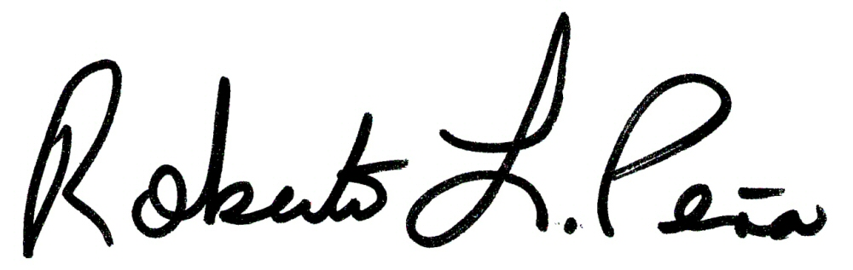
Roberto L. Peña
Retirement Administrator

