COUNTY OF FRESNO
Request for Quotation
 |  |  |  |  |  | NUMBER: 760-4286
June 15, 2006
 | ORG/Requisition: 8911/ 8916020033 |  |  |  |  |  |  |  |  | PURCHASING USE |  |  |  |  | /tmp/lo/0000.doc
 |  |  |  |  |  |  |  |  |  | jol
 | IMPORTANT: SUBMIT QUOTATION IN SEALED PACKAGE WITH QUOTATION NUMBER, CLOSING DATE AND BUYER’S NAME MARKED CLEARLY ON THE OUTSIDE TO:
COUNTY OF FRESNO, Purchasing
4525 EAST HAMILTON AVENUE
FRESNO, CA 93702-4599
Closing date of bid will be at 2:00 p.m., on JULY 12, 2006.
QUOTES WILL BE CONSIDERED LATE WHEN THE OFFICIAL PURCHASING TIME CLOCK READS 2:00 P.M.
 | Quotes will be opened and publicly read at that time. All quotation information will be available for review after contract award.
 | Clarification of specifications are to be directed to: Craig Nickel, phone (559) 456-7110, FAX (559) 456-7831.
 |  | GENERAL CONDITIONS
 |  | See “County Of Fresno Purchasing Standard Instructions And Conditions For Request For Proposals (RFP’S) and Requests for Quotations (RFQ’S)” attached.
BIDDER TO COMPLETE
UNDERSIGNED AGREES TO FURNISH THE COMMODITY OR SERVICE STIPULATED IN THE ATTACHED QUOTATION SCHEDULE AT THE PRICES AND TERMS STATED, SUBJECT TO THE “COUNTY OF FRESNO PURCHASING STANDARD INSTRUCTIONS AND CONDITIONS FOR REQUEST FOR PROPOSALS (RFP’S) AND REQUESTS FOR QUOTATIONS (RFQ’S)”ATTACHED.
Except as noted on individual items, the following will apply to all items in the Quotation Schedule.
 |  |  | - Complete delivery will be made within |  |  |  |  |  |  |  |  | calendar days after receipt of Order.
 |  |  | - A cash discount of |  |  |  |  |  | % |  |  |  |  | days will apply.
Company
Address
City |  |  |  |  |  |  |  |  |  |  |  |  |  |  |  |  | State |  | Zip Code
( ) |  |  |  |  |  |  |  | ( )
Telephone Number |  |  |  |  |  |  |  | Facsimile Number |  |  |  |  |  |  |  |  | E-mail Address
Taxpayer Federal I.D. No.:
Signed By
Print Name |  |  |  |  |  |  |  |  |  |  |  |  | Title

COUNTY OF FRESNO PURCHASING
STANDARD INSTRUCTIONS AND CONDITIONS FOR
REQUESTS FOR PROPOSALS (RFP'S) AND REQUESTS FOR QUOTATIONS (RFQ'S)
Note: the reference to “bids” in the following paragraphs applies to RFP's and RFQ's

GENERAL CONDITIONS
By submitting a bid the bidder agrees to the following conditions. These conditions will apply to all subsequent purchases based on this bid.

- BID PREPARATION:
  - All prices and notations must be typed or written in ink. No erasures permitted. Errors may be crossed out, initialed and corrections printed in ink by person signing bid.
  - Brand Names: Brand names and numbers when given are for reference. Equal items will be considered, provided the offer clearly describes the article and how it differs from that specified. In the absence of such information it shall be understood the offering is exactly as specified.
  - State brand or make of each item. If bidding on other than specified, state make, model and brand being bid and attach supporting literature/specifications to the bid.
  - Bid on each item separately. Prices should be stated in units specified herein. All applicable charges must be quoted; charges on invoice not quoted herein will be disallowed.
  - Time of delivery is a part of the consideration and must be stated in definite terms and must be adhered to. F.O.B. Point shall be destination or freight charges must be stated.
  - All bids must be dated and signed with the firm’s name and by an authorized officer or employee.
  - Unless otherwise noted, prices shall be firm for 120 days after closing date of bid.
- SUBMITTING BIDS:
  - Each bid must be submitted on forms provided in a sealed envelope with bid number and closing date and time on the outside of the envelope/package.
  - Interpretation: Should any discrepancies or omissions be found in the bid specifications or doubt as to their meaning, the bidder shall notify the Buyer in writing at once. The County shall not be held responsible for verbal interpretations. Questions regarding the bid must be received by Purchasing at least 5 working days before bid opening. All addenda issued shall be in writing, duly issued by Purchasing and incorporated into the contract.
  - ISSUING AGENT/AUTHORIZED CONTACT: This RFQ has been issued by County of Fresno Purchasing. Purchasing shall be the vendor’s sole point of contact with regard to the RFQ, its content, and all issues concerning it.
All communication regarding this RFQ shall be directed to an authorized representative of County Purchasing. The specific buyer managing this RFQ is identified on the cover page, along with his or her telephone number, and he or she should be the primary point of contact for discussions or information pertaining to the RFQ. Contact with any other County representative, including elected officials, for the purpose of discussing this RFQ, its content, or any other issue concerning it, is prohibited unless authorized by Purchasing. Violation of this clause, by the vendor having unauthorized contact (verbally or in writing) with such other County representatives, may constitute grounds for rejection by Purchasing of the vendor’s quotation.
The above stated restriction on vendor contact with County representatives shall apply until the County has awarded a purchase order or contract to a vendor or vendors, except as follows. First, in the event that a vendor initiates a formal protest against the RFQ, such vendor may contact the appropriate individual, or individuals who are managing that protest as outlined in the County’s established protest procedures. All such contact must be in accordance with the sequence set forth under the protest procedures. Second, in the event a public hearing is scheduled before the Board of Supervisors to hear testimony prior to its approval of a purchase order or contract, any vendor may address the Board.
  - Bids received after the closing time will NOT be considered.
  - Bidders are to bid what is specified or requested first. If unable to or willing to, bidder may bid alternative or option, indicating all advantages, disadvantages and their associated cost.
- FAILURE TO BID:
  - If not bidding, return bid sheet and state reason for no bid or your name may be removed from mailing list.
- TAXES, CHARGES AND EXTRAS:
  - County of Fresno is subject to California sales and/or use tax (7.975%). Please indicate as a separate line item if applicable.
  - DO NOT include Federal Excise Tax. County is exempt under Registration No. 94-73-03401-K.
  - County is exempt from Federal Transportation Tax. Exemption certificate is not required where shipping papers show consignee as County of Fresno.
  - Charges for transportation, containers, packing, etc. will not be paid unless specified in bid.
- W-9 – REQUEST FOR TAXPAYER IDENTIFICATION NUMBER AND CERTIFICATION:
Upon award of bid, the vendor shall submit to County Purchasing, a completed W-9 - Request for Taxpayer Identification Number and Certification if not already a current vendor with The County of Fresno. This form is available from the IRS to complete on line at http://www.irs.gov/pub/irs-pdf/fw9.pdf.
- AWARDS:
  - Subject to the local preference provisions referenced in Paragraph 6 below and more thoroughly set forth in the General Requirements section of this RFQ, award(s) will be made to the most responsive responsible bidder. The evaluation will include such things as life-cycle cost, availability, delivery costs and whose product and/or service is deemed to be in the best interest of the County. The County shall be the sole judge in making such determination.
  - Unless bidder gives notice of all-or-none award in bid, County may accept any item, group of items or on the basis of total bid.
  - The County reserves the right to reject any and all bids and to waive informalities or irregularities in bids.
  - After award, all bids shall be open to public inspection. The County assumes no responsibility for the confidentiality of information offered in a bid.
- LOCAL VENDORS
  - Local Vendor Preference (applicable to RFQ Process only)
The following provisions are applicable only to the County’s acquisition of materials, equipment or supplies through the RFQ process when the funding source does not require an exemption to the Local Vendor Preference.
THE PROVISIONS OF THIS PARAGRAPH ARE APPLICABLE, NOTWITHSTANDING ANY OTHER PROVISIONS OF THIS RFQ TO THE CONTRARY
If the apparent low bidder is not a local vendor, any local vendor who submitted a bid which was within five percent (5%) of the lowest responsive bid as determined by the purchasing agent shall have the option of submitting a new bid within forty-eight hours (not including weekends and holidays) of County’s delivery of notification. Such new bids must be in an amount less than or equal to the lowest responsive bid as determined by the purchasing agent. If the purchasing agent receives any new bids from local vendors who have the option of submitting new bids within said forty-eight hour period, it shall award the contract to the local vendor submitting the lowest responsible bid. If no new bids are received, the contract shall be awarded to the original low bidder as announced by the purchasing agent.
  - Local Vendor Defined
“Local Vendor” shall mean any business which:
- Has its headquarters, distribution point or locally-owned franchise located in or having a street address within the County for at least six (6) months immediately prior to the issuance of the request for competitive bids by the purchasing agent; and
- Holds any required business license by a jurisdiction located in Fresno County; and
- Employs at least one (1) full-time or two (2) part-time employees whose primary residence is located within Fresno County, or if the business has no employees, shall be at least fifty percent (50%) owned by one or more persons whose primary residence(s) is located within Fresno County.
- TIE BIDS:
All other factors being equal, the contract shall be awarded to the Fresno County vendor or, if neither or both are Fresno County vendors, it may be awarded by the flip of a coin in the presence of witnesses or the entire bid may be rejected and re-bid. If the General Requirements of this RFQ state that they are applicable, the provisions of the Fresno County Local Vendor Preference shall take priority over this paragraph.
- PATENT INDEMNITY:
The vendor shall hold the County, its officers, agents and employees, harmless from liability of any nature or kind, including costs and expenses, for infringement or use of any copyrighted or uncopyrighted composition, secret process, patented or unpatented invention, article or appliance furnished or used in connection with this bid.
- SAMPLES:
Samples, when required, must be furnished and delivered free and, if not destroyed by tests, will upon written request (within 30 days of bid closing date) be returned at the bidder's expense. In the absence of such notification, County shall have the right to dispose of the samples in whatever manner it deems appropriate.
- RIGHTS AND REMEDIES OF COUNTY FOR DEFAULT:
  - In case of default by vendor, the County may procure the articles or service from another source and may recover the cost difference and related expenses occasioned thereby from any unpaid balance due the vendor or by proceeding against performance bond of the vendor, if any, or by suit against the vendor. The prices paid by the County shall be considered the prevailing market price at the time such purchase is made.
  - Articles or services, which upon delivery inspection do not meet specifications, will be rejected and the vendor will be considered in default. Vendor shall reimburse County for expenses related to delivery of non-specified goods or services.
  - Regardless of F.O.B. point, vendor agrees to bear all risks of loss, injury or destruction to goods and materials ordered herein which occur prior to delivery and such loss, injury or destruction shall not release vendor from any obligation hereunder.
- DISCOUNTS:
Terms of less than 15 days for cash payment will be considered as net in evaluating this bid. A discount for payment within fifteen (15) days or more will be considered in determining the award of bid. Discount period will commence either the later of delivery or receipt of invoice by the County. Standard terms are Net Forty-five (45) days.
- SPECIAL CONDITIONS IN BID SCHEDULE SUPERSEDE GENERAL CONDITIONS.
The “General Conditions” provisions of this RFP/RFQ shall be superseded if in conflict with any other section of this bid, to the extent of any such conflict.
- SPECIAL REQUIREMENT:
With the invoice or within twenty-five (25) days of delivery, the seller must provide to the County a Material Safety Data Sheet for each product, which contains any substance on “The List of 800 Hazardous Substances”, published by the State Director of Industrial Relations. (See Hazardous Substances Information and Training Act. California State Labor Code Sections 6360 through 6399.7.)
- RECYCLED PRODUCTS/MATERIALS:
Vendors are encouraged to provide and quote (with documentation) recycled or recyclable products/materials which meet stated specifications.
- YEAR COMPLIANCE WARRANTY
Vendor warrants that any product furnished pursuant to this Agreement/order shall support a four-digit year format and be able to accurately process date and time data from, into and between the twentieth and twenty-first centuries, as well as leap year calculations. "Product" shall include, without limitation, any piece or component of equipment, hardware, firmware, middleware, custom or commercial software, or internal components or subroutines therein. This warranty shall survive termination or expiration of this Agreement.
In the event of any decrease in product functionality or accuracy related to time and/or date data related codes and/or internal subroutines that impede the product from operating correctly using dates beyond December 31, 1999, vendor shall restore or repair the product to the same level of functionality as warranted herein, so as to minimize interruption to County's ongoing business process, time being of the essence. In the event that such warranty compliance requires the acquisition of additional programs, the expense for any such associated or additional acquisitions, which may be required, including, without limitation, data conversion tools, shall be borne exclusively by vendor. Nothing in this warranty shall be construed to limit any rights or remedies the County may otherwise have under this Agreement with respect to defects other than year performance.
- PARTICIPATION:
Bidder may agree to extend the terms of the resulting contract to other political subdivision, municipalities and tax-supported agencies.
Such participating Governmental bodies shall make purchases in their own name, make payment directly to bidder, and be liable directly to the bidder, holding the County of Fresno harmless.
- CONFIDENTIALITY:
All services performed by vendor shall be in strict conformance with all applicable Federal, State of California and/or local laws and regulations relating to confidentiality, including but not limited to, California Civil Code, California Welfare and Institutions Code, Health and Safety Code, California Code of Regulations, Code of Federal Regulations.
Vendor shall submit to County’s monitoring of said compliance.
Vendor may be a business associate of County, as that term is defined in the “Privacy Rule” enacted by the Health Insurance Portability and Accountability Act of 1996 (HIPAA). As a HIPAA Business Associate, vendor may use or disclose protected health information (“PHI”) to perform functions, activities or services for or on behalf of County as specified by the County, provided that such use or disclosure shall not violate HIPAA and its implementing regulations. The uses and disclosures if PHI may not be more expansive than those applicable to County, as the “Covered Entity” under HIPAA’S Privacy Rule, except as authorized for management, administrative or legal responsibilities of the Business Associate.
Vendor shall not use or further disclose PHI other than as permitted or required by the County, or as required by law without written notice to the County.
Vendor shall ensure that any agent, including any subcontractor, to which vendor provides PHI received from, or created or received by the vendor on behalf of County, shall comply with the same restrictions and conditions with respect to such information.
- APPEALS
Appeals must be submitted in writing within five (5) working days after the review committee notification of proposed recommendations. Appeals should be submitted to County of Fresno Purchasing, 4525 E. Hamilton Avenue, Fresno, California 93702-4599. Appeals should address only areas regarding RFP contradictions, procurement errors, quotation rating discrepancies, legality of procurement context, conflict of interest in rating process, and inappropriate or unfair competitive procurement grievance regarding the RFP process.
The Purchasing Manager will provide a written response to the complaint within five (5) working days unless the complainant is notified more time is required.
If the protesting bidder is not satisfied with the decision of the Purchasing Manager, he/she shall have the right to appeal to the Purchasing Agent within five (5) business days after notification of the Purchasing Manager’s decision.
If the protesting bidder is not satisfied with Purchasing Agent decision, the final appeal is with the Board of Supervisors.

BIDDING INSTRUCTIONS
VEHICLES OR HEAVY EQUIPMENT
The County of Fresno is soliciting bids for one (1) Snow Plow Truck to be used by its Department of Public Works.
The County of Fresno is in need of the Snow Plow Truck for use during the upcoming Snow season.
LIQUIDATED DAMAGES: The Contractor will be assessed liquidated damages in the amount of two hundred fifty dollars ($250.00) per day for each calendar day delay over the specified time of completion.
DEFINITIONS: The terms Bidder, Proposer, Contractor and Vendor are all used interchangeably and refer to that person, partnership, corporation, organization, agency, etc. which is offering the quotation and is identified on page one of this Request For Quotation (RFQ).
ISSUING AGENT: This RFQ has been issued by County of Fresno Purchasing. The Purchasing shall be the vendor’s sole point of contact with regard to the RFQ, its content, and all issues concerning it.
AUTHORIZED CONTACT: All communication regarding this RFQ shall be directed to an authorized representative of the County’s Purchasing. The specific buyer managing this RFQ is identified on the cover page, along with his or her telephone number, and he or she should be the primary point of contact for discussions or information pertaining to the RFQ. Contact with any other County representative, including elected officials, for the purpose of discussing this RFQ, it content, or any other issue concerning it, is prohibited unless authorized by Purchasing. Violation of this clause, by the vendor having unauthorized contact (verbally or in writing) with such other County representatives, may constitute grounds for rejection by Purchasing of the vendor’s quotation.
The above stated restriction on vendor contact with County representatives shall apply until the County has awarded a purchase order or contract to a vendor or vendors, except as follows. First, in the event that a vendor initiates a formal protest against the RFQ, such vendor may contact the appropriate individual, or individuals who are managing that protest as outlined in the County’s established protest procedures. All such contact must be in accordance with the sequence set forth under the protest procedures. Second, in the event a public hearing is scheduled before the Board of Supervisors to hear testimony prior to its approval of a purchase order or contract, any vendor may address the Board.
VENDOR CONFERENCE: On June 27, 2006 at 10:00 a.m., a vendor's conference will be held in which the scope of the project and quotation requirements will be explained. The meeting will be held at the office of County of Fresno Purchasing, 4525 E. Hamilton (between Cedar and Maple), Fresno, California. An addendum to the RFQ will be prepared and distributed to all bidders only if necessary to clarify substantive items raised during the bidders' conference.
Bidders are to contact Craig Nickel at County of Fresno Purchasing, (559) 456-7110, if they are planning to attend the conference.
INTERPRETATION OF RFQ: Vendors must make careful examination of the requirements, specifications and conditions expressed in the RFQ and fully inform themselves as to the quality and character of services required. If any person planning to submit a quotation finds discrepancies in or omissions from the RFQ or has any doubt as to the true meaning or interpretation, correction thereof may be requested at the scheduled Vendor Conference (see above). Any change in the RFQ will be made only by written addendum, duly issued by the County. The County will not be responsible for any other explanations or interpretations.
Questions may be submitted subsequent to the Vendor Conference, subject to the following conditions:
- Such questions are submitted in writing to County Purchasing at least five (5) County business days prior to the Request for Quotation closing date. Questions must be directed to the attention of the buyer identified on page one.
- Such questions are submitted with the understanding that County can respond only to questions it considers material in nature.
Questions shall be delivered to County of Fresno Purchasing, 4525 E. Hamilton Avenue, Fresno, CA 93702 or faxed to (559) 456-7831. If faxing the bidder must confirm receipt by phone ((559) 456-7110) within one-half (½) hour of transmission.
NOTE: The bidder is encouraged to submit all questions at the Vendor Conference. Time limitations can prevent a response to questions submitted after the conference.
NUMBER OF COPIES: Submit one (1) original and two (2) copies of your quotation no later than the quotation closing date and time as stated on the front of this document to County of Fresno Purchasing. Each copy to be identical to the original, including all supporting documentation (i.e. literature, brochures, reports, schedules, specifications, drawings etc.). The cover page of each quotation is to be appropriately marked “Original” or “Copy”.
AWARD: The County of Fresno reserves the right to reject any and all bids or alternate bids as is in the best interest of the County. Consideration will be given in comparing quotations and in awarding a contract, not only to the amount of the quotations, but also the kind and quality of the equipment offered, its suitability for use in the service intended, as well as the lowest ultimate cost to the County. Time required for delivery is important and may influence the award. Award will be made to the Vendor(s) offering equipment, price, service, delivery and support deemed to be to the best advantage of the County of Fresno.
RIGHT TO REJECT BIDS: The County reserves the right to reject any and all bids and to waive informalities or irregularities in bids.
FIRM QUOTATION: All quotations shall remain firm for at least ninety (90) days.
NON-FUNDING CLAUSE: Funds provided for equipment supplied under the terms of this bid are contingent on the approval of the appropriating government agency. Should sufficient funds not be allocated, the equipment or the amount of equipment to be supplied may be modified or terminated at any time.
TAXES: The quoted amount must include all applicable taxes. If taxes are not specifically identified in the quotation it will be assumed that they are included in the total quoted.
SALES TAX: Fresno County pays California State Sales Tax in the amount of 7.975% regardless of vendor's place of doing business.
MINOR DEVIATIONS: The County reserves the right to negotiate minor deviations from the prescribed terms, conditions and requirements with the selected vendor.
QUOTATION REJECTION: Failure to respond to all questions or not to supply the requested information could result in rejection of your quotation.
AMERINET: The County of Fresno is a member of the Amerinet Group Purchasing Organization.
BIDDERS’ LIABILITIES: County of Fresno will not be held liable for any cost incurred by vendors in responding to the RFQ.
PRICE RESPONSIBILITY: The selected vendor will be required to assume full responsibility for all equipment and services offered in the quotation, whether or not they are provided directly. Further, the County of Fresno will consider the selected vendor to be the sole point of contact with regard to contractual matters, including payment of any and all charges resulting from the contract. The contractor may not subcontract or transfer the contract, or any right or obligation arising out of the contract, without first having obtained the express written consent of the County.
CONFIDENTIALITY: Bidders shall not disclose information about the County's business or business practices and safeguard confidential data which vendor staff may have access to in the course of system implementation.
NEWS RELEASE: Vendors shall not issue any news releases or otherwise release information to any third party about this RFQ or the vendor's quotation without prior written approval from the County of Fresno.
BACKGROUND REVIEW: The County reserves the right to conduct a background inquiry of each proposer/bidder which may include collection of appropriate criminal history information, contractual and business associations and practices, employment histories and reputation in the business community. By submitting a quotation/bid to the County, the vendor consents to such an inquiry and agrees to make available to the County such books and records the County deems necessary to conduct the inquiry.
EXCEPTIONS: Identify with explanation, any terms, conditions, specifications or stipulations of the RFQ with which you CAN NOT or WILL NOT comply. Exceptions to items contained in the SPECIFICATIONS/REQUIREMENTS Section of this RFQ shall be stated in the bidder’s response to that section. All other exceptions shall be stated under a separate section of the bidder’s response to this RFQ. Such section shall be entitled “EXCEPTIONS”.
ADDENDA: In the event that it becomes necessary to revise any part of this RFQ, addenda will be provided to all agencies and organizations that receive the basic RFQ.
CONFLICT OF INTEREST: The County shall not Contract with, and shall reject any bid or quotation submitted by the persons or entities specified below, unless the Board of Supervisors finds that special circumstances exist which justify the approval of such contract:
- Employees of the County or public agencies for which the Board of Supervisors is the governing body.
- Profit-making firms or businesses in which employees described in Subsection (1) serve as officers, principals, partners or major shareholders.
- Persons who, within the immediately preceding twelve (12) months, came within the provisions of Subsection (1), and who were employees in positions of substantial responsibility in the area of service to be performed by the contract, or participated in any way in developing the Contract or its service specifications.
- Profit-making firms or businesses in which the former employees described in Subsection (3) serve as officers, principals, partners or major shareholders.
No County employee whose position in the County enables him to influence the selection of a contractor for this RFQ, or any competing RFQ, and no spouse or economic dependent of such employee, shall be employees in any capacity by a bidder, or have any other direct or indirect financial interest in the selection of a contractor.
INVOICING: All invoices are to be delivered in duplicate to the ordering department. Each invoice shall reference the Purchase Order/Contract number. The Contractor shall obtain the “Invoice to” address when receiving the order.
PAYMENT: The bidder agrees to provide equipment and other requirements as stated in this Request for Quotation. The County of Fresno agrees to pay bidder at the terms and conditions stated in the Request for Quotation.
Payment will be withheld until complete delivery is made by the Vendor and such delivery is accepted by County as being complete and satisfactory.
Partial payment may or may not be acceptable to the County of Fresno. Should partial payment be made by the County of Fresno, a percentage of the agreement amount shall be held until all terms and conditions of the Request for Quotations are satisfied.
PAYMENT TERMS: Payment terms are Net 45 days except when bidder offers an acceptable cash discount. The payment period shall be computed from the date that County makes final acceptance of the equipment or from date of receipt of invoice, whichever is latest. Invoices must be submitted as stated in the Purchase Order/Contract.
QUANTITIES: Quantities shown in the Quotation Schedule are thought to accurately represent County’s current requirements. However, County reserves the right to increase or decrease such quantities. County guarantees no minimum amount.
INDEPENDENT CONTRACTOR: In performance of the work, duties, and obligations assumed by Contractor under any ensuing Agreement, it is mutually understood and agreed that CONTRACTOR, including any and all of Contractor’s officers, agents, and employees will at all times be acting and performing as an independent contractor, and shall act in an independent capacity and not as an officer, agent, servant, employee, joint venturer, partner, or associate of the COUNTY. Furthermore, County shall have no right to control or supervise or direct the manner or method by which Contractor shall perform its work and function. However, County shall retain the right to administer this Agreement so as to verify that Contractor is performing its obligations in accordance with the terms and conditions thereof. Contractor and County shall comply with all applicable provisions of law and the rules and regulations, if any, of governmental authorities having jurisdiction over matters the subject thereof.
Because of its status as an independent contractor, Contractor shall have absolutely no right to employment rights and benefits available to County employees. Contractor shall be solely liable and responsible for providing to, or on behalf of, its employees all legally-required employee benefits. In addition, Contractor shall be solely responsible and save County harmless from all matters relating to payment of Contractor's employees, including compliance with Social Security, withholding, and all other regulations governing such matters. It is acknowledged that during the term of the Agreement, Contractor may be providing services to others unrelated to the County or to the Agreement.
HOLD HARMLESS CLAUSE: Contractor agrees to indemnify, save, hold harmless and at County's request, defend the County, its officers, agents and employees, from any and all costs and expenses, damages, liabilities, claims and losses occurring or resulting to County in connection with the performance, or failure to perform, by Contractor, its officers, agents or employees under this Agreement and from any and all costs and expenses, damages, liabilities, claims and losses occurring or resulting to any person, firm or corporation who may be injured or damaged by the performance, or failure to perform, of Contractor, its officers, agents or employees under this Agreement.
INSURANCE:
Without limiting the COUNTY's right to obtain indemnification from CONTRACTOR or any third parties, CONTRACTOR, at its sole expense, shall maintain in full force and effect the following insurance policies throughout the term of the Agreement:
- Commercial General Liability
Commercial General Liability Insurance with limits of not less than One Million Dollars ($1,000,000) per occurrence and an annual aggregate of Two Million Dollars ($2,000,000). This policy shall be issued on a per occurrence basis. COUNTY may require specific coverages including completed operations, products liability, contractual liability, Explosion-Collapse-Underground, fire legal liability or any other liability insurance deemed necessary because of the nature of this contract.
- Automobile Liability
Comprehensive Automobile Liability Insurance with limits for bodily injury of not less than Two Hundred Fifty Thousand Dollars ($250,000.00) per person, Five Hundred Thousand Dollars ($500,000.00) per accident and for property damages of not less than Fifty Thousand Dollars ($50,000.00), or such coverage with a combined single limit of Five Hundred Thousand Dollars ($500,000.00). Coverage should include owned and non-owned vehicles used in connection with this Agreement.
- Worker's Compensation
A policy of Worker's Compensation insurance as may be required by the California Labor Code.
CONTRACTOR shall obtain endorsements to the Commercial General Liability insurance naming the County of Fresno, its officers, agents, and employees, individually and collectively, as additional insured, but only insofar as the operations under this Agreement are concerned. Such coverage for additional insured shall apply as primary insurance and any other insurance, or self-insurance, maintained by COUNTY, its officers, agents and employees shall be excess only and not contributing with insurance provided under CONTRACTOR's policies herein. This insurance shall not be cancelled or changed without a minimum of thirty (30) days advance written notice given to COUNTY.
Within Thirty (30) days from the date CONTRACTOR executes this Agreement, CONTRACTOR shall provide certificates of insurance and endorsement as stated above for all of the foregoing policies, as required herein, to the County of Fresno, stating that such insurance coverage have been obtained and are in full force; that the County of Fresno, its officers, agents and employees will not be responsible for any premiums on the policies; that such Commercial General Liability insurance names the County of Fresno, its officers, agents and employees, individually and collectively, as additional insured, but only insofar as the operations under this Agreement are concerned; that such coverage for additional insured shall apply as primary insurance and any other insurance, or self-insurance, maintained by COUNTY, its officers, agents and employees, shall be excess only and not contributing with insurance provided under CONTRACTOR's policies herein; and that this insurance shall not be cancelled or changed without a minimum of thirty (30) days advance, written notice given to COUNTY.
In the event CONTRACTOR fails to keep in effect at all times insurance coverage as herein provided, the COUNTY may, in addition to other remedies it may have, suspend or terminate this Agreement upon the occurrence of such event.
All policies shall be with admitted insurers licensed to do business in the State of California. Insurance purchased shall be purchased from companies possessing a current A.M. Best, Inc. rating of A FSC VII or better.
DISPUTE RESOLUTION: The ensuing Purchase Order/Contract shall be governed by the laws of the state of California.
Any claim which cannot be amicably settled without court action will be litigated in the U. S. District Court for the Eastern District of California in Fresno, CA or in a state court for Fresno County.
TERMINATION: The County reserves the right to terminate any resulting Purchase Order/Contract upon written notice.
DEFAULT: In case of default by the selected bidder, the County may procure the equipment and or services from another source and may recover the loss occasioned thereby from any unpaid balance due the selected bidder, or by any other legal means available to the County.
ASSIGNMENTS: The ensuing Purchase Order/Contract will provide that the vendor may not assign any payment or portions of payments without prior written consent of the County of Fresno.
ASSURANCES: Any contract awarded under this RFQ must be carried out in full compliance with The Civil Rights Act of 1964, The Americans With Disabilities Act of 1990, their subsequent amendments, and any and all other laws protecting the rights of individuals and agencies. The County of Fresno has a zero tolerance for discrimination, implied or expressed, and wants to ensure that policy continues under this RFQ. The contractor must also guarantee that services, or workmanship, provided will be performed in compliance with all applicable local, state, or federal laws and regulations pertinent to the types of services, or project, of the nature required under this RFQ. In addition, the contractor may be required to provide evidence substantiating that their employees have the necessary skills and training to perform the required services or work.
F.O.B. DESTINATION: All bids are to be quoted F.O.B. County of Fresno Equipment Division, 4551 East Hamilton Avenue, Fresno, California 93702.
DELIVERY: Prompt delivery is essential. Failure to furnish delivery as promised will constitute a breach of agreement and the County of Fresno may procure items in accordance with the General Conditions of this RFQ.
BRAND NAMES: Whenever in the specifications, any material or process is indicated or specified by patent of proprietary name and/or by name of manufacturer, such specifications shall be deemed to be used for the purpose of facilitating descriptions of the material and/or process. The bidder may offer his/her alternate equivalents if identified and accompanied by specifications. The County shall have the sole authority in determining if an alternate is acceptable.
TRAINING: The successful bidder will arrange training. Training shall include vehicle orientation, operator and mechanic training. This training shall be conducted at numerous sites. All cost of instruction to be borne by the bidder.
OPERATOR TRAINING: If required, successful bidder will arrange training for an operator selected from the staff of the County of Fresno. This training to cover basic theory, proper operations and maintenance of the unit being installed. All cost of class instruction to be borne by the bidder.
MECHANIC TRAINING: The successful bidder(s) may be required to make available maintenance mechanic training classes. The County of Fresno will assume responsibility for travel and lodging expenses.
MAINTENANCE: The successful bidder shall provide all tools or minor equipment specifically required to maintain equipment supplied. Bidder shall list any special oils, additives, or other lubricants needed for maintenance of equipment supplied.
COMPLETE INSTRUCTIONS MANUAL: Supply manual covering instrumentation, complete instructions for installation, operation, maintenance, testing, and a list of spare parts, including manufacturer's part numbers and wiring diagrams/schematics shall be supplied. Delivery will not be considered complete until such manuals are received by County.
FACTORY MANUALS: The successful bidder shall provide two (2) parts manuals, two (2) shop repair manuals for equipment supplied. Manuals shall be in possession of the County of Fresno before delivery will be considered complete.
LITERATURE: Bidders quotation shall include literature which fully describes unit(s) on which they are bidding. Any and all literature submitted must be stamped with bidder's name and address.
EQUIPMENT MANUALS: The successful bidder shall provide the following at or before the time of delivery of equipment:
- One (1) operator’s manual for each unit.
- One (1) complete service and repair manual, including engine per group.
- One (1) complete parts manual, including engine per group.
Manuals to be supplied at time of delivery. Delivery will not be considered complete and formal acceptance of equipment will not be issued until all manuals are received by the appropriate County representative.
Microfiche documents including engine are acceptable as parts manual.
REPAIRS WHILE UNDER WARRANTY: All shipping charges, mileage, charges for servicemen, parts, and labor required shall be included under warranty.
SAFETY/EQUIPMENT STANDARDS: Equipment must be furnished with all protection devices in accordance with the requirements of CALIFORNIA-OSHA.
DEMONSTRATION: Upon request by the County of Fresno, bidder shall provide a demonstration unit for a period of time not to exceed three (3) calendar days. Failure to provide a demonstration within ten (10) working days of the County’s request may be cause for rejection of bidder’s offer. Such demonstration unit shall be of the same make, model and year of that being offered and be equipped accordingly.
BIDDER TO COMPLETE:
WARRANTY & SERVICE:
State the warranty and/or guarantee provisions applicable to the equipment offered. Describe the vendors, specific warranty coverage(s), limitation(s), and contact person and telephone number.
State the specific location where service and/or maintenance can be obtained. Failure to furnish this information will be cause for rejection of bid.
REPAIRS WHILE UNDER WARRANTY: All shipping charges, mileage, charges for servicemen, parts and labor required shall be included under warranty.
SAFETY/EQUIPMENT STANDARDS: Equipment must be furnished with all protection devices in accordance with the requirements of CALIFORNIA OSHA.
If a repair is unable to be completed in a reasonable period of time, will the vendor supply a loaner piece of equipment to the County Department at no charge?
 | Yes |  | No

PARTICIPATION:
The County of Fresno is a member of the Central Valley Purchasing Group. This group consists of Fresno, Kern, Kings, and Tulare Counties and all governmental, tax supported agencies within these counties.
Whenever possible, these agencies co-op (piggyback) on contracts put in place by one of the other agencies.
Any agency choosing to avail itself of this opportunity, will make purchases in their own name, make payment directly to the contractor, be liable to the contractor and vice versa, per the terms of the original contract, all the while holding the County of Fresno harmless. If awarded this contract, please indicate whether you would extend the same terms and conditions to all tax supported agencies within this group as you are proposing to extend to Fresno County.
Yes, we will extend contract terms and conditions to all qualified agencies within the Central Valley Purchasing Group.
No, we will not extend contract terms to any agency other than the County of Fresno.
(Authorized Signature)
Title

Local Vendor Preference
The County of Fresno Local Vendor Preference is applicable to this Request for Quotation. Refer to the General Conditions section for details.
Qualified Vendors that desire consideration as a Fresno County Local Vendor under this RFQ must complete the “Statement of Local Vendor Certification” contained herein and submit it as a part of their quotation. Late submittals of the “Statement of Local Vendor Certification” will not be considered. Submission of this statement will qualify the vendor for treatment as a local vendor for purposes of this RFQ only. The statement made under this RFQ shall not qualify the vendor as a local vendor under any other RFQ.
LOCAL VENDOR CERTIFICATION:
Any vendor claiming to be a local vendor, as defined under the General Conditions section of this RFQ, shall so certify in writing to the purchasing agent. The purchasing agent shall not be required to verify the accuracy or any such certifications, and shall have sole discretion to determine if a vendor meets the definition of “local vendor.”
Any person or business falsely claiming to be a local vendor under this section shall be ineligible to transact any business with the County for a period of not less than three (3) months and not more twenty-four (24) months as determined in the sole discretion of the purchasing agent. The purchasing agent shall also have the right to terminate all or any part of any contract entered into with such person or business.
STATEMENT OF LOCAL VENDOR CERTIFICATION
COUNTY OF FRESNO
Qualified local vendors desiring consideration under the Fresno County Local Vendor Preference must complete the following and submit with their quotation (print or type).
I |  |  |  |  |  | ,
 | (individual submitting bid) |  |  |  |  |  | (title)
Of/for |  |  |  | Certify that
 |  | (Company Name) |  |  |  |  |  | (Company Name)
Is a Fresno County local Vendor as defined under the General Conditions section of this RFQ and therefore qualifies for the Local Vendor Preference.
Signature |  |  |  |  | Title |  |  |  |  | Date

NOTIFICATION OF RE-BID
If a local vendor’s bid qualifies under Fresno County’s Local Vendor Preference, the local vendor will be notified of his/her opportunity to re-bid. if so notified, the Vendor must submit his/her re-bid within forty-eight (48) hours of notification (excluding weekends and holidays). Notification will be issued by e-mail or Fax, whichever is preferred by the vendor. Notification to Vendor shall be considered complete upon County’s transmission of e-mail or Fax.
The local vendor shall state his/her preferred method of notification below along with the appropriate e-mail address or Fax number. Notification by County will be limited to one of those two (2) methods. It will be the local vendor’s responsibility to check his/her e-mail or Fax messages for notification. The vendor’s delay in receiving his/her notification will not alter the forty-eight (48) hour period allowed for re-bid submission.
LOCAL VENDOR TO COMPLETE:
Indicate *ONE method for notification of Local Vendor re-bid by providing the appropriate e-mail address or Fax number. Submit this document as a part of your quotation.
E-Mail Address or Fax Number (Identify contact person if using a Fax Number)
Vendor must complete and return with Request for Quotation.
Firm:
REFERENCE LIST
Submit a list of at least three (3) customer references. Such references shall be customers for whom the bidder has recently provided services that are similar to those requested herein.
Reference Name: |  |  | City:
Contact: |  |  | Phone No.:
Date and Service Provided:
Reference Name: |  |  | City:
Contact: |  |  | Phone No.:
Date and Service Provided:
Reference Name: |  |  | City:
Contact: |  |  | Phone No.:
Date and Service Provided:
Reference Name: |  |  | City:
Contact: |  |  | Phone No.:
Date and Service Provided:
Reference Name: |  |  | City:
Contact: |  |  | Phone No.:
Date and Service Provided:
FAILURE TO PROVIDE A LIST OF AT LEAST THREE (3) CUSTOMERS MAY BE CAUSE FOR REJECTION OF THIS RFQ.
EQUIPMENT GENERAL REQUIREMENTS
The equipment supplied shall be new (unused), current model year production and equal in style, quality and appointments to those offered to the general public. The equipment shall be supplied with all accessories as considered standard equipment for make and model specified.
The following referenced documents of record in effect on the date of the Request for Quotation, form a part of the specifications to the extent they are applicable:
Department of Transportation, Federal Highway Administration, Motor Carrier Safety Regulations.
U.S. Environmental Protection Agency - Current Federal Energy Administration. Gas Mileage Guide California.
California Vehicle Code
Federal Motor Vehicle Safety Regulations and Standards
California Division of Industrial Safety
OSHA Standards
Title 19 State Fire Marshall Code Book
Failure on the part of the bidder to comply with all requirements and conditions of the Request for Quotation and this specification may be cause for rejection of bid.
No exceptions to or deviations from this specification will be considered unless each exception or deviation is specifically stated by the bidder in the designated places. If no exceptions or deviations are shown the bidder will be required to furnish vehicles exactly as specified herein. The burden of proof of compliance with this specification is the responsibility of the bidder.
Federal Excise Tax Exemption - County of Fresno IRS Registration No. 94-73-03401K.
MANUFACTURING, MATERIAL AND DESIGN PRACTICES: It is intended that the manufacturer, in the selection of components will use material and design practices that are the best available in the industry for the type of operating conditions to which the vehicle/unit(s) will be subjected. Suspension, wheels, tires, and other parts shall be selected to give maximum performance, service life and safety. All parts, equipment and accessories shall conform in strength, quality of material, and workmanship to recognized industry standards.
HEAVY DUTY DEFINED: The term “heavy duty”, as used in these specifications, shall mean that the item to which the term is applied shall exceed the quality or capacity supplied with standard production vehicle/unit(s); and it shall be able to withstand unusual strain, exposure, temperature, wear and use.
SPECIFICATION VARIANCES: If any of the equipment bid varies from the specifications, such variation(s) must be listed in writing and attached as part of the quotation under a section entitled “EXCEPTIONS” or in the bidder’s response to the “SPECIFICATIONS/ REQUIREMENTS” section of this RFQ. The County of Fresno reserves the right to waive minor variations if, in the opinion of the County, the basic unit meets the general intent of these specifications.
MANUFACTURER’S SPECIFICATIONS:
- Complete specifications, published literature and photos or illustrations of unit(s) proposed, shall be furnished with the bid.
- Only new models in current production which are catalogued by the manufacturer, and for which printed literature and specifications are available, will be accepted.
MANUFACTURER’S STANDARD EQUIPMENT:
- All equipment and components listed as standard by the manufacturer for model quoted, shall be furnished, whether or not such items are detailed herein, e.g.: special wrenches, tool kits, jacks, adequate to safely lift the vehicle when loaded to rated capacity, etc. Optional equipment as necessary to meet the following requirements of these specifications shall also be supplied.
- Specifications on the following pages are written with the intent to meet all applicable documents, but the final certification to comply shall rest with the vendor and not the County of Fresno. Should requirements as specified not comply, the manufacturer is required to re-figure and revise the specifications to meet all laws, rules and regulations where it applies to items such as the ratings of axles, tires, wheels, brakes, batteries, cooling capacity, etc., and the County of Fresno is to be notified thereof.
- Purchaser will not accept any part, component or system which is not an established standard product of the bidding manufacturer. By this is meant that any item or assembly which, relative to the supplying manufacturer’s standard line of products, could be described as “first of it’s kind”, “experimental”, “only of it’s kind to be built”, “especially modified to comply with specifications”, “prototype”, etc., shall not be acceptable. All parts and components of the system offered and delivered must conform to the manufacturer’s standard production or be off-shelf available hardware production item.
APPLICABLE DOCUMENTS AND CERTIFICATIONS:
- Federal Motor Vehicle Safety Standard, Department of Transportation
- State of California Motor Vehicle Code
- State of California General Industrial Safety Orders
- State of California Health and Safety Code, Motor Vehicle Pollution Control
- California Occupational Safety and Health Act (O.S.H.A.)
- Society of Automotive Engineering Standards
- American Society of Mechanical Engineers (A.S.M.E.)
- E.P.A.
OPERATIONAL NOISE STANDARD: The noise level shall be in conformance with standards established by local, state and federal agencies. Each unit delivered may be tested by County personnel for noise level and must meet noise requirements before the unit is accepted.
DEMONSTRATIONS: The County reserves the option for “on the job demonstration and evaluation” by County personnel. Demonstration shall be available within fourteen (14) days of County’s request. Only units meeting the intent and scope if these specifications shall be demonstrated. Time and amount of hours required for the evaluation shall be as determined by the County and approved by Bidder. Failure to provide demonstration of demonstration equipment for an adequate period is cause for rejection of bidder's offer.
DELIVERY:
- “Caravan” or “In-tow” delivery from points of manufacture or assembly will not be accepted.
- Delivery shall be made to the County of Fresno Corporation Yard, 4551 East Hamilton Avenue, Fresno, California, serviced and operable with a minimum ¼ tank of fuel. G.S. Fleet Services shall be given a minimum of twenty-four (24) hours notice of the Contractor’s intent to deliver the vehicle/unit(s).
- Delivery times are limited to 8:00 a.m. to 3:00 p.m. Monday through Friday. No holidays or weekends.
PRE-DELIVERY AND INSPECTION: Prior to delivery, each vehicle shall be completely inspected and serviced by the delivering dealer and/or the manufacturer's pre-delivery service center.
Normally, vehicles will be inspected at dealer's place of business before delivery. Inspection will be made by an authorized representative of the purchasing agency for workmanship, appearance, proper functioning of all equipment and systems, and conformance to all requirements of bid specifications. In the event deficiencies are detected, the vehicle(s) will be rejected and the delivering dealer will be required to make necessary repairs, adjustments or replacement. Alternately, if the vehicle(s) are inspected after delivery and rejected because of deficiencies, it shall be the dealer's responsibility to pick up the vehicle(s), make the necessary corrections and re-deliver the vehicle(s) for re-inspection and acceptance.
LICENSE: The original dealer’s Report of Sale shall be furnished to the County at the time of delivery of the vehicle(s) before payment can be made.
GUARANTEE:
- The manufacturer and/or dealer delivering the vehicle/unit(s) against these specifications shall guarantee that they meet the minimum requirements set forth herein. If it is found the equipment delivered does not meet the minimum requirements of these specifications, the manufacturer and/or dealer will be required to correct the same at his expense. Failure of the manufacturer and/or dealer to bring the equipment into full compliance with all requirements set forth in this specification within thirty (30) days of delivery shall constitute cause for rejection of the equipment. In case the equipment is rejected, it shall be removed promptly from the County’s premises at the manufacturer’s and/or dealer’s expense.
- In case of default by the supplier, the County of Fresno reserves the right to procure the articles or services from other sources and to hold the supplier responsible for any excess cost occasioned to the County of Fresno thereby.
WARRANTY:
- The vehicle manufacturer shall provide a new vehicle warranty F.O.B. Fresno regardless of the method of delivery for each unit.
- Vehicle and components shall be guaranteed under standard factory and/or dealer warranty and a copy of the manufacturer’s warranty policy shall be delivered with each vehicle.
- Warranty time to start when vehicle(s) are placed in operation, not delivery. County shall notify vendor of date operation commences.
- The engine and transmission shall be guaranteed under the longest and most comprehensive standard factory warranty proposed for municipal equipment.
- The body manufacturer and/or dealer, whichever is primary bidder, shall be solely responsible to guarantee for a period of one (1) year after delivery and acceptance of the entire unit, that the body and appurtenances shall be free from workmanship and material defects. They shall agree to repair or replace all such defective material(s) for workmanship at no cost to the County. The contracting vendor must have service facilities and an adequate supply of service parts available within a reasonable distance from Fresno County.
- Bidders must list the nearest factory authorized service representative to be responsible for servicing the complete unit or any part thereof.
- If the County of Fresno is required to deliver a unit outside of the immediate Fresno area for warranty work, the vendor shall reimburse the County of Fresno at the current hourly employee rate established by the Auditor-Controller/Treasurer-Tax Collector for pick up and delivery time involved.
- The County of Fresno shall be furnished a “no-charge” copy of the work order(s) describing type of repair and parts replaced.
TRAINING:
- The successful contractor shall provide a qualified, factory authorized service representative to give instructions to the operators and maintenance personnel to assure correct operation of the machines after the vehicle has been readied for service by County personnel.
- The amount and time of training to be specified by the County of Fresno.

SPECIFICATIONS/REQUIREMENTS
The following pages state the specifications and requirements for the equipment covered under this Request for Quotation. Bidders are instructed to respond as instructed below.
- Compliance is to be noted by marking “COMPLY” on the line provided to the right of the specification. Non-compliance is to be indicated by marking “DOES NOT COMPLY” on the line. All non-compliant items must be accompanied by a detailed statement explaining why they fail to meet the stated specification or requirement.
NOTE: Merely attaching pre-printed product literature, specifications, etc., does not satisfy the above requirement. As such, it will not exempt the bidder from responding as instructed.
- When the specification includes a size or dimensions, the bidder shall also indicate the size or dimensions of that item for the equipment they are quoting.
- When a specific brand and model is listed, the bidder shall indicate if he/she is offering the same as stated or an equivalent unit. The vendor must identify the brand(s) and model(s) that is/are being offered as equivalents. Include complete specifications for all equivalents offered. Such specifications should be submitted as attachments to the bidder’s quotation.

TRUCK SPECIFICATIONS
The desired truck chassis shall be equal to a International, Model 7400 with a minimum 37,000 G.V.W.

CHASSIS AND FRAME
Comply
Not Comply
TOW HOOK, FRONT (2) Frame Mounted.
FRAME RAILS Heat Treated Alloy Steel (120,000 PSI Yield); 10.125” x 3.580”X 0.312” (257.2mm x 90.9mm x 8.0mm); 456.0” (11582mm) Maximum OAL.
FRAME REINFORCEMENT Outer “C” Channel, Heat Treated Alloy Steel (120,000 PSI yield); 10.813” x 3.892” x 0.312”; (274.6mm x 98.9mm x 8.0mm);456.0” (11582mm) Maximum OAL.
BUMPER, FRONT Steel, Swept Back.
Includes Powder Coated Gray (Argent) Color.
FRAME EXTENSION, FRONT Integral; 20” In Front of Grille, With “C” Channel Reinforcement.
WHEELBASE RANGE Approximately 170”
AXLE, FRONT, I-BEAM TYPE {Dana Spicer 1-140W} Wide Track, 14,000-lb Capacity.
SUSPENSION, FRONT, SPRING Parabolic, Taper Leaf; 14,000-lb Capacity; With Shock Absorbers.
Includes SPRING PINS Rubber Bushings, Maintenance-Free.
BRAKE SYSTEM
BRAKE SYSTEM, AIR Dual System for Straight Truck Applications.
BRAKE CHAMBERS, SPRING (2) Rear Parking.
BRAKE LINES Color Coded Nylon.
DUST SHIELDS, REAR BRAKE.
DUST SHIELDS, FRONT BRAKE.
SLACK ADJUSTERS, FRONT Automatic.
SLACK ADJUSTERS, REAR Automatic.
PARKING BRAKE VALVE Color-Coded Yellow Knob, Located on Instrument Panel.
DRAIN VALVE Twist-Type.
SPRING BRAKE MODULATOR VALVE.
GAUGE, AIR PRESSURE Located in Instrument Cluster Air 1 and Air 2 Gauges;
TRAILER CONTROLS: Hand Control Valve and Tractor Protection Valve, for Straight Truck.
DRAIN VALVE {Berg} Manual; With Pull Chain, for Air Tank.
AIR BRAKE ABS {Bendix AntiLock Brake System} Full Vehicle Wheel Control System (4-Channel) With Automatic Traction Control.
AIR DRYER {Bendix AD-IP} With Heater.
BRAKE CHAMBER IDENTITY, SPRING {MGM Type TR-TS Long Stroke}
BRAKES, FRONT, AIR CAM S-Cam; 16.5” x 5.0”; Includes 20 Sq. In. MGM Long Stroke Brake Chambers.
Includes DUST SHIELDS, FRONT BRAKE.
BRAKES, REAR, AIR CAM 16.5” x 7.0”; Includes MGM TR3030 Long Stroke Brake Chamber and Heavy Duty Spring Actuated Parking Brake.
AIR COMPRESSOR {Bendix Tu-Flo 550} 13.2 CFM.
STEERING
STEERING COLUMN Tilting.
STEERING WHEEL 2-Spoke, 18” Diam., Black.
STEERING GEAR {Sheppard M-100} Power.
DRIVESHAFT SPL140 in lieu of 1710 Series.
EXHAUST SYSTEM Single, Horizontal Muffler, Vertical Tail Pipe, Aluminized Steel; Includes Tail Pipe Guard; Frame Mounted Right Side Under Cab, Outside Rail.
ENGINE EXHAUST BRAKE {PacBrake}
RAIN CAP With Single Exhaust, Non-Bright Finish.
ELECTRICAL SYSTEM
ELECTRICAL SYTEM 12-Volt, Standard Equipment.
BATTERY BOX Mounted perpendicular to frame rail and under cab.
TURN SIGNAL SWITCH Self-Canceling, Headlight Dimmer (with Flash-To-Pass Feature).
HEADLIGHTS (2) Sealed Beam Halogen, 5” X 7” Rectangular, with Chrome Plated Bezels.
HORN, ELECTRIC Single.
PARKING LIGHT Integral with Front Turn Signal and Rear Tail Light.
STOP, TURN, TAIL & B/U LIGHTS Dual, Rear, Combination with Reflector.
STARTER SWITCH Electric Key Operated.
RUNNING LIGHT (2) Daytime.
TURN SIGNALS, FRONT Flush Mounted Include Reflectors and Auxiliary Side Turn Signals, Solid State Flashers;
DATA LINK CONNECTOR In Cab For Vehicle Programming and Diagnostics.
WINDSHIELD WIPERS Single Motor, Electric, Cowl Mounted.
WINDSHIELD WIPER SWITCH 2-Speed Integral with Turn Signal Switch with Wash and Intermittent Feature,
WIRING, CHASSIS Color Coded and Continuously Numbered.
CIGAR LIGHTER
POWER POINT SOURCES – QTY 2
BATTERY SYSTEM {International} Maintenance-Free (2) 12-Volt 900CCA Total.
2-WAY RADIO Wiring Effects; Wiring With 20 Amp Fuse Protection, Includes Ignition Wire With 5 Amp Fuse, Wire Ends Heat Shrink and 10’ Coil Taped to Base Harness.
RADIO {Panasonic CQR-111} AM/FM, With Cassette Player, Includes Multiple Dual Cone Speakers.
Includes: SPEAKERS IN CAB (2) Dual-Cone with Deluxe Interior.
TRAILER CONNECTION SOCKET 7-WAY; Mounted at rear of Frame, Wired for Turn Signals Combined With Stop, Compatible With Trailers That Use Combined Stop, Tail, Turn Lamps
Six Prong Trailer Socket
County to furnish electrical diagrams for trailer connections
Glad hands
Hitch: Pintle Hitch
HORN, AIR {Grover} Black, Single Trumpet, Air Solenoid Operated, Mounted Behind Bumper on Right Rail.
HEADLIGHTS Long Life Halogen; for Two Light System.
Includes: RUNNING LIGHT (2) Daytime.
ALTERNATOR {Leece-Neville 8LHA2241VAH} 12 Volt, 160 Amp, Brush Type.
INDICATOR, LOW COOLANT LEVEL With Audible Alarm.
STARTER MOTOR {Leece-Neville MS2} 12-Volt; less Thermal Over-Crank Protection.
CIRCUIT BREAKERS Manual-Reset (Main Panel) SAE Type III With Trip Indicators, Replaces All Fuses Except For 5-Amp Fuses.
GRILLE Stationary.
BUG SCREEN Front End; Mounted Behind Grille.
FRONT END Tilting, Fiberglass, with hood cutouts for fluid inspection and visual inspection. Hood to have the ability to be opened with the snow plow blade in the down positon.
PAINT SCHEMATIC, PT-1 Single Color, Design 100.
Includes: PAINT SCHEMATIC ID LETTERS “GM”
TOOL KIT Rim Wrench and Handle Only.
PAINT TYPE Base Coat/Clear Coat, 1-2 Tone.
MUD FLAP HOLDER Spring Loaded, Painted Black; With 45-Degree End, With Red and White Reflective Tape; Less Flaps.
CLUTCH Omit Item (Clutch & Control)
RADIATOR HOSES Silicone; Molded
BLOCK HEATER, ENGINE {Phillips} 120 Volt/1250 Watt
Includes: BLOCK HEATER SOCKET Receptacle Type; Mounted below Drivers Door
ENGINE, DIESEL {International DT570 Standard Torque} Electro-Hydraulic Fuel System, 50 State, 310 Horsepower. Engine must meet or exceed 2007 EPA/CARB regulations
Includes: CRUISE CONTROL Electronic; Controls Integral to Steering Wheel
WET TYPE CYLINDER SLEEVES
ENGINE SHUTDOWN Electric, Key Operated
GOVERNOR Road Speed; Electronic
ENGINE OIL DRAIN PLUG Magnetic
OIL FILTER, SPIN ON DESIGN
DAMPER, CRANKSHAFT Viscous
FUEL FILTER Engine Mounted
FAN DRIVE {Horton Drivemaster} Automatic On/Off Type Control, With Normally Closed Temperature Control; Use With International I6 Engine.
Includes: FAN Nylon
RADIATOR Cross Flow, Series System; 940 SqIn Aluminum Radiator Core With Internal Water to Oil Transmission Cooler and 1025 SqIn Charge Air Cooler.
Includes: ANTI-FREEZE Shell Rotella Extended Life Coolant –40F (-40C)
DEAERATION SYSTEM with Surge Tank.
RADIATOR HOSES Premium, Rubber.
AIR CLEANER Dual Element, with Integral Snow Valve and In-Cab Control.
ENGINE CONTROL, REMOTE MOUNTED Provision for; Includes Wiring for Body Builder Installation of PTO Controls; With Ignition Switch Control.
THROTTLE, HAND CONTROL Engine Speed Control; Electronic, Stationary, Variable Speed; Mounted on Steering Wheel.
TRANSMISSION, MANUAL: RTO 11908LL
FOOT POUND RATING: 1150
Front mounted P.T.O.
AXLE, REAR, SINGLE {Meritor RS-23-160} Single Reduction 23,000-lb Capacity With 200 Wheel Ends Gear Ratio: for 67 miles per hour top speed
Detroit Locker Differential
Includes: REAR AXLE DRAIN PLUG (1) Magnetic.
SUSPENSION, RR, SPRING, SINGLE Vari-Rate; 23,500-lb Capacity.
SPRINGS, REAR AUXILIARY Multileaf; 4,500-lb Capacity.
AXLE, REAR, LUBE {EmGard 75W-90} Synthetic Oil; 30 thru 39.99 Pints.
FUEL TANK 100 U.S. Gal., Minumum Capacity, With Quick Connect Outlet, Mounted Left Side, Under Cab.
Includes: FUEL LINES Nylon Tubing With O-Ring Snap-On Quick-Connect Fittings at Both Ends.
CAB Conventional.
Includes: CLEARANCE/MARKER LIGHTS (5) Flush Mounted.
ARM REST (2) Molded Plastic, Smoke Gray; One Each Door.
FLOOR COVERING Rubber, Black.
COAT HOOK Located on Rear Wall, Centered Above Rear Window.
GRAB HANDLE, CAB INTERIOR (1) “A” Pillar Mounted, Passenger Side.
GRAB HANDLE, CAB INTERIOR (2) “B” Pillar Mounted, One Each Side.
STEP (2) Two Steps for Door.
GLASS, ALL WINDOWS Tinted.
HEATER HOSES Silicone.
GAUGE CLUSTER English With English Electronic Speedometer.
Includes: ODOMETER DISPLAY, Miles, Trip Miles, Engine Hours, Trip Hours, Fault Code Readout.
WARNING SYSTEM Low Fuel, Low Oil Pressure, High Engine Coolant Temp, and Low Battery Voltage (Visual and Audible).
GAUGE CLUSTER GAUGES (6) Engine Oil Pressure (Electronic), Water Temperature (Electronic), Fuel (Electronic), Tachometer (Electronic), Voltmeter, Washer Fluid Level.
GAUGE, AIR CLEANER RESTRICTION {Filter-Minder} With Black Bezel Mounted in Instrument Panel.
SEAT, DRIVER {National} Air Suspension, High Back With Integral Headrest, Cloth, Isolated, With 2 Position Front Cushion Adjustment, 6 to 17 Degree Seat Back Adjustment, Air Lumbar Support.
Includes: SEAT BELT 3-Point, Lap and Shoulder Belt Type.
SEAT, PASSENGER {Gra-Mag} Non Suspension, High Back With Integral Headrest, Cloth, With Fixed Back.
MIRROR, CONVEX, LOOK DOWN {Lang Mekra} Right Side; 6” x 10 ¼”.
MIRRORS (2) {Lang Mekra} Rectangular, 7.44” x 14.84”, Brackets Breakaway Type, with 102” Wide Spacing, With 7.44” sq. Convex Both Side, With All Heated Heads, Thermostatically Controlled.
ARM REST, RIGHT, DRIVER SEAT.
CAB SOUND INSULATION Includes Dash Insulator and Engine Cover Insulator
AIR CONDITIONER {International Blend-Air} With Integral Heater & Defroster.
Includes: REFRIGERANT Hydrofluorocarbon HFC-134A
FRESH AIR FILTER
HEATER HOSES Premium
FRESH AIR FILTER for HVAC
CAB INTERIOR TRIM Deluxe
Includes: CONSOL, OVERHEAD Molded Plastic with Dual Storage Pockets and Retainer Nets and CB Radio Pocket; Smoke Gray with Black Netting Over Storage Pockets.
“A” PILLAR COVER Molded Plastic, Smoke Gray.
HEADLINER Printed Cloth.
INSTRUMENT PANEL TRIM Molded Plastic, Drawbridge Gray with Black Center Section, Hidden Cup Holder and Ash Tray (Pull-Out).
DOME LIGHT, CAB Rectangular, Center Mounted, Integral to Console Door Activated, Timed Theater Dimming.
SUN VISOR (2) Padded Vinyl Integral to Console with Driver Side Toll Ticket Strap.
STORAGE POCKET, DOOR (1) Molded Plastic, Smoke Gray, Full-Length; Driver Door.
CAB INTERIOR TRIM PANELS Molded Plastic, Full-Height; All Exposed Interior Sheet Metal is Covered.
DOOR TRIM PANELS (2) Molded Plastic; Driver and Passenger Doors.
CAB REAR SUSPENSION Air Bag Type.
WINDSHIELD WIPER BLADES Snow Type.
WHEELS, FRONT; 22.5” Painted Steele, 10-Stud (285.75MM BC) Hub Piloted, Flanged Nut, Metric Mount, 8.25 DC Rims; With Steel Hubs.
Includes: WHEEL SEALS, FRONT Oil Lubricated, Includes Wheel Bearings.
PAINT IDENTITY, FRON WHEELS White.
WHEELS, REAR DUAL; 22.5” Painted Steel, 10-Stud (285.75MM BC) Hub Piloted, Flanged Nut, Metric Mount, 8.25 DC Rims; With Steel Hubs.
Includes: WHEEL SEALS, REAR OIL Lubricated, Includes Wheel Bearings.
PAINT IDENTITY, REAR WHEELS White.
WHEEL BEARING, FRONT, LUBE {EmGard 50W} Synthetic Oil. 80/90 Wt.
BDY INTG, REMOTE POWER MODULE (2) Mounted Under Cab; Up to 6 Inputs & 6 Outputs each, Max. 20 amp. Per Channel, Max. 80 amp. Total per Power Module (Includes Switch Packs With Latched Switches).
Switch Box: Four additional switches to be dash mounted. These switches will be used at a future date.
BDY INTG, PTO ACCOMODATION for Electric for Hydraulic PTO, Does Not Include Solenoids, With Switch Mounted on Dash, Includes Audible Alarm and Indicator Light in Gauge Cluster (Requires 1 Remote Power Module input & 1 output).
(4) TIRE, REAR 12R22.5 G244 MSD (GOODYEAR) 480 rev/mile, load range H, 16 ply.
(2) TIRE, FRONT 12R22.5 UNISTEEL G159(GOODYEAR) 484 rev/mile, load range H, 16 ply.
Cab Schematic 100GM
PAINT: N0933 IMROM OR EQUAL.
Chassis Schematic N/A
DUMP BODY SPECIFICATIONS
Body Dimensions
(a) Twelve (12) feet long inside, eight (8) feet wide, 7.3 yard capacity with 7 yard ends not including side boards
Floor
(a) Seven (7) gauge high strength steel, minimum yield 50,000 lbs. PSI.
Sides
- To be made of 10 gauge high strength steel, minimum yield 50,000 PSI with full boxed top rail and sloping boxed bottom side rail. Rear corner post to be full depth covering a minimum 6” rear bar.
- Sides and floor to be gusseted with side to floor diagonals running full length of body providing greater strength and a smooth free flowing surface.
- Side Boards
Tailgate
- Will be built of 10 gauge high strength steel, minimum yield 50,000 PSI with fully boxed brace frame around perimeter of gate and having two horizontal center braces. Tailgate shall be double acting with upper and lower chains. Air operated tailgate locks.
Body
- Will be longitudinal design eliminating crossbars and providing greater torsion resistance to twisting. Five inch (5”) structural channel stringer shall run full length of body.
- Truck Cab Protection: 12 inch to 20 inch over truck protection with welded side supports, actual measurements to be approved by Fleet Service during construction.
Hoist
- To be underbody, non-telescopic cylinder, class 50.
- Cylinder housing will not protrude into the body
- All bearing points to be lubricated by means of grease fittings.
- Mounting height not to exceed nine inches (9”).
- Two OSHA approved safety strut to lock body in a raised position will be provided.
Lights: All lights to be L.E.D.
- Trucklite sealed system to include recessed rear stop, tail, turn, backup, marker, and clearance lights. Recessed in rear corner post, wired in single sealed cable.
- Beacon, Federal Signal Model # M443112-02 mounted in the center of cab.
- Whelan strobe system UPS64LX with two (2) strobes PAR 32 recessed mounted in rear corner posts.
Paint
- Equal to IMRON NO933H.
BONNELL STRAIGHT HIGH COUNTRY SNOWPLOW WITH TUBLAR REVERSING ASSEMBLY
MOLDBOARD: Shall be 11 foot long, and shall have a uniform height of 42”. The moldboard is to be made from 10-gauge steel and include an integral deflector, which is to be continuous to at least a 13” overhang perpendicular to the cutting edge.
The front top edge of the moldboard shall be reinforced by ½” x 3 ½” flat steel, which shall run the entire length of the moldboard.
The moldboard shall be reinforced at the bottom with a 4” x 4” x ½” angle, which shall be inverted to create a triangular tube along the full length of the moldboard. To this lower angle, shall be attached a ⁵/₈” x 3” 1018 cold-rolled bar to which the cutting edge may be attached. This bar shall be further reinforced and tied into the bottom angle by means of ½” x 2 ½” diamond gussets on 12” centers along the bottom of the moldboard.
Five lower hinge ears shall span 88”. Each hinge ear consists of two ⁵/₈” plate ears sandwiching each of the five ½” center ribs. The holes are reinforced with heavy wall tubing. The tubing creates a 1 ¾” bearing surface. The table shall be pinned to the moldboard at these points with 1 ¼” C1045 pins.
The moldboard shall be further reinforced with a total of seven ½” x 3” ribs made of sheet steel and plasma cut to the proper moldboard contour.
There shall be an intermediate reinforcement of at least 4” x 4” x ½” angle between the ribs where each telescopic trip assembly pins up.
All welding shall be solid. (No skip welding.)
CUTTING EDGE: The cutting edge shall be ⁵_{/8}” thick x 6” wide x 11” long C1090 high-carbon steel and shall have standard AASHO hole spacing and is to be counter sunk top punched 1 ½” from the top edge to the center of the bolt. The cutting edge is to be attached with ⁵_{/8}” x 2 ½” Grade 8 plow bolts.
TRIPPING MECHANISM: Plow shall be held in the plowing position by 6 trip springs of ½” oil-tempered wire with a minimum collapsed length of 12” and a minimum overall diameter of 4 ¼”.
The extent of forward tripping motion shall be controller by two telescoping trip arms.
The trip arm outer bars shall be fabricated of two ¾” x 2 ¼” slotted bars bridge by two pieces of ¼” x 2 ½” flat bar to form a tube-like construction.
The inner bars shall be of 1 ¼” x 2” flat bar.
Trip bars shall be 51 ¼” apart.
All pins provided in the telescoping assembly shall be at least 1” in diameter and shall be of C1045 cold-drawn steel.
Trip bars shall be anchored at the table with 1 ¼” thick ears that are welded to the table with triple pass welds.
Trip bars shall be anchored at the moldboard horizontal braces with ½” thick ears.
The extent of forward trip shall be limited so as to keep the top edge of the moldboard a minimum of 12” away from the ground at full trip.
TUBULAR REVERSING TABLE AND A-FRAME: The principal members of the table shall be fabricated of 5” square tubing. The front push beam shall be ³_{/8}” wall 5” x 5” square tube. The pivot bushing shall be 3 ½” O. D. x ³¹/₃₂” heavy wall round tubing triple pass welded.
The front push beam shall have ten ears of ⁵/₈” plate to accommodate five 1 ¼” plow hitch pins of C1045 cold-drawn steel. These ears shall span a minimum of 88”.
The front push beam and the rear sector shall be welded together with ⁵_{/8}” plate gussets at the top and bottom corners.
The cylinder hook-up points shall be of ⁵_{/8}” plate with all cylinder holes to be reinforced with heavy wall tubing of sufficient length so as not to allow more than ¼” of cylinder pin to be exposed at the shear point.
The table shall provide ½” x 7” mounting plates to accommodate carrying devices. The table shall also provide positive stop blocks to stop the plow at 34 degrees to relieve the stress on the cylinders.
The principal members of the A-frame shall be four main segments of 4” x 2” x ³/₁₆” rectangular tubing reinforced at the rear with ⁵_{/8}” plate bracing.
The configuration shall be as two A-frames, one of which rides above the table and one of which rides below the table; these two being joined in the rear by a full piece of ⁵_{/8}” plate to form a deep “C” type configuration which straddles the table.
The tubing runs from the rear to the front on both top and bottom. At the front, the tubing is joined together and reinforced on the top and bottom respectively, by ⁵_{/8}” plate, which extends from the pivot point back to the reversing cylinder hook-up point and acts as an integral part of both of these points. These points are reinforced with heavy wall tubing to provide bearing surface for the pins and bolts.
Pivot bolt is to be of 1 ½” diameter Grade 8 material and shall be secured with a slotted nut and cotter pin.
Center cylinder bolt of 1 ¼” diameter Grade 8 material is common to both cylinders and shall be secured with a slotted nut and cotter pin.
Both the pivot and the center cylinder bolt shall be made so that no threads are located in the maximum shear stress areas.
Outside cylinder pins are of 1¼” cold-drawn C1045 steel.
All cylinder hook-up points shall allow no more than ¼” of pin exposure at the critical shear point.
The double-acting reversing cylinders will be of 4” effective diameter bore with a 12” stroke. Rod is to be 2” in diameter and chrome plated. Cylinders will have maximum operating pressure of 2,800 PSI and a bursting pressure of 7,000 PSI.
PAINT: Major components shall be sandblasted. All steel is to receive two coats of epoxy primer and two coats of Omaha Orange DuPont epoxy paint.
BONNELL BV SERIES MATERIAL SPREADER OF 304 STAINLESS STEEL
GENERAL: This specification shall describe a heavy-duty, self-contained hopper-type spreader capable of spreading free-flowing material from four to forty feet. This unit shall consist of a 304 stainless steel body, carbon steel feed conveyor, poly spinner disc, power drive and all components required to deliver maximum performance.
BODY: The body shall be of all welded 304 stainless steel construction and not less than 6.8 cubic yards, 15,000 pounds truck capacity. The inside length is not to be less than 12 feet. There shall be two feet of 10-gauge 304 stainless steel longitudinals overhung for supporting the spinner assembly. Overall height of the unit shall be not less than 50”. The outside width to be not more than 78”. Body sides slope at a 45-degree angle to promote free flow of material to the conveyor. The sides and ends shall be constructed of 12-guage 304 stainless steel continuously welded to each other, and the top edge of the body shall be double crimped, forming a 2” section for greater rigidity. The front and rear panel shall be tapered 23 degrees to relieve pressure to the conveyor. Body sills to be of formed 10-gauge 304 stainless steel that ties the lower edge of the longitudinals to each side support. There shall be an adequate number of 12-gauge 304 stainless steel side supports on 2” centers that extend the full side angle height, rigidly tying in the cross sills with the body sides to give the highest degree of resistance to warping or twisting under heavy loads. The body and conveyor shall be electrically welded into a rugged solid unit. A heavy-duty lift hook of 304 stainless steel shall be provided at each corner. A 4” x 6” formed 304 stainless steel box beam welded to each end will be elevated 3” above the top edge of the hopper, providing a longitudinal brace and hinge point for the top screens. There shall be a 3” formed 304 stainless steel angle welded from the box beam to each side for additional support. A 12” x 18” feed gate of 10-gauge 304 stainless steel with rubber chain wiper and ruler shall be provided at the rear of the body to allow for accurate discharge. This gate shall be adjustable by means of a screw-type jack, which is self-locking. The rear endplate shall be reinforced inside and supported outside to give it maximum strength. All stainless joints shall be welded with stainless steel welding wire. All sub-assemblies will be secured with stainless steel hardware
CONVEYOR: Shall be of the chain barflight type running longitudinally with the body. The top edge of the longitudinals shall be formed down over the chain link strands, leaving only the drag chain bar exposed to the material being spread. Conveyor width shall not be less than 24” and shall be a heat-treated, carbon steel, self-cleaning pintle-type chain. Chain shall be 2 14” pitch with 7/16” locked non-turning pins and a tensile strength of 21,000 pounds. Chain bar flights shall have a cross section of ¼” x 1 ½” x 18 ¾” welded on the top and bottom to every other link and be positioned on approximately 4 ½” centers. Conveyor gearbox shall have a 50:1 reduction and be of bronze worm-gear type having a cast-iron housing with a ring-mount bolt pattern and supported on tapered roller bearings. Chain shall be driven through the gearbox by a low-speed, high-torque (1,200 inch pounds at motor, 60,000 inch pounds where it meets the conveyor) orbital-type hydraulic motor. Conveyor drive sprockets shall be 8 tooth, drop-forged steel keyed to a 1 ½” diameter C1045 steel shaft mounted in seal shelf-aligning ball bearings with grease fittings. The idler sprockets shall be 8 tooth, drop-forged steel keyed to a 1 ½” C1045 steel shaft, which is mounted in sealed self-aligning ball bearings with grease fittings. The conveyor bottom shall be of flat design, be of minimum of 10-gauge 304 stainless steel and roll-over edges, shall bolt in and be replaceable.
SPINNER ASSEMBLY: The entire spinner assembly shall swing-up to allow the spreader to sit on the ground on its longsills. The polyurethane spinner disc shall be 20” in diameter and be equipped with six formed fins designed to give a uniform trajectory form four to forty feet. This disc shall be bolted to a top-mounted cast iron hum directly connected to the independent low-speed, high-torque orbital-type spinner drive motor, which sits above the spinner chute and outside of the flow of material being spread. Spinner motor torque rating shall be 577 inch pounds. Materials shall be guided from the conveyor to the spinner disc by means of a 12-gauge 304 stainless steel material deflector, which is easily adjustable without the use of any tools and is mounted in a fully-enclosed chute. The 12-gauge 304 stainless steel spinnner chute is to be vertically adjustable a total of 12” in 3” increments, providing a spinner position of 20” to 32” below the mounting surface. There shall be two internal spreader baffles to allow material to drop on any quadrant of the spinner, whatever control may be desired. There shall be four 12-gauge 304 stainless steel external spinner baffles to control the direction and width of the spread. Front and rear baffles shall extend beyond the fully extended side baffles to prevent material from striking the chassis. Rear baffle shall be adjustable without the use of tools.
CARBON STEEL TOP SCREENS: Sectional carbon steel screens with a maximum length per section of six feet shall be hinged to the 4” x 6” formed stainless steel box beam, which is welded to both ends of the hopper. Screens shall be constructed of ³_{/8}” steel rods welded to form a 2 ½” square mesh, which is framed by a combination of ¼” x 1 ½” flat steel and 2” angle iron, with the edge supports reinforced by 14” x 1” flat bars. Screens shall be removable and use a lock-type hinge.
GREASE EXTENSIONS: Extended grease tubes shall be provided to allow for lubrication of front bearings to take place at the rear of the unit. Grease tubes shall be of ¼” flexible nylon core 12 ⁵_{/8}” long with a 2,500 PSI working pressure and 10,000 pounds of burst pressure. The tubes shall connect to a ¹/₈” schedule 40 pipe, which runs the length of the hopper. These pipes shall have grease fittings on the rear of the hopper for proper bearing lubrication.
SPRING-LOADED ADJUSTERS: Two spring-loaded adjustment screws with a minimum of 3” of travel shall be provided to maintain proper conveyor tension.
PAINT: All stainless steel metal shall be left unpainted. Carbon steel components shall be chemically cleaned and coated with a lead-free, rust-inhibitor primer and painted with lead-free gray or black enamel.
HYDRAULIC & CONTROL SPECIFICATION
HYDRAULIC RESERVOIR: To be a 22” diameter by 25” long tank with at least 50 gallon capacity. The tank shall be 12-gauge steel, roll-formed in a cylindrical shape. The heads will be convex shaped with rolled, offset flanges. The baffle must be installed vertically, halfway between tank heads. The tank mounting saddle will be 3” x 4.1 pound, roll formed, structural-steel channels. The straps securing the tank in the saddle will be 2” wide by 12-gauge steel with threaded slack adjusters.
RESEVOIR ACCESSORIES
- LHA PBB-40-5-6S filler breather.
- LHA TM 50-100 suction strainer.
- LHA LG5T fluid level gauge with o-ring seals.
- LHA M-16/ PM-10 reservoir magnet.
- LHA SP60NAHV1 return spin-on filter with filter condition indicator gauge.
- LHA BV20N tank return line ball valve.
- LHA BV32N tank suction line ball valve.
- HYD oil return heat dispersion pipe inside tank.
HYDRAULIC PUMP: To be a capable of 18 GPM and 2000 PSI at 1200 RPM. Pump fittings to be bent stem 90-degree, O-ring flange type. The pump will be driven live from the engine crankshaft pulley. Chassis vendor will supply crankshaft pulley.
PUMP DRIVELINE: To be a Norstar 60100 universal driveline or pre-approved equal.
VALVE ASSEMBLY: To be an open center type Commercial model VC20SR-DAX-DX-DX-CX for operating, sand spreader, plow lift, plow angle and dump body hoist (no exception). The valve will control all functions simultaneously regardless of pressure requirements, The sander circuit may also be utilized for a tailgate conveyor requiring a ½-inch pressure and ¾-inch return lines at rear of chassis.
VALVE AIR ACTUATORS: To be Norstar NHP-20120-V2 or equal with stainless steel rods that screw directly into valve spools ( tie rod style actuators will not be acceptable). An easily accessible screw driver slot is required in the piston end of rod (no exception). The internal components of the actuators must be stainless steel or electroplated for corrosion protection. It is possible to manually operate all valve sections with air actuators installed.
VALVE BANK ENCLOSURE: Shall be a weather-tight design constructed with 14-gauge 304 stainless steel. The enclosure will include a floor (valve mounting base), cover and hinged mounting brackets. The edges of the floor will be rolled for rigidity. All hydraulic, pneumatic and electrical lines must enter and exit the enclosure through bulkhead fittings in the floor. The bottom edges of the cover must have a formed flange with ½-inch wide closed cell foam seal. The contour of the cover flange and the edges of the floor must match to form a waterproof seal. The cover must be secured to the floor with four heavy-duty rubber hood latches. The mounting brackets for the enclosure must include full width hinges at the front and rear of the floor that allow the enclosure to swing clear for lid removal and valve access.
HOSE AND FITTINGS: Shall include ½-inch hoses for the snow plow functions, ½-inch pressure and ¾-inch return for sander motors and 1-inch for the body hoist cylinder
CAB CONTROL CENTER: Will be a Norstar model 1AD-1AQ-2AT- console and air controls. The truck dump body hoist, plow lift and plow angle functions will be dual compensating, Vector 91000 series (no exceptions). The hoist control levers will have an automatic neutral lock that pulls up to release. The top of all lever handles will be lighted and labeled with their function and action. The console will have two Norstar NHP20380 air toggles for the sander on and off and tailgate trip toggles will have with guards, indicator lights and labels describing function and action of each. Console will be constructed with 16-gage steel, powder coat finished inside and out. Two console side panels will be removable without removing the top. The console pedestal must be a 2 ½ -inch schedule 40 pipe securely attached to the cab floor with a base plate and bracing to minimize vibration. Air line and wires run into console must have adequate slack to remove the top of the console. Wiring and airline plumbing diagrams must be furnished with each unit. The Fresno County Fleet Manager will determine brand and location of quick disconnects prior to installation.
REMOTE ELECTRIC SANDER CONTROL: Will be a Norstar NS200-OC. The cab control must have an on/off power switch with indicator light, a push button switch that increases to maximum the conveyor feed rare. There shall be two large, dented knobs to control spinner speed and conveyor feed rate. The sander control box will be mounted to Norstar 1AQ-1AD-2AT-cab control center. It must be possible to easily remove or service the sander control box without affecting other operations in the control center console. The valve portion of the Norstar NS-200-OC system must be a dual pressure compensated flow control valve. The valve body will be a single manifold with two electro-proporsitional, solenoid cartridge valves. The cartridge valves must include manual overrides.
Control box to have internal lighting.
Map light , external mounted, to illuminate the control box

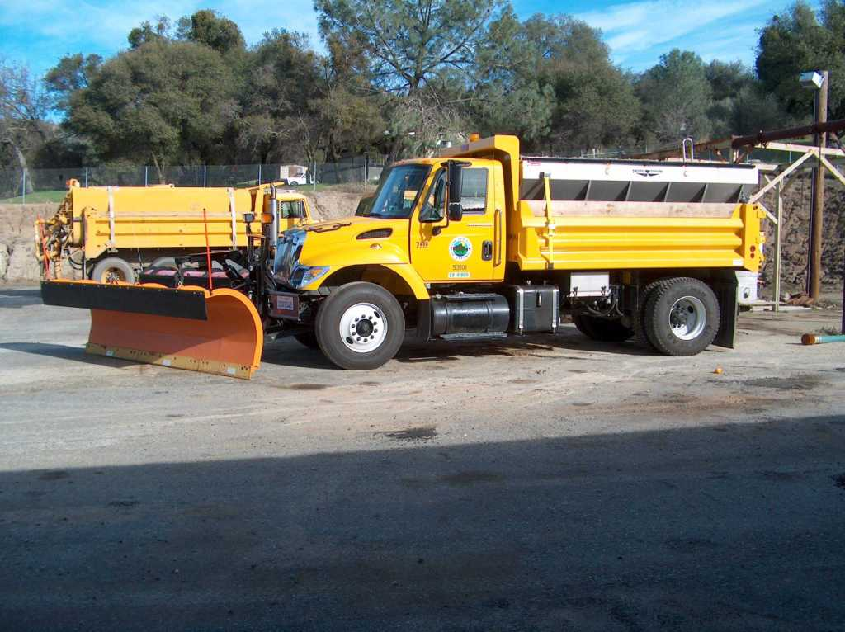
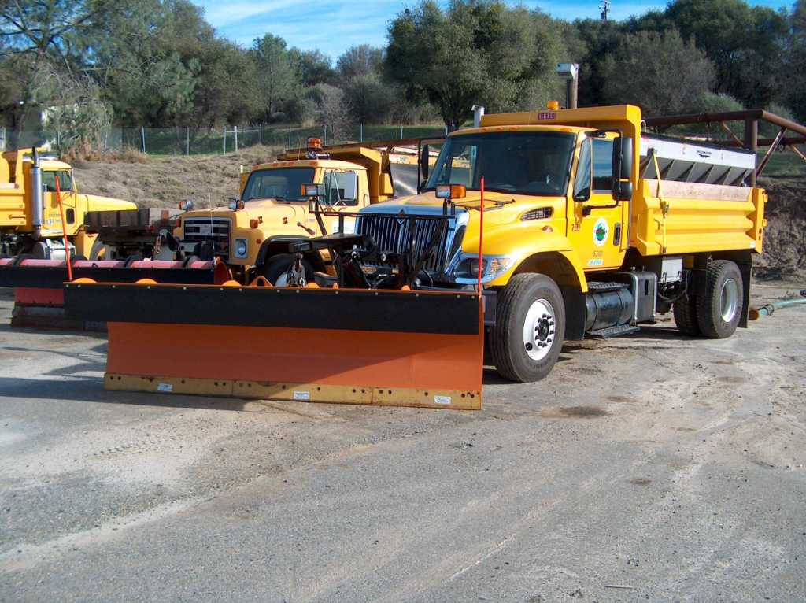
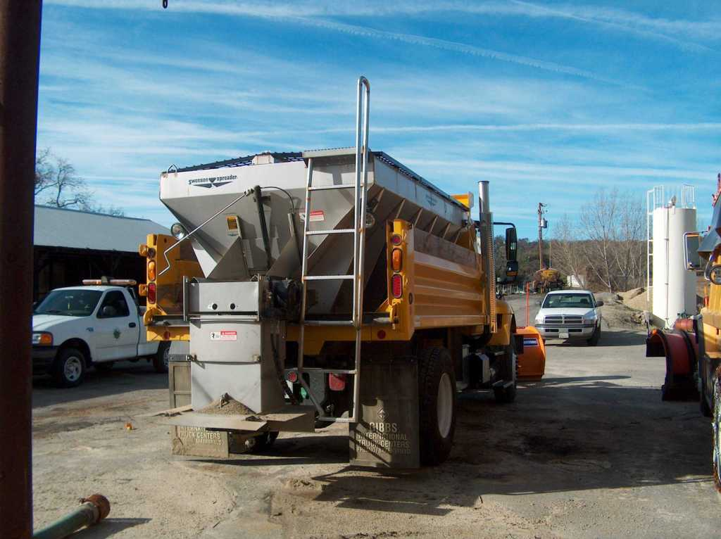
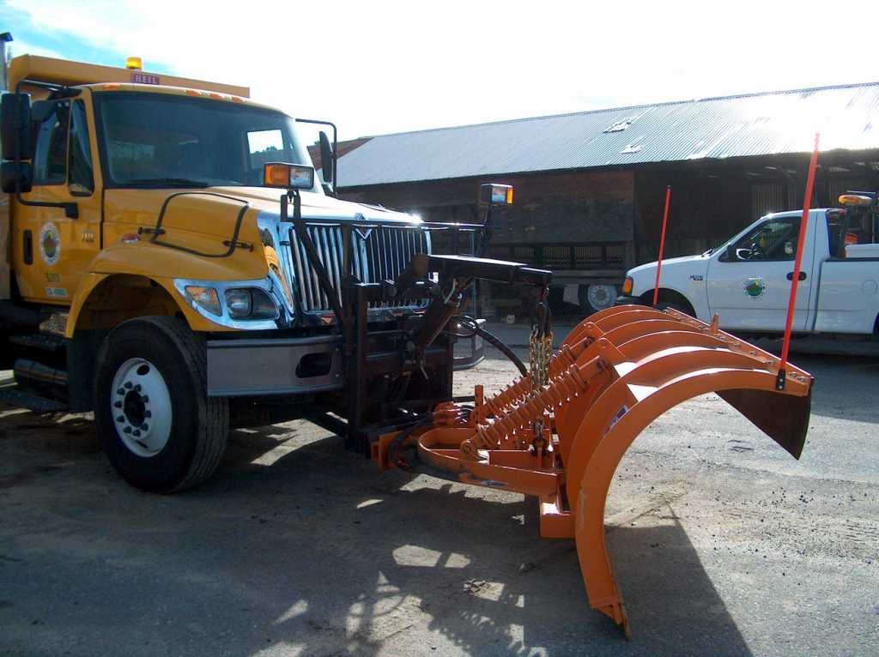
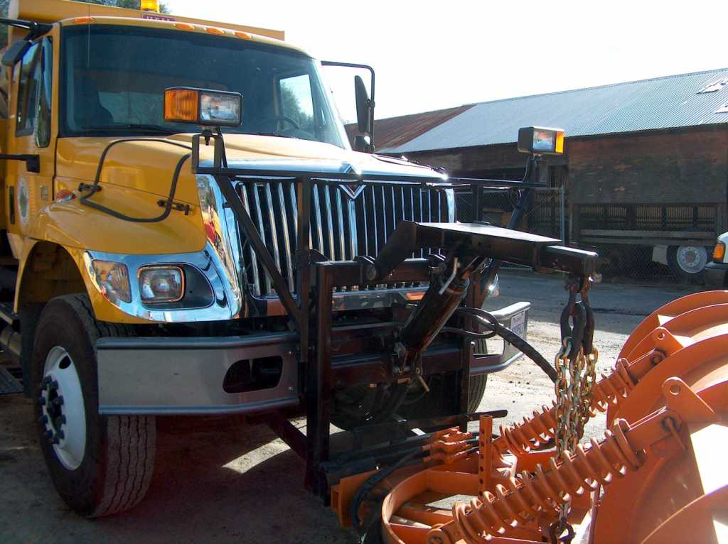

QUOTATION SCHEDULE

 |  |  |  |  |  |  | UNIT PRICE
- Snow Plow Truck, delivered as specified.  Equipment will be delivered by __________ |  |  |  | 1 |  | EA | $
Brand:
Model:
Year:
Sales Tax (7.975%) |  |  |  |  |  |  | $
TOTAL |  |  |  |  |  |  | $
List below all options and features included with the price stated above:
List and quote prices for all options/accessories not included in the unit price quoted above:
 |  | DESCRIPTION | PART NO. |  | * PRICE
 |  |  |  |  | $
 |  |  |  |  | $
 |  |  |  |  | $
 |  |  |  |  | $
 |  |  |  |  | $
 |  |  |  |  | $
*Do not include Sales Tax.

CHECKLIST
This Checklist is provided to assist the vendors in the preparation of their bid response. Included in this list are important requirements and is the responsibility of the bidder to submit with the bid package in order to make the bid compliant. Because this checklist is just a guideline, the bidder must read and comply with the bid in its entirety.
Check off each of the following:
- The Request for Quotation (RFQ) has been signed and completed.
- The Federal Employers Identification Number or Social Security Number has been entered in the space provided.
- Include copies of insurance certificates, bonds, etc.
- One (1) original and two (2) copies of the RFQ has been provided (including all brochures, literature etc.).
- Addendums, if any, have been completed, signed and included in the bid package.
- The Quotation Schedule as provided with this RFQ has been completed, prices reviewed for accuracy and any corrections initialed in ink.
- The “Specifications/Requirements” section as provided with this RFQ has been completed.
- The completed Reference List as provided with this RFQ.
- Indicate all of bidder exceptions to the County’s requirements, conditions and specifications as stated within this RFQ. Submit per instructions stated under the “SPECIFICATIONS/REQUIREMENTS” section of this RFQ and the “EXCEPTIONS” paragraph included under the “BIDDING INSTRUCTIONS” section.
- “BIDDER TO COMPLETE” Page as provided with this RFQ.
- All applicable items as identified in the “EQUIPMENT GENERAL REQUIREMENTS” section of this RFQ under the sub-section “MANUFACTURER’S SPECIFICATIONS”.
- Lastly, on the Lower Left Hand Corner of the sealed envelope, box, etc. transmitting your bid, attached the “Request for Quotation Label” and include the following information:
County of Fresno RFQ No. |  |  | 760-4286
Closing Date: | JULY 12, 2006
Closing Time: | 2:00 P.M.
Commodity or Service:
This Checklist does not need to be returned with your bid.

